.

Child Poverty in New Zealand:
The demographics of child poverty, survey-based descriptions of life ‘below the line’ including the use of child-specific indicators, trends in material hardship and income poverty rates for children, and international comparisons – with discussion of some of the challenges in measuring child poverty and interpreting child poverty statistics

Prepared by Bryan Perry

Ministry of Social Development
Wellington

July 2026

ISBN 978-1-991389-14-5 (Print)

ISBN 978-1-991389-15-2 (Online)

Changes since last report
- Updated with analysis based on 2024-25 HILS data.
- More detail on “what life’s like for children in households in material hardship compared with the vast majority”.
- Trends in real CPI-adjusted household incomes compared with those for nominal incomes
- Reporting on the impact of the level of liquid assets and stock of consumer durables on material wellbeing for households with similar incomes.

Next report

- The next report is scheduled for the second quarter of 2027. The timing is dependent on when Stats NZ publish their Child Poverty Statistics (likely to be February 2027), and on the timing of the availability of the HILS 2025-26 data for MSD use.

Availability on MSD website

- This report is available on the MSD website:
https://www.msd.govt.nz/about-msd-and-our-work/publications-resources/research/child-poverty-in-nz/index.html

Updates since publication on 23 July 2026

- Nil

Acknowledgements

My thanks to all those who provided comments on earlier drafts, including MSD colleagues, staff from Statistics NZ, and others from NGOs. Their advice, questions, challenges and smoothing out of rough patches have added considerably to the report’s robustness, readability and relevance. My thanks especially to Caroline Hodge whose expert SAS coding, preparation of publication-ready tables, ability to succinctly synthesise results from complex investigations of the data, careful review of the full text and unwavering commitment to excellence have been crucial in the production of this report. Responsibility for all the analysis and interpretation in the report (including any errors or omissions) remains mine alone.
About this report

MSD’s Child Poverty Report is a wide-ranging resource designed to inform policy development, research and public discussion on the financial and material wellbeing of children and the households in which they live. Most of what is reported is about material hardship, low incomes and financial stress as these are matters of ongoing public policy interest, but it also reports on how well the vast majority of children and their households are doing in terms of their material wellbeing. Children are those aged under 18 years (1.18 million in 2024-25).

There is naturally some overlap with Stats NZ’s Child Poverty Statistics reports – the same multi-measure approach is adopted recognising that no single measure can adequately capture the different dimensions of poverty as understood in the more economically developed nations, and the same Household Economic Survey (HES) and Household Income and Living Survey (HILS) datasets are used to produce the findings – but the reports are essentially complementary, each with its own focus, purpose and selection of material.

The Stats NZ reports are mainly focussed on fulfilling the requirements of the Child Poverty Reduction Act (2018), reporting on the nine available measures as specified in the Act and enabling an assessment of progress towards the officially gazetted targets. Their focus is on year-on-year changes and changes from the baseline year (2017-18) for all children, and where possible for selected sub-groups (regional council areas, ethnic groups, disability status), in line with the requirements of the Act.

MSD’s reports:
- cover a longer time period than the Stats NZ reports (from 2007 for material hardship (rather than 2013) and from the early 1980s for income (rather than 2007))
- generally focus on overall trends rather than year-on-year and shorter-term changes (except where there are clear real-world factors driving a short-term change), mainly using smoothed rolling two-year averages to more clearly show the overall trends
- use a much wider range of breakdowns (including analysis by tenure, household type and main source of income (market or government))
- provide international comparisons
- compare the material and financial wellbeing of children in their households with that of others in households without children
- have a major focus on what day-to-day life is like for children identified as ‘poor’ compared with other children
- give an integrated account of the different aspects of ‘poverty’ that are reflected in each of the measures, and provide interpretations of the reported trends and numbers using the standard income-wealth-consumption framework used in all MSD’s income and material wellbeing reports
- have a strong research flavour with in-depth coverage of selected conceptual and technical issues
- identify policy-relevant themes throughout.

A detailed Table of Contents assists with navigation to areas of interest.

The latest figures in both Stats NZ’s and MSD’s 2026 reports are based on the same 2024-25 HILS data. (HILS (the Household Income and Living Survey) is the new version of HES (the Household Economic Survey).
The headline CPRA figures in this report are the same as those in the 2026 Stats NZ report. The next Stats NZ report is scheduled for February 2027, with updates using HILS 2025-26.

Four changes of note since the last report in 2024

The 2026 report updates the 2024 edition with analysis from HES 2023-24 and HILS 2024-25. It also includes updates of some of the charts and tables from the 2022 edition that were not included in the shorter 2024 edition. There are however four changes that are not simply updates but are more substantial and worth noting up front.

- Moving from HES to HILS requires the use of revised material hardship measures to ensure continuity of the time series

The main change in terms of impact on the CPRA measures was the inclusion of a revised set of material wellbeing questions (MWQs). A subset of these items in the HES is used for the DEP-17 material hardship (MH) index. When the DEP-17 (6+/17) methodology was applied to the revised MWQs the resulting MH rates were considerably higher than the corresponding ones using the HES data for the same time period. The revised MWQs had in effect made it easier to score 6+/17, so the same level of MH was not being measured which meant that the MH time series would have been broken if that methodology was applied to HILS.

To ensure continuity in the time series a revised MH measure was required. Stats NZ developed a work programme to deliver this and in December 2025 the Government Statistician approved a HILS-based 18-item index (MH-18) with a 7+/18 threshold which achieves this. The HES to HILS transition and especially the change from DEP-17 (6+) to HILS-18 (7+) is discussed and reported on in detail in technical papers from Stats NZ and from MSD. MSD’s HES-based MWI-24 index also required revision to ensure continuity of the MH time series when using it as the MH measure. The HES-based MWI-24 (12-) was replaced by MWI-26 (11-). Item lists comparing the HES-based and HILS-based indices are provided in this report in Appendix 20.

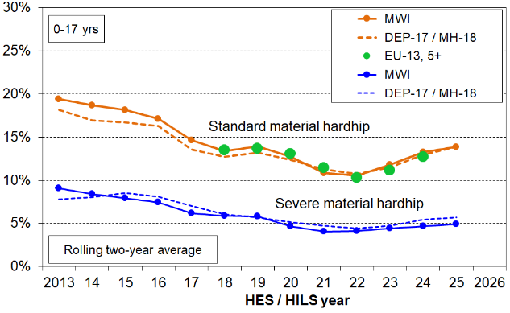
For international comparisons of MH levels and trends the report has used the EU-13 measure. This is not used for HILS 2024-25 MH reporting as we have not yet developed a satisfactory replication using the revised MWQs.

The chart on the right (from Appendix 4) shows the very close similarity of material hardship levels and trends for children using the various indices (DEP-17 / MH-18, MWI-24 / MWI-26 and EU-13 (to 2023-24)).

There are a few other areas that impact comparability between HES and HILS due to changes in the survey design. For the child-specific MWQs the data is available in HILS for 1-14 year olds not for 1-17 year olds as it was in the HES.
HILS also introduced a ‘proxy’ questionnaire module that contained only a limited set of questions, meaning that there is missing information for some variables for individuals that were proxied for; in HES, proxy responses involved someone responding on another’s behalf to the entire questionnaire (but there was no information on quality). The consequence for this report is that for several tables or charts the latest information in this report is for 2023-24 from the HES, particularly where complete information on number of jobs or total hours in employment was required for comparison over time.

- A cautious approach to reporting material hardship (MH) rates in time series that include the COVID years (2020-21 and 2021-22)

The 2024 Child Poverty Report (p19) noted the challenges in interpreting what was behind the relatively large ‘uptick’ in reported 2022-23 MH rates compared with those in 2021-22 (a 2.0 ppt rise from 10.5% to 12.5%). It recognised that the reported rise was ‘no doubt at least in part a reflection of the impact of the cost-of-living crisis’ but suggested caution in the narrative as ‘the lock-downs and other COVID-related factors changed the spending and living patterns of households and it is not clear what impact this had on reported material hardship rates’.

This 2026 report further develops the rationale for a cautious approach to MH time series reporting that covers the COVID years, extending it to both the COVID-impacted years (2020-21 and 2021-22), and noting the challenges in producing a definitive narrative given the range of factors at play: the impacts of ongoing implementation of increased government support from earlier Budget initiatives for households with children (including the Families Package); the changed consumption behaviour induced by the lockdowns; the special extra support in the COVID years. Much of the MH time series analysis in this report is about sub-groups of children, and Stats NZ advise caution when reporting on sub-groups in 2021-22.

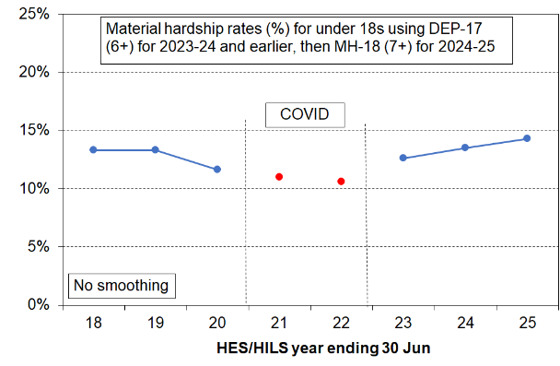
Taking all this into account, the approach used in this report is illustrated in the short-run chart on the right. To remind the reader of the unusual context and the extra uncertainties, the findings for the COVID-impacted years are included but the dots are not joined. Neither the policy-induced reduction in the material hardship rate for children nor the recent rise are edited out by this decision. It simply reminds the reader of the uncertainties around giving a definitive narrative. The rise from 2023 to 2025 is statistically significant and starts from a solid base year.

More detail on the rationale for this approach is given in Section F (pp57ff).

- More use of information on assets

In this report, as in the CPRA and in poverty analysis in OECD and EU countries, poverty is understood at a high level as ‘exclusion from the minimum acceptable way of life (standard of living) in one’s own society because of inadequate resources’. Traditionally household income has been used as the measure of ‘resources’. This approach clearly has limitations, one of which is that households with similar incomes can have quite different ‘liquid assets’ (cash savings and readily accessible investments) and quite different stocks of consumer durables in both quality and quantity. These differences go a long way to explaining the observed mismatch between income- and non-income based measures of poverty.

Previous MSD Child Poverty reports have included some analysis using data on liquid assets together with income data, and this is expanded in the 2026 report through the availability of good quality wealth data from the 2023-24 Net Worth survey. While HES (now HILS) is run every year, it collects additional data on individual and household assets, liabilities, and net worth every three years.

- Fuller set of Appendices

The 2026 report has a fuller set of Appendices than in the past, including extensive updated information on household incomes (eg trends in real terms … and poverty lines converted to ordinary dollars for selected household types) and a detailed record of the changes in the material wellbeing questions when moving from HES to HILS 2024-25.

CPRA official child poverty figures from Stats NZ

Rates (%) and numbers for the nine available CPRA child poverty measures:
Stats NZ figures for 2017-18 to 2024-25
 | Measure | % poor |  |  |  |  |  |  |  | # poor
 | Measure | HES |  |  |  |  |  |  | HILS | HILS
 | Measure | 17-18 | 18-19 | 19-20 | 20-21 | 21-22 | 22-23 | 23-24 | 24-25 | 24-25
P | BHC 50% relative | 16.5 | 13.6 | 13.3 | 12.9 | 11.7 | 12.1 | 12.7 | 12.6 | 148,700
P | AHC 50% anchored line (17/18 ref) | 22.8 | 18.7 | 17.9 | 15.0 | 14.6 | 17.8 | 18.2 | 17.8 | 210,600
P | Material hardship | 13.3 | 13.3 | 11.6 | 11.0 | 10.6 | 12.6 | 13.5 | 14.3 | 169,300
P | Persistent poverty | Not required until after the 2025-26 financial year (likely to be published in Feb 2027)
S | BHC 60% relative | 25.3 | 22.1 | 21.7 | 20.5 | 20.2 | 21.7 | 21.5 | 21.7 | 256,400
S | AHC 60% relative | 30.6 | 27.8 | 27.6 | 27.4 | 27.8 | 29.3 | 30.1 | 29.9 | 354,200
S | AHC 50% relative | 22.8 | 20.1 | 19.5 | 19.6 | 18.8 | 20.5 | 21.1 | 21.5 | 254,500
S | AHC 40% relative | 15.7 | 13.9 | 13.1 | 12.2 | 11.9 | 13.0 | 13.8 | 13.4 | 158,100
S | Severe material hardship | 5.8 | 5.8 | 4.6 | 4.9 | 4.0 | 5.6 | 5.5 | 6.0 | 71,000
S | Both material hardship and low-income (less than 60% AHC) | 8.8 | 7.8 | 6.9 | 6.5 | 5.8 | 6.8 | 7.8 | 8.6 | 101,600
Source: Child poverty statistics: Year ended June 2025 – summary table
Notes for Table:
- BHC is short for ‘household income before deducting housing costs’ and AHC means ‘household income after deducting housing costs’.
- ‘AHC 40% relative’ is short for ‘40% of the median AHC income’, and so on.
- Material hardship and severe material hardship for the HES years are measured using the DEP-17 index with thresholds of 6+ and 9+ respectively. For HILS 24-25 the MH-18 index is used with thresholds of 7+ and 10+.
- P = primary measure (required by the CPRA to have targets).
S = supplementary measure (no targets required).
- The 2024-25 figures are italicised as they are provisional. The figures for the latest survey are always provisional for the February publications as final IRD returns are still to come for some who receive WFF tax credits. In addition, by the time of the next publication there will have been a population rebase. The provisional and revised figures for 2023-24 are shown in Table A2.2.
See the Child Poverty Technical Appendix for more information:
https://www.stats.govt.nz/methods/child-poverty-statistics-year-ended-june-2025-technical-appendix/

Provisional and final rates (%) for the nine available CPRA child poverty measures for 2023-24
 |  | % ‘poor’
 | Measure | 23-24 provisional | 23-24  final
P | BHC 50% relative | 12.7 | 12.7
P | AHC 50% anchored line (17/18 ref) | 17.7 | 18.2
P | Material hardship | 13.4 | 13.5
S | BHC 60% relative | 21.6 | 21.5
S | AHC 60% relative | 29.9 | 30.1
S | AHC 50% relative | 21.1 | 21.1
S | AHC 40% relative | 13.6 | 13.8
S | Severe material hardship | 5.4 | 5.5
S | Both material hardship and low-income (less than 60% AHC) | 7.7 | 7.8

Table of Contents

Glossary, Acronyms, Abbreviations and Definitions 10

Part One
Introduction: concepts, definitions, measures, data sources
Section A
Concepts, definitions and measures 13
The income-wealth-consumption framework used in the MSD reports
‘Poverty’ in this report: High level definition used in richer nations
Using low household income to measure poverty
Using non-income measures to measure poverty - material hardship or deprivation indices
Combining household income and material hardship indices to measure poverty
Setting thresholds or ‘poverty lines’
Updating low-income thresholds (poverty lines) over time: fixed and moving line approaches
Giving the numbers meaning – the need for a reference point
Poverty experienced, including Sen on ‘shame’
Rationale for a focus on child poverty
Box #1 – The UK’s possible new supplementary measure of poverty: BAR (Below Average Resources)

Section B
Data sources 25
The shift from HES (Household Economic Survey) to HILS (Household Income and Living Survey)
Sample size and data collection challenges
Labelling of HES and HILS years

Part Two
Selected Findings
Section C
Material hardship (MH) comparisons with European countries using the EU-13 index 29
All children (0-17 years) in 2024
Two-parent and sole-parent households
Older New Zealanders and children compared
Child-specific deprivation items and selected child-related household items: comparisons with European countries

Box #2 – Measurement and reporting approaches for the MH sections that follow (Sections D, E and F)

Section D 33
What does poverty look like in practice for children in households identified as being in material hardship (MH)?
For children in households identified as ‘in hardship’, life is typically very different from that experienced by the vast majority of New Zealand children
A wider selection of child-relevant household items plus some child-specific items: deprivation rates for each of these items for all aged 6-17 yrs in households in material hardship or severe material hardship
DEP-17 items
Self-assessed income adequacy

Section E 41
The demographics of child material hardship (MH): breakdowns for children in different household contexts and for individual characteristics; comparisons with selected households without children
Overview tables by selected breakdowns
household type
number of children in the household
work intensity and labour market status of household
main source of income – market or government
tenure
private rental by AS receipt
highest educational qualification in the household
ethnicity
disability status
age (younger children compared with older children, all children compared with older New Zealanders)
Children in ‘working’ and ‘beneficiary’ households
Children by their disability status and that of their households
Material hardship in the ‘early years’
Material hardship, low (AHC) income and foodbank usage in six Auckland sub-regions
Material hardship depth and socio-economic status
Section F
Material hardship trends, 2007 to 2025 57
The approach taken to measuring material hardship trends
All children
Comparisons with the whole population and with older New Zealanders
Tenure
Ethnicity
Disability status
‘Working’ and ‘beneficiary’ households
[Numbers only – Children in workless households - including international comparisons]
[Numbers only – Children in workless households, in households with no full-time paid worker and in families in receipt of a main benefit]
Trend in material wellbeing for children in households above the hardship threshold
Self-assessed income adequacy (‘not enough’ and ‘enough’ or ‘more than enough’)

Section G
Trends in the real CPI-adjusted incomes for households with children 71
Real vs nominal trends for selected household incomes
Median incomes – whole population (BHC and AHC)
p20 and p70 – whole population (BHC and AHC)
Median incomes – children in their households (BHC and AHC)
p10, p20 and p30 – children in their households (AHC)
Selected factors impacting on trends in household incomes
Trends in the real hourly rate for the minimum wage and the median wage
Proportion of two parent HHs that are two-earner HHs
Proportion of children in beneficiary households
Real-terms trends in core benefit + FB/WFF and in total incomes for beneficiary families
Household income trends for children by household type and ethnicity (1982 to 2025)

Section H
Trends in AHC low-income (poverty) rates for children in their households 77
Constant value or fixed line approach (FIXED) using AHC 50
Similarity in trends for AHC (fixed) and material hardship
Moving line or relative (REL) approach using AHC 40 50 and 60 REL

Section I
Housing costs and housing affordability for owners & renters (HHs with children) 83
Numbers and proportions of children by tenure (2024-25)
Average housing costs relative to household BHC income, by income quintile, 1988 to 2025
Housing affordability using housing-outgoings-to-income ratios (OTIs) set at 30%, 40% and 50%
All households with children
Low-income households with children, privately owned
Renting privately and receiving the AS

References 87

Appendices 90

- Further information on the Data Sources for the analysis in this report: Stats NZ’s Household Economic Survey (HES) and Household Living Survey (HILS) and some associated administrative data.
- CPRA official child poverty figures from Stats NZ, 2017-18 to 2024-25.
- Composition of material hardship indices used in this report (EU-13, DEP-17/MH-18 and the MWI-24 and MWI-26), plus the child-specific items for HES 2023-24.
- Trends showing the close similarity of material hardship assessments for children using three indices (DEP-17, EU-13 and MWI)
- Whole population version of Table D.5.
- Sensitivity of findings to choice of 80% rather than 50% as the threshold for ‘main source’ of household income.
- Trend in CPI changes for quarter-on-same-quarter-12-months-before.
- Equivalisation and ‘Where does your household fit in the income spectrum?’
- Low-income thresholds (poverty lines) by household type.
- Decile boundaries and means ($2025) 1982 to 2025.
- –
- –
20 Full text of HES and HILS MWQs (material wellbeing questions):
All
DEP-17 and MH-18
MWI-24 and MWI-26

Glossary, Acronyms, Abbreviations and Definitions

CPRA Child Poverty Reduction Act (2018)
GFC Global Financial Crisis (2008-2009)
HES Household Economic Survey
HILS Household Income Living Survey
LIA Living in Aotearoa
GSS General Social Survey
MH ‘Material hardship’. Note that the EU term is ‘material and social deprivation’
SMH ‘Severe material hardship’
Disposable income Income from all sources (incl WFF tax credits) less income tax and ACC earners levy
Main income source For some analysis households are divided into two groups according to the main source of household income – market or government. Market income is income from salaries and wages, self-employment and investment. Government income is income from social welfare benefits, NZS, AS, WFF tax credits, student bursaries, and so on.
AHC income Income after (deducting) housing costs
BHC income Income before (deducting) housing costs
Equivalised income Household income adjusted for household size and composition to enable more reasonable comparisons between households when household income is used as a measure of material wellbeing
BHC 60 etc Low-income threshold or income poverty line = 60% of the BHC median
REL or ‘moving’ Relative-to-contemporary-median (referring to low-income thresholds or ‘poverty lines’ that are calculated as a proportion of the median for the survey year in question)
‘FIXED’ Low-income thresholds kept ‘fixed’ in real (inflation-adjusted) terms, starting with a reference year. They are also referred to as ‘anchored’ lines (OECD)
WFF Working for Families
AS Accommodation Supplement
NZS/VP New Zealand Superannuation / Veterans Pension
FT Full-time (30 hours or more per week). Can also be short for Family Trust
PT Part-time (from 5 to less than 30 hours per week in paid employment)
WL Workless adult (less than 5 hours per week in paid employment)
SE Self-employed (HH) – a household for which more than half the gross income comes from self-employment.
Decile One tenth or 10% of a ranked group of individuals or households
Ventile One twentieth or 5% of a ranked group of individuals or households
p10 The boundary at the top of the lowest income decile (so, P50 is the median)
NZDep13 A socio-economic deprivation index that combines census data relating to income, home ownership, employment, qualifications, family structure, housing, access to transport and communications. NZDep13 provides a deprivation score for each mesh block in New Zealand (typically 60-110 people in each). It is not a household-based measure
EU-SILC Eurostat’s annual Survey of Incomes and Living Conditions (EU-SILC)
OTI ratio The ratio of housing costs outgoings to disposable household income, often expressed as a percentage (eg ‘an OTI > 40%’)
DEP-17 A HES-based index for measuring material hardship (threshold is 6+/17)
MH-18 A HILS-based index for measuring material hardship (threshold is 7+/18)
MWI-24 MSD’s HES-based 24-item Material Wellbeing Index – ranks households across the full MWB spectrum from low to high
MWI-26 MSD’s HILS-based 26-item Material Wellbeing Index – ranks households across the full MWB spectrum from low to high
MWI Shorthand for one or both the above, used when context makes the meaning of this shortened version clear
Liquid Assets In short, savings and accessible investments

Useful links

The latest Stats NZ Child Poverty Statistics release (February 2026):
https://www.stats.govt.nz/information-releases/child-poverty-statistics-year-ended-june-2025/
Budget 2026 Child Poverty Report:
https://budget.govt.nz/budget/2026/child-poverty-report/index.htm
2023 BIM (prepared by the Child Wellbeing and Poverty Reduction Group while part of DPMC - the CWPRG is now in MSD)
https://www.msd.govt.nz/documents/about-msd-and-our-work/child-youth-wellbeing/advice-to-ministers/bim-2023-child-poverty-reduction.pdf
Budget 2023 Child Poverty Report – see pp45ff in:
B2 Wellbeing Budget 2023 - Support for Today, Building for Tomorrow - 18 May 2023 (treasury.govt.nz)
Child Wellbeing and Poverty Reduction Group (MSD):
https://www.msd.govt.nz/about-msd-and-our-work/child-wellbeing-and-poverty-reduction/index.html
Previous MSD Child Poverty Reports (2021, 2022, 2024):
https://www.msd.govt.nz/about-msd-and-our-work/publications-resources/research/child-poverty-in-nz/index.html
‘Insights from New Zealand child poverty data, 2022’, Treasury Analytical Note (Meghan Stephens): https://www.treasury.govt.nz/sites/default/files/2022-09/an22-04.pdf

Development of a new measure of poverty in the UK to sit alongside the existing HBAI measures:
https://www.gov.uk/government/statistics/below-average-resources-developing-a-new-poverty-measure/below-average-resources-developing-a-new-poverty-measure
https://socialmetricscommission.org.uk/
https://povertystrategycommission.org.uk/

Part One
Concepts, definitions, measures and data sources

Section A
Concepts, definitions, measures

Section A describes and discusses the conceptual, methodological and technical infrastructure used in this report and other similar ones internationally. The choices made in the process of going from raw survey and administrative data to the dataset used for analysis and then to the tables and charts in the report have an impact on the picture that is painted. Not every aspect of the journey is covered – the report’s major focus is on the steps after the analysis data set is created. See Stats NZ’s February 2025 Technical Appendix for more detail.

The section opens with a description of the income-wealth-consumption framework used in MSD reports to assist with thinking through the relationship between material wellbeing (or living standards), material hardship, household income, financial and physical assets, and other factors.

It then gives the high-level definition of ‘poverty’ used in this report and discusses the three main metrics used to implement the definition in practice:
- household incomes before and after deducting housing costs (BHC and AHC)
- non-income measures / non-monetary indicators and the associated indices created by using selections of these items together
- using both income and non-income measures together in a hybrid.

Whatever measure is used, judgment calls are needed to set poverty thresholds. This matter is discussed next.

A decision has to also be made as to how to update the low-income thresholds over time. What is the threshold to be anchored to? Past standards held fixed in real terms or to the middle household in the survey year?

To give the resulting numbers meaning, reference points are needed. The report uses international comparisons, trends over time, comparisons among sub-groups and descriptions of life below selected thresholds using individual deprivation items.

For those wishing to go straight to the charts and tables – they begin in Section C (page 29).
The income-wealth-consumption framework used in the MSD reports

MSD’s reports use the framework outlined in Figure A.1 below for thinking through the relationship between material wellbeing (or living standards), household income, financial and physical assets, and other factors.
- ‘Current’ household income and financial and physical assets together largely determine the economic resources available to most households to support their consumption of goods and services and therefore their material standard of living.
- For low-income households that have very limited or no financial assets, income is the main resource available to generate their standard of living (along with the stock of physical assets such as furniture, whiteware and other consumer durables). Such households struggle in varying degrees to meet basic needs, and are also very vulnerable to the negative impacts of ‘shocks’, such as even a small drop in income or an unexpected expense.
- The framework recognises that factors other than current income and assets can also impact on material wellbeing. These factors are especially relevant for low-income / low-asset households, and can make the difference between ‘poverty/hardship’ and ‘just getting by’.
- Current physical and financial assets are a product of previous income, special demands on the household budget and budgeting decisions, gifts from outside the household, and so on; and also the history of the household itself in terms of dissolutions and re-formations involving current household members. The framework can be used in both static and dynamic contexts.

Figure A.1
The income-wealth-consumption framework used in the MSD reports
Financial and physical assets (in part reflecting previous income)
Resources available for consumption
Household income (equiv)
Basic needs / essentials
Discretionary spend / desirable non-essentials

MWI
DEP-17 MH-18

Material wellbeing or living standards
Factors that may reduce MH for a given income and asset level
assistance from outside the household (family, friends, community, state), good stock of consumer durables

Factors that may increase MH for a given income and asset level
high housing costs, high employment-related costs (eg childcare, transport), high or unexpected health or debt servicing costs, disability that incurs extra costs

. Ability to convert given resources into valued consumption

In line with the above, a key theme of this report and MSD’s main Household Incomes and Material Wellbeing reports is that ‘not all households with low incomes are in hardship, and not all in hardship have low incomes’. The overlap between material hardship and income-based measures is limited, typically of the order of 45%, and as low as 30%, depending on the low-income measure used. Factoring this into our reading of the figures is critical for understanding and interpreting child poverty statistics.

For Figure A.2 and the associated table individual children within each AHC household income quintile are ranked on the level of liquid assets of their respective households, then split into three equal groups. The right-hand third within each quintile has the highest level of liquid assets. (‘Liquid assets’ refers in the main to savings and accessible investments.)

The results show that for households with similar incomes (after deducting housing costs), higher levels of liquid financial assets go with lower levels of material hardship. This is hardly a surprising finding, but it is not often explicitly to the fore in discussion and debate, in part because it is rare for a single dataset to have the three pieces of information needed to enable the analysis to be done (income, liquid assets such as savings and accessible investments, and material hardship).

The table shows that, within each AHC income quintile, households with higher liquid asset levels also have higher levels of non-vehicle consumer durables (whiteware, other kitchen appliances, furniture, bedding, electronics including televisions, audio systems and so on). These too are resources that contribute to the material wellbeing of the household.

Figure A.2
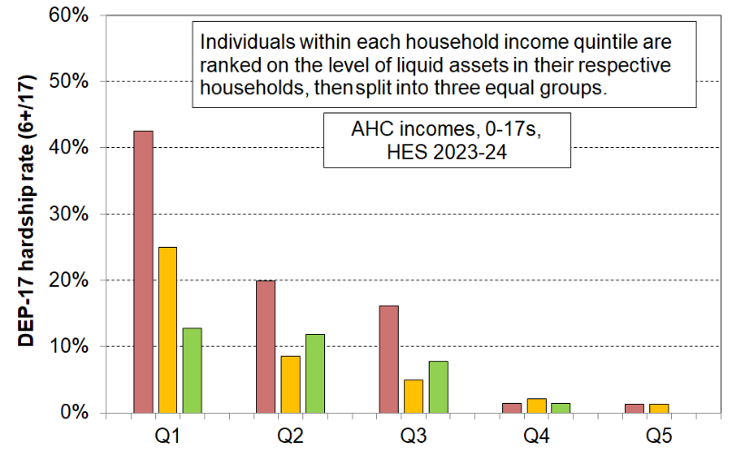
Material hardship rates depend on the level of liquids assets as well as on household income
Reading notes for Figure A.2 and associated table below:
- The five quintiles are quintiles of AHC household income – Q1 is the lowest quintile and so on.
- The quintiles are whole population quintiles so the subgroup (0-17s) is not evenly spread across the quintiles - see bottom row in table below.
- Individuals within each household income quintile are ranked by their household’s level of liquid assets, then split into three equal-sized groups.

HES 2023-24 | Q1 |  |  | Q2 |  |  | Q3
avg AHC household income (equivalised) | 16,000 | 15,000 | 14,000 | 28,000 | 28,000 | 29,000 | 40,000 | 40,000 | 40,000
median liquid assets ($) | 0 | 500 | 11,000 | 300 | 2,600 | 23,300 | 600 | 5,900 | 32,600
median consumer durables (excl vehicles) ($) | 8,000 | 15,000 | 25,000 | 18,000 | 35,000 | 35,000 | 25,000 | 49,000 | 64,000
self-assessed income adequacy – ‘not enough’ | 30 | 27 | 18 | 26 | 16 | 9 | 13 | 5 | 11
material hardship rate (%) (6+/17, DEP-17) | 43 | 25 | 13 | 20 | 9 | 12 | 16 | 5 | 8
put up with cold ‘a lot’ to save on costs (%) | 16 | 9 | 7 | 19 | 5 | 7 | 7 | 3 | 2
used a foodbank more than once in previous 12 months (%) | 32 | 15 | 4 | 15 | 10 | 6 | 11 | 1 | 8
borrowed from fam/friends more than once in previous 12 months to pay for basics (%) | 36 | 13 | 8 | 19 | 12 | 10 | 14 | 6 | 1
can pay an unexpected + essential $500 bill within a month without borrowing (%) | 42 | 62 | 89 | 59 | 84 | 87 | 78 | 91 | 94
All 0-17s | 98,000 | 98,000 | 99,000 | 89,000 | 89,000 | 90,000 | 79,000 | 79,000 | 80,000

[As an aside, it is worth noting that in the table above the self-assessed income adequacy responses are clearly contextualised ones about the adequacy of household income given their particular household circumstances. They follow the material hardship rates reasonably closely, indicating that in their self-assessments respondents take account of the full range of household circumstances, not just income.]
‘Poverty’ in this report

Poverty in this report and in the measures specified in the Child Poverty Reduction Act (CPRA) is essentially about household resources being insufficient to enable households to meet basic household needs in a more economically developed country (as in the OECD or EU). Poverty is understood as ‘exclusion from the minimum acceptable way of life (standard of living) in one’s own society because of inadequate resources’. It is in line with the EU definition which was first agreed at the 1975 EU Council of Ministers, and which was inspired by the work of Peter Townsend in the UK in the 1970s.

It is important to keep in mind the distinction between this conceptualisation of poverty and some others that are used. For example:
- it differs from a subsistence definition which focuses on the bare minimum needed for survival and which is used in discussing and measuring poverty in poorer countries
- it is more narrowly focussed than are the multi-dimensional poverty and disadvantage analyses that are becoming more common
- it is more narrowly focussed too than the colloquial use of the term as a catch-all that refers to any serious disadvantage or cluster of disadvantages experienced by individuals, households or geographical areas
- it is quite different from the more general notion of wellbeing, though it is related to it
- it can and ought to be clearly distinguished from the causes, correlates and consequences of the core issue (poverty as inadequate command over resources).

The definition given above leaves open the question as to whether poverty should be measured using resources, more directly through a measure of standard of living as experienced in practice, or by using both approaches together - an ‘overlap’ approach. All three are used in the measures defined in the CPRA, and by governments and researchers in the richer nations (eg OECD / EU).

Using low household income to measure poverty

Household income, adjusted for household size and composition (‘equivalised’), has traditionally been used in the richer countries as a proxy measure of household resources. While this approach produces valuable information on the (changing) number of ‘low-income’ households and on income inequality in the lower half of the income distribution, it has several limitations as a poverty measure. These shortcomings are all consistent with the conceptual and empirical matters presented in Figures A.1 and A.2 above.
- Different households with very similar current income can have different levels of non-income resources, sometimes reflecting different income trajectories in previous years, sometimes the degree of assistance from outside the household (family/friends, communities, Government) or the level of assistance given to other households. The differing non-income resources include the levels of ‘liquid assets’ (cash savings and readily accessible investments), and the quantity and quality of the stock of basic household items, especially durables.
- Different households with very similar current income can also have quite different basic needs. Some of these differences can be addressed: household income can be adjusted for household size and composition (‘equivalised’); the differing demands on the budget for differing housing costs can be addressed to a degree by using income after deducting housing costs (AHC income) to make comparisons more realistic. However, there are some differing demands on the household budget (ie differing needs) that cannot easily be adjusted for (eg special health- or disability-related costs, high debt servicing, child-care costs, and so on). There is also variability in the ability of households to convert a given income into valuable consumption.

As a result, when using a given low-income threshold (‘income poverty line’), it is found that some of the low-income households do not experience financial and material hardship, and others with incomes ‘above the line’ do. Low income on its own, even when accurately measured, does not distinguish well between those with adequate resources to sustain a minimum acceptable standard of living and those without these.

The limitations of household income as a reliable proxy measure of a household’s ‘command over resources’ and the resulting limitations of low-income measures for assessing levels and trends in poverty do not mean that income has little impact on the material wellbeing of individual households. For lower-income households especially, any increase in income will almost always make a positive difference. It is just that when it comes to measuring poverty (as defined above, ‘resources not enough to meet basic needs’), income on its own (especially BHC income) has some significant limitations as an identifier of those who are actually struggling to achieve a minimum acceptable material standard of living. The very clear impact of income changes on a given household’s material wellbeing is a quite different matter to the challenges of using household income as a measure of the level of and trends in poverty as defined above.

While recognising the limitations of household income as an indicator of a household’s ‘command over resources’, the monitoring of the trends in household income for the population as a whole and for those in lower-income groups is nevertheless of considerable value for informing public discussion, policy advice and political decision-making. For most lower-income households, household income is the major resource available for meeting basic needs and, for governments in the richer OECD-type nations, policies impacting on household incomes are the main levers available for poverty reduction.

Using non-income measures to measure poverty – material hardship or deprivation indices

Over the last three decades growing use has been made of non-income measures / non-monetary indicators to more directly measure material standard of living and material hardship. These measures use survey information about what basics and near-basics households can and cannot in practice afford. By using carefully selected items from the survey information, indices can be created to rank households across a spectrum from no hardship through to severe hardship. They enable a more direct measurement of ‘minimum acceptable standard of living’ than household income does.

In the early 2000s, MSD developed the Economic Living Standards Index (ELSI) which was further developed in 2009 into the 24-item Material Wellbeing Index (MWI). These indices rank households across the full material wellbeing spectrum from high to low, with greater sensitivity at the low end. In response to stakeholders asking for a simpler, more intuitive version which focused mainly on the material hardship end, MSD developed a 17-item material deprivation index (DEP-17). This index and its revised version for use with HILS data (the MH-18 index) are now widely used, including in the CPRA suite of measures. DEP-17 can be used only from the 2013 HES and later, whereas the MWI and its ELSI predecessor can go back to the 2007 HES. Their use in MSD’s reports enables longer material hardship time series to be produced, from 2007 to 2025. For material hardship measurement, the MWI and DEP-17 / MH-18 give close to identical numbers from 2013 on for both the whole population and for children.

The EU has formally adopted a 13-item material and social deprivation index (‘EU-13’ in this report) as one of its suite of social inclusion indicators. Both EU-13 and DEP-17 (MH-18) are designed as instruments to rank households by their differing degrees of material hardship, using a balanced set of indicators that cover a range of domains and degrees of depth of deprivation, reflect the same underlying concept (or ‘latent variable’), and which apply reasonably well to people in different age groups and household types. The two indices use different sets of items, but give the same trends from 2013 on, and close to identical numbers especially in recent years.

While the development and increasing use of material hardship indices is a valuable advance for poverty measurement, they too have their own challenges. One is that the information for the indices comes from surveys and some of the items have a subjective element in their requirement for respondents to report the seriousness of the material or financial constraints they are experiencing. There is evidence that some disadvantaged respondents compare themselves with others in similar precarious circumstances or even with those worse off than themselves (rather than to an independently determined standard) and adapt their expectations accordingly. This can lead to an under-estimate of material hardship rates. Poorer respondents may also (consciously or unconsciously) adopt a strategy that to a degree preserves their dignity by replying “don’t have because don’t want” rather than “don’t have because of cost” – and only the latter responses get counted towards their deprivation or hardship score. There is also a decision to be made on how to aggregate the number of reported deprivations into an index – is it just a simple count, or should it be a weighted count with the greatest weight going to items deemed (by survey) to be the most commonly possessed? The rationale for the latter weighting is that it ‘hurts’ more to be deprived of those items that are more commonly possessed items than those less so.

Combining household income and material hardship indices to measure poverty

There is a good case for using a combination of both low income and material hardship as a poverty measure. Ireland uses the combination method to measure what they call ‘consistent poverty’, as in their view this (overlap) group best fits the high-level definition which has both an input (resources) and outcome dimension (minimum acceptable material standard of living). It also goes some way to addressing the mismatch issues identified above in the discussion of the use of household income alone. MSD uses the combination method as one of the measures in its multi-measure multi-level approach. It is one of the specified measures in the CPRA suite.

Setting thresholds

Whichever measurement approach is used – one of the household income measures or a material hardship index using non-income measures or an overlap measure – value judgments are needed to decide on how to give practical effect to the ‘minimum acceptable’ and ‘inadequate’ descriptors in the definition (ie what minimum standard of living is acceptable? … at what level does income become too low to support this minimum acceptable standard of living? ie where to draw the poverty line? … what rules to use for updating thresholds over time?). These decisions are very influential on the resulting numbers and therefore on the overall perception of the size of the ‘poverty issue’. Making these value judgments is an inescapable aspect of poverty measurement and debate. This however does not mean that any measure will do nor that all measures are equally imperfect. Some are clearly more reasonable and defensible than others.

For low-income thresholds one way of reaching a view on a plausible threshold range is to develop what are often called ‘reference budgets’ for selected household types. In developing the estimates some key assumptions are specified. For example, the households are usually assumed to have no savings to draw on, but they do have basic furnishings, furniture and household appliances; there are no special health- or disability-related extra demands on the household budget; the household has stable financial circumstances and very good financial management abilities; the purchasing power of the budget is ‘strictly minimal’ covering core costs only but being enough to allow the household to live independently without resorting to a foodbank or other outside assistance. To simplify the process even further, the tenure of the specified households is usually limited to rentals only.

The judgment call can also be informed by survey-based evidence of levels of material hardship for households at varying levels of low income and by citizens’ reflection on the reasonableness of the dollar value of the proposed low-income thresholds.

A defensible BHC low-income threshold is particularly difficult to pin down, mainly because of the wide range of accommodation costs for similar housing in different geographical regions or areas within cities. Recognising this and other regional differences in transport, clothing, and food costs, Statistics Canada produce 53 different low-income thresholds in their Market Basket Measure approach which Canada uses as their official poverty measure as specified in their Poverty Reduction Act. We do not have such a detailed and sophisticated measurement infrastructure in New Zealand. In fact, households that are eligible for the Accommodation Supplement receive higher AS assistance if they live in more expensive areas, thus (perversely) reducing their chances of being counted as ‘in poverty’ using BHC measures, all else equal. In addition, BHC measures cannot be used to validly compare the financial circumstances of owners without mortgages with those of renters, unless imputed rent is included for owners. We do not have official estimates of imputed rent in New Zealand. For all these reasons and those noted earlier, this report does not use BHC incomes for poverty measurement.

It is less difficult to reach a view on a reasonable and defensible AHC income band for use in poverty measurement. For this judgment call, the question is: if this ‘poverty line’ income is the household’s only financial resource after paying for accommodation costs (no savings to draw on), and assuming no special extra demands on the budget from health- or disability-related costs or from ongoing debt repayments, and assuming a reasonable stock of furniture, bedding and household appliances, could this household reasonably be expected to maintain a minimum acceptable standard of living without needing to seek help from outside sources such as foodbanks, family or friends or from the state via Special Needs Grants or the like?

Recent ‘reference budget’ analysis carried out by MSD estimated that for households renting privately and receiving core income-tested benefits a reasonably narrow range of AHC 40 to AHC 50 is plausible. For working households, the extra child-care and transport costs mean a threshold of more like AHC 55 is justified. A similar range was found in the data reported by focus group research carried out in the 1990s by the New Zealand Poverty Measurement Project.

For a household comprising a sole parent plus two children (both under 14), the AHC 40 threshold in June 2025 was $520 per week once the accommodation is paid for, and the AHC 50 threshold was $650 pw. For a household comprising two parents with two children the corresponding figures were $685 and $855 pw. (See Appendix 9 for low-income thresholds for other household types). The reader is invited to make their own assessment as to whether incomes in this range or just above it are sufficient for these households with children to ‘make ends meet for the basics’ and to what degree they could be expected to participate in the ordinary living patterns and activities of their community (assuming no savings to draw on, no outside assistance from family or friends or community sources, and no special demands on the budget as described above).

As for a low-income AHC threshold, a material hardship threshold that reflects ‘minimum acceptable living standards’ can be shown to be in a relatively narrow range. For this report a threshold of 6+/17 on the DEP-17 HES-based index is used (7+/18 for the revised MH-18 HILS-based index), the same as is used by the Government Statistician for the CPRA reports. Eurostat’s material and social deprivation index (EU-13) uses different items than those in the DEP-17 and the threshold is set at 5+/13. Each measure produces material hardship rates for New Zealand that are very close for the whole population, children and other sub-populations. This does not prove that the 6+/17 DEP-17 threshold is ‘correct’ but it certainly supports its credibility. This report also uses a ‘more severe hardship’ threshold of 9+/17 to track the trends of those children in deeper hardship and to understand who they are.

Updating the low-income thresholds (poverty lines) over time: ‘fixed’ & ‘moving’ lines

Once a low-income poverty line is established for a given survey, the question arises as to what approach to use to adjust that threshold for the next survey. There are two commonly-used ways in which this adjustment is made and they differ in how they assess whether an improvement has occurred in a household’s income circumstances:
- One approach considers that a low-income household has improved its situation when its income rises in real terms, irrespective of what is happening to the incomes of other households – the FIXED line approach (sometimes called the ‘anchored’ line approach (eg OECD)).
- The other uses the median household as the reference and an improvement is considered to have occurred when a poor household moves closer to the median, irrespective of what is happening to median incomes – the ‘moving line’ or ‘relative (REL)’ approach.
In both cases, the reported income poverty rate decreases if the ‘improvement’ leads to the household moving from below to above the particular line.

Both approaches reflect the ‘relative disadvantage’ concept of poverty and hardship. The REL approach is self-evidently a relative approach. The FIXED-line approach has to be benchmarked against community standards in some way to start with, then after some years of being kept at the same level in real terms it has to be re-based – again relative to some estimate of community standards. Both approaches are used in income poverty analysis in OECD-type nations. The OECD itself reports changes over time using both approaches. They each have an important and valid story to tell about the situation of people in lower-income households.

In the short to medium term at least, the FIXED-line measure can be seen as the more fundamental measure for assessing trends over time in the sense that it reveals whether the incomes of low-income households are rising or falling in real terms. Whatever is happening to the incomes of the ‘non-poor’, if more and more people end up falling below a FIXED threshold (and therefore experiencing greater difficulty ‘making ends meet’ for basics), then in the population at large there is likely to be growing concern about increasing poverty. A FIXED-line measure can provide an unambiguous warning of a serious issue to be addressed.

The fully relative (REL) measures have value too, especially in the medium to longer term. If low incomes and middle incomes move further apart, even if the lower incomes maintain their purchasing power in real inflation-adjusted terms, then those in low-income households become less able to participate in the ordinary living patterns and activities of their community. This is an issue not just for ‘social cohesion’ and inequality in the lower half of the income distribution, but also for poverty measurement itself given the core conceptualisation used in the richer countries and discussed above. The REL trends therefore need to be carefully monitored.

Giving the numbers meaning: the need for a reference point

Headline child poverty numbers have no practical meaning in their own right. They need at the very least to be connected to the measure used to create them. Simple assertions such as ‘there are 80,000 … 150,000 … 250,000 poor children in New Zealand’ or that ‘there are now 50,000 more or fewer poor children than five years ago’ may be useful for advocacy purposes (with the number and direction chosen depending on what one is advocating), but on their own they have no value for properly assessing the size of any ‘child poverty’ problem, nor for guiding policy or political responses. Reference points are essential.

MSD’s reports, including this one, provide several means for giving meaning to the poverty numbers. Being clear about which measure is being used for a particular claim is a good start and is fundamental for clear communication, but more is needed. Key reference points that can give practical meaning to the numbers include:
- comparing with rates in earlier years:
  - are the rates increasing, decreasing or staying much the same on a given measure?
  - what do the reported trends mean on the different measures?
  - do the rates for those in deeper poverty change in much the same way as for those in less severe poverty?
- comparing rates with those for other population groups using the same measure(s)
- comparing with rates in other countries when using measures that are valid for international comparisons
- describing what poverty looks like in practical day-to-day terms for the different measures, using material deprivation items for which there is a broad consensus that they are ‘essentials’
- examining and reporting on the relationship between those identified as poor on the different measures (eg material hardship v AHC 50).

Summing up: the logic used in this report for setting and using defensible thresholds (poverty lines)
- Narrow the plausible range – this is doable for MH and for AHC low-income measures.
- For each approach, use more than one threshold to monitor trends and levels at different degrees of stringency. This recognises that different value judgements draw the line in different places and that poverty exists on a continuum from more to less severe. Poverty is not a simple binary notion.
- Use reference points to further assist in giving meaning to the numbers: international, over time, and sub-group comparisons.
- Examine, describe and explain differences in levels and trends for the different measures.
- Tell a coherent story about levels and trends for MH and low incomes using a multi-measure framework.

Given that we now have legislation (the CPRA) which specifies ten measures of child poverty (three of which are ‘primary’ and must have targets set by the Government), a realpolitik logic points to using them whatever conclusions the logic above leads to. While there may be differences in the way a story is woven from the findings, for the setting of thresholds there is fortunately no conflict between the principles-based approach noted above and what the legislation specifies.

Poverty persistence

The HES and HILS datasets enable reporting on repeat cross-section poverty estimates, using a different sample of respondents each year. Longitudinal datasets are required to estimate persistent poverty rates – these datasets have information on the same individuals (in their households) over more than one year.

In line with the requirements of the CPRA Stats NZ’s next Child Poverty Statistics (early 2027) is scheduled to have the first official estimates of persistent poverty rates for children in their households.

Poverty experienced

The understanding of poverty and the associated measurement approach used in this report (and in other MSD reports) is narrowly focussed. It is about ‘unacceptable financial or material hardship’ and the insights about this that can be gleaned from a large-scale national survey.

This is a legitimate focus but, in pursuing it, it is important to be aware that there is much more to ‘poverty’ than what can be measured (albeit imperfectly) through analysis of data from income or deprivation surveys. These can tell us about the material core (‘unacceptable material or financial hardship’), but a different type of research is needed to give insight into how this unacceptable hardship is experienced and understood and felt.

What is at issue here is the non-material as well as the material manifestations of poverty. Poverty has to be understood not just as a disadvantaged and insecure economic condition but also as a shameful and corrosive social relation … [The non-material aspects include] … lack of voice; disrespect, humiliation and assault on dignity and self-esteem; shame and stigma; powerlessness; denial of rights and diminished citizenship … They stem from people in poverty’s everyday interactions with the wider society and from the way they are talked about and treated by politicians, officials, the media and other influential bodies. Lister (2004, p7)

What people on low incomes report is a situation of great complexity in which the pressures they face are cumulative. Basics become luxuries that have to be prioritised and saved for. Solutions to one problem create problems of their own, as when saving on heating exacerbates illness and borrowing from the rent money generates arrears and threats of eviction. Poverty feels like entrapment when options are always lacking, the future is looming and unpredictable, and guilt seems ever present, arising from an inability to meet one’s children’s needs, one’s own expectations and society’s demands. Tomlinson and Walker (2009, p16)

[Poverty] is to live under the dictatorship of material necessity without choice and control in one’s daily life. That’s what poverty is, it’s about freedom and power and the lack thereof. Ringen (2009, p7)

Sen and shame

It has become popular in discussions of human wellbeing to use Amartya Sen’s dictum that the basic concern of human development or of ‘the good life’ is ‘our capability to lead the kind of lives we have reason to value’. The same language is sometimes used in relation to discussions around strategies to address poverty, with the goal of poverty alleviation intervention being characterised as helping people ‘lead the kind of lives they have reason to value’.

In using only this aspect of Sen’s thinking, that sort of narrative misses two key elements that Sen himself identifies in his writing on the conceptualisation of poverty. The first is the matter of the ‘irreducible absolutist core’– poverty alleviation is about having households attain a minimum acceptable standard, which may nevertheless be (well) below ‘leading the kind of lives they have reason to value’. The second is how for Sen and for ‘the poor’, shame is at the core of poverty experienced. There is a case that the bumper-sticker type of use of the notion of ‘leading the kind of lives we have reason to value’ in the context of poverty discourse both misrepresents Sen on poverty and understates the stress of life at the hard end.

Whatever else poverty is understood to be it is in essence an unacceptable state-of-affairs. Properly understood, “use of the term ‘poverty’ carries with it an implication and moral imperative that something should be done about it” (Piachaud (1987) p161).
Rationale for a focus on child poverty

There is considerable public, media and political interest in the wellbeing of children, including their material wellbeing – how they are faring in satisfying their material needs and accessing the necessities of life. The special interest derives from two considerations:
- Children are very dependent on others for their survival, for having their material needs met and for the opportunities to grow and develop in a positive healthy way. Parents, the wider family, the community and the state all have a part to play. No one wants to see children missing out on the basics and being unable to participate in the childhood activities our society expects and values for all children.
- Living in persistent low income or hardship is not only an experience that impacts negatively on children in the here-and-now, it also increases the chances of poor outcomes later in childhood and in adulthood. While much of the observed association between persistent low income and hardship (‘poverty’) and poor outcomes can be explained by other factors that drive both the ‘poverty’ and the other poor outcomes, not all of it can. There is now good evidence that childhood experience of persistent low income or material hardship can in itself have a negative impact later on. The impact operates through pathways such as:
- the more limited (financial) resources available for investment in children and their development
- the parental stress arising from the daily pressure of not being able to pay the bills, of having to make difficult trade-off decisions where solutions to one problem create problems of their own in another area, and from a sense of shame and disappointment at not being able to provide for the children.

The fact that the negative impacts show up across multiple domains contributes to a larger cumulative impact that is greater than the sum of the negative impacts taken one at a time.

In addition to the diminished life chances, the assault on dignity and self-worth and the undermining of life satisfaction, child poverty is also costly in a fiscal sense for society as a whole through higher health costs, lower employment, lower wages, lower tax revenue and lower productivity.

Finally, we have international treaty obligations, the main one being the United Nations Convention on the Rights of the Child (UNCRC) which New Zealand ratified in 1993. Under Article 27, New Zealand is obligated to recognize the right of every child to a standard of living adequate for their physical, mental, spiritual, moral, and social development. It mandates that the government take appropriate measures to assist parents and guardians in fulfilling this right.

New Zealand also committed (in 2015) to the UN’s 2030 Agenda which includes a commitment to the UN’s Sustainable Development Goals (SDGs). Two of the SDGs are of direct relevance to the measurement and addressing of child poverty:
- SDG 1: No Poverty – End poverty in all its forms everywhere. The target of particular relevance for New Zealand and other similar countries is "By 2030, reduce at least by half the proportion of men, women and children of all ages living in poverty in all its dimensions according to national definitions."
- SDG 2: Zero Hunger - Aims to end malnutrition and stunting in children under five, ensuring every child has access to safe, nutritious food.

Factors that impact on current levels of child poverty as measured by material hardship indices and household low-income rates

There are a wide range of factors that impact current levels of poverty as measured through surveys of people in private dwellings, both household level variables and wider social and economic factors.

The framework in Figure A.1 above is a useful schema to underline at a very simple level that there are many factors involved in determining current levels of material hardship or low-income rates. The more developed stylised schema in Appendix 17 in MSD’s 2019 Household Incomes Report elaborates in more detail – see https://www.msd.govt.nz/about-msd-and-our-work/publications-resources/monitoring/household-incomes/household-incomes-1982-to-2018.html.

A synthesis of the literature on this theme is currently beyond the scope of this report.
The UK’s possible new supplementary measure of poverty:
BAR (Below Average Resources)

When poverty is conceptualised in terms of ‘household resources being insufficient to enable households to meet basic needs’ (as in this report and elsewhere), the value and need for including resources beyond direct household income for estimating ‘income-based’ poverty rates has long been recognised. For example:
- The Stiglitz-Sen-Fitoussi Commission (2009) recommended looking at the joint distribution of economic resources.
- An OECD-Eurostat Expert Group on the joint distribution of income, consumption and wealth was launched in November 2017.
- The academic literature has research on the theme (eg Kuypers and Marx (2016), Davidson et al (2025)).
- The OECD has published analysis on ‘asset-based poverty’ using various definitions – see for example an overview PowerPoint:
https://ec.europa.eu/social/BlobServlet?docId=19263&langId=en
It is also recognised that households have varying needs that go beyond housing costs (addressed to some degree through the use of AHC incomes), and household size and composition (addressed via equivalisation).
In the UK, the Social Metrics Commission (SMC) has developed an experimental poverty measure that is still essentially income-based (ie it is not a non-income based approach using material wellbeing questions as in DEP-17, MH-18 and EU-13) but which moves beyond income to take a more expansive view of available resources that includes both savings and inescapable costs. https://socialmetricscommission.org.uk/
This has led to the Office for National Statistics formally recommending that the DWP assess how the SMC proposals ‘can enhance the public value of our statistics’.
https://www.gov.uk/government/statistics/below-average-resources-developing-a-new-poverty-measure/below-average-resources-developing-a-new-poverty-measure
In association with their established Households Below Average Income report, the DWP have published some preliminary analysis using their version of the SMC’s measure.
Below Average Resources: for financial years ending 2001 to 2023 - GOV.UK

* * * * * * * * * * * * * * * * * * * * * *
Baroness Stroud, who led the work of the Social Metrics Commission, now also leads the work of the London-based charity the Poverty Strategy Commission (PSC). The PSC is an independent Commission formed to develop consensus around a strategy for tackling poverty in the UK and is hosted within the Centre for Social Policy Studies. Its work builds on the poverty measure developed by the SMC. https://povertystrategycommission.org.uk/

Section B
Data sources: Stats NZ’s Household Economic Survey (HES), Household Income and Living Survey (HILS) and associated administrative data for income information

The analysis and findings in MSD’s Child Poverty Reports are based mainly on data from Stats NZ’s Household Economic Survey (HES) with some of the survey data going as far back as the early 1980s.

Up to and including the 2017-18 HES, the data available to MSD for its reports was the ‘HES-TAWA’ data. This analytical dataset is made up of the original survey data with some of the more problematic survey-based income information that respondents are more likely to incorrectly estimate (for example, benefit and Working for Families income and the Accommodation Supplement) replaced by modelled estimates provided by the Treasury using their Tax and Welfare Analysis (TAWA) model or its predecessors.

Starting with the 2018-19 HES, Stats NZ moved to using administrative data for most of the income information. Tax data from Inland Revenue and data from MSD on benefits paid has been used to provide salary and wages and benefit income. Working for Families tax credit information comes from IR or MSD depending on which agency made the payment. Information on other sources of income such as self-employment income, investment income, income earned overseas, and irregular income is provided by the respondent at interview time. The sample sizes are much larger, more effort was made to get a better sample / response at the bottom end, and a more comprehensive set of benchmarks was used to weight up to population estimates. These datasets (‘HES-Admin’) are available to MSD for use for this and other reports.

The increased sample size starting with the 2018-19 survey allows more detailed breakdowns for children in different contexts to be reported with greater confidence (for example, poverty rates by their household type, the tenure of their household, the labour market status of their households, their ethnicity, and so on).

The shift from HES to HILS

In 2022 Stats NZ started interviews and data collection for the new longitudinal Living in Aotearoa (LIA) survey and followed up with the second wave in 2023. The LIA was to provide the needed longitudinal data for reporting on poverty persistence as required by the CPRA and was intended to replace the Household Economic Survey (HES) after an overlap period. In early 2024 the Government Statistician terminated the LIA survey because of data collection challenges and increasing costs.

After the 2023-24 survey Stats NZ discontinued HES and replaced it with HILS (Household Income and Living Survey) as the main source for the data for measuring material and financial wellbeing and housing costs.

The main change in terms of impact on the CPRA measures was a revised set of material wellbeing questions (MWQs). These had first been used in the LIA then were included in the 2024-25 HILS. A subset of these items in the HES is used for the DEP-17 material hardship (MH) index. When the DEP-17 (6+/17) methodology was applied to the revised MWQs the resulting MH rates were considerably higher than the corresponding ones using the HES data for the same time period. The revised MWQs had in effect made it easier to score 6+/17, so the same level of MH was not being measured. This meant that the MH time series would have been broken if that methodology was applied to HILS.

To ensure continuity in the time series a revised MH measure was required. Stats NZ developed a work programme to deliver this and in December 2025 the Government Statistician approved a HILS-based 18-item index (MH-18) with a 7+/18 threshold which achieves this continuity. The HES to HILS transition and especially the change from DEP-17 (6+) to HILS-18 (7+) is discussed and reported on in detail in technical papers from Stats NZ and from MSD. MSD’s HES-based MWI-24 index also required revision to ensure continuity of the MH time series when using it as the MH measure. The HES-based MWI-24 (12-) was replaced by MWI-26 (11-). Short-form item lists comparing the HES-based and HILS-based indices are provided in this report in Appendix 3 and full text comparisons in Appendix 20.

For international comparisons of MH levels and trends the report has used the EU-13 measure. This is not used for HILS 2024-25 MH reporting as we have not yet developed a satisfactory replication using the revised MWQs.

The chart on the right (from Appendix 4) shows the very close similarity of material hardship levels and trends for children using the various indices (DEP-17 / MH-18 and MWI-24 / MWI-26 to 2024-25, and EU-13 to 2023-24).

There are a few other areas that impact comparability between HES and HILS due to changes in the survey design. For the child-specific MWQs the data is available in HILS for 1-14 year olds not for 1-17 year olds as it was in the HES. HILS also introduced a ‘proxy’ questionnaire module that contained only a limited set of questions, meaning that there is missing information for some variables for individuals that were proxied for; in HES, proxy responses involved someone responding on another’s behalf to the entire questionnaire (but there was no information on quality). The consequence for this report is that for several tables or charts the latest information is for 2023-24 from the HES, particularly where complete information on number of jobs or total hours in employment was required for comparison over time.

Sample size and data collection challenges

- The achieved sample for the 2018-19 HES was 21,000 households compared with previous HES samples of 3500 to 5500. Importantly for reporting on child poverty, the 2018-19 HES sample has around 7500 households with children, compared with the previous 1100 to 1800 in the years prior to 2018-19.
- The 2019-20 and 2020-21 HES samples are a little smaller than the 2018-19 HES as in each case the surveying was unable to be carried out over the full 12 months because of COVID-related restrictions (~16,000 households, 5600 with children).
- The data collection for the 2021-22 HES was severely hampered by both COVID- and weather-related events: only 9000 households were interviewed (3000 with children) and the data quality was not as good as in the other surveys, especially for reporting on sub-groups.
- The 2022-23 HES sample was 14,000 households (4500 with children). Stats NZ intentionally set a lower target of 15,000 (ie less than the 20,000 desired) to ensure that a good quality representative sample could be achieved in an orderly way in the still-restricted collection environment.
- The 2023-24 HES data collection went well with a response rate of 78% and an achieved sample size of 19,000.
- HILS 2024-25 had a response rate of 82% and an achieved sample size of just under 18,000.

Labelling of HES and HILS years

When reporting findings from the HES and HILS, ‘2017’ is short-hand for ‘2016-17’, and so on. The ‘2017’ survey ran from July 2016 to June 2017. Some of the items refer to how households were faring in the 12 months prior to the interview.
- This means that the ‘2017’ material wellbeing scores / hardship rates reflect on average how households were faring towards the end of 2016.
- The HES income information is about income in the twelve months prior to the interview. For those interviewed early in the survey (eg July 2016) the income information is for July 2015 to June 2016, for those interviewed in August 2016 the income information is for August 2015 to July 2016, and so on. This means that ‘2017’ income-based figures include information from July 2015 through to June 2017.
- Both the ‘2017’ and 2016-17’ formats are used in the report, depending on the context.

All this matters for the interpretation of trends in relation to assessing the impact of policy changes or major economic events and for assessing the performance of governments in the child poverty space. For example, the impact of a policy change which increased the Family Tax Credit in July 2030 would be only partially reflected in the 2030-31 survey results as only those households interviewed in June 2031 would have (close to) a full year’s impact of the change showing in their reported income. The impact of the change would be fully reflected in the 2031-32 survey, with the findings reported in early 2033 on current patterns of reporting times.

The surveys gather information on the usually resident population living in private dwellings
The survey therefore includes those living in retirement villages, but not those in non-private dwellings such as rest homes, hotels, motels, boarding houses and hostels. Other sorts of surveys are needed to obtain a picture of what life is like for those in more transient accommodation or those ‘living rough’.

This does not mean that the survey does not reach households with very limited financial resources or those in more severe hardship. For example, in the 2018-19 HES: 724 of the households interviewed reported receiving help from a food bank or other community organisation more than once in the previous 12 months, 1698 households reported putting up with feeling cold ‘a lot’ in the previous 12 months because of needing to spend on other basics, and 25% came from the two most deprived NZDep13 deciles (ie the most deprived 20%). The achieved response rates for the most deprived NZDep13 deciles are similar to the overall response rate – for example, 75% for 2020-21 for deciles 8, 9 and 10.

* * * * * * * * * * * * * * * * *

Appendix 1 has further information and discussion on the data sources.

Part Two
Selected Findings

Section C
Material hardship comparisons with European countries

The material wellbeing questions in the HES allow us to closely replicate the EU’s measure of material and social deprivation (EU-13) which is based on Eurostat’s EU-SILC survey. For simplicity this section refers to the EU-13 rates as ‘material hardship rates’. See Appendix 3 for the item list.

There are two ways to show where a country ranks:
- relative to the average rate for all children in Europe – the average is strongly influenced by the larger countries (2 in 3 children live in Germany, France, Italy, Spain and Poland)
- relative to the median country – even if there is no change in a country’s MH rate, the ranking can change over time as countries move from above to below (and vice versa) – in recent years there has also been an increased number of countries in the 9% to 14% zone which means that the New Zealand ranking can change with only small changes to rates.

Table C.1 shows how New Zealand compares with the EU countries plus Switzerland and Norway. New Zealand’s child material hardship rate using the EU-13 measure for children was 13% for 2023-24 (160,000). This is a little above the 11% median for the European countries included in Table C.1, but close to the full population-weighted EU average of 14%.

Table C.1
Material hardship rates (%), 0-17 yrs
29 European countries + New Zealand, EU-SILC 2024 and NZ HES 2023-24
 |  | Standard 5+ | Severe 7+ |  |  | Standard 5+ | Severe 7+
Croatia | HR | 4 | 1 | Lithuania | LT | 11 | 5
Slovenia | SI | 4 | 2 | Portugal | PT | 11 | 5
Poland | PL | 5 | 2 | Malta | MT | 11 | 7
Switzerland | CH | 6 | 3 | Cyprus | CY | 11 | 4
Netherlands | NL | 7 | 4 | Germany | DE | 13 | 7
Luxembourg | LU | 7 | 3 | New Zealand | NZ | 13 | 5
Sweden | SE | 7 | 4 | EU average |  | 14
Latvia | LV | 7 | 4 | Belgium | BE | 14 | 8
Finland | FI | 8 | 4 | Slovakia | SK | 15 | 11
Denmark | DK | 8 | 5 | Ireland | IE | 15 | 8
Estonia | EE | 8 | 4 | France | FR | 16 | 9
Austria | AT | 9 | 5 | Spain | ES | 20 | 11
Norway | NO | 9 | 4 | Hungary | HU | 20 | 13
Czech Republic | CZ | 9 | 4 | Bulgaria | BG | 27 | 18
Italy | IT | 11 | 6 | Romania | RO | 28 | 21
 |  |  |  | Greece | EL | 29 | 14
Notes for Table:
- UK last supplied data to the EU in 2018, and Iceland in 2019 - they are therefore not included in the table.

New Zealand’s child material hardship rate is close to countries such as Germany and Belgium, a little lower than Ireland and France, and well above the best performers such as Croatia, Slovenia, Poland and Switzerland. Compared with 2017-18 (the first year we can compare) there is no measurable change in New Zealand’s rate using the EU-13 measure (13%), though New Zealand’s country ranking has deteriorated a little as rates for several countries (Lithuania, Latvia, Italy, Portugal, and Cyprus) have fallen from above to below New Zealand’s rate.
[Comparisons with Australia, Canada and the USA are not possible as they do not collect the data to enable EU-13, DEP-17 or MH-18 indices to be replicated in those countries, though Australia and Canada have more recently had survey information that gathers financial and material hardship information using items of the same sort as the HES and HILS MWQs.]

Two parent and sole parent households
- The 2023-24 the EU-13 material hardship rate for New Zealand two parent households with one or two children was 7%, close to the EU median for this household type (~7%). For two parent households with three or more children the New Zealand rate (15%) is above the median EU rate for this group (12%).
- New Zealand’s EU-13 material hardship rate for sole parent households (32% in 2023-24) is at the high end of the rankings, similar to Hungary, France and Spain, and well above the European median of 20%. In contrast, Slovenia, Italy, Finland, Poland and Norway have rates in the range of 10 to 17%. New Zealand also has a relatively high proportion of sole parent households compared with European countries.

Older New Zealanders (66+) and children (0-17) compared

Figure C.1 compares the material hardship (MH) rates and international rankings for children and older New Zealanders (66+).

The MH rate for older New Zealanders using the EU-13 measure was 5% in 2023-24, alongside others at the lower end of the spectrum, and below the EU median of 7-8% for 2022-23 to 2024-25.

For New Zealand the ratio of the MH rate for children to that for those aged 66+ is 2.9 for 2024, higher than all European countries except Sweden, and well above the country median of 1.3. This ranking is longstanding, going back at least to 2008 when the comparison was first available through MSD’s 2008 Living Standards Survey, though the ratio itself is lower now than in 2008.

The low MH rate for older New Zealanders is mainly a reflection of the high mortgage-free home ownership rate for older New Zealanders (~70%, albeit down from 83% in 1995), together with a universal pension (NZ Super) that over the last two decades has mostly been in the range of 50% to 55% of median BHC household income.

Figure C.1
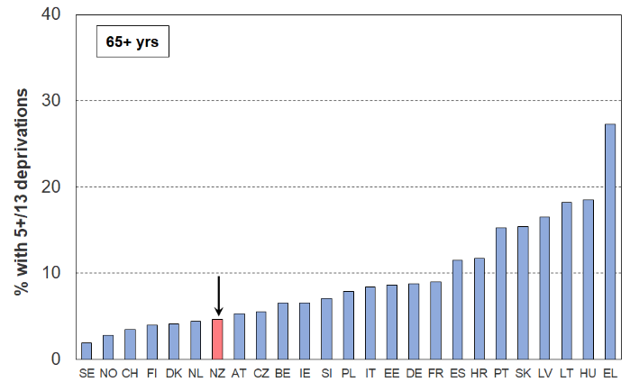
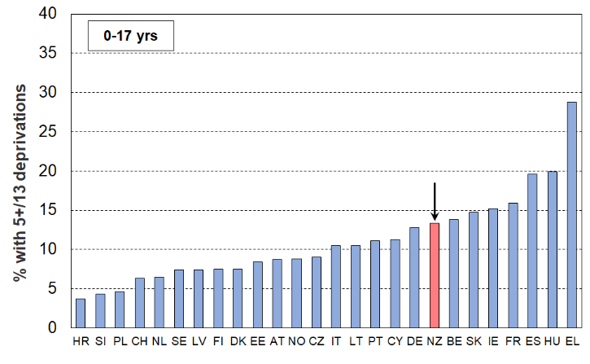
Material hardship rates (%), 0-17 yrs compared with those aged 66+ (EU-SILC 2024, HES 2023-24)
Note for Figure C.1
- To avoid clutter on the chart Luxembourg and Malta (small populations of ~600,000) are omitted, as are Bulgaria and Romania (high MH rates similar to Greece, and their MH rates for those age 66+ a little higher than the corresponding rate for Greece).
- The reported material hardship rates for children in Figure C.1 are based on figures to on dp. In Table C.1 the figures are all rounded to the nearest whole number. This means that countries such as Sweden and the Netherlands are both reported with rates of 7% in the table but in the chart the heights of their respective bars are different (6.5% v 7.4%).
Child-specific deprivation items and selected child-related household items: comparisons with European countries

Table C.2 shows where New Zealand children rank for 7 child-specific essentials and 4 child-related household items. Most of the items are of the ‘enforced lack’ variety (that is, “don’t have or do” because of shortage of money / cost, not some other reason). The full text for the child-specific items is available in Appendix 3 (Table 3.4). For Table C.2 children are aged under 16 yrs.

The ‘high performance’ for New Zealand children for access to a private vehicle could possibly reflect both the relatively high ‘vehicles per capita’ rate for New Zealand, and the relative qualities across countries of accessible public transport.

Table C.2
Enforced lacks of 7 child-specific items and 4 child-related general household items (%):
NZ compared with 25 EU countries (EU-SILC 2021, avg of three HES years 2020-21, 2021-22, and 2022-23)
Child-specific items |  |  |  |  |  |  |  |  |  |  |  |  |  | Child-related HH items
Shoes |  | Fruit & veg |  | Proteins |  | Celebration |  | Friends |  | Schl trips |  | Holidays |  | Arrears |  | Internet |  | Hm warm |  | Car
PT | 0 | AT | 0 | PT | 0 | FI | 0 | FI | 0 | MT | 0 | SI | 3 | NL | 3 | SI | 0 | SI | 1 | CY | 1
FI | 0 | FI | 0 | CY | 0 | EE | 0 | SE | 0 | SI | 0 | CZ | 4 | CZ | 4 | FI | 0 | FI | 1 | SI | 1
SE | 0 | NL | 0 | SE | 0 | SI | 0 | SI | 0 | EE | 1 | DK | 5 | SE | 6 | NL | 0 | EE | 1 | LU | 1
HR | 0 | SE | 0 | FI | 0 | SE | 1 | DK | 0 | SE | 1 | EE | 5 | BE | 6 | EE | 0 | SE | 2 | MT | 1
CY | 0 | CY | 0 | DK | 0 | DK | 1 | EE | 1 | NL | 1 | FI | 5 | DK | 7 | SE | 0 | NL | 2 | NZ | 2
CZ | 1 | DK | 0 | SI | 1 | FR | 1 | NL | 1 | LT | 1 | SE | 6 | AT | 7 | CY | 0 | CZ | 2 | IT | 2
EE | 1 | LU | 0 | EE | 1 | AT | 1 | AT | 1 | FI | 1 | LT | 6 | EE | 7 | LU | 0 | AT | 2 | HR | 3
AT | 1 | PT | 0 | LU | 1 | NL | 1 | CZ | 1 | DK | 1 | NL | 7 | DE | 8 | AT | 0 | LU | 3 | EE | 3
SI | 1 | EE | 1 | NL | 1 | DE | 1 | PT | 1 | DE | 1 | LU | 8 | PT | 9 | DK | 0 | LV | 3 | NL | 3
LU | 1 | SI | 1 | AT | 1 | CZ | 1 | HR | 2 | HR | 1 | LV | 8 | LV | 9 | HR | 1 | IE | 3 | SE | 3
NL | 1 | HR | 1 | IE | 1 | HR | 2 | IE | 2 | BE | 2 | FR | 11 | LU | 10 | LV | 1 | DK | 3 | PT | 3
LT | 2 | MT | 1 | LV | 2 | PT | 2 | DE | 2 | AT | 2 | HR | 11 | SI | 10 | FR | 1 | HR | 3 | FR | 4
DK | 2 | DE | 1 | FR | 2 | IE | 2 | FR | 2 | CZ | 3 | DE | 11 | IT | 10 | CZ | 1 | DE | 4 | FI | 5
ES | 2 | CZ | 1 | HR | 2 | LT | 2 | LV | 2 | FR | 3 | AT | 11 | LT | 10 | PT | 1 | BE | 4 | AT | 5
EL | 2 | IT | 1 | LT | 2 | LV | 2 | NZ | 3 | CY | 3 | MT | 15 | MT | 10 | LT | 1 | FR | 6 | DK | 5
IT | 2 | LV | 1 | NZ | 2 | BE | 3 | LT | 3 | IE | 4 | PT | 16 | NZ | 11 | EL | 2 | HU | 7 | ES | 6
FR | 3 | BE | 1 | CZ | 2 | IT | 3 | MT | 4 | NZ | 4 | IT | 17 | FI | 13 | IE | 2 | MT | 7 | CZ | 6
DE | 3 | IE | 1 | IT | 3 | MT | 4 | BE | 4 | LV | 4 | BE | 17 | FR | 15 | BE | 2 | IT | 8 | BE | 6
LV | 3 | FR | 2 | ES | 3 | LU | 4 | LU | 4 | LU | 4 | IE | 21 | IE | 18 | ES | 2 | NZ | 8 | IE | 6
NZ | 3 | ES | 2 | BE | 3 | NZ | 4 | IT | 5 | IT | 5 | CY | 24 | HU | 18 | DE | 2 | PT | 10 | LT | 6
BE | 4 | EL | 3 | MT | 3 | ES | 6 | EL | 6 | PT | 7 | NZ | 25 | HR | 20 | MT | 3 | ES | 13 | EL | 6
MT | 4 | NZ | 3 | DE | 3 | HU | 6 | ES | 6 | ES | 7 | ES | 26 | ES | 20 | NZ | 3 | EL | 17 | DE | 7
HU | 4 | LT | 4 | EL | 6 | CY | 6 | CY | 6 | HU | 10 | EL | 26 | CY | 25 | IT | 5 | LT | 19 | LV | 9
IE | 4 | HU | 10 | HU | 11 | EL | 13 | HU | 12 | EL | 11 | HU | 29 | EL | 41 | HU | 6 | CY | 25 | HU | 18
Source: Bespoke analysis of EU-SILC data for this report by Anne-Catherine Guio from the Luxembourg Institute for Social and Economic Research.
- Romania and Bulgaria are omitted as their standard of living is quite different from that of New Zealand, having very high income poverty and material hardship numbers.
- The bulk of the EU items above are in the ‘enforced lack’ modality – that is, “don’t have or do” because of shortage of money / cost, not some other reason. The New Zealand survey data aligns with that.
- The ‘school trips’ item is an enforced lack for the EU, and an ‘economised-a-lot-because-of-shortage-of-money’ item for NZ. The NZ equivalent figure could be anything between 2.1% and 5.3%, so it was recorded as 4%. The overall ranking picture is not changed by this uncertainty.
- The ‘proteins’ item is about an enforced lack of a meal with meat, fish or chicken (or vegetarian equivalent) each day.
- The ‘arrears’ item is about arrears in utility, rent or mortgage payments.
- Where the items do not apply to very young children (eg internet and school trips), the denominator is adjusted accordingly.
Measurement and reporting approaches
for the material hardship sections that follow (Sections D, E and F)

The indices used for measuring material hardship
- DEP-17 is a HES-based 17-item material hardship index, with a hardship threshold of 6+/17.
- MH-18 with a hardship threshold of 7+/18 is the HILS-based replacement for DEP-17.
- MWI-24 is MSD’s 24-item material wellbeing index that ranks households across the full material wellbeing spectrum from high to low, with greater sensitivity at the low end. It can be used as a material hardship measure.
- MWI-26 is the 26-item HILS-based replacement for the MWI-24.

Stats NZ uses the DEP-17 and MH-18 measures in their reporting of official material hardship statistics.

When used to measure material hardship, the MWI-24 gives close to identical numbers to those produced by DEP-17. Similarly for MWI-26 and MH-18.

See Appendices 3 and 20 for item lists and scoring rules.

Material hardship as experienced by children
The measures above give hardship rates at a household-level. All household members are given the same MH rate. See Section D for a description of how children experience material hardship in these households.

Reporting on trends in material hardship rates
  - For reporting on material hardship trends MSD’s reports use the MWI indices. The DEP-17 measure can be used only from the 2013 HES and later, whereas the MWI-24 and its Economic Living Standards (ELSI) predecessor can go back to the 2007 HES, thus enabling longer time series reporting.
  - When reporting on trends the focus in this report is usually on longer-run trends rather than on the year-on-year or other short-run changes that Stats NZ use in line with their responsibilities under the Child Poverty Reduction Act (2018).
  - The trend-lines in this report are usually shown using a rolling two-year average to smooth the short-run fluctuations and better show the ‘big picture’. This means that the numbers for a given year in the trend charts will usually not be the exactly the same as those reported by Stats NZ.

More detailed information on the indices is available in several placesSection A, opening page
- Appendix 3
- Appendix 20 for detailed item lists
- MSD’s 01/19 Working Paper
- MSD’s 02/26 Working Paper
Working papers are available at: https://www.msd.govt.nz/about-msd-and-our-work/publications-resources/working-papers/index.html#WorkingPapers

Section D
What does poverty look like in practice for children in households identified as being in material hardship?

This section reports the material and financial deprivations experienced by children in households identified as being in material hardship and highlights the considerable difference between their experience and that of the great majority of New Zealand children. The following approaches are used:
- The cumulative number of missing essentials out of a set of 16 essentials: 5 child-relevant household items and 11 child-specific items relevant for 6-17-year-olds.
- Item-by-item rates for a set of child-relevant household items and child-specific items relevant for 6-17-year-olds.
- Enforced lacks for the DEP-17 items themselves (some of which are essentials and some are commonly-desired non-essentials).
- Self-assessed income adequacy and its relationship to reported material hardship levels.

For children in households identified as ‘in hardship’, life is typically very different from that experienced by the vast majority of New Zealand children

This sub-section uses the 16 items listed in Table D.1 to give a picture of what life is like for children in households identified as in material hardship. Two factors were used to select the 16 items: first, they needed to have a focus and relevance to children’s lives; and second, they needed to be items that would receive strong support as ‘essentials’, things that no child should have to go without / things that every child in New Zealand should have. The 16 items do not themselves constitute ‘another index’ like DEP-17, MH-18 or EU-13. These are all general indices that cover households of all types and ages, not just households with children; they also have some items that are more like ‘commonly-desired non-essentials’. Of the 16 items 11 are child-specific items and as such are not in the DEP-17, MH-18 or EU-13 indices. Of the 5 general household items, 4 are in DEP-17 and MH-18 and these 4 are all from the more deprived end of the spectrum. The other one is on foodbank usage.

Table D.1
The 16 essential items used for Figures D.1 and D.2
Selected child-specific items (11) | Child-relevant general household items (5)
Do not have:  - two pairs good shoes for each child  - two sets of warm winter clothes for each child  - a separate bed for each child  - fresh fruit and vegetables daily  - meal with meat, fish or chicken (or vegetarian equivalent) each day  - good access at home to a computer and internet for homework  - friends around to play and eat from time to time (because of the cost)  Economised ‘a lot’:  - unable to pay for school trips / events for each child  - had to limit children’s involvement in sport  - children had to go without music, dance, kapa haka, art, swimming or other special interest lessons  - continued wearing worn out / wrong size clothes or shoes | Household deprivations that have direct relevance to children:  - received help from food bank or other community group (more than once in last year)  - dampness or mould in dwelling (‘major problem’)  - respondent reports putting up with feeling cold to keep down costs for other basics (‘a lot’)  - delayed repair or replacement of appliances (‘a lot’)  - no access to car or van
Notes for Table D.1:
- See Appendix 20 for the full text for the items.
- The economising questions ask about economising so as to be able to pay for other basics, not just to be thrifty or save up for a special non-essential. Possible responses were ‘not at all’, ‘a little’, and ‘a lot’
For Figures D1 and D.2 children aged 6-17 years are ranked by their households’ material wellbeing using MWI-24, then grouped into ventiles (twenty equal groups of 5% each). This information is used in two ways to give an indication of what material hardship looks like in practice for children in households identified as being in material hardship using the official measures. (In 2023-24 there were around 800,000 children aged 6 to 17 years so there are around 40,000 in each ventile.)
Figure D.1
- The question is: For each ventile group, what proportion has a given number of missing essentials?
Figure D.1 shows the profiles for 4+ and 5+ missings (eg in ventile 1, 64% have 4 or more missing essentials). See the list of essentials / basics in Table D.1 above.
Figure D.2
  - The question is: What proportion of all children missing a given number of essentials is in each ventile?
Figure D.2 shows the profiles for 4+ and 5+ missings (eg of all those missing 4 or more (50,000) 48% are in ventile 1 and 90% are in the lower three ventiles (the hardship zone)).
.
Figure D.1
Multiple deprivation for children:
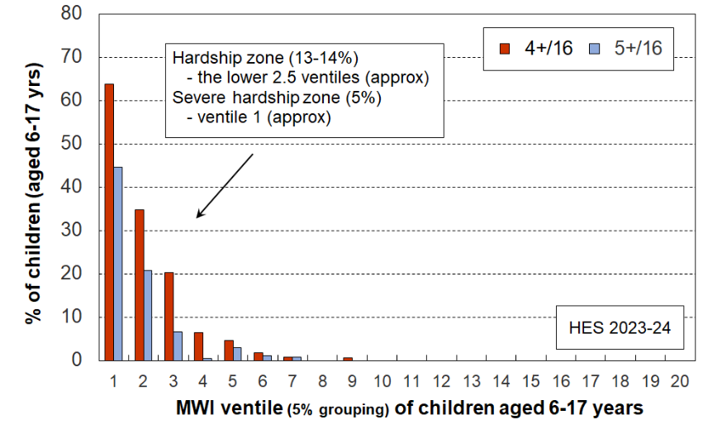
proportion of children in each ventile with 4+ or 5+ missing essentials (%)

Figure D.2
Multiple deprivation for children:
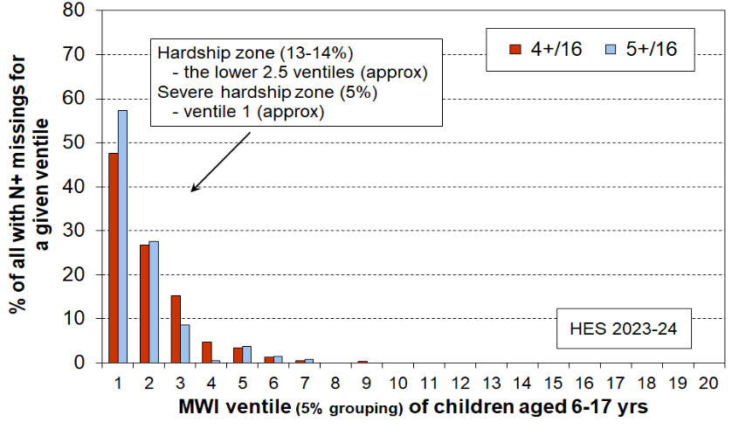
proportion of all with 4+ or 5+ missing essentials … for a given ventile (%)
The charts show how different life is for children in the hardship zone (lower two to three ventiles) compared with that experienced by the vast majority of New Zealand children. This marked difference illustrates what it means in practice to be ‘excluded from the minimum acceptable way of life in one’s own society because of inadequate resources’, the high-level definition of poverty commonly used for richer countries, as discussed in Section A. There is no social gradient of ‘acceptable inequality’ across the material wellbeing spectrum when it comes to missing out on common essentials – this experience is all heavily focussed at the lower end, especially the lower 5-10% of children. The difference is not just a ‘less than’ comparison, but a much more serious status of ‘missing out on things that all children should have and none should go without’.

It is also worth noting that while the MWI index is a general index, is not focussed on households with children and has no child-specific items, the above analysis shows that it does a good job in identifying the children experiencing material hardship.

A wider selection of child-relevant household items plus some child-specific items: deprivation rates for each of these items for all aged 6-17 yrs in households in material hardship or severe material hardship

The analysis and information in this sub-section provides a counterpoint to the previous sub-section and its Figures D.1 and D.2.
- The latter reported the accumulation of missing essentials for those at different levels of material wellbeing, showing that the key difference between those in material hardship and those not is the high level of accumulated deprivation of essentials / basics.
- In this sub-section the analysis in Table D.2 (next page) focuses on individual items themselves and reports the rate of deprivation for each for those in material hardship.
- It also notes what proportion of all children who experience deprivation of that item come from households in hardship and, in doing so, points to the many who are not in MH yet still experience some individual restrictions on basics, just not having a large accumulation of such.
Two types of item are used in the table, both reported for 6-17 year olds only, for consistency with the child-specific items:
- general child-relevant household items – many are index items but some are non-index items of general interest (eg use of foodbanks)
- child specific items – none are index items as the index is designed for all ages.

Table D.2 uses the HES-based DEP-17 index. The left-hand panel of numbers in the table (‘Rates (%)’) shows the proportion of children (6-17 yrs) who face restrictions on the basics in the list – for all 6-17 year olds, those in households not in MH, those in standard MH and those in severe MH.

The right-hand panel (‘Composition (%)’) shows the proportion of all of those deprived of the item whose household has a DEP-17 score of 6+ (ie they are in the hardship zone). For example, 65% of all children whose household relied on help from a community agency or foodbank for food or cash in the 12 months prior to interview … are in households in the 6+/17 hardship zone; 35% come from households not identified as in material hardship.

Comparing the rates in the 6+/17 column (for children in households in MH) with the 0-5/17 column (those not in hardship) gives a very clear contrast, better than using the ‘All’ column as that is by definition a mixed in MH / not in MH group.

These underline the point made earlier that the difference is not just a ‘less than’ comparison, but a much more serious status of ‘missing out on things that all children should have and none should go without’. Life for those identified as being in material hardship is very different than what the vast majority of New Zealand children experience.

Table D.2
Deprivations/restrictions for children (6-17 yrs) in households not in MH (0-5/17), and in MH (6+/17, 9+/17), HES 2023-24
 |  | Rates (%) |  |  |  |  | Composition (%)
 |  | Deprivation rate for item for all aged 6-17 yrs, those in HHs not in hardship, in hardship and in severe hardship |  |  |  |  | Proportion of all deprived of the item whose household is in the specified hardship zone
 |  | All | 0-5/17 | 6+/17 | 9+/17 |  | 6+/17
Child-relevant general HH items
Foodbank / other community help | more than once | 8 | 3 | 40 | 51 |  | 65
Delayed replace/repair appliances | a lot | 13 | 6 | 58 | 73 |  | 62
Car | don't have | 5 | 4 | 11 | 16 |  | 32
Dampness or mould | major problem | 5 | 3 | 17 | 19 |  | 46
Can afford to keep home warm | no | 9 | 4 | 38 | 51 |  | 58
Crowding | 2+ needed - severe | 3 | 2 | 7 | 8 |  | 32
Crowding | 1+ more rooms needed | 14 | 12 | 27 | 29 |  | 27
Borrowed for basics from family/friends | more than once | 11 | 5 | 54 | 67 |  | 64
Can pay unexpected $500 essential bill | no | 22 | 14 | 76 | 84 |  | 46
Income adequacy for basics | not enough | 14 | 8 | 53 | 67 |  | 51
Holiday away each year | don't have - cost | 30 | 23 | 75 | 83 |  | 34
Holiday away each year | don't have - other | 9 | 10 | 5 | 4 |  | 8
Life satisfaction | dissatis / very dissatis | 5 | 3 | 18 | 24 |  | 49
Child-specific items (6-17s)
Two pairs of good shoes | don't have | 4 | 1 | 19 | 28 |  | 67
Two sets of warm winter clothes | don't have | 1 | 1 | 7 | 10 |  | 65
A waterproof coat | don't have - cost | 4 | 2 | 20 | 23 |  | 62
A waterproof coat | don't have - other | 3 | 3 | 7 | 6 |  | 31
Separate bed | don't have | 4 | 2 | 15 | 16 |  | 51
Fruit and veg daily | don't have | 8 | 4 | 34 | 47 |  | 58
Protein meal daily | don't have | 5 | 3 | 20 | 26 |  | 54
Computer / internet | don't have | 3 | 2 | 14 | 18 |  | 55
Friends around to play / eat | don't have - cost | 3 | 1 | 14 | 19 |  | 75
Friends around to play / eat | don't have - other | 7 | 7 | 12 | 13 |  | 21
Unable to fund school trips | a lot | 2 | 1 | 11 | 18 |  | 75
Had to limit participation in sport | a lot | 4 | 1 | 21 | 28 |  | 73
Had to go without special interests | a lot | 4 | 1 | 23 | 30 |  | 71
Continued to wear worn out / wrong size shoes/clothes | a lot | 2 | 1 | 13 | 21 |  | 74
Note for Table D.1
- For the full text for each item, see Appendix 20 (Table 20.6).

DEP-17 items

Table D.3 shows the deprivation rates for DEP-17 items, for age 0-17s in their households. DEP-17 is a household-level measure of deprivation which scores across a mixture of household and individual items. Some items relate to the household as a whole (for example the contents insurance, fruit & veg, and appliances items) and others to the individual experience of the adult respondent in the household (eg shoes, protein meal, doctor, dentist). In HES, a suitable adult respondent is selected to answer questions relating to the household, and this adult answers both sets of questions.

Comparing the rates in the ‘6+/17’ columns (for children in households in MH) with the ‘0-5/17’ columns (those not in hardship) gives a very clear contrast. Those in the severe hardship zone (9+/17) are, as expected, in an even more different household context.

These underline the point made earlier that the difference is not just a ‘less than’ comparison, but a much more serious status of ‘missing out on things that all children should have and none should go without’. Life for those identified as being in material hardship is very different than what the vast majority of New Zealand children experience. See Table D.4 (next page) for the full text for each item and the item deprivation rates for all children.

Table D.3
DEP-17 deprivations/restrictions for children in households not in MH (0-5/17), those in MH (6+/17) and those in severe MH (9+/17), HES 2017-18 to 2023-24
 |  | Deprivation rate for items for children in HHs not in hardship, for those in HHs in hardship (6+/17) or severe hardship (9+/17)
 |  | 0-5/17 |  |  |  |  | 6+/17 |  |  |  |  | 9+/17
Enforced lacks |  | 17-18 | 18-19 | 19-20 | 22-23 | 23-24 | 17-18 | 18-19 | 19-20 | 22-23 | 23-24 | 17-18 | 18-19 | 19-20 | 22-23 | 23-24
 | protein meal | 0 | 0 | 0 | 1 | 1 | 12 | 11 | 9 | 11 | 11 | 21 | 17 | 16 | 23 | 18
 | shoes | 1 | 1 | 1 | 1 | 1 | 26 | 22 | 17 | 19 | 20 | 46 | 39 | 29 | 29 | 32
 | suitable clothes | 1 | 2 | 1 | 1 | 1 | 31 | 31 | 24 | 28 | 24 | 50 | 48 | 42 | 39 | 37
 | presents | 1 | 2 | 2 | 2 | 2 | 26 | 30 | 27 | 29 | 25 | 34 | 40 | 41 | 43 | 37
 | contents ins | 10 | 12 | 12 | 12 | 13 | 66 | 62 | 68 | 65 | 67 | 75 | 78 | 80 | 81 | 77
Economised ‘a lot’
 | fruit & veg | 1 | 1 | 1 | 3 | 3 | 33 | 28 | 27 | 38 | 43 | 62 | 46 | 47 | 57 | 66
 | meat | 7 | 8 | 8 | 13 | 11 | 71 | 69 | 67 | 77 | 70 | 89 | 85 | 86 | 87 | 83
 | heating | 3 | 4 | 4 | 3 | 3 | 45 | 43 | 39 | 31 | 31 | 63 | 58 | 59 | 45 | 46
 | doctor | 3 | 5 | 4 | 4 | 5 | 52 | 55 | 50 | 49 | 42 | 71 | 68 | 67 | 64 | 57
 | dentist | 20 | 23 | 22 | 21 | 23 | 83 | 86 | 81 | 79 | 82 | 90 | 92 | 88 | 85 | 93
 | local trips | 6 | 8 | 7 | 8 | 10 | 68 | 64 | 67 | 72 | 67 | 81 | 78 | 82 | 86 | 85
 | appliances | 5 | 5 | 5 | 5 | 5 | 55 | 58 | 61 | 58 | 57 | 77 | 75 | 76 | 76 | 70
Arrears
 | utilities | 4 | 4 | 4 | 5 | 4 | 46 | 46 | 46 | 50 | 50 | 66 | 62 | 57 | 66 | 68
 | vehicle exp | 3 | 3 | 3 | 3 | 3 | 45 | 46 | 46 | 46 | 49 | 58 | 58 | 64 | 66 | 69
Financial stress
 | borrowed | 5 | 6 | 5 | 6 | 5 | 55 | 58 | 55 | 55 | 56 | 65 | 72 | 67 | 69 | 68
 | ‘very limited’ | 9 | 10 | 9 | 11 | 11 | 80 | 74 | 71 | 74 | 76 | 94 | 84 | 86 | 80 | 87
 | $500 bill | 20 | 18 | 18 | 15 | 14 | 89 | 84 | 85 | 76 | 76 | 95 | 92 | 93 | 82 | 83
Reading note for Table D.3:
- The reported figures in Table D.3 are based on the information provided by the household’s respondent. For example, in the fresh fruit and vegetables row for ‘the 6+/17’ group (those children in households defined as in material hardship) in 2018-19 28% of children were in households where the respondent said they (or their partner) went without or cut back ‘a lot’ (rather than ‘a little’ or ‘not at all’).
- See Appendix 5 for this table for the whole population.

Some care is needed when using the DEP-17 items to describe what material hardship means for children. For example, it is sometimes said that “it’s about not having two pair of good shoes, going without meals, not being able to go to the doctor”. This leaves the misleading impression that these are child-specific items that are being used in the index. There are no child-specific items in the DEP-17 index.

While many of the DEP-17 item deprivations may not directly relate to the experience of children in the household, they do illustrate the living conditions of the households of these children. The analysis reported in Figures D.1 and D.2 above and the associated text is relevant to the themes in this paragraph and the previous one.

The same patterns are evident when the HILS 2024-25 data is used with the MH-18 index, even with the changed wording for several items. HES 2023-24 is used here as it allows rates for multiple years to be reported using the same items.

Table D.4
Fuller text for DEP-17 items and item deprivation rates for all children in their households

Dep-17 items |  |  |  | item deprivation rates for all children in their HHs
Enforced lack of essentials (for respondent or household as a whole) |  |  |  | 17-18 | 18-19 | 19-20 | 22-23 | 23-24
 | protein meal | R | meal with meat, fish or chicken (or vegetarian equivalent) at least each 2nd day | 1 | 1 | 1 | 2 | 2
 | shoes | R | two pairs of shoes in good repair and suitable for everyday use | 3 | 2 | 2 | 3 | 3
 | suitable clothes | R | suitable clothes for important or special occasions | 4 | 4 | 3 | 4 | 4
 | presents | R | presents for family and friends on special occasions | 5 | 4 | 5 | 6 | 5
 | contents ins | H | home contents insurance | 19 | 18 | 16 | 18 | 20
Economised, cut back or delayed purchases ‘a lot’ (because money was needed for other essentials, not just to be thrifty or to save for a trip or other non-essential)
 | fruit & veg | H | went without fresh fruit and vegetables | 4 | 4 | 5 | 8 | 8
 | meat | H | bought cheaper cuts of meat or bought less than wanted | 15 | 13 | 15 | 21 | 19
 | heating | R/H | put up with feeling cold to save on heating costs | 8 | 6 | 7 | 7 | 6
 | doctor | R | postponed visits to the doctor | 9 | 9 | 9 | 10 | 10
 | dentist | R | postponed visits to the dentist | 29 | 27 | 25 | 28 | 31
 | local trips | R/H | did without or cut back on trips to the shops or other local places | 14 | 11 | 14 | 16 | 17
 | appliances | H | delayed repairing or replacing broken or damaged appliances | 11 | 10 | 10 | 12 | 12
In arrears more than once in last 12 months (because of shortage of cash at the time, not through forgetting)
 | utilities | H | rates, electricity, water | 9 | 9 | 9 | 10 | 11
 | vehicle exp | H | vehicle registration, insurance or warrant of fitness | 8 | 7 | 8 | 8 | 9
Financial stress and vulnerability
 | borrowed | H | borrowed from family or friends ‘more than once’ in the last 12 months to cover everyday living costs | 11 | 11 | 12 | 12 | 12
 | ‘very limited’ | R | feel ‘very limited’ by the money available when thinking about purchase of clothes or shoes for self (options were: not at all, a little, quite limited, and very limited) | 16 | 16 | 16 | 19 | 19
 | $500 bill | H | could not pay an unexpected and unavoidable bill of $500 within a month without borrowing | 25 | 23 | 22 | 22 | 22
Reading note for Table D.4
- In Table D.4, the second from left column indicates whether the item is respondent-focussed (R) or household-focussed (H). Though for most items the R/H distinction is clear, a few could be either.

Self-assessed income adequacy

The self-assessed income adequacy question in both HES and HILS asks the designated household respondent how well the household’s total income meets everyday needs for such things as accommodation, food, clothing, and other necessities. The response options are ‘not enough’, ‘only just enough’, ‘enough’, and ‘more than enough’.

Table D.5 shows that:
- For 50% of children in households identified as being in material hardship (the 6+ column) the household reports having ‘not enough’ income for basics, and 95% have ‘not enough’ or ‘only just enough’. Very few report having ‘enough’ or ‘more than enough’.
- For those in households not designated as in hardship (the 0-3 and 4-5 columns), the proportions reporting ‘not enough’ are much lower, as expected.

Table D.5
Self-assessed income adequacy for those in households in different levels of hardship,
for age 0-17s and whole population (% down), HES 2023-24
 | Age 0-17s |  |  |  |  | Whole population
 | All | DEP-17 |  |  |  | All | DEP-17
 | All | 0-3 | 4-5 | 6+ | 9+ | All | 0-3 | 4-5 | 6+ | 9+
Not enough | 14 | 6 | 22 | 50 | 62 | 11 | 5 | 22 | 50 | 62
Only just enough | 33 | 26 | 62 | 45 | 36 | 29 | 22 | 58 | 43 | 35
Enough | 37 | 44 | 16 | 5 | 2 | 41 | 46 | 20 | 7 | 3
More than enough | 16 | 25 | 1 | 0 | 0 | 19 | 26 | 1 | 0 | 0
All | 100 | 100 | 100 | 100 | 100 | 100 | 100 | 100 | 100 | 100

As well as giving a further indication of how life is experienced for those in material hardship, the analysis also gives assurance about the validity of the index, given both the vertical and horizontal distributions in the table.

The HES 2023-24 data is used for the analysis in the table as most of Section D is based on the HES data. Analysis of the HILS 2024-25 data produces the same overall findings and very similar numbers.

Section E
The demographics of child material hardship: breakdowns for children in different household contexts and for individual characteristics; comparisons with selected households without children

This section provides detailed breakdowns on material hardship for children for a range of household contexts and individual characteristics:
- household type
- number of children in the household
- tenure
- work intensity
- main source of income – market or government
- highest educational qualification in the household
- ethnicity
- disability status
- age (younger children compared with older children, all children compared with older New Zealanders)

It also reports on:
- foodbank usage for Auckland
- the distribution of children across levels of socio-economic status using the NZDep index

Most of the analysis uses the MH-18 index with HILS 2024-25 but some of the breakdowns noted above are not available from HILS. In these cases the 2023-24 HES data is used with the DEP-17 index.

Table E.1 provides a succinct summary of material hardship (MH) rates and MH composition for children in selected household contexts.
- The MH rates are the MH numbers in the second column as a percentage of the total number of children in households of that type (eg for children in two parent households, the 67,000 is 8% of all children in these households).
- The MH composition column reports the numbers in the second column as a percentage of all in MH (169,000). The right-hand composition column is about all children, not just those in MH. The ratio of the composition % for those in MH to the population composition gives the risk ratio or relative risk for the selected group.
- Around three out of five (59%) of all children in hardship come from a ‘disabled household’, that is a household with at least one disabled member.
- Around half of children in hardship come from ‘beneficiary’ families and half from ‘working’ families.

Table E.1
Material hardship for children in selected sub-groups:
MH-18 7+ rates, numbers and composition, HILS 2024-25
 | 0-17s in HHs in material hardship |  |  | All 0-17s
 | Rate (%) | Numbers | Composn (%) | Composn (%) | Numbers
ALL 0-17s | 14 | 169,000 | 100 | 100 | 1,183,000
Household type
Two parent with any dep ch | 8 | 67,000 | 40 | 68 | 804,000
Sole parent with any dep ch | 36 | 76,000 | 45 | 18 | 211,000
Other family HHs with any dep ch | 16 | 25,000 | 15 | 13 | 158,000
Number of children in HH
1 | 10 | 30,000 | 18 | 24 | 288,000
2 | 10 | 50,000 | 29 | 44 | 516,000
3 | 18 | 43,000 | 25 | 20 | 231,000
4+ | 33 | 46,000 | 27 | 12 | 142,000
Main source of HH income
Main source market | 8 | 82,000 | 48 | 84 | 996,000
Main source government | 47 | 88,000 | 52 | 16 | 186,000
HH work intensity (HES 23-24)
2+ earner HH – 1+ FT | 6 | 38,000 | 24 | 51 | 593,000
Sole earner HH – FT | 15 | 40,000 | 25 | 23 | 268,000
Part-time only | 22 | 14,000 | 9 | 5 | 63,000
No earner (workless) | 46 | 65,000 | 41 | 12 | 140,000
Self-employed | 2 | 2,000 | 1 | 9 | 109,000
Tenure of household
Owned with mortgage (incl FT) | 5 | 25,000 | 15 | 43 | 514,000
Owned no mortgage (incl FT) | 4 | 6,000 | 3 | 13 | 156,000
Private rental (no AS) | 10 | 21,000 | 12 | 18 | 213,000
Private rental (with AS) | 40 | 78,000 | 46 | 16 | 195,000
Social rental (HNZ & LA) | 49 | 36,000 | 21 | 6 | 73,000
Ethnicity
Māori | 25 | 77,000 | 32 | 20 | 306,000
Pacific | 31 | 54,000 | 23 | 12 | 176,000
Asian | 6 | 15,000 | 6 | 16 | 251,000
European | 12 | 86,000 | 36 | 49 | 746,000
Other | 18 | 7,000 | 3 | 3 | 41,000
Disability
Disabled children | 27 | 32,000 | 19 | 10 | 118,000
Children in a ‘disabled household’ | 27 | 100,000 | 59 | 31 | 365,000
Notes for table
- Index used is MH-18 (7+).
- Ethnicity uses total ethnicity approach - composition is out of all person-ethnicities.
- The household type breakdown shows only the three household types for dependent children. There are a small number of under-18s who appear in other household types: these are included in the total and in other breakdowns but their households types are not included in the table.
Children in households at different depths of material hardship, by selected household contexts, disability status and ethnicity: hardship rates and composition within the categories

Interpreting the tables that follow

Table E.2 below is an extract from the first of the fuller tables that follow (Table E.3a, E.3b and E.3c), and is used to support a walk-through of the numbers to assist with interpretation for those not too familiar with ‘rates and composition’ tables.
- The 7+ material hardship columns are shaded as they give the standard material hardship information using the MH-18 index; 10+ is the level used for severe material hardship.
- The brown shaded 4% figure is the hardship rate for children in two-parent HHs which have a hardship score of 9+/18 (much lower than the 23% rate for children in sole parent households at the same depth).
- The green shaded 52% figure says that of all the children in households in severe material hardship (10+/17), around half are from sole parent households.
- The ‘ALL’ columns show the number and % of children in each household type overall. The composition % divided by the ‘ALL’ % gives ‘the risk ratio’. For children in sole parent households at the 10+ level, the risk ratio is 2.9 (52/18), whereas for children in two parent households the risk ratio is 0.47 (32/68). Whether by comparing rates directly or by comparing risk ratios, the same conclusion is reached: children in sole-parent households are five to six times more likely to be in severe material hardship than those in two-parent households.

Table E.2
Material hardship rates and composition for selected population groups (MH-18 index, 5 thresholds),
Children (aged 0-17 years), HILS 2024-25

HILS 2024-25 | Material hardship rates |  |  |  |  | Composition
 | what % of this group is in hardship, using the different thresholds? |  |  |  |  | what % of all those in hardship (using a given threshold) are in this group / cell? |  |  |  |  | 000’s | %
Material hardship threshold as # of items lacked out of 17 | 6+ | 7+ | 8+ | 9+ | 10+ | 6+ | 7+ | 8+ | 9+ | 10+ | ALL | ALL
All children (0-17 yrs) | 18 | 14 | 11 | 8 | 6 | 100 | 100 | 100 | 100 | 100 | 1,185 | 100
Household type
2P HH with any dependent children | 11 | 8 | 6 | 4 | 3 | 42 | 40 | 36 | 32 | 32 | 805 | 68
SP HH with any dependent children | 43 | 36 | 31 | 23 | 17 | 42 | 45 | 48 | 50 | 52 | 210 | 18
Other fam HHs with any dep ch | 20 | 16 | 13 | 10 | 7 | 15 | 15 | 15 | 17 | 16 | 160 | 13
Note for table:
- A small number of children live in household types other than the three types shown in the table. Numbers are too small to report hardship rates for them as a separate “Other” household type.

Tables E.3a, E.3b and E.3c show the material hardship rates and composition for children in households at different depths of material hardship, by selected household contexts, disability status and ethnicity

The HILS 2024-25 dataset supports most but not all of the sub-group analysis that the HES datasets support. Tables E.3a and E.3b report the analysis for HILS 2024-25 using the MH-18 measure. Table E.3c uses the HES 2023-24 dataset to report by work intensity, labour market status and highest educational qualification in the household – these breakdowns are not available from the HILS 2024-25 dataset.

Table E.3a
MH rates and composition for selected population groups (MH-18 index, 5 thresholds),
Children (aged 0-17 years), HILS 2024-25

HILS 2024-25 | Material hardship rates |  |  |  |  | Composition
 | what % of this group is in hardship, using the different thresholds? |  |  |  |  | what % of all those in hardship (using a given threshold) are in this group / cell? |  |  |  |  | 000’s | %
Material hardship threshold as # of items lacked out of 18 | 6+ | 7+ | 8+ | 9+ | 10+ | 6+ | 7+ | 8+ | 9+ | 10+ | ALL | ALL
All children (0-17 yrs) | 18 | 14 | 11 | 8 | 6 | 100 | 100 | 100 | 100 | 100 | 1,185 | 100
Household type
2P HH with any dependent children | 11 | 8 | 6 | 4 | 3 | 42 | 40 | 36 | 32 | 32 | 805 | 68
SP HH with any dependent children | 43 | 36 | 31 | 23 | 17 | 42 | 45 | 48 | 50 | 52 | 210 | 18
Other fam HHs with any dep ch | 20 | 16 | 13 | 10 | 7 | 15 | 15 | 15 | 17 | 16 | 160 | 13
Number of dep children in household
1 | 14 | 10 | 8 | 6 | 5 | 19 | 18 | 17 | 18 | 19 | 290 | 24
2 | 13 | 10 | 7 | 5 | 4 | 30 | 29 | 28 | 26 | 26 | 515 | 44
3 | 23 | 18 | 14 | 10 | 8 | 25 | 25 | 24 | 23 | 25 | 230 | 20
4+ | 39 | 33 | 29 | 22 | 15 | 26 | 27 | 31 | 32 | 29 | 140 | 12
Source of HH income in the 12 months prior to interview
Main source market | 12 | 8 | 6 | 4 | 2 | 53 | 48 | 43 | 39 | 33 | 995 | 84
Main source government | 54 | 47 | 41 | 32 | 25 | 47 | 52 | 57 | 61 | 67 | 185 | 16
Tenure of household
Owned with mortgage (incl FT) | 7 | 5 | 3 | 2 | 1 | 17 | 15 | 12 | 10 | 10 | 515 | 43
Owned no mortgage (incl FT) | 5 | 4 | 3 | 2 | 1 | 3 | 3 | 3 | 3 | 3 | 155 | 13
Private rental | 30 | 24 | 19 | 14 | 10 | 57 | 58 | 59 | 58 | 58 | 410 | 34
Social rental | 59 | 49 | 44 | 34 | 26 | 20 | 21 | 24 | 25 | 26 | 75 | 6
Private rental by AS receipt
Private rental (no AS) | 13 | 10 | 7 | 4 | 3 | 13 | 12 | 11 | 10 | 10 | 215 | 18
Private rental (with AS) | 49 | 40 | 33 | 24 | 18 | 44 | 46 | 48 | 49 | 49 | 195 | 16
Disability
Disabled children | 31 | 27 | 22 | 18 | 14 | 17 | 19 | 20 | 22 | 23 | 120 | 10
Children in a ‘disabled household’ | 32 | 27 | 23 | 17 | 13 | 54 | 59 | 61 | 65 | 67 | 365 | 31
Notes for table:
- A small number of children live in household types or tenures other than those shown in the table. In both cases, numbers are too small to report hardship rates for them as a separate “Other” household type or tenure group.

Table E.3b
MH rates and composition by ethnic group (MH-18 index, 5 thresholds),
Children (aged 0-17 years), HILS 2024-25

HILS 2024-25 | Material hardship rates |  |  |  |  | Composition
 | what % of this group is in hardship, using the different thresholds? |  |  |  |  | what % of all those in hardship (using a given threshold) are in this group / cell? |  |  |  |  | 000’s | %
Material hardship threshold as # of items lacked out of 18 | 6+ | 7+ | 8+ | 9+ | 10+ | 6+ | 7+ | 8+ | 9+ | 10+ | ALL | ALL
Material hardship rates (%)
All children (0-17 yrs) | 18 | 14 | 11 | 8 | 6 | 100 | 100 | 100 | 100 | 100 | 1,185 | 100
Ethnicity (total)
European | 15 | 12 | 9 | 6 | 5 | 36 | 36 | 34 | 33 | 34 | 745 | 49
Māori | 29 | 25 | 21 | 17 | 12 | 30 | 32 | 34 | 36 | 36 | 305 | 20
Pacific peoples | 40 | 31 | 26 | 20 | 15 | 23 | 23 | 24 | 24 | 25 | 175 | 12
Asian | 9 | 6 | 3 | 2 | 1 | 8 | 6 | 4 | 4 | 3 | 250 | 16
Other | 19 | 18 | 14 | 9 | 7 | 3 | 3 | 3 | 3 | 3 | 40 | 3
Ethnicity (prioritised)
European | 10 | 8 | 5 | 4 | 3 | 24 | 23 | 20 | 18 | 18 | 505 | 43
Māori | 29 | 25 | 21 | 17 | 12 | 42 | 45 | 49 | 52 | 53 | 305 | 26
Pacific peoples | 43 | 32 | 26 | 19 | 15 | 24 | 23 | 24 | 24 | 25 | 120 | 10
Asian | 8 | 5 | 3 | 2 | 1 | 9 | 7 | 5 | 5 | 3 | 235 | 20
Other | suppressed – numbers too small |  |  |  |  | suppressed – numbers too small |  |  |  |  | 20 | 2
Note: a small number of children have a prioritised ethnicity outside of the four categories listed – however numbers are too small to report the hardship levels for this group at the different thresholds in the table.
Reading note for interpreting ‘total ethnicity’ percentages. The total ethnicities approach counts ethnicities, not children. There are around 300,000 more ethnicity responses than there are children, as many report more than one ethnicity.
- The ‘31%’ figure in the Pacific row for the 7+/17 hardship rate means that 31% of children reporting a Pacific ethnicity are in material hardship (whether only Pacific or Pacific and one or more other ethnicities).
- The ‘23%’ figure in the Pacific row for 7+/17 composition means that out of all the ethnicities reported by children in the 7+ hardship column, 23% are Pacific (whether only Pacific or Pacific and one or more other ethnicities).

Starting with HES 2007, ethnicity for children is provided in the survey data, with the information coming from either the children themselves or from their parents. Individuals can specify more than one ethnicity. In Table E.3b ethnic groups are created (for the purposes of analysis) using both the total response method and the prioritised method for determining ethnicity.

In the total response approach, each person’s total ethnicity response is counted. This means that individuals may be counted more than once, and the total figures will be greater than the population numbers (around 300,000 more in the case of children in HILS 2024-25). The analysis is actually about the total number of ethnicities provided for the children – it is not directly about the children themselves.

In the prioritised approach, if a respondent reports more than one ethnicity, the ethnicity attributed is determined according to a prioritised classification of Māori, Pacific peoples, Asian, European then Other. This ensures that the total number of responses equals the total population being reported on. In doing so, prioritisation does not show the diversity within and overlapping between ethnic groups by eliminating multiple ethnicities from the analysis. This systematic prioritisation of the data gives highest priority to Māori ethnicity – meaning, for example, an individual who might self-identify as both Pacific and Māori would be counted as Māori.

Table E.3c uses the HES 2023-24 dataset to report by ‘work intensity’, ‘labour market status’ and ‘highest educational qualification in the household’ – these breakdowns are not available from the HILS 2024-25 dataset. Table E.3c also reports the 2023-24 material hardship numbers for children by ‘household type’, ‘number of dependent children in the HH’ and ‘main source of income’ to enable some comparison with the 2024-25 results for those subgroups (see Table E.3b). The two surveys produce very similar numbers. This gives some assurance that the 2024-25 figures for the ‘work intensity’, ‘labour market‘ and ‘highest educational qualification’ categories are likely to be well estimated by the HES 2023-24 figures.

Table E.3c
MH rates and composition for further selected population groups (DEP-17 index, 5 thresholds),
Children (aged 0-17 years), HES 2023-24

HES 2023-24 | Material hardship rates |  |  |  |  | Composition
 | what % of this group is in hardship, using the different thresholds? |  |  |  |  | what % of all those in hardship (using a given threshold) are in this group / cell? |  |  |  |  | 000’s | %
Material hardship threshold as # of items lacked out of 17 | 5+ | 6+ | 7+ | 8+ | 9+ | 5+ | 6+ | 7+ | 8+ | 9+ | ALL | ALL
All children (0-17 yrs) | 18 | 14 | 10 | 8 | 5 | 100 | 100 | 100 | 100 | 100 | 1,170 | 100
Household type
2P HH with any dependent children | 11 | 8 | 6 | 4 | 3 | 43 | 40 | 41 | 38 | 40 | 810 | 69
SP HH with any dependent children | 42 | 33 | 25 | 20 | 14 | 37 | 39 | 38 | 42 | 40 | 185 | 16
Other fam HHs with any dep ch | 24 | 20 | 15 | 11 | 7 | 19 | 20 | 20 | 20 | 19 | 165 | 14
Number of dep children in household
1 | 16 | 12 | 9 | 7 | 5 | 21 | 20 | 19 | 20 | 20 | 270 | 23
2 | 13 | 10 | 7 | 6 | 4 | 32 | 30 | 30 | 33 | 31 | 505 | 43
3 | 21 | 16 | 13 | 9 | 7 | 24 | 25 | 26 | 25 | 25 | 245 | 21
4+ | 32 | 27 | 21 | 14 | 11 | 22 | 24 | 25 | 22 | 24 | 140 | 12
Work intensity (2P & SP, adults all ages)
2P - both FT | 8 | 5 | 3 | 3 | 2 | 13 | 11 | 9 | 9 | 10 | 335 | 29
2P - FT PT | 9 | 6 | 5 | 4 | 2 | 7 | 5 | 6 | 6 | 5 | 150 | 13
2P - FT WL | 15 | 12 | 10 | 5 | 4 | 13 | 13 | 14 | 10 | 10 | 175 | 15
2P - no FT | 33 | 28 | 25 | 16 | 15 | 9 | 11 | 12 | 11 | 14 | 60 | 5
SP - FT | 25 | 18 | 11 | 9 | 7 | 8 | 8 | 6 | 7 | 7 | 70 | 6
SP - PT | 42 | 29 | 22 | 17 | 6 | 6 | 5 | 5 | 5 | 3 | 30 | 2
SP - WL | 60 | 51 | 40 | 32 | 24 | 23 | 26 | 26 | 29 | 30 | 80 | 7
Other | 16 | 13 | 10 | 7 | 5 | 21 | 22 | 22 | 22 | 21 | 280 | 24
Labour market status of household
Self-employed | 3 | 2 | 2 | 1 | 1 | 2 | 1 | 1 | 1 | 1 | 110 | 9
At least one FT worker | 13 | 9 | 7 | 5 | 3 | 53 | 49 | 47 | 46 | 47 | 860 | 73
No FT worker (may have PT) | 47 | 39 | 31 | 23 | 17 | 46 | 49 | 52 | 52 | 52 | 205 | 17
PT work only | 30 | 22 | 17 | 11 | 5 | 9 | 9 | 9 | 8 | 5 | 65 | 5
Some work (excl SE) | 14 | 10 | 7 | 5 | 4 | 62 | 58 | 56 | 54 | 52 | 925 | 79
Workless | 55 | 46 | 37 | 28 | 22 | 37 | 41 | 43 | 44 | 47 | 140 | 12
Source of HH income in the 12 months prior to interview
Main source market | 12 | 8 | 6 | 4 | 3 | 57 | 53 | 52 | 51 | 49 | 1,000 | 85
Main source government | 53 | 44 | 35 | 26 | 19 | 43 | 47 | 48 | 49 | 51 | 170 | 15
Education (highest qualification in HH)
Higher degree | 6 | 4 | 3 | 2 | 1 | 8 | 7 | 6 | 6 | 6 | 285 | 24
Bachelors or similar | 10 | 7 | 4 | 3 | 2 | 13 | 12 | 9 | 8 | 9 | 270 | 23
Post-school non-degree qual | 20 | 16 | 13 | 10 | 7 | 33 | 34 | 36 | 37 | 38 | 335 | 28
School qual | 32 | 24 | 19 | 14 | 10 | 30 | 30 | 30 | 30 | 30 | 195 | 17
No formal qual | 38 | 31 | 24 | 18 | 12 | 16 | 17 | 18 | 18 | 17 | 90 | 8

Children in ‘working’ and ‘beneficiary’ households

Table E.4 (next page) provides a picture of what life is like for children aged 6-17 years living in ‘working’ and ‘beneficiary’ households. The approach is much the same as earlier in Section D: the hardship profiles are based on information about child-specific hardship items and general household items that are directly child-relevant (see Table D.1).

The two groups (‘working’ and ‘beneficiary’ households) are identified by their respective main sources of income over the 12 months prior to interview – market (wages and salaries, self-employment and investment) or government (includes main benefits, WFF, AS, and so on). Some of the ‘working’ households will receive WFF or AS payments, and some of the ‘beneficiary’ households will receive market income from part-time work.

Unsurprisingly, the left-hand panel of Table E.4 shows that children in ‘working’ households are on average much better off than those in ‘beneficiary’ households (fewer restrictions / deprivations). One of the main drivers of this difference is the higher income received on average by ‘working’ households (a median of $39,000 pa compared with $19,000 for beneficiary households – note, these are equivalised dollars, not ‘ordinary’ dollars).

The right-hand panel in Table E.4 to a considerable degree removes the impact of the income factor by looking only at households in the lower AHC income quintile (Q1). These low-income ‘working’ and ‘beneficiary’ households have hardship profiles that are a little less different than when looking at the whole income spectrum, though the children in low-income ‘working’ households are still better off (fewer restrictions / deprivations). The respective material hardship rates are 8% and 44% across all incomes and 17% and 47% when only those in the low-income zone (Q1) are considered – a rough means of controlling for income.

Table E.5 takes the analysis a step further by adding information on the level of liquid assets and the stock of non-vehicle consumer durables. The two left-hand panels are similar to the two panels in Table E.4, but are for all children in their households, not just 6-17-year-olds. They report for those in households across the whole income spectrum and for those in the bottom AHC quintile (Q1). An inspection of the liquid asset and consumer durable information in the middle panel (AHC Q1) shows that the ‘working households’ have noticeably higher levels of these resources. At the same or similar income levels the 'working households' therefore have a higher level of resources to draw on.

The third panel adds a further ‘control’, restricting the analysis in those columns to those with both low incomes and having liquid assets less than $2000. The respective material hardship rates are 8% and 44%, 17% and 47%, and finally 27% and 53%. The ‘working households’ are still better off than the ‘beneficiary households’, but the gap closes noticeably once incomes and assets are ‘controlled’ for. Why do 'working households' have higher liquid asset levels and a better stock of consumer durables? Does this reflect different income trajectories? It would not be a surprise if it did. The HES dataset on its own cannot however answer that. A longitudinal dataset is needed.

Table E.4
Deprivations/restrictions for children (6-17 yrs) in ‘working’ & ‘beneficiary’ households HES 2023-24 (%)
 |  | ALL aged 6-17 yrs (%) |  |  | Q1 (AHC) aged 6-17 yrs (%)
 |  | ALL | Main income source |  | ALL | Main income source
 |  | ALL | Market | Govt | ALL | Market | Govt
Population in each group (000s) |  | 809 | 693 | 116 | 196 | 116 | 80
Population in each group (%) |  | 100 | 86 | 14 | 100 | 59 | 41
Material hardship rate (6+/17 for DEP-17) |  | 13 | 8 | 44 | 29 | 17 | 47
Child-relevant general household items
Income adequacy for basics | not enough | 14 | 10 | 38 | 30 | 21 | 42
Income adequacy for basics | just enough | 32 | 30 | 44 | 43 | 44 | 42
Foodbank / other community help | more than once | 8 | 4 | 32 | 20 | 10 | 34
Borrowed for basics from family/friends | more than once | 11 | 7 | 33 | 24 | 16 | 37
Can pay unexpected $500 essential bill | no | 22 | 16 | 56 | 42 | 30 | 59
Delayed replace/repair appliances | a lot | 13 | 10 | 28 | 22 | 17 | 28
Can afford to keep home warm | no | 9 | 6 | 25 | 17 | 12 | 26
Child-specific items (6-17 yrs)
Two pair of shoes | don't have | 4 | 2 | 14 | 9 | 5 | 15
Two sets winter clothes | don't have | 1 | 1 | 5 | 2 | - | 3
Separate bed | don't have | 4 | 2 | 13 | 9 | 5 | 15
Fruit and veg daily | don't have | 8 | 5 | 21 | 16 | 11 | 22
Protein meal daily | don't have | 5 | 3 | 14 | 11 | 7 | 17
Computer / internet | don't have | 3 | 2 | 10 | 7 | 4 | 11
Birthday and other celebrations | don't have - cost | 4 | 2 | 12 | 8 | 5 | 12
Birthday and other celebrations | don't have - other | 8 | 7 | 13 | 10 | 8 | 13
Unable to fund school trips | a lot | 2 | 1 | 8 | 4 | 2 | 8
Had to limit participation in sport | a lot | 4 | 3 | 11 | 9 | 7 | 11
Had to go without special interests | a lot | 4 | 3 | 11 | 10 | 8 | 12
Continued to wear worn out / wrong size shoes/clothes | a lot | 2 | 1 | 8 | 5 | 2 | 10
Median AHC household income ($ equivalised) |  | 35,000 | 38,900 | 18,800 | 16,500 | 17,300 | 15,600
Notes:
- In this report, all cells with original sample sizes of less than 15 are suppressed (-).
- For all 6-17 year olds, 14% are in ‘beneficiary’ households and 86% in ‘working’ households. The Q1 composition is 41% and 59% respectively.
- Main income source: households are divided into two groups according to the main source of household income – market or government. Market income is income from salaries and wages, self-employment and investment. Government income is income from social welfare benefits, NZS, AS, WFF tax credits, student bursaries, and so on. This is in effect setting the threshold at 50% of total income from all sources (after paying income tax and ACC earner levies). Table A.6.1 in Appendix 6 sets the threshold higher at 80%+ and shows that the high-level findings are unchanged when this higher threshold is used.

Table E.5
HH liquid assets & consumer durables for children (0-17 yrs) in ‘working’ and ‘beneficiary’ households, HES 2023-24
 |  | ALL aged 0-17 yrs (%) |  |  | Q1 (AHC) aged 0-17 yrs (%) |  |  | Q1 (AHC) aged 0-17 yrs (%) - LA<$2k
 |  | All | Main income source |  | All | Main income source |  | All | Main income source
 |  | All | Market | Govt | All | Market | Govt | All | Market | Govt
 |  | 2024 | 2024 | 2024 | 2024 | 2024 | 2024 | 2024 | 2024 | 2024
Individuals 0-17 (000s) |  | 1,177 | 1,006 | 171 | 291 | 174 | 117 | 161 | 73 | 88
Households with 0-17s (000s) |  | 641 | 559 | 82 | 141 | 85 | 56 | 74 | 33 | 41
% of all 0-17s |  | 100 | 85 | 15 | 25 | 15 | 10 | 14 | 6 | 7
% of income source group (all, mkt, or govt) |  | 100 | 100 | 100 | 25 | 17 | 68 | 14 | 7 | 51
Material hardship rate (6+/17 for DEP-17) |  | 14 | 8 | 44 | 29 | 17 | 47 | 41 | 27 | 53
Incomes and housing costs
AHC income (equivalised) | Median | 34,400 | 38,000 | 18,800 | 17,300 | 18,000 | 16,500 | 16,500 | 18,800 | 16,200
AHC income (equivalised) | Mean | 41,400 | 45,200 | 19,400 | 15,400 | 15,400 | 15,600 | 15,600 | 15,600 | 15,500
BHC income (equivalised) | Median | 47,200 | 51,800 | 29,400 | 29,400 | 30,700 | 26,600 | 29,600 | 31,000 | 26,100
BHC income (equivalised) | Mean | 55,100 | 59,500 | 28,900 | 29,400 | 31,300 | 26,500 | 28,500 | 30,700 | 26,700
Housing costs (unequivalised) | Median | 28,700 | 30,400 | 20,100 | 28,700 | 32,500 | 22,400 | 28,700 | 32,100 | 24,100
Housing costs (unequivalised) | Mean | 31,300 | 33,200 | 20,300 | 30,400 | 36,100 | 21,900 | 27,200 | 32,900 | 22,400
Liquid assets & consumer durables
Liquid assets (equivalised, $) | Median | 4,800 | 6,300 | 300 | 600 | 1,700 | 200 | 100 | 200 | 0
Liquid assets (equivalised, $) | Mean | 29,800 | 33,100 | 11,100 | 10,300 | 15,100 | 2,700 | 200 | 200 | 200
Consumer durables (excl vehicles) (unequivalised, $) | Median | 40,000 | 48,000 | 7,500 | 15,000 | 23,000 | 7,500 | 7,500 | 15,000 | 7,500
Consumer durables (excl vehicles) (unequivalised, $) | Mean | 83,800 | 94,100 | 25,300 | 45,300 | 59,700 | 22,600 | 25,400 | 36,300 | 16,400
Notes for Table:
- AHC Q1 represents the 20% of individuals having the lowest equivalised household AHC incomes, calculated across the whole population. As seen in the middle panel of the table, 25% of 0-17s are in this group.
- The yellow shaded 68% figure says that of all the children in beneficiary households, 68% are in AHC Q1. By comparison, 17% of children in working households are in this lowest income group.
- In the same way, around half (51%) of children in beneficiary households are in the low income-low assets group, compared with just 7% of children in working households.

Disability status

Starting with HES 2019-20, disability data was collected which allows reporting on disability status of individuals and their households. For the 2024-25 HILS the definitions were revised in several ways – one of the changes was that the adult questions are now used for 15 to17 year olds whereas the questions used previously were the set used for the 5 to 14 year olds.

The following definitions are used in HILS 2024-25:
- Children under 2 years old are not assessed for disability.
- People aged 2 to 4 are disabled if they have serious difficulty with at least one of the following: seeing (even with glasses), hearing (even with hearing aids), walking (without the use of equipment or assistance), manual dexterity, communicating, learning, playing, or controlling their own behaviour.
- People aged 5 to 14 are disabled if they have serious difficulty with at least one of the following: seeing (even with glasses or contact lenses), hearing (even with hearing aids), walking (without the use of equipment or assistance), personal care such as feeding or dressing themselves, communicating, learning, remembering, concentrating, accepting change, controlling their own behaviour, making friends, anxiety, or depression.
- People aged 15 or over are disabled if they have serious difficulty with at least one of the following: seeing (even with glasses or contact lenses), hearing (even with hearing aids), walking (without the use of equipment or assistance), manual dexterity, upper body strength, personal care such as washing and dressing, communicating, remembering or concentrating (due to a long-term condition or health problem), anxiety, or depression.

Table E.6 reports the material hardship rates for children by their disability status and that of their household. The numbers are drawn directly from Stats NZ’s February 2026 Child Poverty release (Tables 3.04 and 8.04), with some rounding.
- Disabled children are over-represented in the material hardship figures. For example, in the disabled children column, the risk ratio is around 1.9 (21/11), whereas for non-disabled children it is around 0.9 (79/89).
- Around one in five children living in households experiencing material hardship are disabled (21%), one in four for those in severe hardship (25%).
- Almost 60% of children in material hardship come from households with at least one disabled person (a ‘disabled household’), 67% of those experiencing severe hardship.

Table E.6
MH-18 7+/17 material hardship rates (%) for children by disability status,
HILS 2024-25
 | Disabled children | Non-disabled children | Children in disabled household | Children in non-disabled household
Numbers in hardship | 32,000 | 121,000 | 100,000 | 69,000
Hardship rate | 27 | 13 | 28 | 8
Proportion of those in hardship | 21 | 79 | 59 | 41
Numbers in severe hardship | 16,000 | 49,000 | 48,000 | 24,000
Severe hardship rate | 14 | 5 | 13 | 3
Proportion of those in severe hardship | 25 | 75 | 67 | 33
Size of group (#) | 118,000 | 954,000 | 365,000 | 818,000
Size of group (%) | 11 | 89 | 31 | 69
Notes for table:
- A disabled household is one with at least one disabled person.
- Numbers of disabled & non-disabled children relate only to those aged 2 to 17 yrs.
- Children of all ages are included in the numbers for disabled and non-disabled households.

See also https://www.whaikaha.govt.nz/news/news/disabled-children-still-more-likely-to-live-in-material-hardship
While disabled children and children in disabled households are over-represented in MH, they differ from most other groups who are over-represented in MH in that they are found in reasonably even numbers across the whole material wellbeing spectrum. This is shown in Table E.7 and Figure E.1 below, using the material wellbeing index (MWI). They show the distribution across the material wellbeing spectrum of all children, and that of disabled children (11% of children) and children in a household with a disabled member (31% of children). MWI level 1 is the hardship zone and level 6 is the highest material wellbeing level.
- The light grey columns in Figure E.1 show how all children are distributed across the MWI levels. The coloured columns show the distribution of disabled children and children in disabled households.
- While there is clear over-representation in the hardship zone (Level 1), and to some degree in Level 2 (‘near hardship’), almost 40% of disabled children are found in three better-off levels. 54% are in Levels 3 to 6, well clear of the Level 1 hardship zone.

Table E.7
Distribution of children across the full material wellbeing spectrum,
with 6 groupings using MWI scores, HILS 2024-25
MWI level (6=highest material wellbeing) → | 1 | 2 | 3 | 4 | 5 | 6 | Size of group
 | 0-11 | 13-17 | 18-23 | 24-29 | 30-33 | 34-35 | 000s | %
All children (0-17 yrs) | 14 | 12 | 18 | 23 | 19 | 12 | 1,185 | 100
Disabled children | 27 | 18 | 17 | 17 | 13 | 7 | 120 | 10
Non-disabled children | 13 | 12 | 18 | 24 | 20 | 13 | 955 | 81
Children in households with a disabled member | 27 | 17 | 17 | 18 | 13 | 8 | 365 | 31
Children in households without a disabled member | 9 | 10 | 18 | 26 | 22 | 15 | 820 | 69

Figure E.1
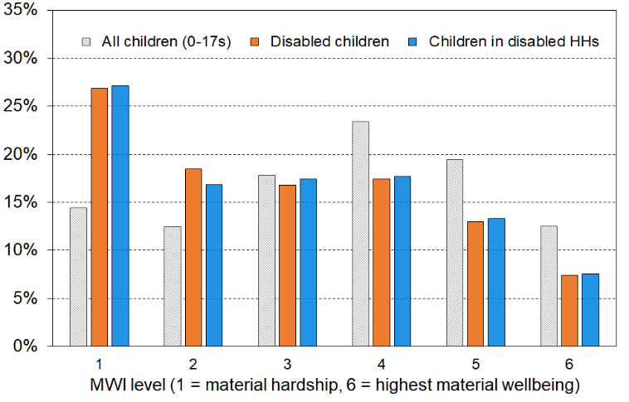
Distribution of disabled children & children in disabled HHs across the full material wellbeing spectrum
Reading note for the chart:
- The vertical bars represent the distribution across the material wellbeing spectrum. of all children, disabled children and children in disabled households. Each colour adds to 100% across the MWI levels. They are not rates of hardship.

Material hardship in the ‘early years’

There is widespread acknowledgment of the critical importance of the material, social, emotional and nurturing contexts in the early years of a child’s life for outcomes later in childhood and in adulthood. One area of public policy interest is how younger children are faring in terms of material wellbeing.

Table E.8a uses the HILS 2024-25 dataset to reports on the material hardship rates for under 5s and under 7s using different hardship thresholds. The MH-18 7+/17 threshold is the one used by Stats NZ for the standard material hardship rate for their HILS-based reporting under the CPRA. For both groups (under 5s and under 7s), the same pattern is evident for each of the three material hardship levels shown:
- under-5s and under-7s in households where all children are in these groups (ie no age 5-17s / 7-17s in the household) have the lowest hardship rate (10-12% for 7+/17)
- those in households with older children have the highest rate (20-21% for 7+/17) – this could be because they are more likely to be in larger families which on average have higher hardship rates (eg in the 2023-24 HES those with 4+ children have a hardship rate of 33% compared with all children at 14% and 10% for those with 1-2 children - see Table E.3a)
- the overall rate for both ‘early years’ groups is much the same as the overall hardship rate for all children aged 0-17 yrs (14%).

The same pattern is found in Table E.8b using the HES 2022-23 and 2023-24 datasets.

There is no evidence here of the ‘early years’ groups being in greater material hardship than older children.
Table E.8a
Material hardship for younger children:
HILS 2024-25
 | Material Hardship (rates, %) |  |  | Material Hardship (numbers) |  |  | Total numbers
 | 6+ | 7+ | 10+ | 6+ | 7+ | 10+ | Total numbers
Age-groups
0-17 | 18 | 14 | 6 | 216,000 | 169,000 | 71,000 | 1,183,000
0-4 (all) | 19 | 15 | 6 | 57,000 | 45,000 | 19,000 | 298,000
0-4 (with siblings aged 5+) | 24 | 20 | 9 | 34,000 | 28,000 | 12,000 | 138,000
0-4 only (with no siblings aged 5+) | 15 | 10 | 4 | 24,000 | 17,000 | 7,000 | 160,000
0-6 (all) | 19 | 15 | 6 | 80,000 | 64,000 | 27,000 | 424,000
0-6 (with siblings aged 7+) | 25 | 21 | 9 | 41,000 | 34,000 | 15,000 | 164,000
0-6 only (with no siblings aged 7+) | 15 | 12 | 5 | 39,000 | 30,000 | 12,000 | 260,000
Note for table:
- The MH-18 material hardship index is used - the material hardship (MH) threshold is ‘7+’ (ie 7+/18), and 10+ for severe MH.

Table E.8b
Material hardship for younger children:
Two year average for HES-Admin years (2022-23 & 2023-24)
 | Material Hardship (rates, %) |  |  | Material Hardship (numbers) |  |  | Total numbers
 | 5+ | 6+ | 9+ | 5+ | 6+ | 9+ | Total numbers
Age-groups
0-17 | 17 | 13 | 6 | 202,000 | 152,000 | 64,000 | 1,163,000
0-4 (all) | 18 | 14 | 6 | 55,000 | 41,000 | 17,000 | 300,000
0-4 (with siblings aged 5+) | 22 | 18 | 8 | 29,000 | 24,000 | 10,000 | 132,000
0-4 only (with no siblings aged 5+) | 15 | 10 | 4 | 25,000 | 17,000 | 7,000 | 164,000
0-6 (all) | 18 | 14 | 6 | 78,000 | 59,000 | 24,000 | 428,000
0-6 (with siblings aged 7+) | 24 | 19 | 8 | 38,000 | 31,000 | 12,000 | 162,000
0-6 only (with no siblings aged 7+) | 15 | 11 | 4 | 40,000 | 28,000 | 12,000 | 266,000
Notes for table:
- The table uses the average of the two HES years 22-23 and 23-24 to improve the precision of the numbers..
- The DEP-17 material hardship index is used – the material hardship (MH) threshold is ‘6+’ (ie 6+/17), and for severe MH the threshold is ‘9+’.
Material hardship, low (AHC) income and foodbank usage in six Auckland sub-regions

Material wellbeing and hardship are not evenly distributed across Auckland (or any major city), so looking at the average statistics for the whole region do not provide a picture that is useful for policy purposes or even for just understanding the nature of our largest city.

When Auckland's eight former councils were merged into a single ‘Super City’ in 2010, the Auckland region was divided into 13 wards and 21 local boards. The analysis in this section uses groupings of selected wards to enable a breakdown of the Auckland region into six sub-regions, as in Table E.9.

Table E.9
The six sub-regions defined by the agglomeration of selected wards
Sub-region | Wards included in the sub-region
Northern | North Shore, Albany and Rodney
Western | Waitākere (incl Massey-Henderson-Te Atatū); and Whau (incl New Lynn, Green Bay, Kelston, Avondale, Blockhouse Bay)
Central 1 | Albert-Eden-Puketāpapa (incl Pt Chevalier, Mt Albert, Mt Roskill, Balmoral, Mt Eden, Epsom, Royal Oak, Lynfield); and Ōrākei (incl Parnell, Newmarket, Remuera, Meadowbank, Ōrākei, Mission Bay, St Heliers, Glendowie)
Central 2 | Maungakiekie-Tāmaki (incl One Tree Hill, Onehunga, Te Papapa, Mt Wellington, Ellerslie, Panmure, Point England, Glen Innes, St Johns); and Waitematā-Gulf (incl Grey Lynn, Westhaven, Waiheke)
Southern | Manukau and Manurewa-Papakura
Howick-Franklin | Howick (incl Pakuranga, Botany Downs, Half-Moon Bay, Eastern Beach, East Tamaki Heights) and Franklin
Note for Table E.8:
- Follow the link and scroll down for an Auckland map showing the wards: https://www.aucklandcouncil.govt.nz/about-auckland-council/how-auckland-council-works/governing-body-wards-committees/wards/Pages/find-your-ward.aspx

Tables E.9a and E.9b give an indication of the size of each grouping of wards and of the differing levels of material and financial hardship across selected areas of the Auckland region, for all people and for children (0-17 years). The figures in the tables are the average for the two most recent surveys (2023-24 and 2024-25), to ensure there are sufficient numbers in the joint sample to give findings on the various statistics that are reliable enough for high-level comparisons such as those in the summary observations at the end of this section. There is no evidence of any upward or downward movement between the two years so taking the average does not lose any information.

Four measures of material and financial hardship are reported:
- AHC 50 REL: the proportion (%) of people (children) living in households that have an after-deducting-housing costs (AHC) income of less than half the AHC median for the whole country.
- Material Hardship: the standard material hardship measure used by Stats NZ and this report, households lacking 6 or more of the 17 items in the DEP-17 index in HES 2023-24, and 7 or more of the 18 items in the MH-18 index in HES 2024-25.
- The severe material hardship (SMH) version of the above using 9+/17 for HES 2023-24, and 10+/18 for HILS 2024-25.
- Foodbank usage: the proportion (%) of people (children) living in households that report using a foodbank or similar at least once in the 12 months prior to interview.

Table E.9a
Low-income (AHC 50), material hardship and foodbank usage for Auckland and six groupings of wards: children (0-17 yrs), average over HES 2023-24 and HILS 2024-25 (%)
Geographic Area | AHC 50 | MH | SMH | Total # children | Foodbank %
New Zealand | 20 | 14 | 6 | 1,180,000 | 12
Auckland | 22 | 15 | 7 | 412,000 | 13
Northern wards | 17 | 6 | 2 | 102,000 | 7
Western wards | 25 | 18 | 9 | 82,000 | 12
Central 1: Albert-Eden-Roskill & Ōrākei, | 14 | 8 | 4 | 47,000 | 8
Central 2: Maungakiekie-Tāmaki & Waitematā-Gulf | 29 | 16 | 9 | 37,000 | 18
Southern wards | 24 | 28 | 12 | 96,000 | 23
Howick-Franklin wards | 25 | 8 | 3 | 47,000 | 9
Notes for tables E.9a & E.9c:
MH is defined as DEP-17 6+ in HES 2023-24 and MH-18 7+ in HILS 2024-25.
SMH (severe material hardship) is defined as DEP-17 9+ in HES 2023-24 and MH-18 10+ in HILS 2024-25.

The numbers that immediately stand out are those for the Southern wards, albeit they are not surprising given other well-known statistics:
- 28% of children in material hardship compared with a country-wide and AKL figure of 14-15%
- 12% in severe material hardship compared with 6% country-wide and 7% for AKL
- 23% of children in households using a foodbank at least once in the 12 months prior to interview, compared with 12% country-wide.

Looking at the figures another way, children (under-18s) living in the Southern wards make up:
- 23% of Auckland’s under-18 population but 44% of under-18 Aucklanders in material hardship
- 8% of the country’s under-18s, but 16% of all under-18s in material hardship.

Material hardship depth and socio-economic status

NZDep is a socio-economic deprivation index that combines census data relating to income, home ownership, employment, qualifications, family structure, housing, access to transport and communications. NZDep provides a deprivation score for each meshblock in New Zealand (typically 60-110 people in each). It is not a household-based measure.

Table E.10 reports the hardship rates and composition analysis by NZDep quintile:
- Half of children in MH and 60% of children in SMH live in the most deprived NZDep quintile
- Three quarters of children in MH and 80% of children in SMH live in the two most deprived NZDep quintiles.

Table E.10
Distribution of children (0 -17 years) in various levels of MH across NZDep quintiles:
MH-18 index, HILS 2024-25
HILS 2024-25 | Material hardship rates |  |  |  |  | Composition
 | what % of this group is in hardship, using the different thresholds? |  |  |  |  | what % of all those in hardship (using a given threshold) are in this group / cell? |  |  |  |  | 000’s | %
Material hardship threshold as # of items lacked out of 18 | 6+ | 7+ | 8+ | 9+ | 10+ | 6+ | 7+ | 8+ | 9+ | 10+ | ALL | ALL
All children (0-17 yrs) | 18 | 14 | 11 | 8 | 6 | 100 | 100 | 100 | 100 | 100 | 1,185 | 100
NZDep Quintile
Q1(least deprived 20%) | 6 | 4 | 2 | suppressed* |  | 6 | 5 | 4 | 2 | 2 | 220 | 19
Q2 | 7 | 4 | 3 | suppressed* |  | 7 | 6 | 5 | 4 | 3 | 220 | 19
Q3 | 16 | 12 | 8 | 6 | 5 | 17 | 16 | 14 | 15 | 15 | 230 | 19
Q4 | 21 | 17 | 13 | 9 | 6 | 24 | 24 | 23 | 22 | 21 | 240 | 20
Q5 (most deprived 20%) | 38 | 31 | 27 | 21 | 16 | 46 | 49 | 54 | 57 | 59 | 265 | 23
Notes for table:
- rates are suppressed for cells where the numerator is under 5k

Section F
Trends in material hardship and material wellbeing for children: headline rates and breakdowns by selected household and child characteristics

This section reports the trends in material hardship for children from HES 2007 to HILS 2025:
- for all children
- for children compared to the whole population and older New Zealanders (66+)
- by household tenure
- by ethnic group of the children
- by disability status
- by main source of income of the household (market or government)
- % of children living in workless households – trend with international comparisons.

The approach taken to reporting material hardship trends

The analysis uses the Material Wellbeing Index (MWI) to estimate material hardship (MH) levels, enabling a longer time series than using DEP-17 and MH-18

For reporting on MH trends, the MSD report uses the MWI and its predecessor as these can give the trends from 2007 whereas the DEP-17 index can start only at 2013. The two indices report the same trends, especially when using a two-year rolling average, and give very similar hardship rates in a given year. For example, HES 2023-24 MH rates for children were 13.5% using both DEP-17 and and MWI-24, and for the HILS 2024-25 year they were 14.3% for MH-18 and 14.4% for MWI-26. See Appendix 4 for comparisons over the last ten years.

The focus is on overall smoothed trends rather than year-on-year or other short-run changes
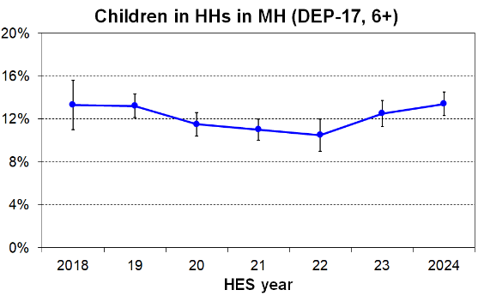
When comparing year-on-year figures it is important to take into account the sampling errors for the point estimates (see error bars in the chart), and also the resulting sampling errors on the changes themselves. For example, the sampling error on the reported 2.0 ppt increase from 21-22 to 22-23 is itself 2.0 ppt, thus making the change only just statistically significant despite what ‘looks’ like a definite increase in the chart.

When reporting on changes over time the focus in this report is usually on longer-run trends rather than on the year-on-year or other short-run changes that Stats NZ use in compliance with their responsibilities under the Child Poverty Reduction Act.
The trend lines are usually shown using a rolling two-year average to smooth the short-run fluctuations and better show the ‘big picture’. The smoothing can also help to reduce the risk of users (understandably) reading too much into year-on-year fluctuations when sampling errors are not to hand. The visual impression of a line on a chart is very powerful even when one is aware of the uncertainties inevitably present in any sample survey, even good quality ones.

The report takes a cautious approach for MH reporting for the COVID-impacted years (2020-21 and 2021-22) – plotting the measured MH rates for those years, but not ‘joining the dots’ as part of the time series (see chart below )

Reporting for the COVID years

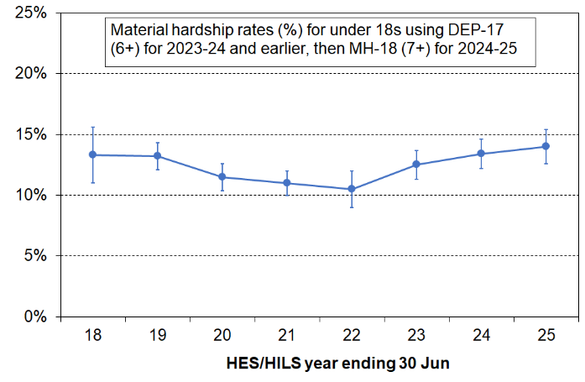
The chart on the right shows the material hardship trend for children from 2018 to 2025 with its separate falling and rising sections. Setting aside for a moment any impact from COVID-related factors on the figures for 2021 and 2022, a fall through to 2022 is in line with the impact that could be expected from the considerable extra government support for households with children over this period, from initiatives such as real increases in core benefit rates, the lagged impact of the Families Package (including increases in the Family Tax Credit, the Accommodation Supplement, and the introduction of the Winter Energy Payment), increases in the minimum wage, subsidised public transport, free doctor visits extended to cover all under 14s, and so on. The subsequent rise in the MH rate can be understood as reflecting the lagged impact of elevated inflation which began in around June 2021. While most year-on-year changes in the period are not statistically significant, the fall from 2019 to 2022 is, as is the rise from 2022 to 2025, indeed from 2023 to 2025 also. The net change from 2019 to 2025 is not statistically significant.

The above narrative is relatively straightforward and is plausible in its account of the general trend including both the initial decrease and the subsequent increase during the ‘cost of living crisis’. When however COVID-related factors are brought into consideration, there are grounds for questioning whether it is reasonable to join the dots for the COVID years (2021 and 2022) as if they are part of a ‘normal’ time series.
- Both the 2020-21 and (especially) the 2021-22 data collections were severely disrupted by both the COVID restrictions and decisions made by households themselves. Weather disruption also impacted the 2021-22 collection. Stats NZ conducted extensive statistical analysis regarding the quality of the 2020-21 and 2021-22 data and concluded that from a purely statistical perspective the quality of the sampling and of the data for both these COVID-impacted HES years was good enough to publish the CPRA figures for children and the whole population but not for most sub-group analysis. Much of the time series analysis in this report is about sub-groups so there are grounds for not reporting time series continuity for those charts. For the sake of consistency, the report uses the same approach for the ‘all children’ chart.
- The second main consideration is quite different from those relating to the collection challenges. During the COVID years there was considerable extra government support for households and individuals. The lockdowns and personal decisions about how to live safely led to changes in consumer behaviour. These factors no doubt had their own impact on reported material hardship levels in 2021 and 2022. This means that even if the data quality is good enough to use for reporting for all children, there is uncertainty when it comes to giving an account of what lies behind the figures for the COVID years. What was the relative contribution to the reported reduction in MH for children of the Families Package and the other extra government support noted above on one hand, compared with the COVID-related factors noted in this paragraph on the other?

Taking all this into account, the approach used in this report is illustrated in the short-run chart on the right. To remind the reader of the unusual context and the extra uncertainties, the findings for the COVID-impacted years are included but the dots are not joined. Neither the policy-induced reduction in the material hardship rate for children nor the recent rise are edited out by this decision. It simply reminds the reader of the uncertainties. The rise from 2023 to 2025 is statistically significant and starts from a solid base year.

What of the impact on household incomes? The report does not produce low-income time series analyses for sub-groups of children so even if there was some uncertainty or noise the matter is not as pressing as it is for MH. For much of the report’s detailed income-related analysis it uses data from just one year, preferably HILS 2024-25, and can avoid using 2020-21 and 2021-22 for these analyses.

There is a dip in the COVID years for the AHC relative low-income rates for children (see Section H). It is not totally clear how to interpret the dip. Household incomes as seen in the data for this period will have been affected by several factors: the collection challenges for achieving a representative sample of the population, the extra COVID financial support from the government, the delivery of the final benefit increases and other support from earlier Budget initiatives, and the loss of regular employment income. Median AHC incomes dropped away a little in the COVID years and this in itself leads to a small fall in relative AHC low-income rates even if nothing else changed. It is difficult to know whether the lower COVID-period AHC income poverty rates are mainly from the median (and therefore the poverty lines) dropping a little, or from the extra government support in the period or from a mix of both. The report therefore notes the need for caution in using the 2020-21 and 2021-22 income information for low-income assessment but reports as if there is continuity (as do Stats NZ).

All children (1.18 million in 2024-25)

Material hardship rates for children increased during the GFC and associated downturn, then steadily improved from 2011 to 2020 (Figure F.1). The downward trend can be attributed to a combination of rising employment rates, rising real wages, increased labour market hours for two-parent families, increases to income support for families with children, increased support for housing and child-care costs, and other measures that reduce demand on the family budget (eg free doctors’ visits for under 14s and the food-in-schools programme).

The downward trend continued to 2022, falling to the lowest level since measurement of material hardship began with the 2007 HES. As discussed above, the reported rates for the COVID-impacted years are set aside from the ongoing time series as a visual reminder of the unusual circumstances of the period, and that there are several factors that are likely to have contributed to the reported low rate in 2022 (ongoing impact of earlier policy changes that increased support for lower-income households with children, changed consumer behaviour and extra support in the COVID years, disrupted collection for Stats NZ). A cautious approach is needed when developing a narrative about the reported rates in the COVID years.

There has been an unambiguous increase in material hardship rates from 2022 through to 2025.

Reading off Figure F.1 below (which uses the MWI measure) material hardship rates for children are much the same in 2024-25 as in 2018-19, bearing in mind the typical level sampling errors of around ±1.2 ppt. For the 2024-25 survey, this is around 170,000 children aged under 18 in MH.

The same conclusion is reached when using the DEP-17 and MH-18 indices without any smoothing. Stats NZ report a 1.1 ppt increase in MH rates from 2017-18 to 2024-25, 13.3% to 14.3%, with a calculated sample error on the change of 2.7 ppts. As the sample error of 2.7ppt is greater than the rate increase of 1.1ppt the change in rates from 2017-18 to 2024-25 is not statistically significant.

The severe material hardship rate using the MWI measure has remained reasonably steady over recent years at around 5% (55-60,000), around half the rate reported in the downturn following the GFC (9%). See Tables D.2 and D.5 for detailed information showing the seriousness of the deprivation for these children and their households using 2023-24 HES data.

Figure F.1
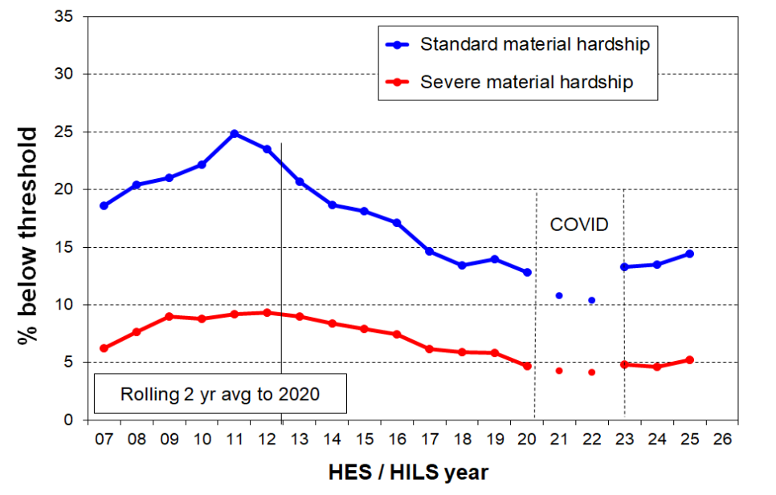
Material hardship trends for children (0-17 yrs), 2007 to 2025
Note for chart: Index used is the MWI (see p57).

Comparisons with the whole population and older New Zealanders (66+)

Material hardship rates for children are higher than for the population as a whole (Figure F.2). The ratio of rates for children to that for the whole population has been around 1.5 to 1.7 since just after the GFC (say, 2011). For EU countries it is typically much lower with the median country ratio being around 1.1.

The main reason for the relatively high ratio (children to whole population) is the relatively low MH rate for older New Zealanders (typically 3-4%). For EU countries the median ratio of under 18 to age 66+ hardship rates is typically around 1.3. For NZ using EU-13. it is currently 5.2, higher than any EU country except Sweden. The NZ ratio using EU-13 has been steady at around 5 to 6 since 2013.

Figure F.2
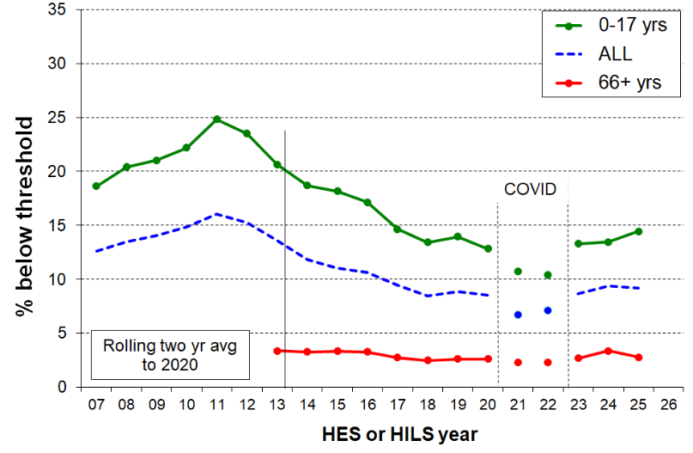
Trends in material hardship for children (0-17 yrs), the whole population and older New Zealanders (66+)

Note for chart: Index used is the MWI (see p57).

Tenure

In 2024-25 43% of all children lived in owned-with-mortgage households and another 13% in owned-without-mortgage households. Around a third lived in private rentals with half of these receiving the Accommodation Supplement (AS) and half not, and 6% in ‘social’ rentals. The distribution was much the same in 2018-19.

Unsurprisingly, the MH rates for those in private accommodation are highest for those in private rentals and receiving the AS, running at 35 to 40% in the 2023-24 and 2024-25 surveys, compared with 10% for those in private rentals but no AS, and 6% for owners-with-mortgages using the MWI measure.

Figure F.3 shows the trends in MH rates for children from 2007 to 2024 by the tenure of their households. In the post-GFC period there was a general downward trend through to 2020 for private renters and for the owners-with-mortgages group. Following the COVID-impacted years (2020-21 and 2021-22) the 2022-23 rates were similar to those in 2019-20. The MH rates for children in private rentals where AS is received have shown a strong rise through to 2024-25 while the rates for those in other tenures have remained steady.

For children living in social housing the reported MH rates are high, on average running at 45-50% in recent years (excluding the COVID years when the MH rate was ~40%).This is as would be expected given the eligibility criteria, even with the rent capped at 25% of income. The longer-run trend back to 2007 is not reported as the sample numbers for those in social housing are relatively small for the years prior to 2018-19 and the observed fluctuations in that period are likely to give a misleading impression and invite over-interpretation. The more recent figures noted above (45-50%) are steady over the period and can safely be used for comparisons with MH rates in other tenures.

Figure F.3
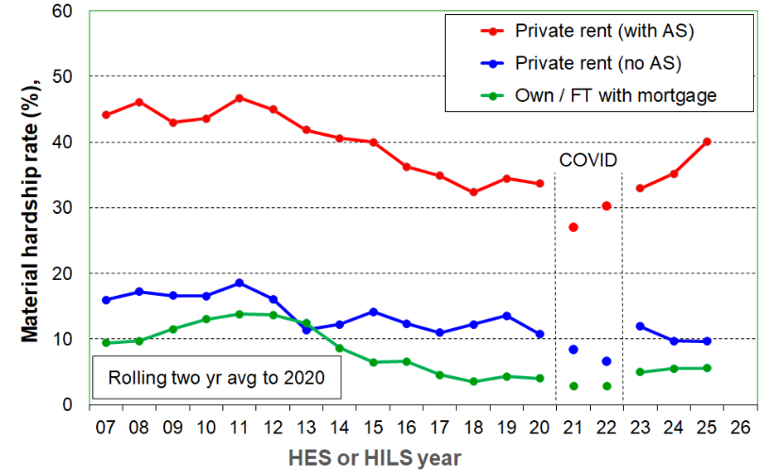
Material hardship trends for children (0-17 yrs), by tenure of their household
Notes for Figure F.3:
FT = Family Trust
Index used is the MWI (see p57).

Ethnicity

For most of the HES surveys prior to 2018-19 the sample size is too small to provide robust estimates for smaller sub-groups. Even in the larger 2018-19 survey, the sample error is 2.3 ppt for the material hardship numbers for children in the Māori ethnic grouping, 4.2 ppt for Pacific and 1.7ppt for Asian.

To address this small sample issue Table F.1a groups three surveys together for the years prior to 2018-19 to enable trends to be reported from 2007-09 through to 2025.

Each group saw an increase through the GFC and the following few years then a fall through to 2020, though the peak lasted longer for the Pacific peoples group. In the immediate post-COVID period, MH rates in the 2023 survey were generally a little higher than for the 2020 survey though the changes are not statistically significant. The further rise for tamariki Māori through to 2025 (a 6 ppt rise) is a statistically significant increase for 2020 to 2025.

The composition columns give an idea of the over- or under- representation of the different groups in the MH statistics.

Table F.1a
Material hardship rates for children by ethnic grouping (total ethnicity approach), 2007 to 2025,
using the same ELSI / MWI spliced series as in Figures F.1 to F.3
(three-year groupings to 2018)
 | Material hardship rates (%) |  |  |  |  |  |  |  |  | MH Composn (%) | Overall Composn (%)
 | 2007-09 | 2010-12 | 2013-15 | 2016-18 | 2019 | 2020 | 2023 | 2024 | 2025 | 2025 | 2025
Māori | 33 | 36 | 34 | 24 | 24 | 19 | 22 | 23 | 25 | 32 | 20
Pacific | 44 | 47 | 47 | 34 | 32 | 29 | 32 | 31 | 31 | 23 | 12
European | 14 | 18 | 13 | 10 | 10 | 9 | 10 | 10 | 12 | 37 | 49
Asian | 19 | 16 | 8 | 6 | 7 | 5 | 4 | 7 | 6 | 6 | 16
ALL | - | - | - | - | - | - | - | - | - | 100 | 100
Notes for Table F.1a
- There are 40,000 in the ‘Other’ category – this includes MELAA and “Other” ethnicities (including “New Zealander”), both of which groups have low numbers and high sampling error. For example, in 2025 the sampling error for the “Other” subgroup was of the order of 12 ppt on a point estimate of around 26% for material hardship, and for MELAA 8 ppt on a point estimate of 14%. The row is suppressed in Tables F.1a and F.1b.
- See Section E for discussion of the counting approach used for ‘total ethnicity’.

Table F.1b repeats the analysis in Table F.1a but uses the ‘prioritised’ conceptualisation of ethnicity. Māori rates of course remain the same. Pacific rates also remain much the same, but European and Asian rates fall a little. The main takeaways are the same whichever approach is used.

Table F.1b
Material hardship rates for children by ethnic grouping (prioritised ethnicity approach), 2007 to 2025,
using the same ELSI / MWI spliced series as in Figure F.1 to F.3
(three-year groupings to 2018)
 | Material hardship rates (%) |  |  |  |  |  |  |  |  | MH Composn (%) | Overall Composn (%)
 | 2007-09 | 2010-12 | 2013-15 | 2016-18 | 2019 | 2020 | 2023 | 2024 | 2025 | 2025 | 2025
Māori | 33 | 36 | 34 | 24 | 24 | 19 | 22 | 23 | 25 | 44 | 26
Pacific | 45 | 49 | 46 | 36 | 34 | 30 | 36 | 34 | 32 | 23 | 10
European | 11 | 15 | 9 | 7 | 8 | 6 | 8 | 7 | 8 | 24 | 43
Asian | 17 | 16 | 7 | 6 | 7 | 4 | 3 | 6 | 5 | 7 | 20
ALL | 20 | 24 | 19 | 14 | 15 | 11 | 13 | 13 | 14 | 100 | 100
Notes for Table F.1b:
- There are 18,000 in the ‘Other’ category – this row is suppressed – see note for Table D.1a above.
Material hardship by disability status

Questions relating to disability were added to HES in survey year 2019-20. This allows reporting on the disability status of individuals and their households for this and subsequent survey years.

Material hardship rates for disabled children and children in disabled households were steady from 2019-20 to 2023-24 at close to the levels shown for HES 2023-24 in Table F.2 below. There were no statistically significant changes in that period.

Table F.2
DEP-17 6+/17 material hardship rates (%) for children by disability status,
HES 2023-24
 | Disabled children | Non-disabled children | Children in disabled household | Children in non-disabled household
Numbers in hardship | 26,000 | 115,000 | 78,000 | 79,000
Hardship rate | 21 | 12 | 23 | 10
Proportion of those in hardship | 18 | 82 | 50 | 50
Numbers in severe hardship | 12,000 | 45,000 | 36,000 | 27,000
Severe hardship rate | 10 | 5 | 10 | 3
Proportion of those in severe hardship | 21 | 79 | 57 | 43
Size of group (#) | 124,000 | 931,000 | 345,000 | 827,000
Size of group (%) | 12 | 88 | 29 | 71
Notes for Table F.2
- A disabled household is one with at least one disabled person.
- Numbers of disabled & non-disabled children relate only to those aged 2 to 17 yrs.
- Children of all ages are included in the numbers for disabled and non-disabled households.

Definition revisions for HILS 2024-25 – break in time series

For the 2024-25 HILS the definitions were revised in several ways:
- 15 to 17-year-olds are now asked the adult set of questions. This aligns with how the questions are asked in the Health and Disability Survey, and with advice received from the Washington Group.
- Improvements have been made to disability question wording across the survey. The questions now clarify that they are about long-term health issues or conditions (with ‘long-term’ defined as longer than six months). Further, the questions reflect updates made to WG module documentation and feedback from cognitive testing.
- Adding clarifying text: in addition to defining “long-term difficulty” in the module introductions, clarifying text is now incorporated throughout the question set to better communicate the intended scope of the question.

The following definitions are used in HILS 2024-25:
- Children under 2 years old are not assessed for disability.
- People aged 2 to 4 are disabled if they have serious difficulty with at least one of the following: seeing (even with glasses), hearing (even with hearing aids), walking (without the use of equipment or assistance), manual dexterity, communicating, learning, playing, or controlling their own behaviour.
- People aged 5 to 14 are disabled if they have serious difficulty with at least one of the following: seeing (even with glasses or contact lenses), hearing (even with hearing aids), walking (without the use of equipment or assistance), personal care such as feeding or dressing themselves, communicating, learning, remembering, concentrating, accepting change, controlling their own behaviour, making friends, anxiety, or depression.
- People aged 15 or over are disabled if they have serious difficulty with at least one of the following: seeing (even with glasses or contact lenses), hearing (even with hearing aids), walking (without the use of equipment or assistance), manual dexterity, upper body strength, personal care such as washing and dressing, communicating, remembering or concentrating (due to a long-term condition or health problem), anxiety, or depression.
The changes to the definition and conceptualisation of disability status and their interaction with the revised MWQs mean that there is a break in the MH disability time series starting with the 2024-25 HILS. The 2024-25 rates should not be compared with the earlier HES-based rates.

The material hardship figures in Table F.3 are the first figures in the new time series starting in HILS 2024-25. The numbers are drawn directly from Stats NZ’s February 2026 Child Poverty release (Tables 3.04 and 8.04), with some rounding.

Table F.3
MH-18 7+/17 material hardship rates (%) for children by disability status,
HILS 2024-25
 | Disabled children | Non-disabled children | Children in disabled household | Children in non-disabled household
Numbers in hardship | 32,000 | 121,000 | 100,000 | 69,000
Hardship rate | 27 | 13 | 28 | 8
Proportion of those in hardship | 21 | 79 | 59 | 41
Numbers in severe hardship | 16,000 | 49,000 | 48,000 | 24,000
Severe hardship rate | 14 | 5 | 13 | 3
Proportion of those in severe hardship | 25 | 75 | 67 | 33
Size of group (#) | 118,000 | 954,000 | 365,000 | 818,000
Size of group (%) | 11 | 89 | 31 | 69
Notes for Table F.3:
- A disabled household is one with at least one disabled person.
- Numbers of disabled & non-disabled children relate only to those aged 2 to 17 yrs.
- Children of all ages are included in the numbers for disabled and non-disabled households.

For more detailed analysis, see Wilson and McLeod (2025) and Wilson, McLeod and Godfrey (2025).

See also Section E above.

Children in ‘working’ and ‘beneficiary’ households

In this section, ‘working’ means that most of the income for the household comes from the market, and ‘beneficiary’ means that most of the income comes from the government.

Figure F.4 shows the MH trends for the two groups of children, with beneficiary MH rates being around four to five times the rates for children in working households (42% and 9% respectively in 2023-24). In Section E there is more detail on the characteristics of the two groups (pp43ff).

Figure F.4
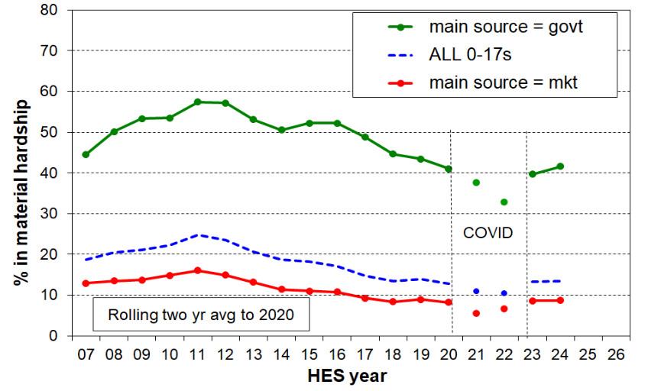
Trends in material hardship rates for children (0-17 yrs), by main source of household income

Figure F.5 reports on the composition of those in hardship. From 2016 to 2020, around 55% of children in MH came from ‘working’ households, and this pattern returned in 2022-23 and 2023-24 after the COVID-impacted years (2020-21 and 2021-22). Although working households have lower hardship rates, there are many more such households than beneficiary households, so the numbers roughly even up.

Figure F.5
Trends in the numbers of children (0-17 yrs) in households in material hardship,
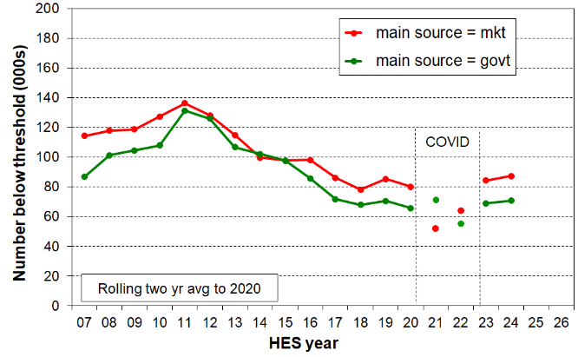
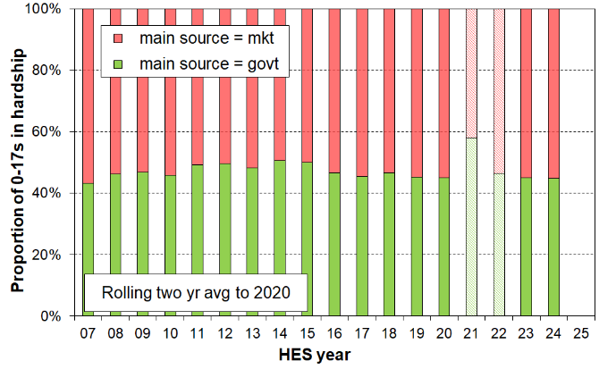
by main source of household income
Note for Figures F.4 and F.5:
- As for all Section F, the MH rates are produced from the MWI index – see further comment on the opening page of Section F.

Children in workless households: international comparisons

Table F.4 compares New Zealand with EU countries on the proportion of children in workless households. In 2012, at the height of the GFC impact, New Zealand was at the high end of the table with a rate of 18%, similar to Hungary, Ireland and Bulgaria (16-20%). In 2024 the rate was 12%, but still at the top end of the table, and well above the EU median of 7% and the weighted average of 8%. The rates for Hungary, Ireland and Bulgaria have all fallen to lower levels than New Zealand (4-9%).

Table F.4
International comparisons of the proportion of children living in jobless households (%):
2008 to 2025 (calendar years)
 | 2008 | 2012 | 2017 | 2019 | 2024 | 2025 |  | 2008 | 2012 | 2017 | 2019 | 2024 | 2025
Romania | 10 | 12 | 9 | 7 | 15 | 16 | Latvia | 8 | 11 | 8 | 7 | 7 | 7
New Zealand | 17 | 18 | 11 | 10 | 12 | - | Slovakia | 9 | 10 | 8 | 8 | 5 | 7
Belgium | 11 | 12 | 12 | 12 | 12 | 12 | Austria | 6 | 5 | 7 | 6 | 6 | 7
France | 8 | 10 | 12 | 12 | 10 | 10 | Denmark | 3 | 8 | 9 | 8 | 6 | 6
Estonia | 7 | 9 | 6 | 8 | 8 | 10 | Portugal | 5 | 9 | 6 | 5 | 5 | 5
Ireland | 13 | 20 | 12 | 11 | 9 | 9 | Malta | 9 | 8 | 8 | 7 | 7 | 5
Finland | 4 | 4 | 5 | 5 | 7 | 9 | Netherlands | 6 | 6 | 7 | 5 | 5 | 5
Germany | 10 | 9 | 9 | 8 | 9 | 9 | Czechia | 7 | 9 | 6 | 6 | 4 | 4
Italy | 7 | 9 | 10 | 9 | 9 | 8 | Cyprus | 4 | 7 | 10 | 6 | 5 | 4
EU-27 wgtd avg | 8 | 10 | 9 | 9 | 8 | 8 | Hungary | 15 | 16 | 8 | 6 | 4 | 4
Bulgaria | 11 | 18 | 11 | 9 | 8 | 7 | Poland | 8 | 9 | 8 | 8 | 4 | 4
Lithuania | 11 | 12 | 10 | 9 | 6 | 7 | Greece | 4 | 13 | 9 | 8 | 5 | 4
Luxembourg | 4 | 4 | 8 | 6 | 4 | 7 | Croatia | 7 | 11 | 8 | 6 | 4 | 3
Spain | 6 | 13 | 9 | 8 | 8 | 7 | Slovenia | 3 | 4 | 3 | 3 | 2 | 2
- EU Source: https://ec.europa.eu/eurostat/databrowser/view/LFSI_JHH_A/default/table?lang=en (19 May 2026).
- The reported EU proportions are for the calendar years specified. The HES cuts across adjacent calendar years. For example, the NZ figure for 2023 is the average of the HES 2022-23 and 2023-24. The 2024 figure for NZ is reported for HES 2023-24 as HILS 24-25 does not collect the relevant data.
- For the EU figures, ‘workless’ means ‘no paid work’. For the New Zealand figures ‘workless’ means ‘no adult in paid work for 5 or more hours per week’.
- Australia reports the number and proportion of children aged under 15 in workless families, not workless households (ABS Labour Force Status of Families). Given that 80-85% of children are in two parent or sole parent households, the size of the difference is not likely to be great.12% of children were in workless families in Australia in 2023.

Children in workless households, in households with no full-time paid worker and in families in receipt of a main benefit

Leading up to the GFC and in the downturn associated with it (2008 to 2012), around one in four New Zealand children lived in households where there was no adult in full-time employment. This dropped to around one in six in the 2016-17 HES and has been steady since then (Table F.5). This figure, like the 2023-24 jobless figure (12%), is nevertheless high by EU standards (see Table F.4 above).
Table F.5
Proportion of children in ‘workless’ households (% of all children)
HES survey year | 2007-08 | 2011-12 | 2016-17 | 2017-18 | 2018-19 | 2019-20 | 2020-21 | 2021-22 | 2022-23 | 2023-24
In jobless HHs | 17 | 19 | 11 | 11 | 10 | 10 | 12 | 11 | 11 | 12
In HHs with no FT worker | 24 | 25 | 16 | 17 | 16 | 16 | 17 | 17 | 16 | 17
In beneficiary families | 19 | 21 | 16 | 15 | 15 | 16 | 18 | 18 | 18 | 19
The proportion of children in beneficiary families (bottom row) is unlikely to ever match the proportions in either of the other two rows for several reasons:
- a beneficiary family may live in a household where an adult is in FT work (eg a sole parent family living with the mother’s parents or other relatives)
- some beneficiary families receive income from part-time employment
- the beneficiary information is a snapshot at 31 March (from 2013 on), whereas the HES-based figures are an average over the full survey year.

Trend in material wellbeing for children in households above the hardship threshold, with pre- and post-COVID comparisons

The Child Poverty Report has a major focus on material hardship, low incomes and financial stress, all of which are matters of ongoing public policy interest. This justifiable focus can sometimes lead us to forget that the vast majority of New Zealand children are living in households in which their basic material needs are being consistently met.

MSD’s Material Wellbeing Index (MWI) ranks households across the full material wellbeing spectrum from low to high, rather than just being focussed on the low end as the DEP-17, MH-18 and EU-13 indices are. The maximum possible MWI score is 35. Material hardship rates to 2023-24 are calculated using an MWI score of 12 or less, equivalent to a DEP-17 score of 6+/17. Applying the MWI to the HES data enables the creation of a fuller picture of how children are faring.

Using the MWI to report on trends is similar to using a fixed line household income measure. The same fixed standard is used from one survey to the next, whereas the moving or relative line approach for incomes uses a moving standard, namely, median household income. Figure F.6 makes use of this feature of the MWI, starting with a given MWI score (level of material wellbeing) in 2012-13, and showing the increasing proportions of children in households achieving that level or better over the period to 2019-20, followed by a small decrease for the post-COVID years , 2022-23 and 2023-24.

The chart shows the trend in material wellbeing from 2013 on for those starting with a score of 25 or more in 2013, representing children in households with good to very good material living standards. 46% of children were in households with a score of 25+ in 2012-13. By 2019-20 this proportion had reached 57%. Following the COVID years it decreased to 54%, in line with the economic slowdown and the flat-lining of real inflation-adjusted incomes.

Figure F.6
Proportion of children (0-17yrs) in households with average to very good material living standards,
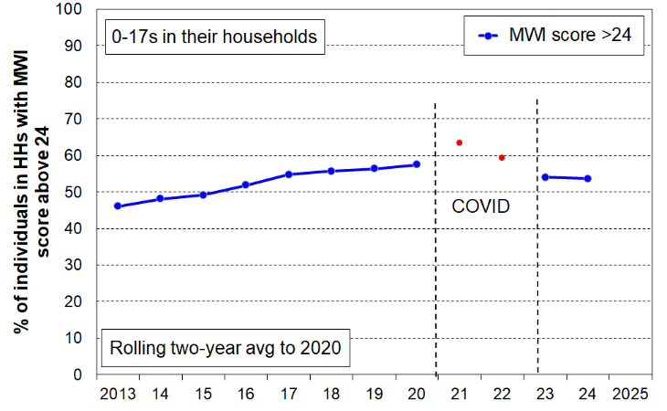
2013 to 2024

The higher and out-of-sync proportions for the COVID years give further support to the report’s decision to separate out the COVID years by ‘not joining the dots’ as a visual reminder of the very unusual circumstances in the period.

Self-assessed income adequacy

For 2013 to 2020, the proportion of children in households who reported that they did not have enough income for basics steadily declined from 21% to 13% and dropped further during the COVID years (Figure F.7). This trend reversed post-COVID and increased to 15% in 2024-25.

Figure F.7
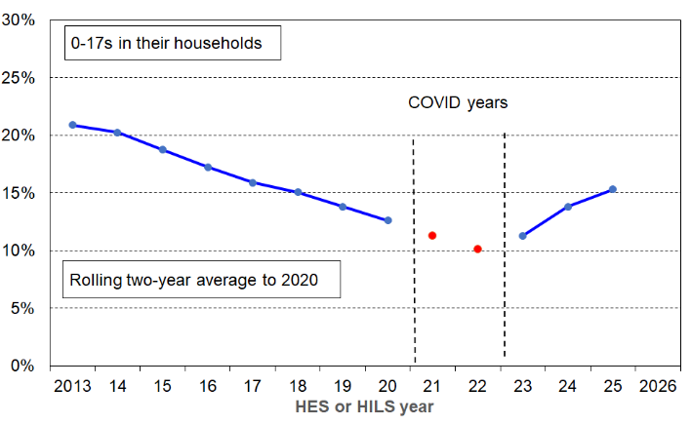
Proportion of children (0-17yrs) in households with self-assessed income adequacy for basics of
‘not enough’, 2013 to 2025 (%)

For 2013 to 2015, around 47% of children were in households that reported that they had enough or more than enough income for basics (Figure F.8).This proportion steadily rose after that and reached 57% in 2020. The upward trend for ‘enough/more than enough’ reversed post-COVID and there has been a decline in the proportion of children in households that say they have enough or more than enough for basics to 50% in 2024-25.

Figure F.8
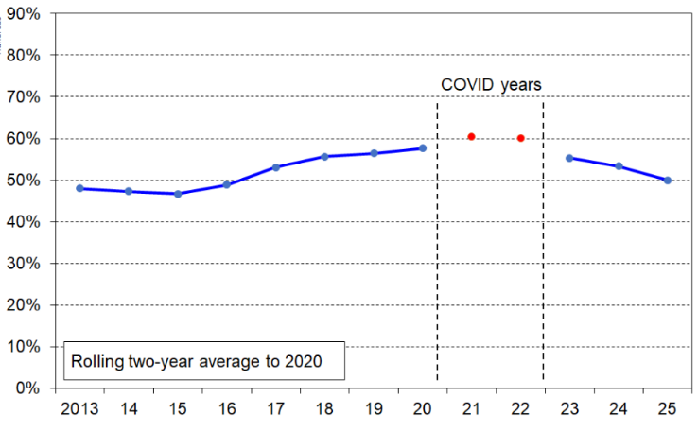
Proportion of children (0-17yrs) in households with self-assessed income adequacy for basics of ‘enough / more than enough’, 2013 to 2025 (%)

Section G
Trends in the real CPI-adjusted incomes of households with children

While household income has its limitations as a reliable indicator of a household’s ‘command over resources’ (see Section A), household income levels nevertheless have a major impact on the material wellbeing of households and their members, on their ability to access the basics and to have at least some minimal ability to participate in the normal patterns of living.

Before coming to reporting on trends in low-income rates for children (Section I), this section provides contextual information on income trends for the households in which children live, and describes trends in some key drivers of household income. The emphasis is on trends in real CPI-adjusted income rather than nominal income. The rationale for this is that it is the real purchasing power of household income that matters for household standard of living, not nominal income. Trends in real income have considerable policy, political and practical relevance and implications.

Figure G.1 compares real and nominal trends for the median for both BHC and AHC incomes for the whole population. The two charts illustrate the importance of reporting real incomes, not just nominal alone. Doing the latter can lead to claims of ‘strongly rising incomes in recent years’ which create the impression of ‘things getting better’ when in fact in recent years in New Zealand the purchasing power of many households has stagnated. Figure G.2 compares real and nominal trends for lower-income households (at p20, top of decile 2) and higher middle-income households (at p70) for both BHC and AHC incomes. The same plateauing of real income is seen here as at the median in Figure G.1.

Figure G.1
Trends in nominal and real (CPI inflation-adjusted) median household incomes:
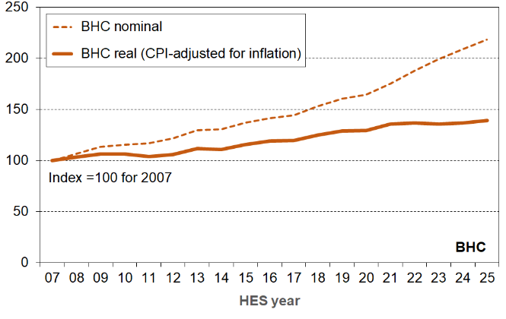
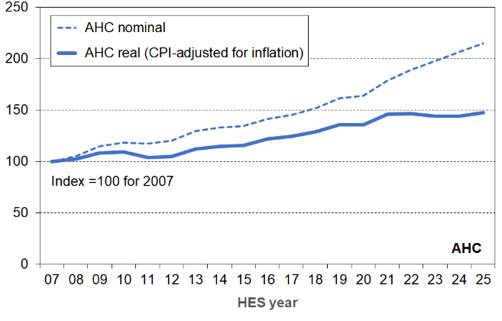
BHC (left) and AHC (right), whole population

Figure G.2
Trends in nominal and real (inflation-adjusted) household incomes for the top of deciles 2 and 7:
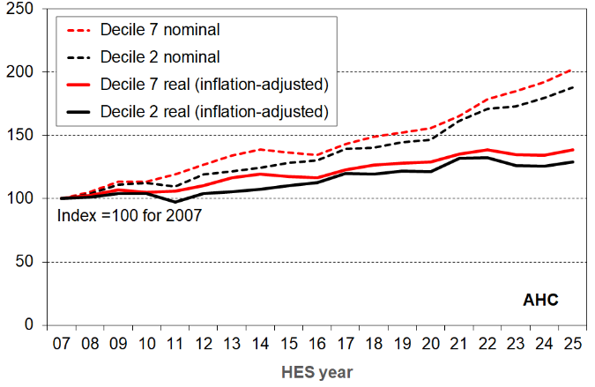
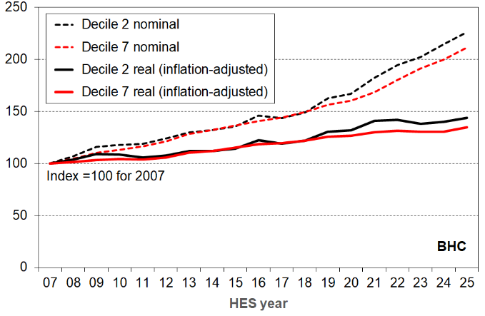
BHC (left) and AHC, whole population (right)
Figure G.3 compares real and nominal trends for the median for both BHC and AHC incomes for children in their households. The pattern is similar to that for the whole population as noted above, with a strongly rising nominal trend and a plateauing real trend from around 2021 through to 2025.

Figure G.3
Trends in nominal and real (inflation-adjusted) median household incomes (for 0-17s):
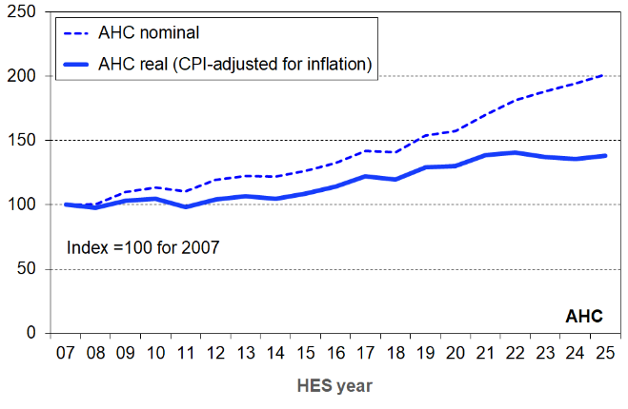
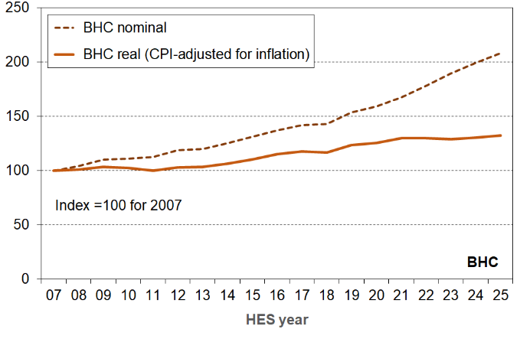
BHC (left) and AHC (right)

Figure G.4 shows the trends in AHC incomes in real CPI-adjusted terms for children in low-income households:
- from around 2014 to 2021, incomes rose in real terms for children at p10, p20 and p30 … then the trend plateaued through to 2025
- the visual impression that the trends for AHC p10, p20, p30 and the median followed the same path in the full period from 2007 to 2025 is borne out by the data: p10 remained steady at around 45% of the median, p20 at around 60%, and p30 at around 73% in that period
- for BHC incomes over the full period from 2007 to 2025, p10 remained steady at around 54% of the median, p20 at around 68%, and p30 at around 78%.

Figure G.4
Trends in real (inflation-adjusted) AHC household incomes for the median and the top of deciles 1 to 3:
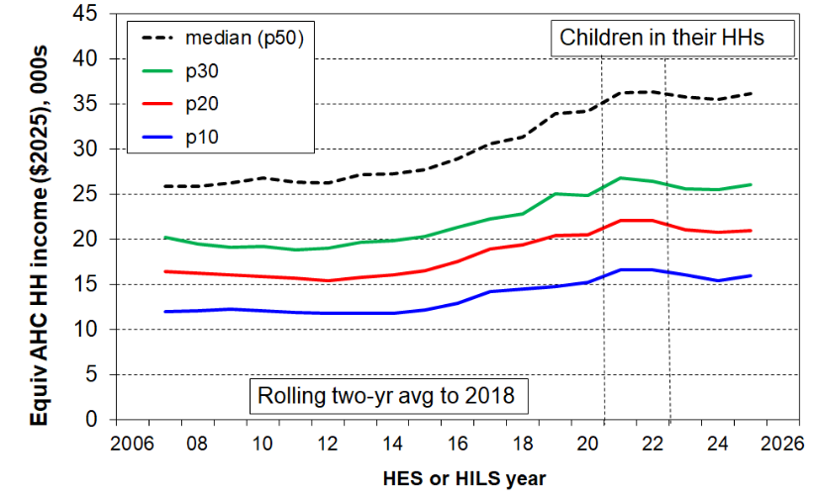
for 0-17s in their households

There are several tables in the Appendices which give more detailed income information, for both children in their households and for the whole population.
- Appendix 8 conversion from equivalised $ to ordinary $ for selected
HH types and a range of incomes
- Appendix 8 conversion from ordinary $ to equivalised $ for selected HH
types, with location in equivalised dollar deciles
- Appendix 9 low-income thresholds (‘poverty lines’) for selected HH types
- Appendix 10 decile boundaries and means using $2025, 1982 to 2025
Factors impacting on trends in household incomes

There are many factors that impact on the trends for real household incomes for households with children. A full explanation of what has driven the steady rise then the recent plateauing of household incomes in real terms is beyond the scope of this report, but the following factors would be part of any full answer and their trends are reported on here:
- minimum and median hourly wage rates (real CPI adjusted)
- proportion of two-parent households that are dual-earner
- total number of hours worked by earners in the household
- incomes from core benefit plus Family Tax Credit (real CPI adjusted)
- BHC and AHC incomes from all sources for beneficiary families (real CPI adjusted)
- housing costs (rent, rates, dwelling insurance, mortgage repayments) as a proportion of household income.

The trends in the real value of both the minimum hourly wage and the median hourly wage have flattened in the last 4-5 years

Figure G.5 shows the recent flattening of the trends for both the minimum and median gross hourly real wage rates.

Figure G.5
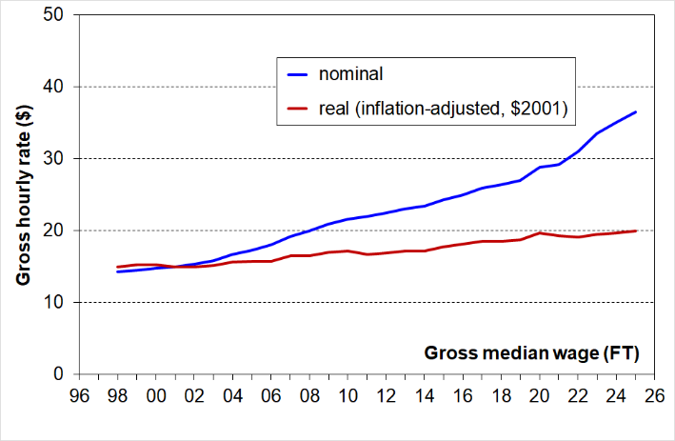
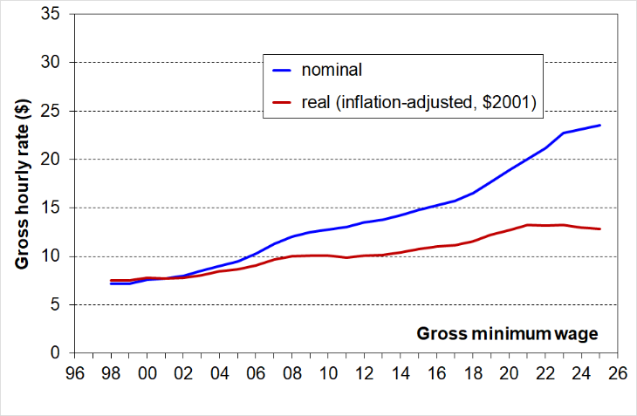
Gross minimum and median hourly wage rates – nominal and real

Increasing proportion of dual-earner two-parent households

Around 70% of all children live in two-parent households. Median household income is strongly impacted by the incomes of these households. Figure G.6 shows the long-run trend to increasing work intensity among two-parent households with dependent children.
- The arrangement of one partner in full-time paid employment and one not in paid employment (‘workless’) was the dominant pattern in the early 1980s. By around 2005, the most common arrangement was for both parents to be employed full-time (~40%), and in 2024 the figure had reached just over one in two (52%).
- The one-FT-one-PT arrangement has declined a little since the early 2000s, down from ~30% to 21% in 2024.
- Where at least one parent is employed full-time, around three of every four two-parent families were dual-earner families in 2024, up from around one in two in the early 1980s.
- This increasing proportion of dual-earner two-parent households is a major factor behind the longer-run consistent rise in material wellbeing for the vast majority of children up to the COVID years (2021 and 2022). Even though the proportion has continued to rise since 2022 other factors have thwarted the previous steady rise in material living standards (such as flat wage rates in real terms, Figure G.5).
- It also points to / is consistent with the view that in general, single-earner households are now much less likely to be a viable option for providing economic security than they were 25-40 years ago.

Figure G.6
Increasing proportion of two-earner two-parent households (with dependent children),
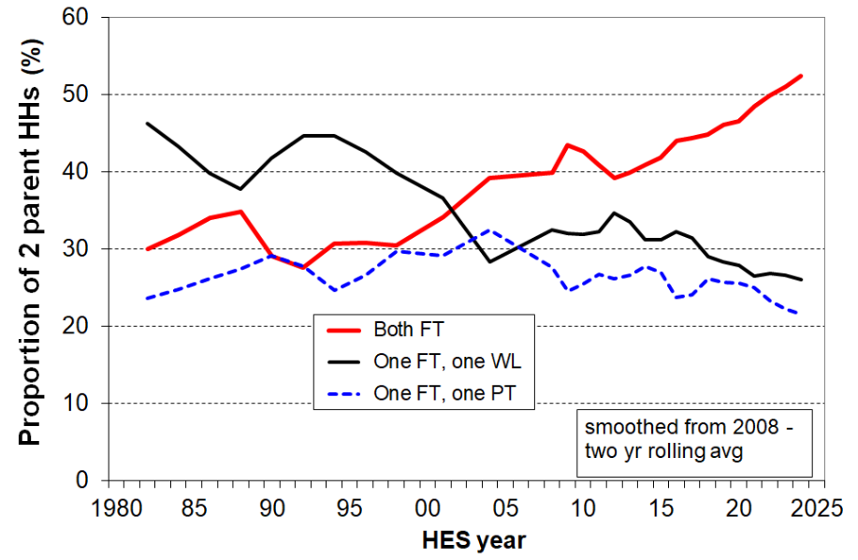
1982 to 2024

Comparisons with Australia

- Australia has seen a similar long-term rise in the proportion of two-parent families with both in paid employment: in 2022, both parents were employed in 71% of couple families with children under 15 years, up from 56% in 2000 and 40% in 1979.
- However, Australia has a lower proportion with both parents working full-time hours (31% in 2021 compared with just under 50% for New Zealand). It is more common for one parent to be full-time and the other part-time (steady at 36% in 2021, compared with 25% in New Zealand and trending down.)

Core income support levels for beneficiary families with children increased in real terms in recent years through to 2024 after a relatively flat period following the introduction of Working for Families in 2004

Figure G.7 shows the long-run trends (1947 to 2024) in inflation-adjusted base support for the most common beneficiary households / families.
The incomes include core benefit income and income from the Family Tax Credit and its predecessors, but do not include the Winter Energy Payment, Best Start and the Accommodation Supplement.
Figure G.7
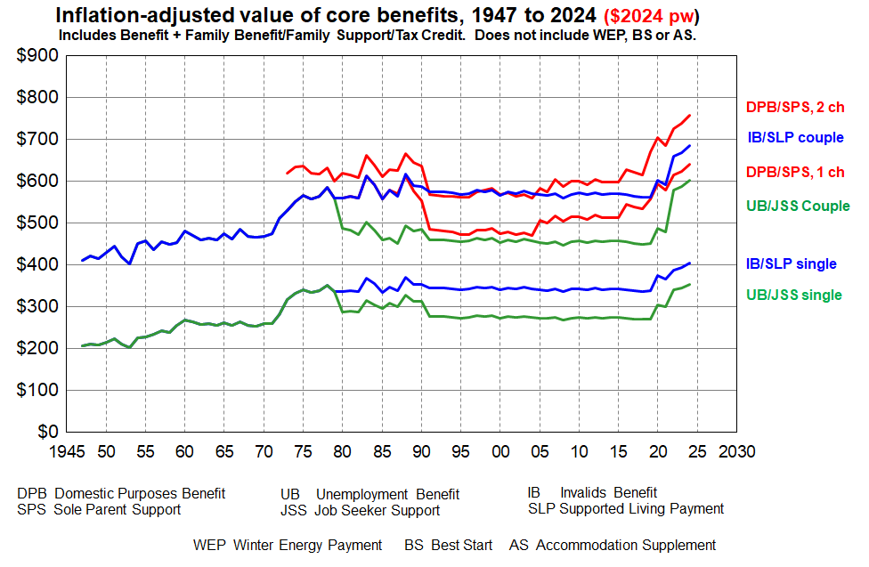
Source: MSD collation from information from the Royal Commission on Social Security, Department of Social Welfare Annual Reports, Income Support Service / Work and Income Fact Sheets and Budget documents.

While Figure G.7 provides valuable information about key aspects of the trends in income of selected beneficiary recipients it does not tell the full story. In particular, it does not take account of either accommodation costs or the housing support provided through the Accommodation Supplement (AS) since 1993 or the Income-Related Rent subsidy (IRRS) for those in public housing (from 2000). The Temporary Additional Support (TAS) assistance can also have a significant impact on the level of housing support for some.
- Net housing costs depend on both the level of housing costs and the entitlement to different housing subsidies. The subsidies are provided at different levels depending on geographical area, household income, and other factors. Given the wide variations in housing costs and subsidy amounts there are considerable challenges for producing a full ‘after housing costs and housing support’ time series using the example families approach as in Figure G.7 above.
- Recent analysis by MSD using actual beneficiary income and housing costs data is now available in the ‘Total Incomes’ report which is available on the MSD website at:
https://www.msd.govt.nz/about-msd-and-our-work/publications-resources/research/benefit-system/total-incomes-annual-report-2024.html.

AHC income trends are also impacted by trends in rent, rates, insurance and mortgage interest and house prices

See Section I for information on this.

Household income trends for children by household type and ethnicity (1982 to 2025)

Figure G.8 shows the trend in ‘real’ CPI-adjusted median incomes after deducting housing costs (AHC) for households with children and for couple-only (<65) households for comparison.
- The steady rise in real incomes through to around 2022 is evident, followed by a flattening of the trend.
- Incomes for two-parent households generally track much the same as the overall population median, other multi-adult family households with children a little lower, and sole-parent households much lower.
- Median AHC incomes for sole-parent households have tracked at around 50-55% of the population median since the 1991 benefit cuts.

Figure G.8
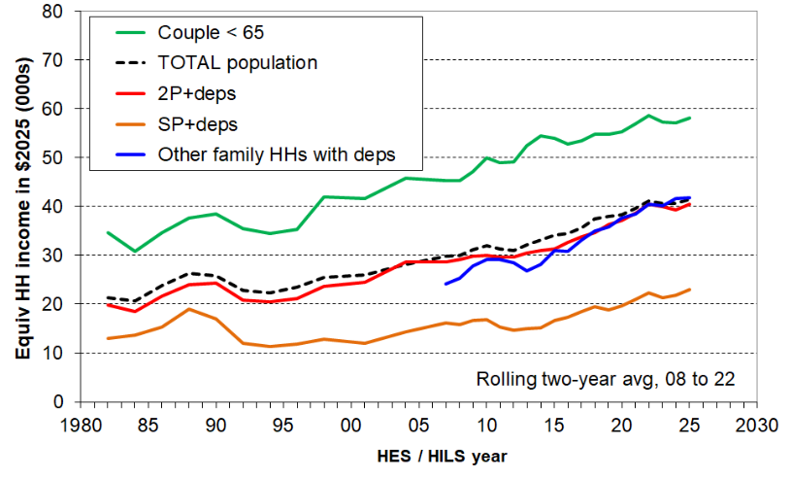
Median incomes (equivalised AHC) of selected household types in $2025, 1982 to 2025

Figure G.9 reports median AHC household income for children by ethnicity in real terms.
- There have been solid net increases in real terms since 2007 for children in each of the main ethnic groups, albeit with different trajectories through and immediately after the GFC (2007 to 2011) and a stalling of the steady increases starting from around 2022.
- For the European, Māori and Asian groupings, the real (CPI-adjusted) increases from 2007 to 2025 were 35% to 40%. The increase for the Pacific grouping was lower at 30%.
- From 2018 to 2025 (the CPRA years), the increases in real AHC median income for the Māori and Pacific groupings have been stronger than for the European and Asian groupings (20-25% compared with around 10%). This is likely to reflect the increased support for low-income families for much of the period (through core benefit increases, the Families Package and solid real minimum wage increases).

Figure G.9
Median AHC household incomes for children, by (total) ethnicity ($2025), HES 2007 to 2025
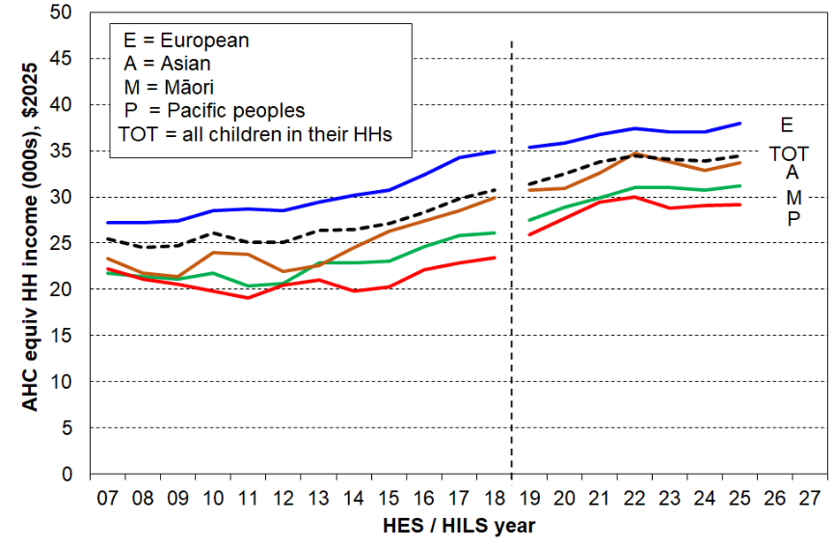
Section H
AHC low-income (poverty) rates for children in their households

This section reports on:
- long-run trends for AHC low-income (poverty) rates for children using the AHC ‘fixed’ or ‘anchored line’ approach
- the similarity of the trends for material hardship rates and the AHC 50 fixed line rates
- long-run trends for AHC relative low-income (poverty) rates
- AHC low-income rates for children in a range of sub-groups (household type, number of children, main source of income (market/government), tenure and so on).

AHC low-income (poverty) rates for children, ‘fixed line’ approach

Figure H.1 shows the AHC low-income (poverty) rates for children from 1981-82 to 2024-25, using the ‘fixed line’ approach. The fixed line approach sets the low-income threshold in a reference year and adjusts it forward and back using the CPI. In other words, the low-income threshold is fixed in real terms. The reported poverty rate falls if the incomes of low-income households increase in real terms irrespective of what is happening to the incomes of the other households … and vice versa. Figure H.1 uses the AHC 50 fixed line measure, with two different reference years, 2007 and 2018.

Figure H.1
Long-run trends in rates of low AHC household income (AHC 50) for children (0-17 yrs),
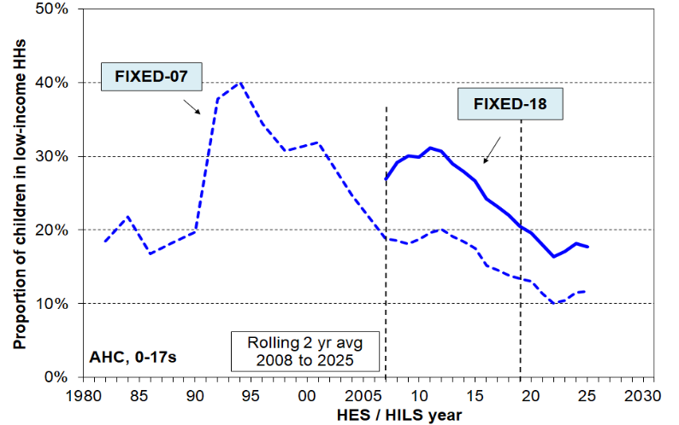
using FIXED line thresholds

- The AHC 50 FIXED-07 low-income rate doubled from 20% to 40% in a very short period in the late 1980s to early 1990s, reflecting rising unemployment, a falling average wage, demographic changes (more sole parent families), the 1991 benefit cuts and the introduction of market rents in public housing.
- The rate then steadily fell through to 2008 with improving employment, a rising average wage, rising female employment, the re-introduction of income-related rents and the roll-out of Working for Families.
- The FIXED-07 trend line reports an AHC 50 rate for children of around 18-20% in 2007 to 2012, much the same as in the 1980s. This is because it took two to three decades for the real (the inflation-adjusted) AHC incomes of low-income households to return to what they were in the 1980s.
- The post-GFC slow-down led to a slight rise on both the FIXED-07 and FIXED-18 measures. through to around 2012, followed by a steady decline through to 2022, reflecting good economic conditions, a rising real minimum wage, and in the three years to 2022 real increases in government support for low-to-middle income households with children through the Families Package (including increases in the Family Tax Credit, the Accommodation Supplement, and the introduction of the Winter Energy Payment), real increases in core benefit rates, and extra support in the COVID years.
- The end of the falling trend and plateauing through to 2025 is consistent with the real income trends noted in Section G (a plateauing or even slight net decline in real AHC incomes from 2022).

Similarity in trends for AHC fixed line and material hardship rates

Figure H.2 shows the similarity in the trends for material hardship and AHC 50 FIXED-18 low-income rates. The similarity is not surprising as:
- both measures are of the ‘fixed reference’ type
- household income levels have a major impact on levels of material hardship, all else equal.

Figure H.2
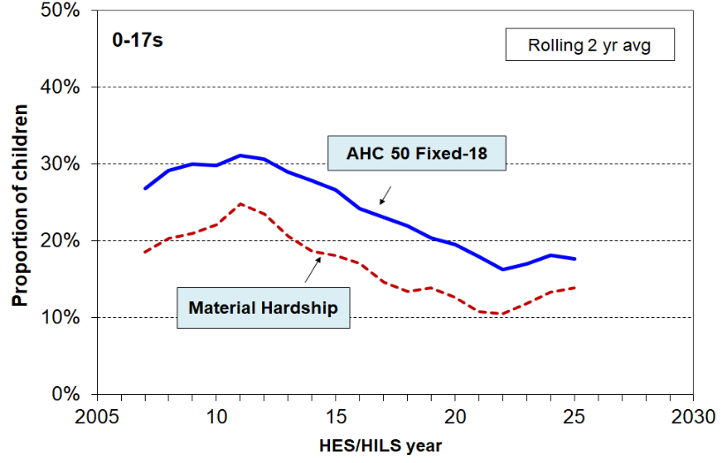
Trends in AHC 50 FIXED-18 rates and MH rates, 2007 to 2025
Notes for chart:
- The CPI is used for adjustments for inflation for the AHC fixed line measure.
- The MWI is used for the MH rates, MWI-24 to 2023-24 for the HES and MWI-26 for HILS 2024-25.
- This report does not usually include the ‘COVID years’ (2020-21 and 2021-22) as part of a continuous time series for MH trends given the wide range of unique impacts on consumption behaviour through lockdowns, subsidies, the final implementation of the Families Package and so on (see Section A). An exception is made for this chart as the purpose is not to report the MH trend per se but to illustrate the relationship between MH rates and those of the fixed-line AHC 50 rates.

To date, there is no reliable model available for forecasting future trends in material hardship rates resulting from policy changes or expected trends in economic or social factors (neither in New Zealand or internationally). The best we can do at present is to use the similarity in trends for AHC 50 FIXED-18 and material hardship as an indirect means to get an indication of the likely future material hardship trend based on the modelled future low-income rates. While the correlation is very good, it can only be used to give an indication of future material hardship trends, not a precise forecast.

Trends for fully relative AHC low-income measures

Figure H.3 shows the trends for the three fully relative AHC measures that are specified in the CPRA. The figures for 2018 to 2025 are the same as those for Stats NZ, except that a two-year rolling average has been applied to more clearly show the trends.

The low-income AHC rates for children were fairly flat for the AHC 40 and AHC 50 measures over the 25 years from the mid-1990s to 2018 on these measures, with a small decrease for rates using the AHC 60 measure. This indicates that low incomes were roughly keeping pace with median incomes, with no noticeable change in income inequality in the lower half of the AHC incomes distribution. In contrast, the large change in income inequality from the late 1980s to the early 1990s saw AHC low-income rates double during this period.

The strongest net fall in low-income (poverty) rates from 2018 was shown for the AHC 40 measure, down from 16% in 2018 to 13% (160,000) in 2025. The fall from 2018 to 2023 reflects: the increases in government support for low-to-middle income households with children through the Families Package (including increases in the Family Tax Credit, the Accommodation Supplement, and the introduction of the Winter Energy Payment), real increases in core benefit rates; extra support in the COVID years: and the small fall in the AHC median during COVID (see Figure G.3). The latter had its own independent impact on the measured relative low-income rates creating a further small decline for this relative low- income measure.

The AHC 50 measure showed an initial smaller fall than for the AHC 40 measure, with no measurable net change from 2018 to 2025 (22%, 255,000).

The trend for the AHC 60 measure was the least impacted by the extra government support and changes in the COVID years, with the rate returning to 30% (355,000) in 2025.

[See Stats NZ’s detailed summaries at https://www.stats.govt.nz/information-releases/child-poverty-statistics-year-ended-june-2025/]

Figure H.3
Long-run trends in rates of low AHC household income for children (0-17 yrs),
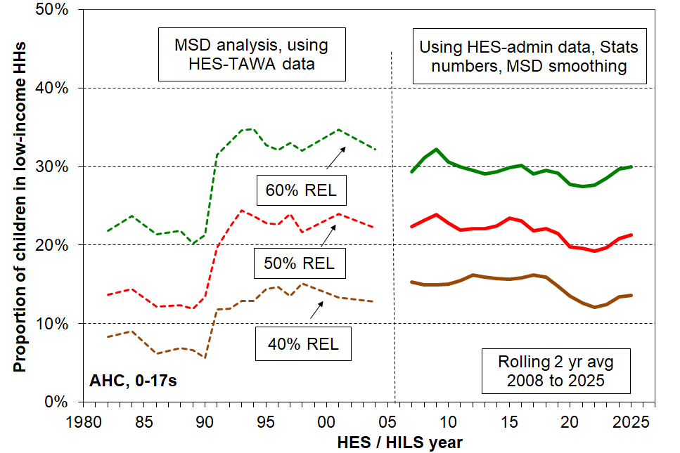
Relative REL (‘moving’) thresholds

Tables H.1 and H.2 use four AHC low-income thresholds to give an indication of the differing depth of low-income experienced by the various sub-groups (left-hand panel). The right-hand panel shows the composition of each sub-group.

Table H.1
Low-income rates and composition for selected population groups (AHC incomes, selected thresholds)
Children (aged 0-17 yrs) HILS 2024-25

HILS 2024-25 | Low-income rates |  |  |  |  | Composition
AHC | what % of this group is in a low-income household, using the different thresholds? |  |  |  |  | what % of all those in low-income households (using a given threshold) are in this group / cell? |  |  |  |  | 000’s | %
Low-income threshold as % of median | ≥70 | <70 | <60 | <50 | <40 | ≥70 | <70 | <60 | <50 | <40 | ALL | ALL
All children (0-17 yrs) | 63 | 37 | 29 | 20 | 11 | 100 | 100 | 100 | 100 | 100 | 1,150 | 100
Household type
2P HH with any dependent children | 70 | 30 | 22 | 16 | 9 | 76 | 55 | 52 | 52 | 53 | 780 | 68
SP HH with any dependent children | 28 | 72 | 61 | 44 | 25 | 8 | 34 | 38 | 39 | 39 | 205 | 18
Other fam HHs with any dep ch | 71 | 29 | 20 | 13 | 6 | 15 | 11 | 9 | 9 | 7 | 155 | 14
Other HHs (some 0-17s, no dep ch) | Cell sizes too small – rates supressed |  |  |  |  | 1 | 1 | 1 | 1 | 1 | 10 | 1
Number of dep children in household
1 | 71 | 29 | 22 | 15 | 10 | 28 | 19 | 18 | 19 | 21 | 280 | 25
2 | 69 | 31 | 23 | 16 | 9 | 48 | 36 | 34 | 35 | 36 | 495 | 43
3 | 53 | 47 | 38 | 27 | 15 | 17 | 24 | 26 | 26 | 25 | 225 | 20
4+ | 37 | 63 | 50 | 34 | 17 | 7 | 20 | 21 | 20 | 18 | 140 | 12
Source of HH income in the 12 months prior to interview
Main source market | 72 | 28 | 20 | 13 | 7 | 97 | 64 | 59 | 55 | 55 | 970 | 84
Main source government | 13 | 87 | 75 | 58 | 33 | 3 | 36 | 41 | 45 | 45 | 180 | 16
Tenure of household
Owned with mortgage (incl FT) | 74 | 26 | 19 | 13 | 8 | 51 | 31 | 29 | 28 | 29 | 500 | 44
Owned no mortgage (incl FT) | 84 | 16 | 10 | 6 | 3 | 18 | 6 | 5 | 4 | 4 | 155 | 13
Private rental | 46 | 54 | 44 | 33 | 19 | 25 | 50 | 52 | 55 | 57 | 390 | 34
Social rental | 29 | 71 | 56 | 34 | 14 | 3 | 12 | 12 | 11 | 8 | 70 | 6
Other | 71 | 29 | 20 | 16 | 10 | 3 | 2 | 2 | 2 | 2 | 30 | 3
Private rental by AS receipt
Private rental (no AS) | 59 | 41 | 32 | 23 | 14 | 16 | 19 | 19 | 19 | 21 | 200 | 17
Private rental (with AS) | 32 | 68 | 57 | 43 | 25 | 8 | 31 | 33 | 36 | 36 | 195 | 17
NZDep Quintile
Q1(least deprived 20%) | 81 | 19 | 14 | 10 | 7 | 24 | 10 | 9 | 10 | 11 | 215 | 19
Q2 | 70 | 30 | 24 | 18 | 10 | 21 | 15 | 15 | 16 | 17 | 210 | 18
Q3 | 62 | 38 | 29 | 22 | 14 | 19 | 20 | 20 | 20 | 23 | 220 | 19
Q4 | 57 | 43 | 33 | 23 | 12 | 19 | 24 | 24 | 24 | 22 | 235 | 21
Q5 (most deprived 20%) | 48 | 52 | 40 | 27 | 14 | 17 | 32 | 32 | 30 | 27 | 265 | 23

Table H.2
Low-income rates and composition for selected population groups (AHC, 5 thresholds),
Children (aged 0-17 years), HILS 2024-25
HILS 2024-25 | Low-income rates |  |  |  |  | Composition
AHC | what % of this group is in a low-income household, using the different thresholds? |  |  |  |  | what % of all those in low-income households (using a given threshold) are in this group / cell? |  |  |  |  | 000’s | %
Low-income threshold as % of median | ≥70 | <70 | <60 | <50 | <40 | ≥70 | <70 | <60 | <50 | <40 | ALL | ALL
All children (0-17 yrs) | 63 | 37 | 29 | 20 | 11 | 100 | 100 | 100 | 100 | 100 | 1,150 | 100
Ethnicity (total)
European | 67 | 33 | 25 | 17 | 10 | 54 | 42 | 41 | 40 | 40 | 730 | 49
NZ Māori | 54 | 46 | 35 | 24 | 13 | 18 | 24 | 24 | 24 | 22 | 300 | 20
Pacific peoples | 49 | 51 | 40 | 28 | 14 | 9 | 15 | 16 | 16 | 13 | 175 | 12
Asian | 63 | 37 | 30 | 23 | 16 | 16 | 15 | 16 | 17 | 21 | 235 | 16
Other | 62 | 38 | 32 | 22 | 15 | 3 | 3 | 3 | 3 | 3 | 40 | 3
Ethnicity (prioritised)
European | 71 | 29 | 22 | 15 | 8 | 48 | 34 | 33 | 31 | 31 | 490 | 43
NZ Māori | 54 | 46 | 35 | 24 | 13 | 23 | 32 | 32 | 31 | 29 | 300 | 26
Pacific peoples | 51 | 49 | 40 | 28 | 13 | 8 | 14 | 14 | 14 | 12 | 120 | 10
Asian | 63 | 37 | 29 | 23 | 15 | 19 | 19 | 19 | 21 | 26 | 220 | 19
Other | 59 | 41 | 35 | 23 | 13 | 1 | 2 | 2 | 2 | 2 | 20 | 2
Reading note for interpreting ‘total ethnicity’ percentages. The total ethnicities approach counts ethnicities, not children. There are around 250,000 more ethnicity responses than there are children, as many report more than one ethnicity.
- The ‘28%’ figure in the Pacific row for the 50% AHC low-income rate means that out of all the ethnicities reported by children in the 50% AHC column, 28% are Pacific (whether only Pacific or Pacific and one or more other ethnicities).
- The ‘16%’ figure in the Pacific row for the 50% AHC composition means that out of all the ethnicities reported by children in the 50% AHC column, 16% are Pacific (whether only Pacific or Pacific and one or more other ethnicities).

Section I
Housing costs and housing affordability for owners & renters (HHs with children)

This Section on housing affordability focuses on those households with children who are already in their own homes or renting. It does not look at affordability from the perspective of those in the market seeking to purchase a property.

High outgoings for housing costs relative to income are often associated with financial stress for low- to middle-income households. Low-income households especially can be left with insufficient income to meet other basic needs such as food, clothing, basic household operations, transport, medical care and education for household members.

There is no internationally agreed measure of housing (un)affordability but the general idea of a ratio of housing costs outgoings to income is widely used. The ratio is called OTI for short (outgoings-to-income ratio).

The Section reports:
- the number and proportions of children by tenure of their household for HES 2024-25
- average housing costs relative to household BHC income, by income quintile, 1988 to 2025, for all households with children (adults under 65 yrs)
- spending on housing costs as a proportion of BHC income for all household with children and for low-income renters receiving the AS, by OTIs greater than 30%, 40% and 50%.

Table I.1 shows where children live in terms of the tenure of their households. The majority (close to 60%) live in owner-occupied dwellings and a third are in private rental accommodation. The bulk of the renters are in private rentals, evenly split between households receiving assistance from the Accommodation Supplement and those who don’t. The proportions reported below are very similar to those published in 2024 using the H

Table I.1
Numbers and proportions (%) of children and households with children by tenure:
HILS 2024-25
 | Owned incl Family Trust | Rent (private) no AS | Rent (private) with AS | Rent (social) | Other | ALL
Households with children (numbers) | 383,000 | 123,000 | 103,000 | 31,000 | 17,000 | 656,000
Children (numbers) | 670,000 | 213,000 | 195,000 | 73,000 | 32,000 | 1,183,000
Households with children (% across) | 58 | 19 | 16 | 5 | 3 | 100
Children (% across) | 57 | 18 | 16 | 6 | 3 | 100

Of the 170,000 children in households reporting material hardship in 2024-25:
- 6,000 are from owned-no-mortgage homes
- 25,000 are from owned-with-mortgage homes
- 21,000 are from private rentals with no AS
- 78,000 are from private rentals with AS
- 36,000 are from social rentals, and another 5000 from ‘other’ categories.

The risk ratios for Private Rent with AS (2.8) and Social Rent (3.4) indicate over-representation of these groups reporting material hardship.
Figure I.1 shows the trends in average housing costs as a proportion of average unequivalised BHC income for income quintiles of households with dependent children (with all adults under 65). Housing costs are:
- up from 15% in 1988 to 22% in HES 2019 and 25% in HILS 2025, for all households with children
- up from 23% in 1988 to 44% in 2025 for the lowest income quintile (Q1); and for Q2, up from 19% in 1988 to 30% for 2019 to 2021 and even higher at 32-33% for 2023 to 2025.

Figure I.1
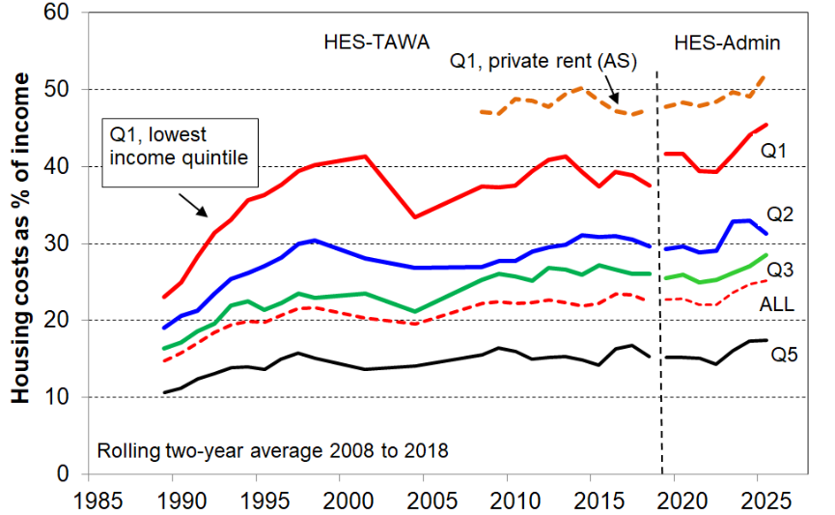
Avg housing costs relative to unequivalised income (%), under 65 households with children, 1988 to 2025
Note for Figure I.1:.
The longer-term trend lines give robust indications of current and past levels of spending on accommodation relative to income, and of the relativities between groups (as reported in the associated text). The year-on-year fluctuations are usually not robust enough to support conclusions about rises or falls in these and similar short periods.

The reported Q1 proportion in Figure I.1 above (averaging 40 to 45% in recent years) is dampened by the presence of households that reside in public / social housing for which the rent is capped at 25% of income. Most of these households are in Q1. For many in low-income households, rent makes up more than 40-45% of income. One such group are those that rent privately and receive the Accommodation Supplement (AS), with around half of household income spent on accommodation on average by those in Q1 (top broken line in chart). This leaves very little for the other necessities and it is not surprising that this group has high material hardship rates (~40%, see Fig F.3). MH rates for children in social housing are high at around 45-50% despite a cap on rentals. This no doubt in part reflects the application of eligibility criteria to enable a focus on those most in need.

Table I.2
Mean housing costs (HC) as a % of unequivalised household income
HHs with children (age 0-17s), households with all under-65 only
 | HES 2023-24 |  | HILS 2024-25
 | mean HCs as % of income | # HHs | mean HCs as % of income | # HHs
Q1 | 44 | 121,000 | 45 | 122,000
Q2 | 33 | 120,000 | 31 | 122,000
Q3 | 27 | 119,000 | 29 | 123,000
Q4 | 24 | 116,000 | 25 | 121,000
Q5 | 17 | 113,000 | 17 | 117,000
All | 25 | 589,000 | 25 | 606,000
Q1/Q2 | 37 | 241,000 | 37 | 244,000
Q1, private rent (AS) | 49 | 40,000 | 52 | 40,000
Q1/Q2, private rent (AS) | 42 | 70,000 | 44 | 70,000
All, private rent (AS) | 34 | 95,000 | 34 | 100,000
Note for Table I.2
- Quintiles are on unequivalised disposable income for households with age 0-17s. Households with children where there is an adult aged 65+ are removed after the quintiles are assigned.
Housing affordability using housing-outgoings-to-income ratios (OTIs)

Figure I.2 looks at housing costs relative to income in a different way. It uses OTIs (housing outgoings-to-income ratios) with thresholds set at 30%, 40% and 50%. It shows that for all households with children, in the latest 2025 survey, around 13% spend more than half their BHC income on housing costs and 24% spend more than 40% of their income on housing. At each threshold, there is an increase from 2019 to 2025.
Figure I.2 = 23 in Slim 24 and I.1 in Purple 22
Spending on accommodation as a proportion of BHC income (%)
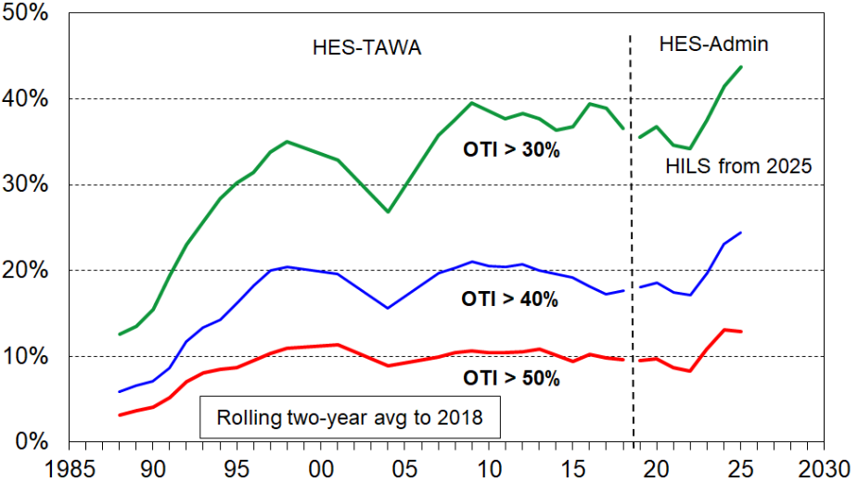
for all households with children, using OTIs, 1988 to 2025
Note for chart.
Data points for 21 and 22 are omitted because of uncertainties about their reliability given COVID induced collection challenges and behavioural changes brought on by lockdowns, etc. The omitted points all lie below the interpolated trend lines.

Figure I.3 repeats the analysis for low-income (Q1+Q2) households with children who own their own homes. The recent significant increase in housing stress is clear, with 21% spending more than 40% of their income on housing costs compared with 13-14% in the years from 2013 to 2022.

Figure I.3
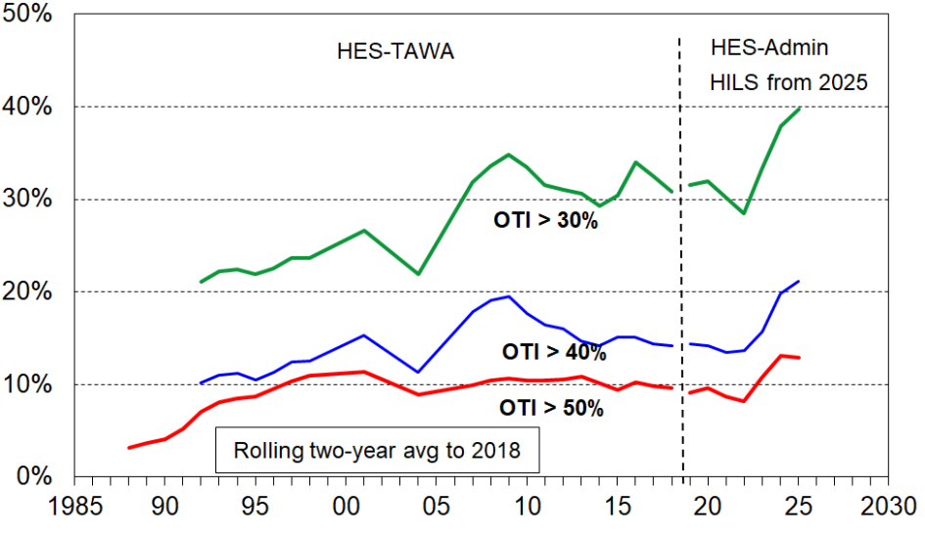
Spending on accommodation as a proportion of BHC income (%) for low-income (Q1+Q2) households with children, privately owned, 2007 to 2025, using OTIs

Figure I.4 repeats the analysis in Figure I.3 for low-income households with children who are renting privately and receiving the Accommodation Supplement (AS).

This breakdown means that the sample sizes supporting the analysis behind each line are relatively small, so the main messages should be drawn from the general levels rather than from the ‘wobbles’. Almost 60% of this group spend more than 40% of their income on housing costs, and around 30% more than half their income. Lower-income households with such high relative accommodation costs have very low residual or after-housing-costs (AHC) incomes for applying to other household budget items.

Figure I.4
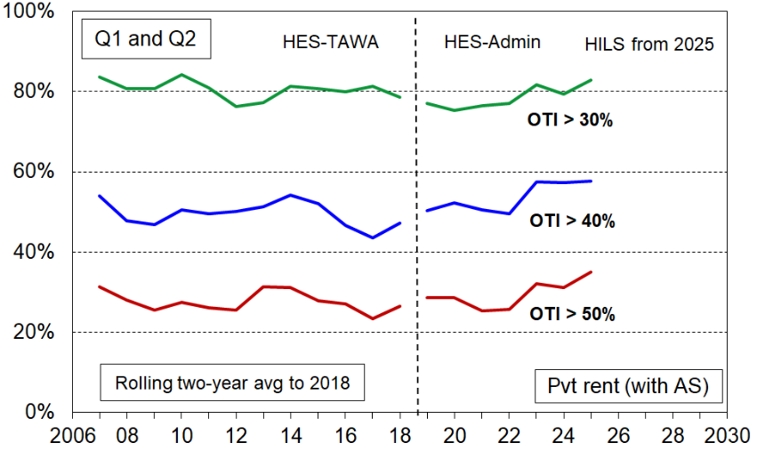
Spending on accommodation as a proportion of BHC income (%) for low-income (Q1+Q2) households with children, renting privately and receiving the AS, 2007 to 2025, using OTIs

References

Alkire, S., Kanagaratnam, U. and Suppa, N. (2019). ‘The Global Multidimensional Poverty Index (MPI) 2019’, OPHI MPI Methodological Note No. 47, Oxford Poverty and Human Development Initiative (OPHI), University of Oxford.
Auckland City Mission (2014a), ‘Speaking for Ourselves: The Truth about what keeps people in poverty from those who live it.’ Summary of findings from the Family 100 project. Auckland City Mission. Auckland-City-Mission-Family100-Speaking-for-Ourselves.pdf (aucklandcitymission.org.nz)
Auckland City Mission (2014b), ‘Demonstrating the complexities of being poor. An empathy tool for the Family 100 project.’ Auckland City Mission. Demonstrating-the-Complexities-of-Being-Poor-An-Empathy-Tool.pdf (aucklandcitymission.org.nz)
Balestra, C. (2018), ‘Asset-based Poverty: Insights from the OECD Wealth Distribution Database’. Social Situation Monitor Research Seminar, Brussels March 2028.
Baxter, J. (2023). ‘Employment patterns and trends for families with children’ (Research Report). Melbourne: Australian Institute of Family Studies. https://aifs.gov.au/research/research-reports/employment-patterns-and-trends-families-children
Brandolini, A. et al (2018). ‘Asset-Based Measurement of Poverty’, Institute for Research on Poverty Discussion Paper # 1372-10.
Council of the European Communities (1975), Council Decision of 22 July 1975 concerning a programme of pilot schemes and studies to combat poverty, 75/458/EEC, OJ L 199, 30.7.1975, Brussels..
Cribb, J., Henry, A., Karjalainen, H., Ray-Chaudhuri, S., Waters, T. and Wernham, T. (2024), ‘Living standards, poverty and inequality in the UK: 2024.’ IFS Report R329. https://ifs.org.uk/sites/default/files/2024-07/Living-standards-poverty-and-inequality-in-the-UK-2024-IFS-Report-R329.pdf
Davidson, P., Naidoo, Y. & Bradbury, B. (2025), ‘Measuring Poverty in Australia—The Role of Income’. Australian Economic Review, 58: S45-S57. https://doi.org/10.1111/1467-8462.70019
Department for Work & Pensions (2023), GOV.UK website, statistical release, Income Dynamics: 2010 to 2021.
Espasa-Reig, J. et al. (2025), ‘Household financial fragility and asset poverty in OECD regions: New indicators and an experimental imputation method’, OECD Regional Development Papers, No. 160, OECD Publishing, Paris, https://doi.org/10.1787/ee9f2f16-en.
European Commission (2004), Joint Report on Social Inclusion, Luxembourg: Office for Official Publications of the European Communities.
Goedemé, T. & Rottiers, S. (2010). ‘Poverty in the Enlarged European Union: A Discussion about Definitions and Reference Groups.’ Herman Deleeck Centre for Social Policy, University of Antwerp.
Goedemé, T. (2020). ‘The steep and winding road to comparable reference budgets in Europe’, in Deeming, C. (ed.), Minimum Income Standards and Reference Budgets, Bristol: The University Press, pp. 255-270.
Graham, S. & Garlick, T. (2022). ‘Incomes and Costs for Example Families in 2022.’ Wellington, New Zealand: Ministry of Social Development. Available at: incomes-and-costs-for-example-families-in-2022.pdf (msd.govt.nz)
Grant, M., Prickett, K. C., Morton, S. M. B., Miller, S., Pillai, A., Paine, S-J. (2023). Now We Are 12: Material Hardship. Snapshot 2. Auckland: Growing Up in New Zealand. Available from: www.growingup.co.nz
Guio, A-C., Marlier,E., Vandenbroucke, F. & Verbunt, P. (2020). ‘Micro- and Macro-Drivers of Child Deprivation in 31 European Countries’. Eurostat Statistical Working Papers 2020 Edition, European Union, Luxembourg., Available at SSRN: https://ssrn.com/abstract=3531002

Guio, A.-C., Gordon, D., Najera, H. & Pomati, M. (2017). ‘Revising the EU material deprivation variables (analysis of the final 2014 EU-SILC data)’, Eurostat Methodologies and Working Papers, Luxembourg: Publications Office of the European Union.
Krassoi Peach, E. and J. Cording (2018), Multiple disadvantage among sole parents in New Zealand. www.thehub.swa.govt.nz/assets/Uploads/Multiple-disadvantagesole-parents-report-FINAL.pdf
Kuypers, S. & Marx, I. (2016). ‘Poverty in the EU using augmented measures of financial resources: The role of assets and debt’. Journal of European Social Policy 2021, Vol. 31(5) 496–516
Lister, R. (2004). Poverty, Cambridge: Polity Press.
Ministry of Social Development (2023). ‘The Families Package: Final Report 2023’. Available at: https://www.msd.govt.nz/documents/about-msd-and-our-work/publications-resources/evaluation/families-package-reports/summaries-of-findings/families-package-final-report.pdf
Nájera, H. & Gordon, D. (2023). ‘A Monte Carlo Study of Some Empirical Methods to Find the Optimal Poverty Line in Multidimensional Poverty Measurement’. Social Indicators Research 167:391-419.
Nolan, B. & Whelan, C. (1996). Resources, Deprivation and Poverty. Oxford: Clarendon Press.
Nolan, B. & Whelan, C. (2011). Poverty and Deprivation in Europe. Oxford: University Press.
Notten, G. & Kaplan, J. (2022). ‘An Empirical Validation Method for Narrowing the Range of Poverty Thresholds’. Social Indicators Research 161: 251-271. https://doi.org/10.1007/s11205-021-02817-1
Notten, G et al (2024). Measuring Poverty with a Material Deprivation Index (MDI): An Updated Index for Canada.
Notten, G., Seer, S., Mendelson, M., Matern, R. & Parkin, A. (2024). Measuring Poverty with a Material Deprivation Index (MDI): An Updated Index for Canada. 10.13140/RG.2.2.23590.95049
OECD (2024). OECD Economic Surveys: New Zealand 2024, OECD Publishing, Paris, https://doi.org/10.1787/603809f2-en
Penne, T., Cussó Parcerisas, I., Mäkinen, L., Storms, B., Goedemé, T. (2016). ‘Can reference budgets be used as a poverty line?’ ImPRovE Working Paper N°16/05. Antwerp: Herman Deleeck Centre for Social Policy – University of Antwerp.
Perry, B. (2019). ‘Background paper on EU-13, DEP-17 and MWI-24 to assist with discussions with StatsNZ on the material hardship measures for the Child Poverty Reduction Act (CPRA)’, Working Paper 01/09, Ministry of Social Development, Wellington.
https://www.msd.govt.nz/about-msd-and-our-work/publications-resources/working-papers/index.html#WorkingPapers20191
Perry, B. (2019). Household Incomes in New Zealand: Trends in Indicators of Inequality and Hardship, 1982 to 2018. Wellington: Ministry of Social Development.
https://www.msd.govt.nz/about-msd-and-our-work/publications-resources/monitoring/household-incomes/index.html

Perry, B. (2021). International Comparisons of Housing Affordability for Renters and Owners. Wellington: Ministry of Social Development.
https://www.msd.govt.nz/about-msd-and-our-work/publications-resources/monitoring/household-incomes/index.html
Perry, B. (2022). Child Poverty in New Zealand. Wellington: Ministry of Social Development.
https://www.msd.govt.nz/about-msd-and-our-work/publications-resources/research/household-incomes-material-wellbeing-poverty-inequality-and-hardship.html
Perry, B. (2024). Child Poverty in New Zealand. Wellington: Ministry of Social Development.
https://www.msd.govt.nz/about-msd-and-our-work/publications-resources/research/household-incomes-material-wellbeing-poverty-inequality-and-hardship.html
Piachaud, D. (1987), ‘Problems in the definition and measurement of poverty’, Journal of Social Policy, 16 (2), 147-164.
Riggs, L. (2023), ‘Multidimensional Disadvantage and Wellbeing’, Working Paper 2023/01, New Zealand Productivity Commission.
Ringen, S. (1988). ‘Direct and indirect measures of poverty’, Journal of Social Policy, 17(3): 351- 365
Smith, C., Peach, E. K., & Cording, J. (2019). ‘The impact of multiple disadvantage on subjective wellbeing: NZ families.’ Ministry of Social Development. https://www.msd.govt.nz/documents/about-msd-and-our-work/publications-resources/research/impact-of-multiple-disadvantage/the-impact-of-multiple-disadvantage-on-subjective-wellbeing.pdf
Statistics New Zealand (2025). ‘Child Poverty Statistics: Year ended June 2024’. Available at:
https://www.stats.govt.nz/information-releases/child-poverty-statistics-year-ended-june-2024/
Stephens, M. (2022), ‘Insights from New Zealand child poverty data’, Treasury Analytical Note 22/04, Wellington. https://www.treasury.govt.nz/sites/default/files/2022-09/an22-04.pdf
Stephens, R. & Waldegrave C (2001), ‘The effectiveness of the transfer and tax system in reducing poverty in 1998’, Social Policy Journal of New Zealand, Issue 16.
Superu (2017), Patterns of multiple disadvantage across New Zealand families, Social Policy Evaluation and Research Unit, Wellington.
Tomlinson, M. & Walker, R. (2009), ‘Coping with Complexity: Child and Adult Poverty.’ London: Child Poverty Action Group.
Vera-Toscano, E & Wilkins, R. (2022). ‘The Dynamics of Income Poverty in Australia: Evidence from the HILDA Survey, 2001 to 2019.’ Melbourne Institute: Applied Economic & Social Research, The University of Melbourne.
Whelan, C., Layte, R. & Maître, B. (2004). ‘Understanding the mismatch between income poverty and deprivation: a dynamic comparative analysis.’ European Sociological Review, 20(4), 287-302
Whelan, C., & Maître, B. (2010). ‘Welfare Regime and Social Class Variation in Poverty and Economic Vulnerability in Europe: An Analysis of EU-SILC’. Journal of European Social Policy, 20(4),316-332.
http://dx.doi.org/10.1177/0958928710374378
Whelan, C. & Maître, B. (2012a). Material deprivation, economic stress and reference groups in Europe: An analysis of EU-SILC 2009 (AIAS Amsterdam, GINI Discussion Paper).
Whelan, C. & Maître, B. (2012b). ‘Understanding material deprivation: A comparative European analysis.’ Research in Social Stratification and Mobility, 30(4), 489-503. https://www.sciencedirect.com/science/article/abs/pii/S0276562412000261?via%3Dihub
Wilkins, R.,Vera-Toscano, E., Botha, F. &. Dahmann, S. (2021). The Household, Income and Labour Dynamics in Australia Survey: Selected Findings from Waves 1 to 19. Melbourne Institute: Applied Economic & Social Research, the University of Melbourne.
Wilson, M. & McLeod, K. (2025). Material hardship of children in households with a disabled person. Wellington: Ministry of Social Development. https://www.msd.govt.nz/about-msd-and-our-work/publications-resources/research/findings/material-hardship-of-children-in-households-with-a-disabled-person.html
Wilson, M., McLeod, K. & Godfrey, J. (2025). ‘Estimating the additional income needed to address higher deprivation levels of children in households with disabled people.’ Policy Quarterly 21 (2), 57-67. https://ojs.victoria.ac.nz/pq/issue/view/1018/109

Appendices

- Further information on the Data Sources for the analysis in this report: Stats NZ’s Household Economic Survey (HES) and Household Living Survey (HILS) and some associated administrative data.
- CPRA official child poverty figures from Stats NZ, 2017-18 to 2024-25.
- Composition of material hardship indices used in this report (EU-13, DEP-17/MH-18 and the MWI-24 and MWI-26), plus the child-specific items for HES 2023-24.
- Trends showing the close similarity of material hardship assessments for children using three indices (DEP-17, EU-13 and MWI)
- Whole population version of Table D.5.
- Sensitivity of findings to choice of 80% rather than 50% as the threshold for ‘main source’ of household income.
- Trend in CPI changes for quarter-on-same-quarter-12-months-before.
- Equivalisation and ‘Where does your household fit in the income spectrum?’
- Low-income thresholds (poverty lines) by household type.
- Decile boundaries and means ($2025) 1982 to 2025.
- –
- –
20 Full text of HES and HILS MWQs (material wellbeing questions):
All
DEP-17 and MH-18
MWI-24 and MWI-26
Child-specific

Appendix 1
Data sources: Stats NZ’s Household Economic Survey (HES) and associated administrative data for income information

This Appendix needs to be read together with Section B.

The surveys gather information on the usually resident population living in private dwellings
The survey therefore includes those living in retirement villages, but not those in non-private dwellings such as rest homes, hotels, motels, boarding houses and hostels. Other sorts of surveys are needed to obtain a picture of what life is like for those in more transient accommodation or those ‘living rough’.

This does not mean that the survey does not reach households with very limited financial resources or those in more severe hardship. For example, in the 2018-19 HES: 724 of the households interviewed reported receiving help from a food bank or other community organisation more than once in the previous 12 months, 1698 households reported putting up with feeling cold ‘a lot’ in the previous 12 months because of needing to spend on other basics, and 25% came from the two most deprived NZDep13 deciles (ie the most deprived 20%). The achieved response rates for the most deprived NZDep13 deciles are similar to the overall response rate – for example, 75% for 2020-21 for deciles 8, 9 and 10.

Processing the collected data ready for analysis

Once the interviews are completed and the collected data is stored, Stats NZ carries out a comprehensive process to prepare a final dataset that can be used for data analysis and the production of output tables and statistics. The processing stage includes:
- combining the survey data with admin-based income data from Inland Revenue and MSD
- checks on the internal consistency of responses from individuals and households
- imputation for missing data.

In addition, weights are developed to enable population estimates to be produced based on the sample. A weight is attached to each unit in the sample that indicates the number of households and people it represents in the final population estimate. Weighting ensures that estimates reflect the sample design, adjust for non-response, and align with current population estimates.

The reporting on child poverty and other similar statistics for the whole population that Stats NZ and MSD do is based on analysis of the final dataset, together with the weights.

Findings based on sample surveys have statistical uncertainties

Some of the uncertainties arise by chance as the information is from a sample rather than the whole population. This is often referred to as ‘sample error’ or ‘sampling error’. Sample/sampling error is not a mistake. It exists even if a survey is perfectly designed and implemented and a 100% response rate is achieved. It is an inevitable feature of using a sample rather than counting everyone in the population of interest.

The larger HES samples that are available starting with 2018-19 reduce sample error considerably compared with the sample errors in the HES-TAWA series. The sample errors for the CPRA child poverty rates are typically 1.0 to 1.2 percentage points (ppts) for HES 2018-19 (21,000 households), compared with 2 to 3 percentage points for the HES-TAWA series which have much smaller sample sizes (3000 to 5500 households). The sample sizes for 2019-20 and 2020-21 were smaller than planned due to the COVID lock-downs and related health protocols – each around 16,000 households This led to sample errors for the income-based CPRA child poverty rates increasing to around 1.3 to 1.5 ppts for these years. For the 2021-22 survey, for which the data collection challenges were considerable and the sample size smaller still, the sample errors were around 1.7 to 2.1 ppts. For the 2024-25 HILS the sample errors were around 1.2 to 1.4 ppts.

Knowing the sample error for a statistic in given years enables estimates of the sample error on the change from one survey to another. If the size of the change is smaller than the calculated sample error on the change then the change is reported as ‘not statistically significant’. For example, for the AHC 40 child poverty measures the increase from 2021-22 to 2022-23 was 1.2 ppt but the sample error on the change was 2.2 ppt so we cannot be sure that the reported change is caused by ‘real world’ changes. For material hardship, both the increase and the sample error on the change were 2.0 ppt, which makes it a close call as to whether the reported change is ‘real’ or simply an artefact of the sampling process.

Sample surveys can also have what are loosely referred to as ‘non-sample errors’ or ‘non-sampling errors’. This is a catchall term that includes any errors that are not sample errors – ie not the inevitable uncertainties associated with interviewing a sample rather than the whole population. Non-sample error can occur in any survey, whether the estimates are derived from a sample or a census. Sources of non-sample error include non-response, errors in respondents’ reporting or interviewers’ recording of answers, poor questionnaire design, individuals in surveyed households not able to be (properly) matched to the administrative data, and errors in data processing.

Sample bias through non-response is one of the most common sources of non-sampling error. Non-response can affect the reliability of results and introduce bias if the people who do not respond systematically differ in some important characteristic from those who do respond. Careful design and application of weights can mitigate the impact of lower response rates from certain subgroups of the population (by adjusting the weights upwards). If the non-response for particular sub-groups is too great then the mitigation through weights will not eliminate the bias and its impact on population estimates.

Addressing issues raised by the presence of households reporting very low incomes

The use of administrative data has in many ways further improved the income information available for HES analysis (for example, by removing measurement error when income from a respondent is misreported through recall issues or deliberately, and by avoiding the need to make assumptions about ‘take-up’ as is required for the modelled estimates of income in HES-TAWA). However, the proportion of very-low-income (VLI) households has increased when compared with previously published income distribution information based on HES-TAWA. Some but not all of these are self-employed households … which is a well-known source of ‘noise’ at the lower end of income distributions. Some of the VLI issue arises because of difficulty in matching households and individuals in the survey to the administrative data. What else is causing the relatively high number of VLI households is not at present fully understood – there are likely to be multiple drivers.

In the 2025-26 HILS Stats NZ have included a question asking for an estimate of gross household income. This will assist with efforts to reduce the number of VLI households.

While the VLI group makes up only a very small proportion of the whole population (typically around 2-4%), when the population of interest is a low-income group they can make up a non-trivial portion of this group in the new HES-Admin data series – as high as 25% in some cases. Most of those in the VLI group also have low material hardship rates, much lower than those in the ‘ordinary’ low-income zone. This adds to the noise already in the lower end of the income distribution when income is being used as a proxy for material wellbeing. It also artificially reduces reported rates for the low-income-material hardship overlap measure. MSD has developed an interim treatment to mitigate the impact of the presence of the VLI households and applies this to selected statistics.

For the headline low-income child poverty rates and numbers, this report uses the Stats NZ published numbers. For some other statistics (such as the overlap measure using both low-incomes and material hardship, and housing affordability trends) the MSD treatment is applied. No treatment is needed for reporting on material hardship rates.

The latest (2024-25) numbers are provisional

The income-related figures reported from the latest available HILS data are provisional (as they were for HES). The provisional nature of the latest figures occurs mainly because the ‘final’ Working for Families data is available from Inland Revenue only after all (or almost all) tax returns are filed which for some tax-payers is several months after publication of the Stats NZ reports. Revisions are also made reflecting updated population estimates.
- For the 19-20 to 21-22 surveys the revised figures were around 0.5 to 1.0 ppt lower.
- For 22-23 HES most revised figures showed a small increase of 0.1-0.2 ppt on the provisional figures, with the BHC50 relative measure an exception decreasing by 0.4 ppt.
- For 23-24 HES, again most revised figures were within 0.2 ppt of the provisional figures with changed figures usually showing an increase, except for the AHC50 fixed line measure which increased by 0.5 ppt. See Appendix 2 for more detail for 23-24.

Labelling of HES and HILS years

When reporting findings from the HES and HILS, ‘2017’ is short-hand for ‘2016-17’, and so on. The ‘2017’ survey ran from July 2016 to June 2017. Some of the items refer to how households were faring in the 12 months prior to the interview.
- This means that the ‘2017’ material wellbeing scores / hardship rates reflect on average how households were faring towards the end of 2016.
- The HES income information is about income in the twelve months prior to the interview. For those interviewed early in the survey (eg July 2016) the income information is for July 2015 to June 2016, for those interviewed in August 2016 the income information is for August 2015 to July 2016, and so on. This means that ‘2017’ income-based figures include information from July 2015 through to June 2017.
- Both the ‘2017’ and 2016-17’ formats are used in the report, depending on the context.

All this matters for the interpretation of trends in relation to assessing the impact of policy changes or major economic events and for assessing the performance of governments in the child poverty space. For example, the impact of a policy change which increased the Family Tax Credit in July 2030 would be only partially reflected in the 2030-31 survey results as only those households interviewed in June 2031 would have (close to) a full year’s impact of the change showing in their reported income. The impact of the change would be fully reflected in the 2031-32 survey, with the findings reported in late 2032 or early 2033.

Appendix 2:
CPRA official child poverty figures from Stats NZ
Table 2.1
Rates (%) and numbers for the nine available CPRA child poverty measures:
Stats NZ figures for 2017-18 to 2024-25
 | Measure | % poor |  |  |  |  |  |  |  | # poor
 | Measure | HES |  |  |  |  |  |  | HILS | HILS
 | Measure | 17-18 | 18-19 | 19-20 | 20-21 | 21-22 | 22-23 | 23-24 | 24-25 | 24-25
P | BHC 50% relative | 16.5 | 13.6 | 13.3 | 12.9 | 11.7 | 12.1 | 12.7 | 12.6 | 148,700
P | AHC 50% anchored line (17/18 ref) | 22.8 | 18.7 | 17.9 | 15.0 | 14.6 | 17.8 | 18.2 | 17.8 | 210,600
P | Material hardship | 13.3 | 13.3 | 11.6 | 11.0 | 10.6 | 12.6 | 13.5 | 14.3 | 169,300
P | Persistent poverty | Not required until after the 2025-26 financial year (likely to be published in Feb 2027)
S | BHC 60% relative | 25.3 | 22.1 | 21.7 | 20.5 | 20.2 | 21.7 | 21.5 | 21.7 | 256,400
S | AHC 60% relative | 30.6 | 27.8 | 27.6 | 27.4 | 27.8 | 29.3 | 30.1 | 29.9 | 354,200
S | AHC 50% relative | 22.8 | 20.1 | 19.5 | 19.6 | 18.8 | 20.5 | 21.1 | 21.5 | 254,500
S | AHC 40% relative | 15.7 | 13.9 | 13.1 | 12.2 | 11.9 | 13.0 | 13.8 | 13.4 | 158,100
S | Severe material hardship | 5.8 | 5.8 | 4.6 | 4.9 | 4.0 | 5.6 | 5.5 | 6.0 | 71,000
S | Both material hardship and low-income (less than 60% AHC) | 8.8 | 7.8 | 6.9 | 6.5 | 5.8 | 6.8 | 7.8 | 8.6 | 101,600
Source: Child poverty statistics: Year ended June 2025 – summary table
Notes for Table:
- P = primary measure (required by the CPRA to have targets).
S = supplementary measure (no targets required, but can have if desired).
- BHC is short for ‘household income before deducting housing costs’ and AHC means ‘household income after deducting housing costs’.
- ‘AHC 40% relative’ is short for ‘40% of the median AHC income’, and so on.
- Material hardship and severe material hardship for the HES years are measured using the DEP-17 index with thresholds of 6+ and 9+ respectively. For HILS 24-25 the MH-18 index is used with thresholds of 7+ and 10+.
- The 2024-25 figures are italicised as they are provisional. The figures for the latest survey are always provisional for the February publications as final IRD returns are still to come for some who receive WFF tax credits. In addition, by the time of the next publication there will have been a population rebase. The provisional and revised figures for 2023-24 are shown in Table 2.2.
See the Child Poverty Technical Appendix for more information:
https://www.stats.govt.nz/methods/child-poverty-statistics-year-ended-june-2025-technical-appendix/

Table 2.2
Provisional and final rates (%) for the nine available CPRA child poverty measures for 2023-24
 |  | % ‘poor’
 | Measure | 23-24 provisional | 23-24  final
P | BHC 50% relative | 12.7 | 12.7
P | AHC 50% anchored line (17/18 ref) | 17.7 | 18.2
P | Material hardship | 13.4 | 13.5
S | BHC 60% relative | 21.6 | 21.5
S | AHC 60% relative | 29.9 | 30.1
S | AHC 50% relative | 21.1 | 21.1
S | AHC 40% relative | 13.6 | 13.8
S | Severe material hardship | 5.4 | 5.5
S | Both material hardship and low-income (less than 60% AHC) | 7.7 | 7.8

Figure 2.3
% of children in households in Material Hardship (DEP-17, 6+ / MH-18, 7+):
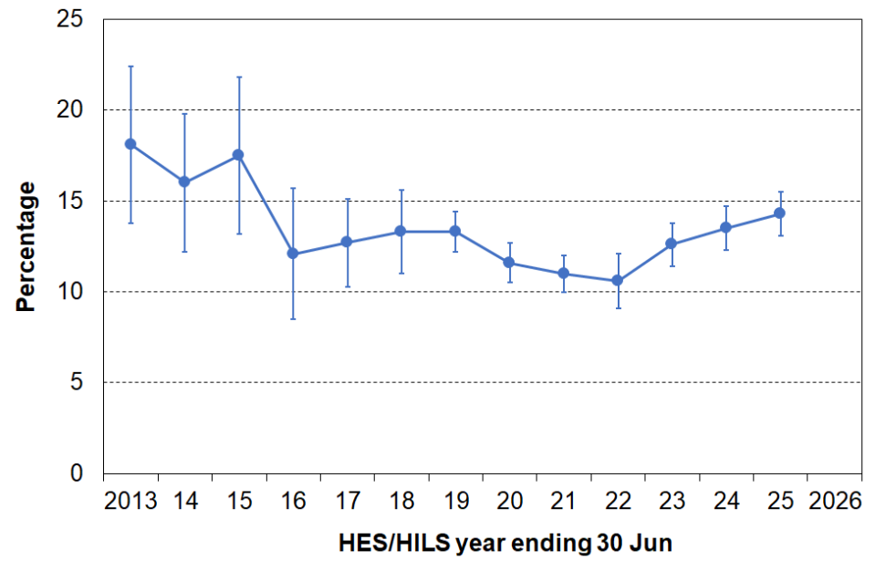
Stats NZ figures for 2012-13 to 2024-25, with error bars
Source: Stats NZ, Table 3.01:
https://www.stats.govt.nz/information-releases/child-poverty-statistics-year-ended-june-2025/

Appendix 3
Composition of indices (DEP-17, MH-18, EU-13, MWI-24 and MWI-26) and list of child specific items

See Appendix 20 for the full text for each item.

Table 3.1
Composition of DEP-17 and MH-18
DEP-17 |  | MH-18
Enforced lack of essentials (for respondent or household as a whole)
 | meal with meat, fish or chicken (or vegetarian equivalent) at least each 2nd day | meal with meat, seafood, eggs, or plant-based protein at least each 2nd day
 | two pairs of shoes in good condition and suitable for everyday use | two pairs of shoes in good condition and suitable for everyday use
 | suitable clothes for important or special occasions | suitable clothes for important or special occasions
 | presents for family and friends on special occasions | presents for family and friends on special occasions
 | home contents insurance | home contents insurance
 |  | a good bed to sleep in
 |  | access to both a computer and internet connection at home
Economised, cut back or delayed purchases ‘a lot’ because money was needed for other essentials (not just to be thrifty or to save for a trip or other non-essential)
 | went without fresh fruit and vegetables | went without or cut back on fresh fruit and vegetables
 | bought cheaper cuts of meat or bought less than wanted | bought cheaper cuts of meat or bought less than wanted
 | put up with feeling cold to save on heating costs | put up with feeling cold to save on heating costs
 | postponed or put off visits to the doctor | put off visits to the doctor
 | postponed or put off visits to the dentist | put off visits to the dentist
 | did without or cut back on trips to the shops or other local places | -
 | delayed repairing or replacing broken or damaged appliances | put off repairing or replacing broken or damaged appliances
In arrears more than once in last 12 months (because of shortage of cash at the time, not through forgetting)
 | rates, electricity, water | rates, electricity, water
 | vehicle registration, insurance or warrant of fitness | vehicle registration, insurance or warrant of fitness
Financial stress and vulnerability
 | borrowed money from family or friends more than once in the last 12 months to cover everyday living costs | borrowed money from family or friends more than once in the last 12 months to cover everyday living costs
 | feel ‘very limited’ by the money available when thinking about purchase of clothes or shoes for self (options were: not at all, a little, quite limited, and very limited) | feel ‘very limited’ by the money available when thinking about purchase of clothes or shoes for self (options were: not at all, a little, quite limited, and very limited)
 | could not pay an unexpected and unavoidable bill of $500 within a month without borrowing | could not pay an unexpected and unavoidable bill of $500 within a month without borrowing
Note: an enforced lack is an item that is wanted but not possessed because of the cost.

Table 3.2
Composition of EU-13
Seven household deprivations (enforced lacks)
ability to face unexpected expenses of NZD1500
have one week’s annual holiday away from home
avoid arrears in mortgage or rent, utility bills or HP instalments
have a meal with meat, fish or chicken every second day
keep the home adequately warm
have access to a car / van for personal use
replace worn-out furniture
Six personal deprivations (enforced lacks)
replace worn-out clothes by some new ones
have two pairs of properly fitting shoes
spend a small amount of money each week on oneself
have regular leisure activities
have a get together with friends/family for a drink/meal at least monthly
have both a computer and an internet connection

Table 3.3
The composition and scoring for the HES-based MWI-24 and the HILS-based MWI-26
Item description |  | MWI-24 | MWI-26
Ownership or participation (have/do, don’t have/do and enforced lack (EL))
For both, score an EL as a 0, otherwise 1
1 | Two pairs of shoes in a good condition and suitable for daily activities
2 | Suitable clothes for important or special occasions
3 | Contents insurance
4 | A protein meal at least each 2nd day
5 | A good bed
6 | Presents for family/friends on special occasions
7 | Usually replace worn-out clothes with new (not second-hand) ones
8 | Holiday away from home at least once every year
9 | Overseas holiday at least once every three years
** | Can afford to keep accommodation adequately warm | -
** | Have access to car or van for personal use | -
** | Have access to both a computer and internet connection at home | -
Economising (not at all, a little, a lot) – to keep down costs to help in paying for (other) basic items (not just to be thrifty or to save for a trip or other non-essential)
For both, score ‘not at all as 2, ‘a little’ as 1, and ‘a lot’ as 0
10 | Gone without on fresh fruit and vegetables (MWI-24)  Gone without or cut back on fresh fruit and vegetables (MWI-26)
11 | Buy cheaper cuts of meat or bought less meat than you would like
12 | Put up with feeling cold
13 | Do without or cut back on trips to the shops or other local places
14 | Delay replacing or repairing broken or damaged appliances
15 | Spent less on hobbies or other special interests than you would like
16 | Postponed visits to the doctor
17 | Postponed visits to the dentist
Housing problems (no problem, minor problem, major problem … in the last 12 months)
For both, score as 2, 1 and 0 respectively
18 | Dampness or mould
19 | Heating or keeping it warm in winter (not collected in HILS) |  | -
Freedoms/Restrictions
20 | When buying, or thinking about buying, clothes or shoes for yourself, how much do you usually feel limited by the money available? (4 point response options: ‘not at all limited, a little limited, quite limited, very limited)  For both, score as 3, 2, 1 and 0 respectively
21 | $400 spot purchase for an ’extra’, not a necessity ($300 in HES/MWI-24) – how limited do you feel about buying it? (5 point response options: not at all limited, a little limited, quite limited, very limited, couldn’t buy it)  For MWI-24, score as 4, 3, 2, 1 and 0 respectively. MWI-26, score as 3, 2, 1, 0 and 0
22 | $500 unexpected unavoidable expense on an essential – can you pay in a month without borrowing? (yes/no)  For both, score ‘yes’ as 2 and ‘no’ as 0
Financial strain (in last 12 months) (not at all, once, more than once)
For both, score ‘not at all’ as 2, ‘once’ as 1, ‘more than once’ as 0
23 | Behind on rates or utilities
24 | Behind on car registration, wof or insurance

Table 3.4
The 20 child-specific items in the HES from 2018-19 to 2023-24
Have/do, don’t have/do for each of your children (Respondents are asked whether any have/do lacks are because of cost or for some other reason.)
two pairs of shoes in a good condition that are suitable for daily activities
two sets of warm winter clothes
waterproof coat
all the uniform required by their schools
a separate bed
fresh fruit and vegetables daily
a meal with meat, fish or chicken (or vegetarian equivalent) each day
a range of books at home suitable for their ages
a suitable place at home to do school homework
their friends around to play and eat from time to time
their friends around for a birthday party
good access at home to a computer and the internet for homework
a mobile phone if aged 11 or older
Economising (not at all, a little, a lot) – to keep down costs to help in paying for (other) basic items (not just to be thrifty or to save for a trip or other non-essential). In this report, economising ‘a lot’ is taken as equivalent to an enforced lack.
postponed a child's visit to the doctor
postponed a child's visit to the dentist
did not pick up a child's prescription
been unable to pay for a child to go on a school trip or other school event
had to limit children’s involvement in sport
had your children go without music, dance, kapa haka, art, swimming or other special interest lessons
had your children continue wearing shoes or clothes that were worn out or the wrong size
Notes for Table:
- None of these items are included in DEP-17 or EU-13 which are general purpose indices that are designed to apply to all ages and household types and so on.
- See Appendix 20 (Table 20.6) for the HILS changes to the child-specific items.

Appendix 4
Trends showing the close similarity of material hardship assessments for children using three indices (DEP-17, EU-13 and MWI)

Figure 4.1
Comparison of trends in MH rates using MWI-24, MWI-26, DEP-17, MH-18 and EU-13, 2013 to 2025:
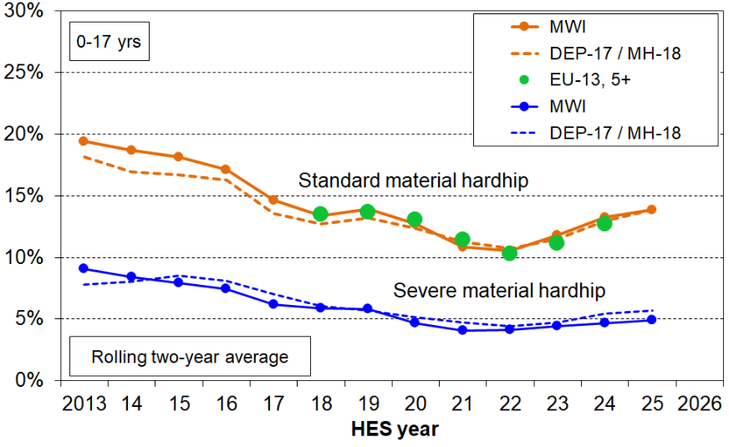
Children (0-17 yrs)

Appendix 5
Whole population version of Table D.5

Table 5.1
Reported DEP-17 deprivations (%) for all in selected population group and those in MH and severe MH:
Whole population, HES 2017-18 to 2023-24
 |  | Deprivation rate for item for whole population, and for those in HHs in hardship or severe hardship (%)
 |  | All |  |  |  |  | 6+/17 |  |  |  |  | 9+/17
Enforced lacks |  | 17-18 | 18-19 | 19-20 | 22-23 | 23-24 | 17-18 | 18-19 | 19-20 | 22-23 | 23-24 | 17-18 | 18-19 | 19-20 | 22-23 | 23-24
 | meat meal | 1 | 2 | 1 | 2 | 2 | 14 | 13 | 11 | 12 | 14 | 27 | 20 | 18 | 24 | 22
 | shoes | 2 | 2 | 2 | 2 | 2 | 23 | 20 | 18 | 19 | 20 | 39 | 37 | 32 | 30 | 31
 | suitable clothes | 3 | 4 | 3 | 3 | 3 | 30 | 29 | 25 | 27 | 25 | 51 | 45 | 44 | 40 | 38
 | presents | 4 | 5 | 4 | 5 | 5 | 31 | 34 | 30 | 31 | 29 | 41 | 44 | 45 | 47 | 42
 | contents ins | 13 | 15 | 14 | 14 | 16 | 65 | 61 | 65 | 63 | 66 | 71 | 76 | 79 | 77 | 76
Economised ‘a lot’
 | fruit & veg | 4 | 4 | 3 | 6 | 7 | 35 | 31 | 31 | 41 | 44 | 64 | 50 | 50 | 61 | 67
 | meat | 11 | 13 | 12 | 16 | 16 | 70 | 67 | 68 | 75 | 73 | 85 | 84 | 85 | 86 | 86
 | heating | 7 | 8 | 7 | 6 | 6 | 47 | 46 | 43 | 37 | 36 | 68 | 61 | 60 | 54 | 53
 | doctor | 6 | 8 | 7 | 8 | 8 | 50 | 52 | 51 | 50 | 44 | 70 | 67 | 66 | 63 | 58
 | dentist | 21 | 25 | 23 | 23 | 26 | 80 | 83 | 81 | 81 | 82 | 88 | 91 | 87 | 88 | 91
 | local trips | 10 | 11 | 10 | 12 | 13 | 70 | 65 | 66 | 70 | 68 | 86 | 81 | 82 | 86 | 85
 | appliances | 8 | 9 | 8 | 8 | 9 | 55 | 56 | 58 | 57 | 60 | 75 | 73 | 74 | 75 | 73
Arrears
 | utilities | 5 | 6 | 6 | 6 | 7 | 41 | 42 | 41 | 44 | 44 | 60 | 59 | 55 | 59 | 60
 | vehicle exp | 5 | 6 | 5 | 5 | 6 | 41 | 40 | 41 | 42 | 43 | 51 | 55 | 58 | 59 | 60
Financial stress
 | borrowed | 7 | 9 | 8 | 8 | 8 | 51 | 52 | 53 | 50 | 50 | 64 | 68 | 67 | 66 | 64
 | ‘very limited’ | 12 | 13 | 11 | 13 | 14 | 78 | 71 | 70 | 71 | 73 | 92 | 85 | 85 | 80 | 84
 | $500 bill | 21 | 21 | 20 | 17 | 17 | 87 | 83 | 85 | 76 | 74 | 94 | 92 | 94 | 84 | 86

Enforced lack of essentials (for respondent or household as a whole)
 | meat meal | R | meal with meat, fish or chicken (or vegetarian equivalent) at least each 2nd day
 | shoes | R | two pairs of shoes in good repair and suitable for everyday use
 | suitable clothes | R | suitable clothes for important or special occasions
 | presents | R | presents for family and friends on special occasions
 | contents ins | H | home contents insurance
Economised, cut back or delayed purchases ‘a lot’ (because money was needed for other essentials, not just to be thrifty or to save for a trip or other non-essential)
 | fruit & veg | H | went without fresh fruit and vegetables
 | meat | H | bought cheaper cuts of meat or bought less than wanted
 | heating | R/H | put up with feeling cold to save on heating costs
 | doctor | R | postponed visits to the doctor
 | dentist | R | postponed visits to the dentist
 | local trips | R/H | did without or cut back on trips to the shops or other local places
 | appliances | H | delayed repairing or replacing broken or damaged appliances
In arrears more than once in last 12 months (because of shortage of cash at the time, not through forgetting)
 | utilities | H | rates, electricity, water
 | vehicle exp | H | vehicle registration, insurance or warrant of fitness
Financial stress and vulnerability
 | borrowed | H | borrowed from family or friends ‘more than once’ in the last 12 months to cover everyday living costs
 | ‘very limited’ | R | feel ‘very limited’ by the money available when thinking about purchase of clothes or shoes for self (options were: not at all, a little, quite limited, and very limited)
 | $500 bill | H | could not pay an unexpected and unavoidable bill of $500 within a month without borrowing
Reading note for tables:
The reported figures are based on the information provided by the household’s respondent. For example, in the fresh fruit and vegetables row for ‘ALL’ in 17-18, 4% of the population were in households where the respondent said they (or their partner) went without or cut back ‘a lot’ (rather than ‘a little’ or ‘not at all’). In the lower table, the second from left column indicates whether the item is respondent-focussed (R) or household-focussed (H). Though for most items the R/H distinction is clear, a few could be either. This uncertainty has been addressed in the 2024-25 Household Incomes and Living Survey (HILS).
Appendix 6
Analysis by main source of income using an 80% threshold compared with using a 50% threshold

For some analysis households are divided into two groups according to the main source of household income, market or government. Market income is income from salaries and wages, self-employment and investment. Government income is income from social welfare benefits, NZS/VP, AS, WFF tax credits, student bursaries, and so on. The standard approach in this report is to simply compare the dollar value of the two sources and allocate according to where the most income is from, market or government. This is in effect setting the threshold at 50% of total income from all sources (after paying income tax and ACC earner levies). Table 6.1 sets the threshold higher at 80%+ to assess how sensitive the findings are to using ‘tighter’ definitions:
- For ‘main source market’, when using the 80% threshold and compared with using the 50% threshold:
- The material hardship rate drops a little from 8% to 5%;
- Children are a little more likely to come from two parent rather than sole parent households, and from owned rather than rented accommodation (with AS);
- Household incomes are a little higher for both BHC and AHC.
- For ‘main source government’, the changes are the mirror image, except in the tenure comparison the proportion of owners is unchanged (18%).

The overall conclusion is that using 80% rather than 50% has no reportable impact on the findings about the differences between the two groups.

Table 6.1
Comparing selected characteristics for children in their households using three thresholds for source of income (government / market)
HILS 2024-25 |  | Age 0-17s
 |  | All  0-17s | govt source (tightest to loosest) |  |  | mkt source (loosest to tightest)
 |  | All  0-17s | 80%+ govt source income HHs | 50%+ govt source income HHs | 20%+ govt source income HHs | 20%+ market source income HHs | 50%+ market source income HHs | 80%+ market source income HHs
Individuals 0-17 (000s) |  | 1,183,000 | 84,000 | 186,000 | 331,000 | 1,096,000 | 996,000 | 849,000
Households with 0-17s (000s) |  | 656,000 | 43,000 | 89,000 | 162,000 | 611,000 | 567,000 | 493,000
% of all 0-17s |  | 100 | 7 | 16 | 28 | 93 | 84 | 72
Material hardship rate (7+/18 for MH-18) |  | 14 | 49 | 47 | 38 | 12 | 8 | 5
Severe MH rate (10+/18 for MH-18) |  | 6 | 26 | 25 | 17 | 4 | 2 | 2
Household type
SP HH with any deps | % | 18 | 59 | 57 | 41 | 15 | 11 | 9
2P HH with any deps | % | 68 | 22 | 24 | 35 | 72 | 76 | 81
Other fam HHs with any deps | % | 13 | 17 | 18 | 23 | 13 | 13 | 10
Other | % | 1 | 2 | 1 | 1 | 1 | 1 | 1
TOTAL | % | 100 | 100 | 100 | 100 | 100 | 100 | 100
Tenure
Owned (any) | % | 57 | 18 | 18 | 26 | 60 | 64 | 69
Rent private - no AS | % | 18 | 2 | 4 | 6 | 19 | 21 | 22
Rent private - AS | % | 17 | 53 | 49 | 45 | 14 | 10 | 5
Rent - Social | % | 6 | 25 | 27 | 20 | 5 | 2 | 1
Other | % | 3 | 3 | 2 | 3 | 3 | 3 | 3
TOTAL | % | 100 | 100 | 100 | 100 | 100 | 100 | 100
Incomes and housing costs
AHC income (equivalised) | Mean | 42,500 | 17,800 | 19,900 | 24,300 | 44,500 | 46,700 | 49,700
BHC income (equivalised) | Mean | 56,900 | 28,600 | 30,400 | 34,900 | 59,200 | 61,800 | 65,600
Housing costs (unequivalised) | Mean | 32,600 | 22,000 | 22,700 | 23,800 | 33,400 | 34,500 | 36,000
Appendix 7
CPI inflation

Figure 7.1 shows the annual % change in the CPI from the same quarter in the previous year, for each quarter up to December 2025. The latest income data used in the report is from June 2025 – the CPI information in the chart goes beyond that end point.

Figure 7.1
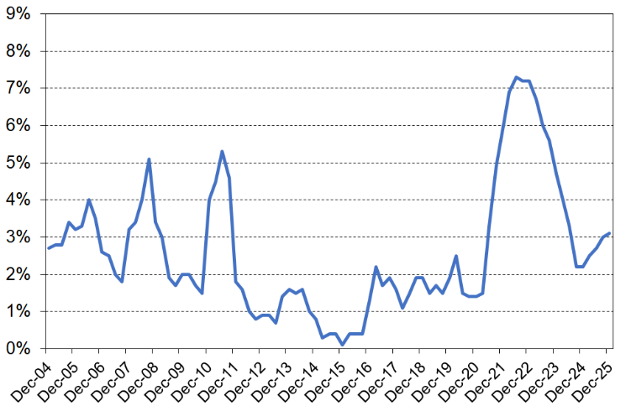
Annual % change in CPI (All Groups) from the same quarter in the previous year, 2004 to 2025
Source: Stats NZ CPIQ-SE9A

Even when overall CPI inflation falls to a lower 3-4% pa rate, inflation for core essentials such as food and energy can still remain high or be rising quickly in the short-term (see Figure 7.2). This means that trends in real CPI-adjusted incomes can under-estimate the short-run impact of inflation on lower-income households compared with middle-to-higher-income households as the former spend a higher proportion of their income on essentials.
Figure 7.2
Annual % change in CPI from the same quarter in the previous year, 2018 to 2025
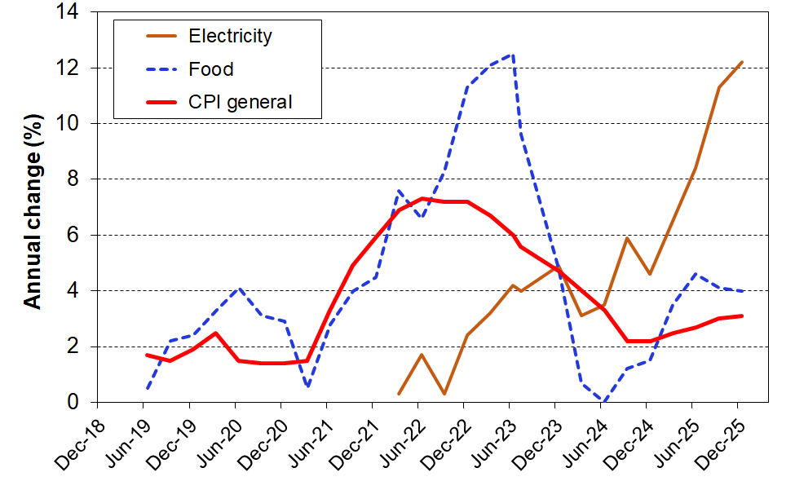
All Groups, food and electricity

There are many households that are ‘just getting by’ (low financial resilience) … and who do not appear in the material hardship or in the low-income groups we normally report on. It only takes a modest unexpected / unplanned-for expense or rapid increase in costs for basics to put such households into a ‘not making ends meet’ group. This can happen for both ‘working’ and ‘beneficiary’ households.

Appendix 8
Equivalised disposable household income

Most of the income analysis in this report uses ‘equivalised disposable household income’.

Disposable household income is the total from all household members from all sources less income tax. ‘Disposable’ does not mean ‘discretionary’ in this report.

Equivalisation reflects the two common sense notions that:
- a larger household needs more income than a smaller household for the two households to have similar standards of living (all else being equal)
- there are economies of scale as household size increases.

Most sets of equivalence ratios also assume that children cost less than adults. This assumption is contestable, as to a large extent it requires setting aside any consideration of opportunity costs for the adult who provides child-care for the children.

Equivalising is a means of standardising household incomes in terms of household size and composition so that the relative material well-being of households of different sizes and compositions can be analysed. The adjustment also makes comparisons over time more realistic because it takes into account the changes over time in the composition and average size of households.

While considerable research has been undertaken to try to estimate appropriate values for equivalence scales, no universally accepted ‘correct’ set of equivalence ratios has emerged, even when household size and composition are the only factors being considered.

Ideally, equivalence scales would also take into account other factors such as the age of children, employment-related costs, the extra costs of disability, the differing costs faced by people in different geographical locations, the different ratios needed for households of the same type but with different incomes, and so on. Such considerations further complicate an already fraught estimation process and the common practice is to settle for simpler scales as a rough-and-ready but better-than-nothing approximation.

This report uses what has come to be known as the ‘modified OECD scale’. It is used by Eurostat, the Australian Bureau of Statistics, Stats NZ and many others:
- this scale uses a weight of 1.0 for the first adult, 0.5 for other household members aged 14+, and 0.3 for those aged 0-13 years
- a (2,3) household comprising 2 adults and 3 children with one aged 17 and 2 aged under 14 is allocated a weighting or scale value of 2.6 (1.0+0.5+0.5+0.3+0.3).

The tables that follow give information on the conversion of unequivalised (‘ordinary’) dollars to equivalised dollars across low to middle equivalised income deciles (Tables 8.1 and 8.2).

Table 8.1 provides look-up charts to convert equivalised dollars (dollars per equivalent adult) to ordinary dollars and vice versa for selected households. As the same equivalence scale is used for BHC and AHC incomes in this report, the one chart covers both BHC and AHC conversions.

The first row of figures identifies the family or household type: (1,2) is a one adult, two child household, and so on. The second row gives the values of the equivalence ratios used. The body of the tables indicates, for example, that a (2,2) household needs around $52,500 to have the same purchasing power as a (1,1) household with an income of around $32,500. Each has an equivalised income of $25,000 (or, to put it another way, each household has an income of $25,000 per equivalent adult).

Table 8.1
Conversion of equivalised dollars to ordinary dollars (BHC and AHC)
Equiv income | Income for families and households of various types  in ‘ordinary dollars’
 | (1,0) | (1,1) | (1,2) | (1,3) | (2,0) | (2,1) | (2,2) | (2,3) | (2,4) | (3,0)
 | 1.00 | 1.30 | 1.60 | 1.90 | 1.50 | 1.80 | 2.10 | 2.40 | 2.70 | 2.00
$10,000 | 10,000 | 13,000 | 16,000 | 19,000 | 15,000 | 18,000 | 21,000 | 24,000 | 27,000 | 20,000
$11,000 | 11,000 | 14,300 | 17,600 | 20,900 | 16,500 | 19,800 | 23,100 | 26,400 | 29,700 | 22,000
$12,000 | 12,000 | 15,600 | 19,200 | 22,800 | 18,000 | 21,600 | 25,200 | 28,800 | 32,400 | 24,000
$13,000 | 13,000 | 16,900 | 20,800 | 24,700 | 19,500 | 23,400 | 27,300 | 31,200 | 35,100 | 26,000
$14,000 | 14,000 | 18,200 | 22,400 | 26,600 | 21,000 | 25,200 | 29,400 | 33,600 | 37,800 | 28,000
$15,000 | 15,000 | 19,500 | 24,000 | 28,500 | 22,500 | 27,000 | 31,500 | 36,000 | 40,500 | 30,000
$20,000 | 20,000 | 26,000 | 32,000 | 38,000 | 30,000 | 36,000 | 42,000 | 48,000 | 54,000 | 40,000
$25,000 | 25,000 | 32,500 | 40,000 | 47,500 | 37,500 | 45,000 | 52,500 | 60,000 | 67,500 | 50,000
$30,000 | 30,000 | 39,000 | 48,000 | 57,000 | 45,000 | 54,000 | 63,000 | 72,000 | 81,000 | 60,000
$35,000 | 35,000 | 45,500 | 56,000 | 66,500 | 52,500 | 63,000 | 73,500 | 84,000 | 94,500 | 70,000
$40,000 | 40,000 | 52,000 | 64,000 | 76,000 | 60,000 | 72,000 | 84,000 | 96,000 | 108,000 | 80,000
$45,000 | 45,000 | 58,500 | 72,000 | 85,500 | 67,500 | 81,000 | 94,500 | 108,000 | 121,500 | 90,000
$50,000 | 50,000 | 65,000 | 80,000 | 95,000 | 75,000 | 90,000 | 105,000 | 120,000 | 135,000 | 100,000
- This table applies the “modified OECD” equivalence scale which uses a weight of 1.0 for the first adult, 0.5 for other household members aged 14+, and 0.3 for those aged 0-13 years. The rest of the report uses the same scale, except where it is stated otherwise.

Many people do not have a realistic idea as to where they (and their household) fit in the income distribution. Tables 8.2 (BHC) and 8.3 (AHC) give the annual (unequivalised) disposable income levels for different household types in each (equivalised) income decile. From these tables, most people will be able to locate where they and their households fit on the income distribution.

To use these tables, select the column heading that best describes your household situation. Go down the column until you find your household’s disposable income range (ie annual after-tax income, including all social assistance and tax credits from the state). The row gives the equivalised income decile for your household income. For example, a household comprising a sole parent with two children with a disposable income of $51,000 pa is in decile 2.

Table 8.2

Where does your household fit in the overall household income distribution (BHC)?
HILS 2024-25
Equivalised income decile | Ordinary dollars (ie not equivalised)
Equivalised income decile | One person,  no children  (reference HH) | Sole parent, one child | Sole parent, two children | Sole parent, three children | Sole parent, four children
Bottom decile | < $28,200 | < $36,600 | < $45,100 | < $53,600 | < $62,000
Decile 2 | 28,200 - 34,400 | 36,600 - 44,700 | 45,100 - 55,000 | 53,600 - 65,300 | 62,000 - 75,600
Decile 3 | 34,400 - 41,100 | 44,700 - 53,500 | 55,000 - 65,800 | 65,300 - 78,100 | 75,600 - 90,500
Decile 4 | 41,100 - 48,600 | 53,500 - 63,100 | 65,800 - 77,700 | 78,100 - 92,300 | 90,500 - 106,800
Decile 5 | 48,600 - 55,800 | 63,100 - 72,500 | 77,700 - 89,300 | 92,300 - 106,000 | 106,800 - 122,700
Decile 6 | 55,800 - 64,100 | 72,500 - 83,300 | 89,300 - 102,600 | 106,000 - 121,800 | 122,700 - 141,000
Decile 7 | 64,100 - 73,500 | 83,300 - 95,600 | 102,600 - 117,600 | 121,800 - 139,700 | 141,000 - 161,700
Decile 8 | 73,500 - 85,600 | 95,600 - 111,200 | 117,600 - 136,900 | 139,700 - 162,600 | 161,700 - 188,200
Decile 9 | 85,600 - 107,400 | 111,200 - 139,600 | 136,900 - 171,800 | 162,600 - 204,000 | 188,200 - 236,200
Top decile | > $107,400 | > $139,600 | > $171,800 | > $204,000 | > $236,200

Note: use disposable household income when using this table – that is, household income from all sources after paying personal income tax and after receiving all tax credits (from Working for Families) and other state transfers (eg NZS, AS, main benefits)

Table 8.3

Where does your household fit in the overall household income distribution (BHC)?
HILS 2024-25
Equivalised income decile | Ordinary dollars (ie not equivalised)
Equivalised income decile | Couple or 2 adults sharing | Couple,  one child | Couple,  two children | Couple,  three children | Couple, four children | Three adults, one child
Bottom decile | < $42,300 | < $50,700 | < $59,200 | < $67,700 | < $76,100 | < $64,800
Decile 2 | 42,300 - 51,500 | 50,700 - 61,900 | 59,200 - 72,200 | 67,700 - 82,500 | 76,100 - 92,800 | 64,800 - 79,000
Decile 3 | 51,500 - 61,700 | 61,900 - 74,000 | 72,200 - 86,300 | 82,500 - 98,700 | 92,800 - 111,000 | 79,000 - 94,600
Decile 4 | 61,700 - 72,800 | 74,000 - 87,400 | 86,300 - 102,000 | 98,700 - 116,500 | 111,000 - 131,100 | 94,600 - 111,700
Decile 5 | 72,800 - 83,700 | 87,400 - 100,400 | 102,000 - 117,200 | 116,500 - 133,900 | 131,100 - 150,600 | 111,700 - 128,300
Decile 6 | 83,700 - 96,200 | 100,400 - 115,400 | 117,200 - 134,600 | 133,900 - 153,800 | 150,600 - 173,100 | 128,300 - 147,400
Decile 7 | 96,200 - 110,300 | 115,400 - 132,300 | 134,600 - 154,400 | 153,800 - 176,400 | 173,100 - 198,500 | 147,400 - 169,100
Decile 8 | 110,300 - 128,400 | 132,300 - 154,000 | 154,400 - 179,700 | 176,400 - 205,400 | 198,500 - 231,000 | 169,100 - 196,800
Decile 9 | 128,400 - 161,100 | 154,000 - 193,300 | 179,700 - 225,500 | 205,400 - 257,700 | 231,000 - 289,900 | 196,800 - 247,000
Top decile | > $161,100 | > $193,300 | > $225,500 | > $257,700 | > $289,900 | > $247,000

Note: use disposable household income when using this table – that is, household income from all sources after paying personal income tax and after receiving all tax credits (from Working for Families) and other state transfers (eg NZS, AS, main benefits).

Appendix 9
Low-income thresholds

Table 9.1
50% and 60% low-income thresholds or ‘poverty lines’ for various household types (BHC)
($2025, per week)
 |  | REL (‘moving’) |  | CV (‘anchored’ / ‘fixed’)
Household type | Equiv ratio | 50% of 2025 median | 60% of 2025 median | 50% of 2007 median in $2025 | 60% of 2018 median in $2025
One-person HH | 1.0 | 535 | 645 | 405 | 595
SP, 1 child <14 | 1.3 | 695 | 835 | 530 | 770
SP, 2 children <14 | 1.6 | 860 | 1030 | 650 | 950
SP, 3 children <14 | 1.9 | 1020 | 1225 | 775 | 1125
Couple only | 1.5 | 805 | 965 | 610 | 890
2P, 1 child <14 | 1.8 | 965 | 1160 | 730 | 1070
2P, 2 children <14 | 2.1 | 1125 | 1350 | 855 | 1245
2P, 3 children <14 | 2.4 | 1285 | 1545 | 975 | 1425
2P, 4 children <14 | 2.7 | 1450 | 1740 | 1100 | 1600
3 adults | 2.0 | 1075 | 1285 | 815 | 1185
Note:
- The figures above are calculated before any treatment is applied to the dataset.

Table 9.2
40%, 50% and 60% low-income thresholds or ‘poverty lines’ for various household types (AHC)
($2025, per week)
 |  | REL (‘moving’) |  |  | CV (‘anchored’ / ‘fixed’)
Household type | Equiv ratio | 40% of 2025 median | 50% of 2025 median | 60% of 2025 median | 50% of 2007 median in $2025 | 60% of 2018 median in $2025
One-person HH | 1.0 | 325 | 405 | 490 | 290 | 445
SP, 1 child <14 | 1.3 | 425 | 530 | 635 | 375 | 575
SP, 2 children <14 | 1.6 | 520 | 650 | 780 | 465 | 710
SP, 3 children <14 | 1.9 | 620 | 775 | 925 | 550 | 840
Couple only | 1.5 | 490 | 610 | 730 | 435 | 665
2P, 1 child <14 | 1.8 | 585 | 730 | 880 | 525 | 795
2P, 2 children <14 | 2.1 | 685 | 855 | 1025 | 610 | 930
2P, 3 children <14 | 2.4 | 780 | 975 | 1170 | 695 | 1065
2P, 4 children <14 | 2.7 | 880 | 1100 | 1320 | 785 | 1195
3 adults | 2.0 | 650 | 815 | 975 | 580 | 885
Notes:
- The figures above are calculated before any treatment is applied to the dataset.
- For the CV numbers, the $2025 thresholds include the full inflation adjustment from the reference year to March 2025.

Appendix 10
Decile boundaries and means, 1982 to 2025

While household income is far from perfect as a measure of material wellbeing it is generally a useful enough indicator (see Section A). There are however some households for whom it would clearly be highly misleading to take their incomes as even a rough and ready indicator of their material living standards. This assessment is based on comparisons with information beyond the incomes reported in the survey:
- some households have implausibly low incomes, well below the minimum social support levels
- some have reported expenditures well above their reported incomes
- some have reported (low) material hardship rates that are more like those with incomes around the median or higher
- some report having ‘enough or more than enough income for the basics’
- some meet all these criteria.

Some of these households will be declaring income from self-employment. This can legitimately be much lower than reported expenditure – the declared income may even be negative. Others will have accurately reported their incomes but will have had access to loans, gifts or savings in one form or other which have been used for purchasing goods and services. Others will have intentionally or unintentionally under-reported their incomes. For others there may have been difficulties for Stats NZ in matching the individuals or households with administrative data.

As a result, the incomes of those in the bottom income decile are too often not a reliable indicator of their material wellbeing level. The unreliability of bottom-decile incomes as an indicator of living standards is not an issue that is unique to New Zealand.

For reporting that involves household income, from 2007 on MSD uses a treatment for households with ‘very low / implausible’ incomes. See Appendix 1 for further on this. For the tables that follow this treatment is applied. It helps address the issue but not completely. MSD’s advice is that using top-of-decile income levels is the preferred way to report across the income spectrum (Tables 10.1 and 10.2), but if reporting on decile means or shares is needed, to do so for deciles 2 to 10 only (Tables 10.3 and 10.4).

Table 10.1
Real equivalised household incomes (BHC): decile boundaries and overall mean ($2025)
 |  | P10 | P20 | P30 | P40 | P50 (median) | P60 | P70 | P80 | P90 | mean
HES-TAWA | 1982 | 20,100 | 23,800 | 27,600 | 31,900 | 36,300 | 41,300 | 47,000 | 54,800 | 65,600 | 39,900
HES-TAWA | 1984 | 19,700 | 23,400 | 26,900 | 30,900 | 35,200 | 40,200 | 46,600 | 54,200 | 65,400 | 39,300
HES-TAWA | 1986 | 19,700 | 23,200 | 27,000 | 30,300 | 34,400 | 38,400 | 43,900 | 51,500 | 62,500 | 37,900
HES-TAWA | 1988 | 20,300 | 23,900 | 27,400 | 31,200 | 35,300 | 40,500 | 46,600 | 53,200 | 63,300 | 39,300
HES-TAWA | 1990 | 19,800 | 23,200 | 26,700 | 30,100 | 34,600 | 40,100 | 46,300 | 55,500 | 68,400 | 41,100
HES-TAWA | 1992 | 17,000 | 20,500 | 23,000 | 26,700 | 31,100 | 36,800 | 42,600 | 52,000 | 65,200 | 37,100
HES-TAWA | 1994 | 16,200 | 19,900 | 22,200 | 25,600 | 30,300 | 35,400 | 41,900 | 50,900 | 63,900 | 36,300
HES-TAWA | 1996 | 17,600 | 21,100 | 23,600 | 27,400 | 32,300 | 37,500 | 44,400 | 53,800 | 67,300 | 39,200
HES-TAWA | 1998 | 19,400 | 22,200 | 24,900 | 29,400 | 34,800 | 40,800 | 47,500 | 57,200 | 72,100 | 42,100
HES-TAWA | 2001 | 18,800 | 22,700 | 25,500 | 30,200 | 35,700 | 42,700 | 50,000 | 59,800 | 75,600 | 43,800
HES-TAWA | 2004 | 19,100 | 23,000 | 26,900 | 32,100 | 38,700 | 45,800 | 54,000 | 63,100 | 79,700 | 45,700
HES-TAWA | 2007 | 21,600 | 26,900 | 31,500 | 36,400 | 42,300 | 48,400 | 56,600 | 67,300 | 84,600 | 49,700
HES-TAWA | 2008 | 22,500 | 27,300 | 32,500 | 37,600 | 43,200 | 49,700 | 57,700 | 69,300 | 87,800 | 52,400
HES-TAWA | 2009 | 23,300 | 28,400 | 33,300 | 38,500 | 44,500 | 50,700 | 58,900 | 70,400 | 89,800 | 53,400
HES-TAWA | 2010 | 23,000 | 27,700 | 33,400 | 38,500 | 44,400 | 51,500 | 59,300 | 69,500 | 89,400 | 52,700
HES-TAWA | 2011 | 22,500 | 26,800 | 31,900 | 37,500 | 43,500 | 49,900 | 59,500 | 70,100 | 93,000 | 53,700
HES-TAWA | 2012 | 24,200 | 27,900 | 33,600 | 38,400 | 43,400 | 51,400 | 61,200 | 72,700 | 92,100 | 53,500
HES-TAWA | 2013 | 23,800 | 28,300 | 33,700 | 38,300 | 44,100 | 53,800 | 63,200 | 72,900 | 94,900 | 55,500
HES-TAWA | 2014 | 24,100 | 28,500 | 34,000 | 40,400 | 46,400 | 55,200 | 64,300 | 77,900 | 99,500 | 57,300
HES-TAWA | 2015 | 25,300 | 29,800 | 35,600 | 41,800 | 48,200 | 55,200 | 64,600 | 77,200 | 99,100 | 59,700
HES-TAWA | 2016 | 25,600 | 30,500 | 36,000 | 41,500 | 47,400 | 54,400 | 64,500 | 77,600 | 102,400 | 58,800
HES-TAWA | 2017 | 26,100 | 30,800 | 37,400 | 43,600 | 50,200 | 57,600 | 66,900 | 80,100 | 103,600 | 61,400
HES-TAWA | 2018 | 26,100 | 31,300 | 37,500 | 44,200 | 51,400 | 59,600 | 68,300 | 81,400 | 108,000 | 62,300
HES-Admin | 2019 | 26,400 | 31,700 | 38,200 | 45,000 | 52,100 | 59,500 | 68,800 | 80,500 | 101,000 | 60,700
HES-Admin | 2020 | 26,600 | 32,000 | 38,600 | 45,200 | 52,300 | 59,700 | 69,200 | 81,600 | 101,000 | 60,800
HES-Admin | 2021 | 28,200 | 34,000 | 40,600 | 47,500 | 54,500 | 61,900 | 71,000 | 84,000 | 104,700 | 63,000
HES-Admin | 2022 | 27,400 | 33,800 | 40,700 | 47,500 | 54,600 | 62,800 | 71,500 | 83,700 | 104,200 | 62,000
HES-Admin | 2023 | 26,900 | 33,100 | 39,700 | 46,900 | 54,500 | 61,700 | 71,000 | 82,500 | 103,700 | 62,800
HES-Admin | 2024 | 27,400 | 33,800 | 40,500 | 47,500 | 55,000 | 62,700 | 71,300 | 83,000 | 103,900 | 63,200
HILS-Admin | 2025 | 28,200 | 34,400 | 41,100 | 48,600 | 55,800 | 64,100 | 73,500 | 85,600 | 107,400 | 64,800

Table 10.2
Real equivalised household incomes (AHC): decile boundaries and overall mean ($2025)
 |  | P10 | P20 | P30 | P40 | P50 (median) | P60 | P70 | P80 | P90 | mean
HES-TAWA | 1982 | 13,700 | 17,200 | 19,900 | 23,300 | 26,500 | 30,100 | 35,300 | 41,500 | 50,300 | 29,500
HES-TAWA | 1984 | 13,300 | 16,900 | 19,500 | 22,200 | 25,700 | 29,700 | 34,500 | 40,500 | 49,600 | 28,900
HES-TAWA | 1986 | 14,300 | 17,800 | 20,800 | 23,300 | 26,800 | 30,300 | 34,700 | 40,600 | 49,800 | 29,700
HES-TAWA | 1988 | 13,800 | 17,200 | 20,000 | 22,900 | 26,300 | 30,500 | 35,000 | 40,300 | 49,300 | 29,400
HES-TAWA | 1990 | 13,500 | 16,600 | 19,300 | 22,400 | 25,800 | 30,200 | 35,500 | 42,900 | 53,800 | 31,100
HES-TAWA | 1992 | 10,100 | 13,500 | 16,900 | 19,800 | 22,800 | 27,100 | 32,200 | 38,700 | 50,600 | 27,600
HES-TAWA | 1994 | 9,200 | 12,600 | 16,300 | 19,000 | 22,300 | 26,800 | 32,100 | 38,900 | 48,900 | 27,000
HES-TAWA | 1996 | 9,600 | 14,000 | 17,400 | 19,800 | 23,500 | 28,200 | 33,200 | 41,100 | 53,600 | 29,300
HES-TAWA | 1998 | 10,100 | 14,800 | 18,400 | 21,400 | 25,500 | 30,500 | 36,400 | 44,400 | 57,100 | 31,700
HES-TAWA | 2001 | 10,800 | 14,600 | 18,200 | 21,800 | 26,100 | 31,300 | 37,900 | 45,500 | 60,300 | 32,900
HES-TAWA | 2004 | 11,200 | 16,000 | 19,700 | 23,600 | 28,200 | 34,300 | 41,600 | 49,600 | 63,800 | 34,600
HES-TAWA | 2007 | 13,100 | 18,200 | 21,900 | 25,600 | 30,200 | 35,800 | 41,800 | 53,100 | 69,500 | 37,300
HES-TAWA | 2008 | 13,900 | 18,300 | 21,700 | 26,000 | 30,500 | 36,200 | 43,100 | 52,500 | 69,500 | 39,200
HES-TAWA | 2009 | 14,100 | 18,900 | 22,600 | 27,400 | 32,300 | 38,300 | 44,600 | 54,100 | 71,900 | 40,200
HES-TAWA | 2010 | 13,900 | 19,000 | 23,300 | 28,000 | 32,400 | 37,800 | 44,100 | 54,100 | 72,900 | 40,000
HES-TAWA | 2011 | 13,300 | 18,200 | 21,900 | 25,900 | 31,400 | 37,600 | 44,500 | 54,300 | 72,600 | 40,500
HES-TAWA | 2012 | 13,600 | 19,000 | 22,800 | 27,000 | 31,900 | 38,200 | 46,300 | 56,900 | 74,000 | 40,400
HES-TAWA | 2013 | 13,700 | 19,200 | 23,100 | 27,800 | 33,300 | 40,800 | 48,700 | 57,700 | 75,800 | 42,600
HES-TAWA | 2014 | 14,000 | 19,600 | 23,400 | 28,300 | 34,000 | 41,200 | 49,800 | 61,400 | 81,100 | 43,800
HES-TAWA | 2015 | 14,700 | 20,500 | 24,700 | 29,500 | 35,300 | 41,900 | 49,500 | 60,800 | 81,700 | 46,000
HES-TAWA | 2016 | 14,800 | 20,600 | 24,500 | 29,400 | 34,800 | 40,300 | 48,900 | 61,100 | 81,100 | 44,700
HES-TAWA | 2017 | 16,300 | 22,100 | 25,900 | 31,500 | 37,700 | 44,600 | 51,600 | 62,800 | 84,500 | 48,000
HES-TAWA | 2018 | 16,000 | 21,700 | 26,300 | 31,900 | 38,400 | 45,000 | 53,100 | 64,800 | 87,700 | 48,500
HES-Admin | 2019 | 16,500 | 22,700 | 27,400 | 33,000 | 39,000 | 46,000 | 53,800 | 64,700 | 84,500 | 47,500
HES-Admin | 2020 | 16,700 | 22,900 | 27,600 | 33,300 | 39,500 | 46,200 | 54,300 | 65,700 | 84,500 | 47,700
HES-Admin | 2021 | 18,200 | 24,500 | 29,800 | 35,900 | 41,800 | 48,200 | 56,700 | 67,900 | 89,100 | 49,900
HES-Admin | 2022 | 18,500 | 24,200 | 29,700 | 35,800 | 42,000 | 49,400 | 58,100 | 69,000 | 89,000 | 49,600
HES-Admin | 2023 | 17,600 | 23,200 | 28,700 | 35,100 | 41,300 | 48,200 | 56,400 | 68,200 | 87,400 | 49,700
HES-Admin | 2024 | 17,400 | 23,300 | 29,000 | 35,000 | 41,500 | 48,400 | 56,500 | 66,900 | 86,700 | 49,500
HILS-Admin | 2025 | 17,900 | 23,900 | 29,600 | 35,800 | 42,300 | 49,400 | 58,500 | 69,400 | 90,400 | 51,100

Table 10.3
Decile means of equivalised household incomes (BHC), ($2025)
 | HES year | Negatives set to zero
 | HES year | 1 | 2 | 3 | 4 | 5 | 6 | 7 | 8 | 9 | 10
HES-TAWA | 1982 | 13,600 | 22,200 | 25,700 | 29,700 | 33,900 | 38,700 | 44,300 | 50,800 | 60,100 | 80,500
HES-TAWA | 1984 | 13,600 | 21,800 | 25,200 | 28,800 | 33,100 | 37,700 | 43,300 | 50,200 | 59,300 | 80,400
HES-TAWA | 1986 | 13,600 | 21,500 | 25,300 | 28,500 | 32,300 | 36,300 | 41,000 | 47,100 | 56,300 | 77,300
HES-TAWA | 1988 | 13,600 | 22,300 | 25,700 | 29,300 | 33,300 | 37,900 | 43,400 | 49,700 | 57,900 | 79,700
HES-TAWA | 1990 | 15,700 | 21,600 | 24,900 | 28,400 | 32,200 | 37,200 | 43,000 | 50,900 | 61,700 | 95,500
HES-TAWA | 1992 | 11,100 | 18,900 | 21,600 | 24,600 | 29,000 | 33,800 | 39,600 | 47,000 | 57,900 | 87,200
HES-TAWA | 1994 | 11,200 | 18,100 | 21,100 | 23,900 | 27,800 | 33,000 | 38,700 | 46,100 | 56,300 | 87,000
HES-TAWA | 1996 | 11,900 | 19,800 | 22,400 | 25,400 | 29,600 | 34,900 | 40,600 | 49,000 | 59,700 | 99,100
HES-TAWA | 1998 | 12,800 | 21,100 | 23,600 | 27,100 | 32,200 | 37,600 | 44,100 | 52,600 | 63,700 | 106,500
HES-TAWA | 2001 | 13,700 | 21,100 | 24,100 | 27,900 | 33,100 | 39,000 | 46,200 | 54,500 | 66,800 | 111,700
HES-TAWA | 2004 | 12,600 | 21,400 | 24,900 | 29,500 | 35,300 | 42,300 | 50,000 | 58,400 | 70,300 | 112,200
HES-TAWA | 2007 | 16,900 | 24,000 | 29,000 | 33,800 | 39,100 | 45,100 | 52,400 | 61,700 | 75,500 | 119,100
HES-TAWA | 2008 | 18,300 | 24,900 | 29,800 | 35,100 | 40,200 | 46,200 | 53,600 | 63,500 | 76,900 | 135,300
HES-TAWA | 2009 | 19,200 | 25,600 | 30,900 | 36,000 | 41,600 | 47,300 | 54,700 | 64,100 | 78,700 | 135,900
HES-TAWA | 2010 | 18,700 | 25,300 | 30,600 | 36,100 | 41,400 | 47,800 | 55,200 | 63,700 | 78,000 | 130,500
HES-TAWA | 2011 | 17,900 | 24,700 | 29,300 | 34,800 | 40,300 | 46,300 | 54,600 | 64,800 | 79,700 | 144,200
HES-TAWA | 2012 | 19,100 | 25,800 | 30,800 | 36,000 | 40,700 | 47,000 | 55,900 | 67,000 | 81,200 | 130,900
HES-TAWA | 2013 | 18,900 | 25,800 | 31,200 | 36,100 | 41,200 | 48,800 | 58,800 | 68,000 | 82,500 | 144,100
HES-TAWA | 2014 | 18,600 | 26,200 | 31,400 | 37,200 | 43,300 | 50,700 | 59,400 | 71,000 | 87,100 | 148,200
HES-TAWA | 2015 | 20,200 | 27,300 | 32,600 | 38,700 | 44,800 | 51,400 | 59,800 | 70,300 | 86,700 | 164,900
HES-TAWA | 2016 | 19,700 | 27,700 | 33,200 | 38,700 | 44,400 | 51,000 | 58,900 | 70,900 | 88,700 | 154,400
HES-TAWA | 2017 | 20,500 | 28,400 | 34,000 | 40,700 | 46,900 | 53,700 | 62,300 | 72,800 | 89,100 | 165,600
HES-TAWA | 2018 | 20,300 | 28,300 | 34,500 | 40,800 | 47,900 | 55,400 | 63,800 | 74,500 | 92,500 | 164,600
HES-Admin | 2019 | 20,500 | 28,900 | 35,000 | 41,600 | 48,500 | 55,700 | 64,000 | 74,400 | 89,300 | 149,100
HES-Admin | 2020 | 20,700 | 29,100 | 35,200 | 41,800 | 48,800 | 56,000 | 64,200 | 75,100 | 90,000 | 147,300
HES-Admin | 2021 | 22,000 | 30,800 | 37,200 | 44,100 | 51,100 | 58,200 | 66,300 | 77,200 | 92,700 | 150,500
HES-Admin | 2022 | 22,200 | 30,500 | 37,300 | 44,200 | 50,900 | 58,600 | 66,800 | 77,200 | 92,300 | 139,900
HES-Admin | 2023 | 22,100 | 29,800 | 36,400 | 43,300 | 50,400 | 58,000 | 66,300 | 76,500 | 91,700 | 153,500
HES-Admin | 2024 | 21,900 | 30,400 | 37,200 | 44,000 | 51,200 | 58,800 | 66,800 | 76,900 | 91,800 | 152,600
HILS-Admin | 2025 | 22,800 | 31,200 | 37,700 | 44,900 | 52,100 | 59,800 | 68,800 | 79,300 | 94,800 | 156,300

This report advises against the use of this Decile 1 column for reporting on trends for low-income HHs. See discussion at the beginning of this Appendix.

Appendix 20

Table 20.1
Changes to questionnaire wording for all MWQ items in HILS compared with HES (changes in red)
DK = don’t know RF = refuse to answer
ISP = individual spending HSP = household spending
Short name | Deprivation response | Changes for question wording, response options and introductory text |  | HILS module
Short name | Deprivation response | HES for DEP-17 | HILS for MH-18 | HILS module
Ownership or participation |  | I'm now going to ask you about some things you may or may not have or do…  Yes/No/DK/RF  If No: Don’t want, cost, other, DK, refuse | HSP & ISP intro- The next questions are about being forced to keep costs down…  Yes/No/DK/RF  If No: Don’t want, cost, other, DK, refuse
Shoes | Don't have - cost | Do you have at least two pairs of shoes in a good condition that are suitable for your daily activities? | Do you have at least two pairs of shoes in good condition, suitable for your daily activities? | ISP
New clothes | Don't have - cost | Do you usually replace worn out clothes with new clothes, rather than second-hand? | Do you usually replace worn out clothes with new clothes? | ISP
Clothes for special | Don't have - cost | Do you have suitable clothes for important or special occasions? | Do you have suitable clothes for important or special occasions? | ISP
Contents ins | Don't have - cost | Do you have home contents insurance? | Does your household have home contents insurance? | HSP
Protein meal | Don't have - cost | Do you have a meal with meat, fish, or chicken (or vegetarian equivalent) at least each second day? | Do you have a meal with meat, seafood, eggs, or plant-based protein at least every second day? | ISP
Good bed | Don't have - cost | Do you have a good bed to sleep in? | Do you have a good bed to sleep in? | ISP
Keep accomm warm | no | Can you [and your partner] afford to keep your accommodation adequately warm?  Yes/No/DK/RF | Can your household afford to keep the dwelling adequately warm?  Yes/No/DK/RF | HOU
 |  | Note: this question in both HES and HILS does not have the “if no why not?”
Gifts | Don't have - cost | Do you give presents to family or friends on birthdays, Christmas, or other special occasions? | Do you give presents to family or friends on birthdays, Christmas, or other special occasions? | ISP
Local holidays | Don't have - cost | Do you usually have a holiday away from home for at least a week every year? | Do you usually have a holiday away from home for at least a week every year? | ISP
Overseas holidays | Don't have - cost | Do you have a holiday overseas at least every three years? | Do you have a holiday overseas at least every three years? | ISP
Vehicle access | Don't have - cost | Do you have access to a car or van for personal use? | Does your household have access to a vehicle for private use? | HSP
 |  | Vehicle (in HILS) – could include motor bikes, scooters, bicycles, …
Computer & internet | Don't have - cost | Do you have access to both a computer and internet connection at home? | (derived from Computer and Internet questions) | n/a
Computer | Don't have - cost | n/a | Does your household have access at home to a computer such as a PC, laptop or tablet? | HSP
Internet | Don't have - cost | n/a | Does your household have an internet connection at home? | HSP
 |  | Note in HILS the computer and Internet questions are separate
Get together | Don't have - cost | Do you have a get together with friends or extended family for a drink or meal at least once a month? | Do you get together with friends or extended family for a meal or a drink at least once a month? | ISP
Economising |  | I'm now going to read out a list of things some people do to help keep costs down. This is not about choosing to spend less. It is about being forced to keep costs down to pay for other basic things that you need. Use showcard S2 to tell me if you had to do any of the following things to keep down costs in the last 12 months 'not at all', 'a little', or 'a lot':  - not at all  - a little  - a lot  DK/RF | HSP & ISP intro- The next questions are about being forced to keep costs down.  Looking at showcard P102, in the last 12 months …  yes - a little  yes - a lot  no - not at all  DK/RF
Fresh fruit & veg | a lot | ... go without fresh fruit and vegetables? | ...has the household had to go without, or cut back on, fresh fruit and vegetables? | HSP
Cheaper / less meat | a lot | ... buy cheaper cuts of meat or buy less meat than you would like? | ...has the household had to buy cheaper cuts of meat, or buy less meat than you'd like? | HSP
Put up with cold | a lot | ... put up with feeling cold? | ...has the household had to put up with feeling cold? | HSP
Local trips | a lot | ... do without or cut back on trips to the shops or other local places? | ..., to keep costs down, have you ever had to do without or cut back on visits to local places, including the shops? | ISP
Appliances | a lot | ... delay replacing or repairing broken or damaged appliances? | ...has the household had to put off replacing or repairing appliances? | HSP
Furniture | a lot | … delay replacing or repairing broken or worn-out furniture? | ... has the household had to put off replacing or repairing furniture? | HSP
Hobbies | a lot | … spend less on hobbies or other special interests than you would like? | ..., to keep costs down, have you ever had to spend less on hobbies or other special interests than you would like? | ISP
Doctor | a lot | … postpone or put off visits to the doctor? | ... have you ever had to put off going to the doctor? | ISP
Dentist | a lot | ... postpone or put off visits to the dentist? | ... have you ever had to put off going to the dentist? | ISP
Housing problems
Damp/mould problem | major problem | Does your accommodation have no problem, a minor problem, or a major problem with dampness or mould?  no problem  minor problem  major problem  DK/RF | Is there a problem with mould or damp in your dwelling?  Yes/No/DK/RF  If Yes-  Would you say it's a major problem or a minor problem?  major problem  minor problem  DK/RF | HOU
Accomm warm problem |  | Does your accommodation have no problem/minor/major problem with heating and/or keeping it warm in winter?  no problem  minor problem  major problem  DK/RF | question was removed in LIA | -
Crowding | 1+ or 2+ extra bedrooms required | (derived variable = Canadian Index) | (derived variable = Canadian Index)
Freedoms / restrictions
Personal money | none / under $10 | About how much money, on average, do you have each week for spending on things for yourself without consulting anyone else?  none / under $10 / $10 – $25 / $26 – $50 / more than $50 / DK / RF | About how much money on average do you have each week for spending on yourself?  None / under $10 / $10 – $25 / $26 – $50 / more than $50 / DK / RF | ISP
Limited by money | very limited | When buying, or thinking about buying, clothes or shoes for yourself, how much do you usually feel limited by the money available?  If no money available, select 'very limited'  not at all limited / a little limited / quite limited / very limited / DK / RF | When buying or thinking about buying clothes or shoes for yourself, how much do you feel limited by the money you have available?  If no money available, select 'very limited'.  not at all limited / a little limited / quite limited / very limited / DK / RF | ISP
Non-essential item | very limited or couldn't buy it | Imagine that you have come across an item in a shop or on the internet that you would really like to have. It has a price tag of $300. It is not an essential item for accommodation, food, clothing, or other necessities – it’s an extra. If this happened in the next month, how limited would you feel about buying it?  not at all limited / a little limited / quite limited / very limited / couldn't buy it / DK / RF | Imagine there's something you'd really like to have which costs $400. It's not an essential item for accommodation, food, clothing, or other necessities - it's an extra. Looking at showcard P111, if this happened in the next month, how limited, if at all, would you feel about buying it?  not at all limited / a little limited / quite limited / very limited / couldn't buy it / DK / RF | ISP
Unexpected $500 | no | If you [or your partner] had an unexpected and unavoidable expense of $500 in the next week, could you pay it within a month without borrowing?  yes/no/DK/RF | If your household had an unexpected and unavoidable expense of $500 in the next week, could you pay it within a month without borrowing?  yes/no/DK/RF | HSP
Unexpected $2000 | no  (or no to Unexpected$500) | (if yes to qUnexpected500) - And what If you [or your partner] had an unexpected and unavoidable expense of $1500 in the next week? Could you pay that amount within a month without borrowing?  yes/no/DK/RF | (if yes to qUnexpected500) - And what if your household had an unexpected and unavoidable expense of $2000 in the next week. Could you pay that amount within a month without borrowing?  yes/no/DK/RF | HSP
Financial strain |  | In the last 12 months, have any of the following happened to you or your partner because of a shortage of money?  For each item use showcard S6 to tell me if it happened ‘not at all’, ‘once only’ or ‘more than once’  not at all / once only / more than once / DK / RF | Because of a shortage of money, in the last 12 months…
Late pay utilities | more than once | ... you could not pay electricity, gas, rates, or water bills on time? | … has your household ever been late paying electricity, gas, rates, or water bills?  yes/no/DK/RF  If yes,in the last 12 months how many times has your household been unable to pay electricity, gas, rates, or water bills on time - once, or more than once?  once/more than once/DK/RF | HSP
Late pay loans/HP | more than once | ... you could not pay hire purchase or other loan payments on time? | … has your household ever been late paying hire purchase or other loan repayments?  yes/no/DK/RF  If yes, in the last 12 months how many times has your household been unable to pay hire purchase or other loan repayments on time - once, or more than once?  once/more than once/DK/RF | HSP
Late pay rent/mort | more than once | ... you could not pay rent or mortgage on time? | … has your household ever been late paying the rent/mortgage?  yes/no/DK/RF  If yes, how many times did that happen - once or more than once?  once/more than once/DK/RF | HSP
Late pay car bills | more than once | ... you could not pay for car insurance, registration, or warrant of fitness on time? | ...has your household ever been late paying car insurance, registration, or warrant of fitness?  yes/no/DK/RF  If yes, in the last 12 months how many times has your household been unable to pay for car insurance, registration, or warrant of fitness on time - once, or more than once?  once/more than once/DK/RF | HSP
Borrow from family | more than once | ... you borrowed from family or friends to meet everyday living costs? | ...has your household ever borrowed from family or friends to meet everyday living costs?  yes/no/DK/RF  If yes, in the last 12 months how many times has your household borrowed from family or friends to meet everyday living costs - once, or more than once?  once/more than once/DK/RF | HSP
Community help | more than once | ... you received help in the form of food, clothes or money from a welfare/community organisation such as a church or foodbank? | ... has your household ever received help from a welfare or community organisation such as a foodbank?  yes/no/DK/RF  If yes, in the last 12 months how many times has your household received help from a welfare or community organisation - once, or more than once?  once/more than once/DK/RF | HSP
Global self-ratings
Income enough | not enough | I'd like you to think about how well you and your partner’s combined total income meets your everyday needs for such things as accommodation, food, clothing, and other necessities. Would you say you have not enough money, only just enough money, enough money, or more than enough money?  not enough / only just enough / enough / more than enough | How well does your combined household income meet your everyday needs - things like accommodation, food, clothing, and other necessities?  not enough / only just enough / enough / more than enough | HSP
Life satisfaction | 0-6 | I’m now going to ask you a very general question about your life as a whole. This includes all areas of your life, not just what we have talked about so far.  Looking at showcard S8, where zero is completely dissatisfied, and ten is completely satisfied, how do you feel about your life as a whole?  0-10/DK/RF | On a scale of zero to ten, where zero is completely dissatisfied, and ten is completely satisfied, how do you feel about your life as a whole?  0-10/DK/RF | IND and SCD
HES – Lifesat is asked at the end of the MW section, after all the general HH/ind Qs but before the child specific ones.
HILS – Lifesat is asked attend on individual demographics eg age, dob, how long in NZ

Table 20.2
Item lists for the HES-based DEP-17 and the HILS-based MH-18:
short-form for reference when using Table A20.2b below
Short name | Deprivation response | HILS module | Indices
Short name | Deprivation response | HILS module | DEP-17 | MH-18
Ownership or participation
Shoes | Don't have - cost | ISP | Y | Y
Clothes for special | Don't have - cost | ISP | Y | Y
Contents ins | Don't have - cost | HSP | Y | Y
Protein meal | Don't have - cost | ISP | Y | Y
Gifts | Don't have - cost | ISP | Y | Y
Good bed | Don't have - cost | ISP | - | Y
Computer & internet | Don't have - cost | HSP | - | Y
Economising
Fresh fruit & veg | a lot | HSP | Y | Y
Cheaper / less meat | a lot | HSP | Y | Y
Put up with cold | a lot | HSP | Y | Y
Local trips | a lot | ISP | Y | -
Appliances | a lot | HSP | Y | Y
Doctor | a lot | ISP | Y | Y
Dentist | a lot | ISP | Y | Y
Freedoms / restrictions
Limited by money | very limited | ISP | Y | Y
Unexpected $500 | no | HSP | Y | Y
Financial strain
Late pay utilities | more than once | HSP | Y | Y
Late pay car bills | more than once | HSP | Y | Y
Borrow from family | more than once | HSP | Y | Y
Table note:
- The table is intended to give an overall guide only – the detail of the wording of some of the items changed from HES to HILS. See Table A20.3b below for detail

Table 20.3
Changes to questionnaire wording for items used in HILS for MH-18 compared with what was used in HES for DEP-17 (changes in red)
DK = don’t know RF = refuse to answer
ISP = individual spending HSP = household spending
Short name | Deprivation response | Question wording
Short name | Deprivation response | HES | HILS
Ownership or participation |  | I'm now going to ask you about some things you may or may not have or do…  Yes/No/DK/RF  If No: Don’t want, cost, other, DK, refuse | HSP & ISP intro- The next questions are about being forced to keep costs down…  Yes/No/DK/RF  If No: Don’t want, cost, other, DK, refuse
Shoes | Don't have - cost | Do you have at least two pairs of shoes in a good condition that are suitable for your daily activities? | Do you have at least two pairs of shoes in good condition, suitable for your daily activities?
Clothes for special | Don't have - cost | Do you have suitable clothes for important or special occasions? | Do you have suitable clothes for important or special occasions?
Contents ins | Don't have - cost | Do you have home contents insurance? | Does your household have home contents insurance?
Protein meal | Don't have - cost | Do you have a meal with meat, fish, or chicken (or vegetarian equivalent) at least each second day? | Do you have a meal with meat, seafood, eggs, or plant-based protein at least every second day?
Gifts | Don't have - cost | Do you give presents to family or friends on birthdays, Christmas, or other special occasions? | Do you give presents to family or friends on birthdays, Christmas, or other special occasions?
Economising |  | I'm now going to read out a list of things some people do to help keep costs down. This is not about choosing to spend less. It is about being forced to keep costs down to pay for other basic things that you need. Use showcard S2 to tell me if you had to do any of the following things to keep down costs in the last 12 months 'not at all', 'a little', or 'a lot':  - not at all  - a little  - a lot  DK/RF | HSP & ISP intro- The next questions are about being forced to keep costs down.  Looking at showcard P102, in the last 12 months …  yes - a little  yes - a lot  no - not at all  DK/RF
Fresh fruit & veg | a lot | ... go without fresh fruit and vegetables? | ...has the household had to go without, or cut back on, fresh fruit and vegetables?
Cheaper / less meat | a lot | ... buy cheaper cuts of meat or buy less meat than you would like? | ...has the household had to buy cheaper cuts of meat, or buy less meat than you'd like?
Put up with cold | a lot | ... put up with feeling cold? | ...has the household had to put up with feeling cold?
Local trips | a lot | ... do without or cut back on trips to the shops or other local places? | ..., to keep costs down, have you ever had to do without or cut back on visits to local places, including the shops?
Appliances | a lot | ... delay replacing or repairing broken or damaged appliances? | ...has the household had to put off replacing or repairing appliances?
Doctor | a lot | … postpone or put off visits to the doctor? | ... have you ever had to put off going to the doctor?
Dentist | a lot | ... postpone or put off visits to the dentist? | ... have you ever had to put off going to the dentist?
Freedoms / restrictions
Limited by money | very limited | When buying, or thinking about buying, clothes or shoes for yourself, how much do you usually feel limited by the money available?  If no money available, select 'very limited'  not at all limited / a little limited / quite limited / very limited / DK / RF | When buying or thinking about buying clothes or shoes for yourself, how much do you feel limited by the money you have available?  If no money available, select 'very limited'.  not at all limited / a little limited / quite limited / very limited / DK / RF
Unexpected $500 | no | If you [or your partner] had an unexpected and unavoidable expense of $500 in the next week, could you pay it within a month without borrowing?  yes/no/DK/RF | If your household had an unexpected and unavoidable expense of $500 in the next week, could you pay it within a month without borrowing?  yes/no/DK/RF
Financial strain |  | In the last 12 months, have any of the following happened to you or your partner because of a shortage of money?  For each item use showcard S6 to tell me if it happened ‘not at all’, ‘once only’ or ‘more than once’  not at all / once only / more than once / DK / RF | Because of a shortage of money, in the last 12 months…
Late pay utilities | more than once | ... you could not pay electricity, gas, rates, or water bills on time? | … has your household ever been late paying electricity, gas, rates, or water bills?  yes/no/DK/RF  If yes,in the last 12 months how many times has your household been unable to pay electricity, gas, rates, or water bills on time - once, or more than once?  once/more than once/DK/RF
Late pay car bills | more than once | ... you could not pay for car insurance, registration, or warrant of fitness on time? | ...has your household ever been late paying car insurance, registration, or warrant of fitness?  yes/no/DK/RF  If yes, in the last 12 months how many times has your household been unable to pay for car insurance, registration, or warrant of fitness on time - once, or more than once?  once/more than once/DK/RF
Borrow from family | more than once | ... you borrowed from family or friends to meet everyday living costs? | ...has your household ever borrowed from family or friends to meet everyday living costs?  yes/no/DK/RF  If yes, in the last 12 months how many times has your household borrowed from family or friends to meet everyday living costs - once, or more than once?  once/more than once/DK/RF

Table 20.4
Item lists for the HES-based MWI-24 and the HILS-based MWI-26:
short-form for reference when using Table A.20.3b below
Short name | Deprivation response | HILS module | Indices
Short name | Deprivation response | HILS module | MWI-24 | MWI-26
Ownership or participation
Shoes | Don't have - cost | ISP | Y | Y
New clothes | Don't have - cost | ISP | Y | Y
Clothes for special | Don't have - cost | ISP | Y | Y
Contents ins | Don't have - cost | HSP | Y | Y
Protein meal | Don't have - cost | ISP | Y | Y
Good bed | Don't have - cost | ISP | Y | Y
Keep accomm warm | no | HOU | - | Y
Gifts | Don't have - cost | ISP | Y | Y
Local holidays | Don't have - cost | ISP | Y | Y
Overseas holidays | Don't have - cost | ISP | Y | Y
Vehicle access | Don't have - cost | HSP | - | Y
Computer & internet | Don't have - cost | HSP | - | Y
Economising
Fresh fruit & veg | a lot | HSP | Y | Y
Cheaper/less meat | a lot | HSP | Y | Y
Put up with cold | a lot | HSP | Y | Y
Local trips | a lot | ISP | Y | Y
Appliances | a lot | HSP | Y | Y
Hobbies | a lot | ISP | Y | Y
Doctor | a lot | ISP | Y | Y
Dentist | a lot | ISP | Y | Y
Housing problems
Damp or mould problem | major problem | HOU | Y | Y
Accomm warm problem | major problem | - | Y | -
Freedoms / restrictions
Limited by money | very limited | ISP | Y | Y
Non-essential item | very limited or couldn't buy it | ISP | Y | Y
Unexpected $500 | no | HSP | Y | Y
Financial strain
Late pay utilities | more than once | HSP | Y | Y
Late pay car bills | more than once | HSP | Y | Y
Table note:
- The table is intended to give an overall guide only – the detail of the wording of some of the items changed from HES to HILS. See Table A20.3b below for detail

Table 20.5
Changes to questionnaire wording for items used in HILS for MWI-26 compared with what was used in HES for MWI-24 (changes in red)
DK = don’t know RF = refuse to answer
ISP = individual spending HSP = household spending

Short name | Changes for question wording, response options and introductory text |  | HILS module
Short name | HES for MWI-24 | HILS for MWI-26 | HILS module
Ownership or participation | I'm now going to ask you about some things you may or may not have or do…  Yes/No/DK/RF  If No: Don’t want, cost, other, DK, refuse | HSP & ISP intro- The next questions are about being forced to keep costs down…  Yes/No/DK/RF  If No: Don’t want, cost, other, DK, refuse
Shoes | Do you have at least two pairs of shoes in a good condition that are suitable for your daily activities? | Do you have at least two pairs of shoes in good condition, suitable for your daily activities? | ISP
New clothes | Do you usually replace worn out clothes with new clothes, rather than second-hand? | Do you usually replace worn out clothes with new clothes? | ISP
Clothes for special | Do you have suitable clothes for important or special occasions? | Do you have suitable clothes for important or special occasions? | ISP
Contents ins | Do you have home contents insurance? | Does your household have home contents insurance? | HSP
Protein meal | Do you have a meal with meat, fish, or chicken (or vegetarian equivalent) at least each second day? | Do you have a meal with meat, seafood, eggs, or plant-based protein at least every second day? | ISP
Good bed | Do you have a good bed to sleep in? | Do you have a good bed to sleep in? | ISP
Keep accomm warm | (not used in MWI-24) | Can your household afford to keep the dwelling adequately warm?  Yes/No/DK/RF | HOU
 | Note: this question in both HES and HILS does not have the “if no why not?”
Gifts | Do you give presents to family or friends on birthdays, Christmas, or other special occasions? | Do you give presents to family or friends on birthdays, Christmas, or other special occasions? | ISP
Local holidays | Do you usually have a holiday away from home for at least a week every year? | Do you usually have a holiday away from home for at least a week every year? | ISP
Overseas holidays | Do you have a holiday overseas at least every three years? | Do you have a holiday overseas at least every three years? | ISP
Overseas holidays | Do you have a holiday overseas at least every three years? | Do you have a holiday overseas at least every three years? | ISP
Computer & internet | (not used in MWI-24) | (derived from Computer and Internet questions) | n/a
Computer | (not used in MWI-24) | Does your household have access at home to a computer such as a PC, laptop or tablet? | HSP
Internet | (not used in MWI-24) | Does your household have an internet connection at home? | HSP
 | Note in HILS the computer and Internet questions are separate
Economising | I'm now going to read out a list of things some people do to help keep costs down. This is not about choosing to spend less. It is about being forced to keep costs down to pay for other basic things that you need. Use showcard S2 to tell me if you had to do any of the following things to keep down costs in the last 12 months 'not at all', 'a little', or 'a lot':  - not at all  - a little  - a lot  DK/RF | HSP & ISP intro- The next questions are about being forced to keep costs down.  Looking at showcard P102, in the last 12 months …  yes - a little  yes - a lot  no - not at all  DK/RF
Fresh fruit & veg | ... go without fresh fruit and vegetables? | ...has the household had to go without, or cut back on, fresh fruit and vegetables? | HSP
Cheaper / less meat | ... buy cheaper cuts of meat or buy less meat than you would like? | ...has the household had to buy cheaper cuts of meat, or buy less meat than you'd like? | HSP
Put up with cold | ... put up with feeling cold? | ...has the household had to put up with feeling cold? | HSP
Local trips | ... do without or cut back on trips to the shops or other local places? | ..., to keep costs down, have you ever had to do without or cut back on visits to local places, including the shops? | ISP
Appliances | ... delay replacing or repairing broken or damaged appliances? | ...has the household had to put off replacing or repairing appliances? | HSP
Hobbies | … spend less on hobbies or other special interests than you would like? | ..., to keep costs down, have you ever had to spend less on hobbies or other special interests than you would like? | ISP
Doctor | … postpone or put off visits to the doctor? | ... have you ever had to put off going to the doctor? | ISP
Dentist | ... postpone or put off visits to the dentist? | ... have you ever had to put off going to the dentist? | ISP
Housing problems
Damp/mould problem | Does your accommodation have no problem, a minor problem, or a major problem with dampness or mould?  no problem  minor problem  major problem  DK/RF | Is there a problem with mould or damp in your dwelling?  Yes/No/DK/RF  If Yes-  Would you say it's a major problem or a minor problem?  major problem  minor problem  DK/RF | HOU
Freedoms / restrictions
Limited by money | When buying, or thinking about buying, clothes or shoes for yourself, how much do you usually feel limited by the money available?  If no money available, select 'very limited'  not at all limited / a little limited / quite limited / very limited / DK / RF | When buying or thinking about buying clothes or shoes for yourself, how much do you feel limited by the money you have available?  If no money available, select 'very limited'.  not at all limited / a little limited / quite limited / very limited / DK / RF | ISP
Non-essential item | Imagine that you have come across an item in a shop or on the internet that you would really like to have. It has a price tag of $300. It is not an essential item for accommodation, food, clothing, or other necessities – it’s an extra. If this happened in the next month, how limited would you feel about buying it?  not at all limited / a little limited / quite limited / very limited / couldn't buy it / DK / RF | Imagine there's something you'd really like to have which costs $400. It's not an essential item for accommodation, food, clothing, or other necessities - it's an extra. Looking at showcard P111, if this happened in the next month, how limited, if at all, would you feel about buying it?  not at all limited / a little limited / quite limited / very limited / couldn't buy it / DK / RF | ISP
Unexpected $500 | If you [or your partner] had an unexpected and unavoidable expense of $500 in the next week, could you pay it within a month without borrowing?  yes/no/DK/RF | If your household had an unexpected and unavoidable expense of $500 in the next week, could you pay it within a month without borrowing?  yes/no/DK/RF | HSP
Financial strain | In the last 12 months, have any of the following happened to you or your partner because of a shortage of money?  For each item use showcard S6 to tell me if it happened ‘not at all’, ‘once only’ or ‘more than once’  not at all / once only / more than once / DK / RF | Because of a shortage of money, in the last 12 months…
Late pay utilities | ... you could not pay electricity, gas, rates, or water bills on time? | … has your household ever been late paying electricity, gas, rates, or water bills?  yes/no/DK/RF  If yes,in the last 12 months how many times has your household been unable to pay electricity, gas, rates, or water bills on time - once, or more than once?  once/more than once/DK/RF | HSP
Late pay car bills | ... you could not pay for car insurance, registration, or warrant of fitness on time? | ...has your household ever been late paying car insurance, registration, or warrant of fitness?  yes/no/DK/RF  If yes, in the last 12 months how many times has your household been unable to pay for car insurance, registration, or warrant of fitness on time - once, or more than once?  once/more than once/DK/RF | HSP

Table 20.6
Changes to questionnaire wording for child-specific items in HILS compared with what was used in HES (changes in red)
NA = not applicable ISP = individual spending HSP = household spending

Short name | Changes for question wording, response options and introductory text |  | HILS module
Short name | HES for MWI-24 | HILS for MWI-26 | HILS module
Ownership or participation | Do the children have [iChildItem]  Yes/No/NA  If No: Is the reason the children don't have  [iChildItem], because of the cost, or some other  reason?  because of the cost, some other reason | Do they each have:  Yes/No  If No: Is cost the reason each child doesn't have [iItem]?  Yes/No
Child shoes | Do the children have two pairs of shoes in a good condition that are suitable for daily activities? | Do they each have at least two pairs of shoes in good condition, suitable for daily activities? | CHI
Child winter clothes | Do the children have two sets of warm winter clothes? | Do they each have at least two changes of warm winter clothes? | CHI
Child coat | Do the children have a waterproof coat? | Do they each have a raincoat? | CHI
Child uniform | Do the children have all the uniform required by their school/s? | Do each of the children have all the uniform required by their school? | CHI
 | Note: in HILS this question is only asked if at least one child is aged >= 5
Child bed | Do the children have a separate bed? | Do they each have a separate bed to sleep in? | CHI
Child phone | Do the children have a mobile phone if aged 11 or older? | Does each child aged 11 or over have a mobile phone? | CHI
 | Note: in HILS this question is only asked if at least one child is aged >= 11
Child fruit | Do the children have fresh fruit and vegetables daily? | Do they have fresh fruit and vegetables every day? | CHI
Child meat | Do the children have a meal with meat, fish, or chicken (or vegetarian equivalent) each day? | Do they have a meal with meat, seafood, eggs, or plant-based protein every day? | CHI
 | Note: in HILS this question is only asked if the respondent has protein at least every second day (Is ISP: qIndProtein = yes)
Child books | Do the children have a range of books at home suitable for their age/s? | Do they each have a range of books at home suitable for their ages? | CHI
Child place | Do the children have a suitable place at home to do school homework? | Do they have a suitable place at home to do schoolwork? | CHI
 | Note: in HILS this question is only asked if at least one child is aged >= 5
Child play | Do the children have their friends around to play and eat from time to time? | Do they have friends around from time to time to play and eat? | CHI
Child birthday | Do the children have their friends around for a birthday party? | Do they have friends around for birthday parties? | CHI
Child computer | Do the children have good access at home to a computer and the internet for homework? | Do they have good access at home to the internet and a device?  If internet/device is available but not used, select 'not applicable'  yes, no, NA | CHI
Note: in HILS this question is only asked if at least one child is aged >= 5,
AND qComputer and qInternet from HSP = YES)
Economising | Use showcard S9 to tell me if you had to do any of the following things to keep down costs in the last 12 months 'not at all', 'a little', or 'a lot':  - not at all  - a little  - a lot  - NA | To keep costs down, in the last 12 months have you ever…  Yes/No  If Yes: Did that happen a little or a lot?  - a little  - a lot
Child dentist | - postponed a child's visit to the dentist? | - put off taking any of the children to the dentist? | CHI
Child doctor | - postponed a child's visit to the doctor? | - put off taking any of the children to the doctor? | CHI
Child prescription | - could not pick up a child's prescription? | - been unable to pick up a prescription for any of the children? | CHI
Child trip | - been unable to pay for a child to go on a school trip or other school event? | To keep costs down, in the last 12 months were you ever unable to pay for any of them to go on a school trip or other school event?  Yes, No, NA  If Yes - Did that happen every now and then, or was it for most school trips or events?  - every now and then  - for most school trips / events | CHI
 | Note: in HILS this question is only asked if at least one child is aged >= 5
Child sport | - had to limit your children's involvement in sport? | Looking at showcard P128, to keep costs down, in the last 12 months how much have you had to limit any of the children's involvement in sport?  not at all, a little, a lot, NA | CHI
Child lessons | - had your children go without music, dance, kapa haka, art, swimming, or other special interest lessons? | Looking at showcard P128, to keep costs down, in the last 12 months how much have you had to limit any of the children's special interest lessons such as music, dance, kapa haka, art, or swimming?  not at all, a little, a lot, NA | CHI
Child wornclothes | - had your children continue wearing shoes or clothes that were worn out or the wrong size? | In the last 12 months, to keep costs down have any of the children had to wear shoes or clothes that were worn out or the wrong size?  yes, no  If Yes - Did that happen a little or a lot?  a little, a lot | CHI
Note for Table 20.6:
- There are several changes to the way the data on child-specific items is collected in HILS compared with HES. One important one is that In HES questions are asked relating to age 1-17s in the HH. In HILS, questions are asked relating to age 1-14s in the HH (with age 15-17s now answering the individual MWQs themselves). In this report only the HES items are used (2023-24 mainly).

https://www.stats.govt.nz/methods/about-the-transition-from-the-household-economic-survey-to-the-household-income-and-living-survey/ and https://www.stats.govt.nz/methods/measuring-child-poverty-concepts-and-definitions-fourth-edition/
See the MSD Working Papers 01/26 and 02/26 at https://www.msd.govt.nz/about-msd-and-our-work/publications-resources/working-papers/index.html
The revised rates are 10.6% and 12.6% with the same 2.0 ppt rise and a 2.0 ppt sampling error on the change (ie just statistically significant).
See the box on p24 (end of Section A) for an application by the UK of a conceptualisation of resources that goes beyond household income.
See Perry (2002), Whelan et al (2004) and Nolan and Whelan (2011).
Liquid assets represent the total across the following asset classes: Foreign and NZ currency greater than $1000, Bank deposits, Bonds and other debt, Managed funds and other investment funds, Shares in listed corporations, Other non-pension financial assets.
https://www.stats.govt.nz/methods/child-poverty-statistics-year-ended-june-2025-technical-appendix/
In the literature ‘current’ household income sometimes refers to income over the previous week or month. For this report (including Figure A.1) it refers to annual income in a recent 12 month period in contrast to income in the longer-term over several years.
See Council of the European Communities (1975), and European Commission (2004) for a more recent version of the same.
See, for example, Oxford University’s Multidimensional Poverty Index (MPI) which is designed for ‘developing countries’ (Alkire et al (2019)). For New Zealand examples of multiple disadvantage analysis in a richer country, see Superu (2017), Smith et al (2019) and Riggs (2023).
See Brandolini et al (2008) and Balestra (2018) for more detailed discussion and data analysis.
See Appendix 8 for information on equivalisation,
See Section J in MSD’s 2022 Child Poverty Report for analysis and discussion in support of this ability to go back to 2007.
See Appendix 3 for lists of items for the DEP-17, MH-18, EU-13 and MWI indices.
See the chart in Appendix 4. Where small differences do occur there is no impact on the overall trend message from a research perspective. Note that for the purposes of the CPRA the Stats NZ numbers are the official ones.
See Guio et al (2017).
See especially Nolan and Whelan (1996, 2011) and Whelan et al (2004).
See Penne et al (2016) for reference budgets in Europe and Graham & Garlick (2022) for New Zealand. Notten & Kaplan (2022) and Nájera & Gordon (2023) report on empirical alternatives that ‘narrow the range of plausible thresholds’.
See, for example: https://www150.statcan.gc.ca/n1/en/pub/75f0002m/75f0002m2023007-eng.pdf?st=rS8MUnl6
MSD’s Household Incomes Report uses BHC incomes for selected purposes, including for monitoring BHC low-income trends and income inequality both within New Zealand and internationally. This larger publication has the space to fully discuss the pros and cons of the BHC approach, whereas the Child Poverty Report does not have that space.
See Graham and Garlick (2022). Table 2 sets out the range of items deemed to make up the basic basket of goods for core costs that allow a household to ’just get by’ without borrowing. It also has a slightly less restrictive list which allows for some minimal ‘participation’ costs such as presents for immediate family and a few friends, sports/fitness costs and so on.
See Appendix 6 in Perry (2019).
See Section M in MSD’s 2022 Child Poverty Report for more on this and for further discussion on the setting of low-income thresholds.
These figures are based on the 2024-25 HILS AHC median.
See Section L in MSD’s 2022 Child Poverty Report for further discussion on the setting of hardship thresholds.
We have not yet found a way of using the revised MWQs in HILS 2024-25 to construct a usable proxy for EU-13.
Despite the different items used in DEP-17 and EU-13, the correlation between the scores produced by the two indices is high (0.86), and the overlap in children identified as being in hardship is 80% (85% for bottom quintile). See also the chart in Appendix 4.
The threshold for the AHC 50 FIXED-18 line was equivalent to AHC 47 in 2023, and AHC 63 in 2007. The AHC 50 FIXED -07 line was equivalent to AHC 37 in 2023.
As happened in New Zealand from the late 1980s through to the mid-1990s, then again during the recent period of high inflation and low real-terms growth.
For Stats NZ’s definition of persistent poverty and baseline estimates see https://www.stats.govt.nz/news/stats-nz-delivers-on-its-commitment-to-measure-persistent-child-poverty/
A good example is the Auckland City Mission’s ‘Family 100’ project reported in Auckland City Mission (2014a, 2014b).
In his efforts to reconcile the relative and absolute notions of poverty, Sen distinguished between ‘capabilities’ and ‘functionings’. Capabilities are the potential that people have to lead fulfilled and engaging lives and are absolute and everywhere the same. Functionings, on the other hand, are the facilities and resources required to enable people to achieve their capabilities and are determined by cultural expectations and resource constraints. Sen’s view is that ‘the ability to go about without shame’, like a capability, is at the ‘irreducible absolutist core in the idea of poverty’.
Three examples from the literature are Whelan and Maître (2012b), Guio et al (2020) and JRF (2026) https://www.jrf.org.uk/what-drives-poverty-and-inequality-and-how-can-governments-tackle-them
Stats NZ created special combined HES-HLFS datasets for producing a 2007 to 2018 BHC low-income back series to assist with estimating the 2017-18 BHC baseline low-income rates for the CPRA. These datasets were larger than the HES datasets themselves and thus the sample error was reduced. The back series for AHC incomes and material hardship measures use the HES-TAWA data, but with upgraded weights. This data is published by Stats NZ for their child poverty statistics for 2007-2018 but is not used in the body of this report due to limitations in the subgroup analysis able to be carried out with it. See Sections J and Section N in the 2022 Child Poverty Report for more detail. https://www.msd.govt.nz/about-msd-and-our-work/publications-resources/research/child-poverty-in-nz/child-poverty-2022-report.html
The revisions to the MWQs included changes to the wording of some of the MWQ items themselves, changes to some of the response options, and changes to where in the questionnaire the MWQs were located. The full text of HES-based and HILS-based MWQs are listed and compared in Table 20.1 in Appendix 20.
https://www.stats.govt.nz/methods/about-the-transition-from-the-household-economic-survey-to-the-household-income-and-living-survey/ and https://www.stats.govt.nz/methods/measuring-child-poverty-concepts-and-definitions-fourth-edition/
See the MSD Working Papers 01/26 and 02/26 at https://www.msd.govt.nz/about-msd-and-our-work/publications-resources/working-papers/index.html
For example, the HES does not include the families in Emergency Housing which in February 2023 included around 3200 children. At the end of the HILS 2024-25 collection period in June 2025 the numbers were 426. (Source: MSD Monthly Housing Update available at https://www.msd.govt.nz/about-msd-and-our-work/publications-resources/statistics/housing/housing-monthly-archive/index.html ).
For example, the Ministry of Housing and Urban Development (HUD) contracted the University of Otago to produce an estimate of New Zealand’s homeless population, using 2018 Census data. This estimated that there were around 3500 people living without shelter, and 7500 people in emergency housing, campgrounds, motels, and other temporary accommodation. 2018 Severe Housing Deprivation Estimate - Te Tūāpapa Kura Kāinga - Ministry of Housing and Urban Development (hud.govt.nz)
Once the population weights were applied to gross up the sample numbers to population estimates the number of individuals in the lower two NZDep deciles was 19.4%.
See also Stats NZ’s reports at https://www.stats.govt.nz/methods/child-poverty-statistics-year-ended-june-2022-technical-appendix/ and https://www.stats.govt.nz/methods/child-poverty-statistics-year-ended-june-2025-technical-appendix/
For a more detailed discussion of the HES data especially in relation to addressing issues relating to households with very low incomes (VLIs), see Sections N and O in MSD’s 2022 Child Poverty Report available at: https://www.msd.govt.nz/about-msd-and-our-work/publications-resources/research/child-poverty-in-nz/index.html
We have not yet developed a satisfactory replication using the revised MWQs in HILS 2024-25. HES 2023-24 comparison is therefore the latest available. Comparisons in this report are still valid, but will not remain so indefinitely.
For Australia see Section 3 in the HILDA Statistical Reports starting with 2021 https://melbourneinstitute.unimelb.edu.au/hilda/publications/hilda-statistical-reports, and for Canada see Notten et al (2024).
Krassoi Peach and Cording (2018).
HES 2023-24 data is used for the analysis in this section as the HILS 2024-25 data has information from child-specific items only for those aged 6 to 14 years rather than 6-17 years as in the HES, and some of the items in HILS have different wording compared with the HES versions. See Appendix 20 for more information on these differences.
Because of the way respondents are selected to answer the child MWQs there were no responses to these questions for around 10% of children in HES 2023-24. Children with no child item responses are distributed evenly across the ventiles, and the proportions with 4+ and 5+ in Figure D.1 represent these children as a proportion of those who have child item responses (36,000 per ventile, rather than 40,000).
Cf Notten and de Neubourg (2011).
The risk ratio is a very useful statistic that can be used to succinctly summarise the over- or under-representation of a population subgroup (in this case) in a hardship category, with ratios greater than 1 indicating over-representation
To state the obvious, one of the main reasons for the difference in hardship rates for these two household types is that there is much less potential for paid employment hours in sole parent households compared with two parent (and other multi-adult) households with children. This needs to be part of the conversation about the difference.
A third way is the single/combination classification which counts people in mutually exclusive categories. People are counted just once in the relevant single or combination group.
The application of the ‘total ethnicity’ approach in this report is a little different from the way Stats NZ implement it, but the relativities reported are the same.
Liquid assets in brief are savings and accessible investments. More fully, for the HES, they are the total across the following asset classes: foreign and NZ currency greater than $1000, bank deposits, bonds and other debt, managed funds and other investment funds, shares in listed corporations, other non-pension financial assets.
Differences in the way disabled people are defined means that these figures are not comparable with disability rates from the 2013 Disability Survey (nor with the previous HES series).
The MWI ranks households across the full MWB spectrum from low to high. See Section A and Appendix 3 in this report, and MSD’s 02/26 Working Paper at https://www.msd.govt.nz/about-msd-and-our-work/publications-resources/working-papers/index.html# for information on the MWI.
Sampling errors are not mistakes. They are an inevitable consequence of using a sample rather than interviewing / gathering information on the whole population.
The sampling error on the change is derived from the sampling errors on the two years in question.
Appendix 2 shows the longer trend with error bars. Stats NZ publishes detailed tables that include sampling errors on the changes – see, for example, Table 3.01 in the 2026 release, available at: https://www.stats.govt.nz/information-releases/child-poverty-statistics-year-ended-june-2025/
That is, from HES 2017-18 to HILS 2024-25.
The 2.0 ppt change from 2022 to 2023 is / looks quite strong compared with the other annual changes, but it is only just statistically significant, with the sampling error on the change also being 2.0 ppt.
See Figure G.6.
See the ‘Summary Table’ on the landing page of Stats NZ’s February 2026 Child Poverty Statistics release, https://www.stats.govt.nz/information-releases/child-poverty-statistics-year-ended-june-2025/ . Note that the 1.1 ppt change is calculated from unrounded numbers.
When using other material hardship measures (eg MWI, DEP/MH) this ratio for NZ differs slightly however remains high, typically around 4 to 5.
Around 5% using DEP-17 and MH-18 measures.
Author’s own calculations using the ‘square root of the sum of the squares’ approximation and the level sampling errors in Stats NZ’s release in February 2026. The rise from 2023 to 2025 is also statistically significant.
See Table 3.04 in Stats NZ’s 2025 release: https://www.stats.govt.nz/information-releases/child-poverty-statistics-year-ended-june-2024/
https://www.washingtongroup-disability.com/
For more detail see https://www.stats.govt.nz/methods/about-the-transition-from-the-household-economic-survey-to-the-household-income-and-living-survey/
Differences in the way disabled people are defined means that these figures are not comparable with disability rates from the 2013 Disability Survey (nor with the previous HES series).
The focus in this report is on paid work. The value of unpaid work is immense, especially in relation to parenting and other caring responsibilities, but is not looked at in this report.
The reporting currently goes only to 2023-24 as the HILS 2024-25 data behind this analysis currently produces a split for the two categories in 2024-25 that is at variance with the steady pattern and trends up to and including 2023-24.
In this report, Section A and Appendix 3.give basic information on the MWI. See Section E in Perry (2019) for more detailed information on the index, available at https://www.msd.govt.nz/about-msd-and-our-work/publications-resources/monitoring/living-standards/.
See Perry (2022), available at https://www.msd.govt.nz/about-msd-and-our-work/publications-resources/research/child-poverty-in-nz/child-poverty-2022-report.html
One of the design requirements for the revised HILS-based MWI index was that it had to provide continuity in measuring material hardship from HES to HILS. It achieved that goal using an MWI-26 index with a ‘less than 12’ threshold.(see the 2026 Working paper available at https://www.msd.govt.nz/about-msd-and-our-work/publications-resources/working-papers/index.html ). However it cannot provide continuity for any particular level of standard of living above the MH level (eg for a time series in line with MWI-24 greater than 24, an MWI-26 threshold of 24 is too high and 23 is too low, Hence the analysis on this page can go only to 2024).
See Section G and Appendix 10 for information on the trends in real household income.
For a detailed analysis of nominal household incomes in New Zealand, see Stats NZ’s February 2026 report: https://www.stats.govt.nz/information-releases/household-income-and-housing-cost-statistics-year-ended-june-2025/
The reported trend goes only to 2024 (the final HES year) as the HILS 2025 data does not support the analysis behind Figure G.6. See also Material Hardship Lead Indicators Dashboard - Ministry of Social Development for employment rates for partnered and sole parent females.
In 2024, around 4% of all two-parent households had only part-time workers and around 5% were workless.
See Baxter (2023).
The April 2024 rates are the benefit levels relevant to the latest HILS 2024-25 incomes data.
The household income is ‘equivalised’ – it is adjusted for household size and composition to enable more reasonable comparisons of the purchasing power of household income between households of different types. In Figure G.9, the unequivalised incomes of couple households with dependent children may well be equal to or higher than those of couple households without children, but after equivalisation they are on average lower. See Appendix 8 for more information.on equivalisation.
The threshold for the AHC 50 FIXED-18 line was equivalent to AHC 46 in 2025, and AHC 63 in 2007. The AHC 50 FIXED -07 line was equivalent to AHC 36 in 2025. See Appendix 9 for low-income thresholds for all measures for all HH types.
The AHC 50 fixed line measure is one of the three primary measures specified in the CPRA. Stats NZ report on this in their annual Child Poverty Statistics Report as ‘Measure (b)’, with 2018 as the reference year. See Child poverty statistics: Year ended June 2025 | Stats NZ
See p4 in Treasury’s Budget 2026 Child Poverty Report: Child Poverty Report 2026 | The Treasury New Zealand and Material Hardship Lead Indicators Dashboard - Ministry of Social Development.
See MSD (2023) for a comprehensive evaluation report on the impact of the Families Package, etc. https://www.msd.govt.nz/documents/about-msd-and-our-work/publications-resources/evaluation/families-package-reports/summaries-of-findings/families-package-final-report.pdf
See Section I in Perry (2022) for a discussion of the difference between the OECD’s approach (using gross housing costs) and Eurostat’s approach (which uses net housing costs after offsetting gross with any housing support such as the AS). This report uses the OECD approach. See also Perry (2021) for some international comparisons.
Another approach is to use a minimum level of ‘residual income’ as an indicator of housing stress. ‘Residual income’ is income left over after paying for accommodation. This method is covered off in the use of AHC low-income measures earlier in the report.
Using the standard MH-18 (7+) measure. See Table E.1.
The risk ratio (or ‘relative risk’) is a statistic that can be used to succinctly summarise the over- or under-representation of a population subgroup (in this case) in a hardship category, with ratios greater than 1 indicating over-representation. The simplest way to understand it in this instance is as the ratio of the proportion of the sub-group in hardship to the proportion of the sub-group in the population as a whole. See Table E.1 for these proportions.
For example, the HES does not include the families in Emergency Housing which in February 2023 included around 3200 children. At the end of the HILS 2024-25 collection period in June 2025 the numbers were 426. (Source: MSD Monthly Housing Update available at https://www.msd.govt.nz/about-msd-and-our-work/publications-resources/statistics/housing/housing-monthly-archive/index.html ).
For example, the Ministry of Housing and Urban Development (HUD) contracted the University of Otago to produce an estimate of New Zealand’s homeless population, using 2018 Census data. This estimated that there were around 3500 people living without shelter, and 7500 people in emergency housing, campgrounds, motels, and other temporary accommodation. 2018 Severe Housing Deprivation Estimate - Te Tūāpapa Kura Kāinga - Ministry of Housing and Urban Development (hud.govt.nz)
Once the population weights were applied to gross up the sample numbers to population estimates the number of individuals in the lower two NZDep deciles was 19.4%.
Further information on the processing methodology is available at: https://www.stats.govt.nz/methods/child-poverty-statistics-year-ended-june-2025-technical-appendix/
See Figure A2.2 in Appendix 2 for the material hardship trend with error bars included.
Stats NZ’s Summary Table in their February 2026 release has good information on both the level sampling error and the sampling error on the change between periods. https://www.stats.govt.nz/information-releases/child-poverty-statistics-year-ended-june-2025/
See Stats NZ’s Technical Appendix for their Child Poverty Statistics release for an account of the strategies and procedures used to reduce non-sample error including the chances of sample bias. https://www.stats.govt.nz/methods/child-poverty-statistics-year-ended-june-2025-technical-appendix/#hils
See Sections N and O of the 2022 Child Poverty Report for more detailed discussion of the VLI issue and MSD’s interim treatment methodology and its rationale: https://www.msd.govt.nz/about-msd-and-our-work/publications-resources/research/child-poverty-in-nz/child-poverty-2022-report.html
The summary above is for the measures using low income. The non-income measures show only a very small if any changes on the revision as it is only the changes in population estimates that can impact them.
For each country, the amount is set at a suitable value close to (±5%) the per month national income poverty line (60% of median) for the one person household. There is no adjustment for household size or composition.
Both the ONS and DWP in the UK use this scale for BHC incomes and a slightly different one for AHC incomes.
For example, a survey conducted in 1999 by the Social Policy Research Centre (University of New South Wales, Sydney) showed that the vast majority of Australians thought that their household incomes placed them in the middle of the distribution. Around half thought they were in either the 4th or 5th deciles and virtually none thought they were in the top quintile (Saunders, 1999). A similar perception is likely to hold in New Zealand too.
The calculations in the two tables assume that any children are aged under 14 years.
See Stats NZ’s discussion in their Feb 2026 Child Poverty release: https://www.stats.govt.nz/methods/child-poverty-statistics-year-ended-june-2025-technical-appendix/#very-low

