Child Poverty in New Zealand:
The demographics of child poverty, survey-based descriptions of life ‘below the line’ including the use of child-specific indicators, and international comparisons, with discussion of some of the challenges in measuring child poverty and interpreting child poverty statistics

Prepared by Bryan Perry

Ministry of Social Development
Wellington

June 2021

Selected Findings from the main report

Selected Findings from MSD’s 2021 Child Poverty report

The findings in MSD’s full 2021 Child Poverty report are based on analysis of Stats NZ’s Household Economic Survey (HES) and use the measures specified in the Child Poverty Reduction Act 2018 (CPRA). Some of the material is from previous issues of MSD’s two regular reports on the material wellbeing of New Zealand households (the Household Incomes Report and the Non-Incomes Report), but much of it is new analysis based on Stats NZ’s 2018-19 and 2019-20 HES datasets. This new material will be incorporated into the full 2021 MSD reports, scheduled for publication in late July this year.

This report provides some Selected Findings from the full report, leaving aside the bulk of the more technical material included in Part Two of the main report. It is not intended as a full summary: rather, following a brief introduction about how poverty is defined and measured, it focuses on the following themes:

- The demographics of child poverty:
  - How do rates for children vary across different household contexts such as household type, tenure, paid work intensity, and so on?
  - Do these findings vary with depth of poverty?
  - How do child poverty rates compare with rates for other groups?

- What is life like for children in households ‘below the line’ (as defined by CPRA measures, both low-income and material hardship)?
  - This section uses a suite of 12 child-specific items and 6 general household items of direct relevance to child material wellbeing to paint a picture of ‘life below the line’.

- How are New Zealand children faring in an international context?
  - Comparisons with European nations for material hardship rates and for the proportion living in workless households.

- Looking across the full material wellbeing spectrum (going beyond material hardship), how are New Zealand children faring?
  - in different household contexts
  - by ethnicity
  - compared with other groups.

Previous MSD reports have provided analysis on most of these themes via indicative estimates based on averages over several surveys. The difference for the 2021 Child Poverty Report comes from two features of the 2018-19 and 2019-20 HES datasets:
- First, the large increase in sample size for these two surveys allows more detailed breakdowns for children in different contexts to be reported with much more confidence (for example, poverty rates by their household type, the tenure of their household, their ethnicity, and so on). The achieved sample for the 2018-19 HES is 21,000 households compared with previous HES samples of 3500 to 5500. Importantly for this report, the 2018-19 HES sample has around 7300 households with children, compared with the previous 1100 to 1800. The 2019-20 HES sample is a little smaller than the 2018-19 HES as the surveying was forced to stop after around 9 months because of the COVID-19 lockdown in 2020 (16,000 households, 5600 with children).
- The second feature that has enabled new analysis is the collection of child-specific material wellbeing / hardship information from parents and caregivers – examples include whether each child has two pairs of shoes in good condition and suitable for daily use, two sets of warm winter clothes, a protein meal each day, the ability to participate in sport and /or special interests, and so on. These items have value in themselves, but when used together with some general household items of direct relevance to children (such as the ability to keep the home warm), they can provide detailed descriptions of what ‘life below the line’ is like for children identified as ‘poor’ using the CPRA measures.

Relationship of the MSD report to the Stats NZ Child Poverty release in February 2021

The Stats NZ release in February 2021 provides the official headline child poverty statistics in relation to the requirements of the CPRA. These statistics are the ones that are used by the government for formal reporting on progress on reducing child poverty rates as required by the CPRA. The baseline rates are those reported by Stats NZ for the 2017-18 HES year. The Stats NZ release also provides more detailed breakdown by ethnicity, regional council area for 2018-19 and 2019-20 and disability for 2019-20. The release is available at:
https://www.stats.govt.nz/information-releases/child-poverty-statistics-year-ended-june-2020

The MSD report is complementary to the Stats NZ child poverty report: the Stats NZ report covers off the recent trends in the nine available CPRA measures and enables an assessment of progress towards gazetted targets, whereas this MSD report focuses on what it means in practice day-to-day for children who are identified as ‘poor’ by one or more of the CPRA measures and on how New Zealand children are faring compared with their European counterparts, and on matters relating to the interpretation of the high-level CPRA figures. The headline child poverty figures are the same in both reports for 2017-18 and later (the CPRA figures), except in a few specific circumstances.

The wider context: impact of the Families Package and COVID

Impact of the Families Package

The bulk of the material in both the Selected Findings and in the main report is based on the larger 2018-19 HES. The impact of the Families Package (implemented mainly from 1 July 2018, with AS changes from 1 April) is only partially reflected in the 2018-19 figures. This is so because the survey asks for income in the 12 months prior to interview, which means the income is more like calendar 2018 income on average. For some interviewed early on in the collection period, the impact of the Families Package on their 2018-19 incomes is very limited. Some of the material hardship questions seek information about a similar time period and for some others the focus is more around the time of interview. While the precise timeframe of the survey is of considerable importance for interpreting changes to time series in relation to major changes in policy or the economy, it is not very significant for the sort of detailed breakdowns and comparisons highlighted in these Selected Findings. Poverty rates may change from one survey to the next with the impact of new policy, but the big picture breakdowns take a while to be shifted. Where the 2019-20 data shows a different pattern this is noted.

COVID impact

The 2019-20 HES stopped at the March 2020 lockdown, around three months before its scheduled end-point of 30 June. The HES data therefore gives a clear picture of how things were pre-COVID. The 2020-21 survey which is currently in the field will give some indication of the COVID impact.
The figures in the Stats NZ release in February 2021 and in this MSD report are therefore all pre-COVID.

Latest Stats NZ statistics for the 9 available CPRA measures

The CPRA and its specified low-income and material hardship measures of child poverty provide an important context for much of what is covered in this report. For reference, the latest figures from Stats NZ are provided in the table below. The February 2021 release is available at:
https://www.stats.govt.nz/information-releases/child-poverty-statistics-year-ended-june-2020

The table shows the Stats NZ rates for the nine available CPRA measures for the three surveys, HES 2017-18 to HES 2019-20, together with the numbers of children for 2019-20. These are still the latest available child poverty figures – there are no more up to date figures in this report. The next CPRA child poverty statistics release by Stats NZ is scheduled for early 2022, based on HES 2020-21 and administrative data for the period.

Rates (%) and numbers for the nine available CPRA child poverty measures
(Stats NZ figures for 2017-18 to 2019-20 HES)
 | Measure | % poor |  |  | # poor
 |  | 2017-18 | 2018-19 | 2019-20 | 2019-20
P | BHC 50% relative | 16 | 14 | 14 | 160,000
S | BHC 60% relative | 25 | 22 | 22 | 250,000
S | AHC 40% relative | 16 | 14 | 14 | 160,000
S | AHC 50% relative | 23 | 20 | 20 | 230,000
S | AHC 60% relative | 31 | 28 | 28 | 320,000
P | AHC 50% anchored line (2017/18 ref) | 23 | 18 | 18 | 210,000
P | Material hardship (DEP-17, 6+/17) | 13 | 13 | 11 | 130,000
S | Severe material hardship (9+/17) | 6 | 6 | 5 | 50,000
S | Both material hardship and low-income (less than 60% AHC) | 9 | 8 | 7 | 75,000
Notes for Table:
- BHC is short for ‘household income before deducting housing costs’ and AHC means ‘household income after deducting housing costs’.
- ‘AHC 40% relative’ is short for ‘40% of the median AHC income’, and so on.
- P = primary measure (required to have targets). S= supplementary measure (no targets required).
- Because the survey is a sample survey and not a full census, there are uncertainties in each figure. These uncertainties are often called ‘sampling errors’ but they are not mistakes - they are inevitable when using samples, even in perfectly designed and implemented surveys. The sampling errors are around 1-2 percentage points (10-20,000) for each of the first seven measures, with the 2018-19 figures having the smallest of the three years. The sampling errors for the bottom two measures are around 1 percentage point. In general, the sampling errors are larger for finer breakdowns as the number of people in the category of interest decreases.
- The figures are rounded to the nearest whole number and nearest 10,000 respectively (except for the bottom two measures which are to the nearest 5,000).
- See the Stats NZ link above for details, including the rates to one decimal place and the time series back to the 2006-07 HES.

Child Poverty Related Indicators

The CPRA requires the government to report annually on one or more ‘child poverty related indicators’ or ‘CPRIs’. These are measures related to the broader causes and consequences of child poverty, and/or outcomes with a clear link to child poverty. The Government has identified five CPRIs that it reports on.

The Child Poverty Unit publishes these and other child poverty information on the DPMC website, with the latest release being on 13 May 2021.
https://dpmc.govt.nz/our-programmes/reducing-child-poverty

Glossary and Abbreviations

HES Stats NZ’s Household Economic Survey
AHC After (deducting) housing costs
BHC Before (deducting) housing costs
BHC 60 Low-income threshold or income poverty line = 60% of the BHC median
VLI Very low income (see Appendix 5 for definitions as the term is used in this report)
REL Relative-to-contemporary-median (referring to low-income thresholds or ‘poverty lines’ that are calculated as a proportion of the median for the survey year in question) = ‘moving lines’
AS Accommodation Supplement
WFF Working for Families
FT Full-time (30 hours or more per week)
PT Part-time (less than 30 hours per week)
WL Workless (adult or HH)
SE Self-employed (HH) – a household for which more than half the gross income comes from self-employment
HH Household
SP Sole parent
2P Two parent
NIM Non-income measure (or sometimes, a non-monetary indicator (NMI))
DEP-17 MSD’s 17-item material hardship / deprivation index. Also used by Stats NZ for three CPRA measures
EU-13 The EU’s 13-item material and social deprivation index.
MWI MSD’s 24-item material wellbeing index which scores households across the full spectrum from hardship to high living standards.
EU-SILC The European Union’s Survey of Income and Living Conditions.
Equivalised income Household income adjusted for household size and composition to enable more reasonable comparisons between households when household income is used as a measure of material wellbeing
Quintile One fifth or 20% of a ranked group of individuals or households.
Decile One tenth or 10% of a ranked group of individuals or households.
Ventile One twentieth or 5% of a ranked group of individuals or households.
CPRA Short for the CPRA (2018), the Child Poverty Reduction Act (2018)

- When ‘child’ is used without qualification, it means a person aged 0-17 years.
- ‘Dependent children’ are all those under 18 yrs, except for those 16 and 17 year olds who are in receipt of a benefit in their own right or who are employed for 30 hrs or more a week.
- A household ‘with children’ always means a household with at least one dependent child – the household may or may not have adult children or other adults who are not the parents or caregivers.

Numbering of Tables and Charts
To assist with following up for more analysis and information, the tables and charts in this Selected Findings report retain the numbering of their sources in the full Child Poverty report.
What do we mean by ‘child poverty’? and how is it measured?

Poverty is essentially about household resources being insufficient to meet basic needs.

In the MSD reports, as in most richer countries, poverty is commonly understood as ‘exclusion from the minimum acceptable way of life (standard of living) in one’s own society because of inadequate resources’. This high-level definition is in line with the EU definition which was first agreed at the 1975 EU Council of Ministers, and which was inspired by the work of Peter Townsend in the UK in the 1970s.

Household income, adjusted for household size and composition, has traditionally been used as a proxy measure of resources. While this approach produces valuable information on income inequality and on the number of households with incomes below selected low-income lines, it has several limitations as a poverty measure.
- Different households with very similar current income can have different levels of non-income resources, sometimes reflecting different income trajectories in previous years, sometimes the degree of assistance from outside the household or the level of assistance given to other households. The differing non-income resources include the levels of cash savings, and the quantity and quality of the stock of basic household items, especially durables.
- Different households with very similar current income can have quite different basic needs. Some of these differences can be addressed: household income can be adjusted for household size and composition (‘equivalised’); the differing demands on the budget for differing housing costs can be addressed to a degree by using income after deducting housing costs (AHC income) to make comparisons more realistic. However, there are some differing demands on the household budget (ie differing needs) that cannot easily be adjusted for (eg special health costs, high debt servicing, and so on).

As a result, when using a given low-income threshold (‘income poverty line’), some of the low-income households do not experience financial hardship, and others with incomes ‘above the line’ do. Low income on its own does not distinguish well between those with adequate resources to sustain a minimum acceptable standard of living and those without these. In other words, household income on its own does not perform well as a poverty measure.

This does not mean that income has little impact on the material wellbeing of individual households – on the contrary, for low-income households especially, any increase in income makes a positive difference. It’s just that when it comes to measuring poverty, income on its own is not a very good identifier of those who are actually struggling, for the reasons outlined above.

Over the last two decades growing use has been made of non-income measures (NIMs) to more directly measure material standard of living and material hardship. These measures use survey information about what basics and near-basics households can and cannot in practice afford. By using carefully selected items from the survey information indices can be created to rank households across a spectrum from no hardship through to severe hardship. They provide a more direct measurement of ‘minimum acceptable standard of living’ than household income does.

The EU has formally adopted a 13-item material and social deprivation index (‘EU-13’ in this report) as one of its suite of social inclusion indicators. New Zealand uses a similar 17-item index to measure hardship (DEP-17). Both these indices are designed as instruments to rank households by their differing degrees of material hardship, using a balanced set of indicators that cover a range of domains and degrees of depth of deprivation. The selected indicators reflect the same underlying concept (or ‘latent variable’), and which apply reasonably well to people in different age groups and household types.

The NIMs approach is not without its challenges too. For example, being clear whether the non-possession of a basic is because of cost or simply due to personal preference, the phenomenon of ‘adaptive preferences’, and deciding on a method for turning the survey responses into a valid and easily understood index. These are however more tractable issues to address than the deeper conceptual and practical issues for the household income approach.

Some use a combination of both low income and material hardship as a poverty measure. Ireland uses the combination method to measure what they call ‘consistent poverty’, as in their view this (overlap) group best fits the high-level definition which has both an input (resources) and outcome dimension (minimum acceptable material standard of living). MSD uses the combination method as one of the measures in its multi-measure multi-level approach. It can be seen (as in Ireland) as the preferred measure, or simply as a measure of deeper poverty. It is one of the specified measures in the CPRA suite.

Child poverty

In this wider context of what we mean by poverty and how it is measured, child poverty is understood to be about children living in families / households with financial and material resources that are not adequate for meeting the basic needs of the family / household.

When it is said, for example, that ‘the child poverty rate is 15% on a particular measure’, this is a short-hand for ‘15% of children live in families / households whose total annual household income is below the threshold used in the given measure’ … or ‘15% of children live in families / households whose material hardship score is above the threshold used’. It is too cumbersome to repeat this each time, so the shorthand version is used: ‘the child poverty rate is 15%’.

Low-income thresholds (income poverty lines)

This Child Poverty report uses the CPRA relative low-income thresholds. Their levels in dollars per week for selected household types are provided in Appendix 2.

Data source

The analysis in the MSD Child Poverty report is based on data from Stats NZ’s Household Economic Survey (HES). As noted above, the increased sample size starting with the 2018-19 survey allows more detailed breakdowns for children in different contexts to be reported with much more confidence (for example, poverty rates by their household type, the tenure of their household, their ethnicity, and so on). The sample size for 2019-20 was smaller than planned due to the COVID lock-down. The achieved sample size was 16,000 households compared to 21,000 in 2018-19 which increased. This led to an increase in sample errors for the main CPRA child poverty rates of around 0.2 to 0.3 percentage points.

The surveys gather information on the usually resident population living in private dwellings
The survey therefore includes those living in retirement villages, but not those in non-private dwellings such as rest homes, hotels, motels, boarding houses and hostels. Other sorts of surveys are needed to obtain a picture of what life is like for those in more transient accommodation or those ‘living rough’.

This does not mean that the survey does not reach households with very limited financial resources or those in more severe hardship. For example, in the 2018-19 HES: 724 of the households interviewed reported receiving help from a food bank or other community organisation more than once in the previous 12 months,1698 households reported putting up with feeling cold ‘a lot’ in the previous 12 months because of needing to spend on other basics, and 25% came from the lower two NZDep13 deciles (20%). The achieved response rates for lower NZDep13 deciles for HES 2019-20 were all around the same as the overall response rate of 75%.

Findings based on sample surveys have statistical uncertainties

Some of the uncertainties arise by chance as the information is from a sample rather than the whole population. This is often referred to as ‘sampling error’. Sampling error is not a mistake. It exists even if a survey is perfectly designed and implemented and a 100% response rate is achieved. It is an inevitable feature of using a sample rather than counting everyone in the population of interest. The larger samples reduce sampling error considerably.

Administrative data has been used as the source for most of the household income information used in this report

Up to and including the 2017-18 HES, the data available to MSD for its reports was the ‘HES-TAWA’ data. This analytical dataset is the original survey data with some of the more problematic survey-based income information that respondents may misreport (for example, benefit and Working for Families income and the Accommodation Supplement) replaced by the Treasury using their Tax and Welfare Analysis (TAWA) model or its predecessors. For the 2018-19 and 2019-20 HES, Stats NZ moved to using administrative data for most of the income information and created an improved set of weights to provide population estimates from the survey sample. These datasets (‘HES-admin’) are available to MSD for use for this and other reports.

The use of administrative data has in many ways further improved the income information available for HES analysis (for example, by removing measurement error when income from a respondent is misreported through recall issues or deliberately). However, the number of very-low-income (VLI) households has increased when compared with previously published income distribution information based on HES-TAWA. What it is that is causing this difference is not at present understood. Stats NZ is carrying pout further investigations.

In the HES, as in many other similar surveys elsewhere, the VLI households present a challenge for the analysis in the Child Poverty report on two counts:
- first, the incomes are so extremely low (for this report, usually under ~15% of the median), well below all safety net income support levels
- second, there is good evidence that many of these households report a material standard of living very much higher than those in the ‘normal / less extreme’ low-income range, more like those in the middle of the income distribution.

While they make up only a very small proportion of the whole population (typically around 2-4%), when the population of interest is the low-income group they can make up a non-trivial portion as high as 25% in some cases. Some treatment is generally needed to address the issue, and especially so for the 2018-19 HES, the main year’s data used in this report. For this report, households with BHC equivalised incomes below $5000 pa (in $2007 dollars) and whose DEP-17 score is zero or who self-rate their income as ‘enough’ or ‘more than enough’ are removed from the dataset. The AHC threshold is $3000 (in $2007). See Appendix 5 for more detail.

Stats NZ are aware of the VLI issue in relation to how it may possibly impact on the child poverty rates they report on in the context of the requirements of the CPRA, and also more generally for the way the presence of these extreme incomes can impact other information based on the HES. They are carrying out further investigation, especially for HES 2018-19 and later. In the Technical Appendix for the February 2021 release of Child Poverty Statistics, Stats NZ note that:
“We have decided at present that we will not apply any treatment to try and correct for this group of people who have very low income when producing poverty rates. However, users of the data should be aware of this issue when analysing this end of the distribution and may want to apply their own treatment depending on the purpose of their analysis. We will continue to investigate what is driving what we observed and to further improve the dataset.”

Section O of the full report outlines the rationale for the treatment and its impact on selected statistics.
Annex: The mismatch between income and non-income measures of poverty

As illustrated in the diagram below, the overlap between material hardship and income-based measures is limited, usually only of the order of 40-50% at best. This mismatch in the relationship between the household income and material hardship measures of poverty is a key theme of the Child Poverty report (and the MSD reports more generally).
Households in material hardship
Low-income households

Some low-income households are not in hardship
Some households in hardship do not have low incomes

MSD reports use the framework outlined in Figure A.1 for thinking through the relationship between material wellbeing (or living standards), household income, financial and physical assets, and other factors.
- ‘Current’ household income and financial and physical assets together largely determine the economic resources available to most households to support their consumption of goods and services and therefore their material standard of living.
- For low-income households that have very limited or no financial assets, income is the main in-house resource available to generate their standard of living. Such households struggle in varying degrees to meet basic needs, and are also very vulnerable to the negative impacts of ‘shocks’, such as even a small drop in income or an unexpected expense.
- The framework recognises that factors other than ‘current’ incomes and assets can also impact on material wellbeing. These factors are especially relevant for low-income/low-asset households, and can make the difference between ‘poverty/hardship’ and ‘just getting by’.

Figure A.1
The income-wealth-consumption framework used in the MSD reports

Basic needs / essentials
Discretionary spend / desirable non-essentials
Material wellbeing or living standards
Resources available for consumption
Household income
DEP-17
MWI

Financial and physical assets (in part reflecting previous income)

Other factors
eg assistance from outside the household (family, community, state), housing costs, high or unexpected health or debt servicing costs, lifestyle choices and ability to convert given resources into valuable consumption, ability to access available resources

- The framework provides a high-level explanation for the observation that not all households with low incomes are in hardship, and not all in hardship have low incomes. There are many factors in addition to income that determine a household’s level of material wellbeing (living standards).
- The level of liquid financial assets held by a household is one such factor, as shown in the Figure A.2 and the associated table below. For households with similar incomes, lower levels of liquid financial assets mean higher levels of material hardship. It is not often that a single dataset has information on household income, material hardship and liquid assets. HES 2017-18 had all three and enabled the analysis reported below.

Figure A.2
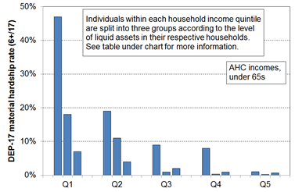
Material hardship rates depend on the level of liquid financial assets as well as on household income, HES 2017-18

Household Economic Survey 2017/18 | Q1 |  |  | Q2 |  |  | Q3
median liquid assets ($) | 0 | 400 | 8,000 | 100 | 1,200 | 12,000 | 500 | 3,600 | 19,300
material hardship rate (6+/17, DEP-17) | 47% | 18% | 7% | 19% | 11% | 4% | 9% | 1% | 2%
avg AHC household income (equivalised $) | 11,000 | 11,000 | 10,000 | 21,000 | 21,000 | 22,000 | 30,000 | 31,000 | 31,000
self-assessed income adequacy = ‘not enough’ | 45% | 21% | 17% | 22% | 10% | 5% | 14% | 6% | 4%
Reading notes for table:
- The three quintiles are quintiles of AHC household income – Q1 is the lowest quintile and so on.
- Q4 and Q5 are not shown in the table (limited space).
- Individuals within each household income quintile are ranked by their household’s level of liquid assets, then split into three equal-sized groups.
- No treatment is applied.

The demographics of child poverty

This section reports how child poverty rates vary across different household contexts, using DEP-17 material hardship measures. See the main report for the corresponding low-incomes analysis.

To more fully understand the child poverty picture, the composition of poverty within each household context also needs to be considered. For example, on all measures, child poverty rates for sole parent households are much higher than for two parent households … but there are more children in poverty from two parent households as there are many more two parent households. Both rates and composition matter. The tables provide both sets of information, and also how the rates and composition vary at different depths of poverty.

This section also reports on how children are faring compared with those from ‘working-age’ one-person households and those aged 65+.

* * * * * * * * * * * * * * * * * *
The table below on this page is an extract from the first of the full tables that follow, and is used to support a walk-through of the numbers to assist with interpretation for those not too familiar with ‘rates and composition’ tables.
- The 6+ material hardship columns are shaded as they give the standard material hardship information using the DEP-17 index; 9+ is the level used for severe material hardship.
- The shaded 5% figure says that 5% of children in two parent HHs have a hardship rate of 8+/17 (much lower than the 20% rate for children in sole parent households at the same depth).
- The shaded 41% figure says that of all the children in households in severe material hardship (9+/17), 41% are from sole parent households.
- Note that the composition columns all add to 100% (except for the two parent / sole parent work intensity panel in the full table on the next page – these add to less than 100% as all other household types and all fully workless households are not included).
- The ‘ALL’ columns show the number and % of children in each household type overall. The composition % divided by the ‘ALL’ % gives ‘the risk ratio’. For children in sole parent households at the 9+ level, the risk ratio is 2.9 (41/14), whereas for children in two parent households the risk ratio is 0.54 (37/69). Whether by comparing rates directly or by comparing risk ratios, the same conclusion is reached: children in sole-parent households are five to six times more likely to be in severe material hardship than those in two-parent households.

Material hardship rates and composition for selected population groups (DEP-17 index, 5 thresholds),
Children (aged 0-17 years), HES 2018-19

HES 2018-19 | Material hardship rates |  |  |  |  | Composition
 | what % of this group is in hardship, using the different thresholds? |  |  |  |  | what % of all those in hardship (using a given threshold) are in this group / cell? |  |  |  |  | 000’s | %
Material hardship threshold as # of items lacked out of 17 | 5+ | 6+ | 7+ | 8+ | 9+ | 5+ | 6+ | 7+ | 8+ | 9+ | ALL | ALL
Material hardship rates (%)
All children (0-17 yrs) | 18 | 13 | 10 | 8 | 6 | 100 | 100 | 100 | 100 | 100 | 1,135 | 100
Household type
2P HH with any deps | 12 | 9 | 7 | 5 | 3 | 48 | 46 | 44 | 42 | 37 | 785 | 69
SP HH with any deps | 40 | 32 | 26 | 20 | 17 | 32 | 34 | 35 | 37 | 41 | 160 | 14
Other fam HHs with any deps | 23 | 16 | 14 | 10 | 8 | 20 | 19 | 21 | 21 | 22 | 180 | 16
Other HHs (some 0-17s, no dep ch) | Suppressed - numbers too small |  |  |  |  | 1 | 1 | 0 | 1 | 0 | 10 | 1
Table B.1a
Material hardship rates and composition for selected population groups (DEP-17 index, 5 thresholds),
Children (aged 0-17 years), HES 2018-19

HES 2018-19 | Material hardship rates |  |  |  |  | Composition
 | what % of this group is in hardship, using the different thresholds? |  |  |  |  | what % of all those in hardship (using a given threshold) are in this group / cell? |  |  |  |  | 000’s | %
Material hardship threshold as # of items lacked out of 17 | 5+ | 6+ | 7+ | 8+ | 9+ | 5+ | 6+ | 7+ | 8+ | 9+ | ALL | ALL
Material hardship rates (%)
All children (0-17 yrs) | 18 | 13 | 10 | 8 | 6 | 100 | 100 | 100 | 100 | 100 | 1,135 | 100
Household type
2P HH with any deps | 12 | 9 | 7 | 5 | 3 | 48 | 46 | 44 | 42 | 37 | 785 | 69
SP HH with any deps | 40 | 32 | 26 | 20 | 17 | 32 | 34 | 35 | 37 | 41 | 160 | 14
Other family HHs with any deps | 23 | 16 | 14 | 10 | 8 | 20 | 19 | 21 | 21 | 22 | 180 | 16
Other HHs (some 0-17s, no dep ch) | Cell sizes too small – rates suppressed |  |  |  |  | 1 | 1 | 0 | 1 | 0 | 10 | 1
Number of children in household
1 | 14 | 11 | 8 | 6 | 5 | 17 | 17 | 17 | 17 | 18 | 245 | 22
2 | 14 | 10 | 8 | 5 | 4 | 33 | 33 | 32 | 30 | 30 | 485 | 43
3 | 19 | 13 | 11 | 9 | 6 | 25 | 23 | 24 | 27 | 24 | 255 | 23
4+ | 35 | 27 | 22 | 16 | 13 | 24 | 26 | 27 | 26 | 28 | 140 | 12
Work intensity (2P and sole parent)
2P (all ages) - both FT | 9 | 6 | 5 | 3 | 1 | 11 | 11 | 10 | 8 | 5 | 260 | 23
2P (all ages) - FT PT | 10 | 7 | 5 | 4 | 2 | 8 | 8 | 7 | 7 | 6 | 165 | 15
2P (all ages) - FT WL | 18 | 12 | 9 | 6 | 4 | 16 | 15 | 14 | 14 | 13 | 185 | 17
SP (all ages) - FT | 23 | 17 | 12 | 10 | 7 | 6 | 6 | 6 | 6 | 6 | 55 | 5
SP (all ages) - PT | 39 | 28 | 22 | 15 | 11 | 6 | 6 | 6 | 5 | 5 | 30 | 3
Labour market status of household
Self-employed | 4 | 2 | 1 | 1 | 0 | 2 | 2 | 1 | 1 | 1 | 140 | 12
At least one FT worker | 14 | 10 | 7 | 5 | 3 | 57 | 54 | 52 | 48 | 44 | 820 | 72
No FT worker (may have PT) | 47 | 38 | 31 | 25 | 20 | 41 | 44 | 47 | 50 | 55 | 175 | 16
PT work only | 34 | 25 | 19 | 15 | 11 | 10 | 10 | 10 | 10 | 10 | 60 | 5
Some work (excl SE) | 15 | 11 | 8 | 6 | 4 | 67 | 64 | 61 | 59 | 54 | 875 | 77
Workless | 53 | 44 | 37 | 30 | 25 | 31 | 34 | 38 | 40 | 45 | 120 | 10
Source of HH income in the 12 months prior to interview
Main source market | 12 | 9 | 6 | 4 | 3 | 60 | 56 | 52 | 48 | 45 | 975 | 86
Main source government | 52 | 42 | 35 | 29 | 23 | 40 | 44 | 48 | 52 | 55 | 160 | 14
Tenure of household
Owned with mortgage (incl FT) | 8 | 5 | 3 | 2 | 1 | 22 | 18 | 14 | 13 | 11 | 540 | 47
Owned no mortgage (incl FT) | 5 | 3 | 3 | 3 | 2 | 3 | 3 | 3 | 4 | 4 | 120 | 10
Private rental | 29 | 23 | 19 | 14 | 11 | 53 | 56 | 59 | 58 | 61 | 365 | 32
Social rental | 54 | 44 | 35 | 28 | 20 | 20 | 22 | 23 | 25 | 24 | 75 | 7
Other | 8 | 4 | 2 | 2 | 1 | 1 | 1 | 1 | 1 | 1 | 35 | 3
Private rental by AS receipt
Private rental (no AS) | 16 | 11 | 9 | 6 | 4 | 15 | 15 | 15 | 14 | 12 | 195 | 17
Private rental (with AS) | 45 | 36 | 30 | 23 | 18 | 38 | 41 | 44 | 44 | 49 | 170 | 15
Education (highest qualification in HH)
Higher degree | 6 | 4 | 2 | 1 | 1 | 7 | 6 | 4 | 3 | 3 | 230 | 20
Bachelors or similar | 9 | 6 | 4 | 3 | 2 | 11 | 9 | 9 | 8 | 8 | 250 | 22
Post-school non-degree qualification | 20 | 15 | 12 | 9 | 7 | 35 | 35 | 37 | 37 | 37 | 360 | 32
School qualification | 29 | 22 | 17 | 13 | 10 | 31 | 32 | 32 | 32 | 32 | 215 | 19
No formal qualification | 44 | 34 | 27 | 22 | 17 | 17 | 17 | 18 | 20 | 20 | 80 | 7
NZDep Quintile
Q1(least deprived 20%) | 6 | 4 | 2 | 2 | 1 | 7 | 6 | 4 | 4 | 3 | 210 | 19
Q2 | 9 | 6 | 4 | 3 | 2 | 10 | 9 | 7 | 7 | 7 | 230 | 20
Q3 | 14 | 9 | 7 | 5 | 3 | 16 | 14 | 14 | 14 | 12 | 230 | 21
Q4 | 19 | 14 | 11 | 7 | 5 | 20 | 20 | 20 | 17 | 15 | 210 | 19
Q5 (most deprived 20%) | 39 | 31 | 26 | 21 | 17 | 48 | 51 | 54 | 58 | 64 | 250 | 22
Note for Table B.1a: ‘All ages’ in Work Intensity panel refers to the age of the adults in two parent and sole parent households.

Table B.1b repeats the hardship rates and composition analysis for ethnicity.

Starting with HES 2007, ethnicity for children is provided in the survey data, with the information coming from either the children themselves or from their parents. Individuals can specify more than one ethnicity. In Table B.1b ethnic groups are created (for the purposes of analysis) using both the total response method and the prioritised method for determining ethnicity.

In the total response approach, each person’s total ethnicity response is counted. This means that individuals may be counted more than once, and the total figures will be greater than the population numbers (around 250,000 more in the case of children). The analysis is actually about the total number of ethnicities provided for the children – it is not directly about the children themselves. Stats NZ generally use this approach

In the prioritised approach, if a respondent reports more than one ethnicity, the ethnicity attributed is determined according to a prioritised classification of Māori, Pacific peoples, Other and then European. This ensures that the total number of responses equals the total population being reported on. In doing so, prioritisation conceals diversity within and overlapping between ethnic groups by eliminating multiple ethnicities from the analysis. This systematic prioritisation of the data gives highest priority to Māori – meaning, for example, an individual who might self-identify as both Pacific and Māori would be counted as Māori.

Material hardship rates are much higher for Māori and Pacific children/ethnicities (23-28%) compared with that for European or Asian children/ethnicities (6-10%). This difference is much the same as in previous MSD reports using multi-year averages.

Table B.1b
Material hardship rates and composition by ethnicity (DEP-17 index, 5 thresholds),
Children (aged 0-17 years), HES 2018-19
HES 2018-19 | Material hardship rates |  |  |  |  | Composition
 | what % of this group is in hardship, using the different thresholds? |  |  |  |  | what % of all those in hardship (using a given threshold) are in this group / cell? |  |  |  |  | 000’s | %
Material hardship threshold as # of items lacked out of 17 | 5+ | 6+ | 7+ | 8+ | 9+ | 5+ | 6+ | 7+ | 8+ | 9+ | ALL | ALL
Material hardship rates (%)
All children (0-17 yrs) | 18 | 13 | 10 | 8 | 6 | 100 | 100 | 100 | 100 | 100 | 1,135 | 100
Ethnicity (total)
European | 13 | 10 | 7 | 6 | 4 | 36 | 36 | 36 | 36 | 35 | 53 | 53
Māori | 29 | 23 | 19 | 14 | 11 | 32 | 34 | 35 | 35 | 37 | 21 | 21
Pacific peoples | 38 | 28 | 23 | 18 | 14 | 20 | 20 | 21 | 22 | 23 | 10 | 10
Asian | 11 | 6 | 4 | 2 | 2 | 8 | 6 | 5 | 4 | 4 | 13 | 13
Other | 24 | 18 | 10 | 7 | 5 | 4 | 4 | 3 | 3 | 2 | 3 | 3
Ethnicity (prioritised)
European | 10 | 7 | 5 | 4 | 3 | 26 | 25 | 24 | 24 | 21 | 535 | 47
Māori | 29 | 23 | 19 | 14 | 11 | 41 | 44 | 47 | 47 | 50 | 290 | 26
Pacific peoples | 41 | 29 | 24 | 19 | 14 | 19 | 19 | 20 | 21 | 21 | 95 | 8
Asian | 11 | 6 | 4 | 2 | 2 | 9 | 7 | 5 | 4 | 4 | 170 | 15
Other | 25 | 20 | 10 | 9 | 6 | 5 | 5 | 4 | 4 | 4 | 40 | 4
Reading note for interpreting ‘total ethnicity’ percentages. The total ethnicities approach counts ethnicities, not children. There are around 250,000 more ethnicity responses than there are children, as many report more than one ethnicity.
- The ‘28%’ figure in the Pacific peoples row for 6+/17 hardship rate means that out of all the ethnicities reported by children in the 6+ hardship column, 28% are Pacific (whether only Pacific or Pacific and one or more other ethnicities).
- The ‘20%’ figure in the Pacific peoples row for 6+/17 composition means that out of all the ethnicities reported by children in the 6+ hardship column, 20% are Pacific (whether only Pacific or Pacific and one or more other ethnicities).

Comparing poverty rates for children, one-person households (aged 18-64 yrs), and older New Zealanders (65+ yrs)

This section provides HES-based evidence and commentary to assist with policy discussion in relation to two matters:
- Poverty rates for children are sometimes compared with the (lower) rates for older New Zealanders, with the conclusion reached that ‘we treat our older people better than our children’.
- One-person households do not feature as often in poverty discussions as children do. This section draws attention to the relatively high poverty rates for this group.

It also provides a good illustration as to why it is important to not rely on just one measure when assessing how different population groups are faring in their material wellbeing.

Table B.3 compares low-income and material hardship rates for children, those in one-person households (aged 18-64 yrs), and older New Zealanders (65+ yrs), using the nine CPRA measures.
- On all measures, one-person households have higher poverty rates than children, and on all but one (BHC 60) higher than older New Zealanders.
- On all but one measure (BHC 60), older New Zealanders have the lowest poverty rates of all three groups.

Table B.3
Low-income and material hardship rates (%) compared for
one person households (18-64 yrs), children (0-17 yrs), and older New Zealanders (65+), HES 2018-19
New Zealand comparisons | HES 2018-19 | One person HHs (18-64 yrs) | Children  (0-17yrs) | Older NZers (65+ yrs) | ALL
 |  | 180,000 | 1.13m | 700,000 | 4.9m
 | BHC 50 | 31 | 13 | 9 | 10
 | BHC 60 | 37 | 22 | 37 | 20
 | AHC 40 | 31 | 12 | 7 | 10
 | AHC 50 | 37 | 19 | 13 | 15
 | AHC 60 | 44 | 27 | 26 | 22
 | Material hardship (DEP-17, 6+/17) | 21 | 13 | 3 | 9
 | Severe material hardship (9+/17) | 10 | 6 | 1 | 4
 | Material hardship plus income less than AHC 60 | 19 | 8 | 2 | 5
EU comparisons for material hardship (EU-13) | EU-13, 5+/13 | 22 | 14 | 4 | 10
 | EU median | 14-15 | 11-12 | 8 | 10
 | NZ material hardship rate relative to EU countries | NZ rate relatively high, along with Ireland, Belgium (21-23%) etc. Better only than Serbia, Latvia, Lithuania, Romania, etc. | A little above the EU median – similar to Italy, Portugal, Belgium | Among those with lowest rates such as the UK, Finland, Denmark, Switzerland, etc

  - A claim sometimes made regarding the relative positions of children and older New Zealanders goes along these lines (or similar): ‘NZ Super is widely understood as an effective basic income that is highly successful in preventing poverty. Incomes for beneficiary households with children should be raised to a similar level to help address child poverty.’
    - NZS is in fact only just above the BHC 50 level, so does not ‘prevent poverty’ as measured, for example, by BHC 60 (37%, among the highest in the OECD/EU). It is NZS plus the very high rates of mortgage-free tenure that leads to lower hardship and lower AHC 40 rates. Older New Zealanders who rent privately have a hardship rate of 12%, a little less than children but higher than the overall 65+ rate of 3%.
    - For many beneficiary households with children, their total BHC household income including AS and WFF is already well above NZS levels and above the 50% BHC threshold. The issue is that these households have much higher housing costs on average compared with older New Zealanders, so their AHC incomes often fall below 50% AHC threshold, and sometimes below 40%AHC.
    - The assumptions in the claim are not supported by the evidence. This is not an argument for or against doing more for children or older New Zealanders, it is just that the way the case is often presented is highly contestable.

- The lower rates for children compared with adults in one-person households reflect the cumulative impact of policy decisions over many years which have improved the incomes of households in which there are children, both beneficiary and low-income working households … with little change for one-person beneficiary households.

- The relatively high rate for older New Zealanders using the BHC 60 measure (37%) reflects two factors: (a) NZS is currently close to / just above the BHC 50 line; and (b) around 40% of those aged 65+ live in households with incomes from NZS plus less than $100 pw more from their own resources. This puts a large clump of 65+ households in the 50-60% BHC range and leads to the very high reported rate on this measure.
- Using several measures allows the overall story to be told (older New Zealanders have low material hardship rates and low AHC low-income rates), with the outlier (BHC 60) being able to be accounted for very simply and without undermining the overall picture.

Further comparisons of material hardship rates for one-person households and children (looking at beneficiary households), and for older New Zealanders who rent.

Table B.4 provides some further breakdown of the material hardship figures reported in Table B.3 above.
- The material hardship rate for one-person beneficiary households is very high in itself (46-48%), and is higher than the rate for children in beneficiary households whichever of the two ways it is measured (35-42%).
- Older New Zealanders who rent have a higher material hardship rate than overall for this age group (12% compared with 3%), but their rates are still much lower than for the other two groups.

Table B.4
Material hardship rates (%) for
one person households (18-64 yrs), children, and older New Zealanders (65+) in selected circumstances
HES 2018-19
One-person HHs (18-64 yrs) |  |  | Children (0-17 yrs) |  |  | Older NZers (65+ yrs) |  | Whole population
ALL | Some benefit income | Govt income as main source | ALL | In HHs with some benefit income | In HHs with govt income as main source | ALL | renters
21 | 46 | 48 | 13 | 35 | 42 | 3 | 12 | 9
Note for Table B.4: The rates for beneficiary households and older New Zealanders who rent are based on relatively small sub-samples of around 700 households in each case. The sampling errors (95% CI) will be large. This means that the hardship rates for these groups should not be taken as reliable precision estimates, though they are still reliable enough to support the conclusions above. This analysis is possible now because of the much higher sample size for HES 2018-19.

Beneficiary incomes – long-run trends

Children in beneficiary households typically make up around half of children in low-income households (using the CPRA measures) and around half of those in households reporting material hardship. Trends in the incomes of beneficiary households with children are therefore highly relevant for understanding the New Zealand child poverty story. See Appendix 4 for long-run trend of beneficiary income in real inflation-adjusted terms and relative to the average wage (after tax).

International comparisons

International poverty comparisons in the richer nations have traditionally been made using low-income league tables (eg from the OECD, using BHC 50; from Eurostat, using BHC 60). There is increasing recognition of the limitations of an incomes approach to poverty measurement, for international comparisons especially.

In the traditional approach, household income is used as a proxy for household resources that can generate consumption. Even when used as a within-country measure there is good evidence to show that household income on its own does not do a very good job in identifying those households in financial hardship or not meeting minimum acceptable day-to-day material living standards. This limitation arises for two main reasons, even when using an after-housing-costs measure (AHC): households have other resources to supplement income (eg some liquid assets / accessible savings) and some do not; and some households have needs beyond the average (eg high debt servicing, high health or disability costs) and many do not. For international comparisons, the incomes approach faces a further challenge: the ‘poverty line’ in richer OECD/.EU countries is greater than the median in many poorer OECD/EU countries, which renders comparisons invalid when using the standard high-level definition. Recent European research using reference budgets for selected European countries shows that ‘in the poorest EU Member States, even adequate food and housing are barely affordable at the level of the [standard EU BHC 60] threshold, whereas a decent living standard is much more in reach for those living on the threshold in the richer EU Member States’.

Partly because of these limitations, the EU developed and uses a 13-item Material and Social Deprivation index as one of its official social inclusion measures (in this report, ‘EU-13’ for short). We can replicate the index to a very good degree of certainty for New Zealand using data from the HES. The EU-13 and the DEP-17 indices rank households in much the same order (correlation of 0.86).
See Appendix 1 for the EU-13 item list.

International comparisons of material hardship rates for those aged 0-17 years

Using the EU-13 index and HES 2018-19 data, 14% of New Zealand children lived in households that reported five or more of the thirteen enforced lacks. Figure D.1 below shows that New Zealand’s EU-13 child material hardship rate is much higher than for countries like Sweden, Denmark, Norway, Finland, the Netherlands and Switzerland (5-8%). New Zealand ranks alongside Belgium, Portugal, Ireland, the UK, France and Spain at the ‘low’ (ie higher hardship rates) end of the ‘old EU’ for hardship rates for children (14-16%). See Appendix 3 for the list of European countries and their 2-letter codes.

Figure D.1
Material and social deprivation rates (% with 5+ enforced lacks), EU-13, 0-17 yrs
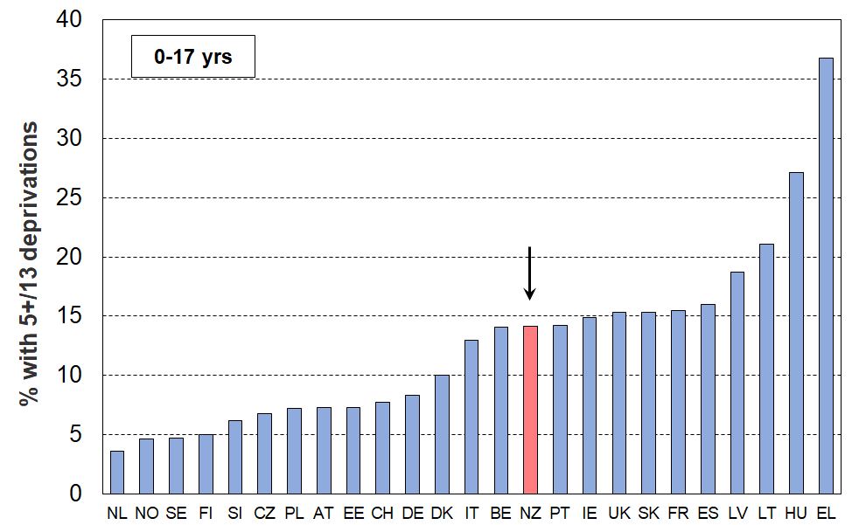
23 European countries + NZ, ranked on % with 5+ (EU-SILC 2018, NZ HES 2018/19)
Reaching the 2027-28 target of a 6% material hardship rate

The scatterplot in Figure D.2 uses both material hardship rates for children (horizontal axis) and for those aged 65+ (vertical axis), with the chart divided into quadrants using the respective median hardship rates as the boundaries. New Zealand, along with the UK, Ireland and Belgium are in the SE quadrant – relatively low material hardship for older citizens and relatively high rates for children. In contrast, in the SW quadrant are countries with relatively low rates for both groups (Netherlands, Norway, Finland, Sweden, and so on).

Using a stylised ‘day after’ approach, reaching the ten-year child material hardship target of 6% (2027-28) would shift New Zealand as shown by the arrow. The depiction assumes that DEP-17 and EU-13 give similar figures, and that all other countries rates remain frozen. Both these assumptions are likely to not fully hold over the next decade, but the chart nevertheless gives an idea of the magnitude of the proposed change and of the task to achieve the goal.

Figure D.2
Material hardship rates for children (0-17 yrs) and those aged 65+:
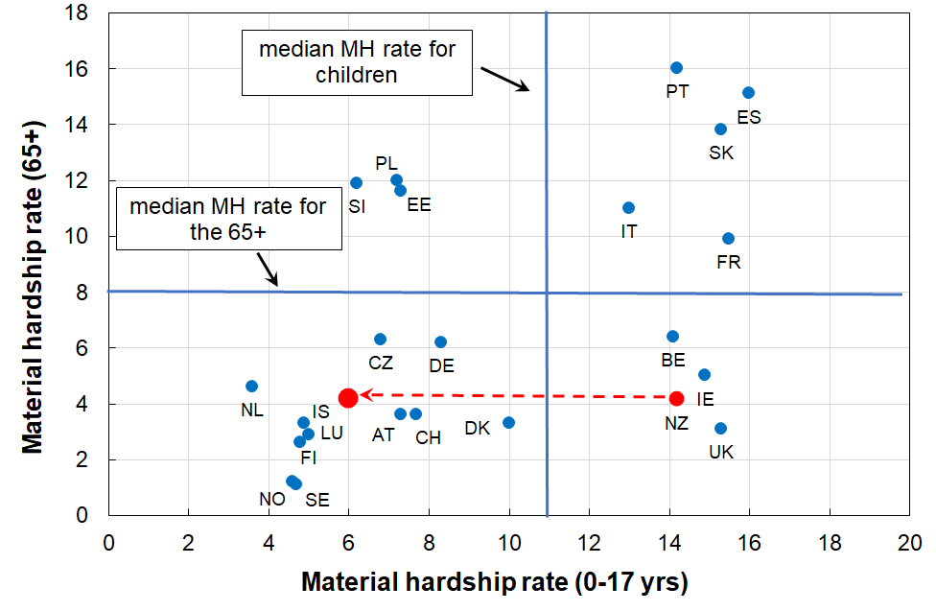
comparisons with selected European countries (2018)
Notes for Figure D.2:
- Countries with even higher material hardship rates for either children or those aged 65+ (or both) are omitted from the chart to better enable NZ to be rated against the countries we usually make comparisons with. The omitted countries are Greece, Hungary, Latvia and Lithuania. They are however included for calculating the medians.
- The medians are for all the EU countries plus Norway, Switzerland and Iceland.

The assumption of ‘nothing else changing’ is not as far-fetched as it may initially sound. There are not that many countries with large changes in the last decade or so (ie from pre-GFC to now): for the 65+ group, only Poland, the Czech Republic and Estonia changed greatly (decreases); and for children, these three plus Slovakia, Lithuania and Portugal decreased considerably and Greece increased. The median for child material hardship for the full EU decreased from around 15% to 11% in the last decade or so. When Norway, Iceland and Switzerland are added to the EU list, the drop in the median hardship rate for children is less as these countries have lowish rates and did not change very much.
Children in workless households

Table D.6 compares New Zealand with EU countries on the proportion of children in workless households. In HES 2011-12, at the height of the GFC impact, New Zealand was at the high end of the table with a rate of 18%, similar to Hungary, the United Kingdom and Ireland (16-20%). By HES 2018-19, the rate had fallen to 11%, though this still leaves New Zealand at the higher end of the table.

Table D.6
International comparisons of the proportion of children living in workless households (%):
HES years 2007-8, 2011-12, 2016-17 and 2018-19
HES survey year | 2007-08 | 2011-12 | 2016-17 | 2018-19 |  | 2007-08 | 2011-12 | 2016-17 | 2018-19
France | 8 | 10 | 12 | 12 | Latvia | 8 | 11 | 8 | 8
Ireland | 13 | 20 | 12 | 11 | Estonia | 7 | 9 | 6 | 7
United Kingdom | 17 | 17 | 12 | 11 | Romania | 10 | 12 | 9 | 7
Sweden | 8 | 7 | 6 | 11 | Malta | 9 | 8 | 8 | 7
Belgium | 11 | 12 | 12 | 11 | EU-27 median | 8 | 10 | 9 | 7
New Zealand | 17 | 18 | 11 | 11 | Croatia | 7 | 11 | 8 | 6
Bulgaria | 11 | 17 | 12 | 9 | Hungary | 15 | 16 | 8 | 6
Lithuania | 11 | 12 | 10 | 9 | Cyprus | 4 | 7 | 10 | 6
Italy | 7 | 9 | 10 | 9 | Luxembourg | 4 | 4 | 8 | 6
Slovakia | 9 | 10 | 8 | 8 | Austria | 6 | 6 | 7 | 6
Spain | 7 | 14 | 10 | 8 | Czechia | 7 | 8 | 6 | 6
Greece | 4 | 13 | 9 | 8 | Portugal | 5 | 9 | 6 | 5
Germany | 10 | 9 | 9 | 8 | Netherlands | 5 | 6 | 6 | 5
Denmark | 3 | 8 | 9 | 8 | Finland | 4 | 4 | 5 | 5
Poland | 8 | 9 | 8 | 8 | Slovenia | 3 | 4 | 3 | 3
Source for EU data is:
http://appsso.eurostat.ec.europa.eu/nui/show.do?dataset=lfsi_jhh_a&lang=en - accessed on 16 Oct 2020.
The figures for New Zealand to 2016-17 are derived using the sample weights developed by the New Zealand Treasury for use with the HES, as these are constructed using core benefit numbers as one of the benchmarks. 2019 figures use the (new) Stats NZ weights starting with HES 2018-19 which use benefit numbers (core plus other) as one of the benchmarks.

Children in workless households, in households with no full-time worker and in families in receipt of a main benefit

Leading up to the GFC and in the downturn associated with it (2008 to 2012), around one in four New Zealand children lived in households where there was no adult in full-time employment. This has dropped to around one in six in the 2018-19 HES (Table D.7). This figure, like the workless figure, is nevertheless high by OECD and EU standards.

Table D.7
Proportion of children in ‘workless’ households (% of all children)
HES survey year | 2007-08 | 2011-12 | 2016-17 | 2017-18 | 2018-19
In workless HHs | 17 | 18 | 11 | 11 | 11
In HHs with no FT worker | 24 | 25 | 16 | 17 | 16
In beneficiary families | 19 | 21 | 16 | 15 | 15

The proportion of children in beneficiary families is unlikely to ever match either of the other two lines for several reasons:
- a beneficiary family may live in a household where an adult is in FT work (eg a sole parent family living with the mother’s parents or other relatives)
- some beneficiary families receive income from part-time employment
- the beneficiary information is a snapshot at 31 March (from 2013 on), whereas the HES-based figures are an average over the full year.

Life ‘below the line’ – what does ‘living in a poor household’ look like for children?

When we say that 20% of children (230,000) live in households with incomes below the AHC 50 (relative) low-income line – what is life actually like for these 230,000 children? Given the mismatch between income and material hardship measures noted in the section before last, it is likely there will be some who experience serious deprivations and others who have a reasonable standard of living and many in between – but, what is the picture really like? Can we paint it more precisely?

When we say in the 2018-19 HES 13% of children (140,000) were in households identified as in material hardship using the 6+/17 DEP-17 measure, what does it actually mean for the children in day-to-day terms?

There is a reasonably commonly promoted narrative that goes like this:
- Around one in four (five) New Zealand children are in poverty.
- They are going without many things that most of us take for granted (don’t have two pairs of good shoes, don’t have a good meal at least once a day, live in homes which are cold because there’s not enough money for paying the electricity bill, can’t participate in sport and special interests as there is not enough money, and so on).
- Conclusion: This is unacceptable – much more government action is required / give to XYZ charity.

The claim about one in four (or five) being in poverty (a) above) probably uses BHC 60 or AHC 50 low-income numbers.

The deprivations listed in the next statement (b) are all reasonable descriptions of poverty as most would understand it. However, the leap from an income-based measure to a list of serious deprivations as if the same notion of ‘poverty’ is used for both is a fallacy. Even in households with DEP-17 scores of 6+ it is not the case that all or even the majority of the children experience these deprivations, even less so for low-income households using the CPRA measures. The analysis that follows provides good evidence of how life is for children in households ‘below the line’.

The approach: Using child-specific items and directly child-relevant general household items to help describe what poverty looks like for children in households identified as poor

The 2018-19 and 2019-20 HES surveys gathered information on twenty child-specific items that cover a wide range of possessions and activities that most would agree every child should have and none should be deprived of in New Zealand today. These are listed in Table C.1 on the next page. A more detailed version is available in Appendix 1, including whether the reason for not having an item is because of cost or some other reason.

These child-specific indicators are not suitable for use in indices such as DEP-17 or the MWI as they do not meet two of the key criteria for such measures – they are not suitable for all ages, and do not represent a good range of severity of hardship, only deeper hardship for most of the indicators. They do, however, provide valuable information on the realities of daily life for those children identified as being ‘in hardship’ by the DEP-17 or MWI index score of their household, or as being in low-income households. They can be used on their own, or combined with information on more general household conditions that are directly child-relevant (eg ability to keep home warm and dry).

When describing what poverty looks like for children in households identified as poor, this section uses a range of items that describe aspects of financial and material hardship. It often uses a special set of 18 essential items made up of 12 of the 20 child-specific items and 6 general household items that have direct relevance for children. These are listed in Table C.2 on the next page. The chosen essentials were limited to those that would likely command a wide consensus as items that no child should have to go without and that all children should have. These, and other similar items, are referred to in the main report as the calibration items, as distinct from the index items that make up Dep-17, EU-13, and so on.

Table C.1
Child-specific items:
the % of age 6-17s without the item or who are very restricted in the specified activity,
as reported by household respondent (HES 18/19 and 19/20)
Don't have (for any reason): |  | 18/19 | 19/20
 | Two pairs of shoes in a good condition and suitable for daily activities | 7 | 5
 | Two sets of warm winter clothes | 2 | 1
 | Waterproof coat | 9 | 6
 | A separate bed | 5 | 4
 | Fresh fruit and vegetables daily | 7 | 5
 | A meal with meat, fish or chicken (or vegetarian equivalent) daily | 6 | 4
 | Good access at home to a computer and internet for homework? | 6 | 5
 | A range of books at home suitable for their ages | 5 | 4
 | A suitable place at home to do school homework | 2 | 2
 | Friends around to play and eat from time to time | 11 | 11
 | Friends around for a birthday party | 13 | 11
Do/not do a lot in order to save money:
 | Postponed visits to the doctor | 2 | 1
 | Postponed visits to the dentist | 1 | 1
 | Did not pick up child’s prescription | 0 | 1
 | Unable to pay for a child to go on a school trip or other school event | 3 | 2
 | Had to limit children’s involvement in sport | 6 | 4
 | Had children go without music, dance, Kapa haka, art, swimming or other special interest lessons | 7 | 5
 | Children continue wearing shoes or clothes that were worn out or the wrong size | 3 | 2
Don't have (age 11+ only):
 | Mobile phone if aged 11+ | 18 | 14

Table C.2
The 18 essential items used for various calibration exercises
Selected child-specific items (12) | Child-relevant general household items (6)
Do not have:  - two pairs good shoes for each child  - two sets of warm winter clothes for each child  - waterproof coat for each child (because of cost)  - a separate bed for each child  - fresh fruit and vegetables daily  - meal with meat, fish or chicken (or vegetarian equivalent) each day  - good access at home to a computer and internet for homework  - friends around to play and eat from time to time (because of the cost)  Economised ‘a lot’:  - unable to pay for school trips / events for each child  - had to limit children’s involvement in sport  - children had to go without music, dance, kapa haka, art, swimming or other special interest lessons  - continued wearing worn out / wrong size clothes or shoes | Household deprivations that have direct relevance to children:  - received help from food bank or other community group (more than once in last year)  - accommodation severely crowded (2+ extra bedrooms needed)  - dampness or mould in dwelling (‘major problem’)  - respondent reports putting up with feeling cold to keep down costs for other basics (‘a lot’)  - delayed repair or replacement of appliances (‘a lot’)  - no access to car or van
Notes for Table C.2:
- See Appendix 1 for the full text for the child-specific items.
- The economising questions ask about economising so as to be able to pay for other basics, not just to be thrifty or save up for a special non-essential. Possible responses were ‘not at all’, ‘a little’, and ‘a lot’.

Figure C.5
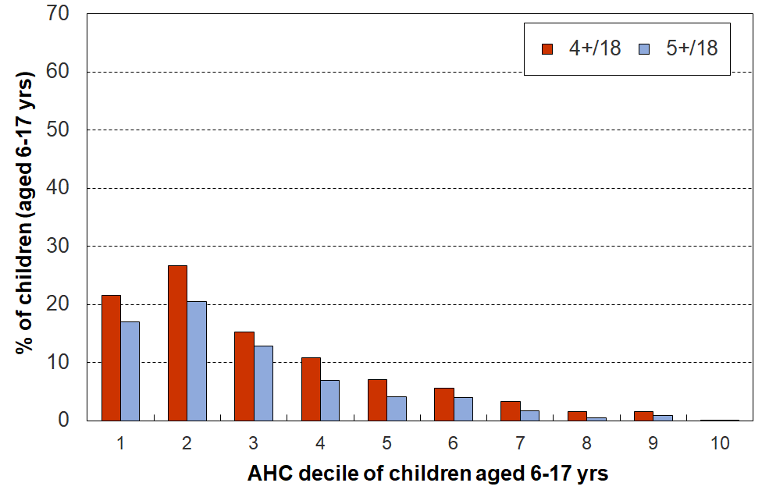
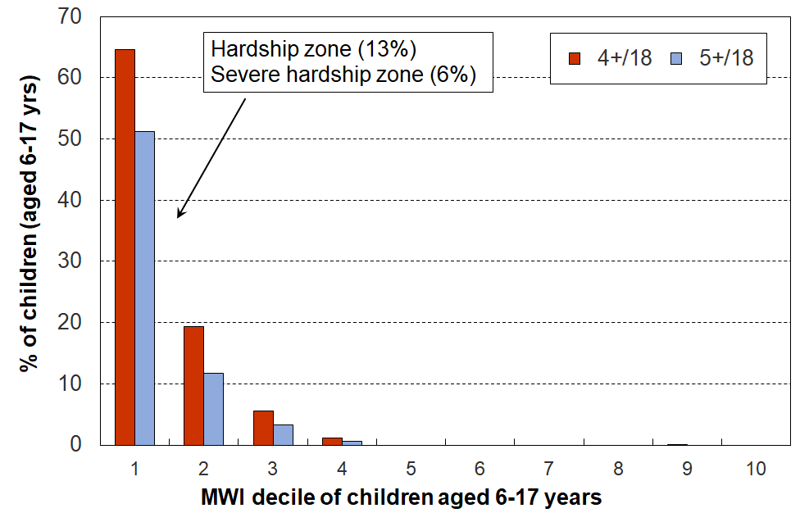
Multiple deprivation for children using 18 essential child-specific and general HH items, HES 2018-19
Note for Figure C.5:
- The ‘treatment’ discussed on page 7 and in Appendix 5 for partially addressing the issue of implausibly low incomes is applied in the above charts. See Section O of the main report for full discussion.

A key takeaway from this analysis, using the 18 essential items, is how the distribution of the deprivation items is so different depending on whether the ranking of households is done by an outcome measure (MSD’s MWI) or by an input measure (AHC income).

All up, in the 2018-19 HES, around 57,000 children aged 6-17 years (~10%) experienced 4+ deprivations out of the 18 in the list in Table C.2.
- When households are ranked by their material wellbeing (using the MWI), 75% of these children are found in the bottom decile (of children) and 93% are in the bottom two deciles, as shown in the left-hand chart.
- When households are ranked by their AHC incomes, the 57,000 6-17 year-olds experiencing these deprivations are spread much more widely: only around half are in the bottom two deciles (instead of 93%), and it takes the lower six deciles to capture 94% (compared with only the lower two deciles for the 93% on the MWI ranking.

When considering possible interventions to reduce material hardship rates for children, this finding shows two things: (a) how a good portion of the impact can (needs) to come from improved incomes for households with incomes above standard ‘poverty lines’ and even up to the median, and (b) the fact that there are a range of non-income factors that can increase or reduce hardship means that there are some non-income policy options for assisting households to improve their position (see Figure A.1).

A second takeaway is the implication for interpreting findings for the bottom income decile given the households-with-very-low-income issue, if there is no reasonable treatment applied. This matter is illustrated several times too in what follows below.

A third takeaway is how multiple material disadvantage for children clusters strongly at the hardship end of the spectrum (see, for example, Table C.3 below). The 18 items are those in Table C.2. The children are ranked in deciles by the MWI score of their households. For the most materially deprived 10% of children, 61% experience 4 or more of the 18 deprivations, all of which are about very basic needs. This is the average score for that group. For the most deprived, the proportion experiencing multiple deprivations is much greater.

While there is evidence here and elsewhere of some hardship in the next 10% (MWI decile 2), there is no gradient across all the deciles reflecting what could be called ‘acceptable inequality’. The analysis shows that for those children in the most materially deprived households (~5 to 8%), life is undeniably very different from that experienced by the vast majority of New Zealand children. This finding is in line with what was found using similar indicators from the 2008 Living Standards Survey. It illustrates what it means in practice to be ‘excluded from the minimum acceptable way of life in one’s own society’, the high-level definition of poverty commonly used for richer countries and adopted in MSD reports.

The 18 items used in Table C.3 are the same 18 as are used for Figure C.5 (see Table C.2).

Table C.3
Children’s restrictions by the MWI score of their household (children, 6-17 yrs),
grouped by quintiles of children, with the bottom quintile broken out into deciles
HES 2018/19 (%):
 | All | D1 | D2 |  | Q1 | Q2 | Q3 | Q4 | Q5
Distribution of children (6-17yrs) across MWI deciles/quintiles of children (%) | 100 | 10 | 10 |  | 20 | 20 | 20 | 20 | 20
Don’t have
2 pairs of shoes in good condition and suitable for daily activities for each child | 7 | 36 | 15 |  | 26 | 4 | 2 | . | .
2 sets of warm winter clothes for each child | 2 | 13 | 3 |  | 8 | . | . | . | .
waterproof coat for each child (because of the cost) | 5 | 28 | 7 |  | 18 | 3 | . | . | .
separate bed for each child | 5 | 25 | 10 |  | 18 | 5 | . | . | .
fresh fruit and vegetables daily | 7 | 45 | 12 |  | 29 | 5 | . | . | .
meal with meat, fish or chicken (or vegetarian equivalent) each day | 6 | 31 | 13 |  | 22 | 5 | . | . | .
good access at home to a computer and internet for homework | 6 | 27 | 14 |  | 21 | 6 | 2 | . | .
friends around to play and eat from time to time (because of the cost) | 4 | 21 | 7 |  | 14 | 3 | . | . | .
Economised ‘a lot’ on children’s items to keep down costs to enable other basic things to be paid for (not just to be thrifty or to save for a trip or other non-essential)
had to go without music, dance, kapa haka, art, swimming or other special interest lessons (“a lot”) | 7 | 35 | 17 |  | 26 | 6 | . | . | .
unable to pay for school trip or other school event (“a lot”) | 3 | 24 | 6 |  | 15 | 1 | . | . | .
involvement in sport had to be limited (“a lot”) | 6 | 32 | 15 |  | 24 | 4 | . | . | .
continue to wear shoes or clothes that are worn out or the wrong size (“a lot”) | 3 | 19 | 7 |  | 13 | . | . | . | .
Multiple restrictions of child-specific items (the 12 above)
2+ out of 12 | 12 | 68 | 28 |  | 49 | 9 | . | . | .
3+ out of 12 | 8 | 53 | 17 |  | 36 | 4 | . | . | .
4+ out of 12 | 6 | 43 | 9 |  | 27 | 2 | . | . | .
Child-relevant general household items
received help (food, clothes, money) from a community organisation more than once in the last 12 months | 5 | 31 | 9 |  | 20 | 4 | . | . | .
accommodation severely crowded (2+ extra bedrooms needed) | 3 | 6 | 6 |  | 6 | 5 | 2 | . | .
dampness or mould a ‘major problem’ in the accommodation | 8 | 36 | 20 |  | 28 | 8 | 3 | . | .
respondent reports putting up with feeling cold to keep down costs for other basics (‘a lot’) | 10 | 49 | 27 |  | 38 | 9 | 1 | . | .
delayed replacing or repairing broken or damaged appliances to keep down costs for other basics (‘a lot’) | 12 | 62 | 29 |  | 45 | 12 | 3 | . | .
household has no access to car or van for personal use | 5 | 14 | 7 |  | 10 | 6 | 3 | 2 | .
Multiple restrictions out of 12 child-specific and 6 general child-relevant household items (18 in all)
3+ out of 18 | 14 | 78 | 34 |  | 57 | 8 | . | . | .
4+ out of 18 | 9 | 64 | 18 |  | 42 | 3 | . | . | .
5+ out of 18 | 7 | 50 | 11 |  | 31 | 2 | . | . | .
Postponed doctor’s visits ‘a lot’ to keep down costs to enable other basic things to be paid for (not just to be thrifty or to save for a trip or other non-essential)
For children (a lot) | 2 | 8 | 5 |  | 7 | . | . | . | .
For respondent (a lot) | 11 | 52 | 33 |  | 42 | 11 | 3 | . | .
For children (a little or a lot) | 5 | 22 | 11 |  | 17 | 6 | . | . | .
For respondent (a little or a lot) | 28 | 84 | 71 |  | 77 | 46 | 16 | 2 | .
Respondent reports life satisfaction
dissatisfied or very dissatisfied with life | 6 | 23 | 14 |  | 19 | 7 | 3 | 2 | .
satisfied or very satisfied with life | 79 | 42 | 60 |  | 51 | 74 | 84 | 92 | 95
Note: Information is suppressed in cells with less than 15 households in the original sample.
Table C.7 repeats Table C.3, this time using AHC household incomes as the variable to rank households.

A comparison between the two tables shows the same sort of differences between rankings on low-income and ranking on the MWI as is shown in Figure C.5 above: restrictions for children are much more dispersed across the household income spectrum than they are across the MWI spectrum.

Table C.8a (was C.7a)
Children’s restrictions by AHC income of their household (children, 6-17 yrs),
grouped by quintiles of children, with the bottom quintile broken out into deciles
HES 2018-19 (%)
 | All | D1 | D2 |  | Q1 | Q2 | Q3 | Q4 | Q5
Distribution of children (6-17yrs) across AHC deciles/quintiles of children (%) | 100 | 10 | 10 |  | 20 | 20 | 20 | 20 | 20
Don’t have
2 pairs of shoes in good condition and suitable for daily activities for each child | 7 | 17 | 19 |  | 18 | 9 | 5 | . | .
2 sets of warm winter clothes for each child | 2 | 4 | 5 |  | 5 | 2 | . | . | .
waterproof coat for each child (because of the cost) | 5 | 11 | 12 |  | 11 | 6 | 4 | . | .
separate bed for each child | 5 | 10 | 12 |  | 11 | 7 | 4 | 3 | .
fresh fruit and vegetables daily | 8 | 15 | 19 |  | 17 | 10 | 5 | 3 | .
meal with meat, fish or chicken (or vegetarian equivalent) each day | 6 | 16 | 13 |  | 14 | 10 | 3 | 3 | .
good access at home to a computer and internet for homework | 6 | 12 | 16 |  | 14 | 9 | 5 | . | .
friends around to play and eat from time to time (because of the cost) | 4 | 9 | 8 |  | 8 | 5 | 3 | . | .
Economised “a lot” on children’s items to keep down costs to enable other basic things to be paid for (not just to be thrifty or to save for a trip or other non-essential)
had to go without music, dance, kapa haka, art, swimming or other special interest lessons (“a lot”) | 7 | 15 | 15 |  | 15 | 10 | 6 | 2 | .
unable to pay for school trip or other school event (“a lot”) | 4 | 8 | 9 |  | 9 | 5 | . | . | .
involvement in sport had to be limited (“a lot”) | 6 | 14 | 12 |  | 13 | 10 | 4 | . | .
continue to wear shoes or clothes that are worn out or the wrong size (“a lot”) | 3 | 5 | 9 |  | 7 | 5 | . | . | .
Multiple restrictions of child-specific items (the 12 above)
2+ out of 12 | 13 | 28 | 30 |  | 29 | 17 | 9 | 4 | .
3+ out of 12 | 9 | 20 | 23 |  | 22 | 11 | 6 | 2 | .
4+ out of 12 | 6 | 15 | 17 |  | 16 | 8 | 4 | . | .
Child-relevant general household items
received help (food, clothes, money) from a community organisation more than once in the last 12 months | 5 | 13 | 14 |  | 14 | 7 | 2 | . | .
accommodation severely crowded (2+ extra bedrooms needed) | 3 | 2 | 4 |  | 3 | 5 | 4 | 4 | .
dampness or mould a “major problem” in the accommodation | 8 | 17 | 13 |  | 15 | 12 | 8 | 5 | 2
respondent reports putting up with feeling cold to keep down costs for other basics (a lot) | 10 | 16 | 25 |  | 21 | 14 | 8 | 4 | 3
delayed replacing or repairing broken or damaged appliances to keep down costs for other basics (a lot) | 12 | 22 | 26 |  | 24 | 19 | 10 | 5 | 4
household has no access to car or van for personal use | 5 | 9 | 11 |  | 10 | 6 | 3 | 3 | .
Multiple restrictions out of 12 child-specific and 6 general child-relevant household items (18 in all)
3+ out of 18 | 14 | 32 | 33 |  | 32 | 20 | 10 | 3 | .
4+ out of 18 | 10 | 22 | 27 |  | 24 | 13 | 6 | 3 | .
5+ out of 18 | 7 | 17 | 21 |  | 19 | 10 | 4 | . | .
Postponed doctor’s visits “a lot” to keep down costs to enable other basic things to be paid for (not just to be thrifty or to save for a trip or other non-essential)
For children (a lot) | 2 | 2 | 5 |  | 3 | 2 | . | . | .
For respondent (a lot) | 11 | 23 | 22 |  | 23 | 17 | 9 | 5 | 3
For children (a little or a lot) | 5 | 9 | 11 |  | 10 | 9 | 2 | . | .
For respondent (a little or a lot) | 29 | 49 | 46 |  | 48 | 40 | 30 | 18 | 8
Respondent reports life satisfaction
dissatisfied or very dissatisfied with life | 6 | 12 | 12 |  | 12 | 9 | 5 | 3 | 3
satisfied or very satisfied with life | 79 | 64 | 69 |  | 66 | 73 | 78 | 86 | 90

What is life like for those below the five CPRA relative low-income thresholds?

Table C.8 shows the proportion of children in households experiencing deprivations of specific items for those with incomes under the five CPRA low-income measures. The items go a little wider than the 18 essentials listed in Table B.1.
- The child-relevant general household items are almost all ‘enforced lacks’ (ie the household does not have it because of shortage of money), or serious lacks (eg had to economise ‘a lot’ because of lack of money, ‘major problem’, and so on).
- The child-specific items are mostly simple ‘don’t haves’ as they are considered essentials that all children should have and none should be without. The ‘economise a lot’ items are very close to enforced lacks.

Table C.9 (was C.8)
Item deprivations for children aged 6-17 yrs (%)
in households with incomes below selected BHC and AHC relative low-income thresholds,
HES 2018-19 (%)
 |  | All (%) | Relative low-income thresholds / ‘income poverty lines’
 |  |  | BHC 50 | BHC 60 | AHC 40 | AHC 50 | AHC 60
Child-relevant general HH items | Response
Income adequacy for basics | not enough | 13 | 33 | 30 | 33 | 31 | 27
Foodbank / other community help | more than once | 5 | 14 | 14 | 13 | 13 | 12
Borrowed for basics from family/friends | more than once | 12 | 26 | 25 | 28 | 27 | 24
Can pay unexpected $500 essential bill | no | 26 | 51 | 49 | 52 | 49 | 47
Delayed replace/repair appliances | a lot | 12 | 25 | 25 | 24 | 25 | 22
Car | don't have | 5 | 8 | 8 | 8 | 8 | 8
Holiday away each year | don't have - cost | 30 | 50 | 50 | 48 | 51 | 49
Holiday away each year | don't have – other | 10 | 10 | 9 | 10 | 9 | 10
Dampness or mould | major problem | 8 | 18 | 17 | 16 | 14 | 15
Can afford to keep home warm | no | 10 | 25 | 23 | 25 | 24 | 21
Crowding | 1+ more rooms needed | 13 | 26 | 24 | 18 | 19 | 19
Crowding | 2+ needed - severe | 3 | 5 | 5 | 2 | 3 | 3
Life satisfaction | dissatis / very dissatis | 6 | 12 | 12 | 11 | 12 | 12
Child-specific items (6-17 yrs)
Two pairs of shoes | don't have | 7 | 21 | 18 | 18 | 18 | 16
Two sets winter clothes | don't have | 2 | 6 | 5 | 4 | 5 | 4
Waterproof coat | don't have - cost | 5 | 14 | 12 | 11 | 11 | 10
Waterproof coat | don't have - other | 4 | 7 | 7 | 9 | 7 | 7
Separate bed | don't have | 5 | 15 | 13 | 10 | 11 | 11
Fruit and veg daily | don't have | 8 | 21 | 18 | 15 | 17 | 16
Protein meal daily | don't have | 6 | 16 | 16 | 15 | 14 | 15
Computer / internet | don't have | 6 | 13 | 14 | 11 | 13 | 12
Friends around to play / eat | don't have - cost | 4 | 10 | 9 | 8 | 8 | 8
Friends around to play / eat | don't have - other | 8 | 12 | 14 | 17 | 14 | 13
Birthday and other celebrations | don't have - cost | 5 | 15 | 13 | 12 | 12 | 10
Birthday and other celebrations | don't have - other | 7 | 12 | 12 | 10 | 10 | 10
Unable to fund school trips | a lot | 4 | 11 | 10 | 9 | 9 | 8
Had to limit participation in sport | a lot | 6 | 13 | 13 | 13 | 13 | 12
Had to go without special interests | a lot | 7 | 15 | 16 | 15 | 15 | 15
Continued to wear worn out / wrong size shoes/clothes | a lot | 3 | 8 | 7 | 5 | 7 | 7
DEP-17 material hardship, 6+/17 |  | 14 | 34 | 33 | 32 | 32 | 31
DEP-17 severe material hardship, 9+/17 |  | 6 | 15 | 15 | 15 | 15 | 13
Note for Table C.8:
- For full item descriptions, see Appendix 1
- “Don’t have – other” includes “don’t want”.

What are the hardship rates for children in selected household income bands?

As discussed above, not all those in material hardship come from low-income households, and not all in low-income households are in hardship. This limited overlap finding is well-established for New Zealand data and internationally.

Figure C.4 gives more detail on this by showing the material hardship rates for children in selected AHC income bands. Table C.6 gives the percentages used in Figure C.4 together with the actual numbers of children in hardship in each band. For context, the table also gives the percentages and numbers for all children in the income bands.

The highest hardship rates are for children in households in the lower two AHC income bands (as expected), but the rates are well below 100% (only ~33%). In the 50-60% of median zone, only 25% are in hardship.
Figure C.4
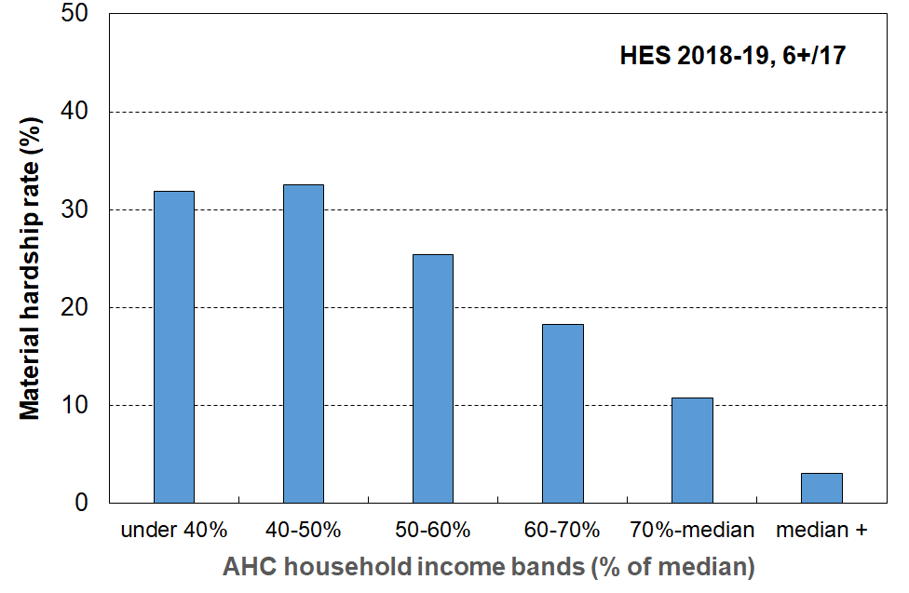
Material hardship rates (%) of children in selected AHC household income bands, HES 2018-19

Table C.6
Numbers and percentages of children in each AHC income band
(all children and children in households in hardship)
HES 2018-19
 |  | < 40% | 40-50% | 50-60% | 60-70% | 70-100% | Median + | Sum across
Numbers (000s) | All children (cell = # of 0-17s in income band) | 130 | 80 | 85 | 100 | 270 | 440 | 1105
 | # of 0-17s in the income band who are in hardship | 40 | 25 | 20 | 20 | 30 | 15 | 150
% | % of all 0-17s who are in the income band | 12 | 7 | 8 | 9 | 25 | 40 | 100
 | % of all 0-17s who are in hardship who come from this income band | 28 | 17 | 15 | 12 | 20 | 9 | 100
 | % of 0-17s in the income band who are in hardship | 32 | 33 | 25 | 18 | 11 | 3 | n/a

Table C.7 repeats the analysis in Table C.6 for each CPRA relative low-income measure rather than for selected bands.
Table C.7
Numbers and percentages of children below each CPRA relative low-income threshold
(all children and children in households in hardship)
HES 2018-19
 |  | BHC 50 | BHC 60 | AHC 40 | AHC 50 | AHC 60
Numbers (000s) | All children (0-17 yrs) | 145 | 245 | 130 | 205 | 295
 | # of 0-17s in the income range who are in hardship | 50 | 80 | 40 | 65 | 90
Percentages | % of all 0-17s who are in the income range | 13 | 22 | 12 | 19 | 27
 | % of 0-17s in the income range who are in hardship | 33 | 32 | 32 | 32 | 30
Reading note for Table C.7:
The numbers in this table are a little lower than the official Stats NZ numbers for 2018-19 as the treatment for VLI households with good material wellbeing has been applied. See Appendix 5 for further information, and Section O in the main report for detail,

What income bands do those in hardship come from?

The analysis on the previous page starts with those in low-income households and asks what proportion are in hardship? On this page, the other question is addressed: it starts with those in households in material hardship and asks what income bands they come from.

A central theme of this report is the relatively limited overlap between low-income and material hardship measures of poverty, for poverty understood as being ‘excluded from the minimum acceptable way of life in one’s own society because of inadequate resources’.

Figure C.4 shows the household income bands that children identified as in hardship come from (children living in households with a DEP-17 score of 6+/17). It shows that:
- (only) around one in four (28%) come from households with incomes below 40% AHC
- almost two in three (60%) come from households with incomes below 60% AHC
- just under one in three (29%) come from households with incomes above 70% AHC.

The second row in Table C.5 shows the distribution across income bands for those in what the CPRA refers to as ‘severe material hardship’ (ie 9+/17 missing items in DEP-17 list).
- one in three (32%) of these children come from households with incomes below 40% AHC
- half (51%) come from households with incomes under 50% AHC
- one in four (26%) come from households with incomes above 70% AHC.

Figure C.4
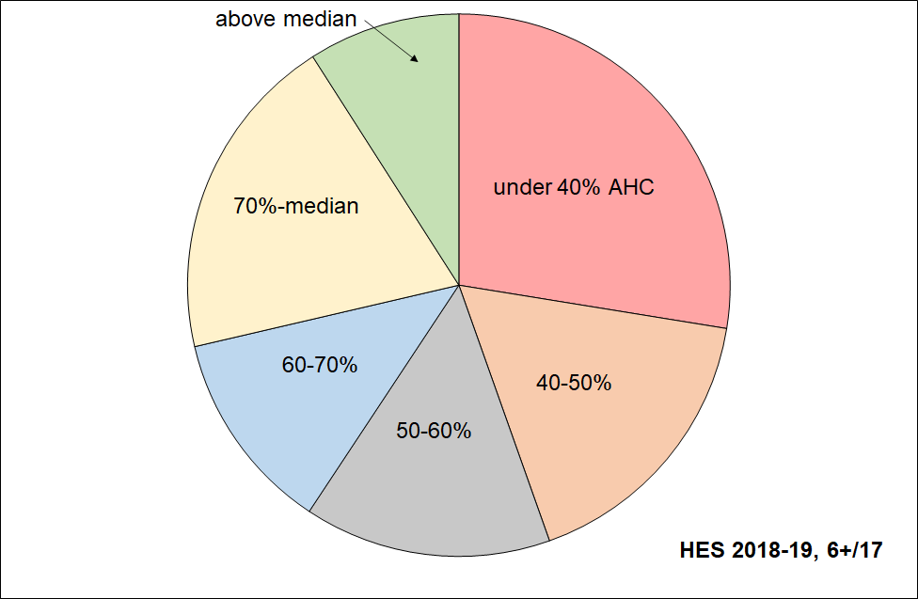
Distribution across household AHC income bands of children identified as in hardship (DEP-17 of 6+/17)

Table C.5
Distribution across household AHC income bands of children identified as in hardship (DEP-17, 6+/17),
and severe material hardship (9+/17)
HES 2018-19 | under 40% | 40-50% | 50-60% | 60-70% | 70%-median | above median | ALL, 0-17 yrs
All 0-17s | 12 | 7 | 8 | 9 | 25 | 40 | 100
DEP-17, 6+/17 | 28 | 17 | 15 | 12 | 20 | 9 | 100
DEP-17, 9+/17 | 32 | 19 | 12 | 10 | 19 | 7 | 100
Reading note for Table C.5 and Figure C.4
The numbers in the first row of this table are a little lower than the official Stats NZ numbers for 2018-19 as the treatment for VLI households with good material wellbeing has been applied. For example, AHC 60 from the above is 27% rather than the official 28%. See Appendix 5 for further information, and Section O in the main report for detail.

What is life like for those in low-income households who also report material hardship?

The combination measure (both low income and in material hardship) is used by Ireland to measure what they call ‘consistent poverty’, as in their view this (overlap) group best fits the high-level definition which has both an input (resources) and outcome dimension (minimum acceptable material standard of living). MSD uses the combination method as one of the measures in its multi-measure multi-level approach. It can be seen (as in Ireland) as the preferred measure, or simply as a measure of deeper poverty. It is one of the specified measures in the CPRA suite.

When looking at the relationship between those in low-income households and those in households reporting material hardship, there are six different groups to consider, as shown in Table C.12a.

The evidence of increasing day-to-day restrictions and hardship is clear, starting with those in neither group and moving through low income only … to both low-income and materially deprived, with the latter group clearly having the greatest restrictions on day-to-day living standards. For example, for children, the level of restrictions for the ‘both … and’ group is typically around double that for the low-income group.

Table C.12a
Profile for the six groups in the low income / hardship nexus (settings as for the CPRA measure),
HES 2018-19
HES 2018-19 | ALL | neither | low income only | low income | material hardship only | material hardship | both
Whole population
size of groups (% of whole population) | 100 | 74 | 17 | 22 | 5 | 9 | 5
% of whole population in households reporting:
put up with cold (a lot) through shortage of money | 8 | 3 | 6 | 16 | 45 | 46 | 47
use of food banks more than once in last 12 months | 3 | 1 | 3 | 9 | 17 | 23 | 29
not enough income for the basics | 11 | 5 | 14 | 24 | 46 | 51 | 56
borrowed from fam/friends for basics - more than once in last 12 months | 9 | 4 | 8 | 18 | 49 | 52 | 54
$500 expense – can’t pay | 21 | 12 | 27 | 41 | 78 | 83 | 88
life satisfaction of ‘dissatisfied / very dissatisfied’ | 6 | 3 | 6 | 11 | 25 | 27 | 29
Children (0-17 yrs)
size of groups (% of all children) | 100 | 68 | 19 | 27 | 6 | 14 | 8
% of all children in households reporting
put up with cold (a lot) through shortage of money | 9 | 3 | 7 | 18 | 43 | 43 | 43
use of food banks more than once in last 12 months | 5 | 1 | 4 | 12 | 19 | 26 | 32
not enough income for the basics | 13 | 5 | 14 | 26 | 43 | 49 | 53
borrowed from fam/friends for basics - more than once in last 12 months | 13 | 4 | 11 | 26 | 51 | 58 | 62
$500 expense - cant pay | 27 | 14 | 32 | 48 | 79 | 84 | 87
life satisfaction of ‘dissatisfied / very dissatisfied’ | 6 | 3 | 6 | 11 | 19 | 21 | 23
Notes: - The AHC 60% of median measure is used for low income.
- The DEP-17 measure is used for material deprivation, with the threshold set at 6+/17.
- Application of the MSD treatment drops AHC 60 from 28% to 27%. See Appendix 5 for more information.

What is life like for children (aged 6-17 years) living in ‘working’ and ‘beneficiary’ households?

Table C.13 (next page) provides a picture of what life is like for children aged 6-17 years living in ‘working’ and ‘beneficiary’ households.

The approach is much the same as earlier in this section: the hardship profiles are based on information about child-specific hardship items and general household items that are directly child-relevant (see Tables C.1 and C.2 above).

The two groups (‘working’ and ‘beneficiary’ households) are identified by their respective main sources of income over the 12 months prior to interview – market or government (includes core benefits, WFF, AS). Some of the ‘working’ households will receive WFF or AS payments, and some of the ‘beneficiary’ households will receive market income from part-time work.

Unsurprisingly, the left-hand panel of Table C.13 (next page) shows that children in ‘working’ households are on average much better off than those in ‘beneficiary’ households (fewer restrictions / deprivations). One of the main drivers of this difference is the higher income received on average by ‘working’ households ($30,400 pa compared with $13,000 for beneficiary households – note, these are equivalised dollars, not ‘ordinary’ dollars).

The right-hand panel to a considerable degree removes the income factor by looking only at households in the lower AHC income quintile (Q1). These low-income ‘working’ and ‘beneficiary’ households have more similar hardship profiles than for overall, though the children in low-income ‘working’ households are still better off (fewer restrictions / deprivations). This is possibly explained in part by their median equivalised household income ($14,400 pa) being a little higher than for ‘beneficiary’ households ($12,000 pa), but may also reflect household income trajectories over recent years as well.

The figures for children in beneficiary households also have value in themselves in that they show the degree of hardship and ‘missing out’ on basics that is experienced on average by these children.

The figures for children in all beneficiary households and those in the low income quintile (Q1) are very similar. This reflects the fact that most beneficiary households have incomes in Q1.

Table C.13
Deprivations/restrictions for children (6-17 yrs) in ‘working’, ‘beneficiary’ households HES 2018-19 (%)
 |  | ALL aged 6-17 yrs (%) |  |  | Q1 (AHC) aged 6-17 yrs (%)
 |  | ALL | Main income source |  | ALL | Main income source
 |  |  | Market | Govt |  | Market | Govt
Population in each group (000s) |  | 762 | 662 | 100 | 184 | 109 | 75
Material hardship rate (6+/17 for DEP-17) |  | 13 | 9 | 41 | 32 | 22 | 45
Child-relevant general household items
Income adequacy for basics | not enough | 13 | 9 | 38 | 28 | 20 | 40
Foodbank / other community help | more than once | 5 | 2 | 23 | 12 | 3 | 25
Borrowed for basics from family/friends | more than once | 11 | 8 | 34 | 25 | 16 | 38
Can pay unexpected $500 essential bill | no | 26 | 20 | 62 | 48 | 36 | 65
Delayed replace/repair appliances | a lot | 12 | 9 | 30 | 23 | 17 | 32
Car | don't have | 5 | 3 | 14 | 9 | 6 | 15
Holiday away each year | don't have - cost | 29 | 25 | 58 | 49 | 40 | 63
Holiday away each year | don't have – other | 10 | 10 | 12 | 10 | 10 | 10
Dampness or mould | major problem | 8 | 7 | 18 | 15 | 12 | 20
Can afford to keep home warm | no | 10 | 6 | 31 | 22 | 13 | 35
Crowding | 1+ more bedrooms needed | 13 | 11 | 26 | 19 | 15 | 25
Life satisfaction | dissatis / very dissatis | 6 | 5 | 14 | 12 | 10 | 15
Child-specific items (6-17 yrs)
Two pairs of shoes | don't have | 7 | 4 | 25 | 16 | 8 | 28
Two sets winter clothes | don't have | 2 | 1 | 6 | 4 | 3 | 6
Waterproof coat | don't have - cost | 4 | 3 | 15 | 10 | 6 | 17
Waterproof coat | don't have - other | 4 | 4 | 6 | 7 | 7 | 7
Separate bed | don't have | 5 | 4 | 15 | 11 | 8 | 16
Fruit and veg daily | don't have | 7 | 5 | 25 | 17 | 8 | 28
Protein meal daily | don't have | 6 | 4 | 21 | 15 | 10 | 22
Computer / internet | don't have | 6 | 4 | 19 | 12 | 7 | 19
Friends around to play / eat | don't have - cost | 3 | 2 | 13 | 8 | 3 | 15
Friends around to play / eat | don't have - other | 8 | 7 | 14 | 13 | 13 | 14
Birthday and other celebrations | don't have - cost | 5 | 3 | 18 | 11 | 4 | 20
Birthday and other celebrations | don't have - other | 7 | 7 | 11 | 10 | 10 | 11
Unable to fund school trips | a lot | 3 | 2 | 14 | 8 | 3 | 15
Had to limit participation in sport | a lot | 6 | 4 | 19 | 12 | 6 | 21
Had to go without special interests | a lot | 7 | 5 | 21 | 15 | 9 | 23
Continued to wear worn out / wrong size shoes/clothes | a lot | 3 | 2 | 11 | 7 | 3 | 12
Notes:
- In this report, all cells with sample sizes of less than 15 are suppressed. Several come close in this table (they have 18 households in sample), but none are below 15.
- For all 6-17 year olds, 13% are in ‘beneficiary’ households and 87% in ‘working’ households. The Q1 composition is 41% and 59% respectively.

Children across the full material wellbeing spectrum

The focus so far has been on material hardship, low incomes and financial stress (‘child poverty’), all of which are matters of considerable ongoing public policy interest. This justifiable focus can sometimes mean that it is easy to forget that the vast majority of New Zealand children are living in households in which their basic material needs are consistently met, and most in fact experience a good to very good material standard of living.

MSD’s Material Wellbeing Index (MWI) ranks households across the full material wellbeing spectrum from low to high, rather than just being focussed on the low end as the DEP-17 and EU-13 indices are. Applying the MWI to the 2018-19 HES data enables the creation of a fuller picture of how all children are faring.

The analysis in this section divides the full spectrum into six groups for illustrative purposes:
- The boundary for the lowest group was selected to make the MWI hardship rate correspond as close as possible to the 6+/17 DEP-17 hardship rate (13%), the one used by Stats NZ in the CPRA child poverty statistics.
- Group 2 could be labelled ‘just getting by’ (the next 15% of children).
- The lower boundary for the highest group was selected so that this group had none of the basics missing and had virtually all the ‘freedoms’ (see text and Table E.1 below).
- The boundaries for the remaining three groups were more arbitrary, but the decisions reflected the fact that the MWI’s discriminatory power diminishes the higher the MWI scores. Group 5 was therefore made larger than Groups 3 and 4, and clearly includes households not in the same league as those in Group 6, but much better off on average than Group 4.

Table E.1 shows the distribution of the whole population and of children across the six groupings, and then uses selected survey items to give an idea of the standard of living for households with children in each grouping or band. This indicative calibration exercise uses items covering both the basics that all should have and none should go without, and some non-basics that most aspire to (‘freedoms’ for short). Table E.2 (next page) repeats the analysis using the same 18 items as in previous tables.

Table E.1
Using household or respondent items to give an indication of the standard of living in each MWI band:
children in their households, HES 2018-19
Group # | 1 | 2 | 3 | 4 | 5 | 6 | ALL
MWI score bands | 0-11 | 12-18 | 19-24 | 25-29 | 30-33 | 34-35
Whole population - across 6 groups (%) | 8 | 11 | 15 | 21 | 25 | 19 | 100
Children (0-17 yrs) – across 6 groups (%) | 12 | 15 | 18 | 20 | 22 | 14 | 100
% of children in households which report these deprivations
No access to car | 12 | 8 | 5 | 3 | 1 | 1 | 5
Help from foodbank more than once in last 12 months | 27 | 8 | 2 | 0 | 0 | 0 | 5
Cut back / went without fresh fruit and veg ‘a lot’ | 28 | 4 | 1 | 1 | 0 | 0 | 4
Cannot keep home warm | 47 | 18 | 5 | 1 | 0 | 1 | 10
Not enough income for basics | 52 | 22 | 9 | 4 | 2 | 1 | 13
% of children in households which report these ‘freedoms’
Holidays away from home at least once each year (have) | 19 | 33 | 55 | 69 | 81 | 90 | 61
$300 spot purchase – not at all restricted | 0 | 1 | 3 | 7 | 23 | 86 | 19
Clothes/shoes for self - not limited by money | 0 | 1 | 4 | 10 | 27 | 88 | 21
Hobbies and special interests – economised ‘not at all’ | 4 | 10 | 17 | 38 | 75 | 98 | 42
Local trips – economised ‘ not at all’ because of money | 4 | 13 | 34 | 60 | 92 | 99 | 54
Dentist – postponed ‘not at all’ because of money | 7 | 16 | 34 | 57 | 87 | 99 | 53
Broken appliances – delayed repairing or replacing ‘not at all’ | 14 | 32 | 50 | 72 | 94 | 100 | 64
Satisfied / very satisfied with life | 44 | 65 | 80 | 86 | 93 | 95 | 80
Note for Table E.1: any cells ≤ 1.5% are recorded as ‘0’.

Table E.2
Using child-relevant household items and child-specific items
to give an indication of the standard of living experienced by children in each MWI band.
HES 2018-19
Group # |  | 1 | 2 | 3 | 4 | 5 | 6 | ALL
MWI score bands |  | 0-11 | 12-18 | 19-24 | 25-29 | 30-33 | 34-35
Whole population - across 6 groups (%) |  | 8 | 11 | 15 | 21 | 25 | 19 | 100
Children (6-17 yrs) – across 6 groups (%) |  | 12 | 15 | 18 | 20 | 22 | 14 | 100
Child-relevant general HH items | Response
Income adequacy for basics | not enough | 52 | 23 | 9 | 5 | 2 | 0 | 13
Foodbank / other community help | more than once | 27 | 7 | 2 | 0 | 0 | 0 | 5
Borrowed for basics from fam/friends | more than once | 51 | 20 | 8 | 3 | 0 | 0 | 11
Can pay unexpected $500 bill | no | 85 | 55 | 26 | 12 | 4 | 0 | 26
Delayed replace/repair appliances | a lot | 56 | 22 | 9 | 2 | 0 | 0 | 12
Car | don't have | 12 | 8 | 4 | 3 | 0 | 2 | 5
Holiday away each year | don't have - cost | 79 | 62 | 35 | 17 | 6 | 0 | 29
Holiday away each year | don't have - other | 3 | 8 | 11 | 14 | 12 | 10 | 10
Dampness or mould | major problem | 34 | 15 | 7 | 2 | 0 | 0 | 8
Can afford to keep home warm | no | 48 | 17 | 5 | 0 | 0 | 0 | 10
Crowding | 1+ more rooms needed | 29 | 20 | 16 | 7 | 8 | 4 | 13
Crowding | 2+ needed - severe | 7 | 4 | 4 | 0 | 2 | 0 | 3
Life satisfaction | dissatis / very dissatis | 22 | 12 | 5 | 3 | 2 | 0 | 6
Child-specific items
Two pairs of shoes | don't have | 32 | 10 | 3 | 0 | 0 | 0 | 7
Two sets winter clothes | don't have | 11 | 2 | 0 | 0 | 0 | 0 | 2
Waterproof coat | don't have - cost | 25 | 5 | 2 | 0 | 0 | 0 | 4
Waterproof coat | don't have - other | 7 | 8 | 5 | 3 | 2 | 0 | 4
Separate bed | don't have | 22 | 8 | 4 | 0 | 0 | 0 | 5
Fruit and veg daily | don't have | 38 | 10 | 3 | 0 | 0 | 0 | 7
Protein meal daily | don't have | 13 | 3 | 0 | 0 | 0 | 0 | 3
Computer / internet | don't have | 23 | 9 | 5 | 2 | 0 | 0 | 6
Friends around to play / eat | don't have - cost | 18 | 5 | 0 | 0 | 0 | 0 | 3
Friends around to play / eat | don't have - other | 17 | 15 | 9 | 5 | 3 | 0 | 8
Birthday and other celebrations | don't have - cost | 26 | 9 | 2 | 0 | 0 | 0 | 5
Birthday and other celebrations | don't have - other | 12 | 12 | 8 | 6 | 4 | 3 | 7
Unable to fund school trips | a lot | 20 | 5 | 0 | 0 | 0 | 0 | 3
Had to limit participation in sport | a lot | 29 | 10 | 2 | 0 | 0 | 0 | 6
Had to go without special interests | a lot | 31 | 14 | 2 | 0 | 0 | 0 | 7
Continued to wear worn out / wrong size shoes/clothes | a lot | 18 | 4 | 0 | 0 | 0 | 0 | 3
DEP-17 material hardship, 6+/17 |  | 88 | 88 | 16 | 0 | 0 | 0 | 0
DEP-17 severe material hardship, 9+/17 |  | 44 | 44 | 0 | 0 | 0 | 0 | 0
Note for Table E.2: any cells ≤ 1.5% are recorded as ‘0’.

The charts in Figure E.1 below show how children in selected household contexts are distributed across the material wellbeing spectrum.
- The six groupings range from material hardship (red) through to very well off (dark green on the right).
- Each cluster of six adds to 100%.
- The right-hand cluster in top chart below shows how all children are distributed across the material well-being spectrum.

Figure E.1
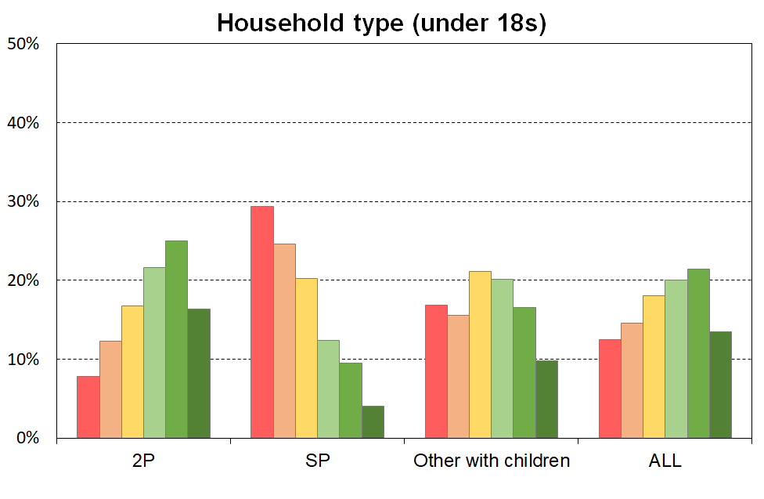
The material wellbeing of children in selected household contexts (6 groupings using MWI scores)
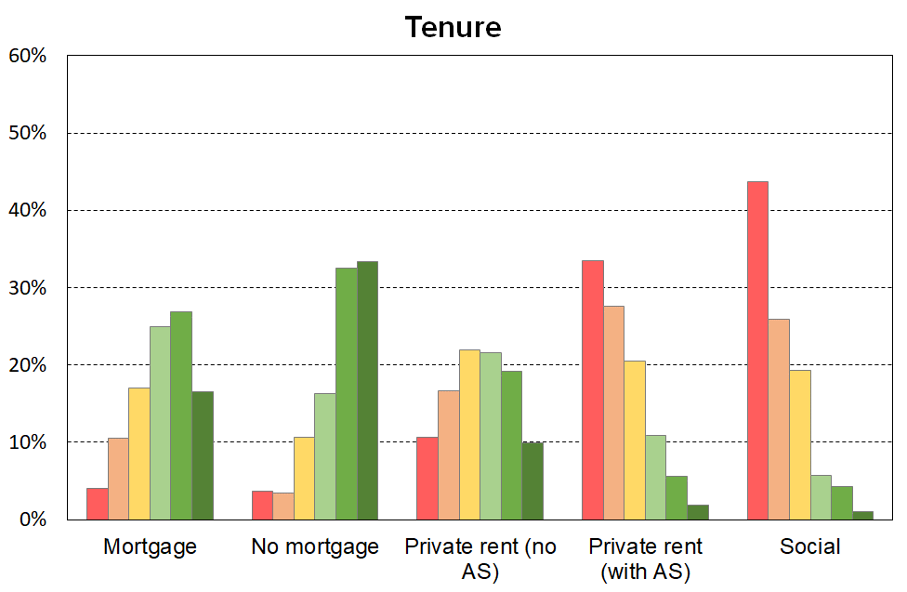
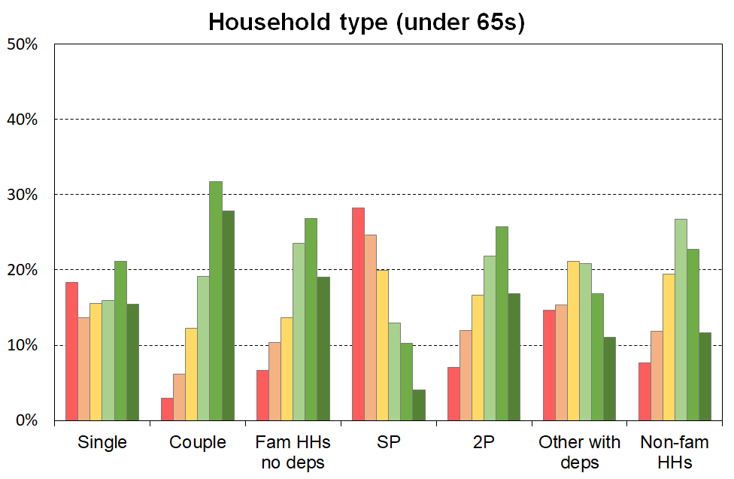
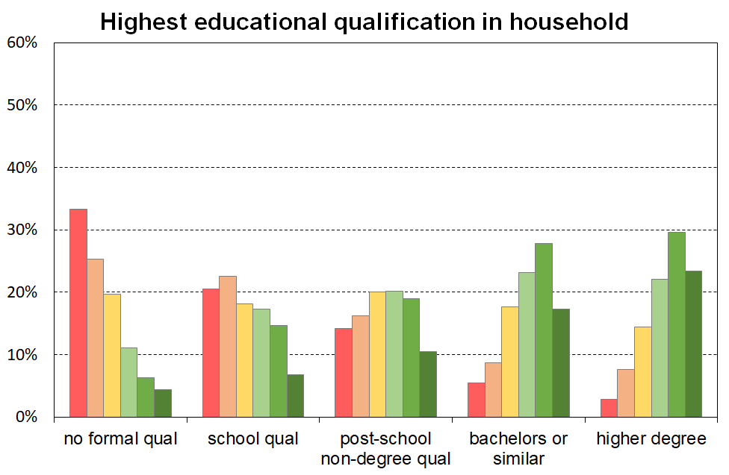
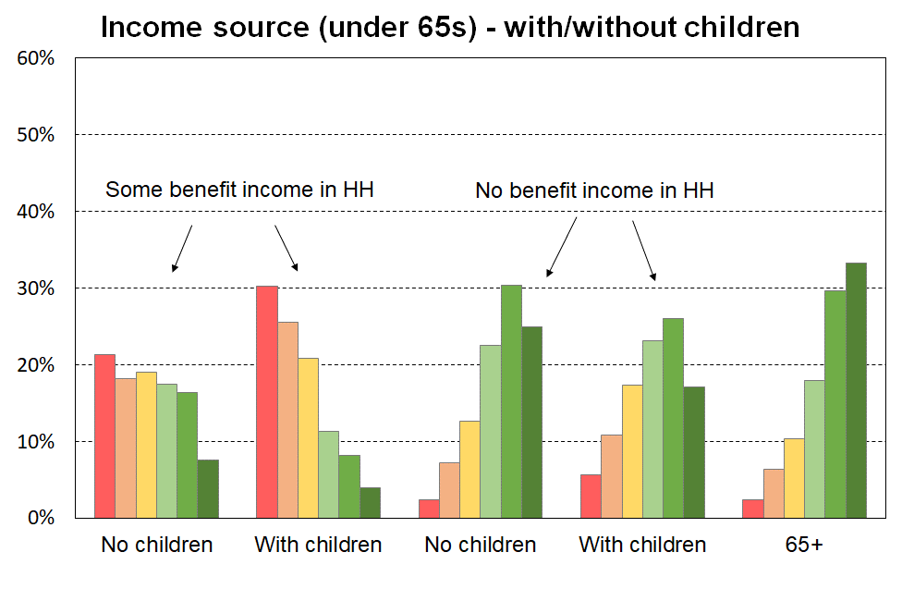
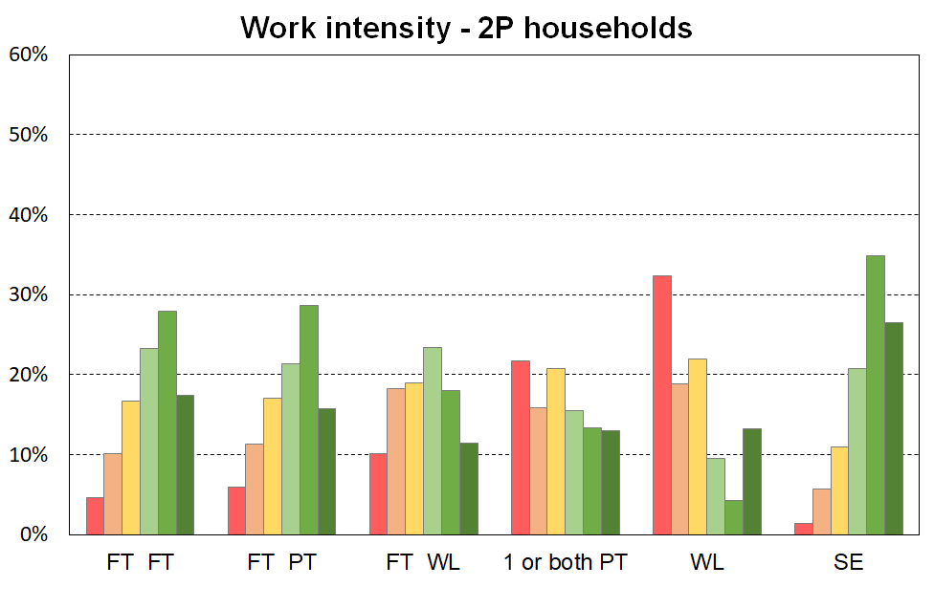
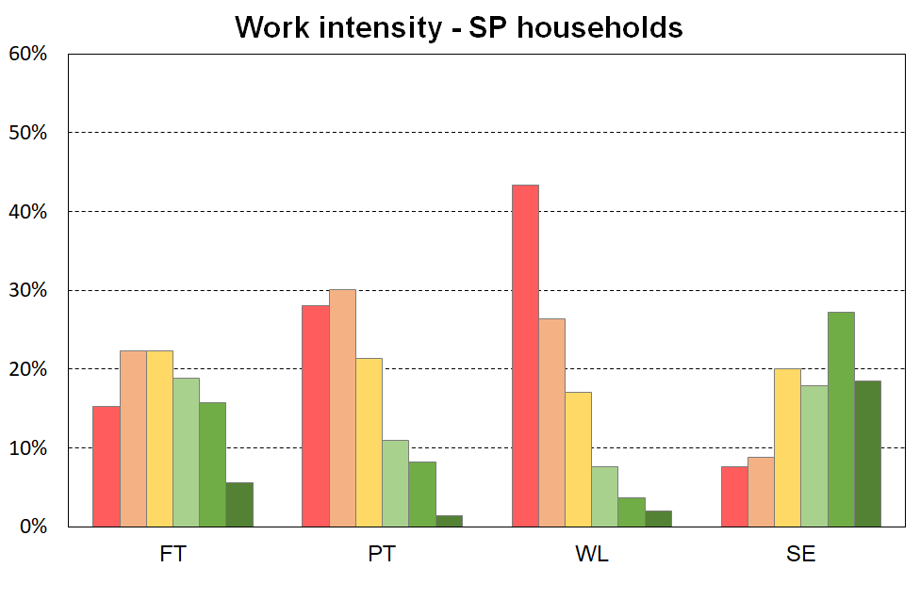

The left-hand chart in Figure E.2 shows how children are distributed across the material wellbeing spectrum by their ethnicity (‘total’ definition).

When interpreting the chart, it is important to note that the information is descriptive only and should not be used as if ethnicity is being portrayed as causal in relation to MWI scores (material wellbeing). To support a causality narrative or conclusion, a starting point would be regression analysis in which other relevant variables are included to control for differences in education, household type, household employment hours, and so on. Even then, further investigation would be needed to understand whether any in the set of control variables themselves have any significant dependency on ethnicity.

The right-hand chart in Figure E.2 looks at the group of children who live in households in which the maximum educational qualification is a tertiary degree. This in effect introduces a simple control for educational qualification (at the degree level). There is a greater similarity for the material wellbeing profiles for these children across the ethnic groupings than there is when all children are looked at, though some differences are still evident.

Figure E.2
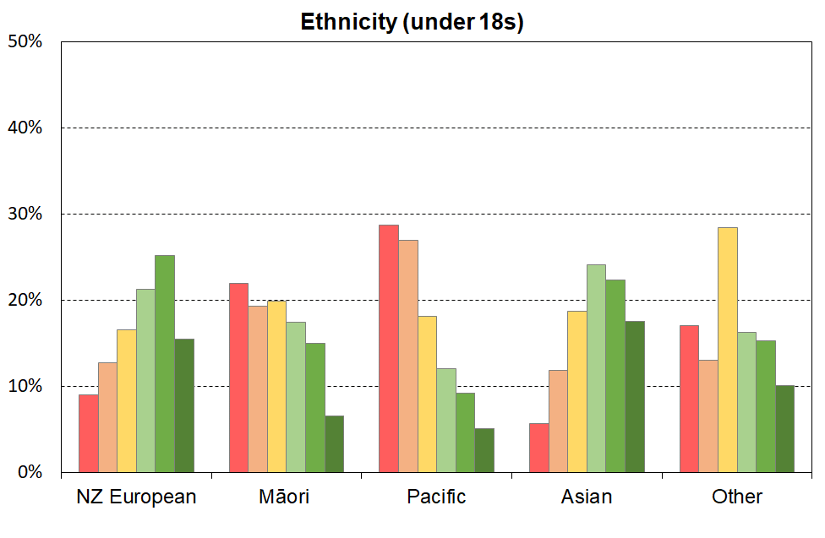
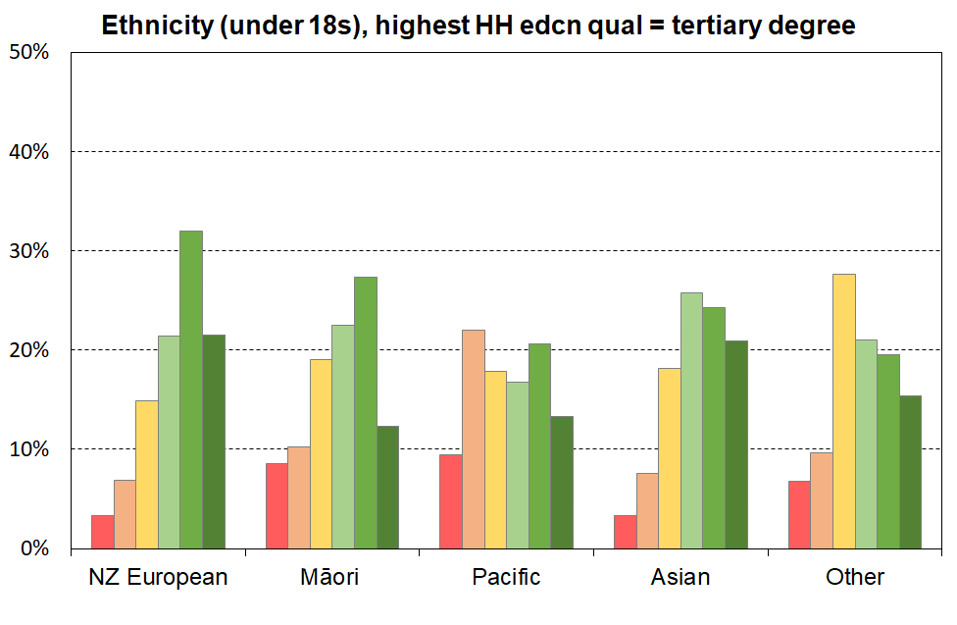
The material wellbeing of children by their ethnicity (6 groupings using MWI scores)

Poverty experienced

The understanding of poverty and the associated measurement approach used in this report (and in the full MSD reports) is narrowly focussed. It is about ‘unacceptable financial or material hardship’ and the insights about this that can be gleaned from a large-scale national survey.

This is a legitimate focus but, in pursuing it, it is important to be aware that there is much more to ‘poverty’ than what can be measured (albeit imperfectly) through analysis of data from income or deprivation surveys. These can tell us about the material core (‘unacceptable material or financial hardship’), but a different type of research is needed to give insight into how this unacceptable hardship is experienced and understood and felt.

What is at issue here is the non-material as well as the material manifestations of poverty. Poverty has to be understood not just as a disadvantaged and insecure economic condition but also as a shameful and corrosive social relation … [The non-material aspects include] … lack of voice; disrespect, humiliation and assault on dignity and self-esteem; shame and stigma; powerlessness; denial of rights and diminished citizenship … They stem from people in poverty’s everyday interactions with the wider society and from the way they are talked about and treated by politicians, officials, the media and other influential bodies. Lister (2004:7)

What people on low incomes report is a situation of great complexity in which the pressures they face are cumulative. Basics become luxuries that have to be prioritised and saved for. Solutions to one problem create problems of their own, as when saving on heating exacerbates illness and borrowing from the rent money generates arrears and threats of eviction. Poverty feels like entrapment when options are always lacking, the future is looming and unpredictable, and guilt seems ever present, arising from an inability to meet one’s children’s needs, one’s own expectations and society’s demands. Tomlinson and Walker (2009:16)

[Poverty] is to live under the dictatorship of material necessity without choice and control in one’s daily life. That’s what poverty is, it’s about freedom and power and the lack thereof. Ringen (2009:7)

Sen and shame

It has become popular in discussions of human wellbeing to use Amartya Sen’s dictum that the basic concern of human development or of ‘the good life’ is ‘our capability to lead the kind of lives we have reason to value’. The same language is sometimes used in relation to discussions around strategies to address poverty, with the goal of poverty alleviation intervention being characterised as helping people ‘lead the kind of lives they have reason to value’.

In using only this aspect of Sen’s thinking, it misses two key elements that Sen himself identifies in his writing on the conceptualisation of poverty. The first is the matter of the ‘irreducible absolutist core’– poverty alleviation is about having households attain a minimum acceptable standard, which may nevertheless be (well) below ‘leading the kind of lives they have reason to value’. The second is how for Sen and for ‘the poor’, shame is at the core of poverty experienced. There is a case that the bumper-sticker type of use of the notion of ‘leading the kind of lives we have reason to value’ in the context of poverty discourse both misrepresents Sen on poverty and understates the stress of life at the hard end.

Appendix 1
Item lists for indices used in the report and the full list of HES non-monetary indicator items including the child specific suite

Composition of DEP-17
Enforced lack of essentials (for respondent or household as a whole)
meal with meat, fish or chicken (or vegetarian equivalent) at least each 2nd day
two pairs of shoes in good repair and suitable for everyday use
suitable clothes for important or special occasions
presents for family and friends on special occasions
home contents insurance
Economised, cut back or delayed purchases ‘a lot’ because money was needed for other essentials (not just to be thrifty or to save for a trip or other non-essential)
went without or cut back on fresh fruit and vegetables
bought cheaper cuts of meat or bought less than wanted
put up with feeling cold to save on heating costs
postponed visits to the doctor
postponed visits to the dentist
did without or cut back on trips to the shops or other local places
delayed repairing or replacing broken or damaged appliances
In arrears more than once in last 12 months (because of shortage of cash at the time, not through forgetting)
rates, electricity, water
vehicle registration, insurance or warrant of fitness
Financial stress and vulnerability
borrowed money from family or friends more than once in the last 12 months to cover everyday living costs
feel ‘very limited’ by the money available when thinking about purchase of clothes or shoes for self (options were: not at all, a little, quite limited, and very limited)
could not pay an unexpected and unavoidable bill of $500 within a month without borrowing
Note: an enforced lack is an item that is wanted but not possessed because of the cost.

Composition of EU-13
Seven household deprivations (enforced lacks)
ability to face unexpected expenses of NZD1500
have one week’s annual holiday away from home
avoid arrears in mortgage or rent, utility bills or HP instalments
have a meal with meat, fish or chicken every second day
keep the home adequately warm
have access to a car / van for personal use
replace worn-out furniture
Six personal deprivations (enforced lacks)
replace worn-out clothes by some new ones
have two pairs of properly fitting shoes
spend a small amount of money each week on oneself
have regular leisure activities
have a get together with friends/family for a drink/meal at least monthly
have both a computer and an internet connection

The 37 items in HES 2018-19 and 2019-20, and how the relevant items are scored for the three indices (MWI, DEP-17 and EU-13)
Item description |  | MWI | DEP-17 | EU-13
Ownership or participation (have/do, don’t have/do and enforced lack (EL))
For DEP-17 and EU-13, score an EL as 1, otherwise 0
For MWI, score an EL as a 0, otherwise 1
1 | Two pairs of shoes in a good condition and suitable for daily activities
2** | Replace worn-out clothes by some new (not second-hand) ones |  | -
3 | Suitable clothes for important or special occasions |  |  | -
4 | Contents insurance |  |  | -
5 | A meal with meat, fish or chicken (or vegetarian equivalent) at least each 2nd day
6 | A good bed |  | - | -
7** | Keep home adequately warm | - | -
8 | Presents for family/friends on special occasions |  |  | -
9 | Holiday away from home at least once every year |  | -
10 | Overseas holiday at least once every three years |  | -
11* | Access to car or van for personal use | - | -
12* | Access to both a computer and internet connection at home | - | -
13* | Have a get together with friends or extended family for a drink or meal at least once a month | - | -
Economising (not at all, a little, a lot) – to keep down costs to help in paying for (other) basic items (not just to be thrifty or to save for a trip or other non-essential)
For DEP-17 and EU-13, score ‘a lot’ as 1, otherwise 0
For MWI, score ‘not at all as 2, ‘a little’ as 1, and ‘a lot’ as 0
14 | Gone without or cut back on fresh fruit and vegetables |  |  | -
15 | Buy cheaper cuts of meat or bought less meat than you would like |  |  | -
 | Continued wearing worn out clothes (to 2018 only) |  | - | -
16 | Put up with feeling cold |  |  | -
17 | Do without or cut back on trips to the shops or other local places |  |  | -
18 | Delay replacing or repairing broken or damaged appliances |  |  | -
19* | Delay replacing or repairing broken or worn out furniture | - | -
20 | Spent less on hobbies or other special interests than you would like |  | -
21 | Postponed visits to the doctor |  |  | -
22 | Postponed visits to the dentist |  |  | -
Housing problems (no problem, minor problem, major problem … in the last 12 months)
For MWI, score as 2, 1 and 0 respectively.
23 | Dampness or mould |  | - | -
24 | Heating or keeping it warm in winter |  | - | -
 | Crowding (derived variable = Canadian Index) | - | - | -
Freedoms/Restrictions
25 | About how much money, on average, do you have each week for spending on things for yourself without consulting anyone else? (under $10, 10-25, 26-50, >50)  For EU-13, score ‘under$10’ as 1, and anything else as 0 | - | -
26 | When buying, or thinking about buying, clothes or shoes for yourself, how much do you usually feel limited by the money available? (4 point response options: ‘not at all limited, a little limited, quite limited, very limited)  For DEP-17, score ‘very limited’ as 1, otherwise 0.  For MWI, score as 3, 2, 1 and 0 respectively. |  |  | -
27 | $300 spot purchase for an ’extra’, not a necessity – how limited do you feel about buying it? (5 point response options: not at all limited, a little limited, quite limited, very limited, couldn’t buy it)  For MWI, score as 4, 3, 2, 1 and 0 respectively. |  | - | -
28 | $500 unexpected unavoidable expense on an essential – can you pay in a month without borrowing? (yes/no)  For DEP-17, score ‘no’ as 1, and ‘yes’ as 0  For MWI, score ‘yes’ as 2 and ‘no’ as 0 |  |  | -
29* | $1500 unexpected unavoidable expense on an essential – can you pay in a month without borrowing? (yes/no)  For EU-13, score ‘no’ as 1, and ‘yes’ as 0 | - | -

Item description |  | MWI | DEP-17 | EU-13
Financial strain (in last 12 months) (not at all, once, more than once)
For DEP-17 and EU-13, score ‘more than once’ as 1, otherwise 0
For MWI, score ‘not at all’ as 2, ‘once’ as 1, ‘more than once’ as 0
30 | Behind on rates or utilities |  |  | (any one, more than once)
31** | Behind on HP and other loan payments
32 | Behind on rent or mortgage | - | -
33 | Behind on car registration, wof or insurance |  |  | -
34 | Borrowed from family or friends to meet everyday living costs | - |  | -
35 | Received help in the form of food, clothes or money from a welfare or community organisation such as a church or food bank | - | - | -
Global self-ratings
36 | Adequacy of income to cover basics of accommodation, food, clothing, etc (not enough, only just enough, enough, more than enough) | - | - | -
37 | Satisfaction with life (very satisfied, satisfied, neither, dissatisfied, very dissatisfied) | - | - | -
* introduced in 2018 HES
** introduced in 2019 HES
No asterisk = available from 2013

The 20 child-specific items in the 2018-19 and 2019-20 HES
Have/do, don’t have/do for each of your children (Respondents are asked whether any have/do lacks are because of cost or for some other reason.)
two pairs of shoes in a good condition that are suitable for daily activities
two sets of warm winter clothes
waterproof coat
all the uniform required by their schools
a separate bed
fresh fruit and vegetables daily
a meal with meat, fish or chicken (or vegetarian equivalent) each day
a range of books at home suitable for their ages
a suitable place at home to do school homework
their friends around to play and eat from time to time
their friends around for a birthday party
good access at home to a computer and the internet for homework
a mobile phone if aged 11 or older
Economising (not at all, a little, a lot) – to keep down costs to help in paying for (other) basic items (not just to be thrifty or to save for a trip or other non-essential). In this report, economising ‘a lot’ is taken as equivalent to an enforced lack.
postponed a child's visit to the doctor
postponed a child's visit to the dentist
did not pick up a child's prescription
been unable to pay for a child to go on a school trip or other school event
had to limit children’s involvement in sport
had your children go without music, dance, kapa haka, art, swimming or other special interest lessons
had your children continue wearing shoes or clothes that were worn out or the wrong size
Note: None of these items are included in DEP-17 or EU-13 which are general purpose indices that are deigned to apply to all ages and household types and so on.

Appendix 2
Low-income thresholds

Table 2A

50% and 60% low-income thresholds or ‘poverty lines’ for various household types (BHC)
($2021, per week) (Using the modified OECD equivalence scale)
 |  | REL (‘moving’) |  | CV (‘anchored’ /‘fixed’)
Household type | Equiv ratio | 50% of 2019-20 median in $2021 | 60% of 2019-20 median in $2021 | 50% of 2006-07 median in $2021 | 60% of 2017-18 median in $2021
One-person HH | 1.0 | 410 | 490 | 330 | 490
SP, 1 child <14 | 1.3 | 530 | 635 | 430 | 635
SP, 2 children <14 | 1.6 | 655 | 785 | 530 | 780
SP, 3 children <14 | 1.9 | 775 | 930 | 630 | 925
Couple only | 1.5 | 610 | 735 | 495 | 730
2P, 1 child <14 | 1.8 | 735 | 880 | 595 | 880
2P, 2 children <14 | 2.1 | 855 | 1030 | 695 | 1025
2P, 3 children <14 | 2.4 | 980 | 1175 | 795 | 1170
2P, 4 children <14 | 2.7 | 1100 | 1320 | 895 | 1320
3 adults | 2.0 | 815 | 980 | 660 | 975

Table 2B

(40%, 50% and 60% low-income thresholds or ‘poverty lines’ for various household types (AHC)
($2021, per week) (Using the modified OECD equivalence scale)
 |  | REL (‘moving’) |  |  | CV (‘anchored’ /‘fixed’)
Household type | Equiv ratio | 40% of 2019-20 median in $2021 | 50% of 2019-20 median in $2021 | 60% of 2019-20 median in $2021 | 50% of 2006-07 median in $2021 | 60% of 2017-18 median in $2021
One-person HH | 1.0 | 250 | 310 | 375 | 245 | 370
SP, 1 child <14 | 1.3 | 325 | 405 | 485 | 315 | 480
SP, 2 children <14 | 1.6 | 400 | 500 | 600 | 390 | 590
SP, 3 children <14 | 1.9 | 475 | 595 | 710 | 460 | 705
Couple only | 1.5 | 375 | 470 | 560 | 365 | 555
2P, 1 child <14 | 1.8 | 450 | 560 | 675 | 440 | 665
2P, 2 children <14 | 2.1 | 525 | 655 | 785 | 510 | 775
2P, 3 children <14 | 2.4 | 600 | 750 | 900 | 585 | 890
2P, 4 children <14 | 2.7 | 675 | 840 | 1010 | 655 | 1000
3 adults | 2.0 | 500 | 625 | 750 | 485 | 740

Appendix 3
Two-letter codes for European Countries referred to in the International Section

Table 3.1
European countries and their two-letter codes
AT | Austria | IS | Iceland
BE | Belgium | IT | Italy
CH | Switzerland | LT | Lithuania
CY | Cyprus | LU | Luxembourg
CZ | Czech Republic | LV | Latvia
DE | Germany | MT | Malta
DK | Denmark | NL | Netherlands
EE | Estonia | NO | Norway
EL | Greece | PL | Poland
ES | Spain | PT | Portugal
FI | Finland | RO | Romania
FR | France | SE | Sweden
HR | Croatia | SI | Slovenia
HU | Hungary | SK | Slovakia
IE | Ireland | UK | United Kingdom

Appendix 4
Income of households in receipt of main benefits

Income of households in receipt of main benefits

Children in beneficiary households typically make up around half of children in low-income households (using the CPRA measures) and around half those in households reporting material hardship. Trends in the incomes of beneficiary households with children are therefore highly relevant for understanding the New Zealand child poverty story.

Figures C.7 and C.8 below show the long-run trends in beneficiary household income from two perspectives for selected benefit types:
- in real inflation-adjusted terms
- relative to the after-tax average wage.

In this analysis, beneficiary income includes core benefits plus Family Tax Credit and its predecessors (Family Benefit / Support). The income is net income (ie after tax). It does not include the Winter Energy Payment, Best Start or the Accommodation Supplement.

The time series goes from 1 April 1945 to 1 April 2022, and includes the changes announced in Budget 21. In 2022, beneficiary income for sole parent households with children (<12) will be higher in real terms for the first time since the 1991 benefit cuts.

If the information in the charts that follow is being used to help form a view about the adequacy of beneficiary incomes, there are several factors to bear in mind in addition to the income trends and levels:
- Some of the non-included payments noted above have played an increasing role in the income support system.
- The increases in housing costs as a proportion of income for low-income households means that ‘residual’ or ‘after-housing-costs-are-deducted’ income has not in recent years risen as much as ‘before-housing-costs’ income, and in some particular cases may have fallen.
- Even if 2021 or 2022 levels are assessed as ‘adequate’, this would likely have to be qualified by something like ‘for households with no significant health / medical / disability-related costs and no high debt servicing costs and a reasonable stock of household appliances and furniture’. Where these provisos are not met, then the ‘adequate’ assessment may no longer be justified.

Figure C.7 shows the trends in inflation-adjusted (‘real’) beneficiary incomes for the most common beneficiary households / families.

In 2022, beneficiary income for sole parent households with children (<12) will be higher in real terms for the first time since the 1991 benefit cuts.

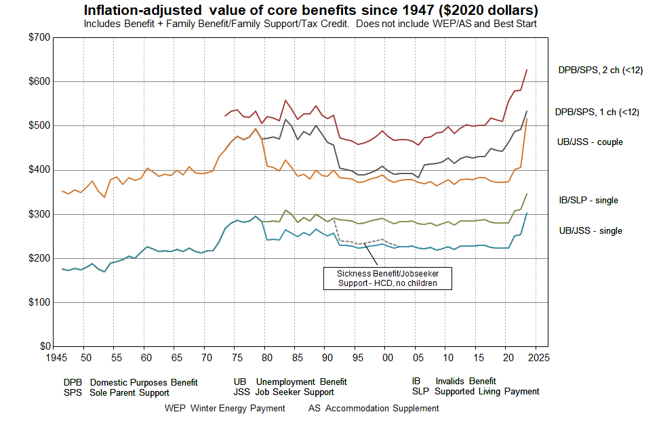
Figure C.7
Source: MSD collation from information from the Royal Commission on Social Security, Department of Social Welfare Annual Reports, Income Support Service / Work and Income Fact Sheets and Budget 2021.

Some key dates
1946 Universal Family Benefit
1972 Royal Commission on Social Security
1991 Benefit cuts
2004-05 Working for Families
2016 Child Material Hardship Package
2018 Families Package
2020 $25 increase (April)
2020 Indexation to average wage commences (Apr)
2021 $20 pw increase (July)
2022 WEAG plus $15 pw for families with children (Apr)

Figure C.8 compares beneficiary income with the average wage (after tax). The child-related information is in the DPB/SPS trends. From the late 1980s through to 2019 there was a steady decline in beneficiary incomes compared with the average wage, albeit with a short-run reversal for sole parents when Working for Families was introduced in 2004-05. From 2020 to 2022 beneficiary incomes for sole parent households improved relative to the average wage.

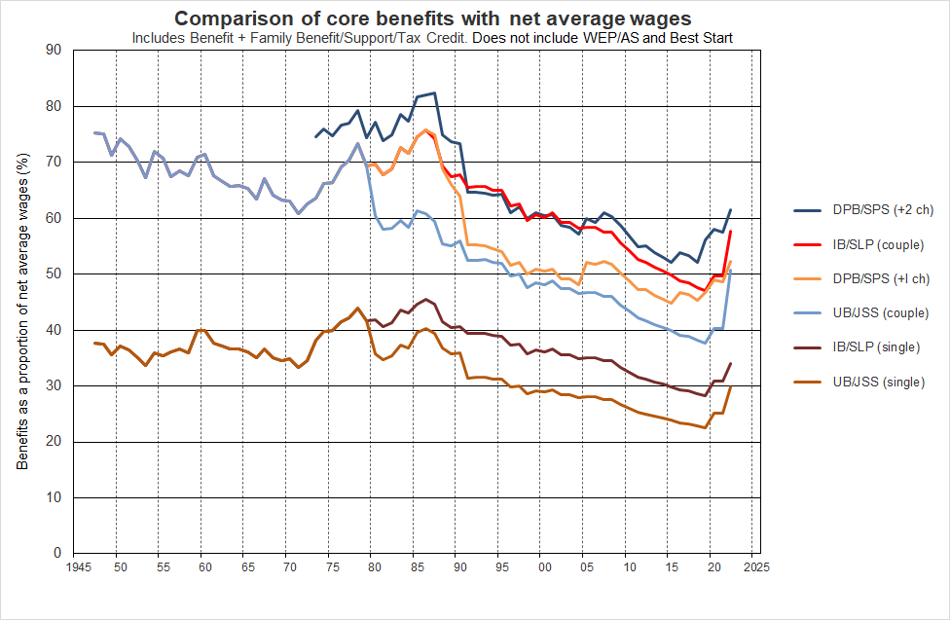
Figure C.8
Source: MSD collation from information from the Royal Commission on Social Security, Department of Social Welfare Annual Reports, Income Support Service / Work and Income Fact Sheets and Budget 2021.

Some key dates
1946 Universal Family Benefit
1972 Royal Commission on Social Security
1991 Benefit cuts
2004-05 Working for Families
2016 Child Material Hardship Package
2018 Families Package
2020 $25 increase (April)
2020 Indexation to average wage commences (Apr)
2021 $20 pw increase (July)
2022 WEAG plus $15 pw for families with children (Apr)

The New Zealand Superannuation (NZS) ‘married couple’ rate has for some time been at 66% of the net average wage, and the ‘single-living-alone’ rate at 43% (65% of the ‘married couple’ rate). This compares with around 50% for a UB/JSS couple and 30% for a UB/JSS single in 2022, as shown in the chart above.

Figure C.9 uses the same data source as Figure C.8 but shows the actual trend in the average wage (after tax) and the minimum wage (before tax). It compares beneficiary income for selected beneficiary households / families with the average wage (after tax) and the minimum wage (before tax).

The child-related information is in the DPB/SPS trends. From the late 1980s through to 2019 there was a steady decline in beneficiary incomes compared with the average wage, albeit with a short-run reversal for sole parents when Working for Families was introduced in 2004-05. From 2020 to 2022 beneficiary incomes for sole parent households improved relative to the average wage.

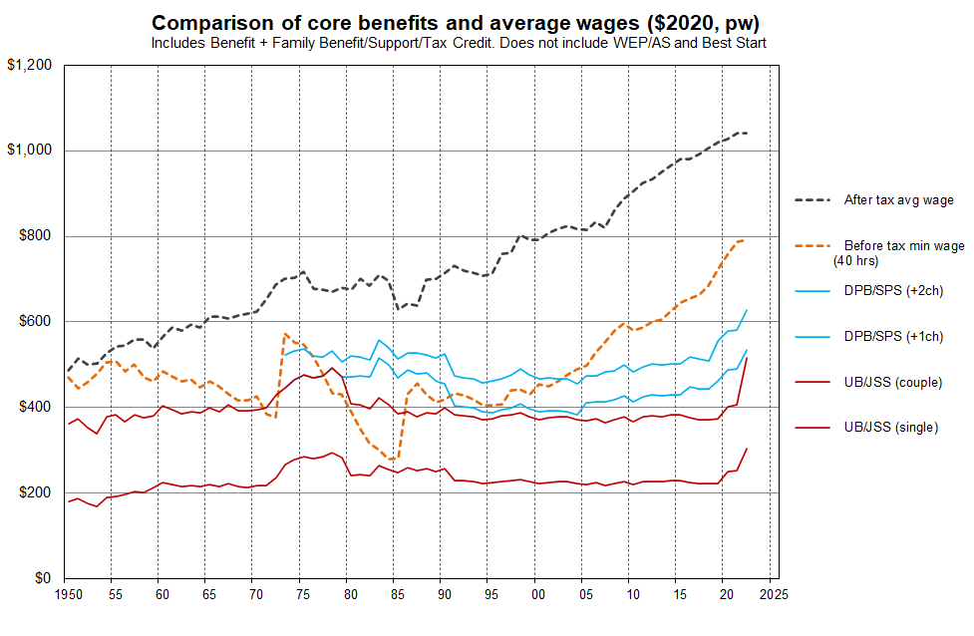
Figure C.9

Source: MSD collation from information from the Royal Commission on Social Security, Department of Social Welfare Annual Reports, Income Support Service / Work and Income Fact Sheets and Budget 2021.

Some key dates
1946 Universal Family Benefit
1972 Royal Commission on Social Security
1991 Benefit cuts
2004-05 Working for Families
2016 Child Material Hardship Package
2018 Families Package
2020 $25 increase (April)
2020 Indexation to average wage commences (Apr)
2021 $20 pw increase (July)
2022 WEAG plus $15 pw for families with children (Apr)

Appendix 5
Treatment used for very-low-income households who report good (or even very good) material wellbeing

The Household Economic Survey, like similar ones elsewhere, includes a small group of very-low-income (VLI) households the great majority of whom report consumption / material wellbeing more like households with incomes in the middle of the income distribution. While there is considerable variation in reported material hardship levels for other ‘ordinary’ low-income households – not all low-income households are in hardship and not all in hardship are from low-income households (ie the limited overlap observation) – the VLI group is different from the ordinary-low-income group on two counts:
- first, the incomes are so extremely low (for this report, usually under ~15% of the median), well below all safety net income support levels
- second, there is good evidence that an unexpectedly high proportion of these VLI households report a material standard of living much higher than those with incomes a little above (eg those in ventile 2), and higher than those in the ‘normal / less extreme’ low-income range.

For the 2018-19 HES data, this VLI group with good material wellbeing is larger than for previous HES datasets MSD has used. As this group is in general so much better off than their counterparts with ordinary low household income, their presence can lead to misleading and incongruous findings, and especially for 2018-19 HES data. This is the dataset that much of the analysis in this report is based on. The impact is seen on statistics such as lower decile shares and other income inequality measures, measures of poverty depth, measures of housing affordability using outgoing-to-income measures, and when examining the overlap between income and non-income measures of poverty (a major theme of this report). They make up only a very small proportion of the whole population (around 2-4%), but when the population of interest is the low-income group, they can make up a non-trivial portion as high as 25% in some cases. Their presence can also impact on reported low-income (poverty) rates and on the credibility of those numbers.

MSD’s reports have applied various treatments in the past to seek to reduce the noise from this VLI group for selected statistics as required. One treatment involved using household spending to impute a more realistic income for the VLI households, and another simply deleted households with incomes under a selected very low level of a few thousand dollars per annum. The expenditure treatment is available only every third year (starting with 2006-07) so has limitations for time series, and the deletions based purely on income can open the analysis to the charge that it potentially eliminates from the dataset some households that are genuinely in poverty, thus under-estimating the level of need.

For this report, a different approach is used.

All VLI households whose DEP-17 score is zero or who self-rate their income as enough or more than enough are removed from the dataset.
- ‘Very low’ is defined (in equivalised dollars) as:
  - under $5000 pa ($2007) for BHC
(this is around $250 pw for a (2,2) household in $2020, and $175 pw for a (1,1) household, both being well below safety net incomes, and well below survival rates if income is the only financial resource (~15% of median)
  - under $3000 pa ($2007) for AHC.
(this is around $3600 pa in $2020 - $150 pw for a (2,2) household, and $90 pw for a (1,1) household), both being well below safety net incomes, and below survival rates if income is the only financial resource (~10% of median).

The main purpose of the treatment used in this report is to enable analysis which:
- gives a reasonably valid and plausible account of the overlap between households with low incomes and those in material hardship
- paints a reliable picture of what life is like for households with children living ‘below the line’,
- produces housing affordability figures for low-income households (using outgoing-to-income ratios for renters and home-owners) that are not too distorted by VLI households.

This purpose is achieved with the current treatment, albeit only just in some cases as, for one thing, the treatment is a fairly conservative one There is a case for using higher VLI thresholds, and MSD is investigating this option.

The treatment applied should be considered interim and better than not doing it at all for the purposes of this report. MSD’s view is that it is not however adequate for CPRA purposes but is a contribution to the further work being done on that. Using a medical analogy, the current treatment dulls the pain to some degree, but not fully, and ideally the cause of the pain will be established and addressed as well as possible, even if some relief of residual symptoms is still required.

Figures 5.1 and Table 5.1 give examples of the pre-treatment incongruities and the difference the treatment makes. More examples are provided in Section O of the main report.

In the untreated version of Figure 4.1, the average hardship rate for children in households below the 40% AHC threshold is lower than for those in ‘higher’ low-income households, 40-50% AHC. This is incongruous. After the treatment has been applied the rates for the lower two groups are much the same, which is a considerable improvement. Nevertheless, the question remains as to whether a less conservative treatment should be considered using, say, a slightly higher VLI definition. MSD is investigating this option.
Figure 5.1
Material hardship rates (%) of children in selected AHC household income bands:
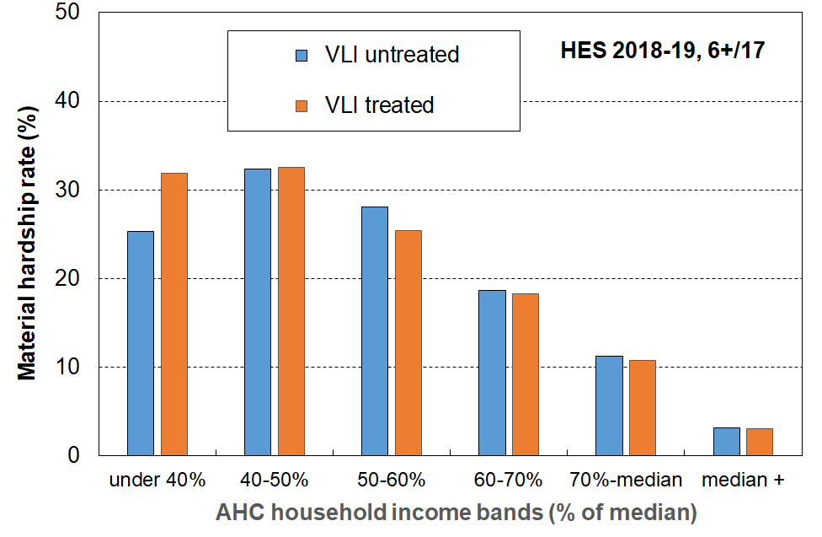
untreated and treated, HES 2018-19

Table 5.1 shows that for the untreated data, foodbank usage by the VLI group was very much lower than for the rest of the under AHC 40 group (5% v 26%) and was similar to that for those households with incomes well above the BHC threshold. This too is incongruous. The application of the treatment improved the comparisons, though there is further evidence here for the treatment being ‘too conservative’.
Table 5.1
Use of foodbanks / other community support groups at least once in the 12 months prior to interview (%),
untreated and treated, HES 2018-19
 | Under $6k | $6k to BHC 50 | BHC 50 to 65% | BHC 65 to median
Untreated | 5 | 26 | 19 | 6
Treated | 16 | 26 | 19 | 6

Stats NZ are aware of the VLI issue in relation to how it may possibly impact on the child poverty rates they report on in the context of the requirements of the CPRA, and also more generally for the way the presence of these extreme incomes can impact other information based on the HES. They are carrying out further investigation, especially for HES 2018-19 and later. In the Technical Appendix for the February 2021 release of Child Poverty Statistics, Stats NZ note that:
“We have decided at present that we will not apply any treatment to try and correct for this group of people who have very low income when producing poverty rates. However, users of the data should be aware of this issue when analysing this end of the distribution and may want to apply their own treatment depending on the purpose of their analysis. We will continue to investigate what is driving what we observed and to further improve the dataset.”

Section O of the main Child Poverty report more fully outlines the rationale for the MSD treatment and its impact on selected statistics.

Access to the HES data was provided by Statistics New Zealand under conditions designed to meet the confidentiality provisions of the Statistics Act 1975. The results presented in this analysis are the work of the Ministry of Social Development except where otherwise stated.
The main MSD publications (July 2021) will have other child-related information, in addition to the material in this Child Poverty Report.
A revision to the 2019-20 figures was released on 22 April 2021.
The full MSD Household Incomes Report also provides low-income trend information on several measures that start in the mid-1980s (Stats NZ time series generally go back only to HES 2006-07), and the Material Wellbeing Report provides material hardship information from 2006-07 on (Stats NZ time series starts in 2012-13). These MSD reports are scheduled for release in late July / early August 2021.
See, for example, the note under Table C.7 and Table C.12a.
Material hardship rates in a given year are also impacted by longer-term income histories for households and their members. The relatively strong employment growth among families with children over preceding years is also relevant.
See Appendix 1 for the lists of items for DEP-17, EU-13 and for the MWI (MSD’s full spectrum material wellbeing index)
For example, the HES does not include the families in Emergency Housing which includes around 4000 children (Source: MSD Annual Review).
Once the population weights were applied to gross up the sample numbers to population estimates the number of individuals in the lower two NZDep deciles was 19.4%.
Stats NZ created special combined HES-HLFS datasets for producing a 2007 to 2018 BHC low-income back series to assist with estimating baseline low-income rates for the CPRA.
https://www.stats.govt.nz/methods/child-poverty-statistics-year-ended-june-2020-technical-appendix#quality
‘Current’ household income sometimes refers to income over the previous week or month. In the context of this framework it refers to annual income in a recent 12 month period in contrast to income in the longer term over several years. The household that individuals are members of at the time of interview may not always have been their household over the previous 12 months, the reference period for calculating the household income (for example: a recently separated non-employed spouse in a new one-person household, or a new migrant can look as if they have had little or no income in the reference period). This can create some noise in the income / material hardship relationship
Measurement error can no doubt contribute to the mismatch, but there is plenty of evidence to show how ‘other factors’ (Figure A.1) impact. As the analysis below using liquid assets shows, differences in other resources can make a very large difference.
Liquid assets represent the total across the following asset classes: Foreign and NZ currency GT $1000, Bank deposits, Bonds and other debt, Managed funds and other investment funds, Shares in listed corporations, Other non-pension financial assets.
Stats NZ publish more detailed ethnicity tables and cover disability. The Child Poverty Unit, on behalf of their Minister, provide information on housing affordability and food insecurity in the Child Poverty Related Indicators document, in line with CPRA requirements. MSD expect to include detail on these in 2022 Child Poverty Report.
One of the main reasons for the difference in hardship rates for these two household types is that there is much less potential for paid employment hours in sole parent households compared with two parent (and other multi-adult) households with children.
A third way is the single/combination classification which counts people in mutually exclusive categories. People are counted just once in the relevant single or combination group. This approach is likely to be included in the July reports.
WEAG Secretariat (2019), p22. See main report for full citation.
See Goedemé et al (2019). Full citation is available in the References section of the main report.
One of the criteria used in selecting a DEP-17 threshold of 6+/17 for CPRA measurement was that the DEP-17 material hardship rate for New Zealand children (based on the 2017-18 HES data) should be similar to that produced by the EU-13 5+/13 measure. They were each 13%.
The EU before the 2004 (and 2007) expansions, which were mainly about including less well-off countries.
The analysis in this paragraph is based on Eurostat data for EU-9, the predecessor of EU-13.
The child-specific items do not in the main apply to pre-school children so, when using the child-specific items, the analysis here and elsewhere is limited to 6-17 year olds (around 760,000 out of the 1.13m children aged under 18 years (67%)). The ‘school uniform’ item is not included Table C.1 as it is too awkward to use for the purposes of this report. Only older children usually have a uniform requirement and even then not all need them.
See Section J and Appendix 1 of the main report and Section E in Perry (2019d) for more detailed information on the MWI.
See main report for related New Zealand research.
The Reference section in the main report provides full citations for the source used here and the others below.
In his efforts to reconcile the relative and absolute notions of poverty, Sen distinguished between ‘capabilities’ and ‘functionings’. Capabilities are the potential that people have to lead fulfilled and engaging lives and are absolute and everywhere the same. Functionings, on the other hand, are the facilities and resources required to enable people to achieve their capabilities and are determined by cultural expectations and resource constraints. Sen’s view is that ‘the ability to go about without shame’, like a capability, is at the ‘irreducible absolutist core in the idea of poverty’.
Also, see Perry (2021b, forthcoming) for detail on how well the HES items match for constructing EU-13.
For each country, the amount is set at a suitable value close to (±5%) the per month national income poverty line (60% of median) for the one person household. There is no adjustment for household size or composition.
For example, for children in BHC 50 poverty for 2018-19 and 2019-20, around one in six are in VLI households reporting a DEP-17 score of zero, or self-assessed income adequacy of ‘enough or more than enough’.
The AHC VLI threshold at least gives some income after paying for accommodation, albeit very meagre, whereas the BHC VLI threshold does not.
https://www.stats.govt.nz/methods/child-poverty-statistics-year-ended-june-2020-technical-appendix#quality

