Child Poverty in New Zealand:
The demographics of child poverty, survey-based descriptions of life ‘below the line’ including the use of child-specific indicators, and international comparisons - with discussion of some of the challenges in measuring child poverty and interpreting child poverty statistics

Prepared by Bryan Perry

Ministry of Social Development
Wellington

June 2021

ISBN 978-1-99-002371-2 (Print)

ISBN 978-1-99-002372-9 (Online)

Changes since last report

Nil – this is the first of the new series

Next report

- The next report is scheduled for March 2022. The timing is dependent on when Stats NZ publish their Child Poverty Statistics (likely to be February 2022), and on the timing of the availability of the HES data for MSD use.

Availability on MSD website

- This report is available on the MSD website:
www.msd.govt.nz/about-msd-and-our-work/publications-resources/monitoring/index.html

Updates since publication on 3 June 2021

- 11 Jun 2021: Added Fig C.10 (NZS v working age benefit levels for couple and one-person households)

Acknowledgements

I thank all those who provided comments on earlier drafts, including MSD colleagues, staff from the Treasury, Stats NZ and the Child Poverty Unit, and others from NGOs. Their advice, questions, challenges and smoothing out of rough patches have added considerably to the report’s robustness, readability and relevance. My thanks especially to Caroline Hodge whose expert SAS coding, preparation of publication-ready tables, ability to succinctly synthesise results from complex investigations of the data, and general unwavering commitment to excellence have been crucial in the production of this report. Responsibility for all the analysis and interpretation in the report (including any errors or omissions) remains mine alone.

About this report

This report is a resource to inform policy development and public discussion in relation to the material wellbeing of children and the households in which they live. Most of what is reported is about material hardship, low incomes and financial stress (‘child poverty’) as these are matters of considerable ongoing public policy interest, but it also reports on how well the vast majority of children and their households are doing. Children are those aged under 18 years.

The findings are based on analysis of data from Stats NZ’s Household Economic Survey (HES) and use the measures specified in the Child Poverty Reduction Act (CPRA). Some of the material is from previous issues of MSD’s two regular reports on the material wellbeing of New Zealand households (the Household Incomes Report and the Non-Incomes Report), but much of it is new analysis based on Stats NZ’s 2018-19 and 2019-20 HES datasets. Most of this new material will be incorporated into the full 2021 MSD reports, scheduled for publication in late July / early August this year.

Two features of the 2018-19 and 2019-20 HES have made much of the new analysis possible.
- First, the large increase in sample size for these two surveys allows more detailed breakdowns for children in different contexts to be reported with much more confidence (for example, poverty rates by their household type, the tenure of their household, their ethnicity, and so on). The achieved sample for the 2018-19 HES is 21,000 households compared with previous HES samples of 3500 to 5500. Importantly for this report, the 2018-19 HES sample has around 7300 households with children, compared with the previous 1100 to 1800. The 2019-20 HES sample is a little smaller than the 2018-19 HES as the surveying was forced to stop after around 9 months because of the COVID-19 lockdown in 2020 (16,000 households, 5600 with children). Much of the detailed material is based on the 2018-19 HES to make use of the greater certainty a larger sample delivers – any significant differences that using the 2019-20 data would make are noted. Reporting on trends includes the 2019-20 HES.
- The second feature that has enabled new analysis is the collection of child-specific material wellbeing / hardship information from parents and caregivers – examples include whether each child has two pair of shoes in good condition and suitable for daily use, two sets of warm winter clothes, a protein meal each day, is able to participate in sport and /or special interests, and so on. These items have value in themselves, but when used together with some general household items of direct relevance to children (such as the ability to keep the home warm), they can provide detailed descriptions of what ‘life below the line’ is like for children identified as ‘poor’ using the CPRA measures.

The report is in two parts. After a brief Introduction covering key definitions and concepts and the implications of these for measurement (Section A), the rest of Part One presents and discusses a wide range of findings based on analysis of the HES. The main themes covered in Part One are:
- The demographics of child poverty: low-income and material hardship rates (ie ‘poverty rates’) by household type, employment status of adults in the household, main source of income for the household (government or market), highest educational qualification of adults in the household, tenure, and so on.
- The varying composition at different depths of poverty for the above groups.
- Description of life ‘under the line’ and for the ‘near-poor’ who rank a little above the most generous low-income line, using child-specific deprivation items and other general child-relevant household items.
- International comparisons on a range of measures.
- The material wellbeing of children across the full spectrum, rather than just on the material hardship end – using MSD’s Material Wellbeing Index (MWI).
Part Two is more technical: it is essentially an elaboration of the matters raised in summary form in the Introduction (Section A), including detailed information on:
- The measurement approaches used to produce the reported figures,
- The rationale for the various poverty thresholds
- The application to New Zealand of European research which shows that there is a strong link between BHC cross-sectional (ie static) low-income rates and persistence rates (when using the EU definition of persistence).
- Discussion of the way the report addresses some of the data and interpretation challenges that exist in the very low-income range for the HES datasets.

Relationship of this report to the Stats NZ Child Poverty Statistics release in February 2021

The Stats NZ release in February 2021 provides the official headline child poverty statistics in relation to the requirements of the CPRA. These statistics are the ones that are used by the government for formal reporting on progress on reducing child poverty rates as required by the CPRA. The baseline rates are those reported by Stats NZ for the 2017-18 HES year. The Stats NZ release also provides more detailed breakdown by ethnicity, regional council area for 2018-19 and 2019-20 and disability for 2019-20.

The MSD report is complementary to the Stats NZ child poverty report: the Stats NZ report covers off the recent trends in the nine available CPRA measures and enables an assessment of progress towards gazetted targets, whereas this MSD report focuses on what it means in practice day-to-day for children who are identified as ‘poor’ by one or more of the CPRA measures, how New Zealand children are faring compared with their European counterparts, and on matters relating to the interpretation of the high-level CPRA figures. The headline child poverty figures are the same in both reports for 2017-18 and later (the CPRA figures), except in a few specific circumstances.

A good list of References enables readers to further pursue matters of interest.

Appendices provide lists of the items that make up the various indices used in the report, all the non-monetary indicators collected in the HES, and tables showing the weekly dollar values of the CPRA low-income thresholds for selected household types.

A detailed Table of Contents assists in locating areas of interest.

There is a separate much shorter report which provides Selected Findings. It is essentially a truncated version of Part One of the main report with very limited technical material. This shorter report is not intended as a summary as the main report. It is designed as a resource / desk-file on a range of themes to inform policy development and public discussion, rather than a research report whose findings can be distilled into an abstract or short summary.

“There are no poor children, just poor families”

It is sometimes said that the idea of ‘child poverty’ doesn’t make sense as it’s really about families / households with financial and material resources that are not adequate for meeting the basic needs of the family (ie it’s not poor children, it’s poor families / households).

In this report, when it is said, for example, that ‘the child poverty rate is 15% on a particular measure’, this is a short-hand for ‘15% of children live in families / households whose total annual household income is below the threshold used in the given measure’ … or ‘15% of children live in families / households whose material hardship score is above the threshold used’. It is too cumbersome to repeat this each time, so the shorthand version is used: ‘the child poverty rate is 15%’.

This is standard international practice and assumes reasonably equitable distribution of material wellbeing within a household. In the case of children, this is not always the case. Parents and caregivers often make sacrifices themselves that shield their children from (the worst of) the material deprivations they would otherwise experience. In a few cases it’s the other way, and children suffer badly. The HES data does not provide information from the children themselves (not many surveys do), but it allows us to get an insight into the children’s situation through the 20 child-specific deprivation measures included in the 2018-19 survey. These items are used extensively in this MSD Child Poverty Report.

Latest Stats NZ statistics for the 9 available CPRA measures

The CPRA and its specified low-income and material hardship measures of child poverty provide an important context for much of what is covered in this report. For reference, the latest figures from Stats NZ are provided in the table below. The February 2021 release (updated on 22 April) is available at:
https://www.stats.govt.nz/information-releases/child-poverty-statistics-year-ended-june-2020

The table shows the Stats NZ rates for the nine available CPRA measures for the three surveys, HES 2017-18 to HES 2019-20, together with the numbers of children in poverty for 2019-20 (there are 1.14m children all up). These are still the latest available child poverty figures – there are no more up to date figures in this report. The next CPRA child poverty statistics release by Stats NZ is scheduled for early 2022, based on HES 2020-21 and administrative data for the period.

Rates (%) and numbers for the nine available CPRA child poverty measures
(Stats NZ figures for 2017-18 to 2019-20 HES)
 | Measure | % poor |  |  | # poor
 |  | 2017-18 | 2018-19 | 2019-20 | 2019-20
P | BHC 50% relative | 16 | 14 | 14 | 160,000
S | BHC 60% relative | 25 | 22 | 22 | 250,000
S | AHC 40% relative | 16 | 14 | 14 | 160,000
S | AHC 50% relative | 23 | 20 | 20 | 230,000
S | AHC 60% relative | 31 | 28 | 28 | 320,000
P | AHC 50% anchored line (2017/18 ref) | 23 | 18 | 18 | 210,000
P | Material hardship (DEP-17, 6+/17) | 13 | 13 | 11 | 130,000
S | Severe material hardship (9+/17) | 6 | 6 | 5 | 50,000
S | Both material hardship and low-income (less than 60% AHC) | 9 | 8 | 7 | 75,000
Notes for Table:
- BHC is short for ‘household income before deducting housing costs’ and AHC means ‘household income after deducting housing costs’.
- ‘AHC 40% relative’ is short for ‘40% of the median AHC income’, and so on.
- P = primary measure (required to have targets). S= supplementary measure (no targets required).
- Because the survey is a sample survey and not a full census, there are uncertainties in each figure. These uncertainties are often called ‘sampling errors’ but they are not mistakes - they are inevitable when using samples, even in perfectly designed and implemented surveys. The sampling errors are around 1-2 percentage points (10-20,000) for each of the first seven measures, with the 2019-20 figures having the smallest of the three years. The sampling errors for the bottom two measures are around 1 percentage point. In general, the sampling errors are larger for finer breakdowns as the number of people in the category of interest decreases.
- The figures are rounded to the nearest whole number and nearest 10,000 respectively (except for the bottom two measures which are to the nearest 5,000).
- See the Stats NZ link above for details, including the rates to one decimal place and the time series back to the 2006-07 HES.

The Child Poverty Unit also provides a range of child poverty information on the DPMC website:
https://dpmc.govt.nz/our-programmes/reducing-child-poverty

All the HES-based figures to date are pre-COVID

The 2019-20 HES stopped at the March 2020 lockdown, around three months before its scheduled end-point of 30 June. The HES data therefore gives a clear picture of how things were pre-COVID. The 2020-21 survey which is currently in the field will give some indication of the COVID impact.

The figures in the Stats NZ release in February 2021 and in this MSD report are therefore all pre-COVID.

Contents

Glossary and Abbreviations ………………………………………………………………….. 8

PART ONE Introduction and Findings

Section A

Introduction: measurement and meaning
Rationale for a focus on child poverty …………………………………………………………………… 11
High level definition and approaches to measurement ……….…………………………………….… 11
The mismatch between income and non-income measures of poverty …….…………….……… 13
Giving the numbers meaning: the need for a reference point …….….…………………………… 15
Data source: Stats NZ’s Household Economic Survey (HES) and associated administrative
data for income information …………………………….………………………………………………….. 15
Poverty experienced …..………..…………………………………………………………………………… 17
Annex to Section A
Low-income thresholds (poverty lines for selected household types ………………….……… 18
Material deprivation or hardship index (DEP-17) and the Material Wellbeing Index (MWI) …… 19

Section B
The demographics of child poverty: breakdowns for children in different household contexts and for ethnicity, and comparisons for selected households without children
Children in households at different depths of material hardship, in selected household contexts
and by ethnicity: hardship rates and composition within the categories ………………………………. 22
Children in households at different levels of low-income, in selected household contexts
and by ethnicity: low-income rates and composition within the categories ………...…………………. 26
Comparing poverty rates for children, one-person households (aged 18-64 yrs), and
older New Zealanders (65+ yrs) ………..………………………………………….………………………. 29

Section C
Life under the line: what poverty looks like for children in households identified as poor
Approach: using child-specific items and child-relevant household items to provide grounded
descriptions of ‘life under the line’ (ie under a selected threshold) ……………………….…………..... 32
Children in households in material hardship ………………………….………………………………….. 35
Children in low-income households ………..…………………………………………………………….. 40
Children in households that are both low-income and in material hardship ………….……………….. 48
Children in working and beneficiary households ………………………………………………………. 50
Incomes of households in receipt of main benefits: long-run trends …………………………………… 52

Section D
International comparisons
Material hardship rates …………….……………………………………………………………………….. 58
Child-specific material deprivation items and selected child-related household items ………..….. 60
‘Poverty’ comparisons using low-income ………..…………………………………………………….. 61
Children in workless households ………….……….…………………………………………………….. 64

Section E
Children across the full material wellbeing spectrum (using the MWI)
Dividing the full MWI spectrum into six groups ………………………………………………………….. 65
Charts and tables showing how children in selected household contexts are distributed
across the material wellbeing spectrum, from low to high ………….………………….………………. 67

[Sections F to I are placeholders only. The intention is to populate them in the next edition in 2022, building off the 2021 prototype. In this edition, the text in each of Sections F to H point to relevant information in MSD, Stats NZ and CPU publications]

Section F
Long-run trends in low-income and material hardship rates for children
Directions to information …………..……………………………………………………………………….. 71

Section G
Housing quality and affordability
Directions to information …………..……………………….…………………………………………….. 73

Section H
Food insecurity
Directions to information ………………………………………………………………………………….. 75

Section I
Impact of COVID
Comment ………………………….……………………………………………………………………….. 77

PART TWO

Section J

Material hardship and material wellbeing indices
Material hardship in New Zealand (DEP-17) ……….………………………………………………….. 81
International comparisons (EU-13) ………..……………………………………………..……………… 82
Measuring child material hardship - options …………..………..………………………………………… 83
Material wellbeing from low to high (MWI) ……………………………………………………….……… 83

Section K

Setting thresholds for hardship indices
………………………………..………………………………………………….. 85

Section L

Low-income measures
Household income as a proxy measure of resources ………..……………………………………….. 87

Section M

Setting low-income thresholds
Internationally-used thresholds ………………………………………………………………………….. 91
Reference budgets for selected household types ………..……………..……………………………. 92
Using non-monetary indicators ………..……………………..………………………………………… 94
Do these low-income thresholds seem reasonable? ………………………………………………….. 95
Updating thresholds from survey to survey: anchored and moving line thresholds ………..….…. 96

Section N
Persistence
Estimating persistence rates from cross-sectional rates: An extended summary and
application of research by Jenkins and Van Kerm (2012) with estimates of New Zealand persistence
rates for BHC 50 and BHC 60 using the EU definition of persistence ….…………………………….. 97
Overview of the research ………………………………………………………………………………….. 97
Application to New Zealand ……………………………………………………………………………… 98
How robust are the New Zealand persistence estimates? …..……….…………………………………. 99
Little new information? ……………………………………………………………………………………. 100

Section O

Households with very low incomes: Implications for measurement and the

rationale for the treatment applied in this report
Introduction ………..…………. ……………………….………………………………………………….. 103
Size, characteristics and make-up of the very-low-income (VLI) group …………….…………….… 106
Implications for measurement …………….………………………………………………………..……… 112
There are larger proportions of very-low-income (VLI) households in HES 2018-19 and
2019-20 compared with earlier years (especially for households with children) …………..………….. 113
- The data sources: ‘HES-TAWA’ and ‘HES-admin’
- The fundamental issue and related practical issues for this and other MSD reports
- Expenditure by VLI group in HES 2006-07 to 2018-19
- The VLI group as a proportion of the whole population
- The VLI group as a proportion of those with incomes under the BHC 50 and AHC 50
poverty thresholds
The treatment used in this report to (partially) address the measurement implications of
the larger VLI proportion for HES 2018-19 and 2019-20 ……………………………………………….. 117
Examples of the impact of the treatment …………..……………………………………….…………….. 120
The implications of this report’s treatment decision for reporting child poverty rates
(BHC 50 and AHC 50) …………..………………………………………………………..………………… 123

References 127

Appendices 131

Appendix 1 HES Items and composition of indices

Appendix 2 List of HES child-specific items (with endorsement rates)

Appendix 3 Low-income thresholds (income poverty lines)

Glossary and Abbreviations

HES Stats NZ’s Household Economic Survey
AHC After (deducting) housing costs
BHC Before (deducting) housing costs
BHC 60 Low-income threshold or income poverty line = 60% of the BHC median
VLI Very low income (see Section O for definitions as the term is used in this report)
REL Relative-to-contemporary-median (referring to low-income thresholds or ‘poverty lines’ that are calculated as a proportion of the median for the survey year in question) = ‘moving lines’
AS Accommodation Supplement
WFF Working for Families
FT Full-time (30 hours or more per week)
PT Part-time (from 5 to less than 30 hours per week)
WL Workless adult (less than 5 hours per week)
SE Self-employed (HH) – a household for which more than half the gross income comes from self-employment
HH Household
SP Sole parent
2P Two parent
NIM Non-income measure (or sometimes, a non-monetary indicator (NMI))
DEP-17 MSD’s 17-item material hardship / deprivation index – also used by Stats NZ for three CPRA measures
EU-13 The EU’s 13-item material and social deprivation index.
MWI MSD’s 24-item material wellbeing index which scores households across the full spectrum from hardship to high living standards.
EU-SILC The European Union’s Survey of Income and Living Conditions.
Equivalised income Household income adjusted for household size and composition to enable more reasonable comparisons between households when household income is used as a measure of material wellbeing
Quintile One fifth or 20% of a ranked group of individuals or households.
Decile One tenth or 10% of a ranked group of individuals or households.
Ventile One twentieth or 5% of a ranked group of individuals or households.
CPRA Short for the CPRA (2018), the Child Poverty Reduction Act (2018)

- When ‘child’ is used without qualification, it means a person aged 0-17 years.
- ‘Dependent children’ are all those under 18 yrs, except for those 16 and 17 year olds who are in receipt of a benefit in their own right or who are employed for 30 hrs or more a week.
- A household ‘with children’ always means a household with at least one dependent child – the household may or may not have adult children or other adults who are not the parents or caregivers.

PART ONE
Introduction and Findings

Section A - Introduction: measurement and meaning

Rationale for a focus on child poverty

There is considerable public, media and political interest in the wellbeing of children, including their material wellbeing – how they are faring in accessing their material needs and the necessities of life. The special interest derives from two considerations:
- Children are very dependent on others for their survival, for having their material needs met and for the opportunities to grow and develop in a positive healthy way. Parents, the wider family, the community and the state all have a part to play. No one wants to see children missing out on the basics and being unable to participate in the childhood activities our society expects and values for all children.
- Living in persistent low income or hardship as a child is not only a childhood experience that impacts negatively on children in the here-and-now, it also increases the chances of poor outcomes later in childhood and in adulthood. While much of the observed association between persistent low income and hardship (‘poverty’) and poor outcomes can be explained by other factors that drive both the ‘poverty’ and the other poor outcomes, not all of it can. There is now good evidence that childhood experience of persistent low income or material hardship can in itself have a negative impact later on. The impact operates through pathways such as:
- the more limited (financial) resources available for investment in children and their development
- the parental stress arising from the daily pressure of not being able to pay the bills, of having to make difficult trade-off decisions where solutions to one problem create problems of their own in another area, and from a sense of shame and disappointment of not being able to provide for the children
- the fact that the negative impacts show up across multiple domains and can therefore contribute to a larger cumulative impact.
This is all costly, not only for the individual but also for society as a whole through higher health costs, lower employment, lower wages, lower tax revenue and lower productivity.

Poverty: high level definition and approaches to measurement

Poverty is essentially about household resources being insufficient to meet basic needs.

In the MSD reports, as in most richer countries, poverty is commonly understood as ‘exclusion from the minimum acceptable way of life (standard of living) in one’s own society because of inadequate resources’. This high-level definition is in line with the EU definition which was first agreed at the 1975 EU Council of Ministers, and which was inspired by the work of Peter Townsend in the UK in the 1970s.

Household income, adjusted for household size and composition, has traditionally been used as a proxy measure of resources. While this approach produces valuable information on income inequality and on the number of households with incomes below selected low-income lines, it has several limitations as a poverty measure.
- Different households with very similar current income can have different levels of non-income resources, sometimes reflecting different income trajectories in previous years, sometimes the degree of assistance from outside the household or the level of assistance given to other households. The differing non-income resources include the levels of cash savings, and the quantity and quality of the stock of basic household items, especially durables.
- Different households with very similar current income can have quite different basic needs. Some of these differences can be addressed: household income can be adjusted for household size and composition (‘equivalised’); the differing demands on the budget for differing housing costs can be addressed to a degree by using income after deducting housing costs (AHC income) to make comparisons more realistic. However, there are some differing demands on the household budget (ie differing needs) that cannot easily be adjusted for (eg special health costs, high debt servicing, and so on).

As a result, when using a given low-income threshold (‘income poverty line’), some of the low-income households do not experience financial hardship, and others with incomes ‘above the line’ do. Low income on its own does not distinguish well between those with adequate resources to sustain a minimum acceptable standard of living and those without these.

This does not mean that income has little impact on the material wellbeing of individual households – for low-income households especially, any increase in income can make a positive difference. It’s just that when it comes to measuring poverty, income on its own is not a very good identifier of those who are actually struggling, for the reasons outlined above.

Over the last two decades growing use has been made of non-income measures (NIMs) to more directly measure material standard of living and material hardship. These measures use survey information about what basics and near-basics households can and cannot actually in practice afford and by using carefully selected items from the survey information indices can be created to rank households across a spectrum from no hardship through to severe hardship. They provide a more direct measurement of ‘minimum acceptable standard of living’ than household income does.

The EU has formally adopted a 13-item material and social deprivation index (‘EU-13’ in this report) as one of its suite of social inclusion indicators. New Zealand uses a similar 17-item index to measure hardship (DEP-17). Both these indices are designed as instruments to rank households by their differing degrees of material hardship, using a balanced set of indicators that cover a range of domains and degrees of depth of deprivation, reflect the same underlying concept (or ‘latent variable’), and which apply reasonably well to people in different age groups and household types.

The NIMs approach is not without its challenges too. For example, being clear whether the non-possession of a basic is because of cost or simply due to personal preference, the phenomenon of ‘adaptive preferences’, and deciding on a method for turning the survey responses into a valid and easily understood index. These are however more tractable issues to address than the deeper conceptual and practical issues for the household income approach.

Some use a combination of both low income and material hardship as a poverty measure. Ireland uses the combination method to measure what they call ‘consistent poverty’, as in their view this (overlap) group best fits the high-level definition which has both an input (resources) and outcome dimension (minimum acceptable material standard of living). MSD uses the combination method as one of the measures in its multi-measure multi-level approach. It can be seen (as in Ireland) as the preferred measure, or simply as a measure of deeper poverty. It is one of the specified measures in the CPRA suite.

Deciding on thresholds or ‘poverty lines’

Whichever measurement approach is used – one of the household income measures or a deprivation index – value judgments are needed to decide on what is meant in the definition by ‘minimum acceptable’ or ‘adequate’ (ie where to draw the lines). This is an inescapable aspect of poverty measurement and debate, but does not mean that any measure will do nor that all measures are equally imperfect. Some are clearly more reasonable and defensible than others.

The Child Poverty Reduction Act specifies a range of measures and thresholds to better capture the fuller picture of low-income trends and experiences of material hardship. These are listed above on page 4.

This report uses these (in line too with previous MSD reports), and also discusses the rationale and suitability of the various measures and thresholds in Sections J to M in Part Two.

The mismatch between income and non-income measures of poverty

A key theme of this report and MSD’s main Household Incomes and Material Wellbeing reports is that ‘not all households with low incomes are in hardship, and not all in hardship have low incomes’. As illustrated in the stylised diagram below, the overlap between material hardship and income-based measures is limited, usually only of the order of 40-50% at best.
Households in material hardship
Low-income households

Some low-income households are not in hardship
Some households in hardship do not have low incomes

MSD reports use the framework outlined in Figure A.1 for thinking through the relationship between material wellbeing (or living standards), household income, financial and physical assets, and other factors.
- ‘Current’ household income and financial and physical assets together largely determine the economic resources available to most households to support their consumption of goods and services and therefore their material standard of living.
- For low-income households that have very limited or no financial assets, income is the main resource available to generate their standard of living. Such households struggle in varying degrees to meet basic needs, and are also very vulnerable to the negative impacts of ‘shocks’, such as even a small drop in income or an unexpected expense.
- The framework recognises that factors other than ‘current’ incomes and assets can also impact on material wellbeing. These factors are especially relevant for low-income / low-asset households, and can make the difference between ‘poverty/hardship’ and ‘just getting by’.

Figure A.1
The income-wealth-consumption framework used in the MSD reports
Household income
Basic needs / essentials
Discretionary spend / desirable non-essentials
Material wellbeing or living standards
Resources available for consumption
DEP-17
MWI

Financial and physical assets (in part reflecting previous income)

Other factors
eg assistance from outside the household (family, community, state), housing costs, high or unexpected health or debt servicing costs, lifestyle choices and ability to convert given resources into valuable consumption, ability to access available resources

- The framework provides a high-level explanation for the observation that not all households with low incomes are in hardship, and not all in hardship have low incomes. There are many factors in addition to income that determine a household’s level of material wellbeing (living standards).
- The level of liquid financial assets held by a household is one such factor, as shown in the Figure A.2 and the associated table below. For households with similar incomes, lower levels of liquid financial assets mean higher levels of material hardship. It is not often that a single dataset has information on household income, material hardship and liquid assets. HES 2017-18 had all three and enabled the analysis reported below.

Figure A.2
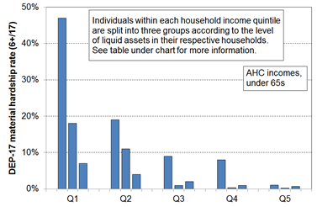
Material hardship rates depend on the level of liquid financial assets as well as on household income, HES 2017-18

Household Economic Survey 2017/18 | Q1 |  |  | Q2 |  |  | Q3
material hardship rate (6+/17, DEP-17) | 47% | 18% | 7% | 19% | 11% | 4% | 9% | 1% | 2%
median liquid assets ($) | 0 | 400 | 8,000 | 100 | 1,200 | 12,000 | 500 | 3,600 | 19,300
avg AHC household income (equivalised $) | 11,000 | 11,000 | 10,000 | 21,000 | 21,000 | 22,000 | 30,000 | 31,000 | 31,000
self-assessed income adequacy = ‘not enough’ | 45% | 21% | 17% | 22% | 10% | 5% | 14% | 6% | 4%
Reading notes for table:
- The three quintiles are quintiles of AHC household income – Q1 is the lowest quintile and so on.
- Q4 and Q5 are not shown in the table (limited space).
- Individuals within each household income quintile are ranked by their household’s level of liquid assets, then split into three equal-sized groups.
- No treatment is applied.

Giving the numbers meaning

Headline child poverty numbers have no practical meaning in their own right. Simple assertions that there are 80,000 … 150,000 … 250,000 … 300,000 poor children in New Zealand may be useful for advocacy purposes (with the number chosen depending on what one is advocating), but on their own they have no value for properly assessing the size of any ‘child poverty’ problem, nor for guiding policy or political responses.

MSD’s reports provide several means for giving meaning to the poverty numbers:
- Being clear about which measure is being used at each step – on its own this is not enough, but it is fundamental for clear communication.
- Comparison with rates for other population groups using the same measure(s).
- Description of what poverty looks like in practical day-to-day terms for the different measures, using material deprivation items for which there is a broad consensus that they are ‘essentials’.
- The relationship between those identified as poor on the different measures (eg material hardship v AHC 50).
- Comparison with rates in earlier years.
- Comparison with rates in other countries when using measures that are valid for international comparisons.

This report provides information on each of these except for the time series (scheduled for publication in July/August in the main MSD reports).

Data source: Stats NZ’s Household Economic Survey (HES) and associated administrative data for income information

The analysis in the MSD Child Poverty report is based on data from Stats NZ’s Household Economic Survey (HES). As noted above, the increased sample size starting with the 2018-19 survey allows more detailed breakdowns for children in different contexts to be reported with much more confidence (for example, poverty rates by their household type, the tenure of their household, their ethnicity, and so on). The sample size for 2019-20 was smaller than planned due to the COVID lock-down. The achieved sample size was 16,000 households compared to 21,000 in 2018-19. This led to an increase in sample errors for the main CPRA child poverty rates of around 0.2 to 0.3 percentage points.

The surveys gather information on the usually resident population living in private dwellings
The survey therefore includes those living in retirement villages, but not those in non-private dwellings such as rest homes, hotels, motels, boarding houses and hostels. Other sorts of surveys are needed to obtain a picture of what life is like for those in more transient accommodation or those ‘living rough’.

This does not mean that the survey does not reach households with very limited financial resources or those in more severe hardship. For example, in the 2018-19 HES: 724 of the households interviewed reported receiving help from a food bank or other community organisation more than once in the previous 12 months,1698 households reported putting up with feeling cold ‘a lot’ in the previous 12 months because of needing to spend on other basics, and 25% came from the lower two NZDep13 deciles (20%). The achieved response rates for lower NZDep13 deciles for HES 2019-20 were all around the same as the overall response rate of 75%.

Findings based on sample surveys have statistical uncertainties

Some of the uncertainties arise by chance as the information is from a sample rather than the whole population. This is often referred to as ‘sampling error’. Sampling error is not a mistake. It exists even if a survey is perfectly designed and implemented and a 100% response rate is achieved. It is an inevitable feature of using a sample rather than counting everyone in the population of interest. The larger samples reduce sampling error considerably.

Administrative data has been used as the source for most of the household income information used in this report

Up to and including the 2017-18 HES, the data available to MSD for its reports was the ‘HES-TAWA’ data. This analytical dataset is the original survey data with some of the more problematic survey-based income information that respondents may misreport (for example, benefit and Working for Families income and the Accommodation Supplement) replaced by the Treasury using their Tax and Welfare Analysis (TAWA) model or its predecessors. For the 2018-19 and 2019-20 HES, Stats NZ moved to using administrative data for most of the income information and created an improved set of weights to provide population estimates from the survey sample. These datasets (‘HES-admin’) are available to MSD for use for this and other reports.

The use of administrative data has in many ways further improved the income information available for HES analysis (for example, by removing measurement error when income from a respondent is misreported through recall issues or deliberately). However, the number of very-low-income (VLI) households has increased when compared with previously published income distribution information based on HES-TAWA. What it is that is causing this difference is not at present understood – there are likely to be multiple drivers. Stats NZ is carrying out further investigations.

In the HES, as in many other similar surveys in other countries, the VLI households present a challenge for the analysis in the Child Poverty report on two counts:
- first, the incomes are so extremely low (for this report, usually under ~15% of the median), well below all safety net income support levels
- second, there is good evidence that many of these households report a material standard of living very much higher than those in the ‘normal / less extreme’ low-income range, more like those in the middle of the income distribution.

While they make up only a very small proportion of the whole population (typically around 2-4%), when the population of interest is the low-income group they can make up a non-trivial portion as high as 25% in some cases. Some treatment is generally needed to address the issue, and especially so for the 2018-19 HES, the dataset that is used for much of the analysis used in this report. For this report, households with BHC equivalised incomes below $5000 pa (in $2007 dollars) and whose DEP-17 score is zero or who self-rate their income as ‘enough’ or ‘more than enough’ are removed from the dataset. The AHC threshold is $3000 (in $2007). See Section O for more detail.

The treatment applied should be considered interim and better than not doing it at all for the purposes of this report. MSD’s view is that it is not however adequate for CPRA purposes but is a contribution to the further work being done on that. Using a medical analogy, the current treatment dulls the pain to some degree, but not fully, and ideally a better understanding of the cause / the causes of the pain should be established and addressed as well as possible, even if some relief of residual symptoms is still required.

Stats NZ are aware of the VLI issue in relation to how it may possibly impact on the child poverty rates they report on in the context of the requirements of the CPRA, and also more generally for the way the presence of these extreme incomes can impact other information based on the HES. They are carrying out further investigation, especially for HES 2018-19 and later. In the Technical Appendix for the February 2021 release of Child Poverty Statistics, Stats NZ note that:
“We have decided at present that we will not apply any treatment to try and correct for this group of people who have very low income when producing poverty rates. However, users of the data should be aware of this issue when analysing this end of the distribution and may want to apply their own treatment depending on the purpose of their analysis. We will continue to investigate what is driving what we observed and to further improve the dataset.”

Poverty experienced

The understanding of poverty and the associated measurement approach used in this report (and in the full MSD reports) is narrowly focussed. It is about ‘unacceptable financial or material hardship’ and the insights about this that can be gleaned from a large-scale national survey.

This is a legitimate focus but, in pursuing it, it is important to be aware that there is much more to ‘poverty’ than what can be measured (albeit imperfectly) through analysis of data from income or deprivation surveys. These can tell us about the material core (‘unacceptable material or financial hardship’), but a different type of research is needed to give insight into how this unacceptable hardship is experienced and understood and felt.

What is at issue here is the non-material as well as the material manifestations of poverty. Poverty has to be understood not just as a disadvantaged and insecure economic condition but also as a shameful and corrosive social relation … [The non-material aspects include] … lack of voice; disrespect, humiliation and assault on dignity and self-esteem; shame and stigma; powerlessness; denial of rights and diminished citizenship … They stem from people in poverty’s everyday interactions with the wider society and from the way they are talked about and treated by politicians, officials, the media and other influential bodies. Lister (2004:7)

What people on low incomes report is a situation of great complexity in which the pressures they face are cumulative. Basics become luxuries that have to be prioritised and saved for. Solutions to one problem create problems of their own, as when saving on heating exacerbates illness and borrowing from the rent money generates arrears and threats of eviction. Poverty feels like entrapment when options are always lacking, the future is looming and unpredictable, and guilt seems ever present, arising from an inability to meet one’s children’s needs, one’s own expectations and society’s demands. Tomlinson and Walker (2009:16)

[Poverty] is to live under the dictatorship of material necessity without choice and control in one’s daily life. That’s what poverty is, it’s about freedom and power and the lack thereof. Ringen (2009:7)

Sen and shame

It has become popular in discussions of human wellbeing to use Amartya Sen’s dictum that the basic concern of human development or of ‘the good life’ is ‘our capability to lead the kind of lives we have reason to value’. The same language is sometimes used in relation to discussions around strategies to address poverty, with the goal of poverty alleviation intervention being characterised as helping people ‘lead the kind of lives they have reason to value’.

In using only this aspect of Sen’s thinking, it misses two key elements that Sen himself identifies in his writing on the conceptualisation of poverty. The first is the matter of the ‘irreducible absolutist core’– poverty alleviation is about having households attain a minimum acceptable standard, which may nevertheless be (well) below ‘leading the kind of lives they have reason to value’. The second is how for Sen and for ‘the poor’, shame is at the core of poverty experienced. There is a case that the bumper-sticker type of use of the notion of ‘leading the kind of lives we have reason to value’ in the context of poverty discourse both misrepresents Sen on poverty and understates the stress of life at the hard end.
Annex to Section A

Low-income thresholds (‘income poverty lines’)

Tables 3A & 3B (repeated here from Appendix 3 for convenience) show the income poverty thresholds in ordinary dollars pw for a range of BHC and AHC measures for selected household types.

Table 3A
50% and 60% low-income thresholds or ‘poverty lines’ for various household types (BHC)
($2021, per week) (Using the modified OECD equivalence scale)
 |  | REL (‘moving’) |  | CV (‘anchored’ /‘fixed’)
Household type | Equiv ratio | 50% of 2019-20 median in $2021 | 60% of 2019-20 median in $2021 | 50% of 2006-07 median in $2021 | 60% of 2017-18 median in $2021
One-person HH | 1.0 | 410 | 490 | 330 | 490
SP, 1 child <14 | 1.3 | 530 | 635 | 430 | 635
SP, 2 children <14 | 1.6 | 655 | 785 | 530 | 780
SP, 3 children <14 | 1.9 | 775 | 930 | 630 | 925
Couple only | 1.5 | 610 | 735 | 495 | 730
2P, 1 child <14 | 1.8 | 735 | 880 | 595 | 880
2P, 2 children <14 | 2.1 | 855 | 1030 | 695 | 1025
2P, 3 children <14 | 2.4 | 980 | 1175 | 795 | 1170
2P, 4 children <14 | 2.7 | 1100 | 1320 | 895 | 1320
3 adults | 2.0 | 815 | 980 | 660 | 975

Table 3B
40%, 50% and 60% low-income thresholds or ‘poverty lines’ for various household types (AHC)
($2021, per week) (Using the modified OECD equivalence scale)
 |  | REL (‘moving’) |  |  | CV (‘anchored’ /‘fixed’)
Household type | Equiv ratio | 40% of 2019-20 median in $2021 | 50% of 2019-20 median in $2021 | 60% of 2019-20 median in $2021 | 50% of 2006-07 median in $2021 | 60% of 2017-18 median in $2021
One-person HH | 1.0 | 250 | 310 | 375 | 245 | 370
SP, 1 child <14 | 1.3 | 325 | 405 | 485 | 315 | 480
SP, 2 children <14 | 1.6 | 400 | 500 | 600 | 390 | 590
SP, 3 children <14 | 1.9 | 475 | 595 | 710 | 460 | 705
Couple only | 1.5 | 375 | 470 | 560 | 365 | 555
2P, 1 child <14 | 1.8 | 450 | 560 | 675 | 440 | 665
2P, 2 children <14 | 2.1 | 525 | 655 | 785 | 510 | 775
2P, 3 children <14 | 2.4 | 600 | 750 | 900 | 585 | 890
2P, 4 children <14 | 2.7 | 675 | 840 | 1010 | 655 | 1000
3 adults | 2.0 | 500 | 625 | 750 | 485 | 740

Material deprivation or hardship index (DEP-17) and the MWI

Material deprivation or material hardship indices are now fairly well-developed for European nations and New Zealand. These measures use survey information about what basics and near-basics households can and cannot afford in order to rank households across a spectrum from no hardship through to severe hardship.

Much of the analysis in this report uses MSD’s DEP-17 general purpose material hardship index – this is also used by Stats NZ for its official reporting on material hardship under the CPRA. The 17 items are shown in the table below.

For each household, one adult respondent is selected at random to answer the questions, some of which are about the household (H) and some about the respondent (R). The DEP-17 score for each respondent is simply the sum of all reported enforced lacks or deprivations. This score is attributed to the household itself and to all household members and the households and the individuals in them are ranked by these scores. Thresholds can then be set, representing different depths of material hardship or deprivation (eg 6+/17, 7+/17, and so on). This is the same approach as is taken with income measures: total household income is attributed to each household member, then thresholds are set at selected income levels and income poverty rates for different depths are reported.

Composition of DEP-17 and the % in households for which the respondent reported various deprivations
(HES 2018-19 and 2019-20)
Enforced lack of essentials (for respondent or household as a whole) |  |  | 18-19 | 19-20
 | meal with meat, fish or chicken (or vegetarian equivalent) at least each 2nd day | R | 2 | 1
 | two pairs of shoes in good repair and suitable for everyday use | R | 2 | 2
 | suitable clothes for important or special occasions | R | 4 | 3
 | presents for family and friends on special occasions | R | 5 | 4
 | home contents insurance | H | 15 | 14
Economised, cut back or delayed purchases ‘a lot’ (because money was needed for other essentials, not just to be thrifty or to save for a trip or other non-essential)
 | went without or cut back on fresh fruit and vegetables | H | 4 | 3
 | bought cheaper cuts of meat or bought less than wanted | H | 13 | 12
 | put up with feeling cold to save on heating costs | R/H | 8 | 7
 | postponed visits to the doctor | R | 8 | 7
 | postponed visits to the dentist | R | 25 | 23
 | did without or cut back on trips to the shops or other local places | R/H | 11 | 10
 | delayed repairing or replacing broken or damaged appliances | H | 9 | 8
In arrears more than once in last 12 months (because of shortage of cash at the time, not through forgetting)
 | rates, electricity, water | H | 6 | 6
 | vehicle registration, insurance or warrant of fitness | H | 6 | 5
Financial stress and vulnerability
 | borrowed from family or friends ‘more than once’ in the last 12 months to cover everyday living costs | H | 9 | 8
 | feel ‘very limited’ by the money available when thinking about purchase of clothes or shoes for self (options were: not at all, a little, quite limited, and very limited) | R | 13 | 11
 | could not pay an unexpected and unavoidable bill of $500 within a month without borrowing | H | 21 | 20
Reading note for table:
The figures in the right-hand two columns are based on the information provided by the household’s respondent. For example, in the fresh fruit and vegetables row for 18/19, 4% of the population were in households where the respondent said they (or their partner) went without or cut back ‘a lot’ (rather than ‘a little’ or ‘not at all’). The third from right column indicates whether the item is respondent-focussed (R) or household-focussed (H). Though for most items the R/H distinction is clear, a few could be either. This ambiguity is being addressed in the 21/22 survey.

Section J in Part Two has more detail on the DEP-17 index, and the Material Wellbeing Index (MWI) items and scoring are listed in Table1.3 in Appendix 1.

Section B - The demographics of child poverty: breakdowns for children in different household contexts and for ethnicity, and comparisons with selected households without children

Section B reports on material hardship rates and low-income rates for children in different household contexts, and by their ethnicity.

The household contexts reported on are:
- household type – see Glossary and Abbreviations (page 8) for definitions
- number of children in the household
- work intensity for two parent and sole parent households at time of interview
- labour market status of the household at time of interview
- source of household income in the 12 months prior to interview (market v government)
- tenure of household
- private rental tenure by AS receipt
- highest educational qualification in the household

Rates are also provided for children by their ethnicity.

In each case rates are provided at different depths of hardship and at different levels of low-income. In these cases, the differing composition at different depths is reported for each demographic grouping.

The situation for children is also compared with that for one-adult households and for older New Zealanders, using the 9 CPRA measures.

Contents

- Children in households at different depths of material hardship.

- Children in households at different levels of low income.

- Comparing poverty rates for children, one-person households (aged 18-64 yrs), and older New Zealanders (65+ yrs).

Children in households at different depths of material hardship, in selected household contexts and by ethnicity: hardship rates and composition within the categories

Interpreting the tables that follow

The table below on this page is an extract from the first of the full tables that follow, and is used to support a walk-through of the numbers to assist with interpretation for those not too familiar with ‘rates and composition’ tables.
- The 6+ material hardship columns are shaded as they give the standard material hardship information using the DEP-17 index; 9+ is the level used for severe material hardship.
- The shaded 5% figure says that 5% of children in two parent HHs have a hardship rate of 8+/17 (much lower than the 20% rate for children in sole parent households at the same depth).
- The shaded 41% figure says that of all the children in households in severe material hardship (9+/17), 41% are from sole parent households.
- Note that the composition columns all add to 100% (except for the two parent / sole parent work intensity panel in the full table on the next page – these add to less than 100% as all other household types and all fully workless households are not included).
- The ‘ALL’ columns show the number and % of children in each household type overall. The composition % divided by the ‘ALL’ % gives ‘the risk ratio’. For children in sole parent households at the 9+ level, the risk ratio is 2.9 (41/14), whereas for children in two parent households the risk ratio is 0.54 (37/69). Whether by comparing rates directly or by comparing risk ratios, the same conclusion is reached: children in sole-parent households are five to six times more likely to be in severe material hardship than those in two-parent households.

Material hardship rates and composition for selected population groups (DEP-17 index, 5 thresholds),
Children (aged 0-17 years), HES 2018-19

HES 2018-19 | Material hardship rates |  |  |  |  | Composition
 | what % of this group is in hardship, using the different thresholds? |  |  |  |  | what % of all those in hardship (using a given threshold) are in this group / cell? |  |  |  |  | 000’s | %
Material hardship threshold as # of items lacked out of 17 | 5+ | 6+ | 7+ | 8+ | 9+ | 5+ | 6+ | 7+ | 8+ | 9+ | ALL | ALL
Material hardship rates (%)
All children (0-17 yrs) | 18 | 13 | 10 | 8 | 6 | 100 | 100 | 100 | 100 | 100 | 1,135 | 100
Household type
2P HH with any deps | 12 | 9 | 7 | 5 | 3 | 48 | 46 | 44 | 42 | 37 | 785 | 69
SP HH with any deps | 40 | 32 | 26 | 20 | 17 | 32 | 34 | 35 | 37 | 41 | 160 | 14
Other fam HHs with any deps | 23 | 16 | 14 | 10 | 8 | 20 | 19 | 21 | 21 | 22 | 180 | 16
Other HHs (some 0-17s, no dep ch) | Suppressed - numbers too small |  |  |  |  | 1 | 1 | 0 | 1 | 0 | 10 | 1

Selected findings on material hardship:

2P and SP households
- SP households have higher rates of hardship at all depths, but because there are many more 2P households, there are more children from 2P households in hardship (6+/17) than from SP households
- However, using the severe hardship threshold (9+/17), the numbers from each household type are fairly close – this reflects the fact that the gap hardship rates for SP households become considerably higher than for 2P households at deeper hardship levels (moves from 3 to 4 times to more like 6 times higher)

Number of children in household
- Households with 1-2 children have the lowest rates, with those with 3 a little higher.
- Households with 4+ report much higher rates, almost three times that for smaller households, at both the 6+ and 9+ levels.
- The hardship composition is quite similar at different depths, around half from househiolds with 1-2 children, and a quarter each from 3 and 4+.

Source of income
- The hardship rate for children in households with some core benefit income in the twelve months prior to interview is around 5 times the rate than for those with none. Nevertheless, around half of children in hardship come from households where there is no core benefit income. This reflects the fact that there are many more households with no core benefit income (broadly, ‘working’ households).

See Table D.6 (p64) for international comparisons of the proportions of children in workless households.

Table B.1a
Material hardship rates and composition for selected population groups (DEP-17 index, 5 thresholds),
Children (aged 0-17 years), HES 2018-19

HES 2018-19 | Material hardship rates |  |  |  |  | Composition
 | what % of this group is in hardship, using the different thresholds? |  |  |  |  | what % of all those in hardship (using a given threshold) are in this group / cell? |  |  |  |  | 000’s | %
Material hardship threshold as # of items lacked out of 17 | 5+ | 6+ | 7+ | 8+ | 9+ | 5+ | 6+ | 7+ | 8+ | 9+ | ALL | ALL
Material hardship rates (%)
All children (0-17 yrs) | 18 | 13 | 10 | 8 | 6 | 100 | 100 | 100 | 100 | 100 | 1,135 | 100
Household type
2P HH with any deps | 12 | 9 | 7 | 5 | 3 | 48 | 46 | 44 | 42 | 37 | 785 | 69
SP HH with any deps | 40 | 32 | 26 | 20 | 17 | 32 | 34 | 35 | 37 | 41 | 160 | 14
Other family HHs with any deps | 23 | 16 | 14 | 10 | 8 | 20 | 19 | 21 | 21 | 22 | 180 | 16
Other HHs (some 0-17s, no dep ch) | Cell sizes too small – rates suppressed |  |  |  |  | 1 | 1 | 0 | 1 | 0 | 10 | 1
Number of children in household
1 | 14 | 11 | 8 | 6 | 5 | 17 | 17 | 17 | 17 | 18 | 245 | 22
2 | 14 | 10 | 8 | 5 | 4 | 33 | 33 | 32 | 30 | 30 | 485 | 43
3 | 19 | 13 | 11 | 9 | 6 | 25 | 23 | 24 | 27 | 24 | 255 | 23
4+ | 35 | 27 | 22 | 16 | 13 | 24 | 26 | 27 | 26 | 28 | 140 | 12
Work intensity (2P and sole parent)
2P (all ages) - both FT | 9 | 6 | 5 | 3 | 1 | 11 | 11 | 10 | 8 | 5 | 260 | 23
2P (all ages) - FT PT | 10 | 7 | 5 | 4 | 2 | 8 | 8 | 7 | 7 | 6 | 165 | 15
2P (all ages) - FT WL | 18 | 12 | 9 | 6 | 4 | 16 | 15 | 14 | 14 | 13 | 185 | 17
SP (all ages) - FT | 23 | 17 | 12 | 10 | 7 | 6 | 6 | 6 | 6 | 6 | 55 | 5
SP (all ages) - PT | 39 | 28 | 22 | 15 | 11 | 6 | 6 | 6 | 5 | 5 | 30 | 3
Labour market status of household
Self-employed | 4 | 2 | 1 | 1 | 0 | 2 | 2 | 1 | 1 | 1 | 140 | 12
At least one FT worker | 14 | 10 | 7 | 5 | 3 | 57 | 54 | 52 | 48 | 44 | 820 | 72
No FT worker (may have PT) | 47 | 38 | 31 | 25 | 20 | 41 | 44 | 47 | 50 | 55 | 175 | 16
PT work only | 34 | 25 | 19 | 15 | 11 | 10 | 10 | 10 | 10 | 10 | 60 | 5
Some work (excl SE) | 15 | 11 | 8 | 6 | 4 | 67 | 64 | 61 | 59 | 54 | 875 | 77
Workless | 53 | 44 | 37 | 30 | 25 | 31 | 34 | 38 | 40 | 45 | 120 | 10
Source of HH income in the 12 months prior to interview
Main source market | 12 | 9 | 6 | 4 | 3 | 60 | 56 | 52 | 48 | 45 | 975 | 86
Main source government | 52 | 42 | 35 | 29 | 23 | 40 | 44 | 48 | 52 | 55 | 160 | 14
Tenure of household
Owned with mortgage (incl FT) | 8 | 5 | 3 | 2 | 1 | 22 | 18 | 14 | 13 | 11 | 540 | 47
Owned no mortgage (incl FT) | 5 | 3 | 3 | 3 | 2 | 3 | 3 | 3 | 4 | 4 | 120 | 10
Private rental | 29 | 23 | 19 | 14 | 11 | 53 | 56 | 59 | 58 | 61 | 365 | 32
Social rental | 54 | 44 | 35 | 28 | 20 | 20 | 22 | 23 | 25 | 24 | 75 | 7
Other | 8 | 4 | 2 | 2 | 1 | 1 | 1 | 1 | 1 | 1 | 35 | 3
Private rental by AS receipt
Private rental (no AS) | 16 | 11 | 9 | 6 | 4 | 15 | 15 | 15 | 14 | 12 | 195 | 17
Private rental (with AS) | 45 | 36 | 30 | 23 | 18 | 38 | 41 | 44 | 44 | 49 | 170 | 15
Education (highest qual in HH)
higher degree | 6 | 4 | 2 | 1 | 1 | 7 | 6 | 4 | 3 | 3 | 230 | 20
bachelors or similar | 9 | 6 | 4 | 3 | 2 | 11 | 9 | 9 | 8 | 8 | 250 | 22
post-school non-degree qual | 20 | 15 | 12 | 9 | 7 | 35 | 35 | 37 | 37 | 37 | 360 | 32
school qual | 29 | 22 | 17 | 13 | 10 | 31 | 32 | 32 | 32 | 32 | 215 | 19
no formal qual | 44 | 34 | 27 | 22 | 17 | 17 | 17 | 18 | 20 | 20 | 80 | 7
NZDep Quintile
Q1(least deprived 20%) | 6 | 4 | 2 | 2 | 1 | 7 | 6 | 4 | 4 | 3 | 210 | 19
Q2 | 9 | 6 | 4 | 3 | 2 | 10 | 9 | 7 | 7 | 7 | 230 | 20
Q3 | 14 | 9 | 7 | 5 | 3 | 16 | 14 | 14 | 14 | 12 | 230 | 21
Q4 | 19 | 14 | 11 | 7 | 5 | 20 | 20 | 20 | 17 | 15 | 210 | 19
Q5 (most deprived 20%) | 39 | 31 | 26 | 21 | 17 | 48 | 51 | 54 | 58 | 64 | 250 | 22
Note for Table B.1: ‘All ages’ in Work Intensity panel refers to the age of the adults in two parent and sole parent households.

Table B.1b repeats the hardship rates and composition analysis for ethnicity.

Starting with HES 2007, ethnicity for children is provided in the survey data, with the information coming from either the children themselves or from their parents. Individuals can specify more than one ethnicity. In Table B.1b ethnic groups are created (for the purposes of analysis) using both the total response method and the prioritised method for determining ethnicity.

In the total response approach, each person’s total ethnicity response is counted. This means that individuals may be counted more than once, and the total figures will be greater than the population numbers (around 250,000 more in the case of children). The analysis is actually about the total number of ethnicities provided for the children – it is not directly about the children themselves. Stats NZ generally use this approach.

In the prioritised approach, if a respondent reports more than one ethnicity, the ethnicity attributed is determined according to a prioritised classification of Māori, Pacific peoples, Other and then European. This ensures that the total number of responses equals the total population being reported on. In doing so, prioritisation conceals diversity within and overlapping between ethnic groups by eliminating multiple ethnicities from the analysis. This systematic prioritisation of the data gives highest priority to Māori – meaning, for example, an individual who might self-identify as both Pacific and Māori would be counted as Māori.

Material hardship rates are much higher for Māori and Pacific children/ethnicities (23-28%) compared with that for European or Asian children/ethnicities (6-10%). This difference is much the same as in previous MSD reports using multi-year averages.

Table B.1b
Material hardship rates and composition by ethnicity (DEP-17 index, 5 thresholds),
Children (aged 0-17 years), HES 2018-19
HES 2018-19 | Material hardship rates |  |  |  |  | Composition
 | what % of this group is in hardship, using the different thresholds? |  |  |  |  | what % of all those in hardship (using a given threshold) are in this group / cell? |  |  |  |  | 000’s | %
Material hardship threshold as # of items lacked out of 17 | 5+ | 6+ | 7+ | 8+ | 9+ | 5+ | 6+ | 7+ | 8+ | 9+ | ALL | ALL
Material hardship rates (%)
All children (0-17 yrs) | 18 | 13 | 10 | 8 | 6 | 100 | 100 | 100 | 100 | 100 | 1,135 | 100
Ethnicity (total)
European | 13 | 10 | 7 | 6 | 4 | 36 | 36 | 36 | 36 | 35 | 53 | 53
Māori | 29 | 23 | 19 | 14 | 11 | 32 | 34 | 35 | 35 | 37 | 21 | 21
Pacific peoples | 38 | 28 | 23 | 18 | 14 | 20 | 20 | 21 | 22 | 23 | 10 | 10
Asian | 11 | 6 | 4 | 2 | 2 | 8 | 6 | 5 | 4 | 4 | 13 | 13
Other | 24 | 18 | 10 | 7 | 5 | 4 | 4 | 3 | 3 | 2 | 3 | 3
Ethnicity (prioritised)
European | 10 | 7 | 5 | 4 | 3 | 26 | 25 | 24 | 24 | 21 | 535 | 47
Māori | 29 | 23 | 19 | 14 | 11 | 41 | 44 | 47 | 47 | 50 | 290 | 26
Pacific peoples | 41 | 29 | 24 | 19 | 14 | 19 | 19 | 20 | 21 | 21 | 95 | 8
Asian | 11 | 6 | 4 | 2 | 2 | 9 | 7 | 5 | 4 | 4 | 170 | 15
Other | 25 | 20 | 10 | 9 | 6 | 5 | 5 | 4 | 4 | 4 | 40 | 4
Reading note for interpreting ‘total ethnicity’ percentages. The total ethnicities approach counts ethnicities, not children. There are around 250,000 more ethnicity responses than there are children, as many report more than one ethnicity.
- The ‘28%’ figure in the Pacific row for 6+/17 hardship rate means that out of all the ethnicities reported by children in the 6+ hardship column, 28% are Pacific (whether only Pacific or Pacific and one or more other ethnicities).
- The ‘20%’ figure in the Pacific row for 6+/17 composition means that out of all the ethnicities reported by children in the 6+ hardship column, 20% are Pacific (whether only Pacific or Pacific and one or more other ethnicities).

Children in households at different levels of low income, in selected household contexts and by ethnicity: low-income rates and composition within the categories

The left-hand panel of Table B.2a (next page) shows the low-income rates for all children in selected household contexts and for four levels of AHC low-income (under 40% of median, 50%, 60%, 70%), and for all those at 70% or above.

The right-hand panel (composition) shows the sizes of the sub-groups within each demographic grouping. For all but two household contexts the percentages add to 100% down for each demographic group. The first exception is in the panel for work intensity for children in two parent and sole parent households – these add to less than 100% as all ‘other’ households and all fully workless households are not included. The analysis by AS is the second exception as this is just for private rentals, a subset of tenure in the panel above.

Table B.2a
Low-income rates and composition for selected population groups (AHC incomes, selected thresholds)
Children (aged 0-17 yrs) HES 2018-19

HES 2018-19 | Low-income rates |  |  |  |  | Composition
AHC | what % of this group is in a low-income household, using the different thresholds? |  |  |  |  | what % of all those in low-income households (using a given threshold) are in this group / cell? |  |  |  |  | 000’s | %
Low-income threshold as % of median | ≥70 | <70 | <60 | <50 | <40 | ≥70 | <70 | <60 | <50 | <40 | ALL | ALL
All children (0-17 yrs) | 64 | 36 | 27 | 19 | 12 | 100 | 100 | 100 | 100 | 100 | 1,100 | 100
Household type
2P HH with any dependent children | 70 | 30 | 21 | 14 | 9 | 75 | 58 | 55 | 52 | 50 | 760 | 69
SP HH with any dependent children | 26 | 74 | 64 | 51 | 34 | 5 | 28 | 32 | 37 | 39 | 150 | 14
Other fam HHs with any dep ch | 73 | 27 | 19 | 12 | 7 | 19 | 13 | 12 | 11 | 10 | 185 | 17
Other HHs (some 0-17s, no dep ch) | Cell sizes too small – rates suppressed |  |  |  |  | 1 | 1 | 1 | 1 | 1 | 10 | 1
Number of dep children in household
1 | 73 | 27 | 20 | 15 | 10 | 24 | 17 | 17 | 17 | 18 | 240 | 22
2 | 69 | 31 | 22 | 16 | 10 | 46 | 37 | 35 | 36 | 37 | 465 | 42
3 | 61 | 39 | 30 | 21 | 14 | 21 | 24 | 25 | 24 | 26 | 245 | 22
4+ | 39 | 61 | 47 | 33 | 16 | 8 | 22 | 22 | 22 | 18 | 140 | 13
Work intensity
2P - both FT | 86 | 14 | 9 | 6 | 4 | 31 | 9 | 8 | 7 | 7 | 255 | 23
2P - FT PT | 74 | 26 | 16 | 10 | 5 | 16 | 11 | 9 | 8 | 7 | 160 | 14
2P - FT WL | 52 | 48 | 34 | 20 | 10 | 13 | 22 | 21 | 17 | 14 | 180 | 16
SP - FT | 53 | 47 | 33 | 21 | 11 | 4 | 6 | 6 | 5 | 5 | 55 | 5
SP - PT | 14 | 86 | 77 | 59 | 34 | 1 | 6 | 7 | 8 | 8 | 30 | 3
Other | 58 | 42 | 34 | 27 | 18 | 35 | 45 | 50 | 55 | 60 | 425 | 39
Labour market status of household
Self-employed | 75 | 25 | 20 | 14 | 10 | 14 | 8 | 9 | 9 | 10 | 130 | 12
At least one FT worker | 73 | 27 | 18 | 11 | 6 | 82 | 56 | 49 | 42 | 36 | 800 | 72
No FT worker (may have PT) | 18 | 82 | 72 | 58 | 40 | 4 | 36 | 42 | 48 | 53 | 175 | 16
PT work only | 26 | 74 | 65 | 49 | 30 | 2 | 11 | 13 | 13 | 13 | 55 | 5
Some work (excl SE) | 70 | 30 | 21 | 13 | 7 | 84 | 66 | 61 | 56 | 49 | 855 | 78
Workless | 14 | 86 | 76 | 63 | 45 | 2 | 25 | 30 | 35 | 40 | 115 | 11
Source of HH income in the 12 months prior to interview
Main source market | 73 | 27 | 18 | 11 | 6 | 98 | 66 | 59 | 51 | 46 | 955 | 87
Main source government | 10 | 90 | 81 | 68 | 47 | 2 | 34 | 41 | 49 | 54 | 150 | 13
Tenure of household
Owned with mortgage (incl FT) | 76 | 24 | 17 | 11 | 7 | 56 | 32 | 30 | 28 | 27 | 525 | 47
Owned no mortgage (incl FT) | 81 | 19 | 12 | 8 | 6 | 13 | 6 | 5 | 5 | 5 | 115 | 11
Private rental | 50 | 50 | 39 | 29 | 20 | 25 | 45 | 47 | 50 | 54 | 350 | 32
Social rental | 27 | 73 | 59 | 41 | 18 | 3 | 14 | 15 | 15 | 11 | 75 | 7
Other | 73 | 27 | 22 | 16 | 12 | 3 | 2 | 2 | 3 | 3 | 35 | 3
Private rental by AS receipt
Private rental (no AS) | 66 | 34 | 24 | 16 | 10 | 17 | 16 | 15 | 14 | 14 | 185 | 17
Private rental (with AS) | 33 | 67 | 56 | 43 | 30 | 8 | 29 | 32 | 35 | 39 | 165 | 15
Education (highest qualification in HH)
Higher degree | 81 | 19 | 13 | 9 | 6 | 25 | 11 | 10 | 10 | 10 | 220 | 20
Bachelors or similar | 75 | 25 | 18 | 12 | 8 | 25 | 15 | 14 | 14 | 15 | 240 | 22
Post-school non-degree qual | 63 | 37 | 28 | 20 | 12 | 31 | 33 | 33 | 34 | 33 | 350 | 32
School qual | 49 | 51 | 39 | 27 | 18 | 15 | 28 | 28 | 28 | 29 | 215 | 19
No formal qual | 35 | 65 | 52 | 40 | 22 | 4 | 13 | 14 | 15 | 13 | 75 | 7
NZDep Quintile
Q1(least deprived 20%) | 79 | 21 | 16 | 11 | 6 | 23 | 11 | 11 | 11 | 9 | 205 | 19
Q2 | 75 | 25 | 18 | 12 | 9 | 23 | 14 | 13 | 13 | 15 | 220 | 20
Q3 | 66 | 34 | 23 | 16 | 10 | 21 | 20 | 18 | 17 | 18 | 225 | 21
Q4 | 59 | 41 | 32 | 22 | 14 | 17 | 22 | 22 | 21 | 22 | 205 | 19
Q5 (most deprived 20%) | 47 | 53 | 42 | 31 | 19 | 16 | 33 | 35 | 37 | 36 | 245 | 22
Note for Table B.1: ‘All ages’ in Work Intensity panel refers to the age of the adults in two parent and sole parent households.
Table B.2b repeats the low-income rates and composition analysis for ethnicity.

Starting with HES 2007, ethnicity for children is provided in the survey data, with the information coming from either the children themselves or from their parents. Individuals can specify more than one ethnicity. In Table B.1b ethnic groups are created (for the purposes of analysis) using both the total response method and the prioritised method for determining ethnicity.

In the total response approach, each person’s total ethnicity response is counted. This means that individuals may be counted more than once, and the total figures will be greater than the population numbers (around 250,000 more in the case of children). The analysis is actually about the total number of ethnicities provided for the children – it is not directly about the children themselves. Stats NZ generally use this approach.

In the prioritised approach, if a respondent reports more than one ethnicity, the ethnicity attributed is determined according to a prioritised classification of Māori, Pacific peoples, Other and then European. This ensures that the total number of responses equals the total population being reported on. In doing so, prioritisation conceals diversity within and overlapping between ethnic groups by eliminating multiple ethnicities from the analysis. This systematic prioritisation of the data gives highest priority to Māori – meaning, for example, an individual who might self-identify as both Pacific and Māori would be counted as Māori.

Low-income rates are much higher for Māori and Pacific children/ethnicities (24-25% for AHC 50 (REL)) compared with that for European children/ethnicities (13-15%), and a little higher than those for Asian children / ethnicities (21%). This difference is much the same as in previous MSD reports using multi-year averages.

Table B2.b
Low-income rates and composition for selected population groups (AHC, 5 thresholds),
Children (aged 0-17 years), HES 2018-19
HES 2018-19 | Low-income rates |  |  |  |  | Composition
AHC | what % of this group is in a low-income household, using the different thresholds? |  |  |  |  | what % of all those in low-income households (using a given threshold) are in this group / cell? |  |  |  |  | 000’s | %
Low-income threshold as % of median | ≥70 | <70 | <60 | <50 | <40 | ≥70 | <70 | <60 | <50 | <40 | ALL | ALL
All children (0-17 yrs) | 64 | 36 | 27 | 19 | 12 | 100 | 100 | 100 | 100 | 100 | 1,100 | 100
Ethnicity (total)
European | 70 | 30 | 22 | 15 | 9 | 58 | 44 | 43 | 41 | 41 | 53 | 53
NZ Māori | 55 | 45 | 33 | 25 | 15 | 19 | 27 | 26 | 28 | 27 | 21 | 21
Pacific peoples | 53 | 47 | 35 | 24 | 13 | 9 | 13 | 13 | 13 | 11 | 10 | 10
Asian | 63 | 37 | 28 | 21 | 15 | 12 | 13 | 13 | 14 | 16 | 13 | 13
Other | 56 | 44 | 38 | 30 | 20 | 3 | 4 | 4 | 5 | 5 | 3 | 3
Ethnicity (prioritised)
European | 73 | 27 | 19 | 13 | 8 | 53 | 35 | 34 | 32 | 33 | 515 | 47
NZ Māori | 55 | 45 | 33 | 25 | 15 | 23 | 34 | 33 | 35 | 34 | 290 | 26
Pacific peoples | 52 | 48 | 36 | 24 | 12 | 7 | 12 | 12 | 11 | 9 | 95 | 9
Asian | 64 | 36 | 28 | 21 | 15 | 14 | 15 | 15 | 16 | 19 | 160 | 14
Other | 55 | 45 | 41 | 31 | 21 | 3 | 5 | 6 | 6 | 6 | 40 | 4
Reading note for interpreting ‘total ethnicity’ percentages. The total ethnicities approach counts ethnicities, not children. There are around 250,000 more ethnicity responses than there are children, as many report more than one ethnicity.
- The ‘24%’ figure in the Pacific row for the 50% AHC low-income rate means that out of all the ethnicities reported by children in the 50% AHC column, 24% are Pacific (whether only Pacific or Pacific and one or more other ethnicities).
- The ‘13%’ figure in the Pacific row for the 50% AHC composition means that out of all the ethnicities reported by children in the 50% AHC column, 13% are Pacific (whether only Pacific or Pacific and one or more other ethnicities).

Comparing poverty rates for children, one-person households (aged 18-64 yrs), and older New Zealanders (65+ yrs)

This section provides HES-based evidence and commentary to assist with policy discussion in relation to two matters:
- Poverty rates for children are sometimes compared with the (lower) rates for older New Zealanders, with the conclusion reached that ‘we treat our older people better than our children’.
- One-person households do not feature as often in poverty discussions as children do. This section draws attention to the relatively high poverty rates for this group.

It also provides a good illustration as to why it is important to not rely on just one measure when assessing how different population groups are faring in their material wellbeing.

Table B.3 compares low-income and material hardship rates for children, those in one-person households (aged 18-64 yrs), and older New Zealanders (65+ yrs), using the nine CPRA measures.
- On all measures, one-person households have higher poverty rates than children, and on all but one (BHC 60) higher than older New Zealanders.
- On all but one measure (BHC 60), older New Zealanders have the lowest poverty rates of all three groups.

Table B.3
Low-income and material hardship rates (%) compared for
one person households (18-64 yrs), children (0-17 yrs), and older New Zealanders (65+)
New Zealand comparisons | HES 2018-19 | One person HHs (18-64 yrs) | Children  (0-17yrs) | Older NZers (65+ yrs) | ALL
 |  | 180,000 | 1.13m | 700,000 | 4.9m
 | BHC 50 | 31 | 13 | 9 | 10
 | BHC 60 | 37 | 22 | 37 | 20
 | AHC 40 | 31 | 12 | 7 | 10
 | AHC 50 | 37 | 19 | 13 | 15
 | AHC 60 | 44 | 27 | 26 | 22
 | Material hardship (DEP-17, 6+/17) | 21 | 13 | 3 | 9
 | Severe material hardship (9+/17) | 10 | 6 | 1 | 4
 | Material hardship plus income less than AHC 60 | 19 | 8 | 2 | 5
EU comparisons for material hardship (EU-13) | EU-13, 5+/13 | 22 | 14 | 4 | 10
 | EU median | 14-15 | 11-12 | 8 | 10
 | NZ rate relative to EU countries | NZ BHC60 rate relatively high, along with Ireland, Belgium (21-23%) etc. Better only than Serbia, Latvia, Lithuania, Romania, etc. | A little above the EU median – similar to Italy, Portugal, Belgium | Among those with lowest rates such as the UK, Finland, Denmark, Switzerland, etc

  - A claim sometimes made regarding the relative positions of children and older New Zealanders goes along these lines (or similar): ‘NZ Super is widely understood as an effective basic income that is highly successful in preventing poverty. Incomes for beneficiary households with children should be raised to a similar level to help address child poverty.’
    - NZS is in fact only just above the BHC 50 level, so does not ‘prevent poverty’ as measured, for example, by BHC 60 (37%, among the highest in the OECD/EU). It is NZS plus the very high rates of mortgage-free tenure that leads to lower hardship and lower AHC 40 rates. Older New Zealanders who rent privately have a hardship rate of 12%, a little less than children but higher than the overall 65+ rate of 3%.
    - For many beneficiary households with children, their total BHC household income including AS and WFF is already well above NZS levels and above the 50% BHC threshold. The issue is that these households have much higher housing costs on average compared with older New Zealanders, so their AHC incomes often fall below 50% AHC threshold, and sometimes below 40%AHC.
    - The assumptions in the claim are not supported by the evidence. This is not an argument for or against doing more for children or older New Zealanders, it is just that the way the case is often presented is highly contestable.

- The lower rates for children compared with adults in one-person households reflect the cumulative impact of policy decisions over many years which have improved the incomes of households in which there are children, both beneficiary and low-income working households (in varying degrees) … with little change for one-person beneficiary households.

- The relatively high rate for older New Zealanders using the BHC 60 measure (37%) reflects two factors: (a) NZS is currently close to / just above the BHC 50 line; and (b) around 40% of those aged 65+ live in households with incomes from NZS plus less than $100 pw more from their own resources. This puts a large clump of 65+ households in the 50-60% BHC range and leads to the very high reported rate on this measure.
- Using several measures allows the overall story to be told (older New Zealanders have low material hardship rates and low AHC low-income rates), with the outlier (BHC 60) being able to be accounted for very simply and without undermining the overall picture.

Further comparisons of material hardship rates for one-person households and children (looking at beneficiary households), and for older New Zealanders who rent.

Table B.4 provides some further breakdown of the material hardship figures reported in Table B.3 above.
- The material hardship rate for one-person beneficiary households is very high in itself (46-48%), and is higher than the rate for children in beneficiary households whichever of the two ways it is measured (35-42%).
- Older New Zealanders who rent have a higher material hardship rate than overall for this age group (12% compared with 3%), but their rates are still much lower than for the other two groups.

Table B.4
Material hardship rates (%) for
one person households (18-64 yrs), children, and older New Zealanders (65+) in selected circumstances
HES 2018-19
One-person HHs (18-64 yrs) |  |  | Children (0-17 yrs) |  |  | Older NZers (65+ yrs) |  | Whole population
ALL | Some benefit income | Govt income as main source | ALL | In HHs with some benefit income | In HHs with govt income as main source | ALL | renters
21 | 46 | 48 | 13 | 35 | 42 | 3 | 12 | 9
Note for Table B.4: The rates for beneficiary households and older New Zealanders who rent are based on relatively small sub-samples of around 700 households in each case. The sampling errors (95% CI) will be large. This means that the hardship rates for these groups should not be taken as reliable precision estimates, though they are still reliable enough to support the conclusions above. This analysis is possible now because of the much higher sample size for HES 2018-19.

Section C - What does poverty look like for children in households identified as poor?

This section uses information about aspects of the day-to-day living standards of children and the households in which they live to give a picture of what poverty looks like for children in households identified as poor using selected official CPRA measures: children in households in material hardship; children in low-income households; children in households that are both low-income and in hardship.

A key theme of the report is that the day-to-day picture of poverty is different depending on whether a material hardship or a low-income approach is used for measurement, even when the two groups are of similar size (eg comparing those in material hardship (13%) and those in households with incomes below 40% AHC (14%)) in HES 2018-19. There are two reasons for this difference.

First, as discussed in the Section A, there are factors in addition to current household income that impact on the actual day-to-day living standards of households. As a result:
- not all low-income households are in hardship (eg their past income could have been higher and they now have savings to draw on; they may have a well-established set of household goods and appliances and little or no debt servicing; they may have financial or significant in-kind support from outside the household, and so on)
- some households with incomes above low-income lines (income poverty lines) are in hardship (eg they may have significant health-related costs or high debt servicing costs; or have been on low-income over several previous years; or be trying to make do on a much lower income than previously after a relationship break-up; and so on).

Figure C.1 below illustrates this limited overlap.

Figure C.1
Limited overlap between those in low-income households and those in households in material hardship

Low-income households
Some low-income households are not in hardship
Some households in hardship do not have low incomes
Households in material hardship

Second, the sort of items used to help paint the picture of ‘life below the line’ (eg the calibration items listed in Tables C.1 and C.2 below) are likely to be reasonably correlated with the items used in the deprivation indices themselves. When these calibration items and other similar items are used to paint the picture of poverty as measured using deprivation indices, most of those lacking the ‘painting-the-picture’ items will be the same households that are defined by the indices as being in hardship.

On the other hand, in the low-income approach, household income is used as a proxy for the resources available to meet basic household material needs. As noted above, there are many other factors in addition to current income that are a part of a household’s material and financial resources. Households reporting material hardship / those in hardship using the DEP-17 6+/17 definition are therefore quite spread across the income spectrum below the median, which means that the ‘painting-the-picture’ items will also be more spread.

The approach:
Using child-specific items and directly child-relevant household items to help describe what poverty looks like for children in households identified as poor

The 2018-19 and 2019-20 HES surveys gathered information on twenty child-specific items that cover a wide range of possessions and activities that most would agree every child should have and none should be deprived of in New Zealand today. These are listed in Table C.1 below. A more detailed version is available in Appendix 1, including whether the reason for not having an item is because of cost or some other reason.

These child-specific indicators are not suitable for use in indices such as DEP-17 or the MWI as they do not meet two of the key criteria for such measures – they are not suitable for all ages, and do not represent a good range of severity of hardship, only deeper hardship for most of the indicators. They do, however, provide valuable information on the realities of daily life for those children identified as being ‘in hardship’ by the DEP-17 or MWI index score of their household, or as being in low-income households. They can be used on their own, or combined with information on more general household conditions that are directly child-relevant (eg ability to keep home warm and dry).

When describing what poverty looks like for children in households identified as poor, this section uses a range of items that describe aspects of financial and material hardship. It often uses a special set of 18 essential items made up of 12 of the 20 child-specific items and 6 general household items that have direct relevance for children. These are listed in Table C.2 on the next page. The chosen essentials were limited to those that would likely command a wide consensus as items that no child should have to go without and that all children should have. These, and other similar items, are referred to in the main report as the calibration items, as distinct from the index items that make up DEP-17, EU-13, and so on.

Table C.1
Child-specific items and the % of age 6-17s without the item or very restricted, as reported by household respondent (HES 18-19 and 19-20)
Don't have (for any reason): |  | 18/19 | 19/20
 | Two pairs of shoes in a good condition and suitable for daily activities | 7 | 5
 | Two sets of warm winter clothes | 2 | 1
 | Waterproof coat | 9 | 6
 | A separate bed | 5 | 4
 | Fresh fruit and vegetables daily | 7 | 5
 | A meal with meat, fish or chicken (or vegetarian equivalent) daily | 6 | 4
 | Good access at home to a computer and internet for homework? | 6 | 5
 | A range of books at home suitable for their ages | 5 | 4
 | A suitable place at home to do school homework | 2 | 2
 | Friends around to play and eat from time to time | 11 | 11
 | Friends around for a birthday party | 13 | 11
Do/not do a lot in order to save money:
 | Postponed visits to the doctor | 2 | 1
 | Postponed visits to the dentist | 1 | 1
 | Did not pick up child’s prescription | 0 | 1
 | Unable to pay for a child to go on a school trip or other school event | 3 | 2
 | Had to limit children’s involvement in sport | 6 | 4
 | Had children go without music, dance, Kapa haka, art, swimming or other special interest lessons | 7 | 5
 | Children continue wearing shoes or clothes that were worn out or the wrong size | 3 | 2
Don't have (age 11+ only):
 | Mobile phone if aged 11+ | 18 | 14
Table C.2
The 18 essential items used for various calibration exercises
Selected child-specific items (12) | Child-relevant general household items (6)
Do not have:  - two pairs good shoes for each child  - two sets of warm winter clothes for each child  - waterproof coat for each child (because of cost)  - a separate bed for each child  - fresh fruit and vegetables daily  - meal with meat, fish or chicken (or vegetarian equivalent) each day  - good access at home to a computer and internet for homework  - friends around to play and eat from time to time (because of the cost)  Economised ‘a lot’:  - unable to pay for school trips / events for each child  - had to limit children’s involvement in sport  - children had to go without music, dance, kapa haka, art, swimming or other special interest lessons  - continued wearing worn out / wrong size clothes or shoes | Household deprivations that have direct relevance to children:  - received help from food bank or other community group (more than once in last year)  - accommodation severely crowded (2+ extra bedrooms needed)  - dampness or mould in dwelling (‘major problem’)  - respondent reports putting up with feeling cold to keep down costs for other basics (‘a lot’)  - delayed repair or replacement of appliances (‘a lot’)  - no access to car or van
Notes for Table C.2:
- See Appendix 1 for the full text for the child-specific items.
- The economising questions ask about economising so as to be able to pay for other basics, not just to be thrifty or save up for a special non-essential. Possible responses were ‘not at all’, ‘a little’, and ‘a lot’.

Figure C.2
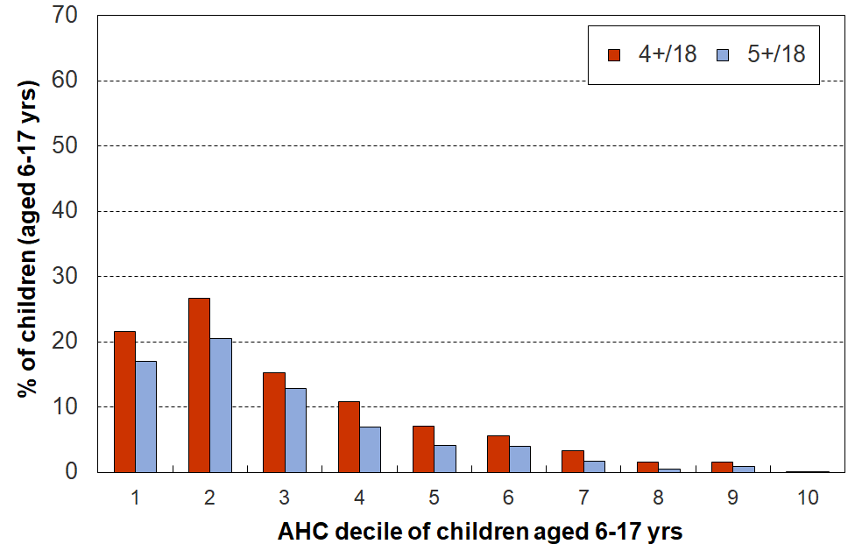
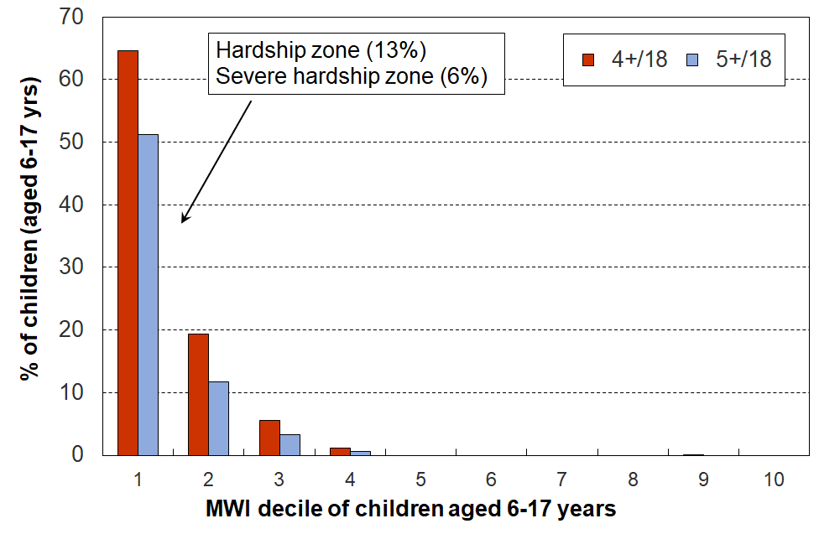
Multiple deprivation for children using 18 essential child-specific and general HH items, HES 2018-19
Note for Figure C.2
- The MWI chart above is based on the same data as the ventile version in Figure B.2 above.
- The average hardship rate for the lowest AHC decile is lower than for decile 2. This reflects a commonly-found feature of some of the households with very low income (eg those in ventile 1, the bottom 5%) – their actual day-to-day living standards are much higher than their incomes would suggest. As discussed in Section O, the report applies a treatment to the very-low-income households that reduces but does not eliminate the anomaly. See below for a brief discussion.

A key takeaway from this analysis, using the 18 essential items, is how the distribution of the deprivation items is so different depending on whether the ranking of households is done by an outcome measure (MSD’s MWI) or by an input measure (AHC income).

All up, in the 2018-19 HES, around 57,000 children aged 6-17 years (~10%) experienced 4+ deprivations out of the 18 in the list in Table C.2.
- When households are ranked by their material wellbeing (using the MWI), 75% of these children are found in the bottom decile (of children) and 93% are in the bottom two deciles, as shown in the left-hand chart.
- When households are ranked by their AHC incomes, the 57,000 6-17 year-olds experiencing these deprivations are spread much more widely: only around half are in the bottom two deciles (instead of 93%), and it takes the lower six deciles to capture 94% (compared with only the lower two deciles for the 93% on the MWI ranking.

When considering possible interventions to reduce material hardship rates for children, this finding and the associated one on the limited overlap between low-income and material hardship measures shows two things:
- how a good portion of the impact can (needs) to come from improved incomes for households with incomes above standard ‘poverty lines’ and even up to the median
- and, the fact that there is a range of non-income factors that can increase or reduce hardship means that there are some policy options in addition to income support for assisting households to improve their position – often involving reducing demand on the household budget (see Figure A.1).

A second takeaway is the implication for interpreting findings for the bottom income decile given the households-with-very-low-income issue, if there is no reasonable treatment applied. This matter is illustrated several times too in what follows below.

A third takeaway is how multiple material disadvantage for children clusters strongly at the hardship end of the spectrum (see, for example, Table C.3 below). The 18 items are those in Table C.2. The children are ranked in deciles by the MWI score of their households. For the most materially deprived 10% of children, 61% experience 4 or more of the 18 deprivations, all of which are about very basic needs. This is the average score for that group. For the most deprived, the proportion experiencing multiple deprivations is much greater.

While there is evidence here and elsewhere of some hardship in the next 10% (MWI decile 2), there is no gradient across all the deciles reflecting what could be called ‘acceptable inequality’ (as there is for many other aspects for social and material wellbeing). The analysis shows that for those children in the most materially deprived households (~5 to 8%), life is undeniably very different from that experienced by the vast majority of New Zealand children. This finding is in line with what was found using similar indicators from the 2008 Living Standards Survey. It illustrates what it means in practice to be ‘excluded from the minimum acceptable way of life in one’s own society’, the high-level definition of poverty commonly used for richer countries and adopted in MSD reports.
.

Children in households in material hardship

For children in households identified as ‘in hardship’, life is typically very different compared with that experienced by the vast majority of New Zealand children: there is no social gradient of ‘acceptable inequality’ across the material wellbeing spectrum when it comes to lacking common essentials – this experience is all heavily focussed in the lower 5-10%.

In Figure C.3 below, children (aged 6-17 yrs) are ranked by their households’ material wellbeing from high to low using the MWI, then grouped into ventiles (twenty equal groups of 5% each). The number of missing basics is counted out of the 18 essentials listed in Table C.2 above.

Figure C.3 shows how different life is for children in the hardship zone. This significant difference illustrates what it means in practice to be ‘excluded from the minimum acceptable way of life in one’s own society because of inadequate resources’, the high-level definition of poverty commonly used for richer countries, as discussed in the Introduction. There is no social gradient of ‘acceptable inequality’ across the material wellbeing spectrum when it comes to missing out on common essentials – this experience is all heavily focussed in the lower end, especially the lower 5-10% or so for children.

Figure C.3
Multiple deprivation for children, using 18 essential child-specific and child-relevant
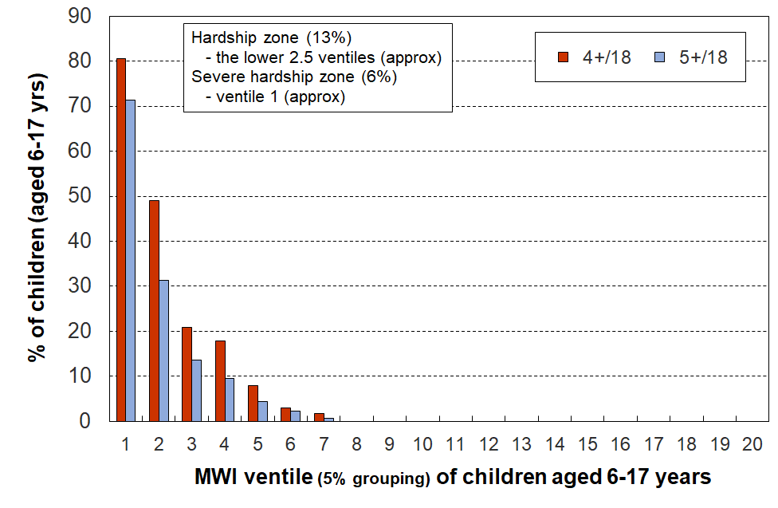
general household items, HES 2018-19

Tables C.3a and C.3b (next page) gives some more detailed analysis which underscores the considerable difference between life in the hardship zone and that for the vast majority of children.

Table C.3a
Children’s restrictions by the MWI score of their household (children, 6-17 yrs),
grouped by quintiles of children, with the bottom quintile broken out into deciles
HES 2018-19 (%)
 | All | D1 | D2 |  | Q1 | Q2 | Q3 | Q4 | Q5
Distribution of children (6-17yrs) across MWI deciles of children (%) | 100 | 10 | 10 |  | 20 | 20 | 20 | 20 | 20
Don’t have
2 pair of shoes in good condition and suitable for daily activities for each child | 7 | 36 | 15 |  | 26 | 4 | 2 | . | .
2 sets of warm winter clothes for each child | 2 | 13 | 3 |  | 8 | . | . | . | .
waterproof coat for each child (because of the cost) | 5 | 28 | 7 |  | 18 | 3 | . | . | .
separate bed for each child | 5 | 25 | 10 |  | 18 | 5 | . | . | .
fresh fruit and vegetables daily | 7 | 45 | 12 |  | 29 | 5 | . | . | .
meal with meat, fish or chicken (or vegetarian equiv) each day | 6 | 31 | 13 |  | 22 | 5 | . | . | .
good access at home to a computer and internet for homework | 6 | 27 | 14 |  | 21 | 6 | 2 | . | .
friends around to play and eat from time to time (because of the cost) | 4 | 21 | 7 |  | 14 | 3 | . | . | .
Economised ‘a lot’ on children’s items to keep down costs to enable other basic things to be paid for (not just to be thrifty or to save for a trip or other non-essential)
had to go without music, dance, kapa haka, art, swimming or other special interest lessons (“a lot”) | 7 | 35 | 17 |  | 26 | 6 | . | . | .
unable to pay for school trip or other school event (“a lot”) | 3 | 24 | 6 |  | 15 | 1 | . | . | .
involvement in sport had to be limited (“a lot”) | 6 | 32 | 15 |  | 24 | 4 | . | . | .
continue to wear shoes or clothes that are worn out or the wrong size (“a lot”) | 3 | 19 | 7 |  | 13 | . | . | . | .
Multiple restrictions of child-specific items (the 12 above)
2+ out of 12 | 12 | 68 | 28 |  | 49 | 9 | . | . | .
3+ out of 12 | 8 | 53 | 17 |  | 36 | 4 | . | . | .
4+ out of 12 | 6 | 43 | 9 |  | 27 | 2 | . | . | .
Child-relevant general household items
received help (food, clothes, money) from a community organisation more than once in the last 12 months | 5 | 31 | 9 |  | 20 | 4 | . | . | .
accommodation crowded or severely crowded (1+ extra bedrooms needed) | 13 | 31 | 23 |  | 27 | 18 | 8 | 8 | 4
accommodation severely crowded (2+ extra bedrooms needed) | 3 | 6 | 6 |  | 6 | 5 | 2 | . | .
dampness or mould a ‘major problem’ in the accommodation | 8 | 36 | 20 |  | 28 | 8 | 3 | . | .
respondent reports putting up with feeling cold to keep down costs for other basics (‘a lot’) | 10 | 49 | 27 |  | 38 | 9 | 1 | . | .
delayed replacing or repairing broken or damaged appliances to keep down costs for other basics (‘a lot’) | 12 | 62 | 29 |  | 45 | 12 | 3 | . | .
household has no access to car or van for personal use | 5 | 14 | 7 |  | 10 | 6 | 3 | 2 | .
Multiple restrictions out of 12 child-specific and 6 general child-relevant household items (18 in all)
3+ out of 18 | 14 | 78 | 34 |  | 57 | 8 | . | . | .
4+ out of 18 | 9 | 64 | 18 |  | 42 | 3 | . | . | .
5+ out of 18 | 7 | 50 | 11 |  | 31 | 2 | . | . | .
Postponed doctor’s visits ‘a lot’ to keep down costs to enable other basic things to be paid for (not just to be thrifty or to save for a trip or other non-essential)
For children (a lot) | 2 | 8 | 5 |  | 7 | . | . | . | .
For respondent (a lot) | 11 | 52 | 33 |  | 42 | 11 | 3 | . | .
For children (a little or a lot) | 5 | 22 | 11 |  | 17 | 6 | . | . | .
For respondent (a little or a lot) | 28 | 84 | 71 |  | 77 | 46 | 16 | 2 | .
Respondent reports life satisfaction
dissatisfied or very dissatisfied with life | 6 | 23 | 14 |  | 19 | 7 | 3 | 2 | .
satisfied or very satisfied with life | 79 | 42 | 60 |  | 51 | 74 | 84 | 92 | 95
Note: Information is suppressed in cells with fewer than 15 households in the sample.

Table C.3b
Children’s restrictions by the MWI score of their household (children, 6-17 yrs),
grouped by deciles and ventiles of children
HES 2018-19 (%)
 | All | V1 | V2 |  | D1 | D2 | D3 | D4 | D5
Distribution of children (6-17yrs) across MWI deciles of children (%) | 100 | 5 | 5 |  | 10 | 10 | 10 | 10 | 10
Don’t have
2 pair of shoes in good condition and suitable for daily activities for each child | 7 | 49 | 23 |  | 36 | 15 | 5 | . | .
2 sets of warm winter clothes for each child | 2 | 20 | . |  | 13 | 3 | . | . | .
waterproof coat for each child (because of the cost) | 5 | 40 | 17 |  | 28 | 7 | 4 | . | .
separate bed for each child | 5 | 30 | 20 |  | 25 | 10 | 5 | 5 | .
fresh fruit and vegetables daily | 7 | 58 | 32 |  | 45 | 12 | 6 | 3 | .
meal with meat, fish or chicken (or vegetarian equiv) each day | 6 | 42 | 21 |  | 31 | 13 | 5 | 4 | .
good access at home to a computer and internet for homework | 6 | 40 | 14 |  | 27 | 14 | 6 | 6 | .
friends around to play and eat from time to time (because of the cost) | 4 | 31 | 10 |  | 21 | 7 | . | . | .
Economised ‘a lot’ on children’s items to keep down costs to enable other basic things to be paid for (not just to be thrifty or to save for a trip or other non-essential)
had to go without music, dance, kapa haka, art, swimming or other special interest lessons (“a lot”) | 7 | 42 | 27 |  | 35 | 17 | 10 | 3 | .
unable to pay for school trip or other school event (“a lot”) | 3 | 26 | 21 |  | 24 | 6 | . | . | .
involvement in sport had to be limited (“a lot”) | 6 | 37 | 28 |  | 32 | 15 | 6 | . | .
continue to wear shoes or clothes that are worn out or the wrong size (“a lot”) | 3 | 26 | 13 |  | 19 | 7 | . | . | .
Multiple restrictions of child-specific items (the 12 above)
2+ out of 12 | 12 | 79 | 58 |  | 68 | 28 | 12 | 5 | .
3+ out of 12 | 8 | 71 | 35 |  | 53 | 17 | 6 | . | .
4+ out of 12 | 6 | 61 | 25 |  | 43 | 9 | . | . | .
Child-relevant general household items
received help (food, clothes, money) from a community organisation more than once in the last 12 months | 5 | 42 | 20 |  | 31 | 9 | 5 | 3 | .
accommodation crowded or severely crowded (1+ extra bedrooms needed) | 13 | 34 | 27 |  | 31 | 23 | 18 | 18 | 9
accommodation severely crowded (2+ extra bedrooms needed) | 3 | 7 | . |  | 6 | 6 | 4 | 5 | .
dampness or mould a ‘major problem’ in the accommodation | 8 | 39 | 33 |  | 36 | 20 | 10 | 7 | 4
respondent reports putting up with feeling cold to keep down costs for other basics (‘a lot’) | 10 | 64 | 33 |  | 49 | 27 | 12 | 6 | 2
delayed replacing or repairing broken or damaged appliances to keep down costs for other basics (‘a lot’) | 12 | 78 | 46 |  | 62 | 29 | 16 | 8 | 3
household has no access to car or van for personal use | 5 | 17 | 10 |  | 14 | 7 | 9 | 3 | 4
Multiple restrictions out of 12 child-specific and 6 general child-relevant household items (18 in all)
3+ out of 18 | 14 | 90 | 66 |  | 78 | 34 | 12 | 3 | .
4+ out of 18 | 9 | 81 | 47 |  | 64 | 18 | 5 | . | .
5+ out of 18 | 7 | 71 | 30 |  | 50 | 11 | . | . | .
Postponed doctor’s visits ‘a lot’ to keep down costs to enable other basic things to be paid for (not just to be thrifty or to save for a trip or other non-essential)
For children (a lot) | 2 | 12 | . |  | 8 | 5 | . | . | .
For respondent (a lot) | 11 | 60 | 44 |  | 52 | 33 | 13 | 8 | 4
For children (a little or a lot) | 5 | 24 | 20 |  | 22 | 11 | 6 | 6 | .
For respondent (a little or a lot) | 28 | 89 | 79 |  | 84 | 71 | 54 | 38 | 21
Respondent reports life satisfaction
dissatisfied or very dissatisfied with life | 6 | 30 | 16 |  | 23 | 14 | 8 | 6 | 3
satisfied or very satisfied with life | 79 | 35 | 50 |  | 42 | 60 | 68 | 80 | 81
Note: Information is suppressed in cells with fewer than 15 households in the sample.

Restrictions for children (aged 6-17 yrs) living in households in material hardship and severe material hardship (DEP-17 scores of 6+/17 and 9+/17 respectively)

Figure C.2 and Table C.3 above use groups of 5% and 10% of children across the MWI spectrum (ie ventiles and deciles of MWI scores). Table C.4 below uses the two CPRA material hardship DEP-17 measures, (6+/17 and 9+/17):
- The left-hand panel of numbers in the table (‘rates’) shows the proportion of children (6-17 yrs) who face restrictions on the basics identified in the list – for all 6-17 year olds and for those in each hardship depth.
- The right-hand panel (‘composition’) shows the proportion of all of those deprived of the item whose household has a DEP-17 score of 6+ or 9+. For example, 71% of all children whose household relied on help from a community agency or foodbank for food or cash in the 12 months prior to interview … are in households in the 6+/17 hardship zone.

Table C.4
Deprivations/restrictions for children (6-17 yrs) in households in hardship (6+/17, 9+/17) HES 2018-19
 |  | Rates (%) |  |  |  | Composition (%)
 |  | Deprivation rate for item for all aged 6-17 yrs, and for those in HHs in hardship and severe hardship |  |  |  | Proportion of all deprived of the item whose household is in the specified hardship zone
 |  | All | 6+/17 | 9+/17 |  | 6+/17 | 9+/17
Child-relevant general household items
Income adequacy for basics | not enough | 13 | 50 | 66 |  | 51 | 28
Foodbank / other community help | more than once | 5 | 26 | 41 |  | 71 | 47
Borrowed for basics from family/friends | more than once | 11 | 54 | 70 |  | 63 | 34
Can pay unexpected $500 essential bill | no | 26 | 84 | 93 |  | 43 | 20
Delayed replace/repair appliances | a lot | 12 | 58 | 75 |  | 63 | 34
Car | don't have | 5 | 12 | 16 |  | 34 | 20
Holiday away each year | don't have - cost | 29 | 74 | 78 |  | 34 | 15
Holiday away each year | don't have - other | 10 | 4 | 4 |  | 5 | 2
Dampness or mould | major problem | 8 | 28 | 31 |  | 46 | 21
Can afford to keep home warm | no | 10 | 44 | 62 |  | 60 | 35
Crowding | 1+ more rooms needed | 13 | 29 | 33 |  | 29 | 14
Crowding | 2+ needed - severe | 3 | 5 | 6 |  | 23 | 11
Life satisfaction | dissatis / very dissatis | 6 | 23 | 31 |  | 48 | 27
Child-specific items
Two pair of shoes | don't have | 7 | 30 | 44 |  | 62 | 38
Two sets winter clothes | don't have | 2 | 11 | 19 |  | 80 | 59
Waterproof coat | don't have - cost | 4 | 24 | 34 |  | 74 | 45
Waterproof coat | don't have - other | 4 | 7 | 7 |  | 24 | 10
Separate bed | don't have | 5 | 20 | 26 |  | 53 | 29
Fruit and veg daily | don't have | 7 | 36 | 54 |  | 68 | 43
Protein meal daily | don't have | 6 | 28 | 42 |  | 62 | 40
Computer / internet | don't have | 6 | 23 | 33 |  | 55 | 33
Friends around to play / eat | don't have - cost | 3 | 17 | 28 |  | 68 | 46
Friends around to play / eat | don't have - other | 8 | 16 | 15 |  | 28 | 11
Birthday and other celebrations | don't have - cost | 5 | 24 | 32 |  | 63 | 36
Birthday and other celebrations | don't have - other | 7 | 13 | 11 |  | 24 | 9
Unable to fund school trips | a lot | 3 | 20 | 24 |  | 80 | 41
Had to limit participation in sport | a lot | 6 | 28 | 38 |  | 69 | 39
Had to go without special interests | a lot | 7 | 30 | 41 |  | 61 | 36
Continued to wear worn out / wrong size shoes/clothes | a lot | 3 | 17 | 27 |  | 78 | 52
Note: See Appendix 1 for ‘don’t have for other reasons’.

What income bands do those in hardship come from?

A central theme of this report is the relatively limited overlap between low-income and material hardship measures of poverty, for poverty understood as being ‘excluded from the minimum acceptable way of life in one’s own society because of inadequate resources’.

Figure C.4 shows the household income bands that children identified as in hardship come from (children living in households with a DEP-17 score of 6+/17). It shows that:
- (only) around one in four (28%) come from households with incomes below 40% AHC
- almost two in three (60%) come from households with incomes below 60% AHC
- just under one in three (29%) come from households with incomes above 70% AHC.

The second row in Table C.5 shows the distribution across income bands for those in what the CPRA refers to as ‘severe material hardship’ (ie 9+/17 missing items in DEP-17 list).
- one in three (32%) of these children come from households with incomes below 40% AHC
- half (51%) come from households with incomes under 50% AHC
- one in four (26%) come from households with incomes above 70% AHC.

Figure C.4
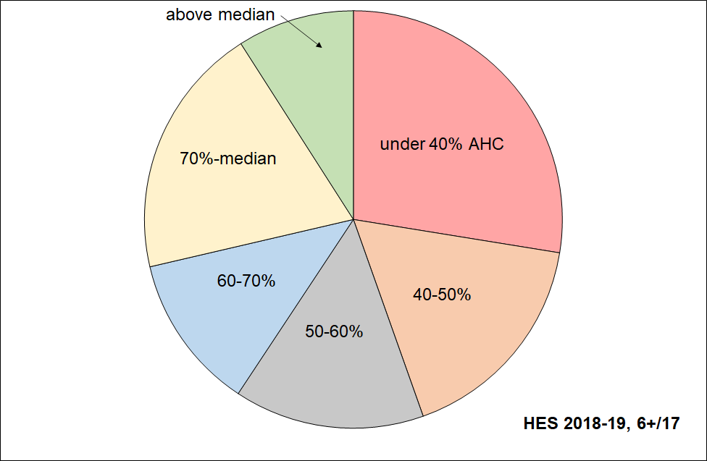
Distribution across household AHC income bands of children identified as in hardship (DEP-17 of 6+/17)

Table C.5
Distribution across household AHC income bands of children identified as in hardship (DEP-17, 6+/17),
and severe material hardship (9+/17)
HES 2018-19 | under 40% | 40-50% | 50-60% | 60-70% | 70%-median | above median | ALL, 0-17 yrs
All 0-17s | 12 | 7 | 8 | 9 | 25 | 40 | 100
DEP-17, 6+/17 | 28 | 17 | 15 | 12 | 20 | 9 | 100
DEP-17, 9+/17 | 32 | 19 | 12 | 10 | 19 | 7 | 100
Reading note for Table C.5 and Figure C.4
The numbers in the first row of this table are a little lower than the official Stats NZ numbers for 2018-19 as the treatment for VLI households with good material wellbeing has been applied. For example, AHC 60 from the above is 27% rather than the official 28%. See Appendix 5 for further information, and Section O in the main report for detail.

Children in low-income households

This sub-section describes ‘life under the line’ for children in low-income households. It uses the same 20 calibration items as in the previous sub-section which looked at children in households experiencing material hardship.

Before coming to the detailed tables, there are two matters worth highlighting:
- a data issue that impacts on the picture painted of life in low-income households, and the strategy used in this report to (partially) address it
- a conceptual matter that is sometimes misunderstood and can lead to an overstatement of the number of children in low-income households experiencing serious material hardship.

The data issue

The Household Economic Survey, like similar ones elsewhere, includes a small group of very-low-income (VLI) households the great majority of whom report consumption / material wellbeing more like households with incomes in the middle of the income distribution. These VLI households have reported incomes of less than around 10-15% of the median, well below all income support safety net levels. There are many possible sources of these implausibly low incomes: for example, some of these incomes are from self-employed households, some are from households with a temporary low income but high savings, others are respondent errors and others arise in the creation of the dataset.

For the 2018-19 HES data, this VLI group with good material wellbeing is larger than for previous HES datasets MSD has used. As this group is in general so much better off than their counterparts with ordinary low household income, their presence can lead to misleading and incongruous findings. They make up only a very small proportion of the whole population (around 2-4%), but when the population of interest is a low-income group, they can make up a non-trivial portion as high as 25% in some cases. Their presence ‘improves’ the reported average material wellbeing of households with incomes under the CPRA poverty lines. As this section is about painting a picture of life for children in low-income households the data issue is of direct relevance.

MSD’s reports have applied various treatments in the past to seek to reduce the noise from this VLI group for selected statistics as required. The treatment used in this report is described in brief in the Section A, and is discussed in much more detail in Section O. In essence it deletes those VLI households who report a DEP-17 score of zero or say they have enough or more than enough income for basics. This is a conservative and interim treatment that helps reduce the distortion, but more work is needed to address it properly.

Stats NZ are aware of the issue and have discussed in the in the Technical Appendices for both the 2020 and the 2021 Child Poverty releases. They are investigating further.

The conceptual / interpretation issue

It is relatively common for media reports and other commentators to use a narrative that goes like this or similar:
- Around one in four (five) New Zealand children are in poverty.
- They are going without many things that most of us take for granted (they don’t have two pairs of good shoes, don’t have a good meal at least once a day, live in homes which are cold because there’s not enough money for paying the electricity bill, can’t participate in sport and special interests as there is not enough money, and so on).
- Conclusion: This is unacceptable – much more government action is required / give to XYZ charity.

The claim about one in four (or five) being in poverty ((a) above) probably uses BHC 60 or AHC 50 low-income numbers.

The deprivations listed in the next statement (b) are all reasonable descriptions of poverty as most would understand it. However, the leap from an income-based measure to a list of serious deprivations as if the same notion of ‘poverty’ is used for both is a fallacy. Even in households with DEP-17 scores of 6+ it is not the case that all or even the majority of the children experience the deprivations listed in ‘b’ above, even less so for low-income households using the CPRA measures. The analysis that follows provides good evidence of how life is for children in households in low-income households and shows that the narrative above is a major over-statement.

What are the hardship rates for children in selected household income bands?

The analysis in Figure C.4 and Table C.5 (above) starts with those in households in hardship and asks what income bands they come from. Here the other question is addressed: it starts with those in selected income bands and asks what their respective hardship rates are.

Figure C.5 answers this question by showing the material hardship rates for children in selected AHC income bands. For example, 33% of those in households with incomes in the 40-50% AHC band are in hardship. This means that 67% are not. Table C.6 gives the percentages used in Figure C.5 together with the actual numbers of children in hardship in each band. For context, the table also gives the sized of the child population in the income bands - percentages and numbers.

The highest hardship rates are for children in households in the lower two AHC income bands (as expected), but the rates are well below 100% (only ~33%). In the 50-60% of median zone, only 25% are in hardship. The data issue noted above means that for the lower two bands especially, the figures are under-estimates, even with the treatment applied.

Figure C.5
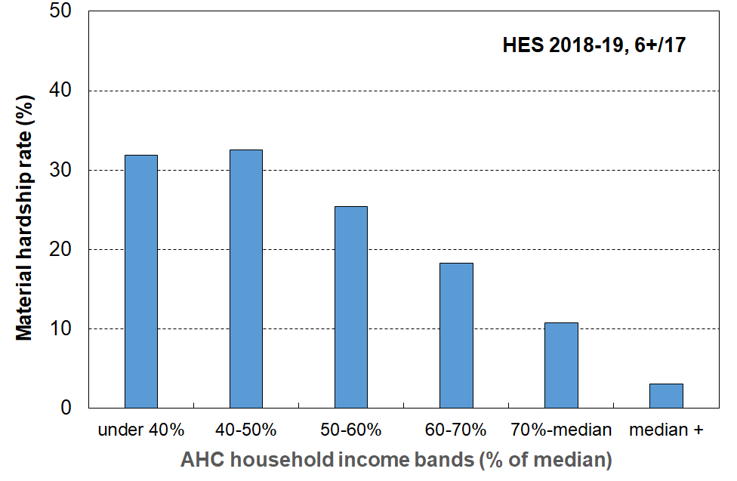
Material hardship rates (%) of children in selected AHC household income bands, HES 2018-19

Table C.6
Numbers and percentages of children in each AHC income band
(all children and children in households in hardship)
HES 2018-19
 |  | < 40% | 40-50% | 50-60% | 60-70% | 70-100% | Median + | Sum across
Numbers (000s) | All children (cell = # of 0-17s) | 130 | 80 | 85 | 100 | 270 | 440 | 1100
 | # of 0-17s in the income band who are in hardship | 40 | 25 | 20 | 20 | 30 | 15 | 150
% | % of all 0-17s who are in the income band | 12 | 7 | 8 | 9 | 25 | 40 | 100
 | % of all 0-17s who are in hardship who come from this income band | 28 | 17 | 15 | 12 | 20 | 9 | 100
 | % of 0-17s in the income band who are in hardship | 32 | 33 | 25 | 18 | 11 | 3 | n/a

Table C.7 repeats the analysis in Table C.6 for each CPRA relative low-income measure rather than for selected bands.
Table C.7
Numbers and percentages of children below each CPRA relative low-income threshold
(all children and children in households in hardship)
HES 2018-19
 |  | BHC 50 | BHC 60 | AHC 40 | AHC 50 | AHC 60
Numbers (000s) | All children (0-17 yrs) | 145 | 245 | 130 | 205 | 295
 | # of 0-17s in the income range who are in hardship | 50 | 80 | 40 | 65 | 90
Percentages | % of all 0-17s who are in the income range | 13 | 22 | 12 | 19 | 27
 | % of 0-17s in the income range who are in hardship | 33 | 32 | 32 | 32 | 30
Reading note for Table C.7:
The numbers in the first and third rows of this table are a little lower than the official Stats NZ numbers for 2018-19 as the treatment for VLI households with good material wellbeing has been applied. See Section O for detail.
In Table C.3a household rankings were done using the MWI. Table C.8a below ranks households using AHC household incomes and Table C.8b uses BHC incomes.

A comparison between the two tables (C.3a and C.8a) shows the same sort of differences between rankings on low-income and ranking on the MWI as is shown in Figures C.2 above: restrictions for children are much more dispersed across the household income spectrum than they are across the MWI spectrum.

Table C.8a
Children’s restrictions by AHC income of their household (children, 6-17 yrs),
grouped by quintiles of children, with the bottom quintile broken out into deciles
 | All | D1 | D2 |  | Q1 | Q2 | Q3 | Q4 | Q5
Distribution of children (6-17yrs) across MWI deciles of children (%) | 100 | 10 | 10 |  | 20 | 20 | 20 | 20 | 20
Don’t have
2 pair of shoes in good condition and suitable for daily activities for each child | 7 | 17 | 19 |  | 18 | 9 | 5 | . | .
2 sets of warm winter clothes for each child | 2 | 4 | 5 |  | 5 | 2 | . | . | .
waterproof coat for each child (because of the cost) | 5 | 11 | 12 |  | 11 | 6 | 4 | . | .
separate bed for each child | 5 | 10 | 12 |  | 11 | 7 | 4 | 3 | .
fresh fruit and vegetables daily | 8 | 15 | 19 |  | 17 | 10 | 5 | 3 | .
meal with meat, fish or chicken (or vegetarian equiv) each day | 6 | 16 | 13 |  | 14 | 10 | 3 | 3 | .
good access at home to a computer and internet for homework | 6 | 12 | 16 |  | 14 | 9 | 5 | 1 | .
friends around to play and eat from time to time (because of the cost) | 4 | 9 | 8 |  | 8 | 5 | 3 | . | .
Economised “a lot” on children’s items to keep down costs to enable other basic things to be paid for (not just to be thrifty or to save for a trip or other non-essential)
had to go without music, dance, kapa haka, art, swimming or other special interest lessons (“a lot”) | 7 | 15 | 15 |  | 15 | 10 | 6 | 2 | .
unable to pay for school trip or other school event (“a lot”) | 4 | 8 | 9 |  | 9 | 5 | . | . | .
involvement in sport had to be limited (“a lot”) | 6 | 14 | 12 |  | 13 | 10 | 4 | . | .
continue to wear shoes or clothes that are worn out or the wrong size (“a lot”) | 3 | 5 | 9 |  | 7 | 5 | . | . | .
Multiple restrictions of child-specific items (the 12 above)
2+ out of 12 | 13 | 28 | 30 |  | 29 | 17 | 9 | 4 | .
3+ out of 12 | 9 | 20 | 23 |  | 22 | 11 | 6 | 2 | .
4+ out of 12 | 6 | 15 | 17 |  | 16 | 8 | 4 | . | .
Child-relevant general household items
received help (food, clothes, money) from a community organisation more than once in the last 12 months | 5 | 13 | 14 |  | 14 | 7 | 2 | . | .
accommodation crowded or severely crowded (1+ extra bedrooms needed) | 13 | 17 | 22 |  | 19 | 20 | 14 | 9 | 4
accommodation severely crowded (2+ extra bedrooms needed) | 3 | 2 | 4 |  | 3 | 5 | 4 | 4 | .
dampness or mould a “major problem” in the accommodation | 8 | 17 | 13 |  | 15 | 12 | 8 | 5 | 2
respondent reports putting up with feeling cold to keep down costs for other basics (a lot) | 10 | 16 | 25 |  | 21 | 14 | 8 | 4 | 3
delayed replacing or repairing broken or damaged appliances to keep down costs for other basics (a lot) | 12 | 22 | 26 |  | 24 | 19 | 10 | 5 | 4
household has no access to car or van for personal use | 5 | 9 | 11 |  | 10 | 6 | 3 | 3 | .
Multiple restrictions out of 12 child-specific and 6 general child-relevant household items (18 in all)
3+ out of 18 | 14 | 32 | 33 |  | 32 | 20 | 10 | 3 | .
4+ out of 18 | 10 | 22 | 27 |  | 24 | 13 | 6 | 3 | .
5+ out of 18 | 7 | 17 | 21 |  | 19 | 10 | 4 | . | .
Postponed doctor’s visits “a lot” to keep down costs to enable other basic things to be paid for (not just to be thrifty or to save for a trip or other non-essential)
For children (a lot) | 2 | 2 | 5 |  | 3 | 2 | . | . | .
For respondent (a lot) | 11 | 23 | 22 |  | 23 | 17 | 9 | 5 | 3
For children (a little or a lot) | 5 | 9 | 11 |  | 10 | 9 | 2 | . | .
For respondent (a little or a lot) | 29 | 49 | 46 |  | 48 | 40 | 30 | 18 | 8
Respondent reports life satisfaction
dissatisfied or very dissatisfied with life | 6 | 12 | 12 |  | 12 | 9 | 5 | 3 | 3
satisfied or very satisfied with life | 79 | 64 | 69 |  | 66 | 73 | 78 | 86 | 90
Note: Information is suppressed in cells with less than 15 households in the sample.
Table C.8b
Children’s restrictions by BHC income of their household (children, 6-17 yrs),
grouped by quintiles of children, with the bottom quintile broken out into deciles
HES 2018-19 (%)
 | All | D1 | D2 |  | Q1 | Q2 | Q3 | Q4 | Q5
Distribution of children (6-17yrs) across MWI deciles of children (%) | 100 | 10 | 10 |  | 20 | 20 | 20 | 20 | 20
Don’t have
2 pair of shoes in good condition and suitable for daily activities for each child | 7 | 21 | 17 |  | 19 | 8 | 4 | . | .
2 sets of warm winter clothes for each child | 2 | 6 | 4 |  | 5 | 2 | . | . | .
waterproof coat for each child (because of the cost) | 5 | 16 | 8 |  | 12 | 6 | 2 | . | .
separate bed for each child | 5 | 15 | 12 |  | 14 | 6 | 4 | 2 | .
fresh fruit and vegetables daily | 8 | 21 | 18 |  | 19 | 8 | 5 | 3 | .
meal with meat, fish or chicken (or vegetarian equiv) each day | 6 | 17 | 16 |  | 16 | 8 | 4 | . | .
good access at home to a computer and internet for homework | 6 | 15 | 14 |  | 15 | 9 | 5 | . | .
friends around to play and eat from time to time (because of the cost) | 4 | 12 | 5 |  | 8 | 6 | 2 | . | .
Economised “a lot” on children’s items to keep down costs to enable other basic things to be paid for (not just to be thrifty or to save for a trip or other non-essential)
had to go without music, dance, kapa haka, art, swimming or other special interest lessons (“a lot”) | 7 | 15 | 17 |  | 16 | 12 | 4 | . | .
unable to pay for school trip or other school event (“a lot”) | 4 | 10 | 9 |  | 10 | 6 | . | . | .
involvement in sport had to be limited (“a lot”) | 6 | 12 | 15 |  | 13 | 10 | 3 | . | .
continue to wear shoes or clothes that are worn out or the wrong size (“a lot”) | 3 | 8 | 7 |  | 7 | 5 | 2 | . | .
Multiple restrictions of child-specific items (the 12 above)
2+ out of 12 | 13 | 31 | 31 |  | 31 | 17 | 7 | 4 | .
3+ out of 12 | 8 | 26 | 21 |  | 23 | 11 | 5 | . | .
4+ out of 12 | 6 | 20 | 15 |  | 18 | 7 | 4 | . | .
Child-relevant general household items
received help (food, clothes, money) from a community organisation more than once in the last 12 months | 5 | 15 | 13 |  | 14 | 8 | 2 | . | .
accommodation crowded or severely crowded (1+ extra bedrooms needed) | 13 | 27 | 23 |  | 25 | 17 | 13 | 8 | 3
accommodation severely crowded (2+ extra bedrooms needed) | 3 | 4 | 7 |  | 5 | 4 | 4 | 2 | .
dampness or mould a “major problem” in the accommodation | 8 | 17 | 16 |  | 16 | 12 | 7 | 4 | .
respondent reports putting up with feeling cold to keep down costs for other basics (a lot) | 10 | 21 | 20 |  | 21 | 14 | 7 | 4 | .
delayed replacing or repairing broken or damaged appliances to keep down costs for other basics (a lot) | 12 | 26 | 23 |  | 25 | 19 | 9 | 5 | 4
household has no access to car or van for personal use | 5 | 12 | 8 |  | 10 | 5 | 4 | 2 | .
Multiple restrictions out of 12 child-specific and 6 general child-relevant household items (18 in all)
3+ out of 18 | 14 | 36 | 33 |  | 34 | 20 | 8 | 3 | .
4+ out of 18 | 10 | 27 | 24 |  | 25 | 13 | 5 | 2 | .
5+ out of 18 | 7 | 23 | 19 |  | 21 | 9 | 4 | . | .
Postponed doctor’s visits “a lot” to keep down costs to enable other basic things to be paid for (not just to be thrifty or to save for a trip or other non-essential)
For children (a lot) | 2 | 3 | 3 |  | 3 | 3 | . | . | .
For respondent (a lot) | 11 | 22 | 23 |  | 22 | 18 | 9 | 4 | 3
For children (a little or a lot) | 5 | 11 | 10 |  | 11 | 7 | 3 | 3 | .
For respondent (a little or a lot) | 28 | 48 | 46 |  | 47 | 40 | 30 | 18 | 8
Respondent reports life satisfaction
dissatisfied or very dissatisfied with life | 6 | 11 | 14 |  | 12 | 9 | 5 | 3 | 2
satisfied or very satisfied with life | 79 | 66 | 64 |  | 65 | 72 | 81 | 85 | 91
Note: Information is suppressed in cells with less than 15 households in the sample.

What is life like for those under the five CPRA relative low-income thresholds?

Table C.9 shows the proportion of children in households experiencing deprivations of specific items for those with incomes under the five CPRA low-income measures. The items go a little wider than the 18 essentials listed in Table C.2.
- The child-relevant general household items are almost all ‘enforced lacks’ (ie the household does not have it because of shortage of money), or serious lacks (eg had to economise ‘a lot’ because of lack of money, ‘major problem’, and so on).
- The child-specific items are mostly simple ‘don’t haves’ as they are considered essentials that all children should have and none should be without. The ‘economise a lot’ items are very close to enforced lacks.

Table C.9
Item deprivations for children aged 6-17 yrs (%),
in households with incomes below selected BHC and AHC relative low-income thresholds,
HES 2018-19 (%)
 |  | All (%) | Relative low-income thresholds / ‘income poverty lines’
 |  |  | BHC 50 | BHC 60 | AHC 40 | AHC 50 | AHC 60
Child-relevant general HH items | Response
Income adequacy for basics | not enough | 13 | 33 | 30 | 33 | 31 | 27
Foodbank / other community help | more than once | 5 | 14 | 14 | 13 | 13 | 12
Borrowed for basics from family/friends | more than once | 12 | 26 | 25 | 28 | 27 | 24
Can pay unexpected $500 essential bill | no | 26 | 51 | 49 | 52 | 49 | 47
Delayed replace/repair appliances | a lot | 12 | 25 | 25 | 24 | 25 | 22
Car | don't have | 5 | 8 | 8 | 8 | 8 | 8
Holiday away each year | don't have - cost | 30 | 50 | 50 | 48 | 51 | 49
Holiday away each year | don't have – other | 10 | 10 | 9 | 10 | 9 | 10
Dampness or mould | major problem | 8 | 18 | 17 | 16 | 14 | 15
Can afford to keep home warm | no | 10 | 25 | 23 | 25 | 24 | 21
Crowding | 1+ more rooms needed | 13 | 26 | 24 | 18 | 19 | 19
Crowding | 2+ needed - severe | 3 | 5 | 5 | 2 | 3 | 3
Life satisfaction | dissatis / very dissatis | 6 | 12 | 12 | 11 | 12 | 12
Child-specific items (6-17 yrs)
Two pair of shoes | don't have | 7 | 21 | 18 | 18 | 18 | 16
Two sets winter clothes | don't have | 2 | 6 | 5 | 4 | 5 | 4
Waterproof coat | don't have - cost | 5 | 14 | 12 | 11 | 11 | 10
Waterproof coat | don't have - other | 4 | 7 | 7 | 9 | 7 | 7
Separate bed | don't have | 5 | 15 | 13 | 10 | 11 | 11
Fruit and veg daily | don't have | 8 | 21 | 18 | 15 | 17 | 16
Protein meal daily | don't have | 6 | 16 | 16 | 15 | 14 | 15
Computer / internet | don't have | 6 | 13 | 14 | 11 | 13 | 12
Friends around to play / eat | don't have - cost | 4 | 10 | 9 | 8 | 8 | 8
Friends around to play / eat | don't have - other | 8 | 12 | 14 | 17 | 14 | 13
Birthday and other celebrations | don't have - cost | 5 | 15 | 13 | 12 | 12 | 10
Birthday and other celebrations | don't have - other | 7 | 12 | 12 | 10 | 10 | 10
Unable to fund school trips | a lot | 4 | 11 | 10 | 9 | 9 | 8
Had to limit participation in sport | a lot | 6 | 13 | 13 | 13 | 13 | 12
Had to go without special interests | a lot | 7 | 15 | 16 | 15 | 15 | 15
Continued to wear worn out / wrong size shoes/clothes | a lot | 3 | 8 | 7 | 5 | 7 | 7
DEP-17 material hardship, 6+/17 |  | 14 | 34 | 33 | 32 | 32 | 31
DEP-17 severe material hardship, 9+/17 |  | 6 | 15 | 15 | 15 | 15 | 13
Note for Table C.8:
- For full item descriptions, see Appendix 1
- “Don’t have – other” includes “don’t want”.
- See Table C.9 for the numbers in each cell.
Table C.10 is the numbers version of Table C.9. It is of value in itself, but it also enables the calculation of the proportion of all those without an item who live in households below a selected low-income line. For example:
- 42% of children in households in which the adults say that they ‘cannot afford to keep the home warm’ come from households under the AHC 50% line – 58% are in households with higher income than this (30,000 / 72,000 = 42%).
- 62% of children who don’t have two pairs of shoes come from households under the BHC 60% line – 38% are in households with higher income than this (26,000 / 42,000 = 62%).

Table C.10
Item deprivations for children aged 6-17 yrs
in households with incomes below selected BHC and AHC relative low-income thresholds,
HES 2018-19 (number aged 6-17 yrs, 000s)
 |  | All  (000s) | Low-income thresholds / ‘income poverty lines’
 |  |  | BHC 50 | BHC 60 | AHC 40 | AHC 50 | AHC 60
Child-relevant general HH items | Response
Income adequacy for basics | not enough | 97 | 32 | 49 | 27 | 42 | 52
Foodbank / other community help | more than once | 36 | 13 | 22 | 11 | 18 | 23
Borrowed for basics from family/friends | more than once | 85 | 24 | 40 | 23 | 36 | 48
Can pay unexpected $500 essential bill | no | 195 | 48 | 79 | 42 | 67 | 92
Delayed replace/repair appliances | a lot | 91 | 24 | 40 | 20 | 34 | 44
Car | don't have | 34 | 7 | 7 | 7 | 7 | 7
Holiday away each year | don't have - cost | 221 | 48 | 82 | 39 | 69 | 96
Holiday away each year | don't have - other | 76 | 9 | 16 | 8 | 13 | 20
Dampness or mould | major problem | 60 | 17 | 28 | 13 | 20 | 29
Can afford to keep home warm | no | 72 | 23 | 37 | 20 | 32 | 41
Crowding | 1+ more rooms needed | 98 | 25 | 40 | 14 | 26 | 37
Crowding | 2+ needed - severe | 23 | 5 | 9 | 2 | 4 | 7
Life satisfaction | dissatis / very dissatis | 47 | 12 | 19 | 9 | 16 | 23
Child-specific items
Two pair of shoes | don't have | 42 | 17 | 25 | 12 | 21 | 26
Two sets winter clothes | don't have | 11 | 5 | 7 | 3 | 6 | 7
Waterproof coat | don't have - cost | 27 | 12 | 17 | 8 | 12 | 17
Waterproof coat | don't have - other | 25 | 6 | 9 | 6 | 9 | 12
Separate bed | don't have | 32 | 12 | 18 | 7 | 13 | 18
Fruit and veg daily | don't have | 45 | 17 | 25 | 11 | 20 | 27
Protein meal daily | don't have | 38 | 13 | 22 | 11 | 17 | 25
Computer / internet | don't have | 36 | 11 | 20 | 8 | 15 | 20
Friends around to play / eat | don't have - cost | 21 | 8 | 12 | 6 | 10 | 13
Friends around to play / eat | don't have - other | 48 | 10 | 19 | 12 | 16 | 22
Birthday and other celebrations | don't have - cost | 32 | 12 | 19 | 8 | 14 | 17
Birthday and other celebrations | don't have - other | 43 | 9 | 16 | 7 | 12 | 17
Unable to fund school trips | a lot | 21 | 9 | 14 | 6 | 11 | 13
Had to limit participation in sport | a lot | 35 | 11 | 18 | 9 | 15 | 20
Had to go without special interests | a lot | 42 | 12 | 22 | 11 | 18 | 24
Continued to wear worn out / wrong size shoes/clothes | a lot | 19 | 7 | 10 | 4 | 8 | 11
Notes for Table C.9:
- For full item descriptions, see Appendix 1.
- “Don’t have – other” includes “don’t want”.

What is life like for those in selected AHC income bands?

Table C.11 gives a more detailed analysis for children in households in selected AHC income bands, ranging from under 40% to 80% and higher.
- Information on both rates and composition are included. The percentages in the composition panel all add to 100% across.
- The very bottom two rows give the material hardship and severe material hardship rates and composition for households in the selected income bands.

Table C.11
Item deprivations for all children aged 6-17 yrs,
and those in households with incomes in selected AHC income bands, HES 2018-19
 |  | Rate |  |  |  |  | Composition
 |  | Deprivation rate (%) for item for all aged 6-17 yrs, for those in HHs with incomes in the specified AHC income zones |  |  |  |  | Proportion (%) of all aged 6-17 yrs deprived of the item, for those in HHs with incomes in the specified AHC income zones
 |  | All (%) | < 40% | 40-60 | 60-80 | 80+ | < 40% | 40-60 | 60-80 | 80+ | ALL
All children (6-17 yrs) |  | - | - | - | - | - | 11 | 15 | 17 | 56 | 100
Child-relevant general HH items | Response
Income adequacy for basics | not enough | 13 | 33 | 22 | 16 | 6 | 28 | 26 | 21 | 25 | 100
Foodbank / other community help | more than once | 5 | 13 | 11 | 7 | 1 | 29 | 34 | 26 | 10 | 100
Borrowed for basics from fam/friends | more than once | 12 | 28 | 22 | 13 | 5 | 27 | 29 | 19 | 25 | 100
Can pay unexpected $500 bill | no | 26 | 52 | 44 | 36 | 14 | 21 | 26 | 23 | 30 | 100
Delayed replace/repair appliances | a lot | 12 | 24 | 21 | 18 | 6 | 22 | 27 | 25 | 27 | 100
Car | don't have | 5 | 8 | 9 | 5 | 2 | 20 | 32 | 18 | 30 | 100
Holiday away each year | don't have - cost | 30 | 48 | 50 | 41 | 18 | 18 | 26 | 24 | 33 | 100
Holiday away each year | don't have - other | 10 | 10 | 10 | 11 | 10 | 10 | 16 | 19 | 55 | 100
Dampness or mould | major problem | 8 | 16 | 14 | 11 | 4 | 22 | 26 | 22 | 31 | 100
Can afford to keep home warm | no | 10 | 25 | 18 | 13 | 4 | 28 | 29 | 22 | 22 | 100
Crowding | 1+ more bedrooms needed | 13 | 18 | 20 | 20 | 9 | 15 | 23 | 25 | 37 | 100
Crowding | 2+ needed - severe | 3 | - | - | - | - | - | - | - | - | -
Life satisfaction | dissatis / very dissatis | 6 | 11 | 12 | 7 | 4 | 20 | 29 | 18 | 33 | 100
Child-specific items
Two pair of shoes | don't have | 7 | 18 | 14 | 9 | 2 | 30 | 33 | 22 | 15 | 100
Two sets winter clothes | don't have | 2 | - | - | - | - | - | - | - | - | -
Waterproof coat | don't have - cost | 5 | 11 | 9 | 6 | 1 | 28 | 33 | 22 | 18 | 100
Waterproof coat | don't have - other | 4 | - | - | - | - | - | - | - | - | -
Separate bed | don't have | 5 | 10 | 11 | 5 | 3 | 22 | 34 | 16 | 27 | 100
Fruit and veg daily | don't have | 8 | 15 | 17 | 8 | 3 | 23 | 36 | 19 | 21 | 100
Protein meal daily | don't have | 6 | 15 | 14 | 6 | 2 | 29 | 36 | 16 | 19 | 100
Computer / internet | don't have | 6 | 11 | 13 | 8 | 2 | 22 | 35 | 25 | 18 | 100
Friends around to play / eat | don't have - cost | 4 | - | - | - | - | - | - | - | - | -
Friends around to play / eat | don't have - other | 8 | 17 | 11 | 10 | 5 | 25 | 21 | 22 | 32 | 100
Birthday and other celebrations | don't have - cost | 5 | 12 | 9 | 9 | 2 | 25 | 28 | 31 | 15 | 100
Birthday and other celebrations | don't have - other | 7 | 10 | 10 | 8 | 6 | 17 | 22 | 20 | 42 | 100
Unable to fund school trips | a lot | 4 | - | - | - | - | - | - | - | - | -
Had to limit participation in sport | a lot | 6 | 13 | 11 | 8 | 2 | 27 | 30 | 25 | 19 | 100
Had to go without special interests | a lot | 7 | 15 | 14 | 8 | 3 | 25 | 33 | 20 | 22 | 100
Continued to wear worn out / wrong size shoes/clothes | a lot | 3 | - | - | - | - | - | - | - | - | -
DEP-17 material hardship, 6+/17 |  | 14 | 32 | 30 | 17 | 5 | 26 | 34 | 21 | 19 | 100
DEP-17 severe material hardship, 9+/17 |  | 6 | 15 | 12 | 7 | 1 | 29 | 34 | 23 | 14 | 100
Note for Table C.11:
- For full item descriptions, see Appendix 1.
Children in households that are both low-income and in material hardship

As shown in Figure C.6 below, the less-than-100% overlap between the low-income and material hardship measures means that there are six groups to consider:
- the income poor (low-income households)
- the materially deprived
- the income poor who are materially deprived (the both/and group)
- the income poor who are not materially deprived (income poor only)
- the materially deprived who are not income poor (materially deprived only)
- those who are neither.

Figure C.6
Six groups, from those in neither group to those in both
In material hardship / materially deprived
Low-income / income poor

In both groups

In neither group
Materially deprived only
Income poor only

The evidence of increasing day-to-day restrictions and hardship is clear in Table C.12a, starting with those in neither group and moving through low income only … to both low-income and materially deprived, with the latter group clearly having the greatest restrictions on day-to-day living standards. For example, for children, the level of restrictions for the ‘both … and’ group is typically around double that for the low-income group.

Table C.12a
Profile for the six groups in the low income / hardship nexus (settings as for the CPRA measure),
HES 2018-19
HES 2018-19 | ALL | neither | low income only | low income | deprived only | deprived | both
Whole population
size of groups (% of whole population) | 100 | 74 | 17 | 22 | 5 | 9 | 5
% of whole population in households reporting:
put up with cold (a lot) through shortage of money | 8 | 3 | 6 | 16 | 45 | 46 | 47
use of food banks more than once in last 12 months | 3 | 1 | 3 | 9 | 17 | 23 | 29
not enough income for the basics | 11 | 5 | 14 | 24 | 46 | 51 | 56
borrowed from fam/friends for basics - more than once in last 12 months | 9 | 4 | 8 | 18 | 49 | 52 | 54
$500 expense – can’t pay | 21 | 12 | 27 | 41 | 78 | 83 | 88
life satisfaction of ‘dissatisfied / very dissatisfied’ | 6 | 3 | 6 | 11 | 25 | 27 | 29
Children (0-17 yrs)
size of groups (% of all children) | 100 | 68 | 19 | 27 | 6 | 14 | 8
% of all children in households reporting
put up with cold (a lot) through shortage of money | 9 | 3 | 7 | 18 | 43 | 43 | 43
use of food banks more than once in last 12 months | 5 | 1 | 4 | 12 | 19 | 26 | 32
not enough income for the basics | 13 | 5 | 14 | 26 | 43 | 49 | 53
borrowed from fam/friends for basics - more than once in last 12 months | 13 | 4 | 11 | 26 | 51 | 58 | 62
$500 expense - cant pay | 27 | 14 | 32 | 48 | 79 | 84 | 87
life satisfaction of ‘dissatisfied / very dissatisfied’ | 6 | 3 | 6 | 11 | 19 | 21 | 23
Notes: - the AHC 60% of median measure is used for low income
- the DEP-17 measure is used for material deprivation, with the threshold set at 6+/17
- MSD treatment of the VLI households drops AHC 60 from 28% to 27%. See Section O for details.
Table C.12b repeats the analysis reported in Table C.12a, but this time using two measures that give similar-sized groups of children (19% for low-income and 23% for material hardship (albeit a non-standard 4+/17 threshold). (AHC 50 and MWI<=16 (equivalent to 4+/17 on DEP-17)). The proportions are close to the lower quintiles on each measure.

The same pattern is evident in both tables.

Table C.12b
Profile for the six groups noted above (similar sized low-income and deprived groups), HES 2018-19
 | ALL | neither | low inc only | low inc | deprived only | deprived | both
Whole population
size of groups (% of whole population) | 100 | 75 | 9 | 15 | 11 | 16 | 6
% of whole population in households reporting:
put up with cold (a lot) through shortage of money | 8 | 2 | 5 | 18 | 34 | 36 | 38
use of food banks more than once in last 12 months | 3 | 0 | 2 | 10 | 13 | 16 | 22
not enough income for the basics | 11 | 5 | 12 | 27 | 37 | 41 | 50
borrowed from fam/friends for basics - more than once in last 12 months | 9 | 3 | 7 | 21 | 32 | 36 | 44
$500 expense - cant pay | 21 | 10 | 23 | 45 | 69 | 73 | 81
life satisfaction of ‘dissatisfied / very dissatisfied’ | 6 | 3 | 5 | 12 | 19 | 21 | 24
Children (0-17 yrs)
size of groups (% of all children) | 100 | 67 | 10 | 19 | 14 | 23 | 9
% of all children in households reporting:
put up with cold (a lot) through shortage of money | 9 | 2 | 5 | 20 | 31 | 33 | 35
use of food banks more than once in last 12 months | 5 | 1 | 3 | 14 | 14 | 19 | 26
not enough income for the basics | 13 | 4 | 10 | 29 | 33 | 40 | 50
borrowed from fam/friends for basics - more than once in last 12 months | 13 | 3 | 8 | 29 | 35 | 41 | 50
$500 expense - cant pay | 27 | 11 | 23 | 51 | 69 | 74 | 81
life satisfaction of ‘dissatisfied / very dissatisfied’ | 6 | 2 | 4 | 12 | 15 | 17 | 20
Notes: - the AHC 50% of median measure is used for the low-income group
- the MWI-24 measure is used for material deprivation, with the threshold set to give a proportion similar to that given by the income poverty measure (MWI<=16 gives 15%).

The combination measure (both low income and in material hardship) is used by Ireland to measure what they call ‘consistent poverty’, as in their view this (overlap) group best fits the high-level definition which has both an input (resources) and outcome dimension (minimum acceptable material standard of living).

MSD uses the combination method as one of the measures in its multi-measure multi-level approach. It can be seen (as in Ireland) as the preferred measure, or simply as a measure of deeper poverty.

It is one of the specified measures in the CPRA suite (see Table C.12a for this).

Children in working and beneficiary households

Table C.13 provides a picture of what life is like for children aged 6-17 years living in ‘working’ and ‘beneficiary’ households.

The approach is much the same as earlier in this section: the hardship profiles are based on information about child-specific hardship items and general household items that are directly child-relevant (see Tables C.1 and C.2 above).

The two groups (‘working’ and ‘beneficiary’ households) are identified by their respective main sources of income over the 12 months prior to interview – market or government (includes core benefits, WFF, AS). Some of the ‘working’ households will receive WFF or AS payments, and some of the ‘beneficiary’ households will receive market income from part-time work.

Unsurprisingly, the left-hand panel of Table C.13 shows that children in ‘working’ households are on average much better off than those in ‘beneficiary’ households (fewer restrictions / deprivations). One of the main drivers of this difference is the higher income received on average by ‘working’ households ($30,400 pa compared with $13,000 for beneficiary households – note, these are equivalised dollars, not ‘ordinary’ dollars).

The right-hand panel to a considerable degree removes the income factor by looking only at households in the lower AHC income quintile (Q1). These low-income ‘working’ and ‘beneficiary’ households have more similar hardship profiles than for overall, though the children in low-income ‘working’ households are still better off (fewer restrictions / deprivations). This is possibly explained in part by their median equivalised household income ($14,400 pa) being a little higher than for ‘beneficiary’ households ($12,000 pa), but may also reflect household income trajectories over recent years as well.

The figures for children in beneficiary households also have value in themselves in that they show the degree of hardship and ‘missing out’ on basics that is experienced on average by these children.

The figures for children in all beneficiary households and those in the low income quintile (Q1) are very similar. This reflects the fact that most beneficiary households have incomes in Q1.

Table C.13
Deprivations/restrictions for children (6-17 yrs) in ‘working’ & ‘beneficiary’ households HES 2018-19 (%)
 |  | ALL aged 6-17 yrs (%) |  |  | Q1 (AHC) aged 6-17 yrs (%)
 |  | ALL | Main income source |  | ALL | Main income source
 |  |  | Market | Govt |  | Market | Govt
Population in each group (000s) |  | 762 | 662 | 100 | 184 | 109 | 75
Material hardship rate (6+/17 for DEP-17) |  | 13 | 9 | 41 | 32 | 22 | 45
Child-relevant general household items
Income adequacy for basics | not enough | 13 | 9 | 38 | 28 | 20 | 40
Foodbank / other community help | more than once | 5 | 2 | 23 | 12 | 3 | 25
Borrowed for basics from family/friends | more than once | 11 | 8 | 34 | 25 | 16 | 38
Can pay unexpected $500 essential bill | no | 26 | 20 | 62 | 48 | 36 | 65
Delayed replace/repair appliances | a lot | 12 | 9 | 30 | 23 | 17 | 32
Car | don't have | 5 | 3 | 14 | 9 | 6 | 15
Holiday away each year | don't have - cost | 29 | 25 | 58 | 49 | 40 | 63
Holiday away each year | don't have – other | 10 | 10 | 12 | 10 | 10 | 10
Dampness or mould | major problem | 8 | 7 | 18 | 15 | 12 | 20
Can afford to keep home warm | no | 10 | 6 | 31 | 22 | 13 | 35
Crowding | 1+ more bedrooms needed | 13 | 11 | 26 | 19 | 15 | 25
Life satisfaction | dissatis / very dissatis | 6 | 5 | 14 | 12 | 10 | 15
Child-specific items (6-17 yrs)
Two pair of shoes | don't have | 7 | 4 | 25 | 16 | 8 | 28
Two sets winter clothes | don't have | 2 | 1 | 6 | 4 | 3 | 6
Waterproof coat | don't have - cost | 4 | 3 | 15 | 10 | 6 | 17
Waterproof coat | don't have - other | 4 | 4 | 6 | 7 | 7 | 7
Separate bed | don't have | 5 | 4 | 15 | 11 | 8 | 16
Fruit and veg daily | don't have | 7 | 5 | 25 | 17 | 8 | 28
Protein meal daily | don't have | 6 | 4 | 21 | 15 | 10 | 22
Computer / internet | don't have | 6 | 4 | 19 | 12 | 7 | 19
Friends around to play / eat | don't have - cost | 3 | 2 | 13 | 8 | 3 | 15
Friends around to play / eat | don't have - other | 8 | 7 | 14 | 13 | 13 | 14
Birthday and other celebrations | don't have - cost | 5 | 3 | 18 | 11 | 4 | 20
Birthday and other celebrations | don't have - other | 7 | 7 | 11 | 10 | 10 | 11
Unable to fund school trips | a lot | 3 | 2 | 14 | 8 | 3 | 15
Had to limit participation in sport | a lot | 6 | 4 | 19 | 12 | 6 | 21
Had to go without special interests | a lot | 7 | 5 | 21 | 15 | 9 | 23
Continued to wear worn out / wrong size shoes/clothes | a lot | 3 | 2 | 11 | 7 | 3 | 12
Notes:
- In this report, all cells with original sample sizes of less than 15 are suppressed. Several come close in this table (18 households in sample), but none are below 15.
- For all 6-17 year olds, 13% are in ‘beneficiary’ households and 87% in ‘working’ households. The Q1 composition is 41% and 59% respectively.

Income of households in receipt of main benefits

Children in beneficiary households typically make up around half of children in low-income households (using the CPRA low-income measures) and around half those in households reporting material hardship. Trends in the incomes of beneficiary households with children are therefore highly relevant for understanding the New Zealand child poverty story.

Figures C.7 and C.8 below show the long-run trends in beneficiary household income from two perspectives for selected benefit types:
- in real inflation-adjusted terms
- relative to the after-tax average wage.

In this analysis, beneficiary income includes core benefits plus Family Tax Credit and its predecessors (Family Benefit / Support). The income is net income (ie after tax). It does not include the Winter Energy Payment, Best Start or the Accommodation Supplement.

The time series goes from 1 April 1945 to 1 April 2022, and includes the changes announced in Budget 21. In 2022, beneficiary income for sole parent households with children (<12) will be higher in real terms for the first time since the 1991 benefit cuts.

The information shown in the charts that follow has sometimes been used to support views about the adequacy or inadequacy of beneficiary incomes. There are several factors to bear in mind when making such an assessment based only on the chart information:
- Some of the non-included payments noted above have played an increasing role in the income support system.
- Even though 2021 or 2022 levels are back above the pre-1991-benefit-cut levels for beneficiary households with children, this in itself supports an ‘adequacy’ assessment for before-deducting-housing-costs (BHC) incomes only if the pre-cut incomes were considered adequate.
- The increases in housing costs as a proportion of income for low-income households in recent years means that ‘residual’ or ‘after-housing-costs-are-deducted’(AHC) income has not in recent years risen as much as (BHC) income, and in some particular cases may have fallen.
- Any assessment of adequacy, whether for beneficiary or working households, needs to be clear about what assumptions are being made about housing costs, health / medical / disability-related costs, debt servicing costs and the stock of household appliances and furniture. What can be reasonably claimed as adequate income for households whose housing costs are ‘average’ and the other costs are ‘low’ is unlikely to be adequate when these assumptions are not met.
- The inflation-adjustment used in Figure C.7 is the all-groups CPI. The cost of living changes for beneficiaries are not necessarily well-represented by the CPI as beneficiary households and low-income households in general typically have a different expenditure bundle than the average household. Stats NZ has developed an inflation adjuster for different groups (the household living-costs price index (HLPI)), one of which is for low-income households. This HLPI goes back only to 2008. For the longer-term series in Figure C.7 the CPI therefore had to be used. It is a reasonable first order approximation, but it doesn’t support precise comparisons especially over the long haul, say, the 1960s to 2021.

Figure C.7 shows the trends in inflation-adjusted (‘real’) beneficiary incomes for the most common beneficiary households / families.

In 2022, beneficiary income for sole parent households with children (<12) will be higher in real terms for the first time since the 1991 benefit cuts.

Figure C.7
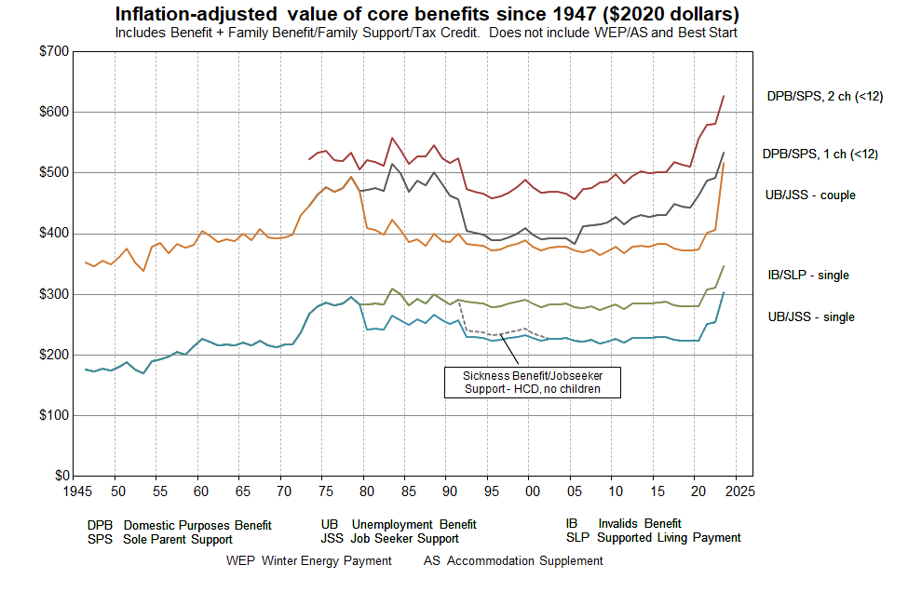
Source: MSD collation from information from the Royal Commission on Social Security, Department of Social Welfare Annual Reports, Income Support Service / Work and Income Fact Sheets and Budget 2021.

Some key dates
1946 Universal Family Benefit
1972 Royal Commission on Social Security
1991 Benefit cuts
2004-05 Working for Families
2016 Child Material Hardship Package
2018 Families Package
2020 $25 increase (April)
2020 Indexation to average wage commences (Apr)
2021 $20 pw increase (July)
2022 WEAG plus $15 pw for families with children (Apr)

Figure C.8 compares beneficiary income with the average wage (after tax). The child-related information is in the DPB/SPS trends. From the late 1980s through to 2019 there was a steady decline in beneficiary incomes compared with the average wage, albeit with a short-run reversal for sole parents when Working for Families was introduced in 2004-05. From 2020 to 2022 beneficiary incomes for sole parent households improved relative to the average wage.

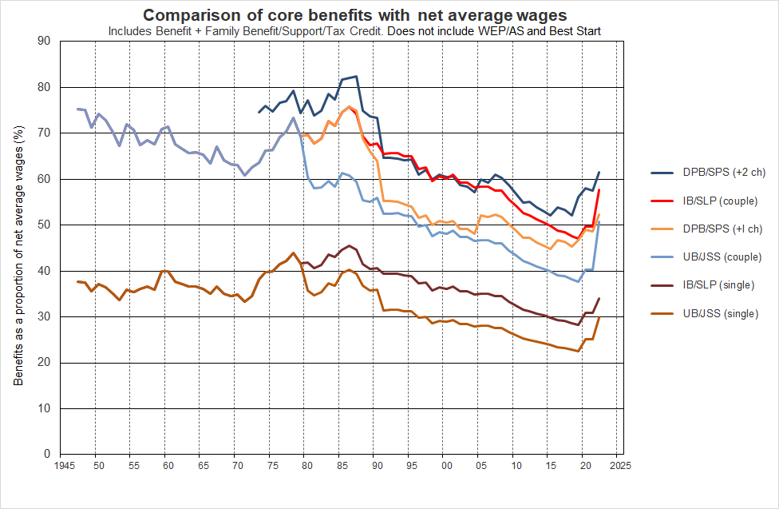
Figure C.8
Source: MSD collation from information from the Royal Commission on Social Security, Department of Social Welfare Annual Reports, Income Support Service / Work and Income Fact Sheets and Budget 2021.

Some key dates
1946 Universal Family Benefit
1972 Royal Commission on Social Security
1991 Benefit cuts
2004-05 Working for Families
2016 Child Material Hardship Package
2018 Families Package
2020 $25 increase (April)
2020 Indexation to average wage commences (Apr)
2021 $20 pw increase (July)
2022 WEAG plus $15 pw for families with children (Apr)

Figure C.9 uses the same data source as Figure C.8 but shows the actual trend in the average wage (after tax) and the minimum wage (before tax). It compares beneficiary income for selected beneficiary households / families with the average wage (after tax) and the minimum wage (before tax).

The child-related information is in the DPB/SPS trends. From the late 1980s through to 2019 there was a steady decline in beneficiary incomes compared with the average wage, albeit with a short-run reversal for sole parents when Working for Families was introduced in 2004-05, and through the Child Material Hardship package in 2016. From 2020 to 2022 beneficiary incomes for sole parent households improved relative to the average wage.

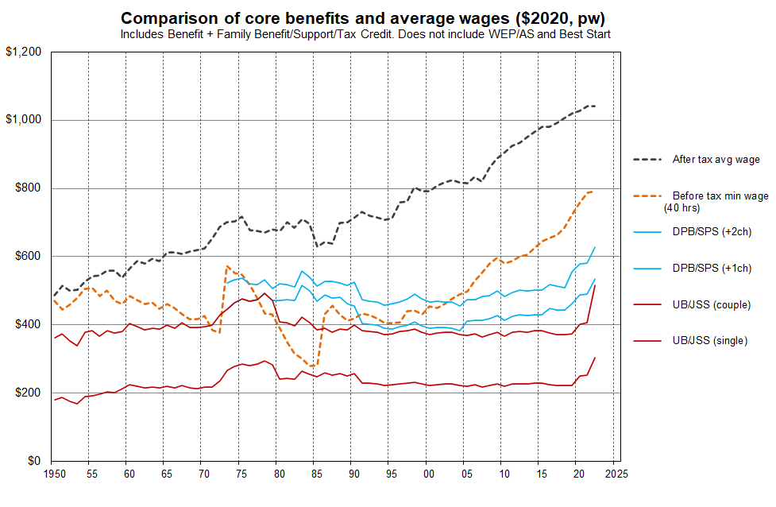
Figure C.9

Source: MSD collation from information from the Royal Commission on Social Security, Department of Social Welfare Annual Reports, Income Support Service / Work and Income Fact Sheets and Budget 2021.

Some key dates
1946 Universal Family Benefit
1972 Royal Commission on Social Security
1991 Benefit cuts
2004-05 Working for Families
2016 Child Material Hardship Package
2018 Families Package
2020 $25 increase (April)
2020 Indexation to average wage commences (Apr)
2021 $20 pw increase (July)
2022 WEAG plus $15 pw for families with children (Apr)

Figure C.10 shows how New Zealand Superannuation (NZS) rates have compared with core benefit rates for couples and singles (no dependent children) over the last thirty years or so.

The NZS ‘married couple’ rate has for some time been at 66% of the net average wage, and the ‘single-living-alone’ rate at 43% (65% of the ‘married couple’ rate). This compares with around 50% for a UB/JSS couple and 30% for a UB/JSS single in 2022.

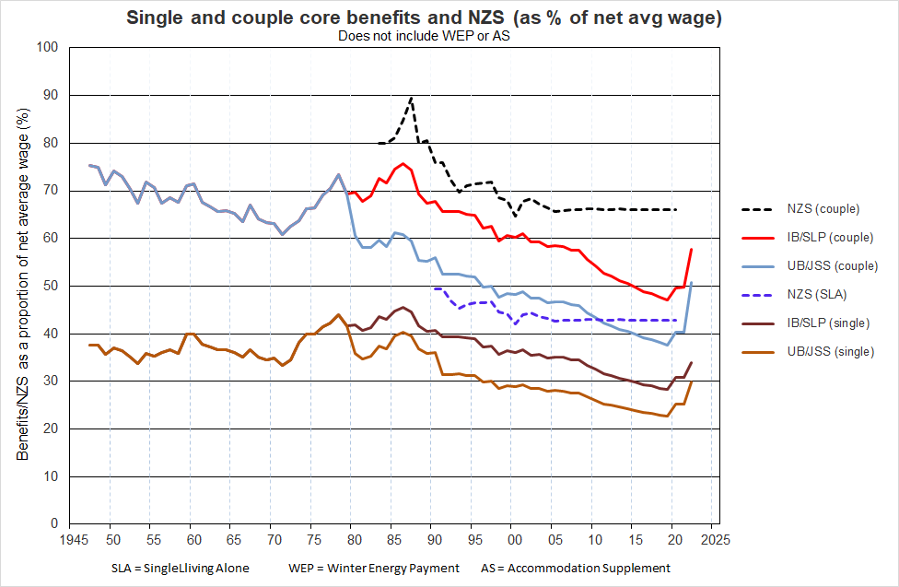
Figure C.10

.

Section D - International comparisons

To assess how New Zealand children are faring in terms of poverty, a reference level or comparison standard is needed. Having agreed low-income thresholds or material hardship thresholds are one way of doing this, but there are other ways too:
- reporting time series on agreed measures: Stats NZ’s Feb 2021 report provides this information for 2007 on, and MSD’s reports give longer low-income series using slightly different datasets
- comparing rates with those in other groups on the same measure(s) – see Sections B and C above for selected comparisons.
- international comparisons with other richer nations (as in the EU or OECD).

This section is about the latter. It gives comparisons in four areas:
- material hardship rates
- child-specific and strongly child-related household material and social deprivation items
- low-income rates
- proportion of children in workless households
.
Particular care is needed to ensure that the comparisons are valid for the purpose stated. In this regard, international low-income league tables are problematic when they are promoted as ranking countries by poverty rates, with poverty defined as in this paper. The low-income issues are discussed in the third part of this section (‘International 3’).

The international comparisons in this section are mainly in relation to European countries (EU plus Norway, Switzerland and Iceland). Table D.1 lists the countries and their two-letter abbreviations.

Table D.1
European countries and their two-letter codes
AT | Austria | IS | Iceland
BE | Belgium | IT | Italy
CH | Switzerland | LT | Lithuania
CY | Cyprus | LU | Luxembourg
CZ | Czech Republic | LV | Latvia
DE | Germany | MT | Malta
DK | Denmark | NL | Netherlands
EE | Estonia | NO | Norway
EL | Greece | PL | Poland
ES | Spain | PT | Portugal
FI | Finland | RO | Romania
FR | France | SE | Sweden
HR | Croatia | SI | Slovenia
HU | Hungary | SK | Slovakia
IE | Ireland | UK | United Kingdom

International 1:
Material hardship rates

The EU uses a 13-item Material and Social Deprivation index as one of its official social inclusion measures (in this report, ‘EU-13’ for short). We can replicate the index to a very good degree of certainty for New Zealand using data from the HES. The EU-13 and the DEP-17 indices rank households in much the same order (correlation of 0.86). See Appendix 1 for the EU-13 item list.

Comparisons for those aged 0-17 years (2018 EU survey, 2018-19 HES for New Zealand)

Using the EU-13 index, 14% of New Zealand children lived in households that reported five or more of the thirteen enforced lacks. New Zealand’s EU-13 child material hardship rate is much higher than for countries like Sweden, Denmark, Norway, Finland, the Netherlands and Switzerland (5-8%). New Zealand ranks alongside Belgium, Portugal, Ireland, the UK, France and Spain at the ‘low’ (ie higher hardship rates) end of the ‘old EU’ for hardship rates for children (14-16%). See Figure D.1 and Table D.2.
Figure D.1
Material and social deprivation rates (% with 5+ enforced lacks), EU-13, 0-17 yrs
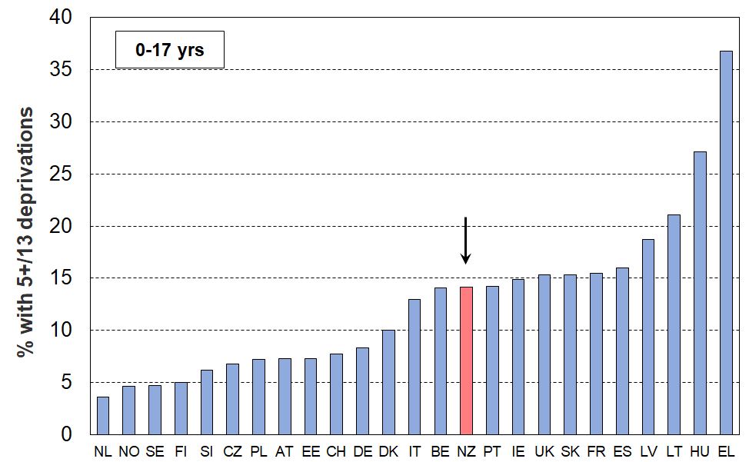
23 European countries + NZ, ranked on % with 5+ (EU-SILC 2018, NZ HES 2018-19)

Table D.2
Material and social deprivation rates (% with 5+ enforced lacks), EU-13, 0-17 yrs
29 European countries + NZ ranked on % with 5+, (EU-SILC 2018, NZ HES 2018-19)
Iceland | IS | 3 | Malta | MT | 12
Netherlands | NL | 4 | Italy | IT | 13
Norway | NO | 5 | Belgium | BE | 14
Sweden | SE | 5 | New Zealand | NZ | 14
Luxembourg | LU | 5 | Portugal | PT | 14
Finland | FI | 5 | Ireland | IE | 15
Slovenia | SI | 6 | United Kingdom | UK | 15
Czech Republic | CZ | 7 | Slovakia | SK | 15
Poland | PL | 7 | France | FR | 16
Austria | AT | 7 | Spain | ES | 16
Estonia | EE | 7 | Latvia | LV | 19
Switzerland | CH | 8 | Cyprus | CY | 20
Germany | DE | 8 | Lithuania | LT | 21
Denmark | DK | 10 | Hungary | HU | 27
Croatia | HR | 11 | Greece | EL | 37
Source for European data: https://ec.europa.eu/eurostat/web/main/data/database - accessed on 28 February 2021. The full list of EU-SILC rates for 2019 was not quite complete when this report was being finalised, but to date the rates for 2018 and 2019 are very similar for most countries, with only two reporting more than a 1-2 percentage point change. The median rate is looking to be similar to 2018 at around 11%.
The material hardship rate for older New Zealanders (65+) is by contrast among the best in Europe (~4%). The scatterplot in Figure D.2 uses both material hardship rates for children (horizontal axis) and for those aged 65+ (vertical axis), with the chart divided into quadrants using the respective median hardship rates as the boundaries. New Zealand, along with the UK, Ireland and Belgium are in the SE quadrant – relatively low material hardship for older citizens and relatively high rates for children. In contrast, in the SW quadrant are countries with relatively low rates for both groups (Netherlands, Norway, Finland, Sweden, and so on).

Using a stylised ‘day after’ approach, reaching the ten-year child material hardship target of 6% (2027-28) would shift New Zealand as shown by the arrow. The depiction assumes that DEP-17 and EU-13 give similar figures, and that all other countries rates remain frozen. Both these assumptions are likely to not fully hold over the next decade, but the chart nevertheless gives an idea of the magnitude of the proposed change and of the task to achieve the goal.

Figure D.2
Material hardship rates for children (0-17 yrs) and those aged 65+:
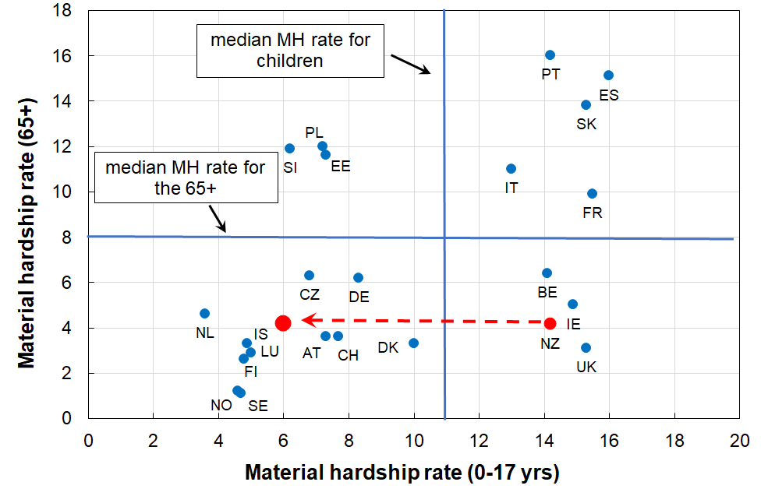
comparisons with selected European countries (2018)

Notes for Figure D.2:
- Countries with even higher material hardship rates for either children or those aged 65+ (or both) are omitted from the chart to better enable NZ to be rated against the countries we usually make comparisons with. The omitted countries are Greece, Hungary, Latvia and Lithuania. They are however included for calculating the medians.
- The medians are for all the EU countries plus Norway, Switzerland and Iceland.

The assumption of ‘nothing else changing’ is not as far-fetched as it may initially sound. There are not that many countries with large changes in the last decade or so (ie from pre-GFC to now): for the 65+ group, only Poland, the Czech Republic and Estonia changed greatly (decreases); and for children, these three plus Slovakia, Lithuania and Portugal decreased considerably and Greece increased. The median for child material hardship for the full EU decreased from around 15% to 11% in the last decade or so. When Norway, Iceland and Switzerland are added to the EU list, the drop in the median hardship rate for children is less as these countries have lowish rates and did not change very much.
International 2:
Child-specific material and social deprivation items and selected child-related household items

Table D.3 shows where New Zealand children rank for 7 child-specific essentials and 3 child-related household items.
- The country abbreviations are as in Table D.1 above.
- The full text for the child-specific items is available in Appendix 2

Deprivation rates for New Zealand children using the single-item indicators in Table D.3 are typically ‘mid-table’ or lower (ie higher rates). The ‘high performance’ for NZ children for access to a private vehicle could possibly reflect the relative qualities across countries of public transport as much as anything.

These items are now being collected in each HES, so trends should be evident after a few more years of survey data are available.

Table D.3
Enforced lacks of 7 child-specific items and 3 child-related general household items (%):
New Zealand compared with 24 EU countries and Switzerland (EU-SILC 2014, HES 2018-19)
Child-specific items |  |  |  |  |  |  |  |  |  |  |  |  |  | Child-related HH items
Shoes |  | Fruit & veg |  | Proteins |  | Celebration |  | School trips |  | Internet |  | Friends |  | Car |  | Home warm |  | Holidays
SE | 0 | SE | 0 | SE | 0 | FI | 0 | DE | 1 | NL | 0 | FI | 0 | NZ | 2 | FI | 1 | CH | 5
CH | 0 | FI | 0 | FI | 0 | DK | 1 | FI | 1 | SE | 0 | CH | 0 | LU | 2 | SE | 1 | SE | 5
LT | 0 | DK | 0 | DK | 1 | SE | 1 | SE | 1 | FI | 0 | SE | 1 | IT | 2 | LU | 1 | FI | 7
EL | 1 | CH | 1 | LU | 1 | CH | 1 | CH | 1 | DK | 1 | NL | 1 | FR | 3 | CH | 1 | SI | 7
FI | 1 | AT | 1 | PT | 1 | DE | 1 | DK | 1 | DE | 1 | DK | 1 | SE | 3 | EE | 1 | CZ | 9
LU | 1 | NL | 1 | CH | 1 | AT | 2 | NL | 1 | EE | 1 | DE | 2 | SI | 3 | DK | 2 | DK | 9
AT | 1 | LU | 1 | SI | 1 | LU | 2 | SI | 2 | CH | 1 | LU | 2 | FI | 4 | NL | 3 | LU | 9
SI | 1 | SI | 1 | AT | 2 | NL | 2 | AT | 2 | AT | 1 | CZ | 2 | DE | 4 | SI | 4 | EE | 10
PO | 1 | ES | 2 | FR | 2 | UK | 2 | EE | 3 | SI | 1 | FR | 2 | CH | 4 | AT | 4 | FR | 12
EE | 2 | DE | 2 | NL | 2 | SI | 2 | UK | 3 | LU | 1 | IE | 3 | DK | 5 | BE | 5 | SK | 16
UK | 2 | BE | 2 | BE | 3 | IE | 3 | IE | 3 | FR | 2 | SI | 3 | NL | 6 | FR | 5 | NL | 16
DE | 2 | IT | 3 | ES | 3 | EE | 3 | LU | 4 | PO | 3 | AT | 4 | IE | 7 | DE | 5 | DE | 17
DK | 2 | IE | 3 | PO | 3 | CZ | 4 | BE | 4 | BE | 4 | NZ | 4 | ES | 7 | CZ | 6 | AT | 18
IT | 3 | FR | 3 | UK | 3 | LT | 5 | FR | 5 | CZ | 4 | EE | 5 | HR | 7 | SK | 8 | LT | 19
CZ | 3 | PT | 3 | IE | 3 | FR | 5 | CZ | 5 | NZ | 4 | BE | 6 | AT | 7 | PO | 8 | BE | 19
ES | 3 | CZ | 3 | DE | 4 | NZ | 6 | NZ | 5 | UK | 5 | UK | 7 | BE | 7 | HR | 9 | PO | 26
HR | 3 | PO | 3 | NZ | 4 | HR | 6 | LT | 6 | IE | 5 | HR | 7 | PO | 8 | UK | 9 | LV | 28
PT | 4 | UK | 4 | CZ | 5 | BE | 6 | LV | 8 | HR | 5 | IT | 7 | EL | 9 | IE | 9 | HR | 29
NL | 4 | HR | 5 | IT | 6 | IT | 7 | HR | 8 | LT | 5 | PO | 9 | EE | 10 | NZ | 10 | IT | 29
BE | 4 | EL | 5 | EE | 6 | PT | 8 | PO | 9 | LV | 8 | LT | 10 | PT | 10 | ES | 12 | NZ | 30
FR | 5 | NZ | 6 | HR | 6 | PO | 10 | SK | 9 | EL | 9 | LV | 11 | UK | 11 | LV | 18 | ES | 35
NZ | 5 | EE | 7 | LT | 6 | LV | 10 | PT | 9 | SK | 9 | ES | 13 | CZ | 12 | IT | 18 | UK | 35
IE | 6 | LT | 8 | LV | 8 | ES | 11 | IT | 10 | IT | 11 | PT | 14 | LT | 12 | PT | 25 | PT | 37
SK | 7 | SK | 10 | EL | 9 | SK | 12 | ES | 11 | PT | 11 | EL | 14 | SK | 14 | LT | 26 | EL | 41
LV | 12 | LV | 10 | SK | 13 | EL | 19 | EL | 21 | ES | 14 | SK | 15 | LV | 23 | EL | 31 | IE | 53
 | 5 | EU | 4 |  | 5 |  | 7 |  | 8 |  | 7 |  | 8 |  | 9 |  | 10 |  | 27
Source: Selection from Table 6 in Guio et al (2018) using EU-SILC 2014, plus MSD analysis of HES 2018-19.
Notes for Table D.3:
- The EU analysis is for children aged from 1-15 yrs, whereas the NZ data is for 6-17 years This is unlikely to impact on the high level findings above.
- The bulk of the EU items above are in the ‘enforced lack’ modality – that is, “don’t have or do” because of shortage of money / cost, not some other reason. The NZ data aligns with that.
- The ‘school trips’ item is an enforced lack for the EU, and an ‘economised-a-lot-because-of-shortage-of-money’ item for NZ. The NZ equivalent figure could be anything between 3.5% and 6.5%, so it was recorded as 5%. The overall conclusion about the ranking picture is not changed by this uncertainty.
International 3:
‘Poverty’ comparisons using low income

International league tables which rank countries on their income poverty (low-income) rates are now commonly created and published. This report takes the view that such tables are highly misleading when they are promoted as ranking countries by their poverty rates, with poverty understood as ‘being excluded from a minimum acceptable standard of living in one’s own country because of inadequate resources’. At best they are rankings of countries by their income inequality in the lower half of the household income distribution. This is a useful international comparison, but that is not how the league tables are generally described or promoted.

The following theoretical-conceptual and empirical considerations support the view taken in the report:
- The income-wealth-material wellbeing framework used in this report (see Figure A.1 above) draws attention to the fact that there are several key factors other than income that determine a household’s material wellbeing or living standards. For example, income does not cover all the relevant ‘resources’ available to households to generate consumption, and there are non-standard extra ‘needs’ such as those relating to high health costs and debt servicing. Low income on its own does not do a very good job of identifying those in poverty (when using the common high-level definition noted above). It is not surprising therefore that there is a significant mismatch between those identified as ‘poor’ using low income and those identified as ‘poor’ using a material deprivation index which is based on information about the actual day-to-day living conditions.
- Household income can therefore at best only be a rough proxy for material wellbeing. This is one of the reasons why the EU’s official descriptor for their BHC 60 low-income headline measure is the ‘at-risk-of-poverty’ indicator. This matter is further discussed in Section L. This is, in the first instance, an issue for within-country conceptualisation and measurement of poverty using low household incomes. There are additional issues when it comes to using low incomes for international comparisons.
- When relative low-income measures are used in international comparisons they are best understood as measures of inequality in the lower half of the distribution rather than as measures of relative poverty. They provide a useful way of comparing how dispersed or compressed the income distribution is below the median on a country-by-country basis.
When they are used as ‘poverty’ measures for international league tables they are giving a comparison of the proportion of people from households that have incomes more than a defined distance from middle incomes for each country. This is consistent with a relative disadvantage notion of poverty and can be useful when looking at trends and relativities within a country. They are, however, misleading for international league tables purporting to measure ‘poverty’.
- The difficulty arises because people often (understandably) take the low-income league tables to be about ‘poverty’ understood as experiencing poor material living conditions assessed against some common international standard. This is still a relative perspective, but the reference is no longer the middle incomes of a particular country, but some notion of minimum acceptable living conditions that is the same for all the (richer) countries being compared. There is good evidence that for those living in the richer nations there is a reasonably common and coherent view as to what are ‘necessities’ and what constitutes a minimum acceptable material standard of living (eg Dickes et al (2010) for the EU as a whole). This is hardly surprising given the inter-connectedness of the 21st century world and the awareness of how other countries live through readily available international communications and widespread inter-country travel (pre-COVID).
- The issue described above is well illustrated in Figure D.3 (next page) which shows for OECD countries the very low correlation (around 0.4) between 50% BHC low-income (‘poverty’) rates and how households assess their ability to live on their current income. The self-assessment information comes from a 2010 Gallup survey and was reported in the OECD’s 2011 Society at a Glance.

Figure D.3
Very weak relationship between ‘income poverty’ (BHC 50) and reported income difficulties:
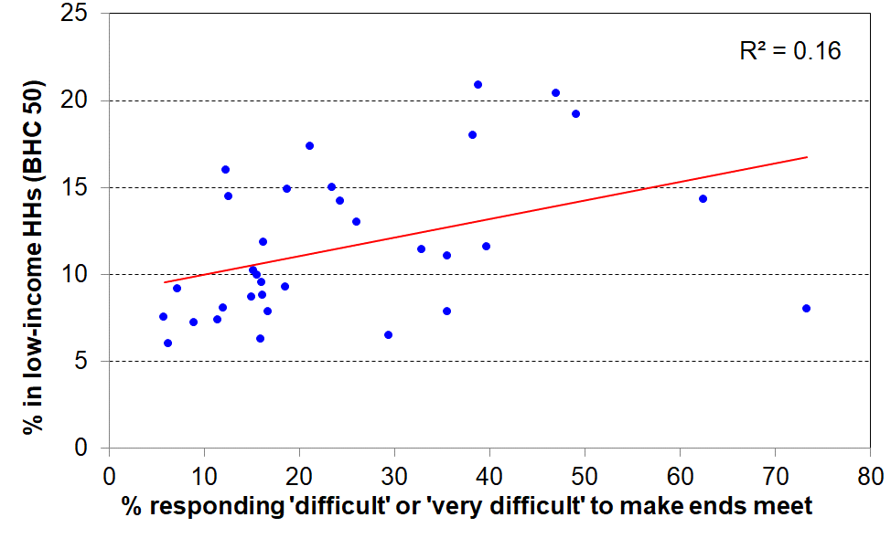
34 OECD countries c 2010
- Finally, the income approach can produce incongruous results for the comparison of ‘poverty’ rates in richer countries. Figure D.4 below uses 2018 Eurostat data and shows that countries with very similar ‘poverty’ (low-income) rates can have quite different material deprivation or hardship rates. For example, Netherlands and Hungary both have 13% low-income (poverty) rates, but very different deprivation rates (5% and 20% respectively).

Figure D.4
Correlation between low-income rates (BHC 60%) and material hardship rates (EU-13, 5+)
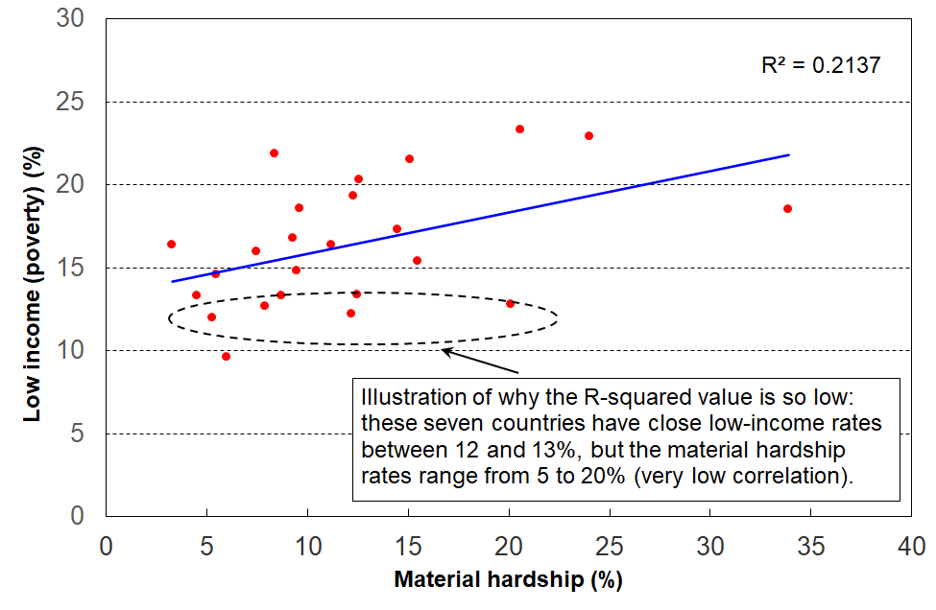
for 25 European countries (EU-SILC 2018)

The concerns raised in this report about the use of low-income for international comparisons of poverty are not new. A recent example is Goedemé et al (2019), who use reference budgets for selected European countries to show how the 60% BHC thresholds bear little relation to what is actually needed in many poorer European countries to reach even survival level.

For completeness, low-income rates for New Zealand children are reported in Table D.4 in relation to the EU median rate. Based on the above analysis, this report’s view is that the comparisons do not tell us anything about how New Zealand children are faring in their material wellbeing relative to their European counterparts. That is better assessed using material hardship indices and deprivation items as in the first two sub-sections, International 1 and 2 above. The comparisons in Table D.4 indicate that on these BHC measures, income inequality in the lower half of the income distribution for New Zealand households with children is a little above the European country median.

Table D.4
Low-income rates (BHC) for New Zealand children (0-17 yrs)
compared with the European country median
HES 2018-19, EU-SILC 2018
 | New Zealand | EU
BHC 60 | 22 | 19
BHC 50 | 14 | 11
Note: European figures include all EU countries plus non-EU countries Norway, Switzerland and Iceland. The UK was still in the EU at the time of the EU-SILC 2018.

International 4:
Children in workless households

Table D.6 compares New Zealand with EU countries on the proportion of children in workless households. In HES 2012, at the height of the GFC impact, New Zealand was at the high end of the table with a rate of 18%, similar to Hungary, the United Kingdom and Ireland (16-20%). By HES 2019, the rate had fallen to 11%, though this still leaves New Zealand at the higher end of the table.

Table D.6
International comparisons of the proportion of children living in workless households (%):
2008, 2012, 2017 and 2019
 | 2008 | 2012 | 2017 | 2019 |  | 2008 | 2012 | 2017 | 2019
France | 8 | 10 | 12 | 12 | Latvia | 8 | 11 | 8 | 8
Ireland | 13 | 20 | 12 | 11 | Estonia | 7 | 9 | 6 | 7
United Kingdom | 17 | 17 | 12 | 11 | Romania | 10 | 12 | 9 | 7
Sweden | 8 | 7 | 6 | 11 | Malta | 9 | 8 | 8 | 7
Belgium | 11 | 12 | 12 | 11 | EU-27 median | 8 | 10 | 9 | 7
New Zealand | 17 | 18 | 11 | 11 | Croatia | 7 | 11 | 8 | 6
Bulgaria | 11 | 17 | 12 | 9 | Hungary | 15 | 16 | 8 | 6
Lithuania | 11 | 12 | 10 | 9 | Cyprus | 4 | 7 | 10 | 6
Italy | 7 | 9 | 10 | 9 | Luxembourg | 4 | 4 | 8 | 6
Slovakia | 9 | 10 | 8 | 8 | Austria | 6 | 6 | 7 | 6
Spain | 7 | 14 | 10 | 8 | Czechia | 7 | 8 | 6 | 6
Greece | 4 | 13 | 9 | 8 | Portugal | 5 | 9 | 6 | 5
Germany | 10 | 9 | 9 | 8 | Netherlands | 5 | 6 | 6 | 5
Denmark | 3 | 8 | 9 | 8 | Finland | 4 | 4 | 5 | 5
Poland | 8 | 9 | 8 | 8 | Slovenia | 3 | 4 | 3 | 3
Source for EU data is:
http://appsso.eurostat.ec.europa.eu/nui/show.do?dataset=lfsi_jhh_a&lang=en - accessed on 16 Oct 2020.
The figures for New Zealand to 2017 are derived using the sample weights developed by the New Zealand Treasury for use with the HES, as these are constructed using benefit numbers as one of the benchmarks. 2019 figures use the (new) Stats NZ weights starting with HES 2018-19 which use benefit numbers as one of the benchmarks.

Children in workless households, in households with no full-time worker and in families in receipt of a main benefit

Leading up to the GFC and in the downturn associated with it (2008 to 2012), around one in four New Zealand children lived in households where there was no adult in full-time employment. This has dropped to around one in six in the 2018-19 HES (Table D.6). This figure, like the workless figure, is nevertheless high by OECD and EU standards.

Table D.7
Proportion of children in ‘workless’ households (% of all children)
HES survey year | 2007-08 | 2011-12 | 2016-17 | 2017-18 | 2018-19
In workless HHs | 17 | 18 | 11 | 11 | 11
In HHs with no FT worker | 24 | 25 | 16 | 17 | 16
In beneficiary families | 19 | 21 | 16 | 15 | 15

The proportion of children in beneficiary families is unlikely to ever match either of the other two lines for several reasons:
- a beneficiary family may live in a household where an adult is in FT work (eg a sole parent family living with the mother’s parents or other relatives)
- some beneficiary families receive income from part-time employment
- the beneficiary information is a snapshot at 31 March (from 2013 on), whereas the HES-based figures are an average over the full year.

Section E - Children across the full material wellbeing spectrum

The focus so far has been on material hardship, low incomes and financial stress (‘child poverty’), all of which are matters of considerable ongoing public policy interest. This justifiable focus can sometimes mean that it is easy to forget that the vast majority of New Zealand children are living in households in which their basic material needs are consistently met, and most in fact experience a good to very good material standard of living.

MSD’s Material Wellbeing Index (MWI) ranks households across the full material wellbeing spectrum from low to high, rather than just being focussed on the low end as the DEP-17 and EU-13 indices are. Applying the MWI to the 2018-19 HES data enables the creation of a fuller picture of how all children are faring.

The analysis in this section divides the full spectrum into six groups for illustrative purposes:
- The boundary for the lowest group was selected to make the MWI hardship rate correspond as close as possible to the 6+/17 DEP-17 hardship rate (13%), the one used by Stats NZ in the CPRA child poverty statistics.
- Group 2 could be labelled ‘just getting by’ (the next 15% of children).
- The lower boundary for the highest group was selected so that this group had none of the basics missing and had virtually all the ‘freedoms’ (see text and Table E.1 below).
- The boundaries for the remaining three groups were more arbitrary, but the decisions reflected the fact that the MWI’s discriminatory power diminishes the higher the MWI scores. Group 5 was therefore made larger than Groups 3 and 4, and clearly includes households not in the same league as those in Group 6, but much better off on average than Group 4.

Table E.1 shows the distribution of the whole population and of children across the six groupings, and then uses selected survey items to give an idea of the standard of living for households with children in each grouping or band. This indicative calibration exercise uses items covering both the basics that all should have and none should go without, and some non-basics that most aspire to (‘freedoms’ for short). Table E.2 (next page) repeats the analysis using just child-specific material hardship items.

Table E.1
Using household or respondent items to give an indication of the standard of living in each MWI band:
children in their households, HES 2018-19
Group # | 1 | 2 | 3 | 4 | 5 | 6 | ALL
MWI score bands | 0-11 | 12-18 | 19-24 | 25-29 | 30-33 | 34-35
Whole population - across 6 groups (%) | 8 | 11 | 15 | 21 | 25 | 19 | 100
Children (0-17 yrs) – across 6 groups (%) | 12 | 15 | 18 | 20 | 22 | 14 | 100
% of children in households which report these deprivations
No access to car | 12 | 8 | 5 | 3 | 1 | 1 | 5
Help from foodbank more than once in last 12 months | 27 | 8 | 2 | 0 | 0 | 0 | 5
Cut back / went without fresh fruit and veg ‘a lot’ | 28 | 4 | 1 | 1 | 0 | 0 | 4
Cannot keep home warm | 47 | 18 | 5 | 1 | 0 | 1 | 10
Not enough income for basics | 52 | 22 | 9 | 4 | 2 | 1 | 13
% of children in households which report these ‘freedoms’
Holidays away from home at least once each year (have) | 19 | 33 | 55 | 69 | 81 | 90 | 61
$300 spot purchase – not at all restricted | 0 | 1 | 3 | 7 | 23 | 86 | 19
Clothes/shoes for self - not limited by money | 0 | 1 | 4 | 10 | 27 | 88 | 21
Hobbies and special interests – economised ‘not at all’ | 4 | 10 | 17 | 38 | 75 | 98 | 42
Local trips – economised ‘ not at all’ because of money | 4 | 13 | 34 | 60 | 92 | 99 | 54
Dentist – postponed ‘not at all’ because of money | 7 | 16 | 34 | 57 | 87 | 99 | 53
Broken appliances – delayed repairing or replacing ‘not at all’ | 14 | 32 | 50 | 72 | 94 | 100 | 64
Satisfied / very satisfied with life | 44 | 65 | 80 | 86 | 93 | 95 | 80
Note for Table E.1: any cells ≤ 1.5% are recorded as ‘0’.

Table E.2
Using child-relevant household items and child-specific items
to give an indication of the standard of living experienced by children in each MWI band.
HES 2018-19
Group # |  | 1 | 2 | 3 | 4 | 5 | 6 | ALL
MWI score bands |  | 0-11 | 12-18 | 19-24 | 25-29 | 30-33 | 34-35
Whole population - across 6 groups (%) |  | 8 | 11 | 15 | 21 | 25 | 19 | 100
Children (6-17 yrs) – across 6 groups (%) |  | 12 | 15 | 18 | 20 | 22 | 14 | 100
Child-relevant general HH items | Response
Income adequacy for basics | not enough | 52 | 23 | 9 | 5 | 2 | 0 | 13
Foodbank / other community help | more than once | 27 | 7 | 2 | 0 | 0 | 0 | 5
Borrowed for basics from fam/friends | more than once | 51 | 20 | 8 | 3 | 0 | 0 | 11
Can pay unexpected $500 bill | no | 85 | 55 | 26 | 12 | 4 | 0 | 26
Delayed replace/repair appliances | a lot | 56 | 22 | 9 | 2 | 0 | 0 | 12
Car | don't have | 12 | 8 | 4 | 3 | 0 | 2 | 5
Holiday away each year | don't have - cost | 79 | 62 | 35 | 17 | 6 | 0 | 29
Holiday away each year | don't have - other | 3 | 8 | 11 | 14 | 12 | 10 | 10
Dampness or mould | major problem | 34 | 15 | 7 | 2 | 0 | 0 | 8
Can afford to keep home warm | no | 48 | 17 | 5 | 0 | 0 | 0 | 10
Crowding | 1+ more rooms needed | 29 | 20 | 16 | 7 | 8 | 4 | 13
Crowding | 2+ needed - severe | 7 | 4 | 4 | 0 | 2 | 0 | 3
Life satisfaction | dissatis / very dissatis | 22 | 12 | 5 | 3 | 2 | 0 | 6
Child-specific items
Two pair of shoes | don't have | 32 | 10 | 3 | 0 | 0 | 0 | 7
Two sets winter clothes | don't have | 11 | 2 | 0 | 0 | 0 | 0 | 2
Waterproof coat | don't have - cost | 25 | 5 | 2 | 0 | 0 | 0 | 4
Waterproof coat | don't have - other | 7 | 8 | 5 | 3 | 2 | 0 | 4
Separate bed | don't have | 22 | 8 | 4 | 0 | 0 | 0 | 5
Fruit and veg daily | don't have | 38 | 10 | 3 | 0 | 0 | 0 | 7
Protein meal daily | don't have | 13 | 3 | 0 | 0 | 0 | 0 | 3
Computer / internet | don't have | 23 | 9 | 5 | 2 | 0 | 0 | 6
Friends around to play / eat | don't have - cost | 18 | 5 | 0 | 0 | 0 | 0 | 3
Friends around to play / eat | don't have - other | 17 | 15 | 9 | 5 | 3 | 0 | 8
Birthday and other celebrations | don't have - cost | 26 | 9 | 2 | 0 | 0 | 0 | 5
Birthday and other celebrations | don't have - other | 12 | 12 | 8 | 6 | 4 | 3 | 7
Unable to fund school trips | a lot | 20 | 5 | 0 | 0 | 0 | 0 | 3
Had to limit participation in sport | a lot | 29 | 10 | 2 | 0 | 0 | 0 | 6
Had to go without special interests | a lot | 31 | 14 | 2 | 0 | 0 | 0 | 7
Continued to wear worn out / wrong size shoes/clothes | a lot | 18 | 4 | 0 | 0 | 0 | 0 | 3
DEP-17 material hardship, 6+/17 |  | 88 | 88 | 16 | 0 | 0 | 0 | 0
DEP-17 severe material hardship, 9+/17 |  | 44 | 44 | 0 | 0 | 0 | 0 | 0
Note for Table E.2: any cells ≤ 1.5% are recorded as ‘0’.

The charts in Figure E.1 below show how children in selected household contexts are distributed across the material wellbeing spectrum.
- The six groupings range from material hardship (red) through to very well off (dark green on the right).
- Each cluster of six adds to 100%.
- The right-hand cluster in the household type chart (left-hand chart below) shows how all children are distributed across the material well-being spectrum.
- Table E.3 gives the data behind the charts.

Figure E.1
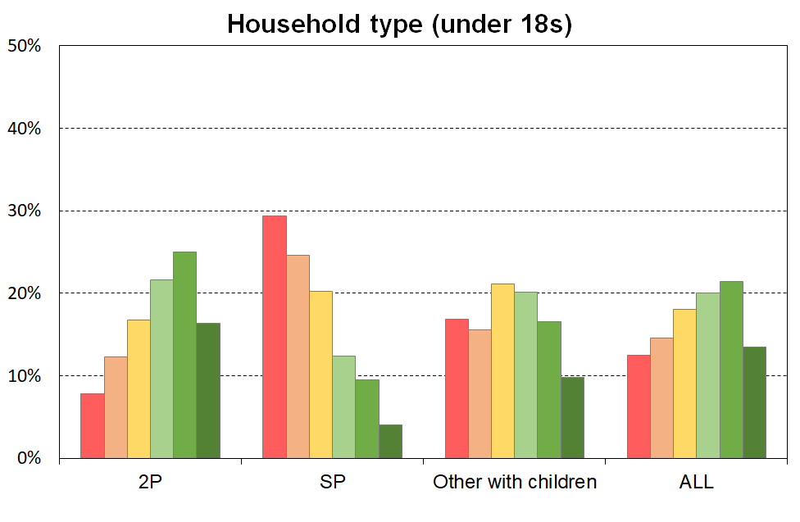
The material wellbeing of children in selected household contexts (6 groupings using MWI scores)
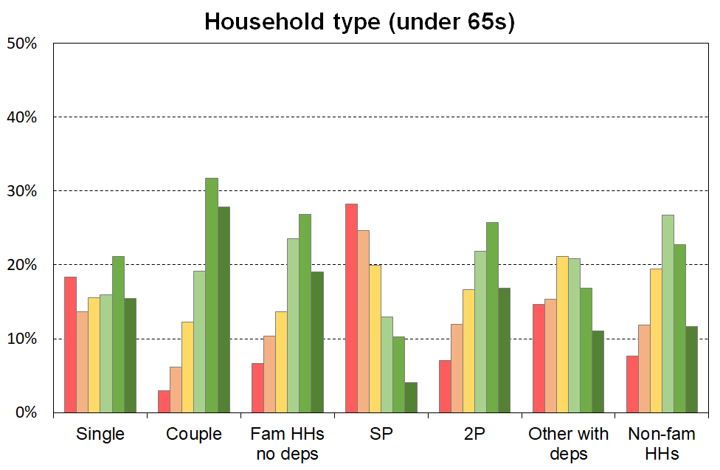
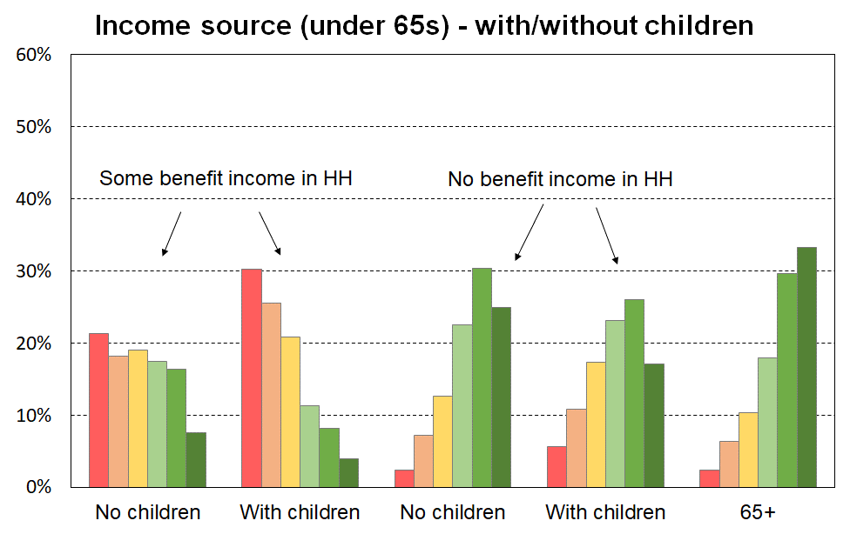
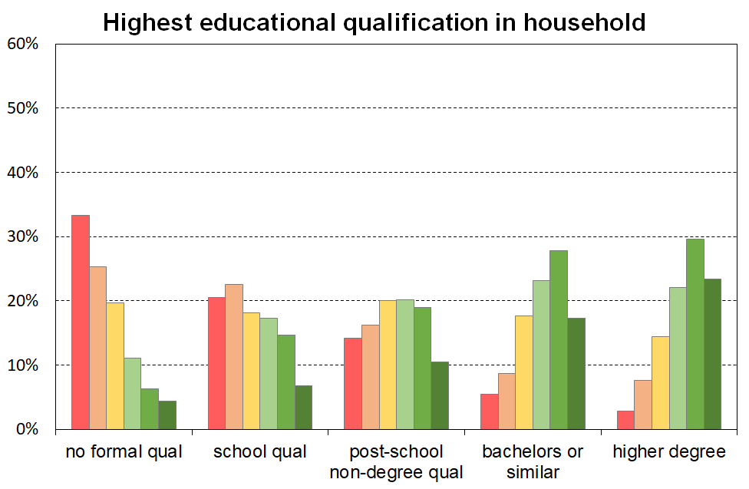
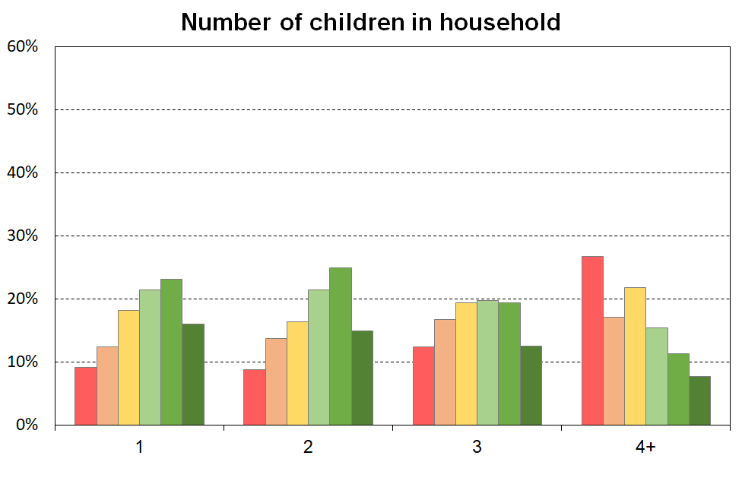
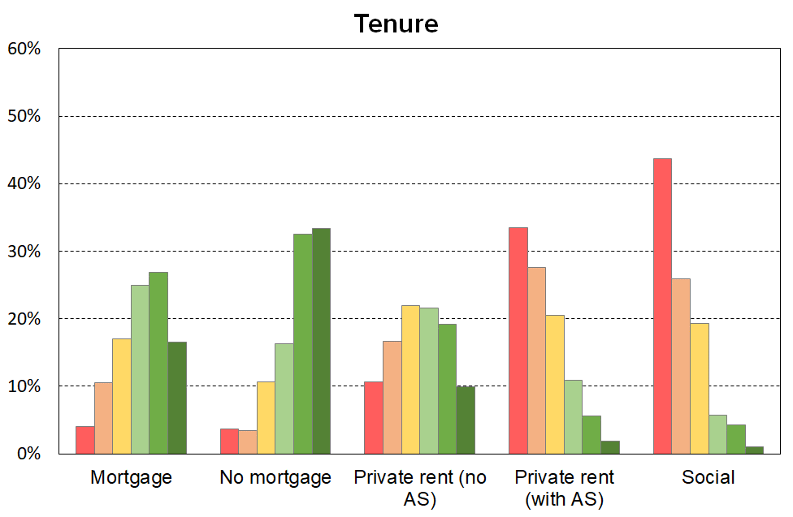

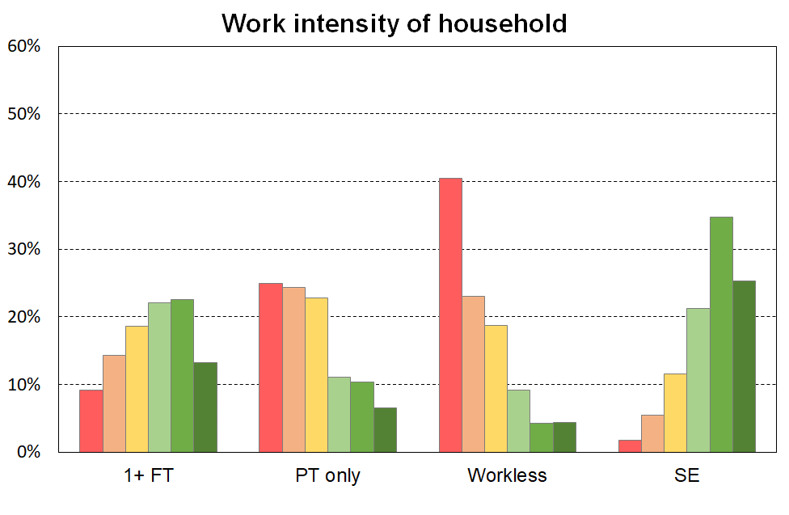
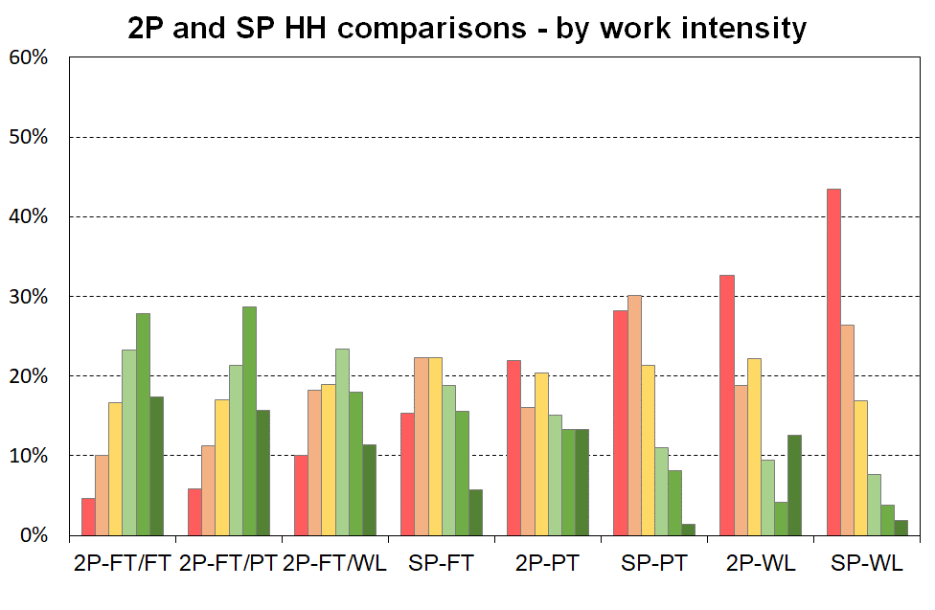
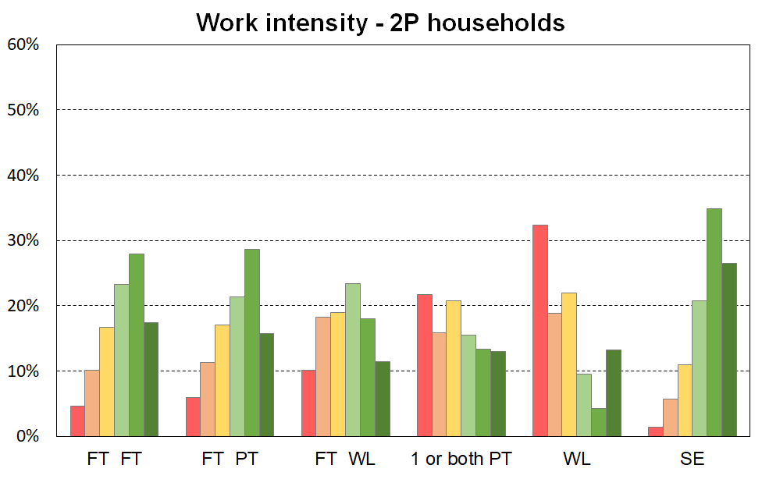
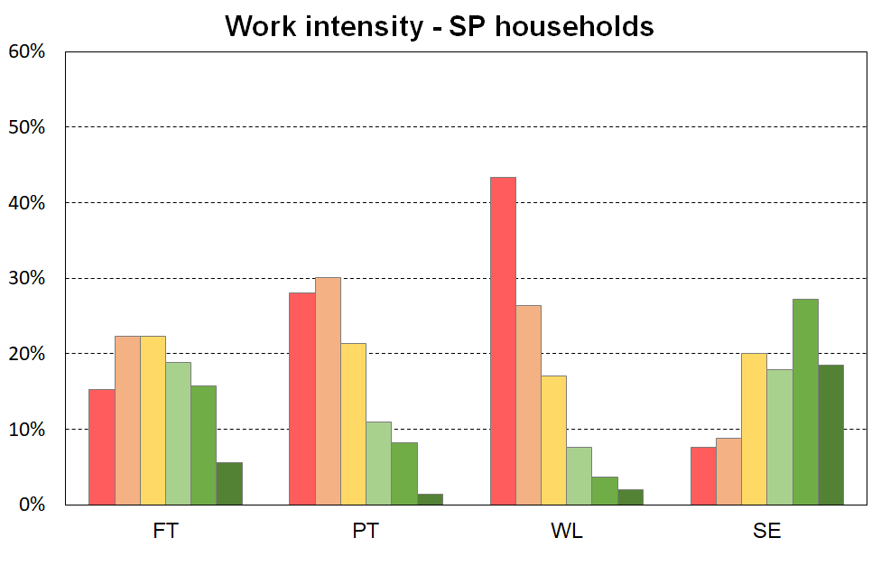

The left-hand chart in Figure E.2 shows how children are distributed across the material wellbeing spectrum by their ethnicity (‘total’ definition).

When interpreting the chart, it is important to note that the information is descriptive only and should not be used as if ethnicity is being portrayed as causal in relation to MWI scores (material wellbeing). To support a causality narrative or conclusion, a starting point would be regression analysis in which other relevant variables are included to control for differences in education, household type, household employment hours, and so on. Even then, further investigation would be needed to understand whether any in the set of control variables themselves have any significant dependency on ethnicity.

The right-hand chart in Figure E.2 looks at the group of children who live in households in which the maximum educational qualification is a tertiary degree. This in effect introduces a simple control for educational qualification (at the degree level). There is a greater similarity for the material wellbeing profiles for these children across the ethnic groupings than there is when all children are looked at, though some differences are still evident.
Figure E.2
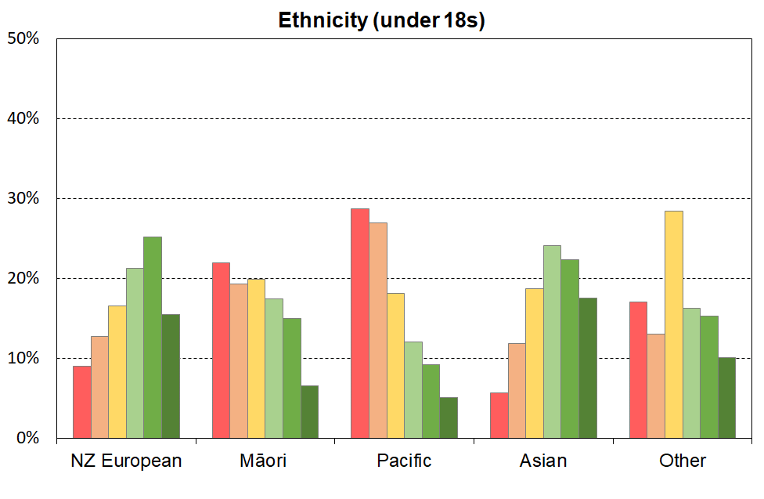
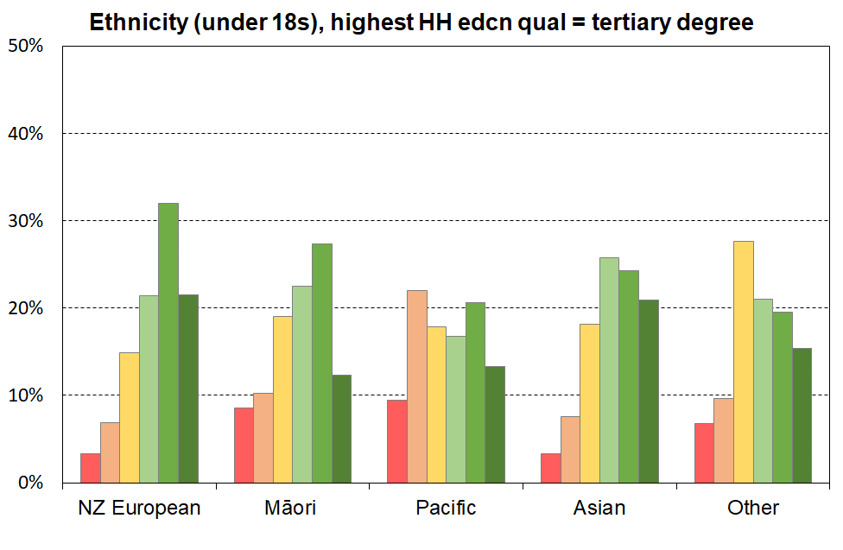
The material wellbeing of children by their ethnicity (6 groupings using MWI scores)

Table E.3
The material wellbeing of children in selected household contexts (6 groupings using MWI scores),
HES 2018-19
MWI level (6=highest scores) ==> | 1 | 2 | 3 | 4 | 5 | 6 | Size of group
 |  |  |  |  |  |  | 000s | %
All children (0-17 yrs) | 13 | 15 | 18 | 20 | 21 | 13 | 1130 | 100
Household type
Two parent | 8 | 12 | 17 | 22 | 25 | 16 | 780 | 69
Sole parent | 29 | 25 | 20 | 12 | 9 | 4 | 175 | 15
Other under 65 households | 17 | 16 | 21 | 20 | 17 | 10 | 170 | 15
All children (0-17 yrs)_ | 13 | 15 | 18 | 20 | 21 | 14 | 1130 | 100
Number of children in households
1 | 10 | 13 | 18 | 21 | 23 | 15 | 245 | 22
2 | 9 | 14 | 16 | 21 | 25 | 15 | 485 | 43
3 | 13 | 17 | 19 | 20 | 19 | 12 | 255 | 23
4+ | 28 | 17 | 22 | 15 | 11 | 8 | 140 | 12
Highest educational qualification in HH
no formal qualification | 33 | 25 | 20 | 11 | 6 | 4 | 80 | 7
school qualification | 21 | 23 | 18 | 17 | 15 | 7 | 215 | 19
post-school non-degree qualification | 14 | 16 | 20 | 20 | 19 | 11 | 355 | 31
bachelors or similar | 5 | 9 | 18 | 23 | 28 | 17 | 250 | 22
higher degree | 3 | 8 | 14 | 22 | 30 | 23 | 230 | 20
Tenure of household
owned with mortgage | 4 | 11 | 17 | 25 | 27 | 17 | 530 | 47
owned without mortgage | 4 | 3 | 11 | 16 | 32 | 33 | 115 | 10
private rent (no AS) | 11 | 17 | 22 | 22 | 19 | 10 | 195 | 17
private rent (with AS) | 34 | 28 | 20 | 11 | 6 | 2 | 175 | 15
social | 44 | 26 | 19 | 6 | 4 | 1 | 80 | 7
Income source (and 65+)
Some benefit income, no dep ch | 20 | 12 | 31 | 26 | 10 | 2 | 5 | 0
Some benefit income, with dep ch | 33 | 26 | 20 | 10 | 7 | 3 | 250 | 22
No benefit income, no dep ch | 7 | 13 | 13 | 19 | 26 | 22 | 5 | 0
No benefit invcome, with dep ch | 7 | 12 | 17 | 23 | 26 | 16 | 870 | 77
65+ | 2 | 6 | 10 | 18 | 30 | 33 | 715 | -
Household work intensity – sole parent HHs
FT | 16 | 22 | 23 | 18 | 15 | 6 | 60 | 5
PT | 28 | 30 | 22 | 11 | 8 | 1 | 35 | 3
WL | 44 | 26 | 17 | 8 | 3 | 2 | 70 | 6
SE | 8 | 9 | 21 | 18 | 25 | 19 | 10 | 1
Household work intensity – 2 parent HHs
FT FT | 5 | 11 | 16 | 23 | 27 | 17 | 255 | 23
FT PT | 7 | 11 | 17 | 21 | 29 | 15 | 165 | 15
FT WL | 11 | 19 | 20 | 23 | 17 | 11 | 190 | 17
1 or both PT (no FT) | 25 | 14 | 18 | 14 | 14 | 15 | 20 | 2
WL | 33 | 18 | 24 | 9 | 3 | 13 | 30 | 3
SE | 1 | 5 | 11 | 21 | 35 | 27 | 120 | 11
HH work intensity – other HHs with deps
1+ FT | 15 | 16 | 22 | 21 | 17 | 10 | 135 | 12
WL | 40 | 19 | 17 | 14 | 10 | 1 | 20 | 2
SE | 3.4 | 1.3 | 11.1 | 30.5 | 26.1 | 27.5 | 10 | 1
Other | 14 | 27 | 37 | 4 | 8 | 10 | 10 | 1
Household work intensity
1+ FT | 9 | 14 | 19 | 22 | 23 | 13 | 810 | 72
PT only | 25 | 24 | 23 | 11 | 10 | 7 | 60 | 5
WL | 41 | 23 | 19 | 9 | 4 | 4 | 120 | 11
SE | 2 | 5 | 12 | 21 | 34 | 26 | 140 | 12

Table E.3 (cont’d)
The material wellbeing of children by their ethnicity (6 groupings using MWI scores)
MWI level (6=highest scores) ==> | 1 | 2 | 3 | 4 | 5 | 6 | Size of group
 |  |  |  |  |  |  | 000s | %
Ethnicity of child (all children)
European | 9 | 13 | 17 | 21 | 25 | 15 | 740 | 65
NZ Māori | 22 | 19 | 20 | 17 | 15 | 7 | 275 | 24
Pacific peoples | 29 | 27 | 18 | 12 | 9 | 5 | 140 | 12
Asian | 6 | 12 | 19 | 24 | 22 | 18 | 185 | 16
Other | 17 | 13 | 28 | 16 | 15 | 10 | 45 | 4
Ethnicity of child (children in HHs with highest educational qual of university degree)
European | 3 | 7 | 15 | 21 | 32 | 21 | 318 | 28
NZ Māori | 9 | 10 | 19 | 23 | 27 | 12 | 62 | 5
Pacific peoples | 9 | 22 | 18 | 17 | 21 | 13 | 29 | 3
Asian |  | 8 | 18 | 26 | 24 | 21 | 121 | 11
Other | 7 | 10 | 28 | 21 | 20 | 15 | 23 | 2
Note: the ‘total ethnicity’ approach is used – see Section B for definition.

Section F - Trends in low incomes, material hardship and material wellbeing for children

MSD’s 2019 Household Incomes Report and the 2019 Material Wellbeing Report have quite long-run time series for the full range of low-income measures, for material hardship and for the mixed low-income and material hardship measure, up to and including HES 2017-18.
https://www.msd.govt.nz/about-msd-and-our-work/publications-resources/monitoring/household-incomes/household-incomes-1982-to-2018.html

As discussed in Section O, it is not yet clear whether we can continue an unbroken time series with the new 2018-19 and 2019-20 HES data.

We are working on the issue and hope to be able to have time series in the full MSD reports in July/August 2021.

In the meantime, see Stats NZ’s Child Poverty reports for short-run time series for recent years.
https://www.stats.govt.nz/information-releases/child-poverty-statistics-year-ended-june-2020

Section G – Housing quality and affordability

MSD’s 2021 Household Incomes Report and the 2021 Material Wellbeing Report are scheduled to have information on the above themes drawing on HES and Census data and MSD admin data. The same issue around the possibility of an unbroken time series is also relevant for some of the housing affordability measures (using outgoing-to-income ratios).

In the meantime, there is good information from the Child Poverty Unit on these themes in their April 2021 Child Poverty Related indicators release.

https://childyouthwellbeing.govt.nz/resources/child-poverty-related-indicators-report-20192020

Section H – Food insecurity

MSD’s 2021 Household Incomes Report and the 2021 Material Wellbeing Report are scheduled to have information on the above themes drawing on HES and Census data and MSD admin data.

In the meantime, there is good information from the Child Poverty Unit on these themes in their April 2021 Child Poverty Related indicators release.

https://childyouthwellbeing.govt.nz/resources/child-poverty-related-indicators-report-20192020

Section I – COVID impact

Over the next few reports, data will come available that should allow us to report to some degree on the COVID-19 impact, although it will always be challenging to separate out this impact especially given the increases in income support levels for beneficiaries and others.

The data for this 2021 report is all pre-COVID so no impact is captured.

PART TWO
Selected measurement themes and issues:
more detailed discussion

Section J – Indices
Material deprivation or hardship indices, and MSD’s material wellbeing index

Material deprivation or material hardship indices are now fairly well-developed for European nations and New Zealand. These measures use survey information about what households can and cannot afford in order to rank households across a spectrum from no hardship through to severe hardship.

Much of the analysis in this report uses MSD’s DEP-17 general purpose material hardship index – this is also used by Stats NZ for its official reporting on material hardship under the CPRA. The 17 items are shown in Table J.1 below.

For each household, one adult respondent is selected at random to answer the questions, some of which are about the household (H) and some about the respondent (R). The DEP-17 score for each respondent is simply the sum of all reported enforced lacks or deprivations. This score is attributed to the household itself and to all household members and the households and the individuals in them are ranked by these scores. This is the same approach as is taken with income measures: total household income is attributed to each household member, then thresholds are set at selected income levels and income poverty rates for different depths are reported.

Table J.1
Composition of DEP-17 and the % in households for which the respondent reported various deprivations
(HES 2018-19 and 2019-20)
Enforced lack of essentials (for respondent or household as a whole) |  |  | 18-19 | 19-20
 | meal with meat, fish or chicken (or vegetarian equivalent) at least each 2nd day | R | 2 | 1
 | two pairs of shoes in good repair and suitable for everyday use | R | 2 | 2
 | suitable clothes for important or special occasions | R | 4 | 3
 | presents for family and friends on special occasions | R | 5 | 4
 | home contents insurance | H | 15 | 14
Economised, cut back or delayed purchases ‘a lot’ (because money was needed for other essentials, not just to be thrifty or to save for a trip or other non-essential)
 | went without or cut back on fresh fruit and vegetables | H | 4 | 3
 | bought cheaper cuts of meat or bought less than wanted | H | 13 | 12
 | put up with feeling cold to save on heating costs | R/H | 8 | 7
 | postponed visits to the doctor | R | 8 | 7
 | postponed visits to the dentist | R | 25 | 23
 | did without or cut back on trips to the shops or other local places | R/H | 11 | 10
 | delayed repairing or replacing broken or damaged appliances | H | 9 | 8
In arrears more than once in last 12 months (because of shortage of cash at the time, not through forgetting)
 | rates, electricity, water | H | 6 | 6
 | vehicle registration, insurance or warrant of fitness | H | 6 | 5
Financial stress and vulnerability
 | borrowed from family or friends ‘more than once’ in the last 12 months to cover everyday living costs | H | 9 | 8
 | feel ‘very limited’ by the money available when thinking about purchase of clothes or shoes for self (options were: not at all, a little, quite limited, and very limited) | R | 13 | 11
 | could not pay an unexpected and unavoidable bill of $500 within a month without borrowing | H | 21 | 20
Reading note for table:
The figures in the right-hand two columns are based on the information provided by the household’s respondent. For example, in the fresh fruit and vegetables row for 18/19, 4% of the population were in households where the respondent said they (or their partner) went without or cut back ‘a lot’ (rather than ‘a little’ or ‘not at all’). The third from right column indicates whether the item is respondent-focussed (R) or household-focussed (H). Though for most items the R/H distinction is clear, a few could be either. This ambiguity is being addressed in the 21/22 survey.
Table J.2 shows how the DEP-17 scores are distributed for the population as a whole, children aged under 18, and children aged 6-17 years. The latter group is included as for reporting on child-specific deprivation items the report uses this age-group. The distribution is almost identical to that for all children.

The material hardship threshold used by the MSD reports and by Stats NZ for the CPRA statistics is 6+/17, and the severe hardship threshold is 9+/17. These are shaded in the table.

Table J.2
Cumulative distribution of the DEP-17 scores (% individuals), HES 2018-19
Score | 0+ | 1+ | 2+ | 3+ | 4+ | 5+ | 6+ | 7+ | 8+ | 9+ | 10+ | 11+
ALL (%) | 100 | 46 | 30 | 22 | 17 | 13 | 9 | 7 | 5 | 4 | 3 | 2
0-17 yrs (%) | 100 | 54 | 38 | 29 | 23 | 18 | 13 | 10 | 8 | 6 | 4 | 3
6-17 yrs (%) | 100 | 53 | 38 | 29 | 23 | 18 | 13 | 10 | 8 | 5 | 4 | 3

International comparisons (EU-13)

For the international comparisons in Section D this report uses the EU’s 13-item Index of Material and Social Deprivation (‘EU-13’ for short). The 2018-19 and 2019-20 HES have most of the EU-13 items in it and the remainder can be reasonably approximated. The 13 items are listed in Appendix 1 (and in Section J).

The correlation between the DEP-17 and EU-13 indices in the 2018-19 HES was 0.86 for the whole population and 0.87 for children, and is much the same in the 2017-18 and 2019-20 data. As illustrated in the selection in Table J.3 below, the EU-13 and DEP-17 measures give very similar hardship rates for different population sub-groups.

Table J.3
Comparisons of hardship rates for selected groups for HES 2018, DEP-17 and EU-13: children (0-17 yrs)
 | HES 2017-18 |  | HES 2018-19 |  | HES 2019-20
 | EU-13 (5+) | DEP-17 (6+) | EU-13 (5+) | DEP-17 (6+) | EU-13 (5+) | DEP-17 (6+)
All children (0-17 yrs) | 13 | 13 | 14 | 13 | 12 | 11
Household type
2P HH with any deps | 9 | 8 | 10 | 9 | 8 | 7
SP HH with any deps | 34 | 38 | 32 | 32 | 30 | 32
Other fam HHs with any deps | 16 | 15 | 16 | 16 | 15 | 13
Other HHs | 7 | 11 | 15 | 11 | 10 | 10
Number of children in household
1 | 8 | 9 | 11 | 11 | 9 | 8
2 | 10 | 10 | 10 | 10 | 10 | 9
3 | 17 | 16 | 16 | 13 | 13 | 12
4+ | 27 | 26 | 28 | 27 | 24 | 23
Labour market status of household
Self-employed | 3 | 3 | 3 | 2 | 3 | 3
At least one FT worker | 10 | 9 | 11 | 10 | 8 | 7
No FT worker (may have PT) | 39 | 42 | 38 | 38 | 37 | 35
PT work only | 26 | 32 | 29 | 25 | 25 | 23
Some work (excl SE) | 11 | 11 | 12 | 11 | 9 | 8
Workless | 45 | 46 | 42 | 44 | 45 | 43

When using deprivation indices such as DEP-17 (and EU-13) it is important to recognise what they are and what they are not:
- They do not purport to use the 17 (or 13) most important or most serious deprivations – the selection process for such an approach would be fraught and would not be likely to command widespread support.
- Rather they are designed as instruments to rank households by their differing degrees of material hardship, using a balanced set of indicators that cover a range of domains and degrees of depth of deprivation, reflect the same underlying concept (or ‘latent variable’), and which apply reasonably well to people in different age groups and household types.
- Not every conceivable deprivation item has to be used to create a valid and useful index. What is needed is a judiciously selected set of items which tap into the same underlying latent variable. Those lacking these basics and near-basics are more often than not without other potential index items. That is why EU-13 and DEP-17 give similar results. There is good evidence of a relatively widespread consensus on what basic and near-basic needs are.

Measuring child material hardship

In broad terms, there are three types of indices that can be used to produce child material hardship statistics:
- Those that use only child-specific items (often based on information from the household respondent). An example of this is the 14-item index used in UNICEF’s 2012 Report Card #10 and the 2013 Report Card #11. A limitation of this approach is that it does not take account of a wide range of general household items that are very relevant to the material wellbeing of children in the household (eg keeping home warm, no dampness or mould, access to private vehicle, getting appliances repaired or replaced, and so on). It also cannot be used to compare children with other age-groups and household types.
- Those that use both child-specific and child-relevant general household items. An example of this is the new Child Material and Social Deprivation Index recently developed by European researchers and formally adopted for EU usage in March 2018. The UK government also uses a mixed-item index for measuring child material hardship. This approach addresses the first issue noted above (some general household items are very relevant to the material wellbeing of children in the household), but still cannot be used to compare children with others.
- Those that use only general household items and items that relate to the adult respondent. This approach addresses both the issues above, but leaves hanging the question as to whether a general household index reasonably reflects the situation of the children in the household. For the purposes of ranking countries on their child material hardship rates in league tables, the second and third approaches give very similar results.

The MSD report uses the third approach as cross-group comparisons are priority outputs. It uses the second approach to assist with painting a grounded picture of ‘life under the line’ (Section C), and for scale calibration (Sections K and M). The report does not use the first one at all, but reports on individual child-specific items and how their lack is distributed across household income or material well-being deciles.

DEP-17 and EU-13 are material hardship indices, focussing on the lower end of the material wellbeing spectrum. MSD has also developed a Material Wellbeing Index (MWI) which ranks households across the full material wellbeing spectrum from low to high. The MWI ranks households very much the same at the lower end as does DEP-17. The 24 MWI items are listed in Appendix 1.

Section K – Setting thresholds for hardship indices

DEP-17 is a good ranking instrument for households at the lower end of the material wellbeing spectrum, but there is no straightforward way of just looking at the DEP-17 item list and concluding that a household is experiencing material hardship (ie ‘unacceptably low living standards’) if it has, say, 4+ or 8+ or some other count of the 17 deprivation items. This is in part because DEP-17 includes a few items that some would say are not ‘absolute essentials’ for a minimum acceptable standard of living in New Zealand – more like ‘near essentials’. This makes it difficult to use the internal logic of the index by itself to set a range of defensible thresholds that would command widespread support.

To assist the judgement call that is inherent in setting any threshold at all, additional information from outside the 17 index items is needed. MSD’s reports use two external reference points for this purpose:
- A suite of 18 items for which there is a strong case for considering them all as essentials for New Zealand children, items that no child should go without.
- The level set by the Eurostat when using their EU-13 index.

The 18 essential items are listed in Table K.1 below and used in Figure K.1 below (next page). The list is made up of 12 child-specific items and 6 general household items that are directly child-related and essential for them.

Table K.1
The 18 essential items used for the calibration in Figure K.1
Selected child-specific items (12) | General child-relevant household items (6)
Do not have:  - two pairs good shoes for each child  - two sets of warm winter clothes for each child  - waterproof coat for each child (because of cost)  - a separate bed for each child  - fresh fruit and vegetables daily  - meal with meat, fish or chicken (or vegetarian equivalent) each day  - good access at home to a computer and internet for homework  - friends around to play and eat from time to time (because of the cost)  Economised ‘a lot’:  - unable to pay for school trips / events for each child  - had to limit children’s involvement in sport  - children had to go without music, dance, kapa haka, art, swimming or other special interest lessons  - continued wearing worn out / wrong size clothes and shoes | Household deprivations that have direct relevance to children:  - received help from food bank or other community group (more than once in last year)  - accommodation severely crowded (2+ extra bedrooms needed)  - dampness or mould in dwelling (‘major problem’)  - respondent reports putting up with feeling cold to keep down costs for other basics (‘a lot’)  - delayed repair or replacement of appliances (‘a lot’)  - no access to car or van
Note for Table J.1:
- See Appendix 1 for the full text for the child-specific items.
- The economising questions ask about economising so as to be able to pay for other basics, not just to be thrifty or save up for a special non-essential. Possible responses were ‘not at all’, ‘a little’, and ‘a lot’.
- In the MSD analysis, the child-specific items apply to 6-17 year olds.

Figure K.1 ranks children by their MWI ventile (5% grouping), and shows the rapidly increasing chance of missing out on several of the 18 essentials for the lower ventiles, especially the lower two (ie lower 10% of children aged 6-17 years).
Figure K.1
Multiple deprivation for children, using 18 essential child-specific and child-relevant
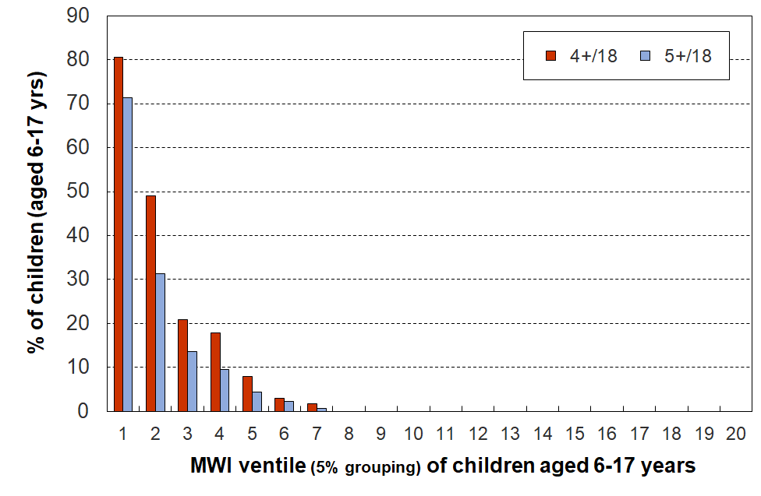
general household items, HES 2018-19

This analysis supports a material hardship threshold in the range of 6+/17 to 8+/17 (see Table K.2 below which shows a child material hardship rate of 8-13% in this range of thresholds).

Table K.2
Cumulative distribution of the DEP-17 scores (% individuals), HES 2018-19
Score | 0+ | 1+ | 2+ | 3+ | 4+ | 5+ | 6+ | 7+ | 8+ | 9+ | 10+ | 11+
ALL (%) | 100 | 46 | 30 | 22 | 17 | 13 | 9 | 7 | 5 | 4 | 3 | 2
0-17 yrs (%) | 100 | 54 | 38 | 29 | 23 | 18 | 13 | 10 | 8 | 6 | 4 | 3
6-17 yrs (%) | 100 | 53 | 38 | 29 | 23 | 18 | 13 | 10 | 8 | 5 | 4 | 3

One of the values of the material hardship approach is that it allows fairly straightforward international comparisons of how children are faring in terms of material wellbeing. We are able to compare New Zealand hardship rates with those from European countries using Eurostat’s EU-13 measure. Setting a DEP-17 threshold that gives hardship numbers that are in line with those produced using EU-13 is a second external reference point that can be used. Eurostat uses a 5+/13 threshold for EU-13.

Table K.3 below compares DEP-17 rates for different age-groups using thresholds of 6+/17, 7+/17 and 8+/17 with the EU-13 rates for a threshold of 5+/13. The DEP-17 6+/17 threshold gives very similar figures to the 5+/13 threshold for EU-13.

Table K.3
Comparisons of hardship rates using EU-13 (5+/13) and selected DEP-17 thresholds:
selected age groups for HES 2018/19
 | EU-13 | DEP-17
 | 5+ | 6+ | 7+ | 8+
Population | 11 | 9 | 7 | 5
0-17 | 14 | 13 | 10 | 8
18-24 | 10 | 10 | 7 | 5
25-44 | 10 | 10 | 7 | 5
45-64 | 10 | 8 | 6 | 5
65+ | 4 | 3 | 2 | 2

MSD reports now use the 6+/17 threshold for DEP-17. Stats NZ does the same for their official CPRA reporting on child poverty rates, with 9+/17 for severe material hardship.
Section L – Low-incomes

Household income as a (proxy) measure of resources

In relation to the high level definition of poverty used in most of the richer nations –‘exclusion from the minimum acceptable way of life (standard of living) in one’s own society because of inadequate resources’ – household income, adjusted for household size and composition, has traditionally been used as a proxy measure of resources for the purposes of poverty measurement.

While this approach produces valuable information on income inequality and on the number of households with incomes below selected low-income lines, it has several serious limitations as a poverty measure. In particular, different households with very similar current income can have different levels of non-income resources, sometimes reflecting higher income in previous years (eg some cash savings, a good stock of basic household items, help in cash and kind from outside the household, and so on), and different demands on the household budget (eg from differing housing costs, special health costs, debt servicing, and so on).
- This means that low income on its own does not distinguish well between those with adequate resources to sustain a minimum acceptable standard of living and those without these. Using household income after housing costs (AHC income) helps but it is not a complete answer. In other words, household income does not perform well as a poverty measure.
- This does not mean that income has little impact on the material wellbeing of individual households – for low-income households especially, any increase in income makes a positive difference. It’s just that when it comes to measuring poverty, income on its own is not a very good identifier of those who are actually struggling, for the reasons outlined above.

What follows elaborates further on this theme (household income not performing well in identifying those who are actually struggling financially):
- three examples using data from the 2017/18 and 2018-19 HES
- examples from the international literature
- recognition of the issue by Eurostat.

Figure L.1 shows the relationship between BHC household income and household MWI score. The solid line shows the average MWI score for each BHC income decile, and the dashed lines show the average MWI scores ± one standard deviation. Higher household incomes are generally associated with higher levels of material wellbeing, as expected. There is, however, considerable variation in material wellbeing for given income levels (in deciles), though this variation diminishes for higher household incomes. In addition, the correlation between BHC income and MWI score is relatively modest at 0.33 (calculated on a household by household basis).

While measurement error and the range of income within each income decile will explain some of the variation, the bulk is likely to reflect the impact of different levels of financial and physical assets and of the ‘other’ factors noted above and in the framework diagram (Figure A.1).

Figure L.1
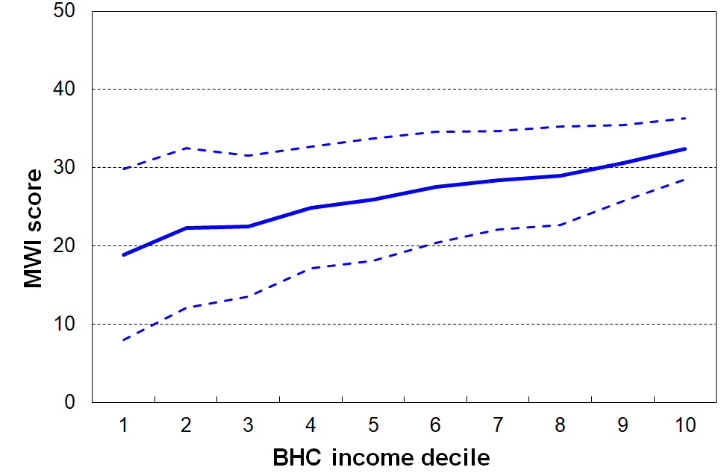
Average MWI scores for BHC income deciles with MWI standard deviation for each decile, HES 2017/18
Figure L.2 and the associated table below the chart show that for households with similar incomes (after deducting housing costs), higher levels of liquid financial assets mean lower levels of material hardship. This is hardly a surprising finding, but it is not often to the fore in discussion and debate, and it is rare for a single dataset to have all three pieces of information (income, liquid assets and material hardship) to enable the analysis to be done.

The bottom two rows of the table are of particular relevance to the matter of the reliability and suitability of household income as a measure of poverty as defined above. There is explicit evidence here that households with close to the same income give quite different responses to an income adequacy question, depending on their liquid assets. The responses are contextualised ones about the adequacy of household income given their particular circumstances. MWI and DEP-17 scores reflect the impact on living standards of these other circumstances as well as that of household income, whereas household income is a more indirect measure of material wellbeing, a proxy that cannot take account of other key factors.

Figure L.2
Material hardship rates depend on the level of liquid financial assets as well as on household income, HES 2017/18

Household Economic Survey 2017/18 | Q1 |  |  | Q2 |  |  | Q3
material hardship rate (6+/17, DEP-17) | 47% | 18% | 7% | 19% | 11% | 4% | 9% | 1% | 2%
median liquid assets ($) | 0 | 400 | 8,000 | 100 | 1,200 | 12,000 | 500 | 3,600 | 19,300
can pay an unexpected + essential $500 bill within a month without borrowing | 24% | 43% | 67% | 51% | 71% | 79% | 69% | 84% | 85%
received help from food bank / community group ‘more than once’ | 25% | 10% | 2% | 6% | 5% | 1% | 4% | 0% | 0%
put up with cold ‘a lot’ to save on heating costs | 26% | 13% | 11% | 10% | 8% | 4% | 7% | 5% | 4%
avg AHC household income (equivalised $) | 11,000 | 11,000 | 10,000 | 21,000 | 21,000 | 22,000 | 30,000 | 31,000 | 31,000
income adequacy ‘not enough’ | 45% | 21% | 17% | 22% | 10% | 5% | 14% | 6% | 4%
Reading notes for table and chart:
- The three quintiles are quintiles of AHC household income – Q1 is the lowest quintile and so on.
- Q4 and Q5 are not shown in the table (limited space).
- Individuals within each household income quintile are ranked by their household’s level of liquid assets, then split into three equal-sized groups.
- No treatment is applied.

The third illustration is given in Figure L.3 which shows the household income bands for the households in which children identified as in hardship live (children living in households with a DEP-17 score of 6+/17). It shows that:
- ((only) around one in four (28%) come from households with incomes below 40% AHC
- almost two in three (60%) come from households with incomes below 60% AHC
- just under one in three (29%) come from households with incomes above 70% AHC.

Figure L.3
Distribution across household AHC income bands of children identified as in hardship (DEP-17 of 6+/17)
Note: Figure L.3 repeats Figure C.4 – see the latter for more detail.

The concerns raised in this report about the use of income on its own for identifying the poor / measuring poverty are not new. Ringen (1988) made a persuasive case that household income was both an indirect and unreliable measure of poverty, to the extent that the statistics produced are ‘invalid’. The issue is well summed up by Nolan and Whelan in their 1996 publication on Resources, Deprivation and Poverty (p219):
‘[There are inherent difficulties in measuring income accurately …. but] the fundamental issue about reliance on income in measuring poverty is not simply one of measurement: it is whether income, properly measured, in fact tells us what we want to know when we set out to measure poverty’ (p219).

More recently, Guio et al (2020:8) sum up:
Although current (disposable) household income is usually used as a proxy for “command over resources”, the association between current income and deprivation is far from perfect. This imperfect link is documented extensively in the literature (see among others Whelan et al, 2001; Whelan and Maître, 2006; 2007; Berthoud and Bryan, 2011; Fusco et al, 2011; Nolan and Whelan,2011; Verbunt and Guio, 2019).

The development of the EU-13 material and social deprivation measure was motivated in part by the the limitations of household income measures of poverty. Notten et al (2017) have recently developed a deprivation index using Canadian data, with similar motivation.

The EU itself explicitly recognised the issue in 2002 through its naming of their official headline low-income rate (BHC 60%) as the ‘at-risk-of-poverty rate’ (Atkinson et al, 2002). Nolan and Whelan (2011) note that ‘this reflects an acceptance that low income on its own may not always be a reliable indicator of poverty and social exclusion’ (p42). The Eurostat glossary notes that ‘this indicator does not measure wealth or poverty, but low income in comparison to other residents in that country, which does not necessarily imply a low standard of living’.

In practice, however, the ‘at-risk-of’ qualifier is very often dropped and the discourse reverts to ‘19% of children in country X live in poverty’ or similar, even at the official level. Examples abound.

The formal media release in January 2021 from the UN’s special rapporteur on extreme poverty and human rights after his ‘mission’ to the EU in late 2020 / early 2021 talks in many places about ‘poverty reduction’ and ‘almost 100 million living in poverty’, and so on, while only once or twice does the full ‘at-risk-of-poverty’ language get used. The impression left is that the EU is in dire straits.

Use of ‘poverty’ language for household income measures is given further legitimacy by the OECD’s use of the 50% BHC measure as its preferred one – without even the EU caveat.

Most UNICEF Report Cards on children in richer countries include a poverty league table using BHC 50 or BHC 60 measures, without any qualification or caveat. All of this tends to legitimise the use of relative low-income measures as poverty measures, despite the well-founded cautions of academics and the built-in caveat in Eurostat’s at-risk-of-poverty language.

A recent UK publication on the working poor (McNeil and Parkes, 2021) notes that “The relative poverty line is computed as 60 per cent of the median equivalised household income, with any household under this amount being described as ‘in poverty’.” The quote marks around ‘in poverty’ raise an unarticulated question but it is never discussed.

Does all this mean that income should not be used in poverty measurement?

While household income has some serious limitations as a precise indicator of poverty as defined above (‘resources not adequate to support a minimum acceptable material standard of living’), there is a good case for using it as part of a suite of measures that together provide a reasonable picture of how material disadvantage is distributed and how it is changing over time.

In particular, there is a rights-based argument that there is an obligation on governments (international commitments) and a public policy interest from citizens to have publicly available information on how income is distributed across households and how trends in rates change over time for selected groups.

Income support is the main lever available to a government for poverty alleviation. The impact of the use of re-distribution needs to be monitored and its impact observed, alongside the impact of other interventions.

The use of expenditure is not generally accepted as an alternative, in part because it also is not a good proxy for reporting consumption possibilities, but also because the quality of the expenditure data is often patchy.

While the use of non-income measures and material deprivation indices has developed strongly in the last two decades, on their own they are not sufficient and also have their own challenges (eg adaptive preferences).

So, no, household income information is very important despite the challenges in using it for poverty measurement.

Section M – Setting low-income thresholds

Just as in the case of material hardship indices, judgment calls are needed for setting low-income thresholds or ‘poverty lines’.

This report and the main MSD reports use the suite of relative low-income measures that are specified in the CPRA. In one sense, therefore, the decisions are already made, but there is value in discussing and documenting what justifications there are for the traditional selections.

This report (and the main MSD source reports) use four approaches for assisting the judgement calls:
  - the thresholds commonly used internationally
  - thresholds that are arrived at by the use of reference budgets for selected household types
  - evidence of where on the household income spectrum there is a clear increase (if any) in reported hardship at low-income levels, using more direct non-monetary indicators
  - sense check by readers when given the weekly dollar values of various thresholds for selected household types.

When applying these approaches and using the selected low-income thresholds the report does not (expect to be able to) reach a definitive conclusion about a sharp cut-off with those below being ‘poor’ and those above ‘not poor’ – for all the reasons outlined in Section L and elsewhere. The report takes the view that any low-income threshold, even those with the strongest support from evidence of the type listed above, can only ever be either:
- a rough-and-ready proxy for resources, or command over resources.
- a ‘rights-based’ minimum income required to reach and maintain a minimum acceptable standard of living, given a set of assumptions about:
- the defining characteristics of the minimum acceptable standard (eg don’t need to use foodbanks)
- the household having a good enough base stock of furniture, whiteware, clothing and so on
- there being no special high demands on the budget for health or disability issues, addressing debt and so on
- the household having reasonable ability to turn a given income into useful consumption
- an accepted set of equivalence ratios to enable reasonably fair comparisons across different household types.

Internationally used low-income measures and thresholds

BHC 50 and BHC 60 measures are widely used, especially by the OECD and the EU respectively.

AHC 60 used by Scotland in their official measures of poverty, and the HBAI reports for the UK as a whole use the AHC 40, 50 and 60 measures as well as BHC measures.

There is very little formal use of AHC measures in the richer nations although in the last year or so Eurostat have begun reporting on these.

Reference budgets for selected household types

The most up-to-date reference budgets for New Zealand are reported in the Example Families and Budgets background paper prepared for the 2019 Welfare Expert Advisory Group.

The research provides estimated budgets for six example families with adults of working age and on low incomes: three are single people without children, and three are families with children (two sole parents, one couple).

The main focus of the research is on the adequacy of the income support system. For the purposes of this section of the Child Poverty report, the relevant findings are the budget costs reported as a proportion of the median household income at the time.

Budgets Costs are calculated for two levels of expenditure:
- a level sufficient to cover ‘core’ (or basic) costs (for example, rent, food, power, clothes, medical costs, transport, school costs, etc), and
- a level to cover both core and ‘participation’ costs (for example, including a small personal allowance, low-cost activities, cheap presents for family, etc) – these costs reflect modest needs and a relatively minimal interpretation of participation and include no spending on alcohol or tobacco and no debt repayments.

Key assumptions include:
- the families are based in Manurewa (South Auckland) – though other locations are considered later in the paper
- no cash assets (savings)
- no debt.

The research finds that in order to meet core expenditure needs:
- BHC incomes need to be in the range of 63% to 75% of the BHC median for Manurewa, and a wider range when other areas with different housing costs are considered.
- AHC incomes need to be in the range of 45% to 50% of the AHC median for Manurewa, and are much the same when other areas with different housing costs are considered.

New Zealand Poverty Measurement Project focus groups from the 1990s.

The research carried out by the New Zealand Poverty Measurement Project (NZPMP) in the 1990s used focus groups of low-income householders to provide some grounded indication of what a poverty line would look like for New Zealand, a ‘realistic poverty line for use in social and economic policy. Each group was asked to reach reasonable agreement on a minimum adequate budget for a household comprising two adults and three children (aged 7-11). This weekly budget was then expressed as a proportion (%) of the median household income from Stats NZ’s Household Economic Survey (HES) and these results were used to reach a ‘60%’ conclusion for a New Zealand BHC poverty line at the time. Many have gone on to mistakenly use this to support an AHC 60% conclusion.

The household budget template set out 15 categories of spending and each group had to decide on a dollar amount for each line in the budget. The purchasing power of the budget was to be ‘strictly minimal’, but such that the household could live independently, without resorting to a food bank, for example. The households were assumed to have basic furnishings and household appliances, no significant costs for sickness or disability, stable financial circumstances and very good financial management abilities.
The focus groups were carried out in Lower Hutt and Wainuiomata in 1993, in some Lower North Island towns in 1995, and then in Auckland and Wellington in 1996. Further focus groups were run in the 2000s but the results are not yet published.

The main focus was on just one household type: two adults and three children. The 1993 Lower Hutt focus groups also provided a budget for a household with a sole parent and two children.

The original focus group information was re-analysed by MSD in 2018. This work concluded that:
- The research in the 1990s does not unambiguously and clearly support a 60% BHC threshold – it points to a range of 55 to 80%, depending on location (and housing costs especially).
- It supports an AHC threshold of 50 to 55% of the median.

Summary of findings from New Zealand reference budget research

The two pieces of research point in the same direction for estimates of low-income thresholds or poverty lines:
- For BHC incomes, a wide range is indicated (55% to 80% of the BHC median), strongly reflecting differing housing costs in different areas. This finding illustrates two key themes outlined earlier in this section and illustrated in the framework in Figure A.1:
  - Factors other than current household income have a major impact on material living standards - housing costs are one of the main factors.
  - Household income is best seen as a rough-and-ready proxy for resources, rather than as a reliable and precise indicator of material wellbeing.
- For AHC incomes, a much tighter range is indicated – 45% to 55% of the median.

Using non-monetary indicators

Is there any evidence that somewhere towards the low end of the household income spectrum there is a clear increase in reported hardship?

The analysis below is based on 2015 and 2017 HES data. The income bands are all AHC income bands expressed as a proportion of the AHC median.

Surviving without outside help?

A reasonable minimum requirement of an above-poverty-line budget is that it allows a household to be able to live independently, without for example having to rely on a food bank.

The two charts below show that:
- There are much higher rates of dependence on outside assistance (whether food banks or friends/family) for those with incomes in the below 40% AHC and in the 40-50% AHC bands, compared with those with incomes in bands above this.
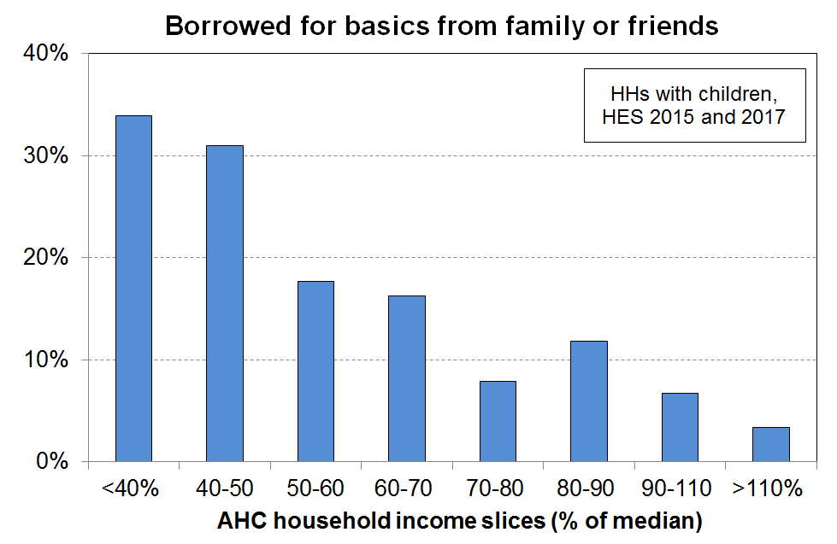
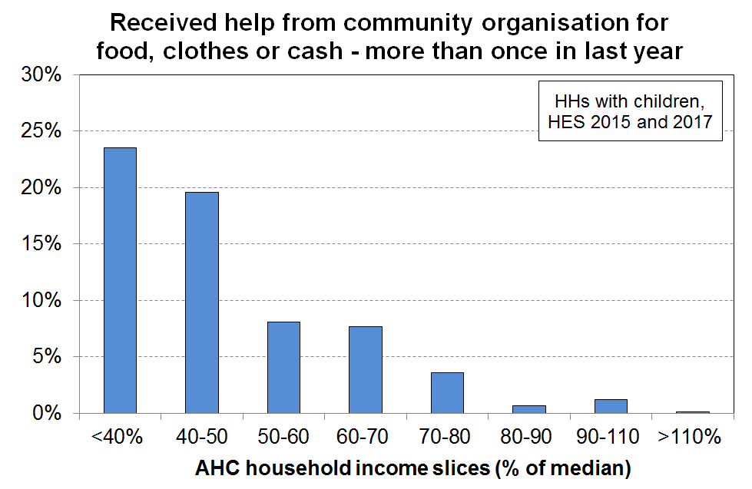
- Even in the 50% to 70% bands there are still 15% of households with children needing to borrow for basics. This is in line with a view which sees any ‘poverty line’ as simply a rough-and-ready guide rather than a precise cut-off.

Two very basic items: fruit/veges and shoes for the respondent

In households with children, the deprivation of fresh/fruit and vegetables (‘a lot’) is clearly much higher for the under 40% AHC households, and the inability to have two pair of reasonable shoes is much higher for the respondents in under 50% AHC households than for households with incomes above this.
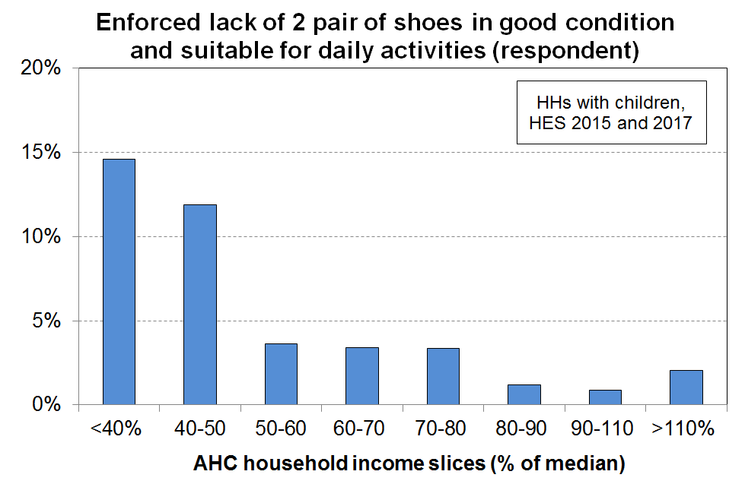
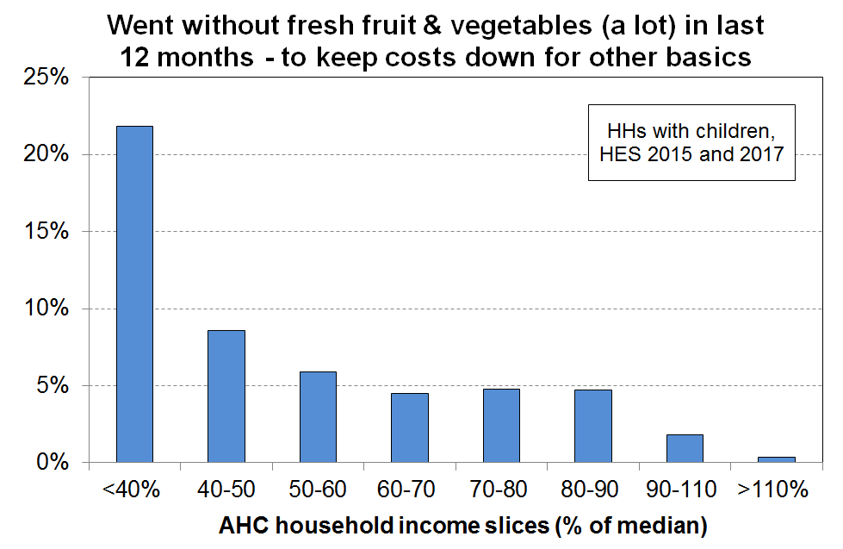

The results are not definitive but are reasonably consistent with those from the reference budgets.

Do these weekly dollar values seem reasonable?

The dollar value of the low-income thresholds used in the Household Incomes Report are provided in Appendix 3 for a range of household types, and are repeated here for convenience. Most householders have a fair idea as to what the minimum AHC income is needed to barely survive, or (a little better) to just get by.

Table 3A
50% and 60% low-income thresholds or ‘poverty lines’ for various household types (BHC)
($2021, per week) (Using the modified OECD equivalence scale)
 |  | REL (‘moving’) |  | CV (‘anchored’ /‘fixed’)
Household type | Equiv ratio | 50% of 2019-20 median in $2021 | 60% of 2019-20 median in $2021 | 50% of 2006-07 median in $2021 | 60% of 2017-18 median in $2021
One-person HH | 1.0 | 410 | 490 | 330 | 490
SP, 1 child <14 | 1.3 | 530 | 635 | 430 | 635
SP, 2 children <14 | 1.6 | 655 | 785 | 530 | 780
SP, 3 children <14 | 1.9 | 775 | 930 | 630 | 925
Couple only | 1.5 | 610 | 735 | 495 | 730
2P, 1 child <14 | 1.8 | 735 | 880 | 595 | 880
2P, 2 children <14 | 2.1 | 855 | 1030 | 695 | 1025
2P, 3 children <14 | 2.4 | 980 | 1175 | 795 | 1170
2P, 4 children <14 | 2.7 | 1100 | 1320 | 895 | 1320
3 adults | 2.0 | 815 | 980 | 660 | 975

Table 3B
40%, 50% and 60% low-income thresholds or ‘poverty lines’ for various household types (AHC)
($2021, per week) (Using the modified OECD equivalence scale)
 |  | REL (‘moving’) |  |  | CV (‘anchored’ /‘fixed’)
Household type | Equiv ratio | 40% of 2019-20 median in $2021 | 50% of 2019-20 median in $2021 | 60% of 2019-20 median in $2021 | 50% of 2006-07 median in $2021 | 60% of 2017-18 median in $2021
One-person HH | 1.0 | 250 | 310 | 375 | 245 | 370
SP, 1 child <14 | 1.3 | 325 | 405 | 485 | 315 | 480
SP, 2 children <14 | 1.6 | 400 | 500 | 600 | 390 | 590
SP, 3 children <14 | 1.9 | 475 | 595 | 710 | 460 | 705
Couple only | 1.5 | 375 | 470 | 560 | 365 | 555
2P, 1 child <14 | 1.8 | 450 | 560 | 675 | 440 | 665
2P, 2 children <14 | 2.1 | 525 | 655 | 785 | 510 | 775
2P, 3 children <14 | 2.4 | 600 | 750 | 900 | 585 | 890
2P, 4 children <14 | 2.7 | 675 | 840 | 1010 | 655 | 1000
3 adults | 2.0 | 500 | 625 | 750 | 485 | 740

Summing up for low-income thresholds

BHC 50 and 60 are commonly used internationally and are within the range identified by NZ research. As poverty lines, they are however very dependent on housing costs variation for eliably indicating financial stress.

AHC measures are not common internationally though UK report in HBAI and Scotland have it in legislation and the EU has recently started reporting. Unfortunately they all use 60% AHC on the basis that they use 60% BHC for official measures. 60% AHC and 60% BHC are very different measures and support quite different standards of living (all else equal). This is because at median BHC income housing costs are around 20% of income, but in the lower deciles housing costs are much more than 20% - more like 30-40% on average. This makes AHC 60 a much more generous threshold than BHC 60, reflected in the higher reported poverty rates. Reference budgets (both recent WEAG and NZPMP in the 1990s) point to thresholds in the 45% to 55% range for AHC.

Note that AHC 50 rates are close to BHC 60 rates and AHC 40 rates are close to BHC 50 rates, consistent with the logic outlined above..

Updating the low-income thresholds (‘poverty lines’) from survey to survey: anchored and moving line thresholds

- There are two common approaches to updating the low-income thresholds (‘poverty lines’) from survey to survey:
- select a threshold in a reference year and update it each survey using an appropriate inflation index (an anchored, fixed line or constant-value approach)
- use thresholds that are a fixed percentage of the median (a fully relative approach).

- The two approaches correspond to two different conceptualisations of what an ‘improvement’ means for low-income households:
  - on the first approach (anchored line), the situation of a low-income household is said to have improved if its income rises in real terms, irrespective of whether its rising income makes it any closer or further away from middle-income households
  - on the second approach (moving line or fully relative approach), the situation of a low-income household is said to have improved if its income gets closer to that of the median household, irrespective of whether it is better or worse off in real terms.

- The Household Incomes Report uses both approaches but takes the view that the anchored line is the more fundamental in the short to medium term, in the sense that it reveals whether the incomes of low-income households are rising or falling in real terms. Whatever is happening to the incomes of the ‘non-poor’, if more and more people end up falling below an anchored-line threshold, as happened in New Zealand from the late 1980s through to the mid 1990s, then in the population at large there is likely to be growing concern about increasing poverty.

- The anchor or reference year needs to re-set from time to time if household incomes continue to rise in real terms. The report initially used 1998 as the reference year, then in 2008 changed to 2007. The report also reports a time series starting in 2017 using 2018 as the reference year which aligns with the reporting requirements in the Child Poverty Reduction Act (2018).

Section N – Estimating persistence rates from cross-sectional rates: a synthesis and application of research by Jenkins and van Kerm (2012)

New Zealand does not have any current longitudinal data to allow population-wide analysis of income dynamics – mobility, persistence and so on. The Survey of Family, Income and Employment (SoFIE) is the latest source for such longitudinal data and ran from 2002 to 2009.

Stats NZ is developing a new longitudinal survey with a view to having persistence statistics available for children (and others) for the 2025-26 year in line with the requirements of the CPRA. Their current proposal is to use the EU definition as the main one (‘in poverty in the current year, and in poverty at least two out of three from the previous three years’), but the data will enable a range of persistence measures to be produced. International comparisons for New Zealand, using the EU definition, will not be available from the new longitudinal study until 2027, although Stats NZ plan on having some persistence analysis available in 2026.

There is however some recent European research (Jenkins and Van Kerm, 2012) that points to a way of making reasonable estimates of low-income persistence rates for children in the interim. A central theme of the research is that when using the EU definition of low-income persistence there is a near- linear relationship between current and persistent low-income rates. This section provides a summary of the research and applies it to New Zealand.

Overview of the research

The research shows theoretically from first principles that this relationship could be expected, building a predictive model based on some simplifying assumptions around exit and entry rates. The model shows a linear relationship between current and persistence rates. The only inputs needed for the model to be able to predict persistence rates are the entry and exit rates and the cross-sectional low-income rates (from the EU-SILC data).

When they applied the predictive model using EU-SILC data for transition rates and cross-sectional rates for each country, they found that the predicted persistence rates were reasonably accurate vis-à-vis the survey-based persistence rates.

They also show that the relationship holds in practice using both EU-SILC data for 2007 and earlier data from the European Community Household Panel. For the current and persistent low-income rates from the 2007 EU-SILC data, the Pearson correlation coefficient was 0.91 when looking at the whole population in each country. The relationship was not quite as strong for sub-groups, but was still very good for children, the best of the sub-groups.

Table N.1 shows that the strong relationship is still evident in the data when updated to 2017, for both the whole population and for children (0-17 years).

Table N.1
Correlation between current and persistent low-income rates, 32 European countries (2017)
 | Whole population | Children (0-17 yrs)
BHC 60 | 0.94 | 0.91
BHC 50 | 0.95 | 0.93
Source: MSD analysis of Eurostat low-income current and persistent low-income rates.
The strong relationship between current and persistent low-income rates when using the EU definition of persistence means that if we know the current rate, then a reasonable estimate of the persistence rate can be made.

Application to New Zealand

The scatterplot in Figure N.1 below shows the relationship between current low-income rates and persistent low-income rates for 32 European countries using 2017 EU-SILC data (BHC 50% and 60%). New Zealand’s cross-sectional rates are known for 2017 (from the 2017-18 HES), which allows estimates of the New Zealand persistence rates to be made, as per the dashed red lines. These are around 13% for BHC 60 and 5% for BHC 50.

Figure N.1
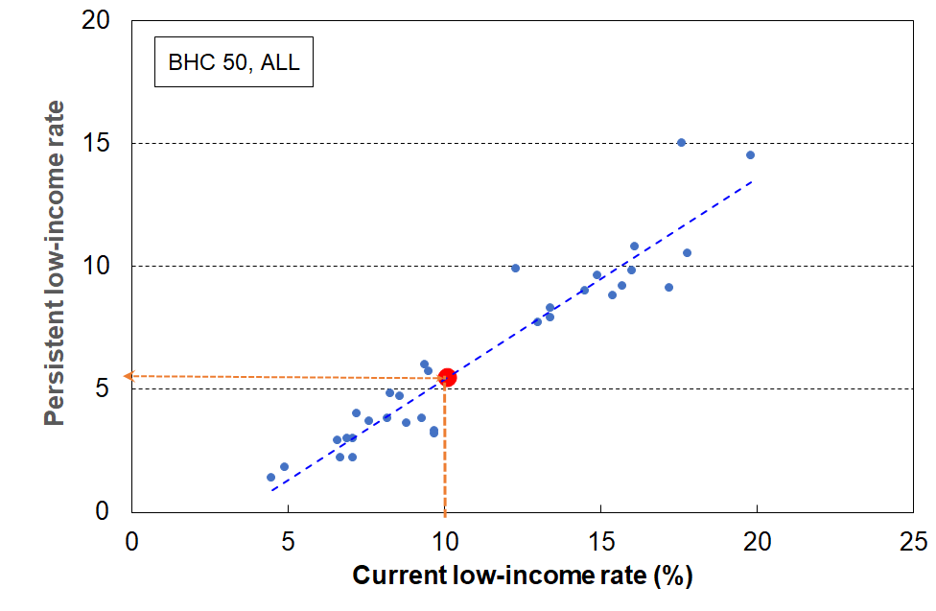
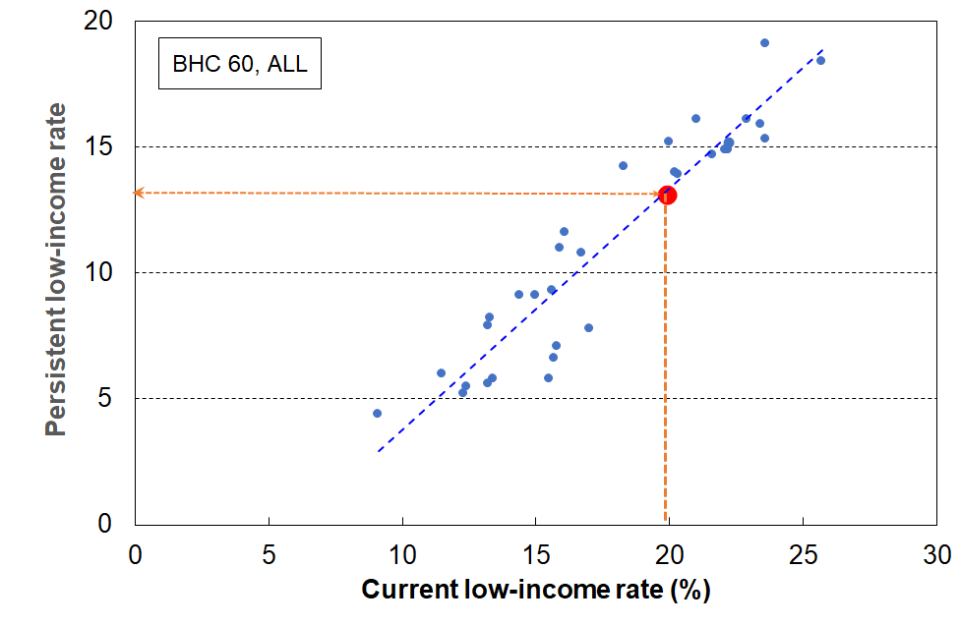
Estimating NZ’s low-income persistence rates for the whole population, based on the strong relationship between current rates and persistence rates when using the EU definition of persistence (2017)
.

Figure N.2 repeats the analysis for children (aged under 18 years). New Zealand’s cross-sectional rates for children are known for 2017 for BHC 60 and BHC 50 (24% and 15%) which allows estimates of the New Zealand persistence rates to be made, as per the dashed red lines. These are around 16% for BHC 60 and 9% for BHC 50.

Figure N.2
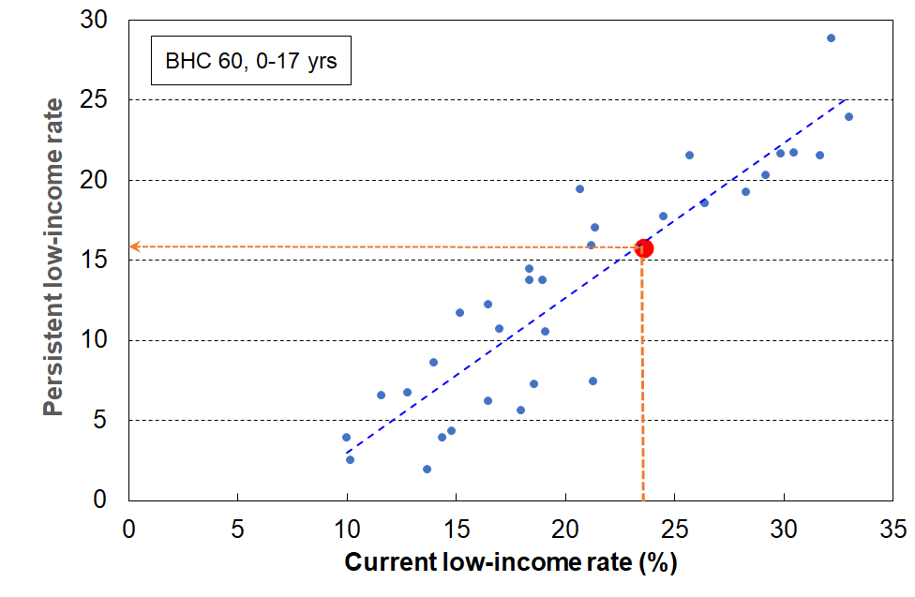
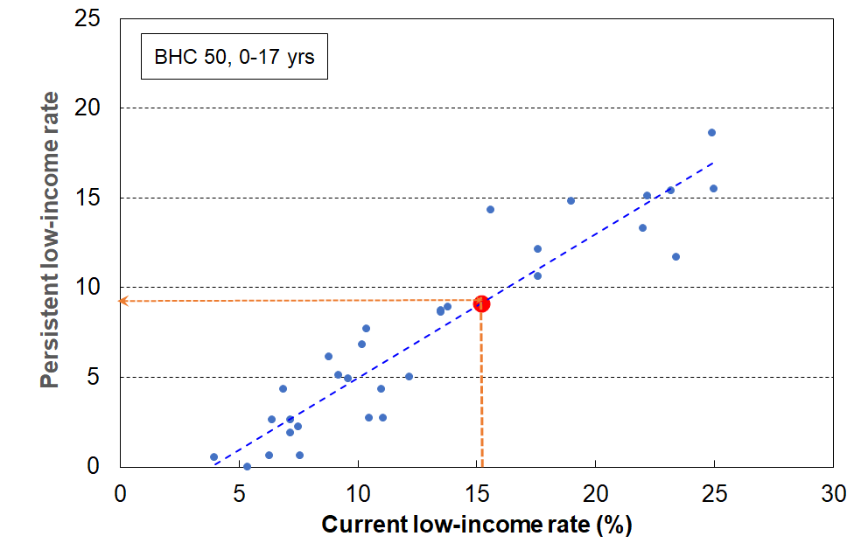
Estimating NZ’s low-income persistence rates for children, based on the strong relationship between current rates and persistence rates when using the EU definition of persistence (2017)

The 32 European countries in Figures N.1 and N.2 and the associated analysis include several that are not usually used in international comparisons in MSD’s reports – Romania, Bulgaria, Hungary, Turkey, Montenegro, Serbia and North Macedonia. When the analysis is repeated using just the remaining 25 European countries with whom New Zealand is more commonly compared:
- the correlation coefficients are virtually unchanged
- the New Zealand low-income persistence estimates remain unchanged, for both the whole population and for children (ie the slopes of the dashed lines above remain much the same)
- median rates remain very similar as there is a bunching of countries near the median, and rates for some of the deleted 7 countries are below the median
- New Zealand rates remain a few percentage points above the median (see the previous section on current low-income rates for detail)
- what does change is New Zealand’s position on the league tables for children, from around 10th to12th highest for the 32 as in Figure 12, to around 5th to 6th highest for the 25.

How robust are the New Zealand persistence estimates?

Looking only at the charts, a reasonable conclusion would be that the New Zealand estimates would need to be reported as ‘X±2%’ to fit within the observed variability around the linear relationship. There is however a further finding in the research that points to being able to have greater confidence in the New Zealand estimates.

As noted above (see n53), a key assumption of the model developed by Jenkins and Van Kerm is that poverty entry and exit rates remain steady for each country over the four-year period for which the persistence rate is measured. When they applied their model using EU-SILC data, they found for almost all countries that they could quite reasonably predict the persistence rate (albeit slightly under-estimated), based on the current low-income rate and just that one year’s transition rates.

Given the importance in the model of the steady-state assumption regarding transition rates, and the observed variability of these rates in the EU-SILC data from year to year even when there was no major (macro-) economic change or re-distributional policy change, they repeated the predictive analysis using the average of the last two years of transition information instead of just the latest year’s. The correlation coefficient between actual and predicted persistence improved markedly to around 0.9.
In relation to Figures N.1 and N.2, this finding means that a good portion of the deviation from the linear relationship for the European countries can be put down to ‘noise’ (the variability in transition rates derived from the EU-SILC samples as a result of the usual uncertainties in all sample surveys (sampling and non-sampling errors)). The New Zealand estimates can be taken as much more secure than what is suggested looking only at the charts.

Little new information?

Jenkins and Van Kerm note that an important implication of the strong relationship between current and persistent low-income rates when using the Eurostat definition of persistence is that the independent production of persistence rates from longitudinal data ‘adds relatively little information to that which is revealed by the “headline” current poverty rate’ (ibid, p21). In applying this finding in their European context they put the case that the EU might want to consider using a different longitudinal measure for its official persistence reporting so as to deliver ‘new information’. They make it clear that it is not an argument against the collection of longitudinal low-income data – they are very supportive of the value of such data.

As with Jenkins and Van Kerm in the European context, applying the research finding in a New Zealand context is not about questioning the value of collecting longitudinal data for child poverty persistence monitoring. There are many good reasons for doing so. For example, even if the Jenkins / Van Kerm estimation is valid for New Zealand as a whole and for children when using the EU definition, and is good enough for a high-level finding:
- The estimation is unlikely to be precise enough to be able to be used for target-setting and accountability under the CPRA for a primary measure. In addition to the usual uncertainties when using sample surveys, there is also another layer of uncertainty added as the relationship is just ‘near-linear’, even though from a research perspective it is a very strong relationship.
- The current New Zealand commitment to (more than) halve the BHC 50 low-income rate for children by 2028 requires considerable redistributive effort. This means that entry and exit rates are unlikely to be steady over the period (they will need to fall and rise respectively), which is likely to invalidate the steady state transition assumption that is required for a robust estimate based on the Jenkins and van Kerm model.
- Understanding the persistence of household income for different sub-groups requires a longitudinal data set (estimates from cross-sectional rates would be too uncertain).
- Monitoring and understanding changes in entry and exit rates is an important exercise in itself that requires separate longitudinal data.
- Monitoring persistent material hardship requires survey information.

The question the ‘little new information’ finding raises is about the choice of a persistence measure or suite of measures. This relates both to decisions for official statistics that will meet the requirements of the CPRA (2018), and also for decisions for what measures MSD might report on post-2026.

The advantage of using the EU definition is that it is well-established and allows international comparisons. There are however other definitions of persistence that can be used and which add value, albeit without the international comparisons. For example:
  - Look at all households over an N-year period, and define persistence as having an average income that is less than an average low-income threshold. This ‘chronic’ approach avoids counting those whose incomes move from a little above the threshold to a little below between surveys (and vice versa) as transitions into or out of poverty, while their actual standard of living doesn’t change. MSD’s Household Incomes Report reports on this measure, based on analysis of Stats NZ’s Survey of Family, Income and Employment (2002 to 2009) by Carter and Imlach Gunasekara (2012).
  - Look at all households in the current year (not just those with low incomes) and those in the previous 2 years and count those ‘under the line’ in 2 out 3 years (or previous 3 years, counting those under the line for 3 out of 4 years).

Section O – Households with very low incomes: implications for measurement and the rationale for the treatment applied in this report

The Household Economic Survey, like similar ones elsewhere, includes a small group of very-low-income (VLI) households the great majority of whom report consumption / material wellbeing more like households with incomes in the middle of the income distribution. While there is considerable variation in reported material hardship levels for other ‘ordinary’ low-income households – not all low-income households are in hardship and not all in hardship are from low-income households (ie the limited overlap observation) – the VLI group is different from the ordinary-low-income group on two counts:
- first, the incomes are so extremely low (for this report, usually under ~15% of the median), well below all safety net income support levels
- second, there is good evidence that an unexpectedly high proportion of these VLI households report a material standard of living much higher than those with incomes a little above (eg those in ventile 2), and higher than those in the ‘normal / less extreme’ low-income range.

For much of the analysis in this report, leaving these VLI households in the dataset is highly problematic as household income is used as an indicator of material wellbeing / consumption possibilities for households, albeit a rough and ready indicator at times. Their presence leads to misleading and incongruous findings, as this group is so much better off than their counterparts with ordinary low household income. They make up only a very small proportion of the whole population (typically around 2-4%), but when the population of interest is the low-income group, they can make up a non-trivial portion as high as 25% in some cases.

MSD’s reports have applied various treatments in the past to seek to reduce the distortion for particular statistics such as decile shares and other income inequality measures, measures of poverty depth, measures of housing affordability using outgoing-to-income measures, and when examining the overlap between income and non-income measures of poverty (a major theme of this report). One treatment involved using household spending to impute a more realistic income for the VLI households, and another simply deleted households with incomes under a selected very low level of a few thousand dollars per annum. The expenditure treatment is available only every third year (starting with 2006-07) so has limitations for time series, and the deletions based purely on income can open the analysis to the charge that it potentially eliminates from the dataset some households that are genuinely in poverty, thus under-estimating the level of need.

For this Child Poverty report, a different approach is used: households with BHC equivalised incomes below $5000 pa (in $2007 dollars) and whose DEP-17 score is zero or who self-rate their income as ‘enough’ or ‘more than enough’ are removed from the dataset. The AHC threshold is $3000 (in $2007). This approach deals with the critique noted above about potential over-culling. It is however fairly conservative (eg the VLI threshold could be made a little higher), but it is sufficient as an interim measure for the main purposes of this report.

Stats NZ are aware of the VLI issue in relation to how it may possibly impact on the child poverty rates they report on in the context of the requirements of the CPRA, and also more generally for the way the presence of these extreme incomes can impact other information based on the HES. They are carrying out further investigation, especially for HES 2018-19 and later. In the Technical Appendix for the February 2021 release of Child Poverty Statistics, Stats NZ note that:
‘We have decided at present that we will not apply any treatment to try and correct for this group of people who have very low income when producing poverty rates. However, users of the data should be aware of this issue when analysing this end of the distribution and may want to apply their own treatment depending on the purpose of their analysis. We will continue to investigate what is driving what we observed and to further improve the dataset.’

This section discusses the context and rationale for the treatment decision used in this report, and reports the impact on selected statistics.
Introduction

Household income, adjusted for household size and composition, is commonly used as a proxy measure of household material wellbeing, with low household income used as a measure of (income) poverty. While there are some well-known challenges and limitations for this approach, as outlined in Section A and discussed in more detail in Section L, it performs well enough when it is understood as a rough and ready guide to a household’s consumption possibilities. For example, looking across the income spectrum, the lower the household income the lower on average are the material living standards of households.

There is however a small group of households at the lower end of the distribution for most of whom there is a strong divergence from the usual relationship between household income and consumption / material wellbeing. This divergence can be shown in a range of ways. Figure O.1 shows two of these, using HES 2018-19 data:
- total household expenditure (as a proxy for consumption) for unequivalised household income ventiles for the whole population
- material wellbeing (as measured by average Material Wellbeing Index scores) for equivalised household income ventiles for under 65s.

Figure O.1
Household expenditure for all ages and MWI scores for under 65s across the household income spectrum:
Evidence of significant divergence for a small group of households with very low incomes.
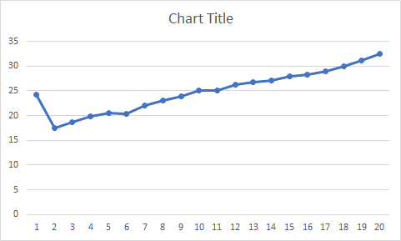
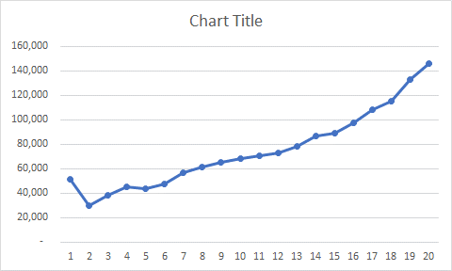
Expenditure MWI

The incomes of the households in the divergence zone are extremely low (under 15% of the median, and well below all safety net income support levels), yet they have reported expenditure more like those in the 3rd and 4th deciles and material wellbeing scores that are more like the average for those with incomes around the median.

The more general observation highlighted in this report and by many others elsewhere – that not all low-income households are in hardship and not all in hardship are from low-income households (ie the limited overlap observation) – holds true even when all the households with extremely low income are simply deleted. The more general ‘limited overlap’ observation, and this ‘strong divergence / extremely low incomes’ observation are two related but distinct aspects of the income / material wellbeing relationship. The VLI group is different from the ordinary low-income group on two counts:
- first, the incomes are so extremely low (for this report, usually under ~15% of the median, and well below all safety net income support levels)
- second, there is good evidence that an unexpectedly high proportion of these VLI households report a material standard of living much higher than those with incomes a little above (eg those in ventile 2), and higher than those in the ‘normal / less extreme’ low-income range.

Reports and studies that (include a) focus on the low-income zone of the distribution show a range of responses to the extremely low-income issue. Some simply ignore it or accept it as unfortunate noise. Others conclude that it is mainly an issue about the reporting of income for the self-employed: this is certainly a factor, but is only a part of the story as the evidence below shows (especially for HES 2018-19 and 2019-20).

The Australian Bureau of Statistics (ABS) has recognised the issue for many years in its Household Incomes Reports, and has recently changed from its earlier approach of using only deciles 2 and 3 to describe ‘low income’ (a very blunt treatment) to now using an adjusted low-income quintile which excludes households with incomes in the lowest 2%. The ABS does not however use this modified dataset to report on low-income rates (‘income poverty’). Davidson et al (2020), in a joint Australian Council of Social Services / University of New South Wales report provide low-income rates for Australia using ABS data. They exclude from the survey sample households reporting zero or negative incomes and self-employed households, ‘since their reported incomes are not good indicators of their living standards’.

The UK recognises the issue, and in their main Household Below Average Income reports they italicise the BHC 50 rates to remind readers of the extra uncertainty when using this low-income threshold. They also note that ‘[h]ouseholds reporting the lowest incomes may not have the lowest living standards. The bottom 10 per cent of the income distribution should not, therefore, be interpreted as having the bottom 10 per cent of living standards’. While this is undoubtedly true, it doesn’t say what to do about the matter when using low-income thresholds such as BHC 50 and so on.

Brewer et al (2017) provides a comprehensive analysis of UK data in relation to the divergence, reporting the same ‘tick’ relationship as in Figure O.1, and including an assessment of the likely cause of the observation. They sum up in their Conclusion section (pp45f):

‘…… median expenditure is higher for those with very low income than for those with moderately low income. In fact, those at the very bottom of the income distribution have expenditure equal to the population-level median expenditure. In short, the graph of median expenditure by reported income maps out a ‘tick’. This pattern could be explained by any combination of under-reporting of income, over-reporting of expenditure, or that households smooth consumption over time, and this article investigates what roles each of these candidates has to play. Of the three (non-mutually exclusive) hypotheses which could explain the tick, we argue that under-reporting of income plays the most important role.’

In the 1990s, the New Zealand Poverty Measurement Project (NZPMP) recognised the problem, and sought to address it by deleting from the dataset those self-employed who declared losses and those whose expenditure was more than three times their income. The effect of this adjustment to the dataset was to reduce reported poverty rates. In 1991, the deletions reduced the size of the database by 4.4 percentage points, and lowered the overall poverty incidence by three percentage points. .

MSD has discussed the issue in Appendix 8 of the Household Incomes Report, and created a plausible interim treatment involving expenditure which it has applied to selected statistics. The result of the treatment is reported in Appendix 9 of the Incomes Report. Since the 2006-07 HES, expenditure has been available only every third year so the treatment has not been able to be used for a full annual time series.

There are three points of departure for this report (and the forthcoming main MSD reports) in relation to efforts to better understand the size and characteristics of this VLI group and for the development and application of a reasonable mitigating treatment:
- The need to ensure the credibility and reasonable validity of reported findings regarding: the overlap or lack of overlap between income and non-income measures; the description of ‘life below the line’ for income-poor families; standard poverty depth analysis using low-income measures; housing affordability measures using outgoing-to-income ratios (OTIs), and so on. All these are impacted by the presence of the VLI group that leads to misleading and/or incongruous findings.
- The size of this VLI group with unexpectedly good material living standards is notably higher in HES 2018-19 and 2019-20 than in the previous HES data available for MSD’s reports, especially for households with children (the proportion of children in this group is 3-4 times higher than in earlier years).
- The increased proportion of households with dependent children under the BHC 50 low-income line whose material standard of living is too high for them to be plausibly identified as ‘poor’ raises questions about the credibility and validity of the numbers produced when using this measure as an indicator of poverty, or even as a proxy indicator of resources. The BHC 50 measure is a primary measure under the CPRA, meaning governments are required to set targets using this measure to provide accountability for child poverty reduction. As the BHC 50 child poverty rate declines for children, in line with the intent of the CPRA, its prima facie credibility and validity will be undermined if the VLI group stays around the same size as in 2018-19 and 2019-20 … and therefore increases as a proportion of the overall number of children identified as being in BHC 50 poverty in coming years. As BHC 50 child poverty numbers reduce, the ongoing presence of a sizeable VLI group will also in future years make it progressively more difficult to further reduce the numbers (in addition to the core income transfer challenges). Similar issues arise for the numbers produced by the AHC 40 and AHC 50 measures (whether fixed or moving line).

This rest of this section:
- Describes the size, characteristics and make-up of the VLI group, for households overall and for households with children. It includes comparisons with the rest of the BHC 50 income-poor group, those with incomes a little higher (50-65% of the median), those with incomes between 65% of the median and the median itself, and with the whole population. It uses 2018-19 HES data for this analysis.
- Discusses the implications for measurement, especially for describing what life is like for those in households ‘below the line’ (ie in low-income households), for reporting low-income rates for children (BHC 50), and for other selected statistics.
- Outlines the evidence in support of the report’s claim that the issue with very low incomes is larger in 2018-19 and 2019-20 HES data than before that, and especially for households with children.
- Describes the treatment used in this report, the rationale for it and the impact on the statistics above when the treatment is applied (except for child poverty rates).
- Reports and discusses the impact of a range of treatments on reported child poverty rates.

Size, characteristics and make-up of the VLI group

Tables O.1 and O.2 below provide information from MSD’s analysis of HES 2018-19 regarding the size and selected characteristics of the VLI group (as defined in this report) for the population as a whole and for children.

Around 2% of the whole population and 2% of children are in the VLI households. These in themselves are relatively small numbers, but when the focus is on low-income households their presence and impact is much greater. This can be seen in the third row in each table below: the VLI group makes up 18% of the poor overall and 14% of poor children (using the BHC 50 measure).
The unexpectedly good level of material wellbeing and the very low levels of material hardship of the VLI group are clearly evident. For example, for the whole population, based on HES 2018-19 data and using BHC incomes with BHC 50 as the low-income / poverty line:
- 90% of these VLI households are not in hardship on DEP-17, only 10% are in hardship (compared with 25% in hardship for the rest of low-income households, and 9% overall).
- 96% did not use a foodbank at any time in the previous 12 months, 4% did (compared with 18% for the rest of low-income HHs).
- 67% can pay a $1500 unexpected unavoidable expense on an essential in a month without borrowing (which is much better than the rest of low-income HHs (only 35%) and better than the population overall (59%).
- The reported median housing costs of the VLI group is $16,000 compared with $9,000 for the rest of the low-income group. The $16,000 is similar to the population as a whole and to the group below the median but above the BHC 60 low-income line ($18,000).

Table O.2 repeats the analysis for those aged 0-17 years.

Table O.1
Selected characteristics of the very-low-income group (for all individuals in their households)
compared with other low-income and low-to-middle income households and the population overall
HES 2018-19 (%)
HES 2018-19 (no treatment) | <6k | 6k to 50% BHC | 50% BHC to 65% | 65% BHC to median | Total popln
% in each income group (individuals in their households) | 2 | 9 | 13 | 26 | 100
% in each income group (households) | 3 | 10 | 16 | 23 | 100
% of all individuals in households below the BHC50 low-income line who are in VLI households | 18 | n/a | n/a | n/a | n/a
DEP-17 = 6+/17 | 10 | 25 | 17 | 11 | 9
Used foodbanks (at least once in 12 months prior to interview) | 4 | 17 | 11 | 5 | 5
Income adequacy (enough or more than enough) | 61 | 37 | 45 | 52 | 62
DEP 17 = 0 | 58 | 30 | 40 | 42 | 54
Can pay unexpected unavoidable $1500 bill within a month without borrowing | 67 | 35 | 45 | 47 | 57
Median housing costs | $16,000 | $9,000 | $8,000 | $18,000 | $18,000
Notes: The income bands are based on the count of individuals in their households as is standard practice for low-income (poverty ) measurement. The analysis unit is also the individual. Using the household as the analysis unit makes very little difference to the numbers.
$5000 in 2007 is around $6200 in 2019 in $2007 terms. The $6k threshold used for VLI households in Table O.1, etc means that there will be some small differences compared to analysis elsewhere which uses the $5k ($2007) threshold (eg Figure O.4)

Table O.2
Selected characteristics of the very-low-income group (for 0-17s in their households)
compared with other low-income and low-to-middle income households and the population overall
HES 2018-19 (%)
HES 2018-19 (no treatment) | <6k | 6k to 50% BHC | 50% BHC to 65% | 65% BHC to median | Total popln
% in each income group (0-17s in their households) | 2 | 12 | 13 | 32 | 100
% in each income group (households with 0-17s) | 2 | 10 | 11 | 31 | 100
% of all children (0-17 yrs) in households below the BHC50 low-income line who are in VLI households | 14 | n/a | n/a | n/a | n/a
DEP-17 = 6+/17 | 13 | 33 | 28 | 13 | 13
Used foodbanks (at least once in 12 months prior to interview) | 5 | 26 | 19 | 6 | 8
Income adequacy (enough or more than enough) | 56 | 31 | 36 | 48 | 57
DEP 17 = 0 | 56 | 20 | 24 | 37 | 46
Can pay unexpected unavoidable $1500 bill within a month without borrowing | 66 | 24 | 28 | 40 | 50
Median housing costs | $22,000 | $14,000 | $17,000 | $21,000 | $21,000
Notes: As per Table O.1.

Figure O.2 uses two indicators of material wellbeing (self-rated income adequacy of enough / more than enough, and a DEP-17 score of zero) and shows how the ‘both’ combination generally declines across the income ventiles from high to low until ventile 1, and how the ‘neither’ combination generally increases until ventile 1. The results for ventile 1 correspond to the ‘tick’ charts in Figure O.1 and show again this special feature of these VLI households.

Figure O.2
Self-rated income adequacy (enough / more than enough) and zero hardship
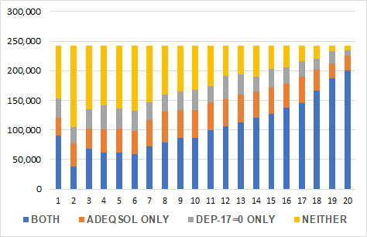
by BHC income ventile, HES 2018-19

Table O.3a compares the make-up of the VLI group by household work status across the same very-low-to-middle income groups used in Tables O.1 and O.2 (HES 2018-19). It also provides an age split between households with at least one member aged 65+ and those with all members under 65.

Tables O.3b and Table O.3c repeat the 2018-19 analysis from Table O.3a for HES 2017-18 and 2014-15 respectively. (These latter were selected as they have larger sample sizes than other HES-TAWA years (c 5500 households), albeit still fewer than the 21,000 for HES 2018-19.)

Comparing the BHC analyses over the three years, and drawing in the relevant information on households with children from Table O.4 (see below, page 118):
- There are around 20,000 more VLI households in 2018-19 than in 2017-18
- Numbers of workless (13-14,000) and PT households (2-3000) remained much the same across the three years.
- The bulk of the 20,000 increase (55%) came from an increase in working-age households with one or more FT workers, followed by 65+ singles (30% of the increase), and self-employed households (~14% of the increase).
- One third of the increase came from extra households with children in the VLI group.

Looking now within Table O.3a across the different income bands (ie for 2018-19 on its own):
- Working-age households with one or more in FT work make up the largest sub-group within the VLI group (40%).
- Self-employed households (18%) are over-represented in the VLI group compared with their representation in the rest of the low-income group (7-8%) and in the population as a whole (11%).
- Workless households (34%) are over-represented in the VLI group compared with their profile in the population as a whole (13%), but the composition proportion is reasonably in line with their counterparts in other low-income bands.
- Households with children have gone from 15% of all VLI households in 2014-15 and 2017-18 to 22% in 2018-19.

Tables O.3d to O.3f are the AHC versions of Tables O.3a to O.3c.
Table O.3a
Make-up of the BHC very-low-income group by household paid work status,
compared with other low-income and low-to-middle income households and the population overall
HES 2018-19 (%)
HES 2018-19 (no treatment) | <6k | 6k to 50% BHC | 50% BHC to 65% | 65% BHC to median | Total popln
Household paid work status (all members under 65)
Self-employed | 18 | 8 | 7 | 9 | 11
One or more FT | 40 | 25 | 44 | 74 | 70
PT only | 8 | 14 | 16 | 7 | 6
Workless | 34 | 54 | 33 | 10 | 13
 | 100 | 100 | 100 | 100 | 100

Household age groups
All under 65 | 78 | 86 | 47 | 83 | 81
With at least one 65+ | 22 | 14 | 53 | 17 | 19
 | 100 | 100 | 100 | 100 | 100
Notes: The definition of a self-employed household in this table is one for which more than half the HH income comes from self-employment. Using a stricter definition (more than 90% from SE) makes no discernible difference to the under $6k paid work status column, but roughly halves the SE proportions in each of the other three columns with the dropped households moving to the ‘one or more FT’ category.
The classification into FT, PT and workless is based on the number of hours in paid work reported in the survey (30 or more, 5 to less than 30, and less than 5 respectively).

Table O.3b
Make-up of the BHC very-low-income group by household paid work status,
compared with other low-income and low-to-middle income households and the population overall
HES 2017-18 (%)
HES 2018-19 (no treatment) | <6k | 6k to 50% BHC | 50% BHC to 65% | 65% BHC to median | Total popln
Household paid work status (all members under 65)
Self-employed | 16 | 7 | 9 | 11 | 13
One or more FT | 14 | 23 | 52 | 78 | 71
PT only | 12 | 15 | 13 | 5 | 5
Workless | 58 | 55 | 26 | 6 | 11
 | 100 | 100 | 100 | 100 | 100

Household age groups
All under 65 | 87 | 94 | 45 | 83 | 81
With at least one 65+ | 13 | 6 | 55 | 17 | 19
 | 100 | 100 | 100 | 100 | 100

Table O.3c
Make-up of the BHC very-low-income group by household paid work status,
compared with other low-income and low-to-middle income households and the population overall
HES 2014-15 (%)
HES 2018-19 (no treatment) | <6k | 6k to 50% BHC | 50% BHC to 65% | 65% BHC to median | Total popln
Household paid work status (all members under 65)
Self-employed | 13 | 4 | 8 | 10 | 9
One or more FT | 28 | 26 | 42 | 76 | 72
PT only | 9 | 12 | 17 | 7 | 6
Workless | 51 | 58 | 32 | 7 | 12
 | 100 | 100 | 100 | 100 | 100

Household age groups
All under 65 | 93 | 97 | 48 | 82 | 81
With at least one 65+ | 7 | 3 | 52 | 18 | 19
 | 100 | 100 | 100 | 100 | 100
Table O.3d
Make-up of the AHC very-low-income group by household paid work status,
compared with other low-income and low-to-middle income households and the population overall
HES 2018-19 (%)
HES 2018-19 (no treatment) | <4k | 4k to 40% AHC | 40% AHC to 60% | 60% AHC to median | Total popln
Household paid work status (all members under 65)
Self-employed | 17 | 7 | 8 | 9 | 11
One or more FT | 41 | 30 | 47 | 74 | 70
PT only | 11 | 11 | 14 | 7 | 6
Workless | 31 | 51 | 31 | 10 | 13
 | 100 | 100 | 100 | 100 | 100

Household age groups
All under 65 | 85 | 86 | 65 | 73 | 81
With at least one 65+ | 15 | 14 | 35 | 27 | 19
 | 100 | 100 | 100 | 100 | 100
Note: See under Table O.3a

Table O.3e
Make-up of the AHC very-low-income group by household paid work status,
compared with other low-income and low-to-middle income households and the population overall
HES 2017-18 (%)
HES 2018-19 (no treatment) | <4k | 4k to 40% AHC | 40% AHC to 60% | 60% AHC to median | Total popln
Household paid work status (all members under 65)
Self-employed | 16 | 6 | 12 | 9 | 13
One or more FT | 25 | 30 | 57 | 79 | 71
PT only | 11 | 15 | 10 | 5 | 5
Workless | 49 | 49 | 21 | 6 | 11
 | 100 | 100 | 100 | 100 | 100

Household age groups
All under 65 | 91 | 92 | 61 | 74 | 81
With at least one 65+ | 9 | 8 | 39 | 26 | 19
 | 100 | 100 | 100 | 100 | 100

Table O.3f
Make-up of the AHC very-low-income group by household paid work status,
compared with other low-income and low-to-middle income households and the population overall
HES 2014-15 (%)
HES 2018-19 (no treatment) | <4k | 4k to 40% AHC | 40% AHC to 60% | 60% AHC to median | Total popln
Household paid work status (all members under 65)
Self-employed | 10 | 4 | 9 | 8 | 9
One or more FT | 31 | 29 | 53 | 79 | 72
PT only | 15 | 12 | 13 | 6 | 6
Workless | 43 | 54 | 25 | 7 | 12
 | 100 | 100 | 100 | 100 | 100

Household age groups
All under 65 | 94 | 93 | 71 | 71 | 81
With at least one 65+ | 6 | 7 | 29 | 29 | 19
 | 100 | 100 | 100 | 100 | 100

While using the ‘main source’ definition to identify self-employed households is in most circumstances a satisfactory approach, using it for households with incomes under the $6k VLI threshold may not properly reveal the ‘source-of-income’ story. To investigate this possibility, the 2018-19 analysis in Table O.3a is repeated in Table O.3g using an ‘any self-employment income’ definition of a self-employed household, for both under 65 households and all households.

The distribution of VLI households across the work status categories remains much the same using the ‘any self-employment’ definition. The self-employed group is still an important part of the story (23% up from 18%), but the FT/PT paid employment group still dominates for under 65s (36% down from 40% as some shifted to the SE group).

Comparing the under 65 and all households numbers behind the percentages in Table O.3g enables the 65+ contribution to be deduced. The 65+ self-employment and FT/PT contributions to the VLI group are small and the workless contribution is large.

Table O.3g
Make-up of the BHC very-low-income group by household paid work status,
compared with other low-income and low-to-middle income households and the population overall
HES 2018-19 (%)
HES 2018-19 (no treatment) | <6k | 6k to 50% BHC | 50% BHC to 65% | 65% BHC to median | Total popln
Household paid work status (all members under 65)
Self-employed (any SE income) | 23 | 15 | 17 | 19 | 25
One or more FT | 36 | 20 | 37 | 65 | 57
PT only | 7 | 12 | 13 | 6 | 5
Workless | 34 | 53 | 33 | 9 | 13
 | 100 | 100 | 100 | 100 | 100
Household paid work status (all households)
Self-employed (any SE income) | 20 | 14 | 9 | 17 | 22
One or more FT | 28 | 17 | 18 | 55 | 48
PT only | 7 | 11 | 7 | 7 | 5
Workless | 45 | 58 | 66 | 21 | 25
 | 100 | 100 | 100 | 100 | 100
Note: uses an ‘any self-employment income’ definition of a self-employed HH - see also the text above Table.

In all the Tables above, the work status categorisation for the non-SE households is based on the information about hours worked as provided by respondents. An alternative approach is to use the income information itself and to categorise the non-SE households according to whether they have an identified income source or not.

Using the ‘main source’ definition for self-employed households, 16% of BHC VLI households are self-employed and 29% have no identified source of income. For under 65 households, the corresponding figures are 19% and 25%.

Implications for measurement

This sub-section gives two examples of the incongruities that motivate the creation and application of some sort of treatment for the VLI households. More examples are provided later in this section (Section O) when the treated and untreated results are reported together for various statistics.

Figure O.3 shows that the average hardship rate for children in households below the 40% AHC threshold is lower than for those in ‘higher’ low-income households, 40-50% AHC. This is not only incongruous in itself, but it also impacts on the descriptions of what life is like for children in households with incomes ‘below the line’, a central theme of this report.
Figure O.3
Material hardship rates (%) of children in selected AHC household income bands:
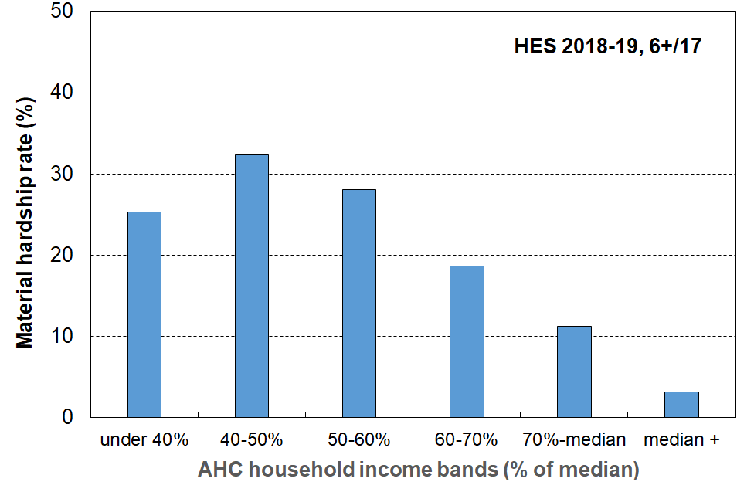
HES 2018-19

Figure O.4 shows the trend in housing affordability pressure for households with children, using a housing-outgoing-to-income ratio (OTI) of greater than 50% (ie those spending more than half their income on housing). The figures for 2018-19 and 2019-20 are well above the (rising) trend line from 2006-07 to 2018-19, reflecting the greater proportion of households with children in the VLI group in the 2018-19 and 2019-20.

Figure O.4
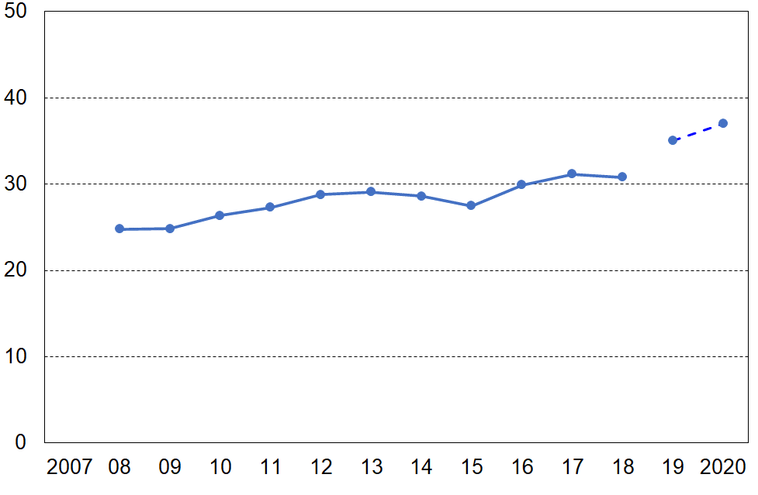
Proportion (%) of households with children with OTIs greater than 50%
Note: the 2007 to 2018 trend line is smoothed using a rolling two-year average

Stats NZ are aware of the VLI issue in relation to how it may possibly impact on the child poverty rates they report on in the context of the requirements of the CPRA, and also more generally for the way the presence of these extreme incomes can impact other information based on the HES. They are carrying out further investigation, especially for HES 2018-19 and later. In the Technical Appendix for the February 2021 release of Child Poverty Statistics, Stats NZ note that:
“We have decided at present that we will not apply any treatment to try and correct for this group of people who have very low income when producing poverty rates. However, users of the data should be aware of this issue when analysing this end of the distribution and may want to apply their own treatment depending on the purpose of their analysis. We will continue to investigate what is driving what we observed and to further improve the dataset.”
There are larger proportions of very-low-income (VLI) households in HES 2018-19 and 2019-20 compared with earlier years (especially for households with children)

The analysis in this report is based on data from Stats NZ’s Household Economic Survey (HES).

Up to and including the 2017-18 HES, the data available to MSD for its reports was the ‘HES-TAWA’ data, a dataset created by Stats NZ by merging direct survey information with modelled data from Treasury’s TAWA model. For HES 2018-19 and 2019-20 the data available was the ‘HES-admin’ data, a dataset created by Stats NZ by incorporating administrative data for most of the household income components.

The data sources: ‘HES-TAWA’ and ‘HES-admin’

TAWA is the Treasury’s microsimulation model of the New Zealand personal tax and transfer system and relies on input data from Stats NZ’s Household Economic Survey (HES). Its main purpose is to provide indicative comparisons of the impacts of selected changes to policy settings on the personal / family / household income distributions.

TAWA and its predecessors have also been used to produce the after-tax-and-transfer income estimates for individuals in the households interviewed in the HES (ie disposable income).

It is well-established that some of the components of income gathered in sample surveys are not reliable. In particular, the income received from government transfers is often inaccurately reported. The TAWA model improves on the accuracy of the income data gathered in the HES survey by modelling first-tier income support payments (JSS, SPS, SLP and NZS), and the second tier AS, and WFF tax credits available to families with dependent children …. then calculating personal income tax. (More recently TAWA has been further developed to model the Best Start support for families with new babies and the WEP.)

Up to 2017-18 Stats NZ merged this disposable income information (and other variables) from TAWA into their HES survey dataset, and this composite dataset was used by Stats NZ, MSD and others to produce reports on trends in median household incomes, low-income rates, income inequality, housing affordability through outgoing-to-income ratios, and so on. The composite dataset is known as the HES-TAWA dataset.

Reported income from self-employment and income from investment are also known to have inaccuracies but these are not modelled by TAWA for the HES-TAWA dataset. The reported survey values are used. Similarly, the income from wages and salaries as reported by respondents was used in the HES-TAWA dataset for these components of income.

Since 2017-18, the TAWA model has been further improved by integrating administrative sources of income (for example, first-tier income support receipt, wage and salary, self-employment) from Stats NZ’s Integrated Data Infrastructure. Where administrative data is not available for an individual, the survey response has been used as a proxy though this is proxy information is no longer collected for some income sources from HES 2019-20 onwards. This ‘augmented’ HES-TAWA dataset is used for Treasury advice, but is not used in this report.

For the 2018-19 and 2019-20 HES, Stats NZ moved to using administrative data for most of the income information, and calculated disposable income themselves rather than relying on Treasury to do so via TAWA. The sample sizes are much larger, more effort was made to get a better sample / response at the bottom end, and a more comprehensive set of benchmarks was used to weight up to population estimates. These datasets (‘HES-admin’) are available to MSD for use for this and other reports.

The use of administrative data has in many ways further improved the income information available for HES analysis (for example, by removing measurement error when income from a respondent is misreported through recall issues or deliberately). However, the number of very-low-income (VLI) households has increased when compared with previously published income distribution information based on HES-TAWA. In the Technical Appendix for the February 2021 release of Child Poverty Statistics, Stats NZ note that:
Both survey and admin data include households with extremely low and even negative income, which places them well below the safety net of income support provided by government benefits, NZ Superannuation, and other income support. Households may under-report their incomes in the survey at all income levels, including low-income households. Households may also correctly report low levels of income if they have incurred losses in their unincorporated business or have negative returns from other investments. Many households containing older individuals report low incomes but have expenditure levels which suggest the use of assets to maintain a higher standard of living than implied by their incomes alone.

The use of admin data in HES for sources of income such as salaries and wages and benefit receipt has removed one source of measurement error, due to respondents to our survey misreporting these categories of income. However, the number of households captured in HES with zero or very low income has increased when compared with previously published income distribution data. When using admin data this may be because household income is not available in the data source, or because errors have occurred in linking the household to admin data. We will continue to investigate to increase our understanding of this dataset.

The fundamental issue and related practical issues for this and other MSD reports

The increased proportion of VLI households in HES-admin does not in itself make the HES-TAWA datasets the gold standard as they too have their own challenges, albeit often quite different ones (eg what to do about assumptions regarding take-up of entitlements, and how best to model the Accommodation Supplement entitlements of benefit units). Nevertheless, the fundamental issue is to properly understand why there is such a difference between the HES-TAWA and HES-admin data vis-à-vis the size of the VLI group, especially for households with children, and to seek ways to reduce the size of the VLI issue for the new HES-admin data.

The practical current issues for this report, for MSD’s main Household Incomes and Material Wellbeing reports and for reporting on child (low-income) poverty trends more generally are that:

- The higher proportion of VLI households in the 2018-19 and 2019-20 HES data compared with the HES-TAWA data raises a serious question about the validity of a HES low-income time series (on any theme) that uses HES-TAWA followed by HES-admin starting in 2018-19:
  - these time series, many of which go back to the 1980s, have been and are central to MSD’s reports
  - the HES-TAWA statistics are in the international arena especially via Stats NZ’s information sent to the OECD over many years for its Income Distribution Database, from which international league tables and the like are constructed – international comparisons are a central aspect of MSD’s reports.
- The high proportion of VLI households in the 2018-19 and 2019-20 HES data creates the urgent need to develop a treatment to reduce the now much greater noise at the bottom end of the income distribution to enable better quality reporting of poverty statistics and related matters for children and indeed for the whole population.

The analysis which follows shows the increase in the proportion of VLI households in the 2018-19 and 2019-20 HES-admin datasets, and the implications this has for the proportion of VLI households with children who are under the BHC 50 low-income line.

Expenditure in HES 2006-07 to 2018-19

When compared with the previous HES-TAWA data, the 2018-19 HES-admin data has a much larger proportion (%) of decile one households with reported spending more than 3x their income. The proportion has almost trebled, from around 15% on average for HES-TAWA to close to 40% for HES-admin.
Figure O.5
Proportion (%) of decile one households with reported spending more than 3x their income
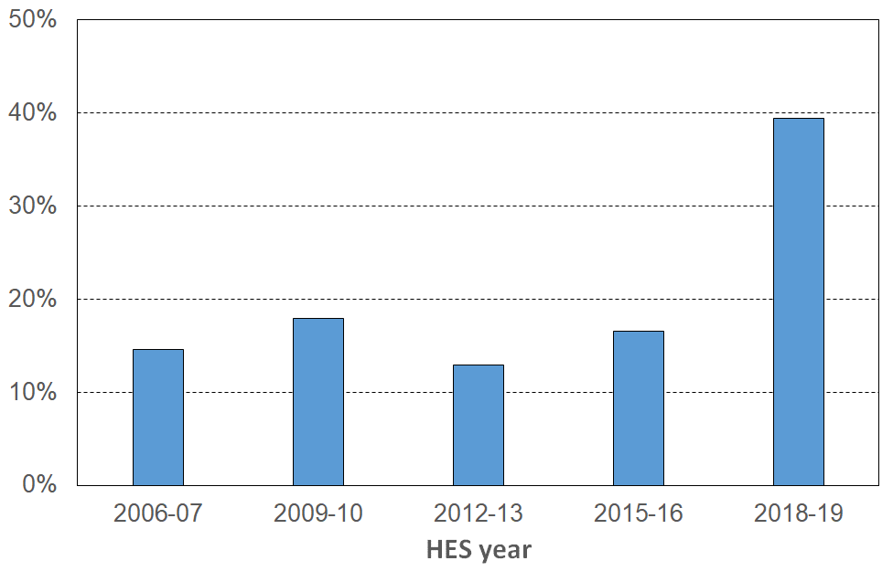
is much higher in HES 2018-19
The VLI group as a proportion of the whole population

When compared with the previous HES-TAWA data, the proportion of VLI households in the 2018-19 and 2019-20 HES-admin data sets is a much larger proportion (%) than for the previous HES-TAWA data. This is especially noticeable for households with children for whom the proportion has doubled. The difference is evident whether we count households with children or children, and is not greatly impacted by whether population weights are applied or not.

Figure O.6a
Proportion of households with very low incomes (unweighted data), HES 2018-19:
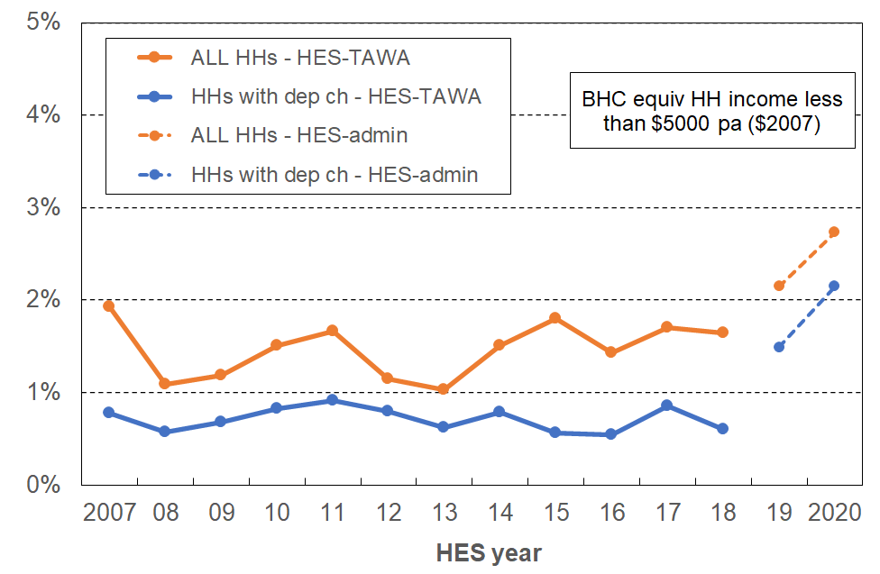
all households and households with children

Figure O.6b
Proportion of individuals in very low incomes (weighted data), HES 2018-19:
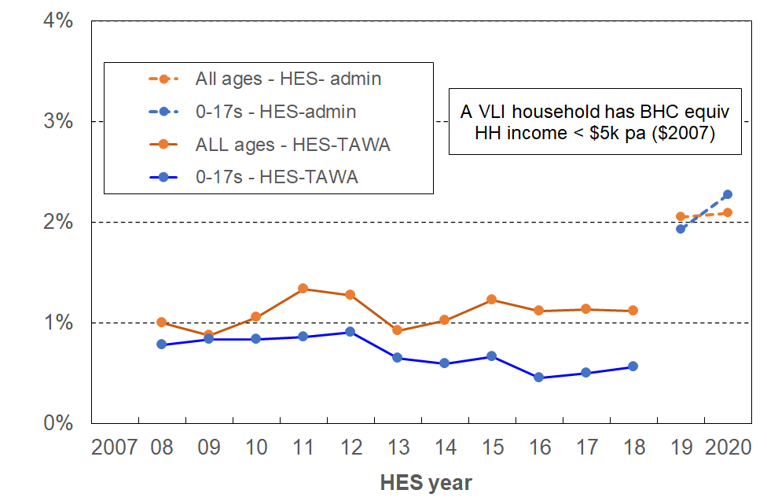
all ages and children
The VLI group as a proportion of those with incomes under the BHC 50 and AHC poverty thresholds

When compared with the previous HES-TAWA data, the proportion of all BHC 50 low-income households that are VLI is larger in the 2018-19 and 2019-20 HES-admin data is larger than for the previous HES-TAWA data (Figure O.7). For households with children this proportion has roughly doubled, from around 6% to around 12% on average over the two HES-admin datasets, using unweighted data. When counting children and using the weighted data, the proportion trebled from around 5% to around 15%. The difference is evident whether we count households with children or children, and is not greatly impacted by whether population weights are applied or not.

Figure O.7a
Proportion of VLI households compared with those below the BHC 50 low-income threshold
(unweighted data), HES 2018-19:
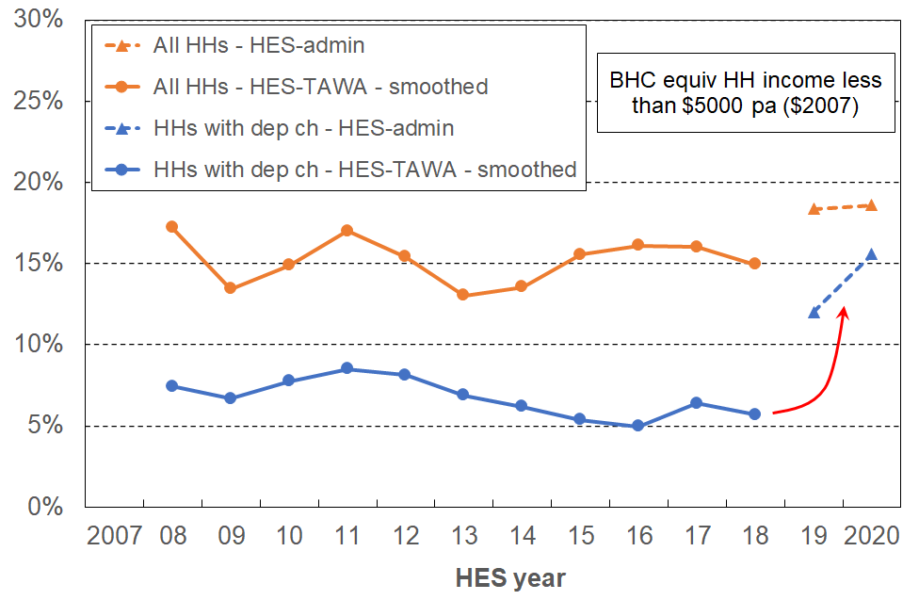
all households and households with children

Figure O.7b
Proportion of individuals in VLI households compared with all those below the BHC 50 low-income threshold (weighted data), HES 2018-19:
all ages and children
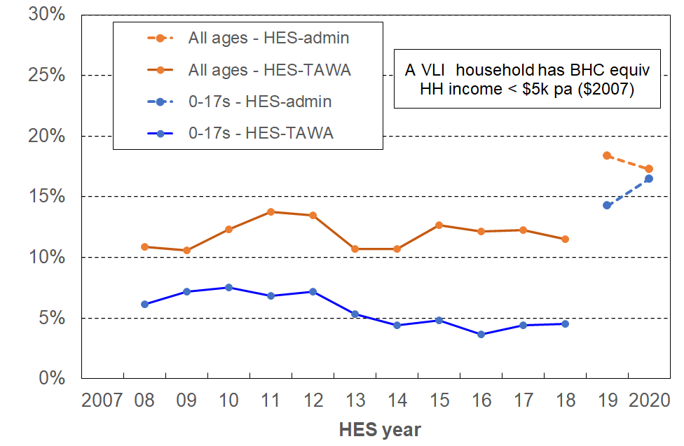

The bulk of these VLI households with children report very low material deprivation and have good to very good material wellbeing indicators. The increased proportion of households with dependent children under the BHC 50 low-income line whose material standard of living is too high for them to be plausibly identified as ‘poor’ raises questions about the credibility and validity of the numbers produced when using this measure as an indicator of poverty, or even as a proxy indicator of resources. The BHC 50 measure is a primary measure under the CPRA, meaning governments are required to set targets using this measure to provide accountability for child poverty reduction. As the BHC 50 child poverty rate declines for children, in line with the intent of the CPRA, its prima facie credibility and validity will be undermined if the VLI group stays around the same size as in 2018-19 and 2019-20 … and therefore increases as a proportion of the overall number of children identified as being in BHC 50 poverty in coming years. As BHC 50 child poverty numbers reduce, the ongoing presence of a sizeable VLI group will also in future years make it progressively more difficult to further reduce the overall numbers (in addition to the core income transfer challenges). Similar issues arise for the numbers produced by the AHC 40 and AHC 50 measures (whether fixed or moving line).

There is also a question about the BHC 50 child poverty rate itself as reported based on current HES-admin data. When the data is improved, what is likely to happen to the reported child poverty rate as a result of the improvements?

Assuming that most of the current VLI households with children end up with revised incomes below the median and above the BHC 50 threshold (which is where their material wellbeing rates suggest they may well be), then the reported BHC 50 child poverty rate is likely be lower by around one percentage points (or up to 2 percentage points if a less conservative treatment is used). If they end up distributed both above and below the median then the median will decrease and the reported BHC 50 child poverty rate will be lower, though by less.

For MSD’s time series based on HES-TAWA to 2017-18, and now moving to HES-admin, the earlier question remains – do we have to identify a new time series starting with 2018-19?

The implications of any data improvements for the level of the HES 2017-18 CPRA low income baseline figures (which use admin data for income), and on the shape of the Stats NZ BHC 50 time series back to HES 2006-07, is not predictable from first principles. It will require the analysis to be done.

The treatment used in this report to (partially) address the measurement implications of the larger VLI proportion for HES 2018-19 and 2019-20

MSD’s reports have applied various treatments in the past to seek to reduce the distortion for particular statistics such as decile shares and other income inequality measures, measures of poverty depth, measures of housing affordability using outgoing-to-income measures, and when examining the overlap between income and non-income measures of poverty (a major theme of this report). One involved using household spending to impute a more realistic income for the VLI households, and another simply deleted households with incomes under a selected very low level of a few thousand dollars per annum. The expenditure treatment is available only every third year (starting with 2006-07) so has limitations for time series, and the deletions based purely on income can open the analysis to the charge that it potentially eliminates from the dataset some households that are genuinely in poverty, thus under-estimating the level of need.

For this report a different approach is used:
- All VLI households whose DEP-17 score is zero or who self-rate their income as enough or more than enough are removed from the dataset.
- ‘Very low’ is defined (in equivalised dollars) as:
  - under $5000 pa ($2007) for BHC
(this is around $6200 pa in $2020 - $250 pw for a (2,2) household, and $175 pw for a (1,1) household, both being well below safety net incomes, and well below survival rates if income is the only financial resource (could not even pay for accommodation) (~15% of median)
  - under $3000 pa ($2007) for AHC.
(this is around $3600 pa in $2020 - $150 pw for a (2,2) household, and $90 pw for a (1,1) household), both being well below safety net incomes, and below survival rates if income is the only financial resource (~10% of median).

By using non-income indicators to identify those VLI households that have (at least) reasonably good material wellbeing / no hardship, it addresses a key weakness inherent in the set of treatments that simply delete VLI households based on their income alone – they can over-delete, taking out some VLI households that are genuinely in great need.

Table O.4a gives the numbers of households and individuals removed by the treatment for both BHC and AHC incomes. Table O.4b gives an idea of the size of the removals relative to the population as a whole and to the bottom deciles (BHC and AHC), and Table O.4c shows the size of the removals as a proportion (%) of the bottom income decile and of all those in the VLI category.

Table O.4a
Numbers of VLI households and individuals removed by the treatment,
HES 2018-19
 | BHC |  |  | AHC
 | Before | After | Removed | Before | After | Removed
All households | 48,000 | 14,000 | 34,000 | 99,000 | 36,000 | 63,000
Households with children | 11,000 | 3,000 | 8,000 | 28,000 | 12,000 | 17,000
All individuals | 99,000 | 28,000 | 71,000 | 229,000 | 86,000 | 144,000
Children (0-17 yrs) | 22,000 | 7,000 | 15,000 | 54,000 | 23,000 | 32,000

Table O.4b
Numbers of VLI households and individuals removed by the treatment,
compared with population and with bottom income deciles,
HES 2018-19
 | BHC |  |  | AHC
(numbers) | All | Bottom decile | Removed | Before | Bottom decile | Removed
All households | 1,755,000 | 175,500 | 34,000 | 1,755,000 | 175,500 | 63,000
Households with children | 604,000 | 48,500 | 8,000 | 604,000 | 50,000 | 17,000
All individuals | 4,855,000 | 485,500 | 71,000 | 4,855,000 | 485,500 | 144,000
Children (0-17 yrs) | 1,133,000 | 133,500 | 15,000 | 1,133,000 | 124,500 | 32,000
Note: For the whole population, whether households or individuals, the bottom income decile has 10% of the population numbers in it. For households with children, the numbers in the bottom decile are a little less than 10% and for children themselves the bottom decile has a little more than 10% of children in it. This suggests that VLI households with children have on average more than the average number of children.

Table O.4c
Proportion (%) of households and individuals removed by the treatment,
compared with bottom income deciles and with total VLI numbers,
HES 2018-19
 | BHC |  | AHC
(percentages) | VLI as % of bottom decile | Removed as % of VLI | VLI as % of bottom decile | Removed as % of VLI
All households | 19 | 71 | 36 | 63
Households with children | 16 | 71 | 33 | 59
All individuals | 15 | 72 | 30 | 63
Children (0-17 yrs) | 11 | 69 | 25 | 58

The main purpose of the treatment used in this report is to enable analysis which:
- gives a reasonably valid and plausible account of the overlap between households with low incomes and those in material hardship
- paints a reliable picture of what life is like for households with children living ‘below the line’
- produces housing affordability figures for low-income households (using outgoing-to-income ratios for renters and home-owners) that are not too distorted by VLI households.

This purpose is reasonably achieved with the current treatment, albeit only just in some cases as the treatment is in many ways a fairly conservative one. There is a case for using higher VLI thresholds, and MSD is investigating this option. There are households with incomes above the treatment thresholds but still in the ‘low-income’ range that also have DEP-17 scores of zero and an enough / more than enough self-rating of income adequacy. The question to be addressed is how much higher should the treatment go, if any higher at all

There is also a question also as to whether re-weighting should occur given the new (truncated) dataset. The treatment used in this report does not re-weight – it is likely that re-weighting would make only a small difference to the details of the analysis reported here.

The treatment applied should be considered interim and better than not doing it at all for the purposes of this report. MSD’s view is that it is not however adequate for CPRA purposes but is a contribution to the further work being done on that. Using a medical analogy, the current treatment dulls the pain to some degree, but not fully, and ideally a better understanding of the cause or causes of the pain should be established and addressed as well as possible, even if some relief of residual symptoms is still required.

Examples of the impact of the treatment

Figures O.8 to O.12 and Tables O.5 and O.6 show the impact of the treatment on selected analysis.

The tick chart reported in Figure O.1 for expenditure and MWI scores also shows up for income ventiles. Figure O.8 shows how the treatment impacts on BHC and AHC charts for HES 2018-19. The conservative nature of the treatment is evident.

Figure O.8
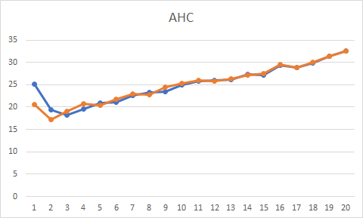
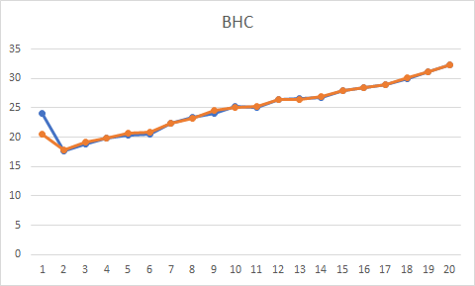
MWI scores for under 65s, BHC and AHC

Figure O.9
Self-rated income adequacy (enough / more than enough) and zero hardship score
by BHC income ventile, HES 2018-19

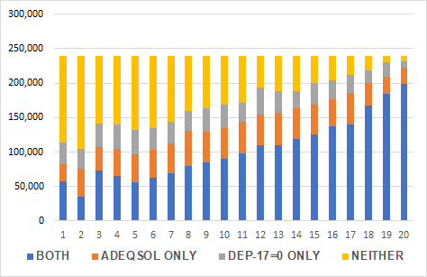
No treatment Treatment applied

Figure O.10
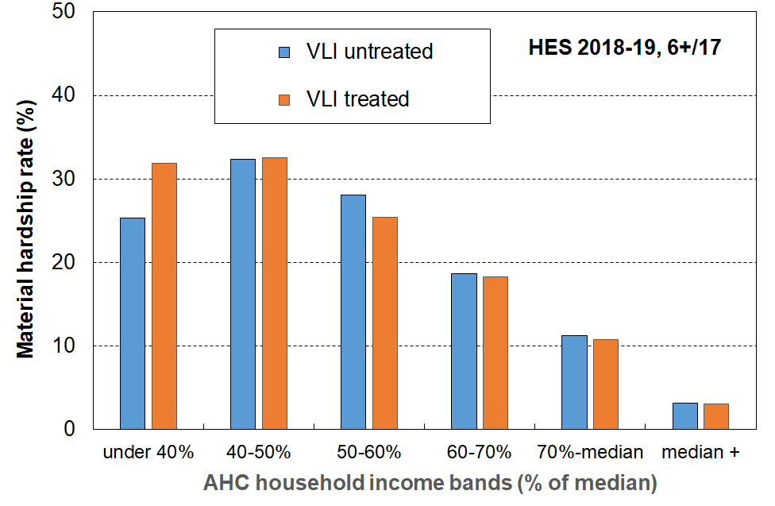
Material hardship rates (%) of children in selected AHC household income bands: untreated and treated, HES 2018-19

Figure O.11 shows how the incongruous decile one figures (top right chart) are made more credible by the treatment.

Figure O.11 (top two are from Figure C.5)
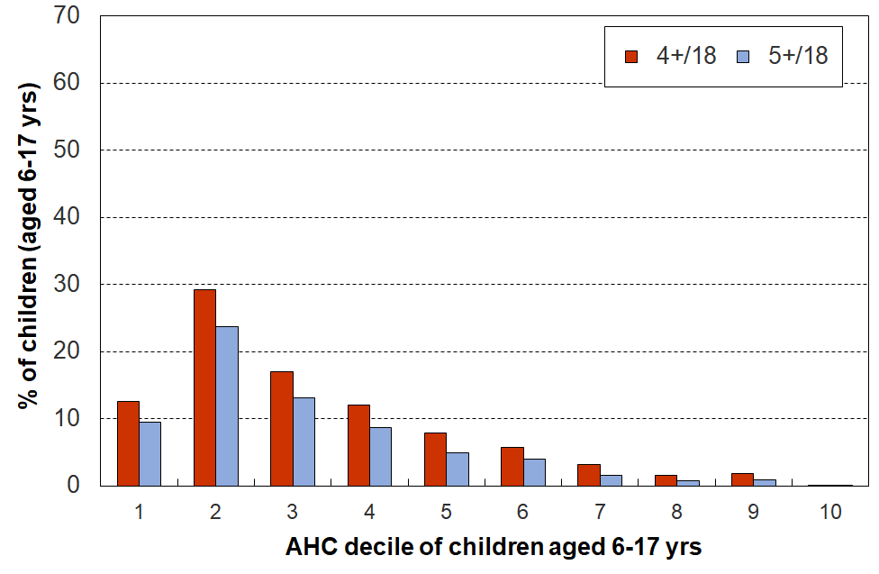
Multiple deprivation for children using 18 essential child-specific and general household items, HES 2018-19
Note for Figure C.5 :
- The average hardship rate for the lowest AHC decile is lower than for decile 2. This reflects a commonly-found feature of some of the very low-income households – their actual day-to-day living standards are much higher than their incomes would suggest. This situation can arise for several reasons, as discussed in Section O.

With treatment – not totally resolved but much better (albeit the treatment is conservative).

Housing Affordability (OTIs)

Without this report’s treatment being applied (ie just using MSD’s standard light-touch treatment for this statistic = ‘delete negatives and zeroes’), Figure O.12 (next page) shows that the reported OTIs for 2018-19 and 2019-20 are high relative to the previous trend line. Application of the treatment used in this report has a marked impact as shown. The pattern for OTIs GT 40% are similar. This is an important analysis for policy decisions, as if the blue dots do properly represent reality, it points to the unaffordability situation being even worse than previous information had suggested. Until the VLI matter is resolved, this report suggests that the untreated 2018-19 and 2019-20 figures should not be used for policy purposes.

Figure O.12
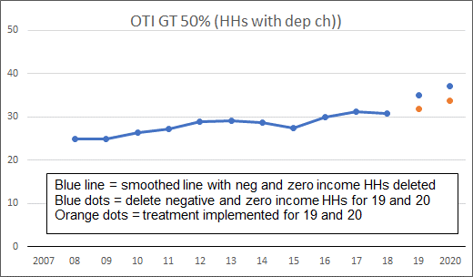
OTIs greater than 50% for households with dependent children

Table O.5
(compare with Table O.1 below, repeated here for convenience)
Selected characteristics of the very-low-income group (for all individuals in their households)
compared with other low-income and low-to-middle income households and the population overall
HES 2018-19 (%)
HES 2018-19 (with treatment) | <6k | 6k to 50% BHC | 50% BHC to 65% | 65% BHC to median | Total popln
% in each income group (individuals in their households) | <1 | 10 | 14 | 26 | 100
% in each income group (households) | <1 | 11 | 16 | 24 | 100
% of all individuals in households below the BHC50 low-income line who are in VLI households | 6 | n/a | n/a | n/a | n/a
DEP-17 = 6+/17 | 31 | 25 | 17 | 11 | 9
Used foodbanks (at least once in 12 months prior to interview) | 12 | 17 | 11 | 5 | 5
Income adequacy (enough or more than enough) | 0 | 37 | 44 | 53 | 62
DEP 17 = 0 | 0 | 30 | 39 | 43 | 53
Can pay unexpected unavoidable $1500 bill within a month without borrowing | 29 | 36 | 44 | 47 | 57
Median housing costs | $14,000 | $9,000 | $8,000 | $18,000 | $18,000
Notes: The income bands are based on the count of individuals in their households as is standard practice for low-income (poverty ) measurement. The analysis unit is also the individual. Using the household as the analysis unit makes very little difference to the numbers.
$5000 in 2007 was around $6000 in 2019 in $2007 terms – hence the $6k threshold for VLI households in Table O.1.
The <6k figure in row three (~6%) is calculated using the new median after the treatment is applied.
Because of the targeted deletions, the <6k column has even fewer in it than in the original Table O.1. The numbers should be taken as indicative only rather than as precise estimates. They all move in the right direction vis-à-vis those in Table O.1.

Table O.1
(repeated here for convenience)
Selected characteristics of the very-low-income group (for all individuals in their households)
compared with other low-income and low-to-middle income households and the population overall
HES 2018-19 (%)
HES 2018-19 (no treatment) | <6k | 6k to 50% BHC | 50% BHC to 65% | 65% BHC to median | Total popln
% in each income group (individuals in their households) | 2 | 9 | 13 | 26 | 100
% in each income group (households) | 3 | 10 | 16 | 23 | 100
% of all individuals in households below the BHC50 low-income line who are in VLI households | 18 | n/a | n/a | n/a | n/a
DEP-17 = 6+/17 | 10 | 25 | 17 | 11 | 9
Used foodbanks (at least once in 12 months prior to interview) | 4 | 17 | 11 | 5 | 5
Income adequacy (enough or more than enough) | 61 | 37 | 45 | 52 | 62
DEP 17 = 0 | 58 | 30 | 40 | 42 | 54
Can pay unexpected unavoidable $1500 bill within a month without borrowing | 67 | 35 | 45 | 47 | 57
Median housing costs | $16,000 | $9,000 | $8,000 | $18,000 | $18,000

Table O.6 (compare O.2 below)
Selected characteristics of the very-low-income group (for 0-17s in their households)
compared with other low-income and low-to-middle income households and the population overall
HES 2018-19 (%)
HES 2018-19 (with treatment) | <6k | 6k to 50% BHC | 50% BHC to 65% | 65% BHC to median | Total popln
% in each income group (0-17s in their households) | <1 | 12 | 14 | 33 | 100
% in each income group (households with 0-17s) | <1 | 10 | 12 | 32 | 100
% of all children (0-17 yrs) in households below the BHC50 low-income line who are in VLI households | 5 | n/a | n/a | n/a | n/a
DEP-17 = 6+/17 | 41 | 33 | 29 | 12 | 13
Used foodbanks (at least once in 12 months prior to interview) | 16 | 26 | 19 | 6 | 8
Income adequacy (enough or more than enough) | 0 | 31 | 35 | 49 | 56
DEP 17 = 0 | 0 | 20 | 23 | 38 | 46
Can pay unexpected unavoidable $1500 bill within a month without borrowing | 49 | 26 | 24 | 27 | 41
Median housing costs | $19,000 | $14,000 | $17,000 | $21,000 | $23,000
Notes: As per Table O.4.

Table O.2
(repeated here for convenience)
Selected characteristics of the very-low-income group (for 0-17s in their households)
compared with other low-income and low-to-middle income households and the population overall
HES 2018-19 (%)
HES 2018-19 (no treatment) | <6k | 6k to 50% BHC | 50% BHC to 65% | 65% BHC to median | Total popln
% in each income group (0-17s in their households) | 2 | 12 | 13 | 32 | 100
% in each income group (households with 0-17s) | 2 | 10 | 11 | 31 | 100
% of all children (0-17 yrs) in households below the BHC50 low-income line who are in VLI households | 14 | n/a | n/a | n/a | n/a
DEP-17 = 6+/17 | 13 | 33 | 28 | 13 | 13
Used foodbanks (at least once in 12 months prior to interview) | 5 | 26 | 19 | 6 | 8
Income adequacy (enough or more than enough) | 56 | 31 | 36 | 48 | 57
DEP 17 = 0 | 56 | 20 | 24 | 37 | 46
Can pay unexpected unavoidable $1500 bill within a month without borrowing | 66 | 24 | 28 | 40 | 50
Median housing costs | $22,000 | $14,000 | $17,000 | $21,000 | $21,000
Notes: As per Table O.1.

The implications of this report’s treatment decision for reporting child poverty rates (BHC 50 and AHC 50)

Table O.7 reports the impact on reported child poverty rates of a selection of treatments (BHC 50). Other age-groups are included for comparison of impact.

The treatment in column #2 is the one described above and used in this report. Treatments #3 and #4 are variations on the deletion theme, with #3 being the same as #2 except that the median is held fixed. As discussed above, Treatment #2 is not open to the common criticism of a deletion approach that it might have removed households that are in genuine need. It is in fact very conservative and could be questioned on that ground. Treatment #4 (delete bottom 2%) is likely to be seen as too blunt to be useful for child poverty measurement but is useful for illustrative purposes here.

The main alternative to deletion as a treatment approach is to impute. As a part of the investigation into possible treatments MSD increased the equivalised disposable income of the VLI households by $25,000, taking their incomes above the BHC 60 poverty line but below the median – this is the region on the income distribution where the analysis reported in Figure O.1 indicated that there were similarities with the VLI households average expenditure and material wellbeing scores. This approach does not change the median, so the change in reported poverty rates a rises solely from the reshuffling upwards of the (initially-)VLI households who also report good material wellbeing. It too is included here for illustrative purposes only.

Table O.7
BHC 50 low-income rates by age-group (%), using different treatments to address the issue of
very-low-income households with good to very good material wellbeing
HES 2018-19
 | 1  (no treatment) | 2  (delete using MSD treatment and recalculate median) | 3  (delete using MSD treatment and hold median the same) | 4  (delete bottom 2% and let median increase) | 5  (create modified dataset through imputation which leaves median unchanged)
0-17 yrs | 13.5 | 12.7 | 12.4 | 12.5 | 12.2
18-24 | 11.3 | 10.7 | 10.5 | 10.6 | 10.4
25-44 | 8.8 | 7.8 | 7.6 | 7.6 | 7.5
45-64 | 12.4 | 11.1 | 10.8 | 10.8 | 10.7
65+ | 9.6 | 8.7 | 8.1 | 8.5 | 8.0
ALL | 11.2 | 10.2 | 9.9 | 10.0 | 9.7
Treatment descriptions for Table O.7:
- No treatment (negatives are re-set to zero, but this has no impact on low-income rates).
- Removes all with BHC incomes below $5000 (in $2007) who report enough/more than enough for income adequacy or who have a DEP-17score of zero. Median is recalculated after deletions are made (median increases a little), and the new BHC 50 threshold is applied. This is the main treatment approach used in this report. No re-weighting.
- As in #2, except that the median and therefore the BHC 50 threshold are held the same as in #1. No re-weighting.
- All households with incomes in the lower 2 percent of the BHC distribution are deleted. No re-weighting. This is a more severe and blunter version of #2 (the main treatment approach in this report). No re-weighting.
- This is the imputation approach described in the text above the table..

Table O.8 reports the impact of a selection of treatments on reported child poverty rates (AHC 50). Other age-groups are included for comparison of impact.

The treatment in column #2 is the one described above and used in this report. Treatments #3 and #4 are variations on the deletion theme, with #3 being the same as #2 except that the median is held fixed. As discussed above, Treatment #2 is not open to the common criticism of a deletion approach that it might have removed households that are in genuine need. It is in fact very conservative and could be questioned on that ground. Treatment #4 (delete bottom 2%) is likely to be seen as too blunt to be useful for child poverty measurement but is useful for illustrative purposes here.

The main alternative to deletion as a treatment approach is to impute. As a part of the investigation into possible treatments MSD increased the BHC equivalised disposable income of the BHC VLI households by $25,000, taking their incomes above the BHC 60 poverty line but below the median – this is the region on the income distribution where the analysis reported in Figure O.1 indicated that there were similarities with the VLI households average expenditure and material wellbeing scores. Of all the reported treatments this one gave the largest reported decrease in BHC 50 child poverty rates (and population rates), but the impact is more muted for AHC 50. This is likely to reflect the fact that very low AHC incomes can arise because of either very low BHC incomes or when reported housing costs are disproportionately high relative to reported BHC income, or both. It too is included here for illustrative purposes only.

Table O.8
AHC 50 low-income rates by age-group (%), using different treatments to address the issue of
very-low-income households with good to very good material wellbeing
HES 2018-19
 | 1  (no treatment) | 2  (delete using MSD treatment and recalculate median) | 3  (delete using MSD treatment and hold median the same) | 4  (delete bottom 2% and let median increase) | 5  (create modified dataset through imputation which leaves median unchanged)
0-17 yrs | 20.1 | 18.8 | 17.9 | 19.0 | 18.8
18-24 | 18.2 | 15.4 | 14.9 | 16.1 | 17.3
25-44 | 14.6 | 12.7 | 12.2 | 13.0 | 13.2
45-64 | 16.4 | 14.1 | 13.7 | 14.5 | 14.6
65+ | 14.1 | 12.9 | 12.1 | 13.6 | 12.5
ALL | 16.6 | 14.7 | 14.1 | 15.1 | 15.2
Treatment descriptions for Table O.8:
- No treatment (negatives are re-set to zero, but this has no impact on low-income rates).
- Removes all with AHC incomes below $3500 (in $2007) who report enough/more than enough for income adequacy or who have a DEP-17score of zero. Median is recalculated after deletions are made (median increases a little), and the new AHC 50 threshold is applied. This is the main treatment approach used in this report. No re-weighting.
- As in #2, except that the median and therefore the AHC 50 threshold are held the same as in #1. No re-weighting.
- All households with incomes in the lower 2 percent of the AHC distribution are deleted. No re-weighting. This is a more severe and blunter version of #2 (the main treatment approach in this report). No re-weighting.
- This is the imputation approach described in the text above the table.

Figure O.13 shows the impact on the BHC 50 HES-TAWA / HES-admin time series of the report’s treatment decision. There is almost no impact for the HES-TAWA component (2012-13 to 2017-18), but a clear lower rate for HES-admin. This is consistent with the observation that the proportion of VLI households is higher in HES-admin (2018-19 and 2019-20) than in recent HES-TAWA years.

Figure O.13
Impact on BHC 50 low-income rates for children (0-17 years)
of the treatment used in this report to address the issue of very-low-income households who have good to very good material wellbeing
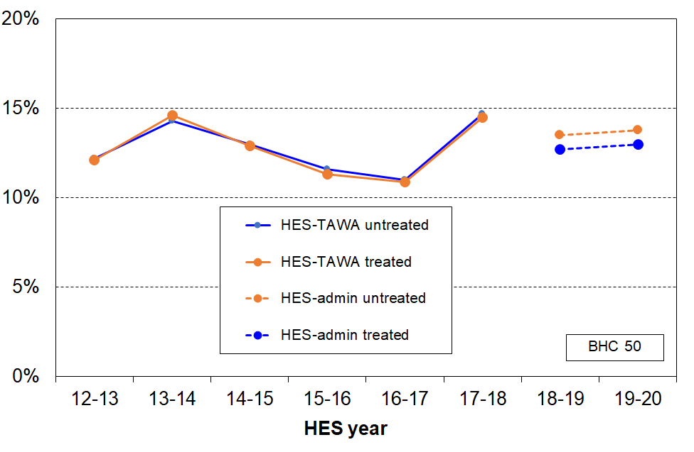
HES 2012-13 to 2019-20
Notes: The time series can only start from 2012-13, as the treatment uses HES data only available from 2012-13 on (DEP-17 was not available earlier).
The Stats NZ BHC time series that is used for the purposes of the CPRA is a bespoke one for that purpose and generally gives numbers a little higher than the HES-TAWA data does (up to 2017-18).

References

Atkinson, A. B., Cantillon, B., Marlier, E., & Nolan, B. (2002). Social Indicators: The EU and Social Inclusion. Oxford: Oxford University Press.
Auckland City Mission (2014a). ‘Speaking for Ourselves: The Truth about what keeps people in poverty from those who live it.’ Summary of findings from the Family 100 project. Auckland City Mission.
Auckland City Mission (2014b). ‘Demonstrating the complexities of being poor’. An empathy tool for the Family 100 project. Auckland City Mission.
Both the above are available at https://www.aucklandcitymission.org.nz/latest-news/resources/
Berthoud, R. and Bryan, M. (2011). Income, deprivation and poverty: a longitudinal analysis. Journal of Social Policy, 40(01), 135-156.
Bradshaw, J., & Finch, N. (2003). ‘Overlaps in Dimensions of Poverty’. Journal of Social Policy (32), 513-525.
Brewer, M., Etheridge, B. & O’Dea C. (2017). ‘Why are Households that Report the Lowest Incomes So Well‐off?’, Economic Journal, Royal Economic Society, vol. 127(605), pages 24-49, October.
Carter, K., Mok, P. & Le, T (2014). ‘Income Mobility in New Zealand: A Descriptive Analysis’. New Zealand Treasury Working Paper 14/15.
Carter, K. & Imlach Gunasekara, F. (2012). ‘Dynamics of Income and Deprivation in New Zealand, 2002-2009. A descriptive analysis of the Survey of Family, Income and Employment (SoFIE).’ Public Health Monograph Series No. 24. Wellington: Department of Public health, University of Otago, Wellington.
Davidson, P., Saunders, P., Bradbury, B. & Wong, M. (2020), ‘Poverty in Australia 2020: Part 1, Overview’. ACOSS/UNSW Poverty and Inequality Partnership Report No. 3, Sydney: ACOSS.
de Neubourg, C., Bradshaw J., Chzhen, Y., Main, G., Martorano, B. & and Menchini, L. (2012). ‘Child deprivation, multidimensional poverty and monetary poverty in Europe’. Innocenti Working Paper 2012-02, UNICEF Innocenti Research Centre, Florence.
Dickes, P., Fusco, A., & Marlier, E. (2010), 'Structure of national perceptions of social needs across EU countries', Social Indicators Research, 95(1), 143-167.
Fahey, T. (2007), ‘The case for an EU-wide measure of poverty’, European Sociological Review, 23(1), 35-47
Fusco, A., Marlier, E., & Guio, A.-C. (2010) Income poverty and material deprivation in European countries. Eurostat Methodologies and Working Papers, OPOCE: Luxembourg.
Fusco, A. Guio, A.-C. & Marlier, E. (2011). Characterising the income poor and the materially deprived in European countries. In: Atkinson A.B. and Marlier E. (eds.), Income and living conditions in Europe, Publications Office of the European Union, Luxembourg, pp.132-153.
Fusco (2015). ‘The relationship between income and housing deprivation: A longitudinal analysis.’ Economic Modelling 49 (2015) 137–143.
Goedemé, T. & Rottiers, S. (2011). ‘Poverty in the Enlarged European Union: A Discussion about Definitions and Reference Groups.’ Herman Deleeck Centre for Social Policy, University of Antwerp.
Goedemé, T. et al (2019). ‘What Does It Mean to Live on the Poverty Threshold? Lessons From Reference Budgets.’ Chapter 1 in Cantillon, B., Goedemé, T. and Hills, J. (2019), Decent incomes for all: Improving poverty reduction in Europe, Oxford: Oxford University Press.
Guio, A.-C., Gordon, D., & Marlier, E.(2012). ‘Measuring material deprivation in the EU: Indicators for the whole population and child-specific indicators’, Eurostat Methodologies and Working Papers, OPOCE: Luxembourg.
Guio, A.-C., Gordon, D., & Marlier, E.(2017a). ‘Measuring child material deprivation in the EU’, Chapter 11 in Atkinson, Guio and Marlier (Eds) ‘Monitoring Social Inclusion in Europe’. Luxembourg: Eurostat.
Guio, A.-C., Gordon, D., Najera, H. & Pomati, M. (2017b). ‘Revising the EU material deprivation variables (analysis of the final 2014 EU-SILC data)’, Eurostat Methodologies and Working Papers, Luxembourg: Publications Office of the European Union.
Guio, A.-C., Marlier, E. & Pomati, M. (2017c). ‘Evolution of material deprivation over time’, Chapter 20 in Atkinson, Guio and Marlier (Eds) ‘Monitoring Social Inclusion in Europe’. Luxembourg: Eurostat.
Guio, A.-C., Gordon, D., Marlier, E., Naiera, H. & Pomati, M. (2018). ‘Towards an EU measure of child deprivation’, Child Indicators Research 11: 835-860.
Guio, A.-C., Marlier, E., Vandenbrouke, F. & Verbunt, P. (2020). ‘Micro-and macro-drivers of child deprivation in 31 European countries’, Eurostat Statistical Working Papers, Luxembourg: Publications Office of the European Union.

Halleröd, B. (2006). ‘Sour Grapes: Relative Deprivation, Adaptive Preferences and the Measurement of Poverty’. Journal of Social Policy 35 (03):371-390.

Jäntti, M., Törmälehto, V., & Marlier, E. (2013). The use of registers in the context of EU-SILC: challenges and opportunities. Publications Office of the European Union.

Jenkins, S. & Van Kerm (2014). ‘The Relationship Between EU Indicators of Persistent and Current Poverty’, Social Indicators Research Vol 116(2): 611-638.
“The current poverty rate and the persistent poverty rate are both included in the European Union’s (EU's) portfolio of primary indicators of social inclusion. We show that there is a near-linear relationship between these two indicators across EU countries drawing on empirical analysis of EU-SILC and ECHP data. Using a prototypical model of poverty dynamics, we explain how the near-linear relationship arises and show how the model can be used to predict persistent poverty rates from current poverty information. In the light of the results, we discuss whether the EU's persistent poverty measure and the design of EU-SILC longitudinal data collection require modification.”
Jenkins, S. (2018). ‘Perspectives on Poverty in Europe’. IZA Discussion Paper No. 12014.
Kyzyma, I. (2020) ‘How poor are the poor? Looking beyond the binary measure of income poverty.’ Journal of Economic Inequality 18:525–549
Lister, R. (2004), Poverty, Cambridge: Polity Press.
Lohmann, H, (2011). ‘Comparability of EU-SILC survey and register data: The relationship among employment, earnings and poverty’. Journal of European Social Policy Vol. 21(1): 37–54.
McNeil, C. & Parkes, H. (2021) ‘No longer managing:The rise of working poverty and fixing Britain's broken social settlement’, IPPR. http://www.ippr.org/research/publications/no-longer-managing
Morton, S. et al (2020). Growing Up in New Zealand: A longitudinal study of New Zealand children and their families. Now We Are Eight. Auckland: Growing Up in New Zealand.
Nolan, B., & Whelan, C. T. (1996), Resources, Deprivation and Poverty, Oxford: Clarendon Press.
Nolan, B., & Whelan, C. T. (2011), Poverty and Deprivation in Europe, Oxford: Oxford University Press.
Notten, G. (2015). ‘Child Poverty in Ontario: The Value Added of Material Deprivation Indicators for Comparative Policy Analysis in North America.’ Journal of Comparative Policy Analysis: Research and Practice (17:5): 533-551.
Notten, G., Charest, J. & Heisz,, A. (2017). ‘Material Deprivation in Canada.’ Working Paper 1715E, Department of Economics, University of Ottawa.
Office of the Children’s Commissioner and Oranga Tamariki (2019), ‘What makes a good life? Children and young people’s views on wellbeing’. Wellington: Office of the Children’s Commissioner.
Penne, T., Cussó Parcerisas, I., Mäkinen, L., Storms, B., Goedemé, T. (2016), ‘Can reference budgets be used as a poverty line’, ImPRovE Working Paper N°16/05. Antwerp: Herman Deleeck Centre for Social Policy – University of Antwerp.
Perry, B. (2015). ‘Measuring and monitoring material hardship for New Zealand children: MSD research and analysis used in advice for the Budget 2015 child hardship package’. Unpublished report. Wellington: Ministry of Social Development. (Available from author.)
Perry, B. (2018). Household Incomes in New Zealand: Trends in Indicators of Inequality and Hardship, 1982 to 2017. Wellington: Ministry of Social Development.
Perry, B. (2019a). ‘Material hardship measures for the Child Poverty Reduction Act (2018)’. MSD Working Paper 01/19, available at: https://www.msd.govt.nz/about-msd-and-our-work/publications-resources/working-papers/index.html#WorkingPapers20191
Perry, B. (2019b). ‘Stats NZ Child Poverty Statistics release, 2 April 2019: MSD Background and Overview’. MSD Working Paper 02/19, available at: https://www.msd.govt.nz/about-msd-and-our-work/publications-resources/working-papers/index.html#WorkingPapers20191
Perry, B. (2019c). Household Incomes in New Zealand: Trends in Indicators of Inequality and Hardship, 1982 to 2018. Wellington: Ministry of Social Development.
Perry, B. (2019d). The Material Wellbeing of New Zealand Households: Trends and Relativities using Non-income Measures, with International Comparisons. Wellington: Ministry of Social Development.
Perry, B. (2021a, forthcoming). Household Incomes in New Zealand: Trends in Indicators of Inequality and Hardship, 1982 to 2020. Wellington: Ministry of Social Development.
Perry, B. (2021b, forthcoming). The Material Wellbeing of New Zealand Households: Trends and Relativities using Non-income Measures, with International Comparisons. Wellington: Ministry of Social Development.
Rea, D., Anastasiadis, S., Benny, V., Chokkanathapuram, A., Lee, W., Smith, C., and Vandenbroucke, B. (2019). ‘Measuring the living standards of people receiving income-tested main benefits.’ Working paper, Wellington: Social Investment Agency and Ministry of Social Development.
Ringen, S. (1988). ‘Direct and indirect measures of poverty’, Journal of Social Policy, 17(3):351- 365
Ringen, S. (2009). ‘Poverty – The Rowntree Project Revisited’, paper delivered at the Kennedy School of Government, Harvard University, 1 June 2009.
Saunders, P., Wong, M., Bradbury, B. (2016). ‘Poverty in Australia since the financial crisis: the role of housing costs, income growth and unemployment.’ Journal of Poverty and Social Justice 24(2): 97–112.
Serafino, P. & Tonkin, R. (2017). ‘Comparing poverty estimates using income, expenditure and material deprivation, Chapter 13 in Atkinson, Guio and Marlier (Eds) ‘Monitoring Social Inclusion in Europe’. Luxembourg: Eurostat.
Sheehy-Skeffington, J & Rea, J. (2017), ‘How poverty affects peoples decision-making processes.’ London: Joseph Rowntree Foundation.
Statistics New Zealand (2019). ‘Measuring child poverty: Material hardship’. Available from https://www.stats.govt.nz/methods/measuring-child-poverty-material-hardship
Stephens, R. & Waldegrave C (2001) ‘The effectiveness of the transfer and tax system in reducing poverty in 1998’, Social Policy Journal of New Zealand, Issue 16.
Stephens, R., Waldegrave, C., & Frater, P. (1995), 'Measuring poverty in New Zealand', Social Policy Journal of New Zealand, (5), 88-112.
Tomlinson, M. & Walker, R. (2009), ‘Coping with Complexity: Child and Adult Poverty.’ London: Child Poverty Action Group.
Townsend, P.(1979) ‘Poverty in the United Kingdom’, Harmondsworth, PenguinBooks Ltd.
Van Kerm, P. (2007). ‘Extreme incomes and the estimation of poverty and inequality indicators from EU-SILC’. In: Comparative EU statistics on income and living conditions: Issues and challenges. Proceedings of the EU-SILC conference (Helsinki, 6-8 November 2006). Office for Official Publications of the European Communities, Luxembourg.
Verbunt, P. & Guio, A-C. (2019). ‘Explaining Differences Within and Between Countries in the Risk of Income Poverty and Severe Material Deprivation: Comparing Single and Multilevel Analyses.’ Social Indicators Research,144: 827-868.
Welfare Expert Advisory Group Secretariat (2019), ‘Example Families and Budgets: Investigating the Adequacy of Incomes (Background Paper for the WEAG).’ Wellington: Welfare Expert Advisory Group
Waldegrave, C., Stephens, R., & King, P. (2003), 'Assessing the progress on poverty reduction', Social Policy Journal of New Zealand, (23), 197-222.
Waldegrave, C., Stuart, S., & Stephens, R. (1996), 'Participation in poverty research: drawing on the knowledge of low-income householders to establish an appropriate measure for monitoring social policy impacts', Social Policy Journal of New Zealand, (7), 191-206.

Appendices

Appendix 1 Indices and HES items

Appendix 2 List of HES child-specific hardship items, with endorsement rates.

Appendix 3 Low-income thresholds (income poverty lines)

Appendix 1 – indices and HES items including child-specific material deprivation items
Composition of indices (DEP-17, EU-13, MWI) and list of child specific items

Table 1.1
Composition of DEP-17
Enforced lack of essentials (for respondent or household as a whole)
meal with meat, fish or chicken (or vegetarian equivalent) at least each 2nd day
two pairs of shoes in good repair and suitable for everyday use
suitable clothes for important or special occasions
presents for family and friends on special occasions
home contents insurance
Economised, cut back or delayed purchases ‘a lot’ because money was needed for other essentials (not just to be thrifty or to save for a trip or other non-essential)
went without or cut back on fresh fruit and vegetables
bought cheaper cuts of meat or bought less than wanted
put up with feeling cold to save on heating costs
postponed visits to the doctor
postponed visits to the dentist
did without or cut back on trips to the shops or other local places
delayed repairing or replacing broken or damaged appliances
In arrears more than once in last 12 months (because of shortage of cash at the time, not through forgetting)
rates, electricity, water
vehicle registration, insurance or warrant of fitness
Financial stress and vulnerability
borrowed money from family or friends more than once in the last 12 months to cover everyday living costs
feel ‘very limited’ by the money available when thinking about purchase of clothes or shoes for self (options were: not at all, a little, quite limited, and very limited)
could not pay an unexpected and unavoidable bill of $500 within a month without borrowing
Note: an enforced lack is an item that is wanted but not possessed because of the cost.

Table 1.2
Composition of EU-13
Seven household deprivations (enforced lacks)
ability to face unexpected expenses of NZD1500
have one week’s annual holiday away from home
avoid arrears in mortgage or rent, utility bills or HP instalments
have a meal with meat, fish or chicken every second day
keep the home adequately warm
have access to a car / van for personal use
replace worn-out furniture
Six personal deprivations (enforced lacks)
replace worn-out clothes by some new ones
have two pairs of properly fitting shoes
spend a small amount of money each week on oneself
have regular leisure activities
have a get together with friends/family for a drink/meal at least monthly
have both a computer and an internet connection

Table 1.3
The 37 items in HES 2018-19 and 2019-20, and how the relevant items are scored for the three indices (MWI, DEP-17 and EU-13)
Item description |  | MWI | DEP-17 | EU-13
Ownership or participation (have/do, don’t have/do and enforced lack (EL))
For DEP-17 and EU-13, score an EL as 1, otherwise 0
For MWI, score an EL as a 0, otherwise 1
1 | Two pairs of shoes in a good condition and suitable for daily activities
2** | Replace worn-out clothes by some new (not second-hand) ones |  | -
3 | Suitable clothes for important or special occasions |  |  | -
4 | Contents insurance |  |  | -
5 | A meal with meat, fish or chicken (or vegetarian equivalent) at least each 2nd day
6 | A good bed |  | - | -
7** | Keep home adequately warm | - | -
8 | Presents for family/friends on special occasions |  |  | -
9 | Holiday away from home at least once every year |  | -
10 | Overseas holiday at least once every three years |  | -
11* | Access to car or van for personal use | - | -
12* | Access to both a computer and internet connection at home | - | -
13* | Have a get together with friends or extended family for a drink or meal at least once a month | - | -
Economising (not at all, a little, a lot) – to keep down costs to help in paying for (other) basic items (not just to be thrifty or to save for a trip or other non-essential)
For DEP-17 and EU-13, score ‘a lot’ as 1, otherwise 0
For MWI, score ‘not at all as 2, ‘a little’ as 1, and ‘a lot’ as 0
14 | Gone without or cut back on fresh fruit and vegetables |  |  | -
15 | Buy cheaper cuts of meat or bought less meat than you would like |  |  | -
 | Continued wearing worn out clothes (to 2018 only) |  | - | -
16 | Put up with feeling cold |  |  | -
17 | Do without or cut back on trips to the shops or other local places |  |  | -
18 | Delay replacing or repairing broken or damaged appliances |  |  | -
19* | Delay replacing or repairing broken or worn out furniture | - | -
20 | Spent less on hobbies or other special interests than you would like |  | -
21 | Postponed visits to the doctor |  |  | -
22 | Postponed visits to the dentist |  |  | -
Housing problems (no problem, minor problem, major problem … in the last 12 months)
For MWI, score as 2, 1 and 0 respectively.
23 | Dampness or mould |  | - | -
24 | Heating or keeping it warm in winter |  | - | -
 | Crowding (derived variable = Canadian Index) | - | - | -
Freedoms/Restrictions
25 | About how much money, on average, do you have each week for spending on things for yourself without consulting anyone else? (under $10, 10-25, 26-50, >50)  For EU-13, score ‘under$10’ as 1, and anything else as 0 | - | -
26 | When buying, or thinking about buying, clothes or shoes for yourself, how much do you usually feel limited by the money available? (4 point response options: ‘not at all limited, a little limited, quite limited, very limited)  For DEP-17, score ‘very limited’ as 1, otherwise 0.  For MWI, score as 3, 2, 1 and 0 respectively. |  |  | -
27 | $300 spot purchase for an ’extra’, not a necessity – how limited do you feel about buying it? (5 point response options: not at all limited, a little limited, quite limited, very limited, couldn’t buy it)  For MWI, score as 4, 3, 2, 1 and 0 respectively. |  | - | -
28 | $500 unexpected unavoidable expense on an essential – can you pay in a month without borrowing? (yes/no)  For DEP-17, score ‘no’ as 1, and ‘yes’ as 0  For MWI, score ‘yes’ as 2 and ‘no’ as 0 |  |  | -
29* | $1500 unexpected unavoidable expense on an essential – can you pay in a month without borrowing? (yes/no)  For EU-13, score ‘no’ as 1, and ‘yes’ as 0 | - | -

Item description |  | MWI | DEP-17 | EU-13
Financial strain (in last 12 months) (not at all, once, more than once)
For DEP-17 and EU-13, score ‘more than once’ as 1, otherwise 0
For MWI, score ‘not at all’ as 2, ‘once’ as 1, ‘more than once’ as 0
30 | Behind on rates or utilities |  |  | (any one, more than once)
31** | Behind on HP and other loan payments
32 | Behind on rent or mortgage | - | -
33 | Behind on car registration, wof or insurance |  |  | -
34 | Borrowed from family or friends to meet everyday living costs | - |  | -
35 | Received help in the form of food, clothes or money from a welfare or community organisation such as a church or food bank | - | - | -
Global self-ratings
36 | Adequacy of income to cover basics of accommodation, food, clothing, etc (not enough, only just enough, enough, more than enough) | - | - | -
37 | Satisfaction with life (very satisfied, satisfied, neither, dissatisfied, very dissatisfied) | - | - | -
* introduced in 2018 HES
** introduced in 2019 HES
No asterisk = available from 2013

Table 1.4
The 20 child-specific items in the 2018-19 HES
Have/do, don’t have/do for each of your children (Respondents are asked whether any have/do lacks are because of cost or for some other reason.)
two pairs of shoes in a good condition that are suitable for daily activities
two sets of warm winter clothes
waterproof coat
all the uniform required by their schools
a separate bed
fresh fruit and vegetables daily
a meal with meat, fish or chicken (or vegetarian equivalent) each day
a range of books at home suitable for their ages
a suitable place at home to do school homework
their friends around to play and eat from time to time
their friends around for a birthday party
good access at home to a computer and the internet for homework
a mobile phone if aged 11 or older
Economising (not at all, a little, a lot) – to keep down costs to help in paying for (other) basic items (not just to be thrifty or to save for a trip or other non-essential). In this report, economising ‘a lot’ is taken as equivalent to an enforced lack.
postponed a child's visit to the doctor
postponed a child's visit to the dentist
did not pick up a child's prescription
been unable to pay for a child to go on a school trip or other school event
had to limit children’s involvement in sport
had your children go without music, dance, kapa haka, art, swimming or other special interest lessons
had your children continue wearing shoes or clothes that were worn out or the wrong size
Note: None of these items are included in DEP-17 or EU-13 which are general purpose indices that are deigned to apply to all ages and household types and so on.
See Appendix 2 for more detail.

Table 1.5
EU’s Child Material and Social Deprivation Index

The list of items for the measurement of child deprivation consists of 12 ‘children’ and 5 ‘household’ items, which cover both material and social aspects of deprivation:

Children items:
1. Some new (not second-hand) clothes
2. Two pairs of properly fitting shoes
3. Fresh fruit and vegetables daily
4. Meat, chicken, fish or vegetarian equivalent daily
5. Books at home suitable for the children’s age
6. Outdoor leisure equipment
7. Indoor games
8. Regular leisure activities
9. Celebrations on special occasions
10. Invitation of friends to play and eat from time to time
11. Participation in school trips and school events
12. Holiday

Household items:
13. Replace worn-out furniture
14. Arrears
15. Access to Internet
16. Home adequately warm
17. Access to a car for private use

We can almost replicate the index for New Zealand – we do not have items 6, 7 and 8.

Appendix 2

Child specific items in 2018-19 and 2019-20

The 2018-19 and 2019-20 HES gathered information on twenty child-specific items that cover a wide range of possessions and activities that most would agree every child should have and none should be deprived of in New Zealand today. These are listed in Table 2.1 below. A more detailed version is provided in Table 2.2 including whether the reason for not having an item is because of cost or some other reason.

These child-specific indicators are not suitable for use in indices such as DEP-17 or the MWI as they do not meet two of the key criteria for such measures – they are not suitable for all ages, and do not represent a good range of severity of hardship, only deeper hardship for most of the indicators. They do, however, provide valuable information on the realities of daily life for those children identified as being ‘in hardship’ by the DEP-17 or MWI index score of their household, or as being in low-income households. They can be used on their own, or combined with information on more general household conditions that are child-relevant.

Table 2.1
Child-specific items:
the % of age 6-17s without the item or who are very restricted in the specified activity,
as reported by household respondent (HES 18/19 and 19/20)
Don't have (for any reason): |  | 18/19 | 19/20 | Table D.3 abbreviation
 | Two pairs of shoes in a good condition and suitable for daily activities | 7 | 5 | Shoes
 | Two sets of warm winter clothes | 2 | 1 | -
 | Waterproof coat | 9 | 6 | -
 | A separate bed | 5 | 4 | -
 | Fresh fruit and vegetables daily | 7 | 5 | Fruit & veg
 | A meal with meat, fish or chicken (or vegetarian equivalent) daily | 6 | 4 | Proteins
 | Good access at home to a computer and internet for homework? | 6 | 5 | Internet
 | A range of books at home suitable for their ages | 5 | 4 | -
 | A suitable place at home to do school homework | 2 | 2 | -
 | Friends around to play and eat from time to time | 11 | 11 | Friends
 | Friends around for a birthday party | 13 | 11 | Celebration
Do/not do a lot in order to save money:
 | Postponed visits to the doctor | 2 | 1 | -
 | Postponed visits to the dentist | 1 | 1 | -
 | Did not pick up child’s prescription | 0 | 1 | -
 | Unable to pay for a child to go on a school trip or other school event | 3 | 2 | School trips
 | Had to limit children’s involvement in sport | 6 | 4 | -
 | Had children go without music, dance, kapa haka, art, swimming or other special interest lessons | 7 | 5 | -
 | Children continue wearing shoes or clothes that were worn out or the wrong size | 3 | 2 | -
Don't have (age 11+ only):
 | Mobile phone if aged 11+ | 18 | 14 | -

Table 2.2
Child-specific items – more detail
% of age 6-17s without the item or who are very restricted in the specified activity,
as reported by household respondent (HES 18/19 and 19/20)
Child Item |  | Response | 18/19 | 19/20
 | Two pairs of shoes in a good condition and suitable for daily activities | Have | 93 | 95
 |  | Don't have - cost | 5 | 3
 |  | Don't have - other | 2 | 2
 | Two sets of warm winter clothes | Have | 98 | 98
 |  | Don't have - cost | 2 | 1
 |  | Don't have - other | 0 | 0
 | Waterproof coat | Have | 91 | 94
 |  | Don't have - cost | 4 | 3
 |  | Don't have - other | 4 | 3
 | All the uniform required by their schools | Have | 90 | 90
 |  | Don't have - cost | 3 | 2
 |  | Don't have - other | 1 | 1
 |  | Not applicable | 6 | 8
 | A separate bed | Have | 94 | 96
 |  | Don't have - cost | 3 | 2
 |  | Don't have - other | 3 | 2
 | Fresh fruit and vegetables daily | Have | 93 | 95
 |  | Don't have - cost | 6 | 3
 |  | Don't have - other | 2 | 1
 | A meal with meat, fish or chicken (or vegan equivalent) at least each 2nd day | Have | 93 | 96
 |  | Don't have - cost | 4 | 2
 |  | Don't have - other | 2 | 2
 | Good access at home to a computer and internet for homework? | Have | 91 | 92
 |  | Don't have - cost | 4 | 3
 |  | Don't have - other | 2 | 1
 | A range of books at home suitable for their ages | Have | 95 | 95
 |  | Don't have - cost | 2 | 2
 |  | Don't have - other | 2 | 3
 | A suitable place at home to do school homework | Have | 97 | 97
 |  | Don't have - cost | 1 | 1
 |  | Don't have - other | 1 | 1
 | Friends around to play and eat from time to time | Have | 88 | 89
 |  | Don't have - cost | 3 | 3
 |  | Don't have - other | 8 | 8
 | Friends around for a birthday party | Have | 86 | 87
 |  | Don't have - cost | 5 | 3
 |  | Don't have - other | 7 | 8
 | Postponed visits to the doctor | Not at all | 93 | 95
 |  | A little | 3 | 3
 |  | A lot | 2 | 1
 | Postponed visits to the dentist | Not at all | 95 | 96
 |  | A little | 3 | 2
 |  | A lot | 1 | 1
 | Did not pick up childs prescription | Not at all | 96 | 96
 |  | A little | 3 | 2
 |  | A lot | 0 | 1
 | Unable to pay for a child to go on a school trip or other school event | Not at all | 87 | 91
 |  | A little | 8 | 5
 |  | A lot | 3 | 2
 | Had to limit children’s involvement in sport | Not at all | 81 | 86
 |  | A little | 12 | 8
 |  | A lot | 6 | 4

Table 2.2 (cont’d)
Child-specific items – more detail
 | Had to limit children’s involvement in sport | Not at all | 81 | 86
 |  | A little | 12 | 8
 |  | A lot | 6 | 4
 | Had children go without music, dance, kapa haka, art, swimming or other special interest lessons | Not at all | 82 | 85
 |  | A little | 10 | 8
 |  | .A lot | 7 | 5
 | Children continue wearing shoes or clothes that were worn out or the wrong size | Not at all | 86 | 90
 |  | A little | 11 | 8
 |  | .A lot | 3 | 2
 | Mobile phone if aged 11+* | Have | 77 | 81
 |  | Don't have - cost | 5 | 3
 |  | Don't have - other | 13 | 11
 |  | Not applicable | 5 | 5

Appendix 3 – low-income thresholds

Table 3A
50% and 60% low-income thresholds or ‘poverty lines’ for various household types (BHC)
($2021, per week) (Using the modified OECD equivalence scale)
 |  | REL (‘moving’) |  | CV (‘anchored’ /‘fixed’)
Household type | Equiv ratio | 50% of 2019-20 median in $2021 | 60% of 2019-20 median in $2021 | 50% of 2006-07 median in $2021 | 60% of 2017-18 median in $2021
One-person HH | 1.0 | 410 | 490 | 330 | 490
SP, 1 child <14 | 1.3 | 530 | 635 | 430 | 635
SP, 2 children <14 | 1.6 | 655 | 785 | 530 | 780
SP, 3 children <14 | 1.9 | 775 | 930 | 630 | 925
Couple only | 1.5 | 610 | 735 | 495 | 730
2P, 1 child <14 | 1.8 | 735 | 880 | 595 | 880
2P, 2 children <14 | 2.1 | 855 | 1030 | 695 | 1025
2P, 3 children <14 | 2.4 | 980 | 1175 | 795 | 1170
2P, 4 children <14 | 2.7 | 1100 | 1320 | 895 | 1320
3 adults | 2.0 | 815 | 980 | 660 | 975

Table 3B
40%, 50% and 60% low-income thresholds or ‘poverty lines’ for various household types (AHC)
($2021, per week) (Using the modified OECD equivalence scale)
 |  | REL (‘moving’) |  |  | CV (‘anchored’ /‘fixed’)
Household type | Equiv ratio | 40% of 2019-20 median in $2021 | 50% of 2019-20 median in $2021 | 60% of 2019-20 median in $2021 | 50% of 2006-07 median in $2021 | 60% of 2017-18 median in $2021
One-person HH | 1.0 | 250 | 310 | 375 | 245 | 370
SP, 1 child <14 | 1.3 | 325 | 405 | 485 | 315 | 480
SP, 2 children <14 | 1.6 | 400 | 500 | 600 | 390 | 590
SP, 3 children <14 | 1.9 | 475 | 595 | 710 | 460 | 705
Couple only | 1.5 | 375 | 470 | 560 | 365 | 555
2P, 1 child <14 | 1.8 | 450 | 560 | 675 | 440 | 665
2P, 2 children <14 | 2.1 | 525 | 655 | 785 | 510 | 775
2P, 3 children <14 | 2.4 | 600 | 750 | 900 | 585 | 890
2P, 4 children <14 | 2.7 | 675 | 840 | 1010 | 655 | 1000
3 adults | 2.0 | 500 | 625 | 750 | 485 | 740

Access to the HES data was provided by Statistics New Zealand under conditions designed to meet the confidentiality provisions of the Statistics Act 1975. The results presented in this analysis are the work of the Ministry of Social Development except where otherwise stated.
The main MSD publications (July/August 2021) will have other child-related information, in addition to the material in this Child Poverty Report.
In the past, MSD’s reports have provided indicative estimates for these breakdowns based on averages over several surveys.
A revision to the 2020-21 figures was released on 22 April 2021.
The full MSD Household Incomes Report also provides low-income trend information on several measures that start in the mid-1980s (Stats NZ time series generally go back only to HES 2006-07) and the Material Wellbeing Report provides material hardship information from 2006-07 on (Stats NZ time series starts in 2012-13). These MSD reports are scheduled for release in late July / early August 2021.
See, for example, the note under Table C.7 and Table C.12a.
See Appendix One for the lists of items for DEP-17, EU-13 and for the MWI (MSD’s full spectrum material wellbeing index).
This mismatch is well-established in the international literature – see, for example, Bradshaw and Finch (2003), Nolan and Whelan (2011), Brewer et al (2017), Verbunt and Guio (2019).
‘Current’ household income sometimes refers to income over the previous week or month. In the context of this framework it refers to annual income in a recent 12 month period in contrast to income in the longer term over several years. The household that individuals are members of at the time of interview may not always have been their household over the previous 12 months, the reference period for calculating the household income (for example: a recently separated non-employed spouse in a new one-person household, or a new migrant can look as if they have had little or no income in the reference period). This can create some noise in the income / material hardship relationship
Measurement error can no doubt contribute to the mismatch, but there is plenty of evidence to show how the ‘other factors’ noted in Figure A.1 impact. As the analysis using liquid assets shows, differences in other resources can make a very large difference.
Liquid assets represent the total across the following asset classes: Foreign and NZ currency GT $1000, Bank deposits, Bonds and other debt, Managed funds and other investment funds, Shares in listed corporations, Other non-pension financial assets.
For example, the HES does not include the families in Emergency Housing which includes around 4000 children (Source: MSD Annual Review).
Once the population weights were applied to gross up the sample numbers to population estimates the number of individuals in the lower two NZDep deciles was 19.4%.
Stats NZ created special combined HES-HLFS datasets for producing a 2007 to 2018 BHC low-income back series to assist with estimating baseline low-income rates for the CPRA.
https://www.stats.govt.nz/methods/child-poverty-statistics-year-ended-june-2020-technical-appendix#quality
See Auckland City Mission (2014a, 2014b) for information coming out of their Family 100 project.
In his efforts to reconcile the relative and absolute notions of poverty, Sen distinguished between ‘capabilities’ and ‘functionings’. Capabilities are the potential that people have to lead fulfilled and engaging lives and are absolute and everywhere the same. Functionings, on the other hand, are the facilities and resources required to enable people to achieve their capabilities and are determined by cultural expectations and resource constraints. Sen’s view is that ‘the ability to go about without shame’, like a capability, is at the ‘irreducible absolutist core in the idea of poverty’
One of the main reasons for the difference in hardship rates for these two household types is that there is much less potential for paid employment hours in sole parent households compared with two parent (and other multi-adult) households with children.
A third way is the single/combination classification which counts people in mutually exclusive categories. People are counted just once in the relevant single or combination group. This approach is likely to be included in the July reports.
A third way is the single/combination classification which counts people in mutually exclusive categories. People are counted just once in the relevant single or combination group. This approach is likely to be included in the July reports.
WEAG Secretariat (2019), p22. See main report for full citation.
The stylised diagram (Figure C.6) has the same percentages in each of the two sets. When the sizes of the two sets are different the reported size of the overlap depends on which is used as the denominator. For example, if there is 20% in one, 8% in the other and 5% in both, the overlap group is 25% of one and 63% of the other. When the two sets are of different size, careful communication is required. For example, if the 20% in the example is low income and the 8% is material hardship, one conclusion could be that most (75%) in low income are not in hardship. To give context, it would be useful to select the low-income and material hardship thresholds to give similar numbers in each, then look at the overlap, and report on that as well. Table C.12b does that.
One of the criteria used in selecting a DEP-17 threshold of 6+/17 was that the DEP-17 material hardship rate for New Zealand children should be similar to that produced by the EU-13 5+/13 measure in 2017/18.
The EU before the 2004 (and 2007) expansions, which were mainly about including less well-off countries.
The analysis in this paragraph is based on Eurostat data for EU-9, the predecessor of EU-13.
Though in practice, the language often gets abbreviated to ‘the poverty rate for X is 12%, and so on. See Section L for further detail.
See, for example, Atkinson et al (2002), Fahey (2007), Fusco et al (2010), Nolan and Whelan (2011), Goedemé and Rottiers (2011) and Jenkins (2018).
In this report, Section J and Appendix 1 give basic information on the MWI. See Section E in Perry (2019d) for more detailed information on the index.
This approach is an approximation to reality. It assumes equitable sharing of resources/ material wellbeing / hardship within a household. While this is likely to be a reasonable assumption for most households, there are exceptions. For example, parents in households facing hardship sometimes sacrifice for their children, allowing the children to be in less severe hardship. More rarely, the children experience much greater hardship than the parents. For a range of reasons, adults in the same household may not experience similar levels of hardship. The gathering of information from all adults starting with the 2022 survey will enable some investigation of intra-household differences in material hardship.
See Guio et al (2012, 2017b) for detail on the criteria and process followed for item selection for the EU-13 measure and on the validity and reliability of the index itself.
See Dickes et al (2010) for the EU as a whole; Gordon et al (2013), and Mack and Lansley (2015) for the UK.
de Neubourg et al (2012).
Guio et al (2018). The items are listed at the end of Appendix 1.
See, for example, Section 12 in the House of Commons Library’s Briefing Paper #7096 available at: https://dera.ioe.ac.uk/id/eprint/34239
No HES items are available that have information based on the responses of children themselves. For recent New Zealand research which does, see Office of the Children’s Commissioner and Oranga Tamariki (2019) for their research on ‘What makes a good life? Children and young people’s views on wellbeing’.
See Perry (2019d) for more detailed information about the MWI.
The same approach is used in Section C for painting a picture of ‘life below the line’.
See Statistics New Zealand (2019) and Perry (2019a) for further detail.
The question of the validity of using low-income measures to rank countries in poverty league tables as is done by the EU, the OECD, UNICEF, and so on, is a related but different question. The question in this section (Section L) is – ‘does low-income reliably identify those in serious financial difficulty in a given country?’. The international question includes that issue, but also asks ‘does a low-income measure (% of country median) reasonably rank countries in a poverty table when there is great variation in GDP per capita between the countries?’. This report addresses the international question in Section D, and more briefly, on the next page.
https://ec.europa.eu/eurostat/statistics-explained/index.php?title=Glossary:At-risk-of-poverty_rate
A notable exception is UNICEF’s Report Card #10 which has a full discussion about the limitations of using household income, especially in international comparisons. See also de Neubourg et al (2012) for a Working Paper supporting the approach in RC #10.
The rights-based approach does not therefore resolve the limitations of the household incomes approach, but it does set them in a clear context.
See www.weag.govt.nz/weag-report/background-papers
Waldegrave, Stephens and King (2003:198), ‘Assessing the progress on poverty reduction’. For more detail about the research, and for the source of the tables used in this section, see Waldegrave, Stuart and Stephens (1996), ‘Participation in poverty research: Drawing on the knowledge of low-income householders to establish an appropriate measure for monitoring social policy impacts’.
See Appendix 6 in Perry (2018).
This finding is consistent with the Canadian approach to measuring poverty which sets different low-income thresholds in different regions, mainly as a reflection of differing housing costs. A standard basket of goods is costed for around 50 different regions / communities across Canada for a reference household of two adults and two children. The largest component of the variability comes from housing costs – the costlier regions / communities have housing costs around 60% higher than the cheaper regions / communities.
Cf Townsend’s Elbow Figure ….. in Townsend (1979).
The survey gives options of ‘not at all’, ‘a little’, or ‘a lot’
MSD’s narrative about trends in poverty uses a tiered approach in which the first tier is material hardship and anchored line low-income measures, and the second tier is the fully relative low-income measures. It does this on the basis that rises or falls in the first tier measures unambiguously indicate whether the size of the struggling group is getting worse or better, whether we as a nation are slipping or improving in our efforts to reduce poverty. On the other hand, fully relatiove measures cannot speak with that clarity, as they depend on the movement in the median. A falling median can lead to a fall in measured relative income poverty, even if nothing changes in the incomes of low-income households. The MSD approach is a little different from the approach in the CPRA which identifies a second tier measure (BHC 50) as one of the primary measures for which targets must be set. The CPRA primary measures are a balanced set, covering relative and fixed line approaches.
Growing Up in New Zealand is a cohort study – still in early years and not able to give population estimates of persistence.
See Carter and Imlach Gunasekara (2012), Carter et al (2014) and Section L in Perry (2019c).
The model is based on: (a) the EU definition of persistence; and (b) two key assumptions about exit and entry rates (transition rates). The latter are that: (i) average transition rates are steady over time for each country; and (ii) exit and entry rates are the same for all individuals in a given country. The core equation in the model is of the form Persistence rate = K x current cross-sectional rate, where K is a function only of entry and exit rates for the particular country (K is always less than 1 (ie a country’s persistence rate is lower than its current cross-sectional rate)).
The 32 European countries include 26 of the EU-28 countries (no data for Slovakia, and Luxembourg is excluded as an outlier), plus Norway, Switzerland, Turkey, Montenegro, Serbia and North Macedonia. When Romania, Bulgaria, Hungary and the latter four are excluded (25 left), the correlations are almost identical to those for the 32.
Figures from Stats NZ’s child poverty statistics for HES 2017-18.
Given the very high correlation between current and persistent low-income rates, the rankings are much the same for both current and persistence measures.
‘The Pearson correlation between predicted and observed rates is now 0.96 (compared with 0.85) for old member states, and 0.86 (compared with 0.71) for new member states’ (ibid, p20).
Eurostat does not publish persistent material hardship information. However, Guio et al (2017) show that ‘as in Jenkins and Van Kerm (2014) for income poverty, we find a quasi-linear relationship between the persistent MD indicator and the current MD indicator’. (MD= material deprivation). The Guio et al finding is for the population as a whole. It is hoped that for the next version of this MSD report the analysis will be available for children.
https://www.stats.govt.nz/methods/child-poverty-statistics-year-ended-june-2020-technical-appendix#quality
The strong divergence is observed in the lowest 5% grouping (ventile) and typically features around 2-4% of the population as a whole.
Under 65s are used, as the high mortgage-free status of this group leads to a non-monotonic relationship in BHC ventiles 3 to 6 (or thereabouts) – MWI scores are higher than expected.
See Section A, n8.
See Tables O.3a etc and associated text.
See the 2021 HBAI quality and methodology report available at: https://www.gov.uk/government/statistics/households-below-average-income-for-financial-years-ending-1995-to-2020/household-below-average-income-series-quality-and-methodology-information-report-fye-2020
See Stephens, Waldegrave and Frater (1995: 99) and Stephens and Waldegrave (2001: 81). The removal of the identified records raises the median and therefore the threshold, and this has an upward impact on the number below the threshold. The deletion of records naturally also has a direct downward impact. The net reduction occurs because the latter factor is the stronger. The PMP engaged Stats NZ to do the analysis for them. The PMP’s rationale for the deletions was that ‘there is doubt as to whether their income level correctly indicates their standard of living’.
The corresponding figures for HES 2019-20 are 16% and 16% … which should be understood as ‘around the same as for 2018-19’ rather than attempting to read something into the small differences. In other words ‘around 16% (one in six) of all individuals and all children identified as poor using the BHC 50 measure come from VLI households whose deprivation scores are generally very low and whose material wellbeing is good to very good’. This 16% figure for HES-admin compares with around 5-6% for HES-TAWA in recent years.
https://www.stats.govt.nz/methods/child-poverty-statistics-year-ended-june-2020-technical-appendix#quality
Disposable income = income including all government transfers (including core working-age benefits, working-for-families tax credits, NZ Superannuation) and after income tax has been deducted.
Stats NZ created special combined HES-HLFS datasets for producing a 2007 to 2018 BHC low-income back series to assist with estimating baseline low-income rates for the CPRA.
Stats NZ, Technical Appendix for Child Poverty release, February 2021 (p35). Available at https://www.stats.govt.nz/methods/child-poverty-statistics-year-ended-june-2020-technical-appendix#quality
Most likely, there will be multiple causes. The menu will likely include: matching issues between admin and survey information; timing issues with IR data; the challenges in accurately capturing self-employment income and in the fact that SE income does not always give an accurate indication of financial resources available for consumption; households living off investment income or undeclared casual income / gifts; recent immigrants with part-year income only; issues with HES-TAWA re assumptions on take-up etc.
‘Weighted’ and ‘unweighted’ in this context refer to the final stage of the weighting process – the calibration to benchmarks to produce population estimates.
‘Weighted’ and ‘unweighted’ in this context refer to the final stage of the weighting process – the calibration to benchmarks to produce population estimates.
This approach could be used for HES 2018-19 as the expenditure data is available, but only for a sub-sample of around 5000 households. Using this would limit the degree of detailed analysis compared with using the full 21,000 households.
The AHC VLI threshold at least gives some income after paying usual accommodation costs, albeit very meagre, whereas the BHC VLI threshold does not (unless accommodation costs are below around $120 pw).
As noted above, no re-weighting is carried out after the deletion treatments are applied. Re-weighting is unlikely to change the structure and relativities of the findings in Table O.7, though some of the detail may be a little different.
As noted above, no re-weighting is carried out after the deletion treatments are applied. Re-weighting is unlikely to change the structure and relativities of the findings in Table O.8, though some of the detail may be a little different.
For the 2018-19 HES, household income information was available from both survey and admin data. When Stats NZ investigated the VLI matter for their February 2020 release based on HES 2018-19 data, they found that two thirds of the VLI group had survey-based incomes more than $10,000 higher than the income from admin data, double the proportion found overall. While the $25,000 imputation described here is much greater than $10,000, the Stats NZ finding does indicate that it is not necessarily as far-fetched as it might have seemed at first sight. See https://www.stats.govt.nz/methods/child-poverty-statistics-technical-appendix-2018-19 (pp8-9).
In the context of EU-SILC and comparisons for European countries, Van Kerm (2007) has shown that, depending on the treatment of extreme income values, different poverty estimates are achieved, although the overall ordering of the countries is normally not affected. It is possible that for a given country (eg New Zealand) that while treatment changes the level, the general trend is not affected. This is the case in Figure O.13 above, but with only two data points it is too early to reach a conclusion. See also section 4.3 in Kyzyma (2021) for a recent example of treatment applied to EU data.
Also, see Perry (2021, forthcoming) for detail on how well HES items match for constructing EU-13.
For each country, the amount is set at a suitable value close to (±5%) the per month national income poverty line (60% of median) for the one person household. There is no adjustment for household size or composition.
See Guio et al (2018) for further information.
The child-specific items do not in the main apply to pre-school children so, when using the child-specific items, the analysis here and elsewhere is limited to 6-17 year olds (around 760,000 out of the 1.13m children aged under 18 years (67%)).

