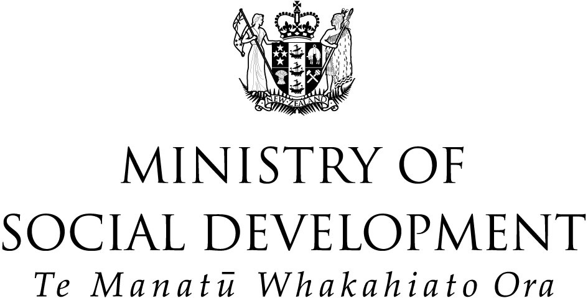

New Zealand Youth Suicide Prevention Strategy

Phase Two Evaluation

Executive summary

Prepared by
Anne Dowden

Prepared for
Centre for Social Research and Evaluation
Te Pokapū Rangahau Arotaki Hapori

January 2005

Purpose

This report presents the findings and conclusions from the phase 2 evaluation of the New Zealand Youth Suicide Prevention Strategy (NZYSPS).

The New Zealand Youth Suicide Prevention Strategy

The NZYSPS was developed by the Ministry of Youth Affairs, the Ministry of Health and Te Puni Kōkiri. It was implemented in 1998.

The Ministry of Youth Development (MYD) is responsible for co-ordinating and monitoring the implementation of the NZYSPS. The initial development of work programmes relating to the implementation of the NZYSPS included the establishment of Suicide Prevention Information New Zealand (SPINZ), Kia Piki Community Development projects, Youth Development Fund projects and a range of guidelines, information pamphlets and training for a variety of audiences. SPINZ was launched in 1999 with the main purpose of providing accurate, up-to-date information on youth suicide prevention.

Dissemination of the NZYSPS has occurred primarily through mail-outs and a small number of presentations to groups, and also through a range of other services and providers, such as public health units and non-governmental organisations. An ongoing process of document distribution has occurred through MYD, the Ministry of Health, Te Puni Kōkiri and SPINZ.

Evaluation of the NZYSPS

Evaluation of the NZYSPS has occurred in two phases.

The earlier evaluation – Phase One Evaluation of the NZYSPS

The Phase One Evaluation was completed in September 2003. It involved in-depth interviews with key informants from government and non-government organisations who had been involved in the high-level development and implementation of the NZYSPS. Findings from this evaluation suggested:
- the NZYSPS is seen as a vital reference tool
- the NZYSPS identifies best-practice principles and consistent advice to those working in the field of youth suicide prevention
- insufficient implementation planning had taken place before the NZYSPS’s release and communications could have been improved.

The current evaluation – Phase Two Evaluation of the NZYSPS

The Phase Two Evaluation involved potential end-users of the NZYSPS as the primary informants, from community and professional organisations who work with youth. In this instance, “end-users” are defined as those who work directly with youth or with those who work with youth. A broad definition of the “NZYSPS” was used, including work that has come about as a result of the NZYSPS and guidelines and programmes.

The objectives of this evaluation included identifying:
- how the NZYSPS is being used
- factors that enhance or limit knowledge about and use of the NZYSPS
- key lessons to inform implementation plans and the communications strategy for the NZYSPS.

The primary goal of this evaluation was to inform MYD’s implementation and communications for the NZYSPS. A qualitative case study approach was employed in the evaluation, to focus on the experiences of five end-user sites and networks. The five sites included in the evaluation were: a suicide prevention network, a District Health Board, a Group Special Education Team, and two projects that came about as part of the implementation of the NZYSPS. SPINZ and central government personnel were also included. In each site, “vertical case studies” were carried out in order to identify the nature of existing communication channels between end-users and sources in central government.

Key findings of the Phase Two Evaluation

Awareness and implementation of the NZYSPS

The findings of the evaluation suggest that there is limited awareness and implementation of the NZYSPS at the end-user level. Most of the informants had read and understood the NZYSPS document, but many believed that there was limited understanding of how to use or implement it in the wider community.

Features that promote or inhibit use of the NZYSPS

There were differing views among informants to the evaluation about the intended use of the NZYSPS, ie whether it was to be used as a reference tool outlining the policy intent or as a practical guide to implementation.

The NZYSPS provided a clear explanation of the range of goals and its broad focus, and was accompanied by useful supporting documents for some recipients (eg those in schools) that promoted its use. However, aspects of the document itself, and the way that it had been disseminated, detracted from its use. In particular, the lack of summaries in the NZYSPS document, the limited number of sector-specific supporting documents, and the perceived limited support for implementation of the NZYSPS were cited as inhibiting factors. Some also indicated that limited financial resources inhibited some people from accessing educational sessions about the NZYSPS.

While the NZYSPS includes Kia Piki te Ora o te Taitamariki, a strategy developed specifically for Mäori, there remained a perception among informants that a communication focus for Mäori audiences was lacking. This was considered to inhibit the use of the NZYSPS for some groups.

Factors for effective communication of the NZYSPS

Due to the nature of youth suicide prevention and the potential consequences of responding inappropriately, those who work with youth were found to be risk-averse in using new information unless it is from a trusted source.

Successful communication of information about youth suicide prevention was identified by informants as having three distinct components:
- a trusted origin or source
- an effective channel to arrive via
- a reliable, preferably local, “endorser”.
Government agencies and some NGOs are considered as sources of “official” and trustworthy information.

“Communication hubs” were identified as an important resource for effective communication of the NZYSPS. Communication hubs are organisations that can act as both sources of information that they have gathered and endorsers of that information as they disseminate it to their networks. Hubs include the Kia Piki Community Development Projects, the Youth Development Fund Projects and SPINZ, which were all set up as part of the implementation plan of the NZYSPS, as well as local government and a range of professional and occupational associations.

Information on youth suicide prevention is more likely to be valued and implemented if it is “endorsed” by someone known and trusted by the recipient. Tailoring NZYSPS information to individual sectors also increases the chances of it being understood, trusted and implemented. Relevance of information promotes its use, as some recipients feel they need significant support to feel confident to respond to the issue of youth suicide prevention.

To promote awareness and use of the NZYSPS, the issue of youth suicide prevention needs to be “on the agenda” for everyone working with youth, at every level. Targeting every level is important for effecting change in organisational priorities so youth suicide prevention information is communicated to those in decision-making or agenda-setting roles as well as to field workers.

Conclusions

Based on this evaluation, there are a range of findings that could be incorporated into implementation plans and a communications strategy for the NZYSPS.

- Communications on youth suicide prevention should ideally target everyone (decisions makers as well as field workers) and be specifically adapted to be relevant to recipients’ roles.

- Communications about youth suicide prevention should ideally include management of each aspect of the communications pathway from central government to end-users. This includes: ensuring that information sources (within and outside of central government) are up-to-date and are likely to provide safe and high-quality information; selecting and using the appropriate communication channels or communications hubs; and providing local or sector-specific endorsement of information (including adapting it to be relevant to recipients).

- Co-ordinating and monitoring the implementation of the NZYSPS may need to be more formal to promote overall co-ordination and support of key service provider organisations as well as co-ordination of community-level activities aiming to implement aspects of the NZYSPS.

Now known as the Ministry of Youth Development (MYD).
Stanton (2003).
The NZYSPS is, in fact, intended to give high-level guidance to youth suicide prevention work.

