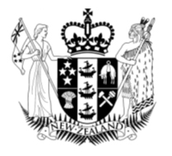
POPULATION AND SUSTAINABLE
DEVELOPMENT 2003

Foreword
This report discusses how changes in New Zealand’s population over the next 50 years are likely to impact on our future development and wellbeing. It is published as part of the Government’s Sustainable Development series. The focus on children and youth and the development of cities has strong links to the Government’s Sustainable development for New Zealand: programme of action, which was released in January 2003.
The main themes of the report are that people both influence and are influenced by sustainable development in quite complex ways and that the opportunities, attitudes, skills and knowledge of New Zealand’s people will be key determinants of our development path and future prosperity. The issues raised in the report include the changing nature of work and the workforce, immigration policies in a global context, our changing age and ethnic mix, and the importance of thriving communities and regions.
Good outcomes depend on the actions of all members of society. The Government has an important leadership role in co-ordinating and building consensus around our future direction. By taking a broad and long-term view, we can minimise the risk of unintended consequences.
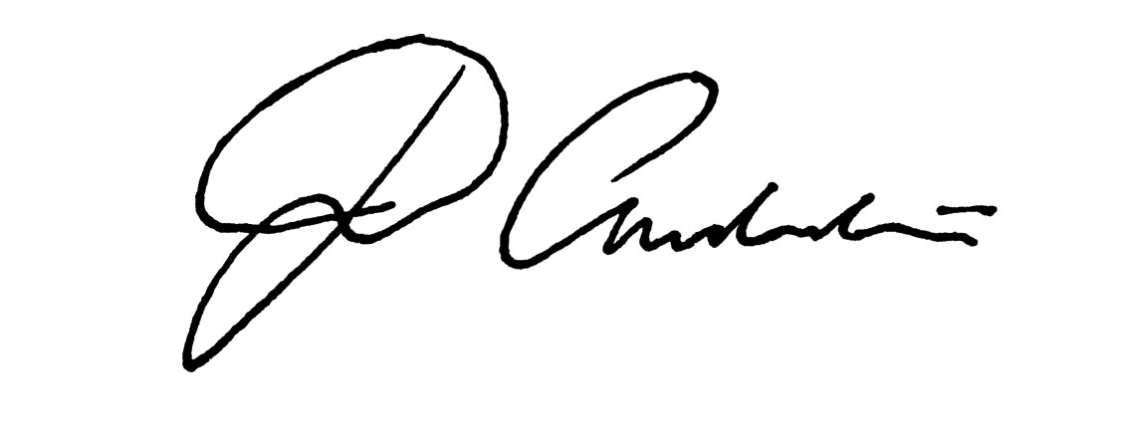
The report draws together information from a wide range of sources in order to raise issues for policy-makers and contribute to the public debate about New Zealand’s future. We hope it is widely read and used.

Jim Anderton
Minister for Economic Development

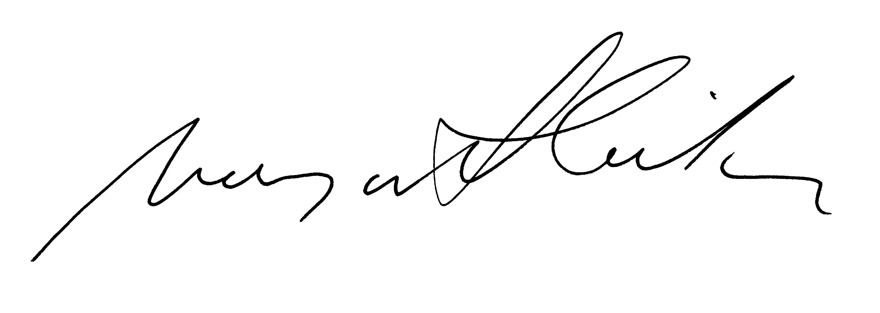
Steve Maharey
Minister for Social Development and Employment
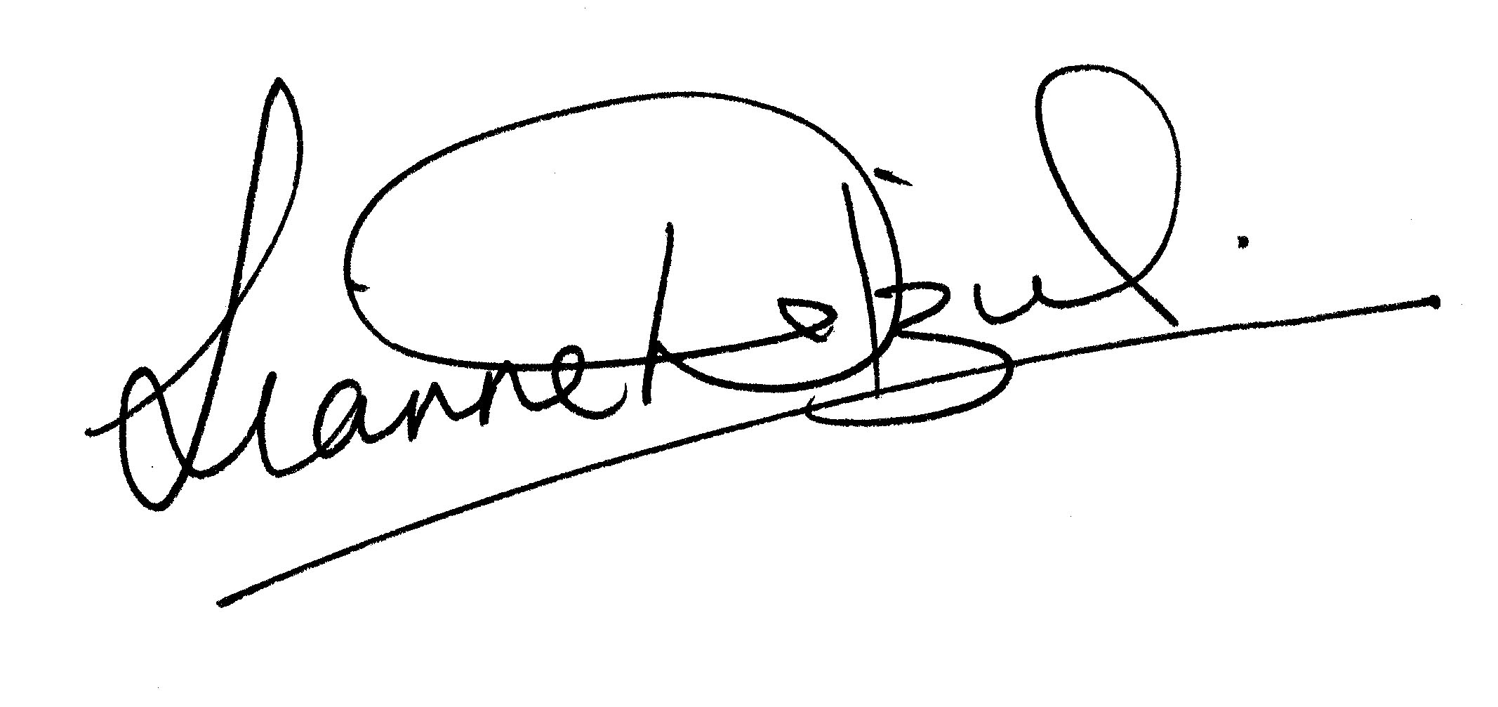
Margaret Wilson
Minister of Labour

Lianne Dalziel
Minister of Immigration

Marian Hobbs
Minister for the Environment
Minister with responsibility for Urban Affairs
Acknowledgements

This report has been jointly written by staff from the Ministry of Economic Development, the Ministry of Social Development, the Department of Labour and Statistics New Zealand.
The following agencies and individuals were consulted during the preparation of the report: the Department of Prime Minister and Cabinet, Ministry for the Environment, Office of Ethnic Affairs, the Treasury, the Ministries of Women’s Affairs, Youth Affairs, Maori Development, Pacific Island Affairs, Education, Health, Culture and Heritage, Transport, and Justice, the Department of Internal Affairs, Local Government New Zealand, Professor Richard Bedford, Professor Ian Pool, Dr Janet Sceats and Dr Judith Davey.

Published by
Ministry of Economic Development
www.med.govt.nz
Ministry of Social Development
www.msd.govt.nz
Department of Labour
www.dol.govt.nz
www.futureofwork.govt.nz
www.worksite.govt.nz

June 2003

ISBN 0-478-26330-9

Contents

Executive Summary 5
Introduction 8

Section 1
Overview of Population Trends 10
1.1: Size and structure 11
1.2: Fertility 16
1.3: Mortality 18
1.4: External migration 19
1.5: Internal migration 20
1.6: Ethnicity 23
1.7: Future trends 25

Section 2
Issues for Sustainable Development 29
2.1: A relatively small population 29
2.2: Mobility and patterns of settlement 32
2.3: A richer ethnic mix 41
2.4: Fertility and family formation 44
2.5: Growing older 48
2.6: The nature of work 52

Conclusion 61
Glossary 65
References 68

Executive Summary
This report has been prepared as part of the New Zealand Sustainable Development Strategy. It identifies population trends and projections and discusses their ramifications for sustainable development in New Zealand. It does not explore whether there is a desirable population size for New Zealand.
The purpose of this report is to increase knowledge of the implications of population changes for sustainable development in New Zealand. It is not to suggest policy solutions.
Population trends
Over the coming decades the main influences on New Zealand’s population size will be the ongoing effects of the large cohorts born between 1943 and 1973, further increases in life expectancy, reductions in fertility rates, and migration flows. Over the next century, the population is expected to reach a new stable age structure with a much higher average age.
Fertility is a key driver of the size and composition of the population. A return to higher fertility is unlikely. Even ethnic, immigrant and religious groups who traditionally exhibit higher fertility are rapidly shifting towards smaller families. Fertility is currently around replacement level and is expected to fall further towards that of other industrialised countries.
Historically, the least volatile component of population change has been mortality. Infant mortality has fallen to low levels. Further declines in infant mortality cannot significantly improve life expectancy. The greatest impact on life expectancy in coming decades will come from increasing longevity at older ages.
Births still exceed deaths by 28,000 per year. Around 2035 the first generations with a below-replacement family size will reach very old age and deaths will begin to exceed births. From then, unless fertility rate trends reverse, natural decrease will become the norm and population growth will be increasingly dependent on net migration gains.
New Zealand will continue to have a small population
The population is unlikely to reach five million in the next 50 years. The New Zealand population is projected to grow to 4.4 million by 2021, grow further to 4.6 million by 2051 and fall back slightly to 4.2 million by 2101.
A relatively small population may mitigate environmental and social costs, in comparison with a large population. But it also means that New Zealand has a small domestic market, which means we have limited ability to take advantage of economies of scale domestically. Because we lack a concentration of highly specialised skills and knowledge, we have a limited ability to take full advantage of knowledge. A small population also limits our capacity to match people’s capability to the widest range of opportunities.
Our future prosperity will be determined by how well we use our human, physical, natural and social capital, while retaining the benefits of having a small population.
People will be:
more mobile
External migration is the most volatile component of population growth. Small net flows conceal much higher gross outflows and inflows of people. Over the past two decades the international movement of people for tourism and education, much like permanent migration, has increased dramatically. Arrivals and departures in New Zealand are growing both in size and as a proportion of the total population.
The combined effect of the loss of New Zealanders and gains from the rest of the world is high population ‘churn’ (or turnover). A consequence is a relatively high proportion of our working-age population being overseas-born.
Attracting the people we need for sustainable development will require us to ensure that:
• migrants are able to use their skills and knowledge
• we accommodate the increased population turnover
• migrants are encouraged to stay and expatriates to return.
Increased mobility also has implications for patterns of settlement, infrastructure and the environment. People leave for overseas from all parts of New Zealand but the majority of new migrants choose to live in Auckland. Rapid rates of migrant-fuelled population growth raise concerns that Auckland’s infrastructure may be a barrier to economic development.
more ethnically diverse
Migrants arriving from an increasing range of countries, faster-growing Maori and Pacific populations, and a growing group of people who identify with several ethnic groups are drivers of a richer ethnic mix.
The emerging richer ethnic mix highlights a need for the development of social capital which builds bridges between people, allowing participation of all in society and a flourishing economy.
and older
Growth in the proportion of older New Zealanders will hasten after 2011, when the large birth cohorts of the 1950s, 1960s and 1970s start entering their sixth decade of life.
At the heart of concerns about an older population is the possibility of significant increases in old age dependency and slower economic growth, as Gross Domestic Product has to be shared among a larger non-working population.
Projections are that over the next 25 years around 70 million people will retire in OECD countries, to be replaced by just five million workers. The working-age population will fall by 65 million. This reduction contrasts with the past 25 years, when 45 million new pensioners were replaced by 120 million baby boomers in the workforce.
Ageing populations will change the nature of work
A consequence of the reduced numbers of workers in OECD countries is that internationally migration policies will become more open. More open international migration will make it more difficult for New Zealand to attract and retain skilled workers. It may also mean that employers are likely to use more machinery and technology, and to economise on labour.
Labour markets will also be affected by the increasing average age of the workforce and the smaller size of entry cohorts. Our ability to improve standards of living will depend on taking account of people’s situations over their lifetime. This will involve new modes of work, new organisational forms and life-long learning if we are to produce a labour force that has the necessary education and skills to support itself and the ageing population.
A scarcity of workers will increase incentives for women to be in paid employment. Unless workplace conditions are responsive to families, these incentives will add to the downward pressure on fertility, thus accelerating the process of population ageing.
These trends mean the quality of our investment in young people will be paramount if they are to participate fully in society and the economy and to support the older population. Looking ahead to the labour market of the 2010s and 2020s we need to remember that the innovative entrepreneur or dropout of 2015 is currently in the key formative years of development. We need to ask whether we are doing enough to ensure that this smaller group of new workers is fully prepared.
We have a window of opportunity
A high birth rate compared with other OECD countries and an increase in births around 1990 (the ‘baby blip’) mean that New Zealand has a window of opportunity to address potential future problems arising from the population trends identified in this report.
Key policy issues facing New Zealand include:
• how to invest effectively in the younger and smaller cohorts to ensure that they have the skills to prosper later in life
• how to adjust to an older workforce, especially enabling older people who choose to remain in paid employment
• how to attract, retain, regain and use the skills New Zealand needs for sustainable development
• how to address infrastructure issues arising from changing patterns of settlement, especially in Auckland
• how to create sustainable paid employment for all
• how to cater for the diverse needs of New Zealand society and create shared values among different groups.
Achieving sustainable development will depend on the extent that the skills and ability of our children match the opportunities available to them in New Zealand.
The government’s contribution to sustainable development is about making good policy decisions that anticipate future population changes.
The key message of this report is the importance of fundamentals for sustainability. This includes ensuring that we have a society that is inclusive, an economy that creates opportunities and an environment that is sustained into the future. For sustainable development, it is the whole package that matters.

Introduction
New Zealand’s population has changed dramatically over the past century.
At the beginning of the 20th century the population numbered 800,000. Children (under 15 years) outnumbered older people (those aged over 64) by eight to one. The life expectancy of a new-born child was about 60 years. Maori made up five percent of the population. Immigrants made up about one-third of population growth. Immigrants were mostly from the United Kingdom. More people lived in rural areas than in towns and cities.
At the beginning of the 21st century, the population numbers approximately four million. Children outnumber older people by a ratio of two to one. A newborn child can expect to live nearly 80 years. Maori make up nearly 15 percent of the population. While net migration still accounts for around one-third of population growth, migrant sources are markedly more diverse. We are highly urbanised.
Our population has an older age structure, is ethnically more diverse, and is likely to live in smaller but more complex family structures, in urban areas in the North Island, and be highly mobile.
During the 20th century, New Zealand experienced steady population growth. The period 1946 to 1976 saw the highest growth. The population reached one million in 1908, two million in 1952 and three million in 1973.
The main influences on New Zealand’s population over coming decades are the ongoing impact of the large cohorts born between 1943 and 1973, further increases in life expectancy, a continuing reduction in the average number of children born to each woman of childbearing age (the fertility rate), different ethnic population trends, and migration flows.
The size and composition of the population are major influences on a country’s ability to create wealth, the range of industries it can support, the pool of talent that can be called on, the strength of communities and the structure of government spending. Therefore, the make-up of a country’s population is a key factor in choosing and sustaining a development path.
For example:
• a young population provides more new entrants to the labour market than an older population
• young people with families have significantly different patterns of consumption and saving from older people
• different ethnic groups may have different social and cultural values in relation to education, family structures, income distribution within households, social interactions and lifestyles
• a relatively young population requires investment in public health, schools, a housing stock that meets the needs of children, and childcare, while a relatively older population requires investment in individual health, a housing stock that recognises greater disability, and high returns from savings.
These influences are not one-way. Economic, social and environmental performance have a strong influence on people’s choices about having children, life expectations, migration decisions and the type of education and training in which to invest.
A sustainable development approach
Sustainable development is a means to an end. It is an approach to decision-making, not an ideal outcome or final achievement. The starting point for sustainable development is the internationally recognised definition of:
“...development which meets the needs of the present without compromising the ability of future generations to meet their own needs.”
Adopting a sustainable development approach to population requires a long-term perspective. It means addressing all potential consequences of actions. Issues include the consequences of the size and composition of the population, including linkages to quality of life, economic development and environmental enhancement. They include the need to give opportunities for development to people of all ages, now and in the future.
This expands any discussion about population to include our ability to adjust to a growing or shrinking population, where we live and the quality of that life, what we consume and what we produce, and the impact that human activities have on the natural environment.
Each of these topics is worthy of a report in its own right. This report cannot cover any of these issues in depth.
The role of policy
In the past, the Government was faced with population issues - such as high fertility and migration - that could, in theory, be influenced by policy. The traditional definition of an active approach to population is “...all deliberate government actions intended to influence population growth, size, distribution and composition”. Governments today operate in a different environment, and face issues, such as ageing, that are not amenable to the approaches used in the past.
Key policies are those aimed at the needs of different age groups and sub-populations, and at matters such as human capital, social capital, mobility and the changing nature of work. Consideration of population must also take into account broader issues, such as the impact of international events on local regions, and co-ordination between government and non-government sectors.
Purpose
This report provides a broad discussion around the interaction between population and sustainable development in New Zealand. Our aims are to inform policy-makers, stimulate public discussion, and provide input into the government’s sustainable development strategy.
The report does not explore whether there is a desirable population size for New Zealand. Nor does it attempt to develop specific policy solutions.
The Population and Sustainable Development report is based around the following key questions:
- how will the size and composition of the New Zealand population change over the next 50 years?
- what are the key factors that will affect changes in population size and composition?
- where will people live and what will influence their decision to move or stay?
- what are the consequences of these trends for the economy, society and the environment?
- what is the role of the Government in all this?
The first section provides an overview of population trends and projections of the future.
The second section examines the implications of these population trends for sustainable development.
The report ends with some broad conclusions about the population issues we face.
Unless otherwise stated, data in the report is sourced from Statistics New Zealand.

Section 1
Overview of Population Trends
New Zealand is a diverse country. It is diverse in its range of social and physical environments and in its degree of economic development. It is also diverse in the distribution and characteristics of its population.
The focus of this section is on population trends. This section considers current issues in light of past and expected future population trends. It explains the demographic drivers relevant to sustainable development.
The size of New Zealand’s resident population is the result of a complex interrelationship between natural increase (excess of births over deaths) and net external migration (flows of residents and non-residents who migrate on a permanent basis). The contribution from natural increase equals the contribution from births less the contribution from deaths. The difference between the natural increase contribution and total population growth is the contribution from net migration.
Figure 1 shows the relationship between natural increase and net external migration over the past 100 years. Natural increase has been the dominant element in population growth in that time. In half of the last 25 years, the contribution of net migration has been negative.

Figure 1: Population change, natural increase and net migration, 1961-2001
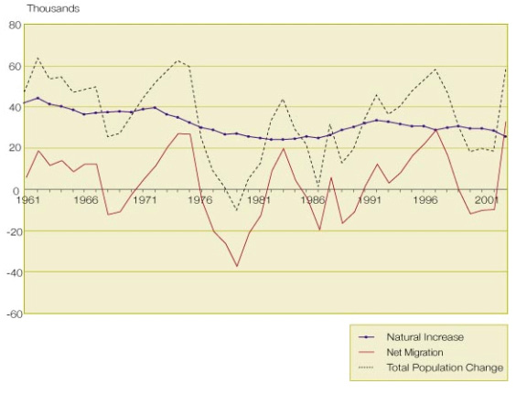
1.1: Size and structure
The 2001 Census counted 3,737,277 people usually living in New Zealand. In addition to this population, there were an estimated 50,000 New Zealand residents temporarily overseas at Census time, and 85,000 people who were not captured by Census data. The resident population was estimated at four million in April 2003.
Over the 20th century, the New Zealand population has moved from a youthful age structure with moderate fertility and high mortality, through a period of marriage boom and associated raised fertility, to a period of low fertility, low mortality and population ageing.
This transition shows a healthy demographic adjustment. The high fertility and high mortality of the 19th century resulted in a young population. High mortality is an undesirable feature in a population. That said, low mortality needs to be accompanied by low fertility to avoid explosive population growth. Low fertility and low mortality result in a stable though older population.
In 1901 half of the male population was under 23.5 years of age. Half the female population was under 21.6 years of age. By 2001 half of the male population was under 34.0 years of age compared with the female population, half of whom were under 35.6 years of age.
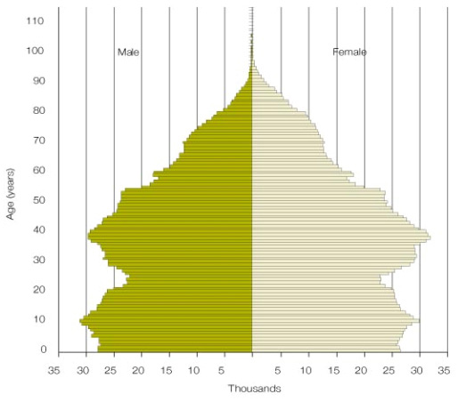
Figure 2: Age-sex pyramid, usually resident population, 2001 Census

The age structures of the main ethnic groups in New Zealand show significant differences.
Figure 3: Age-sex pyramid, European/Pakeha population, 2001 Census

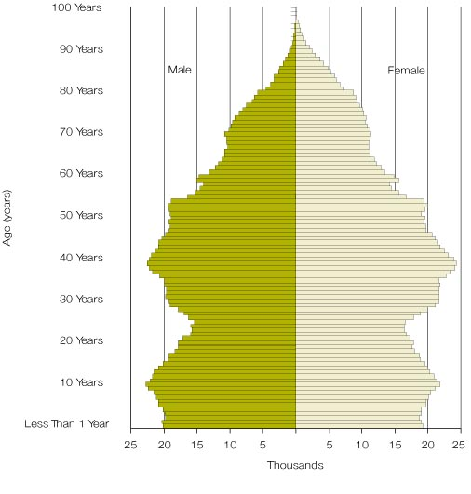
Figure 3 shows the age structure of the usually-resident European/Pakeha population. As this group is 80 percent of the population, this structure has a similar shape to the total population. The pyramid shows the ‘baby blip’ that occurred in the early 1990s. It also shows the baby boomers reaching middle age.
Figure 4: Age-sex pyramid, Maori population, 2001 Census

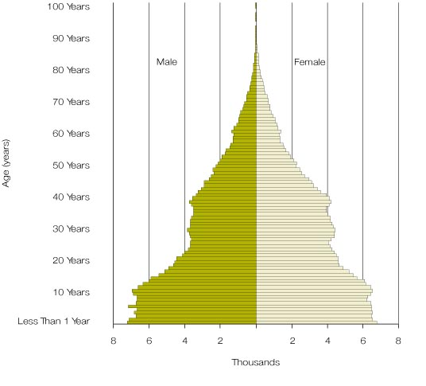
Figure 4 shows the usually-resident Maori population and the relative youthfulness arising from its different population transition.
Figure 5: Age-sex pyramid, Pacific population, 2001 Census
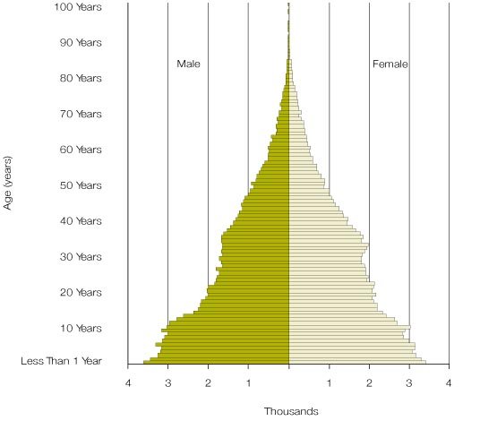
The usually-resident Pacific population pyramid, shown in Figure 5, has a similar shape to the pyramid for Maori. However, an even greater proportion of its population is in the younger age groups.
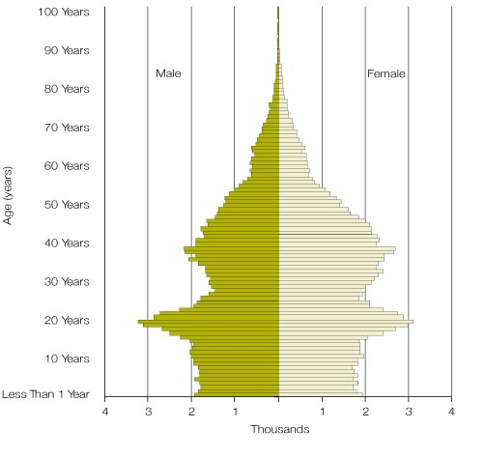
Figure 6: Age-sex pyramid, Asian population, 2001 Census
Figure 6 is the usually-resident Asian population. The bulge around the 20 year age group reflects a high proportion of migrants and students.

The last century is notable for the period of rapid growth from the mid-1930s. Rapid growth was sustained for around three decades by a marriage boom, as more women had children at younger ages.
The marriage and child-bearing boom coincided with a drop in infant mortality. The cause of the latter was improvements in health care and social welfare. The result was much larger surviving cohorts.
Despite a falling fertility rate, the number of births continued to rise and the proportion of women without children was lower than either before or after this period. The number of women of childbearing age also increased.
This baby boom was largely restricted to the European/Pakeha population. Maori underwent a transition from high fertility and infant mortality to lower fertility and lower infant mortality.
The Maori transition to lower fertility rates started later and the rate of change was much higher. To illustrate this, the official Total Fertility Rate (TFR) for Maori in 1962 exceeded 6.0. By 1999 it was around 2.6. Over the same period, the total population shifted from 4.2 to 2.0. In 1951 the non-Maori infant mortality rate was 23 per 1,000 live births, but for Maori it was 68 per 1,000. The current comparable figures are 6.0 for non-Maori and 8.0 for Maori.
The consequence of these differences is a younger Maori population which is ageing more rapidly than the population as a whole.
1.2: Fertility
Table 1 presents the TFR for a number of selected countries and regions. A TFR of 2.1 is the level of reproduction that replaces the population. Like most of the developed world, New Zealand’s fertility rate has been at or below replacement for the best part of a quarter of a century. However, by international standards it remains relatively high, hovering just below replacement level at 2.0 births per woman in 2001.
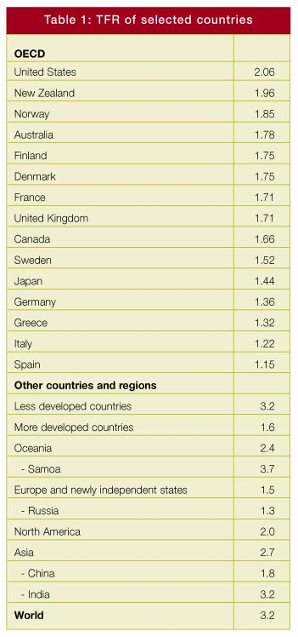
The United States has a total fertility rate similar to New Zealand’s. New Zealand’s higher fertility relative to most developed nations is the result of higher fertility for Maori and Pacific peoples. When these populations are excluded from calculations, New Zealand’s total fertility rate matches Australia’s.
Birth numbers are constrained by the size of the childbearing population. Fertility rates are the result of the number and spacing of births of the childbearing population. The number and spacing of births are in turn related to the age, sex and ethno-cultural composition of the population, as well as other factors.
The current trend is for the age of mothers giving birth to rise. The average age of New Zealand women having children in 2001 was 29.5 years. Those women who give birth have fewer children, and a growing proportion of women remain childless.
All these changes make a return to higher fertility unlikely. Moreover, in the face of economic and social pressures, ethnic, immigrant and religious groups who traditionally have had higher fertility are shifting toward smaller families.
An immediate return to high fertility would aggravate issues associated with dependency rates, at least in the short to medium term, because these children would not enter the workforce for about 20 years.
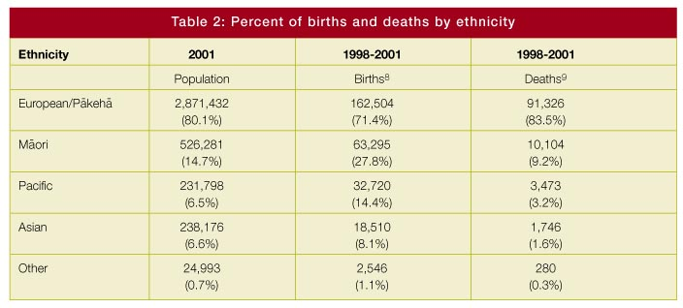
Table 2 shows that the percentage of births in the European/Pakeha population is below its population share. The percentage of deaths for this group is higher than its share. This contrasts with other ethnic groups shown in the table.

Overall births still currently exceed deaths by about 28,000 per year. This margin - natural increase - will continue to be positive until the first generations with a below-replacement family size reach very old age. Deaths will then exceed births unless fertility rises. Natural decrease is expected to become the norm from about 2035.
At the regional level, the effects of lower fertility levels are already being felt. Although many regions have historically lost people through migration, losses have been offset through natural population increase. Between 1991 and 2001, New Zealand’s natural increase slowed by three percent. Between 2001 and 2010, natural increase is projected to decline by 26 percent. By 2021, it will be 34 percent lower than today. This will exacerbate population decline in some regions.
Figure 7: Births and deaths, 1901-2051

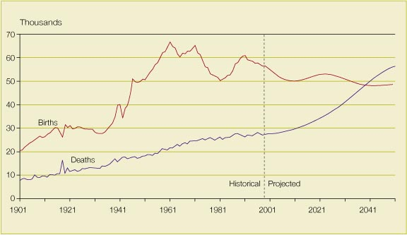
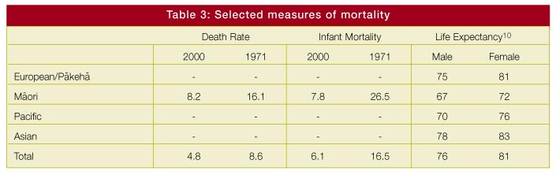
Figure 7 shows the relationship between births and deaths over the 150-year period from 1901.
1.3: Mortality
The least volatile component of population change is mortality.
The timing and cause of a person’s death are usually a consequence of their genes and their accumulated lifetime experiences. A sedentary life of smoking and poor diet increases the likelihood of later cancer, heart disease or stroke. Consequences of events or experiences early in one’s life, such as childhood illness, accidents and stress, can weaken the body, becoming apparent later in life. Experience of deprivation during the 1930s Depression is, for example, still affecting population health today.
As shown in Table 3, there has been a significant decline in rates of mortality in New Zealand in recent decades.
Life expectancy rose dramatically in New Zealand last century. Males could expect to live 17 years longer at the end of the century than at the beginning. Females could expect 20 years more life. The rises are due to advances in standards of living, health, nutrition, medical care and safety.
A key contributor to improved life expectancy has been reductions in infant mortality. Infant mortality fell from 76 per 1,000 in the early 1900s to 40 per 1,000 in the 1930s. By the 1950s, the infant mortality rate had fallen to 23 per 1,000. More recently it has fallen to below seven per 1,000.
While more lives were being saved at younger ages, increases in life expectancy later in life did not keep pace. Life expectancy at age 60 years improved by one year between 1880-82 and 1921-22. It then remained virtually unchanged for the next half century.
During the past 25 years, a major part of longevity improvement has occurred at retirement ages.
Today, only one in 200 children dies in their first year of life. Infant mortality has fallen to such a level that further declines cannot dramatically improve life expectancy. Over 90 percent of newborn babies will see their 60th birthday and 20 percent of babies can now expect to see their 90th birthday, three times the proportion that would have seen this milestone 50 years ago.
1.4: External migration
External migration is the most volatile component of population change. It consists of both outflows from and inflows to New Zealand. Over the course of the last century, New Zealand gained an average of 5,000 people a year net from migration. The average net gain from natural increase over the same period was 25,000 per year.
The biggest changes in migration, especially in recent years, have been the major fluctuations in the gross flows to and from source and destination countries, and in the age of migrants. Over the past two decades, the international movement of people who are not intending to move permanently has increased dramatically.
The number of New Zealanders leaving the country on a self-declared ‘Permanent or Long-term’ basis has increased steadily since the early 1990s. But the extent of this loss has been masked by high immigration. For instance, in the year to June 2001, there was a net loss of 41,000 New Zealand citizens. However, combined with a net gain of 31,000 non-New Zealanders, the overall net loss was only 10,000 people.
Figure 8 shows that for the past two decades there have been ongoing losses of New Zealand citizens. More New Zealanders have been leaving than returning every year since the early 1960s. The new phenomenon of the 1990s has been the substantial increase in gains of other nationalities.
The 2001 Census shows ongoing gains in overseas-born people and a net loss of New Zealand-born people. The net effect of the loss of New Zealand-born people and gains from the rest of the world is high population ‘turnover’. Turnover is particularly significant in the working-age group. As a consequence of high turnover, in 2001 one in five of our working-age population was overseas born. The proportion in Auckland was one in three. These figures compare with one in four in Australia, and one in five in Canada. In the US the figure is one in 10, and in the UK one in 20.
The 2001 Census found nearly 230 countries represented among the birthplaces of people who usually live in New Zealand. More than 50 of these countries contributed more than 1,000 people. It is probable that the majority of our migrants will continue to come from Australia, the United Kingdom and the Pacific, and the new sources of growth such as China, India and Southeast Asia. But more migrants are also arriving from wider areas of Asia, Africa and Latin America.
An important issue related to external migration is where in New Zealand people choose to settle. A second important issue is how well they integrate into their new society and economy. These issues are discussed in Section 2.2.
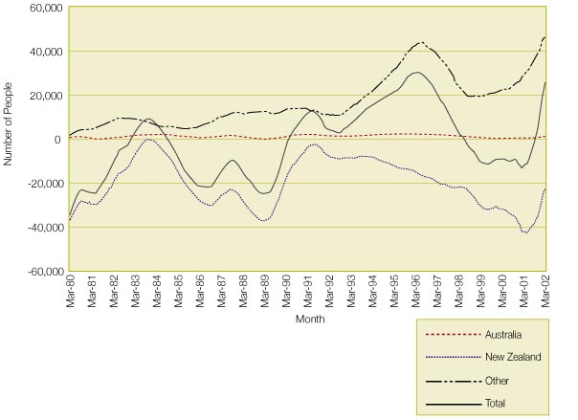
Figure 8: Net Permanent or Long-term migration by nationality

1.5: Internal migration
Changes in the distribution of population around New Zealand are determined by movements between areas, arrivals and departures from overseas, and different fertility and mortality rates. Each area of New Zealand has a different demographic structure.
New Zealanders are very mobile and becoming more so over time. More than half of the population change address in any five-year period.
The South Island has made small population gains from North Islanders in each of the 1991, 1996 and 2001 Censuses. But movements within each island are much larger than movements between islands.
Table 4 shows movements of people within New Zealand based on regional council areas. In some cases, such as the Nelson region, over 20 percent of the population moved out to another region during the five-year period between 1996 and 2001. More than 20 percent of the current population are recent arrivals in the area. The impact of migration on regions is actually greater than shown in the table. This is because the data does not include people who chose to move out of New Zealand rather than to another region.
Many factors determine the intensity of the migration impact. Different demographic profiles of those arriving (inflows) compared with those leaving (outflows) may significantly impact on population profiles. For example, people leaving the Auckland and Wellington regions tend to be older than those arriving (Figure 9).
Canterbury and Southland are both heavily dependent on the rural sector. Patterns of internal migration into Canterbury are similar to those in Auckland and Wellington. But there is a marked contrast in the ages of those migrating (Figure 10). The peaks of Canterbury and Southland inflows are younger than those of either Auckland or Wellington. The outflows are also younger. Outflows from Southland mirror the inflows of the other three regions. Unlike those in the other three regions, the inflows from Southland occur across the age range.
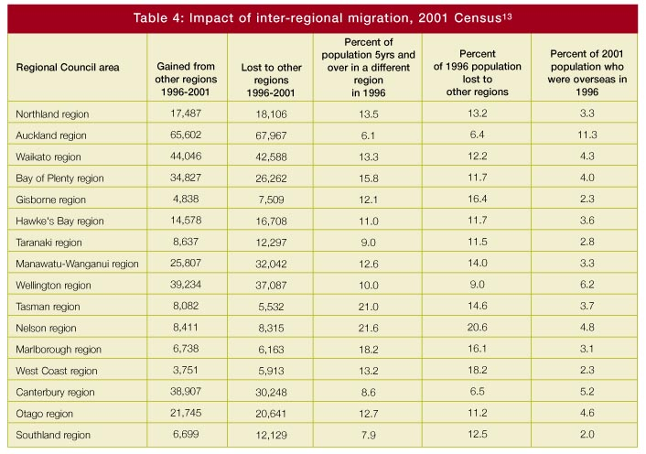
Variation in international outward migration flows between regions has an impact over time on regional populations. In the 1986-1991 period, 53 percent of inward migrants to Auckland were from overseas, rising to 62 percent over the 1991-1996 period. Of all migrants leaving Auckland, 51 percent headed overseas in the 1986-1991 period, falling to 44 percent in the 1991-1996 period. The Auckland region had the lowest inter-regional migration turnover rate of all regions between 1986 and 1996.

Figure 9: Inter-regional inflows and outflows, Auckland and Wellington regions, 1996-2001
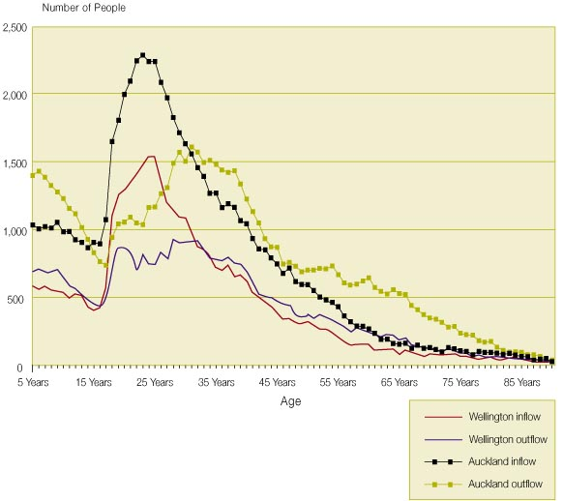
Figure 10: Inter-regional inflows and outflows, Canterbury and Southland regions, 1996-2001
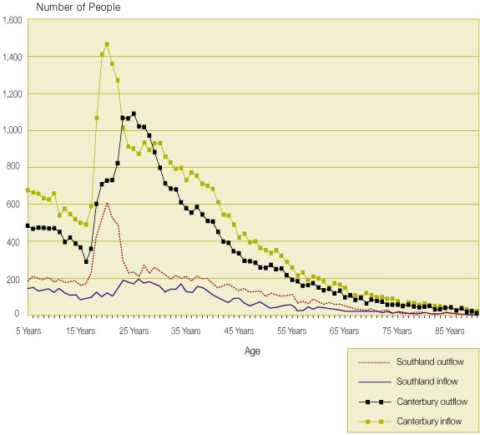
1.6: Ethnicity
Ethnicity data in New Zealand is based on the principle of individual self-identification. Self-identification is the most practical way of collecting this information. In general, ethnicity questions in New Zealand draw high responses.
People associate ethnicity not only with cultural affiliation, but also with such factors as nationality, ancestry, country of birth and country of current residence. The exact mix of these influences is not discernible from the data. Younger people also tend to declare multiple ethnicities more often than older people.
Ethnic groups vary in age structure, geographic distribution, fertility rates and a host of other ways. These variations impact on their educational and workforce profile, patterns of internal migration, and specific social and economic needs.
Looking at aggregated ethnic groups conceals both diversity within groups and similarities between individuals or sub-groups of different aggregate groups. Generalisations about particular ethnic groups should be made with caution. For example, within the broad Asian ethnic group, there are people of various East, Central, South and Southeast Asian ethnicities who have widely differing cultures.
In addition, ethnic groups differ by proportion of those New Zealand born by age. Figure 11 shows that nearly six in 10 of the Pacific peoples in New Zealand are New Zealand born. For those under 15 years of age this proportion exceeds eight in 10 people. For people of Asian ethnicities, just over one in five is New Zealand born. Among under-15 year olds, nearly two in five are born in this country.
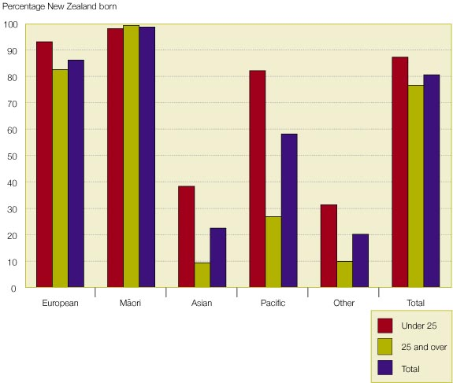
Figure 11: Percentage of people born in New Zealand in selected ethnic groupings by selected age groups, 2001 Census

One of the striking recent trends in ethnicity in New Zealand is the growing proportion of people who report multiple ethnicities. In the 2001 Census nearly one third of a million New Zealanders identified with more than one ethnic group. For example, of the 526,821 people of Maori ethnicity reported in the 2001 Census, 44 percent also declared at least one other ethnicity. There were 212,886 people who described themselves as European/Pakeha and Maori, 31,545 Maori and Pacific, and 7,233 Maori and Asian.
1.7: Future trends
Projections
The population projections presented in this section are Statistics New Zealand’s Series 4 projections. They are based on historical data up to 1999 and medium assumptions of fertility, mortality and net migration of 5,000 per year.
The population projections are plausible scenarios, not best-judgement forecasts. Projections based on different assumptions provide an indication of the sensitivity of population developments to the prime determinants of population change. But they provide little information on the true range of potential outcomes or the chances that different outcomes might eventuate.
Determinants of future population developments are complex. Error margins on projections can be high. For example, few demographers in the 1930s predicted the rapid rise in birth rates that would take place in the 1940s. As noted by Peter Drucker, “...in the late 1930s, President Roosevelt’s Commission on American Population (consisting of the country’s most eminent demographers and statisticians) confidently predicted that America’s population would peak in 1945 and would then start declining”.
History provides insights into the relative importance of components of population change. Table 5 presents decade averages of contributions to annual population growth from births, deaths and migration. The reduction in population growth rates in New Zealand from the 1950s to the 1980s came from a one percentage point fall in the contribution from births. This was compounded by a 0.75 percentage point decline in the net migration contribution but was partially offset by a 0.1 percentage point reduction in the negative contribution from deaths. The increase in population growth in the 1990s was almost entirely driven by the turnaround in migration trends.
Variability measures provide an indication of the relative difficulty in forecasting components of population growth. The inter-decade variability measures provided in Table 5 show that birth rates vary more than death rates. Forecasting births is thus harder than predicting deaths. The high variability in net migration figures is compounded by the complexity of issues that influence individual migration decisions.
If New Zealand’s fertility rate were to drop to that currently experienced by Italy and Spain (around 1.2 births per woman), stable zero-growth population would require an average annual net migration gain of 52,000 people. With net migration at this level the ultimate population size would settle at around 6.5 million people. This scenario is extremely unlikely. Net migration at this level implies gross inflows considerably greater than New Zealand has ever experienced.
For the New Zealand population to reach 10 million by 2050, there would need to be a net gain of 88,000 migrants every year for the next 50 years. Given increasing international competition for skilled migrants and the problems we have had in successfully integrating the current number of migrants, it seems extremely unlikely that the New Zealand population will increase to 10 million over the next 50 years.

At the other extreme, if we were to suffer net losses due to migration at an average of 17,000 per year, long-term stable zero-growth population would require a fertility level of 2.6 births per woman, a level unlikely to be achieved. In this extreme, the ultimate population size would settle at around four million.
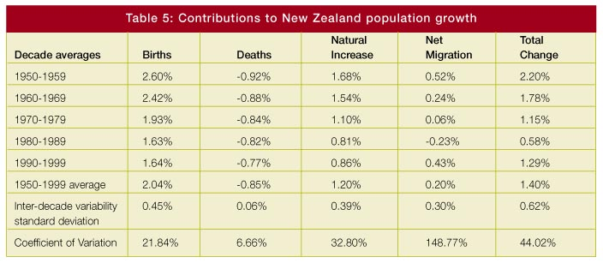
Source: Data derived from U.S. Bureau of the Census, International Database.

The conditions for zero population growth in New Zealand over the next century, based on different fertility rates and net migration, are shown in Figure 12. The combination of a fertility rate of 1.85 and annual net migration of 10,000 is marked with a cross. Figure 12 shows that if, for example, the fertility rate fell to 1.65 then zero population growth would require annual net migration of 20,000.
The combinations of fertility and migration that produce zero population growth in the short term will, over time, affect population size. For example, if zero population growth is achieved today through a fertility rate of 1.85 and annual net migration of 10,000, then the population would be 4.8 million in 2100. On the other hand, if zero growth is achieved through a fertility rate of 1.4 and annual net migration of 36,000, then the population would rise to six million.
In summary, a low fertility rate is clearly not going to produce higher population growth, but it will not restrict population size to its lowest possible level either, because of the potential influence of migration.
Figure 12: Conditions for zero population growth in New Zealand

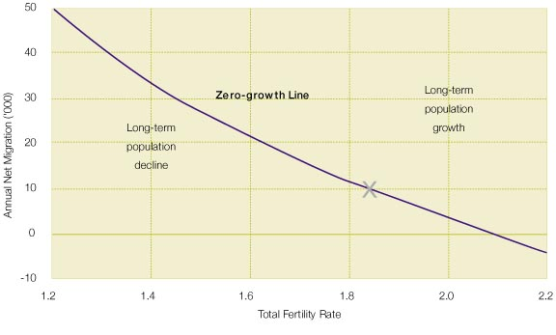
Size and composition of projected population
The resident population may not reach five million in the next 50 years. It may never do so. The New Zealand population is projected to grow to 4.4 million by 2021, to 4.6 million by 2051 and to fall back slightly to 4.2 million by 2101.
Over the next century the population will reach a new stable age structure and a much higher median age.
During the past 50 years the number of New Zealanders aged 65 years and over has more than doubled. The 65+ age group is projected to more than double again over the next half century - from 0.45 million in 1999 to 1.18 million in 2051. By then, this group is expected to make up one in four of the nation’s population, up from 12 percent in 1999. At the same time, the concept of retirement age is becoming anachronistic. People retire at a much wider variety of ages than in the past.
By 2051, half of all New Zealanders will be over the age of 45 years, compared with 34 years in 1999. In 1999, children under 15 years of age comprised 23 percent of the population - by 2051 they are expected to account for around 16 percent. Over this same period their number is projected to decrease from 875,000 in 1999 to 737,000 in 2051, a drop of 138,000. Thus there will be nearly 16 percent fewer children.
This phenomenon has consequences for the education sector. While numbers in the various educational age groups are projected to fluctuate in the future, there will be a general downward trend in all groups.
Over the next two decades the primary school age population (5-12 years) is forecast to drop by 67,000, or 14 percent, to 410,000 in 2021. This compares with a peak of 503,000 reached in 1975. In most of the decades after 2031, there will be further drops. There could be 84,000 fewer primary school children in 2051 than in 1999.
The trend in the secondary school age population (13-17 years) is similar to that for primary schools. The peaks and troughs for secondary schools lag behind those of the primary schools by about six years. The secondary school age population is projected to increase from 272,000 in 1999 to 315,000 in 2007, an increase of 43,000. The number will then drop by 50,000 to 265,000 in 2027. By 2051, the secondary school age population will number 261,000. This is about 62,000 fewer than the 1976 peak.
The patterns in the tertiary age population (taken here as 18-22 years) trail those of secondary schools by about five years. During the decade ending in 2011, there will be an increase of 47,000, followed by drops of 23,000 and 26,000 in the next two decades and smaller changes thereafter. By 2051, there will be 270,000 people aged 18-22 years, almost back to the 1999 figure of 266,000.
The cohorts moving into retirement ages over the next couple of decades were born to younger mothers than subsequent cohorts. With increases in life expectancy there may be two or more living generations in the retirement ages. For instance, a woman currently aged 50 may have a living mother and grandmother. However, in the medium term this will change as the age differential between children and their mothers increases. A child at high school may have parents reaching retirement age. Parents may require care before the child’s tertiary education is complete.
As these large cohorts of recent decades proceed through the older ages, there will be a sharp increase in deaths. Moreover, the number of deaths is expected to exceed the number of births by around 2035 and to continue to do so. This is the result of the large cohorts born in the 1960s and 1970s reaching old age, and the childbearing cohorts at that time being much smaller and having lower fertility. The population will also be much older. It is estimated there will be 12,000 people aged 100 years or more by 2051, compared with around 300 in 1996.

Section 2
Issues for Sustainable Development
The population trends outlined in Section 1 raise many issues for sustainable development.
• By international standards, New Zealand will always have a small population size and density. Consequently we will always have a small domestic market and a limited ability to take advantage of economies of scale, a limited ability to create human capital, and a limited capacity to match people’s capability with opportunities. However, a small population may mitigate environmental and social costs.
• New Zealand’s population will become more mobile - domestically and internationally. The need to attract, retain and regain the people needed for sustainable development has implications for communities, regional development, business opportunities and jobs. Increased mobility also has implications for patterns of settlement, infrastructure and the environment.
• Fertility will continue to drive future changes in the size and composition of the population. Incentives for women to be in paid employment will increase. Unless workplace conditions are responsive to families, this is likely to add to downward pressure on fertility, accelerating population ageing and reducing the future labour force.
• Migrants arriving from an increasing range of countries, faster-growing Maori and Pacific populations, and an increased number of people identifying with several ethnic groups contribute to a richer ethnic mix. This richer ethnic mix has implications for policy development. It highlights the importance of flexible institutional structures. A challenge facing New Zealand is the development of shared social values common to all ethnic groups, including core democratic values, while building tolerance of diversity.
• There will be growth in the population share of older people. The trend to an older population will change the nature of work. It also has implications for government spending in the areas of health, education and the tax and welfare systems. The changing age structure highlights the need to ensure that young people are fully prepared today to meet the challenges of a changing world.
• The labour market will be affected by the ageing workforce, the smaller size of birth cohorts, and an increasingly global market for labour. The ability of the economy to deliver jobs and improve standards of living will depend on New Zealand’s ability to maintain a labour force that has the education, skills and innovative capacity required.
These issues are discussed in more detail below.
2.1: A relatively small population
The population is unlikely to grow substantially. New Zealand will continue to have a small internal market. We have a limited ability to attract and use a wide range of skills and talent by comparison with larger countries. The implication of a small population for sustainable development is that the focus to achieve economic growth must be on enhancing the skills of the population and using the advantages of being small.
Economic implications
A big population is sometimes argued to make a country more economically productive.
Because large populations in industrialised countries provide a large domestic market, firms in those countries are able to reduce costs through large production volumes. Large, densely concentrated populations may generate more ideas via a greater ability to share specialised thought on a face-to-face basis.
Exporting and lowered costs of communications relieve these problems of small size. But they are unlikely to wholly solve them.
A further constraint on economic performance resulting from a small population is difficulty accessing technology. For example, smaller countries source more of their technology offshore. But technologies suited to small countries may not be justified in small production runs. In addition, if small economies have less specialised firms, their need for highly specialised technology is lower. As such technological change is centred on increasingly specialised equipment, this may be problematic.
Large labour markets can reduce the matching problems between workers and firms. In addition large labour markets allow specialised skills to be used, which is attractive to people who wish to employ their specialist skills and have no desire to be ‘Jacks and Jills of all trades’.
Large population size has a number of other economic benefits. Tax burdens in large economies may be lower because costs of publicly provided goods such as a legal system, health, education, defence, customs and the network infrastructure can be more widely shared. Large product markets also tend to support greater competition, driving greater efficiency. Firms benefit from greater access to sophisticated financial markets.
A further economic benefit from a large population arises from the significant cost savings (called agglomeration economies) available to firms from locating in densely peopled areas. These benefits of size include lower transport, negotiation and advertising costs, and reduced costs in finding workers. Agglomeration also facilitates innovation by providing networks that can efficiently distribute knowledge and magnify the interchange of productive ideas.
However, big is not always better. Diminishing returns may set in as a result of industrial congestion, which leads to an increase in scarcity of inputs like land and labour. Transport congestion can arise from high traffic densities.
Nor does population size alone increase productivity. Productivity depends on how well resources like land, physical capital and people’s skills are combined.
Furthermore, exporting in order to earn foreign exchange to fund imports allows small economies of scale that would not be available in the presence of trade barriers. The economies of scale from specialisation in exporting allow a reduction in production costs, importing allows local consumers to enjoy the cost advantages of foreign economies of scale, and the result is a net welfare gain.
Nor are economies of scale the only reason for specialisation. Firms can exploit economies of scope, for example by focusing on the design aspect of a product rather than its production. An alternative approach is to develop in areas where economies of scale are not as critical for competitiveness, such as where economies of scope or adaptability are more important. If adaptability is relatively more important than scale production in a small, isolated economy, then economic performance is likely to be more reliant on the quality of information flows to investors, adapting and absorbing technology, and the institutional arrangements that promote flexibility and the movement of resources.
Smallness also provides opportunities for niche marketing of exports. Smallness means that change can occur more rapidly. Smaller individual shifts can have a greater aggregate effect on the economy. A smaller and relatively less industrialised and specialised population provides flexibility to take advantage of future trends.
Environmental implications
New Zealand’s primary industries - agriculture, horticulture, forestry, fishing, and marine farming - generate much of our wealth. Land-based and marine industries rely on biological processes that depend on the continuing sound functioning of the ecosystems of which they are a part. Tourism too draws heavily on New Zealand’s natural environment. The natural environment makes New Zealand an attractive place to live and work - a significant factor in attracting migrants.
People put pressure on natural capital and the long-term environmental carrying capacity of countries. In general, the more people a country has, the greater the environmental burden (or footprint) on its soil, water and atmospheric resources. Large populations and high population density put pressure on habitats (see section 2.2).
Therefore although New Zealand’s small population has disadvantages for the economy, the opposite may be the case environmentally.
However, this is not always the case. Consumption and production patterns are potentially more important than size of population in determining the ecological impact of a society. This is especially true where economic growth, such as from intensive agricultural production and tourism, does not take account of its impact on the environment.
Small populations may also miss out on economies of scale in the provision of environmental amenities like parks, environmentally friendly practices like well built landfills, and the clean-up of sites polluted by earlier practices.
A small domestic population also creates the necessity for high levels of international trade, which involves high transport requirements. Low population density, combined with New Zealand’s long, thin and mountainous geography, makes our transport and electricity transmission systems less efficient and less environmentally friendly (more fuel intensive, higher wastage) than those in many other countries.
Social implications
The influence of population size and density on society is not clear cut. There are both benefits and costs from more or fewer people.
Large and dense populations bring distinct benefits to society. They provide people with better schools, hospitals, roads and communications. People who live in large cities also tend to have more open attitudes. They more readily tolerate change and accommodate diversity. Large populations can also be more welcoming to new immigrants. They can provide for culturally specific infrastructure such as churches and community halls, or activities such as minority sports and special holidays.
On the other hand, increased density can be associated with social isolation, as well as crime and anti-social behaviour. These costs make living in smaller towns more attractive. Small populations may also involve people more closely in democratic processes and processes for change, as government is more accessible to the public. In smaller populations, the integration of minority communities into the wider community is necessary, thereby creating greater societal cohesion.
The world of our children and their children
Our children and their children are likely to live in a country with a similar population size to our own. But their standard of living will depend on how well New Zealand can innovate and adapt. It will not be the size of the country’s physical, human, natural and social capital that will determine their prosperity, but how these resources are used. Finance and skills drift towards their highest returns. The issue is not whether we can enjoy the benefits of a big population, but the options available for New Zealand’s development that focus on the quality of our resources while enhancing the benefits of having a small population.
Selected areas of work by government with links to this issue
• Treasury research into the economic importance of size and distance
• Ministry for the Environment research into the environmental impacts of population.
2.2: Mobility and patterns of settlement
Patterns of settlement in different parts of New Zealand and in New Zealand or overseas will have a major impact. Employment opportunities are a major influence on people’s decisions about where to live, whether within New Zealand or overseas. Additionally, cultural and personal factors will have a considerable influence on decisions. The numbers of people who leave and arrive through international migration, and the skills and talent they bring or take, will affect New Zealand’s ability to develop sustainably.
Regions with a young population, a strong skill base and low unemployment are likely to experience faster economic growth. They are more likely to provide opportunities to enhance the wellbeing of their population. Regions that are unable to retain or attract young and skilled people are likely to decline, with associated lower levels of wellbeing for the people who remain.
External migration
External migration will have a limited impact on absolute population size and on age structures. For example, a net migration inflow of 5,000 migrants per year over the next 50 years increases population projections for 2050 by around 360,000. It reduces total dependency projections by less than two percentage points. The main reason for this limited impact is that migrants also age and require support. Nonetheless, international migration can have a significant impact on sub-groups of the population and on the population of certain regions, such as Auckland.

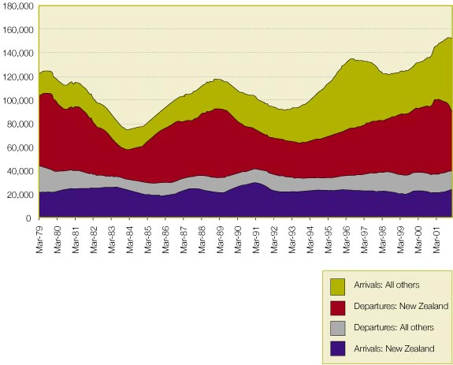
Figure 13: Permanent or Long-term arrivals and departures by citizenship, 1979-2002

Migration trends in New Zealand are changing. Immigrants are coming from a wider range of countries. The increasing range of source countries means that immigration is a major driver of ethnic and cultural diversity. Arrivals and departures are growing both in size and as a proportion of the total population.
Net external migration has a small impact on total long-term population growth. But as it is highly variable year by year it has a big short-term impact. From May 2001 to May 2002, net migration shifted from a loss of 11,100 to a gain of 31,200, a rate unprecedented in the past 30 years. This rapid change creates problems. Various sectors, such as housing, transport and schooling, need to adapt at speed.
The small long-term net contribution of migration to the total population disguises growing inflows and outflows of people, as shown in Figure 13. Average annual net migration between 1979 and 2002 shows an annual net gain of fewer than 500 people. But there has been a tremendous turnover or ‘churn’ of people. Departing New Zealand-born people have been replaced by migrants from other countries. Many of these new migrants may also move on as increasing numbers of people have global working lives.
The increasing flow of people via international migration brings both opportunities and risks.
Skilled New Zealanders have more opportunities to gain work experience in other countries. This experience can be passed on should they return. On the other hand, skilled New Zealanders have a growing incentive to move overseas permanently, because of the relaxation of immigration policies in other OECD countries and because our economic growth has not matched that of other countries. It is more difficult to attract new migrants to replace our own skilled citizens.
People who migrate to New Zealand have, on average, higher measurable skills than the general population. However, they often face barriers to using those skills. While inflows have replaced outflows in terms of numbers, integration into the wider community often takes time. Ensuring successful settlement outcomes is a key factor in retaining migrants’ skills.
High levels of ‘churn’ and adjustment strains are likely to become features of New Zealand’s economy and society. If not done well, this adaptation could lead to a loss of productivity. The specific labour market effects of this are discussed later in ‘The Nature of Work’.
The social impacts of churn may also be large. High churn tests New Zealand society’s capacity to integrate new people. Migrants who do stay long term are likely to participate more in New Zealand society. More of a challenge may be the ‘transient’ migrants, who stay for only a limited period and have less reason to participate in society.
In addition, not everyone in New Zealand has the same view of the desirability of immigration. While there are overall social and economic gains to New Zealand, some New Zealanders gain and others lose. It would be unrealistic to expect those who lose to be enthusiastic about immigration.

Immigration
New Zealand has historically addressed skill shortages via immigration. But international demographic developments are likely to increase international demands for skills. For example, there are population projections suggesting the working-age population in Europe could fall by 65 million during the next 25 years. In addition, technology advances and social integration are lowering the barriers to the international movement of skilled labour. Restrictions on the international movement of skilled people are easing.
Thus our traditional immigration policies are not expected to elicit the same responses as in the past. Some countries will become more successful at recruiting skilled migrants. Such developments will not only make it more difficult for New Zealand to attract skilled migrants, but also increase competition for New Zealand’s own skilled workers.
The characteristics of people who come to New Zealand are conditioned by prevailing immigration policies. Selection criteria are important as well as New Zealand’s image internationally. How New Zealand decides to market itself in source countries will play a major role in the type of people who come here.

Emigration
New Zealanders emigrate long term for a raft of reasons. The biggest group is made up of young, healthy, smart people investigating opportunities overseas. There are 700,000 to one million New Zealanders living overseas, including 400,000 in Australia. Some will return later in life. They bring back work experience, knowledge and advanced qualifications. But the existence of outflows of young people who leave permanently also raises risks of creating a pool of elderly people with no local family support.
Another key group that emigrates is older people following retirement. Older immigrants who leave are often retiring to their country of origin or following their children overseas. But they take with them accumulated experience and resources, particularly as they tend to be wealthier than their non-migrating peers.
Families with dependent children feature less prominently in migration flows, probably because of the logistics of moving children. When they do move it tends to be permanent.
All emigrants are potential returning migrants. In addition we may leverage off their skills and talent through global networks.

Short-term migration
Short-term flows have also been increasing. The two categories of short-term visitors that have the greatest impact on sustainable development are tourists and students.
The number of tourists to New Zealand has roughly doubled in the past 10 years. Short-term arrivals of non-New Zealand citizens rose from around one million in 1992 to almost two million in the year to March 2002. Impacts from growing tourist numbers are discussed below.
Overseas student numbers have been growing rapidly. Numbers of overseas student approvals have increased in the last few years, from around 40,000 to nearly 70,000 per annum. Students are a mix of short- and long-term arrivals. Most growth has been from China. Overseas students are an important source of export earnings. They also provide a good opportunity to recruit skills and talent into the New Zealand population. As they already have experience of living in New Zealand, student migrants are likely to have better settlement outcomes and lower adjustment costs.

Internal migration
Internal migration involves the permanent or long-term change of residence of people between regions.
The majority of people who move do so within regions. But movement between regions has affected the distribution of the population, its age and ethnic composition, and levels of regional income. Internal migration plays a major role in regional growth and decline.
Internal migration can reduce inequalities if people move from regions with high unemployment to regions with low unemployment. But the movement of people also places pressure on both growing and declining communities. As a result, internal migration has a major impact on the sustainability of economic development, the maintenance of appropriate social infrastructures, and the environment. The movement of people affects the ability of regions to maintain services. This, in turn, affects their ability to retain young people and support local industry. Internal migration is an important consideration in designing regional development policy.
People are most likely to move to another region because of employment or educational opportunities. These opportunities are influenced by transport links, matching of jobs and occupations, and the skills and attributes of the local population.
In New Zealand, decisions to move are influenced by age, education and skills, gender, family structure, home ownership, and ethnicity. Other factors include quality of life and access to amenities. For many Maori, hapu and iwi affiliations are an important factor in where they decide to live.
In general, Maori, younger people and people of retirement age, and the skilled are more likely to migrate internally.
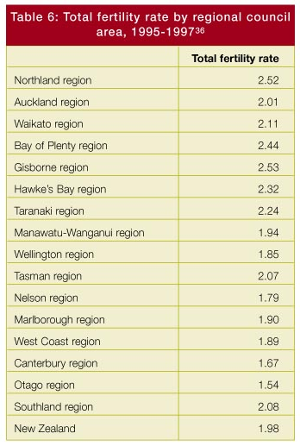
Natural increase
Regional population growth is the result of current net migration from other regions and overseas and natural increase.
Tables 6 and 7 provide an indication of rates of natural increase in different regions. Table 6 shows the total fertility rate by regional council area, while Table 7 shows the geographic distribution of different ethnic groups.
The distribution of the main ethnic groups indicates where growth from natural increase is fastest, as Maori and Pacific populations have higher fertility rates. Consequently Table 7 suggests that natural increase in the North Island and in Auckland will be faster than in the South Island.

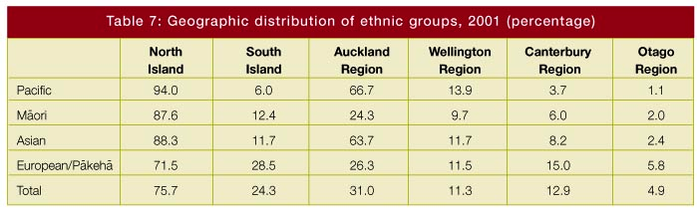

Age structure
Regional differences in age structure, partly because of fertility differences, have an influence on services, such as health, education and transport, needed in different regions. They influence the employment opportunities that are likely to be available, labour market participation rates, and the industries that a region can support.
Table 8 shows the age structure of selected territorial authority regions. Areas such as Kawerau, Manukau, Porirua and Gisborne, with youthful populations, are currently faced with youth unemployment, housing shortages, and other social problems.

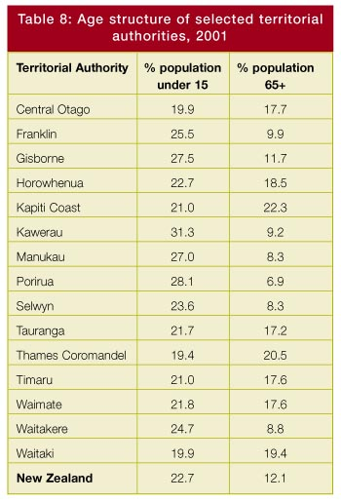
Regional development
Internal migration assists labour market adjustment.
However, many people are unable to move to improve their employment opportunities. They may lack the skills needed to make them employable elsewhere. They may face falling or low real estate prices so housing issues stop them shifting. In these cases, the impact of the ‘advantaged’ leaving the ‘disadvantaged’ behind may cause a vicious cycle of regional decline.
Nonetheless, part of the history of New Zealand is the story of decline of once-prosperous regions and the growth of other, more innovative ones.
Regional development policy is complicated by internal migration flows. Policy to improve the prospects of people in a particular region may be confounded by a large in-migration response. In these cases, assistance can end up benefiting new entrants to the region rather than the initial targeted population. More mobile parts of the population still capture the gains of regional economic change.
Rapid changes in local populations make it difficult for planners to predict future community needs. Problems are exacerbated by the long lead times required to build facilities that retain industries and prevent population loss.
Changing expectations and needs in the different regions highlight the importance of effective local institutions. Experience throughout the world shows that regions that succeed do so because their local institutions support innovation, and they have a strategy based on local resources.
Patterns of settlement
Changes in the mobility of New Zealand’s population impact on patterns of settlement, which has implications for sustainable development. Changing patterns of settlement raise issues around the growth of Auckland, infrastructure needs, housing, and tourism and its environmental impact, including land use.

The growth of Auckland
Auckland is New Zealand’s only medium-sized city. Economic development creates growing geographic concentrations like Auckland until the advantages of getting bigger eventually peter out. The challenge for smaller countries, or regions, is to focus activity in a way that achieves scale economies on some, if not all, fronts.
Rapid growth in Auckland and regional decline elsewhere have seen the potential development of two separate economies - Auckland and the rest. This has major implications for sustainable development, if Auckland is booming and other areas are declining.
Internal migration has played a significant role in the growth of Auckland. But the drift north has recently slowed. Current growth is the result of new international migrants settling in Auckland. This growth has raised concerns that Auckland’s limited infrastructure may act as a barrier to further economic development if the city cannot accommodate the skilled international migrants who are expected to want to live in New Zealand.
The population composition of central Auckland is also expected to change. There will be greater proportions of immigrants and of adults without dependent children. Alongside this trend is the increasing spatial concentration of poverty in greater Auckland, which has social implications especially if negative spill-overs result.
We live in one of the most urbanised nations in the world. The 2001 Census shows that nearly 86 percent of New Zealanders live in urban areas. These areas cover less than three percent of our total land area. Urban living can create noise, traffic congestion, air pollution, loss of privacy, and overloaded water supply and sewerage systems. Runoff from paved roads, footpaths and parking areas is contaminated with hazardous substances that pollute streams and estuaries. If left unattended these problems are expensive to fix.

Infrastructure
Infrastructure is a key issue in relation to patterns of settlement, particularly housing, transport, communications and the provision of public services.
Current housing location results from previous patterns of settlement and transport networks. New Zealand has high levels of home ownership. High levels of home ownership can slow down social adaptation and adjustment to changing employment if there is an increasing gap between the price of houses in growing and shrinking parts of the country.
The balance between the demand and supply of housing has also changed in recent decades as the result of a number of factors:
• the demand for housing is growing faster than the population as households become smaller
• the number of childless couples and sole-parent families has been rising. Both these groups have different housing needs from the traditional New Zealand family
• there are growing numbers of reconstituted families, who have some of their children living with them for some of the time
• Maori and Pacific families tend to be larger than European/ Pakeha families, so these groups have different housing needs
• housing status has implications for general wellbeing, particularly where living in overcrowded houses arises from economic hardship rather than positive choice
• access to adequate housing has long been recognised as a key issue for Pacific peoples
• some of the growing numbers of immigrants live in relatively large family groups. They need larger houses and houses that are designed differently from traditional New Zealand houses
• the younger age structure of the Maori and Pacific populations and their lower average incomes mean they are more likely to live in rented homes and less likely to own their own homes.
Second home ownership is becoming an important housing issue in many areas. Second home owners are generally welcomed by local authorities as they pay rates. But they may not contribute much else to the local economy, especially if they purchase their petrol, food and other goods elsewhere. This affects employment in the area of the second home, and increases local real estate prices. Second home ownership can push up local prices and mean that houses in some areas are beyond the reach of locals.
A significant number of non-resident land holders in an area also means that population density changes during the year. Changing density creates problems for the provision of services, such as water and sewage, and the area’s social dynamics.
Because of a low density population, New Zealanders rely heavily on cars for mobility. Car numbers are linked to economic growth. In Auckland, the efficiency of public transport and the demand for road networks for private transport are a continuing challenge. In de-populating areas, transport issues include deteriorating access to public transport and diminishing ability to afford road maintenance.

Tourism
Tourism in New Zealand includes visits by both domestic and overseas travellers. Tourism is a big industry. It now accounts for one job in 10.
Over 50 percent of international visitors come to New Zealand simply for a holiday. About 25 percent are visiting friends and relatives. Around 10 percent come for business reasons. International visitors directly contributed $4.9 billion to the New Zealand economy in the year ended March 2001.
However, domestic visitors make the major contribution to tourism, spending $6.9 billion in 1999.
The impact of tourism arises from both the numbers of people in a place at any one time, and the goods and services tourists consume from other sectors. Furthermore, when people go on holiday their consumption patterns change. The nature of that change - for example whether people purchase more luxury goods and services or live in a more self-sufficient way - will have a major impact on resource use. However, even a change to simpler needs by going to beaches or hiking can have major effects on environments.
Even when visitors stay only a short time, they have a major impact on the social density of places at different times of the year, and on patterns of settlement and the environment. For example:
• towns grow near tourist attractions
• tourist accommodation puts pressure on water, sewage, roads and other infrastructure. Problems are acute in tourist spots such as Punakaiki (West Coast of South Island) where a population of 300 supports the infrastructure for 650,000 visitors
• rapid growth in tourist numbers can limit access to particular areas. Growth has changed the outdoor experience of many areas that are traditionally part of the New Zealand lifestyle, such as the Abel Tasman National Park
• settlements that rely on income from tourism are highly vulnerable to changing tastes, economic circumstances in other places and the exchange rate
• these new settlements may exacerbate land issues for some Maori.
Tourism has economic benefits. But there is a risk that more tourists will increase environmental pressures. Consequently the sustainability of attractions that draw tourists to visit can be threatened. The ‘clean, green’ image that New Zealand enjoys is eroded if natural resources are not protected.
Nearly half the international visitors to New Zealand are not here primarily to holiday. Other factors will determine growth in their numbers. For example, a significant number of visitors come for business reasons. Their numbers depend on available business opportunities and the extent of overseas links with New Zealand firms. Similarly, while many visitors who come for other reasons are stopping over, many are on working holidays and studying.
The natural environment
The main drivers of human impacts on the natural environment are population growth, economic structure, technology and affluence.
In general, the more people in a country, the greater the environmental burdens. New Zealand is not expected to experience significant population growth over the next 50 years, but the high level of population ‘churn’ from both short- and long-term migration flows may increase the risk of environment exploitation. For example, tourists and residents who are not intending to settle in one place are less likely to have a long-term commitment to the local environment, or may have different attitudes to environmental conservation.
New technology affects environments in two main ways. The first is by enhancing industry’s ability to extract raw materials that were previously not viable economically. For example, technology has made it possible to produce oil and gas from fields that were previously considered too small or that are in areas with extreme geographical conditions that make production and transportation difficult. The second is by reducing environmental damage or pollution through alternative technologies or cleaner processes. Examples include energy production from renewable resources, more efficient use of resources in the production process, and enhancing the ability of one industry to use the waste products from another.
Affluence influences the ecological impact of a society through consumption patterns, air and water quality and problems with waste disposal and transport and energy use.
Economic activity impacts on the environment in two broad ways: the extraction (or removal) of natural resources to provide inputs to the economy as raw material (including the destruction or modification of ecosystems), and the discharge of waste products that pollute land, water and air. The nature and extent of these impacts are strongly determined by the structure and nature of economic activity. The structure of the New Zealand economy is changing but is still dominated by primary industries, including agriculture, fishing, forestry and marine farming. This contrasts with other developed country economies where secondary (manufacturing) industries play a greater role. Changes in production systems are most likely to be driven by changing preferences in our overseas markets.
In many developed countries, such as those in Europe, the major environmental impacts are often caused by pollution. In New Zealand, the major environmental impacts are the loss of natural habitat (and the natural species that rely on this) and pollution of air, fresh water and coastal water from activities such as energy production and use (including transport). Also, runoff from intensive farming, and urban storm-water.
The world of our children and their children
Our children and their children will be more mobile. They will be more likely to spend some of their working lives abroad. They will also be more likely to live in an urban environment, with fewer traditional community ties, more likely to have neighbours from many parts of the world, less likely to spend holidays on the farm with relatives, and more likely to have to travel to other parts of the world to see their families.
Future generations of New Zealanders are likely to be more environmentally aware. There will be opportunities for innovative firms to develop environmentally and socially sustainable solutions. Technology will also make it easier for New Zealand companies to compete in global markets in an environmentally sustainable way.
Selected areas of work by government with links to this issue
• Toward More Sustainable Settlements Project, being led by the Ministry of Transport, the Ministry for the Environment and the Energy Efficiency and Conservation Authority
• Sustainable Cities and Settlements, a research project being funded by the Foundation for Research, Science and Technology
• Regional Partnerships Programme, by Industry New Zealand
• Ongoing immigration policy development and monitoring of external and internal migration trends and immigrant employment outcomes by the Department of Labour
• Housing Strategy, by the Housing New Zealand Corporation
• Transport Strategy, by the Ministry of Transport
• Climate Change, being led by the Ministry for the Environment
• Local Government Act, being led by the Department of Internal Affairs.
2.3: A richer ethnic mix
Levels of social capital are a key characteristic of sustainable development and include the social systems, institutions, networks and relationships and interactions that facilitate co-operation and help society function effectively. The issues that arise from a more diverse ethnic mix in New Zealand relate most strongly to social and cultural capital. Social capital is a resource that exists because of and arises out of these interactions.
Social capital needs to be maintained and augmented as a way to move towards sustainable development.
Relationships between people who share family members, close friends and neighbours are bonds that play a significant role in people’s lives. Activities such as work, sports, religion and other voluntary pursuits help build ties between people who would otherwise have weaker bonds. The links and interactions between citizens are important for maintaining high levels of quality social capital.
As the New Zealand ethnic mix gets richer, it is important for sustainability to develop the social capital that builds bridges between ethnic groups, as well as the social capital within ethnic groups.
Traditionally, ethnic groups have been distinguished by ancestry, cultural values and customs, beliefs, language and common history. As ethnicity data is collected on the basis of self-identification it picks up cultural differences, albeit imperfectly. Nonetheless, the ethno-cultural dimension is just one feature in the broader picture of how people are connected. Connections are also based on gender, social class, sexuality, region, and other activities such as work, sports, leisure and religion. In addition, inter-ethnic marriages create generational and inter-generational linkages across ethnic groups.
At the same time cultures evolve. Our cultural values differ from those of our grandparents. For example, attitudes towards women’s roles, to raising children, to religion and to human rights have all changed. Additionally, it is important to acknowledge that within any culture there will be a wide range of values to be applied to issues.
Valid and reliable ethnicity data plays a crucial role in better understanding the complexities of contemporary New Zealand society. It helps in developing policies to better reflect the needs of New Zealand society in the future.
Government interest in New Zealand’s ethnic mix
Government has an interest in New Zealand’s ethnic mix for several reasons.
Firstly, the effectiveness of government interventions may differ according to ethnic group. Delivery needs to address issues of ethno-cultural fit.
Secondly, different ethnic groups may have different average socio-economic outcomes. Governments may see such outcomes as undesirable, especially if the differences are likely to reflect discrimination or impact adversely on social cohesion.
Thirdly, ethnic differences may, in the absence of social capital that builds bridges between ethnic groups, lead to costly social conflict. Bridging social capital can be difficult to build and easy to destroy.
Finally, ethnic groups produce cultural products (such as language) that are important collective goods to members of the group. Government-driven actions may enhance wellbeing by making it easier for ethnic groups to produce these collective goods.
Key ethnic trends in New Zealand
The current and future ethnic pictures in New Zealand are complicated by the fact that ethnicity is a complex multi-dimensional concept imperfectly captured in official statistics.
The Maori and Pacific population groups are growing more rapidly because of their younger age structure and higher fertility rates. This contributes directly to ethnic diversity.
Additionally, there is a substantial and increasing proportion of the population that identifies with more than one ethnic group. A high rate of childbearing from mixed relationships means that this group will continue to grow. Multi-ethnic people may build bridging social capital between ethnic groups.
Nearly a third of a million New Zealanders (324,093) specified more than one ethnicity in the 2001 Census. Nearly 60 percent of that third (193,500) reported both European and Maori ethnicity. The second largest combination was the nine percent of that third of people (30,018) who reported both European and Pacific ethnicity. The third largest combination was about five percent of mixed ethnicity people (15,606) who reported a Maori and Pacific combination.
The most rapid growth in multi-ethnic people has occurred amongst Maori. The number of Maori reporting multiple ethnicities rose from 26 percent in 1991 to 44 percent in 2001. In absolute terms those reporting only Maori ethnicity declined by eight percent between 1991 and 2001.
People who report multiple ethnicities most commonly report European/ Pakeha ethnicity as part of the mix. But multiple ethnicities are least common in the European/ Pakeha population (10 percent). Of Pacific peoples, 32.5 percent identify with another ethnic group as well, while 11.9 percent of the Asian group have multiple ethnicities.
Finally, the New Zealand population is becoming more ethnically diverse through changes in immigration patterns. New Zealand receives significant numbers of migrants from a broader range of countries than in the past. In addition, even given the country an immigrant is from, New Zealand now receives a greater variety of ethnic groups. For example, historically most New Zealand Indians have been from Gujarati or Punjabi ethnic groups. Today, Indian migrants are more varied in their ethnicity, including significant numbers of Sikhs, Tamils and others.
Implications of a richer ethnic mix
Diversity brings a rich ethno-cultural mix. For many it is a positive addition to their lives. A richer ethnic mix means that New Zealand is exposed to a wider range of views, new goods and services, a greater variety of cultural products, linkages to other countries, and a broader understanding of how the world works.
Sustainable social development issues stem from three key themes. First is the importance of having nationally shared common norms across different ethnic groups, such as tolerance of diversity and acceptance of fundamental democratic values. Secondly, implicit and sometimes explicit agreements are needed about the degree of diversity that society tolerates. Finally, agreement is needed about the issues that need debate by all sectors. Sustainable development will require mitigating the uneven impact of change on different ethnic groups through education, access to institutions and networks, and building social connectedness.
Sustainable population growth requires a climate of inclusiveness and acceptance of cultural differences. This highlights the need to think carefully about how to promote social cohesion which promotes co-operation and lessens conflict. It also promotes greater social and economic gains.
If New Zealand is to take advantage of opportunities arising from diversity, we need to change many of our traditional attitudes. This will require leadership from many sectors of society.
A key sustainable development principle is the need to take extra care when outcomes are irreversible. This highlights a critical sustainability issue related to Maori language.
Language is a tool for communication of common cultural meanings. For many New Zealanders, the Maori language is fundamental to Maori identity, and underpins Maori social and economic development. It also has symbolic value, in that it nurtures a sense of belonging in New Zealand. It provides a road of continuity to the past. Additionally, knowledge of minority languages and being bilingual may be an economic advantage. Others maintain that ethnic minority languages are of economic importance as they form a linguistic skill base for enterprises such as tourism and trade.
The Treaty of Waitangi is part of our constitutional framework. It protects Maori rights, including rights to language, enhancing Maori development. The Treaty settlement process and the related fisheries and forestry developments are important for facilitating Maori development.
Provisional results of the 2001 Survey of the Health of the Maori Language show that 42 percent of Maori adults aged 15 years and over (136,600 people) speak Maori to some extent. Maori language use was limited in household situations. The Social Report 2001 highlighted that Maori who live in an area with a high proportion of Maori residents are the most likely to be Maori language speakers. Regions with higher than average proportions of Maori with conversational Maori skills were Gisborne (34 percent) and Bay of Plenty (27 percent).
These statistics demonstrate that retention of Maori language has stabilised since the 1970s. This stabilisation has been led by Maori initiatives, such as kohanga reo (Maori language nests), government support, and new speakers of Maori within younger age bands. While there has been some success of kohanga reo it remains unclear how successful this approach will be in arresting language decline amongst younger people.
The Maori language continues to be ‘at risk’ of becoming extinct. Total language loss is effectively irreversible. Unlike other ethnic groups who come from locations outside New Zealand, Maori don’t have the option of returning to a native environment as a way of maintaining this aspect of their ethno-cultural identity. This places emphasis on the need to sustain language as a key element of Maori culture.
This is an issue for other groups (migrants and their children), as acculturation into New Zealand society can sometimes be achieved through the relinquishing of native languages, highlighting the tension between bonding and bridging social capital.
The world of our children and their children
Our children and the children of their cohorts will be more ethnically mixed than their parents and grandparents. They will have a greater knowledge of different cultures. A growing recognition of the importance of cultural capital means our children are likely to place a greater emphasis on te reo Maori and other cultural values that they can pass down to future generations.
A greater number of people whose origin was the Pacific, Asia and other countries will be New Zealand born. They will face similar issues around their language and culture, particularly the smaller groups. These issues will be exacerbated for groups who have more of their people living in New Zealand than in their original homeland. It is not clear, however, whether the trend will be towards groups of people struggling to maintain their traditional cultures, or whether a new culture and national identity will emerge that can embrace and integrate aspects of the adopted country.
The greatest number of New Zealand people must be able to access New Zealand institutions, if we are to avoid social conflict and attract people from around the world to live here. There is a need for a common, flexible culture of acceptance to evolve if New Zealand is to have a sustainable future.
Selected areas of work by government with links to this issue
• Ethnic Perspectives in Policy, by the Office of Ethnic Affairs
• Review of Ethnicity, by Statistics New Zealand
• Survey of the Health of the Maori Language (2001), by Statistics New Zealand and Te Puni Kokiri
• Maori Language Strategy, by Te Puni Kokiri
• Reducing Inequalities, interdepartmental
• Capacity Building, interdepartmental.
2.4: Fertility and family formation
Changes in fertility have implications for sustainable development. Fertility will continue to be an important driver of future changes in the size and composition of the population. Equally, work and family issues have broader implications for both fertility and sustainability.
An ageing labour force will increase the demand for women to be in paid employment and this may exert downward pressure on fertility.
Major changes in fertility and family formation have occurred over the past three decades. These changes are not unique to New Zealand. They have occurred across most developed countries.
An important aspect of this transition has been a return to a long-term trend of low fertility.
Accompanied by a shift towards older parenthood, an increasing proportion of New Zealand women are postponing childbearing. Birth rates at older ages have risen. The trend to later parenthood has also been accompanied by an increase in the proportion of women remaining permanently childless. Among women who do have children, there has been a decline in big families.
However, the rise in birth rates of older women suggests that recent trends are partly a repositioning of fertility rather than a total abandonment of childbearing. At present, it is unclear whether the catching up of fertility at older ages is sufficient to compensate for declines at younger ages.
Changes in fertility have been accompanied by changes in family formation. The proportion marrying has declined. The age at first marriage has increased, as has cohabitation, particularly at younger ages. There has been increased union breakdown and a corresponding growth in re-partnering. There has been a growth in social acceptance of same-sex relationships.
These changes have resulted in more diverse family forms. An increasing proportion of children now spend some time living with a single caregiver, changing patterns of partnering and re-partnering have been accompanied by an increase in those living in reconstituted families, and over 5,000 families identified as same-sex couples in the 2001 Census.
While New Zealand has experienced a fertility transition broadly similar to most developed countries, there are differences across ethnic groups. The Maori population has experienced delayed and accelerated fertility decline. Maori fertility fell rapidly during the 1960s and 1970s, and by the early 1980s had almost converged with that of the non-Maori population.
Maori and Pacific women continue to have a higher average number of children than the European/ Pakeha population. There are also ethnic differences in the timing of childbearing. Maori and Pacific women are more likely to have children at an early age than European/Pakeha- women.
Recent trends, however, show an upward shift in the age of childbearing among Maori women. This suggests Maori may be moving towards the fertility patterns of the European/Pakeha population. As yet it is too soon to be sure if this is a temporary phenomenon or indicates fundamental change in fertility behaviour.
Drivers of fertility decline
Changes in fertility have been driven by a complex range of social, economic and cultural factors. A comprehensive review of these factors is beyond the scope of this report. But some of the possible explanations for recent fertility changes include changes in female education and earnings, and changes in the norms and values around childbearing.
Changes have increased the costs to women of not working, in terms of loss of potential earnings. Changes in female economic behaviour have also been accompanied by shifts in attitudes, with an increased emphasis on female careers, and a reduction in gender-role specialisation, which further supports lower fertility.
A similar argument links recent fertility changes to the emergence of dual-earner couples, and the increasing importance of having a second income to meet lifestyle aspirations. Female earnings are progressively more important for the accumulation of assets, consumer goods and the overall economic wellbeing of the family.
On the flip side, many direct costs of having children are also increasing, including childcare, school expenses, and supporting children through tertiary education. The increased cost of having children contributes to postponement of childbearing and declining fertility.
Fertility decline has also been linked to a long-term shift in values systems including an increased emphasis on individual autonomy and the expression of ‘higher order needs’, such as freedom of choice. These changes have resulted in increased individual decision-making around fertility, a growing acceptance of non-traditional lifestyles and an acceptance of non-traditional female roles. These factors support both lower and later fertility.
Low fertility
Over the past 20 years, most developed countries have experienced below-replacement fertility. At around two births per woman, the total fertility rate in New Zealand remains closer to replacement than in most developed nations. But our fertility is expected to fall further over the next two decades.
Below-replacement fertility directly contributes to the process known as structural ageing. Structural ageing occurs when progressively smaller birth cohorts narrow the base of the population age structure, and increase the proportion of the population in the older age groups.
Structural ageing is occurring in its most extreme form in Japan and many southern European countries where fertility rates have been at low levels for several years. Very low birth rates are placing considerable pressure on social institutions, including the age pension and health care system, as increasing proportions of the population are accessing these services.
The prospect of rapid population ageing and future population decline has also raised concerns over the effects on economic growth and labour supply. From a sustainable development perspective, continued low fertility is of concern, as it reduces the size of the labour force and may impact on economic growth.
A further decline in birth rates will increase population ageing and consequently affect the sustainability of social institutions. Conversely, an immediate return to high fertility would swell the number of children in the population at the same time as the older population is undergoing rapid growth. Such a pattern would exert considerable pressure on working-age people.
Migration can moderate but not reverse structural ageing. In the long term, migrants also age and ultimately contribute to ageing. Furthermore migrant numbers required to offset ageing are large and are likely to be unsustainable. Finally demographic trends in other developed countries mean that New Zealand will face increasing competition in attracting skilled migrants (see the discussion in ‘Mobility and Patterns of Settlement’ earlier).
Work and family issues
Recent family formation trends, including delayed childbearing and a decline in family size, have increased women’s ability to participate in paid employment. On the other hand, increasing labour force participation among women is likely to affect decisions around childbearing, particularly the timing of first birth. However, cause and effect in the changing interaction between work and family issues are not always clear.
An increasing proportion of women combine paid work with childcare. As a result, factors that reduce role conflict, such as the availability of quality and affordable childcare services and the development of family-friendly workplaces, are becoming more important.
While the overall age at childbearing has risen, a small proportion of women have children at an early age. These women have different needs, including the provision of second-chance education opportunities and development of childcare services that are accessible to those participating in education and in work.
Traditionally the extended family has provided an important source of unpaid childcare. A number of recent demographic changes may impinge on this relationship. Older women, traditionally an important source of childcare, are now more likely to be in paid employment than previously. Increased family mobility and the geographical isolation of family members may also influence the extended family’s capacity to provide childcare.
Emerging parenting arrangements also have implications for the design and mix of childcare services and workplace policies. A small but increasing proportion of fathers are undertaking primary childcare responsibilities. There has been a trend towards joint parental care-giving responsibilities. The variety of childcare arrangements following separation and divorce are also significant.
Economic circumstances of families
Changes in family structure have implications for families’ economic circumstances. Sole parent families are more likely to experience difficult economic circumstances than two-parent families. In 1997-1998, more than half of sole-parent families had incomes below a poverty threshold (defined as families with incomes below 60 percent of the median, adjusted for housing costs). This compares with 18 percent of two-parent families. An increase in sole-parent families has implications for resources available to children.
Increasing diversity is also apparent in the economic circumstances of two-parent families. There has been an increase in ‘work rich’ families, in which both parents are in full-time employment, and ‘work poor’ families, where neither parent is in paid work.
An increase in families experiencing economic difficulties has implications for the distribution of resources across generations. Support needs of families with dependent children are competing against those of the ageing population. Families who experience prolonged economic hardship are less able to save for their own retirement and are more likely to be completely dependent on taxpayers.
Family support networks
Changes in family formation, including smaller family size, increased childlessness and higher rates of separation and divorce, have implications for support networks available to an ageing population. Smaller family size, for instance, reduces the number of adult children who can potentially provide care for their parents. At the same time, smaller families may have positive effects in increasing the economic resources available to family members.
The implications of increasing levels of separation and divorce among recent cohorts are unknown. One outcome may be a weakening of intergenerational ties and consequently a reduction in the size of family support networks. The economic consequences of separation and divorce may result in families that are less able to invest in their children. Conversely, higher rates of re-partnering and the formation of ‘reconstituted families’ may increase the size of family support networks and raise the importance of the roles of aunts and uncles.
Future trends
Fertility is a key driver of the size and composition of the population.
Predicting future fertility is difficult. Current trends, however, show a marked increase in the proportion of women in their 20s and 30s who do not have children. At this stage, it is unclear whether women are delaying childbearing or whether an increasing proportion of women will remain childless.
Experience of previous cohorts suggests that permanent childlessness is not a preferred option for New Zealand women. Information on the reproductive intentions of childless women shows that most expect to have children at some stage. Only a small proportion intend having only one child. Recent trends may reflect a postponement rather than an abandonment of fertility altogether. However, male decisions about fathering children are also important in determining fertility trends. Little information is available on male fertility decisions.
However, high levels of childlessness among women in their 20s and 30s makes it difficult to discount prospect of further fertility declines.
A consideration of New Zealand’s fertility requires an understanding of why fertility is low. The factors that influence fertility are many and complex. Many of these trends are ongoing. It is possible that fertility will not be made up at the older ages, as many women and couples reassess their plans or experience difficulties in conceiving at the older ages.
Coupled with this, there is no developed country where fertility is increasing. Many comparable countries are currently exhibiting birth rates at much lower levels. All of these changes suggest that New Zealand’s fertility may decline further.
Any examination into future fertility patterns, however, needs to consider factors specific to the New Zealand context. At present, the higher fertility and younger age structure of the Maori and Pacific populations are resulting in a total fertility rate that is relatively high by developed nations’ standards. Although fertility is also falling among Maori and Pacific women, levels of childbearing remain significantly above that of the European/Pakeha population. This may counter a future shift towards very low levels of fertility.
The world of our children and their children
Children born today will face different choices about partnering, childbearing, education and work. Pressures and incentives to work are likely to increase over coming decades, which may result in parenthood being postponed or abandoned.
Our children and their children will grow up with older parents and grandparents. They will have smaller numbers of siblings than current and past generations. This may have implications for parenting style and the nature of children’s relationships with their parents and grandparents.
Changes in partnering patterns suggest that our children and their children will frequently experience more complex family networks, including step-parents and step-grandparents.
Selected areas of work by government with links to this issue
• Pay Equity discussion paper, by the Ministry of Women’s Affairs
• Agenda for Children, by the Ministry of Social Development
• Youth Strategy, by the Ministry of Youth Affairs
• Family Dynamics research programme of the Ministry of Social Development
• Future Directions, by the Ministry of Social Development
• Future of Work, by the Department of Labour.
2.5: Growing older
The average age of New Zealanders is increasing. This continuing trend is the result of improvements in life expectancy and a fall in fertility rates to sub-replacement rates.
The ageing of the New Zealand population is not a new phenomenon. But the combination of a large cohort about to reach retirement age and a small cohort about to enter the workforce creates major risks for the sustainability of New Zealand’s development. Prospects of an ageing population raise concerns that living standards will fall because increases in old-age dependency will mean that output per worker has to be shared amongst a larger population of non-workers.
The number of elderly people in New Zealand around the middle of the 21st century may be higher than suggested by official population projections. Official projections are centred around an assumption of an increase in life expectancy of one year per decade on average. This compares with an experience of a gain of two years per decade during the 20th century for New Zealand and many other industrial countries.
The greatest growth in the world’s older population will be in developing countries, where population ageing is occurring at a faster rate than in industrialised countries. But it has been in industrial countries where the debate on ageing has been keenest. This debate has focused on the increasing proportion of people who are old. It reflects the importance to industrialised countries of the accompanying shrinkage in the size of younger generations and the costs of health care and pensions.
Increases in life expectancy can come from two sources: increases in the number of people reaching old age and increases in potential lifespan. There is evidence to support the former source of expansion in life expectancy. There is growing evidence that potential lifespan is increasing as well. Declines in mortality over the early part of the 20th century were concentrated at younger ages. More recently they have been concentrated among the aged. For example, the number of centenarians is increasing at an exceptionally rapid rate, mostly because of declining mortality after age 80.
Ageing trends for European/Pakeha in New Zealand are in line with other OECD countries, with the greatest impact on the proportion of elderly people the result of the powerful cohort effect from the baby boomers, as opposed to changes in life expectancy
There is little evidence of a simple relationship between income growth and falling mortality, nor between income inequality and mortality rates. But there is evidence that advances in pharmaceuticals, the care of heart disease and levels of education attainment are associated with decreases in mortality. Improvements in life expectancy for men have been smaller than female gains. A faster rate of improvement for females, despite already having lower mortality rates, is evidence that death rates at older ages are not yet approaching biological limits
The significance of increasing life expectancy for older age groups on population statistics can be demonstrated by its impact on the numerical growth of female octogenarians in England and Wales. More than half a million females aged 80 and over are alive today in England and Wales who would have been dead if mortality after age 80 had not fallen from 1950 levels.
Why changes in life expectancy, longevity and mortality matter
The economic and social environment will be influenced by changes in both the lifespan and the vitality of individuals at increased ages. Hardship is likely to increase, the greater the length of time older people spend economically and physically dependent on the assistance of younger generations. Conversely, increased years of economic and physical activity can lessen this hardship. It is open to debate which of these forces will dominate in the coming decades. The impact of an aging population may be greater:
• the lower the growth in working-age population
• the lower people’s willingness or ability to participate in the workforce
• the higher the rate of survival (both into retirement and through retirement)
• the lower the pace of productivity growth (which will impact both on the wages of workers and the returns made on assets accumulated by people as they age.

Labour market participation
We can expect the labour market to respond to a shrinking workforce by raising real wages to encourage higher participation levels. However, it is not clear how older workers will respond, particularly if wage gains are offset by higher taxes to cover increased public expenditure. These issues are discussed in more detail in Section 2.6.

Public finances
Ageing populations will put pressure on public finances, as superannuation payments and health-related expenditures rise. As pressures on welfare systems mount, so will pressures for people to provide for their own retirement. If older people remain active, they are likely to contribute both socially and economically to the wellbeing of their families and communities.

Saving rates
People’s saving behaviour during their working lives will influence their welfare through old age. The wealth held by the elderly will increase their independence by reducing their reliance on transfers from the young. Saving behaviour shows significant gender and ethnic differences. The saving decision process is complex and not well understood.
There are two opposing views about what will happen to the international financial system from 2011 when the baby boomers begin to retire. One view is that they will be trying to liquidate their assets simultaneously, driving down asset prices and leaving baby boomers with a smaller nest egg than anticipated. The other view is that forward-looking financial markets are pricing assets to incorporate the ageing of the boomer generation. As a result there will be no market meltdown when the baby boomers retire.
Given people’s preference for investing in real estate in many countries, many researchers have focused on the impact of an ageing population on housing markets. The consensus view is that there could be a decline in house values as supply exceeds demand. This raises the question of whether home equity should be included in considering the resources available to finance boomers’ consumption in retirement. While it is unclear to what extent today’s aged use their home equity to finance consumption, the aged in the future may need to make greater use of this source of finance.

Productivity
There is little evidence as to whether an ageing workforce will stimulate innovation and productivity or be less dynamic and have a negative impact. Therefore the main population impact on productivity is expected to come from higher capital investment as labour becomes more scarce.

Consumption patterns
World expenditure on medical and pharmaceutical technology is likely to increase in coming decades. One view is that the post-World War II baby boom has been a strong force in determining economic events. It will continue to be in coming decades. Whenever boomers reach a new stage of life, demand for related products soars. Demand slumps when they move on. The first boom was in baby products. In the 1950s and 1960s, the key issue was pressures placed on schools. Likewise, as this generation approaches retirement age, ageing issues dominate. The ageing of the baby-boom generation points to strong growth in the following industries:
• preventive health care, disability-related equipment and medical technology firms
• travel, leisure and entertainment firms
• financial services
• technology firms.
An increasing proportion of society will be interested in old-age health and disability products. This demand will increase activity in this area. This may result in further improvements in both length and quality of life. Growing ethnic diversity will also impact on the products and services that are available. For example, formal care for the old will need to take greater account of different cultural needs and tastes, in both the type of care that is available and the food that is provided.
Consumption patterns are also influenced by social and cultural values. For example, the increasing value that people place on the environment has meant demands for cleaner air and water, and reduction of waste and the use of hazardous chemicals. We are likely to see an increase in demand for improved urban environments.

Health
Part of the increase in longevity reflects the benefits of past medical and lifestyle improvements. Improvements in the treatment of cardiovascular disease and changes in individual behaviours, such as smoking and diet, have greatly reduced middle-age death rates, particularly for men.
Another reason for optimism about increases in life expectancy in the future is the contribution of advances in medical technology to reducing mortality rates. The amount of resources and effort the world devotes to improving medical knowledge will have a direct impact on life expectancy.
However, increasing longevity may not necessarily mean an increase in disability-free life. In 1998, over half of New Zealanders aged 65 and over had a disability, with significant numbers needing help with everyday activities such as preparing food, bathing, housework, getting out and shopping. Women have more disability-free years than men. Combining projections of ageing and disability implies reductions in prevalence rates of disability for those over 65, but an increase in overall disability numbers.
Health technology improvements will increase life quality and reduce disability. There is likely to be a correlation between longevity and functioning capabilities, with an increase in life expectancy likely to imply an increase in the fully functional component of individuals’ lives. This time could be spent being physically, socially and economically active.
Another factor that may reduce care costs for the elderly is that longer life for males translates into a re-balancing of the female to male ratios in the older age groups. As the number of ageing couples increases, along with an increase in the preference and ability to live in their own homes, the need for formal care may fall. In addition, severe disability only appears at the very end of life. For the age group 60 to 80, disability symptoms have declined over time, while life expectancy without severe disability is increasing across countries. If such tendencies continue, the impacts of ageing on long-term care needs would be substantially reduced.
By international standards, the female advantage over males in life expectancy in New Zealand (5.1 years) is among the lowest in the developed world. Iceland currently holds the distinction of having the greatest life expectancy for males at birth (77.5 years), living on average 1.8 years longer than New Zealand males. Japanese females, with a life expectancy at birth of 84.0 years, live on average 3.2 years longer than New Zealand females. Iceland has the lowest female-male difference in life expectancy at birth (3.9 years) while Japan has one of the highest (6.9 years).
While there is significant potential for further improvement in both male and female life expectancy in New Zealand, the implications for the sex gap are unclear.
Given the high mortality rates of Maori and Pacific peoples, an obvious avenue for future improvements in the longevity of New Zealanders is to improve the life expectancies of these populations. The latest life tables (1995 to 1997) suggest that a non-Maori girl can expect to outlive her Maori counterpart by 9.0 years. For newborn boys, the non-Maori advantage is 8.1 years. However, adults between ages 30 and 70 are disproportionately contributing to this difference, indicating that the disadvantage has accumulated during their childhood and young adult years.
The world of our children and their children
Our children and their children are likely to live in a world where they will compete for resources with a powerful older age lobby. The smaller size of their cohorts means future generations will have less purchasing power than older generations. More consumer products will be aimed at older people. Key issues will include euthanasia and personal security and safety.
Being part of a society with many older people has implications for our children’s and their children’s ability to plan for their own retirement, and their ability to support their families as well as participate in other activities. Having older parents and being older parents, combined with needs to provide higher levels of education for their own children, mean that more of our children will have several generations simultaneously dependent on them.
On the other hand, our children and their children are also likely to live in a world where the elderly are fitter and more active than they are now. An increasing proportion of older people will have different cultural, social and environmental requirements than the present elderly population. The results are difficult to predict.
Smaller families and growing wealth are also likely to result in larger inheritances spread among fewer people. This will ease the financial burden for some, but increase the risk of a higher disparity of wealth amongst the population.
Selected areas of work by government with links to this issue
• Work by the Senior Citizens Unit of the Ministry of Social Development.
2.6: The nature of work
The performance of the economy will have a profound impact on the wellbeing of people living in New Zealand. An integral part of this will be the performance of the labour market, not only in its importance to overall economic performance but also in its direct impact on the wellbeing of individuals and communities. Paid employment is not only the key source of income for most people, it is also an important dimension of people’s participation in society:
“The type of paid work we do - whether it is full time or part time, the skill level of the work we do, and the level of income it attracts … determines our standard of living, and the opportunities we are able to provide for our families. It affects how we feel about ourselves and the time we have to undertake non-work activity.”
The changing New Zealand population structure has significant implications for the labour market in upcoming decades. In this section we will focus on the implications of:
• an increasing average workforce age
• the retirement decision
• greater participation by groups who do not fit a traditional male working model
• unpaid work
• reductions in the size of cohorts entering the workforce
• the role of skills in labour market performance
• the process of skill acquisition
• an increasingly global labour market.
Implications of an older workforce
The extent to which the average age of the workforce rises depends on:
• when workers decide to retire
• when young people decide to enter the workforce
• how workers participate during the middle years of life.
How these three decisions pan out, and what influence factors like migration patterns, technological changes, human capital developments and government decisions play upon them, will contribute to how New Zealand adapts to demographic pressures in coming decades.
There are both advantages and disadvantages associated with an older workforce.
Older workers are, in general, more experienced and more productive. Higher productivity means higher incomes, which in turn implies a heightened capacity for society to support its dependants. Older workers are generally in poorer health. But improvements in health mean that each new cohort of older workers is more physically capable of working at advanced ages than previous ones. From a physical perspective, the latitude of choice about continuing to work or retiring is likely to continue improving. However, there will be proportionally fewer young workers to undertake physically demanding work.
As part of an international survey, the Ministry of Education’s report Adult Literacy in New Zealand, Results for the International Adult Literacy Survey shows that low skills are more prevalent among older workers. Some employment problems for older workers are due to poor literacy and numeracy. Analysis shows that low skills of older workers have more to do with cohort effects than the ageing process itself. Literacy skills, for example, show no more than a modest decline between ages 40 and 65.
In 1995 42 percent of workers in New Zealand aged between 50 and 64 years had less than upper secondary education. This is expected to decline to about 31 percent by 2025. Thus new cohorts of older people will be considerably better educated than in the past. Consequently the skill disadvantage will be reduced.
Other potential problems from an ageing workforce include age discrimination, a possible reluctance of employers to invest in skill training for older workers, and a potential unwillingness among older workers to take lower-paid work or re-train.
Returns on training to the employer will be assessed against the worker’s expected remaining tenure, which is likely to be shorter than their total expected remaining working life. A lower quit rate of older workers raises the relative expected returns to training older workers. Similarly, rapidly changing skill requirements reduce the importance of a long payback period in selecting trainees, but could magnify the importance of any age-related decline in the ability (or willingness) to learn new skills.
In regards to training, a distinction needs to be made between general and specific skills:
• as workers age, skills learned on the job become more important relative to skills learned in school. The more specific nature of on-the-job skills means there is less portability in the skills of older workers. They thus risk large earning losses if they change employers or are made redundant
• firms may under-invest in general skills because these skills are more portable. This market failure is likely to have more acute impacts on older workers owing to the greater period of depreciation in general skills and the compounded effect this might have.
There are a number of other factors that affect older workers:
• under-paying junior workers and over-paying senior/long-tenured workers may have adverse effects on older workers who are attempting to delay retirement or change jobs. Essentially, the wage expectations of older workers might exceed their value to the firm
• the overhead costs of hiring are a doubled-edged sword for the older worker - on one side they increase job security, on the other they act as a disincentive for hiring people who are perceived to have just a limited time in the workforce
• age discrimination appears widespread, but its influence is difficult to identify accurately
• evidence on the substitution patterns for workers of different ages is reasonably limited, but indicates that workers of different ages are quite good substitutes in production. To the extent that this finding is reliable, it suggests that modest declines in the relative earnings of older workers would be sufficient to secure employment for them in the future. However, this side-steps the difficult issue of whether an older workforce will be less adaptable
• age-earning profiles tend to indicate that earnings increase up to around age 50 and then either stabilise or fall until retirement. But it is problematic to differentiate cohort effects from age effects.
Skill levels and ongoing training will have an important bearing on the wages that older workers can command, and hence also on their willingness to stay in active employment.
The retirement decision
Retirement decisions are complex. Today there are many paths to retirement. For a start, the decision to retire is not always a finite one. Conceptually full retirement occurs when a person leaves the workforce and never re-enters it.
In reality there is always the possibility that circumstances will change and a retired person will decide to return to paid work. In other circumstances the retirement process could be quite gradual or be used as an opportunity for a change of career.
In the traditional male working model of factors influencing the retirement process, wages rise as experience, skill and responsibility increase. Eventually wages peak. They may even decline. At the same time, leisure becomes more attractive because the amount of remaining life expectancy declines. There comes a point when free time becomes more important than the money earned in a job. A decision is made to retire.
This simple framework suggests that increased wages for older workers may delay retirement. Likewise an increase in longevity makes taking leisure time today less attractive (since there is more of it) and so also encourages delayed retirement decisions. At the same time, older workers earning low wages and lacking savings may delay retirement on the basis that they cannot afford to retire.
In real life retirement is influenced by more factors than merely wages and life expectancy. Personal health, job opportunities, access to wealth and family circumstances including care responsibilities for partners, parents, children and grandchildren are also key influences.
Although western society has come to regard retirement and potentially a long period of retirement as the norm, it is in fact a fairly recent phenomenon. At the beginning of last century retirement could be described as being relatively uncommon. In 1910, two out of three men past the age of 65 in the United States were employed. Even at age 72, male participation was over 50 percent. Burtless and Quinn (2000) argue that the long-term trend towards earlier male retirement has had an important voluntary component closely related to the concurrent rise in wealth. A study of five OECD countries showed that:
• the transition from work to retirement differs across countries: it is more gradual in the UK and US, and more abrupt in Germany, Italy and the Netherlands
• women tend to retire earlier than men
• civil servants and workers in manufacturing tend to retire earlier
• service workers and the self-employed retire later
• professionals and the better educated tend to stay longer in the work market
• the retirement decision is a joint decision, with the probability of retiring higher if the partner is not active
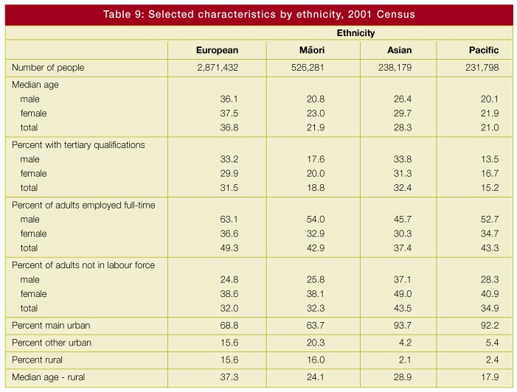
• heads of large households tend to retire later.
Greater participation by groups who do not fit a traditional male working model
However, the traditional male working model outlined above does not reflect typical patterns of many people’s working lives. Women typically experience increasing wages until their 30s, then a sharp drop in the childbearing years. A pick-up typically occurs later but there is never a catch-up to the levels of their male counterparts.
Nor does the model fit the working pattern of an increasing number of men and women who follow diverse lifecycle patterns of employment, including a non-partnered, work-focused life, sharing jobs and child-rearing, mid-life career changes and so on.
Our understanding of these changing trends for women and men is far from complete.
Table 9 presents a number of employment indicators from the 2001 Census broken down by ethnicity and gender, and the relative labour-market characteristics of different groups.
Women have traditionally had lower levels of education and job experience than men. However, women have been catching up on formal education and job experience since World War II.
There has been increasing participation in the labour market by women, particularly those of childbearing age. This trend reflects a number of factors, including changing attitudes to women’s roles, better contraception, the relative decline in manual labour, the rise in part-time work and greater individualism in society.
Today a growing number of women have genuine choices about their paid employment. This trend will continue. Female economic capacity will be enhanced by rising female educational attainment, falling fertility, and social trends removing barriers to women entering the workforce and earning high incomes.
Women’s diverse circumstances will play a role in their future labour market participation. Women’s preferences are likely to range from being full-time carers of small children to working part-time or full-time in paid employment. These decisions will be influenced by the availability of affordable quality childcare and flexible work practices.
The changing ethnic composition of the population is often seen as negatively impacting on economic capacity. Such views implicitly assume that any existing disparities in economic performance will persist. Indeed, the current relatively low level of participation of Maori at higher levels of educational achievement is likely to have ongoing adverse impacts on Maori ability to match capacity with opportunity. But participation and tertiary educational achievements for Maori are improving. Recent trends indicate that this upskilling may be translating into an expansion of Maori employment.
In a world where a growing number of people do not fit traditional male or female models of paid and unpaid work, policies that accommodate this diversity become imperative. Challenges involve creating new modes of work, new organisational forms, and new life-long learning systems. Policy questions include how to encourage more flexible working patterns, how to reduce the incidence of involuntary early retirement and eliminate discrimination, whether people’s expectations of how long they will be actively able can be changed, and how best to support people’s needs to balance work and family.
Unpaid work
In order for society to function, children, the old, the sick and the disabled must be cared for. Food must be prepared, houses cleaned and community activities undertaken. Much of this work is unpaid. Women undertake the majority of it. The distribution of unpaid caring responsibilities is a key economic issue for families. The time taken to do unpaid work limits the carer’s ability to participate in education or employment, and it frees others to get paid work. Indeed, the distinction between those who are economically dependent and independent may be a false one. Rather the relationship is one of mutual dependence.
The issue of who does unpaid work has wider implications for other women. If the work is not done by an unpaid family member, then the family must pay someone to do it. That person is likely to be a woman. Employing people to do these tasks is not an option for poorly paid women. These women must either meet the demands out of their own time, or rely on children or other family members to bear the load. This invites the question of how this unpaid work will be done in the future, as more women work longer hours in paid employment and more bring up families alone.
Fewer younger workers
Fewer young people entering the labour market means those young workers will be sought after. The costs of wasting young people’s potential will rise.
At the same time, the decline in competition for jobs may reduce incentives for young people to acquire broad-based skills. This suggests a potential for a concentration of enhanced qualifications within a highly educated minority. One implication of this would be a potential for considerable wage dispersion. In addition, businesses might find that they need to play a bigger role in training. For example, firms might find it increasingly worthwhile to secure the employment of promising school-leavers by funding post-school training.
In New Zealand the impact of shrinking numbers of new labour market entrants is still 10 years off. In each of the next 10 years, numbers of 20-year-olds will increase. However, once new labour market entrants begin to be dominated by those born in the 1990s, there will be a reversal in this trend. While ageing issues will not impact on New Zealand as much as other industrial countries in the upcoming decade, they are likely to become more relevant in following decades.
Technology to the rescue?
In recent times technology has worked against the unskilled. It has worked in favour of the skilled, creating skilled jobs and destroying unskilled ones.
This may not be the nature of technology advances in the future. Since skilled workers are now more expensive, there is profit in developing ways of doing things that employ now-cheaper lower-skilled workers.
Whatever happens, the importance of basic foundation skills remains. In addition to basic literacy and numeracy, foundation skills include other work and life skills such as punctuality, honesty, reliability and team skills. Although these skills can be developed in work environments, to a large extent they are conditioned by childhood experiences of family, community and school.
When looking ahead, a key question is whether the children who will become the society and workforce of tomorrow are sufficiently prepared. The school dropout of 2015 has already been born and will be entering the school system shortly. Now may be the most cost-effective time to ensure that these young people will have a set of skills that will enable them to engage socially and economically to their potential. This is one of the key areas where policy today will impact on sustainable development.
A global labour market
Over the next 25 years it is projected that around 70 million people in OECD countries will retire. They will be replaced by just five million workers. The working-age population will fall by 65 million. This contrasts with the past 25 years, when 45 million new pensioners were replaced by 120 million baby boomers in the workforce.
In Europe these demographic trends are more pronounced. Fertility rates are entrenched well under replacement rates. This effect has been exacerbated by pension systems that encourage workers to retire early.
Projected reductions in worker supply across the OECD will make the search for workers more international and encourage more open migration policies in many countries. Indeed there are already signs of a more relaxed approach to migration in Europe. For more and more occupations the effective labour market is becoming a global one.
Another consequence is that production processes are likely to become more capital intensive. As skilled workers become scarcer and in international demand they will become even more expensive. Employers will react by using more machines and technology to economise on higher wage bills. Increases in the demand for labour-saving ways of production will also encourage more research and development to focus on this. The pace of labour-saving innovations is likely to continue and even accelerate.
Both these trends will be observed in New Zealand. More New Zealand workers with skills will be operating in a global labour market. For more occupations, earnings will be determined by world supply and demand conditions, not just New Zealand conditions. As a result our labour market will become more sensitive to international developments.
If New Zealand’s conditions are not up to international standards, people will leave. The international demand for labour will be so strong that retaining talented people will depend on the alignment of New Zealand conditions to international standards.
Greater scope for New Zealanders to work abroad can widen New Zealand’s international networks and provide benefits from their experiences. A more global labour market may also mean that New Zealand will have greater access to international talent. Ethnic diversity within New Zealand can have a positive influence on New Zealand’s ability to attract talent, both through the contacts that a diverse migrant pool brings and by providing a more conducive environment for new migrants. But the competition for this talent will be intensive.
We cannot presume that New Zealanders will remain simply because they grew up here. Nor can we presume that simply changing our entry requirements will be sufficient to attract the talent we seek. Indeed commonly used net migration assumptions - for example, net inward migration of 5,000 - for population projections may be difficult to achieve. Population maintenance has as much to do with retaining New Zealand-born residents and past migrants as it does with attracting new migrants. Indeed the retention of New Zealanders is an important objective alongside the recruitment of new migrants because they are already adapted to New Zealand socially, culturally and economically.
Lessons from global capital markets
Although there are obvious differences between the migration of people and the migration of money, there are also interesting parallels. Countries have generally been more open to the international movement of capital than labour. International capital flows are enormous and rapid. In general, capital markets are well behaved with only gradual shifts in net balances or market prices. However, now and then there can be drastic pressures placed by capital mobility on a country’s financial system. International examples include Mexico in the early 1990s, Thailand, Indonesia and other Asian economies in the late 1990s, and most recently Argentina. In all these circumstances, perceptions of the sustainability of imbalances in these countries’ financial systems exceeded a trigger point. Everyone moved to a sell position and sought to take their money offshore. A crisis ensued.
A key lesson from the global migration of money for the global migration of people is the importance of fundamentals. Special deals and loss leaders might attract new customers, but it is the stable long-term conditions that ensure ongoing sustainability. In terms of populations, the impacts of fundamentals such as lifestyle, wages, opportunities and safety will outlast any artificial incentives that may be provided to attract migrants or influence New Zealanders to stay or return.
There is the chance of a downward spiral if New Zealand can’t get the right mix to attract, retain, regain and utilise skilled people. If we do get the mix right, our most talented will want to remain or return. And there will be a bigger pool of desirable prospective migrants to pick from.
The world of our children and their children
A slackening in population growth suggests economic growth and perhaps even productivity growth may decline. However, such adverse impacts on economic performance can be offset by the way society responds to the challenge created by these forces. For example, productivity of workers could increase through a combination of:
• industry using more machinery and better technologies
• better organisation of production
• improvements in workers’ skills and experience
• more rapid integration of new workers
• greater effort.
The combination of an ageing population, declining fertility and international competition for skilled workers could lead to labour shortages. The consequences of labour shortage may include:
• earlier entry into the labour market by school leavers who do not see value in tertiary education
• increases in hours worked
• better use of currently unemployed or under-employed people
• increases in workforce participation by the elderly, due to either necessity or better health and life expectancy.
Society’s sensitivity to the quality of economic management will increase. The consequences of mis-management will be more severe. In addition, the ability to support dependent sectors of society is likely to diminish.
The future for our children and their children will depend on whether they have the capacity to adapt to these challenges. Foundation skills will determine the extent to which people will be able to participate fully in work and society. Further out, economic performance will depend on the extent that the skills and abilities of these new workers match the opportunities available to them in New Zealand.
Selected areas of work by government with links to this issue
• Employment Strategy, being led by the Department of Labour
• Pathways to Opportunity, by the Department of Labour
• Work on job creation and destruction, by the Department of Labour
• Ongoing work associated with the Growth and Innovation Framework, led by the Ministry of Economic Development and Industry New Zealand
• Early Childhood Education, by the Ministry of Education
• Industry Training Review, by the Department of Labour
• Tertiary Education Strategy, by the Ministry of Education and the Tertiary Education Commission.

Conclusion
The population trends outlined in the report are not new or unique to New Zealand. They are largely the result of slow-changing factors set in train last century. There is little that can be done to influence the current population level and trend. While population trends are forces that influence outcomes, they do not pre-determine any particular outcome. Throughout history, societies have shown they can respond to potential doomsday scenarios, including those thrown up by population change. Nevertheless there remains a need to look forward in order to respond effectively.
A sustainable development approach to population issues focuses on the long term. A sustainable development approach reflects good policy development, which involves identifying the problem, assessing options for addressing the problem, considering interconnected issues, and taking account of long-term pros and cons.
A sustainable development approach also enables different perspectives to be drawn out from situations that may at first appear problematic. For example, slow growth in population size could be regarded as an opportunity to use resources that would otherwise be diverted to developing new suburbs or addressing associated social problems, and using them to improve education and training services, address environmental concerns and raise the general quality of life of all New Zealanders.
Population trends
The size of the resident population depends on the number of children that are born to different cohorts, the size of different cohorts, how long those children live, whether they choose to live here or emigrate, and whether overseas migrants stay here permanently or decide to move on. Temporary visitors impact on the total number of people in the country at any one time.
Population trends are ultimately the result of individuals’ personal decisions. But these decisions are themselves the result of complex interactions. New Zealand’s economic, social and environmental conditions will strongly influence the future population by affecting choices around women’s participation in the workforce, choices to have children, life expectations, migration decisions, where to live, and the type of education and training to invest in. In addition, industries and regions have a major impact on immigration policy, the type of migrants who are attracted to New Zealand, and rates of emigration from New Zealand. The relative success of some regions also creates internal population movements that will have profound impacts on both growing and shrinking communities.
Between 1900 and the 1970s the most significant factor in New Zealand’s population growth was numbers of births. Permanent net migration made a small but generally positive contribution.
In recent decades, population growth has primarily been the result of people living longer and positive net migration. In coming decades, the population is projected to grow modestly as a larger cohort reaches childbearing age, people’s longevity continues to increase and net migration remains positive. Beyond 2035 the population is projected to decline. Deaths will outnumber births. We cannot assume that net migration will make up the difference.
The shift from a population with a relatively high birth rate and a short life expectancy to one with fewer births but longer life expectancy will change the issues faced by New Zealand. These population issues are complicated by factors like the changing nature of work, changes in family formation and participation in paid employment, increased population mobility, the varying age structures across different groups, and growing population diversity.
These changes mean that our children are less likely to:
• grow up in the same house with both their natural parents
• work full-time in one job over their working life
• have children and large families early in life
• experience their grandchildren and live near them
• retire in their 60s.
Our children are more likely to:
• have multiple ethnicity
• live outside New Zealand
• have a tertiary qualification
• access life-long learning
• make a significant contribution to their own education, health and retirement.
The role of government
At periods in our history, governments have pursued active population policies by, for example, providing incentives to increase fertility and encouraging immigration from some countries but not others. However, it is debatable how effective the outcomes of these policies were in determining population outcomes.
Governments are not in a position to influence birth rates directly. However government policies, such as the welfare state, have had demographic impacts. Education, health and housing policies have also significantly improved the wellbeing of young families during periods of high fertility and rapid urban growth, and thus had impacts on people’s fertility choices.
In recent years, the direct role of government on population has been to encourage inflows of skilled permanent migrants through immigration policy. However, managing inward flows of permanent migrants is just one aspect of influencing the size and composition of a nation’s population. Other influences include outward migration trends, family formation trends and trends in mortality and longevity - all of which are difficult to control.
Therefore, the government’s role in population issues can be seen as wider but less directive than in the past. The government’s role includes considering public policy influences on:
• skill development
• health outcomes
• incentives to participate in the labour market
• the efficiency of the labour market in matching workers’ skills to employment opportunities
• regional development
• transport
• how people interact with the environment
• our ability to absorb a growing or shrinking population
• what we consume and what we produce
• the access that different groups have to policy interventions
• the diverse needs of different groups over their lifetimes
• the creation of a climate that enables a rich mix of ethnic diversity that is also inclusive
• characteristics that are unique to New Zealand’s population.
With the international demand for skilled people likely to expand, New Zealand’s success will be influenced by international developments as well as domestic policy. Population developments are likely to become increasingly sensitive to how conducive the New Zealand policy environment is, relative to other countries. Such an increase in sensitivity raises risks of increasing gross flows of people in and out of New Zealand. Such flows would represent a costly way of adjusting to changing conditions.
In a period of low fertility and an ageing population, the importance of improving the potential of people to contribute to the economy and society increases. Governments in New Zealand have tended to address problems as they arise on an issue-by-issue basis, rather than taking a future-orientated focus demanded by sustainable development. Analysis can give early signals of future pressures created by demographic trends. Forward planning by central government, in conjunction with local government, business, and community groups, can be effective. It is the whole package that matters.
Population developments have implications for the government’s fiscal position. Emerging issues include our current reliance on income tax and additional costs of care of the disabled and elderly as smaller and more dispersed families become more common.
The Intergenerational Report recently published by the Australian Government suggests that the impact of an ageing population on government expenditure may be less than expected. This optimistic conclusion arises because of a reduced need for spending on unemployment as a result of labour shortages and reduced payments for family benefits as a result of a falling birth rate. These two factors offset, to some degree, increased spending on superannuation. In addition, the report finds that 80 percent of the projected increase in health expenditure in Australia is expected to be the result of the cost of new technology, increased use of services and consumer expectations, rather than the ageing population per se.
We have a window of opportunity
A birth rate that is relatively high compared with other OECD countries and an increase in births around 1990 (the ‘baby blip’) mean that New Zealand has a window of opportunity to address potential future problems arising from the population trends identified in this report. The key issues facing New Zealand are discussed below.
A large cohort will soon begin retiring from the workforce. It will be replaced by a smaller cohort. This puts a focus on the children who are the labour market entrants of the 2010s and 2020s. The priorities for these children should be raising the quality of their education and addressing health and social barriers, so that they can meet the challenges of the future.
An older workforce needs a focused policy response, including finding ways to enable older people to remain in paid employment if they choose.
The ‘baby blip’ will reach late adolescence around 2005-2010, and put pressure on the tertiary sector, including apprenticeship training. The universities, in particular, could be facing a wave of staff retirements around that time.
New Zealand’s ability to attract, regain and retain the skills and talent needed for sustainable development will depend on getting three things right:
• ensuring that migrants can utilise their skills. The changing composition of source countries and the high levels of international competition for skilled migrants stress a need for smooth pathways for immigrants into sustainable employment opportunities and social participation
• offsetting potential negative impacts of the increased population turnover by building community participation and social cohesion
• putting in place conditions that encourage migrants to stay and expatriates to return. Family reasons will be one factor, but others include providing an attractive lifestyle, addressing infrastructure problems, and enabling access to opportunities.
Infrastructure and other issues have arisen from changing patterns of settlement, especially in Auckland.
Access to sustainable paid employment is increasingly important. Ensuring sustainable employment for all groups raises issues of life-long learning, work and family policies, the interface between the tax and benefit systems, regional and industry development, and co-ordination of government policies in general.
Growing ethnic diversity is a result of migrants arriving from an increasing range of countries, the faster-growing Maori and Pacific populations, and the rapidly increasing multi-ethnic population. The richer ethnic mix highlights the need for the development and maintenance of social capital. A richer ethnic mix has implications for social institutions, community cohesion and the development of ethno-cultural and national identity.
While societies do adapt to major change, governments can smooth transitions by having a vision for the future, identifying priority issues, and removing the barriers of tomorrow, today. This requires a long-term perspective, often at variance with the political pressures associated with a three-year electoral cycle.
Governments can build a consensus about broad directions, short-term and long-term goals, and the way those goals will be achieved. A consensus will be increasingly important as New Zealand’s population becomes more ethnically diverse and international trade and business links expand. Building a consensus not only plays a role in achieving political and social stability, but leads to an ‘ownership’ of policies and institutions by society that enhances the likelihood of success.
Governments therefore have a key leadership role in influencing attitudes towards diversity, education and social capital, with the goal of raising society’s capacity to adapt.

Glossary
Ageing population - there are two aspects of population ageing. Structural ageing refers to an increase in the proportion of older people in the population, and is primarily caused by falling fertility. Numerical ageing refers to an absolute increase in the number of aged, and is primarily caused by increasing life expectancy. A population is considered young when it has a median age (half the population is above and half below) of less than 20 years, and old when it has a median age of more than 40 years.
Agglomeration economy - a geographic concentration of people and firms which lowers costs for consumers (since the costs of searching for a product are lower when firms locate together) and lowers costs for firms (since it is cheaper to hire workers when they all live close to one another).
Birth rate - the rate of births relative to the base population.
Churn - see Population turnover.
Cohort - a group of people connected by a similar event, such as being born in a given year or period. The size of a birth cohort is the result of the prevailing birth rate and the number of women of reproductive age.
Death rate - the rate of deaths relative to the base population.
Demography - the study of the characteristics and dynamics of human populations.
Dependency rates - the number of people in the working-age population compared with the number of people younger or older than the working-age range.
Diminishing returns - returns are diminishing from the point where applying more productive input results in a lower increment to output than did the previous addition of productive input.
Economies of scale - lower costs arising from the expansion of production. Typically these are due to large concentrations of population and economic activity. Larger markets allow wider choice and a greater range of specialist services.
Emigration - is used in this report to mean Permanent and Long-Term migration (see separate definition below).
Ethnicity - a social construct of group affiliation and identity. An individual’s ethnicity or ethnicities identify the ethnic group or groups that they identify with or feel that they belong to at the time. An ethnic group is a social group whose members have the following characteristics: they share a sense of common origins; they claim a common and distinctive history and destiny; they possess one or more dimensions of collective cultural individuality; and they feel a sense of unique collective solidarity. Ethnicity is self-perceived and can change over time. People can identify with an ethnicity even though they may not be descended from ancestors with that ethnicity. People may choose to not identify with an ethnicity even though they are descended from ancestors with that ethnicity.
External migration - the number of people leaving New Zealand for 12 months or more, subtracted from the number coming to live in New Zealand for the first time or who have been away for more than 12 months.
Fertility - refer to Total Fertility Rate.
Gross Domestic Product - the sum of domestically produced goods and services.
Human capital - the accumulation of knowledge and skills embodied in a person, typically considered in terms of the economic benefits that derive from it. Human capital can be acquired formally, for example through schooling, or informally, for example through on-the-job learning.
Immigration - is used in this report to mean Permanent or Long-Term migration (see below). It includes migrant approvals under prevailing immigration policy, as well as former New Zealanders returning after a year or more away.
Life expectancy - the number of years that a person could expect to live on average, based on the mortality rates of the population in a given year. Life expectancy can change over the lifecycle. For example, at birth a person may be expected to live for 75 years, but if they survive to 75 they may be expected to live for another 10 years.
Mortality - see Death rate and Life expectancy.
Migration - the movement of people from one defined geographic area to another. It is also referred to as population mobility. External migration is the movement of people in and out of the country, while internal migration is the movement of people within the country.
Natural Increase - the contribution to the size of the resident population from births less the contribution from deaths. Natural increase is positive when the number of births exceeds deaths, and negative when deaths exceed births.
Net migration - the inflows of people into a region or country minus the outflows. Net migration can be measured in three different ways: as the total flows, short-term flows, or permanent and long-term flows.
Permanent or Long-Term migration - includes arrivals both of domestic residents who return to New Zealand after one year or more overseas and overseas residents who intend to stay in New Zealand for one year or more, and departures both of domestic residents who intend to leave New Zealand for one year or more and overseas residents who are departing from New Zealand after a stay of one year or more.
Population turnover - the sum of population inflows and outflows as a ratio of the total population base.
Short-term migration - arrivals and departures of domestic residents who are out of New Zealand for less than one year and of overseas residents who stay in New Zealand for less than one year.
Social capital - the combination of informal institutions, norms, conventions and social preferences possessed by a society enabling effective achievement of social and economic goals. Bonding social capital draws people in a given group more closely together, while bridging social capital builds links between social groups.
Social institutions - formal organisations and informal associations that contribute to social and community norms and networks. Examples are local government, trade associations, school boards, unions and voluntary groups.
Structural ageing - see Ageing population.
Sustainable development - an approach to decision-making, as opposed to a prescription of what the world should look like. Development is any process that aims to enhance the wellbeing of people and their environment. Development is sustainable when it achieves stable or increasing wellbeing over time.
Total Fertility Rate (TFR) - the average number of live births that a woman would have during her life if she experienced the age-specific fertility rates of that year. It excludes the effect of mortality. It is derived from the sum of the age-specific fertility rates relating to a given year, and subject to annual fluctuations in births. While TFRs represent each year’s experience, they do not necessarily represent the lifetime reproductive experience of real generations or cohorts of women. The TFR is sometimes used as a proxy for average family size, but it is an imperfect proxy because it is affected by delayed fertility and the proportion of women having no children. A TFR of 2.1 is regarded as the level of reproduction that replaces the population.

References
Ades A and Glaeser E (1999), ‘Evidence on Growth, Increasing Returns, and the Extent of the Market’, The Quarterly Journal of Economics, Vol. 114 (3), pp. 1025-1046.
Alesina A and Wacziarg R (1998), ‘Openness, Country Size and Government’, Journal of Public Economics, Vol. 69 (2), pp. 305-322.
Azariadis C and Drazen A (1990), ‘Threshold Externalities in Economic Development’, The Quarterly Journal of Economics, Vol. 105 (2), pp. 501-526.
Bacon B (1996), ‘An Ageing Society: A Working Life/Retirement Perspective’, Working Paper 96/4, Retirement and Income Modelling Unit, Australian Treasury.
Ball D (2000), ‘Delayed Childbearing in New Zealand’ An Analysis of Trends and Determinants, New Zealand Population Review, Vol 26 (2), pp. 91-104.
Barnes A (2001), ‘Low Fertility: A Discussion Paper’, Department of Family and Community Services, Occasional Paper No. 2, Canberra, Australia.
Bedford R (2001), ‘2001: Reflections on the Spatial Odysseys of New Zealanders’, Briefing Paper No. 2, New Directions Seminar, April.
Bell M and Hugo G (2001), ‘Internal Migration in Australia 1991-1996 - Overview and the Overseas Born’, www.immi.gov.au/research/publications/im.im1.htm.
Blöndal S and Scarpetta S (1998), ‘The Retirement Decision in OECD Countries’, Ageing Working Paper: AWP 1.4, Paris, OECD.
Booth T, Grimmond D and Stroombergen A (2000), ‘Determinants of Saving Behaviour’, Research Report 00/1f, Wellington, Office of the Retirement Commissioner.
Box S (2000), ‘Economic Geography - Key Concepts’, Treasury Working Paper 00/12, www.treasury.govt.nz/workingpapers/2000/00-12.asp.
Brooks R (2000), ‘What will Happen to Financial Markets When the Baby-boomers Retire?’, IMF Working Paper WP/00/18, International Monetary Fund, February.
Bründtland G (ed) (1987), Our Common Future: The World Commission on Environment and Development, Oxford, Oxford University Press.
Burtless G and Quinn J (2000), ‘Retirement Trends and Policies to Encourage Work Among Older Americans’, Working Paper CRR WP 2000-03, Center for Retirement Research at Boston College.
Bushnell P and Choy W-K (2001), ‘Go West, Young Man, Go West’, People and Place, Vol. 9 (3), pp. 66-83.
Callister P (1998), ‘‘Work-Rich’ and ‘Work-Poor’ Individuals and Families: Changes in the Distribution of Paid Work from 1986 to 1996’, Social Policy Journal of New Zealand, Vol. 10 (June), pp. 101-121.
Canadian Human Resources Department (2001), ‘Recent Immigrants have Experienced Unusual Economic Difficulties’, Applied Research Bulletin, Vol. 7 (1), www.hrdc-drhc.gc.ca/sp-ps/arb dgra/publications/bulletin/vol7n1/e/v7n1_04e.shtml.
Ciccone A and Hall R (1996), ‘Productivity and the Density of Economic Activity’, American Economic Review, Vol. 86 (1), pp. 54-70.
Claus I and Scobie G (2002), ‘Saving in New Zealand: Measurement and Trends’, Treasury Working Paper 02/02, www.treasury.govt.nz/workingpapers/2002/02-2.asp.
Commonwealth of Australia (2002), ‘Intergenerarnal/web/nzstories.nsf/htmldocs/Looking+past+the+20th+Century’.
Cook L (2000), ‘Looking Past the 20th Century’, Statistics New Zealand,
www.stats.govt.nz/domino/external/web/nzstories.nsf/htmldocs/Looking+past+the+20th+Century.
Cutler D and Meara E (2001), ‘Changes in the Age Distribution of Mortality over the 20th Century’, NBER Working Paper 8556.
Dalziel Hon Lianne (2001), The New Zealand Positive Ageing Strategy, Wellington, Ministry of Social Development.
Deaton A and Paxson C (2001), ‘Mortality, Income, and Income Inequality over Time in Britain and the United States’, NBER Working Paper 8534.
Department of Labour (2001), Workforce 2010, New Zealand Government, March www.dol.govt.nz/PDFs/workforce2010%20rep.pdf.
Disney R (1996), Can We Afford to Grow Older?, Cambridge, Massachusetts, The MIT Press.
Drucker P (2001), ‘The Next Society’, Survey article in The Economist, 3 November.
Duncan S and Edwards R (eds) (1997), Single Mothers in an International Context: Mothers or Workers?, London, UCL Press.
Galor O and Weil D (2000), ‘Population, Technology, and Growth: From Malthusian Stagnation to the Demographic Transition and Beyond’, The American Economic Review, Vol. 89 (2), pp. 150-154.
Gorringe P (2001), ‘Economics for Policy: Expanding Boundaries’, in Essays by Peter Gorringe, edited by A Grimes, A Jones, R Procter and G Scobie, Institute of Policy Studies, Victoria University of Wellington.
Grimmond D (2000), ‘Measuring Age Dependency: A Review of the International Literature’, Infometrics Ltd, Report prepared for the Office of the Retirement Commissioner.
Heslop A (1999), ‘Ageing and Development’, Social Development Working Paper: 3, Help Age International.
Holmes T (1999), ‘Scale of Local Production and City Size’, American Economic Review, Vol. 89 (2), pp. 317-320.
Hurst C, Thisse J-F and Vanhoudt P (2000), ‘What Diagnosis for Europe’s Ailing Regions?’, European Investment Bank Papers, Vol. 5 (1), pp. 9-31.
Inter-departmental Committee on Population Policy (1989), ‘The Human Face of New Zealand: A Context for Population Policy into the Twenty-First Century’, New Zealand Government, Wellington, December.
Jackson N (2001), ‘The Policy Maker’s Guide to Population Ageing: Key Concepts and Issues’, Policy Research Paper No 13, Department of Family and Community Services, Canberra.
Jacobzone S, Cambois E, Robine J M and Caplain E (1998), ‘Long Term Care Services to Older People, A Perspective on Future Needs: The Impact of an Improving Health of Older Persons’, Ageing Working Paper AWP 4.2, OECD.
Johnstone K et al (2001) ‘Fertility and family surveys in Countries of the ECE Region: Standard Country Report New Zealand’, United Nations, New York and Geneva.
Kerr S, Maré D, Power W and Timmins J (2001), ‘Internal Mobility in New Zealand’, Treasury Working Paper 01/04, www.treasury.govt.nz/workingpapers/2001/01-4.asp.
Kerr S and Timmins J (2000), ‘Economic Geography and Spatial Statistics: Theory and Empirics of New Zealand Regions’, Treasury Working Paper 00/11, www.treasury.govt.nz/workingpapers/2000/00-11.asp.
Kim S (1989), ‘Labor Specialization and the Extent of the Market’, Journal of Political Economy, Vol. 97 (3), pp. 692-705.
Lang K (2002), ‘Measuring Ethnicity in the New Zealand Population Census’, Statistics New Zealand, www.stats.govt.nz/domino/external/web/aboutsnz.nsf/874ea91c142289384c2567a80081308e/1ad29a474e3ccf5acc25691c0003a039/$FILE/Ethnicity%20question.pdf.
Lesthaeghe R and Willems P (1999), ‘Is Low Fertility a Temporary Phenomenon in the European Union?’, Population and Development Review, Vol. 25 (2), pp. 211-228.
Lutz W, Sanderson W, Sherbov S and Goujon A (1996), ‘World Population Scenarios for the 21st Century’, in The Future of the World, What Can We Assume Today?, W Lutz (ed), International Institute for Applied Systems Analysis.
McDonald P (2000), ‘Low Fertility in Australia: Evidence, Causes and Policy Responses’, People and Place, Vol. 8 (2), pp. 6-21.
McDonald P and Kippen R (2000), ‘Population Futures for Australia and New Zealand: An Analysis of the Options’, New Zealand Population Review, Vol. 26 (2), pp. 45-65.
McFarlane L (1999), ‘Conference on Ageing, Housing and Urban Development: Background Paper’, Room Document No. 1 for 21-23 May 2000 OECD conference in Oslo.
McPherson M (2000), ‘The Extended Family in New Zealand: Demographic Description and Policy Implications’, New Zealand Population Review, Vol. 26 (1), pp. 67-91.
Manne A (2001), ‘Women’s Preferences, Fertility and Family Policy; The Case for Diversity’, People and Place, Vol. 9 (4), pp. 6-24.
Maré D and Choy W K (2001), ‘Regional Labour Market Adjustment and the Movements of People: A Scoping Paper’, Treasury Working Paper 01/08, www.treasury.govt.nz/workingpapers/2001/01-8.asp.
Ministry of Education (1997), ‘Adult Literacy in New Zealand: Results from the International Adult Literacy Survey’, Ministry of Education.
Ministry for the Environment (1997), The State of New Zealand’s Environment 1997, Ministry for the Environment and GP Publications, www.mfe.govt.nz/about/publications/ser/ser.htm.
Ministry of Social Policy (2001), The Social Report 2001, Ministry of Social Policy, Wellington.
Ministry of Pacific Island Affairs (1999), Pacific Directions Report: A Report to Government on a Possible Pathway for Achieving Pacific Peoples’ Aspirations, Ministry of Pacific Island Affairs, Wellington.
Morgan J, Bicknell K and Cullen R (1997), ‘Population Change and Conservation, Environment and Recreation’, Panel Discussion 2D, Population Conference, Wellington 12-14 November.
Mullin C and Philipson T (1997), ‘The Future of Old-Age Longevity Competitive Pricing of Mortality Contingent Claims’, NBER Working Paper 6042.
Newell J (2001), ‘Scoping Regional Migration and its Interaction with Labour Markets in New Zealand’, Occasional Paper 2001/02, Department of Labour.
OECD (1998), Maintaining Prosperity in an Ageing Society, OECD, Paris.
OECD (1999), OECD Health Data 1999, OECD, Paris.
Ogawa N and Retherford R (1993), ‘The Resumption of Fertility Decline in Japan; 1973-92’, Nihon University, Population Research Institute, Tokyo, Japan.
Plater V and Claridge M (2000), ‘Facts about Economic Integration: How Integrated is New Zealand with the Rest of the World?’, Treasury Working Paper 00/21, www.treasury.govt.nz/workingpapers/2000/00-21.asp.
Pool I (1991), Te Iwi Maori: A New Zealand Population Past, Present and Projected, Auckland University Press, Auckland.
Pool I and Bedford R (1997), ‘Population Change: From Dynamics and Structure to Policies, Background Paper for Plenary Session’, Population Conference, Wellington 12-14 November.
Radner D (1998), ‘The Retirement Prospects of the Baby Boom Generation Social Security Bulletin’, Vol. 61 (1), pp. 3-19.
Skilling D (2001), ‘Comparative Disadvantage: New Zealand’s Economic Growth in Historical Perspective’, Preliminary Draft: 7 September 2001, Economic Transformation Project, Treasury, Wellington.
Smith V, Taylor D and Sloan F (2001), ‘Longevity Expectations and Death: Can People Predict their own Demise?’, American Economic Review, Vol. 91 (4), pp. 1126-1134.
Statistics New Zealand (1998), Vital Statistics, Statistics New Zealand, Wellington.
Statistics New Zealand (1999), Measuring Unpaid Work in New Zealand, Reference Report, Statistics New Zealand, Wellington.
Statistics New Zealand (2001), Socio-economic Factors and the Fertility of New Zealand Women: A study of data from the New Zealand 1996 Census and Population and Dwellings, Statistics New Zealand, Wellington.
Statistics New Zealand (2001a), Census 2001, Wellington, Statistics New Zealand.
Statistics New Zealand (2001b), ‘Framework for the Measurement of Social Capital in New Zealand’, www.stats.govt.nz.
Statistics New Zealand (2002a), Demographic Trends 2001, Statistics New Zealand, Wellington.
Statistics New Zealand (2002b), ‘2001 Survey on the Health of the Maori Language’, www.stats.govt.nz/domino/external/Web/prod_serv.nsf/3153e23ac69cb3d84c25680800821fa4/bb4546765e8c98e1cc256b120074d2bf/$FILE/ATTJYXVU/May-02.pdf.
Sterling W and Waite S (1998), Boomernomics: The Future of your Money in the Upcoming Generational Warfare, New York, Ballentyne Publishing Group.
Stephenson J and Scobie G (2002), ‘The Economics of Population Ageing’, Treasury Working Paper 02/05, www.treasury.govt.nz/workingpapers/2002/02-5.asp.
Stigler G (1951), ‘The Division of Labor is Limited by the Extent of the Market’, The Journal of Political Economy, Vol. 59 (3), pp. 185-193.
The Treasury (2001), ‘Geography and the Inclusive Economy: A Regional Perspective’, Treasury Working Paper 01/17, www.treasury.govt.nz/workingpapers/2001/01-17.asp.
Tourism Research Council (2002), Understanding the Dynamics of New Zealand Tourism, New Zealand.
Turner D, Giorno C, De Serres A, Vourc’h A and Richardson P (1998), ‘The Macroeconomic Implications of Ageing in a Global Context’, Working Paper AWP 1.2, OECD.
Vaupel J (1998), ‘Demographic Analysis of Aging and Longevity’, American Economic Review, Vol. 88 (2), pp. 242-247.
Yates J (2001), ‘Housing Implications of Social, Spatial and Structural Change’, Paper prepared for the SPRC National Social Policy Conference Competing Visions, 4-6 July.
Walker U (2001), ‘A Question of Ethnicity - One Word, Different People, Many Perceptions: The Perspectives of Groups Other than Maori, Pacific Peoples and New Zealand Europeans’, Statistics New Zealand, www.stats.govt.nz/.
Winkelmann L and Winkelmann R (1998), ‘Immigrants in the New Zealand Labour Market: a Cohort Analysis Using the 1981, 1986 and 1996 Census Data’, Labour Market Bulletin, 1998 1 and 2, pp. 34-70.
World Bank (1994), Averting the Old Age Crisis, New York, Oxford University Press.

Brundtland (1987).
Cited in Pool and Bedford (1997).
At any point population size is also affected by temporary inflows of visitors to do business, work, visit friends and family, holiday or study, and the temporary outflow of New Zealanders doing the same overseas.
The data in the ethnic age-gender pyramids includes all people who identified with a particular ethnicity. For example, the European/Pakeha group includes all people who stated they had at least one European ethnicity. It includes people who also have non-European ethnicities. As a result, the underlying data includes significant multiple counting. Those counted more than once are more likely to be young. Therefore this approach (described as ‘total ethnic response’) magnifies observed age differences between ethnic groups with a high proportion of multiple counts and those with a low proportion of multiple counts.
TFR is defined as the average number of babies born to women during their reproductive years
Statistics New Zealand (1998).
Data is sourced from OECD (1999). Data for other countries and regions is for 1998 and is sourced from www.overpopulation.com.
Of those who specified ethnicity, 46,636 (20.5 percent) reported more than one ethnicity. Ethnicity was not recorded for 279 babies (0.1 percent).
Of those who specified ethnicity, 1,112 (1.1 percent) reported more than one ethnicity. Ethnicity was not recorded for 3,654 people (3.3 percent).
Life expectancy projections for Pacific peoples and people of Asian ethnicities are not as reliable as those for other groups. One factor that may be affecting these projections is the number of Pacific peoples returning to their countries of birth after retirement, resulting in deaths occurring outside New Zealand. Similarly, the greater life expectancy at birth of Asian ethnicities in New Zealand may be influenced by the fact that the majority of this population consists of recent migrants, and it is a young and highly mobile population, with few deaths as yet occurring in New Zealand.
2001 Census.
1998 World Bank figures from Plater and Claridge (2000).
For comparability, data in column 3 refers to people aged five years and over in 2001, while data in column 4 refers to people aged 0 years and over in 1996.
In the 2001 Census only four percent of people did not report ethnicity.
These assume that: • fertility rates trend toward 1.90 children per woman (compared with high/low assumptions of 2.15 and 1.65 children per woman respectively). • mortality rates continue to fall, so that the average life expectancy at birth for men will be 82.0 in 2051 and 86.5 for women. The comparable life expectancies under the high mortality assumption are 80 years for men and 85 for women, and under the low mortality assumption, 84 and 88 respectively. The population projections also depend on assumptions about the age distribution of migrants, which are not usually explicitly discussed in Statistics New Zealand publications.
Drucker (2001).
McDonald and Kippen (2000).
Australia is projecting a population roughly double this size, which will still be a small population by international standards.
McDonald and Kippen (2000).
Ades and Glaeser (1999).
Stigler (1951).
Holmes (1999).
Skilling (2001).
Ibid.
Alesina and Wacziarg (1998).
Ciccone and Hall (1996).
Ministry for the Environment (1997).
Statistics New Zealand population projections.
The employment rate gap between recent migrants (those living in New Zealand for one to five years) and native-born New Zealanders is about 17 percentage points (Bushnell and Choy, 2001). This gap is a problem internationally. Winkelmann and Winkelmann (1998) document the problem with both Australian and New Zealand data; Canadian evidence is summarised in Canadian Human Resources Department (2001).
For a fuller discussion of these issues see Pool and Bedford (1997).
McFarlane (1999).
Bedford (2001).
New Zealand Immigration Service data shows 69,524 individuals were issued with student permits in the 12 months to April 2002, compared with 41,637 in the previous 12 months. These figures undercount the number of overseas students because student permits are not required for courses of less than three months.
Research on why New Zealanders move is hampered by a lack of data. Available evidence is distorted by the different size of regional boundaries, which shifts the balance between inter-regional and intra-regional migration movements in arbitrary ways. In addition, it could be argued that migration to Australia is internal rather than external migration as the two countries are virtually part of the same labour market. This argument could also be extended to parts of the Pacific.
For a fuller discussion see Maré and Choy (2001).
Statistics New Zealand (2002a).
See for example Hurst et al. (2000).
In 1997, Statistics New Zealand projections to 2016 forecast dwelling numbers to rise by 28 percent with population increasing by 22 percent.
Morgan et al. (1997).
Statistics New Zealand (2001b).
Walker (2001).
Lang (2002).
Walker (2001).
Statistics New Zealand (2002b).
Ibid.
Ministry of Social Policy (2001).
Johnstone et al. (2001)
Statistics New Zealand (2001).
For a discussion of these issues see Lesthaeghe and Willems (1999) and McDonald (2000).
Ogawa and Retherford (1993).
Barnes (2001).
McDonald and Kippen (2000).
Ministry of Social Policy (2001).
Callister (1998).
McPherson (2000).
Ball (2000).
For a discussion of these issues see Lesthaeghe and Willems (2001).
An average fertility rate of 2.1 live births per woman is regarded as the level of reproduction that replaces the population.
The populations of China and eastern Europe are also ageing quickly. Countries with slow-ageing populations include India, Indonesia, Latin American countries, Mexico and Turkey. It took 140 years for France to double the proportion of its old people, while this is expected to happen in China in 34 years (by 2026) and in Venezuela in 22 years (by 2035). See World Bank (1994), p. 34.
Life expectancy in New Zealand increased on average by two years per decade during the 20th century. Lifespans are expected to continue increasing in the 21st century, with forecast improvements ranging from one to three years per decade.
Cutler and Meara (2001).
Vaupel (1998).
Lutz et al. (1996) demonstrate that for western Europe an increase in life expectancy of one year per decade implies a share of those aged 60+ in the total population of between 23 and 26 percent in 2020. Three-year-per-decade increases in life expectancy would only increase this proportion to between 24 and 28 percent.
See Cutler and Meara (2001) and Deaton and Paxson (2001).
Vaupel (1998).
Ibid.
Grimmond (2000), p. 6. Grimmond also notes (p. 5) the importance of social factors such as: the contributions that older people make to their families and communities; differences in the effects of ageing between people of equal age; the impact that different social arrangements can have on people’s reliance on others and the extent that institutional or technological changes might mitigate demographic pressures.
For a fuller discussion of these issues see Stephenson and Scobie (2002).
A good starting point for the interested reader is Booth et al. (2000).
Brooks (2000) argues that the forward-looking nature of capital markets may not be sufficient protection against falling asset prices when the baby boomers in the world’s rich countries begin to retire.
Claus and Scobie (2002) estimate home ownership accounts for 85 percent of household assets in New Zealand.
Radner (1998)
Sterling and Waite (1998)
Cook (2000).
For example, Smith et al. (2001) found that physical disabilities point to shorter life expectancies. In addition, demand for formal care is correlated with measurements of disability (Jacobzone et al. 1998), and disability increases with age. If such tendencies continue, the impacts of ageing on long-term care needs would be substantially reduced.
McFarlane (1999).
Department of Labour (2001) p 5.
OECD (1998).
Ibid.
Bacon (1996), p. 9.
Burtless and Quinn (2000) p. 1.
Burtless and Quinn (2000). Real per capita GDP in the US has more than doubled since 1960, increasing about two percent a year. Some of this increased wealth has been used to purchase more leisure. Americans now stay in school longer, enter the workforce later, work fewer hours per year, and leave the labour force earlier.
Blondal and Scarpetta (1998).
Manne (2001).
Statistics New Zealand (1999).
McFarlane (1999).
Even if encouraging early retirements is an unintended impact, early retirements and lower workforce participation at older ages are an empirical consequence. See Blöndal and Scarpetta (1998).
Conditions include the overall living standards package, including not just good workplace and good economic outcomes, but high community and environmental quality, and civil and political rights.

