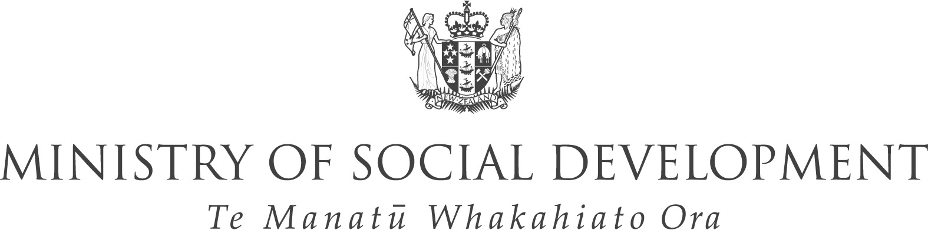

GOOD PRACTICE GUIDE
FOR WORKING WITH LOCAL
GOVERNMENT

Ministry of Social Development’s contributions
to community outcomes processes

Good Practice Guide For Working With Local Government was produced by
Ministry of Social Development
Bowen State Building
Bowen Street
P.O. Box 12-136
Wellington
New Zealand
Telephone +64 4 916-3300
Facsimile 64 4 918-0099
Website www.msd.govt.nz
April 2005
ISBN 0-478-18343-7
FOREWORD
from the Chief Executive

Working with local government and communities as they work through their community outcomes processes is an important area of work for the Ministry of Social Development (MSD). In fact it is one of the key work areas that I have asked Regional Commissioners to focus on over the next few years. We have a co-ordination role to promote effective relationships between local authorities and social sector departments represented at the local level.
This Good Practice Guide for Working with Local Government: Ministry of Social Development’s contributions to community outcomes processes is a very useful tool to help us work effectively with local government.
Part 1 of the Guide provides useful information about local government, the Local Government Act 2002 and the community outcomes process outlined in this Act. It also clearly outlines roles within MSD and the Department of Internal Affairs in working with local government. Part 2 provides examples of our contributions to date and practical suggestions for how to be involved at different stages.
The collaborative work of the MSD project team that developed this Guide, involving Work and Income, the Regional Social Policy Group and Social Services Policy, with wide consultation across MSD, is the kind of initiative that I would like to see mirrored in our work with local government and with other social sector departments.
The Local Government Act 2002 provides a great framework for central government agencies to work in a more concerted way alongside local government and communities to help achieve better outcomes for the many communities in New Zealand. It also provides an opportunity to more effectively promote a social development approach through strengthening regional and local collaboration and undertaking joint initiatives to improve social outcomes, such as improved health and social connectedness and participation in paid work and in leisure and recreation activities.
I hope that you find this Good Practice Guide for Working with Local Government valuable for informing your work with local government.

Peter Hughes
Chief Executive

Contents
Foreword from the Chief Executive 3
Introduction 5
Part 1: Community outcomes and local government – central government engagement 6
About local government 6
About the Local Government Act 2002 7
About community outcomes 7
Central government’s involvement and roles in community outcomes processes 11
Ongoing debate about central government’s involvement 12
Opportunities for MSD 13
Roles within MSD 14
Department of Internal Affairs (DIA) 15
Roles of other government agencies 16
Part 2: Practical ways to contribute to community outcome processes 17
Background Knowledge 17
Contributing to the stages in the community outcomes process 18
A. Providing information 19
B. Planning 20
C. Developing the community outcomes process 21
D. Discussing, identifying & prioritising community outcomes with communities 23
E. Responding to community priorities and delivering on outcomes 25
F. Monitoring and reporting on progress towards community outcomes 27
Summary of MSD contributions at each stage 28
Principles and tips for collaborative work 29
Appendix 1 – Useful websites, resources and contacts 31

Introduction

This good practice guide is an internal resource to assist Ministry of Social Development (MSD) staff to work with local authorities (LAs) as they implement the consultation, planning, and reporting requirements of the Local Government Act 2002 (LGA 2002). The guide particularly focuses on the opportunity for MSD (including Work and Income) to work with LAs on the community outcomes process and projects.
Cabinet recognised, as part of a series of decisions about the central government engagement in community outcome processes, “that MSD has a co-ordination role to promote effective relationships between local authorities and social sector departments represented at the local level”.
In anticipation of MSD’s expanded role with LAs after the LGA 2002 was passed, MSD developed the following key principles and practices¹. This Guide builds on the following principles that were developed:
• MSD is a key stakeholder.
• MSD has knowledge, skills and leverage to apply to the identification and promotion of community outcomes.
• The relationships between MSD and LAs will generally be managed by Regional Commissioners.
• These relationships, and MSD, will evolve over time.
This Guide is the result of a joint Regional Social Policy Group (RSPG) and Work and Income project, and has been developed by a wider MSD/Work and Income project team². The guide was shaped from learnings from MSD’s work with LAs that have already begun community outcomes processes. It has been informed by discussions with other government agencies and a stocktake of the LA approaches. To clarify the expectations LAs had of MSD’s actual and potential roles and contributions, interviews were conducted with representatives from a range of LAs that were at different stages of the community outcomes process.³
Part 1 of this Guide provides background information and context about local government, community outcome processes and central government agencies’ roles in this process with a focus on MSD. Part 2 provides useful information for MSD staff including an overview of the community outcomes process and practical ways to be involved. There is also an appendix of useful website links and resources.

1 Ministry of Social Development Principles for Engagement on Community Plans and Outcomes, 2003.
2 Project team members included members of the Regional Social Policy Group, Child Family and Community Policy in the Social Services Policy Group, and social development managers from Work and Income. Wider consultation and comment from staff throughout MSD also provided valuable contributions to the development of the Guide.
3 Key informants from 5 areas were selected and interviewed from LAs who were at different stages and taking different approaches. The experiences/perspectives of 16 LAs were included. All Work and Income regions were included in the stocktake and social development managers reported on regional activities.

PART 1
Community outcomes and
local government – central government engagement
About local government
There are 86 local authorities (LAs) in New Zealand consisting of:
• twelve regional councils that focus primarily on environmental issues, plus civil defence and transport, but potentially have a broader mandate
• seventy four territorial authorities (58 district and 16 city councils) that focus primarily on infrastructure, land use planning and development control and community well-being and development. Four of these councils are unitary authorities ie district or city councils that also have the responsibilities, duties and powers of a regional council.
The councils have hugely varied level of resources, such as money and personnel. Some LAs have a rating district with hundreds of people (for example, the Chatham Islands has a population of 780 people) whereas others have hundreds of thousands of people in their city or region. This in turn influences the roles and capabilities of these councils.
Local Government New Zealand (LGNZ) is a separate organisation that represents the national interests of all 86 councils. It champions best practice in the local government sector and provides policy advice and training to LAs.

About the Local Government Act 2002
The Local Government Act 2002 (LGA 2002) was a major shift in emphasis from central towards local governance and replaced most of the 1974 Act. It expanded the mandate of LAs from a prescriptive framework of duties (such as roads, rates, and rubbish) to a principles approach where councils have broad scope to act as they deem appropriate. This is framed within their purpose of seeking to promote the current and future economic, social, environmental, and cultural wellbeing of their community and enabling greater community influence on decision-making.
The LGA 2002 introduced a requirement for LAs to identify community outcomes using a process discussed with other stakeholders, and to engage the public to discuss and prioritise those outcomes. There is also specific emphasis on LAs gaining and supporting Mäori involvement in decision-making processes, and encouragement for more work in partnership with other LAs, government agencies and community organisations.
LAs have a role in facilitating joint local and regional activity by communities, other LAs, government agencies, and local organisations, and the business sector to achieve progress towards the outcomes and priorities identified by the community and more effective and efficient use of resources. They are required to report on the progress towards achieving outcomes at least every three years. LGA 2002 implementation emphasises the need for information to be available at LA level to inform planning and decision making, and to monitor and report on progress.
About community outcomes
Community outcomes are a reflection of what is important to a local community within a city, district, or region.
The purposes of community outcomes and the processes for identifying them are addressed in Section 91 of the LGA 2002 (see below, emphasis added). Clauses 2(c), (d) and (e), and 3(a) indicate the role of central government.

(1) A local authority must, not less than once every 6 years, carry out a process to identify community outcomes for the intermediate and long-term future of its district or region.
(2) The purposes of the identification of community outcomes are:
(a) to provide opportunities for communities to discuss their desired outcomes in terms of the present and future social, economic, environmental, and cultural well-being of the community; and
(b) to allow communities to discuss the relative importance and priorities of identified outcomes to the present and future social, economic, environmental, and cultural well-being of the community; and
(c) to provide scope to measure progress towards the achievement of community outcomes; and
(d) to promote the better co-ordination and application of community resources; and
(e) to inform and guide the setting of priorities in relation to the activities of the local authority and other organisations.
(3) A local authority may decide for itself the process that it is to use to facilitate the identification of community outcomes under subsection (1), but the local authority:
(a) must, before finally deciding on that process, take steps
(i) to identify, so far as practicable, other organisations and groups capable of influencing either the identification or the promotion of community outcomes; and
(ii) to secure, if practicable, the agreement of those organisations and groups to the process and to the relationship of the process to any existing and related plans; and
- must ensure that the process encourages the public to contribute to the identification of community outcomes.

Community outcomes provide a means for people and organisations in the district/city/region to help identify and prioritise needs for that area. They can provide a structure for activities at a local level, and joint initiatives or resource use. The following diagram indicates how different parties can fit into the process.

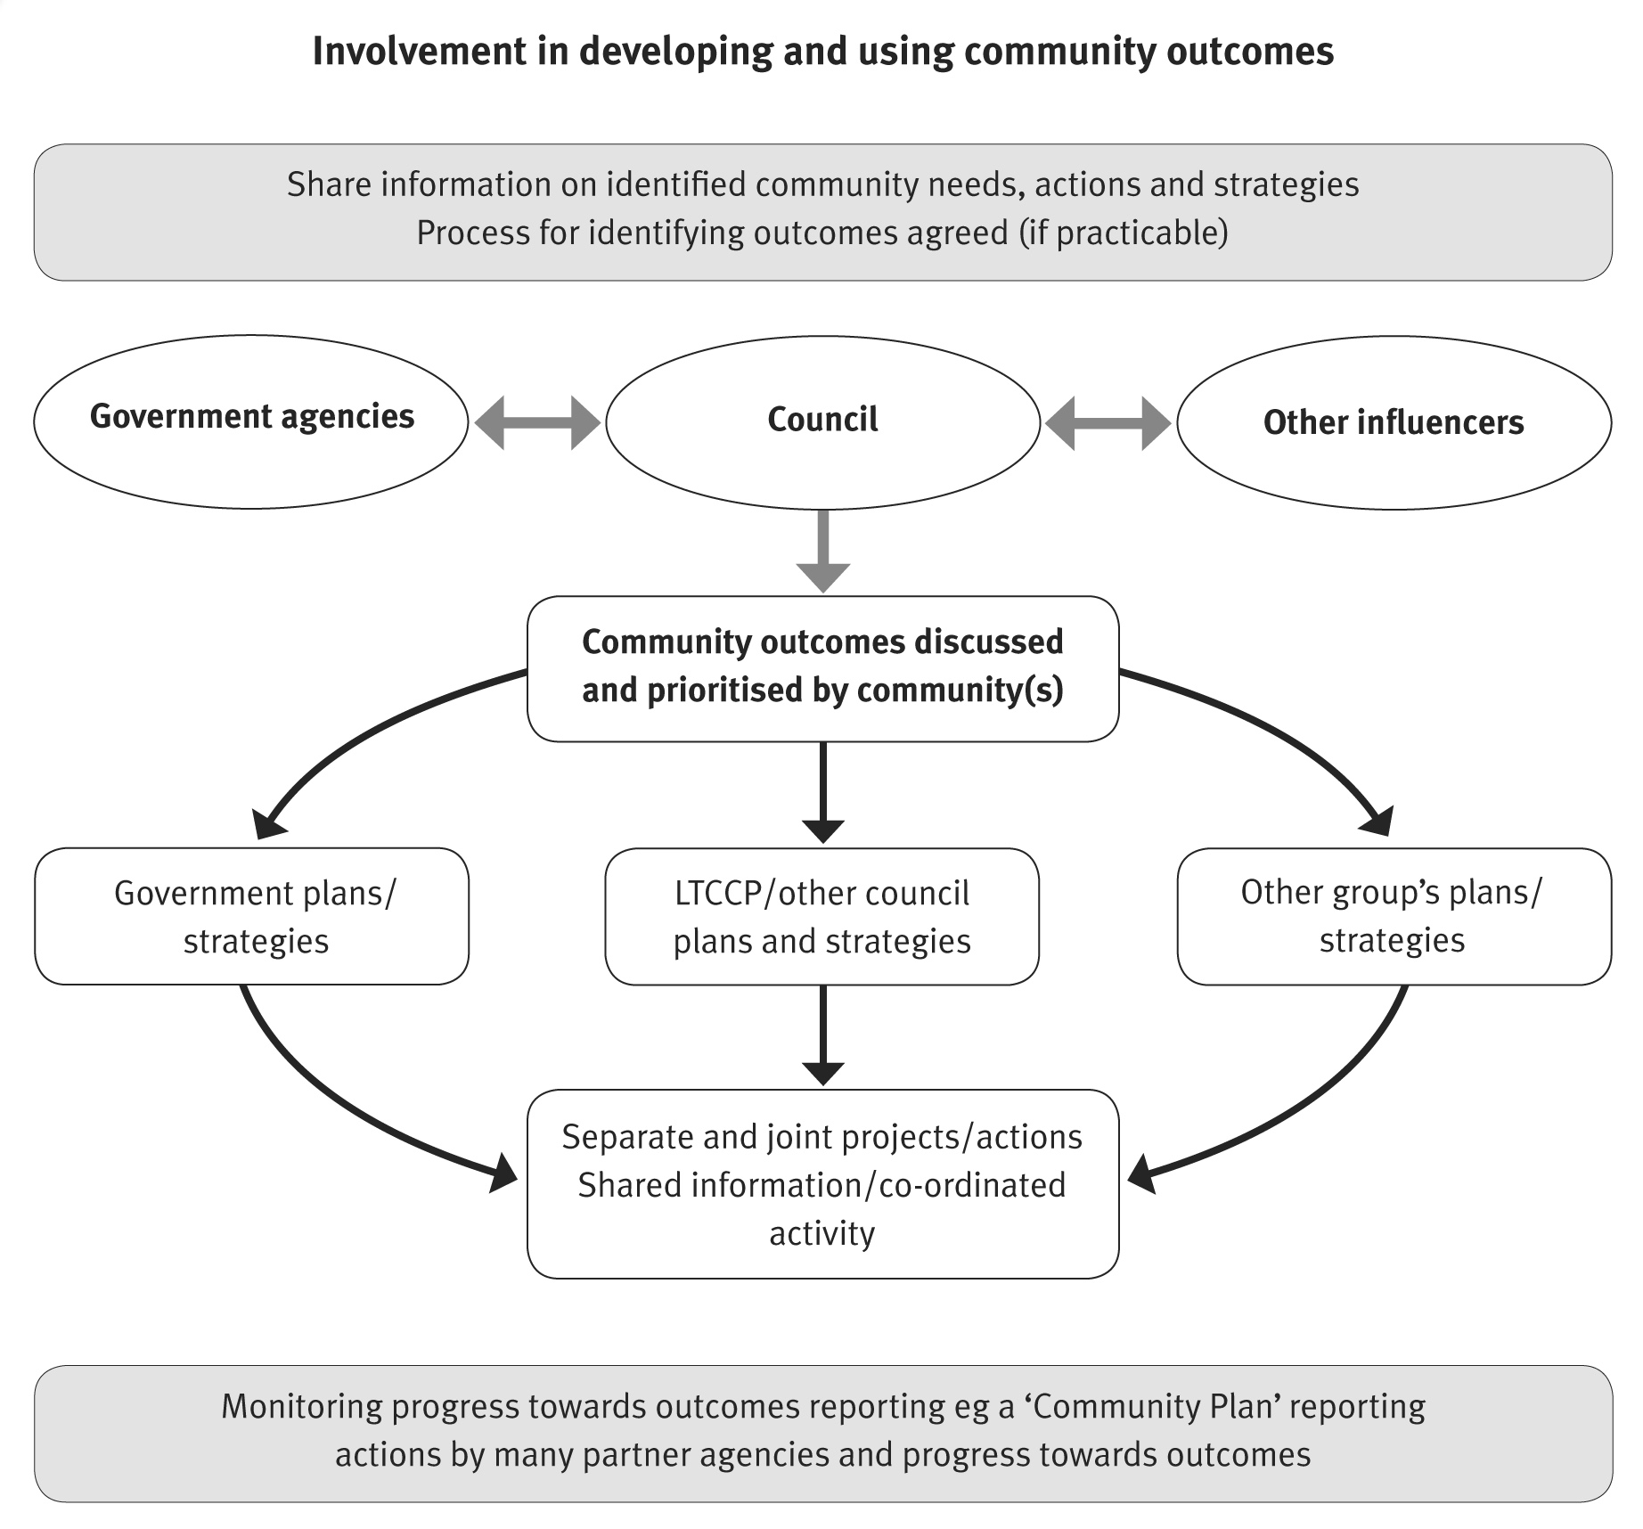

After the identification and prioritisation of outcomes, LAs will describe the community outcomes and priorities in their long-term council community plans (LTCCPs) – a ten-year plan (updated at least every three years) of the activities a council will undertake. LAs will use these outcomes, where appropriate, to guide activity in the LTCCP and other planning, policy and strategy documents and to feed into interagency work.
The LGA 2002 required LAs to deliver a full LTCCP, supported by a community discussion and prioritisation of community outcomes, not later than 2006/2007. Some councils chose to follow a full process in their first LTCCPs (either 2003/2004 or 2004/05), while others used existing information to guide their first 10-year plans and are currently in the process of identifying and prioritising community outcomes to guide their 2006/2007 LTCCPs.

Unless LAs move to synchronise their processes over time, stakeholders will find some LAs are at different stages in a cycle of identifying and prioritising community outcomes, developing LTCCPS, and reviewing and reporting on progress towards achieving outcomes. For example in 2004, best estimates suggest that approximately one third⁴ of councils were up to the stage of reviewing and reporting on progress towards community outcomes, while the remainder were beginning their first full identification of community outcomes.
The timelines and processes for reviewing and reporting will vary but, as noted above, during 2005 around two thirds of LAs will be undertaking their first community outcomes process which will be described in the 2006/2007 LTCCP. An estimated timeline for this process is outlined below.

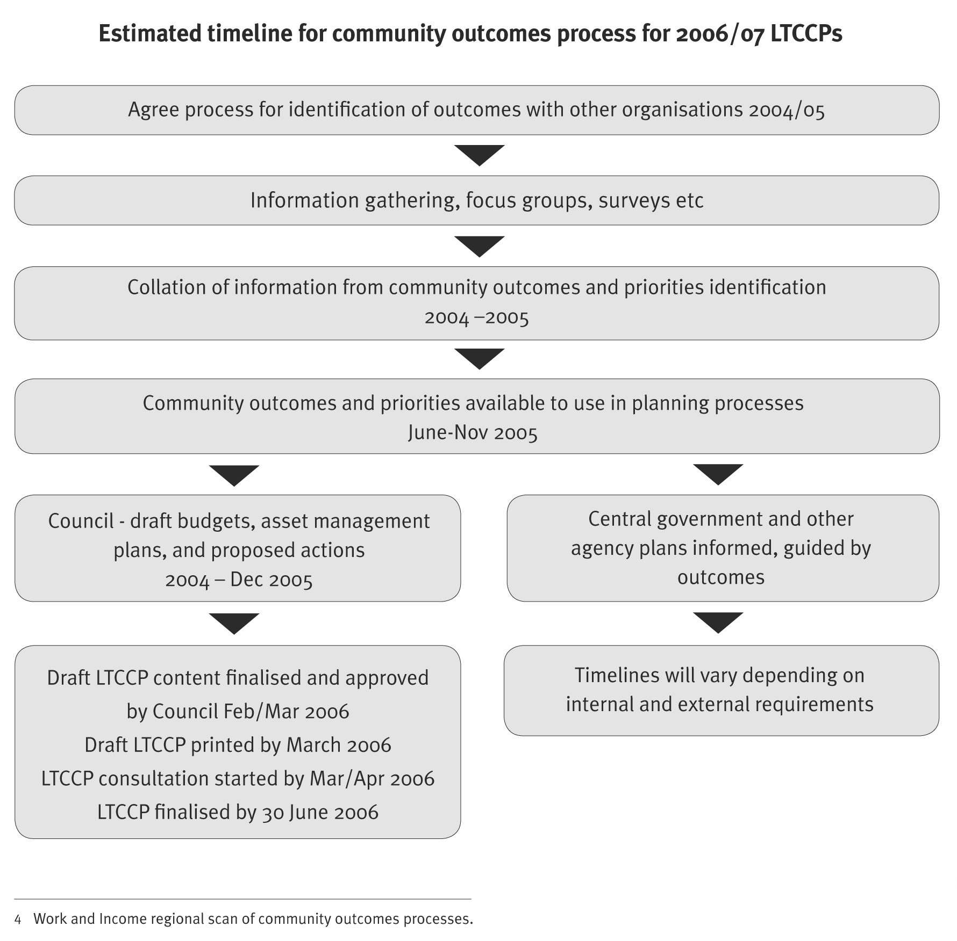

Central government’s involvement and roles in community outcomes processes
Although the LGA 2002 does not explicitly require central government to participate in the identification and delivery of community outcomes, Sections 91 and 92 of the LGA 2002 require LAs to engage with all relevant parties that contribute to outcomes. Section 91 (2) (e) clearly states that the community outcomes are to inform and guide the priorities of other organisations’ activities as well as LAs. This implies that government agencies and other organisations should take an interest in and support processes for identifying outcomes and use them to guide their own regional and local planning and delivery within the wider central government requirements. Central government and local government are also encouraged to work together and with communities to develop effective relationships to support the promotion of community well-being.
The principles of working collaboratively to achieve outcomes and use resources more efficiently and effectively apply across the board. Central government policy direction reflected in the Review of the Centre and whole of government initiatives supports these concepts. There is also an increasing move towards linking whole of government to whole of region/whole of community approaches. The community outcomes process has the potential to link these approaches.
There are also some challenges. The LGA 2002 strengthens opportunities for collaboration and encourages central government to contribute as a partner to local government-led processes. This is not a role central government is generally accustomed to. Increased central government engagement with local government also increases the need for co-ordination across central government agencies.
There are issues of capability and over-consultation for government departments and Mäori as well as for other groups in the community (and within LAs). Where multiple community outcomes processes need to involve the same iwi or government departments, it may be appropriate to promote senior decision makers involvement at a regional level, rather than in multiple local meetings; although local people should be involved at a local level.

Ongoing debate about central government’s involvement
While the community outcomes process has the potential to strengthen regional and local collaboration, in some cases it will take some time for the roles and responsibilities of central government agencies to develop to meet this potential.
The extent to which central government should become engaged in the community outcomes process varies and is related to polarised opinions about who ‘owns’ the process. Opinions vary on what central government’s role should be, from the collaborative view shared by MSD to the view that central government has a limited role.
The collaborative view is that central government has a significant role in supporting, and sharing responsibility for community outcomes. Issues include the following:
• Local authorities (especially small ones with a low rating base) expect central government agencies with a regional presence to support their facilitation of the community outcomes.
• Some stakeholders (from different sectors) regard community outcomes as a process that should be owned by all stakeholders and one that has the potential to provide a platform for regional/local level strategic planning and action.
• Stakeholders from central government are, in general, aware they have a role in the process and in contributing to, delivering on and monitoring outcomes. They are less clear about the implications community outcomes have for their work and how they can engage without overwhelming the contributions of other stakeholders.

The other views are that central government has a limited role in community outcomes.
Issues include the following:
• Not all LAs want central government to be involved in the identification of community outcomes, although they do expect central government to contribute to delivering on community outcomes.
• There is a view that central government’s involvement may result in them exerting undue influence over what is seen as a local government responsibility. Where central government is not sharing the resourcing (including, but not limited to, costs) of the community outcomes processes, it is not seen as a “weight-bearing” partner (noting that just contributing funding without getting involved would also reinforce a lack of inter-agency commitment to the outcomes process as a framework for whole of government – whole of region work).

There is, however, a level of agreement amongst LAs that central government has responsibility for making relevant information much more accessible to LAs. This includes: information about strategic goals, current or planned work programmes directed at improving community outcomes; information to contribute to decision-making about effective responses to community outcomes; and up-to-date statistical data and information that can help track progress towards achieving community outcomes.
A number of projects and resources are being developed to assist with information sharing and monitoring, such as: DIA’s website (www.dia.govt.nz/copwebsite.nsf), a Statistics NZ-led interagency project to identify core indicators (Linked Indicators Project), sub-regionalisation of MSD’s The Social Report data, where possible, work to geocode Work and Income data to local authority level, and the information aspects of FACS Local Services Mapping projects.
Opportunities for MSD
For MSD, the emphasis on community wellbeing and on collaboration to achieve community outcomes means that the potential for regional social development has been strengthened. In many regions MSD/Work and Income already has well established partnerships with local authorities through, for example, Mayors’ Taskforce for Jobs and Youth Transitions work. The LGA 2002 provides an opportunity to extend the work being done with LAs, to bring in other partners, and strengthen MSD’s focus on regional social development. It also extends the opportunities for monitoring the extent to which MSD programmes and investment contribute individually and collectively to improvements in outcomes.
In June 2004, Cabinet agreed⁵, as part of a series of decisions about the central government engagement in community outcome processes, “that MSD should continue to develop its co-ordination role to promote effective relationships between local authorities and social sector departments represented at the local level”.
Cabinet also noted that:
• “there is no specific level or type of engagement required by departments, rather departments who decide to engage in community outcome processes will determine their appropriate level of participation; and
• Ministers will still retain responsibility for the government’s policy goals and priority outcomes, and decision making authority over the allocation of public resources in relation to those goals and priorities”.

- POL Min (04) 12/15, confirmed by CAB Min (04) 18/4.

To improve its capacity to lead social development and work with LAs, MSD has widened the role of regional commissioners to include responsibility for leading social development within the region. It has also appointed social development managers in each regional office and established a new Regional Social Policy Group (RSPG) within the Social Development Policy and Knowledge Group with regional policy advisors (RPAs) to provide a policy capability in the regions. These developments have bolstered MSD’s capacity to work with LAs and other social sector agencies in promoting social development at the local level and delivering on community outcomes.
MSD has a co-ordination role for social sector agencies and the Department of Internal Affairs (DIA)⁶ has the lead role in interactions between central and local government through its Central/Local Government Interface Team. Specific roles and contexts for central government engagement will develop over time and will vary in different districts/regions. Intersectoral processes are in place in most regions and are likely to expand and develop mechanisms for achieving joint outcomes.
Roles within MSD
MSD National Office’s policy and research work with LAs includes:
• contributing a social development perspective to policy related to local government including issues for the community and voluntary sector and for specific population groups, such as older people and people with disabilities
• co-ordinating briefings to Ministers, when requested, on MSD’s involvement with local authorities
• consulting, as appropriate, with local authorities on policy issues
• collating information to measure Social Report indicators at a national and, where possible, regional level
• providing MSD data and information relevant to local government, as appropriate
• taking information from local and regional planning processes forward into policy development and decision making processes.

Family and Community Services (FACS) - works with local authorities on projects that aim to achieve better co-ordination of service planning and delivery at the local, regional and national level. In particular, FACS has responsibility for managing Local Services Mapping (LSM) projects. The main focus of LSM is on social services for families, but other community priorities will also be covered. The project is intended to be rolled out nationwide over the next 5 years.

- For more information on DIA’s role, see section on Department of Internal Affairs (DIA).

LSM projects aim to collate regional socio-demographic data, stocktakes of social service providers, information on gaps, needs and opportunities for service planning and delivery and agreed actions or recommendations to respond to these gaps and opportunities. This information is to be summarised in a community report and community action plans, which can inform the community outcomes process. The linkages into these processes are managed on a local level through FACS staff⁷.
LSM projects overlap with the development of community outcomes and with LTCCPs. FACS regional managers are expected to look for the synergies between LSM and LA processes.
Ministry of Youth Development – work includes consulting on national youth policy issues, providing resources, encouraging and supporting LAs to actively involve young people in decision-making processes, and partnering with LAs to develop regional/local youth policies and initiatives.
MSD regional roles include the following:
• Regional commissioners – provide regional leadership for social development and the principal contact for mayors and chief executives of LAs.
• Social development managers – support regional commissioners, manage day-to-day relationships with LAs and the co-ordination of social services sector, and participate in local-central government projects.
• Other Work and Income staff – support community outcomes indirectly by allocating staff resource, such as case managers, to participate, provide local knowledge and encourage client groups to participate.
• Community Labour Market Development Teams – assist in community labour market and skills development, industry partnerships and employment opportunities.
• Regional policy advisors – support regional commissioners and social development managers, provide policy support and guidance and link to the General Manager, Regional Social Policy in National Office.
Department of Internal Affairs (DIA)
At a national level DIA provides:
• policy advice and information on local government issues
• advisory and support services to the Local Government Commission
• administration of the Local Government Act 2002 and other statutes.
DIA’s work includes monitoring the local government system, preparing briefings and speech notes and providing support for the Minister of Local Government and the Minister for the Community and Voluntary Sector.

- For more information, contact FACS regional managers and see LSM process guidelines available from FACS regional managers.

The Central/Local Government Interface Team (CLGI Team) in DIA’s Local Government and Community Branch promotes effective central government engagement with local government as part of local government’s identification of community outcomes (See Appendix 1 for contact details).
The CLGI Team has the key responsibility in central government to:
• provide information and support to LAs and central government agencies involved in the community outcomes process
• develop and maintain a directory of central government agencies [www.dia.govt.nz/copwebsite.nsf] to help LAs make contact with agencies that have a role in the community outcomes process
• facilitate contact through relationship managers, online directory and information broker between LAs and central government agencies
• collate and disseminate relevant information and examples of good practice in community outcomes processes through the online directory, an annual workshop seminar and other mechanisms.
DIA also provides policy advice on community and whänau/hapu/iwi development issues. A community development service operates from a national office and 16 regional offices providing information, resources and facilitation services to enable communities, whänau/hapu/iwi, and Mäori organisations and community groups to develop responses to meet their own needs.
Roles of other government agencies
A range of government agencies work with local government and have a role in community outcome processes. This includes general roles and wide involvement in identifying and promoting community outcomes, and specific roles such as Audit New Zealand and the Office of the Auditor General involvement in auditing consultation processes.
There are also some specific initiatives under way involving central and local government and communities. For example, in Auckland the Sustainable Cities programme is a collaborative programme of work across central and local government and the private and community sectors. It contributes to the overarching social, economic, environmental and cultural goals contained in the LGA 2002.

PART 2
Practical ways to contribute to community outcome processes
This part of the guide provides information on how MSD/Work and Income staff have contributed to and may contribute to the community outcomes process. MSD’s contribution is likely to evolve over time as central government, local government and communities become more familiar with the process and look for ways to use it more strategically.
Background Knowledge
Before starting – 10 things for each region to find out about:
1. How well does the Work and Income region match LA regional, district and city boundaries? If there is a local government area that falls into two Work and Income regions, what is the most practical way to deal with that?
2. What stage is each LA in the region at in the community outcomes process?
3. What arrangements do they already have in place for the process?
4. Are there existing inter agency mechanisms for cross sector co-operation? If so, how well do they work? Who is represented and who is not?
5. Which other agencies (within MSD and externally) are active in relevant regional and local work or could be encouraged to be more involved?
6. What other collaborative projects might have an impact on the community outcomes work (for example, FACS’s Local Service Mapping projects)?
7. Are other regional/local consultation processes underway or being planned?
8. Is there any MSD information that could be useful?
9. How do LAs view MSD/Work and Income in this process? As a partner, a supportive helper, a participant in the process, irrelevant, or a threat?
10. What relationship building is needed with LA staff and, where appropriate, with local body politicians? (Although relationships with mayors and senior council executives are the role of the Regional Commissioner, some small LAs have flexible boundaries and expect staff to work across all levels. This can work well if the political and professional roles and responsibilities of all partners are respected).

Contributing to the stages in the community outcomes process
There are a number of ways that MSD can be involved in community outcome processes. Actual involvement is likely to vary across the country and within regions, based on what local authorities want, what resources are available and what suits local conditions.
Regional commissioners and regional operations managers will need to consider staff resources and government priorities when commitments are made. Resources will need to be committed with consideration of the time and commitment needed (some roles can be very time-intensive), what roles different councils want or need extra resources for, and how to encourage good joint strategic work and co-ordination.
There are several stages in the community outcomes processes facilitated by councils, each stage providing different opportunities to contribute. These stages are shown in the diagram below. Each stage of the cycle is then discussed in more detail, with examples that have often occurred in multiple regions and snapshot information from three regions. For more information about the snapshots see the contact details of the relevant social development managers in the Appendix.
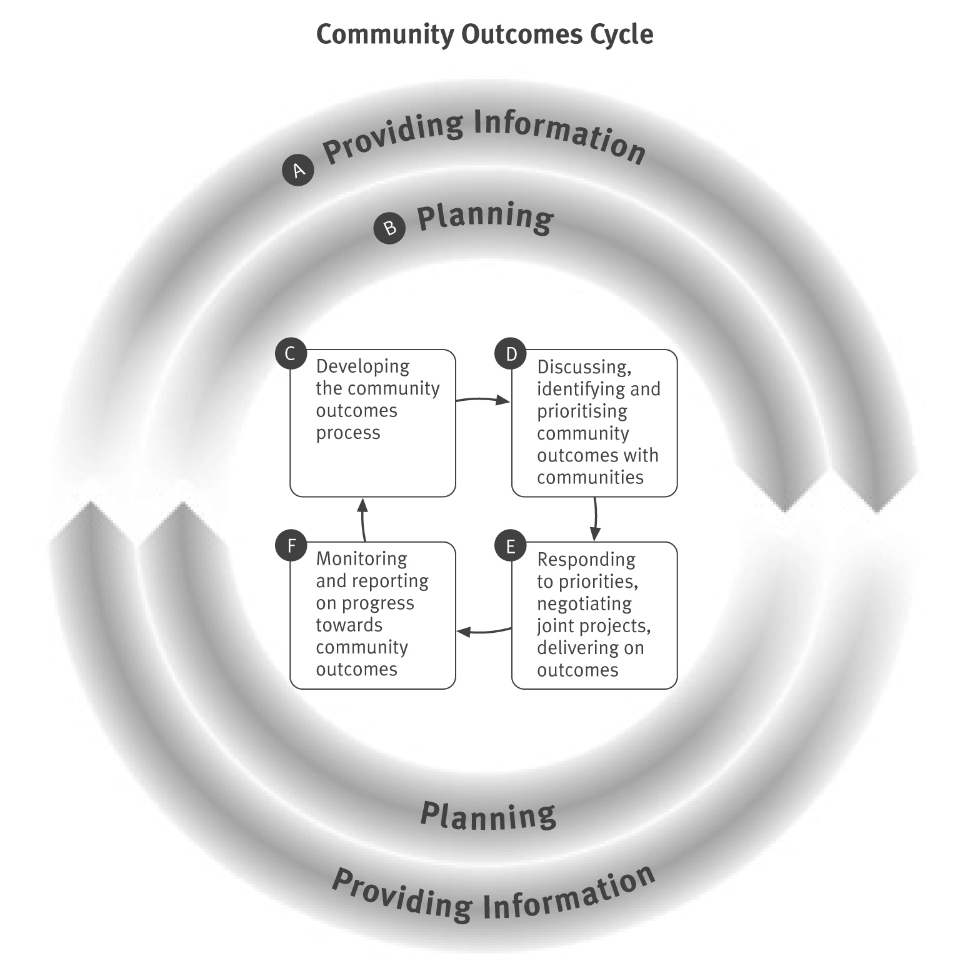

A. Providing information
Information provision is ongoing and feeds in to all parts of the community outcomes cycle. It includes:
• providing information to support and guide the identification of community outcomes
• providing information on projects, strategies, research and consultation underway/planned with various organisations
• providing information for monitoring and reporting (see section F).
Examples of contributions⁸
To date regional MSD/Work and Income staff have:
• provided regional and local demographic profiles
• provided Work and Income statistics
• contributed to the development of monitoring frameworks
• provided information on MSD’s strategies, goals, and outcomes
• encouraged other agencies to provide information on their strategies, goals, projects and outcomes.
Lessons learnt
• Larger LAs typically have access to regional/local profile information; smaller LAs are more likely to welcome assistance with this.
• Monitoring frameworks are being developed in various ways, sometimes as joint work between councils in a region and sometimes with national assistance.

Practical ways to assist with LAs’ information needs
Practical suggestions include:
• providing information to help develop profiles of the region, such as links to Statistics NZ profiles, FACS LSM project information, Work and Income data, industry and skills information
• identifying gaps/issues with current information and measurements that councils and other agencies may need, for example, what is measured, timing, and area boundaries and ways to address these
• being available for discussions on co-ordinating and integrating measures, consultation and research
• encouraging your networks/contacts in other government social sector departments to provide information that is needed or would be useful to LAs or for measuring progress on community outcomes
• encouraging outward information flow on processes and projects and make links to the community outcomes, if appropriate, in media releases and other documents
• providing additional support such as staffing assistance for LAs that have limited resources.

- Please note that these examples are not indicative of all contributions made in different areas. They are intended to give a broad flavour of what has been done using specific examples, while avoiding repetition. See Appendix for a list of contacts for further information on snapshots.

B. Planning
Involvement in planning is an ongoing process that feeds in throughout the community outcomes cycle.
It includes:
• identifying who can be involved and what can be done
• participating in strategic planning
• developing monitoring tools to meet joint reporting needs and timetables.
Examples of contributions
• Social development managers (SDMs) and regional commissioners contributed to inter-agency forums, and to developing economic and social development strategies with local and central government and other local stakeholders.
Lessons learnt
• Not all LAs are approaching the current community outcomes identification process as an opportunity for joint strategic planning.
• Some councils plan to develop more joint/interagency planning later in the process.

Practical ways to support planning
Practical suggestions include:
• reviewing how existing mechanisms for interagency co-ordination and collaboration can support the community outcomes process, and consider what else is needed
• identifying social sector stakeholders and networks and discussing with LAs what involvement they want them to have at regional and local levels
• looking at where existing information contributes to planning the process of identifying outcomes
• encouraging a strategic approach
• contributing, as appropriate, to planning meetings, analysis, and other work
• looking at ways to include community outcomes in MSD’s planning processes
• comparing consultation, funding and/or planning cycles and looking for opportunities to synchronise.

C. Developing the community outcomes process
LAs are in charge of the process. Their work includes:
• taking steps to identify other parties who can influence the identification and promotion of community outcomes and try to secure their agreement to the process
• ensuring the process encourages the public, including Mäori, to contribute
• providing the public with an opportunity to discuss and prioritise community outcomes at least once every six years.
Examples of contributions
Snapshot – Kaipara⁹
• The regional commissioner led social sector involvement by advocating for additional resources for the LA through the regional intersectoral forum and membership of the joint agency Community Outcomes Steering Group. The regional policy advisor (RPA) was also active in helping the Steering Group maintain momentum.
• The RPA took a hands-on approach to getting the community outcomes process started by helping to design consultation processes, and briefing agency staff and local body politicians on facilitation methods.
• Both the SDM and RPA helped support consultation processes, for example, through providing information and helping design brochures to inform communities about local issues.
• The Council thought this level of commitment and involvement gave the process credibility and increased other agencies’ confidence in it – to the extent that relationships with the social sector improved significantly as a result.

Snapshot – Bay of Plenty region
• The SDM initiated the establishment of a local government/MSD working group to facilitate central government involvement in the community outcomes process. The group organised a joint meeting of regional managers (and national representatives where appropriate). The SDM managed the invitations and collation of information and contracted a facilitator for the initial meeting. The meeting reached agreement for regional local - central government meetings to occur on a regular basis to progress information sharing and work on community outcomes.

9 It should be noted that in Kaipara the roles played were extensive by agreement between that Council and the Regional Commissioner and the GM RSPG. This level of commitment may be difficult to achieve on a wider basis or in other regions.

Snapshot – Waikato region
• The SDM and RPA have regularly attended regional strategic planning meetings and contributed to discussions on the process.
• The SDM provided information and contacts between iwi (at Trust Board/senior levels) and councils in the region and assisted with developing processes for consultation to reduce multiple/conflicting demands on iwi time.
Lessons learnt
• Intersectoral forums are a useful vehicle for generating interest in the outcomes process and securing social sector involvement.
• While MSD/Work and Income’s involvement in helping to set up the outcomes process was highly regarded in the Kaipara snapshot, not all LAs want that level of central government involvement and it was resource intensive. Open discussion is needed to be clear about what level of support is wanted and what can be provided.
• Some LAs have made partnerships with each other a priority for this round of the process and have established joint region-wide outcomes processes. For these LAs, other agencies may be viewed as stakeholders rather than as partners.
• Interagency work to identify outcomes prior to community discussion can help integrate existing knowledge and be used to frame strategic joint planning.

Practical ways to support developing the community outcomes process
Practical suggestions include:
• finding out councils’ ideas about how they intend to engage stakeholders and how they intend to involve wider community perspectives
• discussing with LAs what social sector co-ordination would be useful for them
• linking into existing inter-agency forums and encouraging participation by agencies
• helping develop new forums around each iwi in a region, if appropriate
• encouraging the use of existing information to help identify community outcomes
• starting discussion on how to monitor progress on outcomes and the effects of actions taken
by MSD and other agencies
• referring to the MSD resource Mosaics Whataahua Papariki: Key Findings and Good Practice Guide for Regional Co-ordination and Integrated Service Delivery and the website www.goodpracticeparticipate.govt.nz for advice on interagency work.

D. Discussing, identifying and prioritising community outcomes with communities
This part of the LA-led process should provide opportunities for communities to discuss:
• their desired outcomes for their present and future social, economic, cultural and environmental wellbeing
• the relative importance and priority of outcomes.
LAs should encourage all members of a community to participate, with an emphasis on ensuring Mäori have the capacity and relevant information to contribute. Government, business, environmental, cultural and social organisations also have a role to play, not just individuals.
Examples of contributions
Snapshot - Kaipara
• The RPA reviewed the consultation plan as it was implemented. This assistance gave the LA confidence that their process was robust enough to provide what was needed.
• The LA found that having MSD/Work and Income regional staff as members of the council project team kept things moving along and provided practical help when things got stuck.
• Work and Income service centre managers and staff facilitated clients’ involvement through focus groups, administration of questionnaires and encouragement to attend workshops.
• The RPA reviewed implementation of the consultation plan and identified what was working and what was not so adjustment could be made (for example, adapting the process to get better representation from young people).
• MSD regional staff helped facilitate consultation meetings.

Snapshot – Bay of Plenty
• Case managers and service centre staff encouraged clients to get involved and gave community consultation documents to clients.
• Staff at different levels encouraged central government agencies to attend and participate in community forums and add their experience and knowledge to discussions.

Lessons learnt
• There is no one right way to identify community outcomes. Using multiple methods helps ensure wider participation.
• When working with small LAs, monitoring the process and suggesting adjustments can be valuable.
It requires good relationships and it is up to the LA to decide if it wants that kind of input.
• The consultation process is taxing for LAs and practical help can be of real value.
• Work and Income service centre managers and staff can be valuable resource people.
• Encouraging groups who often don’t participate in consultation exercises helps to obtain a broader picture of the community.
• Providing high levels of contribution to district level processes is extremely resource intensive and hard to sustain, and it may cause tensions within the regional community if it is not offered to other councils.

Practical ways to support discussion, identification and prioritisation of community outcomes with communities
Practical suggestions include:
• providing information on groups that can be involved and helping to make contacts, where appropriate, between iwi, other networks and council
• sharing ideas on how to involve different types of people (for information on various consultation methods see www.goodpracticeparticipate.govt.nz)
• assisting with public consultation, such as staff to facilitate meetings, hosting meetings and involving clients
• encouraging staff and clients to participate in the process and share their personal experience and knowledge
• encouraging social sector agencies to attend public consultation meetings, if required
• helping with analysis of consultation and outcomes, if appropriate.

E. Responding to community priorities and delivering
on outcomes
There is a considerable amount of planning and co-ordination needed for this part of the process that is still developing in many districts/regions. Activities include:
• looking at what is already being done
• identifying where gaps exist or processes could be improved
• sharing information and co-ordinating existing projects
• forming project teams of appropriate agencies (government and non-government) to address particular outcome areas and develop new projects (including joint projects), where appropriate.
Examples of MSD/Work and Income contributions
• MSD has facilitated joint projects between government agencies, community organisations and councils in Kaipara.
• Staff in several regions are actively involved in projects that contribute to achieving community outcomes.
• MSD involvement has helped strengthen focus on Work and Income client groups for some joint initiatives around the country, for example Manukau City.
• Some LAs have found it challenging to keep agencies committed to joint projects. They regard MSD as having a critical role in making that happen. Other agencies, such as DIA, are also contributing to this process.
Lessons learnt
• Delivering on outcomes is the most important part of the process and in these early years of the process delivery has been patchy. Some of the barriers are:
– different agency structures, regional accountabilities and mandates, and a lack of local cross-agency accountability processes and structures¹⁰
– even where mandates overlap on inter-related problems, there can be different consultation, planning and funding cycles, and boundaries
- local authorities have the mandate but no additional funding to facilitate the community outcomes/LTCCP process. It will take some time for central government’s involvement to become clear.

10 Summarised from Craig, D (2004) Building better contexts for partnership and sustainable local collaboration:
A review of core issues, with lessons from the ‘Waitakere Way’. Social Policy Journal of New Zealand 23: 45-64.
• For MSD to actively influence joint responses to outcomes requires high levels of trust in local-central government partnerships.
• MSD’s involvement is valued by councils because information is shared, duplication of effort is reduced, work is more effective and strategic planning is enhanced. Improved understanding about organisations’ different business processes leads to better planning, relationships, co-ordination and alignment of initiatives.
• It is important to understand that the community outcomes process is intended to include and be used by central government agencies (regionally and nationally), as well as LAs. Where the view from local or central government is that central government agencies are just ‘helping local government’ by involvement in the process, it does not match the intention of the LGA 2002 or realise its potential.
• Identifying local outcomes and priorities can inform government planning and community planning. It has the potential to increase collaboration and partnerships, and to improve resource allocation and information-sharing.
• Despite some misgivings, most councils want stronger partnerships with central government. The lack of mechanisms to set up central-local government agreements (for examples, service agreements, formal arrangements for integrating community outcomes into government agencies’ strategic plans, and joint resource commitments to time and cost of the process) are often a barrier.

Practical ways to respond to community priorities and deliver
on outcomes
Practical suggestions include:
• identifying issues MSD has the most influence over and where it may play a leading or significant role
• including business as usual – where MSD/Work and Income’s service delivery and social development activities and FACS LSM projects already contribute to community priorities
• identifying the different roles councils would like MSD/Work and Income/FACS to play in implementation and who the appropriate people are to fill those roles (without over-committing particular staff members)
• thinking about how to get best value for time and resources. For example, in some cases it may not be possible to commit to participating in separate projects for each council, but joint regional projects might be possible
• looking at which agencies might need to be involved in joint projects/co-ordinated working to get best results, leverage resources and existing/potential programmes, and ensure a co-ordinated approach (see www.tomorrowsmanukau.co.nz/initiatives.asp)
• linking community outcomes projects to existing interagency arrangements, and strengthening member organisations’ commitment to projects
• ensuring those who are involved in interagency action have the mandate to speak for their organisations will keep their organisations informed and will attend consistently
• identifying where a dedicated co-ordination/strategic broker role may be needed and what that role would provide.

F. Monitoring and reporting on progress towards community outcomes
This needs to be done for the city, district, or region at least every three years and should ideally be a multi-agency monitoring and reporting tool. The LGA 2002 requires reports at least every three years on progress towards community outcomes. These reports go beyond what LAs themselves have done.
Examples of contributions
• MSD staff have helped to develop indicators in some regions and have shared knowledge about what data may be available and suitable.
• There are several national projects underway to address information needs for LAs to report on progress made towards community outcomes. MSD and other agencies are looking at geocoding their data to overcome data boundary issues. MSD’s 2005 Social Report will provide data to LA level, where possible. Joint projects, such as the Linked Indicators Project (LIP) led by Statistics New Zealand, are creating frameworks and compiling data for common core indicators.
• MSD staff have helped to link local government staff to national indicator projects.

Practical ways to support monitoring and reporting on community outcomes progress
Practical suggestions include:
• sharing information / joint databases of relevant information sources
• making MSD/Work and Income information more accessible (work is underway within CSRE to geocode data and make headline client data reports available to local authority level by the end of 2005)
• developing shared monitoring and reporting structures
• co-ordinating reporting requirements
• working with LAs on continued indicator development and monitoring
• collating case studies of work with LAs on community outcome processes.

Lessons learnt
• Councils do not have a common view on what roles MSD should have in monitoring and reporting. Larger well-resourced councils in particular may not expect MSD to have any particular role in
developing indicators or reporting frameworks. Smaller councils have, however, expressed a need for more technical assistance to develop indicators, obtain the right data, and cope with different administrative boundaries.
• Councils (big and small) share the view that it would be good to get assistance to help LAs understand what works and why.
• There may be capacity/capability issues about who should do what, and there will be variability in what contributions councils want. Some LAs may want very little involvement from MSD; others may want help with planning, integrating information, developing strategies, project teams and policy work.
Summary of MSD contributions at each stage
The following diagram summarises MSD’s roles in contributing to the different stages of the community outcomes process. Actual involvement will vary between regions and with each local authority.
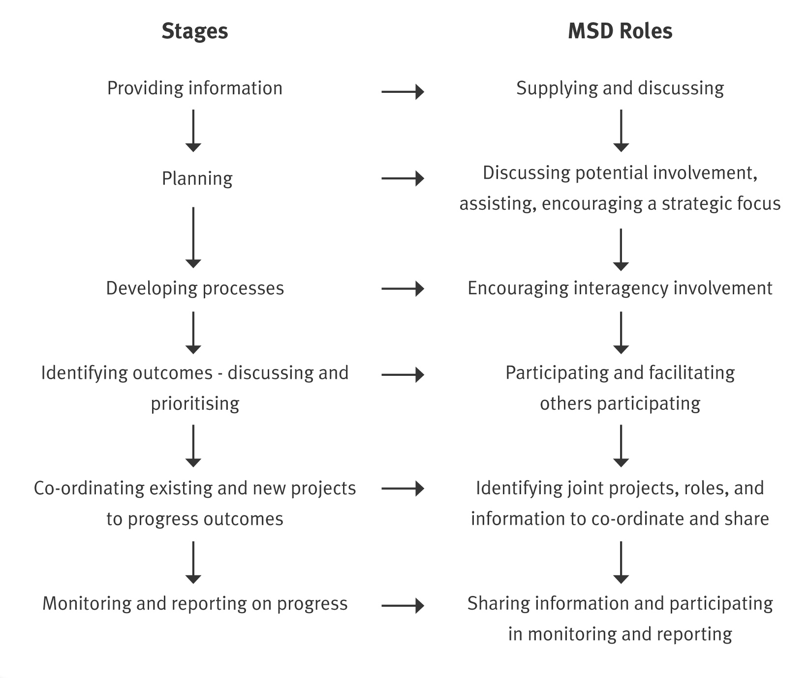

Principles and tips for collaborative work

Principles for working together include:
• taking care of relationships and allowing lots of time to build trust and respect
• respecting the differences and roles of other parties and being clear about MSD’s role
• making an effort to understand others’ perspectives and constraints
• building on existing networks and involving new members
• understanding the dynamics (relationships, drivers, strengths and weaknesses) of communities
and LAs, and identifying community champions
• knowing what services, events, and projects are already underway
• pooling resources and sharing risks
• looking for where to add value and being clear about why agencies are working together and
what they want to achieve
• being honest about what can and cannot be done
• being flexible
• being willing to share information and work towards positive solutions
• making decisions by consensus.

The following table provides some further tips on how to work with local government on collaborative processes.

Extract from www.goodpracticeparticipate.govt.nz
Planning a collaborative process with local government
Keep in mind the following things when embarking on a collaborative process with local government.
Local and national strategies
Local government develops local strategies that meet local needs. Central government agencies have a strong focus on national strategies. Look for the common ground between local and national interests.
Indicators
Because central government, local government and communities may have different expectations of the collaboration, their measures of success may vary. It’s best if all parties can agree on indicators at the beginning of any collaborative exercise.
Planning timeframes
Central government agencies’ timeframes and objectives can be affected by changes of government, Ministers or budgets. When working with local authorities try to identify any limitations that this may have on your ability to make commitments.
Delegated authority
Government agencies can vary in the amount of autonomy given to their local or regional offices.
Collaboration with a local authority can be easier if it involves someone from your agency who is able to make commitments on the agency’s behalf. If this isn’t possible it may be helpful, at least initially, if the local authority and your agency’s senior managers meet to discuss their interface.
Regional boundaries
Central government agencies’ administrative boundaries differ from local authority boundaries. For instance, a local authority in Taranaki may deal with central government agencies’ offices in New Plymouth, Palmerston North, and Wellington. Be conscious that this can add to local authority staff workloads. It can also create special challenges.

Appendix 1 – Useful websites, resources and contacts
Websites
www.familyservices.govt.nz/directory/index.jsp – Family and Community Services directory that lists programmes, services and resources for families.
http://socialreport.msd.govt.nz/2003/index.shtml – The Social Report provides information on the social health and well-being of New Zealand society. Indicators are used to measure levels of well-being, to monitor trends over time and to make comparisons with other countries.
www.dia.govt.nz – The Department of Internal Affairs’ website has information on local government and local government policy.
www.lgnz.co.nz – Local Government New Zealand’s website has useful information on local government.
www.lgnz.co.nz/projects/toolkit/ – Link to a web-based toolkit on child and youth participation. This resource was development by the Ministries of Social Development and Youth Affairs but is hosted on Local Government New Zealand’s website.
www.goodpracticeparticipate.govt.nz – The MSD Office for the Community and Voluntary Sector’s website resource for government agencies on participation, in particular refer to the section on working with local government.
www.population.govt.nz – Part of the Sustainable Development for New Zealand: Programme of Action. This website provides access to New Zealand population statistics published by a wide range of government departments and agencies and gives guidance on some of the key frameworks used to analyse population issues.
www.stats.govt.nz – New Zealand’s major source of official statistics.
www.stats.govt.nz/statistics-by-area/default.htm – It has links to community profiles to a local authority level and in some cases down to information on smaller communities as well as online maps, regional statistics and information on urban/rural characteristics.
www.arts.auckland.ac.nz/lpg/plainenglishguide.cfm – provides examples, templates and advice on partnerships, brokerage, and decentralisation of tasks based on Waitakere City interagency work.
www.oag.govt.nz/HomePageFolders/LTCCP/LTCCP.htm – From 2006, the Auditor-General will have a new statutory duty to issue opinions on local authorities’ LTCCPs.
www.msd.govt.nz/media-information/benefit-fact-sheets/ – These factsheets provide a time series on the main benefit statistics and are updated quarterly.
www.mch.govt.nz/ – The Ministry for Culture and Heritage provides advice on culture and heritage issues.

Resources
Family and Community Services, MSD (2005) Local Services Mapping – Process Guidelines
(internal document only).
Local Government New Zealand, Department of Internal Affairs, SOLGM (2003) The Local Government Knowhow Guide to Decision Making. LGNZ: Wellington.
MSD (2002) Briefing to the Incoming Minister: Improving Wellbeing for all New Zealanders.
MSD: Wellington.
MSD (2003) Involving Children: A guide to engaging children in decision-making. MSD: Wellington.
MSD (2003) Mosaics Whataahua Papariki: Key Findings and Good Practice Guide for Regional Co-ordination and Integrated Service Delivery. MSD: Wellington [in particular refer to the section on working with
local government, p59-62].
MSD (2004) Ministry of Social Development Statement of Intent 2004. MSD: Wellington.
MSD (2004) The Social Report 2004. MSD: Wellington.
Ministry of Youth Affairs (2002) Youth Development Strategy Aotearoa. MYA: Wellington.
Ministry of Youth Affairs (2003) Youth Development Participation Guide: Keepin’ it real: A resources for involving young people. MYA: Wellington.
New Zealand Government (2001) Statement of Government Intentions for an Improved Community – Government Relationship. Wellington.
Office for the Minister for Social Development (2004) Opportunities for all New Zealanders. Office for the Minister for Social Development: Wellington.
Work and Income Regional Plans.
Contacts
DIA’s Central Local Government Interface Team currently consists of:
Suzanne Sinclair Relationship Manager, Northern Ph (09) 362 7942
Martin Maguire Relationship Manager, Southern Ph (03) 977 2074
Nigel Ingram Information Broker, Wellington Ph (04) 495 7221

Work and Income Regional Office contacts for further information on snapshots are:
Kaipara Beth Neil, Social Development Manager, Northland
Bay of Plenty Susan Jolley, Social Development Manager, Bay of Plenty
Waikato Deanne McManus-Emery, Social Development Manager, Waikato

Ministry of Social Development contact information
NATIONAL OFFICE
Bowen State Building, Bowen Street, PO Box 12 136, Wellington, Phone (04) 916 3300
• Work and Income, Strategy Support Manager
• Family and Community Services, National Coordinator Local Services Mapping
• Office for the Community and Voluntary Sector, PO Box 12 136, Wellington
• Office for Disability Issues, PO Box 12 136, Wellington
• Office for Senior Citizens, PO Box 12 136, Wellington
Ministry of Youth Development, PO Box 10-300, Wellington, Phone (04) 916 3645

REGIONAL OFFICES
Northland Regional Office:
PO Box 947, Whangarei
Social Development Manager, Phone (09) 983 9112
Auckland Regional Office:
Private Bag 68 911, Newton, Auckland
Social Development Manager, Phone (09) 916 1775 or (09) 916 1801
FACS Northern Regional Office, Regional Manager, Phone (09) 916 1835
Waikato Regional Office:
PO Box 19 199, Hamilton
Social Development Manager, Phone (07) 957 1516
Bay of Plenty Regional Office:
Private Bag 3016, Rotorua
Social Development Manager, Phone (07) 921 8026
FACS Central North Regional Office,
Regional Manager, Phone (07) 921 8169
Taranaki Regional Office:
Private Bag 2005, New Plymouth.
Social Development Manager, Phone (06) 968 6629
Central Regional Office:
Private Bag 11 400, Palmerston North
Social Development Manager, Phone (06) 952 1416
East Coast Regional Office:
Private Bag 6015, Napier
Social Development Manager, Phone (06) 974 8256
Wellington Regional Office:
PO Box 27 504, Wellington
Social Development Manager, Phone (04) 917 7135
FACS Central South Regional Office, PO Box 12 136, Wellington, Phone (04) 916 3564

Nelson Regional Office:
Private Bag 24, Nelson.
Social Development Manager, Phone (03) 989 7029
Canterbury Regional Office:
PO Box 5292, Christchurch
Social Development Manager, Phone (03) 963 2341
FACS Southern Regional Office, Regional Manager, Phone (03) 963 2369
Southern Regional Office:
PO Box 297, Dunedin
Social Development Manager, Phone (03) 955 6536

