Housing affordability for renters and owners:
International comparisons

Prepared by Bryan Perry

Ministry of Social Development
Wellington

November 2021

Housing affordability for renters and owners:
International comparisons

Bryan Perry, MSD
November 2021

Introduction

High outgoings for housing costs relative to household income are often associated with financial stress for low- to middle-income households. Low-income households especially can be left with insufficient income to meet other basic needs such as food, clothing, basic household operations, transport, medical care and education for household members. Unaffordable housing can also lead to overcrowding with sharing accommodation and housing costs with others used as a survival strategy.

This report:
- shows where New Zealand ranks internationally on selected aspects of housing affordability for those already in their own homes or renting, using a high housing costs relative to household income measure, applied to lower-income households
- provides international comparisons of housing costs as a proportion of income for owners and renters, going beyond lower-income households and covering the whole population
- outlines the different approaches taken to measuring housing costs relative to income (for international comparisons), and illustrates how these different approaches and the inclusion or exclusion of different sub-groups in the analysis can impact on the overall picture produced.

The analysis uses data from Stats NZ’s Household Economic Survey (HES) to produce two sets of comparisons:
- It first re-visits and updates some housing affordability information first published by the OECD in 2018. The OECD report limits housing costs to mortgage and rent payments and uses the ‘more-than-40%’ outgoings-to-income (OTI) threshold. The analysis excludes those who own outright (no mortgage). It reports country rankings for households in the lowest income quintile, but looks also at households across the income spectrum, breaking down the quintile information by tenure. This enables comparisons to be reported for housing (un)affordability as usually understood (low-income households spending ‘too much’ on accommodation), as well as cross-country comparisons of relatively high spending on accommodation for all households.
- The report also applies Eurostat’s Housing Cost Overburden (HCO) methodology to HES data and locates New Zealand in the published tables to compare with European nations. Their HCO statistics also use a 40% threshold when comparing housing costs and household income, but the Eurostat HCO analysis is different from the OECD OTI analysis on four counts:
  - The Eurostat approach looks at net housing costs (gross less any subsidy or housing assistance (such as our Accommodation Supplement)) and compares that with household income excluding housing assistance. The OECD approach uses gross housing costs and includes housing support in household income.
  - Eurostat uses a broader definition of housing costs including rates, insurance and utilities, but it excludes mortgage principal.
  - Unlike the OECD report, the EU income quintile information is not broken down further by tenure or other categories of interest, but it does give age-group analysis overall.
  - Eurostat’s reporting uses all households in their HCO estimates – including those without a mortgage. Country rankings are therefore impacted by the proportion in each country who are outright owners, not just by rent and mortgage repayments.
HES data used in this report

Up to and including the 2017-18 HES, the data available to MSD for its reports was the ‘HES-TAWA’ data. This analytical dataset is the original survey data together with some modelled data that replaces some of the more problematic survey-based income information that respondents may misreport (for example, benefit and Working for Families income and the Accommodation Supplement). The modelled data is generated by the Treasury using their Tax and Welfare Analysis (TAWA) model or its predecessors.

For the 2018-19 and 2019-20 HES, Stats NZ redesigned the survey to better meet the needs of reporting under the Child Poverty Reduction Act (2018). The redesign package included a much larger sample size, moving to using administrative data for most of the income information and the creation of an improved set of weights to provide population estimates from the survey sample. These datasets (‘HES-admin’) are available to MSD for use for this and other reports.

The use of administrative data has in many ways further improved the income information available for HES analysis (for example, by removing measurement error when income from a respondent is misreported through recall issues or deliberately). However, when time series are constructed for housing affordability (and some other) measures there is evidence of a discontinuity from 2017-18 to 2018-19. One of the likely causes of the discontinuity is that the proportion of very-low-income (VLI) households is higher in HES-admin data than in HES-TAWA data – these are households with incomes well below benefit and NZ Superannuation levels. Many of these households have reported housing costs that are around the median for the whole population, and which are much higher than those with ‘ordinary’ low incomes. This means that for VLI households their housing costs relative to income are very high, much higher on average than any other income group, and often the ratio is more than 100%. All this leads to a higher proportion of low-income households reporting housing unaffordability compared with what is reported using HES-TAWA data. It is likely to account for some of the observed discontinuity.

The full picture of what it is that is causing the observed discontinuities is not at present fully understood – in addition to the VLI issue there are likely to be other drivers too. Stats NZ is carrying out further investigations, including consideration as to whether a new time series has to be formally declared from 2018-19, with or without treatment of the income data to address the VLI matter. This work is expected to be completed by December 2021.

For the OECD analysis (which is the main source for the Findings), this report uses 2017-18 HES-TAWA data to update the previously published New Zealand numbers and to fill the gaps in the OECD database where no New Zealand data is currently available. This avoids the more serious VLI issue in the current 2018-19 and 2019-20 HES data. The HES 2017-18 incomes relate to calendar 2017 on average, and the findings therefore do not reflect either the Families Package and core benefit increases, nor the impact on rents and mortgages of the large rises in house prices in 2020 and 2021.

For the EU analysis, the 2017-18 HES data does not have the necessary detail for the housing costs calculations for replicating the EU approach. The report therefore uses the 2018-19 HES-admin data for the EU comparisons, and applies the same (interim and relatively ‘light-touch’) treatment to the 2018-19 data as was done for the Child Poverty Report in June this year. This reduces but does not eliminate the likely over-estimation of HCOs (see Section O in that report (Perry, 2021) for details). The 2019-20 HES data gives almost identical numbers to those obtained using HES 2018-19.

This report and MSD’s Household Incomes Report

MSD’s Household Incomes Report (HIR) has a wide range of HES-based analysis on housing affordability for renters and those paying off a mortgage: it reports using OTIs of 30%, 40% and 50% for different tenures, ages, household types and income levels (quintiles), and time series to show trends in the medium term (three decades or so).

By presenting international comparisons, this new report provides a further reference frame to assist with understanding the state of housing (un)affordability in New Zealand, for those already in their accommodation. When the HIR resumes in 2022, these international comparisons will be included alongside the purely New Zealand material.

This report does not cover the other aspect of housing affordability – the ability of prospective home- owners to be able to afford a purchase and service the associated mortgage. There is good material available on this in other sources.

Overview and key findings

This standalone report adds an international dimension to the existing New Zealand housing affordability time series already published in the Household Incomes Report.

The report provides international housing affordability comparisons for owners and renters, using OECD and EU datasets and MSD analysis of Stats NZ’s Household Economic Survey (HES) to provide New Zealand numbers. It does not cover affordability regarding the purchase of a house, though trends for that are relevant to the theme of this report as eventually changes in house prices impact on housing affordability for owners and renters.

The OECD and the EU both use a 40% ‘housing-outgoings-to-income’ (OTI) measure though their definitions of housing costs are somewhat different:
- Low-income households that spend more than 40% of their income on housing costs have a high chance of experiencing serious housing stress unless they have some liquid assets / savings to draw on or financial assistance from outside the household.
- Using a 40% threshold is a more stringent approach than the common ’30-40’ measure – this defines housing stress as occurring for households that spend more than 30% of their income on housing costs and have income in the bottom two quintiles (bottom 40%).
- Eurostat’s reporting uses all households (including those without a mortgage) in their ‘Housing Cost Overburden’ (HCO) estimates. This is a quite different approach to the OECD one which looks only at households with rent or mortgage costs. The Eurostat numbers and country rankings are impacted by the differing proportions who own outright. They are both valid approaches but look at affordability comparisons in quite different ways.

The New Zealand numbers are all calculated using the OECD and Eurostat definitions used in the sources. This ensures the comparisons are ‘apples with apples’.

Timeframes for the OECD findings
- The OECD comparisons are the main ones used in this report.
- For most countries, the income reference year is either 2017 or 2018.
- The New Zealand numbers for the league tables are based on data from the 2017-18 HES which ran from 1 July 2017 to 30 June 2018.
- Respondents were asked about their incomes in the 12 months prior to the interview.
- This means that the 2017-18 household incomes draw on incomes from part of 2016, all of 2017 and part of 2018. On average the New Zealand numbers relate to household circumstances in calendar 2017.
- The findings therefore do not reflect either the Families Package or the core benefit increases, nor the impact on rents and mortgages of the large rises in house prices in 2020 and 2021.
- The 2017-18 HES is often referred to as the 2018 HES for short, thus leading readers to think it refers to the state-of-affairs in 2018. This is not the case.

Looking ahead – what would an update using HES 2020-21 data look like?
- The HES 2020-21 data will come available in early 2022.
- Whether New Zealand’s rankings will be much different in that update depends on the relative strengths of two New Zealand factors (assuming other OECD countries remain much the same):
  - rises in rents and mortgage repayments in the interim
  - offsetting increases in household income for low-income households, taking account of rising wages, higher minimum wage, adjustments to the Accommodation Supplement in 2018, the Families Package, core benefit increases, and so on.
- At best, the latter may be stronger than the former, but in any case it is hard to see that New Zealand’s rankings will change very much in a 2022 update using 2020-21 data.
- This assessment is supported by what we can see already in the 2019-20 data, with the VLI group deleted.

Selected key findings

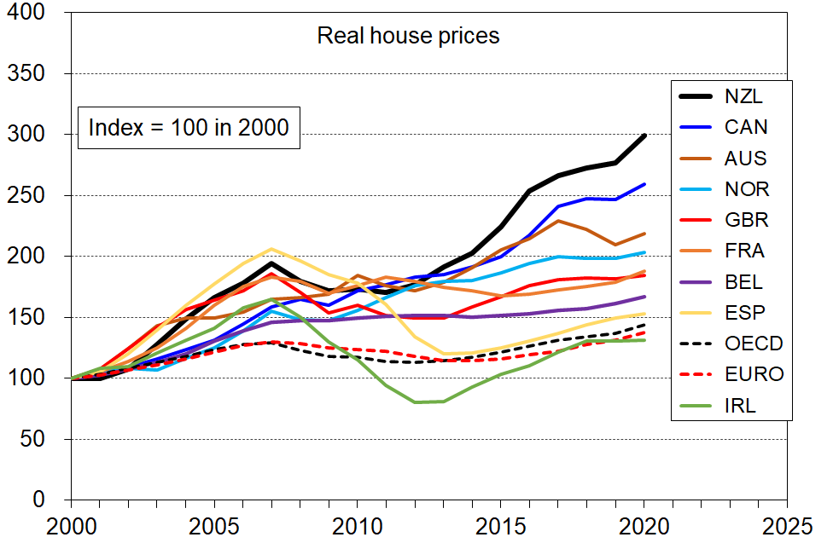
New Zealand has had the largest rise in house prices (in real terms) in the OECD, 2000 to 2020

New Zealand has a long-run trend of increasing housing (un)affordability for low-income households
- This trend has been sustained for those with housing costs > 50% of income even when the less stringent measures (>30%, >40%) showed signs of plateauing in more recent years.
- The chart (from the Incomes Report) shows trends for low-income under-65 households with housing costs greater than 30%, 40% and 50% of HH income. Low-income households here refers to households with income in the bottom quintile (Q1).
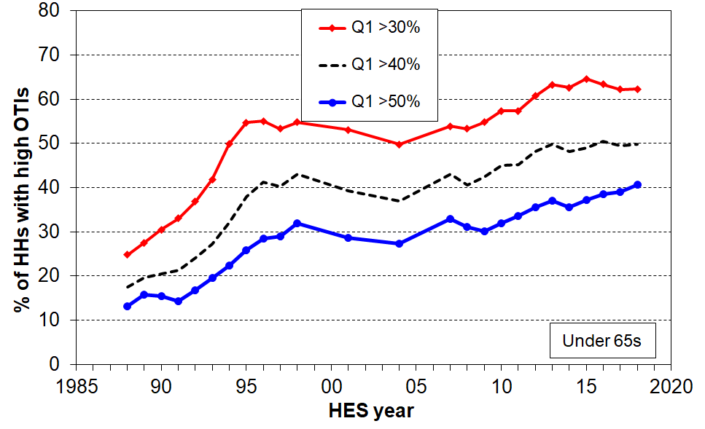

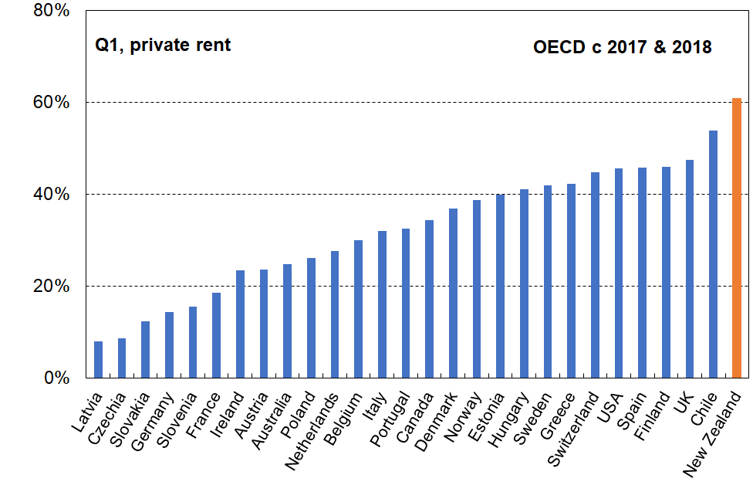
60% of low-income private renters (Q1) are in households that spend more than 40% of their income on rent, the highest rate in the OECD

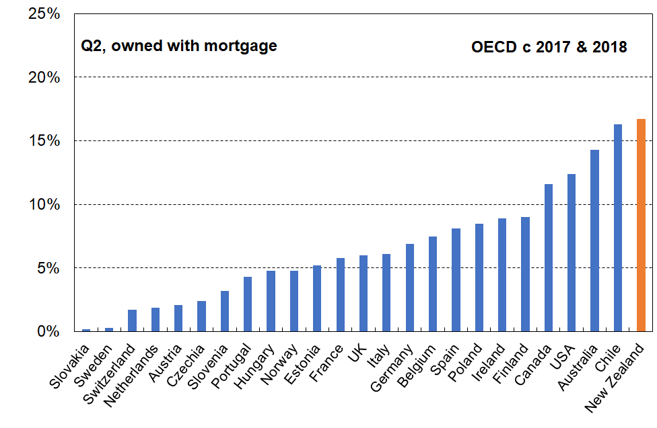
17% of those living in low-income mortgaged households (Q2) spend more than 40% of their income on the mortgage, the highest rate in the OECD

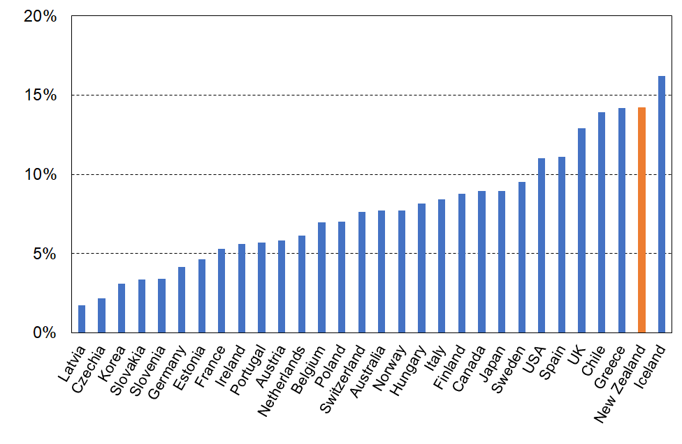
14% of all households paying a mortgage or renting spend more than 40% of their income on housing costs the highest rate in the OECD after Iceland, and the same as Chile and Greece

On the EU approach (which includes those households owning outright), NZ children overall are more than twice as likely as older NZers (65+) to be living in households spending more than 40% of their income on housing costs (9% v 4%), higher than almost all European countries
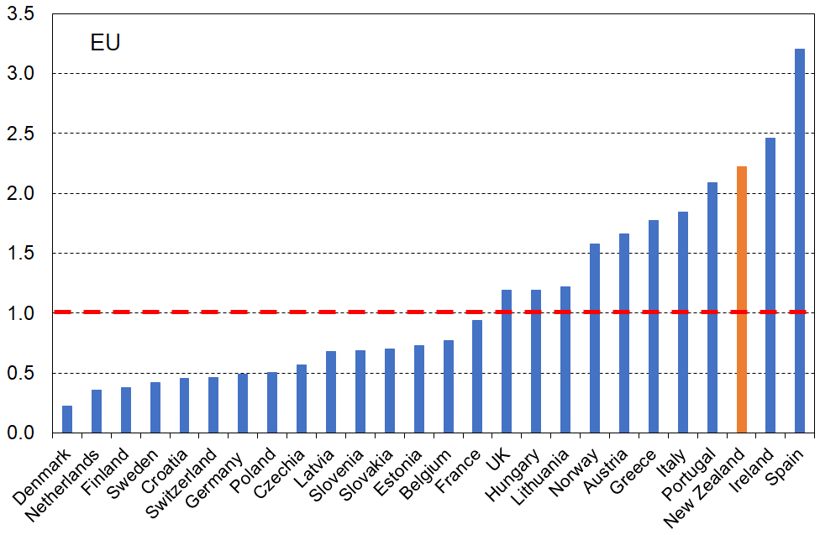
- The relativity between children and those aged 65+ varies considerably across European countries. This means that it is not simply a life-stage phenomenon; the relativities can be impacted by policy differences and cultural norms and expectations.
Note: the horizontal dashed line at value ‘1.0’ indicates where the ratio would be if children and those aged 65+ had the same chance of having housing costs greater than 40%.

Contents

Glossary and Abbreviations ………………………………………………………………….. 10

PART 1: Definitions and other contextual information
The different tenures used in housing affordability reports …..………………….…………….……… 11
Tenure distribution for OECD countries ………………..……….……….….…………………………… 12
Tenure distribution across household income quintiles and age groups for New Zealand .….……… 12
Unit for presentation: individuals or households? ……….……………..………………………………… 14
Defining housing costs ………………..…………………………………………………………………… 15
Interpreting the rankings ..………………………………………………………………………………….. 15
House prices in New Zealand: trends relative to other OECD countries …………….………………… 16
Timeframe for survey and other data used for the Findings in this report …………………………… 16

PART 2: Findings

OECD comparisons
Introduction ……………………………………………….………………………………………………….. 17
Individuals in low-income households spending more than 40% of their income on housing costs
(private rent and mortgage) ……………………………………………………………………………….. 18
Individuals in all households spending more than 40% of their income on housing costs (private rent and mortgage, all incomes) …………………………………………………………………………………..…. 20
Housing costs as % of income for each quintile by rent and mortgage and overall – median OTIs .... 21

Comparisons with European countries
Whole population and selected age groups ……………..……………………………………………….. 28
Household income quintiles ……………………………………………………………………………….. 30

References 32

Appendices 33

Appendix 1 Higher OTIs for lower income households mean a higher likelihood of higher levels of material and financial hardship

Appendix 2 Comparison of information sent to OECD by Stats NZ in 2018 and the information in this report, reflecting differences in methodology and a wider range of reporting by MSD

Appendix 3 Social Housing Stock in OECD countries

Appendix 4 Tenure Distribution – Supplementary Tables

Appendix 5 Sensitivity of Findings to treatment applied to VLIs

Appendix 6 Upper quintile income boundaries

Glossary and Abbreviations

HES Stats NZ’s Household Economic Survey
AHC After (deducting) housing costs
BHC Before (deducting) housing costs
BHC 60 Low-income threshold or income poverty line = 60% of the BHC median
REL Relative-to-contemporary-median (referring to low-income thresholds or ‘poverty lines’ that are calculated as a proportion of the median for the survey year in question) = ‘moving lines’
OTI the ratio of housing outgoings-to-income for households
HCO for EU statistics, the housing costs overburden is the percentage of the population living in households where the total housing costs ('net' of housing allowances) aret more than 40% of disposable income ('net' of housing allowances)
AS Accommodation Supplement
HH Household
LA rentals Local Authority rentals – these are provided with varying levels of subsidy
HNZ Housing New Zealand – in 2019 Kāinga Ora was created as a Crown agency, bringing together Housing New Zealand and the KiwiBuild Unit from the Ministry of Housing. ‘HNZ’ is used in this report as the HES data that sit behind the numbers were collected prior to KO’s creation
SP Sole parent
2P Two parent
DEP-17 MSD’s 17-item material hardship / deprivation index – also used by Stats NZ for three measures in the official Child Poverty suite
EU-SILC The European Union’s Survey of Income and Living Conditions
HBAI The Households Below Average Income report provides statistics on low incomes in the UK
Quintile One fifth or 20% of a ranked group of individuals or households
Decile One tenth or 10% of a ranked group of individuals or households
Ventile One twentieth or 5% of a ranked group of individuals or households
VLI households Very-Low-Income households (typically those with reported BHC incomes of less than $6000 pa (equivalised))

Part 1: Definitions and other contextual information to assist with interpreting the findings that follow in Part 2

The different tenures used in housing affordability reports

While renters and owners are the two main tenure categories used, different reporting regimes use different sub-groups and different combinations of these:
- Renters
  - social / public – residential rental accommodation provided at sub-market prices and allocated according to specific rules rather than market mechanisms
  - private
  - all renters
- Owners
  - no mortgage (owners outright)
  - with mortgage
  - all owners
- Mixed
  - private renters and mortgaged owners together
  - all renters and all owners together

When social renters are included in analysis for renters, the reported housing unaffordability rates are lower than when only private renters are included. The size of the reduction depends on the definition of ‘social housing’ that is used, the proportion of renters who are in social housing and on the size of the rent reduction relative to market prices. Each measure has its purpose and value: using just low-income private renters gives a picture of the level of housing stress for this important group; using all low-income renting households gives a picture of the overall housing affordability for renters in the country in question, with the size of the decrease from the private rental rate giving an indication of the impact of the social housing programme.

Similarly, when mortgage-free households are included in analysis for owners, the reported unaffordability rates are lower than when just households with a mortgage are included. The size of the reduction depends on the proportion of outright owners among all owners, and this varies considerably across countries (see Figure 1 below). Each measure has its purpose and value.

Provided the same measure is used for all countries in a particular report, international league tables can give valid international comparisons for each measure.

Many countries also provide housing support for lower-income households paying market rents or for owners with mortgages. In New Zealand the mechanism is the Accommodation Supplement (AS). As noted in the Introduction, the OECD and EU treat such support in different ways when assessing housing (un)affordability for renters and owners with mortgages.

Tenure distribution for OECD countries

Figure 1 shows the wide range of tenure distribution within OECD countries, with countries ranked on the level of outright ownership. Figure 2 combines the information on ownership with and without mortgage and re-ranks by overall ownership, which runs from around 80% to 95% in the former Soviet Bloc / Warsaw Pact countries through to 38% in Switzerland, ‘a nation of tenants’.

Figure 1
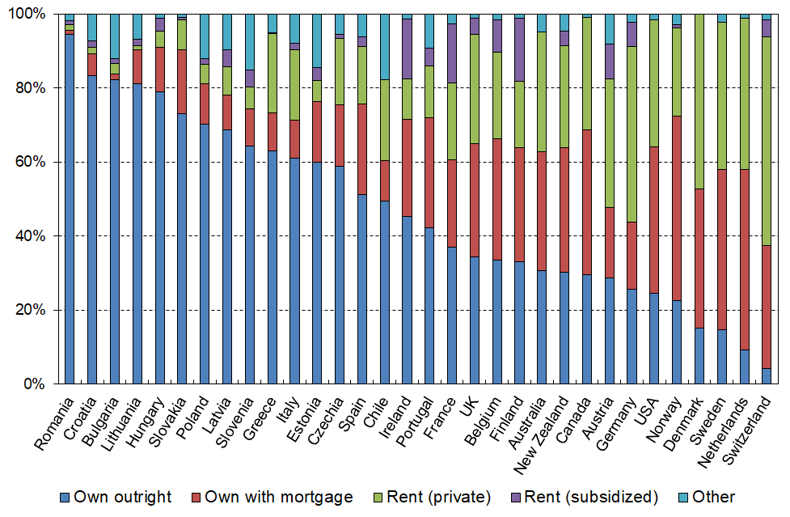
Distribution of housing tenure across OECD countries (ranked by outright ownership), c. 2018

Figure 2
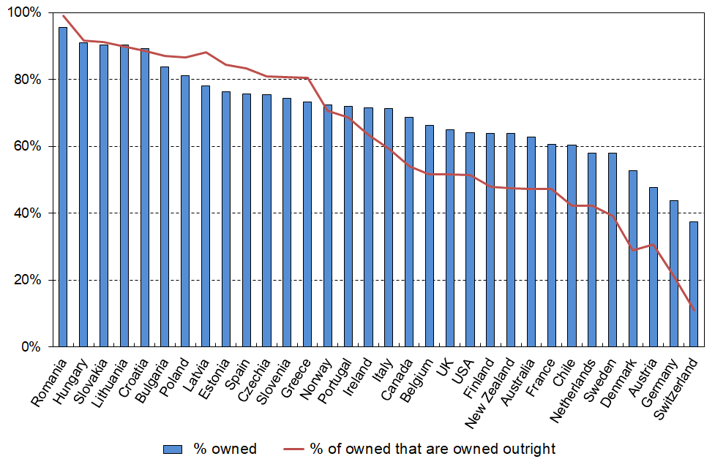
Distribution of home ownership across OECD countries

From a New Zealand perspective, home ownership (and especially mortgage-free home ownership) is seen as something to aspire to and is generally associated with higher living standards and better quality housing than is the case on average for rental accommodation. This is not the case for all countries across the OECD and EU. For example, ‘home ownership’ in the former Soviet Bloc countries is very high but many of these homes are crowded and poorly maintained apartments, purchased relatively cheaply in the1990s from the (previous) communist governments.

For social housing in the OECD, there is a considerable variation in the degree of subsidisation, the eligibility criteria and in the range of providers used. At one end of the spectrum social housing accounts for more than 20% of dwellings for three countries (Netherlands, Denmark and Austria). A little further down are Ireland, the UK and France in the 10-20% range. For Australia, Canada, New Zealand, Norway, Italy and Belgium, social housing stock is around 4-5% of all dwellings, and Spain, Estonia and Czechia have less than 1%. The majority of OECD countries (24/37) have under 7%. The bulk of these households are in the bottom income quintile, which is the one used most often to examine housing stress for renters especially.

Figure 3 shows the distribution of housing tenure for households in the bottom income quintile (20%).

Figure 3
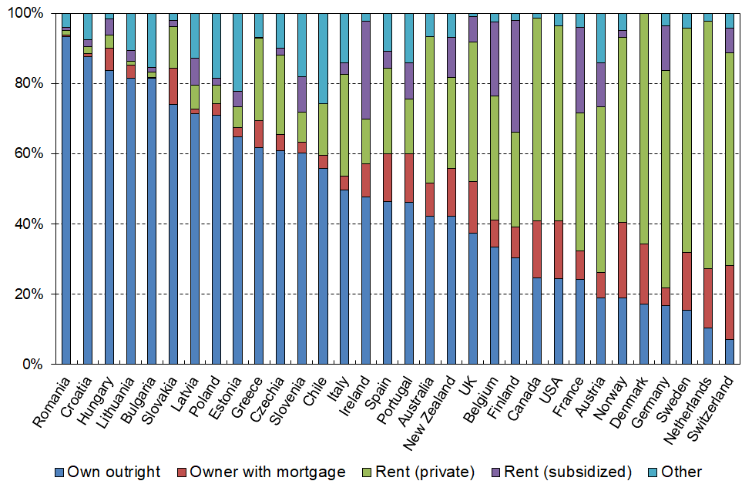
Housing tenure distribution for the lowest income quintile, ranked by outright ownership c.2018

For interpreting the affordability figures in Part 2, there are several features of Q1 tenure that are worth noting:
- For the bulk of OECD countries (leaving aside the former Soviet Bloc countries), compared with the distribution across all households (Figure 1), the proportion of rentals is much higher and the owned-with-mortgage proportions are much lower in Q1 (Figure 3). This means that the Q1 rankings for housing stress for the owned-with-mortgage category are not likely to give reliable estimates given the small sub-sample size for many countries. For this group it is better to use Q2 and Q3 rankings as the sub-samples are much more sizeable for them.
- For the owned-outright group, the proportions in Q1 are not greatly different from those for all households.
- For New Zealand, around 80% of Q1 households without a mortgage are households with at least one member who is 65+.
- The bulk of each country’s social housing is found in Q1 (eg two-thirds for NZ).

Units of analysis and presentation

Housing affordability is a household-based assessment, but findings can be presented either through counting households or by counting individuals in their households.

Households vary in size, and are not distributed evenly across the income or tenure distributions, so the two approaches produce different numbers. This is illustrated in Tables 1a and 1b below.

For the international comparisons in this report:
- The OECD uses both, depending on the theme. This report makes it clear which is used.
- The EU uses only individuals for their numbers.

Tenure distribution across household income quintiles for New Zealand

Table 1a reports the tenure distribution of households across income quintiles and overall for HES 2017-18. Table 1b repeats this for individuals in their households rather than for the households themselves.

One of the main differences between the household and the individual distributions can be seen in Q1 and Q2 for outright owners (ie those with no mortgage): the proportion Q1 individuals in mortgage-free households is low (27%) compared with the proportion when counting households themselves (39%); in Q2 it is 21% compared with 31%. These differences in the main reflect the high proportion of older New Zealanders (65+) who are mortgage-free yet have modest incomes, often little more than New Zealand Superannuation and placing them in Q1 and sometimes in Q2. Their households are smaller on average than those for under 65s, leading to the significant difference between a household analysis compared with an analysis for individuals in their households.

Table 1a
Tenure for households by income quintile (% down), HES 2017-18
 | Q1 | Q2 | Q3 | Q4 | Q5 | TOTAL
Owned outright (no mortgage) | 39 | 31 | 26 | 23 | 38 | 31
Owned with mortgage | 14 | 29 | 39 | 47 | 46 | 35
Rented | 43 | 37 | 32 | 28 | 15 | 31
Private rent | 26 | 32 | 31 | 27 | 15 | 26
Social housing (HNZ & LA) | 17 | 5 | 2 | 0 | 0 | 5
Other | 4 | 3 | 3 | 2 | 1 | 3
Total | 100 | 100 | 100 | 100 | 100 | 100
Social rental as proportion of all rental | 40 | 12 | 5 | 2 | 0 | 15

Table 1b
Tenure for individuals (in their households) by income quintile (% down), HES 2017-18
 | Q1 | Q2 | Q3 | Q4 | Q5 | TOTAL
Owned outright (no mortgage) | 27 | 21 | 22 | 19 | 33 | 24
Owned with mortgage | 17 | 36 | 45 | 52 | 50 | 40
Rented | 52 | 40 | 30 | 27 | 15 | 33
Private rent | 34 | 35 | 29 | 26 | 15 | 28
Social housing (HNZ & LA) | 18 | 5 | 2 | 0 | 0 | 5
Other | 4 | 3 | 3 | 2 | 2 | 3
Total | 100 | 100 | 100 | 100 | 100 | 100
Social rental as proportion of all rental | 34 | 13 | 5 | 1 | 1 | 15
Note for Table 1:
- Local Authority (LA) rents are usually less than market rates, though the level of subsidisation varies. LA rentals make up around 3% of all rentals.

Appendix 4 reports tenure distribution using HES 2017-18 for those aged 65+ and also for the whole population (households) for HES 2019-20.
Defining ‘housing costs’

Table 2 shows the different definitions of housing costs used by selected sources in New Zealand and internationally. These differences impact on the interpretation of the statistics and relativities in the charts and tables in the Findings section (Part 2 of the report).

For the international comparisons in this report the New Zealand numbers are all calculated using the appropriate OECD and Eurostat definitions so that there can be ‘apples with apples’ comparisons.

Table 2
Components of housing costs included in affordability analysis by selected sources
 | Housing cost components |  |  |  |  |  |  | Treatment of housing support
 | Rent | Mortgage Principal | Mortgage Interest | Rates | Building Insurance | Utilities for water, electricity, gas, etc | Repairs and maintenance
Eurostat |  | - |  |  |  |  | - | Deducted from HC
OECD ‘short’ |  |  |  | - | - | - | - | Included in income
OECD ‘total’ |  |  |  |  |  |  |  | Included in income
HBAI (UK) |  | - |  |  |  |  | - | Included in income
Stats NZ from 2007 |  |  |  |  |  | - | - | Included in income
MSD (standard) |  |  |  |  |  | - | - | Included in income
MSD (customised) | Components selected as required for specified application |  |  |  |  |  |  | (as required)

Household income and equivalisation

Household Income is income from all household members from all sources, less income tax paid.

Equivalised household income is household income adjusted for household size and composition to enable more reasonable comparisons between households when household income is used as a measure of material wellbeing:
- the OECD figures use the square root scale (square root of number of people in the household)
- the EU figures use what is called the ‘modified OECD scale’ (1.0 for first adult, 0.5 for subsequent people aged 14+, and 0.3 for younger children)

Interpreting the rankings

The reported rankings should be taken to provide a ‘good indication’ of where in the spectrum New Zealand (or any other country) sits, rather than a precise and definitive ranking of ‘12th’ or similar. The main rationale for this caution is the inevitable ‘sampling uncertainties’ challenge that all survey-based comparisons have. In addition, for international studies, differences between countries in the way core definitions are applied, despite best efforts by the administrators, can also alter rankings.

This caution does not however undermine the cumulative and compelling evidence that New Zealand ranks at the ‘unaffordable’ end of the spectrum relative to other OECD countries.

Another caution when interpreting rankings is to note that they do not include anything on the quality of the accommodation, simply the direct cost relative to income. A fuller assessment would need to take account of this too, though the mediocre average quality of New Zealand’s housing stock is not likely to improve its ranking on a more comprehensive metric.

House prices in New Zealand: trends relative to other OECD and EU countries

Although this report does not look at affordability from the perspective of those in the market seeking to purchase a property, the trend in house prices nevertheless provides an important context as house prices impact on the size of mortgage repayments and on rents charged. Figure 4 shows the two recent periods of rapid rise for New Zealand, 2000 to 2007 before the GFC, then again from 2012 on. In the period from 2000, New Zealand experienced the largest increase in real house prices in the OECD. Canada and Sweden (not shown) had similar increases.

Figure 4
Real house prices, 2000 to 2020, New Zealand and selected OECD countries
Source: OECD House Prices and Related Indicators

New Zealand also has the highest rise when using 1980 as the start date, a more than five-fold rise to 2020 (the index rose from 100 to 546), with the next highest rise being the UK (100 to 352), a distant second. Canada and Australia also experienced only a three-fold rise (100 to 301 and 100 to 335 respectively). For OECD countries overall, the increase was only 75% (100 to 175).

Timeframe for survey and other data used for the Findings in this report

- OECD: calendar 2017 to 2019 (NZ, calendar 2017 on average)

- EU: calendar 2018 to 2019 (NZ, calendar 2018 mainly)

Looking at time series from calendar 2013 to 2019, there is very little change to rankings on the key comparisons included in this report (OECD 40% OTI unaffordability, median housing costs as % of household income, EU 40% HCO), so the relative datedness of the data is highly unlikely to be giving any misleading or unreliable impressions about the situation for countries in 2021, either for the numbers or the rankings ….

…. except perhaps for New Zealand, as a result of the very large increases in house values and purchase prices in 2020 and 2021 which will almost certainly impact on OTIs for mortgaged households and (eventually) on OTIs for renting households, all else equal. There are some countervailing trends such as increases in real terms in core benefit rates, the minimum wage and the Accommodation Supplement (2018), and low interest rates, but these may not be sufficient in the circumstances to improve New Zealand’s international rankings.

MSD plans to update this report in 2022 as new information becomes available (HES 2020-21, and international updates).

The New Zealand numbers in this report are pre-COVID.

Part 2: Findings

OECD comparisons

The OECD’s 2018 Housing Affordability Report and its recent update (see OECD (2021)) provide comparisons across member countries of the proportion of households spending more than 40% of their income on housing costs. They use the following definitions:
- income is household disposable income – ie income from all sources (including any housing support and other government transfers and social welfare benefits), less income tax
- housing costs are gross housing costs for rent and mortgage (both principal and interest)
- the focus is on households with these housing costs (households who own outright (no mortgage) are excluded)
- rental households are sometimes just private rentals and sometimes social housing renters are also included.

High outgoings for housing costs relative to household income ( ‘high OTIs’) are often associated with financial stress for low- to middle-income households. Low-income households especially can be left with insufficient income to meet other basic needs such as food, clothing, basic household operations, transport, medical care and education for household members. Unaffordable housing can also lead to overcrowding with sharing accommodation and housing costs with others used as a survival strategy.

This section opens with country comparisons for high spending on housing costs for households in the lower income quintiles (OTIs > 40%) as this is where the highest housing stress is likely to be found.

It then reports on the median OTI for low to middle-income households (Q1, Q2, Q3) with overall rates for context.

For both measures (proportion with OTIs > 40% and median OTIs), rankings are provided for both renting households and households with mortgage payments.

For interpreting the numbers and relativities, it is important to note that they apply only to those with housing costs (rent or mortgage in this case). There are a good number of households in both Q1 and Q2 who own outright (no mortgage costs) and who therefore are not counted. For example, as reported in Table 1a above for New Zealand, 41% of Q1 households and 31% of Q2 households own outright (2017-18 HES data). Australia’s distribution is very similar.

Across the OECD as a whole, there is a wide range of outright ownership for Q1 and Q2 households. Figure 3 (above) shows this for Q1, with the proportion ranging from around 10% for Switzerland and the Netherlands to 75% and more for Poland and Hungary (and Bulgaria and Romania who are not OECD countries).

There are 38 OECD countries. Not all member countries provide housing affordability information and some provide only partial information. All the countries with which New Zealand usually compares itself have provided sufficient housing affordability information to allow clear conclusions about New Zealand’s relative ranking.

Individuals in low-income households that spend more than 40% of their income on housing costs (private rent and mortgage)

New Zealand has the highest housing affordability stress in the OECD for low-income households (Q1) renting privately, with 61% of individuals living in households spending more than 40% of their income on rent. This places New Zealand clearly at the ‘top’ of the OECD league table (Figure 5a) with a rate double the OECD median of around 30%.

For Q2, New Zealand is also at the ‘wrong end’ of the league tables (Figure 5b). For those in Q2 households renting privately, 22% are in households that spend more than 40% of their income on HC, lower than second-placed UK (26%) UK and higher than Spain (19%). The New Zealand rate is well more than double the OECD median rate of around 9% for Q2 renters.

Figure 5a
Q1, renting privately, spending more than 40% of income on rent, c.2018 (OECD)

Figure 5b
Q2, renting privately, spending more than 40% of income on rent, c.2018 (OECD)
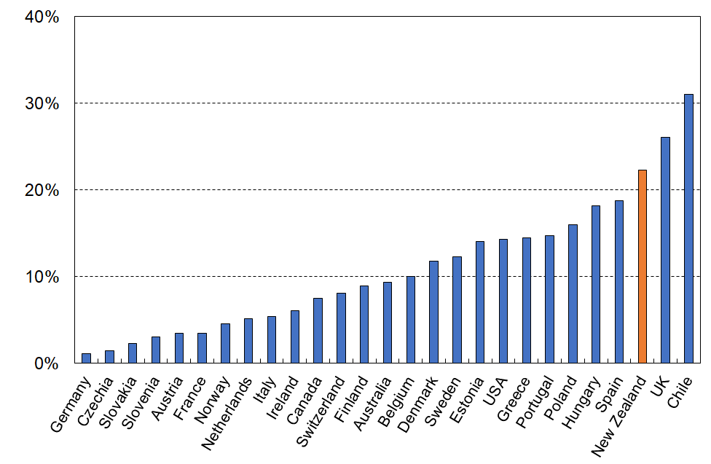

For those in low-income (Q1) households with a mortgage, around 30% spend more than 40% of their income on mortgage repayments, similar to the UK, but above Australia (24%) and well above many other European countries with whom we usually compare ourselves (Figure 6a).

Figure 6a
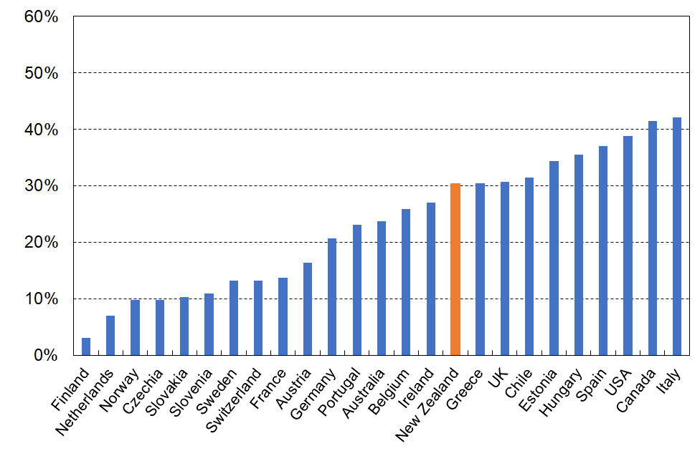
Q1, owned with a mortgage, spending more than 40% of income on mortgage repayments, c.2018 (OECD)

A quarter of mortgaged households in Q1 are older New Zealanders, many of whom will have been in the same house for many years and have only modest mortgage repayments relative to most low-income under 65s. This exerts downward pressure on the OTI > 40% rate for Q1. As noted above, the households-with-mortgage group in Q1 is relatively small (only 14% of all Q1 households – see Table 1) which means there is a sizeable sampling error / degree of uncertainty about the figures and precise rankings.

Figure 6b below uses Q2 households to report on New Zealand’s ranking for housing stress for those in owned-with-mortgage households. The numbers and rankings are much more reliable here.

For those in Q2 households and making mortgage repayments, 17% spend more than 40% of their income on housing costs, third highest after Greece (30%) and Luxembourg (21%) (not shown in the chart), higher than Australia (14%) and Canada (12%), and well above the UK, France and Norway (5-6%). The OECD median for Q2 owners with a mortgage is around 7%.

Figure 6b
Q2, owned with a mortgage, spending more than 40% of income on mortgage repayments, c.2018 (OECD)

Individuals in households spending more than 40% of their income on housing costs (private rent and mortgage), all incomes

When looking at households across the whole income spectrum, New Zealand’s rates for OTI > 40% are again near the ‘top’ of the OECD table. This full spectrum analysis does not tell us about housing stress or housing affordability – that occurs mainly for Q1 and Q2 households. Looking at all incomes nevertheless provides useful information in itself and for context for the Q1 and Q2 figures.
- For private renters (Figure 7), 24% spend more than 40% of their income on housing costs, second highest after the UK (25%) and well above Australia and Ireland (11%) and the OECD median of 12%.
- For owners with a mortgage (Figure 8), 9% spend more than 40% of their income on housing costs, lower only than Greece and Bulgaria (12-15%) (not shown) and higher than Australia, Canada and Ireland (5-6%), and well above the OECD median of just under 4%. For New Zealand around half (47%) of the 9% come from Q1 or Q2.

Figure 7
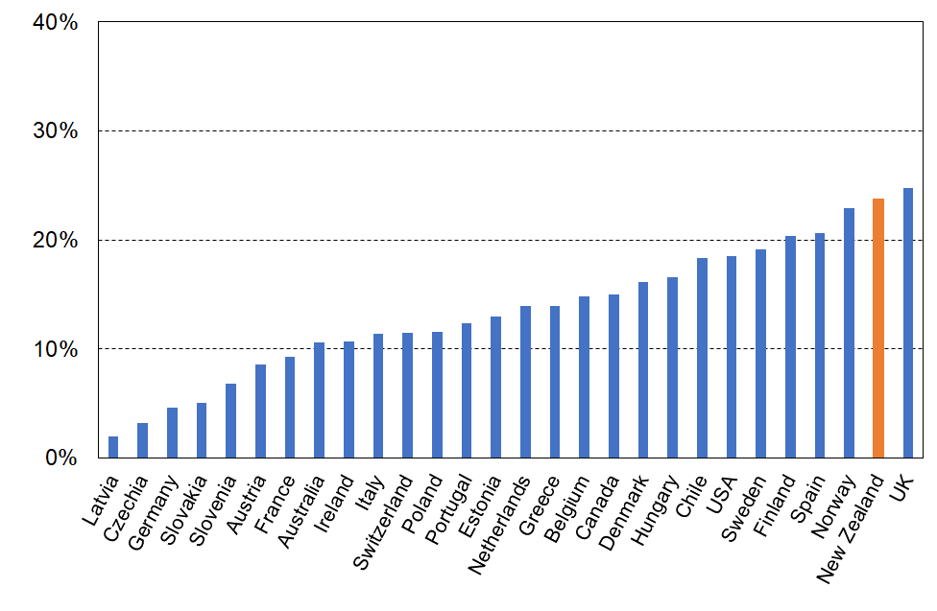
Those in households renting privately and spending more than 40% of income on rent, c.2018 (OECD)

Figure 8
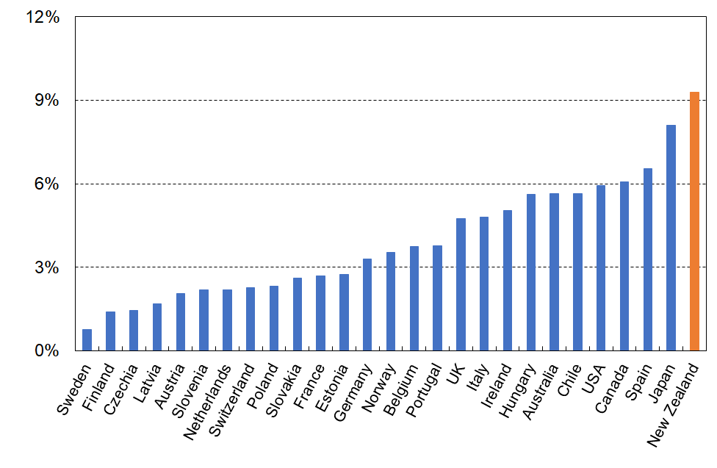
Those in households with a mortgage and spending more than 40% of income on the mortgage, c.2018

Figure 9 shows New Zealand’s overall ranking for all those in households with rent or mortgage housing costs, counting households of all incomes. This analysis includes social housing renters.

New Zealand has the second highest OECD ranking for proportion of people in households who spend more than 40% of their income on housing costs (rent or mortgage) – 14%, similar to Greece, and Chile and well above the OECD median and Australia (8%).

Figure 9
Proportion of those in households with rent or mortgage payments spending more than 40% of income on these housing costs, c.2018 (OECD)

Housing costs as a proportion of household income (or ‘OTIs’) across income quintiles for renters and mortgaged owners and all households – median OTIs

This section uses the median OTI of a selected group to allow comparison of housing costs for that group with the same group in other countries.

Figure 10 shows that the median spend on housing costs for New Zealand households that pay rent or mortgage is 22% of household income. This is at the higher end of the spectrum for OECD countries, similar to Australia, France, Finland and the Netherlands, but much more than for Ireland and Portugal (16%).

Figure 11 breaks the rankings down by renting and mortgaged households, with New Zealand at the high end for both – 28% for renters and 20% for those paying off a mortgage.

Figure 10
Households’ housing costs as a share of household income:
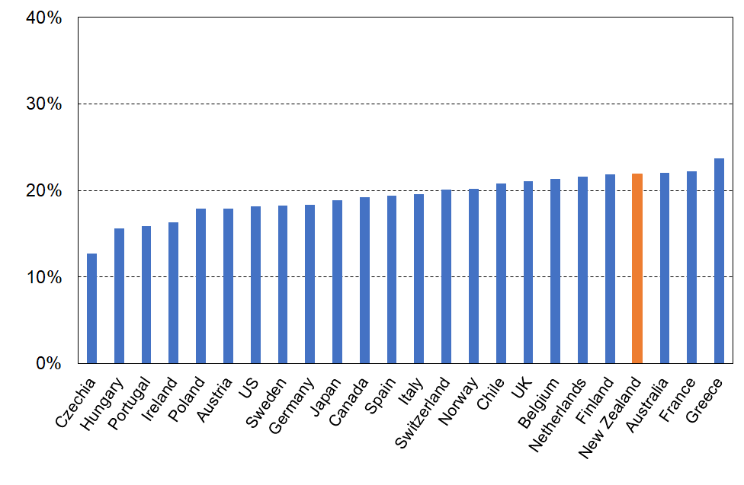
Median OTI for all households renting or owned with a mortgage, c 2018 (OECD)
Figure 11
Households’ housing costs as a share of household income:
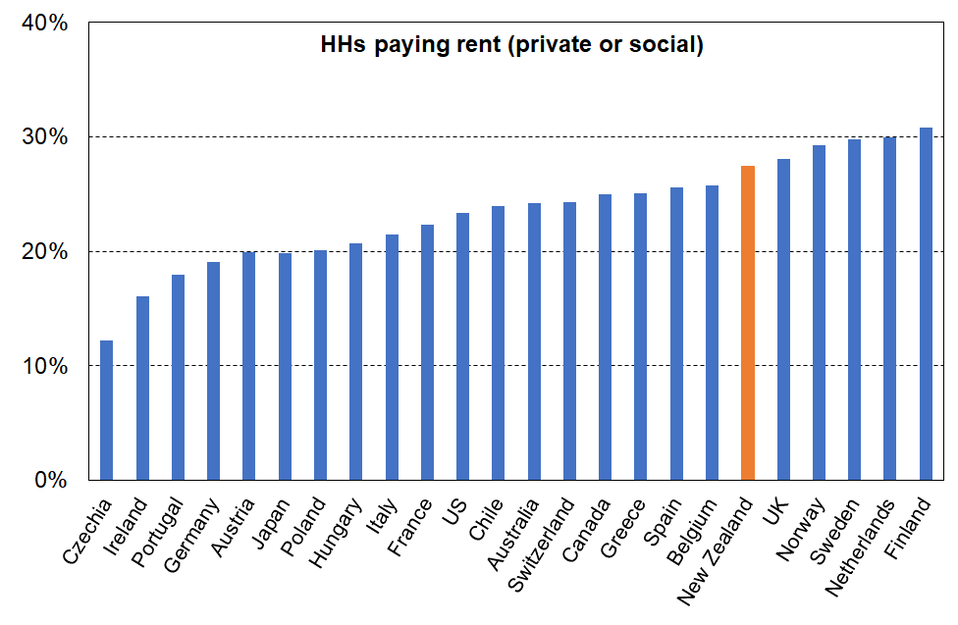
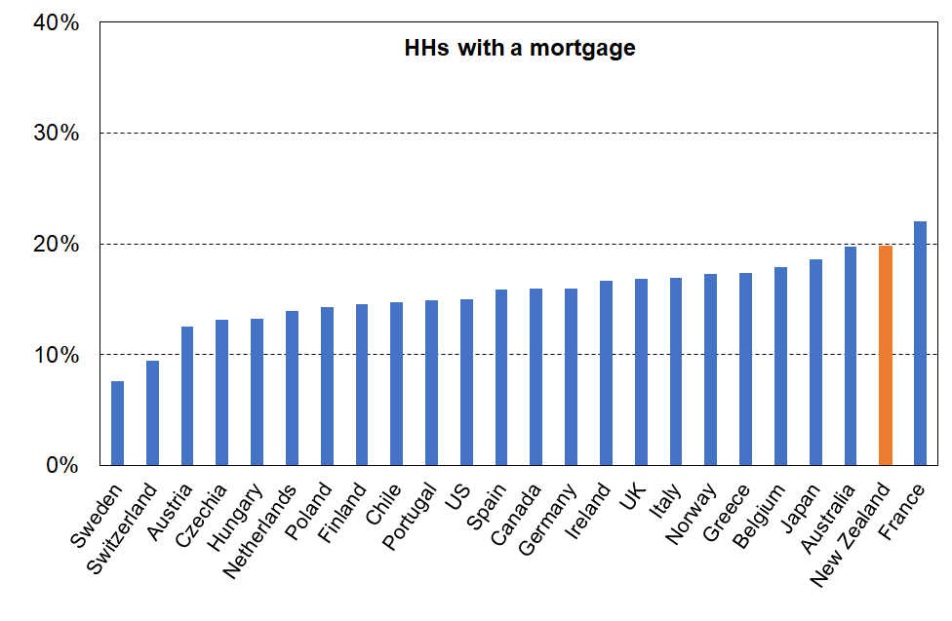
Median OTI for households renting or with a mortgage, c 2018 (OECD)

While the indicators of spending on housing costs overall are of interest, for the purposes of comparing across countries for housing affordability it is the OTIs of lower-income households that matter.

Looking first at lower income renting households, Figures 12 to 14 show New Zealand at the high end of the rankings for housing costs OTIs for each of the lower three income quintiles.

Half of renting households in the bottom income quintile spend more than 41% of their income on rent, similar to Sweden and Switzerland and much more than Australia where half spend more than 32% of their income on rent.
Figure 12
Households’ housing costs as a share of household income:
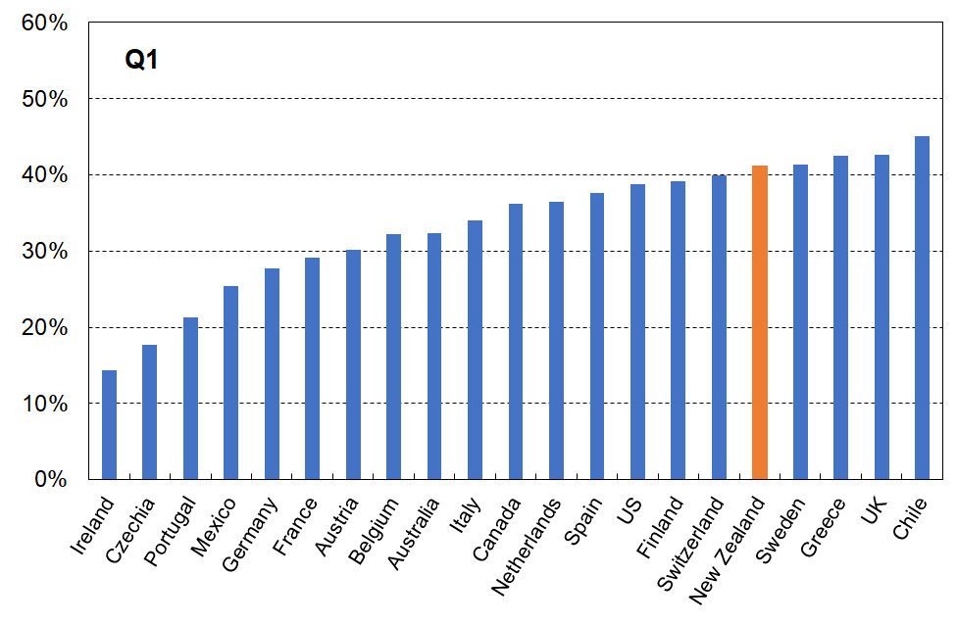
Median OTIs for Q1 households paying rent, c 2018 (OECD)
Figure 13
Households’ housing costs as a share of household income:
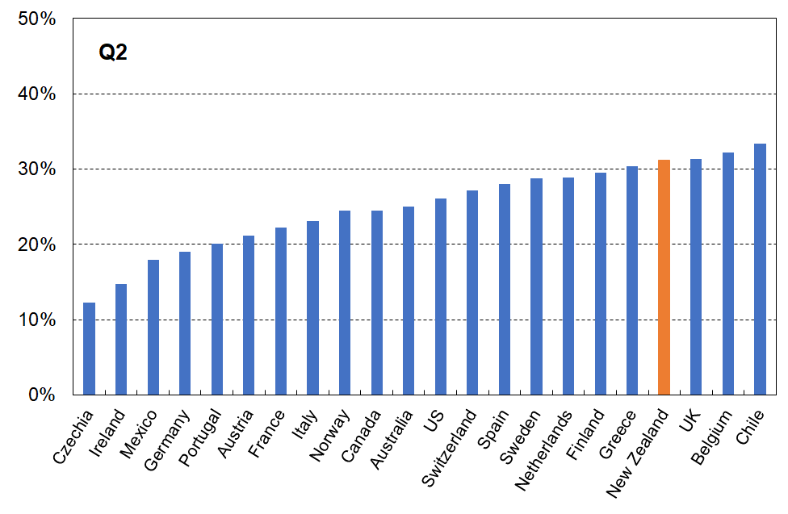
Median OTIs for Q2 households paying rent, c 2018 (OECD)
Figure 14
Households’ housing costs as a share of household income:
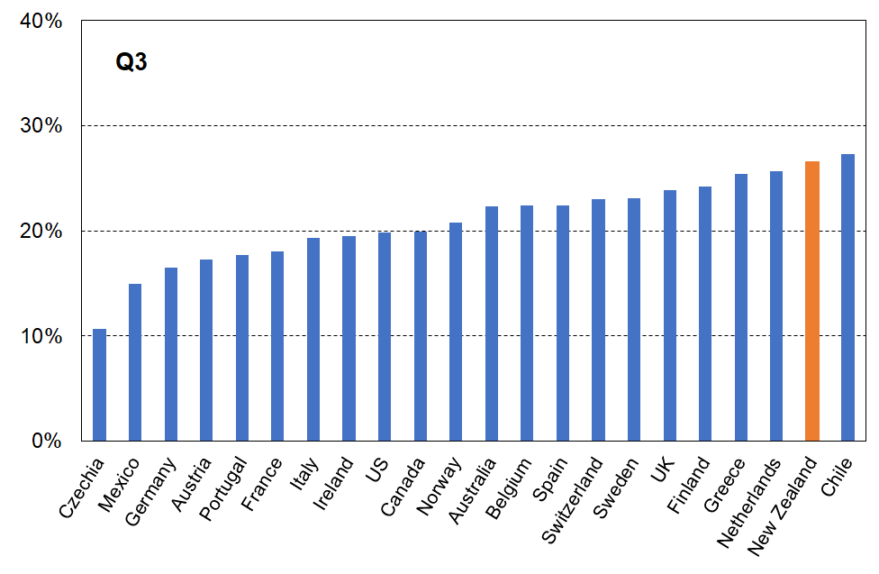
Median OTIs for Q3 households paying rent, c 2018 (OECD)
Looking at low- to middle-income households paying a mortgage shows a similar picture – New Zealand is at the high spending end of the rankings for Quintiles 2 and 3 (Figures 15 and 16).

Figure 17 shows that for the lowest quintile (Q1), New Zealand households’ spending on mortgage repayment is in the middle band, seeming to break the pattern of being at the high end for housing costs. A quarter of mortgaged households in Q1 are older New Zealanders, many of whom will have been in the same house for many years and have only modest mortgage repayments relative to most low-income under 65s. This exerts downward pressure on the OTI rate for Q1.

Figure 15
Households’ housing costs as a share of household income:
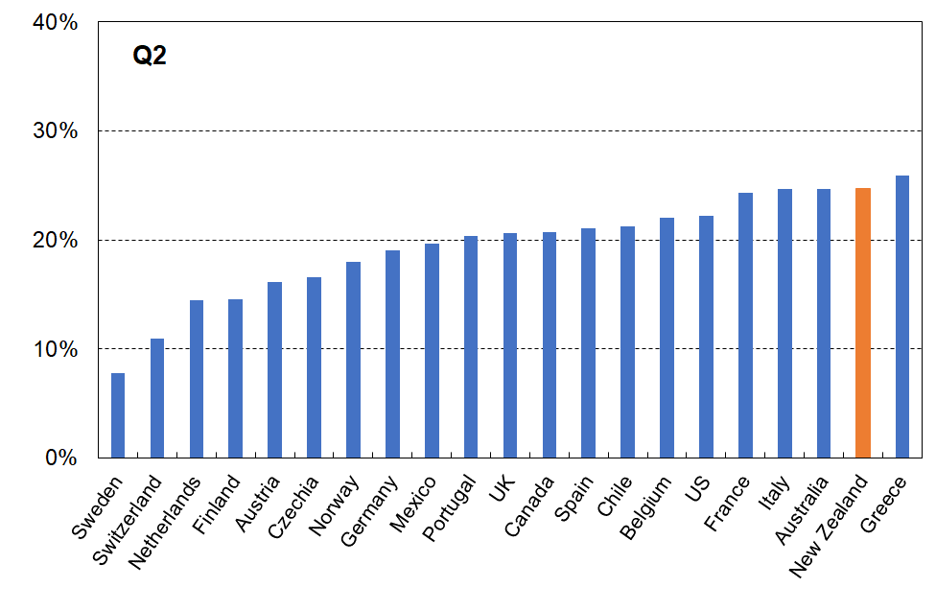
Median OTIs for Q2 households with a mortgage, c 2018 (OECD)
Figure 16
Households’ housing costs as a share of household income:
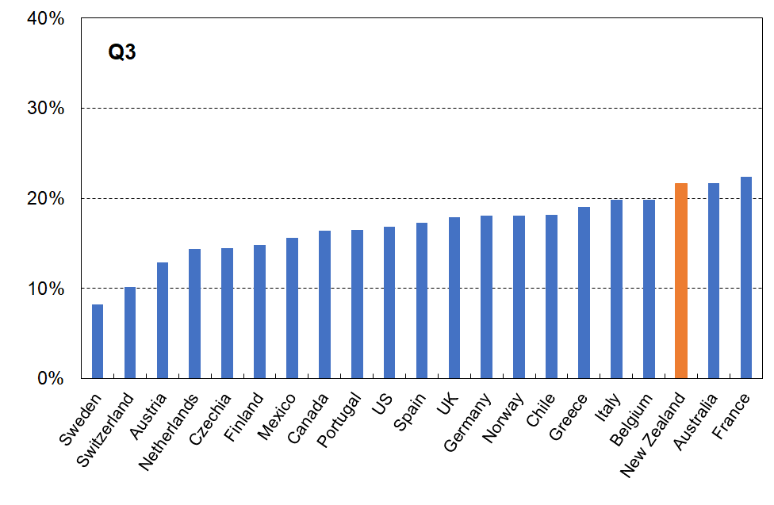
Median OTIs for Q3 households with a mortgage, c 2018 (OECD)
Figure 17
Households’ housing costs as a share of household income:
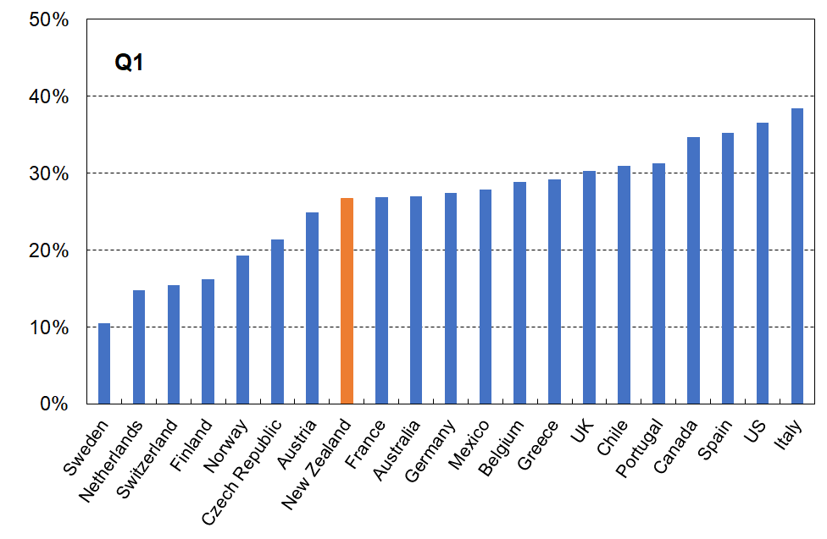
Median OTIs for Q1 households with a mortgage, c 2018 (OECD)
Table 3 summarises New Zealand’s housing stress rates relative the median OECD rates for the main tenure groups reported above. New Zealand rates are typically double those of the median OECD country in each case.

The median OECD rates are the simple median country rates, not the weighted median that takes population sizes into account.

Table 3
New Zealand rates compared with median OECD country rates for OTIs > 40%, low-income and overall
Group | NZ rate | Median OECD rate | Ratio (NZ / median OECD rate)
Private rent, Q1 | 61 | 30 | 2.0
Private rent, Q2 | 22 | 9 | 2.4
Owned with mortgage, Q1 | New Zealand numbers too small to support a reliable comparison
Owned with mortgage, Q2 | 17 | 7 | 2.4
Private rent, all | 24 | 12 | 2.0
Owned with mortgage, all | 9 | 4 | 2.7
Rent or mortgage, all (including social rent) | 14 | 8 | 1.9

Comparison of housing costs relative to income using a wider definition of housing costs

The OECD also reports on housing costs using a wider definition of housing costs which includes dwelling insurance, maintenance and repairs, utilities, and so on, as well as rent and mortgage or imputed rent. The documentation is not clear about whether for owners it is the mortgage repayments or imputed rent that is used. This report errs on the side of caution and does not include this comparison. See Barker et al (2019) at Figure 2 and associated text for a caution about possible upward bias on imputed rent for New Zealand.

The EU comparisons which follow use a wider definition too, but unfortunately exclude mortgage principal repayments.

If a reliable ‘wider housing costs’ analysis for international comparisons comes available, MSD will publish it in a future edition.

Comparisons with European countries

While both the OECD and Eurostat approaches use a 40% OTI threshold, there are three important differences between the methodologies:
- The definition of housing costs is different: for Eurostat it excludes mortgage principal but includes rates, dwelling insurance and utilities (water, electricity, gas).
- When calculating the OTI % (which Eurostat calls ‘Housing Cost Overburden = HCO), they use net housing costs divided by household income net of any housing support. The OECD uses gross housing costs divided by household income.
- The tenure analysis is different: for Eurostat, the ‘owned’ tenure includes those with and those without mortgage – this flows through to the ‘all households’ figures as outright owners are included here. The OECD approach excludes all households without a mortgage.

This means that the two sets of figures (OECD and Eurostat) are not directly comparable. The Eurostat data does however include some useful information not in the OECD data – for example, OTIs by age and household type.

The latest available international comparisons for New Zealand and European countries are from 2018, which corresponds to the 2018-19 HES. In 2018 the EU had 28 members as listed in Table 4 below. In addition, Eurostat publishes findings for three non-EU European countries of interest for New Zealand comparisons: Norway, Iceland and Switzerland. This makes 31 in all.

The charts that follow report on New Zealand and 25 European countries, with 6 omitted to avoid clutter: Bulgaria and Romania are omitted as their general standard of living is much lower than for New Zealand and most of the other European countries in the list (and their outright ownership is very high but of poor quality), and four very small countries are also omitted (Cyprus (1.2m), Luxembourg (650,000), Malta (500,000) and Iceland (360,000)).

Table 4
EU countries in 2018 (EU-28)
‘Old’ Member States (EU-15) |  | ‘New’ Member States (2004)
Austria | AT | Cyprus | CY
Belgium | BE | Czech Republic | CZ
Denmark | DK | Estonia | EE
Finland | FI | Latvia | LV
France | FR | Lithuania | LT
Germany | DE | Hungary | HU
Greece | EL | Malta | MT
Ireland | IE | Poland | PL
Italy | IT | Slovenia | SI
Luxembourg | LU | Slovakia | SK
Netherlands | NL
Portugal | PT | Bulgaria (2007) | BG
Spain | ES | Romania (2007) | RO
Sweden | SE
United Kingdom | UK | Croatia (2013) | HR

OTI levels and trends for those aged 65+ are strongly influenced by the high mortgage-free tenure of this group across European countries (and New Zealand). Their mortgage-free rate is currently around 72% on average overall, and 70% in the lower two BHC income quintiles. The very low housing costs for many in this (increasingly sizeable) group lowers the overall OTI figures, masking what is happening for the under 65s.

The EU section starts with the overall picture for all households, but then gives more detail for the OTI levels for the under 65s which, on average, are much higher than those for the population overall.
Whole population and selected age groups

Figure 18 gives the New Zealand ranking for all people in households that spend more than 40% of their income on housing costs, using Eurostat definitions, and an age breakdown for the same.

For the whole population, New Zealand’s HCO rate (9%) is similar to those of Italy, Sweden, Belgium, Spain, and the Netherlands (8-9%) and close to the EU median of 8%.

The finding that stands out is the relatively low HCO rate for older New Zealanders overall (4% compared with EU median of 7%), and the relatively high rate for those under 18 years overall (9% compared with overall EU median of 7%).

Figure 18
Proportion of individuals in households with ‘Housing Cost Overburden’ > 40%,
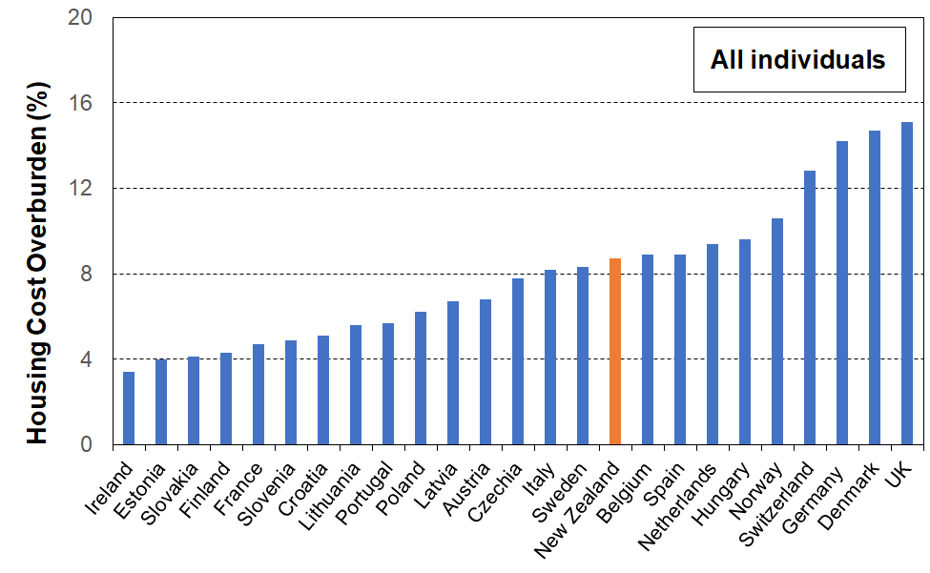
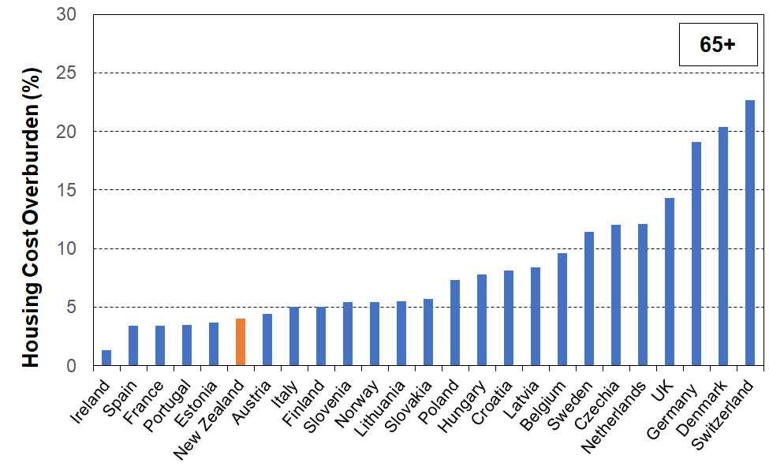
whole population and age-groups as indicated, c 2018
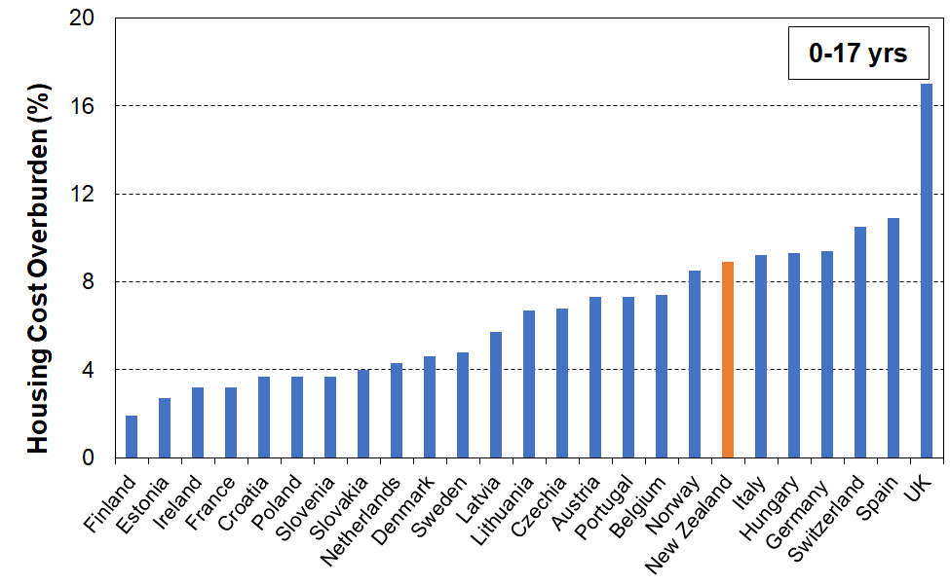
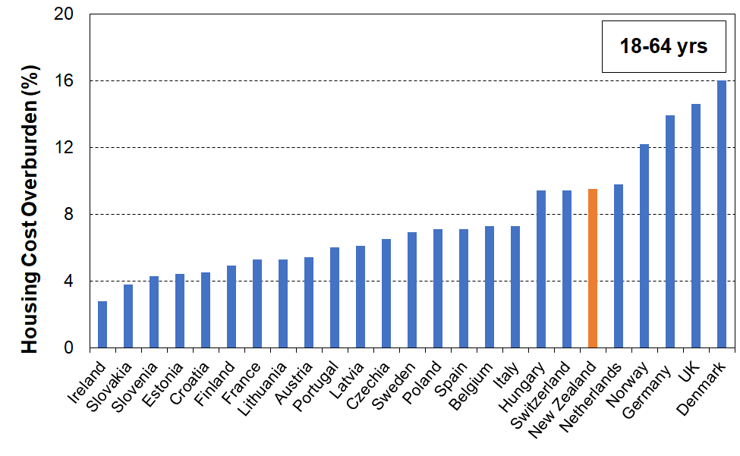

The relativity between the HCO for children and those aged 65+ varies considerably across European countries. In other words, it’s not simply a life-stage phenomenon; the relativities can be impacted by policy differences and cultural norms and expectations.

Figure 19a (next page) reports the ratio of HCO for children to that for those aged 65+ for each country. New Zealand ranks at the high end (the HCO for children is double that for older New Zealanders), lower only than Spain and Ireland, and well above European countries such as Belgium and France for whom the HCO for children is less than that for those aged 65+.

Figure 19a
Ratio of % of those under 18 years with high HCOs (>40%) to that for those aged 65+,
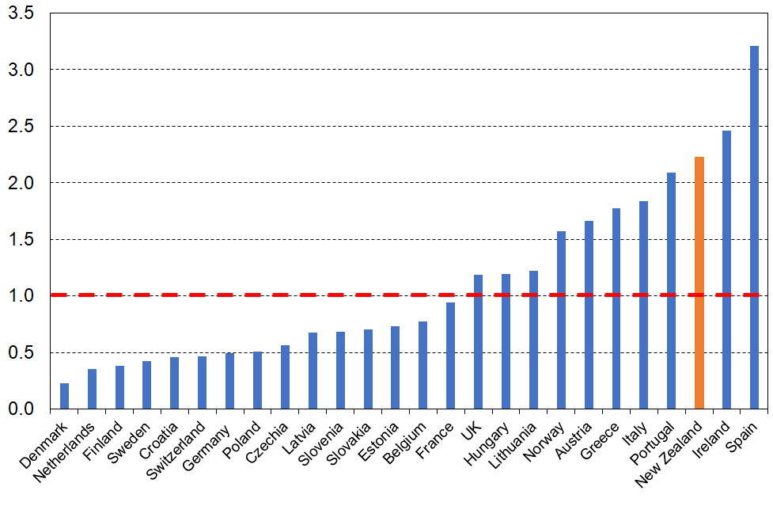
all HHs considered (EU approach and definitions)
Note: the horizontal dashed line at value ‘1.0’ indicates where the ratio would be if children and those aged 65+ each had the same chance of having an HCO greater than 40%.

The analysis above covers households of all tenures. This means that the ratio for each country and the actual rankings are impacted by the (relative) proportion of households that are mortgage-free in each age group category. Figure 19b repeats the analysis using the OECD approach which excludes mortgage-free households. New Zealand is still at the ‘wrong end’ of the rankings even on this approach which removes the impact of the large number of 65+ households that are mortgage-free.

Figure 19b
Ratio of % of those under 15 years with high HCOs (>40%) to that for those aged 65+,
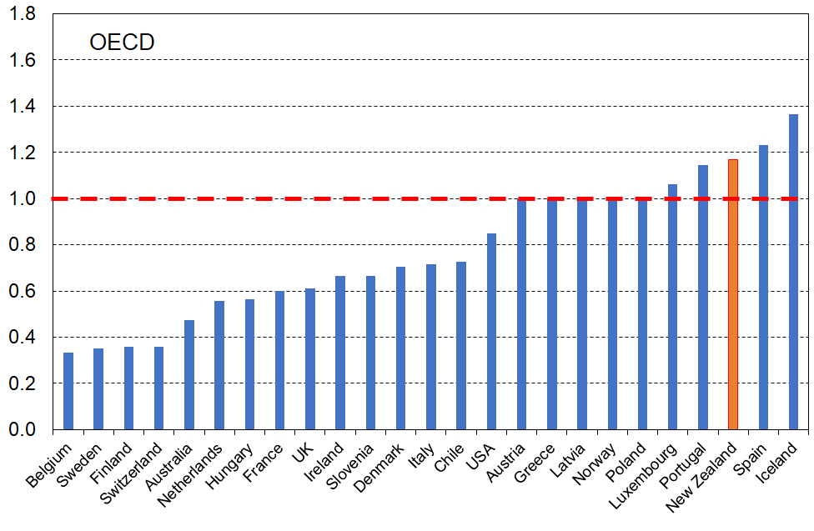
OECD approach (owned-without-mortgage HHs excluded)
The analysis above (in both cases) covers households of all incomes as well as all tenures, so does not give an indication of housing stress or housing unaffordability. This requires analysis looking at households with lower incomes. Findings across income quintiles is reported on later in this European section, albeit not also by tenure or age as Eurostat does not provide this information. Table 5 shows the income quintile breakdown by age breakdown for younger and older New Zealanders, using both the OECD and the EU approaches.

Table 5
Proportion (%) spending more than 40% of household income on housing costs
 | OECD definitions (2017-18) |  |  | Eurostat definitions (2018-19)
 | Q1 | Q2 | ALL | Q1 | Q2 | ALL
All | 39 | 14 | 14 | 25 | 11 | 9
65+ | 21 | 12 | 13 | 9 | 4 | 4
under 18 | 35 | 13 | 15 | 25 | 9 | 9
under 15 | 36 | 13 | 15 | 27 | 10 | 9
Note: see text for the difference between the OECD and EU approaches

Household income quintiles

Figure 20 shows that New Zealand’s 40% HCO rate for the lowest income quintile (all tenures included) is 25%, a little below the rate for the median European country (28%). On the other hand, the Q2 rate in Figure 21 (11%) is above the rate for the median European country (6%).

The Q1 rate is lower than expected, given the Q2 rate. The New Zealand Q1 rate is just over double the Q2 rate, and the next ranked country is the UK with a Q1 rate just under three times the Q2 rate. The bulk of the rest of the countries have a Q1 rate that is 4 or more times the Q2 rate.

Figure 20
Proportion of individuals in households with ‘Housing Cost Overburden’ > 40%,
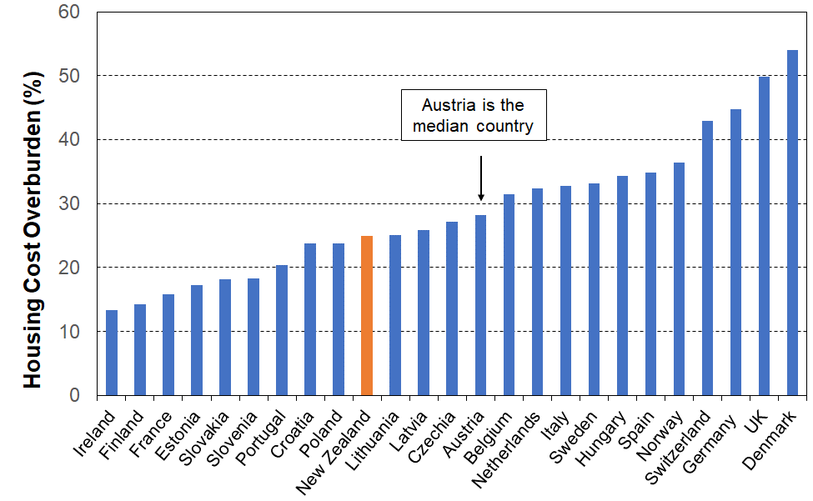
lowest income quintile (Q1), NZ and European comparisons

Figure 21
Proportion of individuals in households with ‘Housing Cost Overburden’ > 40%,
second lowest income quintile (Q2), NZ and European comparisons
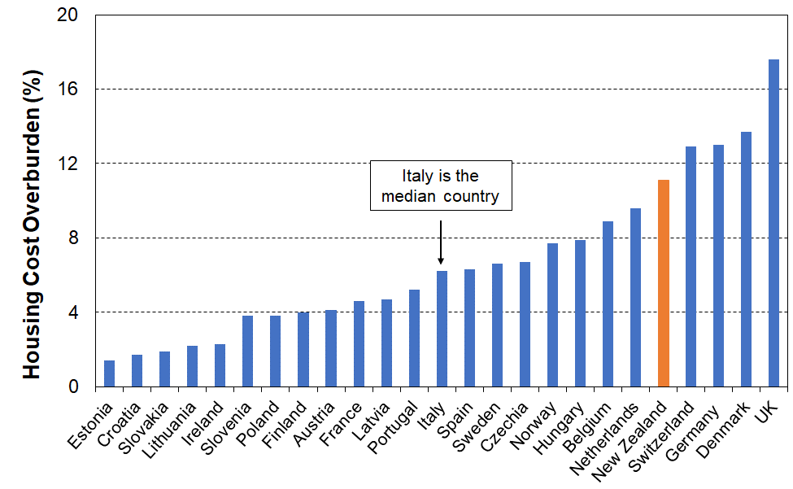

Figure 22 shows the relationship between Q1 and Q2 rates in the scatter diagram and associated linear correlation line. It shows that there is good cause to have expected a New Zealand Q1 rate of 35-45%, all else equal, rather than the much lower 25%.

The reason for this ‘discrepancy’ in the New Zealand Q1 rate when using the EU approach is that Q1 is highly populated with 65+ households, the vast majority of whom own outright. This is a distinctive feature of the New Zealand income distribution and housing tenure nexus that has as one of its consequences the relatively low material hardship rates for those aged 65+.

Figure 22
Proportion of individuals in households with ‘Housing Cost Overburden’ > 40%,
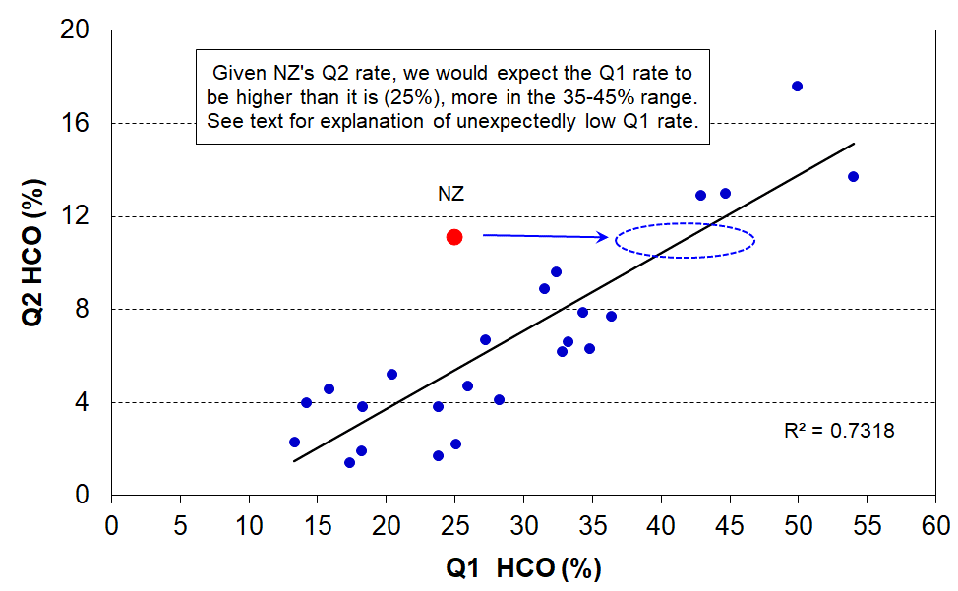
Q1 and Q2 rates compared for European countries and New Zealand

References

Barker, A. (2019), “Improving wellbeing through better housing policy in New Zealand”, OECD Economics Department Working Papers, No. 1565, OECD Publishing, Paris, https://doi.org/10.1787/b82d856b-en

CoreLogic (2021), “The NZ Housing Affordability Report” available at:
https://www.corelogic.co.nz/reports/housing-affordability-report

Johnson, A., Howden-Chapman P. & Eaqub, S. (2018), A Stocktake of New Zealand Housing. Wellington: Ministry of Business, Innovation and Employment.

Massey University Real Estate Analysis Unit (2021), “Home Affordability Report”, https://www.massey.ac.nz/massey/learning/colleges/college-business/school-of-economics-and-finance/research/reau/home-affordability-report.cfm

OECD (2017) OECD Environmental Performance Reviews: New Zealand 2017. Paris: OECD.

OECD (2019a), Under Pressure: The Squeezed Middle Class, OECD Publishing, Paris, https://doi.org/10.1787/689afed1-en

OECD (2019b), OECD Economic Surveys: New Zealand 2019, OECD Publishing, Paris, https://doi.org/10.1787/b0b94dbd-en

OECD (2020a), "Housing overburden rates, by age", in Housing and Inclusive Growth, OECD Publishing, Paris, https://doi.org/10.1787/196db741-en

OECD (2020b), “Social housing: A key part of past and future housing policy”, Employment, Labour and Social Affairs Policy Briefs, OECD, Paris, http://oe.cd/social-housing-2020

OECD (2021), “Building for a better tomorrow: Policies to make housing more affordable”, Employment, Labour and Social Affairs Policy Briefs, OECD, Paris, http://oe.cd/affordable-housing-2021

NZ Productivity Commission (2012), Housing Affordability, Final Inquiry Report, Wellington.
Perry, B. (2019), Household Incomes in New Zealand: Trends in Indicators of Inequality and Hardship, 1982 to 2018. Wellington: Ministry of Social Development.
Perry, B. (2021), Child Poverty in New Zealand. Wellington: Ministry of Social Development.
Salvi del Pero, A. et al. (2016), “Policies to promote access to good-quality affordable housing in OECD countries”, OECD Social, Employment and Migration Working Papers, No. 176, OECD Publishing, Paris. http://dx.doi.org/10.1787/5jm3p5gl4djd-en

Stats NZ (2020). Housing in Aotearoa: 2020. Retrieved from www.stats.govt.nz .

Appendix 1

Higher OTIs for lower income households mean a higher likelihood of higher levels of material and financial hardship

Table 1.1 provides a profile of the relative levels of material and financial hardship for low-income households with lower and higher OTIs. Higher OTIs are 42% and above, and lower are 38% and below. The profiles are reported for the two lower BHC household income quintiles (Q1 and Q2).

Probably the clearest evidence of the difference is in the three shaded rows:
- the median AHC income level is close to unliveable for Q1 households ($5600 equivalised, which is around $220 pw for a two adult, two child household … to cover food, groceries and personal items, electricity, transport, medical and so on).
- the high OTI households have extremely high median OTIs – those in Q1 with high OTIs spend on average two thirds (65%) of their income on housing costs
- material hardship rates for those with higher OTIs are much greater than those with lower OTIs for both income bands, double for Q1 and triple for Q2.

Table 1.1
Higher OTIs means higher material hardship for low-income households, HES 2017-18
HES 2017-18 | Q1 |  | Q2
 | OTI ≤ 38% | OTI ≥42% | OTI ≤ 38% | OTI ≥42%
Subgroup as % of Quintile | 47 | 53 | 76 | 25
Housing costs - median | 5,500 | 19,300 | 12,500 | 27,100
BHC income (equivalised) - median | 19,400 | 17,500 | 29,300 | 28,300
AHC income (equivalised) - median | 14,900 | 5,600 | 22,900 | 13,300
Median OTIs | 21 | 65 | 22 | 52
Material hardship rate (%) (Dep-17 6+) | 15 | 29 | 7 | 20
Self-assessed income adequacy - not enough | 24 | 33 | 10 | 23
Foodbank / other community help - once or more | 13 | 19 | 5 | 9
Computer & internet - enforced lack | 9 | 15 | 3 | 4
Cut back / went without fresh fruit and veg - a lot | 7 | 14 | 3 | 9
Put up with feeling cold - a lot | 13 | 21 | 6 | 13
Delayed replace/repair appliances - a lot | 13 | 23 | 7 | 15
Cannot pay unexpected $500 bill without borrowing | 35 | 48 | 26 | 35
Life satisfaction - dissatisfied / very dissatisfied | 7 | 16 | 7 | 13
Notes for table:
- Q1 = households in the lower 20% (quintile) of the (equivalised) BHC income distribution.
- OTI = ratio of housing outgoings to income.
- Social rentals are excluded – these all have low OTIs but eligibility requirements mean that most have high material deprivation.
- Housing costs include rates, rent, mortgage and dwelling insurance.
- A gap (OTIs 38-42%) is created between the higher and lower OTIs to reduce the ‘noise’ introduced by households that are just above or just below the OTI 40% boundary..
- Households with BHC incomes under $6000 pa who self-assess their income as ‘enough’ or ‘more than enough’ and who have a DEP-17 score of zero … are removed from the data to reduce the chances of these households contaminating the profile of high OTI households and diluting the seriousness of the reported hardship of this group. This treatment removes 53 households, representing around 20,000 households in the weighted data. This is around 6% of Q1 households. See Section O in Perry (2021) for more detail on this.

Appendix 2

Comparison of information sent to the OECD by Stats NZ in 2018 and the information provided in this report, reflecting differences in methodology and a wider range of reporting by MSD

Stats NZ provided 2016-17 HES-based information to the OECD for the 2018 OECD report. This MSD report updates the data to 2017-18 using a methodology in line with that of the bulk of other OECD countries and with the OECD’s standard approach. It also fills out some missing information.

Table 2.1 below compares the methodology used by Stats NZ with that used by MSD in this report.

Table 2.1
The difference between Stats NZ’s methodology for OECD comparisons
and that used by MSD for the comparisons in this report
 | Stats NZ to OECD | MSD (this report) | Comments
Household income for construction of OTIs | Gross | Disposable (ie after tax and transfers) | Stats advised that disposable was not available ‘due to data limitations’. Mexico, Chile, South Korea and the USA did the same.
Equivalisation of HH income in the construction of income quintiles | No equivalisation | Equivalisation applied using the standard OECD approach (square root scale) | Applying equivalisation to HH incomes changes the profile of which HHs are in the key low-income bands (Q1 and Q2) – more larger HHs drop down and crowd out smaller ones. Other countries used equivalised HH income.
Distinction between private and social renters | Not done | Done | Stats advised that ‘no distinction is available between private and subsidised renters’.This means that in the Stats NZ numbers the ’’private rent’ category is actually ‘all renters’.. Almost all other countries could make the distinction
Information gaps | - | Gaps filled | See Table 2.2 for missing NZ data.

Table 2.2 (next page) shows the similarities and differences in the actual numbers that follow from the methodological differences:
- The main difference is for Q1 households with a mortgage for which the Stats NZ approach produces a noticeably higher number than MSD’s approach. The households-with-mortgage group in Q1 is relatively small (only 14% of all Q1 households – see Table 1a in the body of the report), in part because of the relatively high proportion of 65+ households with no mortgage but low income. This means there is a sizeable sampling error / degree of uncertainty about the figures and precise rankings for this group. In that context, the differences in methodology for the figures supplied by Stats to the OECD and those used by MSD may well have shifted a few households across the Q1 boundary (in or out) and with such a small group involved to start with, a few more added or a few removed or both could easily have a surprisingly large impact on the rate and the ranking.
- Otherwise, the numbers are fairly similar. This is likely to be in part because the various differences can make the numbers move in opposite directions, with some cancelling out.

Table 2.2
MSD analysis for this report compared with Stats NZ’s for the OECD in 2018:
Record of the difference the different methodologies make, and of the gaps filled
 | See text for methodology | OECD methodology
 | HES 2016-17 | HES 2016-17 | HES 2017-18
 | Stats NZ to OECD | MSD | MSD  (this report)
Median HC as % of HH income
All renters | 25.9 | 27.8 | 27.4
Q1 renters | 43.9 | 41.8 | 41.2
Q2 renters | 31.3 | 32.8 | 31.6
Q3 renters | 22.9 | 27.3 | 26.6
All HHs with mortgage | 15.7 | 19.4 | 19.8
Q1 HHs with mortgage | 24.3 | 23.5 | 26.7
Q2 HHs with mortgage | 22.8 | 22.7 | 24.8
Q3 HHs with mortgage | 18.2 | 21.0 | 21.7
All HHs with rent or mortgage | nil | 23.5 | 22.9
All HHs | n/a | 14.9 | 15.3
Housing affordability, OTIs > 40%
Q1 own with mortgage | 42.5 | 32.4 | 30.4
Q1 private rent (Stats include ‘social’ here) | 56.0 | 59.9 | 60.8
Q1 all (excl those without a mortgage) | nil | 38.2 | 38.6
All own with mortgage | nil | 10.4 | 9.3
All private rent | nil | 19.9 | 23.8
All excl those without a mortgage | nil | 14.0 | 14.2
Notes
HC = housing costs
OTI = ratio of housing outgoings to income
Median HC as % of HH income - based on counting households
OTIs > 40% - based on counting individuals in their households

Appendix 3

Distribution of social housing stock in OECD countries

Figure 3 is a cut and paste from Figure PH4.2.1 in the Social Rental Housing Stock document available at:
https://www.oecd.org/els/family/PH4-2-Social-rental-housing-stock.pdf

The chart and the footnotes together are a valuable resource.

Figure 3
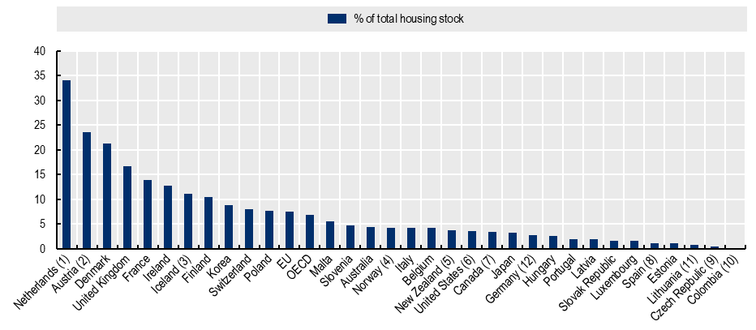
Distribution of social housing stock across OECD countries
1. For the Netherlands, the social dwelling stock is estimated based on rent levels charged by landlords as provided by the Ministry of the Interior and Kingdom Relations. These figures include units in private rentals provided below market rent and units provided by housing associations, excluding those provided at market-rate.
2. For Austria, data only refer to the main residence dwellings.
3. For Iceland, data might also include student housing rent from family members for free or at reduced rate.
4. For Norway, data only contains dwellings provided by municipalities (about 75% of all social housing).
5. For New Zealand, data refer to the number of social housing places (public housing) that are funded through central government, and do not include social housing provided by local authorities.
6. For the United States, the social housing stock includes public housing, subsidised units developed through specific programmes targeting the elderly (section 202) and disabled people (section 811), as well as income-restricted units created through the Low-Income Housing Tax Credit (LIHTC) programme; the number of public housing units as well as section 202 and 811 dwellings financed through the LIHTC programme have been adjusted to avoid double-counting, following OECD correspondence with the U.S. Department of Housing and Urban Development. The data is preliminary.
7. For Canada, data exclude units managed by the Société d'habitation du Québec (SHQ) for the Province of Quebec.
8. For Spain, the figures may also contain other types of reduced rent housing, e.g. employer-provided dwellings.
9. For the Czech Republic, data only contains dwellings provided by the central government.
10. For Colombia, data only refers to social rental housing produced since 2019 in the semillero de propietarios programme.
11. The share of social housing is calculated based on the previous year’s total dwelling stock.

Source: OECD Questionnaire on Social and Affordable Housing (QuASH), 2021. Some information comes from previous QuASH rounds or Bundesanstalt Statistik Österreich (2020); Center d'Etudes en Habitat Durable de Wallonie (2016); Institut Bruxellois de Statistique et d’Analyse (2019); Korean Statistical Information Service (2020); Scottish Government (2019); Northern Ireland Housing Executive (2018); Ministry of Housing and Urban Development New Zealand (2021); Statistics for Wales (2019); Canada Mortgage and Housing Corporation (2019); OECD exchanges with the U.S. Department of Housing and Urban Development and the Dutch Ministry of the Interior and Kingdom Relations in 2021; Poggio and Boreiko (2017).

Appendix 4

Tenure distribution in New Zealand (see also main text, Table 1)

Tables 4.1 and 4.2 compare the distributions for 2017-18 and 2019-20 HES. They are fairly similar. The reported drop in the proportion of public / social housing households in Q1 in 2019-20 is not likely to be statistically significant given the relatively small number of sample households for this group.

Tables 4.3 and 4.4 compare the difference it makes for older New Zealanders as to whether individuals aged 65+ or households with only 65+ in them are counted.

Table 4.1 (=Table 1a)
Tenure for households by income quintile (% down), HES 2017-18
 | Q1 | Q2 | Q3 | Q4 | Q5 | TOTAL
Owned outright (no mortgage) | 39 | 31 | 26 | 23 | 38 | 31
Owned with mortgage | 14 | 29 | 39 | 47 | 46 | 35
Rented | 43 | 37 | 32 | 28 | 15 | 31
Private rent | 26 | 32 | 31 | 27 | 15 | 26
Social housing (HNZ & LA) | 17 | 5 | 2 | 0 | 0 | 5
Other | 4 | 3 | 3 | 2 | 1 | 3
Total | 100 | 100 | 100 | 100 | 100 | 100
Social rental as proportion of all rental | 40 | 12 | 5 | 2 | 0 | 15

Table 4.2
Tenure for households by income quintile (% down), HES 2019-20
 | Q1 | Q2 | Q3 | Q4 | Q5 | TOTAL
Owned outright (no mortgage) | 43 | 33 | 25 | 24 | 30 | 31
Owned with mortgage | 14 | 23 | 37 | 45 | 50 | 34
Rented | 38 | 40 | 35 | 28 | 19 | 32
Private rent | 26 | 35 | 32 | 27 | 18 | 28
Social housing (HNZ & LA) | 13 | 5 | 3 | 1 | 0 | 4
Other | 5 | 4 | 3 | 2 | 1 | 3
Total | 100 | 100 | 100 | 100 | 100 | 100
Social rental as proportion of all rental | 33 | 13 | 8 | 3 | 1 | 14

Table 4.3
Tenure for households with age 65+ only by income quintile (% down), HES 2017-18
 | Q1 | Q2 | Q3 | Q4 | Q5 | TOTAL
Owned outright (no mortgage) | 71 | 80 | 77 | 80 | 88 | 77
Owned with mortgage | 9 | 7 | 13 | 10 | 5 | 9
Rented | 18 | 11 | 9 | 9 | 6 | 13
Private rent | 6 | 10 | 6 | 9 | 6 | 7
Social housing (HNZ & LA) | 12 | 2 | 2 | - | - | 6
Other | Numbers are too small to reliably report on as a separate category
Total | 100 | 100 | 100 | 100 | 100 | 100
Social rental as proportion of all rental | 67 | 16 | 25 | - | - | 44

Table 4.4
Tenure for individuals aged 65+ by income quintile (% down), HES 2017-18
 | Q1 | Q2 | Q3 | Q4 | Q5 | TOTAL
Owned outright (no mortgage) | 70 | 72 | 68 | 67 | 81 | 72
Owned with mortgage | 10 | 14 | 20 | 22 | 15 | 15
Rented | 18 | 12 | 9 | 9 | 4 | 12
Private rent | 8 | 8 | 7 | 9 | 4 | 7
Social housing (HNZ & LA) | 10 | 4 | - | 0 | - | 4
Other | Numbers are too small to reliably report on as a separate category
Total | 100 | 100 | 100 | 100 | 100 | 100
Social rental as proportion of all rental | 56 | 32 | - | 5 | - | 38

Unequivalised household income

Tables 4.5 to 4.7 use unequivalised household income.

Table 4.5 can be compared with Table 4.1 for a comparison for households. Table 4.5 can be compared with Table 4.6 for comparing the distribution for households and individuals, using unequivalised incomes.

Table 4.7 can be compared with Table 4.4 for individuals aged 65+.

Table 4.5
Tenure for households by unequivalised income quintile (% down), HES 2017-18
 | Q1 | Q2 | Q3 | Q4 | Q5 | TOTAL
Owned outright (no mortgage) | 47 | 33 | 23 | 24 | 30 | 31
Owned with mortgage | 13 | 24 | 38 | 49 | 51 | 35
Rented | 36 | 40 | 37 | 25 | 17 | 31
Private rent | 22 | 34 | 33 | 24 | 16 | 26
Social housing (HNZ & LA) | 14 | 5 | 4 | 1 | 0 | 5
Other | 3 | 3 | 3 | 2 | 2 | 3
Total | 100 | 100 | 100 | 100 | 100 | 100
Social rental as proportion of all rental | 38 | 13 | 10 | 3 | 2 | 15

Table 4.6
Tenure for individuals by unequivalised income quintile (% down), HES 2017-18
 | Q1 | Q2 | Q3 | Q4 | Q5 | TOTAL
Owned outright (no mortgage) | 38 | 19 | 18 | 19 | 28 | 24
Owned with mortgage | 16 | 34 | 46 | 51 | 54 | 40
Rented (incl LA and CG rented) | 43 | 43 | 34 | 28 | 16 | 33
Private rent | 29 | 37 | 31 | 27 | 16 | 28
Social housing (HNZ) | 14 | 6 | 4 | 1 | 0 | 5
Other | 3 | 4 | 2 | 2 | 2 | 3
Total | 100 | 100 | 100 | 100 | 100 | 100
Social rental as proportion of all rental | 32 | 14 | 11 | 4 | 1 | 15

Table 4.7
Tenure for individuals aged 65+ by unequivalised income quintile (% down), HES 2017-18
 | Q1 | Q2 | Q3 | Q4 | Q5 | TOTAL
Owned outright (no mortgage) | 73 | 74 | 66 | 69 | 70 | 72
Owned with mortgage | 10 | 16 | 17 | 24 | 23 | 15
Rented | 15 | 8 | 14 | 5 | 5 | 12
Private rent | 8 | 6 | 11 | 5 | 5 | 7
Social housing (HNZ & LA) | 7 | 2 | - | - | - | 4
Other | Numbers are too small to reliably report on as a separate category
Total | 100 | 100 | 100 | 100 | 100 | 100
Social rental as proportion of all rental | 48 | 27 | - | - | - | 38

Composition across quintiles for different tenures

Tables 4.8 and 4.9 report the distribution of tenure across income quintiles (in contrast to the ‘down’ approach in the tables above.

This shows, for example, that for the whole population only 8% of households with a mortgage are in the bottom quintile, yet for those aged 65+, 41% of this group are in the bottom quintile.

It is no surprise that 72% of those in social / public housing are in the lowest income quintile, but it is encouraging to see that the survey produces a very realistic number for this relatively small group. The figure rises to 87% for those aged 65+.

Table 4.8
Tenure for households by income quintile (% across), HES 2017-18
 | Q1 | Q2 | Q3 | Q4 | Q5 | TOTAL
Owned outright (no mortgage) | 25 | 20 | 16 | 15 | 24 | 100
Owned with mortgage | 8 | 17 | 22 | 27 | 26 | 100
Rented | 28 | 24 | 21 | 18 | 10 | 100
Private rent | 20 | 25 | 24 | 21 | 11 | 100
Social housing (HNZ & LA) | 72 | 19 | 7 | 2 | 0 | 100
Other | 29 | 21 | 21 | 18 | 11 | 100
Total | 20 | 20 | 20 | 20 | 20 | 100

Table 4.9
Tenure for households with age 65+ only by income quintile (% across), HES 2017-18
 | Q1 | Q2 | Q3 | Q4 | Q5 | TOTAL
Owned outright (no mortgage) | 37 | 25 | 13 | 10 | 14 | 100
Owned with mortgage | 41 | 20 | 20 | 12 | 8 | 100
Rented | 57 | 21 | 9 | 7 | 6 | 100
Private rent | 34 | 32 | 12 | 12 | 10 | 100
Social housing (HNZ & LA) | 87 | 7 | 5 | - | - | 100
Other | Numbers are too small to reliably report on as a separate category
Total | 41 | 23 | 13 | 10 | 13 | 100

Appendix 5

Sensitivity of Findings to the treatment applied to very low-income (VLI) households

As discussed in the Introduction, the presence of VLI households in surveys like the HES is fairly commonplace. The particular challenge posed by the HES data from 2018-19 and 2019-20 is that there are double the proportion of VLI households compared with previous surveys. Many of these VLI households have fairly ‘normal’ housing costs which means that their OTIs are very high. This in turn impacts on / inflates the reported housing unaffordability estimates for low-income households.

Table 5.1 shows the impact on selected OTI Findings of different ‘treatments’ of the VLI issue for 2018-19 from the new HES-admin data and also for 2016-17 and 2017-18 from the former HES-TAWA data.

Table 5.1
High OTI rates (> 40%) using different treatments to (partially) address the issue of the impact of VLI households on estimates of housing unaffordability
 | Delete negatives and zeroes to allow OTI calculations | Treatment 1 Delete VLIs with good living standards | Treatment 2 Delete VLIs | Treatment 3 Imputation
2016-17 - OECD
Q1 private rent, % with OTI > 40% | 59.9 | 58.5 | 57.6 | 58.5
Q2 private rent, % with OTI > 40% | 21.1 | 20.7 | 20.8 | 21.2
Q1 owned with mortgage, % with OTI >40% | 32.4 | 30.7 | 31 | 32.1
Q2 owned with mortgage, % with OTI >40% | 13.4 | 13.6 | 13.8 | 12.9
ALL, private rent, % with OTI > 40% | 19.9 | 19.7 | 19.5 | 19.8
ALL, owned with mortgage, % with OTI >40% | 10.4 | 10.3 | 10.3 | 10.4
Median OTI for Q1 households paying rent | 41.78% | 40.15% | 39.06% | 38.18%
Median OTI for Q1 households with a mortgage | 23.50% | 23.21% | 24.70% | 21.05%
2017-18 - OECD
Q1 private rent, % with OTI > 40% | 60.8 | 60 | 59.1 | 61.1
Q2 private rent, % with OTI > 40% | 22.3 | 22 | 22.4 | 22.9
Q1 owned with mortgage, % with OTI >40% | 30.4 | 30.3 | 29.9 | 30.6
Q2 owned with mortgage, % with OTI >40% | 16.7 | 16.6 | 16.2 | 16.7
ALL, private rent, % with OTI > 40% | 23.8 | 23.6 | 23.5 | 23.8
ALL, owned with mortgage, % with OTI >40% | 9.3 | 9.3 | 9.2 | 9.3
Median OTI for Q1 households paying rent | 41.2% | 39.6% | 38.6% | 39.6%
Median OTI for Q1 households with a mortgage | 26.7% | 26.4% | 26.3% | 26.4%
2018-19 – OECD (not used in this report)
Q1 private rent, % with OTI > 40% | 72.4 | 69.4 | 68.5 | 71.3
Q2 private rent, % with OTI > 40% | 32.3 | 31.4 | 31.3 | 32.6
Q1 owned with mortgage, % with OTI >40% | 46.4 | 43.4 | 43.1 | 43.9
Q2 owned with mortgage, % with OTI >40% | 13.7 | 13.5 | 13.1 | 13.9
ALL, private rent, % with OTI > 40% | 27 | 26.2 | 25.8 | 26.9
ALL, owned with mortgage, % with OTI >40% | 10.7 | 10.3 | 10.2 | 10.6
Median OTI for Q1 households paying rent | 46.5% | 43.5% | 44.1% | 44.9%
Median OTI for Q1 households with a mortgage | 42.6% | 35.6% | 30.8% | 34.0%
2018-19 - Eurostat
Q1, % with HCO > 40% | 28.1 | 25.0 | 23.8 | 24.7
Q2, % with HCO > 40% | 11.4 | 11.1 | 10.9 | 14.3
Under 18s, % with HCO > 40% | 9.4 | 8.8 | 8.5 | 9.4
Note: see under Table 2.2 for definition of treatments
Table 5.2
Impact of selected ‘treatments’ on VLI numbers and proportions
 | No treatment | Delete negatives and zeroes to allow OTI calculations | Treatment 1 Delete VLIs with good living standards | Treatment 2 Delete VLIs | Treatment 3 Imputation
Sample HHs
2016-17 | 3,703 | 3,679 | 3,664 | 3,640 | 3,703
2017-18 | 5,482 | 5,457 | 5,429 | 5,392 | 5,482
2018-19 | 21,163 | 20,964 | 20,867 | 20,708 | 21,163
VLI sample HHs removed
2016-17 | 0 | 24 | 39 | 63 | 0
2017-18 | 0 | 25 | 53 | 90 | 0
2018-19 | 0 | 199 | 296 | 455 | 0
% VLI sample HHs removed
2016-17 | 0.0 | 0.7 | 1.1 | 1.7 | 0.0
2017-18 | 0.0 | 0.5 | 1.0 | 1.7 | 0.0
2018-19 | 0.0 | 0.9 | 1.4 | 2.2 | 0.0
Weighted HHs
2016-17 | 1,711,552 | 1,699,954 | 1,693,787 | 1,684,149 | 1,711,552
2017-18 | 1,734,025 | 1,724,647 | 1,714,118 | 1,705,541 | 1,734,025
2018-19 | 1,755,131 | 1,735,378 | 1,721,198 | 1,706,668 | 1,755,131
VLI weighted HHs removed
2016-17 | 0 | 11,598 | 17,765 | 27,403 | 0
2017-18 | 0 | 9,378 | 19,907 | 28,484 | 0
2018-19 | 0 | 19,753 | 33,933 | 48,463 | 0
% VLI weighted HHs removed
2016-17 | 0.0 | 0.7 | 1.0 | 1.6 | 0.0
2017-18 | 0.0 | 0.5 | 1.2 | 1.7 | 0.0
2018-19 | 0.0 | 1.1 | 2.0 | 2.8 | 0.0
Treatment descriptions for Tables 5.1 and 5.2:
- Removes all with BHC incomes below $5000 (in $2007) who report enough/more than enough for income adequacy or who have a DEP-17score of zero. No re-weighting. This is the treatment used in this report for the EU comparisons. The VLI threshold is $6000 for HES 2016-17, $6100 for HES 17-18 and $6200 for HES 2018-19.
- Removes all with BHC incomes below $5000 (in $2007) No re-weighting.
- The main alternative to deletion as a treatment approach is imputation. As a part of the investigation into possible treatments MSD increased the equivalised disposable income of the VLI households by $25,000, taking their incomes above the BHC 60 poverty line but below the median – this is the region on the income distribution where there are similarities with the VLI households average expenditure and material wellbeing scores. These numbers are reported for illustrative purposes only and are not used in the body of the report.

Appendix 6

Upper quintile boundaries

Household Quintiles

Table 6.1
Upper boundaries for household income quintiles (BHC) for selected household types,
square root scale, HES 2017-18
HH type | equiv | Q1 | Q2 | Q3 | Q4
(1,0) | 1.00 | 24,300 | 36,700 | 51,100 | 72,100
(1,1) | 1.41 | 34,200 | 51,800 | 72,100 | 101,600
(1,2) | 1.73 | 42,000 | 63,500 | 88,500 | 124,700
(1,3) | 2.00 | 48,500 | 73,400 | 102,300 | 144,100
(2,0) | 1.41 | 34,200 | 51,800 | 72,100 | 101,600
(2,1) | 1.73 | 42,000 | 63,500 | 88,500 | 124,700
(2,2) | 2.00 | 48,500 | 73,400 | 102,300 | 144,100
(2,3) | 2.24 | 54,300 | 82,200 | 114,600 | 161,400
(2,4) | 2.45 | 59,400 | 89,900 | 125,300 | 176,600
(3,0) | 1.73 | 42,000 | 63,500 | 88,500 | 124,700

Table 6.2
Upper boundaries for household income quintiles (BHC) for selected household types,
modified OECD scale, HES 2017-18
HH type | equiv | Q1 | Q2 | Q3 | Q4
(1,0) | 1.00 | 22,700 | 34,000 | 46,800 | 65,200
(1,1) | 1.40 | 31,800 | 47,500 | 65,600 | 91,300
(1,2) | 1.75 | 39,700 | 59,400 | 82,000 | 114,200
(1,3) | 2.06 | 46,800 | 70,000 | 96,500 | 134,400
(2,0) | 1.54 | 35,000 | 52,300 | 72,100 | 100,500
(2,1) | 1.86 | 42,200 | 63,200 | 87,100 | 121,400
(2,2) | 2.17 | 49,300 | 73,700 | 101,600 | 141,600
(2,3) | 2.43 | 55,200 | 82,500 | 113,800 | 158,500
(2,4) | 2.69 | 61,100 | 91,300 | 126,000 | 175,500
(3,0) | 1.98 | 45,000 | 67,200 | 92,700 | 129,200

Table 6.3
Upper boundaries for household income quintiles (BHC) for selected household types,
modified OECD scale, HES 2018-19
HH type | equiv | Q1 | Q2 | Q3 | Q4
(1,0) | 1.00 | 22,600 | 33,200 | 46,100 | 63,500
(1,1) | 1.40 | 31,700 | 46,500 | 64,500 | 88,800
(1,2) | 1.75 | 39,600 | 58,200 | 80,600 | 111,000
(1,3) | 2.06 | 46,600 | 68,500 | 94,900 | 130,700
(2,0) | 1.54 | 34,900 | 51,200 | 70,900 | 97,700
(2,1) | 1.86 | 42,100 | 61,800 | 85,700 | 118,000
(2,2) | 2.17 | 49,100 | 72,100 | 99,900 | 137,700
(2,3) | 2.43 | 55,000 | 80,800 | 111,900 | 154,200
(2,4) | 2.69 | 60,900 | 89,400 | 123,900 | 170,700
(3,0) | 1.98 | 44,800 | 65,800 | 91,200 | 125,600

Quintiles for individuals in their households

Table 6.1
Population BHC quintile boundaries by household type, square root, HES 2017-18
HH type | equiv | Q1 | Q2 | Q3 | Q4
(1,0) | 1.00 | 26,900 | 38,400 | 51,600 | 72,300
(1,1) | 1.41 | 38,000 | 54,100 | 72,800 | 102,000
(1,2) | 1.73 | 46,600 | 66,400 | 89,300 | 125,100
(1,3) | 2.00 | 53,900 | 76,800 | 103,300 | 144,600
(2,0) | 1.41 | 38,000 | 54,100 | 72,800 | 102,000
(2,1) | 1.73 | 46,600 | 66,400 | 89,300 | 125,100
(2,2) | 2.00 | 53,900 | 76,800 | 103,300 | 144,600
(2,3) | 2.24 | 60,300 | 86,000 | 115,700 | 162,000
(2,4) | 2.45 | 66,000 | 94,100 | 126,500 | 177,200
(3,0) | 1.73 | 46,600 | 66,400 | 89,300 | 125,100

Table 6.2
Population BHC quintile boundaries by household type, mOECD, HES 2017-18
HH type | equiv | Q1 | Q2 | Q3 | Q4
(1,0) | 1.00 | 24,000 | 34,100 | 46,200 | 63,400
(1,1) | 1.40 | 33,600 | 47,700 | 64,700 | 88,800
(1,2) | 1.75 | 42,000 | 59,700 | 80,900 | 111,000
(1,3) | 2.06 | 49,400 | 70,200 | 95,200 | 130,700
(2,0) | 1.54 | 36,900 | 52,500 | 71,200 | 97,700
(2,1) | 1.86 | 44,600 | 63,400 | 86,000 | 118,000
(2,2) | 2.17 | 52,000 | 74,000 | 100,300 | 137,700
(2,3) | 2.43 | 58,300 | 82,900 | 112,300 | 154,100
(2,4) | 2.69 | 64,500 | 91,700 | 124,300 | 170,600
(3,0) | 1.98 | 47,500 | 67,500 | 91,500 | 125,600

Table 6.3
Population BHC quintile boundaries by household type, mOECD, HES 2018-19
HH type | equiv | Q1 | Q2 | Q3 | Q4
(1,0) | 1.00 | 24,200 | 35,000 | 46,600 | 63,400
(1,1) | 1.40 | 33,900 | 49,000 | 65,300 | 88,700
(1,2) | 1.75 | 42,300 | 61,200 | 81,600 | 110,900
(1,3) | 2.06 | 49,800 | 72,000 | 96,000 | 130,500
(2,0) | 1.54 | 37,200 | 53,900 | 71,800 | 97,600
(2,1) | 1.86 | 45,000 | 65,100 | 86,700 | 117,900
(2,2) | 2.17 | 52,500 | 75,900 | 101,200 | 137,500
(2,3) | 2.43 | 58,800 | 85,000 | 113,300 | 154,000
(2,4) | 2.69 | 65,000 | 94,100 | 125,400 | 170,500
(3,0) | 1.98 | 47,900 | 69,200 | 92,300 | 125,500

See Appendix 1 for comparisons of material and financial hardship for those with higher and lower OTIs.
Access to the HES data was provided by Stats NZ under conditions designed to meet the confidentiality provisions of the Statistics Act 1975. The results presented in this analysis are the work of the Ministry of Social Development except where otherwise stated.
The original New Zealand material was provided to the OECD by Stats NZ. See Appendix 2 for a discussion of the methodology that was used then and what is used in this report.
Stats NZ created special combined HES-HLFS datasets for producing a 2007 to 2018 BHC low-income back series to assist with estimating baseline low-income rates for the Child Poverty Reduction Act (2018). This bespoke dataset is not used in this report.
The presence of VLI households is a commonly-found feature in surveys like the HES. They are found in both HES-TAWA and HES-admin – the proportion in HES-admin is just much higher. See Appendix 7 for more detail.
OECD rates using the HES 2019-20 data increases New Zealand’s rates compared with those from 2017-18. This means that the overall finding about New Zealand’s OECD ranking (at or near the bottom of the league tables) is a robust finding.
For the 2017-18 OECD comparisons, households with negative or zero incomes are deleted to enable OTIs to be calculated. No other treatment is applied. If the treatment applied to 2018-19 were to be applied to 2017-18 data, the impact would be negligible. See Appendix 5 for the sensitivity of Findings to different ‘treatments’ of the data that aim mitigate the impact of the VLI issue.
The Household Incomes Report (HIR) is paused at present while Stats NZ resolve some income data issues that can have an impact on some of the statistics usually reported in the HIR, including OTIs for low-income households. See Perry (2021), Section O, for details. Stats NZ expect to have the issues sorted by December 2021. The next HIR is scheduled for the third quarter of 2022.
For example: NZ Productivity Commission (2012), Johnson et al (2018), CoreLogic (2021), various Reserve Bank of New Zealand statements
For the purpose of this report, ‘social rental housing’ refers to the stock of residential rental accommodation provided at sub-market prices and allocated according to specific rules rather than market mechanisms (Salvi Del Pero et al., 2016). Across countries there is a considerable variation in the degree of rent reduction, the eligibility criteria and in the range of providers used. For further detail and discussion see OECD (2020b). In New Zealand, social housing is now referred to as public housing. This report follows the international language and uses ‘social’. Some studies use the term ‘subsidised’ rentals when referring to social / public housing (eg Figures 1 and 3 below from the OECD). This report seeks to avoid the use of ‘subsidised’ as a descriptor as it is sometimes used for public housing and sometimes also used to include income support (eg the AS), which is confusing. The AS is given to those who pay market rent or a mortgage and meet eligibility criteria. See also n11 and n12 below.
See Appendix 3 for the full details of the rankings and the differing conceptualisations of social housing used in the comparisons in this report. The main source for the figures and rankings is the OECD Questionnaire on Social and Affordable Housing (QuASH), as reported in OECD (2020b). They differ from the tenure figures reported in OECD (2021) which rely on EU-SILC survey data and on similar surveys in other countries (eg HES for New Zealand). While definitions and source information may vary, both sources support the main point being made above – the impact of including social housing in the estimates of housing stress for renting households varies across countries and readers need to be aware of this when interpreting the numbers and rankings when social housing is included.
The New Zealand Government funds around 71,000 social housing rentals through the income-related-rent subsidy. Of the 71,000, around 10,000 social housing places are provided by community housing providers, and 61,000 by Kāinga Ora (a Crown agency created in 2019, bringing together Housing New Zealand and the KiwiBuild Unit from the Ministry of Housing). Around 4.5 per cent of all residential properties in New Zealand are Housing New Zealand properties.
This drops to around two-thirds when counting individuals, as 65+ households are smaller on average than under 65 households.
It is worth noting though that the rankings are nevertheless remarkably stable year on year for key (un)affordability statistics.
For example, see Johnson et al (2018) and Stats NZ (2020).
The housing affordability information on the OECD database ranges from 2017 to 2019. New Zealand data is from HES 2017-18, using MSD analysis. See also the box above on p14.
See Appendix 1 for comparisons of material and financial hardship for those with higher and lower OTIs.
The New Zealand Q1 private rental figure (61% from HES 2017-18) is in line with the HES 2016-17 figure (60%), and with 75% figure for Q1 under 65 year olds published by MSD in the 2019 Household Incomes Report using a slightly different methodology (Perry, 2019: Figure C.16).
Mortgage repayments for 65+ households in Q1 are on average around $6,000 pa compared with around $12,000 pa for under 65s in Q1. Older New Zealanders (65+) with incomes from NZS alone or NZS and a little more are likely to experience material hardship if they are still paying off a mortgage even at only $6000 pa. Those paying market rent at, say, $12,000 pa ($230pw) are likely to be in an even more perilous situation even with assistance from the AS.
Mortgage repayments for 65+ households in Q1 are on average around $6,000 pa compared with around $12,000 pa for under 65s in Q1. See also p18 above .

