2015 Household Incomes Report
and the companion report using non-income measures (NIMs):
Background and Key Findings

What the reports are about

1 The Household Incomes Report and its companion report using non-income measures (NIMs) provide information on the material wellbeing of New Zealand households from two perspectives:
- household incomes: the reports use disposable household income (after-tax income from all sources for all members of the household)
- non-income measures (NIMs): this approach more directly measures the material wellbeing of households in terms of their having the basics such as adequate food, clothes, accommodation, electricity, transport, keeping warm, maintaining household appliances in working order, and so on, and in terms of freedoms to purchase and consume non-essentials.

2 The reports use an income-wealth-consumption-material wellbeing framework as outlined in the diagram below:
Household income
Discretionary spend / desirable non-essentials

Resources available for consumption
MWI
Basic needs / essentials
Financial and physical assets
DEP-17

Other factors
eg assistance from outside the household (family, community, state), high or unexpected health or debt servicing costs, lifestyle choices, ability to access available resources

Material wellbeing or living standards

- The framework recognises the importance of household income as a key economic resource for determining consumption possibilities and therefore the material wellbeing of households, as well as the fact that financial and physical assets and many other factors also have an impact. One consequence of this is that the overlap between those with low incomes (in income poverty) and those in material hardship is typically only 40 to 50% - not all with low incomes are in hardship, and not all in hardship have low incomes.
- To measure material wellbeing more directly the NIMs report uses both MSD’s material wellbeing index (MWI) and its deprivation index (DEP-17). For the lower 15-20% of the population the MWI and DEP-17 rank households in almost exactly the same order.

Data sources and time periods covered

3 The current releases update earlier reports with data from Statistics New Zealand’s 2013-14 Household Economic Survey (2014 HES), the latest available. The achieved sample size for the 2014 HES was 3400.

4 The Incomes Report covers the period from 1982 to 2014, using data from the HES, supplemented by data from Statistics New Zealand’s longitudinal Survey of Family, Income and Employment (SoFIE) which ran from 2002 to 2009. The interviews for the 2014 HES took place from July 2013 to June 2014. The incomes question asked about incomes “in the last 12 months”. The latest figures (2014 HES) therefore reflect on average what household incomes were in calendar 2013.

5 The NIMs report draws on HES data from 2007 to 2014, and from data gathered in MSD’s 2008 Living Standards Survey.

5 Though most of the survey data is from Statistics New Zealand, the analysis and findings are the work and responsibility of the Ministry of Social Development.

6 Both reports give international comparisons.

Using and interpreting the poverty, hardship and inequality findings in the two reports

7 The reports provide a wide range of information useful for policy development and for informing public debate, but the most widely used information is that provided about low incomes (income poverty), material hardship and income inequality.

8 The reports provide a framework and some general guidelines for interpreting and using the poverty, hardship and inequality figures produced, and these are just as important as the figures themselves. They are outlined and discussed in the associated document available on MSD’s website – Guidelines for Using and Interpreting the Poverty and Inequality Findings in the two Reports. In brief, for reporting on income poverty and hardship:
- the findings sit within an incomes-wealth-consumption-material-wellbeing framework
- the findings are based on data from sample surveys – so, look at trends over several surveys or longer rather than reading too much into year-on-year changes which can be affected by statistical uncertainties because the data is a sample not a full census
- poverty and hardship have several important dimensions, so use a multi-measure approach
- poverty and hardship exist on a continuum from less to more severe, so for each measure use more than one threshold where possible
- for reporting on trends and assessing progress in the short to medium term, the anchored income poverty and the material hardship measures are the primary ones – the fully relative income poverty measures are more relevant for showing aspects of longer-term changes
- use income after deducting housing costs (AHC income) to more sensibly compare the material wellbeing of those households with similar incomes but very different housing costs (eg renters vs those in mortgage-free homes; those in low-cost vs high-cost housing areas)
- information on income mobility and low-income persistence is needed to give a fuller income-based picture of household material wellbeing – up to date NZ data on this is limited at present, though the material hardship measures go some way to capture the impacts of income history beyond the current year’s.

Income data issue in the 2014 HES for the incomes of some beneficiaries

9 The incomes of some beneficiaries are implausibly low in the 2013-14 data. The issue arose in relation to the changes of categories and names for main benefits in July 2013, leading to an under-reporting of the length of time some beneficiaries appeared to be in receipt of their benefit and consequently an under-estimate of their income for the year. The number of beneficiaries in the sample is not impacted by this income issue: in 2013-14 they are as expected.

This income issue has only a minor impact on the Incomes Report. For example, there is no significant impact on the standard AHC 50% and 60% of median poverty measures, but as a precaution the 40% of median measure is not updated for 2013-14 as there are many beneficiary families with incomes in that region or below. Similarly, to be on the safe side, the 50% of median BHC income poverty rate is not updated for 2013-14. A very large part of the increase in this figure from 2012-13 to 2013-14 is driven by the rise in the median, but it is still not reported as some of the increase is likely to be from the impact of the unusually low incomes for some beneficiaries. None of the material hardship figures using non-income measures are affected, and overall none of the main messages are impacted for either report. More detail is given in Section A of the Incomes Report.
Incomes and inequality

Household incomes
- median household income has risen at 3% pa above inflation in the post-GFC recovery phase
- over the last two surveys, incomes for the top two thirds of households rose in real terms while the lower third were flat
- the growth in the incomes of middle-income households (deciles 4-8) post-GFC contrasts with the flat trends for countries like the UK, the US, Ireland, France, Italy, Germany and Spain.

10 From HES 2013 to HES 2014 median household income rose 5% in real terms (5% above the CPI inflation rate). This is a large change compared with changes in incomes nearby – P40 was up 3% and P60 and P70 only 1% – and its size is likely to be a year on year statistical blip. While caution is needed about the precise size of the changes year on year, there is clear evidence of a steady rise in median household income in the post-GFC recovery, of the order of 3% pa in real terms.

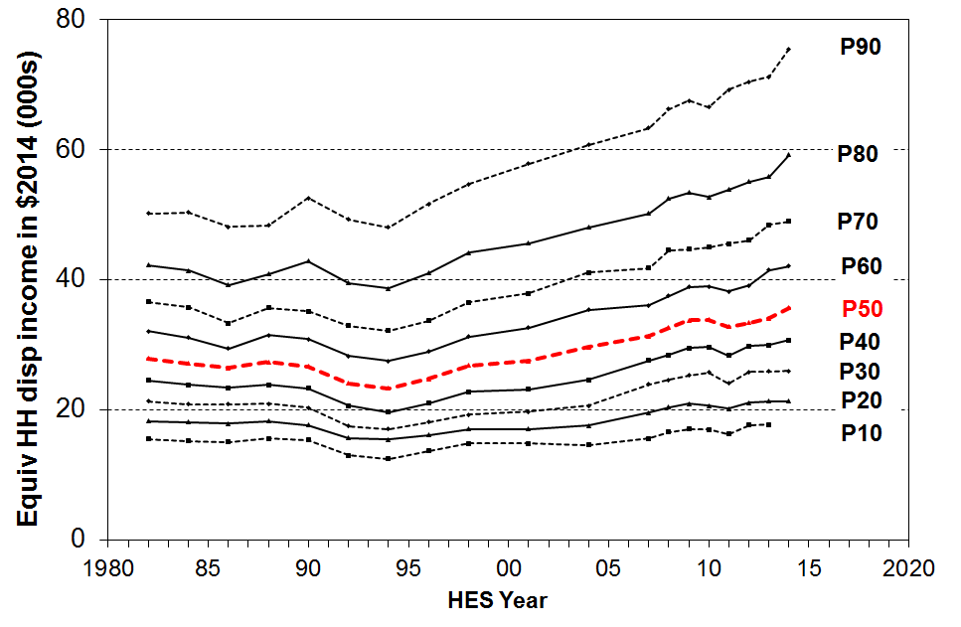
11 From HES 2011 to HES 2014 the proportionate gains from the recovery were shared reasonably evenly across income deciles (6-10% in real terms), though in the HES 2012 to 2014 period incomes in the lower three deciles have been flat (no gains in real terms).

12 The negative impact of the GFC and the associated recession was a little greater for lower income deciles, which means that the net improvement for deciles below the median was 2-5% from HES 2009 to 2014, while for those above the median it was 8-12% in real terms. The net change for the median was 6%.

13 New Zealand’s post-GFC gains are better overall than for many OECD countries. For example, median incomes for both the UK and Ireland fell through the GFC and have been flat since. Italy, Spain, France and Germany were flat through the GFC and have remained so since. The US median has been flat for the last 5 years. New Zealand’s post-GFC gain of 9% at the median is more like that of the top performers such as Belgium, Norway and Sweden (10%), though they did not have the fall in median during the GFC that New Zealand did (-3%).

Income inequality
- there was a large and rapid rise in household income inequality from late 1980s to early 1990s
- there is no conclusive evidence yet of a rising or falling long-run trend since the mid 1990s ….
- … but another survey with a Gini score at or above the level in the 2014 HES will provide evidence of a rise since the mid 2000s
- the share of pre-tax income received by the top 1% was steady for New Zealand at around 8-9% over the 20 years to 2012 (latest figures), a low to middle proportion for OECD countries
- in all OECD countries wealth inequality is higher than income inequality – wealth inequality in New Zealand is around the middle for OECD countries.

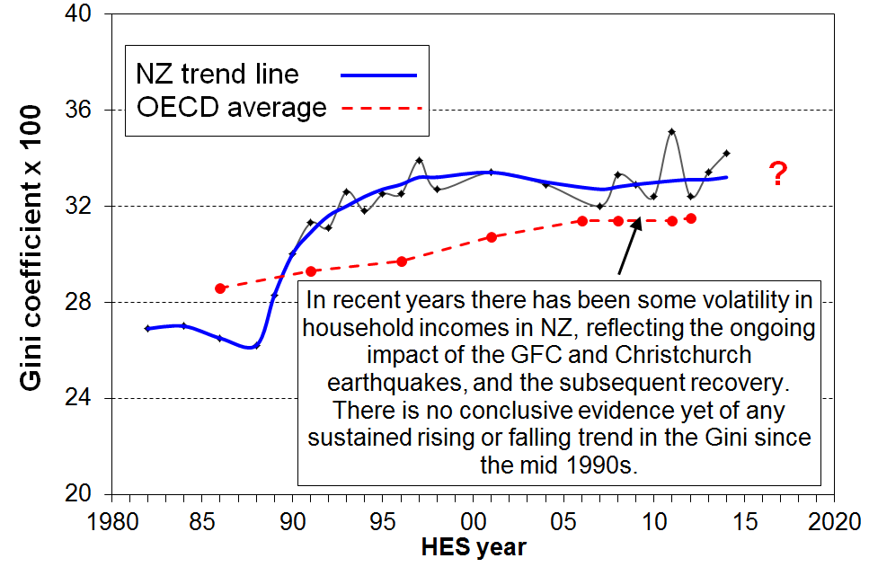
14 Year-on-year income inequality figures have been volatile recently with the GFC shock impacting on investment returns, employment and wages over the five years from 2008-09.There is no conclusive evidence yet of any sustained rise or fall in income inequality using the Gini measure since the mid 1990s. The trend-line is almost flat. However, if the next survey shows a Gini figure similar to or higher than the HES 2014 figure, then that will give reasonable evidence of higher income inequality compared with the level a decade before. On the other hand, if it falls to the trend line or below, the current assessment will stand.

15 The latest available figures for full OECD comparisons are for calendar 2011. New Zealand’s Gini trend-line is a little above the OECD median, at a level similar to Australia, Canada, Italy and Japan, lower than the US, and higher than countries such as Denmark, Norway and Finland.

16 The Palma ratio is now also used widely for international comparisons of household income inequality. It compares the income share for the top 10 % with that for the bottom 40%. This was 1.27 in 2011 for New Zealand. Trend results and international rankings are much the same whether using the Palma or the Gini.

17 Income inequality can also be looked at in terms of the income share received by individuals on very high incomes. For example, the top 1% in New Zealand received around 9% of all taxable income in 2012 (the latest available figures for NZ). This is a little more than in Denmark, Finland, Norway and Sweden (6 to 8%), similar to France and Australia, a little lower than Ireland (11%) and Canada (12%), and much lower than the UK (13%) and the US (18%).
- For NZ, the proportion in 2012 (9%) is the same as it was in the mid 1990s, and has been steady at 8-9% over almost all of the intervening years.
- For almost all OECD countries, the latest figures are all higher than in the 1980s (eg 10% higher for France, 40% higher for NZ and Japan, 60% for Ireland and Canada, 90% for the UK and Australia, and 120% higher for the US).

18 Wealth inequality is usually around double the level of income inequality (using the Gini measure). The most wealthy 10% hold around 50% of all household wealth, whereas the top 10% of income earners receive a 25% share of all income. NZ’s wealth inequality is about average for the OECD.

Housing costs and housing quality

Ongoing housing costs relative to income
- outgoings for housing costs relative to income (OTIs) increased strongly from the mid 2000s
- the proportion with high OTIs has now stopped rising for the lower two quintiles (bottom 40%), albeit the rates are at an historical high
- these are national average figures – there are regional differences that a relatively small sample survey like the HES cannot capture

19 High outgoings for housing costs relative to income (high OTIs) are often associated with financial stress for low- to middle-income households. Low-income households especially (Q1 and Q2) can be left with insufficient income to meet other basic needs such as food, clothing, basic household operations, transport, medical care and education for household members.
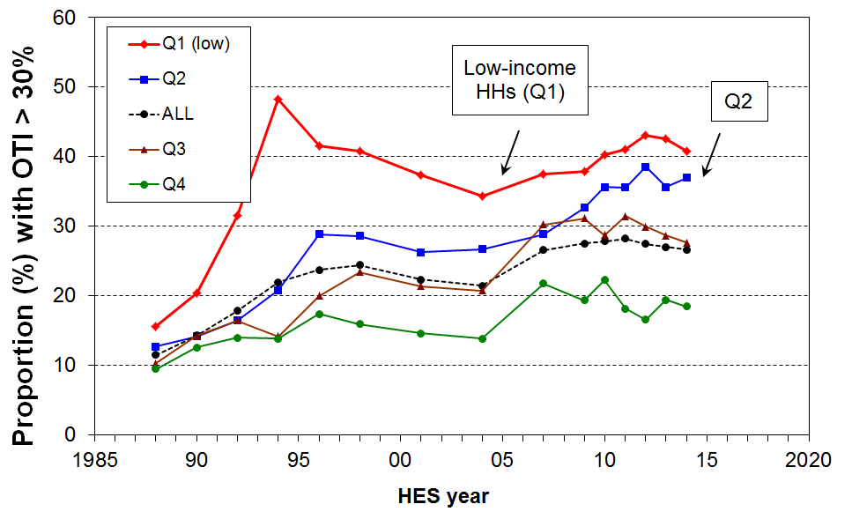
20 Overall, in HES 2014 around 27% of households had high OTIs – that is, housing costs of more than 30% of their disposable (after tax) income. There has been little change in this rate since HES 2009.

21 For the bottom two income quintiles (Q1 and Q2), the proportions were 41% and 37% respectively in HES 2014. While these are considerably higher than a decade earlier (34% and 27% respectively), these rates have stopped rising.

22 From the mid 1990s to 2014, around 13 to 15% of households had an even higher OTI (greater than 40%), up from 5% in the late 1980s. For those in the bottom two quintiles (Q1 plus Q2), the proportion with these higher OTIs peaked in the mid-1990s at 25%, was a little lower at 22% in 2004 but by HES 2009 was back up to 25%. It was still at 25% in HES 2013 and HES 2014.

23 In June 2013, almost all renters receiving the AS (93%) spent more than 30% of their income on housing costs, three in four spent more than 40% and almost half spent more than 50%.

24 In 2013, 50% of AS recipients were receiving the maximum payment, up from 33% in 2007.
Dampness and heating issues
- new survey items in the HES on housing issues will allow us to track national trends over time
- in 2013 and 2014, 7% of households reported a “major problem” with dampness or mould, and 9% a “major problem” with heating the home or keeping it warm in winter, with higher rates for households with children
- 70% of those reporting these major problems are in the lowest material wellbeing quintile – these are households experiencing multiple deprivation across a range of basics.

25 In HES 2013 and HES 2014 respondents were asked whether their accommodation had no problem, a minor problem or a major problem with dampness or mould, and with heating it in winter. 7% had a major problem with dampness or mould and 9% with heating in winter. For those aged under 18 years, the figures were 12% and 13% respectively.

26 The table below shows how these housing quality issues are experienced across the AHC incomes spectrum and the material wellbeing index (MWI) spectrum. The issues are clearly more prevalent in lower-income households than in middle and higher income households, but are especially concentrated in households with low MWI scores – these are households experiencing multiple deprivation across a range of basics. A quarter to a third of these households report “a major problem”. Around 70% of those reporting “major problems” are in the lowest material wellbeing quintile.

Dampness, mould and heating issues: average for HES 2013 and 2014 (%)
 | Ranking measure | ALL | Q1 | Q2 | Q3 | Q4 | Q5
dampness or mould “a major problem” | AHC incomes | 7 | 14 | 11 | 6 | 4 | 2
dampness or mould “a major problem” | MWI | 7 | 26 | 8 | 3 | 1 | 0
heating home and/or keeping it warm in winter “a major problem” | AHC incomes | 9 | 18 | 12 | 7 | 6 | 2
 | MWI | 9 | 36 | 8 | 3 | 2 | 0

Poverty and material hardship
- income poverty rates using the anchored AHC measure rose through the GFC but were on a shallow downward trend after that to 2014 for the population as a whole, and for children
- material hardship rates using any ‘less stringent’ threshold also rose through the GFC and have fallen since then for the population as a whole and for children …
- … however trends using a more severe hardship threshold were relatively flat over the 2009 to 2014 period
- the difference in trends for material hardship rates using less and more stringent thresholds arises from the fact that around half of those under the less stringent threshold come from households with incomes above the poverty / low-income line
  - those below the line are more likely to be beneficiaries or workers on low wages – most of these households are not greatly impacted in the short-term by changes in the economy
  - households above the low-income line are much more impacted by changes in the economy (average wage rates, employment rates and opportunities) and some can slip into and out of lesser hardship very easily, as at the best of times they are “only just getting by” and a relatively small income loss can make a large difference
- trends using fully relative income poverty measures:
  - the upward flick from HES 2013 to 2014 is driven almost entirely by the rise in the median
  - the long-run trend (a slight rise from mid 1990s, but a doubling of rates since the 1980s reflects in the main the increased proportion of household budgets now going to housing costs
- the issue of “the working poor” remains an issue for New Zealand, as it does for most other OECD countries.
Population as a whole

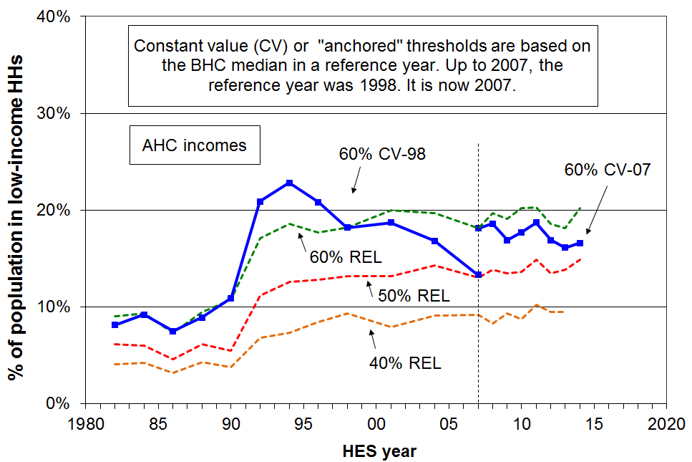
27 For monitoring medium-term trends in income poverty (low incomes), the report uses the AHC (after deducting housing costs) 60% of median “anchored” line measure.

28 On this measure, the population poverty rate more than doubled in a very short period from the late 1980s to early 1990s, reflecting rising unemployment, demographic changes (more sole parent families) and the 1991 benefit cuts. It then steadily fell through to 2007 with improving employment, the introduction of income-related rents and Working for Families. This means that the AHC incomes of many low-income households were rising in real terms from the mid-1990s to 2007.

29 The change in reference year in 2007 from 1998 to 2007 means that the current AHC anchored line series starts at a higher level. Since 2007 there has been an overall decline of around 2 percentage points (19% to 17%). This does not mean that New Zealand’s poverty rate is a definitive 17% - rather the finding is that using this measure, the poverty rate is falling slowly.

30 The three fully relative trend lines show that whatever threshold is chosen, low-income rates at the different depths have tracked in very similar ways over the last twenty years. The increases from HES 2012-13 to 2013-14 in the main reflect the large rise in the median noted above. This raises the dollar value of the relative poverty lines and the low-income (poverty) rates therefore rise.

31 There is no evidence of any increasing depth of income poverty on these relative measures.

32 BHC incomes are higher in real terms in the 2014 HES than in the 1980s, yet the AHC income poverty rates are higher in the 2014 HES. This is mainly because housing costs make up a much greater proportion of household incomes now than in the 1980s.

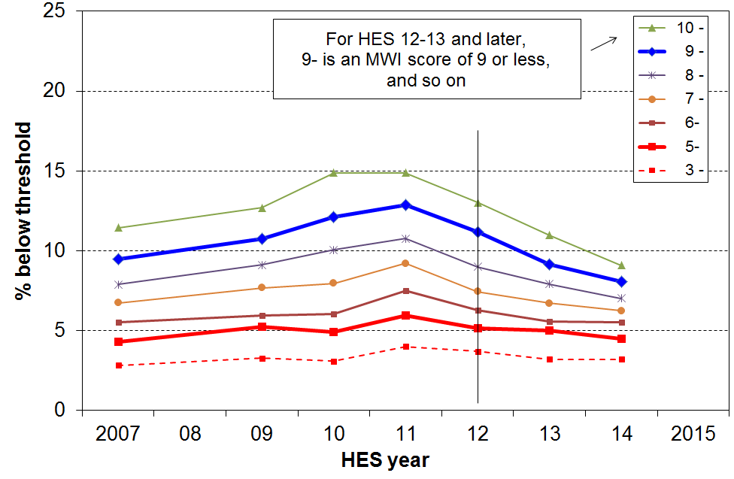
33 Trends in material hardship rates are now available for HES 2006-07 to 2013-14. Starting with HES 2012-13 the non-income measures (NIMs) report uses MSD’s material wellbeing index (MWI) for this. This index gives the same figures and trends as MSD’s deprivation index (DEP-17) but it can also give more detailed information at the lower end. Detailed information on both these indices is given in the NIMs report.

34 Trends are shown in the chart for the whole population using a range of thresholds. The two thicker lines (for MWI scores less than 9 and 5 respectively) correspond in 2012 to the rates produced by the EU’s standard and severe hardship thresholds. The full NIMs report provides evidence using NZ data in support of using the higher threshold as a reasonable one for an upper bound.

35 For the more severe hardship measure the rate has tracked at around 5% through the whole period that we can measure, with only a slight rise through the GFC. For the standard hardship measure, the impacts of the GFC and the recovery are very clear, with the rate first rising then falling from 13% to 8% over the last three surveys. The general state of the economy (wages and employment especially) has a rapid and noticeable impact on those in lesser hardship and those just getting by. For those in deeper hardship, these impacts are less noticeable – most are working-age beneficiaries or low-income workers whose incomes are steady but low, and for some of these and others, there are non-income factors that lead to deeper hardship.

Children

36 In HES 2014, the child poverty rate using the AHC anchored line measure was 3 percentage points lower than the peak rate immediately after the GFC (26% down to 23%), and 8 percentage points down on 2004 (31% down to 23%). This does not mean that New Zealand’s child poverty rate is a definitive 23% – rather the finding is that using this measure, the child poverty rate is falling, albeit slowly.

37 The material hardship measure shows a falling child material hardship rate using a threshold equivalent to the ‘standard’ EU level, down from a peak of 21% immediately after the GFC to 14% in 2014. Using the more severe threshold, there was a slight rise through the GFC to 10% and a small fall to 8%, the level it was at before the GFC.

38 On the AHC moving line measures, child poverty rates in HES 2014 are around the same as their peak after the GFC. A good amount of the rise from HES 2013 to HES 2014 is due to the large rise in the BHC median, as noted above, rather than a change in the numbers in low income per se.

Child poverty and material hardship rates (%) and numbers on seven measures
(selected years – see Incomes Report p101 and the NIMs Report p59 for all years)
 | Material hardship |  | AHC |  |  | BHC | BHC
HES year | EU standard | EU severe | ‘fixed line’ (07) 60% | ‘moving line’ 60% | ‘moving line’ 50% | ‘moving line’ 60% | ‘moving line’ 50%
1988 | - | - | n/a | 13 | 9 | 20 | 9
2004 | - | - | 31 | 28 | 19 | 26 | 14
2009 | 16 | 9 | 24 | 26 | 20 | 21 | 11
max post GFC | 21 | 10 | 26 | 30 | 20 | 23 | 14
2014 | 14 | 8 | 23 | 29 | 21 | 24 | - *
2013 & 2014 avg | 15 | 8 | 23 | 27 | 20 | 22 | 11*

numbers
2004 | - | - | 320,000 | 285,000 | 200,000 | 265,000 | 150,000
2009 | 170,000 | 95,000 | 255,000 | 280,000 | 210,000 | 230,000 | 125,000
max post GFC | 220,000 | 105,000 | 270,000 | 315,000 | 215,000 | 250,000 | 150,000
2014 | 145,000 | 80,000 | 245,000 | 305,000 | 220,000 | 250,000 | -
2013 & 2014 avg | 155,000 | 90,000 | 240,000 | 290,000 | 210,000 | 235,000 | 120,000
* 50% of median BHC income poverty figures not reported for HES 2014 because of data issues – see main report.
Note: some of the numbers prior to the 2014 HES numbers are slightly different than those in the 2014 report as a result of HES data revisions by Statistics New Zealand (see p15 in Incomes Report).

39 At 31 March 2015 there were 187,000 children (17% of all children) in beneficiary families, down from 233,000 (22%) in 2010 and 280,000 (30%) in 1998. While most children in beneficiary families are counted as in poverty or hardship, not all are. Some live in wider households with other adults and some can draw on resources from others outside the household (eg wider family support).

Poverty and hardship composition for children (which children are poor or in hardship?)

40 A sizeable proportion of children identified as poor or in hardship come from working families:
- income poverty rates for children in working families are on average much lower than for those in beneficiary families (11% and 75% respectively), but 2 out of 5 poor children come from families where at least one adult is in full-time work or is self-employed
- using material hardship measures gives a similar picture: around half the children in hardship using the standard EU threshold are from working families, and around one third using the more severe threshold
- whichever figure is used (33%, 40% or 50%), the issue of the working poor is evident – this is an OECD-wide issue and all countries now use an In-work Tax Credit or similar top-up to help address poverty in low-income working families.

41 Other compositional breakdown:
- half of poor children are Maori/Pacific (34% of all children are Maori/Pacific).
- half of poor children are from sole parent families and half from two parent (24% of all children are from sole parent families).
- half of poor children are from households where the highest educational qualification for parent(s) is school or less (31% of all children are in these families).
- 7 out of 10 poor children live in rental accommodation (20% HNZC, 50% in private rental).

Older New Zealanders (aged 65+)
- older New Zealanders (aged 65+) have lower AHC income poverty and material hardship rates than do all other age groups
- the relatively good position of older New Zealanders reflects the mix of universal public provision (mainly NZS) and the private provision built up by most of the current cohort over their lifetime, especially via mortgage-free home ownership
- if as expected there is significant fall in home ownership and especially in mortgage-free home ownership for the next cohorts, this good position of older New Zealanders is likely to be eroded unless this impact is mitigated by asset accumulation over the life course by means other than home ownership (eg KiwiSaver)
- increasing levels of hardship amongst older working-age people living on their own suggest that this group is likely to be particularly vulnerable in their older years.

42 Income poverty rates for older New Zealanders remain lower than those for other age groups when using AHC income measures. Hardship rates using non-income measures show the same. The table gives results for HES 2013 and 2014 (average over the two surveys):

Income poverty and hardship rates for age groups (%):
Average for HES 2013 and 2014
Age group ==> | 0-17 | 18-24 | 25-44 | 45-64 | 65+ | ALL
Income poverty (low income)  - AHC 60% median anchored (2007) | 23 | 20 | 16 | 14 | 8 | 16
Material hardship  - MWI (set to give 16% popln rate) | 25 | 19 | 16 | 12 | 6 | 16
- MWI (set to give a 9% popln rate) | 15 | 10 | 8 | 6 | 2 | 9

43 The ‘dampness or mould’ and ‘hard to heat’ housing issues are also low for older New Zealanders, 3% and 4% respectively, half the population rates.

44 The lower AHC income poverty and low material hardship rates for older New Zealanders reflects the mix of universal public provision (mainly NZS) and the private provision built up by most of the current cohort over their lifetime. A key component of this private provision is mortgage-free home ownership which is relatively high among the current cohort.

45 Most of those with the low AHC incomes and high material hardship rates are, unsurprisingly, those who rent and who have NZS and little or no more to live off.

46 Declining mortgage-free home ownership for the next cohorts coming through to “retirement” suggest that the low poverty and hardship rates may soon start to rise, unless this impact is mitigated by asset accumulation over the life course by means other than home ownership (eg KiwiSaver).

47 The increasing proportion of older New Zealanders in paid employment could also mitigate the impact of declining mortgage-free home ownership if these are the same people who need the extra income to pay the mortgage or the rent. It could also lead to increasing inequality among older New Zealanders if it is the better off who are more likely to continue in paid employment, as is indicated by current evidence.

48 The AHC income poverty rate for older working-age adults living on their own (45-64 years) trebled from 1984 to 2007 and has remained high since (32% on average for 2011 to 2014 compared with 14% for the population overall, and second highest after sole-parents (54%), using the same fixed line 1998 reference year measure). This also points to an increasing number of vulnerable older New Zealanders in the future.

49 While the value of NZS relative to wages was steady from 2004 to 2014, its value relative to median household income dropped to a low of 49% in the 2008-09 HES before rising to 54% in the 2012-13 HES. The turnaround was largely driven by the changes to personal income tax rates which increased after-tax wages and therefore the 66% floor for NZS. Because of the large rise in the median from HES 2012-13 the figure declined to 52% in HES 2013-14.

50 When using a BHC 50% of median income poverty measure (as the OECD does), the rate for older New Zealanders can fluctuate wildly from year to year depending on the value of NZS relative to the median. This and the findings in the table above highlight the importance of using the incomes-wealth-consumption-material-wellbeing framework for understanding and interpreting traditional income poverty figures, as outlined in the Introduction.

International comparisons for income poverty and material hardship
- using the EU’s official material deprivation index, NZ’s population rate is about the middle of the rankings for European nations, but the child hardship rate is higher and the hardship rate for older New Zealanders is low and near the top of the rankings
- for international comparisons especially, the reports advise against relying on BHC income poverty comparisons to reliably estimate where New Zealand ranks in actual day-to-day living standards.

51 The OECD and EU publish international league tables that rank countries on their income poverty rates using 50% and 60% of median poverty lines respectively.

52 On the latest available figures (OECD, c 2011 and EU, c 2012), New Zealand is in the middle of the rankings for both population poverty rates and child poverty rates, though slightly above the middle for children on the OECD 50% of median measure.
 | OECD 50% |  | EU 60%
 | All | 0-17 | All | 0-17
NZ | 10 | 13 | 18 | 20
OECD / EU | 10 | 11 | 17 | 21

53 Using the official 2008 EU deprivation index, New Zealand ranked well for older people (65+) and not so well for children – a finding consistent with the relativities produced within New Zealand using AHC income measures and MWI measures, and the proposed new EU deprivation measure:
  - a 13% population hardship rate, at the EU median
  - an 18% hardship rate for children, above the EU median (15%), and ranking NZ below the richer western European nations against whom we have traditionally benchmarked
  - a 3% hardship rate for those aged (65+), ranking near the top among EU nations.

