Meeting the future needs of older New Zealanders

- Trends, risks and opportunities

Long-Term Insights Briefing

Draft for consultation – October 2025



Executive summary
The New Zealand population is rapidly ageing. The number of people aged 65+ is expected to grow from around 900,000 now (17% of the total population) to 1,400,000 (24% of the total population) in 2050. Over the same period, those aged 85+ are expected to grow from around 100,000 (2% of total) to almost 300,000 (5% of total).
In many ways, this is a positive change. People are living longer and are in better health. Older people contribute to their whānau and community as carers, workers, consumers, volunteers and in many other ways. With an increase in the number of older people, New Zealand stands to benefit even more from this range of contributions.
However, the ageing population also creates significant challenges for Government. As the population ages, the cost of providing existing supports such as New Zealand Superannuation (NZS) and health services will rise substantially, placing ongoing pressure on public finances. As the main provider of financial support to those over 65, the Ministry of Social Development (MSD) will face a significant increase in demand for services and support: nearly all the additional 500,000 people over 65 by 2050 will be receiving NZS. Furthermore, several intersecting social and economic trends suggest disadvantage among older people could increase in the future. If this happens, it is likely that an increasing proportion of NZS recipients will apply for supplementary assistance of some kind and may also require other forms of support services.

Current levels of hardship and disadvantage
While the proportion of the older population facing hardship and disadvantage in New Zealand is currently much lower than for other age groups, there are groups of older people who face significant challenges:
- 25,000 older people (~3%) are in material hardship, which means they are going without many basic essentials, with a further 30,000 in ‘near hardship’.
- 90,000 older people experience disadvantage across two or more areas of life, including financial, health, housing, social connection, and access, and 20,000 experience this across three or more areas of life.
Living standards in older age are driven by multiple factors, many of which accrue across the life course. These include income, levels of savings and wealth, employment, housing, physical and mental health and disability, relationship status, and family, whānau and wider support networks. Understanding how hardship and disadvantage is set to change in the future requires understanding recent and future trends in a range of these areas.

Trends in hardship and disadvantage
Recent decades have seen significant growth in the number of people working alongside receiving NZS. This has significantly improved the later life living standards of some. At the same time, there remains a significant proportion who rely mostly or entirely on NZS as their source of income, and a growing number are renting or still paying a mortgage in later life. These trends mean there has likely been a divergence in living standards among older people in recent years.
We expect these trends to continue. The life-course trajectory of home ownership is likely set: absent drastic change, lower home ownership rates of those currently aged 40 – 64 will persist as this cohort enters later life over the next 25 years. Other factors driving widening differences in older age will likely remain: variation in life-course and later life employment outcomes, and wealth accumulation, particularly KiwiSaver growth among middle-higher income earners, and unequal wealth transfer across generations. Further trends, including increasing health needs among older people, particularly those with lower socio-economic status, and continuing challenges with social isolation and elder abuse will likely intersect with these financial factors.
These trends will likely further increase existing disparities between ethnic groups. On average, Māori and Pacific households have lower levels of savings and wealth, are more likely to have ongoing housing costs, are less likely to be employed, and are more likely to have ongoing health issues.
An important question is whether these trends of widening inequality and the tenure transition for older people also pose risks to income adequacy in older age and will translate to a rise in the proportion of older people struggling to meet their basic material needs. So far, they have not to any great extent. This is likely in part due to the relative generosity of NZS - the highest basic pension in the world - and the design of its annual indexation arrangements, which have ensured rates have generally increased each year in real terms alongside wages.
The extent to which hardship rates for older people increase in the future in part depends on the nature of the housing market, including whether rents continue to rise in line with recent trends. It also depends on how Governments might respond to the increasing costs associated with population ageing – including whether they continue to maintain existing NZS and other income support settings. If Governments look to reduce expenditure through changes to NZS, and wish to ensure hardship and disadvantage is minimised, then ensuring support is maintained to those on the lowest incomes is critical.

Preventing and responding to hardship and disadvantage
There are a range of ways that hardship in later life could be addressed. Considerations include:
- preventing further hardship and disadvantage by addressing life course factors such as employment, housing and savings/wealth and by mitigating disparities in health outcomes
- looking at the supports available to older people who experience hardship and the extent to which these meet people’s housing, health and disability and caring needs
- meeting the needs of a growing client base, particularly those presenting with complex needs.

Table of Contents
Executive summary 2
Introduction 6
Structure of this draft 6
Companion papers 7
Consultation – what we heard through the first phase 7
Principles of Te Tiriti o Waitangi / the Treaty of Waitangi 8
Part one: older people in New Zealand 10
1.1 Different experiences and expectations of later life 11
1.2 Considering specific population groups 12
1.3 Population ageing – national projections 14
1.4 Population ageing – regional considerations 16
Part two: poverty, hardship and disadvantage 20
2.1 Key concepts: wellbeing, poverty, hardship and (multiple) disadvantage 21
2.2 Income poverty 22
2.3 Material hardship 23
2.4 Social wellbeing and health 26
2.5 Multiple disadvantage 27
2.6 Multiple disadvantage – life trajectories 31
Part three: Trends in key drivers of disadvantage 32
3.1 Drivers of material wellbeing and hardship 33
3.2 Employment - recent trends and future possibilities 36
3.3 Employment - benefit receipt and employment support 38
3.4 Income support - NZS settings 40
3.5 Income support - trends in receipt 41
3.6 Income support – future possibilities 43
3.7 Housing - recent trends 45
3.8 Housing - future possibilities 47
3.9 Wealth - net worth and inheritances 49
3.10 Wealth – KiwiSaver 51
3.11 Health, disability and care - recent trends 53
3.12 Health, disability and care - future possibilities 54
3.13 Communities - social connection and isolation 55
3.14 Communities - elder abuse 57
Part four: preventing and/or responding to hardship and disadvantage 58
4.1 Preventing hardship and disadvantage 59
4.2 Responding through income support 60
4.3 Responding through service delivery 60
Appendices 61
List of tables and figures 61
Glossary of key terms and acronyms 63
Bibliography 64

Introduction
Under the Public Service Act 2020, government departments are required to produce a Long-Term Insights Briefing (LTIB) at least every three years. These provide the public with information about medium and long-term trends, risks, and opportunities affecting New Zealand at least 10 years in the future, and options for how we might respond.
LTIBs are not government policy and are prepared independently from Ministers. They provide the opportunity to identify and explore the issues that matter for the future wellbeing of New Zealanders. This briefing is intended to be a resource and evidence-base for public use, as well as a knowledge source to help Government and agencies respond more effectively to the challenges of population ageing and disadvantage.
The topic of MSD’s current LTIB is ‘current and future disadvantage for older New Zealanders’. MSD chose the topic because some evidence suggests disadvantage for older people could become an issue of increasing scale and significance. This is due to demographic changes, social and economic trends, and public finance constraints. MSD consulted with the public on this topic, and a summary of what we heard is on page 7.
Within this broad topic, the emphasis is on areas most relevant to MSD’s responsibilities. MSD is responsible for providing income support, employment services, and funding community services. It is also the primary provider of social policy advice to Government. The LTIB has been developed jointly by MSD and the Office for Seniors. The Office for Seniors is a branded business unit in MSD that advocates for the interests of older people across the full range of government policy. It is responsible for administering Better Later Life – He Oranga Kaumātua 2019 to 2034, New Zealand’s strategy for responding to our ageing population.
The following chapters provide a first draft for public feedback. You are welcome to provide comment on the draft by getting in touch with us. You can email any feedback to ofs@msd.govt.nz, or you can mail your submission to:
Long-Term Insights Briefing Consultation,
PO Box 1556.
Wellington 6140.
Once feedback has been considered, MSD will finalise the report and is aiming to publish a final version by early 2026.

Structure of this draft
The draft report is divided into four parts:
- Part One provides contextual information about the roles of older people in New Zealand, and likely trends related to population ageing
- Part Two provides information about poverty, hardship and disadvantage for older people, including concepts, current levels and trends
- Part Three considers the drivers of material wellbeing, and likely trends in areas related to employment, income support, housing, wealth, and health
- Part Four considers possible policy and service responses to the issues identified.

Companion papers
We have published a range of supporting material alongside this report. It is available here, and provides further detail, analysis and evidence that underpin some of the key points made in this overarching document. This includes:
- A summary of the feedback heard through the first round of engagement.
- Two short papers that provide more consideration of specific topics relevant to Māori and Pacific older people.
- An analytical note produced by Bryan Perry, which explores the material wellbeing of older New Zealanders in detail.
- An update of earlier analysis produced by MSD, the Social Wellbeing Agency and the Ministry of Health focused on multiple disadvantage experienced by older people, drawing from data held in the Integrated Data Infrastructure. The original analysis is and the updated findings are available on MSD’s website.
- Analysis conducted by Massey University’s Health and Ageing Research Team for the Office for Seniors on the impact of mid-life trajectories on later life wellbeing. This can be found on the Office for Seniors website.
Consultation – what we heard through the first phase
Agencies need to run two rounds of public consultation when developing an LTIB. The first round of consultation was in October 2024, and focused on the proposed topic, as required by legislation. We also asked about the key issues and what we should focus on during our analysis.
As part of the consultation, MSD produced a discussion document. People could provide feedback by:
- filling out a short online survey
- writing a submission
- participating in a workshop (these were held with subject matter experts).
MSD also engaged with its Māori Reference Group and Pacific Reference Group.
A summary of the engagement is available at the link below. Throughout the engagement process, we heard near-universal support for the proposed topic. However, we heard a broader range of views on how the topic had been framed - some emphasising the need to draw attention to serious risks to future wellbeing for older New Zealanders, whereas others were concerned about the negative and ‘deficit-focused’ nature of the way the topic was articulated.
Other comments on the overall approach, included:
- the need to consider the wellbeing of older people within the context of their wider families and whānau
- not treating people across 30+ years of life span, and in a variety of different circumstances, as a single homogenous group.
- cautioning against using 65+, older age, and ‘retirement’ as synonymous
- the need to take a geographical lens, and look at differences across urban, rural, and provincial areas.
We received feedback on how to consider issues related to specific groups of older people, including ethnic groups. For example, Māori and Pacific representatives emphasised the need to recognise that many older people were very active in their communities; and also the importance of considering the impact of lifetime disadvantage, structural inequities, and various issues faced by Māori and Pacific people.
Consultees raised a broad range of issues that they thought the LTIB should cover, including issues related to: societal attitudes, ageism and discrimination; supporting employment for older people; physical and mental health issues; the cost of living; issues related to functional ability, accessibility and transport; and social isolation/connection and social support.
Consultees also stressed the need to consider future trends that were not covered in the consultation document, including: wider impacts of changes in housing tenure; future pressure on care and on the health system; risks associated with technological change, and the impact of climate change.
We have responded to this feedback in various ways in this draft, including ensuring that we emphasise the positive roles older people play, and the importance of strengths and resilience factors in supporting wellbeing in older age. However, we are also of the view that it is important to keep a focus on risks to future wellbeing, and to draw attention to the situation of those groups whose wellbeing is already significantly compromised.
Many of the topics that submitters suggested we cover were relevant and important, but we were unable to cover them due to space and the breadth of the topic (and in some cases because they were the responsibility of other agencies). At times we have had to rely on analysis of data for the ‘65+ population’ for practical reasons – either we didn’t have more granular data, or because including finer age breakdowns would have lengthened an already long document.
We are now seeking further public feedback on the analysis and options that we have provided in this draft report, and encourage readers to make a submission via the channels set out on page 6.
The discussion document used to inform the first phase of public consultation is available here. A full summary of what we heard through the first phase can be found here.
Principles of Te Tiriti o Waitangi / the Treaty of Waitangi
The principles of the Treaty of Waitangi have been considered in relation to the topic of this LTIB, informed by DPMC guidance on the application of Treaty principles in policy development and implementation (DPMC, 2019). Two principles are of particular relevance in this context:
- the principle of active protection requires the Crown to actively protect Māori interests;
- the principle of partnership requires the Crown to act reasonably and with the utmost good faith towards Māori. Inherent in this duty is a requirement to make informed decisions on matters that affect Māori interests.
During consultation we engaged with experts, stakeholders and other Māori representatives. We have also explicitly considered the position of older Māori as we have conducted the analysis in this briefing.
Through our engagement, stakeholders emphasised the important cultural roles that older Māori play, particularly as kaumātua, in the preservation and transmission of tikanga, and their key roles in marae life. These roles are important context for considering policy options.
Older Māori are over-represented amongst statistics for poverty, hardship and wider disadvantage, and are also disproportionately impacted by many of the specific risks and issues we cover. Actions to address this disadvantage are likely to be consistent with the principle of active protection, provided these actions are effective for Māori, and that specific consideration is given to what will be effective and culturally appropriate for whānau.

Part one: older people in New Zealand
  - Roles, attitudes and other key context, including population ageing
In this section we outline the diversity of experiences in later life, describe cultural conceptions of age and ageing and step through population projections. We also discuss how age and later life interact and what this means for our analysis. This section sets out the key context for the rest of the issues explored in this LTIB.

1.1 Different experiences and expectations of later life
The older population is not a homogenous group and covers a range of people in diverse circumstances. People over 65 vary widely in their living arrangements, health, socioeconomic status, cultural backgrounds, personal experiences, and lifestyle choices. Some are in good health, highly active, still working, are financially secure, have supportive relationships, and/or are very engaged in their communities. Others may face physical or mental health limitations, financial insecurity, family or relationship difficulties, or social isolation.
The use of 65 as the defining point at which older age or later life begins is itself arbitrary and largely based on the age of eligibility for NZS. In reality the biological and social processes of ageing vary widely and do not necessarily correlate with chronological age. Many of the characteristics this paper discusses will affect individuals at earlier or later ages than 65. This includes systemic variation on the basis of characteristics such as gender and ethnicity. The ‘65+’ group also covers a very wide age range - there are likely to be significant differences in the life experiences of those in their 60s and 70s (‘younger older’ people) and those in their 80s and 90s (‘older older’ people).
The terms ‘65+’, ‘older age’, ‘superannuitant’ and ‘retirement age’ are often used interchangeably. However, many continue to work after reaching the age of 65. Many lead active lives and contribute significantly within their community. There are also cultural dimensions around the roles that people assume as they age (see box below).
There are also generational differences between the oldest older people and the incoming cohort of older people. These differences include education levels, age at first marriage, age of birth of first child, expectations of working and measures of mobility (changes in location of one’s home, changes of job, and changes in occupation). These factors contribute to life experiences and needs in older age. There will similarly be differences in the experiences of those who will come into older age in coming decades. The cohort of people currently aged 50-64 have different contexts for their lives and will not experience older age in the same ways.
Cultural conceptions of age and ageing
Attitudes towards later life differ widely, particularly across cultures. Although ageing is formally a biological process, the meaning it has for older people is culturally informed. It is not possible to examine the wide range of approaches to ageing across cultures here, but some themes include:
- Conceptions of ageing as primarily an individual process or as concerning one’s role within a family or community group
- Emphasis on the physical aspects of ageing vs. the mental or emotional
- Framing of older people as primarily vulnerable or dependent vs. as fulfilling a range of culturally defined roles
- Different focuses for ideas about “successful” ageing such as: physical or mental health, social roles, safety and security, financial wellbeing and prosperity
- The role of spirituality, particularly in the context of age-related health conditions and end-of-life.
Māori and kaumātuatanga
Growing older for Māori is associated with increased mana and respect, increased responsibility through kaumātuatanga, and high levels of activity.
I think ageing and old age is about the roles, responsibilities and expectations that come with it for kaumātua – it’s never about retirement or pensioning them off, they still have mahi to do.” (Te Pou Matakana, 2018; p20).
Māori value elders as an important part of the community who play roles in sustaining tikanga and cultural values and play a particularly significant role at marae. Kaumātua are seen as linking whānau across generations, with a particular responsibility for transmitting cultural knowledge to mokopuna.
Responsibility for supporting elders traditionally sat with whānau in a relationship of reciprocity tied to the position of respect described above. Protective factors for older Māori include whānau, language and cultural connections, turangawaewae, and the support of services imbued in Māori values.
Pacific eldership
Pacific older people in New Zealand come from various Pacific nations, each with its own language, traditions, and cultural values. As for Māori, ageing for many Pacific people is more about ‘eldership’ (Tamasese 2014) rather than retirement. Pacific matua commonly play a significant role in their communities and churches, are fundamental to the transmission of culture and values and lead full, busy lives.
Health and wellbeing are rooted in family, community and church connections, and in cultural values and practices. These provide physical, emotional and spiritual support. Intergenerational living is common and there are expectations around caring for elders and sharing of assets ahead of individual retirement savings (including remittances, Fa’alavelave and investing in education). These practices can place financial strain on families but enhance social cohesion. Practices of reciprocity mean the support is likely to be returned in future.

1.2 Considering specific population groups
The issues covered in this LTIB impact older people in different ways. There are specific population groups who have particular perspectives and needs, and who also are more likely to experience disadvantage across multiple domains:
- Women – Women currently make up 53% of those aged 65+, 60% of those aged 85+, and 65% of those aged 90+. Because women live for longer, they also often spend more time supporting themselves in retirement and living alone. Women are more reliant on NZS, as throughout their working lives they tend to have lower income and accrue fewer savings and investments. This is due to a combination of factors including gender pay gaps, occupational segregation, lower labour market participation over the life course, and the unequal division of unpaid work, particularly care work (Retirement Commission, 2022).
- Māori older people - We have undertaken specific analysis of issues related to older Māori in this LTIB, which is available as a paper. There are specific considerations that need to be taken into account, including Māori perspectives on older age (see box 1 above) and the principles of the Treaty of Waitangi (see page 8 above). Māori disproportionately experience poverty, hardship and wider disadvantage. This disadvantage has historical roots, including the legacy of colonialism and land-loss, and the restructuring of the economy in the late 20th century that disproportionately impacted Māori.
- Pacific older people – We have also undertaken specific analysis of issues related to Pacific older people. Pacific older people have specific needs and issues of disadvantage impact particularly on Pacific older people. On most comparisons, Pacific older people are faring worse than any other ethnic group, with lower rates of home ownership, less savings and wealth, and higher rates of hardship. As with Māori, Pacific people’s disadvantage is driven by historical and systemic factors, including 20th century migration patterns that saw many Pacific people move to New Zealand and be recruited for low-paying labour-intensive employment.
- Ethnic communities – This is a large subset of older New Zealanders and experiences vary considerably between older people born in New Zealand, recent migrants and refugees. Some older people from diverse ethnic communities can face language and cultural barriers, have difficulties accessing support, and be at high risk of social isolation. Some recent migrants do not qualify for NZS on residency grounds, which means they receive less support through the benefit system. Faith and religious affiliation often play an important role for older people in ethnic communities. Many volunteer through faith-based organisations and receive support through these communities.
- People with long-term health conditions and disabled people – Recent data from the Household Disability Survey shows that 35% of people aged 65+ are disabled. This includes both those who have been disabled throughout their lives, and those who have become disabled in later life (as people live longer, they are more are likely to spend a portion of their later years with some form of functional limitation or disability). Both are more likely to experience hardship, but in different ways. Those who have experienced life-long disability are at higher risk of poverty and disadvantage in later life, and some groups of disabled people are known to have lower health expectancy.
- Rainbow older people have often had lifetime experiences of social exclusion, discrimination, victimisation, stigma, and identity concealment. These experiences can have a range of impacts, including diminished health, social isolation and/or incomes that are not commensurate with their education. They may feel reluctant to engage with services, particularly those with narrow heteronormative and cisgendered expectations.
The groups above are not mutually exclusive. Frequently older people belong to more than one group that experiences disadvantage, and the issues they experience can intersect and compound the disadvantage they experience.
Older carers
A significant number of older people are looking after a family member, most often a partner or spouse. Census 2023 data showed that there are more than 500,000 informal and unpaid carers living in New Zealand, around 20 percent of whom are aged 65+.
The New Zealand Longitudinal Study of Ageing found that women and Māori provide higher levels of care. This study suggests that women provide the most care due to gendered role expectations and, in later life, their longevity and the fact that their spouses or partners tend to be older. This study also explored how caregiving for whānau can be perceived as a cultural activity for Māori and can be supported among the wider whānau.
The wellbeing of carers is critical to the wellbeing of the older people they care for. Carers are often managing their own health conditions and require support themselves, alongside dealing with the demands of being a carer. Older carers are particularly vulnerable to social isolation. The demands of older carers reduce their ability to take part in social activities, which can result in a lack of social connectedness.
Carers reported having higher rates of depression and/or anxiety compared to people who are not carers in the State of Caring Aotearoa 2022 Survey. Much of the anxiety and depression was linked with financial stress, higher levels of loneliness, and very low life satisfaction compared to those who are not carers.
Data from the 2023 Household Disability Survey (HDS) found more than half of all disabled people were aged 50 or over, and a third were 65 or over. An ageing population means this number will continue to increase for two key reasons; a greater number of older people living longer will experience more age-related disability, and a growing cohort of those with lifelong disabilities are joining the older age group. This is likely to contribute to increased need for carer support.
Grandparents raising grandchildren
Grandparents can play a crucial role in allowing parents to balance work and childcare, as well as stepping in to raise their grandchildren. In the 2013 Census, nearly 10,000 grandparent families reported that they were raising grandchildren.
Grandparents caring for grandchildren or mokopuna often report great satisfaction but may also report greater stress due to the needs of the children, lack of community supports, lack of financial resources, housing need, health issues, family strain, and involvement of state agencies.

1.3 Population ageing – national projections
The NZ population is rapidly ageing, due to life expectancy gains and declines in fertility rates. The share of the population aged 65+ is projected to grow from around 18% now to 23% by 2050. The share aged 85+ is projected to grow from around 2% to 5% during the same period. Factors such as migration and fertility trends introduce uncertainty in population projections but will not fundamentally alter the overall transition towards an older population.
The growth in the older population is even more stark and certain when looking at growth in numbers, rather than as a proportion of the overall population. By 2050, the total number of people aged 65+ is projected to grow by more than 150% (increasing by 501,100 people), and the number aged 85+ is projected to almost triple (increasing by 188,600).
Figure 1: Stats NZ Population Projections
Population ageing has significant impacts for New Zealand. Stats NZ’s long term labour force projections show a declining labour force participation rate for NZ overall, due to a greater proportion of the population at older ages where rates are lowest. The ratio of non-workers to those working is therefore projected to increase.
The Treasury’s 2021 Long Term Fiscal Statement indicated that net debt is likely to be on an unsustainable trajectory, if expenditure and revenue follow historical trends (and no additional policy adjustments are implemented). A significant contributor to this is the fiscal impact of an ageing population, which will see rising expenditure on NZS and healthcare, along with reduced GDP growth and tax revenue. Long-term care expenditure (including rest-home care and community-based services) are expected to face significant spending pressures.

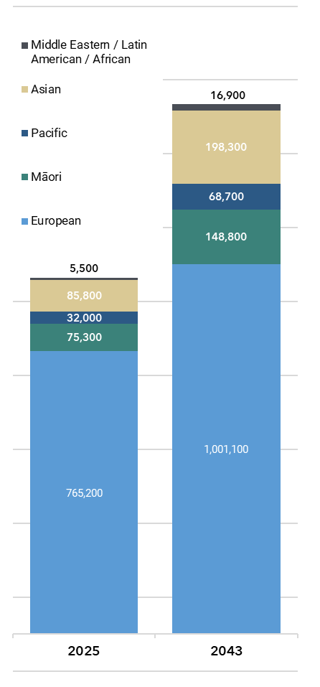
New Zealand’s older population is becoming more ethnically diverse. By 2043, Stats NZ projects that, of those who are over 65, the proportion who are NZ European will decrease from 83% to 75%. All other ethnicities will increase as a proportion of the older population:
Figure 2: Population Projections –
65+ by ethnicity
- Māori will increase from 8% to 11% of the older population
- Pacific will increase from 3% to 5% of the older population
- Asian will increase from 9% to 15% of the older population
- Middle Eastern, Latin American, and African will increase from 0.6% to 1.3% of the population.
The older population will remain less diverse than the total New Zealand population, reflecting the much younger age profile and lower life expectancy for Māori and Pacific people in New Zealand. For the total population in 2043, Stats NZ projects that European will be 65%, Māori will be 21%, Pacific will be 11%, and Asian will be 24%.

1.4 Population ageing – regional considerations
There are differences in how the country will experience population ageing, according to Stats NZ projections, which will have implications for where and how MSD provides services for the older population. For the most part, the areas of highest projected growth are also areas where current disadvantage is more prevalent (e.g. see map in section 2.4). In many cases these are areas with higher overall deprivation and limited access to health and other services.
Figure 3 – increase in number of older people in each TA (2023-2048)
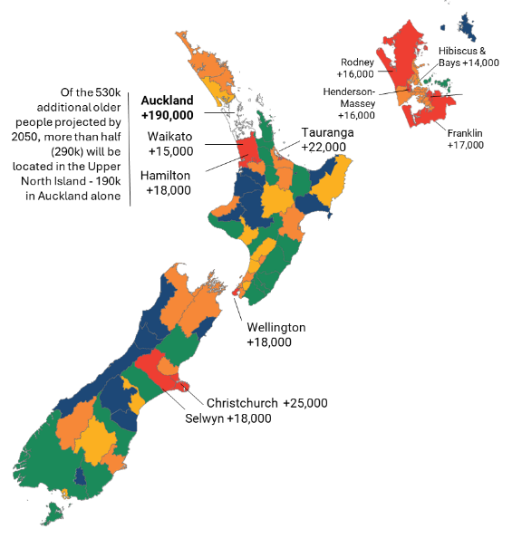
When planning for increased demand for services the increase in absolute numbers of older people is of primary interest. This is shown on the map at right (figure 3), which labels those Territorial Authorities (Tas) that are projected to have an increase of more than 15,000 older people. Growth in absolute numbers generally reflects where the overall NZ population is concentrated and will mainly be in urban areas. Of the 530,000 additional older people by 2048:
- More than a third (190,000) will be in Auckland;
- More than half (280,000) will be in regions associated with major urban areas: Auckland, Hamilton, Lower Hutt, Wellington, Christchurch, and Dunedin;
- This increases to two thirds if large urban areas are added: Whangārei, Rotorua, Gisborne, Hastings, Napier, New Plymouth, Whanganui, Palmerston North, Porirua, Upper Hutt, Nelson and Invercargill.
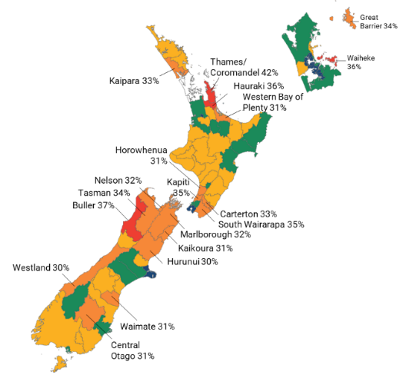
The second map at right shows these same geographical areas in a different way – those with a proportion of older people as a percentage of the local population.
Figure 4 - Proportion of older people in each TA (2048)
This gives a different picture - the areas with the highest proportion of older people will be smaller towns and rural areas. These areas already have an older demographic than cities and will become even more so by 2048. Urban TAs will see their average share of people aged 65+ increase from 15% to 21%, whereas non-urban TAs will increase from 21% to 28%.
Some areas with a very high proportion of older people already will see their profile age further. By 2048, the share of people aged 65+ will increase from 34% to 42% in Thames-Coromandel, 29% to 37% in Buller, 26% to 36% in Hauraki, 25% to 36% in Waiheke, and 27% to 35% in Kāpiti Coast.
The final set of maps and the table show projections of older people in 2043 by ethnicity, and suggest important differences between ethnic groups in where older people will live. This is broadly similar to the current geographic distribution of different ethnic groups. Asian and Pacific older people are projected to continue to be much more highly concentrated in Auckland. A greater proportion of Māori will be in parts of the upper North Island outside Auckland. A greater proportion of older Europeans will live in the South Island than for other ethnic groups. Given that different ethnic groups will have different needs and aspirations, this can inform the provision of culturally appropriate services and supports.

Ageing in place
Many Government strategies and policies are based on the principle of ‘ageing in place’ for older people, as this enables older people to feel safe and secure in their choice of home, and also reduces the need to enter more costly residential care. It is also in line with the expressed preference of the overwhelming majority of New Zealanders of all ages. Adequate service provision, accessibility, safety, and affordability are all factors that impact whether older people can age in the right place for them. In rural areas, ageing in place depends on community support and access to services, which can be challenging due to limited healthcare and longer travel times. This can exacerbate age-related difficulties such as isolation, loneliness, transportation and limited mobility. Urban areas face different challenges, such as providing adequate housing, transport, and healthcare. Ensuring connected neighbourhoods with accessible amenities, and streets that people with mobility, sensory and cognitive issues can navigate independently and safely, is key to supporting older adults in cities.

Figure 5 – Projected Geographical distribution of Māori older people (65+) in 2048  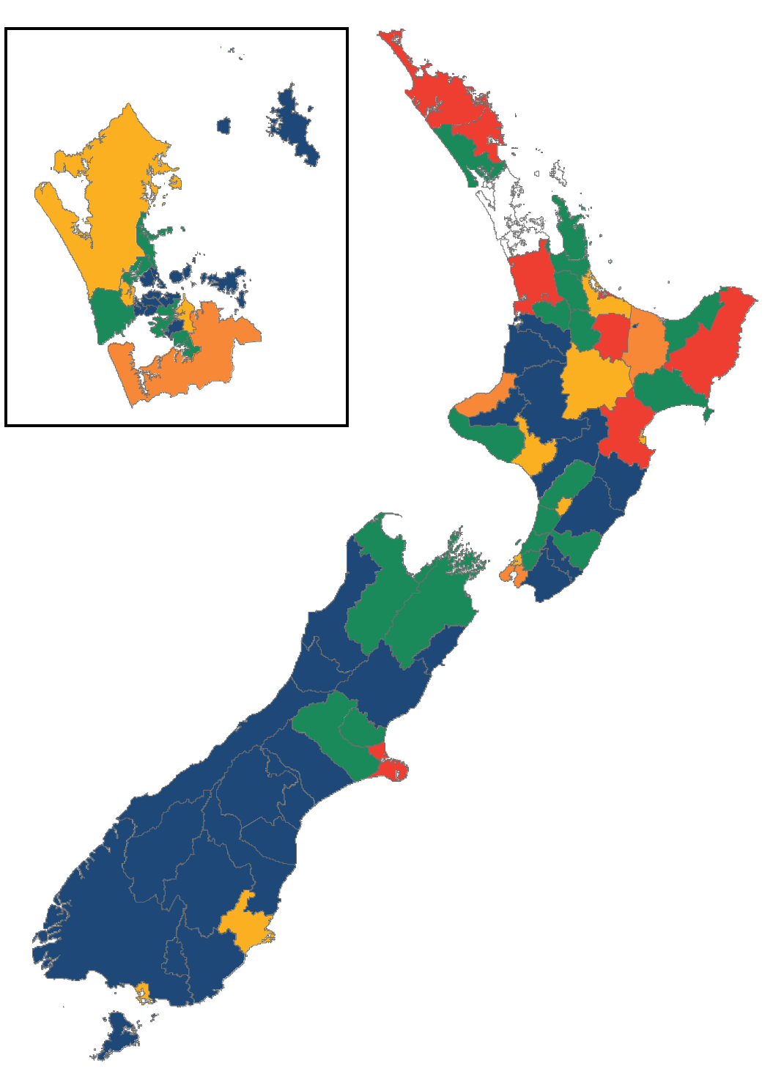 | Figure 6 - Projected Geographical distribution of European older people (65+) in 2048  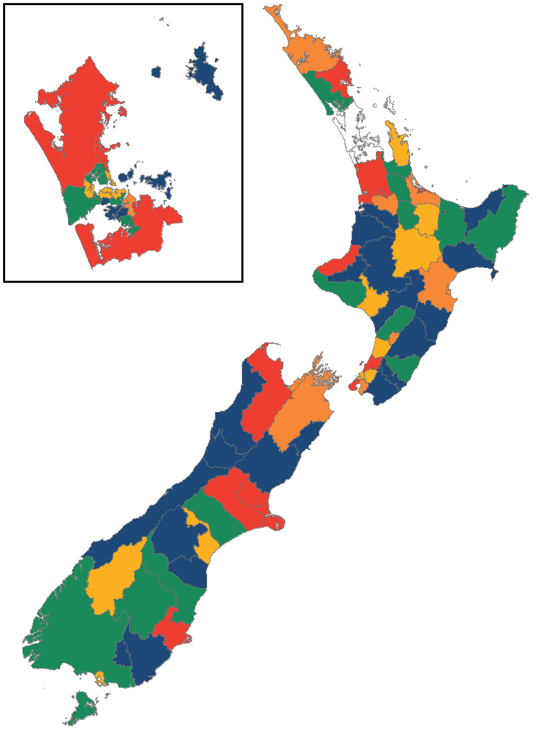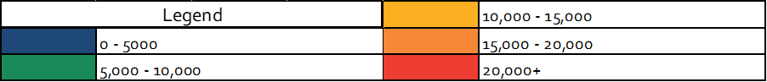
Figure 7 - Projected Geographical distribution of Asian older people (65+) in 2048  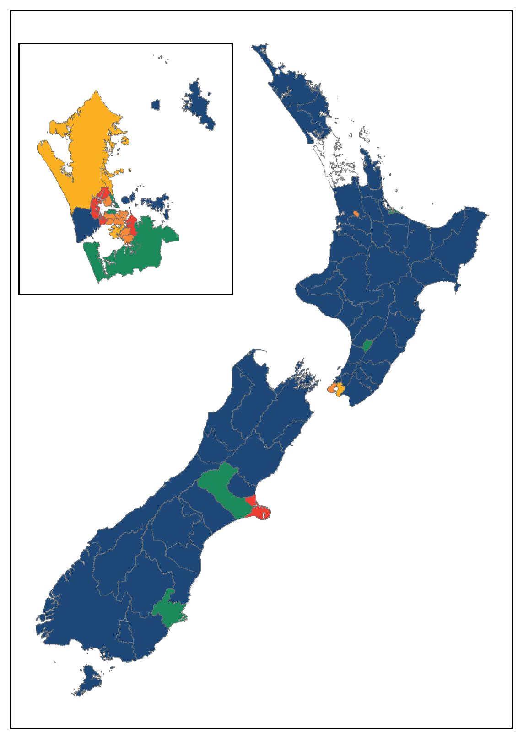 | Figure 8 - Projected Geographical distribution of Pacific older people (65+) in 2048  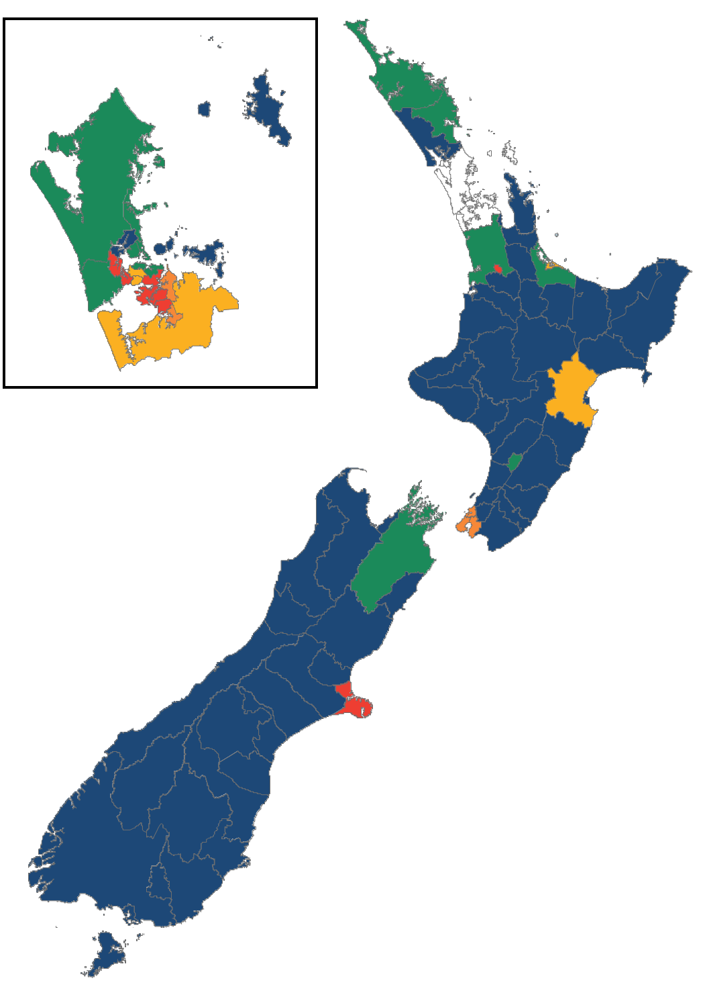
Table 1: Projected Distribution of Older people by ethnic group in 2043
 | Asian | European | Māori | Pacific
Auckland | 63% | 21% | 18% | 61%
Rest of North Island | 24% | 50% | 66% | 29%
South Island | 13% | 29% | 15% | 10%

Part two: poverty, hardship and disadvantage
  - Levels and trends of income poverty, material hardship, wider social wellbeing, and multiple disadvantage
In this section we set out rates of income poverty and material hardship in later life. We also examine broader wellbeing measures for older people and provide updated analysis on experiences of multiple disadvantage in later life. Many of these factors are considered from a life course perspective, examining how earlier experiences of vulnerability or disadvantage carry through to later life.

2.1 Key concepts: wellbeing, poverty, hardship and (multiple) disadvantage

Material wellbeing and overall wellbeing
There are several widely used concepts related to wellbeing and quality of life for older people, including ‘successful ageing’, ‘positive ageing’, ‘active ageing’, and ‘ageing well’. Consistent across these various frameworks are a range of factors associated with overall wellbeing in older age, including being in good health, being physically and socially active, and contributing to society.
Consistent with MSD’s responsibilities relating to employment, income support, and housing, this LTIB has a strong focus on material wellbeing, but it is important to recognise this is just one component of overall wellbeing. Material wellbeing focuses on economic satisfaction and security, encompassing factors like income, financial stability, and standard of living, while overall wellbeing is a broader concept encompassing physical, mental, emotional, and social health, as well as happiness and life satisfaction.

Hardship and disadvantage
Figure 9 - Poverty and broader disadvantage
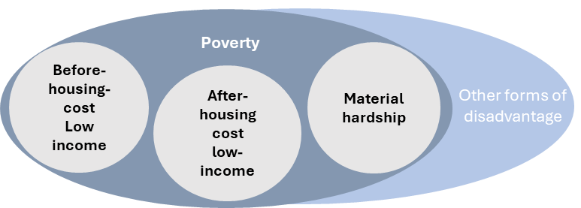
In this document, we use a number of terms – including ‘poverty’, ‘hardship’ and ‘disadvantage’ – to indicate when wellbeing is significantly compromised. These are different concepts:
- Measures of poverty are based on the material circumstances of households, and the extent to which their economic resources enable them to reach a minimum adequate standard of living. They include measures of ‘low income’, based on where household incomes sit relative to average (median) incomes. They also include measures of ‘material hardship’, which look at those essential items and activities people do not have access to, because they cannot afford them.
- Disadvantage is a broader concept, which includes poverty, hardship and also difficulties in other core domains of wellbeing, such as health or social connection. These other kinds of difficulties often ‘cluster together’ with poverty and hardship, but this is not always the case. ‘Cumulative’ disadvantage refers to how different kinds of vulnerability often accumulate over time, ‘multiple disadvantage’ refers to where different issues co-exist, and ‘compounding’ disadvantage refers to where the overall impact of different issues coexisting is more than the sum of their parts.
Using the broader concept of disadvantage enables us to consider the impact of wider issues such as social isolation and health problems, which often go together with financial difficulties.
Figure 10 - domains of (multiple) disadvantage
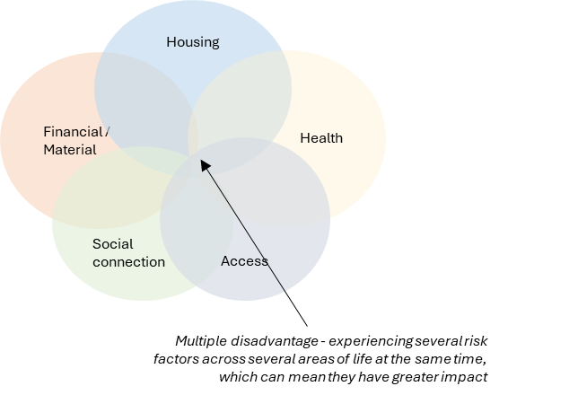

2.2 Income poverty
Income poverty is measured by determining whether a household’s income (before or after housing costs) is below a defined ‘poverty line’ – set in relation to the incomes of the average (median) household. The threshold can either move each year in line with median incomes (moving line measures) or be ‘fixed’ in real terms against a specific base year (fixed line measure’). Both measures have strengths and weaknesses, but fixed line measures are generally preferable for trends over time.
In part because of the unique design of NZ’s universal flat rate pension system, a large proportion of the 65+ population are mostly or entirely reliant on the same rates of NZS, which means there is considerable ‘bunching’ within the income distribution near commonly used poverty thresholds. Poverty rates are therefore highly sensitive to small changes in median incomes, as significant numbers of households can move above or below the ‘poverty line’.
Depending on whether one uses a ‘moving line’ or a ‘fixed line’ measure, recent trends in income poverty for older people run in opposite directions, as shown in the graphs at left:
- On ‘moving line measures’ income poverty has risen sharply – for example, the after-housing-cost 50% of median (AHC50) moving line rate continued to generally remain around 5% across the 2000s and 2010s, but has risen since 2016, reaching 16% in 2023. This is a result of NZS falling slightly as a proportion of median household incomes, with the level of NZS falling below 50% of the before-housing-cost (BHC) median (see Section 3.4).
- On ‘fixed line measures’, income poverty has steadily fallen – for example, the fixed line AHC50 rate fell from ~7-9% in the late 1990s to 3-5% in the 2010s. This likely reflects real after-housing-cost income growth for those older people on the lowest incomes.
As can be seen, rates of income poverty for single people are notably higher than rates for couples, which in part reflects the fact single people are less likely to have other sources of income, in addition to NZS (see sections 3.2 and 3.4 below). This also likely explains the particularly sharp rise in relative poverty for single people in recent years, as a greater proportion will have dropped below the threshold.
Figure 11 - After-housing-cost poverty for 65+ (50% median, Moving Line)  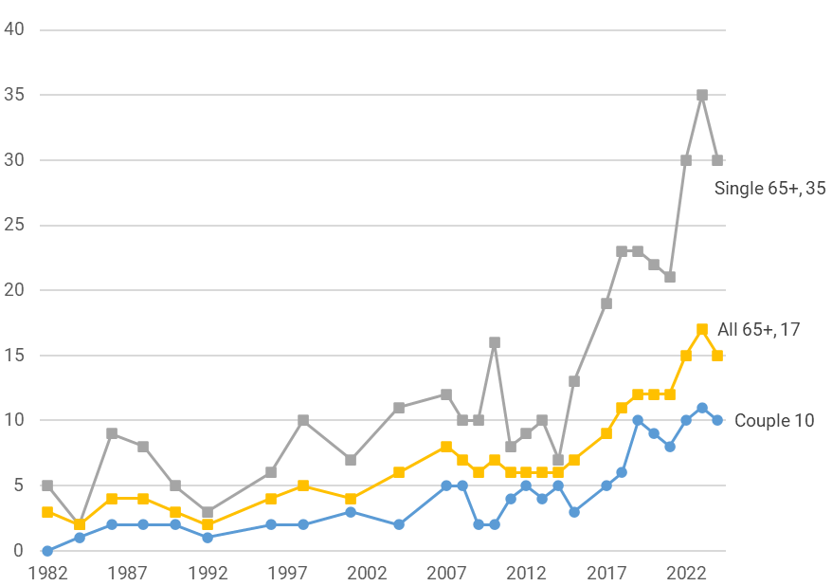 | Figure 12 - After-housing-cost poverty for 65+ (50% median, fixed line)  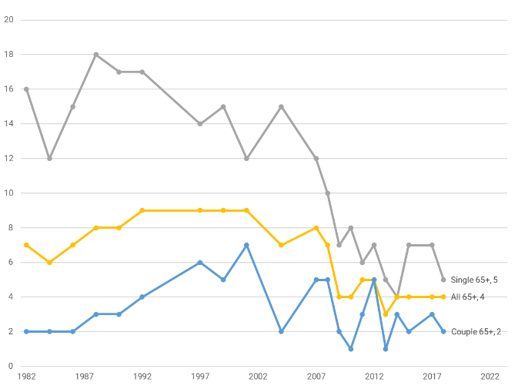
Income poverty measures are of relatively limited value for trends in material living standards of older New Zealanders, particularly compared to material hardship measures. In addition to the ‘bunching’ issue, there are more general issues with using income poverty to monitor trends. Income has several general limitations as a measure of material wellbeing for households (see Perry, p. 2022, p.4-5), and is particularly problematic for comparing the material wellbeing of older people, as this is often determined more by levels of savings, assets, and other investments – which are not factored into income measures.
The OECD uses a BHC moving line measure as the basis for its international comparisons, which is why NZ has gone from one of the better performing countries on income poverty for older people (in the mid-2000s) to below average (in the early 2020s) (OECD, 2017). Material hardship measures are, however, preferable when making international comparisons, both for the reasons set out here and because they are better suited for comparing ‘like with like’ across countries (see Perry, 2022 p.75)

2.3 Material hardship
Material hardship in New Zealand is most commonly measured by DEP-17, a 17 item deprivation index that measures the extent to which individuals or households lack essential everyday items and services. Analysis of material hardship using the index shows:
- There is a group of older people experiencing serious financial difficulties. Around 3% of older people, or 25,000 people, are experiencing material hardship - they experience 6 or more ‘deprivations’ – in areas like feeling very limited in buying clothes or shoes, being unable to afford presents for family or friends on special occasions, having to postpone visits to the doctor or dentist, putting up with feeling cold, or being behind on rates or utilities. A further group of around 4%, or 30,000 people, are in ‘near hardship’ (4+ deprivations) and are also likely to be financially struggling.
- On material hardship rates, older people in New Zealand are doing comparatively well. The rate for older people is lower than for the population as a whole (9%), and much lower than for households with children (13%). NZ also rates well compared with EU countries on material hardship for older people – we are in the upper third of countries.
- Amongst the small group of older people that are in hardship, certain population groups are over-represented. There are much higher hardship rates amongst older Pacific (14%) and Māori (8%), than for European (2%) and Asian (3%). There are higher rates for one-person households (4%) than for couples (1%), and much higher rates for multi-family/generational households, including those without children (5%) and those with children (11%). Compared with mortgage-free homeowners (1%), rates are higher for households with mortgages (5%) and those renting privately without AS (5%), and much higher for renters receiving AS (16%).
- There has not been any significant increase in material hardship for older people over the past decade. As below, the rate of material hardship for those aged 65+ has remained at 2-3% since the early 2010s (trends prior to 2013 are reliant on a different index, which is compatible enough for other age groups, but not for those over 65). Material hardship rates for single people and couples over 65 have remained reasonably steady over the past five years (in contrast to the income poverty trends noted above).
This trend is broadly consistent with other data on self-assessed income adequacy over the same period. That data shows a downward trend in the proportion of older New Zealanders reporting ‘not enough’ income for basic necessities (since 2013).
Figure 13 - Material hardship trends by age
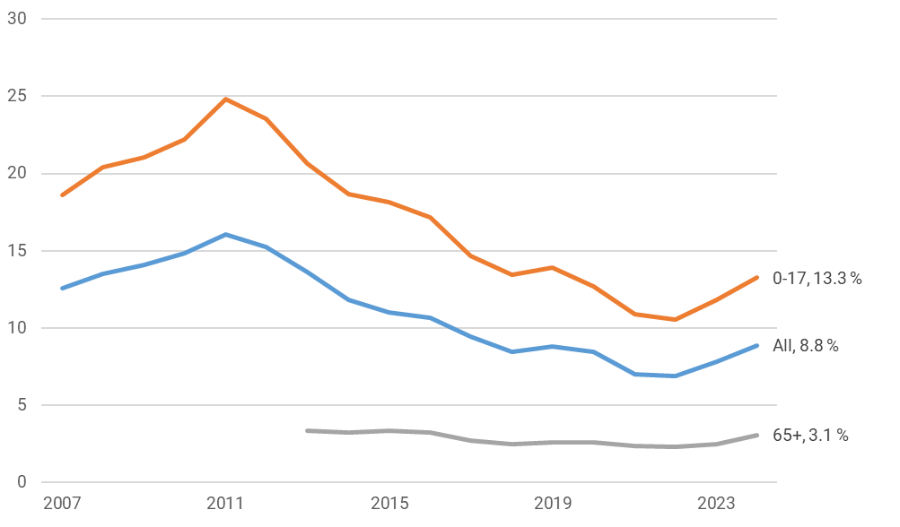
The table below by Perry uses a joint income-savings approach to examine the distribution of material hardship and near material hardship, grouping older households in each income quintile into low, medium, and high savings groups. It suggests that the level of ‘savings’ held by a household has a significant impact on its material and financial wellbeing – within each income band, those with low savings have much higher hardship rates - even for those in the second and third income quintiles.
Table 2 - Distribution of material hardship using a joint income-savings analysis, HES 2020-21
 | Income quintile 1  Av equiv income 23-24k |  |  | Income quintile 2  Av equiv income 33-34k |  |  | Income quintile 3  Av equiv income 45-46k
Savings band (unequiv) | Low | Medium | High | Low | Medium | High | Low | Medium | High
Savings - median ($) | 1,200 | 29,000 | 210,000 | 4,500 | 91,300 | 430,000 | 18,600 | 103,900 | 472,600
Material hardship rate (%) (6+/17) | 6 | 1 | 1 | 7 | 1 | 1 | 1 | 1 | 0
Material hardship/near-hardship rate (%) (4+/17, DEP-17) | 16 | 4 | 2 | 20 | 4 | 1 | 9 | 4 | 0
MSD’s Material Wellbeing Index (MWI) enables households to be ranked across the full spectrum of material wellbeing. In the graph below, material wellbeing is grouped into six categories: red is equivalent to material hardship, orange is ‘just getting by’ through to dark green for those who are very well off.
- Older people are much more likely to be experiencing good levels of wellbeing than for the rest of the population, particularly those with children.
- Couple households have better material wellbeing than single households, and both are higher than multi-family/generational households, particularly those with children
- Those in social and rental housing are much more likely to be in hardship than those who own their homes, particularly those who are mortgage free. Renters receiving Accommodation Supplement (AS) have a notably worse material wellbeing profile than renters who are not.
Figures 14-16: Distribution of households within six material wellbeing bands, low to high
Figure 14 – % of households within six material wellbeing bands: by age group  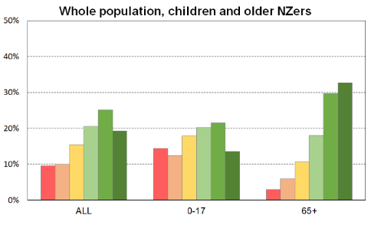 | Figure 15 - % of households within six material wellbeing bands - by household type  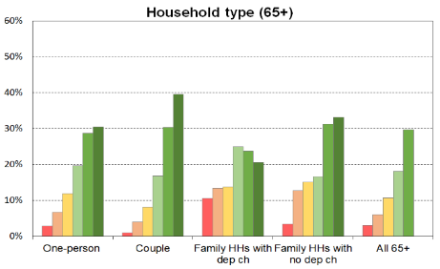
Figure 16 - % of households within six material wellbeing bands: by housing tenure
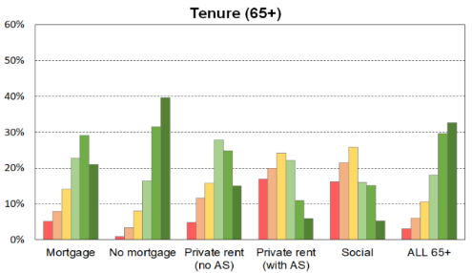
Companion paper available
More detailed analysis of material hardship patterns in older people has been published as a companion paper to this LTIB and can be found at this on MSD’s website.

2.4 Social wellbeing and health
On average, older people generally report better social wellbeing than other age groups. Across most of the indicators in the 2023 General Social Survey (GSS), older people report better outcomes than for the general population, including for: income adequacy and material wellbeing; subjective wellbeing and mental health; social contact and support; and identity and belonging.
On average, older people report higher life satisfaction, with an average rating of 7.9 out of 10 for older people compared with 7.6 out of 10 for all New Zealanders. They also report higher happiness (8/10 vs 7.7/10) and lower anxiety (2.4/10 vs 3/10), view life as more worthwhile (8.2/10 vs 7.9/10) and report greater family wellbeing (8/10 vs 7.6/10).
Nevertheless, there are still many doing poorly across multiple domains, even if the rate is generally lower than for other age groups. According to the GSS:
- 5%, or 40,000 older people, report low happiness the previous day; 13%, or 110,000, reported feeling high anxiety; and 7% or 60,000 report negative net affect.
- 11% or 100,000 older people felt lonely at least some of the time in the last four weeks, and 2% or 20,000 older people felt lonely most or all of the time in the last four weeks.
- 21% or 180,000 older people, have poor overall mental wellbeing.
- 12%, or 100,000 older people report that their home is always or often colder than they would like and 19%, or 160,000 older people report that their home is mouldy.
- 23% or 200,000 older people, have fair or poor general health status.
Table 3: % of population doing poorly on selected GSS indicators – by age group
 |  | Total 15+ | 65+ | 65–74 | 75+
Subjective wellbeing /affect | Lower life satisfaction (<6/10) | 21 | 19 | 21 | 18
Subjective wellbeing /affect | Low happiness yesterday (<4/10) | 7.5 | 5.0 | 6.0 | 3.7
Subjective wellbeing /affect | Higher anxiety yesterday (7+/10) | 16 | 13 | 13 | 12
Subjective wellbeing /affect | Negative net affect | 11 | 7 | 8 | 5
Health | Self-rated general health status: Fair/Poor | 19 | 23 | 21 | 26
Health | Mental wellbeing: Poor | 26 | 21 | 20 | 22
Housing | House or flat colder than would like: always/often | 21 | 12 | 13 | 10
Housing | House or flat is damp: always | 5 | 2 | 3 | 1
Housing | House or flat is mouldy | 35 | 19 | 22 | 14
Housing | Affordability of house or flat (<3/10) | 14 | 9 | 11 | 7
Social contact and loneliness | Level of all contact with family: not enough | 21 | 19 | 18 | 19
Social contact and loneliness | Level of all contact with friends: not enough | 24 | 16 | 16 | 16
Social contact and loneliness | Felt lonely some/most/all of the time | 18 | 11 | 11 | 12
Social contact and loneliness | Felt lonely : most/all of the time | 4 | 2 | 2 | 2
Belonging, identity and trust | Sense of belonging to New Zealand (<4/10) | 4 | 2 | 2 | 2
Belonging, identity and trust | Trust held for people in New Zealand (<4/10) | 13 | 9 | 10 | 7
Belonging, identity and trust | Ability to express identity | 76 | 85 | 83 | 88
The Household Disability Survey 2023 found that 35% of people aged 65+ have a disability. This compares to 17% of the total population. Almost half of disabled people experienced difficulty in multiple domains and 62% reported having at least one unmet care or support need.
Despite being more likely to have health conditions and disabilities, 86% of people aged 65+ reported themselves to be in good, very good or excellent health in 2015. This percentage is considerably higher than the OECD average of 44% and is the highest out of the 34 OECD countries that were surveyed.
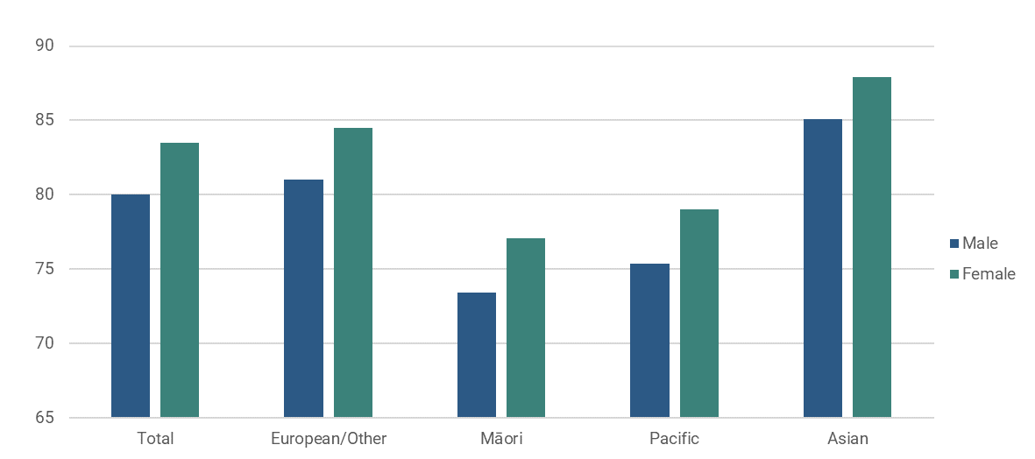
Life expectancy at birth is 81 years for males and 84 years for females. Increases in life expectancy were highest in the late 1980s to early 2000s. While life expectancy is continuing to increase, it has slowed over time. Increases in healthy life expectancy have not kept pace with increases in life expectancy, meaning New Zealanders spend more time on average living in poor health at the end of their life. The difference between average life expectancy for Māori and Pacific people and for the total population has narrowed in recent years but persists. These discrepancies are largely driven by inequality experienced across the life course, as well as in later life. Māori and Pacific people also experience higher rates of disability and long-term conditions and live fewer years in good health. Amenable mortality is substantially higher for Māori and Pacific people.
Figure 17 - life expectancy at birth - by ethnic group and sex (2017-2019)

2.5 Multiple disadvantage

Updated data on vulnerability and multiple disadvantage
MSD, the Social Investment Agency and Ministry of Health have worked together to build an evidence base on the needs of people aged 65 or older, drawing from data gathered in the Census and held in the Integrated Data Infrastructure (IDI) on health, housing, finance, social connection, and access. The original work was published in June 2023, and drew from the 2018 Census. For this LTIB, we have updated the analysis to draw on 2023 data, and found:
- 25% (198,500) experienced health vulnerability - they experienced two or more of a set of physical or mental health conditions.
- 9% (69,800) experienced financial vulnerability - they received any income-tested benefit from MSD.
- 14% (113,700) experienced housing vulnerability - they experienced poor housing quality and/or overcrowding.
- 14% (107,200) experience social connection vulnerability - they were living alone and not helping whānau and/or not volunteering.
- 5% (40,100) of older people experienced access vulnerability – they had no driver’s licence and lived in a household that did not own a vehicle.
This found that:
- 52% / 411,200 had none of the above markers of vulnerability.
- 48% / 378,900 older people experienced disadvantage in at least one area of life
- 15% / 115,500 older people experienced disadvantage across two or more areas of life
- 4% / 29,000 older people experienced this across three or more areas of life
Figure 18 - Number of people - by number of disadvantages
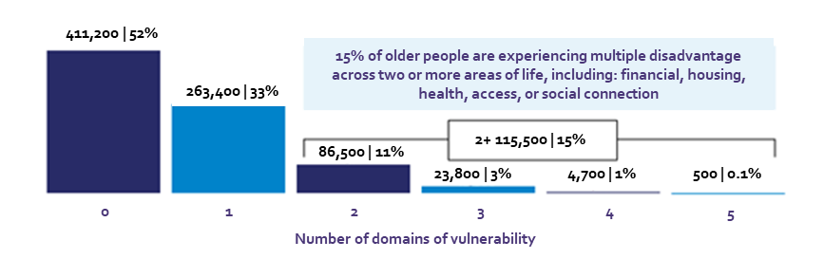
Overall, a higher proportion of women (16%) experienced multiple disadvantage compared to men (13%). Women were much more likely to experience ‘access vulnerability’ (not have a driver’s licence or car) than men (7% vs 3%), and were also more likely to be socially isolated - live alone, not volunteer, and not help family or whānau (16% vs 11%).
Different ethnic groups of older people had differing prevalence rates:
- Pacific older people were most likely to be experiencing multiple disadvantage. This was experienced by 30% of Pacific people, 25% of Māori, 22% of Middle Eastern, Latin American, and African (MELAA), 19% of Asian, and 13% of European.
- Māori and Pacific older people were most likely to experience health vulnerability. This was experienced by 31% of Māori, 31% of Pacific people, and 27% of MELAA, compared with 25% of European and 19% of Asian older people.
- Pacific older people were most likely to experience housing issues. This was experienced by 39% of Pacific people, 27% of Māori, 25% of Asian, 17% of MELAA and 12% of European.
- European older people were most likely to experience social connection vulnerability. This was experienced by 15% of European, followed by 10% of Māori, 7% of MELAA, 6% of Asian and 5% of Pacific people.
Figure 19 at right shows those both the number and proportion of older people experiencing multiple disadvantage by region. Auckland is notable, due to combining a high rate and a large population. Smaller areas with higher rates (but smaller populations) include Gisborne (18% / 1,400 people, the West Coast (17% / 1100 people) and Northland (16% / 5,700 people).
Figure 19 - Multiple disadvantage by region

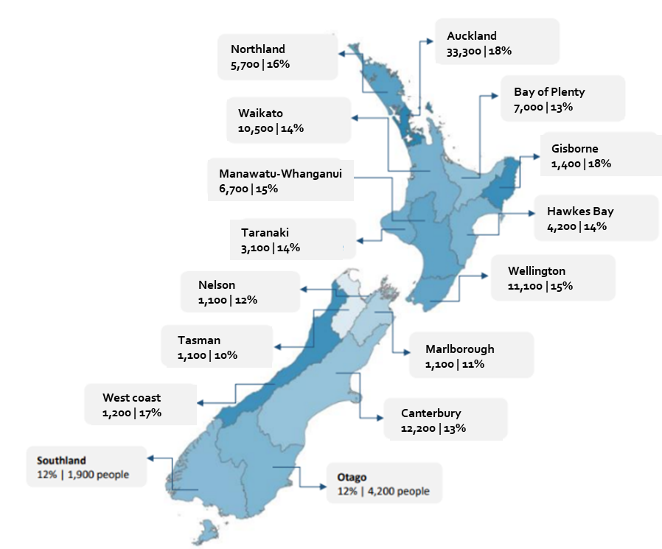

Relationship between multiple disadvantage and past benefit duration
For this LTIB, we extended the previous analysis on multiple disadvantage by exploring its relationship with benefit duration, focusing on those who spent time supported by a main benefit in the decade prior to age 65. Nearly a quarter of those aged 65+ (24% / 193,200) spent at least some time on benefit between age 55 and 65. One in ten (11% / 87,900) spent more than 40% of the period on benefit, and one in twenty (6% / 46,900) spent more than 80% of the period on benefit.
Table 4 – Number and Percentage of those 65+ - by % of time on benefit when aged 55-65
 |  | % time on benefit when 55-65
 |  | 0 | >0-20% | 20-40% | 40-60% | 60-80% | 80-100% | Total
Total | # | 596,886 | 73,305 | 31,998 | 22,701 | 18,318 | 46,902 | 790,110
Total | (%) | 76% | 9% | 4% | 3% | 2% | 6% | 100%
Table Four below shows rates of disadvantage and multiple disadvantage for these duration groups. As might be expected, in every domain the rate of disadvantage and multiple disadvantage increases as the proportion of time spent on benefit increases:
- Those who spent some of the period 55-65 on benefit were more likely to experience multiple disadvantage, and those who spent the majority of their time were much more likely.
- There are around 50,000 older people who were on benefit for the vast majority or all of the decade prior to reaching age 65, who experienced high rates of disadvantage and multiple disadvantage. Of this group, 44% had 2+ disadvantages and 16% experienced 3+ disadvantages.
Table 5 – Rate of each disadvantage for those 65+ - by % of time on benefit aged 55-65
% time on benefit  age 55-65 | Total number of 65+ | Health | Financial | Housing | Social | Access | 2+ | 3+
0 | 596,886 | 22% | 3% | 12% | 12% | 4% | 9% | 2%
>0-20% | 73,305 | 30% | 16% | 19% | 17% | 6% | 21% | 5%
20-40% | 31,998 | 34% | 23% | 21% | 19% | 9% | 28% | 8%
40-60% | 22,701 | 36% | 28% | 23% | 19% | 10% | 32% | 10%
60-80% | 18,318 | 39% | 31% | 24% | 19% | 11% | 35% | 11%
80-100% | 46,902 | 45% | 38% | 26% | 21% | 16% | 44%. | 16%
Total | 790,110 | 25% | 9% | 14% | 14% | 5% | 15% | 4%
Table Five below looks at the relationship in a different way, by showing the composition of those in multiple disadvantage. This shows that:
- a majority of those experiencing multiple disadvantage spent some time on benefit (51% of those in the 2+ group, and 63% of those in the 3+ group), but a significant proportion did not come into contact with the benefit system at all (49% and 37%, respectively)
- despite being significantly over-represented amongst those in multiple disadvantage, the highest duration group (>80%) still makes up just 18% of those in the 2+ group, and 26% of those in the 3+ group.

Table 6 – Composition of 65+ in Multiple disadvantage - by percentage of time on benefit aged 55-65
Benefit duration (55-65) | Total |  | 2+ |  | 3+
Benefit duration (55-65) | # | Composition (%) | # | Composition (%) | # | Composition
 |  |  |  |  |  | (%)
0 | 596,886 | 76% | 56,565 | 49% | 10,725 | 37%
>0-20% | 73,305 | 9% | 15,684 | 14% | 3,807 | 13%
20-40% | 31,998 | 4% | 8,922 | 8% | 2,523 | 9%
40-60% | 22,701 | 3% | 7,245 | 6% | 2,187 | 8%
60-80% | 18,318 | 2% | 6,456 | 6% | 2,070 | 7%
80-100% | 46,902 | 6% | 20,619 | 18% | 7,674 | 26%
Total | 790,110 | 100% | 115,491 | 100% | 28,986 | 100%

Companion paper available
The 2023 paper setting out the results of the original analysis in more detail is available here:
The update of this has been published as a companion paper to this LTIB and can be found at MSD’s website.

2.6 Multiple disadvantage – life trajectories
The Office for Seniors commissioned Massey University’s Health and Ageing Research Team to undertake research into which mid-life trajectories during the period of 45 to 65 years were associated with specific economic and social outcomes and multiple disadvantage in later life. This drew from retrospective data from the Health Work and Retirement Study, focused on 787 people aged over 65, and examined the association of employment status, housing tenure, health and disability status, adverse life events, relationships, number of children, and caring commitments with late life outcomes, including a measure of multiple disadvantage. Findings included that:
- mid-life trajectories which had important influences on late life outcomes were employment patterns, health and disability status, and adverse life events. Paid employment in the twenty years before age 65 influenced social outcomes rather than financial outcomes in this research – those who were employed were less likely to be lonely and more likely to have social support.
- Participants with health conditions after age 50 were more likely to be in economic hardship, and participants who had multiple health conditions throughout their lives were four times more likely to experience economic hardship compared to participants who were healthy or had recovered. Health was also related to social outcomes; participants who reported their health was declining were more likely to be lonely, to report no social support, and more likely to be depressed in later life. Health decline was significantly associated with multiple disadvantage.
- Participants who had experienced assault or abuse were more likely to report being in economic hardship in later life, more likely to be lonely, more likely to be depressed and more likely to have higher health service use. There was a significant positive relationship between experiences of assault or abuse and multiple disadvantage.
Companion paper available
The Massey University’s Paper has been published as a companion paper and can be found at the Office for Seniors website.

Part three: Trends in key drivers of disadvantage
  - Recent and future trends in employment, income support, housing, wealth, health, care and social support
In this section we explore drivers of material wellbeing and hardship. We present a framework with specific life course factors and policy settings, demonstrating the influence of wider economic and structural factors. Then we examine recent and emerging trends in employment, income support, housing, wealth, health, care and social support. While the identified trends are not exhaustive, we aim to demonstrate some of the key influences on older people’s wellbeing and outline drivers that could lead to increased inequality and disadvantage in later life.

3.1 Drivers of material wellbeing and hardship
Figure 20 - Drivers of poverty and material hardship - simplified view
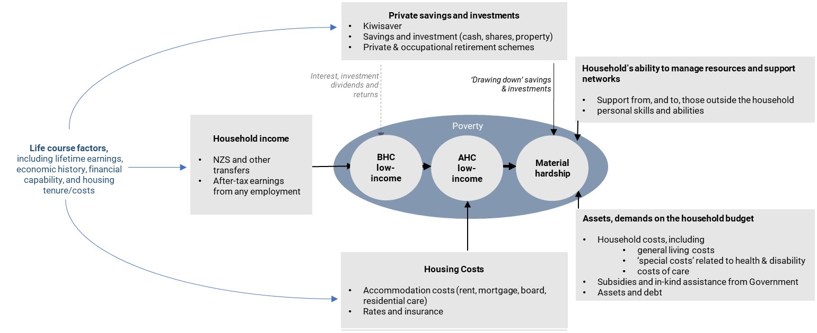
Income support administered by MSD is just one of many influences on the material wellbeing of older people. NZS plays a very important role, as do other supplementary payments MSD provides (AS, Disability Allowance, Temporary Additional Support). But someone’s financial position in older age often reflects a wider range of factors, including the impact of other government settings such as KiwiSaver or the Income Related Rent Subsidy (IRRS), and their life circumstances, which influences their assets, savings, wealth, and health.
We have developed two frameworks for the drivers of poverty and hardship in older age in New Zealand. The first framework (above) is a simplified version of the second (overleaf), which goes into a greater level of detail around specific life course factors and policy settings and places these in the context of wider economic and structural factors which are important for understanding living standards in context.
MSD research on economic living standards found three sets of factors that influence the material wellbeing of older people:
- Current economic circumstances - net income, ongoing accommodation costs, and levels of savings and investments (often linked to ‘life-course’ factors, such as home ownership and employment history).
- Recent and historical financial stresses - exposure to various adverse life events and circumstances, including relationship breakdown, unemployment, bankruptcy, and redundancy.
- Social background - respondents who were Māori or Pacific, had worked in a low socio-economic status occupation, or had lacked formal educational qualifications had lower mean material wellbeing scores, even after controlling for economic circumstances (Fergusson, 2001).
OECD research indicates that inequality and disadvantage amongst older people are driven by their circumstances over the course of their lives: “socio-economic outcomes of individuals build up from childhood to adulthood, and inequality of a given cohort later in life largely results from differences in individual experiences accumulated over the life course” (OECD, 2017).
Figure 21 - Drivers of poverty and material hardship - more detailed view
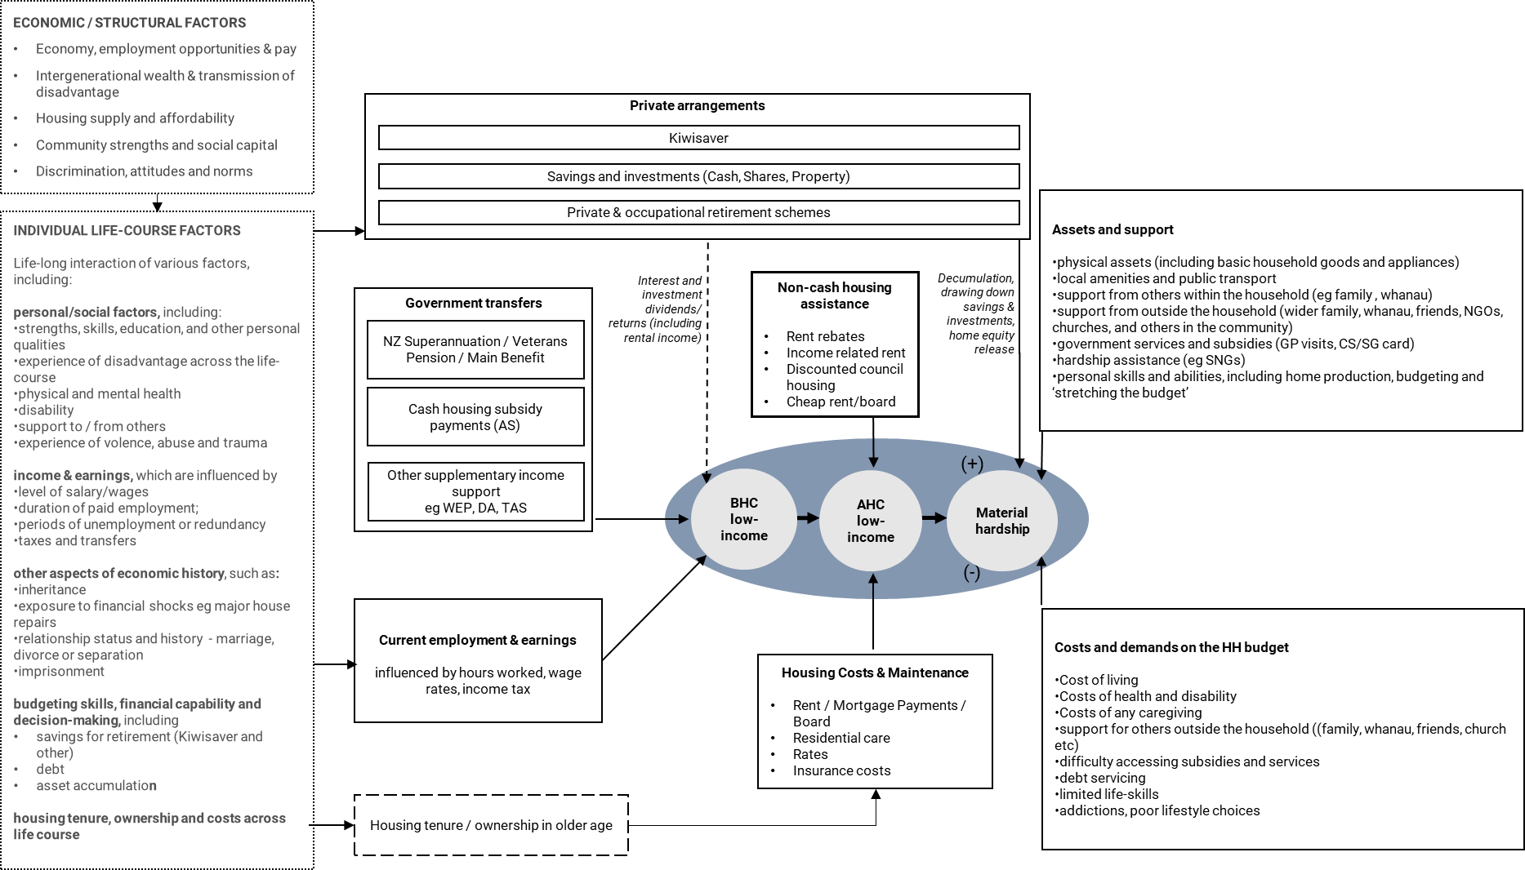

3.2 Employment - recent trends and future possibilities
One particularly significant change is the dramatic increase in employment for older New Zealanders over the past three decades. The employment rate for those aged 65-69 has risen from around 10% in the mid-1990s to nearly 50%, for those aged 70+ it has risen from around 3-4% to around 15%. New Zealand now has one of the highest participation rates in the OECD for those aged 65+, a marked shift from the 1990s when New Zealand was well below the OECD average.
Figure 22 - Trends in employment by age (65+, both sexes)
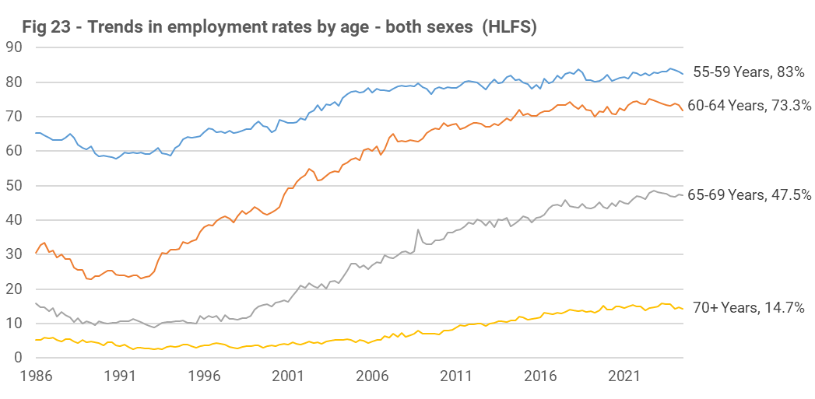
There are a range of possible reasons for this, including the evolving labour market context, improved health and longevity, shifting societal norms and attitudes, changes in employer attitudes and behaviours, personal preferences, and changes in the nature of working conditions (e.g. less physically arduous work, more flexibility). Policy settings are also likely to have contributed, including the increase in the age of eligibility for NZS from age 60 to 65, and the abolition of compulsory retirement under the Human Rights Act 1993. NZ's superannuation policy settings also supported this, as entitlements are not impacted by earnings, meaning there is no disincentive to work in later life (which differentiates NZ from many other OECD countries).
One important question is the extent to which ongoing work participation is driven more by ‘preference’ or ‘need’. MSD analysis has found that employment is spread fairly evenly across the spectrum of material wellbeing and is not limited to those with low or high living standards. A Retirement Commission survey found that, for those aged 65-69 still in paid employment, 68% were working because they wanted to, and 32% because they had to. Those aged 65+ who work because they have to are less likely to own their home, and more likely to still have a mortgage compared to those who work because they want to.
As the number of people over 65 in work has grown, so too has the number who are underemployed or unemployed (i.e. not in work but actively seeking it). The proportion of unemployed people over 65 years is small but has grown in recent years.
Retaining older workers in the workforce often has many benefits for those individuals - maintaining social connections, keeping physically and mentally active and increasing financial stability. Work also generally contributes to people feeling purposeful and connected to their community and aids their overall sense of wellbeing.
When looking at labour force participation by ethnicity, trends are limited by sample size (the estimates below have large sample errors) but nonetheless indicate that increases have occurred for all ethnic groups, though Māori, Pacific and Asian older people have lower labour force participation rates overall than Europeans.
Figure 23 - Labour force participation rates (65-69) - by ethnicity
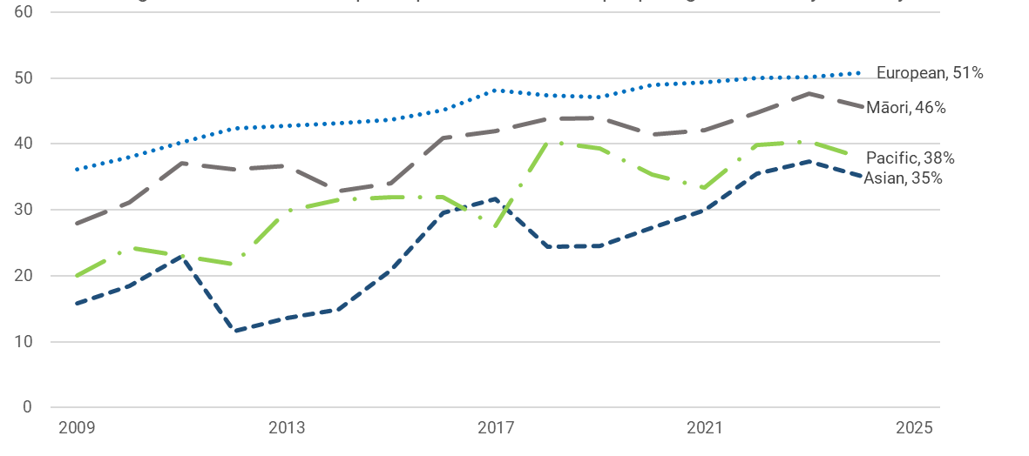
These recent trends in employment have been the major contributor to a significant increase in income inequality amongst older people. Analysis by Perry shows that a large group of older New Zealanders (around 40%) remain heavily reliant on NZS, as this makes up nearly all their income, but there has been a shift away from reliance on NZS in the upper half of the income distribution for older people through the 2000 and 2010s. This has meant steadily increasing inequality for those aged 65 and over, as measured by the Gini coefficient.
Figure 24 - proportion of gross income from transfers (65+)  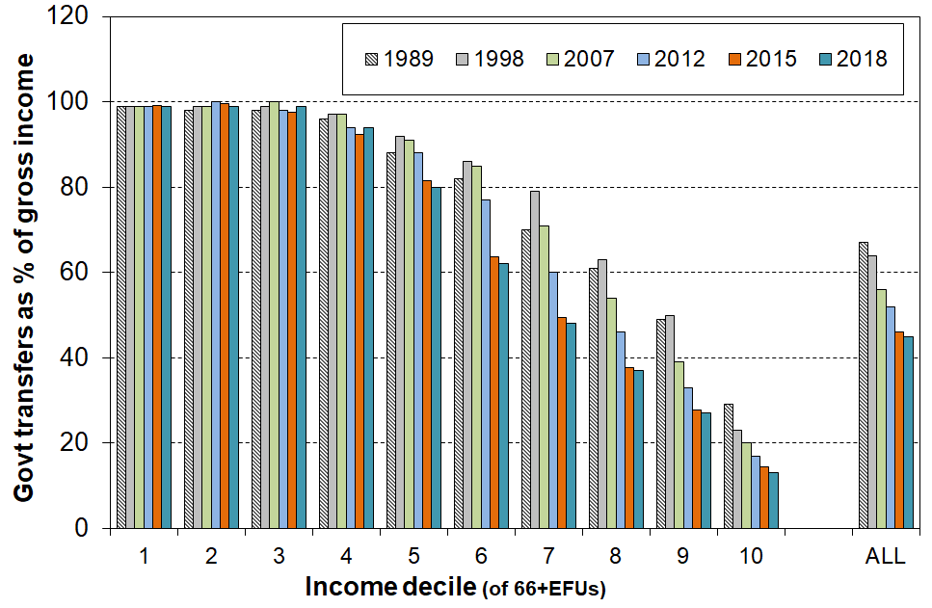 | Figure 25 - Gini for 65+: BHC disposable income  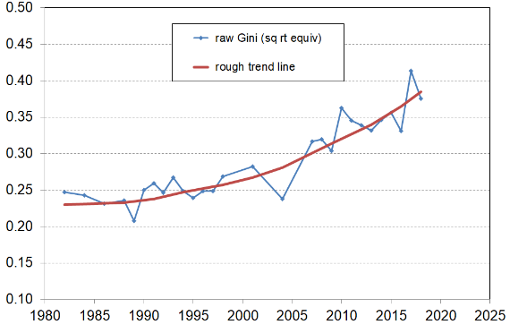
Stats NZ and the Treasury expect workforce participation among older people to “flatten off” but still increase. The Treasury’s forecast assumes that labour force participation for those aged 65-69 will grow by 5 percentage points by 2040, for those aged 70-74 by 4 percentage points, and for those aged 75-79 by 3 percentage points. While this in itself is a significant shift, it is distinctly possible that workforce participation will increase even more than these projections.

3.3 Employment - benefit receipt and employment support
There are key differences in employment patterns among older adults and pathways into retirement. Many workers lose employment and/or leave the labour market before they are eligible for NZS, increasing the risk of low income post 65.
For the December quarter, there were around 46,000 recipients of a main benefit aged 60-64 years, around 15% of the total population in that age bracket. This proportion has generally remained between 12% and 14% since 2008 (see graph below), after declining in the early 2000s.
Figure 26 - Percentage of population 60-64 receiving main benefit
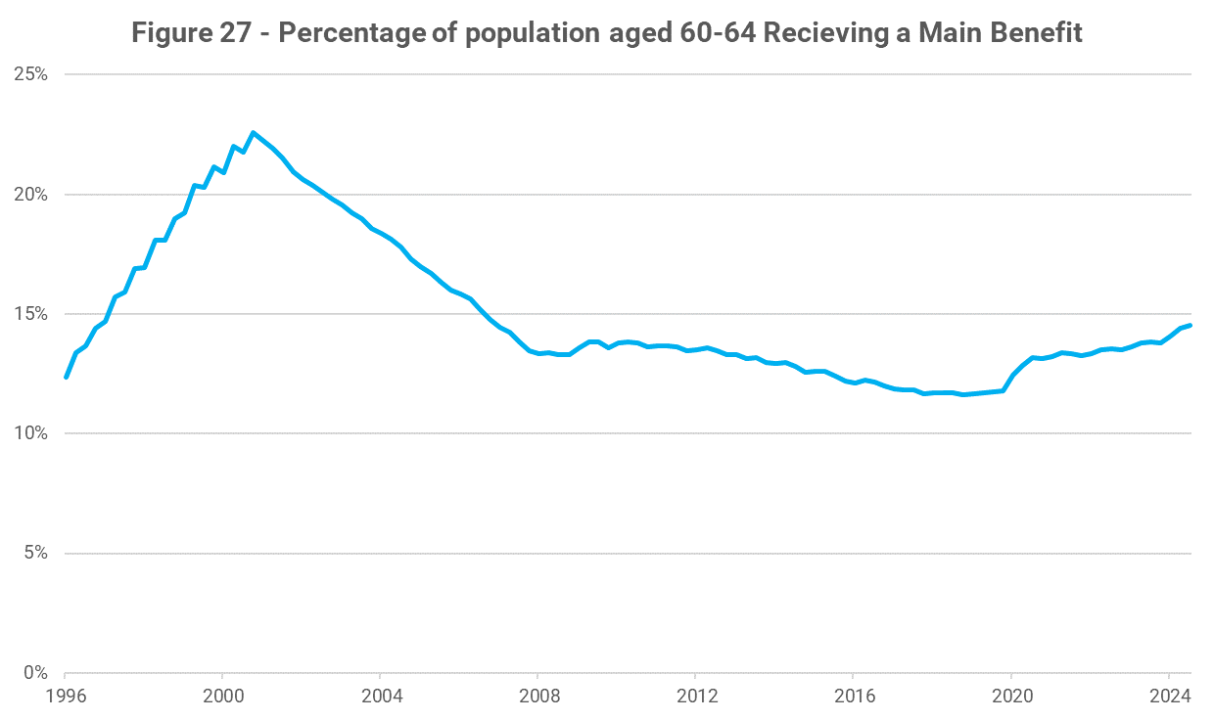
Of those aged 60-64 currently on benefit, more than half (51%, or 23,000 people) had been on benefit for more than five years, and roughly a third (32%, or 14,000 people) had been on benefit for more than 10 years.
We have looked at the benefit receipt of older main benefit recipients in New Zealand and found that:
- People aged 50-64 make up a large proportion of those on working age benefits. Of the 390,000 people receiving a working age benefit, 31% or 120,000 are aged over 50.
- Māori are overrepresented - 30% are Māori, 43% are NZ European, 8% are Pacific, and 16% are other.
- Long-term benefit receipt is common - 63% of have received a main benefit for two or more years, and 22% for 10 or more years
Main benefit recipients over 50 are more likely to receive health and disability benefits than other types of benefits, reflecting the fact that as people age they are more at risk of developing a health condition or a disability that impacts on work capacity. Recipients over 50 years are most likely to be receiving Supported Living Payment – Health Condition and Disability (SLP-HCD, 44%) or Jobseeker Support Health Conditions and Disability (JS-HCD, 31%).
Figure 27 - Main benefit receipt by type and age
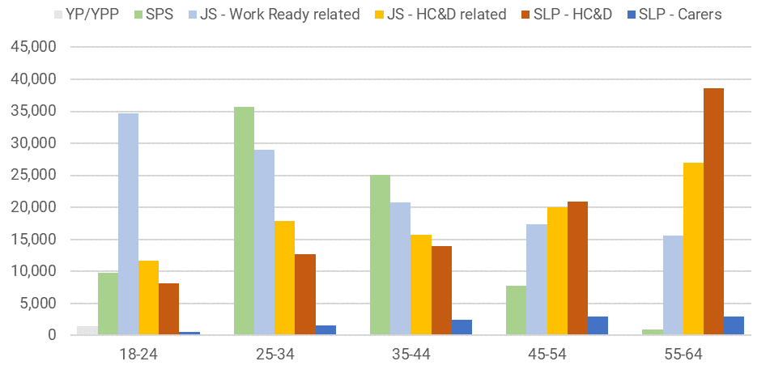
Health conditions for older benefit recipients are more likely to relate to physical health. Compared with those aged under 50, JS-HCD and SLP-HDC recipients over 50 are less likely to be receiving this benefit for mental health conditions, and more likely to be receiving them for physical health problems such as musculoskeletal conditions, cardiovascular disorders, and nervous system disorders (e.g. stroke).
MSD’s employment assistance is currently weighted towards younger clients, which likely in part reflects the different types of benefits received by older cohorts. Analysis of MSD’s Employment Assistance indicates that:
- those aged 50-64 made up around 30 percent of the main benefit population and received around 13 percent of investment
- those aged 65+ (who are primarily receiving NZS rather than other main benefits) received around 0.3% of investment.
Figure 28 – Improved Employment and Social Outcomes Support Multi-Category Appropriation - expenditure by Age
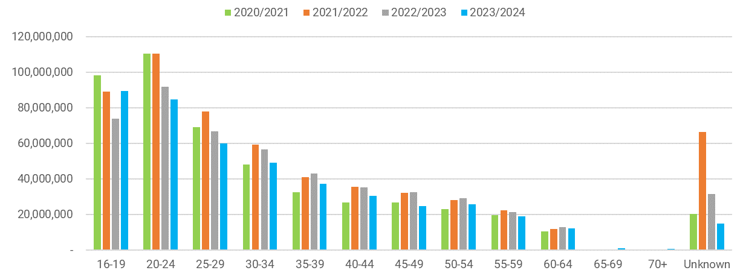

3.4 Income support - NZS settings
Income support for older people in New Zealand is primarily based around NZS, a universal payment to citizens and permanent residents aged 65 years and over, supplemented by the Winter Energy Payment (from May to October), and various forms of supplementary assistance for those in specific circumstances. NZS is not income or asset-tested but couples receive a couple rate, and single people living alone receive a higher rate than those living with others. Those who have served in NZ’s armed forces can qualify for a Veterans Pension (VP) instead, which is paid at the same rate.
Internationally, the NZ pension system is notable for a number of reasons. It is near-unique in its heavy reliance on a universal, non-contributory scheme, and the lack of any other mandatory contributions-based or earnings-related scheme. NZ’s non-contributory first tier benefit is also the highest in the OECD, when expressed as a percentage of average earnings, as can be seen in Figure 29 below.
Figure 29 - first tier benefits in oecd countries - % of gross earnings (2022)
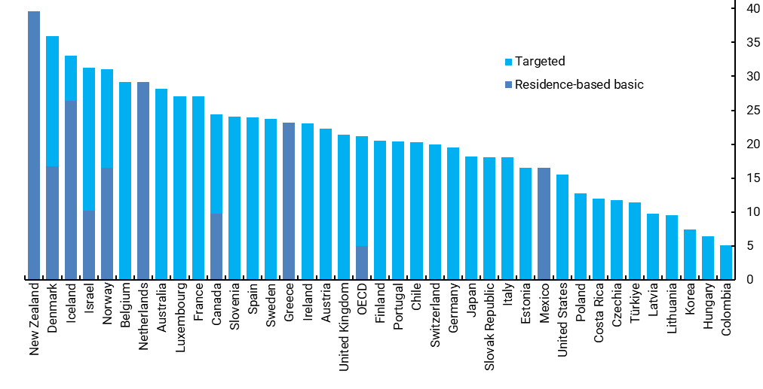
NZS is also world-leading among mandatory pension schemes in the way it limits earnings inequality impacting on pension levels. The OECD constructed a ‘progressivity index’ to assess the extent to which lifetime earnings inequality passes on to pension inequality. On this index New Zealand joins Ireland and the United Kingdom in scoring 100% since all superannuants receive the same basic benefit level, regardless of prior earnings. Similarly, NZS is near-unique in not discouraging labour market participation as discussed above.
Indexation settings for NZS mean that, each April, NZS has been adjusted by the higher of wages or prices, with wages are most commonly the higher of the two. As a result, NZS rates have steadily increased in real terms - between 2008 and 2024, NZS rates increased by 83%, well ahead of the cost of living as measured by either the Consumer Price Index (CPI) (47%) or the Household Living Price Index (56%).
While this suggests that indexation has meant NZS levels have increased faster than costs for all recipients, some caution is needed. These price indexes rely on averages for their ‘basket’ of goods and services, and these may not be representative of the prices and expenditure of all NZS recipients, particularly those with different housing costs.
As the graph below shows, rates have kept pace with average wages (in line with legislative settings) but have steadily declined in relation to median household incomes, as these tend to grow slightly faster, which has implications for income poverty rates (see section 2.1 above.).
Figure 30 - NZS as % of average wages and median household income
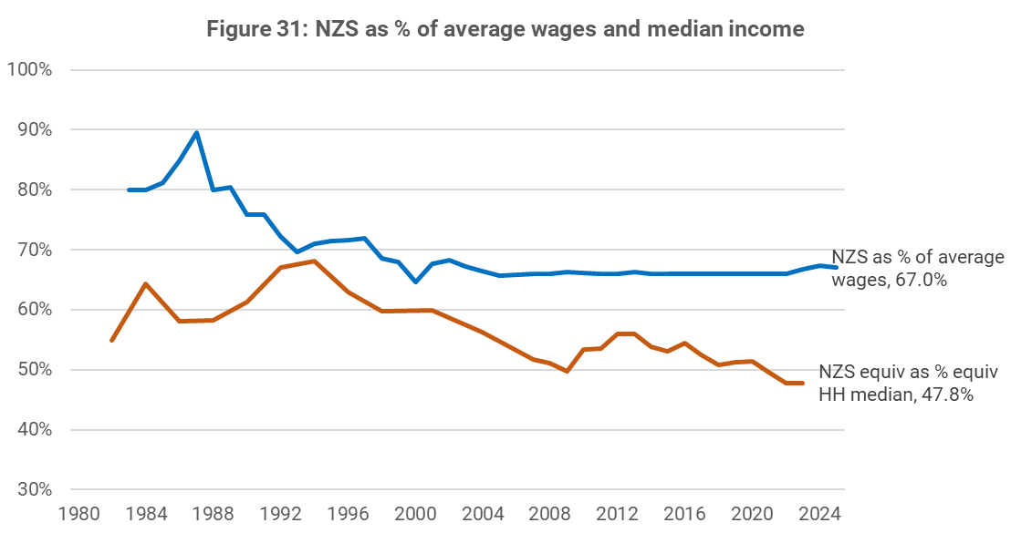
Each year, there are generally around 5,000-10,000 people over 65 receiving benefits other than NZS or VP; mostly either the Emergency Benefit or Supported Living Payment. This is most commonly due to not meeting residency requirements for NZS.
Up until July 2024, someone had to have been resident in New Zealand for at least 10 years since the age of 20, five years of which had to be after the age of 50 to meet the residency requirement. Due to 2021 legislative changes, the minimum overall length of residency is gradually increasing from 10 years to 20 years and will be fully phased by 2042. This will mean an increasing number of people will not be eligible for NZS and may seek other financial support from MSD, which is paid at a lower rate. Those affected by the change will likely be at higher risk of hardship and disadvantage and will more likely be from ethnic and migrant communities.

3.5 Income support - trends in receipt
NZS is a first-tier benefit. Like other first-tier benefits, recipients are potentially eligible for various forms of supplementary assistance. Figure 31 shows trends in the uptake of each payment.
Figure 31 - % of NZS recipients receiving supplementary assistance
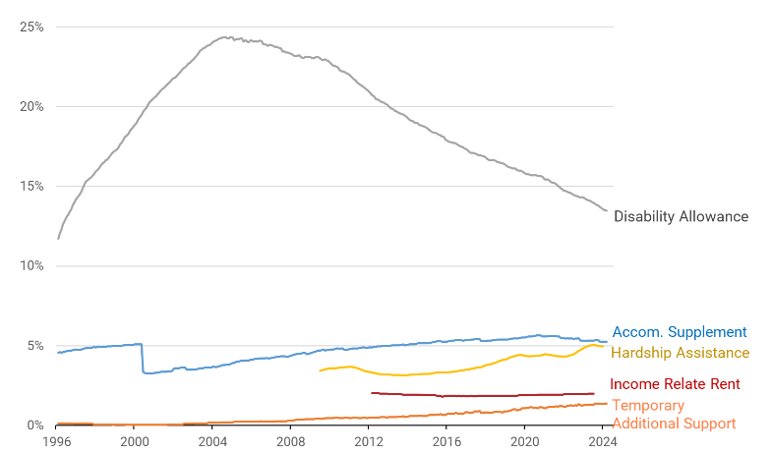
- The Disability Allowance (DA) is the most widely accessed payment and is most commonly received for medical fees (32%) and prescription charges (20%), followed by gardening/lawns (11%) and medical alarms (11%). DA receipt has declined significantly from around 25% of NZS/VP clients in the mid-2000s to around 13%. Uptake has likely been constrained by issues with administrative complexity, accessibility and awareness. In addition, the indexation of DA income thresholds to CPI rather than wages has likely meant a reduction in the number of hours people can work while still receiving DA.
- The Accommodation Supplement (AS) and Temporary Additional Support (TAS) are received by a relatively small proportion of clients, though this number has been growing, likely due to an increase in those facing high housing costs and low residual incomes. One factor that is likely limiting wider AS uptake is the fact that it is subject to a cash asset test of $8,100 for a single person and $16,200 for a couple - these limits have not changed since AS was introduced in 1993 (if adjusted for inflation, they would now be $16,800 and $33,500). This means older people who continue to receive AS can have relatively few savings for later in life or even emergencies - the amount is also below what is typically spent on funeral costs alone.
- The Income Related Rent Subsidy (IRRS). The number of older social housing tenants receiving IRRS in either Housing NZ / Kainga Ora or Community Housing Provider (CHP) properties increased from 12,300 in August 2012 to 18,000 in December 2023. Some of this growth may have been the result of local government ‘pensioner housing’ being transferred to CHPs and becoming eligible for IRRS for new tenants. This has meant that, as a percentage of the overall 65+ population, the proportion of older people receiving IRRS has remained at around 2%.
- The number of one-off hardship grants received by NZS/VP clients has more than doubled since 2016. This mirrors trends for working age benefit recipients, and likely reflects a combination of increased accessibility (2016-2020), temporary COVID-specific factors (2020-2021) and pressures associated with the ‘cost of living crisis’ (2022-2024). Māori and Pacific older people have considerably higher rates of hardship receipt, compared with other ethnicities.
Figure 32 - change in hardship assistance usage - NZS vs working age clients
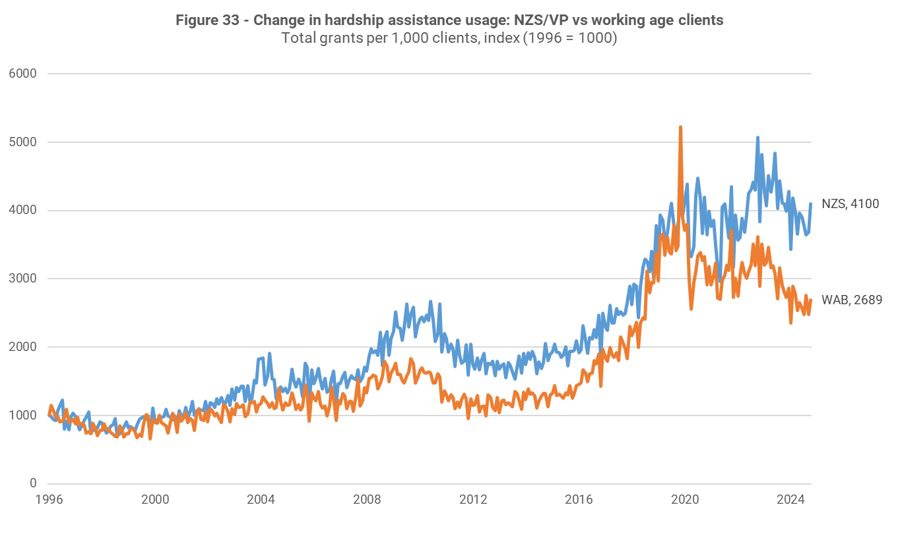
The SuperGold card, which is universally available to those aged 65+, makes available a range of discounts and subsidies that can help to moderate costs for older people. This includes free travel on most off-peak public transport as well as discounts at a range of businesses.

3.6 Income support – future possibilities
Demographic changes are likely to put additional pressure on the Government’s long-term fiscal position, and it is possible that future Governments may explore changes to NZS settings in response. For example, the Treasury’s 2021 combined LTIB/Long-term Fiscal Statement, He Tirohanga Mokopuna, explored two policy changes in particular: changing indexation arrangements, and raising the age of eligibility. There is a third category of options not explored in detail by the Treasury but often raised in debates on NZS sustainability, which involves exploring greater targeting of expenditure.
- Switching to CPI indexation only - The Treasury explored linking the rate at which NZS payments grow to inflation only rather than wages. This would significantly reduce the growth of NZS expenditure but would also likely “undermine the effectiveness of the present system at preventing poverty in old age and enabling older New Zealanders to share in increases in national income which their labour and investment have helped create. Changing patterns of home ownership are likely to add to concerns around old age poverty as we see an increase in the number of people not owning their own home. Given this, more people are likely to find NZS insufficient to live on if they are renting. This would disproportionately impact those on low incomes throughout their working life” (Treasury 2021, p.61).
- Raising the age of eligibility for NZS - The Treasury also explored raising the age of eligibility for NZS from 65 to 67 by 2030. They argued that individuals could respond in various ways, including working longer, or living more frugally and increasing their savings so they could continue to retire at 65. However, they noted that the change would have a greater impact on those with limited ability to work in the later stages of their lives, especially those in physically demanding jobs. Increasing the NZS age of eligibility also has equity implications for ethnic groups such as Māori and Pacific people who have lower life expectancies.
- Other changes that Governments could explore - Governments might also explore greater targeting of payments - either by abating NZS with income received or by changing tax settings on other income received by NZS recipients. These changes would have less impact on those on the lowest incomes but would entail other policy trade-offs, such as reducing financial incentives to continue working beyond 65, discouraging savings and increasing the complexity of the scheme.
The graphs below show the impact of switching from current indexation arrangements to CPI indexation only. Over time, the difference between the two accumulates, and becomes substantial: under CPI indexation, the couple rate would be $392 lower by 2050 than it would be under current settings (figure 33), which equates to $234 lower in 2024 prices (figure 34). Under CPI indexation, NZS would decline as a proportion of average wages to around 50% by 2050, below the 65-70% where it has historically been for the past three decades (figure 35).
Figure 33 - NZS indexation - Status quo vs CPI - nominal  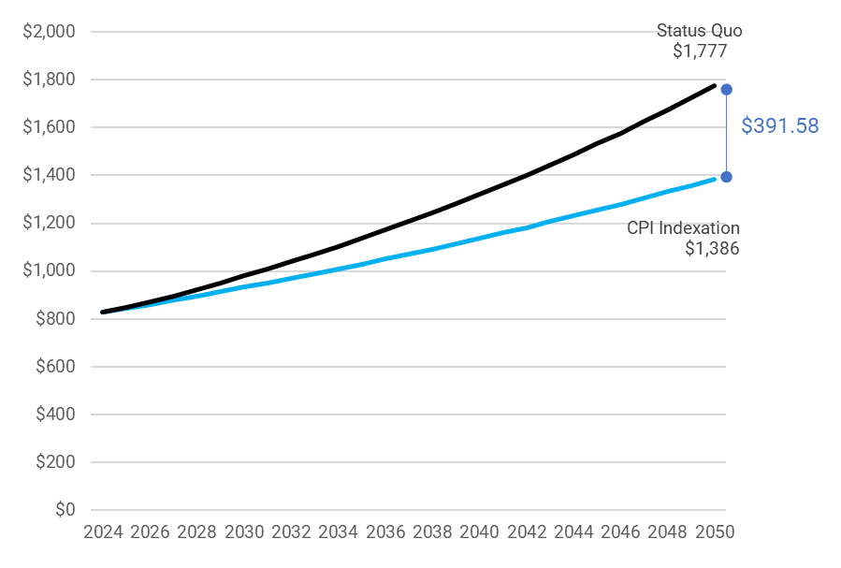 | Figure 34 - NZS indexation - Status quo vs CPI - Real  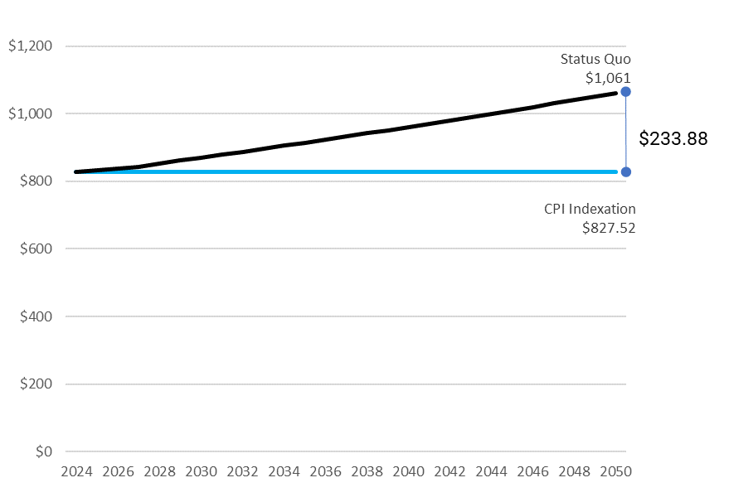
Figure 35- INDEXATION - STATUS QUO VS CPI - % OF NET AVERAGE WAGE
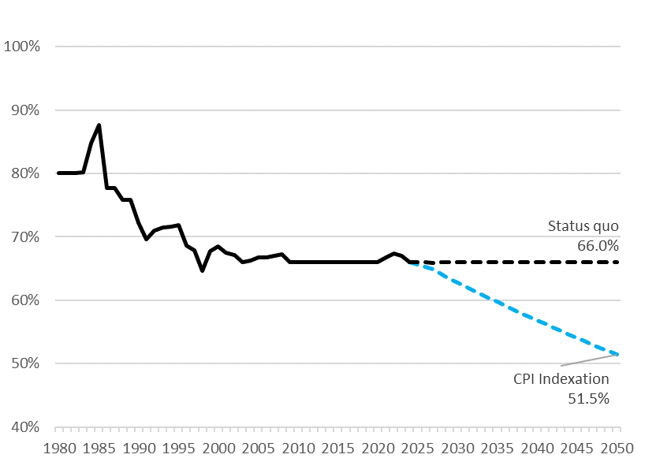

There are other considerations that Governments may wish to take into account when considering the different cost saving measures described above. This includes:
- the different levels of savings that can be achieved under the various options – for example, the Treasury estimated raising the age to 67 would reduce Crown expenditure in 2050 from 33.7% of GDP to 33%, whereas CPI indexation reduced it to 32.2%.
- any arrangements necessary to support a transition to alternative settings. For example, when the age of eligibility was increased from 60 to 65 in the 1990s, a Transitional Retirement Benefit (TRB) provided income-tested support to those who had not yet reached the qualifying age of NZS, and who were to be most financially affected. The qualifying age was gradually increased so that it would reach 65 years in 2004, at which time TRB ended.

3.7 Housing - recent trends
The most striking emerging trends in older people’s housing are the growth in the number of life-long renters and those paying a mortgage in to later life. While mortgage-free home ownership in later life had been the historic norm, rates have been slowly declining across the population. As at the 2023 Census, 16.62% of older people lived in a house they did not own. The decline has been particularly marked for kaumātua Māori and older Pacific people; home ownership rates for these groups are notably lower than the total older population.
Figure 36 - PROPORTIONS OF INDIVIDUAL TENURE AGED 65+ (CENSUS 1996 – 2023)
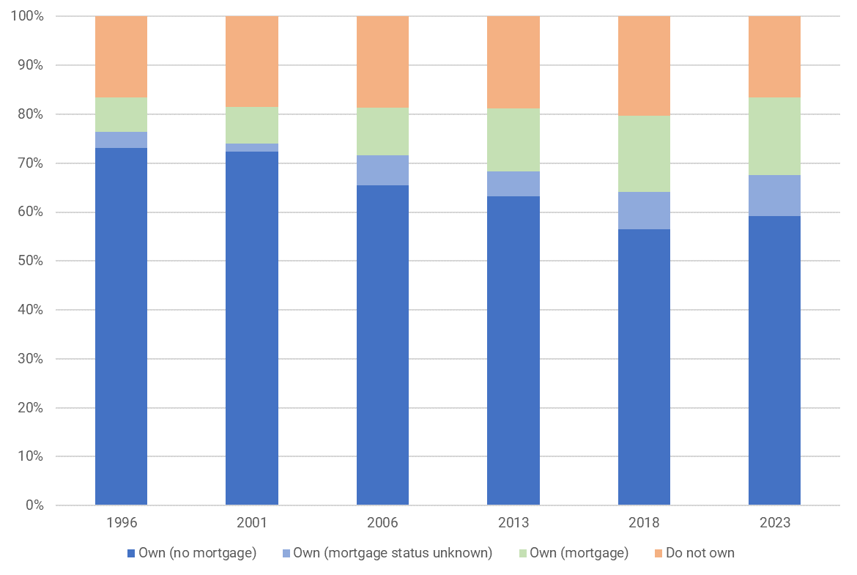
The number of older people paying a mortgage has also risen significantly. As at the 2023 Census 18.9% of homeowners aged 65+ (or 15.7% of the total population) were doing so. The graph below shows that growth in the numbers of older individuals paying mortgages has taken place across all older age brackets but is most pronounced among those aged 65 – 74. This points to a trend of “tailing off” mortgages into later life, perhaps linked to later entry into home ownership and generally higher house prices. More recent data on average mortgage balances indicates that these have grown across all older age groups but continue to follow a trend of diminishing with age.
Figure 37 – Proportion of individual homeowners Aged 65+ paying a mortgage
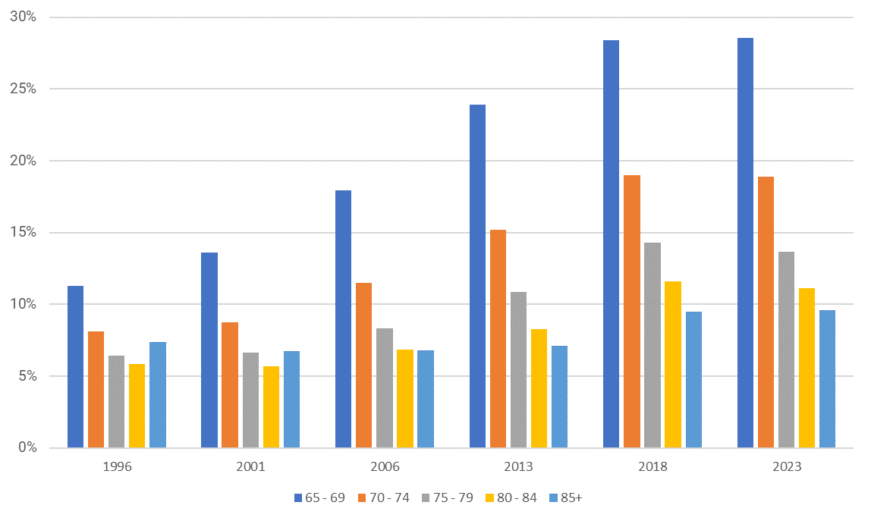
The group of older people who do not own their home or are paying a mortgage makes up a sizeable proportion (23%) of the approximately 40% of the older population who entirely or mostly rely on NZS as their source of income. This suggests that around one in ten older people are both primarily reliant on NZS for income and have higher ongoing housing costs in the form of rent or a mortgage.
The graph below shows lower quartile rents as a proportion of NZS since the early 1990s. Renting has become steadily less affordable for those relying on NZS as their sole or main source of income. This is in line with the overall trend in rental growth during this period, which has run slightly ahead of wage growth (to which NZS is for the most part indexed).
Figure 38 - Lower quartile rent as % of NZS
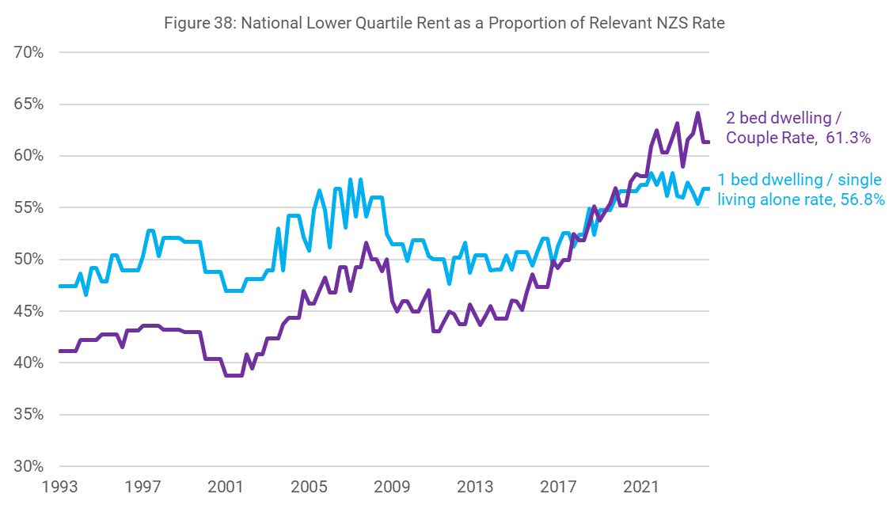
Rental tenure can present other challenges for older tenants. Research has shown that rental housing in Zealand is less healthy than owner-occupier, and survey results indicate that most landlords have little appreciation of older tenants’ needs. Rental tenure is also less secure than home-ownership as older renters have usually live in their dwelling for significantly shorter periods. This can present challenges for establishing and maintaining connections to community, family and friends, which can become especially important in later life.
Historically, the small proportion renting in later life were partly insulated from the private rental market by social housing – notably ‘pensioner housing’ provided by local councils. However, this form of social housing appears to be in long term decline, particularly relative to the size of the older population. The number of council housing units declined from approximately 13,400 in 2016 to approximately 6,400 in 2023. Of the 7,000 no longer under direct council management, the vast majority were transferred to CHPs, and the extent to which these will continue to be earmarked for older people is unclear.
Older people are less likely than other age groups to experience severe housing deprivation, but there is some indication of increasing rates.
Most older people who own their own home are less likely to face housing affordability issues. The ongoing costs of home ownership are generally lower than renting. A mortgage-free home is also a significant store of equity for many older New Zealanders, which can be accessed through instruments such as reverse mortgages, although these remain uncommon. Nonetheless, the costs of home ownership have been increasing disproportionately as shown in the graph below. This will have placed pressure on the household budgets of some older homeowners.
Figure 39 - cumulative price increases for home ownership costs, adjusted for CPI 1981-2024  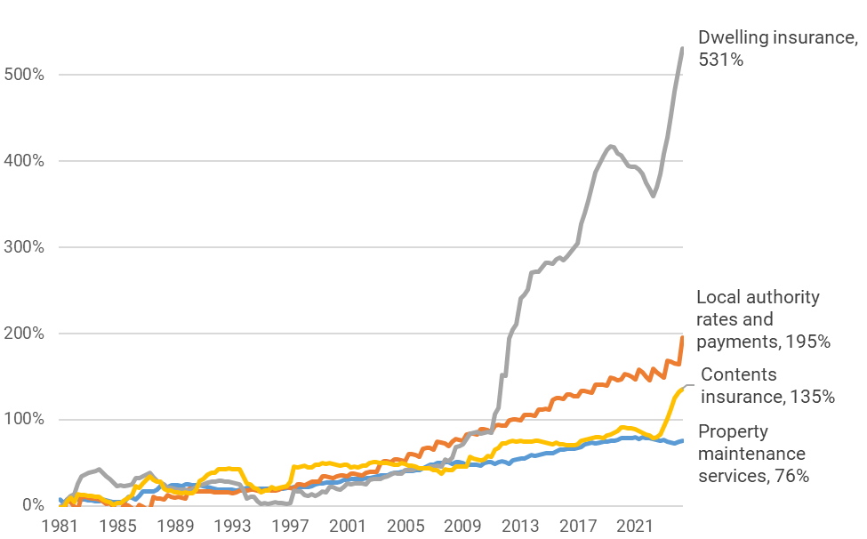 | Figure 40 - Annual change in home ownership costs (CPI) 2010-2024  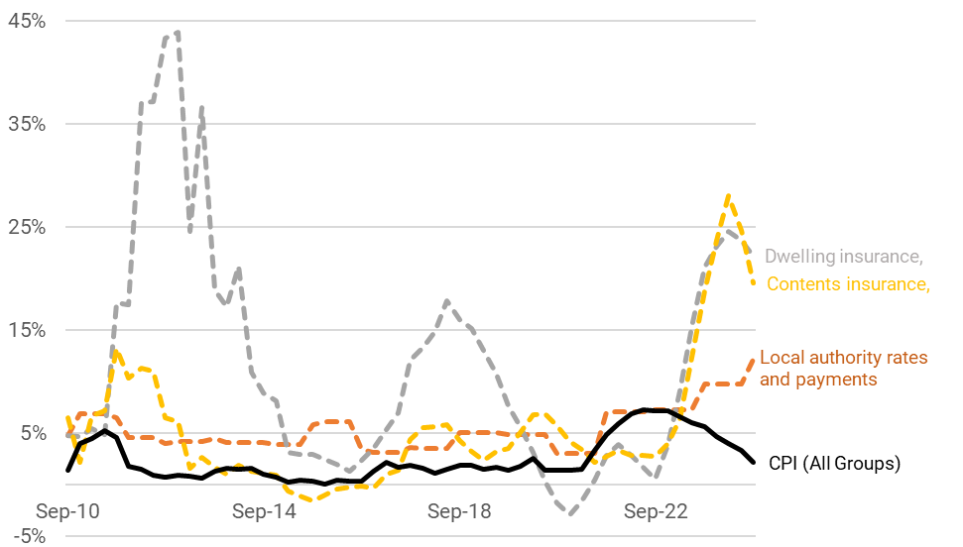
The Ministry of Housing and Urban Development’s 2023 Long Term Insights Briefing considers the implications of the ageing population for housing tenure. It can be found here: https://www.hud.govt.nz/our-work/long-term-insights-briefing-2023

3.8 Housing - future possibilities
The decline in home ownership rates among older people will likely continue. Home ownership rates for successive birth cohorts follow a common trend; growing throughout mid-life, slowing with the approach to later life and declining very slightly during later life. We can therefore predict with some certainty home ownership outcomes for those who will join the 65+ cohort in coming decades.
Figure 41 - home ownership rates by age for birth cohorts
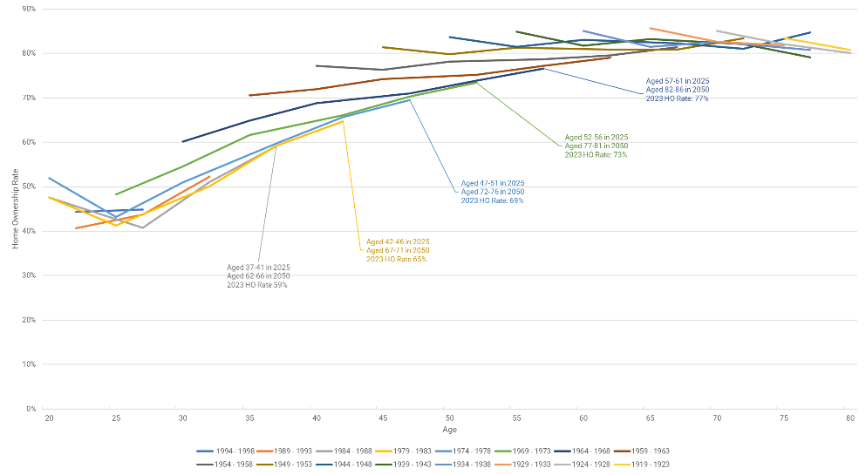
Based on existing cohort home ownership rates and historic cohort trends, we estimate that around 26% of those aged 65+ will be non-homeowners by 2050 (up from 16.62% in 2023). The overwhelming majority of these will likely be renting on the private market. This represents a dramatic increase in numerical terms: from around 138,000 older people as at the 2023 Census to approximately 390,000.
Based on trends to date, affordability is unlikely to improve for these households. The graph below shows how the two scenarios for NZS indexation described at 3.4 above (to average wages or CPI inflation) interact with two scenarios around rental increases: growth in line with wages (3% pa); and growth in line with average annual increase for the past 30 years (4.7%). These are sensitive to the assumptions used but illustrate that more people who are renting are likely to find NZS insufficient to live on if CPI is used and/or rents increase quickly. The only scenario in which the financial situation of older renters does not deteriorate is where both rents and NZS rates move together with wage rates – this scenario essentially guarantees rents will remain a constant proportion of NZS income.
Figure 42 - housing costs as % of NZS - couple paying lower quartile rent  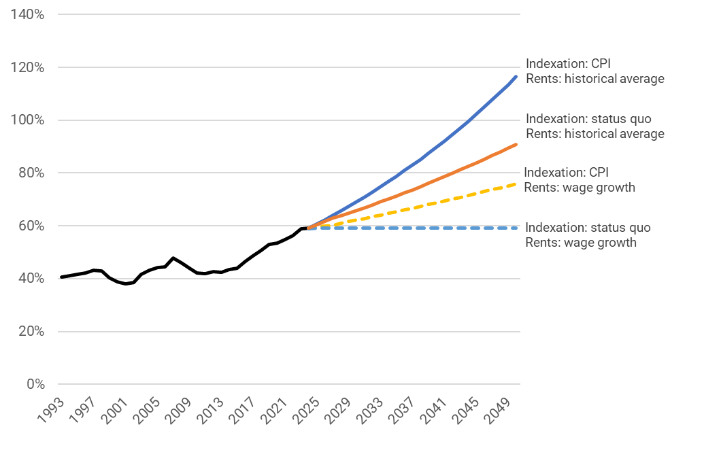 | Figure 43 - residual income for a NZS couple paying lower quartile rent ($2024)  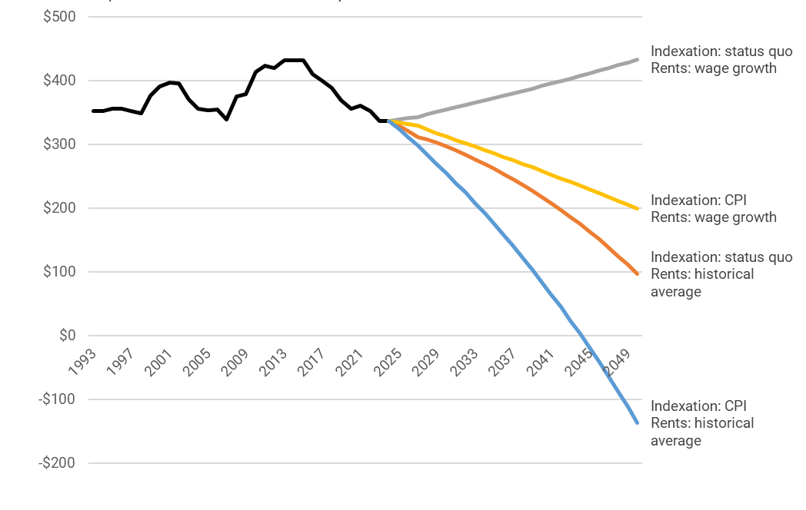
The impacts of unaffordable rental housing on this large cohort depend on a range of other factors but are likely to be significant. If the proportion of older renters receiving AS in 2050 matched the current proportion for example, this would mean 74,000 additional recipients, an almost three-fold increase. This would in turn mean a substantial increase in expenditure on AS for the older population, which is currently $50-60m per year (a relatively small proportion of the $2.2b spent on this payment overall).
The relationship between rental costs and severe housing deprivation is not straightforward, but nevertheless rising rents may well lead to an increase in the proportion of older people experiencing severe housing deprivation.
Without a significant shift in policy, social housing is only likely to support a small proportion of older non-homeowners unable to afford housing in the private rental market. In 2023 around 19,500 people, or 2.4% of the older population, resided in social housing of all kinds. Maintaining this proportion of the total population would require construction or acquisition of around 11,600 additional social housing units solely for older people by 2050. Maintaining the proportion of older non-homeowners housed in social housing (currently approximately 14%) would require approximately 27,500 additional units over the same time period.
Alternatives to private rental housing will continue to form a small but important component of the housing market for older people but are unlikely to expand to provide an at-scale alternative to private rentals. Some social housing providers with a focus on older people, such as Abbeyfields NZ and Haumaru Housing, have ambitious plans to expand their operations. However, additional units that they will add in the foreseeable future number in the hundreds and thousands. In a similar vein, while a range of Māori-led kaumātua and papakāinga developments will provide positive housing solutions in particular rohe, they are unlikely to provide housing at significant scale.
The retirement village industry estimates that its development pipeline will fall short of the current population proportion served (approximately 14% of those aged 75+) by 23,242 units by 2048. These are likely to continue to be positioned as a premium product equivalent in cost to home ownership.
It is not clear that the housing stock currently being constructed will be well suited to the needs of an ageing population. Three and four bedroom family homes predominate, and very few new builds meet accessibility standards. Natural inertia in the makeup of housing stock means that even an immediate and dramatic shift in construction practices is unlikely to make appropriate stock sufficiently available.
The changing makeup of the ageing population means that more older people are likely to live in multigenerational households. This carries a range of implications for these older people as well as the families who they live with. If multigenerational living is seen as a desirable outcome there could be policy solutions to support it, including supporting the construction or conversion of appropriately configured housing stock.

3.9 Wealth - net worth and inheritances

The current distribution of wealth in New Zealand
MSD analysis indicates levels of wealth held by a household has a significant impact on material wellbeing and hardship for older New Zealanders. This wealth can be held as savings, but is also often held as housing. Housing wealth can minimise housing costs and be liquidated it to sustain living standards.
While wealth can be difficult to measure, various data sources indicate systematically lower average levels of wealth for some ethnicities, for disabled people and women. Stats NZ net worth data (2021) suggests there are significant differences in the distribution of wealth in New Zealand, including:
- By net worth quintile – mean household net worth for is $6,000 those in the lowest quintile, $403,000 for those in the middle quintile, and $3 million for those in the highest.
- By ethnicity – median household net worth is $456,000 for a European household, $350,000 for Asian, $220,000 for Māori, and $160,000 for Pacific.
- By gender – median individual net worth is $113,000 for men and $100,000 for women.
Figure 44 - household assets and liabilities - mean value by net worth quintile
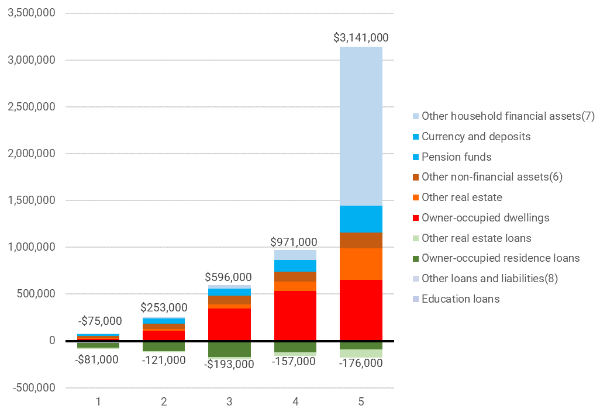
Figure 45 - median net worth for individuals - by ethnicity and age
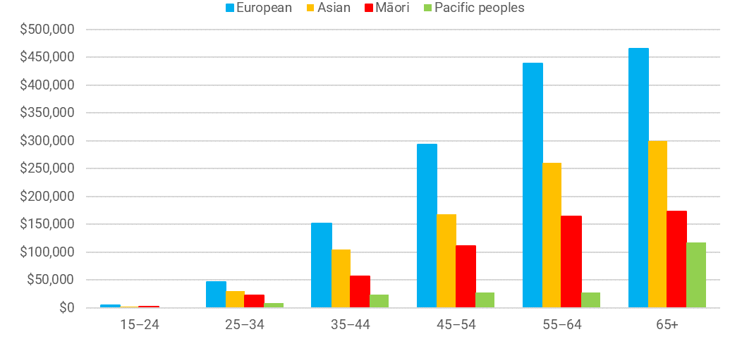

Intergenerational wealth transfer
When thinking about wealth in the future, an important consideration is ‘intergenerational wealth transfer’ via inheritances, which are an important contributor to the retirement savings of future older people. Those aged over 55 currently hold 60% of New Zealand’s $2.29 trillion total individual net wealth, and BERL has estimated that the value transferred by them in the next 20 years will be ~$1.11 trillion (BERL 2024). They conclude that the impact of ‘the great wealth transfer’ is “unlikely to be even” in light of existing wealth inequalities, particularly when ethnicity is taken into account.
The OECD has noted that inheritances are becoming an increasing share of private wealth in many countries, and in the future are expected to grow in value if trends in asset prices continue. This could “further increase wealth inequality and widen the gap between, for instance, the older asset-owning generations and younger generations, who might face increasingly high housing prices”.
As people inherit later in life, this could exacerbate disparities within generations too: “Because wealth is increasingly concentrated and wealthy households tend to receive more and higher value inheritances, intra-generational inequality is also likely to increase. Low fertility rates and smaller families may also mean that there are fewer close family members amongst whom wealth may be divided, so heirs receive a larger share of the donor’s estate.” (OECD 2021)
In New Zealand, there is evidence to suggest wealth has become even more concentrated in those who are older. As shown in Figure 46 below, between 2001 and 2018, older people gained substantially more than younger people from wealth increases, due to trends in house prices, capital gains, and other factors (Symes 2021). This is likely to have significant implications for intergenerational wealth transfer and for differences in savings for future older people.
Figure 46 - median wealth by age in 2001 and 2018 ($2018)
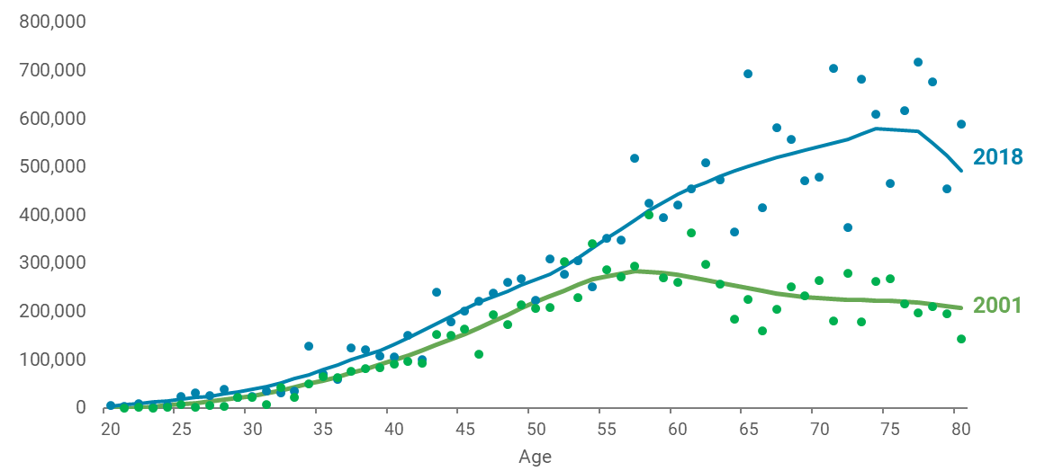

3.10 Wealth – KiwiSaver

Overall trends in contributions and balances
KiwiSaver is an increasingly important part of the retirement income picture - contributions have been steadily rising in real terms since the scheme began, reaching $10.5 billion in 2024.
Figure 47 - total kiwisaver contributions 2008-2024 ($2024)
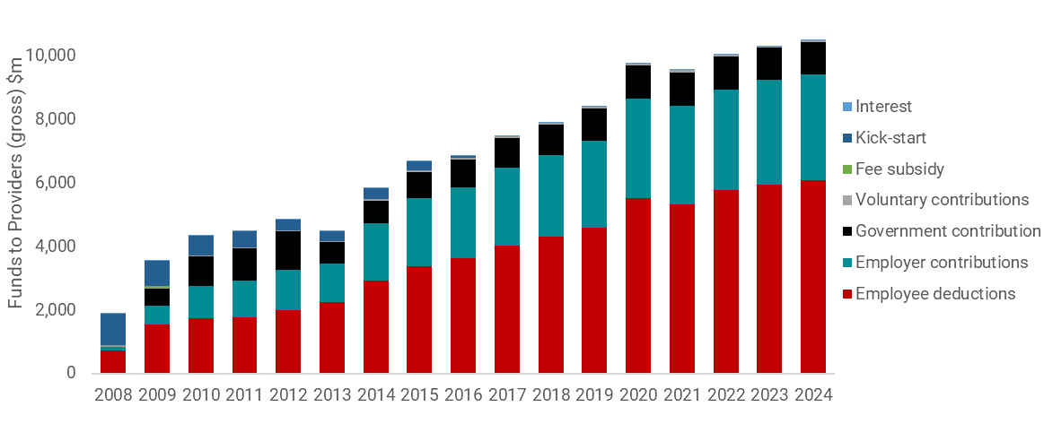
Because the scheme was only established in 2006, its full impact on the retirement income system is yet to be seen – we have not yet had generations reaching 65 who have contributed to the scheme for all or most of their working lives.
The Retirement Commission has released various data on contributions and balances which shows how the scheme is currently working. The average balance is $37,079, and higher for men ($42,700) than women ($34,200). This average is brought up by a small group with higher balances - 12% have balances over $80,000. In comparison, 50% have balances under $20,000, and 70% have balances under $40,000. Data by age bracket shows a steady increase in savings for older members, with those approaching 65 having higher average balances - $50,000-60,000 for women, and $70,000-80,000 for men. As the scheme matures, these balances can be expected to be higher for older members (Retirement Commission 2025).
Figure 48 - Kiwisaver - average balance by age and gender
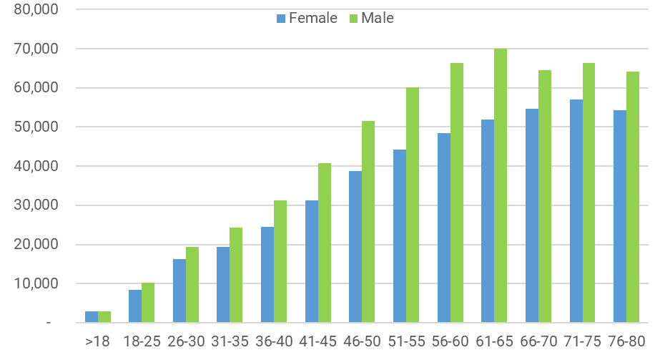

Impact for those on lower incomes
While KiwiSaver is likely to have an increasingly beneficial role in supporting retirement income for a broad range of New Zealanders, it appears to be playing a more limited role for those on lower incomes.
Because employment contributions are based on a percentage of earnings basis, KiwiSaver contributions are likely to perpetuate existing disparities in earnings - those earning less and/or working fewer paid hours will likely accrue a lower KiwiSaver balance than those earning more and/or working more paid hours. This particularly impacts women, Māori and Pacific people.
Inland Revenue data on KiwiSaver indicates that those on lower incomes are: much more likely to opt out of the scheme and not be members; be members but not actively contribute; contribute but only the minimum percentage amount; and be amongst the small group that withdraw for hardship reasons (Retirement Commission 2025).
It is reasonable to assume that the scheme will both support retirement savings and perpetuate differences in wealth, contributing to greater inequality of living standards in older age.
Figure 49 - percentage of non-contributors by income level
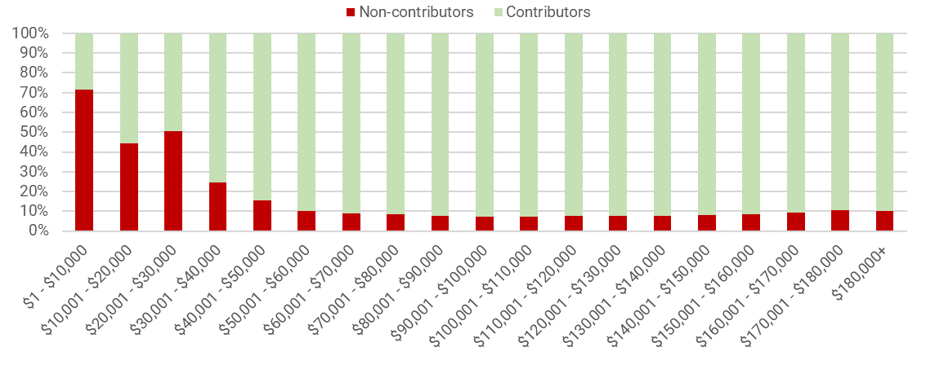
Figure 50 - proportion per contribution rate by income band
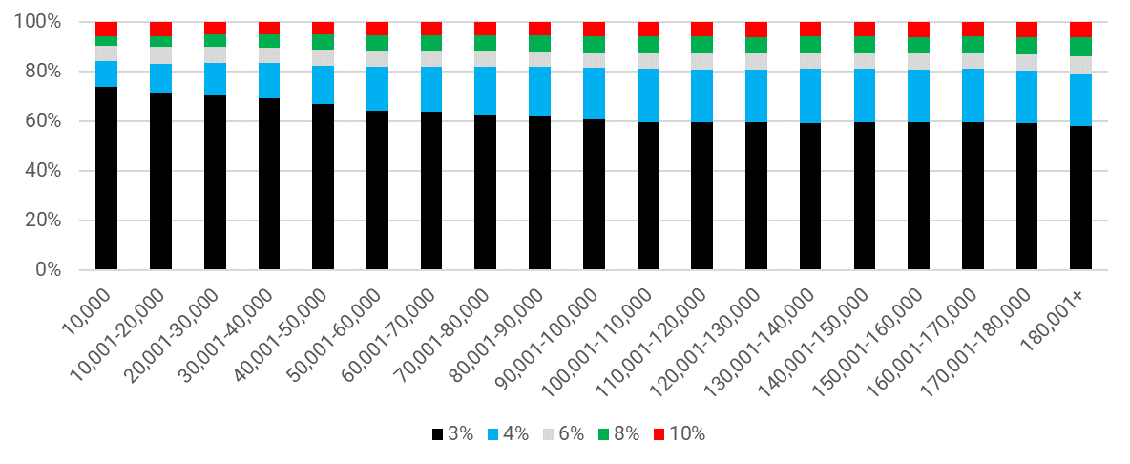
It is a matter of debate the extent to which the KiwiSaver scheme is intended to support those on the lowest incomes. Its stated purpose in the legislation includes “to encourage a long-term savings habit and asset accumulation by individuals who are not in a position to enjoy standards of living in retirement similar to those in pre-retirement”.

3.11 Health, disability and care - recent trends

Health and disability
Life expectancy at birth has continued to grow steadily to 81 for males and 84 for females in 2022. Health-adjusted life expectancy has grown, but more slowly. This means that New Zealanders are spending more time in later life living in both good health and poor health.
There continue to be discrepancies in life expectancy between gender and ethnic groups. These discrepancies are largely driven by inequality experienced across the life course, as well as in later life.
- As well as having lower life expectancy, Māori and Pacific people also experience higher rates of disability and long-term conditions and live fewer years in good health. Amenable mortality is substantially higher for Māori and Pacific people.
- While men have a shorter life and health expectancy than women, women spend more time living in poor health. In 2019, women spent 13.4 years living in poor health, with men spending 11 years living in poor health.
Adults aged 65+ sustain 40% of the burden of disease in New Zealand. The long-term conditions (LTCs) that contribute most to health loss are cancer, cardiovascular and cerebrovascular disease, musculoskeletal conditions, mental illness, respiratory conditions and diabetes. LTCs are caused by a combination of individual lifestyle choices, environmental factors and genetic predispositions. The social determinants of health are an important factor in who develops LTCs. LTCs contribute significantly to functional limitation or disability amongst older people.
The Household Disability Survey 2023 found that 35% of people aged 65+ had a disability. Rates of disability increase with age; 17% of the total population were disabled. Those experiencing a disability earlier in life may experience significant disparities in many life outcomes compared to their non-disabled counterparts, as they are less likely to be employed or have qualifications, have lower average earnings, and are more likely to experience hardship. This means they are at much greater risk of experiencing hardship and disadvantage in older age.

Support and care
Support services for people aged 65+ are administered differently to services for those aged under 65. For those under 65, MSD purchases ‘disability support services’ directly from non-government service providers. For over 65s, funding is delivered by Health NZ, which in turn purchases services from non-government service providers. A range of supports are available for those over 65 through Health NZ, including home and community support services (HCSS) and aged residential care (ARC). Around 80,000 older people receive Health NZ funded HCSS, which includes household management (meal preparation) and personal care (bathing, dressing, medicine management). There are around 33,000 older people in ARC, which has different levels of care: rest home care (13,000), continuing hospital care (14,000), and dementia care and psychogeriatric care (5,800).
ARC is means-tested, meaning that individuals with assets above the threshold will pay the cost of care up to a maximum contribution amount (which is set annually and varies by region). Those below the threshold will qualify for the Residential Care Subsidy. For those not eligible for the residential care subsidy, an interest-free residential care loan is available, secured against their home.
Most people aged 65-74 live at home without any formal assistance from health services. However, around half the population aged 85+ live at home and receive HCSS. Another 28% live in ARC.
Others within this age group will receive support from family, whānau or privately paid carers. The carer population as a whole was estimated to be at least 530,000 in 2023. Earlier statistics suggest this group is older than the general population, with 20% aged 65+. It is also primarily (63%) female. Providing care within the family can have significant life course effects that increase the likelihood of vulnerability in later life. These include foregone earnings, social isolation and physical injury.
Māori, Pacific People and Asian populations are much less likely to be admitted to ARC than NZ Europeans. For those who have been assessed as having a high priority for moving out of a home environment, NZ European individuals are twice as likely to be admitted into an ARC facility within 12 months than Māori individuals with a similar high priority assessment. Pacific and Asian people also face inequity in prompt admittance to ARC. Māori and Pacific people are more likely to receive HCSS, but it is unclear whether this is at equitable rates. The Asian population group is accessing ARC and HCSS at much lower rates than other population groups.
Higher utilisation of in-home services by Māori and Pacific populations is influenced by a number of factors including greater health needs, cultural preferences to stay at home longer, and possibly barriers in accessing ARC services

3.12 Health, disability and care - future possibilities
The trend for life expectancy growth to outstrip expected healthy years will likely continue. The World Health Organisation predicts that life expectancy will grow to 82.9 for males and 85.3 for females by 2050. During the same period, health-adjusted life expectancy is forecast to grow to only 71.4 for both genders (up from 69.6 for males and 70.1 for females in 2021). Despite improvements in health and life expectancy people tend to use more health services as they age.
The incidence of the most prevalent long-term conditions will increase steadily in coming decades. Notably, dementia is expected to more than double to approximately 167,500 people in 2050, comprising 10.8 percent of the population aged 65+. The increase is not solely a result of an ageing population but also reflects the prevalence of younger onset dementia in Māori, Pacific and Asian populations compared to Europeans. Dementia among Māori, Pacific and Asian population groups is expected to triple by 2050.
Health NZ forecasts a need for between 4,000 and 17,000 more ARC beds by 2040. The lower forecast relies on increased care provided in the community and preventative approaches. This is in line with the stated preference of virtually all older New Zealanders to age in place for as long as possible. By 2050 Health NZ also forecasts an increase in demand for HCSS to around 15 million hours annually, up from around 9 million in 2023/24 (assuming no change to current funding and eligibility settings).
While the acuity of those entering ARC (typically supported by the MSD-administered Residential Care Subsidy) is increasing, the level of care required in the community through HCSS and informal care is also increasing. This trend will likely continue, meaning that older people are likely to continue to live in the community for longer with higher and more complex needs. This has significant implications for those caring for them.
In addition to HCSS and ARC, other services are likely to face increased pressure, including primary health care and hospital services. Increased need will challenge the capacity of the health system to respond. It imposes an obvious direct fiscal cost, but other constraints such as availability of skilled staff and physical infrastructure also impose limits.
The health status of the growing older population primarily impacts the health sector. However, the social and economic conditions in which people are born, grow, live, work, and age significantly impact their health outcomes. Important determinants include housing, transportation, education, job opportunities, income, and access to nutritious food and healthcare. These determinants not only affect individuals but also generate highly patterned health differences in populations that reflect inequalities in society. In New Zealand there is a strong association between poverty and poor health outcomes, particularly where poverty is persistent. Poor health and social and economic determinants can also have an ongoing negative impact on each other.
The relationship between health and its social and economic determinants has implications for MSD. Trends suggest that MSD will need to respond to a growing number of older people facing multiple and interrelated problems that require a coordinated and sustained response. These needs can be both broad (multiple issues) and deep (severe or intense). This is likely to entail increased demand for a range of MSD services, notably DA.
The need to care for older people in the community also has significant implications for family carers, most of whom are women and many of whom are older themselves. Caring for a family member can have well-documented impacts on the finances, health and social wellbeing of carers. Increased ‘demand’ for family carers by a growing vulnerable older population risks itself contributing to further need by increasing the later life vulnerability of those who provide that care.
The Ministry of Health’s 2025 Long Term Insights Briefing “Ageing Well” considers options to improve long-term health outcomes for older people. It can be found here: https://www.health.govt.nz/publications/unlocking-the-potential-of-active-ageing

3.13 Communities - social connection and isolation
Studies have shown that both the quality and quantity of our social ties are critical to wellbeing, shaping our mental and physical health, health behaviours, and mortality risk. Overall, older people report they are lonely less frequently than younger people. According to the 2021 GSS, 73.4% of the 65-74 age group felt they had good social support.
While older people report lower levels of loneliness, there are factors that can put older people at greater risk of experiencing social isolation and loneliness, though these are not determinative. These factors include living alone, having poor family and partner relationships, experiencing caregiver burden, bereavement, having poor mental and physical health or a disability, leaving paid work and being an immigrant. Social isolation can also contribute to a lack of ability for older people to meet their needs, as they are cut off from support.
Trends point to an increasing number of older people living alone. The 2023 Census revealed that women and people aged 65 and older were more likely to live alone. Approximately 1 in 4 people aged 65 years and older live alone. The number of people aged 65 and older who live alone is projected to increase to 2 in 3 people by 2043.
Older people often contribute actively to their whānau and community. In the 2021 GSS 60% of those aged 65-74 volunteered regularly in their communities. Volunteering rates drop off for the 75+ age group, with 42.4 percent volunteering. When asked about barriers to volunteering, 46.1 percent of those aged 75+ agreed that health and mobility problems were barriers.
Caring for family and whānau keeps older people actively involved with those that they love, which can be good for social connection. However, many older people care for their spouses who are also older. While caring for family and whānau can be extremely rewarding, caring responsibilities can also impact the ability for older people to foster social connections outside of the home.
Some older people may experience complex support needs, such as difficulty completing basic tasks including self-care or household management or neglecting their mental and physical health. This presentation is known as “self-neglect” or “complex unmet support needs”, as the cohort of people experiencing these symptoms are not able to access support systems. Older people with complex unmet support needs are sometimes referred for help through existing pathways such as MSD’s Elder Abuse Response Providers (EARS). This cohort are generally not well understood in current research in New Zealand and their needs may not be well addressed by current government supports.

Community services funded by MSD
MSD funds a range of community services that support older people in New Zealand. MSD funded providers deliver EARS that address the immediate needs of older people experiencing, or at risk of experiencing, abuse and neglect. MSD also administers the SuperGold and Veterans SuperGold cards, which enable cardholders to access free travel on most off-peak public transport in New Zealand, as well as discounts at a range of businesses.
There are also a wider range of services that are not explicitly targeted towards those over 65 but which provide support to many older people, including those facing hardship and disadvantage. These include services to build financial capability, community food provision, and interventions to address family violence. In rural communities, Heartlands Services community hubs provide access to government and community services, as well as advice, support, and access to free technology.
The changing age profile of NZ, and the potential for an increasing number of older people facing hardship and disadvantage, will have impacts on these services. In addition to a likely overall increase in demand for many of these services, the needs of older people are likely to be more complex in future.

3.14 Communities - elder abuse
Around one in ten older New Zealanders experience elder abuse. The abuse of older people can happen once or repeatedly. It comes in many forms, including psychological, financial, physical, sexual and neglect. Older people may be reluctant to report abuse because of shame or putting critical relationships at risk. Some may feel that staying in abusive situations is preferrable to losing contact with family or putting the perpetrator at risk.
Experiences of elder abuse interact with other forms of disadvantage experienced both in later life and throughout the life course. Common risk factors for experiencing elder abuse include social isolation and poor health (particularly dementia and other conditions that affect cognition). There is some evidence to suggest that Māori, Pacific and Asian people are more at risk of experiencing abuse.
MSD funds the EARS. This includes a free national helpline, where callers are provided with information and advice, and connected to their local provider if required. 37 local providers receive referrals from the helpline, police, doctors, banks, neighbours, friends and family and also receive some self-referrals. They take a case management approach and often work with other providers to ensure older people’s needs are met (e.g. government agencies, health providers, lawyers, banks).
MSD is funding AUT to conduct a first-of-its-kind national study with people aged 55+, about their wellbeing and how they are treated by others. A summary of its results will be included as part of the final version of this report.

Part four: preventing and responding to hardship and disadvantage

This section looks at how a potentially growing group of older New Zealanders experiencing hardship in later life could be supported. Consideration of trade-offs is needed, particularly in relation to costs and savings, the complexity of income support settings and expected outcomes for older people.

4.1 Preventing hardship and disadvantage
Disadvantage experienced across the life course drives inequality in later life. This could be prevented by:
- mitigating the impact of socio-economic disadvantage across the life course – this could be done by supporting children’s development, expanding whānau and community-based supports and improving health outcomes
- improving housing supply and affordability – Governments could consider how to improve housing outcomes across the ‘housing continuum’, including looking at affordability, adequacy and accessibility.
- improving the accumulation of savings, assets, and wealth – particularly for those on lower incomes, including through KiwiSaver
- supporting employment outcomes – by improving lifetime employment outcomes amongst disadvantaged groups, increasing employment assistance for people aged 50 and over or expanding availability of employment services to include those aged 65 and over.
Support tailored to the needs of Māori and Pacific people
Māori and Pacific older people are over-represented among those experiencing hardship and disadvantage. Addressing disadvantage for these groups requires a combination of more general approaches, as well as policies and services that are more explicitly tailored to meeting the needs of Māori and Pacific older people. Examples of existing initiatives include:

Wealth and assets
- Ngāi Tahu’s Whai Rawa iwi-based retirement savings and investment plan with matched savings and distributions made by Ngāi Tahu.
- The Pacific Financial Capability Development Programme (PFC), funded by Ministry for Pacific Peoples, which supports Pacific families’ ability to establish homeownership through financial literacy and financial management.

Housing
- The development of papakāinga on whenua Māori, including those supported by Te Puni Kōkiri.
- The Penina Trust’s multigenerational social housing development in Papakura, with homes that enable privacy and autonomy for Pacific elders but which are connected to shared living areas.

Integrated support
- Funded by Whānau Ora, the Rauawaawa Kaumātua Charitable Trust delivers culturally focused and integrated health, social and community-based support for older people, including social enterprise opportunities.
- TOA Pacific provides a range of services to Pacific older people and Aiga carers, including direct health support, exercise programmes using traditional Pacific music and dance, services to strengthen family safety and capacity, coordination and support for caregivers, and a programme to prevent abuse and neglect of elders.

4.2 Responding through income support
To reduce pressures on long-term fiscals, Governments may explore changes to reduce the overall cost of NZS. The available options that have the least impact on hardship and disadvantage are those that introduce some form of targeting so that support for those with the lowest incomes is maintained.
There are a range of income support options that Governments could explore to rebalance support towards those with higher needs. These include:
- considering relativities between different NZS rates, including how these support a variety of living arrangements in later life
- providing targeted support to those with high housing costs, for example through changes to AS (considerations include the cash asset test, payment rates and uptake)
- providing targeted support to those with high costs associated with health, disability and caring responsibilities, for example through changes to DA (considerations include abatement settings, targeting and streamlining administration).
These options involve consideration of specific design issues and trade-offs, but an overarching issue is the substantial fiscal implications of even minor changes to income support settings. Options for supplementary payments could be considered alongside cost-saving measures, although this would reduce the level of fiscal savings achieved.

4.3 Responding through service delivery
Independent of any policy changes discussed above, population ageing will grow and change MSD’s client base. Considerations include:
- planning for increased demand and ensuring access to services (including both in-person, phone, and digital options)
- integrating services for example through co-location, individualised services plans and alternative approaches tailored to Māori and Pacific older people (see above for examples)
- addressing potential gaps in services, for example those related to ‘self-neglect’ or unmet support needs.

Appendices

List of tables and figures
List of Tables
Table 1: Projected Distribution of Older people by ethnic group in 2043 19
Table 2 - Distribution of material hardship using a joint income-savings analysis, HES 2020-21 25
Table 3: % of population doing poorly on selected GSS indicators – by age group 26
Table 4 – Number and Percentage of those 65+ - by % of time on benefit when aged 55-65 30
Table 5 – Rate of each disadvantage for those 65+ - by % of time on benefit aged 55-65 30
Table 6 – Composition of 65+ in Multiple disadvantage - by percentage of time on benefit aged 55-65 31
List of Figures
Figure 1: Stats NZ Population Projections 15
Figure 2: Population Projections – 16
Figure 3 – increase in number of older people in each TA (2023-2048) 16
Figure 4 - Proportion of older people in each TA (2048) 17
Figure 5 – Projected Geographical distribution of Māori older people (65+) in 2048 19
Figure 6 - Projected Geographical distribution of European older people (65+) in 2048 19
Figure 7 - Projected Geographical distribution of Asian older people (65+) in 2048 19
Figure 8 - Projected Geographical distribution of Pacific older people (65+) in 2048 19
Figure 9 - Poverty and broader disadvantage 21
Figure 10 - domains of (multiple) disadvantage 22
Figure 11 - After-housing-cost poverty for 65+ (50% median, Moving Line) 23
Figure 12 - After-housing-cost poverty for 65+ (50% median, fixed line) 23
Figure 13 - Material hardship trends by age (6+ on Dep-17) 24
Figure 14 – % of households within six material wellbeing bands: by age group 25
Figure 15 - % of households within six material wellbeing bands - by household type 25
Figure 16 - % of households within six material wellbeing bands: by housing tenure 25
Figure 17 - life expectancy at birth - by ethnic group and sex (2017-2019) 27
Figure 18 - Number of people - by number of disadvantages 28
Figure 19 - Multiple disadvantage by region 28
Figure 20 - Drivers of poverty and material hardship - simplified view 33
Figure 21 - Drivers of poverty and material hardship - more detailed view 35
Figure 22 - Trends in employment by age (65+, both sexes) 36
Figure 23 - Labour force participation rates (65-69) - by ethnicity 37
Figure 24 - proportion of gross income from transfers (65+) 37
Figure 25 - Gini for 65+: BHC disposable income 37
Figure 26 - Percentage of population 60-64 receiving main benefit 38
Figure 27 - Main benefit receipt by type and age 39
Figure 28 – Improved Employment and Social Outcomes Support Multi-Category Appropriation - expenditure by Age 39
Figure 29 - first tier benefits in oecd countries - % of gross earnings (2022) 40
Figure 30 - NZS as % of average wages and median household income 41
Figure 31 - % of NZS recipients receiving supplementary assistance 41
Figure 32 - change in hardship assistance usage - NZS vs working age clients 42
Figure 33 - NZS indexation - Status quo vs CPI - nominal 44
Figure 34 - NZS indexation - Status quo vs CPI - Real 44
Figure 35- INDEXATION - STATUS QUO VS CPI - % OF NET AVERAGE WAGE 44
Figure 36 - PROPORTIONS OF INDIVIDUAL TENURE AGED 65+ (CENSUS 1996 – 2023) 45
Figure 37 – Proportion of individual homeowners Aged 65+ paying a mortgage 45
Figure 38 - Lower quartile rent as % of NZS 46
Figure 39 - cumulative price increases for home ownership costs, adjusted for CPI 1981-2024 47
Figure 40 - Annual change in home ownership costs (CPI) 2010-2024 47
Figure 41 - home ownership rates by age for birth cohorts 47
Figure 42 - housing costs as % of NZS - couple paying lower quartile rent 48
Figure 43 - residual income for a NZS couple paying lower quartile rent ($2024) 48
Figure 44 - household assets and liabilities - mean value by net worth quintile 49
Figure 45 - median net worth for individuals - by ethnicity and age 50
Figure 46 - median wealth by age in 2001 and 2018 ($2018) 50
Figure 47 - total kiwisaver contributions 2008-2024 ($2024) 51
Figure 48 - Kiwisaver - average balance by age and gender 51
Figure 49 - percentage of non-contributors by income level 52
Figure 50 - proportion per contribution rate by income band 52

Glossary of key terms and acronyms
Older person/ people – this generally refers to individuals who are typically aged 65 years or over.
Concepts and statistical measures of disadvantage
Disadvantage - a broader concept than poverty and hardship, this is where individuals or groups experience compromised wellbeing in any domain (social, economic, educational).
Multiple disadvantage - Refers to the condition where an individual or household experiences significant challenges in multiple domains. In the IDI analysis included in this paper, it refers to where someone has two or more ‘disadvantages’.
Material wellbeing - refers to the state of having sufficient financial resources and essential items necessary for a comfortable and secure life. This includes having enough money to cover basic needs such as food, clothing, housing, and healthcare, as well as personal satisfaction with one's financial situation.
Material deprivation / hardship – a measure of where individuals or households lack essential items and services due to financial constraints. In New Zealand, material hardship is measured using the DEP-17 index, and refers to when a household is experiencing 6 or more out of 17 ‘deprivations’.
Near-hardship Those who are reporting 4-6 deprivations on the DEP-17 index.
Income poverty - In New Zealand, income poverty is measured using relative income thresholds, such as households living below 50% or 60% of the median income, before or after housing costs.
AHC50 – “After Housing Costs 50%." It is a measure of income poverty that calculates the proportion of people living in households with an income below 50% of the median income, after housing costs.
A moving line measure - a fully relative measure that adjusts the poverty threshold based on changes average (median) household income each year.
Fixed line measure – also called an ‘anchored line’ measure, a fixed line measure of income poverty refers to a poverty threshold that remains constant over time, adjusted only for inflation.
HES - Household Economic Survey. An annual survey conducted in New Zealand by Stats NZ that collects information on household income, savings, and expenditure.
GSS - General Social Survey. This survey is typically carried out every two years by Stats NZ and provides comprehensive information on the wellbeing of New Zealanders aged 15 years and over.
Payments and Supports
AS – Accommodation Supplement. A weekly payment to help people with their rent, board, or the cost of owning a home. It is available to those who meet certain income and asset criteria.
DA – Disability Allowance. A weekly payment for people who have regular, ongoing costs because of a disability.
IRRS – Income Related Rent Subsidy. A subsidy provided to social housing landlords, such as Kāinga Ora and registered Community Housing Providers (CHPs). The IRRS covers the difference between what a public housing tenant pays in rent (set at 25% of net income) and the market rent.
NZS – New Zealand Superannuation is a payment to help meet the living costs for those over 65.
TAS – Temporary Additional Support. A weekly payment to help people who are struggling to meet their essential living costs.
ARC - Aged Residential Care. A type of long-term care provided in residential facilities for older people who can no longer live independently.
HCSS - Home and Community Support Services - Services provided to individuals in their own homes or communities to help them live independently.

Bibliography
Allen, J. and Irwin, K. (2023). Experiences of Secure and Precarious Employment Among Older Māori – Data Insights. Office for Seniors.
Amore, K., Viggers, H. and Howden Chapman, P. (2021). Severe housing deprivation in Aotearoa New Zealand, 2018.
Allport, T., Martin, G., & White, H. (2018). Kaumātuatanga: The needs and wellbeing of older Māori. Te Pou Matakana.
BNZ. (2022). Digital skills for life in Aotearoa.
Citizens Advice Bureau New Zealand. (2020). Face to Face with Digital Exclusion.
Cunningham, C., Durie, M., Fergusson, D., Fitzgerald, E., Hong, B., Horwood, J., Jensen, J., Rochford, M., & Stevenson, B. (2002). Ngā Āhuatanga Noho o te Hunga Pakeke Māori | Living standards of older Maori. Ministry of Social Development.
DeJoseph, M., Ellwood-Low, M., Miller-Cotto, D., Silverman, D., Shannon, K., Reyes, G., Rakesh, D., & Frankenhuis, W. (2024). The promise and pitfalls of a strength-based approach to child poverty and neurocognitive development: Implications for policy. Developmental Cognitive Neuroscience, 66.
Department of the Prime Minister and Cabinet. (2019). Te Tiriti o Waitangi / Treaty of Waitangi guidance (CO (19) 5). https://www.dpmc.govt.nz/publications/co-19-5-te-tiriti-o-waitangi-treaty-waitangi-guidance
Fergusson, D., Hong, B., Horwood, J., Jensen, J., & Travers, P. (2001). Living standards of older New Zealanders. Ministry of Social Policy.
Gluckman, P., Spoonley, P., Bardsley, A., Poulton, R., Royal, T. A. C., Sridhar, H., & Clyne, D. (2023). Addressing the challenges to social cohesion. Koi Tū: The Centre for Informed Futures.
Gordon, L. (2016). The empty nest is refilled: The joys and tribulations of grandparents raising their grandchildren in Aotearoa. Grandparents Raising Grandchildren Trust NZ.
Grimes, A. and White, D. (2019). Digital inclusion and wellbeing in New Zealand. Motu Economic and Public Policy Research.
Hughes, T. (2022). The distribution of advantage in Aotearoa New Zealand: Exploring the evidence (p. 10). The Treasury.
Infometrics. (2014). The economic value and impacts of informal care in New Zealand. The-economic-value-of-informal-care-in-New-Zealand-Final-copy-5.pdf
Irwin, K. G., & Thompson, E. (2022). What does retirement look like for Māori: What the people said about ‘what does retirement look like for Māori’. Office of the Retirement Commission, Te Ara Ahunga Ora.
James Henare Research Centre. (2022). Kāinga Noho – Kāinga Whenua Housing and Whenua: Kaumātua voices. Office of the Retirement Commission, Te Ara Ahunga Ora.
Jarman J, Naus H, & Turner J, (2024). Severe domestic squalor in Aotearoa New Zealand: A preliminary survey. Severe domestic squalor in Aotearoa New Zealand_ A preliminary survey (1).pdf
JLL. (2024). New Zealand retirement villages whitepaper.
Kempton, M. (2022). What does retirement look like for Māori: Literature review. Office of the Retirement Commission, Te Ara Ahunga Ora.
Lapsley H., Hayman K., Muru-Lanning M., Moyes S., Keeling S., Edlin R., & Kerse N., (2019). Caregiving, ethnicity and gender in Māori and non-Māori New Zealanders of advanced age: Findings from LiLACS NZ Kaiāwhina (Love and Support) study. Australasian Journal on Ageing. https://doi.org/10.1111/ajag.12671
McLachlan, R., Gilfallan, G., & Gordon, J. (2013). Deep and persistent disadvantage in Australia. Productivity Commission Staff Working Paper.
Menzies, D., Whitehead, J., Walker, G., Reid, J., & MacFarlane, A. (2019). Whai Rawa Whenua: Economics and financing of housing for Māori literature review.
Ministry of Housing and Urban Development (HUD), 2023. The long-term implications of our ageing population for our housing and urban futures. Long-Term Insights Briefing Consultation Document
Ministry of Social Development. (2019). Mahi Aroha: Carer’s strategy action plan 2019-2023. MSD and New Zealand Carer’s Alliance. Carers' Strategy Action Plan 2019-2023
Napier, J., Neville, S., & Adams, T. (2024). Ageing in place in a rural town in Aotearoa New Zealand: A Deweyan transactional perspective. Journal of Rural Studies, 111, 103413. https://doi.org/10.1016/j.jrurstud.2023.103413
New Zealand Institute of Economic Research. (2024). As safe as houses – Mortgage debt and financial stress in older persons.
Office for Seniors: Te Tari Kaumātua. (2021). Attitudes to Ageing report.
Office for Seniors: Te Tari Kaumātua. (2019). Better Later Life – He Oranga Kaumātua 2019 to 2034.
Office for Seniors: Te Tari Kaumātua. (2024). Business of ageing 2023 update.
Office for Senior Citizens: Te Tari Kaumātua. (2015). Towards gaining a greater understanding of elder abuse and neglect. Elder abuse and neglect in New Zealand summary report.
Organisation for Economic Co-operation and Development. (2021). Inheritance taxation in OECD countries. OECD Tax Policy Studies, No. 28. OECD Publishing.
Organisation for Economic Co-operation and Development (2023), Pensions at a Glance 2023: OECD and G20 Indicators, OECD Publishing, Paris
Organisation for Economic Co-operation and Development. (2017). Preventing ageing unequally. OECD Publishing.
Perry, B. (forthcoming). Analysis of poverty and hardship for older New Zealanders. Ministry of Social Development.
Perry, B. (2017). Household incomes in New Zealand. Ministry of Social Development.
Perry, B. (2022). Child poverty in New Zealand. Ministry of Social Development.
Perry, B. (2024). Child poverty in New Zealand: Overview and selected findings. Ministry of Social Development.
Robertson, N. (2024). The great wealth transfer and inequality. BERL.
Saville-Smith, K. (2019). Housing, New Zealand’s tenure revolution and implications for retirement.
Smith, C., Krassoi Peach, E., & Cording, J. (2019). The impact of multiple disadvantage on subjective wellbeing: New Zealand families. Kotata Insight.
Social Investment Agency. (2023). Older people experiencing vulnerability and multiple disadvantage in New Zealand. Ministry of Social Development.
Stats NZ, 2021. Family and household projections: 2018(base)–2043 | Stats NZ
Stats NZ, 2024. 2023 Census household, family, and extended family highlights | Stats NZ
Stats NZ, 2024. 2023 Census severe housing deprivation (homelessness) estimates.
Stephens, D. (2024, September 26). Longevity and the public purse: Fiscal and economic impacts of increasing longevity. The Treasury.
St John, S., & Dale, C. (2019). Intergenerational impacts: The sustainability of New Zealand superannuation. Commission for Financial Capability. University of Auckland.
Symes, L. (2021). The wealth ladder: House prices and wealth inequality in New Zealand (AN 21/01). The Treasury New Zealand.
Synergia (2022). The State of Caring in Aotearoa Survey. THE STATE OF CARING IN AOTEAROA
Tamasese, T. K., Parsons, T. L., & Waldegrave, C. (2014). Pacific perspectives on ageing in New Zealand: Pacific-focused qualitative research prepared for the New Zealand Longitudinal Study of Ageing (NZLSA). The Family Centre.
Te Ara Ahunga Ora Retirement Commission. (2023). 2022 Review of Retirement Income Policies. Retirement Commission
Te Ara Ahunga Ora Retirement Commission. (2022). New Zealand financial capability, focus on Pacific peoples. Retirement Commission.
Te Ara Ahunga Ora Retirement Commission. (2025). KiwiSaver Demographic Study. Retirement Commission.
Te Ara Ahunga Ora Retirement Commission. (2025). Customised Request to Inland Revenue on Kiwisaver. Retirement Commission.
Te Ara Ahunga Ora Retirement Commission. (2022). What does retirement look like for women? Retirement Commission.
The Treasury. (2025). Draft briefing for consultation: Te Ara Mokopuna long-term insights briefing 2025. The Treasury.
The Treasury. (2021). He Tirohanga Mokopuna 2021: The Treasury's combined statement on the long-term fiscal position and long-term insights briefing. The Treasury. https://www.treasury.govt.nz/publications/ltfp/he-tirohanga-mokopuna-2021
Te Puni Kōkiri. (2023). Understanding climate hazards for Hapori Māori - Insights for policy makers. 2023 11 09 RP Understanding climate hazards for hapori Māori - Insights for policy makers.pdf
Van Hoof J, Kazak JK, Perek-Białas JM, Peek STM. The Challenges of Urban Ageing: Making Cities Age-Friendly in Europe. Int J Environ Res Public Health. 2018 Nov 5;15(11):2473. doi: 10.3390/ijerph15112473. PMID: 30714577; PMCID: PMC6266083.
Waddell, C., Van Doorn, G., Power, G., & Statham, D. (2025). From successful ageing to ageing well: A narrative review. The Gerontologist, 65(1),
Wood, S. (2017). Kaumātuatanga – Māori and ageing in New Zealand: A literature review. Wai Research. Kaumātuatanga – Māori and Ageing in New Zealand: A Literature Review - Wai Rangahau

Inter-regional migration across the life course is likely to play a significant role in age distributions across the country. Trends such as younger people moving to urban centres for education or economic opportunities are well known, as are some older people moving to the “sunshine belt” regions such as Nelson-Tasman or Kāpiti in later life
Each takes a similar but subtly different approach. Successful ageing focuses on maintaining physical health, cognitive function, and active engagement in life. Active ageing emphasises the continued participation of older adults in social, economic, cultural, and civic activities, promoting the benefits of staying engaged and productive. Positive ageing highlights a proactive and optimistic attitude towards ageing, encouraging individuals to embrace the ageing process with a focus on opportunities and strengths rather than limitations. Ageing well is a broad concept that encompasses maintaining overall wellbeing, including physical, mental, and social health, to ensure a high quality of life in older age.
The two measures use quite different notions of what it means for a low-income household to improve its situation from one time period to another, whether moving closer to the median or closer to a reference line fixed in real (CPI-adjusted) terms. The fixed line measure generally tracks in a similar way to the more direct material hardship measures.
Access to the data used in this study was provided by Stats NZ under conditions designed to give effect to the security and confidentiality provisions of the Data and Statistics Act 2022. The results presented in this study are the work of the author, not Stats NZ or individual data suppliers. These results are not official statistics. They have been created for research purposes from the Integrated Data Infrastructure (IDI) which is carefully managed by Stats NZ. For more information about the IDI please visit https://www.stats.govt.nz/integrated-data/. The results are based in part on tax data supplied by Inland Revenue to Stats NZ under the Tax Administration Act 1994 for statistical purposes. Any discussion of data limitations or weaknesses is in the context of using the IDI for statistical purposes, and is not related to the data’s ability to support Inland Revenue’s core operational requirements.
The Gini coefficient is a statistical measure used to quantify the degree of inequality within a population, often computed for income, wealth or consumption, with possible scores ranging from 0 (perfect equality) to 1 (perfect inequality.
Those people will either need to apply for a main benefit, which itself has a residency test, or apply for an emergency benefit, which is paid at the level of Job Seeker Support.
For example, from 1985 to 1998 New Zealand operated a surcharge on superannuitants’ other income – the fiscal cost of abolishing the surcharge in 1998 was estimated to be 10% of the net cost of NZS. The Treasury has also modelled a proposal by St John and Dale, whereby each person receives a universal grant that is not taxable but is subject to a progressive tax regime that effectively provides a ‘claw back’ of the grant for those on higher incomes. Savings from this scheme were estimated at between 14% and 9% of net NZS, if net NZS rates were not changed at the same time.
Although Census 2023 appears to show a significant “rebound” in home ownership rates, there are reasons to doubt this result. Stats NZ changed the way they count Retirement Village residents in 2023; unambiguously including them in the “own” category. Poor response rates in the 2018 Census may also magnify the apparent change.
The fact that the rate of mortgagees/renters is lower for the 40% with little or no income beyond NZS than for the overall population is of interest, as one would expect that the life course factors that mean an older person does not own their home mortgage-free could also mean they have constrained income. It is likely that the 40% group is comparatively older than the overall 65+ population, and mortgagees are more likely to be concentrated in the 65 - 74 age bracket, who are more likely to be in employment and therefore earning income in addition to NZS.

