Coversheet |  | 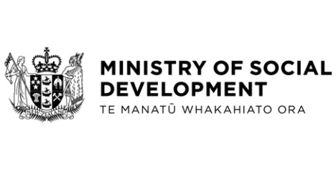

Oral Item: Te Hiku Iwi Crown Accord
Hon Carmel Sepuloni, Minister for Social Development

These documents have been proactively released.
Cabinet minute confirmed on 26 August 2019.
26 August 2019, Oral Item: Te Hiku Iwi Crown Accord – Office of the Minister for Social Development
This Oral Item was presented on the Te Hiku Iwi Crown Accord by Hon Kelvin Davis, Minister for Māori Crown Relations: Te Arawhiti. No papers were provided to support the Oral Item. The Te Hiku Oral Item was an update about the Taumata Rangatira Hui that took place between Te Hiku Iwi and Crown Ministers on 8 August 2019.
Some parts of this information release would not be appropriate to release and, if requested, would be withheld under the Official Information Act 1982 (the Act). Where this is the case, the relevant sections of the Act that would apply have been identified. Where information has been withheld, no public interest has been identified that would outweigh the reasons for withholding it. This is the key to the redaction code used for this release:
- Out of scope.

© Crown Copyright, Creative Commons Attribution 4.0 International (CC BY 4.0)
Search Tags: Te Hiku Iwi Crown Accord

