Coversheet |  | 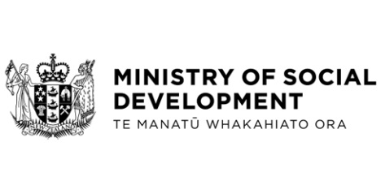

Next Steps on Government Response to the Dame Karen Poutasi Review
Hon Louise Upston, Minister for Child Poverty Reduction
These documents have been proactively released.
10 December 2025, Cabinet paper - Next Steps on Government Response to the Dame Karen Poutasi Review
10 December 2025, Cabinet Social Outcomes Committee Minute SOU-25-MIN-0178, Cabinet Office

These papers are regarding implementation of the Government response to the report by Dame Karen Poutasi on the Joint Review into the Children’s Sector.
Some parts of this information release would not be appropriate to release and, if requested, would be withheld under the Official Information Act 1982 (the Act). Where this is the case, the relevant sections of the Act that would apply have been identified. Where information has been withheld, no public interest has been identified that would outweigh the reasons for withholding it. This is the key to the redaction code used for this release:
- Section 9(2)(f)(iv) - the confidentiality of advice under active consideration.

© Crown Copyright, Creative Commons Attribution 4.0 International (CC BY 4.0)
Search Tags: “Dame Karen Poutasi”, Poutasi, “Government response”, child* (includes child, children), “children’s sector”

