Coversheet |  | 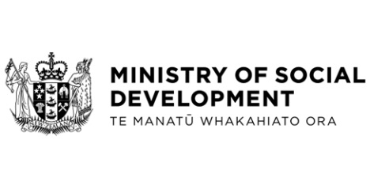

Tightening access to Jobseeker Support and Emergency Benefit for 18 and 19 year olds
Hon Louise Upston, Minister for Social Development and Employment
These documents have been proactively released.
17 September 2025, Cabinet paper – Tightening access to Jobseeker Support and Emergency Benefit for 18 and 19 year olds
17 September 2025, Regulatory Impact Statement: Tightening access to Jobseeker Support and Emergency Benefit for 18 and 19 year olds
17 September 2025, Cabinet Social Outcomes Committee Minute SOU-25-MIN-0126, Cabinet Office.

The paper ‘Tightening access to Jobseeker Support and Emergency Benefit for 18 and 19 year olds’ progresses decisions related to the Budget 2025 initiative to tighten eligibility of Jobseeker Support and Emergency Benefit for people aged 18 and 19 years.
Some parts of this information release would not be appropriate to release and, if requested, would be withheld under the Official Information Act 1982 (the Act). Where this is the case, the relevant sections of the Act that would apply have been identified. Where information has been withheld, no public interest has been identified that would outweigh the reasons for withholding it. This is the key to the redaction codes used for this release:
- Section 9(2)(ba)(i) – to protect information which is subject to an obligation of confidence where making the information available would likely prejudice the supply of similar information
- Section 9(2)(f)(iv) - to protect the confidentiality of advice tendered by Ministers of the Crown and officials.
© Crown Copyright, Creative Commons Attribution 4.0 International (CC BY 4.0)
Search Tags: 18 and 19 Year Olds, Jobseeker Support, Emergency Benefit, Parental Assistance Test, PAT, Budget 2025.

