Coversheet |  | 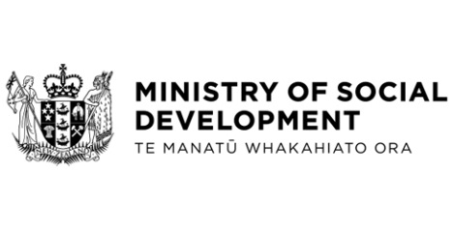

Supporting Jobseekers and Economic Recovery in Tasman
Hon Louise Upston, Minister for Social Development and Employment
These documents have been proactively released.
8 September 2025, Cabinet paper – Supporting Jobseekers and Economic Recovery in Tasman
8 September 2025, Cabinet Minute of Decision CAB-25-MIN-0300, Cabinet Office.

Cabinet approval is required for the Ministry of Social Development to spend up to an additional $300,000 from MSD baselines on Enhanced Taskforce Green (ETFG) to support the clean-up efforts from an adverse weather event in the Tasman district.

© Crown Copyright, Creative Commons Attribution 4.0 International (CC BY 4.0)
Search Tags: Enhanced Taskforce Green, Economic Recovery, Jobseekers, Nelson, Tasman

