Coversheet |  | 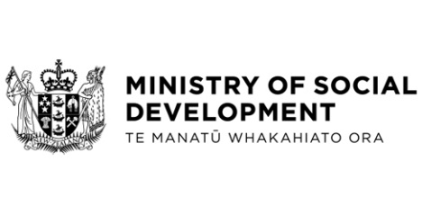

Social Security (Youth Money Management) Amendment Regulations 2025

Hon Louise Upston, Minister for Social Development and Employment

These documents have been proactively released.
1 October 2025, Cabinet paper - Social Security (Youth Money Management) Amendment Regulations 2025
9 October 2025, Cabinet Legislation Committee Minute LEG-25-MIN-0193, Cabinet Office.

Amendment of the Social Security Regulations 2018 is required to ensure that Flexible Childcare Assistance, and Training Incentive Allowance payments can be paid directly to eligible clients as intended by the respective policy intents, rather than being paid in the Youth Money Management manner.

© Crown Copyright, Creative Commons Attribution 4.0 International (CC BY 4.0)
Search Tags: Flexible Childcare Assistance, informal childcare, Training Incentive Allowance, Youth Money Management

