Coversheet |  | 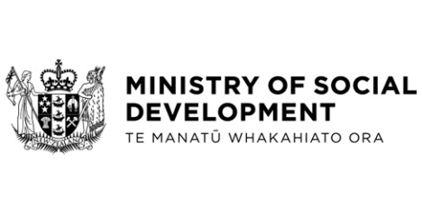

Ministry of Social Development’s Policy Advice Appropriation
Hon Carmel Sepuloni, Minister for Social Development and Employment
These documents have been proactively released.
9 November 2022, Cabinet paper - Ministry of Social Development’s Policy Advice Appropriation.
9 November 2022, Cabinet Social Wellbeing Committee Minute SWC-22-MIN-0195, Cabinet Office.

A fiscally neutral adjustment to the Ministry of Social Development’s Policy Advice Appropriation for 2023/2024 financial year and outyears, with no impact on the operating balance and/or net debt.
Some parts of this information release would not be appropriate to release and, if requested, would be withheld under the Official Information Act 1982 (the Act). Where this is the case, the relevant sections of the Act that would apply have been identified. Where information has been withheld, no public interest has been identified that would outweigh the reasons for withholding it. This is the key to the redaction code used for this release:
- Section 9(2)(f)(iv) - the confidentiality of advice under active consideration

© Crown Copyright, Creative Commons Attribution 4.0 International (CC BY 4.0)
Search Tags: Policy Advice Appropriation

