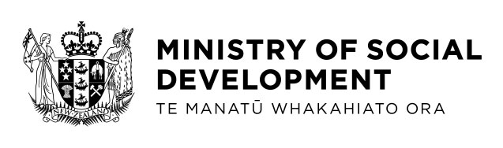
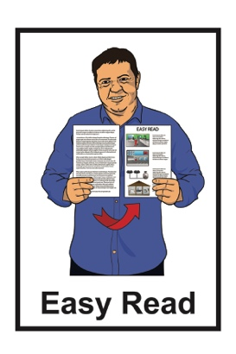

Summary of a Cabinet Paper about possible changes to the
New Zealand Sign Language
Act 2006
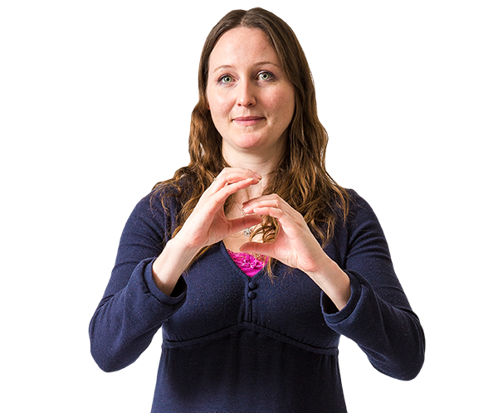

Tell us what you think

October 2022
6What this document is about

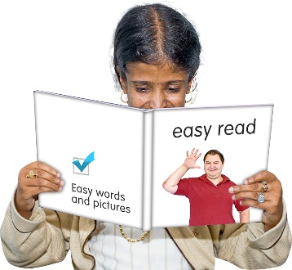
This a summary of a Cabinet Paper from the Minister for Disability Issues.

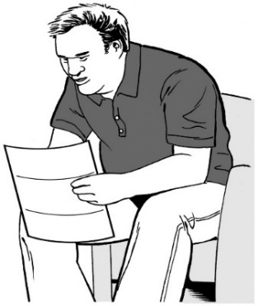
A summary:

- is shorter than the full report
- tells you the main ideas.

Cabinet:
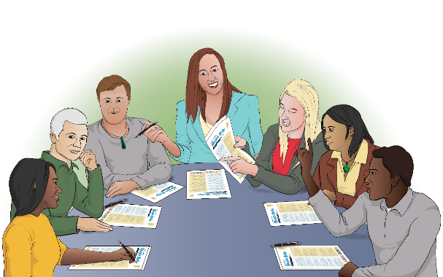
- is a group of senior government ministers

- meets to make important decisions.

A Cabinet paper has information in it that Cabinet needs to:

- know about

- make a decision about.

This Cabinet paper asks Cabinet to work with the Deaf community about some possible changes to the New Zealand Sign Language Act 2006.

New Zealand Sign Language is the main language of the Deaf community in Aotearoa New Zealand.

New Zealand Sign Language is sometimes called NZSL.

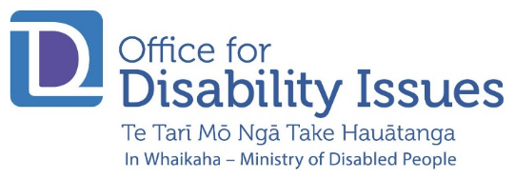
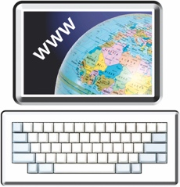
You can find more information about NZSL on the Office for Disability Issues website:

https://tinyurl.com/mvurt2kr

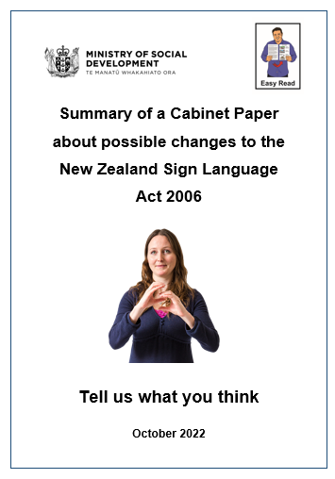
In this Easy Read document we will call the New Zealand Sign Language Act 2006 the NZSL Act.

About the
New Zealand Sign Language Act 2006

In 2006 Parliament agreed to have the NZSL Act.

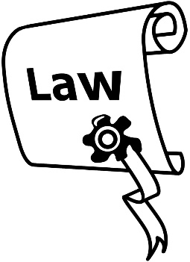
An Act is a law that has been passed / agreed to in Parliament.

A law is like a set of rules that must be followed.

The NZSL Act meant that NZSL became an official language in Aotearoa New Zealand.

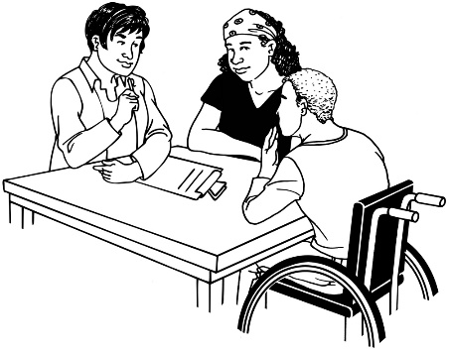
An official language is a language that is spoken / used in that country.

Māori is also an official language in Aotearoa New Zealand.
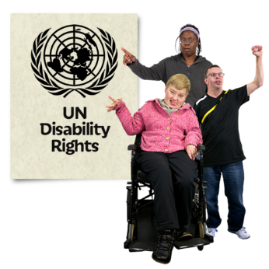
The NZSL Act was made before:

- the New Zealand Government signed the United Nations Convention on the Rights of Persons with Disabilities in 2008

- the setting up of the New Zealand Sign Language Board in 2015
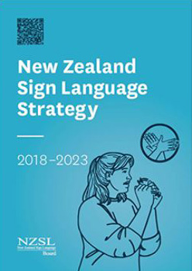
- the New Zealand Sign Language Strategy 2018 – 2023 was written.

The United Nations Convention on the Rights of Persons with Disabilities is a law lots of countries have agreed to.

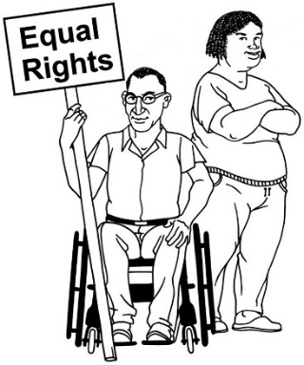
The United Nations Convention on the Rights of Persons with Disabilities is also called the UNCRPD.

It says what governments must do to make sure disabled people get the same rights as everybody else.

The New Zealand Sign Language Board is a small group made up of mostly Deaf people who use NZSL.

The NZSL Board works to:

- make sure Deaf people have the right to use NZSL
- give advice to Government about the use of NZSL

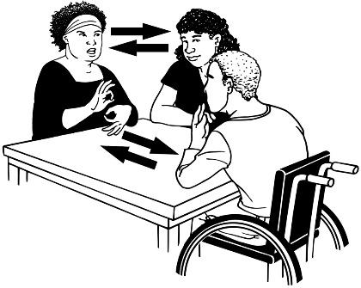
- give advice to the community / other users of NZSL like sign language interpreters.

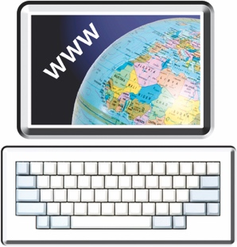
You can find more information about the NZSL Board on the Office for Disability Issues website:

www.odi.govt.nz/nzsl/about-board

The New Zealand Sign Language Strategy is a plan of work that the NZSL Board will do between 2018 and 2023.

You can find more information about the Strategy on the Office for Disability Issues website:

https://tinyurl.com/2whyf9zf

6What the Cabinet Paper is about

The Minister for Disability Issues is Poto Williams.

In the Cabinet Paper the Minister for Disability Issues asked Cabinet to involve the Deaf community in the possible changes to the NZSL Act.

The Minister for Disability Issues has written about the possible changes after working closely with the NZSL Board.

- The first possible change to the NZSL Act is that the NZSL Board could become a ministerial advisory group.

This would mean the NZSL Act would say that the NZSL Board can provide advice to the Minister for Disability Issues and other government ministers.

This would also mean the Board could have legal powers to check how well the NZSL Act is working.

- The second possible change to the NZSL Act is to set up ways to check how well the NZSL Act is being followed.

This would have better ways of checking that places like Government are following the rules outlined in the NZSL Act.

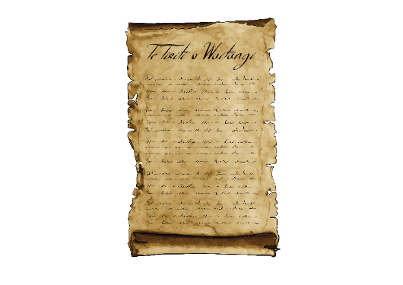
- The third possible change to the NZSL Act is about ways of having Te Tiriti o Waitangi as part of the Act.

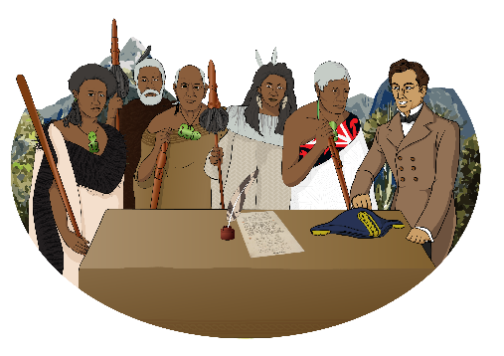
Te Tiriti o Waitangi / The Treaty of Waitangi is a legal document that was signed in 1840.

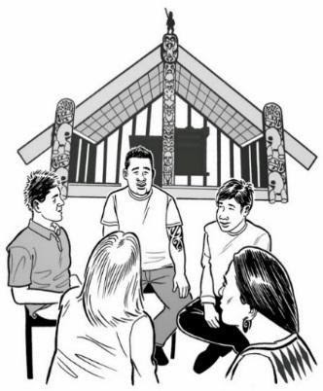
Te Tiriti / The Treaty is important to Aotearoa New Zealand.

It is about Māori and the New Zealand Government:
- making decisions together
- looking after the things that are important to Māori.

The Minister will meet with the Social Wellbeing Committee in December 2022.

The Social Wellbeing Committee is a group of Members of Parliament that looks at social issues in Aotearoa New Zealand.

The Minister will tell the Social Wellbeing Committee:

- the things people said about changing the NZSL Act
- about the changes that are needed to the NZSL Act.

6How to have your say

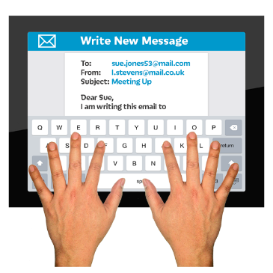
You can have your say about the NZSL Act by:

- emailing your written feedback to:

nzsl_act@msd.govt.nz

- sending your feedback in NZSL by using this link:

www.seeflow.co.nz

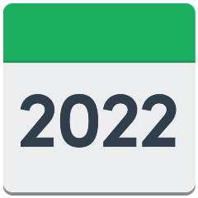
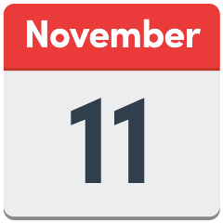
You have until 11 November 2022 to have your say.

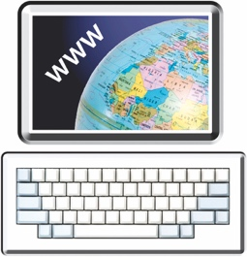
The Office for Disability Issues website has information about meetings being held to talk about the NZSL Act changes:

www.odi.govt.nz/nzsl/nzsl-act-consultation-2022/#online

You can also find more information about the NZSL Act Cabinet Paper on the Ministry of Social Development website:

https://tinyurl.com/ye2xdnh2

This information has been written by the Ministry of Social Development.
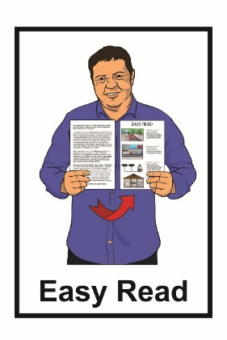
It has been translated into Easy Read by the Make it Easy service of People First New Zealand Inc. Ngā Tāngata Tuatahi.

The ideas in this document are not the ideas of People First New Zealand Inc. Ngā Tāngata Tuatahi.
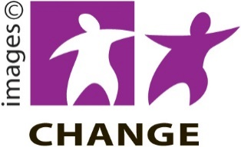
Make it Easy uses images from:

- Changepeople.org

- Photosymbols.com

- SGC Image Works

- Huriana Kopeke-Te Aho.

All images used in this Easy Read document are subject to copyright rules and cannot be used without permission.

