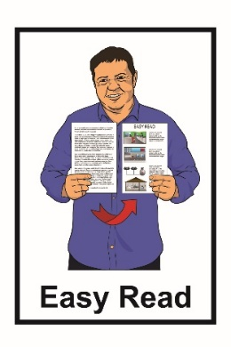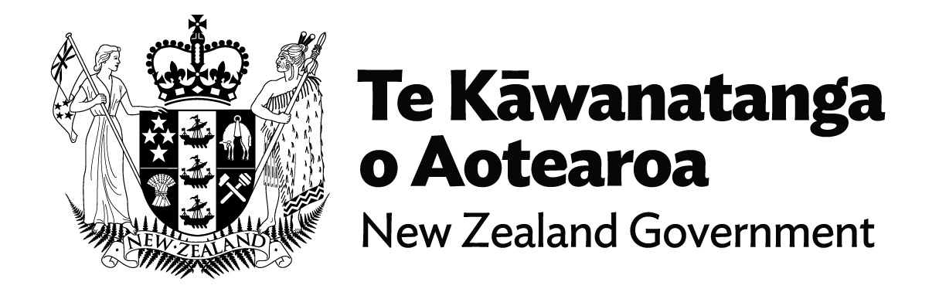

**Cabinet paper from the**

**Minister for Disability Issues:**

**Accessibility for**

**New Zealanders Bill**

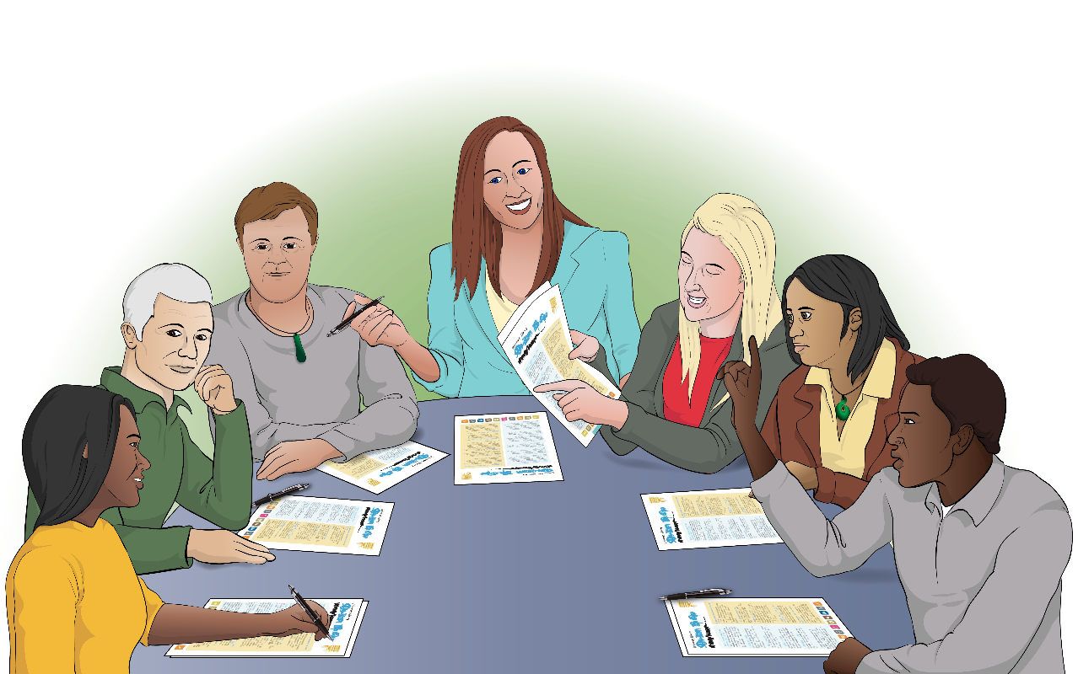

**September 2022**

**What this document is about**

This Easy Read document is a **summary** of a **Cabinet paper** about the **Accessibility for New Zealanders Bill**.

A **summary**:

* is shorter than the full report
* tells you the main ideas.

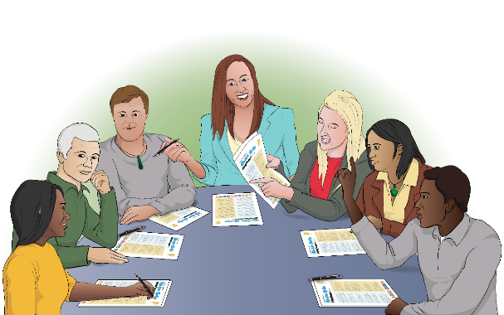**Cabinet:**

* is a group of senior government ministers
* meets to make important decisions.

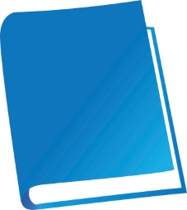A **Cabinet paper** has information in it that Cabinetneeds to:

* 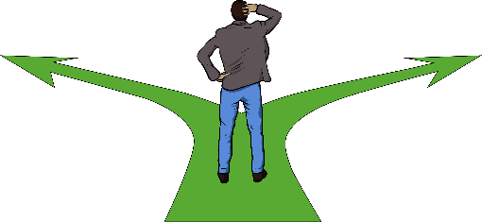know about
* make a decision about.

A **bill** is a government document that tells you about a new law the Government is looking at making.

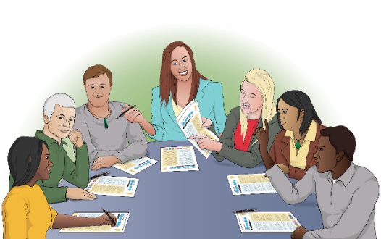

This Cabinet paper is asking Cabinet to agree with introducing the Accessibility for New Zealanders Bill to the **House of Representatives**.

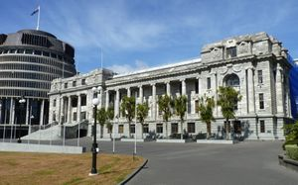**Members of Parliament** meet in the **House of Representatives**.

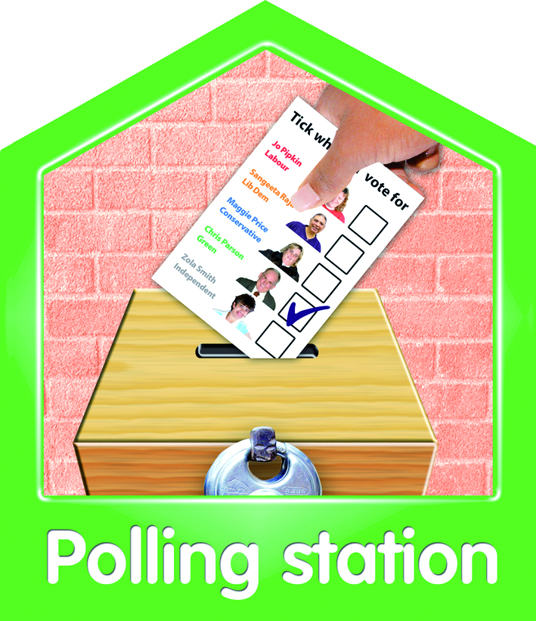

**Members of Parliament:**

* are the people you vote for at election time

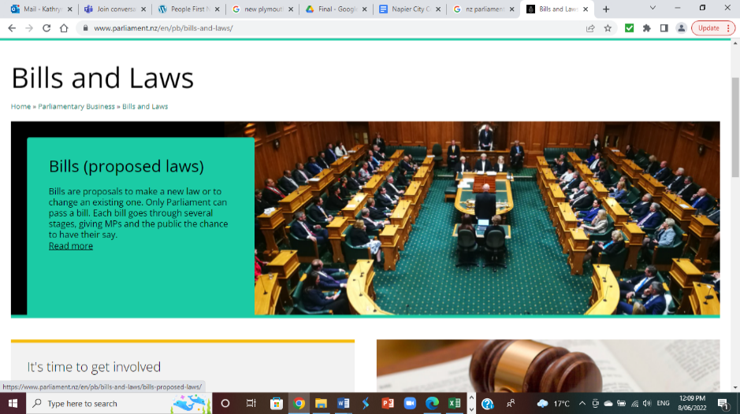

* make important decisions about how New Zealand should be run.

The Accessibility for New Zealanders Bill is about making **accessibility** better for disabled people.

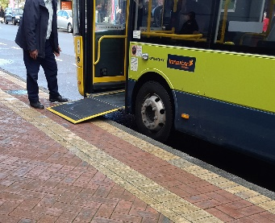**Accessibility** can mean many different things for people.

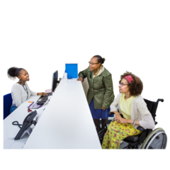

**Accessibility** means that disabled people can:

* get into / move around in buildings
* use services easily
* get around in their community

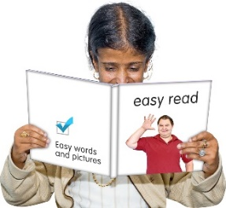

* understand what is being said

get information in ways that they can understand.

**What the bill is about**

This bill will work towards making accessibility better across all   
of Aotearoa New Zealand.

The bill sets up a new way for the New Zealand Government to remove **accessibility barriers**.

**Accessibility barriers** are things that make it harder for disabled people to access things they need.

Better accessibility will allow everyone to take part in their community.

This bill is needed to work towards making New Zealand fully accessible.

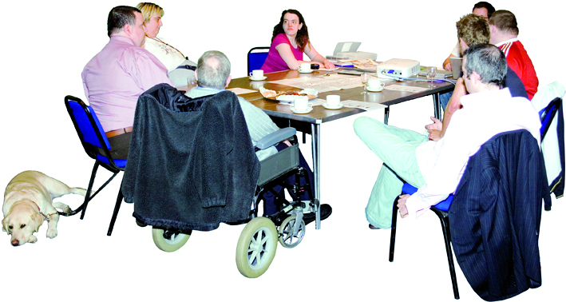To make New Zealand fully accessible the bill will ask for an **Accessibility Committee** to be set up.

**The Accessibility Committee** is a group of people that will work with the government to:

* find what accessibility barriers there are in New Zealand
* Diagram

  Description automatically generatedwork to stop more accessibility barriers being made in New Zealand
* A picture containing diagram

  Description automatically generatedwork to get rid of current accessibility barriers in New Zealand
* work towards making accessibility for all people common in New Zealand.

The bill needs to be checked to:

* make sure it works well
* see if it needs any changes.

The new bill will need to be checked after it has been used for **5 years** to make sure it is working well**.**

**What needs to happen next**

The Minister for Disability Issues is Poto Williams.

The Minister has asked that Cabinet agree that:

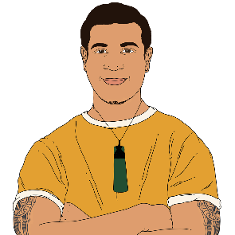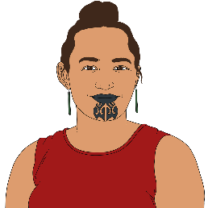

* A picture containing text

  Description automatically generatedat least half of the members on the Accessibility Committee are Māori
* Te Tiriti o Waitangi / the Treaty of Waitangi is followed as part of the bill

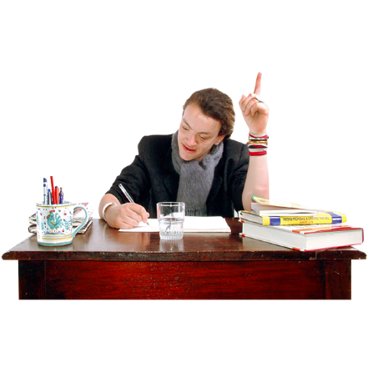

* the **Parliamentary Counsel Office** can keep making small changes to the bill before it is introduced to Cabinet.

The **Parliamentary Counsel Office** is the part of the government that wrote the bill.

The Minister for Disability Issues has also asked that Cabinet agree that:

* when the bill becomes part of New Zealand law the government will need to follow its rules

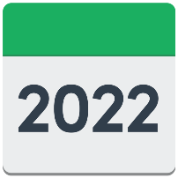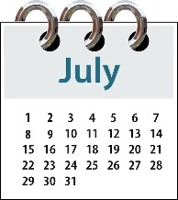

* the bill will be introduced to Parliament by 31 July 2022

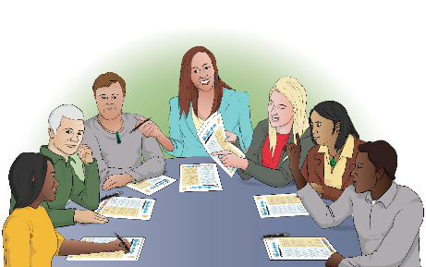

* the bill will be looked at by the **Social Services and Community Committee**

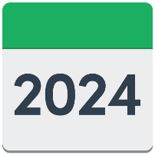

* the bill will start being used by July 2024.

The **Social Services and Community Committee** is a group of Members of Parliament that looks at social issues in New Zealand.

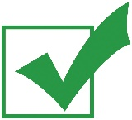The bill will need to be agreed to by enough Members of Parliament to be part of the law.



The bill will not become part of the law if not enough Members of Parliament agree to it.

**Where to find more information**

You can read more about the Accessibility for New Zealander Bill on the Ministry of Social Development website at:

[**https://bit.ly/3Q10xib**](https://bit.ly/3Q10xib)

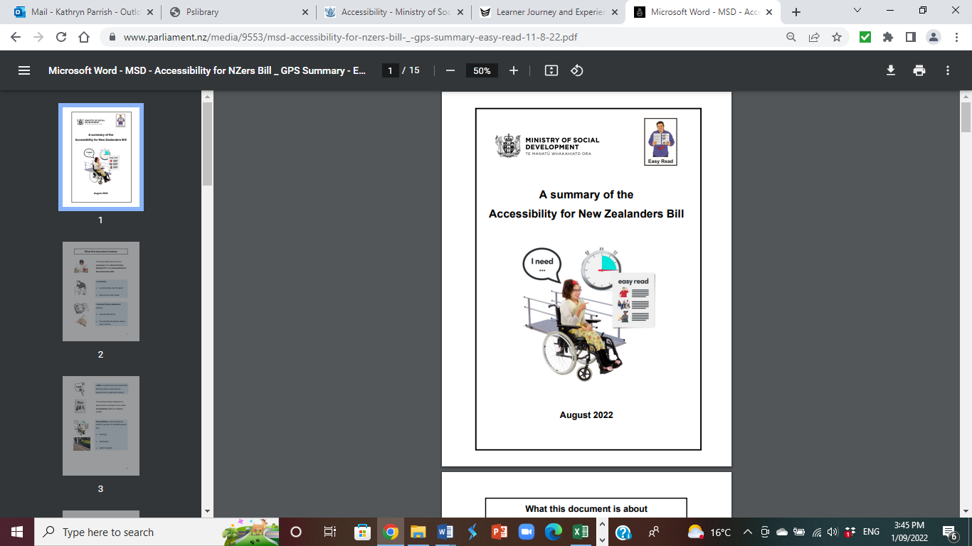

You can find Easy Read information about the Accessibility for New Zealanders Bill:

**https://tinyurl.com/ycm4cszp**

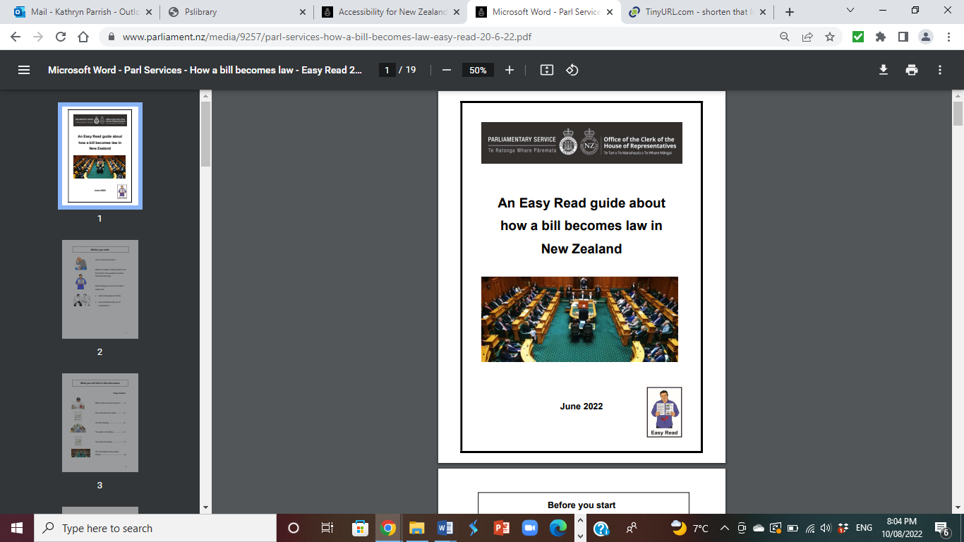You can also find **An Easy Read guide about how a bill becomes law in New Zealand** on the New Zealand Parliament **website**:

**https://tinyurl.com/yckxzjxx**

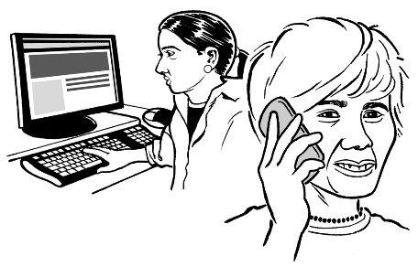If you would like a hard copy of this guide you can:

* email: **parlinfo@parliament.govt.nz**
* phone: **04 817 9647**.

This information has been written by the Ministry of Social Development.

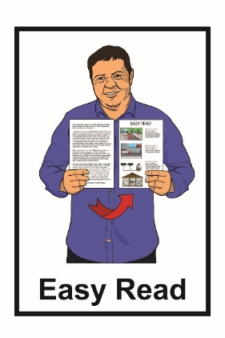

It has been translated into Easy Read by the Make it Easy service of People First New Zealand Inc. Ngā Tāngata Tuatahi.

The ideas in this document are not the ideas of People First New Zealand Inc. Ngā Tāngata Tuatahi.

Change logo.
Change is the name of the organisation.

Make It Easy uses images from:

* Changepeople.org



* Logo

  Description automatically generatedPhotosymbols.com
* Sam Corliss
* Huriana Kopeke-Te Aho.

All images used in this Easy Read document are subject to copyright rules and cannot be used without permission.