The effectiveness of the Flexi-wage Self-employment programme

FINAL

August 2024

Table of Contents

Summary 6

Flexi-Wage Self-Employment 6

Method 6

Limitations 7

Findings 7

Introduction 12

Report structure 12

Employment Assistance evidence catalogue 12

Intervention description 14

Flexi-Wage Self-Employment 14

Timeline of changes 17

FWSE participants 17

Duration of participation on FWSE 23

Cost of FWSE 24

Existing evidence 27

Evaluations of Flexi-wage self-employment 27

Previous evaluations of MSD self-employment programmes 28

International reviews of self-employment programs 29

Non-participant effects of subsidy programmes 30

Impact analysis 31

Interval impacts 31

Cumulative impacts 39

Impact of Flexi-wage Self employment compared to other self-employment subsidy programmes 41

Impact summary tables 42

Method 47

Individualised Cost Allocation Model 48

Counterfactual Approach and method 53

Appendix 1: example balance test results 71

References 94

### Author

Marc de Boer, Principal Analyst, Insights MSD, Strategy and Insights

### Acknowledgements

I would like to thank the following people for their contributions and comments in preparing this report: Purvai Gupta, Aimee Walker.

### Report disclaimer

The views and interpretations in this report are those of the Research and Evaluation team and are not the official position of the Ministry of Social Development.

### Integrated Data Infrastructure (IDI)

Some of the information contained in this report comes from the SNZ IDI. Below are the standard SNZ, IRD and NZDF disclaimers for this information.

#### Statistics New Zealand IDI disclaimer

These results are not official statistics. They have been created for research purposes from the Integrated Data Infrastructure (IDI) and the Longitudinal Business Database (LBD) which are carefully managed by Stats NZ. For more information about the IDI and LBD please visit <https://www.stats.govt.nz/integrated-data/>.

#### Inland Revenue IDI disclaimer

The results are based in part on tax data supplied by Inland Revenue to Stats NZ under the Tax Administration Act 1994 for statistical purposes. Any discussion of data limitations or weaknesses is in the context of using the IDI for statistical purposes, and is not related to the data’s ability to support Inland Revenue’s core operational requirements.

### Creative Commons

This work is licensed under the Creative Commons Attribution 3.0 New Zealand licence. In essence, you are free to copy, distribute and adapt the work, as long as you attribute the work to the Crown and abide by the other licence terms. To view a copy of this licence, visit creativecommons.org/licenses/by/3.0/nz/ Please note that no departmental or governmental emblem, logo or Coat of Arms may be used in any way which infringes any provision of the Flags, Emblems, and Names Protection Act 1981. Attribution to the Crown should be in written form and not be reproduction of any such emblem, logo or Coat of Arms.

### Published

Ministry of Social Development PO Box 1556 Wellington www.msd.govt.nz

May 2025

**ISBN:** 978-1-99-110585-1

# Summary

This report summarises our analysis of the effectiveness of Flexi-Wage Self-Employment (FWSE) in improving the outcomes of people who had participated in the programme between 2013 and 2023. A specific focus of this report is on whether the changes to FWSE in 2021, as part of the COVID-19 economic recovery package, altered its effectiveness.

## Flexi-Wage Self-Employment

FWSE is a subsidy to support someone at risk of long-term benefit receipt and disadvantaged in the local labour market to start their own business. It is often combined with other assistance such as the Self-Employment Start-Up Grant (to cover essential business start-up costs) and the Business, Training and Advice Grant (to cover vetting and supports like mentoring and training). A person must have a viable business plan to receive Flexi-Wage Self-Employment.

## Method

We undertook the analysis of the effectiveness of FWSE in Statistics New Zealand’s Integrated Data Infrastructure (IDI). The IDI is a secure database that links anonymised person level administrative, census and survey data. The IDI has the benefit of:

* covering the entire New Zealand population
* contains longitudinal information across a wide range of domains such as income, employment, education, justice, income support receipt, health care, care and protection, migration and travel as well as socio-demographic and geographic characteristics.

We estimated the impact of FWSE by comparing the quantified outcomes of participants to those of a matched comparison group. We interpret any observed difference in outcomes between the two groups as the causal impact of FWSE on the outcome.

We selected the comparison group using propensity score matching (PSM). Only groups that achieved a sufficient level of balance[1] were included in the analysis. The IDI was then used to track the impact of FWSE on a range of outcomes[2] from one year before participants started FWSE and up to 6 years afterwards.

## Limitations

PSM requires us to assume that, when participants and matched comparison group profiles are balanced, they are also equivalent on any unobserved characteristics as well. What this means is that in the absence of FWSE the participant and comparison group would achieve statistically similar future outcomes. This assumption needs to hold so that any actual difference in outcomes between the two groups can be attributed to the participants having received FWSE.

We justify this assumption by the inclusion of a diverse range of observed characteristics to evaluate balance and the small number of participants relative to the pool of people who could participate in FWSE. Nevertheless, we cannot rule out the possibility that differences remain between the two groups. If these unobserved differences do exist, then the results in this report will be biased[3] and do not reflect the true causal impact of FWSE on participant’s outcomes. The best way to resolve this issue is to undertake a more robust study such as a Randomised Control Trial (RCT).

## Findings

### Participants

From 2012 to 2020 an average of 195 people started FWSE each year. Over this period, participants in FWSE were primarily:

* over the age of 30 (84%)
* identified as European (76%), Māori (24%) and Pacific (9%) ethnicity
* received Jobseeker Support Work Ready benefit (56%)
* had been on benefit for over six months (64%)
* held a post secondary school qualification (NZQF 4 plus, 60%)
* not in any employment before starting FWSE (85%).

The Expansion of FWSE (2021 to 2023) saw yearly participant starts increased to 527 and resulted in the following shifts in who participated:

* younger participants with the share of those aged over 34 falling from 84% to 77%
* increased proportion of people who identified as Pacific (9% to 14%) and Māori (24% to 28%), and reduction in people identifying as European (76% to 68%).

### Programme duration

Median duration on FWSE increased from 23.6 weeks for 2012-2020 participants to 27.9 weeks from 2021 onward.

### Programme cost

The cost[4] of FWSE (including Self-Employment Start-Up Grant) was $9,455 per participant between 2012-2020, this increased to $24,481 during the Expansion period. This increase was in part because of the change to the maximum amount of subsidy a person could receive ($16,800 subsidy plus $10,000 start up grant), as well as an increase in the average duration that people were on FWSE.

### Self-employment outcomes

The proportion of participants who file business income tax after starting FWSE was low. For 2013-2016 participants,33±4.0% had business income at one year after starting FWSE. This proportion fell to 20±3.0% after six years.

Looking at more recent participants indicates a similar trend. With no evidence to date showing that participants who started during the Expansion phase were more likely to be self-employed than those who started before 2020.

Looking at the profile of participants who had self-employment income at one year after starting FWSE. The proportion in self-employment is highest for work ready participants (ie those not on main benefit, better educated and spent a high proportion of their working life in employment) and lowest for those with limited lifetime employment. These results confirm the key finding from the qualitative evaluation of FWSE programme that it is not well suited for the target group (ie people disadvantaged in the labour market or at risk of long term benefit receipt).

### Impact on participant outcomes

Over the four years after starting FWSE, the programme was effective in increasing:

* the time in self-employment (additional 50.0±8.10 weeks)
* the time participants spend in any employment (additional 26.0±11.0 weeks)
* net income from all sources (an additional $13,042±$12,180 in total)
* net income from employment or business (an additional $4,956±$9,810 in total).[5]

The bracketed results are for those who started FWSE between 2013 and 2016 and is measured over the four years from participation start. In addition, the analysis found that there continue to be small impacts after the four year window. For this reason, the impacts reported above underestimate the full impact of FWSE. For more recent participants the trend in cumulative impacts are similar to the 2013 to 2016 group reported above.

The high impact on overall income was largely through the transfer payments participants received as part of FWSE in the first year after starting the programme. After this point, there is not a significant difference in income between the participants and the comparison group.

When we look at income from employment or business, the impacts are much lower than would be expected given the impact on time in employment. This indicates that participants are earning lower incomes from employment than the comparison group.

The number of participants was too small to undertake any sub group analysis for FWSE.

#### FWSE had the largest impact for self-employment subsidies

Comparing FWSE to with Enterprise Allowance which it replaced. FWSE showed larger positive impacts on employment and income.

#### International evidence

International reviews of support for business start-up for the unemployed find a relatively small number of studies looking at the effectiveness of these programmes. In general, these studies find positive effects, especially for programmes operating in Germany and indicate that up to 80% of participants succeed in starting a business, which is considerably higher than for FWSE. The other relevant finding was that these programmes work for specific group of job seekers, mainly better educated and older. This finding is consistent with the participant profile for FWSE.

### No account was made for non-participant effects

The benefits of business start up subsidy programmes to participants are offset by costs to non-participants through displacement (loss of employment among competing firms). We have not accounted for these effects in this report, as they are difficult to estimate. But the international literature indicates these can be substantial (ie up to 90% of the benefits to participants can be offset by displacement effects). What this means is that the aggregate impact of FWSE on overall employment will be much lower than what the participant impacts reported here would suggest.

### Conclusion

FWSE is a high per participant cost programme. Consistent with international evidence, participants tend to be older, have been on benefit for at least six months and hold post school qualifications.

While FWSE was effective in increasing a participant’s time in employment, only a minority of participants earned any income from their business. The low proportion of participants with self-employment income is consistent with stakeholder interviews that found that many participants struggled to establish a viable business. Moreover, those participants further from the labour market were least likely to have business income.

FWSE showed a large impact on overall income, but this was because of the subsidies and grants received by participants during the programme, after programme completion there was little difference in income between participants and the comparison group. In addition, while FWSE had a positive impact on income from employment or business, the level was low considering the higher proportion of participants in employment than the comparison group.

The Expansion of FWSE resulted in an increase in the overall cost of the programme as well as higher per participant cost. However, while we have only short term impacts for these participants, there is no evidence to indicate the programme is more effective as a result.

# Introduction

This report is an analysis of the impact of FWSE on participants’ outcomes. The impact analysis covers people who participated in FWSE between 2012 and 2023. The particular focus of this report is on whether the Expansion of the programme in 2021 altered the programme’s effectiveness in helping participants into employment.

## Report structure

The report is divided into four sections.

**Intervention description**: describes the FWSE programme and its objectives. In addition, this section provides a timeline of design and eligibility changes to the programme, trends in the number and profile of participants and programme expenditure.

**Existing evidence**: summarises earlier research on FWSE and similar New Zealand programmes as well as international evidence on subsidised business start up programmes for the unemployed.

**Impact analysis**: examination of the impact of FWSE on participants’ outcomes and what might be driving the observed impacts.

**Approach and method**: provides more detail on the methods used in this report. In particular the counterfactual approach to identifying the impact of FWSE on participant outcomes, describing the propensity score matching (PSM) methodology and outcome measures.

## Employment Assistance evidence catalogue

The analysis in this report is based on the information available in the Employment Assistance (EA) evidence catalogue (<https://ea.analytics.msd.govt.nz/>). Please refer to the catalogue if you want more detailed information on other interventions referred to in this report. The catalogue covers:

* Intervention information: description, status and timeline of changes
* Participants: trend in participant starts and profile of participants
* Expenditure: overall cost and cost per start
* Impact: impact estimates by selected outcome domains
* References: published reports and papers.

Note that the EA evidence catalogue is updated on an annual basis so may not match exactly to the figures shown in this report.

# Intervention description

This section provides more detail on FWSE’s design and operation as well as any changes made since its inception. In addition, we look at participation trends, participant profile and the cost of FWSE.

## Flexi-Wage Self-Employment

FWSE is a subsidy to support someone at risk of long-term benefit receipt and disadvantaged in the local labour market to start their own business. In some situations, an existing casual or part-time business that is not generating enough income to fully support the participant may be eligible for FWSE. FWSE is often combined with other assistance such as the Self-Employment Start-Up Grant (to cover essential business start-up costs) and the Business, Training and Advice Grant (to cover vetting and supports like mentoring and training). A person must have a viable business plan to receive Flexi-Wage Self-Employment.

### Eligibility

To get FWSE the person must be:

* at risk of long-term benefit receipt, and
* disadvantaged in the labour market.

**Risk of long-term benefit receipt**

Refers to people who will get or continue getting a main benefit for an indefinite period. Case managers are asked to consider a number of factors before deciding if someone is at risk of long-term benefit receipt. These include:

* demographic information (eg age, gender, ethnicity and location)
* level of skills, employment experience and education
* specific barriers to employment (eg medical conditions, caring responsibilities)
* benefit status and history (eg current period they have been getting a main benefit, time spent on and off - benefit, age when they first started getting a benefit)
* previous times they got, or participated in, MSD employment programmes and services.

**Disadvantaged in the labour market**

Refers to anyone who has, or is expected to have, difficulty getting into or staying in unsubsidised employment. This includes a person who:

* has significant barriers to obtaining or retaining employment
* is underemployed or is in a job with low job security or
* is in a job, or recently lost a job, and their occupation, industry or region is, or is expected to be, affected by an economic downturn.

### Setting up a business plan

Alongside being eligible for FWSE, an applicant needs to develop a viable business plan. The business plan sets out:

* evidence that the business location is suitable and an indication that equipment is available to start work
* a description of the business, what it is and how it will operate
* the goods or services that the business will produce or supply
* the market demand and marketing strategies
* identification of competitors and their impact
* financial information (including a cash flow, sources of finance, provision for tax, charge out rate, production costs, how any stock held will be financed, minimum personal expenses)
* knowledge of taxation and relevant business laws/levies/regulations/licences
* a list of financial/legal advisors (bank, accountant, lawyer)
* opportunities for expansion/diversification in the future
* threats to business establishment and growth
* prospects for employing staff in the future
* a contingency plan if things do not go as planned (for example insurance against illness or accident so that the business can operate even if the worker is off work)
* evidence that the applicant has the skills necessary to run the business and the strengths/weaknesses of the plan.

Participants can get assistance from business experts or mentors. Once completed, the business plan is vetted by an independent agent to ensure the plan is viable.

### Additional support

The subsidy is intended to be combined with other assistance so that FWSE participants have access to wrap around support:

* the Self-Employment Start-Up Grant: a lump sum payment or payments of up to $10,000 to cover essential business start-up costs
* the Business, Training and Advice Grant (BTAG): intended to fund coaching to help applicants develop a business plan, vetting the business plan, and post-approval business mentoring.

### 2021 changes (the Expansion)

In 2021, FWSE was expanded and included the following changes.

* Ring-fencing funding of $30 million for FWSE (out of the total $300 million funding available for the wider Flexi-Wage Programme).
* Setting the rate of subsidy to the equivalent of 30 hours at the (then current) minimum wage ($600 gross per week). Previously the rate was discretionary, capped at equivalent of 30 hours at minimum wage, with no specified duration.
* Monthly subsidy claims paid in advance, rather than in arrears.
* Increasing the BTAG maximum grant available in any 52-week period from $1,000 to $5,000.

The Expansion of Flexi-wage and ring-fenced funding for FWSE was intended to encourage innovation and entrepreneurship as part of the recovery from COVID-19, particularly for those disadvantaged in the labour market.

## Timeline of changes

Table 1 summarizes the main policy and design changes to FWSE since its inception.

**Table 1**: Timeline of policy and design changes to FWSE

| Date | Event Type | Description |
| --- | --- | --- |
| 01 July 2012 | Start | Replaced the Enterprise Allowance programme. |
| 01 April 2015 | Design | The capitalisation payment was split out into the Self-Employment Start-up payment. |
| 15 February 2021 | Design | Ring-fenced funding for Flexi-Wage Self-Employment within the wider Flexi-Wage expansion. Development of pilots to test the right mix of pastoral care, mentoring and business support needed to support people to start their own business. |
| 22 February 2021 | Design | Introduced a standard rate for the subsidy of up to $600 a week for up to 28 weeks ($16,800 in total) and allow the discretion to increase this for up to 52 weeks in exceptional circumstances. Also, removed the operational requirement to have tested the local labour market before being eligible for Flexi-Wage Self-Employment |
| 16 August 2021 | Design | Flexi-wage agreements that are approved on or after 16 August 2021 will be able to be paid up to four weeks in advance. The change aligns with other employment products like Mana in Mahi and Apprenticeship Boost. |

## FWSE participants

Figure 1 shows the number of people starting FWSE in each month. Note that starts are not a unique count of individuals as one person may participate in FWSE more than once. From the commencement of FWSE an average of 25 people commenced FWSE each month.

Figure 1 shows a substantial increase in the number of participants starting FWSE after its Expansion.

**Figure 1**: Monthly participation starts in FWSE

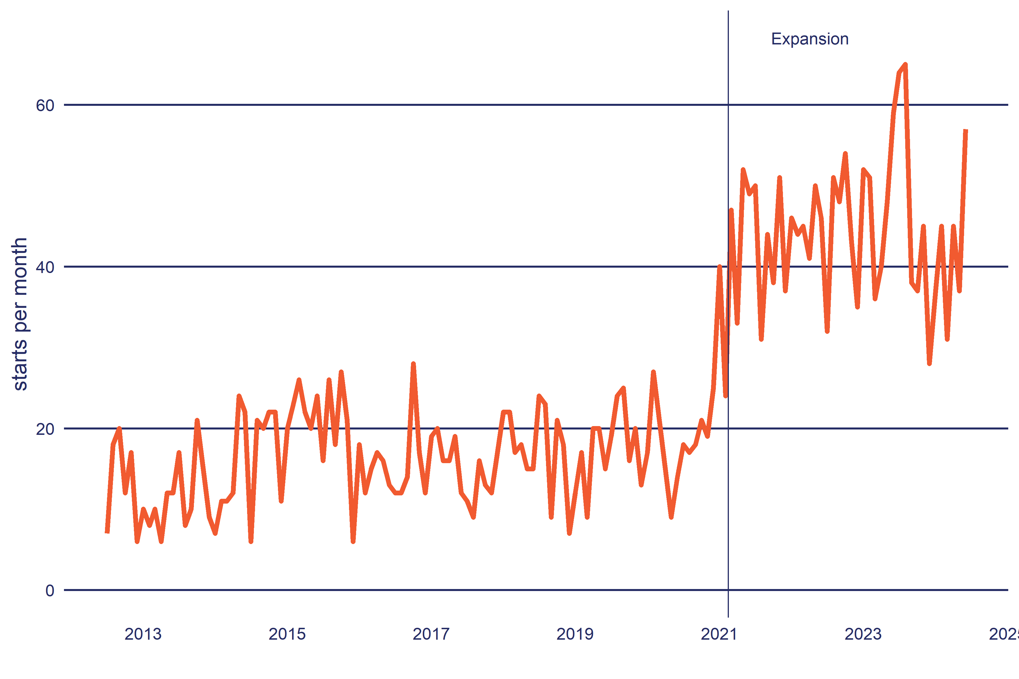

**Source**: Ministry of Social Development, October 2023.

### Participant profile

Here we compare the participant profile of FWSE before and after its Expansion.

#### Age group

Table 2 shows the age profile of FWSE participants. Participants tended to be older with 69% over 34 years, this dropped to 57% after expansion.

**Table 2**: Age profile of FWSE participants by start year

|  | 2012-2020 | Expansion |
| --- | --- | --- |
| **Age** | | |
| 18 to 24 years | 4% | 6% |
| 25 to 29 years | 12% | 16% |
| 30 to 34 years | 14% | 20% |
| 35 to 44 years | 31% | 28% |
| 45 to 54 years | 25% | 20% |
| 55 to 74 years | 13% | 9% |
| **Total** | 1,569 | 1,461 |

a. Due to rounding and suppression, columns may not add up to 100%, 's' indicates the cell value has been supressed for confidentiality.  
  
**Source**: Integrated Data Infrastructure, Statistics New Zealand, October 2023.

#### Ethnicity

Table 3 shows participants by ethnicity. Because people can have more than one ethnic identity, the proportions in this table will exceed 100%. Before the Expansion the majority of participants identified as European 76%, this proportion fell slightly after the expansion. The main group to increase their share of participants were Pacific (from 9% to 14%) followed by Māori (from 24% to 28%).

**Table 3**: Ethnic profile of FWSE participants by start year

|  | 2012-2020 | Expansion |
| --- | --- | --- |
| **Ethnicity** | | |
| Māori | 24% | 28% |
| Pacific | 9% | 14% |
| Asian | 7% | 8% |
| MELAA | 5% | 5% |
| European | 76% | 68% |
| Other | 3% | 2% |
| **Total** | 1,569 | 1,461 |
| a. Ethnicity is total response (ie a person can select more than one ethnic identity) and therefore the sum of percentage values may exceed 100%. b. Due to rounding and suppression, columns may not add up to 100%, 's' indicates the cell value has been supressed for confidentiality. c. MELAA: Middle East, Latin America and Africa.  **Source**: Integrated Data Infrastructure, Statistics New Zealand, October 2023. | | | |

#### Gender

Table 4 shows the profile of participants by gender. For FWSE participants there is an even split between those who identify as male or female. The Expansion saw a small shift towards more participants who identify as male.

**Table 4**: Gender profile of FWSE participants by start year

|  | 2012-2020 | Expansion |
| --- | --- | --- |
| **Gender** | | |
| Female | 55% | 52% |
| Male | 45% | 47% |
| **Total** | 1,569 | 1,461 |
| a. Due to rounding and suppression, columns may not add up to 100%, 's' indicates the cell value has been supressed for confidentiality. b. Category for people who identify as gender diverse is not currently available in the IDI.  **Source**: Integrated Data Infrastructure, Statistics New Zealand, October 2023. | | | |

#### Benefit status

By benefit status, the majority of participants had been on Jobseeker Support Work Ready, followed by people receiving Sole Parent Support (Table 5). The Expansion period saw a proportional shift away from people on Sole Parent Support to people not on main benefit before starting FWSE.

By duration on main benefit, nearly half of participants had been on benefit for six months to three years (53%), most of the remainder had been on benefit for under six months.

**Table 5**: Benefit status of FWSE participants by start year

|  | 2012-2020 | Expansion |
| --- | --- | --- |
| **Current main benefit type** | | |
| Not on main benefit | 9% | 11% |
| Jobseeker Support Work Ready | 56% | 55% |
| Sole Parent Support | 20% | 16% |
| Jobseeker Support HCD | 12% | 14% |
| Supported Living Payment | 3% | 2% |
| **Total** | 1,569 | 1,461 |
| **Duration on current benefit** | | |
| Not on main benefit | 9% | 11% |
| Under 3 months | 13% | 12% |
| 3 to under 6 months | 14% | 12% |
| 6 to under 12 months | 26% | 23% |
| 1 to under 2 years | 20% | 22% |
| 2 to under 3 years | 7% | 10% |
| 3 to under 4 years | 4% | 4% |
| 4 to under 6 years | 4% | 3% |
| 6 to under 10 years | 3% | 2% |
| **Total** | 1,569 | 1,461 |
| a. Due to rounding and suppression, columns may not add up to 100%, 's' indicates the cell value has been supressed for confidentiality. b. Category for people who identify as gender diverse is not currently available in the IDI.  **Source**: Integrated Data Infrastructure, Statistics New Zealand, October 2023. | | | |

#### Highest qualification

Table 6 shows the majority of participants held a post high school qualification (60%), followed by those who had completed a high school qualification (20% with NZQF level 3). The Expansion did not substantially change the qualification profile of participants.

**Table 6**: Highest qualification of FWSE participants by start year

|  | 2012-2020 | Expansion |
| --- | --- | --- |
| **Highest qualification** | | |
| School pre NZQF | 5% | 4% |
| NZQF 1 | 5% | 5% |
| NZQF 2 | 9% | 7% |
| NZQF 3 | 20% | 20% |
| NZQF 4 to 6 | 32% | 34% |
| NZQF 7 plus | 29% | 27% |
| Unknown | 2% | 3% |
| **Total** | 1,569 | 1,461 |
| a. Due to rounding and suppression, columns may not add up to 100%, 's' indicates the cell value has been supressed for confidentiality. b. Category for people who identify as gender diverse is not currently available in the IDI.  **Source**: Integrated Data Infrastructure, Statistics New Zealand, October 2023. | | | |

#### Employment

Table 7 provides the duration in current employment as well as the proportion of working life spent in employment (accounting for time spent overseas). Nearly all participants (85%) were not in employment in the pre expansion phase and this did not change during the expansion. Overall time in employment was also low, with 52% spent under 60% of their working life in New Zealand in employment.

**Table 7**: Employment history of FWSE participants by start year

|  | 2012-2020 | Expansion |
| --- | --- | --- |
| **Duration of current employment** | | |
| Not employed | 85% | 86% |
| Under 3 months | 15% | 14% |
| **Total** | 1,569 | 1,461 |
| **Proportion of adult life in New Zealand in employment** | | |
| 0% | 3% | 2% |
| 1 to 9% | 4% | 3% |
| 10 to 19% | 6% | 6% |
| 20 to 29% | 8% | 6% |
| 30 to 39% | 9% | 11% |
| 40 to 59% | 20% | 22% |
| 60 to 79% | 23% | 23% |
| 80 to 89% | 10% | 11% |
| 90% plus | 16% | 15% |
| **Total** | 1,569 | 1,461 |
| a. Due to rounding and suppression, columns may not add up to 100%, 's' indicates the cell value has been supressed for confidentiality. b. Working life excludes periods over seas or before the year 2000.  **Source**: Integrated Data Infrastructure, Statistics New Zealand, October 2023. | | | |

## Duration of participation on FWSE

The duration on FWSE can be up to 52 weeks. Figure 2 shows the proportion of participants by how long they spend on FWSE. Over the life of the programme, the proportion who remain on the programme has increased, especially after the 2020/2021 financial year.

**Figure 2**: Proportion of participants remaining on FWSE after they started the programme (survival curve)

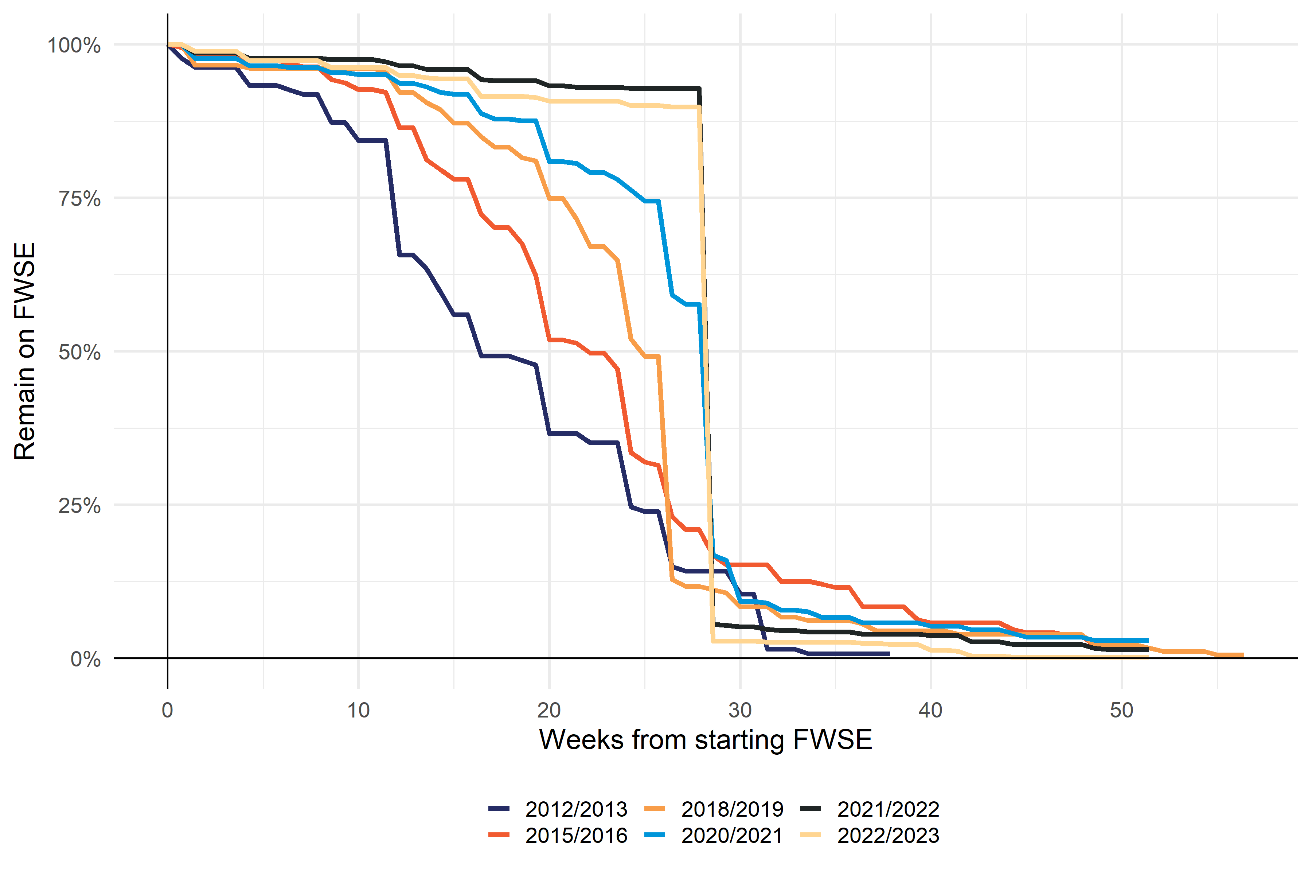

Financial year the person started FWSE, financial year starts on 1 July.

**Source**: Ministry of Social Development, October 2023.

## Cost of FWSE

MSD maintains an individualised Cost Allocation Model (iCAM) that estimates the individual cost of participating in its employment programmes and services. See the method section later in the report for an outline of how the iCAM operates.

### Breakdown of FWSE expenditure by component

Table 8 breaks the total cost of FWSE into the main cost components by financial year. For FWSE the bulk of the cost is from the subsidy payments themselves. The subsidy payment amount also includes the Self-employment Start Up-payment. Indirect costs cover unallocated front-line staff time as well as support staff costs, property, IT and depreciation.

**Table 8**: Breakdown of total cost by component for FWSE by financial year

| **Component** | **2019/2020** | **2020/2021** | **2021/2022** | **2022/2023** |
| --- | --- | --- | --- | --- |
| Subsidy | $2,032 | $4,623 | $12,248 | $15,926 |
| Subsidy Administration | $2 | $2 | $7 | $7 |
| Referral | $2 | $3 | $15 | $21 |
| Case management | $11 | $28 | $74 | $87 |
| Indirect Costs | $28 | $56 | $142 | $192 |
| **Total** | **$2,076** | **$4,713** | **$12,487** | **$16,232** |
| a. Showing the 4 most recent years of expenditure. b. Expenditure is in ,000s and in nominal values (ie not adjusted for inflation). c. Subsidy: subsidy payments, Subsidy Administration: administration of subsidy payments, Referral: staff costs involved in referring people to Flexi-wage, Case management: staff costs in case managing participants while on FWSE, Indirect Costs: non-work frontline staff costs (eg leave), support staff, property, ICT and other general MSD costs.   **Source**: individual Cost Allocation Model (iCAM), Ministry of Social Development, October 2023. | | | | | |

### Average cost per participant start

Table 9 shows the cost for each participant start by financial year. These results differ from Table 8 which shows the expenditure within each financial year and align with published financial accounts. Table 9 on the other hand, allocates participant costs that fall across financial years to the year the participant started FWSE. Combining individual participant costs over financial years is important for programmes such as FWSE since participants can spend up to 12 months on the programme. Finally, because costs are spread over the duration of the participation spell, the results for the most recent years are an underestimate as many of these participants have not yet completed FWSE.

The changes to the design of FWSE has resulted in a marked increase in the average cost for each participant. Over the pre Expansion period, per participant cost was $9,455, this increased to $24,481 during the Expansion period.

**Table 9**: Average cost per participant start for FWSE by financial year

| Phase | Financial year | Total expenditure (in ,000s) | Participant starts | Cost per start |
| --- | --- | --- | --- | --- |
| 2012-2020 | 2012/2013 | $959 | 138 | $6,951 |
| 2013/2014 | $1,410 | 152 | $9,276 |
| 2014/2015 | $2,709 | 237 | $11,430 |
| 2015/2016 | $1,455 | 205 | $7,096 |
| 2016/2017 | $1,957 | 197 | $9,932 |
| 2017/2018 | $1,796 | 170 | $10,565 |
| 2018/2019 | $1,859 | 195 | $9,535 |
| 2019/2020 | $1,877 | 184 | $10,202 |
| 2020/2021 | $1,068 | 118 | $9,053 |
| Expansion | 2020/2021 | $3,610 | 245 | $14,736 |
| 2021/2022 | $12,499 | 523 | $23,898 |
| 2022/2023 | $16,177 | 549 | $29,466 |
| 2023/2024 | $1,522 | 64 | $23,777 |
| a. Total expenditure is in ,000s and in nominal values (ie not adjusted for inflation). b. Excludes participants who started after July 2023. c. Financial year is from July to June.  **Source**: individual Cost Allocation Model (iCAM), Ministry of Social Development, October 2023. | | | | |

# Existing evidence

This section provides a short summary of the international and New Zealand evidence on business start up assistance for job seekers.

## Evaluations of Flexi-wage self-employment

Alongside the current impact evaluation, MSD also undertook a process evaluation of the FWSE programme.

### Flexi-wage self-employment process evaluation 2023

A 2023 evaluation of FWSE used a qualitative case-study approach, with data collected from a range of stakeholders including participants, staff and business advisers (GravitasOPG, 2024). The evaluation concluded the FWSE subsidy did not meet the intended objective of supporting people who are at risk of long-term benefit receipt and disadvantaged in the labour market into sustained self-employment.

The key evaluation finding was that the subsidy was not always targeted to those who are furthest from the labour market. Moreover, it was participants closer to the labour market who were most likely to succeed in starting their business. Successful FWSE participants tended to have:

* long-term employment histories
* shorter periods on a main benefit
* previous experience in their business sector
* existing business skills (for example securing stock, costing goods or services, managing cash flow, understanding regulatory and compliance requirements)
* previous experience running a small business
* high levels of self-motivation and determination to succeed
* fewer complex barriers to employment.

However, for participants further from the labour market, both internal and external stakeholders expressed concern about unintentionally setting these participants up for failure as they lacked the necessary capabilities required to successfully set up their business.

In addition, the evaluation found:

* there was a high attrition rate through the application process because of the time and effort to create a business plan.
* there was a lack of consistency across regions, promotion or encouragement to apply - which was highest in offices where work brokers were more experienced with FWSE.
* MSD staff and BTAG providers felt there was a gap between eligibility criteria and the capabilities required to successfully run a small business. Consequently, only a small proportion of participants were successful.
* there was a lack of tailored business mentoring post-approval by kaupapa Māori and Pasifika BTAG providers that may have contributed to the failure in successful business start-up.

## Previous evaluations of MSD self-employment programmes

The 1996 evaluation of Enterprise Allowance was the one previous evaluation of a MSD funded self-employment subsidy programme (Curtin, 1996). The main findings from the evaluation were as follows.

* Methods of operating the programme varied widely between local offices. This was due partly to employees’ skill in the enterprise area, and to the diverse local arrangements for business skills training and business plan vetting. The operational guidelines for the programme were also out of date resulting in offices applying their own interpretations of Enterprise Allowance guidelines in some areas.
* Staff perceived the programme to be resource intensive.
* Target groups, particularly women, Māori and Pacific people, were under-represented in both standard Enterprise Allowance and the capitalisation option, but Māori are more highly represented than in the self-employed population in general.
* Enterprise Allowance was a relatively expensive programme. For job seekers who completed a project between January and March 1995, the average cost was $11,300[6] under the standard option and $14,300 under the capitalisation option, not including the cost of the programme administration.

Job seeker register outcomes following the programme were relatively high. Of all people who finished either option between August 1992 and March 1995:

* 72% had not re-enrolled within six months of the end of the subsidy
* 64% had not re-enrolled within one year of the end of the subsidy
* 55% had not re-enrolled within two years of the end of the subsidy.

## International reviews of self-employment programs

There have been a number of reviews of programmes to help unemployed people start a business.

### Dvouletý and Lukeš (2016)

Dvouletý and Lukeš (2016) reviewed evidence on self-employment policies for the unemployed in developed countries. They found scarce evidence on effectiveness outside of Germany. They identified 18 such studies that had been completed in the previous 10 years, most studies found:

* positive effects of self-employment policies on employment status and personal income of former unemployed individuals
* increased survival rates of subsidized businesses
* subsidized businesses under-performed regular ones.

### Caliendo & Künn (2011)

Caliendo & Künn (2011) examined the long term impacts of two German business start-up subsidies for the unemployed, they found:

* 80% of participants were integrated in the labour market and had relatively high labour income five years after start-up
* participants were much more satisfied with their current occupational situation compared to previous jobs
* relative to a matched comparison group, the authors found that both programs were effective with respect to income and employment in the five years after start-up
* start-up subsidies for the unemployed tend to be most effective for disadvantaged groups in the labour market.

### Martin & Grubb (2001)

Martin & Grubb (2001) completed a wide review of active labour market programmes (ALMPs) including self-employment assistance. Their findings for self-employment assistance were that this type of intervention was suitable for only a small subset of job seekers who had the education, skills and confidence to set up their own business. This conclusion was based on US studies that suggested that this group consisted of men, mainly aged 30-40 years, with relatively high levels of education.

## Non-participant effects of subsidy programmes

Alongside the impact on participants, we need to also consider the likely impact of subsidy-based interventions on non-participants (Borland, 2016). In the literature there are three effects to consider.

* **Substitution**: employers hiring the subsidised participant instead of another job seeker. As a result, the substituted job seeker will take longer to find employment.
* **Displacement**: employer taking on subsidised workers can undercut competing firms that result in lower employment among those firms.
* **Dead weight**: the employer would have hired the subsidised participant without the subsidy. High dead weight would increase the risk of displacement or employers taking the subsidy as profit.

For self-employment subsidies the concern is specifically around displacement effects where people starting a new business crowd out other competing firms.

It is difficult to reliably estimate the size of these effects and the extent to which they offset any gains in employment and income for the programme participants. A number of studies have indicated likely ranges of the negative impacts on non-participants relative to the positive impacts on participants:

* Martin and Grubb (2001): 40 to 90%
* Neumark (2013): 67 to 96%
* Brown and Koettl (2015): Sweden 65-70%, Ireland and the UK 20%, Belgium 36% and the Netherlands 50%.

# Impact analysis

In this section of the report, we examine the impact of FWSE on participants’ subsequent outcomes.

## Interval impacts

Here we examine the impact of FWSE on selected outcomes in each month before and after starting the programme. Tabular summaries of the following results can be found in the Impact summary tables section below.

### FWSE increased participants’ time in employment

Our analysis begins with those people who started FWSE between 2013 and 2016 (Figure 3).

**Figure 3**: Interval outcomes of FWSE participants and comparison group on time in employment

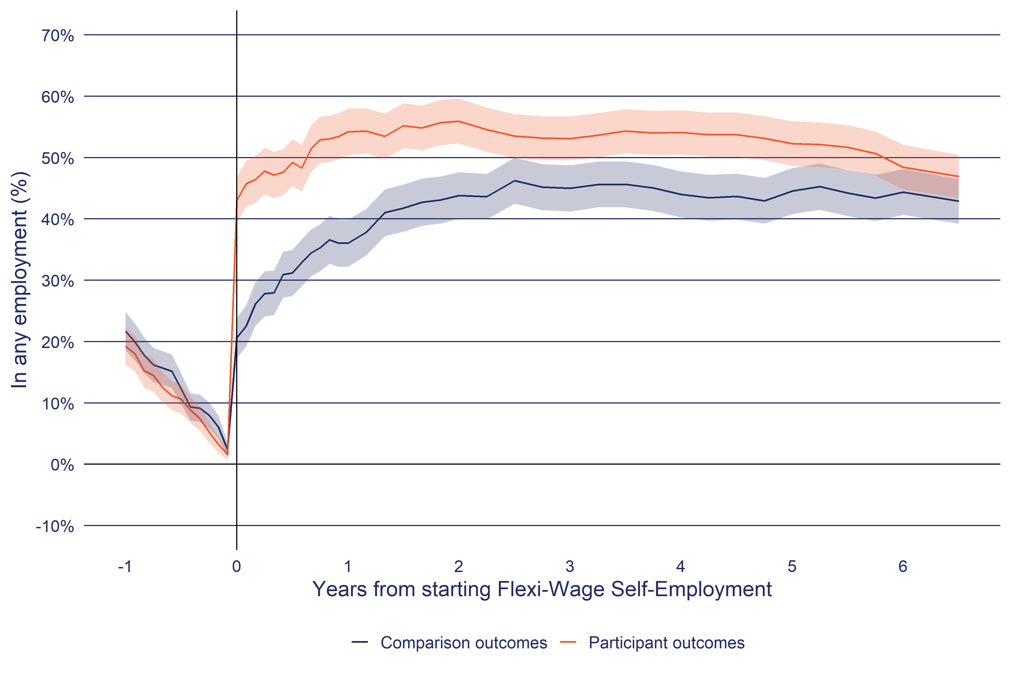

a. The shaded area around each line indicates the 95% confidence interval of the estimate.

b. In any employment: Employment is based on tax data (PAYE and annual tax returns). Periods with less than $100 of real (at report year) employment income per month are excluded. Annual returns are left censored to lapse period 0 if they start before the lapse period 0 calendar date.

**Source**: Statistics New Zealand, Integrated Data Infrastructure, October 2023.

Figure 3 shows the proportion of participants who are in any employment in each month from one year before starting FWSE to 6.5 years afterwards. Alongside the participants, the chart also shows the same outcome for the matched comparison group.

Showing interval outcomes is a useful way of understanding how outcomes change in the period before and after starting the intervention. In the pre-participation period, the proportion of participants in any employment averages at 11%. For FWSE, we can see Ashenfelter’s dip[7] as the proportion of participants in employment steadily falls until just before they start the programme.

After starting FWSE, the proportion of participants in employment is at its highest at around two years after starting the programme at 56±4.0%. However, after this point there is a slight decline in the proportion in employment, falling to 48±4.0% at six years.

For the comparison group, the proportion in any employment also increases in the following two years from 21±3.0% at lapse period zero to 44±4.0% at two years, after which the proportion remains relatively stable. But over the follow up period, the comparison group has a lower level of employment than the participants.

Figure 4 shows the impact of FWSE on the time in employment. Here impact is calculated as the percentage point (ppt) difference in the proportion of time in employment between the participant and the matched comparison group from Figure 3 above. At one month after starting FWSE, the proportion of participants in employment exceed that of the comparison group by 23±5.0 ppt, decreasing to 7.0±5.0 ppt after 2.5 years.

**Figure 4**: Interval impact of FWSE on time in employment

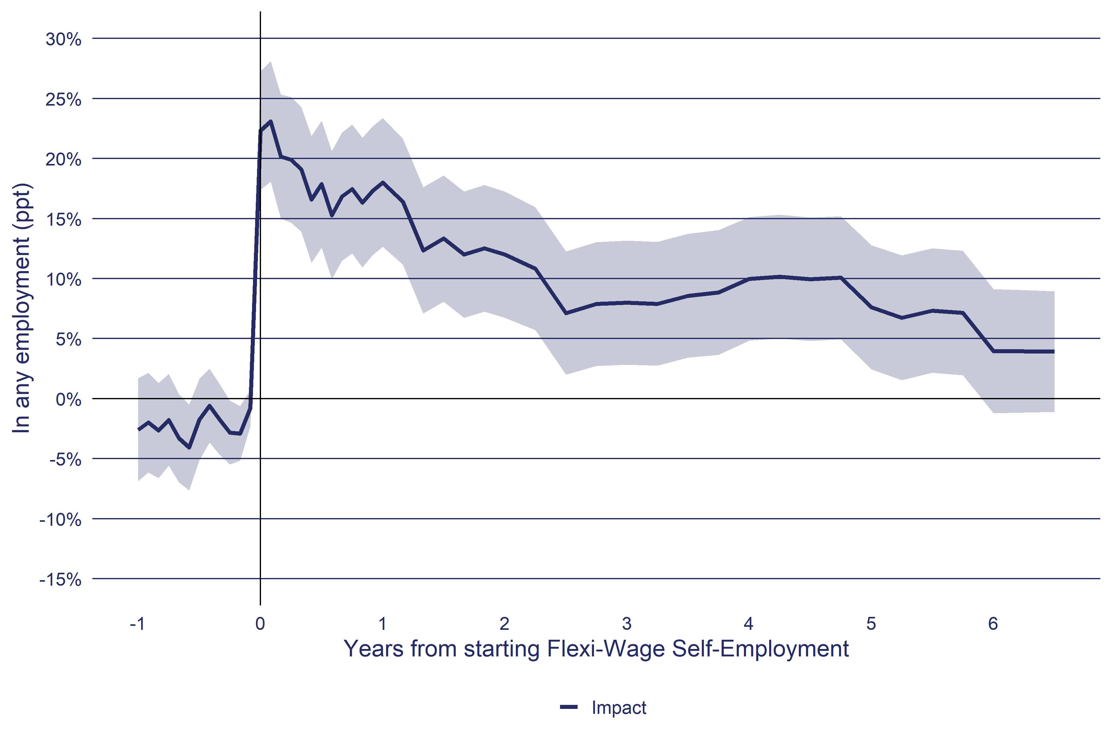

a. The shaded area around each line indicates the 95% confidence interval of the estimate.

b. In any employment: Employment is based on tax data (PAYE and annual tax returns). Periods with less than $100 of real (at report year) employment income per month are excluded. Annual returns are left censored to lapse period 0 if they start before the lapse period 0 calendar date.

**Source**: Statistics New Zealand, Integrated Data Infrastructure, October 2023.

At the end of the follow-up period in Figure 4 we can see that there continues to be a positive, but not significant, impact (4.0±5.0 ppt). This means there are additional impacts that have not yet been observed. For this reason, the impacts reported later in this analysis are an under-estimate of the full impact of FWSE on participant’s employment outcomes.

### Self-employment buisness income

Figure 5 shows the time FWSE participants and matched comparison group spend in self-employment. The outcome measure is based on annual tax returns for business income. Annual returns pose the problem that we do not accurately know when a person started self-employment. Specifically, how to treat self-employment spells that occur in the same tax year as the participants started FWSE. If we assume the participant was in self-employment for the full tax year, then it would appear participants had started their business before receiving FWSE. To solve this problem, in instances where a annual return falls across lapse period zero then the assumption is made that the self-employment spell started **after** lapse period zero date (this will be FWSE start date for participants and the sample selection date for the comparison group). We applied this rule to ensure that, when selecting the comparison group, we do not have confounding by selecting comparison group members who had also started a business after their selection date into the sample.

**Figure 5**: Interval outcomes of FWSE participants and comparison group on time in self-employment

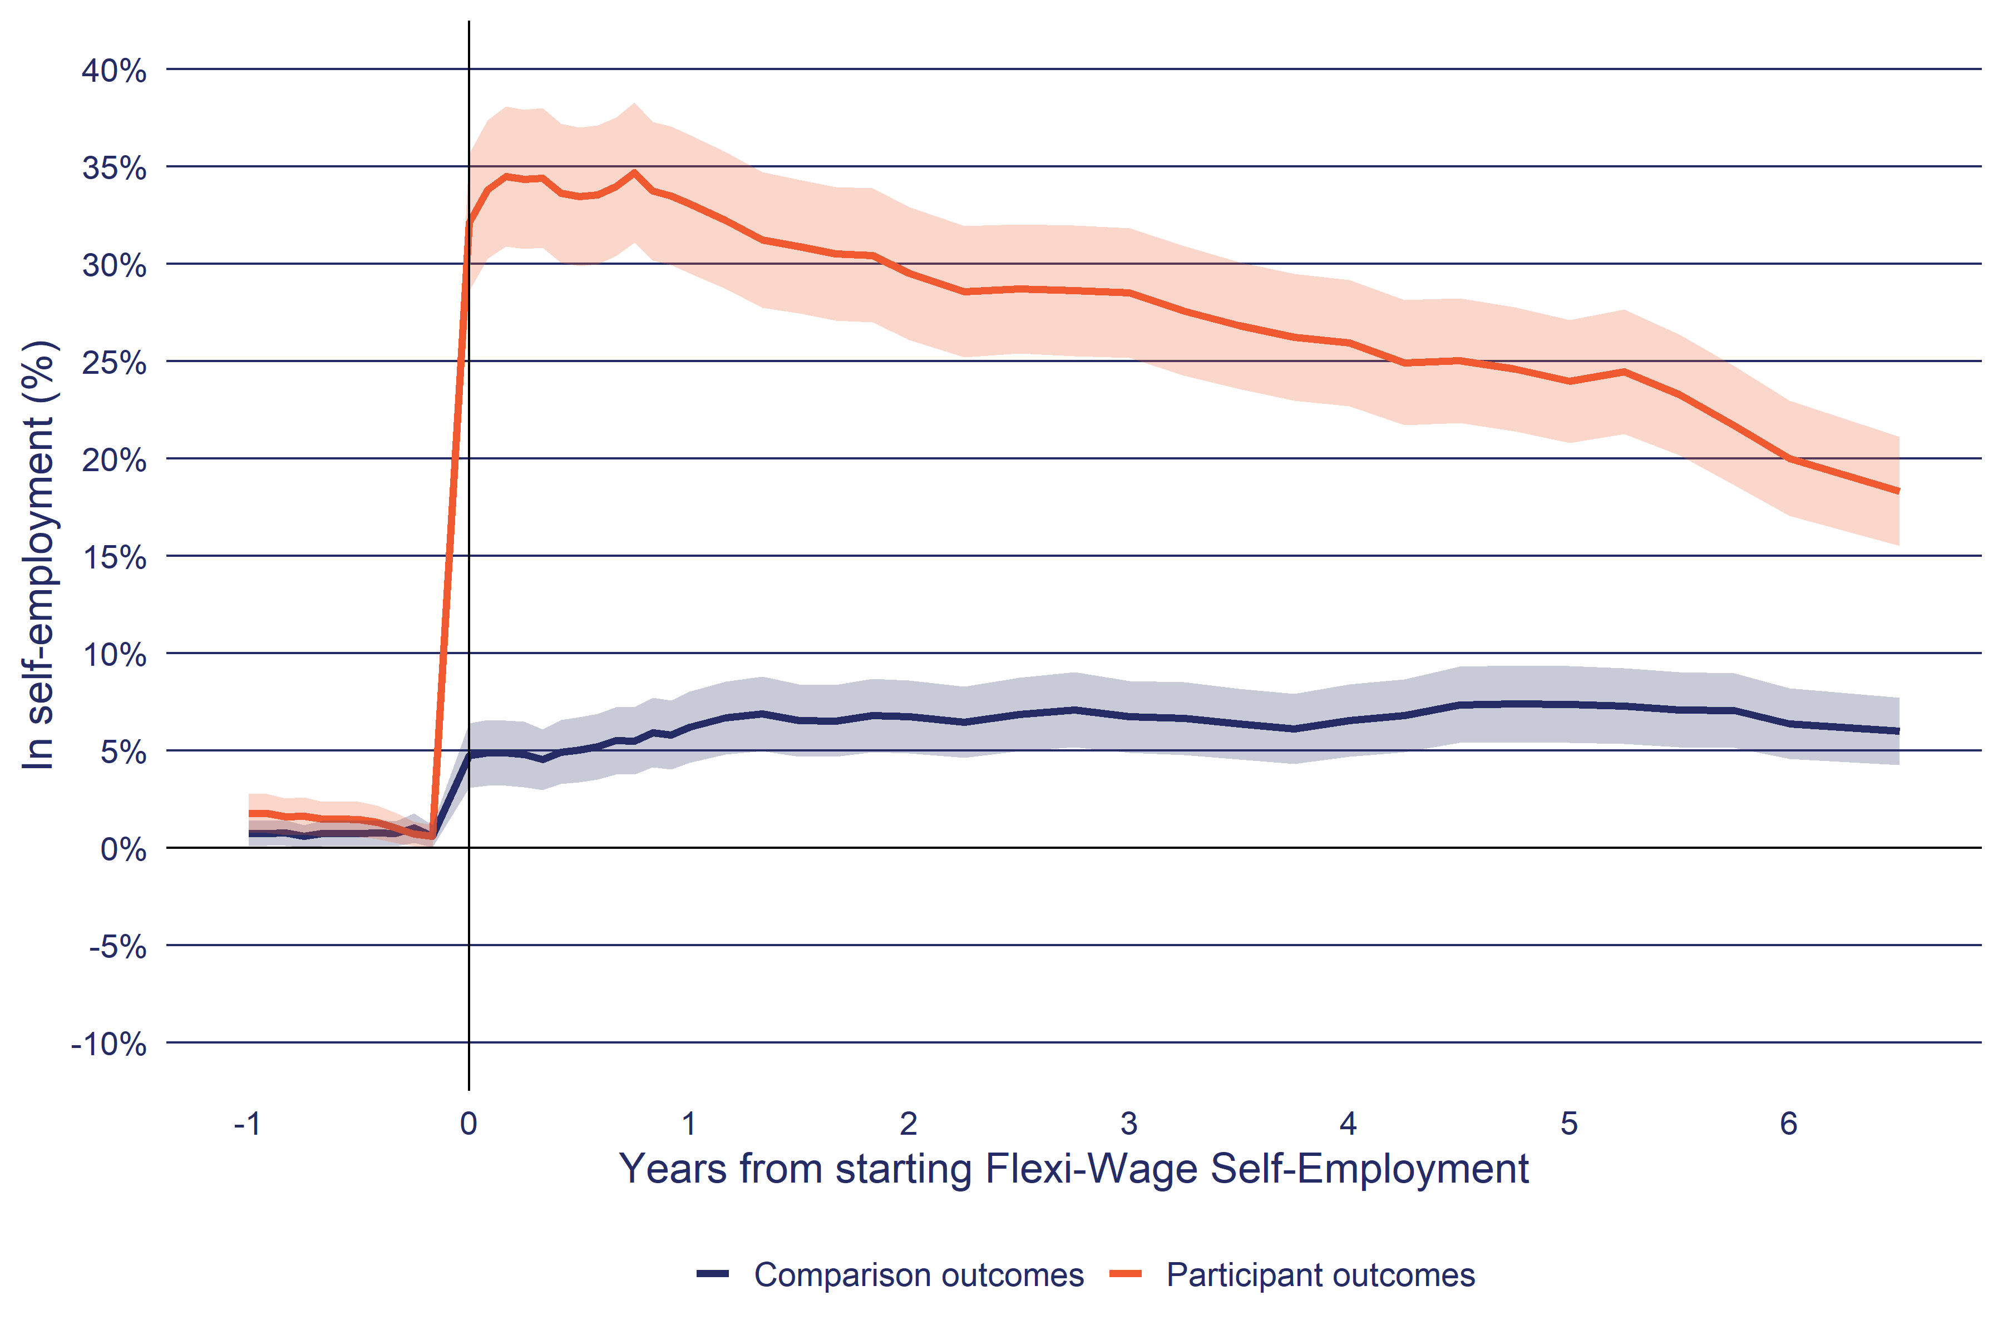

a. The shaded area around each line indicates the 95% confidence interval of the estimate.

b. In self-employment or business partnership: Self-employment is based on tax data (PAYE and annual tax returns). Periods with less than $100 of real (at report year) employment income per month are excluded. Annual returns are left censored to lapse period 0 if they start before the lapse period 0 calendar date.

**Source**: Statistics New Zealand, Integrated Data Infrastructure, October 2023.

The key finding from Figure 5 is that the proportion of participants who have income from self-employment is low. At one year after starting FWSE, 33±4.0% of participants were in self-employment. This proportion decreases over the follow up period to reach 20±3.0% after six years. The level of self-employment for the matched comparison group remained between five to 10 percent over the same period.

#### Self-employment outcomes by participant characteristics

The GravitasOPG (2024) evaluation of FWSE reported that only certain types of participants were successful in establishing a business. Because of the small number of participants we cannot examine the effectiveness of FWSE for the groups identified in the report. However, we can cross check this finding by looking at the proportion of participants in self-employment and their self-employment income in the 12th month after starting FWSE.

Table 10 shows the proportion of FWSE participants in self-employment in the 12th month after starting the programme and the average income from self-employment in the same month. The table confirms the GravitasOPG (2024) finding that participants with fewer indicators of labour market disadvantage are more likely to be in self-employment and have higher average earnings from self-employment.

**Table 10**: FWSE participants by benefit type, benefit duration and time in employment who are in self-employment at one year after programme commencement

| Group | In self-employment or business partnership | Net income from self-employment |
| --- | --- | --- |
| **Duration on current benefit** | | |
| Not on main benefit | 38.29% | $959.76 |
| Under 3 months | 40.08% | $865.49 |
| 3 to under 6 months | 37.99% | $740.54 |
| 6 to under 12 months | 33.90% | $540.65 |
| 1 to under 2 years | 33.07% | $402.76 |
| 3 to under 4 years | 38.21% | $702.81 |
| **Highest qualification** | | |
| School pre NZQF | 25.56% | $332.53 |
| NZQF 1 to 3 | 31.57% | $582.03 |
| NZQF 4 to 6 | 32.57% | $541.57 |
| NZQF 7 plus | 37.53% | $695.55 |
| **Proportion of adult life in New Zealand in employment** | | |
| 1 to 9% | 26.19% | $310.75 |
| 10 to 19% | 22.20% | $286.83 |
| 20 to 29% | 30.85% | $440.00 |
| 30 to 39% | 31.31% | $596.35 |
| 40 to 49% | 29.85% | $424.76 |
| 50 to 59% | 30.70% | $528.87 |
| 60 to 69% | 35.20% | $578.18 |
| 70 to 79% | 37.42% | $631.18 |
| 80 to 89% | 38.79% | $784.81 |
| 90% plus | 45.14% | $964.79 |
| Self-employment is based on tax data (PAYE and annual tax returns). Periods with less than $100 of real (at report year) employment income per month are excluded. Annual returns are left censured to lapse period 0 if they start before the lapse period 0 calendar date. Outcomes are at the 12th month after starting the programme.  **Source**: Statistics New Zealand, Integrated Data Infrastructure, October 2023. | | |

### Impact by year

Here we examine if the Expansion of FWSE altered the effectiveness of the programme (Figure 6).

**Figure 6**: Interval impact of FWSE on time in employment by start year

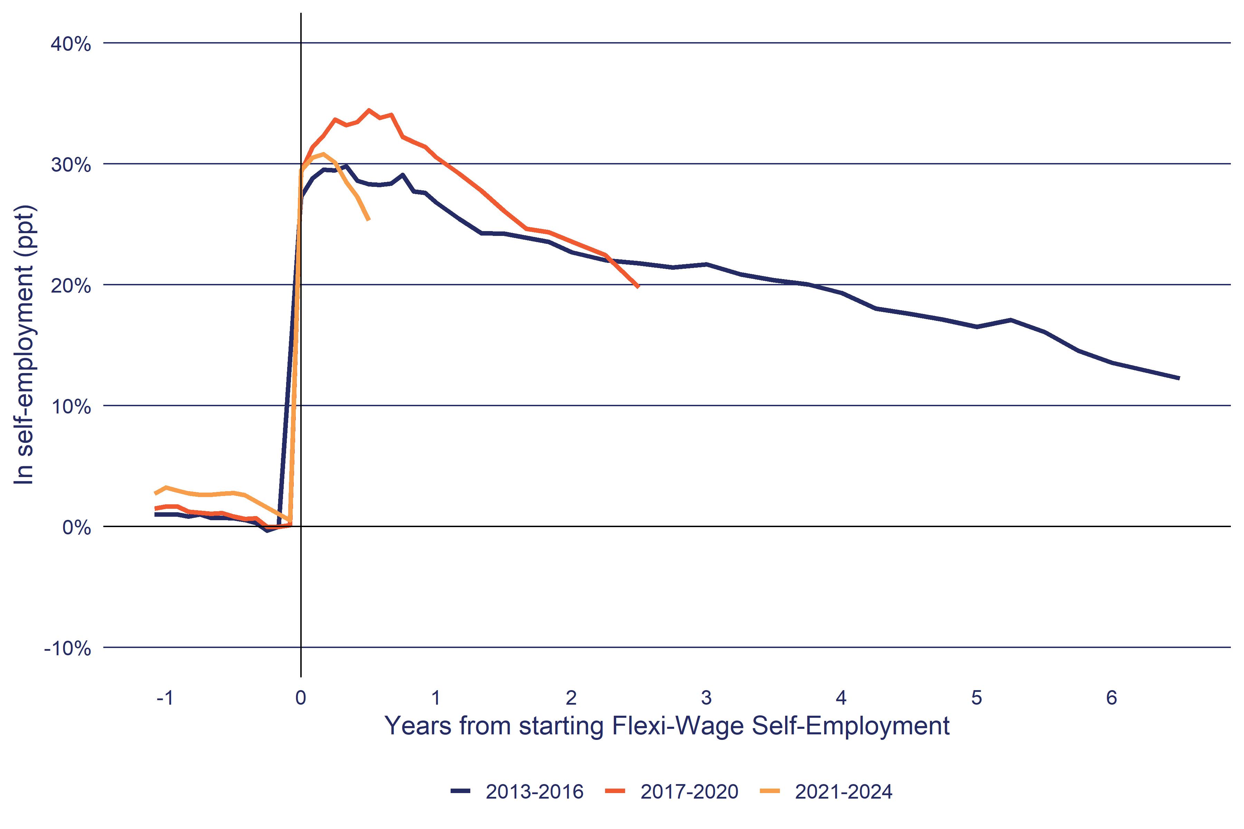

a. The shaded area around each line indicates the 95% confidence interval of the estimate.

b. In self-employment or business partnership: Self-employment is based on tax data (PAYE and annual tax returns). Periods with less than $100 of real (at report year) employment income per month are excluded. Annual returns are left censored to lapse period 0 if they start before the lapse period 0 calendar date.

**Source**: Statistics New Zealand, Integrated Data Infrastructure, October 2023.

Figure 6 tests this by comparing the impact trends of different cohorts of FWSE participants. Using the impact trends of earlier cohorts, we can get an indication of how similar or different the impact trends are for more recent cohorts and what they are likely to be.

Figure 6 shows that the impact trends are similar across all the cohorts. However, the lower trend for the most recent cohort (2021-2024) may be lower because of delays in people filing annual income tax returns. Nevertheless, while still early, these impact trends indicate that the Expansion has not substantially increased the effectiveness of FWSE on the time spent in self-employment.

### Income

Figure 7 compares the net income from all sources between the participant and matched comparison group.

**Figure 7**: Interval outcomes of FWSE participants and comparison group on net income from all sources

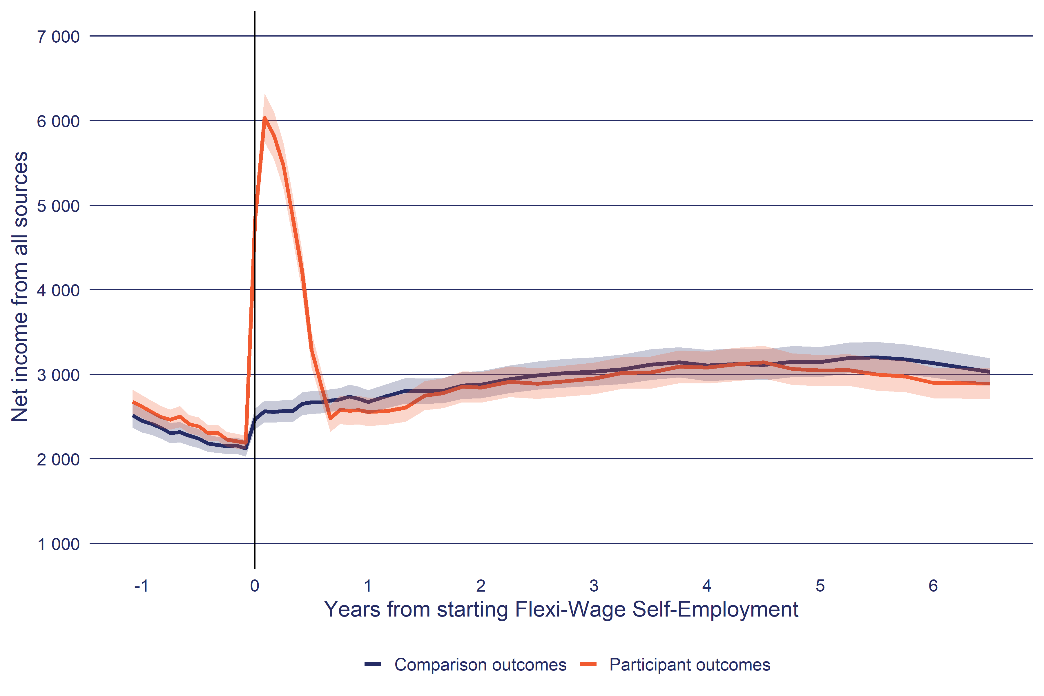

a. The shaded area around each line indicates the 95% confidence interval of the estimate.

b. Net income from all sources: Income includes taxable earnings, taxable and non-taxable income support payments including tax credits and pensions (but excluding recoverable assistance) and student allowance payments net of income tax.

**Source**: Statistics New Zealand, Integrated Data Infrastructure, October 2023.

The initial increase in income for participants in the year after starting FWSE is through the subsidy and capital assistance participants received to start their business. Of concern is that once this support period ends, there is no material difference in the level of income between the participants and matched comparison (despite the participants having higher level of employment, see Figure 3 above).

Figure 8 shows this issue more clearly by tracking the income from employment only (ie excluding any transfer payments). Here we can see a small increase in income from employment for participants relative to the comparison group. However, this difference is not statistically significant and ceases after two and a half years.

**Figure 8**: Interval outcomes of FWSE participants and comparison group on net income from employment

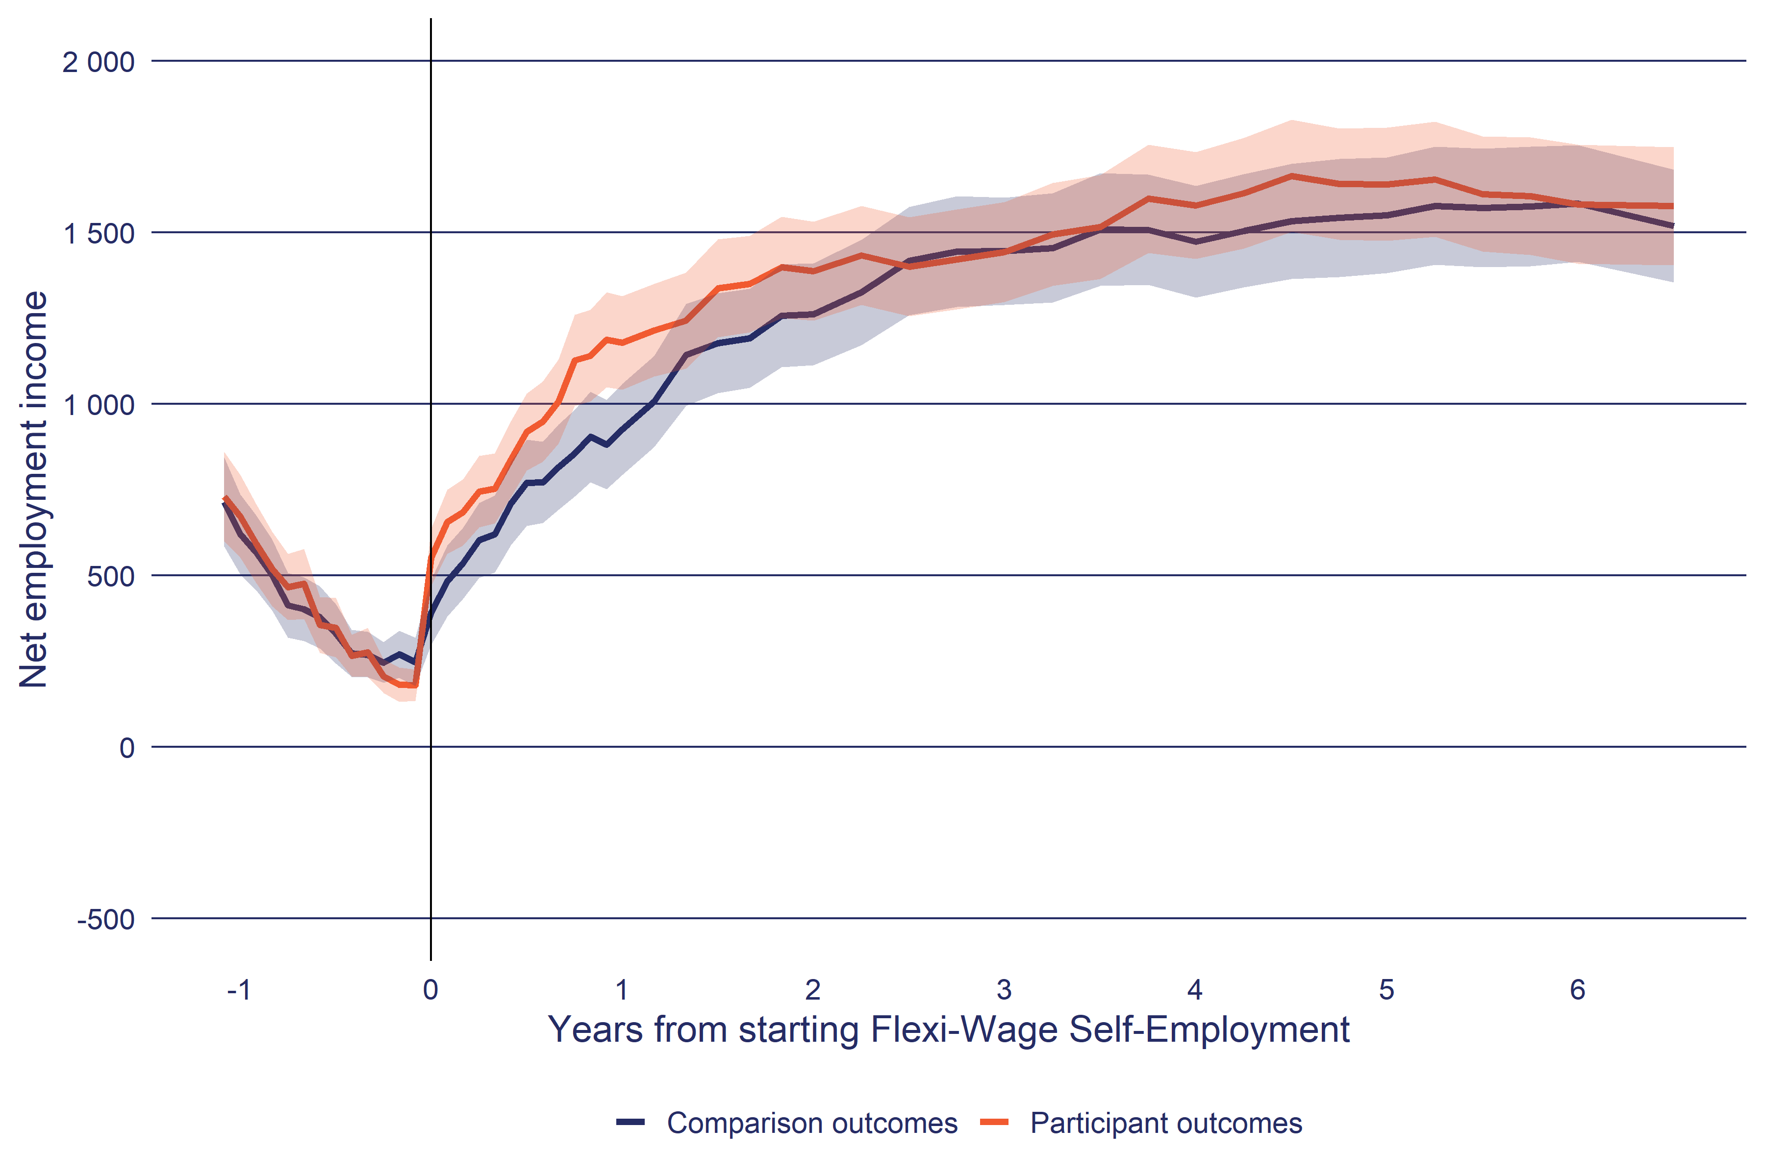

a. The shaded area around each line indicates the 95% confidence interval of the estimate.

b. Net employment income after tax: Employment income includes wage and salary, paid parental leave and business income net of income tax. Annual returns are left censored to lapse period 0 if they start before the lapse period 0 calendar date.

**Source**: Statistics New Zealand, Integrated Data Infrastructure, October 2023.

## Cumulative impacts

So far, we have looked at how impacts changed in each month before and after FWSE start. Such interval impact charts are useful for understanding how the effect of the programme changes over time but are difficult to make a summary statement of the overall impact of FWSE. For the overall impact assessment, we need to measure the cumulative impact of FWSE from when participants started the programme as shown in Table 11.

### Employment

Table 11 splits participants by the calendar year that they started FWSE. At selected years after starting FWSE, the Table shows the additional number of weeks in employment by participants relative to the comparison group. For example, for participants who started between 2013 to 2016, we estimate that after four years, participants spent 26.0±11.0 more weeks in employment than the comparison group. The impact on time in self-employment is larger, with participants spending an additional 50.0±8.10 weeks.

**Table 11**: Cumulative impact of FWSE on time in employment

|  | Years from participation start | | | | |
| --- | --- | --- | --- | --- | --- |
| Period | 0.5 | 1 | 2 | 4 | 6 |
| **Impact on time in employment (weeks)** | | | | | |
| 2013-2016 | 6.00* | 10.0* | 17.0* | 26.0* | 34.0* |
| 2017-2020 | 6.90* | 12.0* | 19.0* |  |  |
| 2021-2024 | 6.00* |  |  |  |  |
| **Impact on time in self-employment (weeks)** | | | | | |
| 2013-2016 | 8.60* | 16.0* | 28.0* | 50.0* | 67.0* |
| 2017-2020 | 9.80* | 18.0* | 31.0* |  |  |
| 2021-2024 | 8.70* |  |  |  |  |
| *: the 95% confidence interval of the impact estimate excludes zero.  **Source**: Statistics New Zealand, Integrated Data Infrastructure, October 2023. | | | | | |

Examining impacts by when participants started the programme, the 2017-2020 cohort had a higher impact than the earlier cohort. For those starting after 2021, the impact is similar to the 2013-2016 cohort. However, because possible delays in filing annual tax returns, this may be an underestimate of the true impact on employment.

### Income

By total income (in 2023 dollars), which includes labour market income (earnings) as well as transfer payments, the Table 12 shows participants experience in increase in income over the first year. However, as discussed earlier, this increase is primarily through the transfer payments that participants receive through participation in FWSE. If we examine impact on income from employment only, then the impacts are more modest and over the medium term (after 5 years) no longer significant.

**Table 12**: Cumulative impact of FWSE on net income (in 2023 dollars)

|  | Years from participation start | | | | |
| --- | --- | --- | --- | --- | --- |
| Period | 0.5 | 1 | 2 | 4 | 6 |
| **Impact on net employment income** | | | | | |
| 2013-2016 | $1,008 | $2,417* | $4,149 | $4,956 | $6,563 |
| 2017-2020 | $2,007* | $3,501* | $5,429* |  |  |
| 2021-2024 | $2,840* |  |  |  |  |
| **Impact on net income from all sources** | | | | | |
| 2013-2016 | $16,414* | $15,834* | $14,750* | $13,042* | $10,011 |
| 2017-2020 | $16,597* | $15,737* | $12,716* |  |  |
| 2021-2024 | $24,225* |  |  |  |  |
| *: the 95% confidence interval of the impact estimate excludes zero.  **Source**: Statistics New Zealand, Integrated Data Infrastructure, October 2023. | | | | | |

Looking at impact by when people started FWSE, the increased level of subsidy in the Expansion phase is evident for 2021-2024 participants, with an impact of $24,225±$2,095. In addition, it does appear that the 2021-2024 participants also experienced a higher level of earnings at $2,840±$1,017 compared to $2,007±$1,061 for the 2017-2020 cohort.

## Impact of Flexi-wage Self employment compared to other self-employment subsidy programmes

FWSE is not the only self-employment subsidy programme administered by MSD. In this section we look at the effectiveness of FWSE compared to its predecessor Enterprise Allowance. Note the method used to estimate the effectiveness of Enterprise Allowance is the same as for FWSE. More information about Enterprise Allowance can be found in the EA evidence catalogue.[8]

**Table 13**: Two-year cumulative impacts for self-employment subsidy interventions

| Programme | Period | In any employment | In self-employment or business partnership | Net employment income after tax | Net income from all sources |
| --- | --- | --- | --- | --- | --- |
| Enterprise Allowance | 2001-2002 | 1.6 (3.2) | 25.8 (2.3) | $-2,102 (2,180) | $-1,723 (2,264) |
| 2001-2004 | 3 (2.3) | 26 (1.7) | $-1,305 (1,552) | $-18 (1,651) |
| 2003-2004 | 4.5 (3.2) | 26.2 (2.4) | $-511 (2,208) | $1,740 (2,385) |
| 2009-2012 | 9.7 (5.1) | 23.1 (3.7) | $-39 (3,928) | $-706 (4,443) |
| Flexi-Wage Self-Employment | 2013-2016 | 17 (5.6) | 28.2 (4.2) | $4,149 (4,539) | $14,750 (6,038) |
| 2017-2020 | 18.5 (5.6) | 31.4 (4.1) | $5,429 (4,713) | $12,716 (6,498) |
| Impact is measured over the two years after starting the programme. The bracketed figure gives 95% confidence interval of the impact estimate.  **Source**: Statistics New Zealand, Integrated Data Infrastructure, October 2023. | | | | | |

Table 13 shows FWSE had a slightly impact on time in self-employment. But showed more substantially impacts on both time in overall employment as well as income from employment, but for income at least, the impacts were not significant.

# Impact summary tables

The following tables provide summaries of the participant and comparison group outcomes and impacts estimates of FWSE reported in the impact analysis section. Table 14 shows the outcomes of the participants and comparison groups and the impact in the month for each lapse period after participation start date.

**Table 14**: Interval impact of FWSE on selected outcomes

|  | | Years from participation start | | | | | |
| --- | --- | --- | --- | --- | --- | --- | --- |
| Period | Measure | 0.5 | 1 | 2 | 3 | 4 | 6 |
| **In any employment** | | | | | | | |
| 2013-2016 starts | Participant | 49% (4.0 ppt) | 54% (4.0 ppt) | 56% (4.0 ppt) | 53% (4.0 ppt) | 54% (4.0 ppt) | 48% (4.0 ppt) |
| Comparison | 31% (4.0 ppt) | 36% (4.0 ppt) | 44% (4.0 ppt) | 45% (4.0 ppt) | 44% (4.0 ppt) | 44% (4.0 ppt) |
| Impact | 18% (5.0 ppt) | 18% (5.0 ppt) | 12% (5.0 ppt) | 8.0% (5.0 ppt) | 10% (5.0 ppt) | 4.0% (5.0 ppt) |
| 2017-2020 starts | Participant | 54% (4.0 ppt) | 57% (4.0 ppt) | 53% (4.0 ppt) |  |  |  |
| Comparison | 33% (4.0 ppt) | 38% (4.0 ppt) | 42% (4.0 ppt) |  |  |  |
| Impact | 21% (5.0 ppt) | 19% (5.0 ppt) | 11% (5.0 ppt) |  |  |  |
| 2021-2024 starts | Participant | 46% (3.0 ppt) |  |  |  |  |  |
| Comparison | 33% (3.0 ppt) |  |  |  |  |  |
| Impact | 12% (5.0 ppt) |  |  |  |  |  |
| **In self-employment or business partnership** | | | | | | | |
| 2013-2016 starts | Participant | 33% (4.0 ppt) | 33% (4.0 ppt) | 30% (3.0 ppt) | 29% (3.0 ppt) | 26% (3.0 ppt) | 20% (3.0 ppt) |
| Comparison | 5.0% (2.0 ppt) | 6.0% (2.0 ppt) | 7.0% (2.0 ppt) | 7.0% (2.0 ppt) | 7.0% (2.0 ppt) | 6.0% (2.0 ppt) |
| Impact | 28% (4.0 ppt) | 27% (4.0 ppt) | 23% (4.0 ppt) | 22% (4.0 ppt) | 19% (4.0 ppt) | 14% (3.0 ppt) |
| 2017-2020 starts | Participant | 39% (4.0 ppt) | 36% (4.0 ppt) | 29% (3.0 ppt) |  |  |  |
| Comparison | 5.0% (2.0 ppt) | 5.0% (2.0 ppt) | 5.0% (2.0 ppt) |  |  |  |
| Impact | 34% (4.0 ppt) | 31% (4.0 ppt) | 24% (4.0 ppt) |  |  |  |
| 2021-2024 starts | Participant | 29% (3.0 ppt) |  |  |  |  |  |
| Comparison | 3.0% (1.0 ppt) |  |  |  |  |  |
| Impact | 25% (3.0 ppt) |  |  |  |  |  |
| **Net employment income after tax** | | | | | | | |
| 2013-2016 starts | Participant | $919 ($112) | $1,178 ($137) | $1,388 ($144) | $1,444 ($146) | $1,579 ($156) | $1,582 ($174) |
| Comparison | $770 ($125) | $926 ($133) | $1,261 ($149) | $1,445 ($156) | $1,473 ($163) | $1,584 ($170) |
| Impact | $144 ($167) | $248 ($189) | $122 ($206) | -$7 ($212) | $100 ($224) | -$8 ($242) |
| 2017-2020 starts | Participant | $1,010 ($121) | $1,281 ($143) | $1,484 ($156) |  |  |  |
| Comparison | $828 ($126) | $1,076 ($142) | $1,312 ($150) |  |  |  |
| Impact | $178 ($174) | $200 ($200) | $168 ($215) |  |  |  |
| 2021-2024 starts | Participant | $1,144 ($120) |  |  |  |  |  |
| Comparison | $862 ($109) |  |  |  |  |  |
| Impact | $278 ($161) |  |  |  |  |  |
| **Net income from all sources** | | | | | | | |
| 2013-2016 starts | Participant | $3,290 ($210) | $2,558 ($168) | $2,846 ($181) | $2,952 ($186) | $3,081 ($189) | $2,898 ($179) |
| Comparison | $2,668 ($136) | $2,673 ($142) | $2,879 ($161) | $3,035 ($168) | $3,105 ($184) | $3,133 ($173) |
| Impact | $616 ($249) | -$120 ($219) | -$38 ($241) | -$89 ($249) | -$31 ($262) | -$241 ($247) |
| 2017-2020 starts | Participant | $3,969 ($234) | $3,041 ($193) | $2,995 ($179) |  |  |  |
| Comparison | $3,224 ($169) | $3,241 ($164) | $3,262 ($160) |  |  |  |
| Impact | $737 ($286) | -$206 ($251) | -$272 ($239) |  |  |  |
| 2021-2024 starts | Participant | $5,729 ($263) |  |  |  |  |  |
| Comparison | $2,870 ($122) |  |  |  |  |  |
| Impact | $2,852 ($288) |  |  |  |  |  |
| a. Income includes taxable earnings, taxable and non-taxable income support payments including tax credits and pensions (but excluding recoverable assistance) and student allowance payments net of income tax. b. Outcomes and impacts are measured at the lapse period from participants started the programme (ie 1 year is the outcome at the 12th months after starting the programme). The bracketed figure gives 95% confidence interval of the outcome estimate.  **Source**: Statistics New Zealand, Integrated Data Infrastructure, October 2023. | | | | | | | |

Table 15 shows the cumulative outcomes of the participants and comparison and the impact as measure from participation start to the end of each lapse period after participation start date.

**Table 15**: Cumultaive impact of FWSE on selected outcomes

|  | | Years from participation start | | | | | |
| --- | --- | --- | --- | --- | --- | --- | --- |
| Period | Measure | 0.5 | 1 | 2 | 3 | 4 | 6 |
| **In any employment** | | | | | | | |
| 2013-2016 starts | Participant | 3.30 (0.30 mths) | 6.40 (0.40 mths) | 13.0 (0.70 mths) | 19.0 (1.10 mths) | 26.0 (1.40 mths) | 39.0 (2.00 mths) |
| Comparison | 1.90 (0.10 mths) | 4.00 (0.40 mths) | 9.00 (0.80 mths) | 14.0 (1.10 mths) | 20.0 (1.50 mths) | 31.0 (2.20 mths) |
| Impact | 6.00 (1.50 wks) | 10.0 (2.90 wks) | 17.0 (5.60 wks) | 21.0 (8.30 wks) | 26.0 (11.0 wks) | 34.0 (16.0 wks) |
| 2017-2020 starts | Participant | 3.50 (0.30 mths) | 6.90 (0.40 mths) | 13.0 (0.70 mths) |  |  |  |
| Comparison | 1.90 (0.10 mths) | 4.10 (0.40 mths) | 9.00 (0.80 mths) |  |  |  |
| Impact | 6.90 (1.50 wks) | 12.0 (2.90 wks) | 19.0 (5.60 wks) |  |  |  |
| 2021-2024 starts | Participant | 3.30 (0.20 mths) |  |  |  |  |  |
| Comparison | 1.90 (0.10 mths) |  |  |  |  |  |
| Impact | 6.00 (1.30 wks) |  |  |  |  |  |
| **In self-employment or business partnership** | | | | | | | |
| 2013-2016 starts | Participant | 2.40 (0.20 mths) | 4.40 (0.40 mths) | 8.10 (0.80 mths) | 12.0 (1.10 mths) | 15.0 (1.40 mths) | 20.0 (1.90 mths) |
| Comparison | 0.30 (0.00 mths) | 0.70 (0.20 mths) | 1.50 (0.40 mths) | 2.30 (0.60 mths) | 3.10 (0.70 mths) | 4.80 (1.10 mths) |
| Impact | 8.60 (1.20 wks) | 16.0 (2.20 wks) | 28.0 (4.20 wks) | 39.0 (6.20 wks) | 50.0 (8.10 wks) | 67.0 (12.0 wks) |
| 2017-2020 starts | Participant | 2.60 (0.30 mths) | 4.90 (0.40 mths) | 8.60 (0.70 mths) |  |  |  |
| Comparison | 0.30 (0.00 mths) | 0.60 (0.20 mths) | 1.20 (0.40 mths) |  |  |  |
| Impact | 9.80 (1.20 wks) | 18.0 (2.20 wks) | 31.0 (4.10 wks) |  |  |  |
| 2021-2024 starts | Participant | 2.30 (0.20 mths) |  |  |  |  |  |
| Comparison | 0.30 (0.00 mths) |  |  |  |  |  |
| Impact | 8.70 (1.00 wks) |  |  |  |  |  |
| **Net employment income after tax** | | | | | | | |
| 2013-2016 starts | Participant | $5,131 ($700) | $11,738 ($1,246) | $27,602 ($2,596) | $44,889 ($3,978) | $63,660 ($5,436) | $103,145 ($8,466) |
| Comparison | $4,123 ($337) | $9,269 ($1,327) | $23,344 ($2,809) | $40,432 ($4,438) | $58,467 ($6,029) | $96,207 ($9,383) |
| Impact | $1,008 ($1,037) | $2,417 ($2,123) | $4,149 ($4,539) | $4,286 ($7,117) | $4,956 ($9,810) | $6,563 ($15,555) |
| 2017-2020 starts | Participant | $6,067 ($782) | $13,395 ($1,384) | $30,363 ($2,749) |  |  |  |
| Comparison | $4,060 ($279) | $9,840 ($1,300) | $24,821 ($2,707) |  |  |  |
| Impact | $2,007 ($1,061) | $3,501 ($2,211) | $5,429 ($4,713) |  |  |  |
| 2021-2024 starts | Participant | $7,292 ($777) |  |  |  |  |  |
| Comparison | $4,453 ($240) |  |  |  |  |  |
| Impact | $2,840 ($1,017) |  |  |  |  |  |
| **Net income from all sources** | | | | | | | |
| 2013-2016 starts | Participant | $34,466 ($1,768) | $50,147 ($2,108) | $82,948 ($3,646) | $118,370 ($5,415) | $155,419 ($7,220) | $229,112 ($10,524) |
| Comparison | $18,051 ($217) | $34,234 ($1,532) | $68,053 ($3,101) | $104,393 ($4,838) | $142,084 ($6,622) | $218,656 ($10,154) |
| Impact | $16,414 ($1,985) | $15,834 ($3,287) | $14,750 ($6,038) | $13,759 ($9,021) | $13,042 ($12,180) | $10,011 ($18,459) |
| 2017-2020 starts | Participant | $38,216 ($1,728) | $56,860 ($2,438) | $93,572 ($4,077) |  |  |  |
| Comparison | $21,619 ($327) | $41,035 ($1,891) | $80,699 ($3,460) |  |  |  |
| Impact | $16,597 ($2,055) | $15,737 ($3,607) | $12,716 ($6,498) |  |  |  |
| 2021-2024 starts | Participant | $44,024 ($1,919) |  |  |  |  |  |
| Comparison | $19,798 ($175) |  |  |  |  |  |
| Impact | $24,225 ($2,095) |  |  |  |  |  |

a. Outcomes and impacts are measured from when participants started the programme (ie 1 year is the 12 months from starting the programme).  
b. The bracketed figure gives 95% confidence interval of the outcome estimate.  
  
**Source**: Statistics New Zealand, Integrated Data Infrastructure, October 2023.

# Method

This section provides a high-level summary of the methods used in this report.

## Individualised Cost Allocation Model

We use the individual Cost Allocation Model (iCAM) to estimate the cost of EA interventions for each financial year (MSD, 2017). Insights MSD created iCAM to provide a view of how spending to date has been allocated to outputs at the individual level. Here we define outputs as activities that MSD does to assist people such as a face-to-face meeting, a main benefit application, or an EA intervention.

### Principles behind the cost allocation model

The cost allocation model works on the following principles:

* **Include all financial costs for Service Delivery (the operational arm of MSD)**: the model starts with appropriation[9] expenditure for all outputs delivered by Service Delivery. The reason behind this principle is to make sure we do not exclude any costs that are already recorded in the Ministry’s financial systems. Having said this, income support payments designed to reduce income inadequacy are currently excluded, but we plan to include this information in later updates.
* **Reconcile allocated expenditure to financial totals**: for each appropriation, the model reconciles (as far possible) the allocated expenditure back to the appropriation amount in each financial year. At the very least, the sum of the allocated expenditure in each financial year should not exceed the appropriation amount.
* **Disaggregate costs down to the individual output level**: to provide the highest level of accuracy and flexibility, the model disaggregates costs down to outputs (see the Cost allocation framework section below) at the person-event level. By doing so, we can accurately assess the amount of expenditure for individuals as well as retain the flexibility to summarise costs for any group of people. By building the model this way, we can also estimate the variability in the cost of delivering specific types of outputs.
* **Apply the same approach over all financial years**: by applying the same approach across financial years (from 2001/2002 onwards) it is possible to identify trends in the cost of Service Delivery outputs across groups of people. However, this also means it is not possible to compare results across different versions of reports or updates to the model.

### Cost allocation framework

In this report, we briefly describe how the cost model works by using an example of an in-house seminar delivered by MSD. For a more detailed description, please refer to the iCAM technical report (MSD, 2017).

We breakdown the cost of an output into components as listed in Table 16. For example, for a seminar, one component would be the time taken to book an appointment, alongside the seminar cost itself in the form of staff running the seminar. On the other hand, a hiring wage subsidy would include referral, placement opportunity, subsidy administration as well as the subsidy payment itself.

The next step is to calculate the component cost for each output by financial year, starting with determining total expenditure (see the Financial inputs section below) for each of these components.

**Table 16**: Cost components and their metrics

| Component | Definition | Metric |
| --- | --- | --- |
| Appointment | Scheduling an appointment | Staff time |
| Benefit administration | Assessing and maintaining entitlement to income support assistance | Staff time |
| Benefit payments | Bank fees for payment of income support benefits | Pay weeks |
| Client contact | Contact with individuals to help them plan and move into employment or time spent updating their records | Staff time |
| Contract Administration | Administration of contracts, including tendering, negotiation, payment and managing the performance of contracted providers | Contract amount |
| Contract payment | Payment of contracts | Contract amount |
| Grant | Financial transfer to people to assist them with further training or with transitioning into employment | Grant amount |
| Grant Administration | Assessing and administering grant applications | Staff time |
| Integrity (fraud and debt) | Identification of benefit fraud and the collection of outstanding debt | Staff time |
| Placement opportunity | Time spent by contact centre staff and work brokers to identify and establish vacancies with employers | Starts |
| Referral | Time spent by case managers in referring people to employment vacancies, employment programmes, or training programmes | Staff time |
| Seminar | Staff time in administering and running seminars | Staff time |
| Study Assistance | Time in assessing and maintaining entitlement to student loans and allowances | Staff time |
| Wage Subsidy | Payments made to employers or sponsors in relation to wage subsidy, work experience, or self-employment programmes | Subsidy payments |
| Wage Subsidy Administration | Cost of administering wage subsidy assistance | Starts |
| Provider management | Staff time in managing service provider information and relationships. | Staff time |
| Unallocated Service Delivery | Unallocated frontline staff time costs for Service Delivery | Duration on income support or student allowance |
|  | | |

The next step is to find a metric related to each component so that we can assign a dollar value to that component. We define metrics as quantitative information about each component of an output. For example, for the appointment component, we can use the number of minutes that staff spent on booking participants for each seminar. Multiplying the number of minutes spent by staff cost-per-minute rate will give us the appointment cost for each seminar attendee.

Finally, we add the cost of each component to arrive at a total cost for the seminar. The variation in the cost of each output for the financial year will depend on the variability in the cost of each of its components.

### Financial inputs

Having identified the outputs, their cost components, and how to assign costs to them, the next question is where we source the financial costs for Service Delivery. We can access records of Service Delivery expenditure through the Ministry’s financial accounting system. These records capture expenditure information down to the cost centre and general ledger (GL) nominal/natural account level.

With monthly financial data the next step is to link expenditure to cost components. For some cost components there is a relatively straightforward link to the financial inputs. For example, the wage subsidy payments for a wage subsidy programme have their own GL nominal code. For others the relationship is less clear. For those cost components that involve staff time, the component costs are a subset of the overall expenditure on staff costs recorded in the financial systems. In these instances, we need to apportion staff costs to components based on the estimated time it took to undertake each component task.

### How do we estimate staff time?

Table 16 above shows that staff time is a commonly used metric in the model. However, obtaining this data is not straightforward. In this section, we summarise how we estimate the time spent on different activities. The source of this information is system transactions on MSD’s various IT administrative systems combined with appointments, seminars and task management data. The key information for these transactions is:

* a unique ID for a staff member
* a unique ID for an individual
* a start time
* an end time
* what the action was.

This allows us to construct a transaction-based view of a staff member’s day. Table 17 below shows an example for a staff member from the start of their day. For each period, the model identifies the type of action they are undertaking and measures the time until the next action based on the Time (end) value. If there is more than one action, then the elapsed time is split evenly between each action as shown in the Minutes column. Where client ID is missing, these represent periods where either the staff member is undertaken action unrelated to a client (eg a lunch break) or the action exceeded the expected time it would have taken to complete the action. The threshold of excessively long tasks is the 90th percentile for that activity over all staff on the same day. In cases whether the activity exceeds the 90th percentile, the activity is split into two records, with the excess time is allocated to non-contact time in the model.

**Table 17**: Example of a staff member's actions from the start of their day

| Time (end) | Action type | Action | Client id | Minutes |
| --- | --- | --- | --- | --- |
| 9:12:00 | Case management | Search for client | 10 | 5.52 |
| 9:16:00 | Case management | Case Management | 25 | 2.00 |
| 9:16:00 | Case management | Scan Document | 25 | 2.00 |
| 9:19:00 | Income Support Administration | Third tier assistance | 6 | 3.00 |
| 9:20:00 | Income Support Administration | Third tier assistance | 6 | 0.50 |
| 9:20:00 | Case management | Case Management | 33 | 0.50 |
| 9:21:00 | Case management | Search for client | 33 | 1.00 |
| 9:22:00 | Income Support Administration | Maintenance | 33 | 0.50 |
| 9:22:00 | Income Support Administration | Third tier assistance | 33 | 0.50 |
| 9:23:00 | Income Support Administration | Third tier assistance | 33 | 1.00 |
| 9:24:00 | Case management | Scan Document | 33 | 1.00 |
| 9:29:00 | Income Support Administration | Maintenance | 33 | 3.50 |
| 9:29:00 | Non contact time | Non contact time | - | 1.50 |
| 9:30:00 | Income Support Administration | Third tier assistance | 33 | 1.00 |
| 9:31:00 | Case management | Case Management | 14 | 1.00 |
| 9:37:00 | Case management | Search for client | 14 | 6.00 |
| 9:38:00 | Case management | Search for client | 14 | 1.00 |
| 9:47:00 | Case management | Case Management | 14 | 3.50 |
| 9:47:00 | Non contact time | Non contact time | - | 5.50 |
| 9:48:00 | Case management | Search for client | 14 | 1.00 |
|  | | | | |

We then link transactions to outputs that have components with staff time as a metric. These transactions should occur around the start date of the output, or within the start date and end date of the output, depending on the type of cost component. Also, staff transactions need to be of the same type. For example, staff time spent on income support administration is not linked to the management or delivery of employment programmes or services.

## Counterfactual Approach and method

This section provides an overview of the approach used to estimate the difference FWSE makes to participants’ outcomes. Also described are outcome domains covered in this analysis and the specific outcome measures used.

### Approach: a quantitative counterfactual framework

In this report, effectiveness is analysed using a quantitative counterfactual framework. The counterfactual framework can be summarised by the question ‘what outcomes would have occurred if the participants had not participated in FWSE?’ Any quantitative difference in outcomes between these two scenarios is interpreted as the causal impact of FWSE on participant’s outcomes.

The obvious challenge is that we cannot observe both scenarios for the participants. Instead, we need a suitable non-participant group whose outcomes can represent the counterfactual scenario (ie the outcomes of participants if they had not participated in FWSE).

### Controlling for participant selection

Central to the selection of a comparison group is to be certain their expected future outcomes are the same as the participants. Discussion on comparison group selection often focuses on how to account for the process by which people become participants (ie selection effects).

For most employment interventions, the number of places available is less than the number of people eligible to participate. Accordingly, there needs to be some process of allocating people to different interventions. How this allocation process varies by intervention as well as over time and across local offices. What this means is that participants usually differ in important ways from those who do not participate. Of these differences, we are most concerned with those that are also important in determining future outcomes. For this reason, we cannot simply use the outcomes of non-participants to represent the counterfactual outcomes of participants (Bryson, Dorsett, & Purdon, 2002).

Selection bias is the term used to refer to difference in the expected outcomes of participants and non-participants **before** the participants receive the intervention. The challenge for counterfactual designs is to control for selection bias as far as possible. If selection bias is not adequately controlled for, then we cannot be sure how much of the difference in observed outcomes between participants and counterfactual are because of the programme or selection effects or, most likely, a combination of the two.

How selection effects occur depend on the intervention being evaluated. However, there are several common sources.

**Participant motivation**

For voluntary interventions, the motivation of people participating in the intervention is a key factor. The common concerned raised with the counterfactual approach is that more motivated and able people participate. Conversely, some people participate for ulterior reasons, such as re-qualifying for financial entitlements or to avoid looking for work. Participant motivation is the most difficult selection effect to account for because evaluators usually have limited insight into individual’s motivation to participate.

**Case manager judgement**

For many interventions we must also look at the motivation of staff referring people to interventions. Here, staff may be making their own judgements on the suitability of individuals for interventions; either consciously or unconsciously (Bryson, Dorsett, & Purdon, 2002).

Alternatively, staff may have performance targets that lead to perverse behaviour. For example, intervention performance is often based on post-participation outcomes. In this case, the motivation is to refer highly employable people to maximise the post-participation outcomes (creaming) and discourage those who appear to face considerable barriers to employment from participating (parking).

Again, evaluators do not have direct knowledge of the motivation of those staff making referrals. However, we may not need to be as concerned over staff motivation as compared with participant motivation. We base this judgement on four observations:

* Statistical risk assessment approaches have been shown to be as good or better than front-line or clinical staff in predicting future outcomes for an individual, see Grove, Zald, Lebow, Snitz, & Nelson (2000), Hanson & Morton-Bourgon (2009). In the context of Public Employment Services, Swiss and Swedish analysis found risk profiling models achieved higher accuracy than caseworkers (Arni and Schiprowski, 2015, and Arbetsförmedlingen, 2014, cited Desiere, Langenbucher and Struyven, 2019). Consequently, if there is a sufficiently rich profile information, it is possible to account for any targeting based on staff assessment of potential outcomes.
* Similarly, there is no evidence to show that front line staff can predict how beneficial an intervention will be for a given individual (Lechner & Smith, 2007; Frölich, 2001; Huber, Lechner, Wunsch, & Walter, 2009; Bell and Orr, 2002). All these studies concluded that case manager referrals are close to random in terms of referring those most likely to benefit.
* While case managers have access to information about potential participants unobserved by the evaluators, it is also true evaluators have information unobserved by case managers. In the context of the SNZ IDI, the evaluators have information about people from many different agencies and the census. Such information is not available to any one case manager, nor could a case manager be able to process this amount of information sensibly.
* Finally, of observable characteristics, the most important is the actual outcomes of individuals. In the context of employment programmes, meaningful changes in outcomes such as employment occur over months or years. It is rare for a case manager to be able to systematically observe the outcomes of all the people they worked with or made a referral decision about.[10] Therefore, any heuristic models case managers may have about the of expected outcomes of individuals or expected impacts of specific interventions suffer from high levels of missing data.

**Explicit eligibility criteria**

To target interventions, organisations often have explicit eligibility criteria on who can participate and who cannot. In addition, there can be rules about the priority for individuals in receiving the service. For evaluators this type of selection effect can be controlled for since the eligibility criteria are often based on information available for all potential participants. Examples include whether a person is on a main benefit, or if they are under a certain age.

**Intervention availability**

The availability of interventions can often vary in time and space. Therefore, evaluators need to account for when and where people participate in the intervention.

### Method: propensity score matching

Within the counterfactual framework, randomly allocating people into a treatment (who participate) or control group (who do not) is the most robust method to estimate the impact of an intervention. The reason is that, other than participating in the service, the treatment and control groups are equivalent in all other respects.[11] This method is referred to as a randomised control trial or RCT.

However, because an RCT was not set up for FWSE, we need to use a less robust method called propensity score matching (PSM). PSM constructs a comparison group who have the same average observed profile as the participants. PSM is more credible if a rich profile is used, and for this reason, the analysis was done using the SNZ IDI (discussed next) as it has information on many varied aspects of people’s lives.

The reason PSM is less robust than RCT is that it is still possible that, after matching, unobserved differences remain in the make-up of the participant and matched comparison group. The implication of these prior differences is that they may also result in differences in future outcomes, irrespective of participating in FWSE or not. Consequently, any actual difference in observed outcomes will be a combination of the effect of participating in FWSE and the effect of prior unobserved differences. It is not possible to

* know whether unobserved differences exist, and
* disentangle the two effects in the analysis.

Instead, we make the assumption that there are no unobserved differences between the matched comparison and the participant group. This assumption is referred to as the Conditional Independence Assumption (CIA).

#### Integrated Data Infrastructure (IDI)

The PSM analysis was undertaken in the Statistics New Zealand Integrated Data Infrastructure (IDI), which is a data platform for researchers that links anonymised individual-level information across several domains ranging from health care through to driver licence status. While researchers have access to individual-level data, all outputs are aggregated with measures in place to protect the privacy of individuals, firms and institutions. Statistics New Zealand reviews all IDI output to ensure that these measures have been implemented.[12]

#### PSM is well suited to evaluate the impact of FWSE

PSM using the SNZ IDI is well suited to evaluating the impact of FWSE for the following reasons:

* participants make up a small proportion of the potential participant population, and therefore we have a large non-participant population to draw a comparison group from
* the IDI has information on the entire New Zealand population, allowing the selection of a potential comparison group from the largest pool of potential matches possible
* the IDI enables us to build a comprehensive set of profile variables to ensure the matched comparison group is similar to the participants on a large number of socio-demographic domains
* MSD has individual-level information on all individuals who have had contact with its services as well as access to information on these people from other government agencies through SNZ IDI.

In addition, examining the referral process for FWSE we have not identified significant issues with confounding. Confounding often occurs when referral is made in anticipation of a future event. Examples include transition to work interventions where it is difficult to identify a comparison group in a similar transition state independent of programme referral.

#### How good is PSM in estimating counterfactual outcomes?

There have been a number of studies that have compared impacts between RCT and non-RCT studies (including PSM). These can be divided between cross and within study comparisons. Looking at each in turn.

**Cross comparison studies**

Cross study comparisons such as meta-analysis can examine if there is any systematic bias between study methods. In particular, whether non-RCT studies tend to produce more positive results that RCTs for the same types of programmes. An important study of this type was by Card, Kluve & Weber (2017) who undertook a meta-analysis of impact of 857 employment or training programmes. As part of the analysis they examined whether the method used influenced the direction or size of reported impacts and found no substantive differences.

**Within study comparisons**

Within studies provide a more robust comparison of alternative methods. LaLonde (1986) is one of the first studies of this kind and concluded that non-experimental approaches did a poor job of replicating the experimental findings for employment programmes. However, later analysis identified that in many instances these studies suffered from the problem that the non-experimental methods were constrained by the data available within the RCT study (Smith, 2000). Orr, Bell, and Klerman (2009) likewise point to the need to have good quality information on programme participants prior employment and earnings trends to account for aspects such as Ashenfelter’s dip as pre-conditions to undertake robust non-experimental studies. These recommendations have been incorporated into the current analysis.

A recent study in the health setting by Wang, Schneeweiss *et al* (2023) point to a similar conclusion. When comparing PSM using US based health insurance data with 32 RCTs, they found a moderate correlation in findings between RCT and PSM (Pearson correlation of 0.82 (95% CI, 0.64-0.91)). But when they limited the analysis to the 16 where PSM was able to emulate the RCT more closely than the correlation increased to 0.93.

These results suggest that with access to comprehensive data, such as through the IDI, non-experimental methods such as PSM can produce similar conclusions as experimental methods. But the literature also confirms that experimental methods will always provide more robust evidence on effectiveness.

#### Profile variables

Central to conducting a robust PSM is having a rich set of profile variables of participants and non-participants to ensure the matched comparison group has:

* the same expected future outcomes as the participants, and
* have similar probability of participating in FWSE.

We have built a standard set of profile variables that are designed to help ensure that participants and matched comparison are similar in these two respects.

Table 18 summarises the domains of the variables included in the PSM for EA interventions. Appendix 1 Table 19 shows, as an example, the participant and matched comparison group profiles for FWSE who started between 2013-2016 starts. For more detailed results refer to the EA evidence catalogue.

**Table 18**: Summary of profile variables used in propensity matching

| Area | Description |
| --- | --- |
| Demographics | |
| Age | Age group |
| Gender | Gender identity, only includes male and female. |
| Ethnicity | Total response, SNZ level one ethnic identity. |
| Education | |
| School | Information on the type of school (state or private), the decile of the school, the number of schools attended, suspensions, standdowns, truancy and special education support. |
| Tertiary study | Time enrolled in tertiary study by NZQF level and enrolled in study at set months before participation profile date. |
| Qualifications | Highest qualification based on education, census, or MSD data sources. Highest qualification is measured a set lapse periods before profile date to account for any changes in qualification status before starting a programme. This control is most important for younger people whose qualification level can change over relatively short periods. |
| Health and disability | |
| Incapacity information | Recorded incapacity information for people who have applied for Health Condition or Disability related benefits. A person can have up to four recorded incapacities at any one time. There are two measures, one for current incapacity status and one for incapacity in the last 5 years. |
| Mental health | Indicators of mental health care access including use of pharmaceuticals. |
| Location | |
| Deprivation index decile | The NZDep is an area-based measure of socioeconomic deprivation in Aotearoa New Zealand, it measures deprivation at SA2 level with decile 1 representing least deprived areas and 10 the most deprived. SA2 geographies aim to reflect communities that interact together socially and economically (eg at the level of a suburb or small town). |
| Urbanisation of location | SNZ classification of the person's location from major urban area through to rural as well as overseas. |
| Local labour market | Labour market information on the location a person lives (SNZ SA2 geographies), including average income, employment or study rate, average qualification level, working age population on main benefit and the dependency ratio. |
| Housing | |
| Number of address changes | Number of changes in recorded address over the last two years. |
| Employment | |
| Duration in employment | If currently employed the duration in their current spell of employment. |
| Duration since last employment | If not employed, the time since last employment. |
| Working life in employment | Proportion of working life (16-64) spent in employment, excluding time living outside New Zealand or before the year 2000. |
| Employment history | Employment status at set months before profile date. |
| Income Support | |
| Current benefit status | Current main benefit information. |
| Benefit duration | Duration on current main benefit. |
| Recent benefit history | Previous main benefit received. |
| Total benefit contact | Proportion of adult life spent on different types of main benefit. |
| First benefit information | Age and which benefit a person was first granted. |
| Childhood benefit receipt | Time that care givers where receiving a main benefit split by age group. |
| Income support history | Total income support payments at set months before profile date. |
| Justice | |
| Police offences | Includes number of offences, the time since last offence, the most serious offence and age of first arrest. |
| Corrections spells | Total time spent in different Corrections services, age of first Correction contact and time since last Correction involvement. |
| Youth Justice | Number of youth justice referrals and time spent in youth justice placements. |
| Corrections history | If in a correction service at set months before profile date. Correction service is split between prison and non-prison service. |
| Income | |
| Income history | Total net income from all sources, labour market income and child support payments at set months before profile date. |
| Residency | |
| Migrant status | Identifies time spent living in New Zealand, age of first arrival in New Zealand, Migrant's first arrival visa, including if arrived as a refugee, region of origin. |
| Overseas | |
| Overseas history | Whether a person is overseas at set lapse periods before profile date. |
| Employment assistance | |
| Participation in employment assistance | Expenditure on MSD funded employment assistance programmes and services at set months before profile date. |
| Care and Protection | |
| Care notifications | Notifications to child protection agencies, split by age group. |
| Care placements in childhood | Time spent in child protection placements, split by age group. |
| Transport | |
| Private driver licence | Private motor vehicle status at set lapse periods before profile date. |
| Commercial driver licence | Commercial driver licence status.. |

One strategy to ensure participants and matched comparison group have similar expected future outcomes is to include key measures of those outcomes in the profile. In particular, a number of profile variables related to outcomes such as employment and education and training are measured at set periods before the profile date. The current periods are 1 to 12, 15, 18, 21, 24, 30, 36 and 42 months before profile date. The purpose of measuring profile variables at set periods before profile date is to account for trend in outcomes leading up to participation in an intervention. For example, it is important to account for the often-observed downward trend in employment and increased benefit receipt by participants in the months before starting an intervention.

#### Selection of matched comparison group

Here we outline the steps in conducting PSM for FWSE. We run a standard PSM matching process across approximately 70 employment programmes, including FWSE. Using a standardised PSM process both increases efficiency and coverage but also ensures that results can be compared across programmes without needing to consider methodological differences. However, such standardisation does reduce some flexibility in the analysis for specific interventions. As far as possible for specific programme questions, such as particular sub-groups of interest are incorporated into the standard matching procedure.

**Participant selection**: depending on the number of starts, FWSE participants are split into one-, two- or four-year cohorts. For smaller programmes and subgroups, these are grouped into longer periods to ensure sufficient number of participants for each PSM cohort (target is more than 2,000). Instances where participants repeat the programme within six months, then the second spell and subsequent spells are excluded from the analysis. In instances where the number of starts exceed 5,000, then a sample of 5,000 is taken.

**Non-participant selection**: using the IDI person table identify anyone who was aged between 16 and 64 in the same PSM cohort period (eg if PSM cohort covers starts between 2018 to 2020, then select all non-participants aged 16 to 64 between 2018 and 2020). Of this population, for each month we select a random date to represent the equivalent of the participation start date (ie if the PSM cohort is 12 months long then 12 dates are selected for each non-participant). The profile date is set to the end of the prior month to reduce the risk of confounding through including profile information from after the participation start date. For example, employee tax data is recorded by calendar month and therefore the income in the month a participant starts a programme may include income earned after participation start. At this stage, the non-participants sample can be in the tens of millions (eg individual non-participants x n-months). To reduce computation, a maximum ratio of 1 participant to 500 non-participants is selected using a propensity score using a reduced number of profile variables, as well as the variables used for exact matching in the final matching stage (discussed below). The selected profile variable are those which have tended to have the largest differences between participants and non-participants. The objective it to select a potential comparison group that is as similar to the participants.

**Exclude participants**: excluded from the non-participant sample are any participants who started over the same period (ie for sub-groups and samples of larger programmes the PSM cohort will not contain all programme participants). Note that we do not exclude non-participants who had participated in FWSE in the past (this is controlled for in the matching). Also we do not exclude any non-participants who participate in FWSE after the selection period.

**Common support**: based on the profile of participants, non-participants are removed from the initial sample where there is no common support. For example, if participants in a given intervention are all under the age of 25, then people who are older than 25 are removed. This step is applied to all categorical profile variables.

**Low participant counts**: PSM is based on a logistic model that may not converge if the number of observations in a categorical variable is less than 2. This issue tends to affect participant profile because of the smaller number of participants than non-participants. To address this issue the affected participant profile variable level response is randomly allocated to another level for the variable. We choose to do this as the number of affected records are small and the random reallocation to another level only increases the noise in the model. The alternative of dropping the entire affected participation record introduces a bias as well as increase the probability that other variables have low counts (ie a level value drops from 2 to 1 participant). This can set up a cascading cycle that can result in the removal of a large proportion of the participant group. As a result, the participant sample is no longer representative of programme participants.

**Model stability**: PSM requires a stable logistic regression model for calculating propensity score. Because of the large number of variables included in the profile, there is a high chance the model is not stable because of multi-collinearity. To ensure a stable model a sample of non-participants and participants are selected, and the logistic model is fitted with all profile variables. If the model has a negative Hessian matrix or is singular, then we drop the variable with the highest standard error and the model is re-estimated. This process is repeated until the model is stable. However, there is a check to limit the number of variables dropped to no more than 10% of the initial number of variables.

**Calculation of the propensity score**: once a non-participant group with broad common support with the participant profile is selected and a stable logistic model is achieved, the next step is to estimate the propensity score. We take a 10 to 1 sample of non-participants to participants and calculate the propensity score using a logistic model, all profile variables are retained in the model. The propensity score is then calculated for all non-sampled non-participants. Because non-participants can be included more than once in the sample (on different month dates) we select for each non-participant the record date with the highest propensity score.

**Matching**: we use nearest neighbour matching with replacement and no calliper restriction. We apply exact matching on calendar period. In the first match round we restrict matches where participant and non-participant start dates are in the same month. If balance is not achieved (discussed below), then the exact match period is extended; first to a quarter, then to six months and finally to a calendar year. If balance is still not achieved, then we remove 5% of participants in the region of the propensity distribution with the lowest common support. This is done by identifying the matched comparison group members with the highest weight (ie matched to multiple participants) and removing the corresponding matched participants ranked by highest propensity score. Once removed, the matching process is repeated. If balance is still not achieved, then matching completes and the cohort is excluded from subsequent impact analysis.

#### Quality of the matching, the balance test

While we cannot test if the conditional independence assumption (CIA) has been violated, we can check to see if the comparison group has a similar average profile to the participants. This is referred to as the balance test, with balance referring to whether the profiles of the participants and comparison group are similar to each other. The balance condition can be expressed as:

$$P\left(D\right)⊥X$$

Where $P\left(D\right)$ is the probability of participating in the programme, while $X$ is a set of observable characteristics, the $⊥$ indicates that $P\left(D\right)$ is independent of $X$. One way to test this condition is to predict $D$ based on $X$, using a logistic model:

$$\frac{D}{1-D}=exp\left(α+x_{1}+x_{2}+⋯+x_{n}\right)$$

Where, the target is membership of the participant group ($D$ =1) or the matched comparison group ($D$ =0), and $x_{n}$ is the set of all the profile variables available for matching (see Table 19). Somewhat counter intuitively, balance is achieved when the logistic model cannot predict $D$ and the model fit is poor. In other words, the regression model cannot identify if a given individual is in the participant or matched comparison group based on the available observed characteristics.

To test model fit, we use the area under a receiver operating characteristic (ROC) curve, abbreviated as AUC. The closer the AUC is to 1 the better the model is at predicting whether a given observation is in the participant or comparison group (ie a low false prediction rate). The lower bound of the AUC scale is 0.5, where the model cannot predict whether a given observation belongs to the participant or matched comparison group.

The next question is determining how high an AUC would need to be before we consider the profiles are unbalanced (ie the profiles of the participant and matched comparison group are not the same). To set this cut-off, we determine the expected AUC based on randomising an equivalent set of individuals into a control and treatment group. We achieve this by combining the participant and matched comparison group into a pooled sample. From this pooled sample, we randomly allocate half to treatment and the other half to a control group. In other words, we replicate an RCT where membership to the control or treatment is, by definition, independent of $X$ (ie $P\left(D\right)⊥X$) and then proceed to calculate the AUC.

We repeated this process 100 times to generate an expected distribution of AUC for randomly allocated control and treatments drawn from the same population and observed profile as the original matched participant and comparison group.[13] Figure 9 shows the results for randomised, matched and eligible AUC for all FWSE matched cohorts. The Matched line shows the AUC for PSM matched, while the Randomised line shows the AUC distribution if these PSM had been randomly assigned to a treatment and control instead. The Eligible line shows the AUC for a sample non-participant group with a greater than zero probability of participating in the intervention.

From Figure 9 we can make the following observations:

* The average AUC for Eligible is 0.78, in other words, a regression model can identify to a high degree of accuracy whether a person is a participant or non-participant based on their observed characteristics. This result provides compelling evidence that participants differ in important ways from the eligible population. Such differences will be driven by a combination of institutional practices and guidelines, case manager preferences and assessments as well as self-selection decisions by participants themselves.
* The Randomised AUC, by contrast, is close, but not centred on 0.5. Instead the AUC of the randomised simulations averages to 0.53 and 95 percentile value of 0.57. This distribution simply reflects that, for any given random draw, there will be spurious associations between $X$ and $D$ and therefore even when $P\left(D\right)⊥X$ is known to be true, the AUC is normally greater than 0.5.
* Of most importance is the Matched AUC that represents the performance of the PSM in selecting a comparison group that is observationally the same as the participant group. Reassuringly, the distribution of Matched AUC closely matches that of the Randomised baseline, with the Matched AUC mean being similar to the RCT AUC at 0.52.

**Figure 9**: AUC distribution for randomised, matched and eligible groups for FWSE

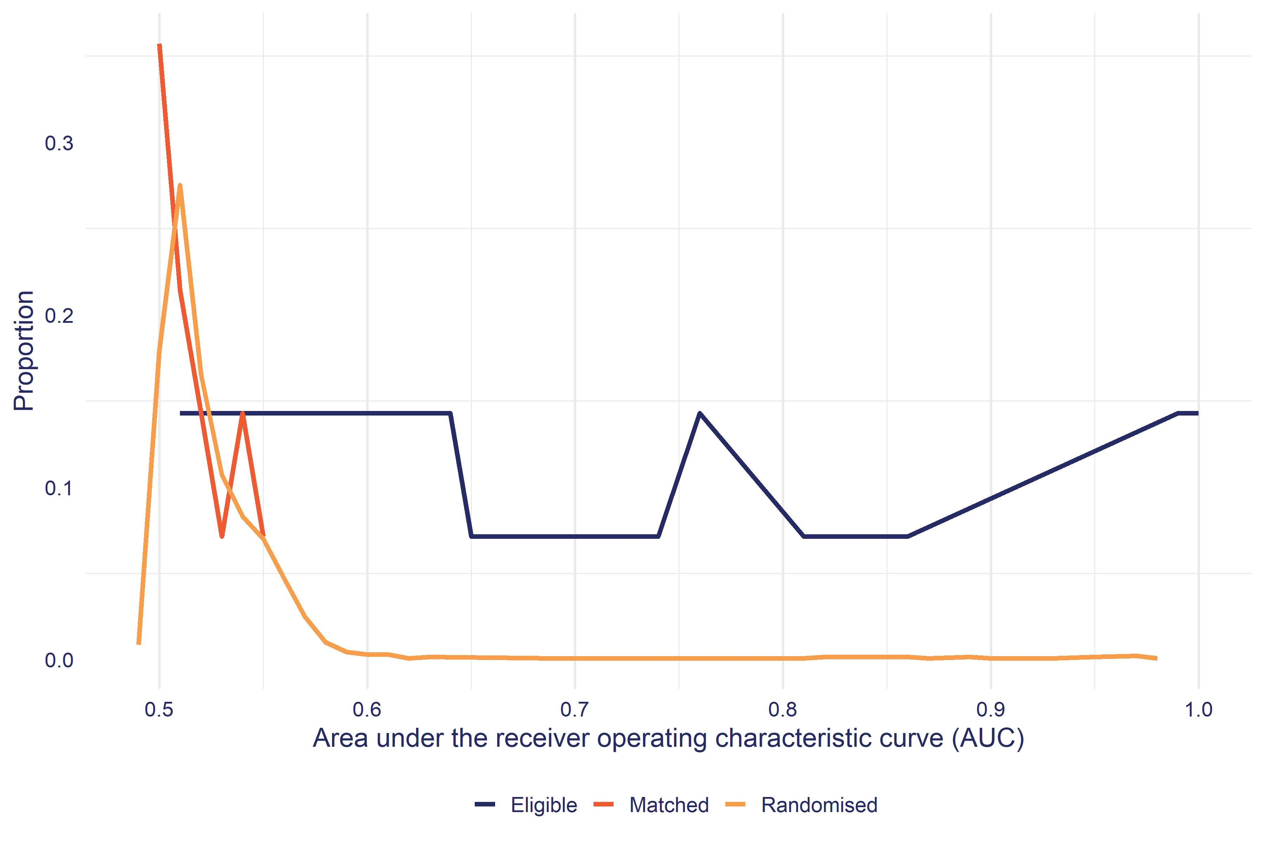

For each PSM cohort, the balance test fails if the PSM AUC is greater than the 95th percentile of the equivalent RCT AUC distribution. In other words, if the PSM AUC is less than the 95th percentile, we conclude it lies within the expected distribution of AUC where $P\left(D\right)⊥X$ is true. In the analysis section of this report, we only show the impacts for cohorts that have passed this balance test.

This is also the reason why the distribution of Matched AUC is to the left of the RCT AUC since we exclude any PSM where the Matched AUC exceeds the 95th percentile of the corresponding RCT. Accordingly the distribution of Matched AUC excludes those results where the balance test was poor and had a high AUC.

### IDI standard outcomes

Alongside the construction of credible comparison groups, the IDI also enables the tracking of meaningful outcomes. In this analysis we focus on the following outcome domains, with the specific outcome measure and its definition:

* **Drivers Licence** - Time spent holding full licence: Drivers licence is a graduated systems from learners to full.
* **Employment Assistance** - Employment assistance marginal cost: Estimated marginal cost of employment assistance received including the intervention being evaluated (marginal cost excludes indirect costs such as property and support services). Costs have been converted to real values based on SNZ general CPI index.
* **Employment** - In any employment: Employment is based on tax data (PAYE and annual tax returns). Periods with less than $100 of real (at report year) employment income per month are excluded. Annual returns are left censored to lapse period 0 if they start before the lapse period 0 calendar date.
* **Income** - Net income from all sources: Income includes taxable earnings, taxable and non-taxable income support payments including tax credits and pensions (but excluding recoverable assistance) and student allowance payments net of income tax.
* **Justice** - Time in any corrections service: Corrections services include prison, community sentence, and home detention.
* **NEET** - In Education Employment or Training: EET is in time spent in either education, employment or training. A person enrolled in education or training may not be attending (ie they have dropped out of the course). Employment of more than $100 per month is included. Annual returns are left censored to lapse period 0 if they start before the lapse period 0 calendar date.
* **Qualifications** - Average of highest NQF level achieved: For each person identify the highest NQF level awarded and calculate the average for the group. NQF levels start from 1 (year 11) through to 9 (PhD).
* **Study** - Enrolled in education or training: Education and training includes school, tertiary institutions and private training organisations. Enrolled does not always mean the person is attending.
* **Welfare** - Income Support expenditure: Income includes taxable and non-taxable income support payments including tax credits and pensions (but excluding recoverable assistance) net of income tax.

### Outcome follow up period

The above outcomes can be tracked over the period before starting FWSE through to a maximum of 6.4 years. The follow-up period is based on when the first cohort of participants started in FWSE (2013)[14] through to the most recent supply of administrative data to the IDI at time of publication (October 2023).

Because of the different ways agencies manage their administrative data, there are also considerable differences in how up to date administrative data is in the IDI. In particular, qualifications information is usually delayed by 18 months (eg information on qualifications gained in 2022 will be available in 2024).

It also follows that that follow up period will be longest for the initial cohort of participants who started FWSE in 2013 and shortest for the most recent cohort who started in 2024

### Interpretation of counterfactual impact estimates

It is important to keep in mind that the comparison group can and do receive other services and assistance. For the majority of impact evaluations, the comparison is not between a service or programme and no assistance, but instead, it compares a service, such as FWSE, against some level of alternative assistance. The level and type of alternative assistance has a bearing on how an impact estimate should be interpreted. For example, if a large proportion of the comparison group receives alternative assistance (such as in a drug trial) then a ‘no-impact’ finding does not mean the new intervention was ineffective, but instead, that it was as effective as current standard treatment.

In the context of FWSE, we can measure the level and amount of employment and related assistance from MSD that both participants and the comparison group receive. Likewise, we can also measure the level of education and training both groups receive through MOE and TEC data. These differences were covered in the results section. On the other hand, assistance through other agencies and NGOs that is not captured through the IDI will be missed in this analysis.

### Interval and cumulative impacts

It is useful at this point to explain how we analyse the outcomes relative to participation in EA interventions. The outcomes described above are all longitudinal in nature. Therefore, we have the ability to measure outcomes at multiple points in time rather than being limited to a small number of measurement periods as would be the case for survey-based outcome measures.

This flexibility allows us to track outcomes relative to participation start dates as shown in Figure 10. The first point to make is that we measure outcomes from when people start an intervention, and this is defined as zero on our timeline. Why we choose the start date as the zero point is explained below. From the zero point, we can then create a series of lapse periods that represent the periods before and after the participation start date. Based on this timeline, we can measure outcomes in two ways: interval and cumulative.

**Figure 10**: Tracking EA intervention outcomes using administrative data

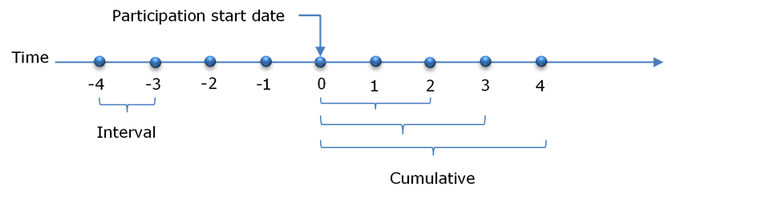

#### Interval outcomes

Interval outcomes are measured within a discrete lapse period, say the amount of income a person earned in the 12th month after starting an intervention. These intervals can vary in duration from one day to any period, but for EA interventions we usually use 30-day intervals.

Tracking interval outcomes is most useful in understanding the dynamic relationship between the intervention and the outcome in question. The purpose of EA interventions is to change the outcome trajectories of participants. Looking at how outcomes change in each lapse interval before and after commencing an intervention provides important information on the likely behavioural responses to the intervention.

#### Cumulative outcomes

While interval outcomes are useful to understand how outcomes and impacts change relative to when people start an intervention, they do not allow us to quantify the overall impact of an intervention. To make summary judgements we use cumulative outcomes. Cumulative outcomes are measured from participation start through to the end of each lapse period. Therefore, a cumulative 12-month outcome is for the entire 12 months from participation start.

#### Why measure outcomes from participation start?

A common question is why we measure outcomes from when people start an intervention, rather than when they finish. There are two reasons. The first is practical, namely that when people finish an intervention is often poorly recorded. Therefore, the date when people actually finish participating in an intervention is much less certain than the date they started.

The second reason is the importance of capturing the full impact of an intervention. The period while a person is on a programme can have an impact on their outcomes. The most common impact is referred to as the lock-in effect. As the name suggests, while people are participating in an intervention they are less likely to achieve an outcome, such as moving into employment. This can occur for a number of reasons. One is simply the reduction in time participants have to look for work. Another is the incentive to complete the programme. This effect is common for training programmes, where the need to complete the course to gain a qualification provides an incentive to turn down job opportunities if they do arise. If we did not include these effects, we run the risk of overstating the effectiveness of interventions.

# Appendix 1: example balance test results

The Table 19 shows the balance test for FWSE 2013-2016 starts. The * against comparison value indicates the simple difference is means is statistically significant.

**Table 19**: Summary of the profile of participants and matched comparison group for FWSE

| Variable | Level | Participant | Comparison | Difference |
| --- | --- | --- | --- | --- |
| Demographics: Age | | | | |
| Age | 18 to 29 years | 18.2% | 20.3% | 2.2ppt |
| 30 to 34 years | 15.2% | 14.3% | 0.9ppt |
| 35 to 44 years | 31.6% | 32.9% | 1.3ppt |
| 45 to 54 years | 23.4% | 22.5% | 0.9ppt |
| 55 to 64 years | 12.1% | 10.4% | 1.7ppt |
| Demographics: Gender | | | | |
| Gender | Female | 58.0% | 57.1% | 0.9ppt |
| Male | 42.0% | 42.9% | 0.9ppt |
| Demographics: Ethnicity | | | | |
| Ethnicity | Maori | 26.0% | 25.1% | 0.9ppt |
| Pacific | 12.1% | 12.1% | 0.0ppt |
| Asian | 8.2% | 10.4% | 2.2ppt |
| MELAA | 4.3% | 6.9% | 2.6ppt |
| European | 72.3% | 69.3% | 3.0ppt |
| Other | 2.6% | 0.9% | 1.7ppt |
| Education: School | | | | |
| School type | Correspondence | 0.9% | 0.9% | 0.0ppt |
| No school record | 83.1% | 83.1% | 0.0ppt |
| Other School | 16.0% | 16.0% | 0.0ppt |
| Schools attended | -0.01 to 0.01 | 83.1% | 83.1% | 0.0ppt |
| 0.02 to 15.3 | 17.3% | 17.3% | 0.0ppt |
| Suspensions | -0.01 to 0.01 | 99.1% | 98.7% | 0.4ppt |
| 0.02 to 6 | 0.9% | 0.9% | 0.0ppt |
| Number of stand-downs | -0.01 to 0.01 | 97.0% | 97.4% | 0.4ppt |
| 0.02 to 10 | 3.5% | 3.0% | 0.4ppt |
| Education: Tertiary study | | | | |
| Currently studying full or part time | Full time | 2.2% | 0.9% | 1.3ppt |
| Part time | 3.9% | 4.3% | 0.4ppt |
| Not studying | 93.9% | 94.8% | 0.9ppt |
| Currently studying at NZQF level | None | 93.9% | 94.8% | 0.9ppt |
| NZQF 1 plus | 6.1% | 5.2% | 0.9ppt |
| Total days enrolled in NZQF 1 to 3 courses | | 815 | 792 | 23.76 |
| Total days enrolled in NZQF 4 to 6 courses | | 814 | 677 | 137 |
| Total days enrolled in NZQF 7 plus courses | | 750 | 791 | 41.13 |
| Total days enrolled in unknown NZQF level courses | | 54.53 | 48.26 | 6.27 |
| Enrolled in study at 0 months before profile date | | 6.9% | 6.1% | 0.9ppt |
| Enrolled in study at 1 month before profile date | | 6.9% | 5.6% | 1.3ppt |
| Enrolled in study at 2 months before profile date | | 7.4% | 8.7% | 1.3ppt |
| Enrolled in study at 3 months before profile date | | 8.7% | 9.1% | 0.4ppt |
| Enrolled in study at 4 months before profile date | | 9.5% | 10.8% | 1.3ppt |
| Enrolled in study at 5 months before profile date | | 10.4% | 12.6% | 2.2ppt |
| Enrolled in study at 6 months before profile date | | 10.8% | 13.4% | 2.6ppt |
| Enrolled in study at 7 months before profile date | | 11.7% | 13.4% | 1.7ppt |
| Enrolled in study at 8 months before profile date | | 11.3% | 12.6% | 1.3ppt |
| Enrolled in study at 9 months before profile date | | 11.7% | 13.0% | 1.3ppt |
| Enrolled in study at 10 months before profile date | | 13.0% | 15.2% | 2.2ppt |
| Enrolled in study at 11 months before profile date | | 13.9% | 16.5% | 2.6ppt |
| Enrolled in study at 12 months before profile date | | 13.9% | 16.0% | 2.2ppt |
| Enrolled in study at 15 months before profile date | | 15.2% | 16.0% | 0.9ppt |
| Enrolled in study at 18 months before profile date | | 16.0% | 15.6% | 0.4ppt |
| Enrolled in study at 21 months before profile date | | 16.0% | 16.5% | 0.4ppt |
| Enrolled in study at 24 months before profile date | | 16.0% | 17.7% | 1.7ppt |
| Enrolled in study at 30 months before profile date | | 16.0% | 19.9% | 3.9ppt |
| Enrolled in study at 36 months before profile date | | 17.7% | 18.6% | 0.9ppt |
| Enrolled in study at 42 months before profile date | | 17.3% | 18.6% | 1.3ppt |
| Education: Qualifications | | | | |
| Highest qualification | School pre NZQF | 2.6% | 2.2% | 0.4ppt |
| NZQF 1 to 3 | 31.2% | 32.0% | 0.9ppt |
| NZQF 4 to 6 | 32.9% | 32.9% | 0.0ppt |
| NZQF 7 plus | 32.0% | 32.0% | 0.0ppt |
| Unknown | 1.3% | 1.3% | 0.0ppt |
| Highest qualification at 1 month before profile date | School pre NZQF 3 | 35.1% | 33.8% | 1.3ppt |
| NZQF 4 to 6 | 32.9% | 32.9% | 0.0ppt |
| NZQF 7 plus | 31.2% | 32.0% | 0.9ppt |
| Unknown | 1.3% | 1.3% | 0.0ppt |
| Highest qualification at 5 months before profile date | School pre NZQF 3 | 35.5% | 35.9% | 0.4ppt |
| NZQF 4 to 6 | 32.5% | 32.0% | 0.4ppt |
| NZQF 7 plus | 30.3% | 30.3% | 0.0ppt |
| Unknown | 1.7% | 1.7% | 0.0ppt |
| Highest qualification at 9 months before profile date | School pre NZQF 3 | 35.9% | 36.8% | 0.9ppt |
| NZQF 4 to 6 | 32.9% | 32.5% | 0.4ppt |
| NZQF 7 plus | 29.0% | 28.6% | 0.4ppt |
| Unknown | 1.7% | 2.6% | 0.9ppt |
| Highest qualification at 11 months before profile date | School pre NZQF 3 | 37.2% | 37.2% | 0.0ppt |
| NZQF 4 to 6 | 32.5% | 32.0% | 0.4ppt |
| NZQF 7 plus | 28.6% | 27.3% | 1.3ppt |
| Unknown | 2.2% | 3.9% | 1.7ppt |
| Highest qualification at 12 months before profile date | School pre NZQF 3 | 37.2% | 37.2% | 0.0ppt |
| NZQF 4 to 6 | 32.5% | 32.5% | 0.0ppt |
| NZQF 7 plus | 27.7% | 26.8% | 0.9ppt |
| Unknown | 2.2% | 3.9% | 1.7ppt |
| Highest qualification at 15 months before profile date | School pre NZQF 3 | 37.7% | 37.2% | 0.4ppt |
| NZQF 4 to 6 | 32.9% | 32.9% | 0.0ppt |
| NZQF 7 plus | 26.8% | 25.5% | 1.3ppt |
| Unknown | 2.6% | 4.3% | 1.7ppt |
| Highest qualification at 18 months before profile date | School pre NZQF 3 | 37.2% | 36.8% | 0.4ppt |
| NZQF 4 to 6 | 32.9% | 32.9% | 0.0ppt |
| NZQF 7 plus | 26.0% | 25.1% | 0.9ppt |
| Unknown | 3.5% | 5.2% | 1.7ppt |
| Highest qualification at 21 months before profile date | School pre NZQF 3 | 39.0% | 38.1% | 0.9ppt |
| NZQF 4 to 6 | 32.5% | 31.2% | 1.3ppt |
| NZQF 7 plus | 25.5% | 24.7% | 0.9ppt |
| Unknown | 3.5% | 5.6% | 2.2ppt |
| Highest qualification at 24 months before profile date | School pre NZQF 3 | 39.4% | 39.4% | 0.0ppt |
| NZQF 4 to 6 | 31.6% | 31.6% | 0.0ppt |
| NZQF 7 plus | 24.7% | 23.4% | 1.3ppt |
| Unknown | 4.3% | 6.5% | 2.2ppt |
| Highest qualification at 30 months before profile date | School pre NZQF 3 | 40.7% | 40.3% | 0.4ppt |
| NZQF 4 to 6 | 31.2% | 29.4% | 1.7ppt |
| NZQF 7 plus | 23.4% | 22.1% | 1.3ppt |
| Unknown | 4.3% | 7.8% | 3.5ppt |
| Highest qualification at 36 months before profile date | None | 0.9% | 0.9% | 0.0ppt |
| School pre NZQF 3 | 41.6% | 40.3% | 1.3ppt |
| NZQF 4 to 6 | 30.3% | 29.0% | 1.3ppt |
| NZQF 7 plus | 22.5% | 20.8% | 1.7ppt |
| Unknown | 5.6% | 8.7% | 3.0ppt |
| Highest qualification at 42 months before profile date | None | s | s | s |
| School pre NZQF 3 | 42.4% | 42.0% | 0.4ppt |
| NZQF 4 to 6 | 29.4% | 28.6% | 0.9ppt |
| NZQF 7 plus | 21.6% | 19.5% | 2.2ppt |
| Unknown | 5.6% | 9.1% | 3.5ppt |
| Health and disability: Incapacity information | | | | |
| Current incapacity for depression | | 1.7% | 2.6% | 0.9ppt |
| Current incapacity for digestive condition | | s | s | s |
| Current incapacity for musculoskeletal condition | | 1.7% | 1.7% | 0.0ppt |
| Current incapacity for nervous | | s | s | s |
| Current incapacity for other psychological | | 2.6% | 3.5% | 0.9ppt |
| Current incapacity for stress | | 0.9% | 1.7% | 0.9ppt |
| Incapacity for bipolar disorder in last 5 years | | 1.7% | 1.3% | 0.4ppt |
| Incapacity for circulatory condition in last 5 years | | s | s | s |
| Incapacity for depression in last 5 years | | 6.9% | 8.7% | 1.7ppt |
| Incapacity for digestive condition in last 5 years | | 1.7% | 2.2% | 0.4ppt |
| Incapacity for endocrine condition in last 5 years | | 1.3% | 1.3% | 0.0ppt |
| Incapacity for injury in last 5 years | | 3.5% | 4.3% | 0.9ppt |
| Incapacity for musculoskeletal condition in last 5 years | | 4.8% | 4.3% | 0.4ppt |
| Incapacity for nervous condition in last 5 years | | 1.3% | 0.9% | 0.4ppt |
| Incapacity for other psychological in last 5 years | | 10.4% | 11.3% | 0.9ppt |
| Incapacity for pregnancy in last 5 years | | 1.7% | 1.7% | 0.0ppt |
| Incapacity for respiratory condition in last 5 years | | s | s | s |
| Incapacity for stress in last 5 years | | 4.3% | 5.6% | 1.3ppt |
| Incapacity for substance abuse in last 5 years | | s | s | s |
| Other incapacity in last 5 years | | 1.7% | 1.3% | 0.4ppt |
| Unspecified incapacity in last 5 years | | 1.3% | 1.3% | 0.0ppt |
| Location: Deprivation index decile | | | | |
| Deprivation index of current address | Decile 1 to 2 | 10.4% | 10.8% | 0.4ppt |
| Decile 3 | 10.0% | 9.5% | 0.4ppt |
| Decile 4 | 9.5% | 8.2% | 1.3ppt |
| Decile 5 | 10.4% | 12.1% | 1.7ppt |
| Decile 6 | 9.5% | 11.3% | 1.7ppt |
| Decile 7 | 13.0% | 12.1% | 0.9ppt |
| Decile 8 | 13.0% | 13.9% | 0.9ppt |
| Decile 9 | 10.8% | 11.7% | 0.9ppt |
| Decile 10 | 12.1% | 10.8% | 1.3ppt |
| Overseas | s | s | s |
| Location: Urbanisation of location | | | | |
| Level of urbanisation of current address | Major urban area | 57.6% | 59.3% | 1.7ppt |
| Large urban area | 15.6% | 13.4% | 2.2ppt |
| Medium urban area | 3.5% | 4.3% | 0.9ppt |
| Small urban area | 6.9% | 7.8% | 0.9ppt |
| Rural settlement | 4.3% | 4.3% | 0.0ppt |
| Rural other | 11.7% | 10.4% | 1.3ppt |
| Overseas | s | s | s |
| Location: Local labour market | | | | |
| Working age dependency ratio | | 0.61 | 0.61 | 0.00 |
| Working age population employment rate | | 0.77 | 0.77 | 0.00 |
| Working age population in average income | | 52,564 | 51,480 | 1,084 |
| Working age population in employment or study rate | | 0.80 | 0.80 | 0.00 |
| Working age population in qualification level | | 4.65 | 4.67 | 0.01 |
| Working age population main benefit rate | | 0.12 | 0.12 | 0.00 |
| Housing: Number of address changes | | | | |
| Address changes in the last two years | 1 to 2 address changes | 38.1% | 38.1% | 0.0ppt |
| 3 address changes | 24.7% | 24.2% | 0.4ppt |
| 4 address changes | 15.2% | 15.2% | 0.0ppt |
| Over 4 address changes | 22.1% | 22.9% | 0.9ppt |
| Employment: Working life in employment | | | | |
| Proportion of adult life in New Zealand in employment | 0% | 2.6% | 4.3% | 1.7ppt |
| 1 to 19% | 8.7% | 10.0% | 1.3ppt |
| 20 to 29% | 8.7% | 10.4% | 1.7ppt |
| 30 to 39% | 9.5% | 10.0% | 0.4ppt |
| 40 to 49% | 8.7% | 8.7% | 0.0ppt |
| 50 to 59% | 11.3% | 8.7% | 2.6ppt |
| 60 to 69% | 11.3% | 13.9% | 2.6ppt |
| 70 to 79% | 12.6% | 13.0% | 0.4ppt |
| 80 to 89% | 10.8% | 9.1% | 1.7ppt |
| 90% plus | 16.9% | 13.0% | 3.9ppt |
| Employment: Employment history | | | | |
| Employed at 0 months before profile date | | 53.2% | 44.6% | 8.7ppt |
| Employed at 1 month before profile date | | 49.8% | 39.8% | 10.0ppt |
| Employed at 2 months before profile date | | 48.1% | 39.0% | 9.1ppt |
| Employed at 3 months before profile date | | 46.8% | 40.3% | 6.5ppt |
| Employed at 4 months before profile date | | 45.5% | 38.5% | 6.9ppt |
| Employed at 5 months before profile date | | 42.9% | 37.2% | 5.6ppt |
| Employed at 6 months before profile date | | 42.0% | 39.0% | 3.0ppt |
| Employed at 7 months before profile date | | 43.3% | 39.4% | 3.9ppt |
| Employed at 8 months before profile date | | 43.3% | 40.3% | 3.0ppt |
| Employed at 9 months before profile date | | 43.3% | 40.7% | 2.6ppt |
| Employed at 10 months before profile date | | 44.6% | 44.2% | 0.4ppt |
| Employed at 11 months before profile date | | 45.0% | 46.8% | 1.7ppt |
| Employed at 12 months before profile date | | 45.9% | 46.8% | 0.9ppt |
| Employed at 15 months before profile date | | 47.2% | 47.2% | 0.0ppt |
| Employed at 18 months before profile date | | 50.2% | 50.2% | 0.0ppt |
| Employed at 21 months before profile date | | 49.8% | 47.6% | 2.2ppt |
| Employed at 24 months before profile date | | 50.2% | 46.3% | 3.9ppt |
| Employed at 30 months before profile date | | 50.2% | 48.1% | 2.2ppt |
| Employed at 36 months before profile date | | 50.2% | 44.2% | 6.1ppt |
| Employed at 42 months before profile date | | 50.2% | 46.3% | 3.9ppt |
| Income Support: Current benefit status | | | | |
| Current main benefit type | Jobseeker Support Work Ready | 58.4% | 59.7% | 1.3ppt |
| Sole Parent Support | 21.2% | 17.7% | 3.5ppt |
| Jobseeker Support HCD | 10.8% | 10.8% | 0.0ppt |
| Supported Living Payment | 2.6% | 3.0% | 0.4ppt |
| Caring For Sick Or Infirm | s | s | s |
| Off Benefit | 6.5% | 8.2% | 1.7ppt |
| Income Support: Benefit duration | | | | |
| Duration on current benefit | | 417 | 386 | 31.71 |
| Income Support: Recent benefit history | | | | |
| Previous benefit type | Off Benefit | 79.7% | 75.8% | 3.9ppt |
| Jobseeker Support Work Ready | 5.6% | 6.5% | 0.9ppt |
| Sole Parent Support | 3.9% | 5.6% | 1.7ppt |
| Jobseeker Support HCD | 10.4% | 10.4% | 0.0ppt |
| Jobseeker Support Student | s | s | s |
| Income Support: Total benefit contact | | | | |
| Proportion of adult life on carer related benefits | -0.01 to 0.01 | 98.7% | 98.7% | 0.0ppt |
| 0.02 to 1.3 | 1.3% | 0.9% | 0.4ppt |
| Proportion of adult life on invalid related benefits | -0.01 to 0.01 | 96.1% | 96.1% | 0.0ppt |
| 0.02 to 2 | 4.3% | 4.3% | 0.0ppt |
| Proportion of adult life on job seeker related benefits | | 0.11 | 0.10 | 0.01 |
| Proportion of adult life on sickness related benefits | | 0.04 | 0.04 | 0.00 |
| Proportion of adult life on sole parent related benefits | | 0.11 | 0.10 | 0.00 |
| Proportion of adult life on student related benefits | | 0.00 | 0.00 | 0.00 |
| Proportion of adult life on youth related benefits | -0.01 to 0.01 | 97.0% | 97.8% | 0.9ppt |
| 0.02 to 1.41 | 3.5% | 2.2% | 1.3ppt |
| Income Support: First benefit information | | | | |
| First type of main benefit granted | Youth | 6.9% | 4.8% | 2.2ppt |
| Jobseeker Support Work Ready | 58.4% | 58.4% | 0.0ppt |
| Jobseeker Support HCD | 13.9% | 12.6% | 1.3ppt |
| Jobseeker Support Student | 6.1% | 4.8% | 1.3ppt |
| Sole Parent Support | 10.8% | 14.3% | 3.5ppt |
| Off Benefit | 3.9% | 5.2% | 1.3ppt |
| Income Support: Childhood benefit receipt | | | | |
| Childhood benefit (0-4) | No time on main benefit | 10.8% | 13.9% | 3.0ppt |
| Under 75% of the period | 8.2% | 6.9% | 1.3ppt |
| Over age range by 1 Janurary 1993 | 81.4% | 79.7% | 1.7ppt |
| Childhood benefit (4-8) | No time on main benefit | 22.9% | 29.0% | 6.1ppt |
| Under 75% of the period | 10.8% | 9.5% | 1.3ppt |
| Over 75% of the period | 10.0% | 8.7% | 1.3ppt |
| Over age range by 1 Janurary 1993 | 56.3% | 53.7% | 2.6ppt |
| Childhood benefit (12-16) | No time on main benefit | 15.6% | 18.6% | 3.0ppt |
| Under 75% of the period | 6.5% | 5.2% | 1.3ppt |
| Over 75% of the period | 8.2% | 6.9% | 1.3ppt |
| Over age range by 1 Janurary 1993 | 69.7% | 69.3% | 0.4ppt |
| Childhood benefit (16-18) | No time on main benefit | 33.3% | 39.0% | 5.6ppt |
| Under 25% of the period | 6.1% | 5.6% | 0.4ppt |
| 25 to 75% of the period | 6.5% | 4.3% | 2.2ppt |
| Over 75% of the period | 10.8% | 9.5% | 1.3ppt |
| Over age range by 1 Janurary 1993 | 43.3% | 41.1% | 2.2ppt |
| Income Support: Income support history | | | | |
| Time on main benefit or pension at 0 months before profile date | | 28.84 | 28.77 | 0.07 |
| Time on main benefit or pension at 1 month before profile date | | 28.94 | 28.84 | 0.09 |
| Time on main benefit or pension at 2 months before profile date | | 28.49 | 28.17 | 0.32 |
| Time on main benefit or pension at 3 months before profile date | | 28.12 | 27.24 | 0.88 |
| Time on main benefit or pension at 4 months before profile date | | 27.18 | 26.23 | 0.96 |
| Time on main benefit or pension at 5 months before profile date | | 26.10 | 24.84 | 1.27 |
| Time on main benefit or pension at 6 months before profile date | | 24.46 | 22.97 | 1.48 |
| Time on main benefit or pension at 7 months before profile date | | 22.45 | 21.73 | 0.73 |
| Time on main benefit or pension at 8 months before profile date | | 20.85 | 20.19 | 0.67 |
| Time on main benefit or pension at 9 months before profile date | | 19.72 | 18.93 | 0.80 |
| Time on main benefit or pension at 10 months before profile date | | 18.77 | 18.54 | 0.23 |
| Time on main benefit or pension at 11 months before profile date | | 17.98 | 18.18 | 0.20 |
| Time on main benefit or pension at 12 months before profile date | | 17.49 | 17.29 | 0.20 |
| Time on main benefit or pension at 15 months before profile date | | 15.31 | 15.50 | 0.19 |
| Time on main benefit or pension at 18 months before profile date | | 13.76 | 14.08 | 0.32 |
| Time on main benefit or pension at 21 months before profile date | | 12.87 | 13.07 | 0.19 |
| Time on main benefit or pension at 24 months before profile date | | 12.78 | 12.73 | 0.06 |
| Time on main benefit or pension at 30 months before profile date | | 10.65 | 10.40 | 0.24 |
| Time on main benefit or pension at 36 months before profile date | | 10.12 | 9.88 | 0.23 |
| Time on main benefit or pension at 42 months before profile date | | 9.38 | 8.87 | 0.51 |
| Justice: Police offences | | | | |
| Number of offences | | 1.40 | 1.14 | 0.26 |
| Time since last offence | Never | 70.6% | 71.9% | 1.3ppt |
| Under 2 years | 8.2% | 8.2% | 0.0ppt |
| 2 to under 4 years | 7.4% | 7.8% | 0.4ppt |
| 4 to under 6 years | 6.1% | 5.6% | 0.4ppt |
| Over 6 years | 6.9% | 6.9% | 0.0ppt |
| Over 10 years | 0.9% | 0.9% | 0.0ppt |
| Most serious offence score | | 56.08 | 63.20 | 7.12 |
| Age of first arrest | Never | 70.6% | 71.9% | 1.3ppt |
| 10 to 24 years | 9.5% | 10.0% | 0.4ppt |
| 25 to 34 years | 10.4% | 9.1% | 1.3ppt |
| 35 to 44 years | 5.6% | 5.6% | 0.0ppt |
| 45 to 64 years | 3.5% | 3.9% | 0.4ppt |
| Justice: Corrections spells | | | | |
| Total time in prison | -0.01 to 0.01 | 92.6% | 95.2% | 2.6ppt |
| 0.02 to 6581 | 6.9% | 5.2% | 1.7ppt |
| Total time in home detention | -0.01 to 0.01 | 97.8% | 97.0% | 0.9ppt |
| 0.02 to 359 | 2.6% | 3.5% | 0.9ppt |
| Total time in community service | | 172 | 158 | 13.12 |
| Age at first Correction service | Never | 77.5% | 80.1% | 2.6ppt |
| 15 to 19 years | 6.9% | 5.2% | 1.7ppt |
| 20 to 24 years | 6.1% | 6.9% | 0.9ppt |
| 25 to 34 years | 5.6% | 4.3% | 1.3ppt |
| 35 to 64 years | 3.5% | 3.5% | 0.0ppt |
| Time since last Corrections involvement | Never | 80.1% | 83.1% | 3.0ppt |
| Under 3 years | 6.1% | 4.3% | 1.7ppt |
| 3 to under 8 years | 6.9% | 6.5% | 0.4ppt |
| Over 8 years | 6.5% | 6.1% | 0.4ppt |
| Justice: Youth Justice | | | | |
| Time in Youth Justice placements | No placement | 65.4% | 66.2% | 0.9ppt |
| Over age range by 1 January 1991 | 34.6% | 34.2% | 0.4ppt |
| Youth Justice referrals | No referrals | 62.3% | 62.3% | 0.0ppt |
| One referral | 1.7% | 1.3% | 0.4ppt |
| Two to four referrals | 1.7% | 2.2% | 0.4ppt |
| Over age range by 1 January 1991 | 34.6% | 34.2% | 0.4ppt |
| Justice: Corrections history | | | | |
| In correction service at 0 months before profile date | Non Prison | 3.0% | 3.0% | 0.0ppt |
| None | 97.0% | 97.4% | 0.4ppt |
| In correction service at 1 month before profile date | Non Prison | 3.0% | 3.0% | 0.0ppt |
| None | 97.0% | 97.4% | 0.4ppt |
| In correction service at 2 months before profile date | Non Prison | 3.0% | 3.5% | 0.4ppt |
| None | 97.0% | 96.5% | 0.4ppt |
| In correction service at 3 months before profile date | Non Prison | 3.0% | 3.5% | 0.4ppt |
| None | 97.4% | 96.5% | 0.9ppt |
| In correction service at 4 months before profile date | Non Prison | 3.0% | 3.5% | 0.4ppt |
| None | 97.0% | 96.5% | 0.4ppt |
| In correction service at 5 months before profile date | Non Prison | 3.5% | 3.5% | 0.0ppt |
| None | 97.0% | 96.5% | 0.4ppt |
| In correction service at 6 months before profile date | Non Prison | 2.6% | 3.5% | 0.9ppt |
| None | 97.8% | 97.0% | 0.9ppt |
| In correction service at 7 months before profile date | Non Prison | 2.6% | 3.0% | 0.4ppt |
| None | 97.4% | 97.0% | 0.4ppt |
| In correction service at 8 months before profile date | Non Prison | 2.2% | 3.0% | 0.9ppt |
| None | 97.8% | 97.4% | 0.4ppt |
| In correction service at 9 months before profile date | Non Prison | 2.6% | 3.0% | 0.4ppt |
| None | 97.8% | 97.4% | 0.4ppt |
| In correction service at 12 months before profile date | Non Prison | 2.6% | 2.6% | 0.0ppt |
| None | 97.8% | 97.4% | 0.4ppt |
| In correction service at 15 months before profile date | Prison | s | s | s |
| Non Prison | 2.2% | 2.6% | 0.4ppt |
| None | 97.4% | 97.0% | 0.4ppt |
| In correction service at 18 months before profile date | Prison | s | s | s |
| Non Prison | 2.6% | 3.0% | 0.4ppt |
| None | 97.0% | 97.0% | 0.0ppt |
| In correction service at 21 months before profile date | Prison | s | s | s |
| Non Prison | 3.0% | 3.0% | 0.0ppt |
| None | 97.0% | 97.4% | 0.4ppt |
| In correction service at 24 months before profile date | Prison | s | s | s |
| Non Prison | 3.0% | 3.0% | 0.0ppt |
| None | 96.1% | 97.0% | 0.9ppt |
| In correction service at 30 months before profile date | Prison | s | s | s |
| Non Prison | 3.5% | 2.6% | 0.9ppt |
| None | 96.1% | 97.4% | 1.3ppt |
| In correction service at 36 months before profile date | Non Prison | 3.0% | 1.3% | 1.7ppt |
| None | 97.4% | 98.7% | 1.3ppt |
| In correction service at 42 months before profile date | Non Prison | 2.6% | 1.7% | 0.9ppt |
| None | 97.8% | 98.7% | 0.9ppt |
| Residency: Migrant status | | | | |
| Proportion of life living in New Zealand | | 0.81 | 0.76 | 0.04 |
| Age at first arrival in New Zealand | Born in NZ | 77.5% | 71.0% | 6.5ppt |
| 5 to 24 years | 7.8% | 10.4% | 2.6ppt |
| 25 to 34 years | 9.1% | 12.6% | 3.5ppt |
| 35 to 54 years | 6.1% | 6.1% | 0.0ppt |
| Arrived as a refugee | | s | s | s |
| Migrant's region of origin | New Zealand | 83.5% | 77.5% | 6.1ppt |
| Oceania | 4.3% | 4.8% | 0.4ppt |
| Asia | 5.2% | 9.1% | 3.9ppt |
| Europe | 1.3% | 3.0% | 1.7ppt |
| United Kingdom | 3.0% | 4.3% | 1.3ppt |
| Americas | s | s | s |
| Africa | 2.2% | 0.9% | 1.3ppt |
| Visa when first arriving in New Zealand | Citizen | 80.1% | 74.5% | 5.6ppt |
| Resident | 10.8% | 12.6% | 1.7ppt |
| Temporary | 9.1% | 13.0% | 3.9ppt |
| Income: Income history | | | | |
| Income support payments at 0 months before profile date | | 1,495 | 1,401 | 93.30 |
| Income support payments at 1 month before profile date | | 1,513 | 1,441 | 72.13 |
| Income support payments at 2 months before profile date | | 1,477 | 1,389 | 87.86 |
| Income support payments at 3 months before profile date | | 1,460 | 1,346 | 114 |
| Income support payments at 4 months before profile date | | 1,394 | 1,280 | 114 |
| Income support payments at 5 months before profile date | | 1,347 | 1,214 | 133 |
| Income support payments at 6 months before profile date | | 1,253 | 1,151 | 102 |
| Income support payments at 7 months before profile date | | 1,165 | 1,089 | 75.39 |
| Income support payments at 8 months before profile date | | 1,090 | 1,010 | 79.84 |
| Income support payments at 9 months before profile date | | 1,023 | 949 | 74.18 |
| Income support payments at 10 months before profile date | | 1,000 | 962 | 37.89 |
| Income support payments at 11 months before profile date | | 940 | 915 | 24.29 |
| Income support payments at 12 months before profile date | | 920 | 885 | 35.06 |
| Income support payments at 15 months before profile date | | 826 | 794 | 31.84 |
| Income support payments at 18 months before profile date | | 769 | 763 | 6.23 |
| Income support payments at 21 months before profile date | | 704 | 699 | 5.37 |
| Income support payments at 24 months before profile date | | 679 | 651 | 27.77 |
| Income support payments at 30 months before profile date | | 582 | 577 | 4.66 |
| Income support payments at 36 months before profile date | | 549 | 519 | 29.92 |
| Income support payments at 42 months before profile date | | 527 | 483 | 43.66 |
| Income transfer payments (yearly average) | | 12,335 | 9,988 | 2,347 |
| Labour market income (yearly average) | | 15,472 | 13,203 | 2,269 |
| Net child support payments (yearly average) | | 112 | 111 | 0.98 |
| Net income at 0 months before profile date | | 2,662 | 2,520 | 142 |
| Net income at 1 month before profile date | | 2,615 | 2,466 | 149 |
| Net income at 2 months before profile date | | 2,565 | 2,457 | 108 |
| Net income at 3 months before profile date | | 2,527 | 2,430 | 96.06 |
| Net income at 4 months before profile date | | 2,417 | 2,327 | 89.18 |
| Net income at 5 months before profile date | | 2,361 | 2,244 | 117 |
| Net income at 6 months before profile date | | 2,359 | 2,316 | 43.04 |
| Net income at 7 months before profile date | | 2,331 | 2,249 | 81.97 |
| Net income at 8 months before profile date | | 2,348 | 2,254 | 94.10 |
| Net income at 9 months before profile date | | 2,391 | 2,299 | 92.00 |
| Net income at 10 months before profile date | | 2,428 | 2,476 | 48.70 |
| Net income at 11 months before profile date | | 2,364 | 2,421 | 56.55 |
| Net income at 12 months before profile date | | 2,458 | 2,459 | 1.32 |
| Net income at 15 months before profile date | | 2,398 | 2,379 | 18.98 |
| Net income at 18 months before profile date | | 2,453 | 2,461 | 7.29 |
| Net income at 21 months before profile date | | 2,493 | 2,480 | 12.94 |
| Net income at 24 months before profile date | | 2,476 | 2,281 | 195 |
| Net income at 30 months before profile date | | 2,340 | 2,190 | 149 |
| Net income at 36 months before profile date | | 2,240 | 2,017 | 223 |
| Net income at 42 months before profile date | | 2,186 | 1,979 | 207 |
| Labour market income at 0 months before profile date | | 466 | 450 | 16.51 |
| Labour market income at 1 month before profile date | | 409 | 375 | 33.55 |
| Labour market income at 2 months before profile date | | 402 | 389 | 12.81 |
| Labour market income at 3 months before profile date | | 384 | 382 | 1.58 |
| Labour market income at 4 months before profile date | | 362 | 332 | 29.54 |
| Labour market income at 5 months before profile date | | 363 | 333 | 29.73 |
| Labour market income at 6 months before profile date | | 461 | 467 | 5.93 |
| Labour market income at 7 months before profile date | | 525 | 467 | 57.90 |
| Labour market income at 8 months before profile date | | 615 | 544 | 70.90 |
| Labour market income at 9 months before profile date | | 739 | 670 | 68.42 |
| Labour market income at 10 months before profile date | | 796 | 825 | 29.46 |
| Labour market income at 11 months before profile date | | 809 | 849 | 39.61 |
| Labour market income at 12 months before profile date | | 931 | 937 | 5.72 |
| Labour market income at 15 months before profile date | | 984 | 1,021 | 37.23 |
| Labour market income at 18 months before profile date | | 1,102 | 1,095 | 7.55 |
| Labour market income at 21 months before profile date | | 1,211 | 1,194 | 17.06 |
| Labour market income at 24 months before profile date | | 1,242 | 1,075 | 166 |
| Labour market income at 30 months before profile date | | 1,247 | 1,126 | 121 |
| Labour market income at 36 months before profile date | | 1,214 | 1,058 | 155 |
| Labour market income at 42 months before profile date | | 1,227 | 1,097 | 129 |
| Net child support payments at 0 months before profile date | | 36.21 | 39.25 | 3.04 |
| Net child support payments at 1 month before profile date | | 34.72 | 37.58 | 2.86 |
| Net child support payments at 2 months before profile date | | 35.48 | 39.38 | 3.90 |
| Net child support payments at 3 months before profile date | | 33.71 | 37.48 | 3.77 |
| Net child support payments at 4 months before profile date | | 28.98 | 32.60 | 3.61 |
| Net child support payments at 5 months before profile date | | 25.49 | 32.13 | 6.63 |
| Net child support payments at 6 months before profile date | | 23.65 | 31.87 | 8.22 |
| Net child support payments at 7 months before profile date | | 23.73 | 30.80 | 7.07 |
| Net child support payments at 8 months before profile date | | 23.26 | 29.62 | 6.36 |
| Net child support payments at 9 months before profile date | | 23.73 | 28.07 | 4.35 |
| Net child support payments at 10 months before profile date | | 21.84 | 26.82 | 4.98 |
| Net child support payments at 11 months before profile date | | 20.28 | 24.71 | 4.43 |
| Net child support payments at 12 months before profile date | | 18.83 | 28.42 | 9.60 |
| Net child support payments at 15 months before profile date | | 12.37 | 18.80 | 6.42 |
| Net child support payments at 18 months before profile date | | 16.17 | 21.25 | 5.07 |
| Net child support payments at 21 months before profile date | | 15.73 | 20.15 | 4.42 |
| Net child support payments at 24 months before profile date | | 14.13 | 12.56 | 1.56 |
| Net child support payments at 30 months before profile date | | 9.88 | 12.88 | 3.00 |
| Net child support payments at 36 months before profile date | | 8.26 | 9.79 | 1.54 |
| Net child support payments at 42 months before profile date | | 9.54 | 11.49 | 1.95 |
| Overseas: Overseas history | | | | |
| Overseas at 0 months before profile date | | 2.6% | 1.7% | 0.9ppt |
| Overseas at 1 month before profile date | | 2.2% | 2.6% | 0.4ppt |
| Overseas at 2 months before profile date | | 2.6% | 2.6% | 0.0ppt |
| Overseas at 3 months before profile date | | 2.6% | 2.6% | 0.0ppt |
| Overseas at 4 months before profile date | | 3.5% | 3.5% | 0.0ppt |
| Overseas at 5 months before profile date | | 4.8% | 4.8% | 0.0ppt |
| Overseas at 6 months before profile date | | 4.3% | 3.5% | 0.9ppt |
| Overseas at 7 months before profile date | | 5.2% | 5.2% | 0.0ppt |
| Overseas at 8 months before profile date | | 6.5% | 4.8% | 1.7ppt |
| Overseas at 9 months before profile date | | 6.9% | 4.8% | 2.2ppt |
| Overseas at 10 months before profile date | | 6.9% | 5.2% | 1.7ppt |
| Overseas at 11 months before profile date | | 8.2% | 6.1% | 2.2ppt |
| Overseas at 12 months before profile date | | 9.1% | 8.2% | 0.9ppt |
| Overseas at 15 months before profile date | | 7.8% | 6.5% | 1.3ppt |
| Overseas at 18 months before profile date | | 9.5% | 6.5% | 3.0ppt |
| Overseas at 21 months before profile date | | 8.7% | 6.9% | 1.7ppt |
| Overseas at 24 months before profile date | | 9.5% | 8.2% | 1.3ppt |
| Overseas at 30 months before profile date | | 10.4% | 9.1% | 1.3ppt |
| Overseas at 36 months before profile date | | 12.1% | 11.7% | 0.4ppt |
| Overseas at 42 months before profile date | | 10.8% | 11.3% | 0.4ppt |
| Employment assistance: Participation in employment assistance | | | | |
| Employment assistance expenditure at 0 months before profile date | | 363 | 227 | 136 |
| Employment assistance expenditure at 1 month before profile date | | 238 | 209 | 28.99 |
| Employment assistance expenditure at 2 months before profile date | | 166 | 210 | 43.43 |
| Employment assistance expenditure at 3 months before profile date | | 171 | 204 | 32.89 |
| Employment assistance expenditure at 4 months before profile date | | 124 | 197 | 73.03 |
| Employment assistance expenditure at 5 months before profile date | | 93.97 | 105 | 10.82 |
| Employment assistance expenditure at 6 months before profile date | | 74.91 | 63.29 | 11.61 |
| Employment assistance expenditure at 7 months before profile date | | 59.58 | 84.42 | 24.84 |
| Employment assistance expenditure at 8 months before profile date | | 62.54 | 67.97 | 5.42 |
| Employment assistance expenditure at 9 months before profile date | | 50.10 | 90.31 | 40.21 |
| Employment assistance expenditure at 10 months before profile date | | 45.90 | 73.98 | 28.08 |
| Employment assistance expenditure at 11 months before profile date | | 54.32 | 676 | 621 |
| Employment assistance expenditure at 12 months before profile date | | 29.29 | 39.63 | 10.35 |
| Employment assistance expenditure at 15 months before profile date | | 31.63 | 75.17 | 43.54 |
| Employment assistance expenditure at 18 months before profile date | | 25.01 | 18.98 | 6.03 |
| Employment assistance expenditure at 21 months before profile date | | 18.04 | 12.65 | 5.40 |
| Employment assistance expenditure at 24 months before profile date | | 13.77 | 8.37 | 5.40 |
| Employment assistance expenditure at 30 months before profile date | | 21.31 | 13.96 | 7.35 |
| Employment assistance expenditure at 36 months before profile date | | 14.02 | 7.48 | 6.54 |
| Employment assistance expenditure at 42 months before profile date | | 16.42 | 17.09 | 0.67 |
| Care and Protection: Care notifications | | | | |
| Care notifications (0-3 years) | One four notifications | 1.7% | 0.9% | 0.9ppt |
| No notifications | 22.5% | 23.8% | 1.3ppt |
| Over age range by 1 January 1991 | 75.8% | 75.3% | 0.4ppt |
| Care notifications (4-7 years) | One more notifications | 3.0% | 2.2% | 0.9ppt |
| No notifications | 34.6% | 38.1% | 3.5ppt |
| Over age range by 1 January 1991 | 62.8% | 59.7% | 3.0ppt |
| Care notifications (8-11 years) | One more notifications | 3.0% | 3.0% | 0.0ppt |
| No notifications | 46.3% | 51.1% | 4.8ppt |
| Over age range by 1 January 1991 | 50.6% | 45.9% | 4.8ppt |
| Care notifications (12-15 years) | One four notifications | 5.6% | 4.3% | 1.3ppt |
| No notifications | 56.7% | 58.9% | 2.2ppt |
| Over age range by 1 January 1991 | 37.2% | 36.8% | 0.4ppt |
| Care and Protection: Care placements in childhood | | | | |
| Time in care (0-3 years) | No placement | 24.2% | 24.7% | 0.4ppt |
| Over age range by 1 January 1991 | 75.8% | 75.3% | 0.4ppt |
| Time in care (4-7 years) | No placement | 37.2% | 40.3% | 3.0ppt |
| Over age range by 1 January 1991 | 62.8% | 59.7% | 3.0ppt |
| Time in care (8-11 years) | No placement | 49.8% | 54.1% | 4.3ppt |
| Over age range by 1 January 1991 | 50.6% | 45.9% | 4.8ppt |
| Time in care (12-15 years) | No placement | 62.8% | 63.2% | 0.4ppt |
| Over age range by 1 January 1991 | 37.2% | 36.8% | 0.4ppt |
| Transport: Private driver licence | | | | |
| Driver licence status at 3 months before profile date | Full | 69.3% | 69.7% | 0.4ppt |
| Restricted | 14.3% | 12.6% | 1.7ppt |
| Learner | 10.0% | 11.7% | 1.7ppt |
| No licence | 6.5% | 6.5% | 0.0ppt |
| Driver licence status at 10 months before profile date | Full | 68.4% | 69.3% | 0.9ppt |
| Restricted | 14.3% | 12.1% | 2.2ppt |
| Learner | 10.8% | 11.7% | 0.9ppt |
| No licence | 6.5% | 6.9% | 0.4ppt |
| Driver licence status at 12 months before profile date | Full | 67.5% | 67.5% | 0.0ppt |
| Restricted | 14.7% | 13.0% | 1.7ppt |
| Learner | 10.8% | 11.7% | 0.9ppt |
| No licence | 6.9% | 7.8% | 0.9ppt |
| Driver licence status at 15 months before profile date | Full | 67.1% | 66.7% | 0.4ppt |
| Restricted | 15.2% | 13.9% | 1.3ppt |
| Learner | 10.8% | 11.7% | 0.9ppt |
| No licence | 7.4% | 8.7% | 1.3ppt |
| Driver licence status at 18 months before profile date | Full | 66.7% | 65.8% | 0.9ppt |
| Restricted | 15.2% | 13.9% | 1.3ppt |
| Learner | 10.8% | 12.1% | 1.3ppt |
| No licence | 7.8% | 8.2% | 0.4ppt |
| Driver licence status at 21 months before profile date | Full | 65.8% | 65.4% | 0.4ppt |
| Restricted | 15.2% | 13.9% | 1.3ppt |
| Learner | 11.3% | 12.1% | 0.9ppt |
| No licence | 7.8% | 9.1% | 1.3ppt |
| Driver licence status at 24 months before profile date | Full | 64.9% | 64.9% | 0.0ppt |
| Restricted | 15.6% | 13.9% | 1.7ppt |
| Learner | 11.3% | 11.3% | 0.0ppt |
| No licence | 8.2% | 10.4% | 2.2ppt |
| Driver licence status at 30 months before profile date | Full | 63.6% | 62.8% | 0.9ppt |
| Restricted | 15.2% | 12.6% | 2.6ppt |
| Learner | 12.6% | 13.0% | 0.4ppt |
| No licence | 8.7% | 11.7% | 3.0ppt |
| Driver licence status at 36 months before profile date | Full | 63.2% | 61.9% | 1.3ppt |
| Restricted | 13.9% | 12.1% | 1.7ppt |
| Learner | 13.4% | 13.4% | 0.0ppt |
| No licence | 9.5% | 12.6% | 3.0ppt |
| Driver licence status at 42 months before profile date | Full | 61.9% | 61.0% | 0.9ppt |
| Restricted | 14.7% | 12.1% | 2.6ppt |
| Learner | 13.0% | 13.0% | 0.0ppt |
| No licence | 10.4% | 13.9% | 3.5ppt |
| Transport: Commercial driver licence | | | | |
| Commercial drivers licence status | Full | 6.5% | 6.5% | 0.0ppt |
| Learner | 0.9% | 3.0% | 2.2ppt |
| No licence | 92.6% | 90.9% | 1.7ppt |
| a. Participant: mean value for the participant group. b. Comparison: mean value for the matched comparison group. c. Difference: difference between participant and comparison means. d. s: supressed for IDI confidentiality.  **Source**: MSD, Statistics New Zealand IDI | | | | |

# References

Bell, S. & Orr, L. (2002) Screening (and creaming?) applicants to job training programs: The AFDC homemaker-home health aide demonstrations, Economics, 9(2), 279-301, url:<https://doi.org/10.1016/S0927-5371(02)00006-4>

Borland, J. (2016) Wage Subsidy Programs: A Primer, Australian Journal of Labour Economics, Volume 19, Number 3, url:<http://ftprepec.drivehq.com/ozl/journl/downloads/AJLE193borland.pdf>

Brown, A. & Koettl J. (2015) Active labor market programs - employment gain or fiscal drain, IZA Journal of Labor Economics, 4:12, 1-36, url:<https://izajole.springeropen.com/articles/10.1186/s40172-015-0025-5>

Bryson, A.<U+FFFD>Dorsett, R. &<U+FFFD>Purdon, S. (2002) The use of propensity score matching in the evaluation of active labour market policies, Department for Work and Pensions working paper (4), Department for Work and Pensions, London, url:<http://eprints.lse.ac.uk/4993/>

Caliendo, M. & Künn, S. (2011) Start-up subsidies for the unemployed: Long-term evidence and effect heterogeneity, Journal of Public Economics, Volume 95, Issues 3-4, April 2011, Pages 311-331, url:<https://doi.org/10.1016/j.jpubeco.2010.11.003>

Curtin, M. (1996) A Review of Enterprise Allowance and the Capitalisation Option, New Zealand Employment Service, Wellington (File ref:A135418)

Desiere, S. Langenbucher, K. & Struyven, L. (2019) Statistical profiling in public employment services: An international comparison, OECD Social, Employment and Migration Working Papers, No. 224, OECD Publishing, Paris, url:<https://doi.org/10.1787/b5e5f16e-en>.

Dvouletý, O. & Lukeš, M. (2016) Review of Empirical Studies on Self Employment out of Unemployment: Do Self-Employment Policies Make a Positive Impact?, International Review of Entrepreneurship, Article #1540, 14(3): pp. 361-376, url:<https://www.researchgate.net/profile/Ondrej-Dvoulety/publication/308174513_Review_of_Empirical_Studies_on_Self-Employment_out_of_Unemployment_Do_Self-Employment_Policies_Make_a_Positive_Impact/links/58297afe08ae950ace72c149/Review-of-Empirical-Studies-on-Self-Employment-out-of-Unemployment-Do-Self-E>

GravitasOPG (2023) Evaluation of the Flexi-Wage Subsidy Expansion Self-Employment Product, GravitasOPG, Wellington, url:<https://objective.ssi.govt.nz/documents/A15486339/details>

Grove, W. M., Zald, D. H., Lebow, B. S., Snitz, B. E., & Nelson, C. (2000) Clinical versus mechanical prediction: A meta-analysis, Psychological Assessment, 12(1), 19-30, url:<https://doi.org/10.1037/1040-3590.12.1.19>

Hanson, R. K., & Morton-Bourgon, K. E. (2009) The accuracy of recidivism risk assessments for sexual offenders: A meta-analysis of 118 prediction studies, Psychological Assessment, 21(1), 1-21. , url:<https://doi.org/10.1037/a0014421>

Huber, M. Lechner, M. Wunsch, C. & Walter, T. (2011) Do German Welfare-to-Work Programmes Reduce Welfare Dependency and Increase Employment?, German Economic Review, 12: 182-204, url:<https://doi.org/10.1111/j.1468-0475.2010.00515.x>

LaLonde, R. J. (1986) Evaluating the Econometric Evaluations of Training Programs with Experimental Data, The American Economic Review, 76(4), 604-620, url:<http://www.jstor.org/stable/1806062>

Lechner, M. & Smith, J. (2007) What is the value added by caseworkers?, Labour Economics, 14(2),135-151, url:<https://doi.org/10.1016/j.labeco.2004.12.002>

Martin, J. & Grubb, D. (2001) What Works and for Whom: A Review of OECD Countries’ Experiences with Active Labour Market Policies, Swedish Economic Policy Review, Vol. 8, No. 2, Fall 2001, pp. 9-56, url:<https://papers.ssrn.com/sol3/papers.cfm?abstract_id=348621>

Neumark, D. (2011) Spurring job creation in response to severe recessions: Reconsidering hiring credits, National Bureau of Economic Research Working Paper 16866, Cambridge, url:<https://www.nber.org/system/files/working_papers/w16866/w16866.pdf>

Orr, L. Bell, S. & Klerman, J. (2009) American Lessons on Designing Reliable Impact Evaluations, from Studies of WIA and Its Predecessor Programs, In The Workforce Investment Act: Implementation Experiences and Evaluation Findings, Douglas J. Besharov and Phoebe H. Cottingham, eds. Kalamazoo, MI: W.E. Upjohn Institute for Employment Research, pp. 431-446, url:<https://doi.org/10.17848/9780880994026.ch15>

Smith, J. (2000) A Critical Survey of Empirical Methods for Evaluating Active Labor Market Policies, Swiss Journal of Economics and Statistics (SJES), 2000, vol. 136, issue III, 247-268, url:<https://EconPapers.repec.org/RePEc:ses:arsjes:2000-iii-2>

Wang SV, Schneeweiss S et al (2023) Emulation of Randomized Clinical Trials With Nonrandomized Database Analyses: Results of 32 Clinical Trials, JAMA. 2023 Apr 25;329(16):1376-1385, url:<https://pubmed.ncbi.nlm.nih.gov/37097356/>

1. Balance is achieved when it is not possible to predict whether a person is a participant or a comparison group member based on their observed characteristics.
2. the outcomes covered in this report are: overall employment and income as well as time in self-employment and business income.
3. Bias occurs because the observed difference in outcomes between the participant and the comparison group are caused by both unobserved prior differences as well as the intervention being evaluated. Moreover, it is not easy to disentangle these two influences on observed outcomes.
4. All dollar values have been adjusted to 2024 values based on Statistic New Zealand CPI index.
5. The confidence intervals are large because a high proportion of participants had zero self-employment income.
6. Original report values have been converted into 2024 dollars.
7. Ashenfelter’s dip is the observation that for many ALMPs, participants experience a fall in employment and labour market earnings in the period before to starting a programme. This downward trend (the dip) in earnings needs to be accounted for when selecting a comparison group who have experienced a similar dip in employment.
8. <https://ea.analytics.msd.govt.nz/>
9. We use the term here to refer to how public money is spent, see: <https://treasury.govt.nz/publications/guide/guide-appropriations-html#section-1>
10. consistent tracking of outcomes is hampered by both changes in the roles of case managers themselves as well as geographic movement of individuals. In addition, there are no performance measure of how good case managers are at judging client future outcomes largely because case manager judgement of how likely a person is to be employed or become long term beneficiary is not recorded.
11. Note this statement holds for the two groups on average and does not mean that each treatment has an identical control.
12. For more detail on the SNZ IDI, please visit <https://www.stats.govt.nz/integrated-data/integrated-data-infrastructure/>
13. Ideally we would use more simulations, such as a 1,000, but because of the computation involved and the number of PSM cohorts that are generated (in the 1,000s) we have used 100 instead.
14. Because of how interventions are grouped for the standard PSM process, there were too few participants in 2018 to include them in the analysis.