The effectiveness of Flexi-wage expansion

FINAL

July 2024

Table of Contents

Summary 5

Flexi-wage 5

Method 6

Limitations 6

Findings 7

Introduction 10

Report structure 10

Employment Assistance evidence catalogue 10

Intervention description 11

Summary 11

Timeline of changes 13

Flexi-wage participants 14

Duration of participation on Flexi-wage 20

Cost of Flexi-wage 21

Existing evidence 24

International evidence on the effectiveness of wage subsidy programmes 24

Evaluations of Flexi-wage 25

Non-participant effects of wage subsidy programmes 25

Impact analysis 27

Interval impacts 27

Cumulative impacts 32

Impact by sub-group 35

Impact compared to other hiring subsidy programmes 41

Impact summary tables 42

Method 45

Individualised Cost Allocation Model 45

Counterfactual Approach and method 49

Appendix 1: example balance test results 67

References 89

###### Page break

### Author

Marc de Boer, Principal Analyst, Insights MSD, Strategy and Insights

### Acknowledgements

We would like to thank the following people for their contributions and comments in preparing this report: Jono Arrell, Purvai Gupta, Natalie Redstone, Adam Adkins, Sophia Riley, and Faye Anderson.

### Report disclaimer

The views and interpretations in this report are those of the Research and Evaluation team and are not the official position of the Ministry of Social Development.

### Integrated Data Infrastructure (IDI)

Some of the information contained in this report comes from the SNZ IDI. Below are the standard SNZ, IRD and NZDF disclaimers for this information.

#### Statistics New Zealand IDI disclaimer

These results are not official statistics. They have been created for research purposes from the Integrated Data Infrastructure (IDI) and the Longitudinal Business Database (LBD) which are carefully managed by Stats NZ. For more information about the IDI and LBD please visit <https://www.stats.govt.nz/integrated-data/>.

#### Inland Revenue IDI disclaimer

The results are based in part on tax data supplied by Inland Revenue to Stats NZ under the Tax Administration Act 1994 for statistical purposes. Any discussion of data limitations or weaknesses is in the context of using the IDI for statistical purposes, and is not related to the data’s ability to support Inland Revenue’s core operational requirements.

### Creative Commons

This work is licensed under the Creative Commons Attribution 3.0 New Zealand licence. In essence, you are free to copy, distribute and adapt the work, as long as you attribute the work to the Crown and abide by the other licence terms. To view a copy of this licence, visit creativecommons.org/licenses/by/3.0/nz/ Please note that no departmental or governmental emblem, logo or Coat of Arms may be used in any way which infringes any provision of the Flags, Emblems, and Names Protection Act 1981. Attribution to the Crown should be in written form and not be reproduction of any such emblem, logo or Coat of Arms.

### Published

Ministry of Social Development PO Box 1556 Wellington www.msd.govt.nz

May 2025

**ISBN:** 978-1-99-110584-4

# Summary

This report summarises our analysis of the effectiveness of Flexi-wage in improving the outcomes of people who had participated in the programme between 2013 and 2023. A specific focus of this report is on whether the changes to Flexi-wage in 2021 altered its effectiveness.

## Flexi-wage

Flexi-wage is a wage subsidy provided by the Ministry of Social Development (MSD) that aims to help people who do not meet the entry level requirements of a role (as determined by the employer) and who are either disadvantaged in the labour market or at risk of long-term benefit receipt to obtain and retain unsubsidised employment. Flexi-wage achieves this by supporting the employer with a wage subsidy and extra assistance while the participant gains the skills to retain unsubsidised employment.

From its introduction in 2012, Flexi-wage was designed to allow MSD work brokers to negotiate a suitable subsidy rate that reflected the time it would take for the participant to gain the skills required to retain unsubsidised employment. In February 2021, the Flexi-wage programme was expanded (Expansion phase), in response to the economic impacts of COVID-19. As part of the Expansion, the flexible scale was replaced by three subsidy bands:

* **Band 1** was $6,624 over 24 weeks
* **Band 2** was $9,936 over 36 weeks
* **Band 3** remained as a flexible band, capped at $22,000[1] subsidy as well as any tailored support if required.[2]

There are different eligibility criteria for each band:

* **Band 1**: people disadvantaged in the labour market
* **Band 2**: people at-risk of long-term benefit receipt
* **Band 3**: people either (i) at-risk of long-term benefit receipt or disadvantaged in the labour market or (ii) at risk of long-term benefit receipt, disadvantaged in the labour market and with specific employment needs.

## Method

We undertook the analysis of the effectiveness of Flexi-wage in Statistics New Zealand’s Integrated Data Infrastructure (IDI). The IDI is a secure database that links anonymised person level administrative, census and survey data. The IDI has the benefit of:

* covering the entire New Zealand population
* contains longitudinal information across a wide range of domains such as income, employment, education, justice, income support receipt, health care, care and protection, migration and travel as well as socio-demographic and geographic characteristics.

We estimated the impact of Flexi-wage by comparing the quantified outcomes of participants to those of a matched comparison group. We interpret any observed difference in outcomes between the two groups as the causal impact of Flexi-wage on the outcome.

We selected the comparison group using propensity score matching (PSM). Only groups that achieved a sufficient level of balance[3] were included in the analysis. The IDI was then used to track the impact of Flexi-wage on a range of outcome domains from one year before participants started Flexi-wage and up to 8 years afterwards.

## Limitations

PSM requires us to assume that, when participants and matched comparison group profiles are balanced, they are also equivalent on any unobserved characteristics as well. What this means is that in the absence of Flexi-wage the participant and comparison group would achieve statistically similar future outcomes. This assumption needs to hold so that any actual difference in outcomes between the two groups can be attributed to the participants having received Flexi-wage.

We justify this assumption by the inclusion of a diverse range of observed characteristics to evaluate balance and the small number of participants relative to the pool of people who could participant in Flexi-wage. Nevertheless, we cannot rule out the possibility that differences remain between the two groups. If these unobserved differences do exist, then the results in this report will be biased[4] and do not reflect the true causal impact of Flexi-wage on participant’s outcomes. The best way to resolve this issue is to undertake a more robust study such as a Randomised Control Trial (RCT).

## Findings

### Participants

The participants in Flexi-wage are primarily:

* under the age of 30 (51%)
* identify as men (63%)
* receive Jobseeker Support Work Ready benefit (57%)
* identify as Māori (40%) and Pacific (15%) ethnicity.

The above values are based on the people who started Flexi-wage between 2012 to 2020.

The Expansion of Flexi-wage (2021 to 2023) changed who participated by:

* increasing those not on any main benefit before starting Flexi-wage (from 18% to 30%)
* reducing the proportion starting from Sole Parent Support benefit (from 13% to 6%).

The changes in eligibility primarily increased the number of participants not on main benefit, with relatively smaller increases among other groups, such as those on Sole Parent Support.

### Programme duration

The switch to eligibility bands increased the duration that participants spent on the programme. Duration increased from 19.6 weeks for 2012-2020 participants to 22.7 weeks from 2021 onward.

### Programme cost

In the pre-expansion period, the cost of Flexi-wage was $4,729 per participant, increasing to $6,916 during the Expansion period.

### Impact on participant outcomes

Over the four years after starting Flexi-wage, the programme was effective in increasing:

* the time participants spend in employment (additional 51.0±3.90 weeks)
* income from all sources (an additional $21,133±$3,919 in total).

The bracketed results are for those who started Flexi-wage in 2016 and is measured over the four years from participation start. Also, the analysis found that there are impacts after the four year window. For this reason, the impacts reported above underestimate the full impact of Flexi-wage.

**The Expansion did not change the effectiveness of Flexi-wage**

Comparing the monthly impact trends for pre-expansion participants to those who started from 2021, there was no substantial difference in the short-term trend. However, for the Expansion group (2021-2023) there was a slightly lower impact in the month after starting Flexi-wage. As a result, the short-term cumulative impacts were lower for the Expansion group than those who had started the programme pre-expansion.

Therefore, at this stage, the longer duration and higher cost per participant of Flexi-wage’s Expansion has not improved its effectiveness.

We did not analyse in detail the reason for the shift in effectiveness, but one factor was the shift in the participant profile towards subgroups, such as not on main benefit, where the programme had a lower impact (see below).

#### Impact by subgroup

In addition to evaluating the overall impact of Flexi-wage, we also looked at whether there were differences in effectiveness by subgroup.

* Age: impact on the time in employment increased with age.
* Gender: Flexi-wage had a higher impact for women than men.
* Benefit: impacts were larger for people on benefits other than Jobseeker Support Work Ready, although the result for Supported Living Payment needs to be treated with caution.
* Benefit duration: impacts are larger for those who had been on main benefit relative to people not in benefit before starting Flexi-wage. The impact of Flexi-wage increases with duration on benefit prior to starting the programme.

#### Flexi-wage had the highest impact for hiring wage subsidies

Comparing Flexi-wage to other hiring wage subsidy programmes administered by MSD, Flexi-wage showed the largest four-year cumulative impact on employment and income. However, because alternative hiring subsidy programmes operated at different periods, we cannot rule out the possibility that these differences are a result of differences in wider policy or labour market settings rather than through better programme design.

### Results for Flexi-wage is consistent with existing evidence

The evaluation findings on the effectiveness of Flexi-wage are consistent with existing evidence on this type of programme. In particular, the finding that programmes such as Flexi-wage are more effective for those at risk of long-term benefit receipt as shown through indicators such as benefit type, benefit duration as well as being older.

### No account was made for non-participant effects

The benefits of wage subsidy programmes to participants are offset by costs to non-participants through effects such as substitution (the person the employer would have hired instead) and displacement (loss of employment among competing firms). We have not accounted for these effects in this report, as they are difficult to estimate. But the international literature indicates these can be substantial (ie up to 90% of the benefits to participants can be offset by substitution or displacement effects). What this means is that the aggregate impact of Flexi-wage on overall employment will be much lower than what the participant impacts reported here would suggest.

# Introduction

This report is an analysis of the impact of Flexi-wage on participants’ outcomes. The impact analysis covers people who participated in Flexi-wage between 2012 and 2023. The particular focus of this report is on whether the Expansion of the programme in 2021 altered the programme’s effectiveness in helping participants into employment.

## Report structure

The report is divided into four sections.

**Intervention description**: describes the Flexi-wage programme and its objectives. In addition, this section provides a timeline of design and eligibility changes to the programme, trends in the number and profile of participants and programme expenditure.

**Existing evidence**: summarises earlier research on Flexi-wage and similar New Zealand programmes as well as international evidence on subsidised job placement programmes.

**Impact analysis**: examination of the impact of Flexi-wage on participants’ outcomes and what might be driving the observed impacts.

**Approach and method**: provides more detail on the methods used in this report. In particular the counterfactual approach to identifying the impact of Flexi-wage on participant outcomes, describing the propensity score matching (PSM) methodology and outcome measures.

## Employment Assistance evidence catalogue

The analysis in this report is based on the information available in the Employment Assistance (EA) evidence catalogue (<https://ea.analytics.msd.govt.nz/>). Please refer to the catalogue if you want more detailed information on other interventions referred to in this report. The catalogue covers:

* Intervention information: description, status and timeline of changes
* Participants: trend in participant starts and profile of participants
* Expenditure: overall cost and cost per start
* Impact: impact estimates by selected outcome domains
* References: published reports and papers.

Note that the EA evidence catalogue is updated on an annual basis so may not match exactly to the figures shown in this report.

# Intervention description

This section provides more detail on Flexi-wage’s design and operation as well as any changes made since its inception. In addition, we look at participation trends, participant profile and the cost of Flexi-wage.

## Summary

Flexi-wage supports employers to take on people who do not meet the entry level requirements of the job by providing a temporary wage subsidy as well as other assistance, if required. This support is targeted for people at-risk of long-term benefit receipt or disadvantaged in the labour market. Flexi-Wage aims to help people get the employment skills and experience they need to get into and stay in unsubsidised employment. The amount paid and the duration of the subsidy is based on a person’s needs, barriers to employment and the level of support they need to reach the entry-level requirements of the job.

Currently, the Flexi-wage Subsidy is split into three bands.

* band 1 is $6,624 gross over 24 weeks
* band 2 is $9,936 gross over 36 weeks
* band 3 is a flexible band (capped at $22,000 and not exceeding the adult minimum wage for 30 hours of work per week) as well as providing any tailored support as required.

People disadvantaged in the labour market are eligible for band 1, band 2 is for people at-risk of long-term benefit receipt while band 3 covers those who are at-risk of long-term benefit receipt, are disadvantaged in the labour market and have specific employment needs.

Flexi-wage can include extra assistance to cover costs associated with helping participants to meet the entry level requirements of the job. This includes up to $1,000 for short-term training and up to $5,000 of NZQF accredited training (up to NZQF level 3). In addition to training support, participants can also receive in-work support. The total amount of assistance for Flexi-wage within a 52-week period cannot exceed $22,000.

### Intention of Flexi-wage

Flexi-wage aims to ensure that people at risk of long-term benefit receipt or disadvantaged in the labour market gain the skills that employers need to help them move toward unsubsidised work. The subsidies are temporary and designed to last until the job seeker can sustain themselves in employment. The expectation is that participants remain with the employer after the subsidy ends.

In addition, the guidelines on employment programmes and services requires the Ministry to take care in the use of subsidy programmes to minimise substitution and displacement effects as well as misuse of the subsidy by employers.[5]

##### Eligibility to participate

To get Flexi-wage the person must not meet the entry level requirements for a role (as determined by the employer) and:

* be at risk of long-term benefit receipt or
* be disadvantaged in the labour market.

The amount paid and the duration is based on a person’s needs and their barriers to employment and reflects the level of support they need to reach the entry-level requirements of the job.

**Risk of long-term benefit receipt** Refers to people who will get or continue getting a main benefit for an indefinite period. Case managers are asked to consider a number of factors before deciding is someone is at risk of long-term benefit receipt. These include:

* demographic information e.g. age, gender, ethnicity and location
* level of skills, employment experience and education
* specific barriers to employment eg medical conditions, caring responsibilities
* benefit status and history e.g. current period they have been getting a main benefit, time spent on and off - benefit, age when they first started getting a benefit
* previous times they got, or participated in, MSD employment programmes and services.

**Disadvantaged in the labour market** Refers to anyone who has, or is expected to have, difficulty getting into or staying in unsubsidised employment. This includes a person who:

-has significant barriers to obtaining or retaining employment -is underemployed or is in a job with low job security or -is in a job, or recently lost a job, and their occupation, industry or region is, or is expected to be, affected by an economic downturn.

#### Flexi-wage Expansion (2021 - 2023)

The Expansion of the Flexi-wage programme, in response to the economic impact of COVID-19, involved:

* additional $300 million of funding, of which $30 million was ring-fenced for Flexi-wage Self-Employment programme[6]
* combining Flexi-wage Basic, Plus, Retention, Next Step, and Project in the Community into a single programme called Flexi-wage as a single welfare programme
* increasing the average subsidy level to $7,500
* expanding the eligibility criteria to include people assessed as disadvantaged in the labour market
* setting the amount paid in defined bands (band 1: $240 a week for 24 weeks, band 2: $240 a week for 36 weeks, band 3: discretionary rate up to a total of $22,000 over 52 weeks).

## Timeline of changes

Table 1 summarizes the main policy and design changes to Flexi-wage since its inception.

**Table 1**: Timeline of policy and design changes to Flexi-wage

| Date | Event Type | Description |
| --- | --- | --- |
| 01 July 2012 | Start | Replaced Skills Investment |
| 15 February 2021 | Design | Combine the five Flexi-wage programmes (Basic, Plus, Retention, Next Step, and Project in the Community) into a single programme. |
| 15 February 2021 | Design | Simplify the subsidy payments for employers into three bands, band 1 ($6,624 over 24 weeks), band 2 ($9,936 gross over 36 weeks), and band 3 (the maximum payable is equivalent to the adult minimum wage for 30 hours work per week, up to $22,000 (gross) in a 52-week period). Payments to employers are made in advance instead of arrears. |
| 15 February 2021 | Design | Flexi-Wage (including Flexi-Wage Basic, Plus, Retention, Next Step, and Project in the Community) shifted into a tailor-made welfare programme for the duration of the expansion (2020-2022). |
| 15 February 2021 | Eligibility | Expanded the eligibility from 'at risk of long-term benefit receipt' to include those 'disadvantaged in the labour market'. In addition, the eligibility age for Flexi-wage was decreased to 16 years and over. |
| 16 August 2021 | Design | Flexi-wage agreements that are approved on or after 16 August 2021 will be able to be paid up to four weeks in advance. The change aligns with other employment programmes like Mana in Mahi and Apprenticeship Boost. |

## Flexi-wage participants

Figure 1 shows the number of people starting Flexi-wage in each month. Note that starts are not a unique count of individuals as one person may participate in Flexi-wage more than once. From the commencement of Flexi-wage an average of 670 people commenced Flexi-wage each month.

Figure 1 shows a substantial increase in the number of participants starting Flexi-wage after its Expansion. However, there was a noticeable downward trend starting in 2022 which may be linked to the expectation of the recession later in the year that has had a flow-on effect of reducing employer hiring activity.

**Figure 1**: Monthly participation starts in Flexi-wage

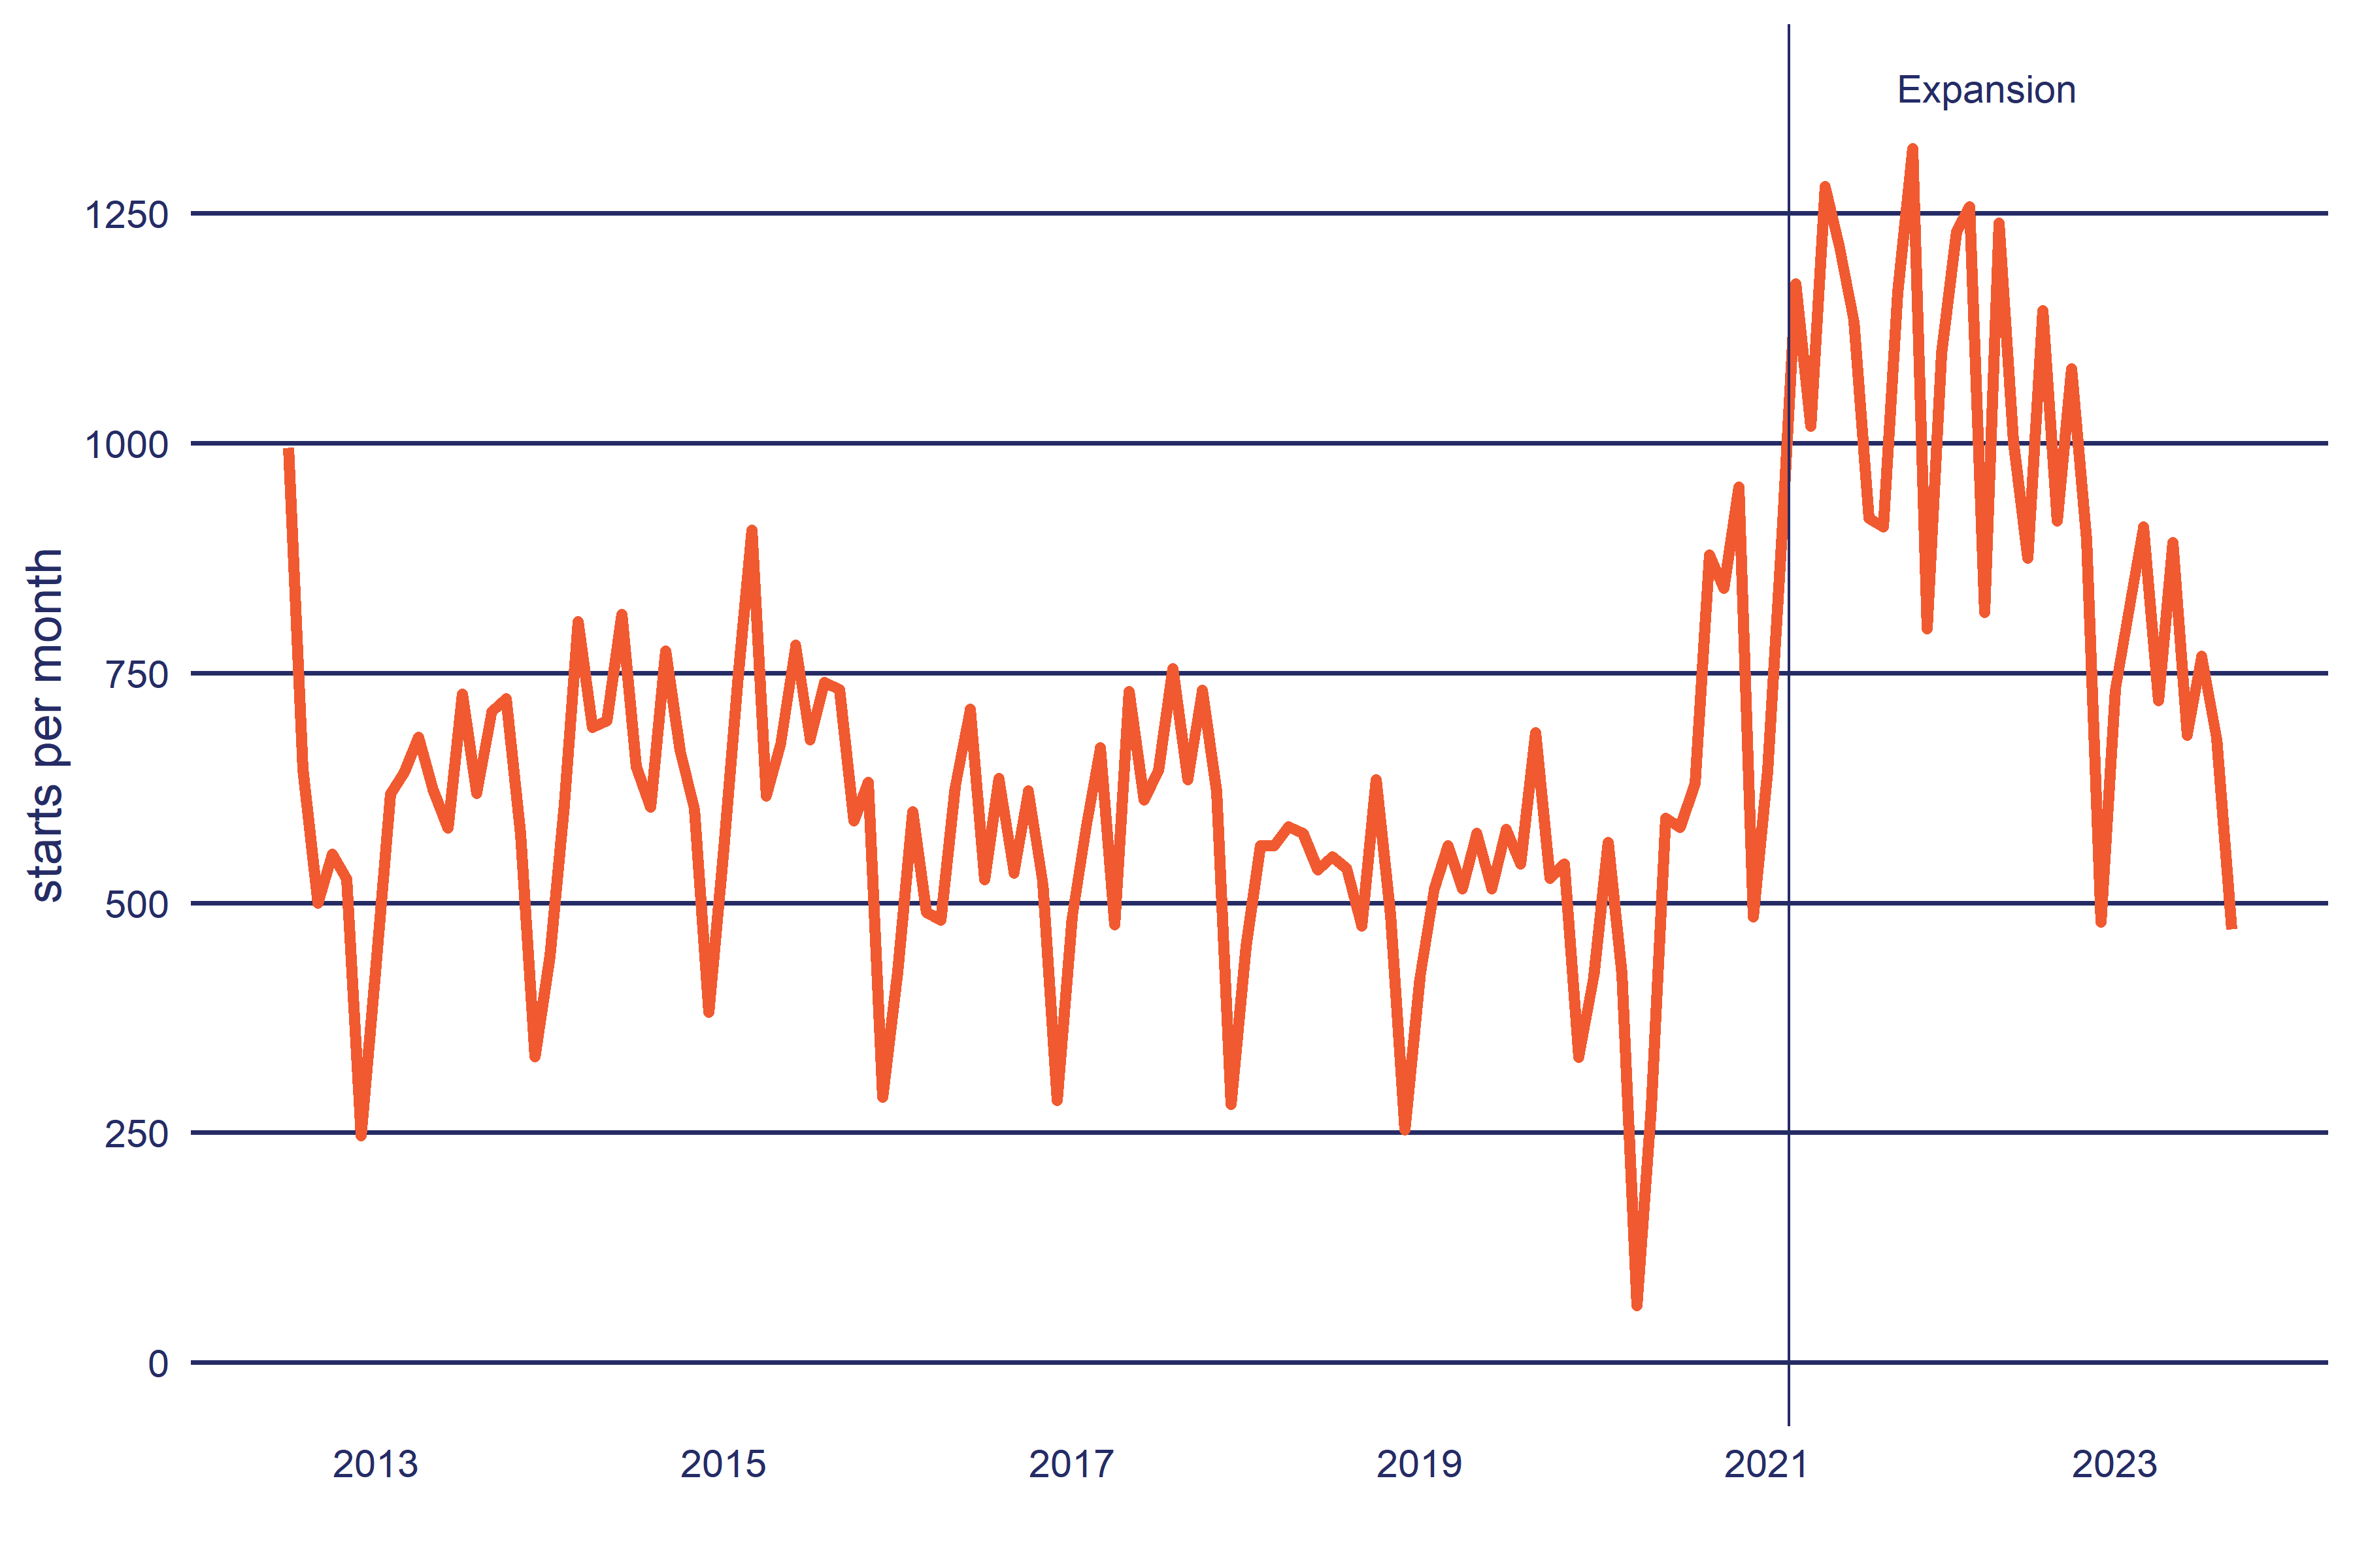

**Source**: Ministry of Social Development, June 2023.

### Participant profile

Here we compare the participant profile of Flexi-wage before and after its Expansion.

#### Age group

Table 2 shows the age profile of Flexi-wage participants split between the pre-expansion period (2012-2020) and the Expansion phase. By age group, participation is concentrated among people under the age of 30, with 51% of participants in this group in 2012 to 2020 period. The Expansion of Flexi-wage has not altered this distribution other than to reduce the proportion of participants over the age of 35.

**Table 2**: Age profile of Flexi-wage participants

|  | 2012-2020 | Expansion |
| --- | --- | --- |
| **Age** | | |
| Under 18 years | 1% | 2% |
| 18 to 19 years | 11% | 10% |
| 20 to 24 years | 25% | 23% |
| 25 to 29 years | 15% | 17% |
| 30 to 34 years | 11% | 13% |
| Over 34 years | 37% | 35% |
| **Total** | 58,278 | 27,471 |
| a. Due to rounding and suppression, columns may not add up to 100%, 's' indicates the cell value has been supressed for confidentiality. b. 2012-2020 is from January 2012 to December 2020, Expansion is from January 2021 onwards.  **Source**: Integrated Data Infrastructure, Statistics New Zealand, June 2023. | | | |

#### Ethnicity

Table 3 shows participants by ethnicity. Because people can have more than one ethnic identity, the proportions in this table will exceed 100%. Since the Expansion of Flexi-wage, there has been a shift from participants who identify as European to those who identify as Māori and Pacific.

**Table 3**: Ethnic profile of Flexi-wage participants

|  | 2012-2020 | Expansion |
| --- | --- | --- |
| **Ethnicity** | | |
| Māori | 40% | 43% |
| Pacific | 15% | 19% |
| Asian | 7% | 7% |
| MELAA | 3% | 2% |
| European | 60% | 55% |
| Other | 2% | 1% |
| **Total** | 58,278 | 27,471 |
| a. Ethnicity is total response (ie a person can select more than one ethnic identity) and therefore the sum of percentage values may exceed 100%. b. Due to rounding and suppression, columns may not add up to 100%, 's' indicates the cell value has been supressed for confidentiality. c. 2012-2020 is from January 2012 to December 2020, Expansion is from January 2021 onwards. d. MELAA: Middle East, Latin America and Africa.  **Source**: Integrated Data Infrastructure, Statistics New Zealand, June 2023. | | | |

#### Gender

Table 4 shows the profile of participants by gender. It is clear from the table, most Flexi-wage participants identify as male, and this proportion has not changed during the Expansion period.

**Table 4**: Gender profile of Flexi-wage participants

|  | 2012-2020 | Expansion |
| --- | --- | --- |
| **Gender** | | |
| Female | 37% | 37% |
| Male | 63% | 63% |
| **Total** | 58,278 | 27,471 |
| a. Due to rounding and suppression, columns may not add up to 100%, 's' indicates the cell value has been supressed for confidentiality. b. 2012-2020 is from January 2012 to December 2020, Expansion is from January 2021 onwards. c. Category for people who identify as gender diverse is not currently available in the IDI.  **Source**: Integrated Data Infrastructure, Statistics New Zealand, June 2023. | | | |

#### Benefit

Table 5 shows the profile of participants by what main benefit they were on just before starting Flexi-wage. Most participants had been on Jobseeker Support Work Ready. There was a noticeable change in the profile of participants after the Expansion, with an increase in the share of participants not on a main benefit (from 18% to 30%). The increase in the proportion of participants not on main benefit resulted in a reduction in the proportion coming from Sole Parent Support and, to a lesser extent, Jobseeker Support Work Ready benefits.

**Table 5**: Benefit profile of Flexi-wage participants

|  | 2012-2020 | Expansion |
| --- | --- | --- |
| **Current main benefit type** | | |
| Jobseeker Support Work Ready | 57% | 52% |
| Sole Parent Support | 13% | 6% |
| Jobseeker Support HCD | 9% | 9% |
| Supported Living Payment | 2% | 2% |
| Caring For Sick Or Infirm | 0% | 0% |
| Youth | 0% | 0% |
| Jobseeker Support Student | 0% | s |
| Woman Alone And Widows | 0% | s |
| Pension | 0% | s |
| Not on main benefit | 18% | 30% |
| **Total** | 58,278 | 27,471 |
| **Duration on current benefit** | | |
| Not on main benefit | 18% | 30% |
| Under 3 months | 29% | 21% |
| 3 to under 6 months | 16% | 12% |
| 6 to under 12 months | 16% | 14% |
| 1 to under 2 years | 10% | 12% |
| 2 to under 3 years | 4% | 5% |
| 3 to under 4 years | 2% | 3% |
| 4 to under 5 years | 1% | 1% |
| 5 to under 6 years | 1% | 1% |
| 6 to under 8 years | 1% | 1% |
| 8 to under 10 years | 1% | 0% |
| Over 10 years | 1% | 1% |
| **Total** | 58,278 | 27,471 |
| a. Due to rounding and suppression, columns may not add up to 100%, 's' indicates the cell value has been supressed for confidentiality. b. 2012-2020 is from January 2012 to December 2020, Expansion is from January 2021 onwards. c. The 'not on main benefit group' can include people who are receiving supplementary assistance only, such as Accommodation Supplement.  **Source**: Integrated Data Infrastructure, Statistics New Zealand, June 2023. | | | |

Most participants had been on a main benefit for less than one year (including those not on a main benefit) and that remained unchanged after the Expansion (from 62% to 64%). It appears that the expansion shifted people from starting after benefit grant to more starting without being granted a benefit. The proportion of participants on a main benefit for less than three months also fell from 29% to 21%. On the other hand, we saw a small increases in the proportion of participants who had been on a main benefit between one and less than six years.

#### Employment history

Table 6 summarises the time participants were in employment before starting Flexi-wage as well as the proportion of their working life (18-64) spent in employment. This measure excludes any periods of time spent overseas.

**Table 6**: Employment Flexi-wage participants before starting the programme

|  | 2012-2020 | Expansion |
| --- | --- | --- |
| **Duration of current employment** | | |
| Not employed | 69% | 60% |
| Under 3 months | 12% | 12% |
| 3 to under 6 months | 5% | 6% |
| 6 to under 12 months | 5% | 8% |
| 1 to under 2 years | 3% | 5% |
| 2 to under 3 years | 1% | 3% |
| 3 to under 4 years | 1% | 2% |
| 4 to under 5 years | 1% | 1% |
| 5 to under 6 years | 0% | 1% |
| 6 to under 8 years | 0% | 1% |
| 8 to under 10 years | 0% | 1% |
| Over 10 years | 1% | 1% |
| **Total** | 58,278 | 27,471 |
| **Proportion of adult life in New Zealand in employment** | | |
| 0% | 6% | 5% |
| 1 to 9% | 10% | 8% |
| 10 to 19% | 11% | 10% |
| 20 to 29% | 11% | 11% |
| 30 to 39% | 11% | 11% |
| 40 to 59% | 21% | 22% |
| 60 to 79% | 16% | 18% |
| 80 to 89% | 6% | 7% |
| 90% plus | 7% | 9% |
| **Total** | 58,278 | 27,471 |
| a. Due to rounding and suppression, columns may not add up to 100%, 's' indicates the cell value has been supressed for confidentiality. b. 2012-2020 is from January 2012 to December 2020, Expansion is from January 2021 onwards.  **Source**: Integrated Data Infrastructure, Statistics New Zealand, June 2023. | | | |

Looking at recent employment, in the 2012-2020 period, 69% of participants were not in employment prior to starting Flexi-wage, with the next largest group having spent less than three months in work. During the Expansion phase, we see an increase in the proportion of participants in employment before starting Flexi-wage. Note, we have not examined whether prior employment was with the same employer as the Flexi-wage placement.

Looking at working life in employment, the distribution in Table 6 shows most participants had spent less than half their working life in employment. Because many of the participants are young, this may reflect engagement in education or training, rather than long periods outside of the labour market.

#### Region

Table 7 shows the region of participants based on their last known address. Outside of the main centres, the largest number of participants are in the Manawatu-Whanganui region.

**Table 7**: Region of Flexi-wage participants

|  | 2012-2020 | Expansion |
| --- | --- | --- |
| **Region of current address** | | |
| Northland | 6% | 5% |
| Auckland | 35% | 32% |
| Waikato | 9% | 11% |
| Bay of Plenty | 7% | 6% |
| Gisborne | 1% | 2% |
| Hawke's Bay | 4% | 4% |
| Taranaki | 4% | 4% |
| Manawatu-Whanganui | 9% | 11% |
| Wellington | 7% | 8% |
| Marlborough | 1% | 1% |
| Nelson | 1% | 1% |
| Tasman | 1% | 1% |
| West Coast | 1% | 1% |
| Canterbury | 9% | 7% |
| Otago | 3% | 3% |
| Southland | 2% | 2% |
| Overseas | 1% | 1% |
| Unknown | 0% | 0% |
| **Total** | 58,278 | 27,471 |
| a. Due to rounding and suppression, columns may not add up to 100%, 's' indicates the cell value has been supressed for confidentiality. b. 2012-2020 is from January 2012 to December 2020, Expansion is from January 2021 onwards.  **Source**: Integrated Data Infrastructure, Statistics New Zealand, June 2023. | | | |

## Duration of participation on Flexi-wage

The duration on Flexi-wage can be up to 52 weeks. Figure 2 shows the proportion of participants by how long they spend on Flexi-wage. Note that a person ending Flexi-wage does not mean they have left the employer or left employment.

**Figure 2**: Proportion remaining on Flexi-wage (survival curve)

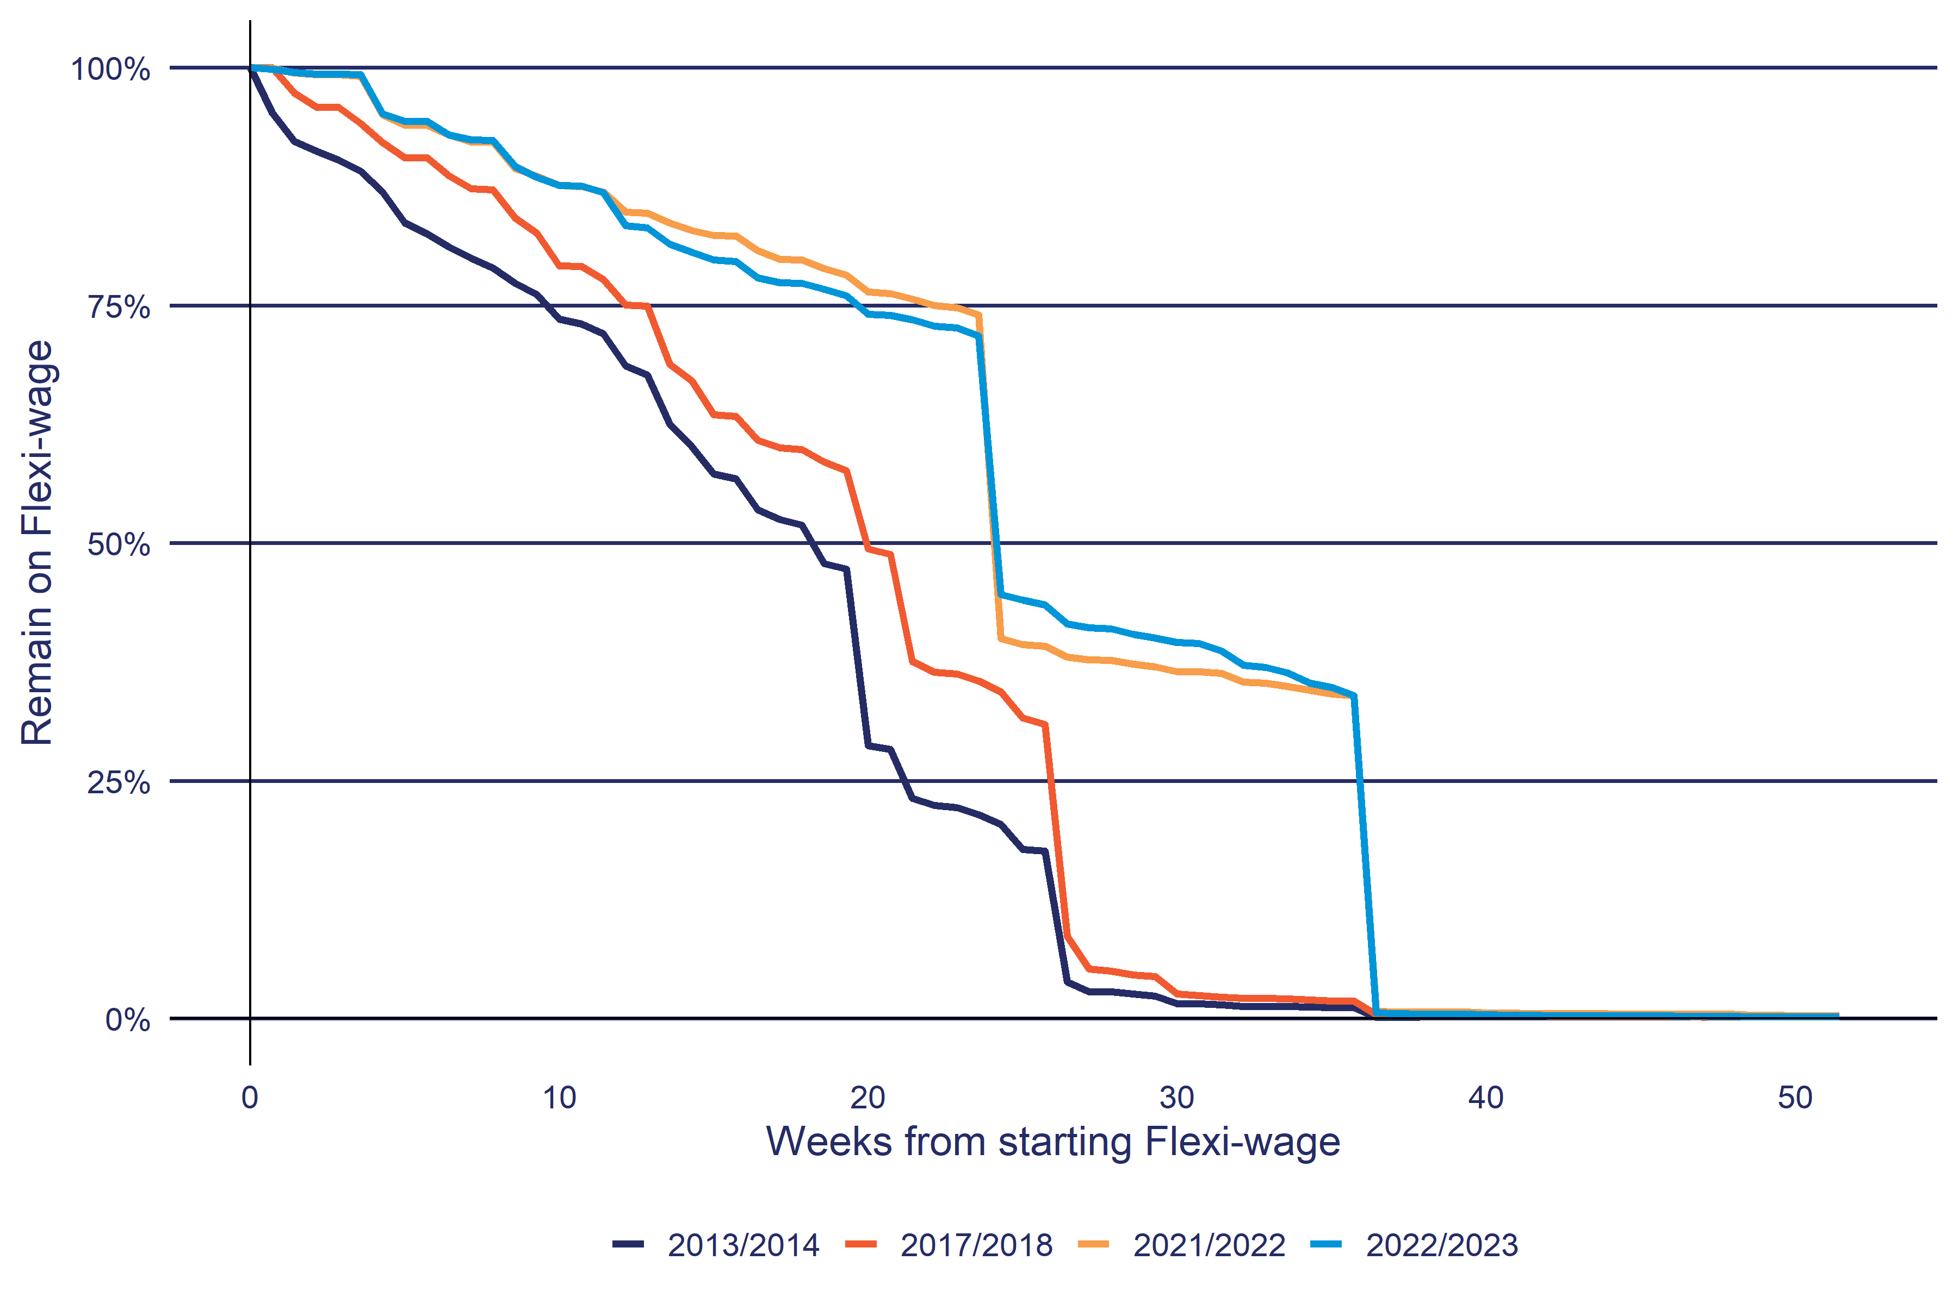

a. Financial year is from July.

**Source**: Ministry of Social Development, June 2023.

In the pre-Expansion period, we can see that the time on the programme decreases until 26 weeks after starting, when most participants complete the programme. In the Expansion phase, the duration profile on Flexi-wage follows the introduction of the three bands, with those on band 1 finishing after 24 weeks, those on band 2 ending at 36 weeks, and the remainder on band 3.

## Cost of Flexi-wage

MSD maintains an individualised Cost Allocation Model (iCAM) that estimates the individual cost of participating in its employment programmes and services. See the method section later in the report for an outline of how the iCAM operates.

### Breakdown of Flexi-wage expenditure by component

Table 8 breaks the total cost of Flexi-wage into the main cost components by financial year. For Flexi-wage the bulk of the cost is from the wage subsidy payments themselves. The second highest direct cost is from setting up the placement with the employer (Placement Opportunity). Indirect costs cover unallocated front-line staff time as well as support staff costs, property, IT and depreciation.

**Table 8**: Breakdown of total cost by component for Flexi-wage by financial year

| **Component** | **2018/2019** | **2019/2020** | **2020/2021** | **2021/2022** | **2022/2023** |
| --- | --- | --- | --- | --- | --- |
| Subsidy | $17,543 | $16,913 | $28,507 | $66,546 | $59,757 |
| Subsidy Administration | $123 | $212 | $527 | $765 | $487 |
| Placement Opportunity | $3,583 | $3,341 | $5,047 | $6,646 | $6,132 |
| Referral | $54 | $59 | $129 | $215 | $203 |
| Case management | $368 | $401 | $1,058 | $1,908 | $1,698 |
| Indirect Costs | $8,453 | $7,747 | $11,191 | $14,022 | $14,305 |
| **Total** | **$30,124** | **$28,672** | **$46,459** | **$90,101** | **$82,582** |
| a. Showing the 5 most recent years of expenditure. b. Expenditure is in ,000s and in nominal values (ie not adjusted for inflation). c. Subsidy: subsidy payments, Subsidy Administration: administration of subsidy payments, Placement Opportunity: setting up of the placement with the employer, Referral: staff costs involved in referring people to Flexi-wage, Case management: staff costs in case managing participants while on Flexi-wage, Indirect Costs: non-work frontline staff costs (eg leave), support staff, property, ICT and other general MSD costs.   **Source**: individual Cost Allocation Model (iCAM), Ministry of Social Development, June 2023. | | | | | |

### Average cost per participant start

Table 9 shows the cost for each participant start by financial year. These results differ from Table 8 which shows the expenditure within each financial year and align with published financial accounts. Table 9 on the other hand, allocates participant costs that fall across financial years to the year the participant started Flexi-wage. Combining individual participant costs over financial years is important for programmes such as Flexi-wage since participants can spend up to 12 months on the programme.

Finally, because costs are spread over the duration of the participation spell, the results for the most recent years are an underestimate as many of these participants have not yet completed Flexi-wage.

**Table 9**: Average cost per participant start for Flexi-wage by financial year

| Phase | Financial year | Total expenditure | Participant starts | Cost per start |
| --- | --- | --- | --- | --- |
| 2012-2020 | 2012/2013 | $27,640 | 7,043 | $3,924 |
| 2013/2014 | $35,291 | 7,742 | $4,558 |
| 2014/2015 | $36,078 | 7,955 | $4,535 |
| 2015/2016 | $35,757 | 6,990 | $5,115 |
| 2016/2017 | $33,711 | 6,678 | $5,048 |
| 2017/2018 | $36,052 | 6,938 | $5,196 |
| 2018/2019 | $30,133 | 6,038 | $4,990 |
| 2019/2020 | $28,748 | 5,549 | $5,181 |
| 2020/2021 | $17,038 | 4,369 | $3,900 |
| Expansion | 2020/2021 | $30,302 | 6,240 | $4,856 |
| 2021/2022 | $90,299 | 12,883 | $7,009 |
| 2022/2023 | $81,850 | 10,151 | $8,063 |
| a. Total expenditure is in ,000s and in nominal values (ie not adjusted for inflation). b. Excludes participants who started after June 2023. c. Financial year is from July to June.  **Source**: individual Cost Allocation Model (iCAM), Ministry of Social Development, June 2023. | | | | |

# Existing evidence

This section provides a short summary of the international and New Zealand evidence on hiring wage subsidies.

## International evidence on the effectiveness of wage subsidy programmes

Within meta-analyses of Active Labour Market Programmes (ALMPs) effectiveness, hiring wage subsidy programmes are defined as ‘Employment Incentives’ which combines a range of programmes. Aside from subsidised employment, this category also includes wage subsidy, bonuses, job rotation and sharing, and other incentives targeting employers and job seekers. Because of the diversity of interventions this evidence on effectiveness tends to be contradictory (ETF, 2022).

Other meta-analysis that have assessed wage-subsidy programmes in isolation have been able to identify factors associated with more effective subsidies. Specifically:

* subsidies targeted to private sector employers (Card, Kluve & Weber, 2010)
* long-term unemployed (indicator for labour market disadvantage) benefit more from human capital development (including private sector employment subsidy) than work first programmes (ie job search) (Card, Kluve & Weber, 2017).

Analysis of United States wage subsidy programmes shows positive impacts on earnings and employment (Dutta-Gupta *et al*, 2016). Dutta-Gupta *et al* found that of the seven programmes with a Cost Benefit Analysis (CBA), all seven showed a net-benefit at one or more implementation site, with four showing positive net benefits overall.

### New Zealand evidence on the effectiveness of wage subsidy programmes

Crichton & Maré (2013) examined the effectiveness and employer use of MSD funded subsidy programmes between 2003 and 2007 using the IDI. Over a 72-month follow-up period, they found participants in subsidy programmes had higher employment and income than for those in the matched comparison group. These impacts were larger over the short term and diminished over time. Crichton & Maré (2013) also found:

* higher impacts for participants who had been on benefit for over 4 years than people on benefit for less than 6 months
* job seekers aged 45–64 experience greater benefits than those aged under 45
* subsidies were effective for those receiving Domestic Purposes (now called Sole Parent Support), Sickness (Jobseeker Support Health Condition or Disability), or Invalid’s benefits (Supported Living Payment).

## Evaluations of Flexi-wage

A process evaluation was also conducted for the expansion of the Flexi-wage programme (GravitasOPG, 2023). The evaluation concluded that, overall, the expansion of Flexi-wage had been implemented reasonably well. The programme worked best when there was a good match between employee, the role, and employer expectations. And when the employer had the systems in place to train and support the employee as they developed towards meeting the entry-level requirements of the job.

However, the evaluation also found Flexi-wage was not always well targeted, resulting in some deadweight loss (employers reporting hiring participants they would have hired anyway). Poor targeting seemed to occur for two reasons.

* the lack of consistency in assessing ‘disadvantaged in the labour market’ and ‘at risk of long-term benefit receipt’
* at least in part, work brokers felt pressured to spend the allocated funding and had a lack of formal training on ensuring fidelity of the programme.

## Non-participant effects of wage subsidy programmes

Alongside the impact on participants, we need to also consider the likely impact of these interventions on non-participants (Borland, 2016). In the literature there are three effects to consider.

* **Substitution**: employers hiring the subsidised participant instead of another job seeker. As a result, the substituted job seeker will take longer to find employment.
* **Displacement**: employer taking on subsidised workers can undercut competing firms that result in lower employment among those firms.
* **Dead weight**: the employer would have hired the subsidised participant without the subsidy. High dead weight would increase the risk of displacement or employers taking the subsidy as profit.

It is difficult to reliably estimate the size of these effects and the extent to which they offset any gains in employment and income for the programme participants. A number of studies have indicated likely ranges of the negative impacts on non-participants relative to the positive impacts on participants:

* Martin and Grubb (2001): 40 to 90%
* Neumark (2013): 67 to 96%
* Brown and Koettl (2015): Sweden 65-70%, Ireland and the UK 20%, Belgium 36% and the Netherlands 50%.

New Zealand analysis of employer use of wage subsidies (Crichton & Maré, 2013) found most firms took on one or two subsidised employees at a time, that firms increased the total number of employees when the participants started, indicating these were not replacing existing workers. Their analysis also found limited evidence for employers letting participants go at the end of the subsidy period.

# Impact analysis

In this section of the report, we examine the impact of Flexi-wage on participants subsequent outcomes.

## Interval impacts

### Flexi-wage increased participants’ time in employment

Our analysis begins with those people who started Flexi-wage in the 2016 calendar year. Figure 3 shows the proportion of participants who are in employment in each month from one year before the participants started Flexi-wage to 6.5 years afterwards. Alongside the participants, the chart also shows the same outcome for the matched comparison group.

**Figure 3**: Interval outcomes of Flexi-wage participants and comparison group on time in employment

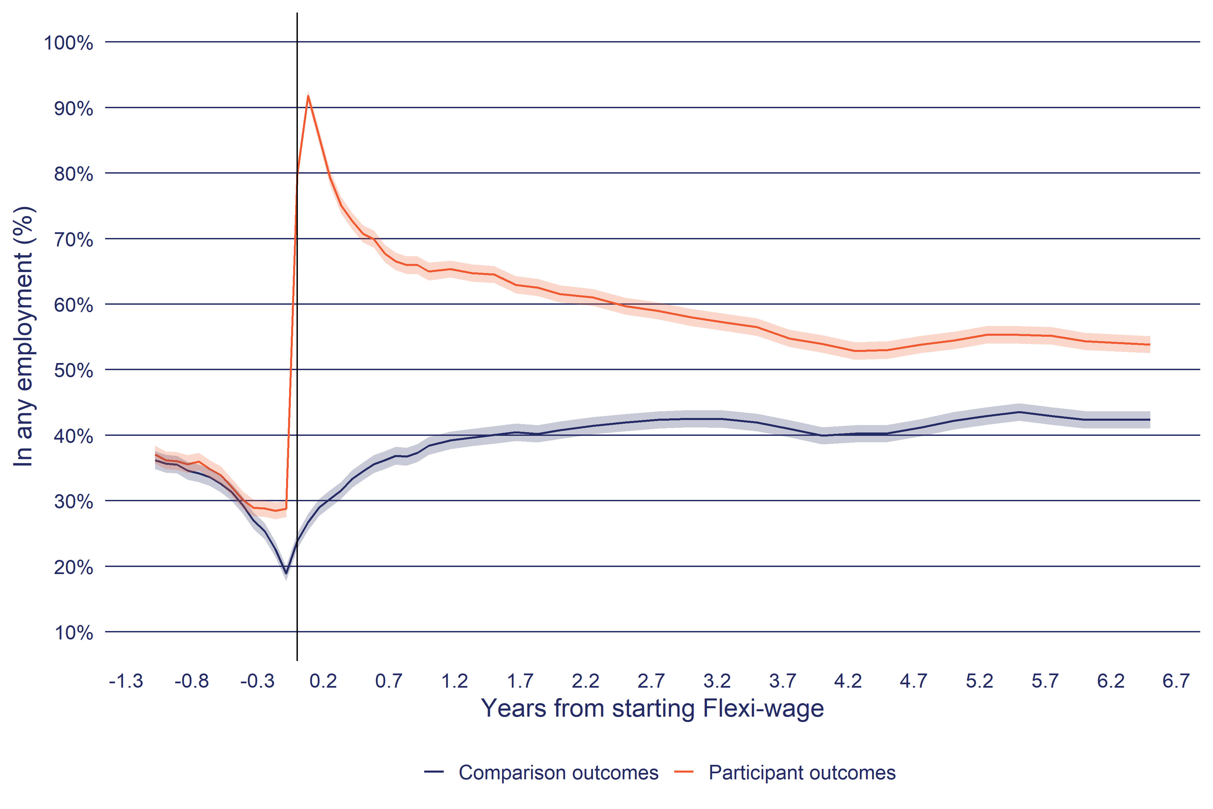

a, The shaded area around each line indicates the 95% confidence interval of the estimate.

b, In any employment: Employment is based on tax data (PAYE and annual tax returns). Periods with less than $100 of employment income per month are excluded.

**Source**: Statistics New Zealand, Integrated Data Infrastructure, June 2023.

Showing interval outcomes is a useful way of understanding how outcomes change in the period before and after starting the intervention. In the pre-participation period, the proportion of participants in employment averages at 33%. For Flexi-wage, we can see Ashenfelter’s dip[7] as the proportion of participants in employment steadily falls until just before they start the programme.

As expected, the proportion of participants in employment is at its highest in the month after starting Flexi-wage at 92±1.0%. However, there is a steady decline in the proportion in employment, falling to 68±1.0% at six months after starting Flexi-wage. From this point the decline in employment is less steep but continues for the next 3 years.

For the comparison group, the proportion in employment also increases in the following year from 24±1.0% to 38±1.0%, after which it remains relatively constant. But over the follow up period, the comparison group has lower level of employment than the participants.

Figure 4 shows the impact of Flexi-wage on employment outcomes. Here impact is calculated as the percentage point (ppt) difference in the proportion of time in employment between the participant and the matched comparison group from Figure 3 above. At one month after starting Flexi-wage, the proportion of participants in employment exceed that of the comparison group by 65±1.0 ppt, decreasing to 27±2.0 ppt after one year.

**Figure 4**: Interval impact of Flexi-wage on time in employment

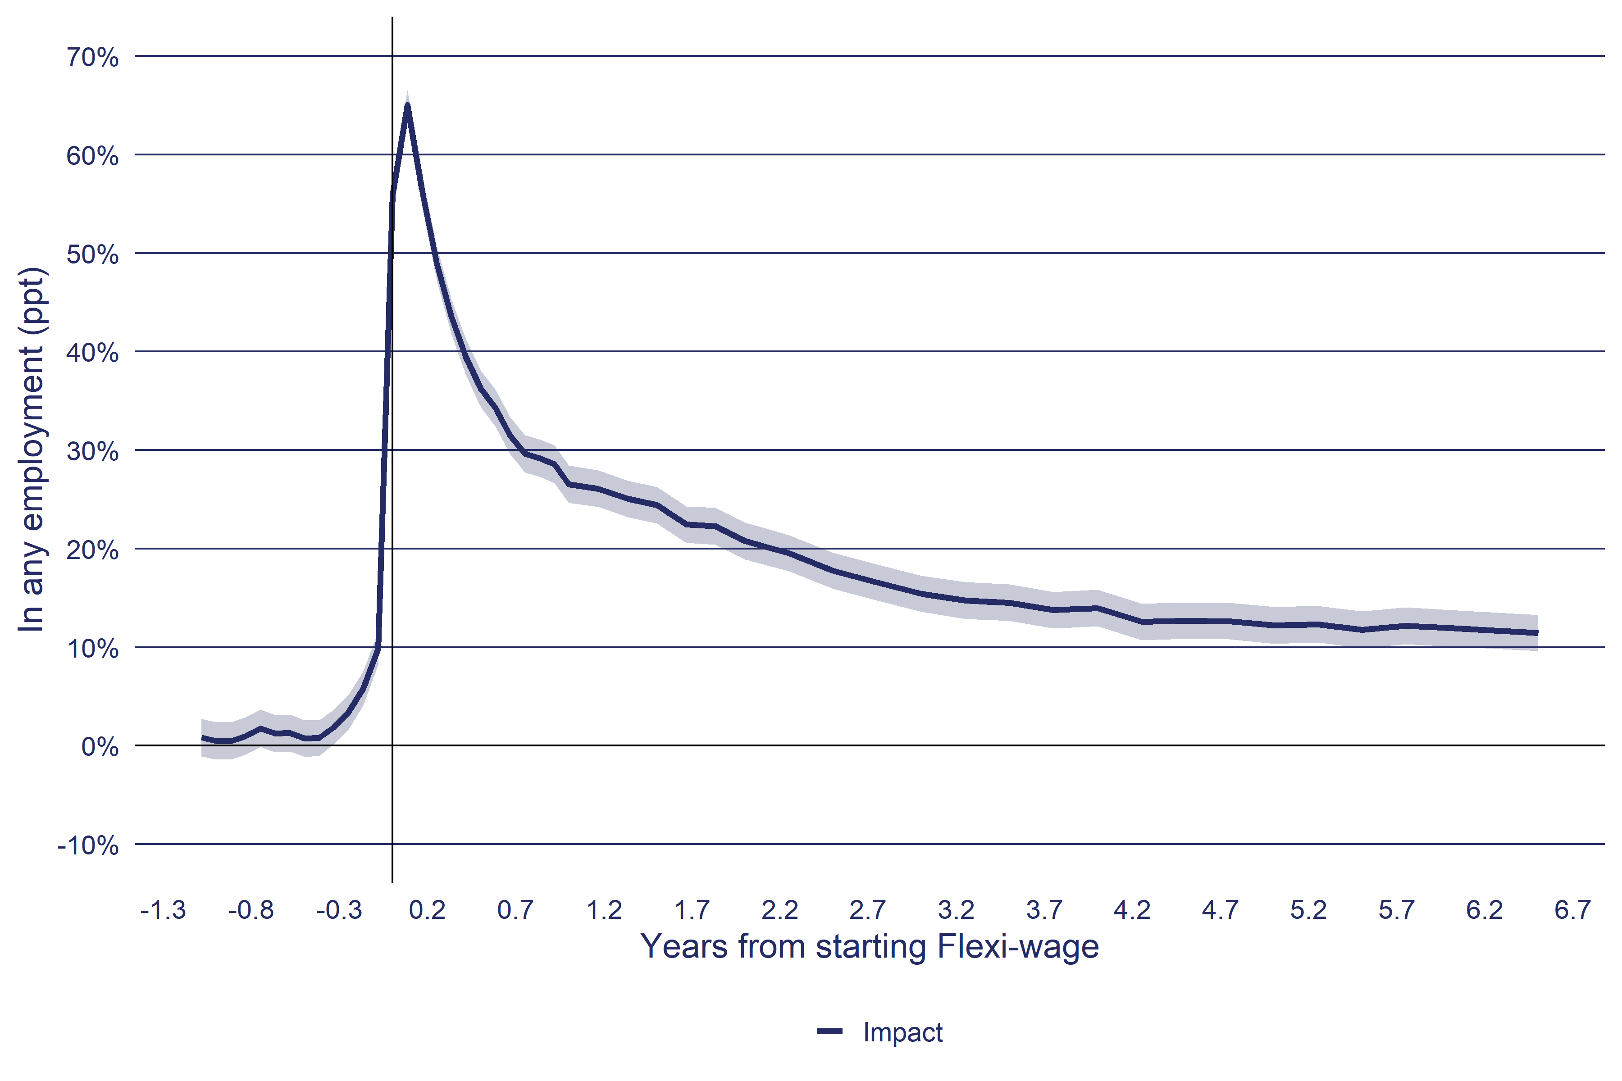

a, The shaded area around each line indicates the 95% confidence interval of the estimate.

b, In any employment: Employment is based on tax data (PAYE and annual tax returns). Periods with less than $100 of employment income per month are excluded.

**Source**: Statistics New Zealand, Integrated Data Infrastructure, June 2023.

At the end of the follow-up period in Figure 4 we can see there continues to be a positive impact. This means there are additional impacts that have not yet been observed. For this reason, the impacts reported later in this analysis are an under-estimate of the full impact of Flexi-wage on participant’s employment outcomes.

### Impact of the Flexi-wage Expansion

Here we examine if the Expansion of Flexi-wage altered the effectiveness of the programme. Figure 5 tests this by comparing the impact trends of different cohorts of Flexi-wage participants. If the short-term trend for newer participants is similar to earlier cohorts, we can assume the long-term trend will also be similar.

**Figure 5**: Interval impact of Flexi-wage on time in employment by start year

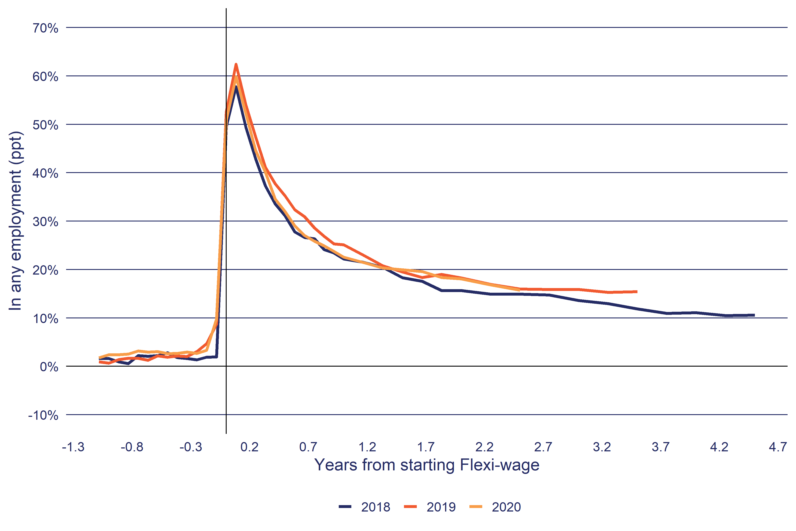

a, The shaded area around each line indicates the 95% confidence interval of the estimate.

b, In any employment: Employment is based on tax data (PAYE and annual tax returns). Periods with less than $100 of employment income per month are excluded.

**Source**: Statistics New Zealand, Integrated Data Infrastructure, June 2023.

Figure 5 shows the trend for those who started Flexi-wage in the two years before the Expansion of Flexi-wage (2018 and 2019), to cohorts who started after the Expansion.

Figure 5 shows that the impact trends are similar across all the cohorts. However, the peak in employment impact is slightly lower for the participants in the Expansion period, but this doesn’t persist over subsequent months. These impact trends indicate that the Expansion has not changed the effectiveness of Flexi-wage on the time spent in employment.

### Education and qualifications

The other outcomes that we look at are enrolment in study and qualifications. In general, programmes that places people into employment reduces the time they spend in education or training. For Flexi-wage (2016) we can see this impact where in the period that participants are on Flexi-wage the proportion enrolled in education or training is lower than the comparison group (Figure 6). However, from one year after starting Flexi-wage the proportion of the participants group in study is similar to that of the comparison group.

**Figure 6**: Interval outcomes of Flexi-wage participants and comparison group on time in study

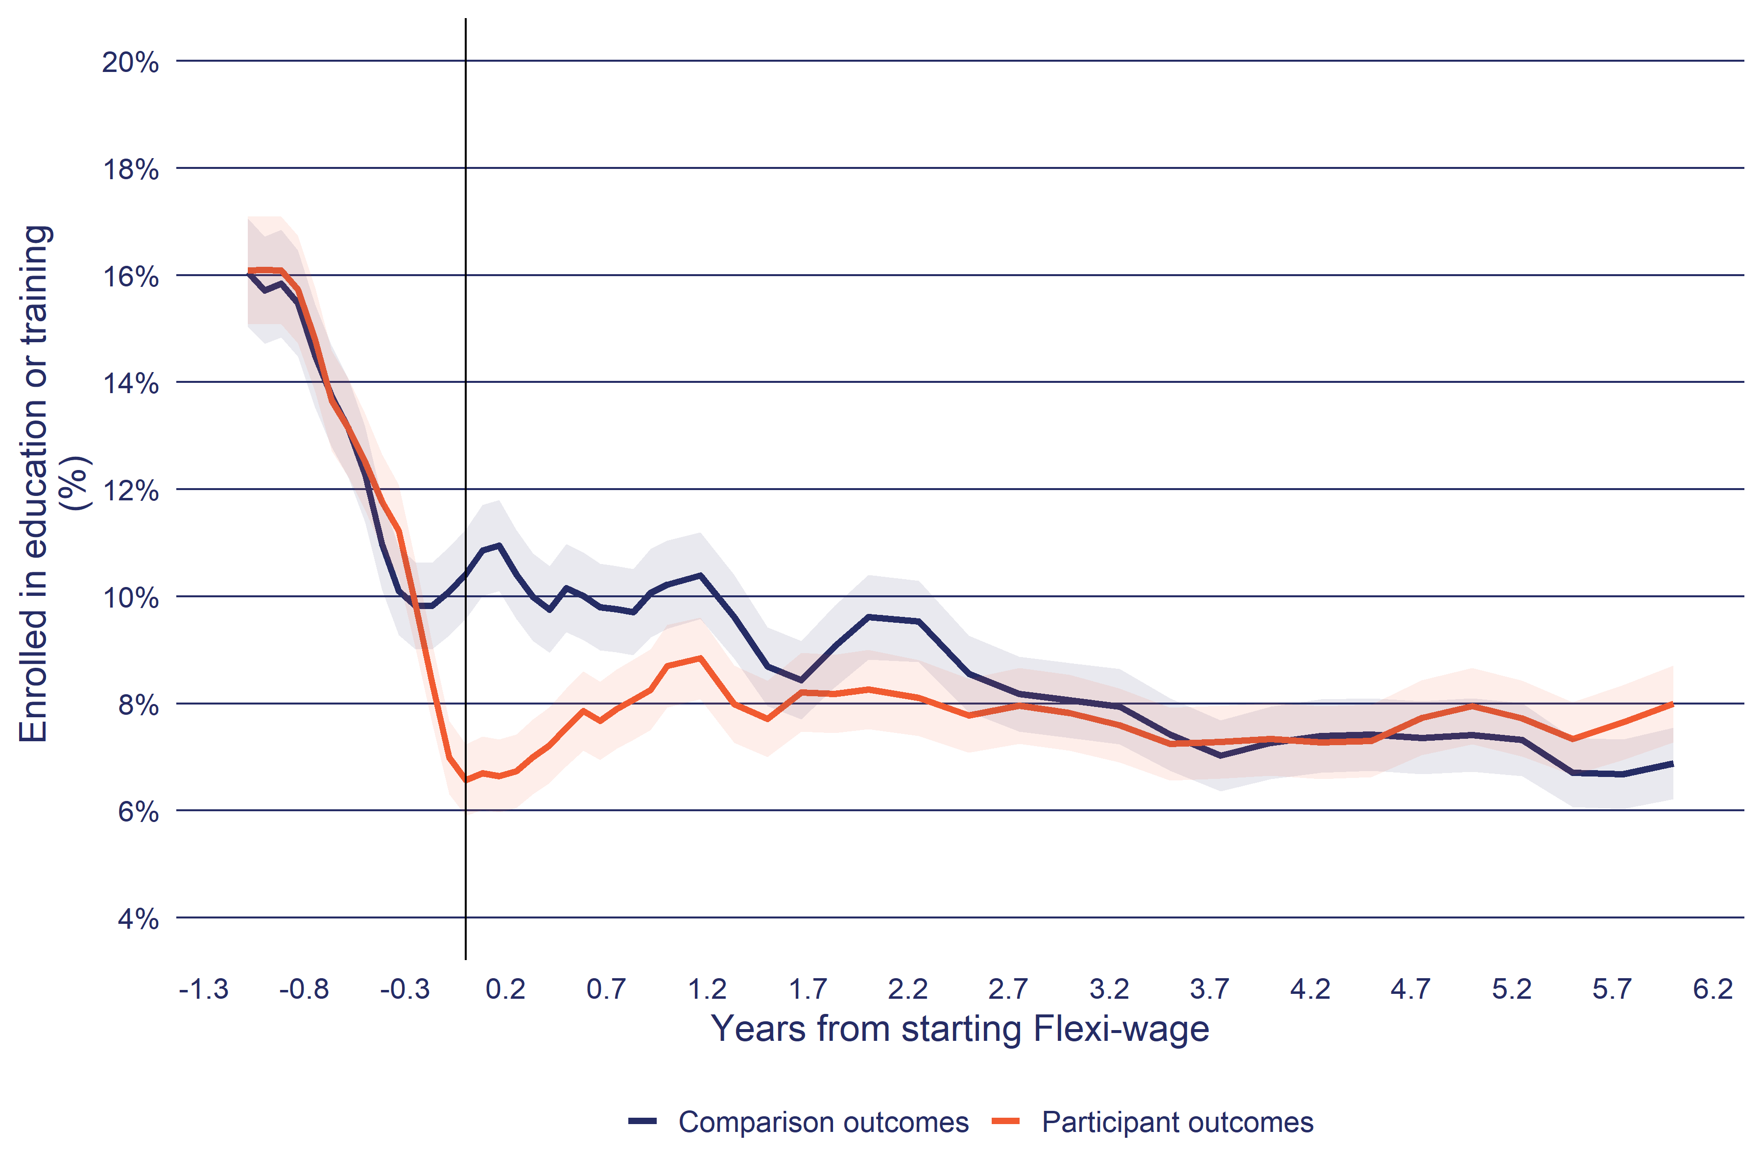

a, The shaded area around each line indicates the 95% confidence interval of the estimate.

b, Enrolled in education or training: Education and training includes school, tertiary institutions and private training organisations. Enrolled does not always mean the person is attending.

**Source**: Statistics New Zealand, Integrated Data Infrastructure, June 2023.

Examining the trend across cohorts, we can not that there was a shift in the impact of Flexi-wage on time enrolled in education or training. Figure 7 compares the impact trend for selected participation years. For those who started Flexi-wage before 2016 we can see an initial negative impact on the time enrolled in education or training. In other words, because of Flexi-wage participants are less likely to be enrolled in education or training than the comparison group. From six months after starting Flexi-wage the trend reverses, and over the medium term, even becomes positive.

**Figure 7**: Interval impact of Flexi-wage on time enrolled in study by start year

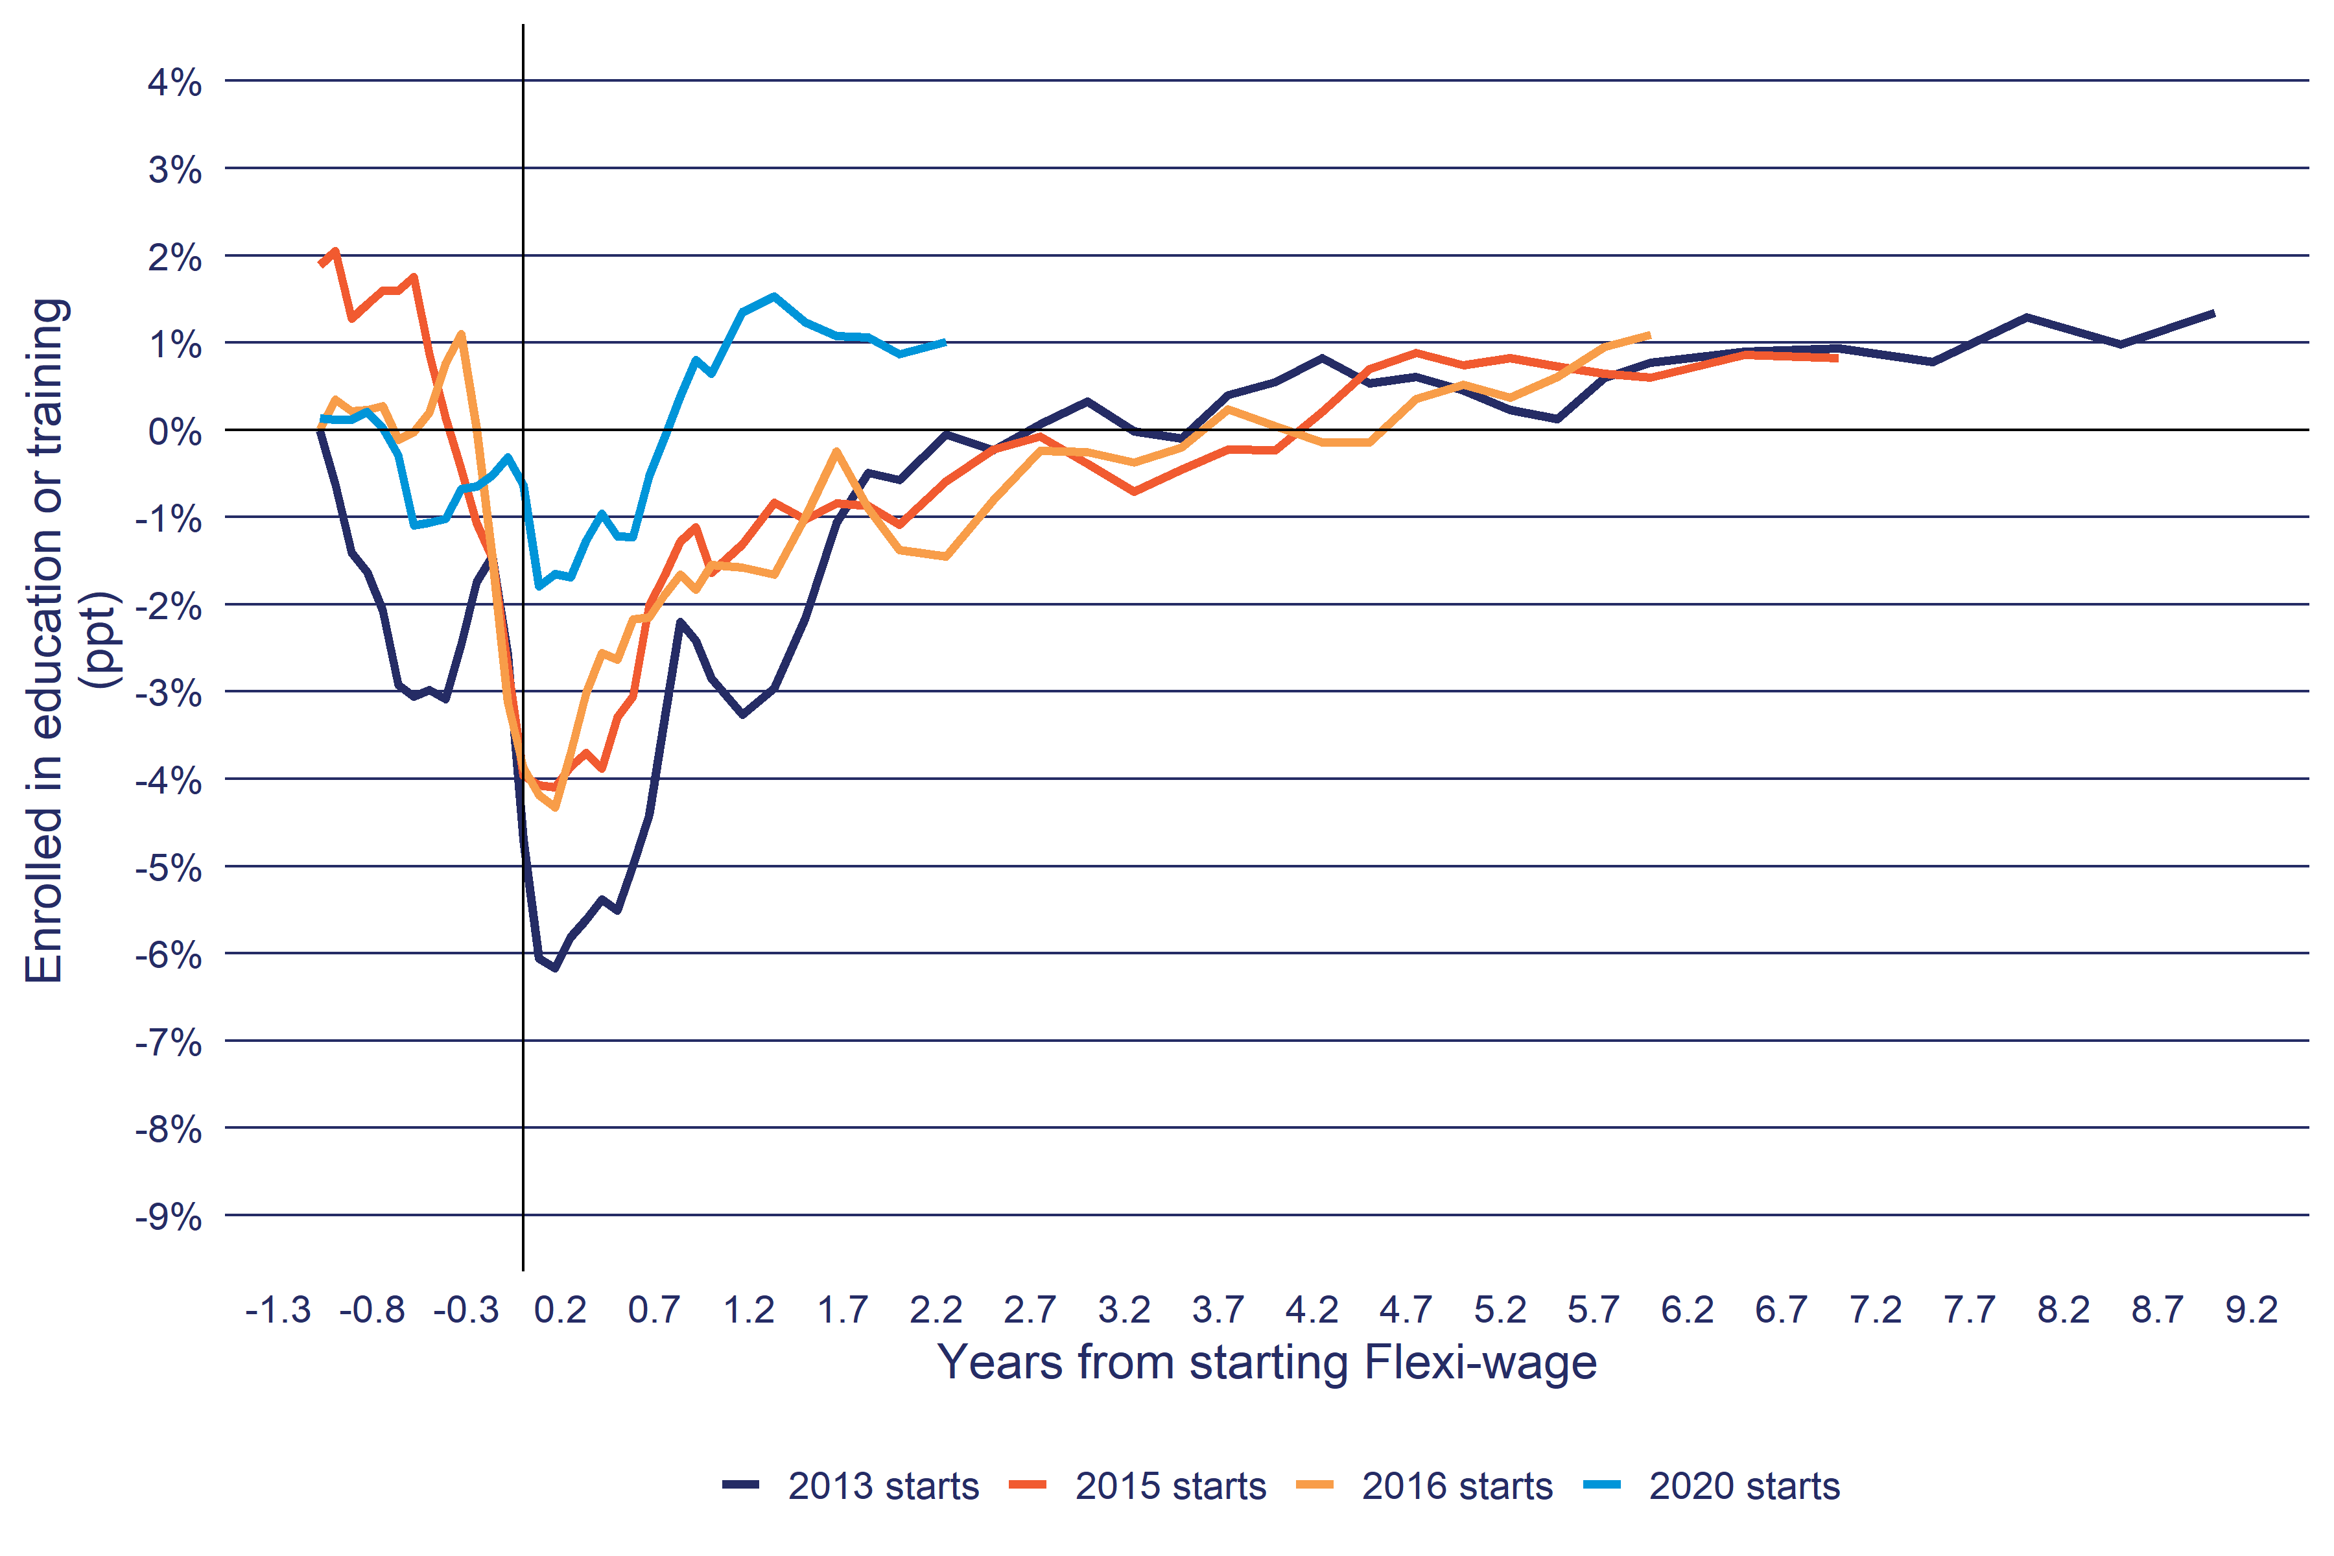

a, Enrolled in education or training: Education and training includes school, tertiary institutions and private training organisations. Enrolled does not always mean the person is attending.

**Source**: Statistics New Zealand, Integrated Data Infrastructure, June 2023.

From 2016 onwards (2016 and 2020 as examples), the initial negative impact of Flexi-wage is reduced, and we can see a larger positive impact on being enrolled in education or training much sooner after starting the programme.

## Cumulative impacts

So far, we have looked at how impacts changed in each month before and after Flexi-wage start. Such interval impact charts are useful for understanding how the effect of the programme changes over time but are difficult to make a summary statement of the overall impact of Flexi-wage from. For the overall impact assessment, we need to measure the cumulative impact of Flexi-wage from when participants started the programme as shown in Table 10.

### Employment

Table 10 splits participants by the calendar year that they started Flexi-wage in. At selected years after starting Flexi-wage, the Table shows the additional number of weeks in employment by participants relative to the comparison group. For example, for participants who started between 2013 to 2016, we estimate that after four years, participants spent 54.0±2.70 more weeks in employment than the comparison group. The trend in Table 10 is that the impact on employment for more recent participants is slightly lower than those who started between 2013 to 2016.

**Table 10**: Cumulative impact of Flexi-wage on time in employment

|  | Years from participation start | | | | |
| --- | --- | --- | --- | --- | --- |
| Participation year | 0.5 | 1 | 2 | 4 | 6 |
| 2013-2016 starts | 16.0* | 24.0* | 36.0* | 54.0* | 68.0* |
| 2017 starts | 14.0* | 21.0* | 32.0* | 47.0* |  |
| 2018 starts | 13.0* | 19.0* | 29.0* | 42.0* |  |
| 2019 starts | 14.0* | 21.0* | 32.0* |  |  |
| 2020 starts | 13.0* | 20.0* | 30.0* |  |  |
| estimate: Impact on time in employment (weeks) *: the 95% confidence interval of the impact estimate excludes zero.  **Source**: Statistics New Zealand, Integrated Data Infrastructure, June 2023. | | | | | |

### Income

In addition to employment, we also measure overall change in income. This measure includes labour market income (earnings) as well as transfer payments. To be successful, Flexi-wage has to both increase employment and overall income for participants. Table 11 shows a positive trend in increasing overall income over time and across participant years.

**Table 11**: Cumulative impact of Flexi-wage on net income (in 2023 dollars)

|  | Years from participation start | | | | |
| --- | --- | --- | --- | --- | --- |
| Participation year | 0.5 | 1 | 2 | 4 | 6 |
| 2013-2016 starts | $4,523* | $7,537* | $12,343* | $20,538* | $26,093* |
| 2017 starts | $4,774* | $8,591* | $15,271* | $22,834* |  |
| 2018 starts | $5,455* | $8,863* | $13,193* | $19,166* |  |
| 2019 starts | $4,646* | $7,464* | $11,409* |  |  |
| 2020 starts | $4,639* | $7,613* | $12,701* |  |  |
| estimate: Impact on net income from all sources *: the 95% confidence interval of the impact estimate excludes zero.  **Source**: Statistics New Zealand, Integrated Data Infrastructure, June 2023. | | | | | |

### Enrolment in education or training

Table 12 confirms the earlier analysis showing that the negative impact on time on enrolled in education or training has reduced from 2016 onwards.

**Table 12**: Cumulative impact of Flexi-wage on enrolment in education or training

|  | Years from participation start | | | | |
| --- | --- | --- | --- | --- | --- |
| Participation year | 0.5 | 1 | 2 | 4 | 6 |
| 2013-2016 starts | -1.20* | -1.80* | -2.50* | -2.30* | -1.60 |
| 2017 starts | -0.60* | -0.60* | -0.30 | 0.40 |  |
| 2018 starts | -0.40* | -0.50* | -0.60 | -0.10 |  |
| 2019 starts | -0.20 | -0.00 | 0.80 |  |  |
| 2020 starts | -0.40* | -0.40 | 0.20 |  |  |
| estimate: Impact on time enrolled in education and training in weeks *: the 95% confidence interval of the impact estimate excludes zero.  **Source**: Statistics New Zealand, Integrated Data Infrastructure, June 2023. | | | | | |

### Highest qualification

Table 13 shows the impact of Flexi-wage on the highest qualification based on the New Zealand Qualifications Framework which has a scale from 1 (year 11 at school) to 9 (PhD). The impact on highest qualification is small. While Flexi-wage increases enrolment in education and training, the courses undertaken may be at levels lower than the highest qualification already held by participants. Therefore, increased time in education and training may not translate to increases in the highest qualification held.

**Table 13**: Cumulative impact of Flexi-wage on highest qualification held

|  | Years from participation start | | | |
| --- | --- | --- | --- | --- |
| Participation year | 0.5 | 1 | 2 | 4 |
| 2013-2016 starts | 0.06* | 0.02 | -0.03 | -0.08* |
| 2017 starts | 0.03 | 0.01 | -0.00 |  |
| 2018 starts | 0.08 | 0.06 | 0.04 |  |
| 2019 starts | -0.00 | -0.01 |  |  |
| 2020 starts | -0.00 |  |  |  |
| estimate: Impact on the highest NZQF level achieved *: the 95% confidence interval of the impact estimate excludes zero.  **Source**: Statistics New Zealand, Integrated Data Infrastructure, June 2023. | | | | |

## Impact by sub-group

In addition to the impact of Flexi-wage on all participants, we also analysed the impact of Flexi-wage on a number of sub-groups. Note that the following tables show the differences in impact of Flexi-wage between sub-groups. While indicative, it is important to remember that any observed trends may be correlations only. It is possible that other factors related to the profile variable explain any differences in impact.

For the subgroup analysis, we group starts into four-year periods to enable comparison between large and small subgroups over the same analysis period. However, even using a four-year participation window, it is not always possible to have enough participants of a particular group to estimate the impact of Flexi-wage on their outcomes.

### Ethnicity

Table 14 shows the cumulative impact on employment by ethnicity. In general, there was no large or consistent differences in the impact of Flexi-wage by ethnic identity.

**Table 14**: Cumulative impact of Flexi-wage on weeks in employment by ethnicity

|  | Years from participation start | | | | | |
| --- | --- | --- | --- | --- | --- | --- |
| Ethnicity | 0.5 | 1 | 2 | 4 | 6 | 8 |
| **Period: 2009-2012 starts** | | | | | | |
| Māori | 16.0* | 24.0* | 35.0* | 52.0* | 63.0* | 69.0* |
| Pacific | 14.0* | 20.0* | 30.0* | 44.0* | 53.0* | 60.0* |
| Pakeha | 15.0* | 23.0* | 36.0* | 52.0* | 65.0* | 76.0* |
| **Period: 2013-2016 starts** | | | | | | |
| Māori | 15.0* | 22.0* | 33.0* | 48.0* | 59.0* |  |
| Pacific | 14.0* | 21.0* | 31.0* | 46.0* | 57.0* |  |
| Asian | 13.0* | 20.0* | 29.0* | 42.0* | 51.0* |  |
| Pakeha | 16.0* | 24.0* | 37.0* | 55.0* | 70.0* |  |
| MELAA | 13.0* | 19.0* | 27.0* | 36.0* | 43.0* |  |
| Other | 15.0* | 23.0* | 34.0* | 53.0* | 61.0* |  |
| **Period: 2017-2020 starts** | | | | | | |
| Māori | 13.0* | 19.0* | 28.0* |  |  |  |
| Pacific | 14.0* | 20.0* | 30.0* |  |  |  |
| Asian | 13.0* | 20.0* | 30.0* |  |  |  |
| Pakeha | 13.0* | 20.0* | 30.0* |  |  |  |
| MELAA | 15.0* | 22.0* | 33.0* |  |  |  |
| **Period: 2021-2024 starts** | | | | | | |
| Māori | 14.0* | 21.0* |  |  |  |  |
| Pacific | 13.0* | 20.0* |  |  |  |  |
| Pakeha | 13.0* | 19.0* |  |  |  |  |
| estimate: Impact on time in employment (weeks) *: the 95% confidence interval of the impact estimate excludes zero.  **Source**: Statistics New Zealand, Integrated Data Infrastructure, June 2023. | | | | | | |

### Age

By age group we see a clear trend in the effectiveness of Flexi-wage increasing with the age of participants (Table 15). This relationship is likely to reflect the relative labour market disadvantage of age groups, whereby older people, especially those receiving income support, spend longer on benefit and have lower employment rates. It is also of interest that the participant profile in Flexi-wage is towards younger rather than older participants (see Table 2).

**Table 15**: Cumulative impact of Flexi-wage on weeks in employment by age group

|  | Years from participation start | | | | | |
| --- | --- | --- | --- | --- | --- | --- |
| Age | 0.5 | 1 | 2 | 4 | 6 | 8 |
| **Period: 2009-2012 starts** | | | | | | |
| 20-24 | 12.0* | 17.0* | 25.0* | 32.0* | 38.0* | 42.0* |
| 30-39 | 16.0* | 24.0* | 37.0* | 52.0* | 64.0* | 74.0* |
| 40-49 | 17.0* | 26.0* | 39.0* | 59.0* | 76.0* | 88.0* |
| **Period: 2013-2016 starts** | | | | | | |
| 20-24 | 14.0* | 20.0* | 29.0* | 42.0* | 53.0* |  |
| 25-29 | 14.0* | 21.0* | 30.0* | 42.0* | 50.0* |  |
| 30-39 | 15.0* | 24.0* | 35.0* | 51.0* | 62.0* |  |
| 40-49 | 16.0* | 26.0* | 40.0* | 60.0* | 75.0* |  |
| 50-59 | 18.0* | 28.0* | 45.0* | 72.0* | 93.0* |  |
| 60 over | 15.0* | 22.0* | 33.0* | 44.0* | 47.0* |  |
| **Period: 2017-2020 starts** | | | | | | |
| 20-24 | 12.0* | 18.0* | 25.0* |  |  |  |
| 25-29 | 12.0* | 18.0* | 26.0* |  |  |  |
| 30-39 | 13.0* | 20.0* | 29.0* |  |  |  |
| 40-49 | 15.0* | 23.0* | 35.0* |  |  |  |
| 50-59 | 16.0* | 25.0* | 40.0* |  |  |  |
| 60 over | 15.0* | 25.0* | 40.0* |  |  |  |
| **Period: 2021-2024 starts** | | | | | | |
| 20-24 | 12.0* | 18.0* |  |  |  |  |
| 30-39 | 13.0* | 20.0* |  |  |  |  |
| estimate: Impact on time in employment (weeks) *: the 95% confidence interval of the impact estimate excludes zero.  **Source**: Statistics New Zealand, Integrated Data Infrastructure, June 2023. | | | | | | |

### Gender

Currently we can only report on Male and Female gender identities, this occurs because Statistics New Zealand has not yet included other gender identities in the IDI. However, even when non-binary identities are included, the number of people who identify in this group may be too small to estimate the effectiveness of Flexi-wage for these people.

Between Male and Female participants, it is those who identify as Female for whom Flexi-wage has the larger impact on time in employment between 2013 and 2016. However, this difference decreased from 2017 onwards.

**Table 16**: Cumulative impact of Flexi-wage on weeks in employment by gender

|  | Years from participation start | | | | | |
| --- | --- | --- | --- | --- | --- | --- |
| Gender | 0.5 | 1 | 2 | 4 | 6 | 8 |
| **Period: 2009-2012 starts** | | | | | | |
| Female | 17.0* | 26.0* | 40.0* | 59.0* | 72.0* | 82.0* |
| Male | 15.0* | 22.0* | 34.0* | 49.0* | 61.0* | 70.0* |
| **Period: 2013-2016 starts** | | | | | | |
| Female | 16.0* | 24.0* | 37.0* | 55.0* | 68.0* |  |
| Male | 15.0* | 23.0* | 34.0* | 50.0* | 63.0* |  |
| **Period: 2017-2020 starts** | | | | | | |
| Female | 13.0* | 20.0* | 30.0* |  |  |  |
| Male | 13.0* | 19.0* | 29.0* |  |  |  |
| **Period: 2021-2024 starts** | | | | | | |
| Female | 12.0* | 19.0* |  |  |  |  |
| Male | 13.0* | 19.0* |  |  |  |  |
| estimate: Impact on time in employment (weeks) *: the 95% confidence interval of the impact estimate excludes zero.  **Source**: Statistics New Zealand, Integrated Data Infrastructure, June 2023. | | | | | | |

### Benefit status

By the benefit before starting Flexi-wage, the impact of the programme is lowest for those not on main benefit, followed by Jobseeker Support Work Ready (Table 17). Impacts are higher for people on Sole Parent Support and Supported Living Payment. With the latter, we must take some care, as people on Supported Living Payment receive these benefits because of long term health conditions or disabilities. The large impact of Flexi-wage on Supported Living Payment may be because of unobserved differences between participants and the matched comparison group for this benefit type.

**Table 17**: Cumulative impact of Flexi-wage on weeks in employment by benefit type

|  | Years from participation start | | | | | |
| --- | --- | --- | --- | --- | --- | --- |
| Benefit | 0.5 | 1 | 2 | 4 | 6 | 8 |
| **Period: 2009-2012 starts** | | | | | | |
| Jobseeker Support Work Ready | 16.0* | 24.0* | 34.0* | 49.0* | 61.0* | 70.0* |
| Sole Parent Support | 15.0* | 24.0* | 38.0* | 57.0* | 72.0* | 86.0* |
| No Benefit | 8.40* | 12.0* | 18.0* | 23.0* | 27.0* | 29.0* |
| **Period: 2013-2016 starts** | | | | | | |
| Jobseeker Support Work Ready | 15.0* | 21.0* | 31.0* | 46.0* | 57.0* |  |
| Jobseeker Support HCD | 16.0* | 25.0* | 38.0* | 59.0* | 75.0* |  |
| Sole Parent Support | 16.0* | 25.0* | 39.0* | 56.0* | 69.0* |  |
| Supported Living Payment | 19.0* | 30.0* | 49.0* | 80.0* | 104.0* |  |
| No Benefit | 8.30* | 13.0* | 19.0* | 28.0* | 35.0* |  |
| **Period: 2017-2020 starts** | | | | | | |
| Jobseeker Support Work Ready | 13.0* | 20.0* | 29.0* |  |  |  |
| Jobseeker Support HCD | 18.0* | 28.0* | 43.0* |  |  |  |
| Sole Parent Support | 14.0* | 22.0* | 33.0* |  |  |  |
| Supported Living Payment | 18.0* | 30.0* | 48.0* |  |  |  |
| No Benefit | 7.60* | 11.0* | 17.0* |  |  |  |
| **Period: 2021-2024 starts** | | | | | | |
| Jobseeker Support Work Ready | 14.0* | 21.0* |  |  |  |  |
| No Benefit | 6.60* | 11.0* |  |  |  |  |
| estimate: Impact on time in employment (weeks) *: the 95% confidence interval of the impact estimate excludes zero.  **Source**: Statistics New Zealand, Integrated Data Infrastructure, June 2023. | | | | | | |

By benefit duration, we find that impact increased with continuous duration on main benefit before starting Flexi-wage (Table 18). The results between Tables 18 and 17 are likely to be closely correlated as people on benefits other than Jobseeker Support Work Ready spend longer on main benefit before starting Flexi-wage. Therefore, the same care needs to be applied to these results as the impact for high durations is likely to be related to the number of people on Supported Living Payment.

**Table 18**: Cumulative impact of Flexi-wage on weeks in employment by continuous benefit duration

|  | Years from participation start | | | | | |
| --- | --- | --- | --- | --- | --- | --- |
| Benefit duration | 0.5 | 1 | 2 | 4 | 6 | 8 |
| **Period: 2009-2012 starts** | | | | | | |
| None | 8.40* | 12.0* | 18.0* | 23.0* | 27.0* | 29.0* |
| Under 1 year | 14.0* | 21.0* | 31.0* | 43.0* | 53.0* | 58.0* |
| Over 2 years | 18.0* | 27.0* | 43.0* | 64.0* | 80.0* | 92.0* |
| **Period: 2013-2016 starts** | | | | | | |
| None | 8.30* | 13.0* | 19.0* | 28.0* | 35.0* |  |
| Under 1 year | 13.0* | 19.0* | 27.0* | 38.0* | 46.0* |  |
| 1 to 2 years | 13.0* | 19.0* | 27.0* | 39.0* | 48.0* |  |
| Over 2 years | 17.0* | 25.0* | 38.0* | 58.0* | 74.0* |  |
| **Period: 2017-2020 starts** | | | | | | |
| None | 7.60* | 11.0* | 17.0* |  |  |  |
| Under 1 year | 13.0* | 18.0* | 26.0* |  |  |  |
| 1 to 2 years | 14.0* | 20.0* | 29.0* |  |  |  |
| Over 2 years | 15.0* | 23.0* | 34.0* |  |  |  |
| **Period: 2021-2024 starts** | | | | | | |
| None | 6.60* | 11.0* |  |  |  |  |
| Over 2 years | 15.0* | 24.0* |  |  |  |  |
| estimate: Impact on time in employment (weeks) *: the 95% confidence interval of the impact estimate excludes zero.  **Source**: Statistics New Zealand, Integrated Data Infrastructure, June 2023. | | | | | | |

## Impact compared to other hiring subsidy programmes

Flexi-wage is not the only hiring wage subsidy programme administered by MSD. In this section we look at the effectiveness of Flexi-wage compared to similar programmes either running currently or have operated in the past. Note the method used to estimate the effectiveness of these other programmes is the same as for Flexi-wage.

Table 19 shows the four-year cumulative impacts for hiring subsidy programmes that have operated between 2001 and 2016. For each participant cohort (period) the table shows the impact on time in employment in weeks and the overall income (transfers plus earnings and adjusted for inflation).

**Table 19**: Four-year cumulative impacts for hiring wage subsidy interventions

| Programme | Period | Employment | Income |
| --- | --- | --- | --- |
| Regional Wage Subsidy | 2001-2004 | 18 (12.3) | $-2,546 (7,387) |
| Job Plus | 2001-2004 | 34.6 (2.7) | $9,961 (1,835) |
| 2005-2008 | 35 (2.8) | $8,525 (2,116) |
| Skills Investment | 2009-2012 | 37.2 (2.8) | $11,851 (2,335) |
| Flexi-wage | 2013-2016 | 43.4 (2.8) | $16,947 (2,569) |
| estimate: Impact on time in employment (weeks), Impact on net income from all sources Impact is measured over the four years after starting the programme. The bracketed figure gives 95% confidence interval of the impact estimate.  **Source**: Statistics New Zealand, Integrated Data Infrastructure, June 2023. | | | | |

Apart from Regional Wage Subsidy, all programmes show positive impacts. Flexi-wage (2013-2016) shows the largest impacts of all the programmes included in the table. However, we do not know if this is because of differences in programme design or changes in the labour market or make up of participants.

# Impact summary tables

The following tables provide summaries of the participant and comparison group outcomes and impacts estimates of Flexi-wage reported in the impact analysis section. Table 20 shows the outcomes of the participants and comparison groups and the impact in the month for each lapse period after participation start date.

**Table 20**: Interval impact of Flexi-wage on selected outcomes

|  | | Years from participation start | | | | | |
| --- | --- | --- | --- | --- | --- | --- | --- |
| Period | Measure | 0.5 | 1 | 2 | 3 | 4 | 6 |
| **In any employment** | | | | | | | |
| 2013-2016 starts | Participant | 72% (1.0 ppt) | 65% (1.0 ppt) | 62% (1.0 ppt) | 60% (1.0 ppt) | 58% (1.0 ppt) | 55% (1.0 ppt) |
| Comparison | 34% (1.0 ppt) | 37% (1.0 ppt) | 41% (1.0 ppt) | 43% (1.0 ppt) | 43% (1.0 ppt) | 43% (1.0 ppt) |
| Impact | 39% (1.0 ppt) | 29% (1.0 ppt) | 21% (1.0 ppt) | 17% (1.0 ppt) | 15% (1.0 ppt) | 12% (1.0 ppt) |
| 2017-2020 starts | Participant | 72% (1.0 ppt) | 65% (1.0 ppt) | 60% (1.0 ppt) |  |  |  |
| Comparison | 38% (1.0 ppt) | 41% (1.0 ppt) | 43% (1.0 ppt) |  |  |  |
| Impact | 33% (1.0 ppt) | 23% (1.0 ppt) | 17% (1.0 ppt) |  |  |  |
| 2021-2024 starts | Participant | 78% (1.0 ppt) | 71% (1.0 ppt) |  |  |  |  |
| Comparison | 43% (1.0 ppt) | 45% (1.0 ppt) |  |  |  |  |
| Impact | 35% (2.0 ppt) | 26% (2.0 ppt) |  |  |  |  |
| **Net income from all sources** | | | | | | | |
| 2013-2016 starts | Participant | $2,926 ($34) | $2,902 ($35) | $2,990 ($39) | $3,081 ($41) | $3,148 ($42) | $3,138 ($40) |
| Comparison | $2,386 ($35) | $2,435 ($35) | $2,626 ($39) | $2,732 ($40) | $2,853 ($42) | $2,947 ($41) |
| Impact | $539 ($48) | $466 ($50) | $364 ($54) | $347 ($57) | $294 ($59) | $190 ($56) |
| 2017-2020 starts | Participant | $3,104 ($40) | $3,127 ($41) | $3,097 ($38) |  |  |  |
| Comparison | $2,506 ($39) | $2,628 ($40) | $2,742 ($38) |  |  |  |
| Impact | $596 ($55) | $498 ($57) | $354 ($53) |  |  |  |
| 2021-2024 starts | Participant | $3,218 ($50) | $3,159 ($51) |  |  |  |  |
| Comparison | $2,627 ($52) | $2,643 ($53) |  |  |  |  |
| Impact | $590 ($72) | $514 ($73) |  |  |  |  |
| Income includes taxable earnings, taxable and non-taxable income support payments including tax credits and pensions (but excluding recoverable assistance) and student allowance payments net of income tax. Outcomes and impacts are measured at the lapse period from participants started the programme (ie 1 year is the outcome at the 12th months after starting the programme). The bracketed figure gives 95% confidence interval of the outcome estimate.  **Source**: Statistics New Zealand, Integrated Data Infrastructure, June 2023. | | | | | | | |

Table 20 shows the cumulative outcomes of the participants and comparison and the impact as measure from participation start to the end of each lapse period after participation start date.

**Table 21**: Cumulative impact of Flexi-wage on selected outcomes

|  | | Years from participation start | | | | | |
| --- | --- | --- | --- | --- | --- | --- | --- |
| Period | Measure | 0.5 | 1 | 2 | 3 | 4 | 6 |
| **In any employment** | | | | | | | |
| 2013-2016 starts | Participant | 5.60 (0.10 mths) | 9.70 (0.10 mths) | 17.0 (0.20 mths) | 25.0 (0.20 mths) | 32.0 (0.30 mths) | 45.0 (0.50 mths) |
| Comparison | 2.00 (0.00 mths) | 4.10 (0.10 mths) | 8.80 (0.20 mths) | 14.0 (0.30 mths) | 19.0 (0.30 mths) | 30.0 (0.50 mths) |
| Impact | 16.0 (0.40 wks) | 24.0 (0.70 wks) | 36.0 (1.40 wks) | 46.0 (2.00 wks) | 54.0 (2.70 wks) | 68.0 (4.10 wks) |
| 2017-2020 starts | Participant | 5.60 (0.10 mths) | 9.60 (0.10 mths) | 17.0 (0.20 mths) |  |  |  |
| Comparison | 2.40 (0.00 mths) | 4.90 (0.10 mths) | 10.00 (0.20 mths) |  |  |  |
| Impact | 14.0 (0.40 wks) | 21.0 (0.70 wks) | 30.0 (1.40 wks) |  |  |  |
| 2021-2024 starts | Participant | 5.90 (0.10 mths) | 10.0 (0.10 mths) |  |  |  |  |
| Comparison | 2.70 (0.00 mths) | 5.40 (0.20 mths) |  |  |  |  |
| Impact | 14.0 (0.50 wks) | 21.0 (1.00 wks) |  |  |  |  |
| **Net income from all sources** | | | | | | | |
| 2013-2016 starts | Participant | $20,611 ($228) | $38,058 ($376) | $73,380 ($737) | $110,398 ($1,132) | $148,561 ($1,542) | $225,730 ($2,289) |
| Comparison | $16,088 ($94) | $30,506 ($383) | $61,007 ($748) | $93,716 ($1,142) | $127,959 ($1,547) | $199,539 ($2,335) |
| Impact | $4,523 ($322) | $7,537 ($618) | $12,343 ($1,231) | $16,636 ($1,909) | $20,538 ($2,625) | $26,093 ($4,061) |
| 2017-2020 starts | Participant | $21,669 ($260) | $40,340 ($433) | $77,884 ($816) |  |  |  |
| Comparison | $16,772 ($108) | $32,160 ($437) | $64,798 ($826) |  |  |  |
| Impact | $4,896 ($368) | $8,162 ($706) | $13,053 ($1,367) |  |  |  |
| 2021-2024 starts | Participant | $22,756 ($338) | $41,914 ($502) |  |  |  |  |
| Comparison | $17,729 ($154) | $33,509 ($569) |  |  |  |  |
| Impact | $5,028 ($493) | $8,383 ($929) |  |  |  |  |
| Employment is based on tax data (PAYE and annual tax returns). Periods with less than $100 of employment income per month are excluded. Outcomes and impacts are measured from when participants started the programme (ie 1 year is the 12 months from starting the programme). The bracketed figure gives 95% confidence interval of the outcome estimate.  **Source**: Statistics New Zealand, Integrated Data Infrastructure, June 2023. | | | | | | | |

# Method

This section provides a high-level summary of the methods used in this report.

## Individualised Cost Allocation Model

We use the individual Cost Allocation Model (iCAM) to estimate the cost of EA interventions for each financial year (MSD, 2017). Insights MSD created iCAM to provide a view of how spending to date has been allocated to outputs at the individual level. Here we define outputs as activities that MSD does to assist people such as a face-to-face meeting, a main benefit application, or an EA intervention.

### Principles behind the cost allocation model

The cost allocation model works on the following principles:

* **Include all financial costs for Service Delivery (the operational arm of MSD)**: the model starts with appropriation[8] expenditure for all outputs delivered by Service Delivery. The reason behind this principle is to make sure we do not exclude any costs that are already recorded in the Ministry’s financial systems. Having said this, income support payments designed to reduce income inadequacy are currently excluded, but we plan to include this information in later updates.
* **Reconcile allocated expenditure to financial totals**: for each appropriation, the model reconciles (as far possible) the allocated expenditure back to the appropriation amount in each financial year. At the very least, the sum of the allocated expenditure in each financial year should not exceed the appropriation amount.
* **Disaggregate costs down to the individual output level**: to provide the highest level of accuracy and flexibility, the model disaggregates costs down to outputs (see the Cost allocation framework section below) at the person-event level. By doing so, we can accurately assess the amount of expenditure for individuals as well as retain the flexibility to summarise costs for any group of people. By building the model this way, we can also estimate the variability in the cost of delivering specific types of outputs.
* **Apply the same approach over all financial years**: by applying the same approach across financial years (from 2001/2002 onwards) it is possible to identify trends in the cost of Service Delivery outputs across groups of people. However, this also means it is not possible to compare results across different versions of reports or updates to the model.

### Cost allocation framework

In this report, we briefly describe how the cost model works by using an example of an in-house seminar delivered by MSD. For a more detailed description, please refer to the iCAM technical report (MSD, 2017).

We breakdown the cost of an output into components as listed in Table 22. For example, for a seminar, one component would be the time taken to book an appointment, alongside the seminar cost itself in the form of staff running the seminar. On the other hand, a hiring wage subsidy would include referral, placement opportunity, subsidy administration as well as the subsidy payment itself.

The next step is to calculate the component cost for each output by financial year, starting with determining total expenditure (see the Financial inputs section below) for each of these components.

**Table 22**: Cost components and their metrics

| Component | Definition | Metric |
| --- | --- | --- |
| Appointment | Scheduling an appointment | Staff time |
| Benefit administration | Assessing and maintaining entitlement to income support assistance | Staff time |
| Benefit payments | Bank fees for payment of income support benefits | Pay weeks |
| Client contact | Contact with individuals to help them plan and move into employment or time spent updating their records | Staff time |
| Contract Administration | Administration of contracts, including tendering, negotiation, payment and managing the performance of contracted providers | Contract amount |
| Contract payment | Payment of contracts | Contract amount |
| Grant | Financial transfer to people to assist them with further training or with transitioning into employment | Grant amount |
| Grant Administration | Assessing and administering grant applications | Staff time |
| Integrity (fraud and debt) | Identification of benefit fraud and the collection of outstanding debt | Staff time |
| Placement opportunity | Time spent by contact centre staff and work brokers to identify and establish vacancies with employers | Starts |
| Referral | Time spent by case managers in referring people to employment vacancies, employment programmes, or training programmes | Staff time |
| Seminar | Staff time in administering and running seminars | Staff time |
| Study Assistance | Time in assessing and maintaining entitlement to student loans and allowances | Staff time |
| Wage Subsidy | Payments made to employers or sponsors in relation to wage subsidy, work experience, or self-employment programmes | Subsidy payments |
| Wage Subsidy Administration | Cost of administering wage subsidy assistance | Starts |
| Provider management | Staff time in managing service provider information and relationships. | Staff time |
| Unallocated Service Delivery | Unallocated frontline staff time costs for Service Delivery | Duration on income support or student allowance |
|  | | |

The next step is to find a metric related to each component so that we can assign a dollar value to that component. We define metrics as quantitative information about each component of an output. For example, for the appointment component, we can use the number of minutes that staff spent on booking participants for each seminar. Multiplying the number of minutes spent by staff cost-per-minute rate will give us the appointment cost for each seminar attendee.

Finally, we add the cost of each component to arrive at a total cost for the seminar. The variation in the cost of each output for the financial year will depend on the variability in the cost of each of its components.

### Financial inputs

Having identified the outputs, their cost components, and how to assign costs to them, the next question is where we source the financial costs for Service Delivery. We can access records of Service Delivery expenditure through the Ministry’s financial accounting system. These records capture expenditure information down to the cost centre and general ledger (GL) nominal/natural account level.

With monthly financial data the next step is to link expenditure to cost components. For some cost components there is a relatively straightforward link to the financial inputs. For example, the wage subsidy payments for a wage subsidy programme have their own GL nominal code. For others the relationship is less clear. For those cost components that involve staff time, the component costs are a subset of the overall expenditure on staff costs recorded in the financial systems. In these instances, we need to apportion staff costs to components based on the estimated time it took to undertake each component task.

### How do we estimate staff time?

Table 22 above shows that staff time is a commonly used metric in the model. However, obtaining this data is not straightforward. In this section, we summarise how we estimate the time spent on different activities. The source of this information is system transactions on MSD’s various IT administrative systems combined with appointments, seminars and task management data. The key information for these transactions is:

* a unique ID for a staff member
* a unique ID for an individual
* a start time
* an end time
* what the action was.

This allows us to construct a transaction-based view of a staff member’s day. Table 23 below shows an example for a staff member from the start of their day. For each period, the model identifies the type of action they are undertaking and measures the time until the next action based on the Time (end) value. If there is more than one action, then the elapsed time is split evenly between each action as shown in the Minutes column. Where client ID is missing, these represent periods where either the staff member is undertaken action unrelated to a client (eg a lunch break) or the action exceeded the expected time it would have taken to complete the action. The threshold of excessively long tasks is the 90th percentile for that activity over all staff on the same day. In cases whether the activity exceeds the 90th percentile, the activity is split into two records, with the excess time is allocated to non-contact time in the model.

**Table 23**: Example of a staff member's actions from the start of their day

| Time (end) | Action type | Action | Client id | Minutes |
| --- | --- | --- | --- | --- |
| 9:12:00 | Case management | Search for client | 10 | 5.52 |
| 9:16:00 | Case management | Case Management | 25 | 2.00 |
| 9:16:00 | Case management | Scan Document | 25 | 2.00 |
| 9:19:00 | Income Support Administration | Third tier assistance | 6 | 3.00 |
| 9:20:00 | Income Support Administration | Third tier assistance | 6 | 0.50 |
| 9:20:00 | Case management | Case Management | 33 | 0.50 |
| 9:21:00 | Case management | Search for client | 33 | 1.00 |
| 9:22:00 | Income Support Administration | Maintenance | 33 | 0.50 |
| 9:22:00 | Income Support Administration | Third tier assistance | 33 | 0.50 |
| 9:23:00 | Income Support Administration | Third tier assistance | 33 | 1.00 |
| 9:24:00 | Case management | Scan Document | 33 | 1.00 |
| 9:29:00 | Income Support Administration | Maintenance | 33 | 3.50 |
| 9:29:00 | Non contact time | Non contact time | - | 1.50 |
| 9:30:00 | Income Support Administration | Third tier assistance | 33 | 1.00 |
| 9:31:00 | Case management | Case Management | 14 | 1.00 |
| 9:37:00 | Case management | Search for client | 14 | 6.00 |
| 9:38:00 | Case management | Search for client | 14 | 1.00 |
| 9:47:00 | Case management | Case Management | 14 | 3.50 |
| 9:47:00 | Non contact time | Non contact time | - | 5.50 |
| 9:48:00 | Case management | Search for client | 14 | 1.00 |
|  | | | | |

We then link transactions to outputs that have components with staff time as a metric. These transactions should occur around the start date of the output, or within the start date and end date of the output, depending on the type of cost component. Also, staff transactions need to be of the same type. For example, staff time spent on income support administration is not linked to the management or delivery of employment programmes or services.

## Counterfactual Approach and method

This section provides an overview of the approach used to estimate the difference Flexi-wage makes to participants’ outcomes. Also described are outcome domains covered in this analysis and the specific outcome measures used.

### Approach: a quantitative counterfactual framework

In this report, effectiveness is analysed using a quantitative counterfactual framework. The counterfactual framework can be summarised by the question ‘what outcomes would have occurred if the participants had not participated in Flexi-wage?’ Any quantitative difference in outcomes between these two scenarios is interpreted as the causal impact of Flexi-wage on participant’s outcomes.

The obvious challenge is that we cannot observe both scenarios for the participants. Instead, we need a suitable non-participant group whose outcomes can represent the counterfactual scenario (ie the outcomes of participants if they had not participated in Flexi-wage).

### Controlling for participant selection

Central to the selection of a comparison group is to be certain their expected future outcomes are the same as the participants. Discussion on comparison group selection often focuses on how to account for the process by which people become participants (ie selection effects).

For most employment interventions, the number of places available is less than the number of people eligible to participate. Accordingly, there needs to be some process of allocating people to different interventions. How this allocation process varies by intervention as well as over time and across local offices. What this means is that participants usually differ in important ways from those who do not participate. Of these differences, we are most concerned with those that are also important in determining future outcomes. For this reason, we cannot simply use the outcomes of non-participants to represent the counterfactual outcomes of participants (Bryson, Dorsett, & Purdon, 2002).

Selection bias is the term used to refer to difference in the expected outcomes of participants and non-participants **before** the participants receive the intervention. The challenge for counterfactual designs is to control for selection bias as far as possible. If selection bias is not adequately controlled for, then we cannot be sure how much of the difference in observed outcomes between participants and counterfactual are because of the programme or selection effects or, most likely, a combination of the two.

How selection effects occur depend on the intervention being evaluated. However, there are several common sources.

**Participant motivation**

For voluntary interventions, the motivation of people participating in the intervention is a key factor. The common concerned raised with the counterfactual approach is that more motivated and able people participate. Conversely, some people participate for ulterior reasons, such as re-qualifying for financial entitlements or to avoid looking for work. Participant motivation is the most difficult selection effect to account for because evaluators usually have limited insight into individual’s motivation to participate.

**Case manager judgement**

For many interventions we must also look at the motivation of staff referring people to interventions. Here, staff may be making their own judgements on the suitability of individuals for interventions; either consciously or unconsciously (Bryson, Dorsett, & Purdon, 2002).

Alternatively, staff may have performance targets that lead to perverse behaviour. For example, intervention performance is often based on post-participation outcomes. In this case, the motivation is to refer highly employable people to maximise the post-participation outcomes (creaming) and discourage those who appear to face considerable barriers to employment from participating (parking).

Again, evaluators do not have direct knowledge of the motivation of those staff making referrals. However, we may not need to be as concerned over staff motivation as compared with participant motivation. We base this judgement on four observations:

* Statistical risk assessment approaches have been shown to be as good or better than front-line or clinical staff in predicting future outcomes for an individual, see Grove, Zald, Lebow, Snitz, & Nelson (2000), Hanson & Morton-Bourgon (2009). In the context of Public Employment Services, Swiss and Swedish analysis found risk profiling models achieved higher accuracy than caseworkers (Arni and Schiprowski, 2015, and Arbetsförmedlingen, 2014, cited Desiere, Langenbucher and Struyven, 2019). Consequently, if there is a sufficiently rich profile information, it is possible to account for any targeting based on staff assessment of potential outcomes.
* Similarly, there is no evidence to show that front line staff can predict how beneficial an intervention will be for a given individual (Lechner & Smith, 2007; Frölich, 2001; Huber, Lechner, Wunsch, & Walter, 2009; Bell and Orr, 2002). All these studies concluded that case manager referrals are close to random in terms of referring those most likely to benefit.
* While case managers have access to information about potential participants unobserved by the evaluators, it is also true evaluators have information unobserved by case managers. In the context of the SNZ IDI, the evaluators have information about people from many different agencies and the census. Such information is not available to any one case manager, nor could a case manager be able to process this amount of information sensibly.
* Finally, of observable characteristics, the most important is the actual outcomes of individuals. In the context of employment programmes, meaningful changes in outcomes such as employment occur over months or years. It is rare for a case manager to be able to systematically observe the outcomes of all the people they worked with or made a referral decision about.[9] Therefore, any heuristic models case managers may have about the of expected outcomes of individuals or expected impacts of specific interventions suffer from high levels of missing data.

**Explicit eligibility criteria**

To target interventions, organisations often have explicit eligibility criteria on who can participate and who cannot. In addition, there can be rules about the priority for individuals in receiving the service. For evaluators this type of selection effect can be controlled for since the eligibility criteria are often based on information available for all potential participants. Examples include whether a person is on a main benefit, or if they are under a certain age.

**Intervention availability**

The availability of interventions can often vary in time and space. Therefore, evaluators need to account for when and where people participate in the intervention.

### Method: propensity score matching

Within the counterfactual framework, randomly allocating people into a treatment (who participate) or control group (who do not) is the most robust method to estimate the impact of an intervention. The reason is that, other than participating in the service, the treatment and control groups are equivalent in all other respects.[10] This method is referred to as a randomised control trial or RCT.

However, because an RCT was not set up for Flexi-wage, we need to use a less robust method called propensity score matching (PSM). PSM constructs a comparison group who have the same average observed profile as the participants. PSM is more credible if a rich profile is used, and for this reason, the analysis was done using the SNZ IDI (discussed next) as it has information on many varied aspects of people’s lives.

The reason PSM is less robust than RCT is that it is still possible that, after matching, unobserved differences remain in the make-up of the participant and matched comparison group. The implication of these prior differences is that they may also result in differences in future outcomes, irrespective of participating in Flexi-wage or not. Consequently, any actual difference in observed outcomes will be a combination of the effect of participating in Flexi-wage and the effect of prior unobserved differences. It is not possible to

* know whether unobserved differences exist, and
* disentangle the two effects in the analysis.

Instead, we make the assumption that there are no unobserved differences between the matched comparison and the participant group. This assumption is referred to as the Conditional Independence Assumption (CIA).

#### Integrated Data Infrastructure (IDI)

The PSM analysis was undertaken in the Statistics New Zealand Integrated Data Infrastructure (IDI), which is a data platform for researchers that links anonymised individual-level information across several domains ranging from health care through to driver licence status. While researchers have access to individual-level data, all outputs are aggregated with measures in place to protect the privacy of individuals, firms and institutions. Statistics New Zealand reviews all IDI output to ensure that these measures have been implemented.[11]

#### PSM is well suited to evaluate the impact of Flexi-wage

PSM using the SNZ IDI is well suited to evaluating the impact of Flexi-wage for the following reasons:

* participants make up a small proportion of the potential participant population, and therefore we have a large non-participant population to draw a comparison group from
* the IDI has information on the entire New Zealand population, allowing the selection of a potential comparison group from the largest pool of potential matches possible
* the IDI enables us to build a comprehensive set of profile variables to ensure the matched comparison group is similar to the participants on a large number of socio-demographic domains
* MSD has individual-level information on all individuals who have had contact with its services as well as access to information on these people from other government agencies through SNZ IDI.

In addition, examining the referral process for Flexi-wage we have not identified significant issues with confounding. Confounding often occurs when referral is made in anticipation of a future event. Examples include transition to work interventions where it is difficult to identify a comparison group in a similar transition state independent of programme referral.

#### How good is PSM in estimating counterfactual outcomes?

There have been a number of studies that have compared impacts between RCT and non-RCT studies (including PSM). These can be divided between cross and within study comparisons. Looking at each in turn.

**Cross comparison studies**

Cross study comparisons such as meta-analysis can examine if there is any systematic bias between study methods. In particular, whether non-RCT studies tend to produce more positive results that RCTs for the same types of programmes. An important study of this type was by Card, Kluve & Weber (2017) who undertook a meta-analysis of impact of 857 employment or training programmes. As part of the analysis they examined whether the method used influenced the direction or size of reported impacts and found no substantive differences.

**Within study comparisons**

Within studies provide a more robust comparison of alternative methods. LaLonde (1986) is one of the first studies of this kind and concluded that non-experimental approaches did a poor job of replicating the experimental findings for employment programmes. However, later analysis identified that in many instances these studies suffered from the problem that the non-experimental methods were constrained by the data available within the RCT study (Smith, 2000). Orr, Bell, and Klerman (2009) likewise point to the need to have good quality information on programme participants prior employment and earnings trends to account for aspects such as Ashenfelter’s dip as pre-conditions to undertake robust non-experimental studies. These recommendations have been incorporated into the current analysis.

A recent study in the health setting by Wang, Schneeweiss *et al* (2023) point to a similar conclusion. When comparing PSM using US based health insurance data with 32 RCTs, they found a moderate correlation in findings between RCT and PSM (Pearson correlation of 0.82 (95% CI, 0.64-0.91)). But when they limited the analysis to the 16 where PSM was able to emulate the RCT more closely than the correlation increased to 0.93.

These results suggest that with access to comprehensive data, such as through the IDI, non-experimental methods such as PSM can produce similar conclusions as experimental methods. But the literature also confirms that experimental methods will always provide more robust evidence on effectiveness.

#### Profile variables

Central to conducting a robust PSM is having a rich set of profile variables of participants and non-participants to ensure the matched comparison group has:

* the same expected future outcomes as the participants, and
* have similar probability of participating in Flexi-wage.

We have built a standard set of profile variables that are designed to help ensure that participants and matched comparison are similar in these two respects.

Table 24 summarises the domains of the variables included in the PSM for EA interventions. Appendix 1 Table 25 shows, as an example, the participant and matched comparison group profiles for Flexi-wage who started between 2016 starts. For more detailed results refer to the EA evidence catalogue.

**Table 24**: Summary of profile variables used in propensity matching

| Area | Description |
| --- | --- |
| Demographics | |
| Age | Age group |
| Gender | Gender identity, only includes male and female. |
| Ethnicity | Total response, SNZ level one ethnic identity. |
| Education | |
| School | Information on the type of school (state or private), the decile of the school, the number of schools attended, suspensions, standdowns, truancy and special education support. |
| Tertiary study | Time enrolled in tertiary study by NZQF level and enrolled in study at set months before participation profile date. |
| Qualifications | Highest qualification based on education, census, or MSD data sources. Highest qualification is measured a set lapse periods before profile date to account for any changes in qualification status before starting a programme. This control is most important for younger people whose qualification level can change over relatively short periods. |
| Health and disability | |
| Incapacity information | Recorded incapacity information for people who have applied for Health Condition or Disability related benefits. A person can have up to four recorded incapacities at any one time. There are two measures, one for current incapacity status and one for incapacity in the last 5 years. |
| Mental health | Indicators of mental health care access including use of pharmaceuticals. |
| Location | |
| Deprivation index decile | The NZDep is an area-based measure of socioeconomic deprivation in Aotearoa New Zealand, it measures deprivation at SA2 level with decile 1 representing least deprived areas and 10 the most deprived. SA2 geographies aim to reflect communities that interact together socially and economically (eg at the level of a suburb or small town). |
| Urbanisation of location | SNZ classification of the person's location from major urban area through to rural as well as overseas. |
| Local labour market | Labour market information on the location a person lives (SNZ SA2 geographies), including average income, employment or study rate, average qualification level, working age population on main benefit and the dependency ratio. |
| Housing | |
| Number of address changes | Number of changes in recorded address over the last two years. |
| Employment | |
| Duration in employment | If currently employed the duration in their current spell of employment. |
| Duration since last employment | If not employed, the time since last employment. |
| Working life in employment | Proportion of working life (16-64) spent in employment, excluding time living outside New Zealand or before the year 2000. |
| Employment history | Employment status at set months before profile date. |
| Income Support | |
| Current benefit status | Current main benefit information. |
| Benefit duration | Duration on current main benefit. |
| Recent benefit history | Previous main benefit received. |
| Total benefit contact | Proportion of adult life spent on different types of main benefit. |
| First benefit information | Age and which benefit a person was first granted. |
| Childhood benefit receipt | Time that care givers where receiving a main benefit split by age group. |
| Income support history | Total income support payments at set months before profile date. |
| Justice | |
| Police offences | Includes number of offences, the time since last offence, the most serious offence and age of first arrest. |
| Corrections spells | Total time spent in different Corrections services, age of first Correction contact and time since last Correction involvement. |
| Youth Justice | Number of youth justice referrals and time spent in youth justice placements. |
| Corrections history | If in a correction service at set months before profile date. Correction service is split between prison and non-prison service. |
| Income | |
| Income history | Total net income from all sources, labour market income and child support payments at set months before profile date. |
| Residency | |
| Migrant status | Identifies time spent living in New Zealand, age of first arrival in New Zealand, Migrant's first arrival visa, including if arrived as a refugee, region of origin. |
| Overseas | |
| Overseas history | Whether a person is overseas at set lapse periods before profile date. |
| Employment assistance | |
| Participation in employment assistance | Expenditure on MSD funded employment assistance programmes and services at set months before profile date. |
| Care and Protection | |
| Care notifications | Notifications to child protection agencies, split by age group. |
| Care placements in childhood | Time spent in child protection placements, split by age group. |
| Transport | |
| Private driver licence | Private motor vehicle status at set lapse periods before profile date. |
| Commercial driver licence | Commercial driver licence status.. |

One strategy to ensure participants and matched comparison group have similar expected future outcomes is to include key measures of those outcomes in the profile. In particular a number of profile variables related to outcomes such as employment and education and training are measured at set periods before the profile date. The current periods are 1 to 12, 15, 18, 21, 24, 30, 36 and 42 months before profile date. The purpose of measuring profile variables at set periods before profile date is to account for trend in outcomes leading up to participation in an intervention. For example, it is important to account for the often-observed downward trend in employment and increased benefit receipt by participants in the months before starting an intervention.

#### Selection of matched comparison group

Here we outline the steps in conducting PSM for Flexi-wage. We run a standard PSM matching process across approximately 70 employment programmes, including Flexi-wage. Using a standardised PSM process both increases efficiency and coverage but also ensures that results can be compared across programmes without needing to consider methodological differences. However, such standardisation does reduce some flexibility in the analysis for specific interventions. As far as possible for specific programme questions, such as particular sub-groups of interest are incorporated into the standard matching procedure.

**Participant selection**: depending on the number of starts, Flexi-wage participants are split into one-, two- or four-year cohorts. For smaller programmes and subgroups, these are grouped into longer periods to ensure sufficient number of participants for each PSM cohort (target is more than 2,000). Instances where participants repeat the programme within six months, then the second spell and subsequent spells are excluded from the analysis. In instances where the number of starts exceed 5,000, then a sample of 5,000 is taken.

**Non-participant selection**: using the IDI person table identify anyone who was aged between 16 and 64 in the same PSM cohort period (eg if PSM cohort covers starts between 2018 to 2020, then select all non-participants aged 16 to 64 between 2018 and 2020). Of this population, for each month we select a random date to represent the equivalent of the participation start date (ie if the PSM cohort is 12 months long then 12 dates are selected for each non-participant). The profile date is set to the end of the prior month to reduce the risk of confounding through including profile information from after the participation start date. For example, employee tax data is recorded by calendar month and therefore the income in the month a participant starts a programme may include income earned after participation start. At this stage, the non-participants sample can be in the tens of millions (eg individual non-participants x n-months). To reduce computation, a maximum ratio of 1 participant to 500 non-participants is selected using a propensity score using a reduced number of profile variables, as well as the variables used for exact matching in the final matching stage (discussed below). The selected profile variable are those which have tended to have the largest differences between participants and non-participants. The objective it to select a potential comparison group that is as similar to the participants.

**Exclude participants**: excluded from the non-participant sample are any participants who started over the same period (ie for sub-groups and samples of larger programmes the PSM cohort will not contain all programme participants). Note that we do not exclude non-participants who had participated in Flexi-wage in the past (this is controlled for in the matching). Also we do not exclude any non-participants who participate in Flexi-wage after the selection period.

**Common support**: based on the profile of participants, non-participants are removed from the initial sample where there is no common support. For example, if participants in a given intervention are all under the age of 25, then people who are older than 25 are removed. This step is applied to all categorical profile variables.

**Low participant counts**: PSM is based on a logistic model that may not converge if the number of observations in a categorical variable is less than 2. This issue tends to affect participant profile because of the smaller number of participants than non-participants. To address this issue the affected participant profile variable level response is randomly allocated to another level for the variable. We choose to do this as the number of affected records are small and the random reallocation to another level only increases the noise in the model. The alternative of dropping the entire affected participation record introduces a bias as well as increase the probability that other variables have low counts (ie a level value drops from 2 to 1 participant). This can set up a cascading cycle that can result in the removal of a large proportion of the participant group. As a result, the participant sample is no longer representative of programme participants.

**Model stability**: PSM requires a stable logistic regression model for calculating propensity score. Because of the large number of variables included in the profile, there is a high chance the model is not stable because of multi-collinearity. To ensure a stable model a sample of non-participants and participants are selected, and the logistic model is fitted with all profile variables. If the model has a negative Hessian matrix or is singular, then we drop the variable with the highest standard error and the model is re-estimated. This process is repeated until the model is stable. However, there is a check to limit the number of variables dropped to no more than 10% of the initial number of variables.

**Calculation of the propensity score**: once a non-participant group with broad common support with the participant profile is selected and a stable logistic model is achieved, the next step is to estimate the propensity score. We take a 10 to 1 sample of non-participants to participants and calculate the propensity score using a logistic model, all profile variables are retained in the model. The propensity score is then calculated for all non-sampled non-participants. Because non-participants can be included more than once in the sample (on different month dates) we select for each non-participant the record date with the highest propensity score.

**Matching**: we use nearest neighbour matching with replacement and no calliper restriction. We apply exact matching on calendar period. In the first match round we restrict matches where participant and non-participant start dates are in the same month. If balance is not achieved (discussed below), then the exact match period is extended; first to a quarter, then to six months and finally to a calendar year. If balance is still not achieved, then we remove 5% of participants in the region of the propensity distribution with the lowest common support. This is done by identifying the matched comparison group members with the highest weight (ie matched to multiple participants) and removing the corresponding matched participants ranked by highest propensity score. Once removed, the matching process is repeated. If balance is still not achieved, then matching completes and the cohort is excluded from subsequent impact analysis.

#### Quality of the matching, the balance test

While we cannot test if the conditional independence assumption (CIA) has been violated, we can check to see if the comparison group has a similar average profile to the participants. This is referred to as the balance test, with balance referring to whether the profiles of the participants and comparison group are similar to each other. The balance condition can be expressed as:

$$P\left(D\right)⊥X$$

Where $P\left(D\right)$ is the probability of participating in the programme, while $X$ is a set of observable characteristics, the $⊥$ indicates that $P\left(D\right)$ is independent of $X$. One way to test this condition is to predict $D$ based on $X$, using a logistic model:

$$\frac{D}{1-D}=exp\left(α+x_{1}+x_{2}+⋯+x_{n}\right)$$

Where, the target is membership of the participant group ($D$ =1) or the matched comparison group ($D$ =0), and $x_{n}$ is the set of all the profile variables available for matching (see Table 25). Somewhat counter intuitively, balance is achieved when the logistic model cannot predict $D$ and the model fit is poor. In other words, the regression model cannot identify if a given individual is in the participant or matched comparison group based on the available observed characteristics.

To test model fit, we use the area under a receiver operating characteristic (ROC) curve, abbreviated as AUC. The closer the AUC is to 1 the better the model is at predicting whether a given observation is in the participant or comparison group (ie a low false prediction rate). The lower bound of the AUC scale is 0.5, where the model cannot predict whether a given observation belongs to the participant or matched comparison group.

The next question is determining how high an AUC would need to be before we consider the profiles are unbalanced (ie the profiles of the participant and matched comparison group are not the same). To set this cut-off, we determine the expected AUC based on randomising an equivalent set of individuals into a control and treatment group. We achieve this by combining the participant and matched comparison group into a pooled sample. From this pooled sample, we randomly allocate half to treatment and the other half to a control group. In other words, we replicate an RCT where membership to the control or treatment is, by definition, independent of $X$ (ie $P\left(D\right)⊥X$) and then proceed to calculate the AUC.

We repeated this process 100 times to generate an expected distribution of AUC for randomly allocated control and treatments drawn from the same population and observed profile as the original matched participant and comparison group.[12] Figure 8 shows the results for randomised, matched and eligible AUC for all Flexi-wage matched cohorts. The Matched line shows the AUC for PSM matched, while the Randomised line shows the AUC distribution if these PSM had been randomly assigned to a treatment and control instead. The Eligible line shows the AUC for a sample non-participant group with a greater than zero probability of participating in the intervention.

From Figure 8 we can make the following observations:

* The average AUC for Eligible is 0.8, in other words, a regression model can identify to a high degree of accuracy whether a person is a participant or non-participant based on their observed characteristics. This result provides compelling evidence that participants differ in important ways from the eligible population. Such differences will be driven by a combination of institutional practices and guidelines, case manager preferences and assessments as well as self-selection decisions by participants themselves.
* The Randomised AUC, by contrast, is close, but not centred on 0.5. Instead the AUC of the randomised simulations averages to 0.55 and 95 percentile value of 0.58. This distribution simply reflects that, for any given random draw, there will be spurious associations between $X$ and $D$ and therefore even when $P\left(D\right)⊥X$ is known to be true, the AUC is normally greater than 0.5.
* Of most importance is the Matched AUC that represents the performance of the PSM in selecting a comparison group that is observationally the same as the participant group. Reassuringly, the distribution of Matched AUC closely matches that of the Randomised baseline, with the Matched AUC mean being similar to the RCT AUC at 0.53.

**Figure 8**: AUC distribution for randomised, matched and eligible groups for Flexi-wage

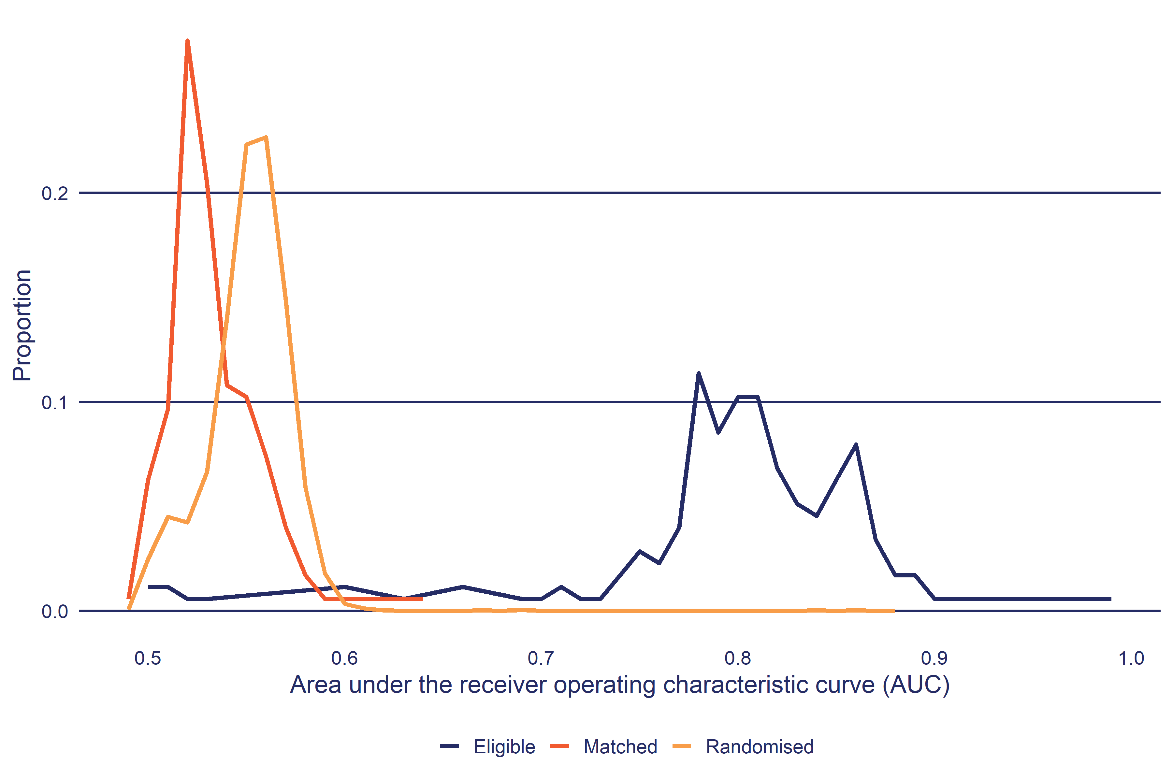

For each PSM cohort, the balance test fails if the PSM AUC is greater than the 95th percentile of the equivalent RCT AUC distribution. In other words, if the PSM AUC is less than the 95th percentile, we conclude it lies within the expected distribution of AUC where $P\left(D\right)⊥X$ is true. In the analysis section of this report, we only show the impacts for cohorts that have passed this balance test.

This is also the reason why the distribution of Matched AUC is to the left of the RCT AUC since we exclude any PSM where the Matched AUC exceeds the 95th percentile of the corresponding RCT. Accordingly the distribution of Matched AUC excludes those results where the balance test was poor and had a high AUC.

### IDI standard outcomes

Alongside the construction of credible comparison groups, the IDI also enables the tracking of meaningful outcomes. In this analysis we focus on the following outcome domains, with the specific outcome measure and its definition:

* **Employment** - In any employment: Employment is based on tax data (PAYE and annual tax returns). Periods with less than $100 of employment income per month are excluded.
* **Income** - Net income from all sources: Income includes taxable earnings, taxable and non-taxable income support payments including tax credits and pensions (but excluding recoverable assistance) and student allowance payments net of income tax.
* **Qualifications** - Average of highest NQF level achieved: For each person identify the highest NQF level awarded and calculate the average for the group. NQF levels start from 1 (year 11) through to 9 (PhD).
* **Justice** - Time in any corrections service: Corrections services include prison, community sentence, and home detention.
* **Study** - Enrolled in education or training: Education and training includes school, tertiary institutions and private training organisations. Enrolled does not always mean the person is attending.
* **Welfare** - Income Support expenditure: Income includes taxable and non-taxable income support payments including tax credits and pensions (but excluding recoverable assistance) net of income tax.

### Outcome follow up period

The above outcomes can be tracked over the period before starting Flexi-wage through to a maximum of 8.9 years. The follow-up period is based on when the first cohort of participants started in Flexi-wage (2013)[13] through to the most recent supply of administrative data to the IDI at time of publication (October 2023).

Because of the different ways agencies manage their administrative data, there are also considerable differences in how up to date administrative data is in the IDI. In particular, qualifications information is usually delayed by 18 months (eg information on qualifications gained in 2022 will be available in 2024).

It also follows that that follow up period will be longest for the initial cohort of participants who started Flexi-wage in 2013 and shortest for the most recent cohort who started in 2023

### Interpretation of counterfactual impact estimates

It is important to keep in mind that the comparison group can and do receive other services and assistance. For the majority of impact evaluations, the comparison is not between a service or programme and no assistance, but instead, it compares a service, such as Flexi-wage, against some level of alternative assistance. The level and type of alternative assistance has a bearing on how an impact estimate should be interpreted. For example, if a large proportion of the comparison group receives alternative assistance (such as in a drug trial) then a ‘no-impact’ finding does not mean the new intervention was ineffective, but instead, that it was as effective as current standard treatment.

In the context of Flexi-wage, we can measure the level and amount of employment and related assistance from MSD that both participants and the comparison group receive. Likewise, we can also measure the level of education and training both groups receive through MOE and TEC data. These differences were covered in the results section. On the other hand, assistance through other agencies and NGOs that is not captured through the IDI will be missed in this analysis.

### Interval and cumulative impacts

It is useful at this point to explain how we analyse the outcomes relative to participation in EA interventions. The outcomes described above are all longitudinal in nature. Therefore, we have the ability to measure outcomes at multiple points in time rather than being limited to a small number of measurement periods as would be the case for survey-based outcome measures.

This flexibility allows us to track outcomes relative to participation start dates as shown in Figure 9. The first point to make is that we measure outcomes from when people start an intervention, and this is defined as zero on our timeline. Why we choose the start date as the zero point is explained below. From the zero point, we can then create a series of lapse periods that represent the periods before and after the participation start date. Based on this timeline, we can measure outcomes in two ways: interval and cumulative.

**Figure 9**: Tracking EA intervention outcomes using administrative data

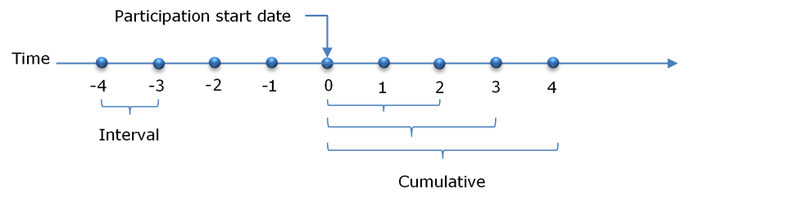

#### Interval outcomes

Interval outcomes are measured within a discrete lapse period, say the amount of income a person earned in the 12th month after starting an intervention. These intervals can vary in duration from one day to any period, but for EA interventions we usually use 30-day intervals.

Tracking interval outcomes is most useful in understanding the dynamic relationship between the intervention and the outcome in question. The purpose of EA interventions is to change the outcome trajectories of participants. Looking at how outcomes change in each lapse interval before and after commencing an intervention provides important information on the likely behavioural responses to the intervention.

#### Cumulative outcomes

While interval outcomes are useful to understand how outcomes and impacts change relative to when people start an intervention, they do not allow us to quantify the overall impact of an intervention. To make summary judgements we use cumulative outcomes. Cumulative outcomes are measured from participation start through to the end of each lapse period. Therefore, a cumulative 12-month outcome is for the entire 12 months from participation start.

#### Why measure outcomes from participation start?

A common question is why we measure outcomes from when people start an intervention, rather than when they finish. There are two reasons. The first is practical, namely that when people finish an intervention is often poorly recorded. Therefore, the date when people actually finish participating in an intervention is much less certain than the date they started.

The second reason is the importance of capturing the full impact of an intervention. The period while a person is on a programme can have an impact on their outcomes. The most common impact is referred to as the lock-in effect. As the name suggests, while people are participating in an intervention they are less likely to achieve an outcome, such as moving into employment. This can occur for a number of reasons. One is simply the reduction in time participants have to look for work. Another is the incentive to complete the programme. This effect is common for training programmes, where the need to complete the course to gain a qualification provides an incentive to turn down job opportunities if they do arise. If we did not include these effects, we run the risk of overstating the effectiveness of interventions.

# Appendix 1: example balance test results

The Table 25 shows the balance test for Flexi-wage 2016 starts. The * against comparison value indicates the simple difference is means is statistically significant.

**Table 25**: Summary of the profile of participants and matched comparison group for Flexi-wage

| Variable | Level | Participant | Comparison | Difference |
| --- | --- | --- | --- | --- |
| Demographics: Age | | | | |
| Age | 15 to 19 years | 11.5% | 11.2% | 0.3ppt |
| 20 to 24 years | 25.3% | 24.8% | 0.5ppt |
| 25 to 29 years | 16.4% | 16.5% | 0.1ppt |
| 30 to 34 years | 9.8% | 9.4% | 0.5ppt |
| 35 to 44 years | 17.0% | 17.9% | 0.9ppt |
| 45 to 54 years | 14.1% | 14.3% | 0.2ppt |
| 55 to 64 years | 5.6% | 5.8% | 0.1ppt |
| Demographics: Gender | | | | |
| Gender | Female | 36.6% | 35.4% | 1.2ppt |
| Male | 63.4% | 64.6% | 1.2ppt |
| Demographics: Ethnicity | | | | |
| Ethnicity | Maori | 40.4% | 41.2% | 0.8ppt |
| Pacific | 15.9% | 16.6% | 0.7ppt |
| Asian | 7.0% | 6.7% | 0.3ppt |
| MELAA | 3.1% | 2.8% | 0.4ppt |
| European | 59.4% | 58.9% | 0.4ppt |
| Education: School | | | | |
| Current school decile | Decile 1 to 2 | 8.4% | 8.3% | 0.1ppt |
| Decile 3 to 4 | 8.8% | 9.2% | 0.5ppt |
| Decile 5 | 6.4% | 5.9% | 0.5ppt |
| Decile 6 to 7 | 7.6% | 7.4% | 0.2ppt |
| Decile 8 to 9 | 5.2% | 5.0% | 0.2ppt |
| No school last 5 years | 63.5% | 64.0% | 0.5ppt |
| School authority for most recent school attended | State | 40.8% | 40.4% | 0.4ppt |
| No school record | 59.1% | 59.5% | 0.4ppt |
| Schools attended | | 1.65 | 1.61 | 0.03 |
| Suspensions | -0.01 to 0.01 | 94.1% | 94.0% | 0.1ppt |
| 0.02 to 6 | 5.9% | 5.9% | 0.1ppt |
| Number of stand-downs | -0.01 to 0.01 | 85.5% | 85.7% | 0.2ppt |
| 0.02 to 19.7 | 14.5% | 14.3% | 0.2ppt |
| Number of special education events | -0.01 to 0.01 | 95.3% | 95.1% | 0.1ppt |
| 0.02 to 13.1 | 4.7% | 4.8% | 0.1ppt |
| Education: Tertiary study | | | | |
| Currently studying at NZQF level | None | 93.4% | 93.7% | 0.3ppt |
| School pre NZQF 6 | 6.5% | 6.2% | 0.3ppt |
| Total days enrolled in NZQF 1 to 3 courses | | 714 | 713 | 1.70 |
| Total days enrolled in NZQF 4 to 6 courses | | 263 | 263 | 0.45 |
| Total days enrolled in NZQF 7 plus courses | | 89.77 | 83.79 | 5.98 |
| Total days enrolled in unknown NZQF level courses | | 30.80 | 32.53 | 1.73 |
| Enrolled in study at 0 months before profile date | | 8.5% | 7.9% | 0.6ppt |
| Enrolled in study at 1 month before profile date | | 9.8% | 9.3% | 0.5ppt |
| Enrolled in study at 2 months before profile date | | 11.2% | 10.3% | 0.9ppt |
| Enrolled in study at 3 months before profile date | | 12.4% | 11.6% | 0.8ppt |
| Enrolled in study at 4 months before profile date | | 13.3% | 12.5% | 0.8ppt |
| Enrolled in study at 5 months before profile date | | 14.6% | 13.6% | 1.1ppt |
| Enrolled in study at 6 months before profile date | | 15.5% | 14.7% | 0.8ppt |
| Enrolled in study at 7 months before profile date | | 15.8% | 15.0% | 0.8ppt |
| Enrolled in study at 8 months before profile date | | 16.8% | 16.0% | 0.8ppt |
| Enrolled in study at 9 months before profile date | | 17.6% | 16.8% | 0.8ppt |
| Enrolled in study at 10 months before profile date | | 18.2% | 16.6% | 1.6ppt |
| Enrolled in study at 11 months before profile date | | 18.1% | 16.5% | 1.6ppt |
| Enrolled in study at 12 months before profile date | | 18.3% | 16.9% | 1.4ppt |
| Enrolled in study at 15 months before profile date | | 19.0% | 18.3% | 0.7ppt |
| Enrolled in study at 18 months before profile date | | 19.9% | 19.3% | 0.7ppt |
| Enrolled in study at 21 months before profile date | | 22.2% | 21.3% | 0.9ppt |
| Enrolled in study at 24 months before profile date | | 23.3% | 22.7% | 0.6ppt |
| Enrolled in study at 30 months before profile date | | 25.1% | 24.4% | 0.7ppt |
| Enrolled in study at 36 months before profile date | | 27.1% | 26.5% | 0.5ppt |
| Enrolled in study at 42 months before profile date | | 28.6% | 27.9% | 0.7ppt |
| Education: Qualifications | | | | |
| Highest qualification | School pre NZQF | 10.7% | 10.5% | 0.2ppt |
| NZQF 1 to 3 | 62.8% | 64.1% | 1.3ppt |
| NZQF 4 to 6 | 22.0% | 20.9% | 1.0ppt |
| NZQF 7 plus | 4.6% | 4.4% | 0.1ppt |
| Highest qualification at 1 month before profile date | School pre NZQF | 11.0% | 10.7% | 0.4ppt |
| NZQF 1 to 3 | 62.6% | 64.0% | 1.4ppt |
| NZQF 4 to 6 | 21.8% | 20.8% | 1.0ppt |
| NZQF 7 plus | 4.4% | 4.4% | 0.1ppt |
| Highest qualification at 2 months before profile date | School pre NZQF | 11.4% | 11.1% | 0.3ppt |
| NZQF 1 to 3 | 62.5% | 63.9% | 1.4ppt |
| NZQF 4 to 6 | 21.5% | 20.6% | 0.9ppt |
| NZQF 7 plus | 4.4% | 4.3% | 0.1ppt |
| Highest qualification at 3 months before profile date | School pre NZQF | 11.5% | 11.5% | 0.0ppt |
| NZQF 1 to 3 | 62.7% | 63.7% | 1.0ppt |
| NZQF 4 to 6 | 21.4% | 20.5% | 0.9ppt |
| NZQF 7 plus | 4.4% | 4.3% | 0.1ppt |
| Highest qualification at 4 months before profile date | School pre NZQF | 12.1% | 11.9% | 0.2ppt |
| NZQF 1 to 3 | 62.4% | 63.6% | 1.2ppt |
| NZQF 4 to 6 | 21.1% | 20.3% | 0.8ppt |
| NZQF 7 plus | 4.3% | 4.1% | 0.2ppt |
| Highest qualification at 5 months before profile date | School pre NZQF | 12.5% | 12.4% | 0.1ppt |
| NZQF 1 to 3 | 62.5% | 63.6% | 1.1ppt |
| NZQF 4 to 6 | 20.8% | 20.0% | 0.7ppt |
| NZQF 7 plus | 4.3% | 4.0% | 0.2ppt |
| Highest qualification at 6 months before profile date | School pre NZQF | 12.7% | 12.5% | 0.2ppt |
| NZQF 1 to 3 | 62.5% | 63.6% | 1.1ppt |
| NZQF 4 to 6 | 20.6% | 19.9% | 0.7ppt |
| NZQF 7 plus | 4.2% | 4.0% | 0.2ppt |
| Highest qualification at 7 months before profile date | School pre NZQF | 12.8% | 12.8% | 0.1ppt |
| NZQF 1 to 3 | 62.5% | 63.4% | 1.0ppt |
| NZQF 4 to 6 | 20.5% | 19.7% | 0.8ppt |
| NZQF 7 plus | 4.1% | 4.0% | 0.1ppt |
| Highest qualification at 8 months before profile date | School pre NZQF | 13.3% | 13.1% | 0.2ppt |
| NZQF 1 to 3 | 62.4% | 63.4% | 1.0ppt |
| NZQF 4 to 6 | 20.3% | 19.6% | 0.7ppt |
| NZQF 7 plus | 4.0% | 3.8% | 0.1ppt |
| Highest qualification at 9 months before profile date | School pre NZQF | 13.6% | 13.3% | 0.3ppt |
| NZQF 1 to 3 | 62.2% | 63.2% | 1.0ppt |
| NZQF 4 to 6 | 20.3% | 19.7% | 0.6ppt |
| NZQF 7 plus | 3.8% | 3.7% | 0.1ppt |
| Highest qualification at 11 months before profile date | School pre NZQF | 14.3% | 14.3% | 0.0ppt |
| NZQF 1 to 3 | 62.0% | 62.7% | 0.7ppt |
| NZQF 4 to 6 | 19.9% | 19.3% | 0.6ppt |
| NZQF 7 plus | 3.8% | 3.7% | 0.2ppt |
| Highest qualification at 15 months before profile date | School pre NZQF | 15.7% | 15.5% | 0.1ppt |
| NZQF 1 to 3 | 60.9% | 62.0% | 1.1ppt |
| NZQF 4 to 6 | 19.6% | 18.8% | 0.8ppt |
| NZQF 7 plus | 3.7% | 3.5% | 0.2ppt |
| Highest qualification at 18 months before profile date | School pre NZQF | 15.1% | 15.2% | 0.1ppt |
| NZQF 1 to 3 | 59.5% | 60.7% | 1.1ppt |
| NZQF 4 to 6 | 18.2% | 18.0% | 0.2ppt |
| NZQF 7 plus | 4.0% | 3.5% | 0.5ppt |
| Unknown | 3.1% | 2.7% | 0.4ppt |
| Highest qualification at 21 months before profile date | School pre NZQF | 16.1% | 16.0% | 0.1ppt |
| NZQF 1 to 3 | 59.0% | 60.0% | 1.0ppt |
| NZQF 4 to 6 | 17.8% | 17.6% | 0.2ppt |
| NZQF 7 plus | 3.7% | 3.5% | 0.2ppt |
| Unknown | 3.4% | 2.9% | 0.5ppt |
| Highest qualification at 24 months before profile date | School pre NZQF | 17.0% | 17.0% | 0.0ppt |
| NZQF 1 to 3 | 58.0% | 58.9% | 1.0ppt |
| NZQF 4 to 6 | 17.6% | 17.3% | 0.3ppt |
| NZQF 7 plus | 3.7% | 3.4% | 0.3ppt |
| Unknown | 3.7% | 3.2% | 0.5ppt |
| Highest qualification at 30 months before profile date | School pre NZQF | 20.0% | 19.9% | 0.1ppt |
| NZQF 1 to 3 | 55.0% | 56.1% | 1.1ppt |
| NZQF 4 to 6 | 16.9% | 16.5% | 0.4ppt |
| NZQF 7 plus | 3.8% | 3.3% | 0.5ppt |
| Unknown | 4.4% | 4.2% | 0.2ppt |
| Highest qualification at 36 months before profile date | School pre NZQF | 22.7% | 22.8% | 0.1ppt |
| NZQF 1 to 3 | 52.4% | 53.2% | 0.8ppt |
| NZQF 4 to 6 | 15.8% | 15.2% | 0.7ppt |
| Unknown | 8.9% | 8.8% | 0.1ppt |
| Highest qualification at 42 months before profile date | School pre NZQF | 20.8% | 21.3% | 0.5ppt |
| NZQF 1 to 3 | 47.9% | 48.6% | 0.7ppt |
| NZQF 4 to 6 | 12.4% | 12.1% | 0.3ppt |
| Unknown | 19.0% | 18.1% | 0.9ppt |
| Health and disability: Incapacity information | | | | |
| Incapacity for depression in last 5 years | | 8.1% | 8.5% | 0.4ppt |
| Incapacity for injury in last 5 years | | 5.8% | 6.3% | 0.5ppt |
| Incapacity for musculoskeletal condition in last 5 years | | 4.0% | 3.8% | 0.1ppt |
| Incapacity for other psychological in last 5 years | | 9.8% | 10.4% | 0.6ppt |
| Incapacity for substance abuse in last 5 years | | 4.1% | 4.6% | 0.4ppt |
| Location: Deprivation index decile | | | | |
| Deprivation index of current address | Decile 1 to 2 | 5.8% | 5.0% | 0.8ppt |
| Decile 3 to 4 | 10.3% | 10.7% | 0.4ppt |
| Decile 5 | 6.8% | 7.1% | 0.2ppt |
| Decile 6 | 9.0% | 9.0% | 0.0ppt |
| Decile 7 | 9.5% | 9.5% | 0.1ppt |
| Decile 8 | 13.3% | 14.0% | 0.7ppt |
| Decile 9 | 17.3% | 17.6% | 0.3ppt |
| Decile 10 | 24.2% | 23.6% | 0.5ppt |
| Unknown location | 3.6% | 3.5% | 0.1ppt |
| Location: Urbanisation of location | | | | |
| Level of urbanisation of current address | Major urban area | 50.3% | 51.4% | 1.1ppt |
| Large urban area | 19.3% | 18.7% | 0.5ppt |
| Medium urban area | 7.4% | 7.0% | 0.5ppt |
| Small urban area | 11.3% | 11.7% | 0.4ppt |
| Rural other | 8.0% | 7.7% | 0.4ppt |
| Unknown | 3.5% | 3.4% | 0.2ppt |
| Housing: Number of address changes | | | | |
| Address changes in the last two years | No change of address | 30.4% | 30.5% | 0.1ppt |
| 1 address change | 22.5% | 22.2% | 0.3ppt |
| 2 address changes | 18.9% | 18.5% | 0.4ppt |
| 3 address changes | 12.2% | 12.5% | 0.3ppt |
| 4 address changes | 7.1% | 7.2% | 0.1ppt |
| Over 4 address changes | 8.7% | 9.1% | 0.4ppt |
| Employment: Working life in employment | | | | |
| Proportion of adult life in New Zealand in employment | 0% | 5.9% | 5.5% | 0.5ppt |
| 1 to 9% | 10.3% | 10.5% | 0.2ppt |
| 10 to 19% | 12.4% | 12.2% | 0.2ppt |
| 20 to 29% | 12.2% | 12.2% | 0.0ppt |
| 30 to 39% | 11.1% | 11.9% | 0.8ppt |
| 40 to 49% | 11.7% | 12.0% | 0.3ppt |
| 50 to 59% | 9.5% | 9.9% | 0.4ppt |
| 60 to 69% | 8.6% | 8.9% | 0.3ppt |
| 70 to 79% | 6.8% | 6.5% | 0.3ppt |
| 80 to 89% | 5.4% | 4.8% | 0.6ppt |
| 90% plus | 6.1% | 5.6% | 0.4ppt |
| Employment: Employment history | | | | |
| Employed at 0 months before profile date | | 30.0% | 28.6% | 1.4ppt |
| Employed at 1 month before profile date | | 29.4% | 28.5% | 1.0ppt |
| Employed at 2 months before profile date | | 29.4% | 29.4% | 0.1ppt |
| Employed at 3 months before profile date | | 30.3% | 30.0% | 0.3ppt |
| Employed at 4 months before profile date | | 31.4% | 31.1% | 0.3ppt |
| Employed at 5 months before profile date | | 33.3% | 31.9% | 1.3ppt |
| Employed at 6 months before profile date | | 34.4% | 33.7% | 0.7ppt |
| Employed at 7 months before profile date | | 35.3% | 35.1% | 0.2ppt |
| Employed at 8 months before profile date | | 36.4% | 36.4% | 0.1ppt |
| Employed at 9 months before profile date | | 36.1% | 35.2% | 0.8ppt |
| Employed at 10 months before profile date | | 36.8% | 36.7% | 0.1ppt |
| Employed at 11 months before profile date | | 37.2% | 36.7% | 0.5ppt |
| Employed at 12 months before profile date | | 37.6% | 37.8% | 0.2ppt |
| Employed at 15 months before profile date | | 39.0% | 39.4% | 0.4ppt |
| Employed at 18 months before profile date | | 39.7% | 39.6% | 0.2ppt |
| Employed at 21 months before profile date | | 38.8% | 37.9% | 0.8ppt |
| Employed at 24 months before profile date | | 37.6% | 36.3% | 1.3ppt |
| Employed at 30 months before profile date | | 35.8% | 34.6% | 1.2ppt |
| Employed at 36 months before profile date | | 34.6% | 34.2% | 0.4ppt |
| Employed at 42 months before profile date | | 32.8% | 32.1% | 0.8ppt |
| Income Support: Current benefit status | | | | |
| Current main benefit type | Jobseeker Support Work Ready | 54.9% | 56.5% | 1.7ppt |
| Sole Parent Support | 14.0% | 13.7% | 0.3ppt |
| Jobseeker Support HCD | 9.7% | 8.5% | 1.2ppt |
| Off Benefit | 21.4% | 21.3% | 0.1ppt |
| Income Support: Benefit duration | | | | |
| Duration on current benefit | | 318 | 308 | 10.25 |
| Income Support: Recent benefit history | | | | |
| Previous benefit type | Off Benefit | 72.4% | 72.0% | 0.4ppt |
| Jobseeker Support Work Ready | 14.6% | 14.5% | 0.2ppt |
| Sole Parent Support | 3.1% | 3.1% | 0.0ppt |
| Jobseeker Support HCD | 9.8% | 10.4% | 0.7ppt |
| Income Support: Total benefit contact | | | | |
| Proportion of adult life on invalid related benefits | -0.01 to 0.01 | 95.7% | 95.9% | 0.1ppt |
| 0.02 to 2 | 4.2% | 4.1% | 0.1ppt |
| Proportion of adult life on job seeker related benefits | | 0.17 | 0.18 | 0.01 |
| Proportion of adult life on sickness related benefits | | 0.05 | 0.05 | 0.00 |
| Proportion of adult life on sole parent related benefits | | 0.10 | 0.10 | 0.00 |
| Proportion of adult life on youth related benefits | | 0.01 | 0.01 | 0.00 |
| Income Support: First benefit information | | | | |
| First type of main benefit granted | Youth | 10.3% | 10.6% | 0.3ppt |
| Jobseeker Support Work Ready | 61.5% | 62.4% | 0.9ppt |
| Jobseeker Support HCD | 10.9% | 10.7% | 0.1ppt |
| Sole Parent Support | 7.9% | 7.5% | 0.4ppt |
| Off Benefit | 9.3% | 8.6% | 0.7ppt |
| Income Support: Childhood benefit receipt | | | | |
| Childhood benefit (0-4) | No time on main benefit | 14.5% | 13.6% | 1.0ppt |
| Under 75% of the period | 10.5% | 10.5% | 0.0ppt |
| Over 75% of the period | 21.2% | 21.8% | 0.5ppt |
| Over age range by 1 Janurary 1993 | 53.7% | 54.1% | 0.4ppt |
| Childhood benefit (4-8) | No time on main benefit | 24.3% | 22.6% | 1.7ppt |
| Under 25% of the period | 5.7% | 5.5% | 0.2ppt |
| 25 to 75% of the period | 10.6% | 10.3% | 0.3ppt |
| Over 75% of the period | 23.5% | 24.3% | 0.8ppt |
| Over age range by 1 Janurary 1993 | 35.9% | 37.2% | 1.3ppt |
| Childhood benefit (12-16) | No time on main benefit | 18.4% | 17.2% | 1.3ppt |
| Under 75% of the period | 13.3% | 12.5% | 0.8ppt |
| Over 75% of the period | 24.6% | 25.8% | 1.2ppt |
| Over age range by 1 Janurary 1993 | 43.5% | 44.4% | 0.8ppt |
| Childhood benefit (16-18) | No time on main benefit | 30.9% | 29.2% | 1.6ppt |
| Under 25% of the period | 6.7% | 6.8% | 0.1ppt |
| 25 to 75% of the period | 12.8% | 12.5% | 0.2ppt |
| Over 75% of the period | 20.9% | 21.8% | 0.9ppt |
| Over age range by 1 Janurary 1993 | 28.6% | 29.7% | 1.0ppt |
| Income Support: Income support history | | | | |
| Time on main benefit or pension at 0 months before profile date | | 24.22 | 24.32 | 0.10 |
| Time on main benefit or pension at 1 month before profile date | | 22.89 | 22.98 | 0.09 |
| Time on main benefit or pension at 2 months before profile date | | 21.67 | 21.79 | 0.12 |
| Time on main benefit or pension at 3 months before profile date | | 20.45 | 20.57 | 0.12 |
| Time on main benefit or pension at 4 months before profile date | | 19.47 | 19.62 | 0.15 |
| Time on main benefit or pension at 5 months before profile date | | 18.55 | 18.86 | 0.32 |
| Time on main benefit or pension at 6 months before profile date | | 17.81 | 18.27 | 0.46 |
| Time on main benefit or pension at 7 months before profile date | | 17.13 | 17.59 | 0.46 |
| Time on main benefit or pension at 8 months before profile date | | 16.50 | 16.85 | 0.36 |
| Time on main benefit or pension at 9 months before profile date | | 15.92 | 15.97 | 0.05 |
| Time on main benefit or pension at 10 months before profile date | | 15.39 | 15.34 | 0.05 |
| Time on main benefit or pension at 11 months before profile date | | 14.95 | 15.02 | 0.06 |
| Time on main benefit or pension at 12 months before profile date | | 14.65 | 14.78 | 0.13 |
| Time on main benefit or pension at 15 months before profile date | | 13.77 | 13.90 | 0.14 |
| Time on main benefit or pension at 18 months before profile date | | 13.28 | 13.50 | 0.22 |
| Time on main benefit or pension at 21 months before profile date | | 13.11 | 13.25 | 0.15 |
| Time on main benefit or pension at 24 months before profile date | | 12.55 | 13.10 | 0.55 |
| Time on main benefit or pension at 30 months before profile date | | 12.07 | 12.51 | 0.44 |
| Time on main benefit or pension at 36 months before profile date | | 11.50 | 11.96 | 0.46 |
| Time on main benefit or pension at 42 months before profile date | | 11.37 | 11.94 | 0.57 |
| Justice: Police offences | | | | |
| Number of offences | | 3.14 | 3.31 | 0.17 |
| Most serious offence score | | 115 | 114 | 1.61 |
| Age of first arrest | Never | 51.3% | 49.2% | 2.1ppt |
| 10 to 14 years | 3.6% | 3.4% | 0.2ppt |
| 15 to 17 years | 9.2% | 9.3% | 0.1ppt |
| 18 to 19 years | 6.7% | 7.1% | 0.4ppt |
| 20 to 24 years | 9.4% | 9.7% | 0.3ppt |
| 25 to 29 years | 5.6% | 5.4% | 0.2ppt |
| 30 to 34 years | 4.4% | 4.9% | 0.5ppt |
| 35 to 44 years | 6.4% | 7.4% | 1.0ppt |
| 45 to 54 years | 3.4% | 3.7% | 0.3ppt |
| Justice: Corrections spells | | | | |
| Total time in prison | | 92.21 | 117 | 24.65 |
| Total time in home detention | -0.01 to 0.01 | 94.5% | 93.7% | 0.8ppt |
| 0.02 to 699 | 5.5% | 6.2% | 0.8ppt |
| Total time in community service | | 312 | 355 | 42.62 |
| Age at first Correction service | Never | 63.7% | 61.6% | 2.1ppt |
| 10 to 17 years | 6.7% | 7.6% | 0.9ppt |
| 18 to 19 years | 8.6% | 8.2% | 0.5ppt |
| 20 to 24 years | 10.4% | 11.1% | 0.7ppt |
| 25 to 34 years | 6.8% | 7.3% | 0.5ppt |
| 35 to 64 years | 3.6% | 4.2% | 0.6ppt |
| Time since last Corrections involvement | Never | 71.6% | 70.5% | 1.1ppt |
| Under 12 months | 6.2% | 6.5% | 0.3ppt |
| 1 to under 3 years | 7.4% | 7.9% | 0.4ppt |
| 3 to under 6 years | 6.5% | 7.3% | 0.8ppt |
| Over 6 years | 8.2% | 7.8% | 0.4ppt |
| Justice: Youth Justice | | | | |
| Time in Youth Justice placements | No placement | 75.9% | 75.2% | 0.7ppt |
| Over age range by 1 January 1991 | 24.0% | 24.8% | 0.8ppt |
| Justice: Corrections history | | | | |
| In correction service at 0 months before profile date | Non Prison | 8.5% | 9.5% | 1.0ppt |
| None | 91.4% | 90.5% | 1.0ppt |
| In correction service at 1 month before profile date | Non Prison | 8.3% | 9.1% | 0.8ppt |
| None | 91.7% | 90.8% | 0.8ppt |
| In correction service at 2 months before profile date | Non Prison | 8.2% | 9.1% | 0.9ppt |
| None | 91.7% | 90.9% | 0.8ppt |
| In correction service at 3 months before profile date | Non Prison | 8.0% | 9.1% | 1.1ppt |
| None | 92.0% | 90.8% | 1.2ppt |
| In correction service at 4 months before profile date | Non Prison | 7.8% | 9.3% | 1.5ppt |
| None | 92.1% | 90.7% | 1.4ppt |
| In correction service at 5 months before profile date | Non Prison | 7.7% | 8.9% | 1.2ppt |
| None | 92.3% | 91.1% | 1.2ppt |
| In correction service at 6 months before profile date | Non Prison | 7.7% | 8.7% | 1.0ppt |
| None | 92.2% | 91.2% | 1.0ppt |
| In correction service at 7 months before profile date | Non Prison | 7.6% | 8.4% | 0.8ppt |
| None | 92.3% | 91.5% | 0.8ppt |
| In correction service at 8 months before profile date | Non Prison | 7.5% | 8.2% | 0.7ppt |
| None | 92.4% | 91.8% | 0.7ppt |
| In correction service at 9 months before profile date | Non Prison | 7.3% | 8.0% | 0.7ppt |
| None | 92.7% | 92.0% | 0.7ppt |
| In correction service at 10 months before profile date | Non Prison | 7.1% | 8.1% | 1.0ppt |
| None | 92.8% | 91.8% | 1.0ppt |
| In correction service at 11 months before profile date | Non Prison | 7.1% | 8.0% | 0.8ppt |
| None | 92.8% | 92.0% | 0.8ppt |
| In correction service at 12 months before profile date | Non Prison | 7.2% | 8.0% | 0.8ppt |
| None | 92.7% | 92.0% | 0.8ppt |
| In correction service at 15 months before profile date | Non Prison | 6.9% | 7.8% | 0.9ppt |
| None | 93.0% | 92.2% | 0.8ppt |
| In correction service at 18 months before profile date | Non Prison | 7.0% | 7.3% | 0.3ppt |
| None | 93.0% | 92.7% | 0.4ppt |
| In correction service at 21 months before profile date | Non Prison | 6.5% | 6.9% | 0.4ppt |
| None | 93.4% | 93.1% | 0.3ppt |
| In correction service at 24 months before profile date | Non Prison | 6.8% | 7.1% | 0.3ppt |
| None | 93.2% | 92.9% | 0.3ppt |
| In correction service at 30 months before profile date | Non Prison | 7.3% | 8.5% | 1.1ppt |
| None | 92.6% | 91.5% | 1.1ppt |
| In correction service at 36 months before profile date | Non Prison | 7.1% | 8.3% | 1.3ppt |
| None | 92.9% | 91.6% | 1.3ppt |
| In correction service at 42 months before profile date | Non Prison | 7.1% | 8.3% | 1.1ppt |
| None | 92.8% | 91.7% | 1.1ppt |
| Residency: Migrant status | | | | |
| Proportion of life living in New Zealand | | 0.90 | 0.91 | 0.01 |
| Age at first arrival in New Zealand | Born in NZ | 86.2% | 87.3% | 1.1ppt |
| Under 17 years | 5.2% | 4.8% | 0.4ppt |
| 18 to 34 years | 5.6% | 4.9% | 0.7ppt |
| 35 to 64 years | 3.0% | 2.9% | 0.1ppt |
| Migrant's region of origin | New Zealand | 90.3% | 90.9% | 0.5ppt |
| Oceania | 4.1% | 4.3% | 0.2ppt |
| Asia | 5.6% | 4.8% | 0.8ppt |
| Visa when first arriving in New Zealand | Citizen | 87.3% | 88.4% | 1.0ppt |
| Resident | 5.3% | 4.8% | 0.5ppt |
| Temporary | 7.3% | 6.8% | 0.5ppt |
| Income: Income history | | | | |
| Income support payments at 0 months before profile date | | 953 | 964 | 11.04 |
| Income support payments at 1 month before profile date | | 909 | 919 | 10.05 |
| Income support payments at 2 months before profile date | | 864 | 875 | 11.33 |
| Income support payments at 3 months before profile date | | 868 | 877 | 9.32 |
| Income support payments at 4 months before profile date | | 851 | 864 | 13.12 |
| Income support payments at 5 months before profile date | | 802 | 825 | 23.16 |
| Income support payments at 6 months before profile date | | 776 | 801 | 25.07 |
| Income support payments at 7 months before profile date | | 758 | 779 | 21.42 |
| Income support payments at 8 months before profile date | | 737 | 763 | 26.23 |
| Income support payments at 9 months before profile date | | 709 | 722 | 13.38 |
| Income support payments at 10 months before profile date | | 693 | 697 | 3.82 |
| Income support payments at 11 months before profile date | | 667 | 683 | 15.96 |
| Income support payments at 12 months before profile date | | 664 | 663 | 0.68 |
| Income support payments at 15 months before profile date | | 588 | 598 | 9.51 |
| Income support payments at 18 months before profile date | | 564 | 578 | 13.29 |
| Income support payments at 21 months before profile date | | 558 | 565 | 6.63 |
| Income support payments at 24 months before profile date | | 536 | 560 | 23.78 |
| Income support payments at 30 months before profile date | | 509 | 522 | 12.61 |
| Income support payments at 36 months before profile date | | 486 | 503 | 16.30 |
| Income support payments at 42 months before profile date | | 479 | 497 | 18.41 |
| Income transfer payments (yearly average) | | 8,226 | 8,311 | 84.12 |
| Labour market income (yearly average) | | 8,408 | 8,009 | 399 |
| Net child support payments (yearly average) | | 7.16 | 1.88 | 5.28 |
| Net income at 0 months before profile date | | 1,617 | 1,616 | 0.47 |
| Net income at 1 month before profile date | | 1,606 | 1,602 | 3.62 |
| Net income at 2 months before profile date | | 1,587 | 1,601 | 13.70 |
| Net income at 3 months before profile date | | 1,631 | 1,642 | 11.03 |
| Net income at 4 months before profile date | | 1,651 | 1,663 | 11.94 |
| Net income at 5 months before profile date | | 1,641 | 1,654 | 12.95 |
| Net income at 6 months before profile date | | 1,650 | 1,682 | 32.65 |
| Net income at 7 months before profile date | | 1,669 | 1,673 | 4.32 |
| Net income at 8 months before profile date | | 1,663 | 1,689 | 25.71 |
| Net income at 9 months before profile date | | 1,657 | 1,651 | 5.87 |
| Net income at 10 months before profile date | | 1,653 | 1,650 | 3.09 |
| Net income at 11 months before profile date | | 1,628 | 1,632 | 4.21 |
| Net income at 12 months before profile date | | 1,662 | 1,653 | 9.62 |
| Net income at 15 months before profile date | | 1,615 | 1,626 | 11.00 |
| Net income at 18 months before profile date | | 1,618 | 1,617 | 0.84 |
| Net income at 21 months before profile date | | 1,595 | 1,587 | 8.26 |
| Net income at 24 months before profile date | | 1,558 | 1,547 | 11.66 |
| Net income at 30 months before profile date | | 1,483 | 1,483 | 0.05 |
| Net income at 36 months before profile date | | 1,427 | 1,417 | 10.68 |
| Net income at 42 months before profile date | | 1,363 | 1,360 | 2.34 |
| Labour market income at 0 months before profile date | | 339 | 327 | 11.72 |
| Labour market income at 1 month before profile date | | 373 | 360 | 12.42 |
| Labour market income at 2 months before profile date | | 399 | 406 | 6.94 |
| Labour market income at 3 months before profile date | | 433 | 443 | 10.49 |
| Labour market income at 4 months before profile date | | 472 | 476 | 3.56 |
| Labour market income at 5 months before profile date | | 515 | 511 | 3.75 |
| Labour market income at 6 months before profile date | | 546 | 560 | 14.71 |
| Labour market income at 7 months before profile date | | 579 | 570 | 8.52 |
| Labour market income at 8 months before profile date | | 596 | 599 | 3.55 |
| Labour market income at 9 months before profile date | | 617 | 599 | 18.71 |
| Labour market income at 10 months before profile date | | 626 | 619 | 7.31 |
| Labour market income at 11 months before profile date | | 631 | 627 | 4.04 |
| Labour market income at 12 months before profile date | | 662 | 660 | 2.27 |
| Labour market income at 15 months before profile date | | 698 | 702 | 3.45 |
| Labour market income at 18 months before profile date | | 718 | 704 | 13.83 |
| Labour market income at 21 months before profile date | | 699 | 687 | 12.40 |
| Labour market income at 24 months before profile date | | 687 | 649 | 37.95 |
| Labour market income at 30 months before profile date | | 653 | 640 | 13.31 |
| Labour market income at 36 months before profile date | | 625 | 608 | 16.99 |
| Labour market income at 42 months before profile date | | 586 | 566 | 19.33 |
| Net child support payments at 0 months before profile date | | 6.44 | 9.05 | 2.61 |
| Net child support payments at 1 month before profile date | | 5.70 | 8.44 | 2.73 |
| Net child support payments at 2 months before profile date | | 4.76 | 4.95 | 0.19 |
| Net child support payments at 3 months before profile date | | 4.27 | 4.11 | 0.15 |
| Net child support payments at 4 months before profile date | | 3.84 | 3.83 | 0.01 |
| Net child support payments at 5 months before profile date | | 3.52 | 3.19 | 0.33 |
| Net child support payments at 6 months before profile date | | 3.38 | 3.07 | 0.31 |
| Net child support payments at 7 months before profile date | | 3.25 | 2.91 | 0.34 |
| Net child support payments at 8 months before profile date | | 3.18 | 3.25 | 0.07 |
| Net child support payments at 9 months before profile date | | 2.95 | 3.46 | 0.51 |
| Net child support payments at 10 months before profile date | | 3.00 | 3.47 | 0.47 |
| Net child support payments at 11 months before profile date | | 3.11 | 3.16 | 0.05 |
| Net child support payments at 12 months before profile date | | 3.15 | 2.63 | 0.53 |
| Net child support payments at 15 months before profile date | | 2.74 | 1.92 | 0.81 |
| Net child support payments at 18 months before profile date | | 2.11 | 0.90 | 1.21 |
| Net child support payments at 21 months before profile date | | 1.97 | 1.20 | 0.76 |
| Net child support payments at 24 months before profile date | | 1.66 | 0.63 | 1.03 |
| Net child support payments at 30 months before profile date | | 2.04 | 0.93 | 1.10 |
| Net child support payments at 36 months before profile date | | 1.25 | 0.90 | 0.35 |
| Net child support payments at 42 months before profile date | | 0.26 | 0.86 | 0.60 |
| Overseas: Overseas history | | | | |
| Overseas at 4 months before profile date | | 3.2% | 3.1% | 0.1ppt |
| Overseas at 5 months before profile date | | 3.4% | 3.0% | 0.4ppt |
| Overseas at 6 months before profile date | | 3.5% | 3.1% | 0.4ppt |
| Overseas at 7 months before profile date | | 3.6% | 3.3% | 0.3ppt |
| Overseas at 8 months before profile date | | 4.0% | 3.5% | 0.5ppt |
| Overseas at 9 months before profile date | | 4.1% | 4.0% | 0.1ppt |
| Overseas at 10 months before profile date | | 3.9% | 3.8% | 0.1ppt |
| Overseas at 11 months before profile date | | 4.2% | 4.1% | 0.1ppt |
| Overseas at 12 months before profile date | | 4.2% | 3.8% | 0.4ppt |
| Overseas at 15 months before profile date | | 4.3% | 4.0% | 0.3ppt |
| Overseas at 18 months before profile date | | 4.7% | 4.4% | 0.2ppt |
| Overseas at 21 months before profile date | | 5.2% | 4.7% | 0.5ppt |
| Overseas at 24 months before profile date | | 5.3% | 4.8% | 0.5ppt |
| Overseas at 30 months before profile date | | 5.9% | 5.3% | 0.6ppt |
| Overseas at 36 months before profile date | | 6.3% | 5.5% | 0.8ppt |
| Overseas at 42 months before profile date | | 6.2% | 5.9% | 0.3ppt |
| Employment assistance: Participation in employment assistance | | | | |
| Employment assistance expenditure at 0 months before profile date | | 313 | 409 | 95.43 |
| Employment assistance expenditure at 1 month before profile date | | 148 | 215 | 67.15 |
| Employment assistance expenditure at 2 months before profile date | | 105 | 138 | 32.82 |
| Employment assistance expenditure at 3 months before profile date | | 95.44 | 111 | 15.77 |
| Employment assistance expenditure at 4 months before profile date | | 54.00 | 68.18 | 14.18 |
| Employment assistance expenditure at 5 months before profile date | | 56.30 | 66.21 | 9.91 |
| Employment assistance expenditure at 6 months before profile date | | 76.04 | 79.97 | 3.93 |
| Employment assistance expenditure at 7 months before profile date | | 87.11 | 60.40 | 26.71 |
| Employment assistance expenditure at 8 months before profile date | | 59.83 | 55.32 | 4.51 |
| Employment assistance expenditure at 9 months before profile date | | 57.71 | 59.78 | 2.06 |
| Employment assistance expenditure at 10 months before profile date | | 58.50 | 50.58 | 7.92 |
| Employment assistance expenditure at 11 months before profile date | | 66.10 | 55.80 | 10.30 |
| Employment assistance expenditure at 12 months before profile date | | 76.03 | 73.34 | 2.69 |
| Employment assistance expenditure at 15 months before profile date | | 54.82 | 53.68 | 1.13 |
| Employment assistance expenditure at 18 months before profile date | | 54.73 | 62.97 | 8.24 |
| Employment assistance expenditure at 21 months before profile date | | 54.46 | 54.19 | 0.27 |
| Employment assistance expenditure at 24 months before profile date | | 54.93 | 60.32 | 5.39 |
| Employment assistance expenditure at 30 months before profile date | | 43.83 | 60.31 | 16.49 |
| Employment assistance expenditure at 36 months before profile date | | 50.65 | 68.00 | 17.35 |
| Employment assistance expenditure at 42 months before profile date | | 54.95 | 65.25 | 10.30 |
| Care and Protection: Care notifications | | | | |
| Care notifications (0-3 years) | One four notifications | 5.8% | 6.1% | 0.3ppt |
| Over age range by 1 January 1991 | 48.0% | 48.4% | 0.5ppt |
| No notifications | 46.2% | 45.4% | 0.8ppt |
| Care notifications (4-7 years) | Two to more notifications | 3.9% | 3.7% | 0.2ppt |
| One notification | 5.3% | 5.4% | 0.1ppt |
| Over age range by 1 January 1991 | 39.7% | 41.0% | 1.3ppt |
| No notifications | 51.1% | 49.9% | 1.2ppt |
| Care notifications (8-11 years) | Two to more notifications | 5.5% | 5.8% | 0.2ppt |
| One notification | 6.2% | 6.5% | 0.2ppt |
| Over age range by 1 January 1991 | 32.2% | 33.6% | 1.4ppt |
| No notifications | 56.0% | 54.1% | 1.9ppt |
| Care notifications (12-15 years) | Two to four notifications | 8.5% | 9.1% | 0.7ppt |
| One notification | 9.2% | 9.4% | 0.1ppt |
| Over age range by 1 January 1991 | 25.8% | 26.7% | 0.9ppt |
| No notifications | 56.5% | 54.9% | 1.6ppt |
| Transport: Private driver licence | | | | |
| Private drivers licence status | Full | 42.3% | 42.0% | 0.2ppt |
| Restricted | 20.4% | 20.5% | 0.1ppt |
| Learner | 22.4% | 22.6% | 0.1ppt |
| No licence | 14.8% | 14.9% | 0.1ppt |
| Full driver licence at 0 months before profile date | | 12.83 | 12.73 | 0.10 |
| Full driver licence at 1 month before profile date | | 12.66 | 12.52 | 0.14 |
| Full driver licence at 2 months before profile date | | 12.56 | 12.45 | 0.10 |
| Full driver licence at 3 months before profile date | | 12.42 | 12.32 | 0.11 |
| Full driver licence at 4 months before profile date | | 12.35 | 12.25 | 0.10 |
| Full driver licence at 5 months before profile date | | 12.25 | 12.17 | 0.08 |
| Full driver licence at 6 months before profile date | | 12.11 | 12.03 | 0.08 |
| Full driver licence at 7 months before profile date | | 11.97 | 11.89 | 0.09 |
| Full driver licence at 8 months before profile date | | 11.88 | 11.78 | 0.10 |
| Full driver licence at 9 months before profile date | | 11.82 | 11.67 | 0.15 |
| Full driver licence at 10 months before profile date | | 11.68 | 11.55 | 0.13 |
| Full driver licence at 11 months before profile date | | 11.58 | 11.43 | 0.14 |
| Full driver licence at 12 months before profile date | | 11.55 | 11.43 | 0.11 |
| Full driver licence at 15 months before profile date | | 11.19 | 11.15 | 0.05 |
| Full driver licence at 18 months before profile date | | 10.95 | 10.95 | 0.00 |
| Full driver licence at 21 months before profile date | | 10.82 | 10.84 | 0.02 |
| Full driver licence at 24 months before profile date | | 10.61 | 10.69 | 0.09 |
| Full driver licence at 30 months before profile date | | 10.23 | 10.32 | 0.08 |
| Full driver licence at 36 months before profile date | | 9.98 | 10.06 | 0.08 |
| Full driver licence at 42 months before profile date | | 9.66 | 9.72 | 0.05 |
| Time without any driver licence at 0 months before profile date | | 4.59 | 4.60 | 0.01 |
| Time without any driver licence at 1 month before profile date | | 4.74 | 4.76 | 0.02 |
| Time without any driver licence at 2 months before profile date | | 4.89 | 4.91 | 0.02 |
| Time without any driver licence at 3 months before profile date | | 5.03 | 5.03 | 0.00 |
| Time without any driver licence at 4 months before profile date | | 5.18 | 5.18 | 0.00 |
| Time without any driver licence at 5 months before profile date | | 5.33 | 5.32 | 0.01 |
| Time without any driver licence at 6 months before profile date | | 5.45 | 5.43 | 0.02 |
| Time without any driver licence at 7 months before profile date | | 5.61 | 5.62 | 0.01 |
| Time without any driver licence at 8 months before profile date | | 5.74 | 5.77 | 0.03 |
| Time without any driver licence at 9 months before profile date | | 5.87 | 5.90 | 0.04 |
| Time without any driver licence at 10 months before profile date | | 5.99 | 6.06 | 0.07 |
| Time without any driver licence at 11 months before profile date | | 6.13 | 6.23 | 0.09 |
| Time without any driver licence at 12 months before profile date | | 6.26 | 6.36 | 0.10 |
| Time without any driver licence at 15 months before profile date | | 6.62 | 6.73 | 0.11 |
| Time without any driver licence at 18 months before profile date | | 7.04 | 7.07 | 0.03 |
| Time without any driver licence at 21 months before profile date | | 7.50 | 7.44 | 0.06 |
| Time without any driver licence at 24 months before profile date | | 7.96 | 7.83 | 0.13 |
| Time without any driver licence at 30 months before profile date | | 8.79 | 8.75 | 0.04 |
| Time without any driver licence at 36 months before profile date | | 9.56 | 9.56 | 0.00 |
| Time without any driver licence at 42 months before profile date | | 10.14 | 10.08 | 0.06 |
| Transport: Commercial driver licence | | | | |
| Commercial drivers licence status | Full | 9.4% | 9.5% | 0.2ppt |
| No licence | 90.6% | 90.4% | 0.2ppt |
| a. Participant: mean value for the participant group. b. Comparison: mean value for the matched comparison group. c. Difference: difference between participant and comparison means. d. s: supressed for IDI confidentiality.  Source: MSD, Statistics New Zealand IDI | | | | |

# References

Bell, S., & Orr, L. (2002) Screening (and creaming?) applicants to job training programs: The AFDC homemaker-home health aide demonstrations, Economics, 9(2), 279-301, url:<https://doi.org/10.1016/S0927-5371(02)00006-4>

Borland, J. (2016) Wage Subsidy Programs: A Primer, Australian Journal of Labour Economics, Volume 19, Number 3, url:<http://ftprepec.drivehq.com/ozl/journl/downloads/AJLE193borland.pdf>

Brown, A. and Koettl J. (2015) Active labor market programs - employment gain or fiscal drain, IZA Journal of Labor Economics, 4:12, 1-36, url:<https://izajole.springeropen.com/articles/10.1186/s40172-015-0025-5>

Bryson, Alex,<U+FFFD>Dorsett, Richard<U+FFFD>and<U+FFFD>Purdon, Susan (2002) The use of propensity score matching in the evaluation of active labour market policies, Department for Work and Pensions working paper (4), Department for Work and Pensions, London, url:<http://eprints.lse.ac.uk/4993/>

Card, D., Kluve, J. & Weber (2010) Active labour market policy evaluations: A meta-analysis, The Economic Journal, 120 (November), F452-F477, Oxford, url:<https://davidcard.berkeley.edu/papers/card-kluve-weber-EJ.pdf>

Card, D., Kluve, J. & Weber (2017) What works? A meta analysis of recent active labor market program evaluations, National Bureau Of Economic Research, Working Paper 21431, Cambridge, url:<http://www.nber.org/papers/w21431>

Crichton, S. & Mare, D. (2013) The Impact of Wage Subsidies on Jobseekers’ Outcomes and Firm Employment, Motu Economic and Public Policy Research, Wellington, url:<http://motu-www.motu.org.nz/wpapers/13_05.pdf>

Desiere, S.,<U+FFFD>K. Langenbucher<U+FFFD>and<U+FFFD>L. Struyven (2019) Statistical profiling in public employment services: An international comparison, OECD Social, Employment and Migration Working Papers, No. 224, OECD Publishing, Paris, url:<https://doi.org/10.1787/b5e5f16e-en>.

Dutta-Gupta, I., Grant, K., Eckel M. and Edelman, P. (2016) Lessons learned from 40 years of subsidized employment programs: a framework, review of models, and recommendations for helping disadvantaged workers, Georgetown Center on Poverty and Inequality, Washington, D.C, url:<https://www.georgetownpoverty.org/wp-content/uploads/2016/07/GCPI-Subsidized-Employment-Paper-20160413.pdf>

ETF (2022) Assessment of the effectiveness of active labour market policies in crisis and post-crisis situations, European Training Foundation, Torino, url:<https://www.etf.europa.eu/sites/default/files/2022-02/almps_effectiveness_0.pdf>

GravitasOPG (2023) Evaluation of the Flexi-Wage Expansion Product Evaluation report, GravitasOPG, Wellington, url:<https://aus01.safelinks.protection.outlook.com/ap/w-59584e83/?url=https%3A%2F%2Fmsdgovtnz-my.sharepoint.com%2F%3Aw%3A%2Fg%2Fpersonal%2Fpurvai_gupta006_msd_govt_nz%2FEe0m89yk_Q1BhYzYDIgN6kMB7QLGXA8WfvyWUGBEMxSnpA&data=05%7C02%7Cmarc.deboer001%40msd.govt.nz%7C3c9ccd0434aa483210fa08dc2128542c%7Ce40c4f5>

Grove, W. M., Zald, D. H., Lebow, B. S., Snitz, B. E., & Nelson, C. (2000) Clinical versus mechanical prediction: A meta-analysis, Psychological Assessment, 12(1), 19-30, url:<https://doi.org/10.1037/1040-3590.12.1.19>

Hanson, R. K., & Morton-Bourgon, K. E. (2009) The accuracy of recidivism risk assessments for sexual offenders: A meta-analysis of 118 prediction studies, Psychological Assessment, 21(1), 1-21. , url:<https://doi.org/10.1037/a0014421>

Huber, M., Lechner, M., Wunsch, C. and Walter, T. (2011) Do German Welfare-to-Work Programmes Reduce Welfare Dependency and Increase Employment?, German Economic Review, 12: 182-204, url:<https://doi.org/10.1111/j.1468-0475.2010.00515.x>

LaLonde, R. J. (1986) Evaluating the Econometric Evaluations of Training Programs with Experimental Data, The American Economic Review, 76(4), 604-620, url:<http://www.jstor.org/stable/1806062>

Martin, J. and Grubb, D. (2001) What Works and for Whom: A Review of OECD Countries’ Experiences with Active Labour Market Policies, Swedish Economic Policy Review, Vol. 8, No. 2, Fall 2001, pp. 9-56, url:<https://papers.ssrn.com/sol3/papers.cfm?abstract_id=348621>

Michael Lechner, Jeffrey Smith, (2007) What is the value added by caseworkers?, Labour Economics, 14(2),135-151, url:<https://doi.org/10.1016/j.labeco.2004.12.002>

Neumark, D. (2011) Spurring job creation in response to severe recessions: Reconsidering hiring credits, National Bureau of Economic Research Working Paper 16866, Cambridge, url:<https://www.nber.org/system/files/working_papers/w16866/w16866.pdf>

Orr, L., Bell, S. and Klerman, J. (2009) American Lessons on Designing Reliable Impact Evaluations, from Studies of WIA and Its Predecessor Programs, In The Workforce Investment Act: Implementation Experiences and Evaluation Findings, Douglas J. Besharov and Phoebe H. Cottingham, eds. Kalamazoo, MI: W.E. Upjohn Institute for Employment Research, pp. 431-446, url:<https://doi.org/10.17848/9780880994026.ch15>

Smith, J. (2000) A Critical Survey of Empirical Methods for Evaluating Active Labor Market Policies, Swiss Journal of Economics and Statistics (SJES), 2000, vol. 136, issue III, 247-268, url:<https://EconPapers.repec.org/RePEc:ses:arsjes:2000-iii-2>

Wang SV, Schneeweiss S et al (2023) Emulation of Randomized Clinical Trials With Nonrandomized Database Analyses: Results of 32 Clinical Trials, JAMA. 2023 Apr 25;329(16):1376-1385, url:<https://pubmed.ncbi.nlm.nih.gov/37097356/>

1. and not exceeding the adult minimum wage for 30 hours of work per week.
2. Note that on the 5th of February 2024 and after this evaluation was completed, these bands were adjusted as follows: - Band 1 a maximum of $5,638.68 over 24 weeks - Band 2 a maximum of $11,277.36 over 36 weeks - Band 3 up to $22,000 in a 52 week period. These changes reflect that an employer is likely to require a greater investment of time and resource when supporting people further from the labour market (Band 2), compared to people who are disadvantaged in the labour market (Band 1).
3. Balance is achieved when it is not possible to predict whether a person is a participant or a comparison group member based on their observed characteristics.
4. Bias occurs because the observed difference in outcomes between the participant and the comparison group are caused by both unobserved prior differences as well as the intervention being evaluated. Moreover, it is not easy to disentangle these two influences on observed outcomes.
5. 8(c)(iv) “employment or work readiness assistance should minimise adverse impacts on the labour market and should not substitute or displace people within New Zealand’s workforce”
6. In this report, we are looking at the impact of the Expansion of Flexi-wage, the analysis for Flexi-wage Self-Employment is being done separately.
7. Ashenfelter’s dip is the observation that for many ALMPs, participants experience a fall in employment and labour market earnings in the period before to starting a programme. This downward trend (the dip) in earnings needs to be accounted for when selecting a comparison group who have experienced a similar dip in employment.
8. We use the term here to refer to how public money is spent, see: <https://treasury.govt.nz/publications/guide/guide-appropriations-html#section-1>
9. consistent tracking of outcomes is hampered by both changes in the roles of case managers themselves as well as geographic movement of individuals. In addition, there are no performance measure of how good case managers are at judging client future outcomes largely because case manager judgement of how likely a person is to be employed or become long term beneficiary is not recorded.
10. Note this statement holds for the two groups on average and does not mean that each treatment has an identical control.
11. For more detail on the SNZ IDI, please visit <https://www.stats.govt.nz/integrated-data/integrated-data-infrastructure/>
12. Ideally we would use more simulations, such as a 1,000, but because of the computation involved and the number of PSM cohorts that are generated (in the 1,000s) we have used 100 instead.
13. Because of how interventions are grouped for the standard PSM process, there were too few participants in 2018 to include them in the analysis.