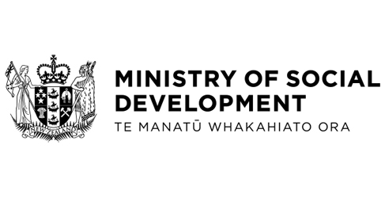

Reducing Debt for MSD clients travelling overseas
An agency discussion document

Owner: | Warren Hudson
Version: | 3
Date: | 30 November 2018

Contents
Introduction 3
Purpose of this consultation 3
Summary of proposal 3
How to make a submission 4
Background 4
The Issue 5
The Solution 6
Current process 7
Proposed new process 7
The AISA 8
How accurate is the current Match? 8
How much debt could the change avoid? 8
Privacy impacts and safeguards 9
FAQs 9

Introduction

Purpose of this consultation
The Ministry of Social Development (MSD) wants to ensure the process it follows before suspending payments does not create unnecessary debt for clients when they travel overseas.
Working-age beneficiary clients are generally not eligible to receive payments while they are overseas. These clients must advise MSD about their travel plans before leaving New Zealand. This is so their benefit eligibility can be properly assessed before they leave (there are certain circumstances in which payments can continue while the client is overseas).
New Zealand Superannuation (NZS) and Veterans Pension (VP) clients do not have an obligation to contact MSD before travelling, unless they plan to be overseas for more than 26 weeks or receive supplementary assistance (e.g. the Winter Energy Payment, Accommodation Supplement, Temporary Additional Support and Disability Allowance). These clients, as well as working-age non-beneficiary clients, are generally eligible to continue receiving supplementary assistance for 28 days while overseas.
MSD currently receives arrival/departure information from the New Zealand Customs Service (Customs) and suspends working-age beneficiary client payments on the day after a client leaves New Zealand.
However, for the supplementary assistance payments NZS/VP and working-age non-beneficiary clients receive, the law requires MSD to follow a particular process before suspension. For clients who have not told MSD about their travel plans, their payments continue while this process is carried out, so clients are over-paid and come home to a debt they must pay back to MSD.
Coming home to a debt is both frustrating and inconvenient for clients. MSD wants to ensure the process it follows before suspending supplementary assistance payments does not result in clients incurring unnecessary debt when they leave the country, even if they don’t tell MSD they are leaving.
MSD proposes to ensure it has the legal authority required to suspend payments immediately by entering into an Approved Information Sharing Agreement (AISA) with Customs. This will align MSD’s process for supplementary assistance payments for all clients with the current process for main benefits. This means MSD will suspend these payments, without notice, on the day after eligibility ends. This will significantly reduce the number of clients coming home to a debt.
The purpose of this consultation is to find out what the public thinks about the proposed change.
The consultation does not cover the current information sharing between MSD and Customs as there will be no change to the type of information shared, the method of transfer or the intended use of the information.

Summary of proposal
MSD proposes to align its process for supplementary assistance payments with the current process for main benefits. This means MSD will suspend these payments, without notice, on the day after eligibility ends. This will significantly reduce the number of clients coming home to a debt.
MSD does not intend to change the process it follows when an NZS/VP client has been away from New Zealand for more than 26 weeks. When this happens, MSD will still try to contact clients before suspending payments and, because of this, clients may come home to a debt.

How to make a submission
Submissions can be made by:
- completing the online submission form at:
  - www.msd.govt.nz/about-msd-and-our-work/newsroom/2018/payments-when-overseas.html
- email to paymentswhenoverseas@msd.govt.nz with “Reducing Debt for MSD clients” in the subject line; or
- post to:
Ministry of Social Development
P O Box 1556
Wellington 6140
New Zealand

Background
Since 1992 Customs has shared information with MSD under an Information Matching Agreement (IMA), currently authorised by section 280 of the Customs and Excise Act 1996.
The current IMA, known as the “Arrivals/Departures Match”, allows Customs to give MSD information about travellers arriving in/departing from New Zealand on a daily basis. This information includes the travellers’ full name, date of birth, gender, travel document number and flight details.
MSD matches the full name and date of birth against its client database to identify which travellers are also MSD clients. Where MSD is satisfied there is a match, it uses the other information for the purposes set out below:
- Verify the entitlement or eligibility of a person to or for any benefit;
- Verify the amount of any benefit to which any person is or was entitled or to which any person was or is eligible; and
- Recover debts due to the Crown in relation to benefits.

The Arrivals/Departures Match is important because working-age beneficiary clients are generally not eligible to receive payments while overseas and there are limits on how long a NZS/VP or working-age non-beneficiary client can be overseas before their entitlement to a particular payment ends.
When a client in receipt of main benefit notifies MSD of their travel plans and has an acceptable reason to keep getting their main benefit, MSD will continue to pay this and their supplementary assistance. Where a client in receipt of a main benefit tells us before they leave NZ but their situation means they are not eligible to continue to receive their main benefit while they are absent from New Zealand, their supplementary assistance can still continue to be paid (where they continue to be eligible for it) for 28 days.

However, where a client does not advise MSD prior to leaving NZ, MSD will immediately suspend their payments (main benefit and any supplementary assistance) on the day after they leave New Zealand. This is possible due to the information received from Customs and an exception to the process MSD would otherwise have to follow before suspending a payment. This exception is found in section 103(1A) of the Privacy Act, but does not apply to all payments made by MSD.
If a NZS/VP or working-age non-beneficiary client does not notify MSD of their travel plans, MSD must follow the process set out in the Privacy Act before suspending any payments they receive. This process requires MSD to send clients a letter once a discrepancy has been found (i.e. a client has not returned to New Zealand within the required timeframe) advising them of MSD’s intention to suspend their payment(s) and giving them 10 days to respond to MSD before that action is taken. This process is called the “adverse action process” and the time given to clients to contact MSD is called the “notice period”. MSD must continue to make payments during the notice period, which leads to clients coming home to a debt.
The purpose of this process is to act as a safeguard. It gives clients the opportunity to tell MSD the information it is relying on is inaccurate and their payments should not be suspended.
In reality, the Arrivals/Departures Match, which has been operating for over 25 years, has a high rate of accuracy and very few clients dispute the actions MSD takes as a result of the information it receives from Customs.
The impact of client debt created by payments continuing during the notice period has been minimal due to the relatively low number of NZS/VP and working-age non-beneficiary clients receiving supplementary assistance payments who travel overseas. However, the introduction of Winter Energy Payment, to which all NZS/VP clients are eligible, has significantly increased the number of people affected.

The Issue
In July 2018, as part of the Ministry’s Families Package, a new supplementary payment called the Winter Energy Payment (WEP) was established. WEP helps people to heat their homes by increasing the funds available to them over the winter months.
Clients don’t need to apply to receive the payment. It is paid automatically to all MSD clients on a main benefit, NZS or VP during the winter months of May to September. Clients can choose to opt out of the payment, but the aim is to give people more money to help them heat their homes during winter.
Because of the existing limitation on receiving payments while working-age beneficiary clients are outside of New Zealand, the WEP travel restrictions have had the greatest impact on NZS/VP clients.
To maintain eligibility for WEP, NZS/VP clients must not be away from New Zealand for more than 28 days in a row during the winter period. This is similar to the existing rules for other supplementary assistance, such as Accommodation Supplement, Temporary Additional Support and Disability Allowance.
The introduction of WEP has increased the number of NZS/VP clients eligible to receive supplementary assistance by more than 350,000 people.
Many of the approximately 500,000 NZS/VP clients who receive WEP are not used to contacting MSD prior to shorter periods of international travel.
Since WEP was introduced in July this year, approximately 9,500 MSD clients have incurred a debt of, on average, $36 while out of the country because of the process MSD must follow before suspending payments. This equates to a total of approximately $340,000 of client debt that could have been avoided by removing the notice period requirement.
The debt must be paid back and this is causing a high level of frustration and inconvenience for clients on their return home and has led to approximately 60 client complaints so far this year.
In particular, clients have told MSD:
- “it was something of shock to learn that I needed to tell the Ministry that I would be away for more that [sic] 28 days without a penalty and the need to pay back on my return”

- “if MSD want to be gnarly and stupid and say that well look we are going to give you some energy payments and in the next breath say well if you are away we are going to ping you”

- “people have to live and having a letter like this shoved down your throat 3 days after you get back, how crazy is that?? I'm angry, incredibly angry”

- “I didn't realise that big brother was looking over my shoulder after working all my bloody years”

- “I've worked all my bloody life and you know you get to superannuation age and you got big brother looking over your shoulder saying how you're getting more or you're not getting enough or you're getting too much or some bloody thing”

- “they told us you don't need to ring us unless you are going to be out of the country more than 26 weeks”

The Solution
While the issue of unnecessary debt created by the notice period was highlighted by the introduction of WEP, the creation of unnecessary debt is an issue across all of MSD’s client groups. MSD intends to use this opportunity to standardise MSD’s practice for all supplementary payments to reduce the chance of coming home to a debt for all clients.
Standardisation of the practice through an AISA will involve a change for NZS/VP and working-age non-beneficiary clients and a strengthening of the legal basis for the current practice for working-age beneficiary clients.

Current process
To meet the obligations under the Privacy Act, the current process MSD follows before suspending NZS/VP and working-age non-beneficiary supplementary assistance payments is:
- Client leaves New Zealand and MSD receives travel information from Customs
- MSD identifies client has left New Zealand
- At day 29, MSD identifies client has been out of New Zealand for more than 28 days using information received from Customs.
- MSD sends a letter to tell the client they have been identified as being out of New Zealand for more than 28 days and, if they do not contact MSD in the next 10 days, their payments will be suspended.
- At day 39, if the client has not contacted MSD and/or has not returned to New Zealand, MSD suspends their payments and sends the client a letter to advise them of this.
- An overpayment is created (due to the notice period and possibly pay cycles) which must be repaid to MSD. A further letter is sent to the client to advise them of this.
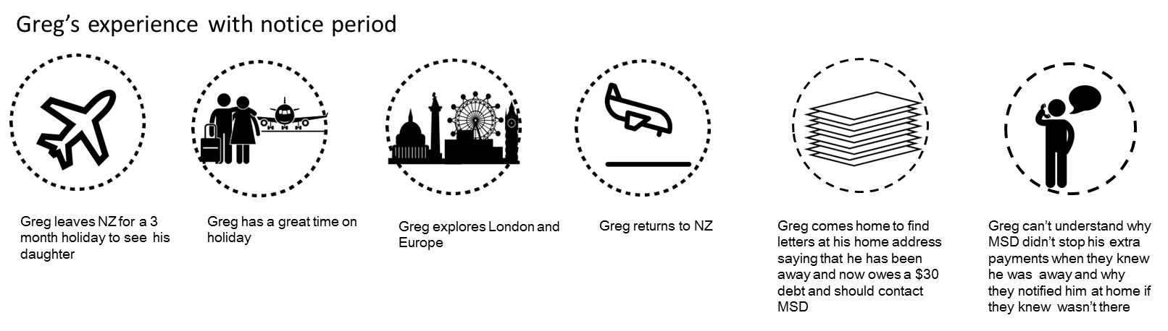
- Client comes home to find letters and must repay debt.

Proposed new process
MSD proposes to change the process it follows before suspending all supplementary assistance payments by removing the 10 day notice period currently required before suspending payments:
- Client leaves New Zealand and MSD receives travel information from Customs
- MSD identifies client has left New Zealand
- If the client has not returned to New Zealand, at day 29, MSD suspends the client’s payments and sends a letter to advise them of this.
- Client comes home and has no debt to pay for the notice period.
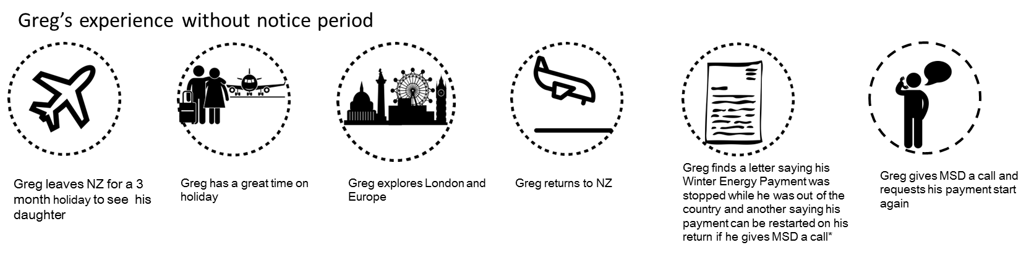

The AISA
An Approved Information Sharing Agreement (AISA) is the newer information sharing mechanism provided for in the Privacy Act. It allows for more flexibility than an IMA, including the ability to amend the rules around how the notice period operates, while also providing robust privacy safeguards around how the information shared may be used.
In the short term, MSD and Customs simply want to replace the Arrivals/Departure IMA with an AISA. This will be a direct “lift and shift” meaning the information shared, the transfer mechanisms and the security measures will remain unchanged.
The only change will be to the process MSD follows before suspending payments – removing the notice period, as set out above, to avoid creating client debt.

How accurate is the current Match?
Over the last five years to 30 June 2018, an average of 64,722 letters of adverse action have been sent each year across the Arrivals/Departures match programme. Of those, an average of 67.6, or 0.1% of letters sent, have been successfully challenged.
The part of the Arrivals/Departure match where payments are already immediately suspended is even more accurate. Over the past five years to 30 June 2018 an average of 53,374 letters of adverse action have been sent each year. Of those, an average of 11.8, or 0.02% of letters sent, have been successfully challenged.
It is important to note that, while adverse action letters have been compared to successful challenges to describe accuracy of the match, the match is actually more accurate than described above as successful challenges don’t generally relate to an inaccuracy in the match itself. For example:
- If a client leaves/returns to NZ on different passports this can sometimes lead to MSD not realising a client has returned within the allowable timeframe.
- When a client tells MSD about their travel plans, and has good reasons to continue receiving their payments, sometimes the client file is not updated correctly due to human error.
- Sometimes a client has good reasons to keep receiving their payments but, for reasons beyond their control, they are unable to notify MSD before leaving.

How much debt could the change avoid?
To illustrate the difference immediate suspension makes, in the 2017/2018 year, only approximately $190,000 of overpayments were established for payments suspended immediately, without a notice period, compared to over $2.3 million of over payments that were established for those subject to the notice period. While the change will not eliminate all of this debt, the opportunity to reduce it is clear.
In relation to the proposed change, MSD has considered how the overall average match accuracy could have affected this year’s creation of WEP debt if MSD had suspended immediately, without applying the required notice period. Applying the average of 0.1% of successful challenges over the last five years, had MSD suspended WEP immediately without applying the required notice period this year, MSD could have established a total of less than $400 of debt incorrectly. In comparison, MSD could have avoided creating at least $340,000 debt in the remaining 99.9% of cases.
It is worth noting that this year WEP was only paid from 1 July to 30 September 2018. In future winter periods, WEP will be paid from 1 May to 30 September 2018, meaning the period in which WEP debt could be incurred will be two months longer, and the number of affected people would increase.

Privacy impacts and safeguards
MSD has produced a Privacy Impact Assessment (PIA) to fully explore the impacts of the proposed change and set out the safeguards in place to mitigate the identified risks. The full PIA is attached to this Discussion Document.

FAQs
- I want to know more about the information matching between MSD and Customs.
An overview of the Arrivals/Departures match can be found on the website of the Office of the Privacy Commissioner: https://privacy.org.nz/privacy-for-agencies/information-sharing/operating-matching-programmes-2/customs-msd-arrivals-departures-programme/

MSD and Customs also operate an information match relating to periods of residence. An overview of that match can also be found on the website of the Office of the Privacy Commissioner: https://privacy.org.nz/privacy-for-agencies/information-sharing/operating-matching-programmes-2/customs-msd-periods-of-residence-programme/

- Why won’t the proposed change completely remove the chance of a client returning home to find a debt?
There are three reasons a client may still have a debt when they return to New Zealand:

First, the proposed change will not change the process MSD follows when an NZS/VP client has been away from New Zealand for more than 26 weeks. When this happens, MSD will still try to contact clients before suspending payments and clients may come home to a debt.
Second, MSD’s payment system operates “pay cycles” which means payments are loaded and approved several days before payments are actually made to clients. If a client is identified through the match in the timeframe between approval and payment, a debt of up to 7 days may be established.
Third, in very rare cases, a client may not be picked up by the information match and MSD may find out they have travelled through other means at a later date. This may generate a debt for the client.
- Does the proposed change apply to NZ Superannuation or Veteran’s Pension?
No, it only applies to any supplementary assistance payments a client may receive e.g. Winter Energy Payment or Temporary Accommodation Supplement. The process for suspending NZ Superannuation and Veteran’s Pension after 26 weeks will remain the same.

During consultation on this PIA, a question arose as to whether, in relation to supplementary assistance payments, this practice aligns with MSD’s legal authority. While MSD intends to fully assess this issue and any potential impacts on clients, the AISA will support continuing this existing practice.
See discussion in PIA re Match Levels
These are set out in section 77 of the Social Security Act 2018 and the Social Security (Effect of Absence of Beneficiary from New Zealand) Regulations 2013
As noted above, MSD is currently assessing its reliance on this section in relation to immediately suspending beneficiary client supplementary assistance. While the policy intent in this area is clear (to suspend all payments at once), it appears the legislation as currently drafted may not reflect that intent. MSD’s intention is for the AISA to ensure the current practice is well supported from a legal perspective.
The accuracy of the match is discussed in more detail in the PIA.
Payments started in July this year.
The safeguards in place to ensure MSD has identified the correct client are discussed in the PIA.
The client may have a small debt caused by pay cycle – see explanation in FAQ 2 below.
MSD intends the AISA to standardise the process for supplementary payments across all clients, including strengthening the legal basis for its current practice in relation to working-age beneficiary clients.
The safeguards in place to ensure MSD has identified the correct client are discussed in the PIA.
The client may have a small debt caused by pay cycle – see explanation in FAQ 2 below.
This debt mostly relates to the pay-cycle and cannot be avoided.
This debt includes NSZ/VP debt, which will not be affected by the proposed changes.

