Key Facts at the end of March 2013

Unemployment Benefit

Current state

At the end of March 2013, 49,000 working-age people (aged 18–64 years) were receiving an Unemployment Benefit. Over the year to March 2013, the number of recipients of an Unemployment Benefit decreased by 5,000, or 9 percent.

Of the clients receiving an Unemployment Benefit at the end of March 2013:
      - two in three (67 percent) were male
      - two in five (41 percent) were mature job seekers (aged 40–64 years)
- 13 percent had a current earnings declaration for their current spell on benefit. This indicates some participation in paid work (during the last 12 months) while receiving a main benefit.

Characteristics of working-age Unemployment Benefit recipients (aged 18–64 years), at the end of March 2008 and at the end of March 2013
Percentage of recipients who were: | Mar-2008 | Mar-2013
Male | 66.6 | 67.3
Female | 33.4 | 32.7
Māori | 38.1 | 38.7
Pacific people | 9.2 | 8.9
18–24 years | 21.1 | 29.5
25–39 years | 33.7 | 29.3
40–54 years | 25.0 | 27.8
55–64 years | 20.2 | 13.3
Declaring earnings | 14.4 | 12.8
Caring for a dependent child aged under 6 years | 7.2 | 6.6
Number of working-age Unemployment Benefit recipients (aged 18–64 years) | 19,034 | 48,756
Source: IAP, numbers of working-age Unemployment Benefit recipients at the end of March.
Note: Numbers receiving an Unemployment Benefit exclude the partners, spouses and dependents of Unemployment Benefit recipients.

Five year trend

The number of clients receiving an Unemployment Benefit at the end of March increased from 19,000 to 60,000 between 2008 and 2010, then remained relatively unchanged between 2010 and 2011 before decreasing over the last two years to 49,000 in March 2013.

Between March 2008 and March 2013, Unemployment Benefit recipients have become more likely to be aged 18–24 years or aged 40–54 years.

Changes between 2008 and 2013 which have affected the number of clients receiving an Unemployment Benefit include changed economic conditions, and an increased focus by Work and Income on moving job seekers into paid work.

Proportion of the working-age population receiving an Unemployment Benefit

The proportion of the working-age population who were receiving an Unemployment Benefit at the end of March decreased each year from 2003 to 2008, then increased to 2011 and decreased over the last two years.

Trends in proportion of the working-age population receiving Unemployment Benefits at the end of March, between 2003 and 2013.

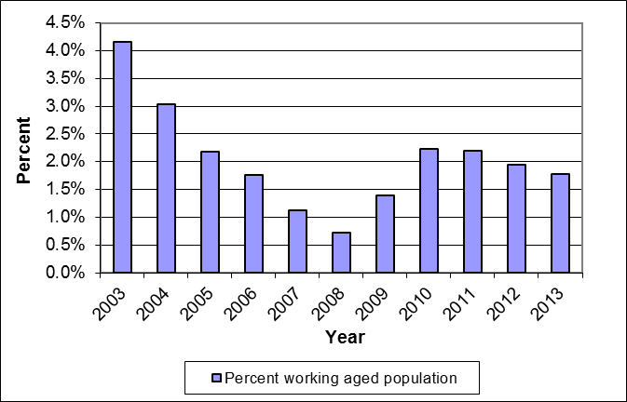

Source: IAP, numbers of working-age Unemployment Benefit recipients at the end of March.
Statistics New Zealand, final population estimates, resident population aged 18–64 years, at 30 September. At the publication of this fact sheet, September 2012 was the most recent quarter for which final population estimates were available.

Duration receiving an Unemployment Benefit

Of the clients receiving an Unemployment Benefit at the end of March 2013:
- three in four (76 percent) had received an Unemployment Benefit continuously for under one year
- 0.1 percent had received an Unemployment Benefit continuously for 10 years or more.

Clients who had received an Unemployment Benefit continuously for 10 years or more made up less than 0.05 percent of the total working-age population at the end of March 2013.

Three percent of Unemployment Benefit recipients at the end of March 2013 had received a main benefit continuously for 10 years or more.

Duration receiving an Unemployment Benefit as a proportion of all working-age Unemployment Benefit recipients and of the working-age population (aged 18–64 years)
 | Proportion of working- age Unemployment Benefit recipients | Proportion of working-age population (aged 18–64 years)
Proportion continuously receiving current benefit:
Less than one year | 76.0 | 1.3
Between one and four years | 21.0 | 0.4
Between four and ten years | 2.9 | 0.1
10 years or more | 0.1 | 0.0
Proportion continuously receiving any benefit:
Less than one year | 60.2 | 1.1
Between one and four years | 29.0 | 0.5
Between four and ten years | 8.3 | 0.1
10 years or more | 2.6 | 0.0
Source: IAP, proportion of working-age Unemployment Benefit recipients at the end of March 2013.
Statistics New Zealand, final population estimates, resident population aged 18–64 years, at 30 September 2012. At the publication of this fact sheet, this was the most recent month for which final population estimates were available.

This fact sheet defines the working-age population as aged 18–64 years to reflect the minimum age of entitlement to most benefits and the age of eligibility for New Zealand Superannuation. All information in this fact sheet refers to working-age recipients of Unemployment Benefits.
In this fact sheet, “Unemployment Benefit” includes Unemployment Benefits and Unemployment Benefits – Hardship (excludes Unemployment Benefits – Student Hardship).
Please note that trends in numbers receiving Unemployment Benefits are more reliably shown by comparisons between the same quarter 12 months apart than by comparisons between consecutive quarters.

