Key Facts at the end of March 2013

Sickness Benefit

Current state

At the end of March 2013, 58,000 working-age people (aged 18–64 years) were receiving a Sickness Benefit. Over the year to March 2013, the number of Sickness Benefit recipients remained relatively flat, decreasing by just 250 (0.4 percent).

Of the clients receiving a Sickness Benefit at the end of March 2013:
- over one in four (28 percent) were Māori, and 7 percent were Pacific people
- three in five (61 percent) were aged over 40 years, while 14 percent were aged 18–24 years.
- 9 percent had a current earnings declaration for their current spell on benefit. This indicates some participation in paid work (during the last 12 months) while receiving a main benefit.

Characteristics of working-age Sickness Benefit recipients (aged 18–64 years), at the end of March 2008 and the end of March 2013
Percentage of recipients who were: | Mar-2008 | Mar-2013
Male | 56.8 | 57.4
Female | 43.2 | 42.6
Māori | 26.7 | 28.1
Pacific people | 6.5 | 6.6
18–24 years | 14.9 | 14.1
25–39 years | 29.0 | 24.9
40–54 years | 34.9 | 37.0
55–64 years | 21.2 | 24.0
Declaring earnings | 10.7 | 9.5
Caring for a dependent child aged under 6 years | 6.0 | 4.5
Number of working-age Sickness Benefit recipients (aged 18–64 years) | 45,676 | 58,208
Source: IAP, numbers of working-age Sickness Benefit recipients at the end of March.
Note: Numbers receiving a Sickness Benefit exclude the partners, spouses and dependents of Sickness Benefit recipients.

Five year trend

The number of working-age clients receiving a Sickness Benefit at the end of March increased from 46,000 to 60,000 between 2008 and 2011, before decreasing in 2012 and remaining relatively unchanged in 2013.

Changes between 2008 and 2013 which have affected the number of Sickness Benefit recipients include the ageing of the population, and increasing movement of people with incapacities into the community.

Incapacities of clients receiving a Sickness Benefit

Of the clients receiving a Sickness Benefit at the end of March 2013:
- around two in five (42 percent) had psychological or psychiatric conditions
- 16 percent had musculo-skeletal disorders.

Main incapacity group for working-age Sickness Benefit recipients (aged 18–64 years), at the end of March 2013
Incapacity group | Proportion of working-age Sickness Benefit recipients
Psychological or psychiatric conditions | 42.3
Musculo-skeletal system disorders | 15.7
Accidents | 7.7
Cardio-vascular disorders | 5.1
Pregnancy-related conditions | 1.9
Other disorders and conditions | 27.4
Total | 100.0
Source: IAP, proportion of working-age Sickness Benefit recipients the end of March 2013.

Proportion of the working-age population receiving a Sickness benefit

The proportion of the working-age population receiving a Sickness Benefit at the end of March has trended upward between 2003 and 2011 before flattening over the last two years. The slight decrease in this proportion between 2007 and 2008 reflects in part the movement of clients from Sickness Benefits to Invalid’s Benefits following reassessment of the level of assistance they were receiving. Changes from 2008 onward are largely a result of changing economic conditions.

Trends in proportion of the working-age population receiving Sickness Benefits at the end of March, between 2003 and 2013

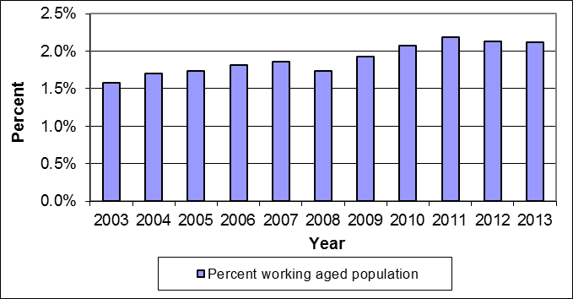
Source: IAP, numbers of working-age Sickness Benefit recipients at the end of March.
Statistics New Zealand, final population estimates, resident population aged 18–64 years, at 30 September. At
the publication of this fact sheet, September 2012 was the most recent quarter for which final population
estimates were available.
Duration receiving a Sickness Benefit

Of the clients receiving a Sickness Benefit at the end of March 2013:
- two in five (41 percent) had received a Sickness Benefit continuously for less than one year
- a similar proportion (39 percent) had received a Sickness Benefit continuously for between one and four years
- 2 percent had received a Sickness Benefit continuously for ten or more years.

Clients who had received a Sickness Benefit for 10 years or more made up 0.1 percent of the working-age population at the end of March 2013.

If spells receiving any main benefits are considered, 0.2 percent of Sickness Benefit
recipients at the end of March 2013 had received a benefit continuously for ten or more years.

Duration receiving a Sickness Benefit as a proportion of working-age Sickness Benefit recipients and of the working-age population (aged 18–64 years)
 | Proportion of working-age Sickness Benefit recipients | Proportion of working- age population (aged 18–64 years)
Proportion continuously receiving current benefit:
Less than one year | 41.3 | 0.9
Between one and four years | 38.9 | 0.8
Between four and ten years | 17.4 | 0.4
10 years or more | 2.4 | 0.1
Proportion continuously receiving any benefit:
Less than one year | 32.2 | 0.7
Between one and four years | 37.1 | 0.8
Between four and ten years | 21.2 | 0.4
10 years or more | 9.5 | 0.2
Source: IAP, proportion of working-age Sickness Benefit recipients at the end of March 2013.
Statistics New Zealand, final population estimates, resident population aged 18–64 years, at 30 September 2012. At the publication of this fact sheet, this was the most recent quarter for which final population estimates were available.

This fact sheet defines the working-age population as aged 18–64 years, to reflect the minimum age of entitlement to most benefits and the age of entitlement to New Zealand Superannuation . All information in this fact sheet refers to working-age recipients of Sickness Benefits.
In this fact sheet, “Sickness Benefit” includes Sickness Benefits and Sickness Benefits – Hardship.

