Changes to the
Job Support Fund and
Training Support Fund

August 2022

There are some changes coming to who looks after the:

- Job Support Fund

- Training Support Fund.

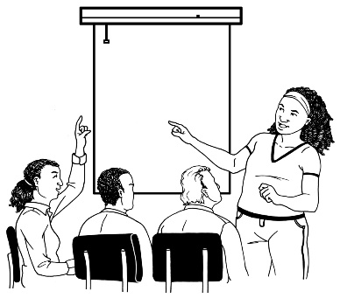
The Job Support Fund and the Training Support Fund are funds that can support disabled people:

- with training for work
- in finding work
- in having a job.

Funding in this document means money that is given by the government.

At the moment Workbridge looks after the Job Support Fund and Training Support Fund.

The Ministry of Social Development and Workbridge have both agreed to the following changes:

- The Ministry of Social Development will look after the Job Support Fund and Training Support Fund

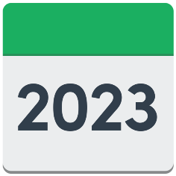
- This change will happen in the first quarter of 2023.

The first quarter of 2023 is 1 January 2023 to 31 March 2023.

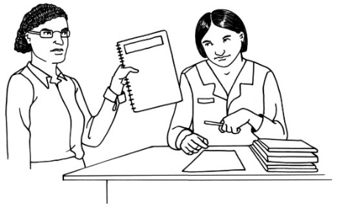
The Ministry of Social Development and Workbridge will work together to make sure these changes happen without any problems.

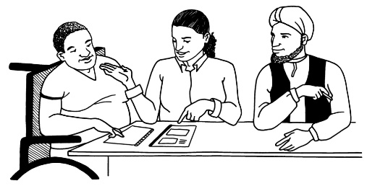
The Ministry of Social Development will use the Job Support Fund and Training Support Fund to keep supporting disabled people with jobs and training costs.

Where to find more information

You can find more information about the Job Support Fund and Training Support Fund on the Workbridge website:

https://supportfunds.co.nz/

If you have any questions about these changes you can email the Ministry of Social Development at:

sftransition@msd.govt.nz

You can also phone Workbridge on:

0508 967 527

This is a free call number which means it will not cost you any money to call that number.
This information has been written by the Ministry of Social Development and Workbridge.
It has been translated into Easy Read by the Make It Easy service of People First New Zealand Inc. Ngā Tāngata Tuatahi.

The ideas in this document are not the ideas of People First New Zealand Inc. Ngā Tāngata Tuatahi.
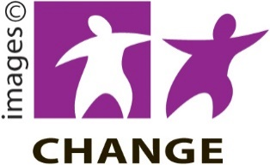
Make It Easy uses images from:

- Changepeople.org
- Photosymbols.com
- Sam Corliss
- Huriana Kopeke-Te Aho.

All images used in this Easy Read document are subject to copyright rules and cannot be used without permission.

