  - Factsheet

Care in the Community Disability Welfare Fund
The $5m Care in the Community (CiC) Disability Welfare Fund is specifically to support the welfare needs of the disabled community and the wellbeing of disabled people and their whānau impacted by COVID-19.
In line with the ‘nothing about us without us’ approach, the Fund is administered by the Ministry of Social Development (MSD) in collaboration with disabled communities.

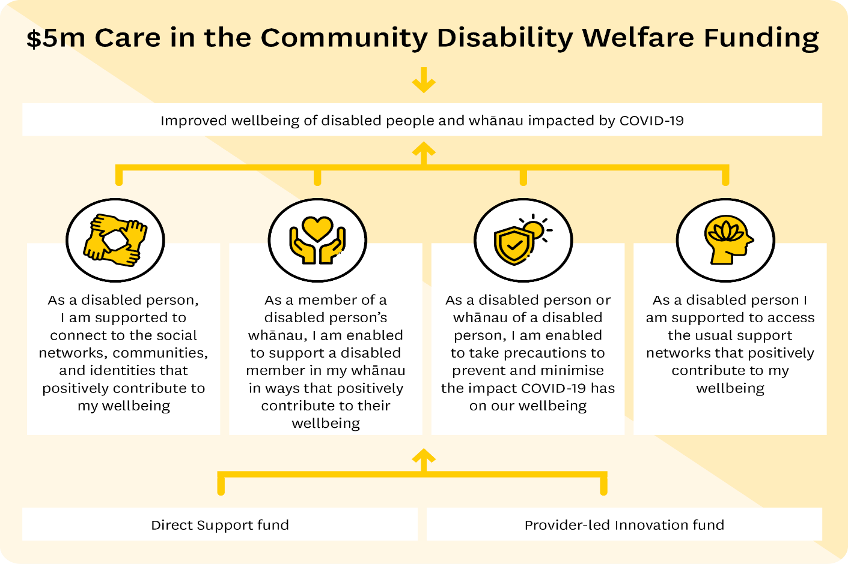

The Fund
MSD has engaged with the disability sector and other government agencies to determine the best options for the use of this funding.
Four key needs have been identified through this engagement and meeting one or more of these needs is the basic criteria for the distribution of funds from either of two new fund types. These needs are:
- Connecting to social networks, communities, and identities
- Support for the whānau of a disabled person
- Precautions to prevent exposure to COVID-19, and
- Connecting with support networks.
The Fund will be split between two fund options:
- Direct support fund (COVID-19 Wellbeing Grants)
The direct support fund enables disabled people and whānau to access support directly from providers that have applied for and received funding.
Providers can apply for up to $50,000 + 15% administration fee, with a disabled person within a whānau able to apply to a provider for assistance of up to $2,000.
Funding is to meet the current needs of the disabled person and whānau only, not their future needs.
Providers of CIC funding should take all necessary steps to ensure the disabled person and whānau they are funding do not receive funding from any other CIC provider.
Providers should also ensure funding for declared needs is not available or already being received from another funding stream. This would mean providers need to be aware of other funds available to meet needs specific to the disabled person and whānau, including food grants, hardship grants, or other MSD funding options. Check out what help’s available for disabled people on the Work and Income site.
- Provider-led innovation fund (community support)
The provider-led innovation fund enables providers to deliver a project, product, or initiative to a target community.
Providers can apply for up to $50,000 based on how many disabled people and whānau the project, product, or initiative will reach. Any costs for capacity will be included in the application and funding provided.
The funds can be used for:
- Previously delivered provider-led initiatives that are no longer funded
- New and innovative provider-led initiatives
NB: The funds cannot be used for capital expenses.

Application process
The open funding round invites applicants (providers/community groups/organisations etc) to apply to receive funding from one or both of the funds.
All applicants should have a New Zealand Business Number (NZBN). A NZBN can be applied for here.
The maximum amount of funding a provider can apply for is $50,000 from each fund. The level of grant funding a provider applies for should be relative to the number of disabled people and whānau they expect to support.
Applications will be assessed by an evaluation panel, with grant funding awarded up to the total amount of funding available ($5m). This is made up of $4 million (including 15% administration costs) for the direct support fund, and $1 million for the provider-led innovation fund.
Applications that demonstrate a focus on supporting Māori, Pacific, ethnic and migrant communities and enable effective and equitable reach are encouraged.
NB: Applicants must ensure they complete all relevant sections on the application form. Incomplete information may mean your application is not considered for funding.
Complete the on-line application form

Key dates
Description | Date (2022)
Fund promotion and application process open | 29 August 2022
Applications close | 29 September 2022
Outcomes communicated | 17 October 2022
Delivery of funds begins  Promotion to general public | 9 November 2022

