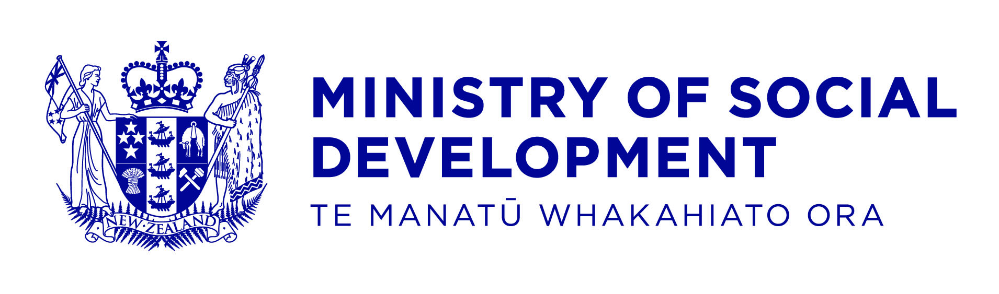

Boards & Committees - expense claim form for meeting attendance fees & other related expenses

To be completed by Claimant

Name of Claimant:
Postal Address:
IRD number (only required for your first claim):
Bank Account to pay into (only required for your first claim):

Notes:
- Withholding tax will be deducted from Meeting Attendance Fees
- MSD require an IR330 form to be completed before making payment
- Tax will be deducted in line with the IR330 form
- The Ministry will only reimburse expenses that are agreed prior to meetings
- Late changes to airfares (where appropriate) are to be arranged with your MSD contact. If this was not possible, please discuss before claiming.
- Invoice to be produced for ‘Other’ Expenses
- Please send completed form to your MSD contact person
- Reasonable time will be allowed for preparation

Meeting attendance fees (withholding tax will be deducted) Mileage Allowance, Actual and Reasonable expense (please attach invoices/ receipts)
Table 1
Ref | Meeting Date | Client Name (BRC meetings only) | Meeting Start and Finish Time | Meeting Prep Time | Mileage --Distance Travelled | Description of actual expense and amount

I certify that to the best of my knowledge, this claim is true and correct in every particular
Claimant’s signature:
Date:

To be completed by MSD contact person (MSD Use Only)
Claimant Employee number:
Meeting attendance fees
Table 2
Cost Centre | Nominal | Project | Total meeting time | Unit Price (Hourly rate/ daily rate) | Total meeting fees- subject to WHT

Mileage
Table 3
Cost Centre | Nominal | Project | Total mileage | Mileage rate | Total mileage allowance

Actual & reasonable expenses
Note: Actual and reasonable expenses are paid by the National Accounting Centre (NAC). Therefore send a copy of this signed form with the invoices/receipts for this part of the payment to be completed.
Table 4
Cost Centre | Nominal | Project | Total expense

To be completed by MSD budget manager
Name of Budget Manager:
Signature:
Designation
Date:

