Title: Team Leader Residential Support Services
Group: Residential Services
Reports to: Residence Manager
Location: As specified
Direct Reports: Residential Support and Administration Staff
Budget: Nil
OUR ORGANISATION
About us | The Ministry for Vulnerable Children, Oranga Tamariki is a new Ministry dedicated to supporting any child in New Zealand whose wellbeing is at significant risk of harm now, or in the future. We also work with young people who may have offended, or are likely to offend. Our belief is that in the right environment, with the right people surrounding and nurturing them, any child can, and should flourish.
Our vision | Our vision is: New Zealand values the wellbeing of tamariki above all else.
Our purpose | Our purpose is: To ensure that all tamariki are in loving whānau and communities where Oranga Tamariki can be realised.
The Oranga Tamariki way | We’re introducing a new way of doing things. A way of looking at the world that guides everything we do:  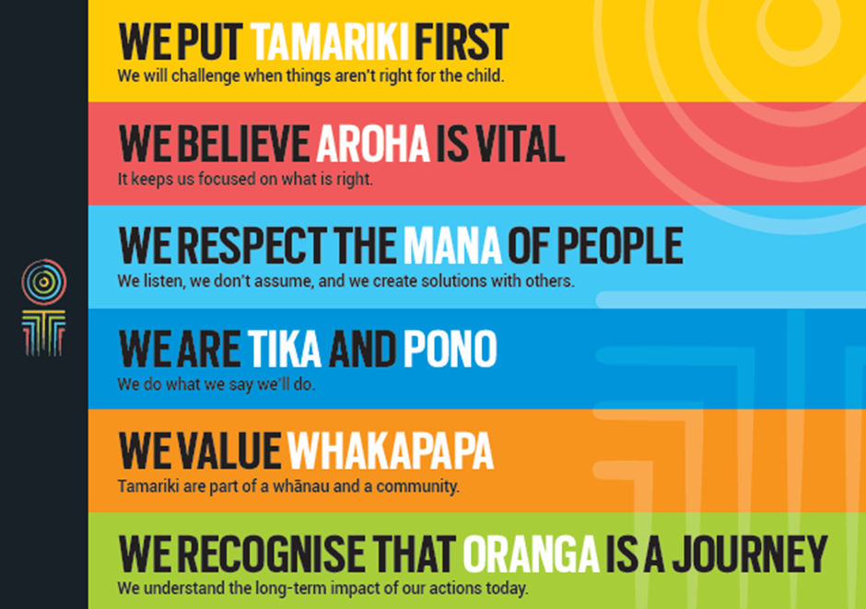
Our core outcomes | Our core outcomes are:  - All children and young people are in loving families and communities where they can be safe, strong, connected, and able to flourish.  - Improved outcomes for all children, especially Maori tamariki and rangatahi.

POSITION PURPOSE
The purpose of the position is to coordinate the provision of all internal administrative, corporate and business services within the Residence.
In carrying out this function the Team Leader Residential Support Services will consult and liaise as appropriate with Residential Managers, Administrators, National Office Residential Team members and other staff to ensure that systems, processes and procedures comply with any relevant Ministerial policy and legislative requirements. In addition they will provide advice and support to the Residential Managers and Administrators regarding all aspects of administrative, corporate and business services run by the Residences and National Office Residential Services.
KEY ACCOUNTABILITIES
Key Result area | Key Accountabilities
Support services | - Lead and manage the support services team by providing an environment within which service delivery excellence can be achieved.  - Ensure that full administrative support and services are provided to the Residential Services Team.  - Co-ordinate administrative activities between National Office and the Residential sites to provide advice and direction as required.  - Ensure compliance with all Occupational Health and Safety policies and guidelines.
Property and facilities management | - Liaise, oversee and manage all property and facilities issues for the Residence. Follow up and resolve issues for the sites when necessary.
Finance, purchasing and supply | - Ensure that a range of financial services are provided including systems to aid the business planning process; accounts receivable/payable processing input and validation into KEA.  - Ensure that a timely travel and accommodation bookings service is provided.  - Work with the residential managers to ensure financial and reporting requirement are met.  - Provide support and guidance around relationships with both local and national suppliers to ensure effective and timely services delivered to the Residences.  - Ensure all issues are resolved quickly and efficiently.  - Analyse monthly operating statements and provide support and advice for budget management.  - Support the Residential Manager in the annual budget allocations process.
Project management | - Responsible for managing specific projects or initiatives across Residential Services as required.
Human resource administration | - Coordinate and ensure that timely and accurate appointment, cessation, leave, time record and payroll information is provided to the National Office payroll unit to ensure that Residential Services National Office’ employees are paid correctly and on time.  - Ensure that all employment processes are provided for casual employees including induction and orientation functions.  - Analyse monthly HR reports and provide support and advice to the all residences regarding management of all planned and unplanned leave.  - Monitor the Performance Development System across the residence.  - Support Residences in the annual implementation of Managers Performance Agreements and Performance Assessments.  - Support the Residences in the monthly supervision process.
Reporting | - Provide reports on financial and other matters as timetabled or requested.  - Support Residences in the monthly reporting requirements of Residence Managers and prepare a collated report for National Office as required.  - Perform associated duties in the annual review of audit reports, including mitigation reports from Residences and Quality Assurance. Monitor the implementation of performance improvement plans.  - Monitor the grievance improvement plans for clients as requested by the Residence Manager
Information management | - Effective and efficient management of the privacy, official information, and ministerial enquiries and the complaints process.  - Ensure the effective coordination of information to and from the Residential Sites and Administrators.  - Manage correspondence as required. Provide proofing and formatting assistance to the Advisory staff.
Residences’ management team | - Effectively participate in the residential management team.  - Ensure effective relationships are built between Residences Administrative staff and colleagues to facilitate the smooth running of the Residence and assist with nationally driven initiatives and requirements.  - Provide administrative support to the quarterly Residence Management meetings.
Risk management | - Assist with monthly risk management reporting, and escalate where required.
Being part of the Oranga Tamariki team | - Actively and positively participate as a member of the team.  - Proactively look for opportunities to improve Oranga Tamariki’s operations.  - Perform any other duties as needed by Oranga Tamariki.  - Comply with and support all health and safety policies, guidelines and initiatives.  - Ensure all incidents, injuries and near misses are reported into our H&S reporting tool.  - Comply with all legislative and regulatory requirements, and report any breaches as soon as they become known.  - Adhere to all Oranga Tamariki’s procedures, policies, guidelines, and standards of integrity and conduct.  - Commitment to the Treaty of Waitangi and respect and incorporate these into your work.
KEY RELATIONSHIPS
Internal | - Residential Senior Management Team  - Residential Services National Office Advisory Team  - All staff in residential sites  - Financial Analyst  - HR Consultant  - All other National Office key stakeholders as required  - Oranga Tamariki staff.
External | - Public/State sector and other organisations  - Providers and suppliers  - General public.

QUALIFICATIONS & EXPERIENCE
Qualifications | - A relevant degree level qualification  - A current “clean” driver’s licence is essential.
Experience | - Sound and demonstrated knowledge, understanding, analytical, reporting skills and experience of the financial and administrative accountability principles and best practice in a Public/State sector environment.  - Significant experience in managing a team accountable for the provision of financial, administrative and corporate services in an organisation (preferably in the Public/State sector).  - Knowledge of the applicable legislation; Public Finance Act, Health & Safety, State Sector Act as well as experience in working within a Public Service Ministry and/or Department, policies, systems and processes.  - Demonstrated experience in the provision of customer focussed financial, administrative and corporate advice and services to managers.  - Experience in the development and implementation of financial and administration systems and standard operating procedures.  - Demonstrated ability to work in collaborative peer and other stakeholder relationships.  - Proven people management skills including performance management and change management.  - An advanced level of computer and keyboard skills, including experience in working with spread sheets, power point and a large integrated management information system.
Skills | - Strong partnership builder  - Exercises sound judgement and political sensitivity  - Highly effective written and verbal communication skills  - Flexible, adaptable and pragmatic  - Strong client focus  - Business acumen  - Welcomes and values diversity, and contributes to an inclusive working environment where differences are acknowledged and respected.
Other requirements | - Willing to travel to fulfil job requirements.

