Title: Team Leader - Reporting
Group: Partnering for Outcomes
Reports to: GM Commissioning and Market Building
Location: Wellington
Direct Reports: 5 (Advisors)
Budget: Yes
OUR ORGANISATION
About us | Oranga Tamariki—Ministry for Children is a new Ministry dedicated to supporting any child in New Zealand whose wellbeing is at significant risk of harm now, or in the future. We also work with young people who may have offended, or are likely to offend. Our belief is that in the right environment, with the right people surrounding and nurturing them, any child can, and should flourish.
Our vision | Our vision is: New Zealand values the wellbeing of tamariki above all else.
Our purpose | Our purpose is: To ensure that all tamariki are in loving whānau and communities where oranga tamariki can be realised.
The Oranga Tamariki way | We’re introducing a new way of doing things. A way of looking at the world that guides everything we do:  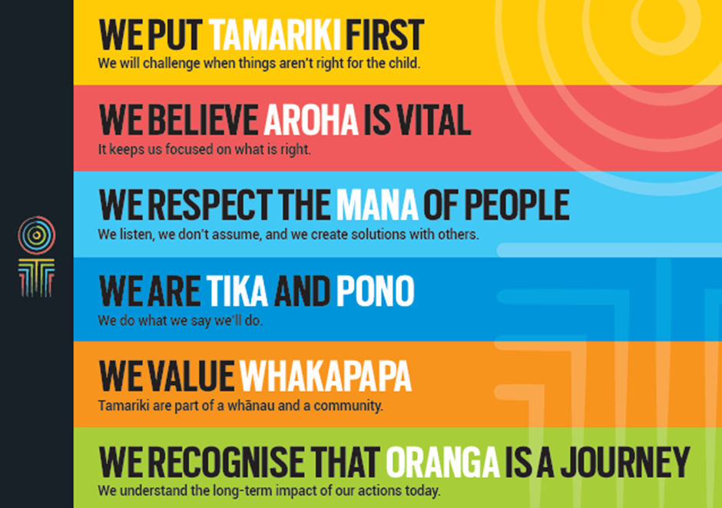
Our core outcomes | Our core outcomes are:  - All children and young people are in loving families and communities where they can be safe, strong, connected, and able to flourish.  - Improved outcomes for all children, especially Maori tamariki and rangatahi.

POSITION PURPOSE
The purpose of this role is to:
- Ensure that the data and intelligence we collect from our staff and partners helps internal and external stakeholders to make informed decisions and ultimately support more young people to achieve their goals; and,
- To increase and champion the access and use of good quality data across Partnering for Outcomes, Oranga Tamariki, and our social service providers and other partners.
KEY ACCOUNTABILITIES
Key Result area | Key Accountabilities
Reporting and Analysis | - Management and development of Partnering for Outcomes reporting processes, policies, and products – ensuring they are, efficient, effective, and economic  - Providing expert advice and support to regional and national colleagues on business intelligence and analytics  - Working with policy, finance and programme leads to ensure we get ever better value from the data and intelligence we collect on our contracted programmes and services  - Research, implementation and adoption of new reporting and analytical tools and approaches  - Developing and managing sector assessment tool
Accountability | - Ensuring that the function operates in a way that is consistent with Treaty principles and values (more than ‘compliant’)
Relationship Management | - Building and maintaining relationships with MSD and Oranga Tamariki senior managers and other internal stakeholders – particularly in Policy, Investment and Evidence, and with key MSD managers
Leadership and Management | - Future builder - help staff and the organisation navigate the future  - People builder – develop people and identify talent  - Deliverer - make things happen, with and through others  - Steward - lead in a public service context, contributing to a better New Zealand.
Being part of the Oranga Tamariki team | - Actively and positively participate as a member of the team  - Proactively look for opportunities to improve Oranga Tamariki’s operations  - Perform any other duties as needed by Oranga Tamariki  - Comply with and support all health and safety policies, guidelines and initiatives  - Ensure all incidents, injuries and near misses are reported into our H&S reporting tool  - Comply with all legislative and regulatory requirements, and report any breaches as soon as they become known  - Adhere to all Oranga Tamariki’s procedures, policies, guidelines, and standards of integrity and conduct  - Commitment to the Treaty of Waitangi and respect and incorporate these into your work.
KEY RELATIONSHIPS
Internal | - Partnering for Outcomes staff and managers  - Will hold key Partnering for Outcomes relationship with Ministry for Social Development and Oranga Tamariki managers with an interest in analysis and business intelligence  - MSD Strategic Planning
External | - Non-Government Organisations (NGOs)  - Staff from other government agencies  - Project specific focus groups

QUALIFICATIONS & EXPERIENCE
Qualifications | - A degree level qualification relevant to the role or similar qualification  - Post-graduate qualification relevant to role or relevant experience [desirable]
Experience | - Demonstrated people management experience - leading high performing teams  - Experience of making sense of complex non-financial and financial data and intelligence for senior management in the public and / or private sector  - Understanding of and involvement in social services  - Experience of working on business intelligence and analytics across large organisations  - Demonstrated ability to critically evaluate data, analysis and research findings  - An understanding of the strategic challenges and issues facing the Ministry  - Experience of prioritising in an often busy and complex environment and applying sound judgement when dealing with competing deadlines  - A high level of computer literacy – including excel and any other data related packages
Skills | - Excellent verbal, written and interpersonal communication skills  - Excellent quantitative and qualitative analytical skills  - Ability to communicate complex ideas to a variety of audiences and build and maintain rapport with others  - Understanding and appreciation of cross cultural issues and concerns, in particular, knowledge of tikanga Maori, and Pacific peoples’ culture.

