Title: Team Leader - HR Advice (Regional)
Group: Corporate Services
Reports to: HR Operations Delivery Manager
Location: Wellington
Direct Reports: Yes
Budget: No
OUR ORGANISATION
About us | Oranga Tamariki—Ministry for Children is a new Ministry dedicated to supporting any child in New Zealand whose wellbeing is at significant risk of harm now, or in the future. We also work with young people who may have offended, or are likely to offend. Our belief is that in the right environment, with the right people surrounding and nurturing them, any child can, and should flourish.
Our vision | Our vision is: New Zealand values the wellbeing of tamariki above all else.
Our purpose | Our purpose is: To ensure that all tamariki are in loving whānau and communities where oranga tamariki can be realised.
The Oranga Tamariki way | We’re introducing a new way of doing things. A way of looking at the world that guides everything we do:  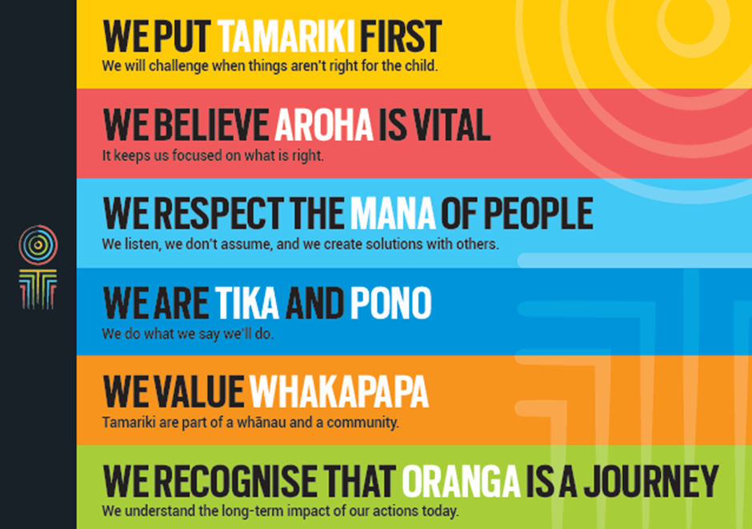
Our core outcomes | Our core outcomes are:  - All children and young people are in loving families and communities where they can be safe, strong, connected, and able to flourish  - Improved outcomes for all children, especially tamariki and rangatahi Māori.

POSITION PURPOSE
Our desired future is one where we demonstrate that our people matter, and that we cannot realise our vision without them. We want our staff to feel listened to, valued and empowered. We want to make things easy for them, to have the right skills, and feel supported to put tamariki first. We have three focus areas to support our people to live the Oranga Tamariki vision, purpose and the Oranga Tamariki way. These are:
- Make our people processes effective and easy so they can focus on oranga tamariki
- Build our capability so we can realise oranga tamariki
- Create an environment where our people are empowered to put tamariki first.
The Team Leader - HR Advice (Regional) will lead a team of Senior HR Advisors based across all the main centres in delivering a range of integrated HR services ranging from generalist advice on HR policies and frameworks through to employment relations, supporting change and organisational development initiatives and learning and development activities.
This role will work closely with other areas of the People and Leadership team. The role champions service culture and seeks opportunities for continuous improvement in support of the delivery of integrated, end-to-end HR service delivery.
KEY ACCOUNTABILITIES
Key Result area | Key Accountabilities
Senior HR Advice and Support | - Manage the delivery of high quality HR advisory services ensuring the Regional team is working together to meet service delivery expectations in a timely, consistent and clear manner across Oranga Tamariki  - Collaborate with the Team Leader Centralised Advice and Senior HR Advisors to ensure an integrated approach to HR service delivery  - Contribute to the development of HR services performance measures and monitor service delivery, identifying and implementing opportunities for improvements  - Regularly review systems, HR processes and team knowledge to assess their effectiveness and identify opportunities to improve service delivery including through process improvement or enhanced self-service  - Manage the delivery of HR advice to maintain excellent customer satisfaction, promoting and driving a passionate customer driven culture  - Provide prompt resolution of any concerns/enquiries and appropriate support to enable staff to excel in their roles, liaising with other teams for the affected area  - Ensure adherence to defined guidelines, processes and procedures, and ensure achievement of agreed performance standards  - Develop an excellent knowledge of P&L processes and procedures, and provide clear guidance, support and training to managers in HR processes  - Develop an understanding of strategic objectives and plans for the Senior HR Advisory team in order to ensure the approach and advice is aligned and consistent with other HR service partners.
People Management | - Lead in a manner that promotes and encourages a culture of team work, innovation and excellence in customer service  - Ensure the Senior HR Advisory team meets their objectives by delivering quality and professional services to Oranga Tamariki managers and staff  - Establish priorities and plans for service delivery, manage workload distribution, allocation of tasks and monitor service levels  - Foster people development by developing and implementing clear performance objectives, coaching, providing feedback, encouraging knowledge management and skills development  - Develop, plan and deliver team induction and ongoing training in partnership with the Organisation Development team  - Act as a first point of escalation in order to solve operational or procedural issues; management of escalations etc.  - Oversee operational processes, and lead employees in the team assigned  - Manage workflow in conjunction with the People and Leadership Management Team, by ensuring appropriate planning, prioritisation and re-prioritisation of work as required, ensuring that priority work is completed to an appropriate standard.
Leadership | - Future builder - help staff and the organisation navigate the future  - People builder – develop people and identify talent  - Deliverer - make things happen, with and through others  - Steward - lead in a public service context, contributing to a better New Zealand  - Understand and implement your manager Health, Safety and Security accountabilities  - Ensure health, safety and security policies and procedures are understood, followed and implemented by all employees  - Foster team culture in order to ensure a strong service attitude and high level of employee engagement  - Promote and role model the values and goals for Oranga Tamariki including good employer principles and practices and expected high standards of integrity, ethics and behaviour in all operations of Oranga Tamariki.
Risk Management | - Identify any organisational risks and take action to minimise their impact  - Effectively manage risks and escalate risks and propose appropriate mitigation where necessary.
Relationship Management | - Develop and maintain effective working relationships across Oranga Tamariki to ensure a thorough understanding of the business and its support requirements  - Build relationships with customers to understand the business context in which HR services are delivered  - Develop strong working relationships with other HR service partners and managers to ensure a coherent and joined up approach to the delivery of HR services to the business.
Process Improvement | - Develop, maintain and update process documentation (working in collaboration with other People and Leadership (P&L) team members) and communicate to stakeholders as appropriate  - Review processes to ensure they are effectively managed by the Senior HR Advisory team  - Monitor and evaluate the performance levels within the team with a view to identifying ways of improving performance levels  - Investigate and document root causes of process irregularities, to inform prevention of future reoccurrences and to improve processes  - Contribute to the client service delivery strategy with a view to improving performance  - Look for opportunities to maintain and raise the knowledge of HR with customers within Oranga Tamariki.
Reporting | - Monitor the collection and cleansing of data to populate management reporting systems  - Monitor the Customer Relationship Management system to ensure quality of data and take steps to enhance where possible.
Customer Service | - Ensure all customer feedback is recognised, recorded, managed and/or escalated as appropriate and that the customer is kept informed of the status and outcome  - Possess a strong awareness of customer satisfaction through regular customer contact and objective measures where possible  - Deal effectively with feedback and service related issues, liaising with the key managers where appropriate  - Optimise the use of ICT to deliver cost effective and efficient customer service.
Team Work | - Undertake any project work relevant to the activities of the Senior HR Advisory team  - Contribute as a key project team member to a wide range of projects focused on the development of new initiatives, programmes and policies across all aspects of our HR strategy  - Work collaboratively with other people and in the team to support key team objectives being achieved and share information and support proactively  - Support HR in policy matters, participating in or recommending appropriate decisions  - Act as a liaison to external and internal partners.
Being part of the Oranga Tamariki team | - Actively and positively participate as a member of the team  - Proactively look for opportunities to improve the operations of Oranga Tamariki  - Perform any other duties as needed by Oranga Tamariki  - Comply with and support all health and safety policies, guidelines and initiatives  - Ensure all incidents, injuries and near misses are reported into our H&S reporting tool  - Comply with all legislative and regulatory requirements, and report any breaches as soon as they become known  - Adhere to all Oranga Tamariki procedures, policies, guidelines, and standards of integrity and conduct  - Demonstrate a commitment to and respect for the Treaty of Waitangi and incorporate these into your work.
KEY RELATIONSHIPS
Internal | - Oranga Tamariki Managers  - P&L leadership team  - Oranga Tamariki staff
External | - Ministry of Social Development (MSD) counterparts  - Workplace representatives including unions  - Other government agencies  - External HR Service Providers
QUALIFICATIONS & EXPERIENCE
Qualifications | - Tertiary qualification in Human Resources or relevant experience is desirable
Experience | - Proven experience in leading/influencing in a customer services environment delivering HR services  - Significant experience in the Human Resources field – you are likely to be a generalist who enjoys enabling successes and developing process that add value  - Good problem solving skills  - Experienced in working with systems and databases  - Able to coach, and mentor to enhance overall capability in people  - Experience of being adept at managing multiple tasks and prioritising the demands of a diverse range of stakeholders  - A love for data – and the ability to critically analyse and interpret complex information and make effective, well-reasoned decisions  - Excellent customer focus – you’ll delight in anticipating and meeting customer needs and be a superb relationship manager  - Detailed knowledge of current NZ employment law and HR practices and can relate this to an organisational context
Skills | - Ability to build effective relationships with all levels of the organisation  - Understanding and appreciation of cross cultural issues and concerns, in particular, knowledge of tikanga Māori, and Pacific peoples’ culture  - Views feedback on the performance of the team as an opportunity for improvement rather than being defensive – you have an aptitude for identifying opportunities for improving performance  - Sound judgement and uses approaches that are appropriate for the situation  - Credibility to front the administration team – you can deal with managers, advisors and other P&L team members  - Collaborative, seeking and considering advice when appropriate  - Awesome communications skills tailored for your audience – you can convey information and ideas clearly to a broad range of people  - Incredible organisational skills with the ability to multi-task, and work to tight and competing deadlines, at pace  - Understanding of the future of HR and delivering the ultimate employee experience aligned to organisational culture  - A strong eye for detail – it’s not often you get it wrong  - An inclusive and approachable working style, you understand that diversity adds value.

