Title: Team Leader Clinical Practice
Group: Residences
Employment Status: Individual Employment Agreement
Reports to: Residence Manager
Location: As specified
Direct Reports: Yes (Case Leaders)
Budget: Yes
OUR ORGANISATION
About us | The Ministry for Vulnerable Children, Oranga Tamariki is a new Ministry dedicated to supporting any child in New Zealand whose wellbeing is at significant risk of harm now, or in the future. We also work with young people who may have offended, or are likely to offend. Our belief is that in the right environment, with the right people surrounding and nurturing them, any child can, and should flourish.
Our vision | Our vision is: New Zealand values the wellbeing of tamariki above all else.
Our purpose | Our purpose is: To ensure that all tamariki are in loving whānau and communities where oranga tamariki can be realised.
The Oranga Tamariki way | We’re introducing a new way of doing things. A way of looking at the world that guides everything we do:  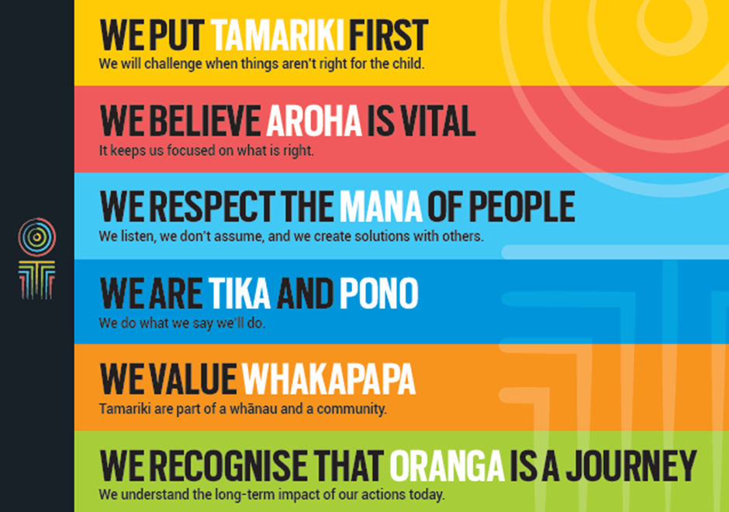
Our core outcomes | Our core outcomes are:  - All children and young people are in loving families and communities where they can be safe, strong, connected, and able to flourish.  - Improved outcomes for all children, especially Māori tamariki and rangatahi.
POSITION PURPOSE
The purpose of this role is to:
- Ensure that interventions, programmes and steps are put in place for each child and young person that effectively addresses underlying trauma, health needs, criminogenic and behavioural issues; to effect a successful transition from the Residence.
- Facilitate and monitor adherence to, and consistency with, Residences service model service principles and standards, clinical best practice standards and evidence based practice.
- Provide individual and group clinical and professional leadership, supervision, support, skill and knowledge enhancement and training.
- Provide oversight to ensure accurate documentation of clinical interventions. Ensure input from a range of stakeholders involved in designing and delivering programmes and services to children and young people.
- Ensure that clinical services are available to children and young people on a 24 hour a day 7 days a week basis.
- Fulfil the administrative and management requirements of the role.
KEY ACCOUNTABILITIES
Key Result area | Key Accountabilities
Service Delivery | - . The Team Leader Clinical Practice works with the Case Leader team to ensure the following:  - A comprehensive assessment process.  - Co-ordination of multidisciplinary input and leadership of programme design, to deliver appropriate clinical and therapeutic interventions to children and young people.  - Interventions use clinical methodologies based on evidence-based practice that are consistent with the Residences service principles, and are effective in achieving positive outcomes for children and young people.  - Delivery of programmes and services tailored to the needs of children and young people, that meet Residences service model service principles and standards, adhere to the clinical best practice standards, and are available to children and young people on a 24 hour a day, 7 days a week basis.  - Removal of barriers to engagement of children and young people in any intervention, and use of appropriate problem solving strategies to overcome these, including assessing strengths and weaknesses within the systemic and ecological context of the young person that impact and contribute to problem behaviours.  - Engagement of key participants in setting the objectives and goals of intervention that are culturally pertinent, with relevant strategies to maintain their level of commitment to achieve the objectives and goals.  - Monitoring to ensure programme integrity.  - Maintaining clear and concise documentation of clinical and therapeutic interventions.  - Facilitate and monitor adherence to, and consistency with, Residences service model service principles and standards, clinical best practice standards and evidence based practice.  - Provide individual and group clinical and professional leadership, supervision, support, skill and knowledge enhancement and training.  - Provide oversight to ensure accurate documentation of clinical interventions. Ensure input from a range of stakeholders involved in designing and delivering programmes and services to children and young people.  - Demonstrate ongoing commitment to continuous development and improving the effectiveness of own role.  - Fulfil the administrative and management requirements of the role.
Staff leadership and management | - Lead and ensure the development and delivery of high quality services, support and advice to mangers and staff.  - Provide evaluation and coaching to lift performance of each individual member of the team.  - Manage workflow in conjunction with your Manager, by ensuring appropriate planning, prioritisation and re-prioritisation of work as required, ensuring that priority work is completed to an appropriate standard.
Being part of the Oranga Tamariki team | - Actively and positively participate as a member of the team.  - Proactively look for opportunities to improve Oranga Tamariki’s operations.  - Perform any other duties as needed by Oranga Tamariki.  - Comply with and support all health and safety policies, guidelines and initiatives.  - Ensure all incidents, injuries and near misses are reported into our H&S reporting tool.  - Comply with all legislative and regulatory requirements, and report any breaches as soon as they become known.  - Adhere to all Oranga Tamariki’s procedures, policies, guidelines, and standards of integrity and conduct.  - Commitment to the Treaty of Waitangi and respect and incorporate these into your work.

KEY RELATIONSHIPS
Internal | - Residence Manager  - National Manager Clinical Services, Residences  - Case Leaders  - Team Leader Operations  - Care Team Social Workers and Youth Workers  - Employment and Programmes Coordinator  - National Manager, Programmes & Services  - Residential Services National Office Team.
External | - Oranga Tamariki Youth Justice Managers, Specialist Services/ Psychologists, Youth Justice Social Workers/Supervisors and Youth Justice Coordinators.  - On-site or contracted allied professional service providers (School Principal/school/education, medical, mental health).  - Allied agencies involved in cases (Ministry of Social Justice, Work and Income, Housing NZ, community providers).  - Other Residential Services practitioners in public and private sector organisations.  - Iwi/Māori.  - Tangata Pasifika.

QUALIFICATIONS & EXPERIENCE
Qualifications | - Minimum of a master’s degree level qualification in psychology, education, social work, nursing (mental health); or another related field.  - A current, clean driver’s licence.
Desirable qualifications | - ‘C’ or ‘D’ level registration with NZCER as a test user.
Experience | - Knowledge and understanding of the provision of training to staff engaged in working therapeutically with children and young people.  - Two years minimum clinical and therapeutic experience coordinating work in a multi-disciplinary setting with children and young people to address complex behavioural issues.  - Sound knowledge and experience of evidence-based practice.  - Understanding of the multi-factor determinants and influences of youth offending.  - Understanding of the model of Multi Systemic Therapy, the analytic process and how this is applied to clinical and therapeutic interventions.  - Understanding of social systems theory, ecological theory and how this is informs assessment and intervention.  - Understanding of behavioural theories and/or cognitive-behavioural theory and how they inform assessment and intervention.  - Sound knowledge of the theories of Child Development and Family Therapy, and experience in applying these to intervention.  - Demonstrated competence in applying the principles of risk assessment in relation to youth offending.  - A sound understanding of issues relating to mental health disorders in youths and adults, and alcohol and substance abuse in youths and adults.
Desirable knowledge and experience | - Familiarity with the application of research to programme design.  - Understanding and appreciation of cross cultural issues and concerns, in particular, knowledge of tikanga Māori and the kawa of local iwi, and those of the Pacific people.  - Knowledge of, and established links to, community networks and experience working in collaboration and conjunction with community service providers, other government departments, including effective work in cross cultural environments and contexts.  - Understanding of the statutory role and objectives of Oranga Tamariki.
Skills | - Interpersonal communication and interviewing skills with a focus on the assessment of social skills, motivational interviewing and assessment.  - Ability to engage individuals, families and other groups in clinical and therapeutic interventions.  - Clinical experience in a multi-disciplinary setting with children and adolescents, and offending behaviours.  - Can apply Cognitive Behavioural therapy and behaviourally-based approaches to address school behaviour and academic performance of adolescents.  - Produce individual focused interventions, within or between multiple systems and groups that affect or influence the behaviour of adolescents.  - Engages in group and/or individual professional clinical and cultural supervision.  - Empathy for children and young persons.  - Demonstrated tolerance and understanding.  - Ability to actively promote a pro-social environment.  - Demonstrated ability to practice ethically and maintain professional boundaries.  - Show a high degree of consistency in behaviour at all times and act as a clear role model, generating confidence and commitment of others through his/her own ethical conduct.  - Able to consistently exercise discretion and be able to earn the trust of children, young persons and other staff.  - Computer and technology literate.
Desirable skills and behaviours | - Knowledge and appreciation of Te Reo Māori and/or a Pacific Island language(s) and an awareness of different and appropriate forms of communication.

POSITION COMPETENCIES
Competency | Description of success profile behaviour
1.Client focus  The desire and willingness to understand and meet or exceed client expectations. Clients are those groups or individuals, internal or external, who use Oranga Tamariki services. | - Delivers superior service to clients.  - Understands, empathises with, and identifies the needs, concerns and priorities of clients and ensures that services are delivered to take account of these.  - Takes responsibility for correcting client service problems and/or “championing” client issues.  - Corrects problems promptly, without becoming defensive.  - Actively supports the interests of the client by making choices and setting priorities to meet their needs.
2. Communication  The ability to clearly convey thoughts and ideas effectively. This may include listening, interpreting, formulating and delivering verbal, non-verbal, written, and/or electronic messages. | - Work shows recognition of the importance of communication in achieving results.  - Seeks to understand others’ frame of reference and uses this understanding to identify the most effective method of conveying information.  - Uses different ways of conveying a message to add clarity and meaning to communications.  - Adapts communications to the views and level of knowledge of the audience.  - Prepares and structures communication well. Is able to make complex issues understandable.  - Sets out arguments clearly and logically; persuades and influences others.
3.Teamwork  The ability and willingness to work with others co-operatively and productively in order to achieve group objectives. This may include informal work groups, advisory groups or committees and project teams. | - Acts to promote a welcoming, productive climate, good morale and cooperation within and between teams.  - Genuinely values others’ input and expertise.  - Contributes own expertise to the team.  - Facilitates and influences positive outcomes that support team goals.  - Promotes team cooperation, even during heated discussions.  - Is willing to set aside personal agenda in order to support the team consensus.  - Assists in mediating between team members to resolve conflict.
4. Relationship management  The ability to interact with and develop effective working relationships with a wide range of people of different types and in different situations. This includes establishing formal and informal working relationships; developing win/win relationships; assessing and responding to individual behaviour. | - Builds good rapport with people at all levels.  - Actively seeks opportunities to contribute to positive outcomes for clients, stakeholders, staff and colleagues.  - Approaches issues or disagreements with the objective of reaching win/win solutions.  - Develops relationships with the intent of achieving effective delivery of relevant services.
5. Planning and organising  The ability to identify objectives and develop effective action plans to achieve them. This may include using sound personal organisation disciplines; using a methodical and systematic approach towards planning workloads; using project management skills; exhibiting appropriate initiative and persistence; focusing on work that is of high quality. | - When prioritising own work, is aware of impact on others.  - Balances conflicting priorities as necessary.  - Anticipates future demands and prepares appropriately.  - Anticipates difficulties and develops contingency plans.  - Contributes to the preparation of plans for the team.  - Demonstrates effective project management skills and breaks down large tasks into separate milestones and deadlines.  - Introduces complex systems and monitors their use.
6. Results orientation  The ability to take personal responsibility for the delivery of results. This includes delivering required results consistently and successfully, exhibiting appropriate initiative and persistence and focusing on work that is of high quality. | - Takes full responsibility for making things happen, including in situations that are very demanding or not clearly defined.  - Tenacious in finding alternative means to meet a goal if difficulties arise.  - Regarded as totally dependable to achieve planned results.
7. Information gathering  The ability to collect and manage information relevant to an issue through a variety of methods. This includes research, networking with others, observation, computer databases and sharing knowledge and information with others. | - Demonstrates thorough knowledge of appropriate information sources.  - Uses all means to research and secure relevant information.  - Is proactive in seeking out new or alternative sources of information.  - Demonstrates a thorough understanding of all information collected and its relevance.  - Ensures that information is accurate, up to date and provided in an easily understood format.
8. Problem solving judgement  The ability to apply an objective, logical reasoning process to a problem or work situation in order to develop a conclusion or recommendation. | - Identifies a number of solutions and weighs the value of each to improve results.  - Peels back multiple layers of complex problems.  - Uses several analytical techniques to break apart complex situations or problems to reach a solution.  - Demonstrates significant evaluative judgement that goes beyond drawing conclusions.  - Is creative in problem solving.
- Change orientation  The ability to think about a situation, issue or process in new or varying ways and to generate new ideas. This includes the willingness to seek out and implement better ways of doing things and to embrace change. | - Stretches to continuously improve activities and results beyond work unit.  - Helps to establish a climate that encourages innovation and receptivity to change.  - Demonstrates consistent ability to generate new ideas and initiatives.  - Shifts focus and activities quickly in response to changing organisational priorities.
- Self development  The ability and desire to take ownership of one’s development and to proactively pursue opportunities to learn and develop. This may include recognising opportunities for self-development, taking responsibility for remaining competent and learning from mistakes and successes. | - Learning is focused on current role, but also on career development.  - Designs a personal action plan to address own issues constructively and understand the most appropriate learning style for self.  - Uses a range of sources to develop own knowledge and skills.  - Seeks feedback from others with the intent of self-improvement.
- Integrity  - The ability to maintain confidences and trust, and to act in an honest, ethical and professional manner. | - Takes action based on a clearly stated set of values, even if such action might disadvantage oneself.  - Does not lie to cover up disadvantageous facts.  - Challenges or confronts abuse of power.
12. Technical skills and knowledge  Demonstrates specialist or technical knowledge and skills within one’s functional area (e.g., Finance, HR, Policy, QA, etc.) | - Possesses expert knowledge in the most complex and advanced aspects of functional area.  - Serves as a subject matter expert and is recognised as a source of expertise within and across divisional groups.  - Challenges current policies and practices.
13. Team management  The ability to provide direction and leadership to others and to maximise the effectiveness of a team. | - Empowers and encourages people to perform better.  - Brings out the best in people through setting challenging objectives.  - Uses a range of strategies to promote team morale and productivity.  - Holds people accountable for performance and consistently compares performance against standards.  - Addresses performance issues effectively, including taking disciplinary action where appropriate.
14. Cultural responsiveness  Shows cultural sensitivity, awareness and understanding of diversity. Builds and maintains effective relationships with Māori and other cultural groups. Is responsive to the needs of Māori and other cultural groups, effectively relating to clients from diverse cultural backgrounds and ensuring opportunities for Māori input into decision-making. | - Demonstrates an understanding of the key concepts embodied within the Treaty of Waitangi and their application to the Department.  - Understands the social, ethnic and behavioural characteristics of those from different cultural backgrounds and is able to translate that knowledge into work practices and delivery of services.  - Collaborates with different cultural communities regarding service delivery and demonstrates a willingness to work together.  - Demonstrates that cultural responsiveness is valued, clearly defined, understood and applied within the Ministry.

