Title: Social Worker
Group: Services for Children and Families [North or South]
Reports to: Social Work Supervisor
Location: Specific Service Delivery Unit to be allocated
Direct Reports: Nil
Budget: No
OUR ORGANISATION
About us | Oranga Tamariki—Ministry for Children is a new Ministry dedicated to supporting any child in New Zealand whose wellbeing is at significant risk of harm now, or in the future. We also work with young people who may have offended, or are likely to offend. Our belief is that in the right environment, with the right people surrounding and nurturing them, any child can, and should flourish.
Our vision | Our vision is: New Zealand values the wellbeing of tamariki above all else.
Our purpose | Our purpose is: To ensure that all tamariki are in loving whānau and communities where oranga tamariki can be realised.
The Oranga Tamariki way | We’re introducing a new way of doing things. A way of looking at the world that guides everything we do:  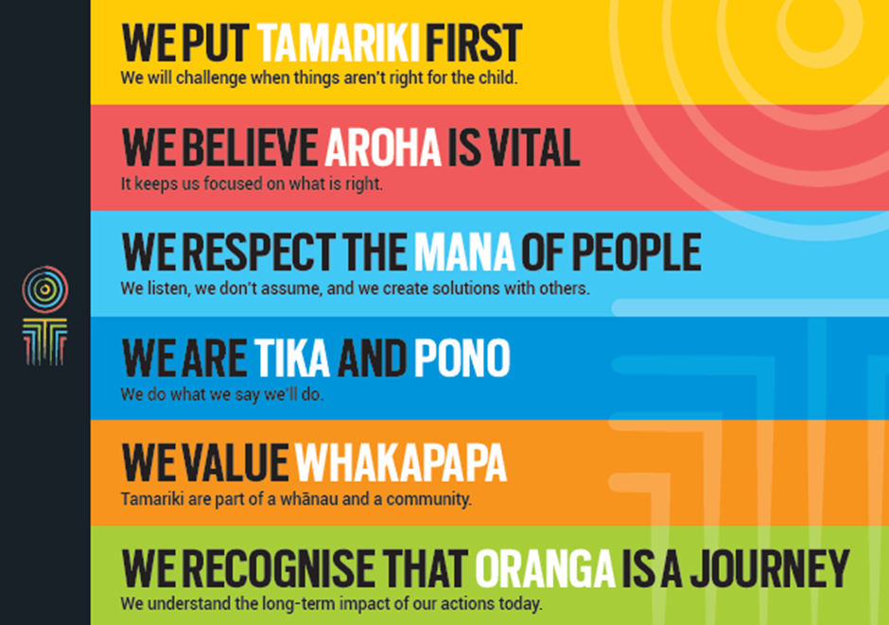
Our core outcomes | Our core outcomes are:  - All children and young people are in loving families and communities where they can be safe, strong, connected, and able to flourish  - Improved outcomes for all children, especially Maori tamariki and rangatahi.

POSITION PURPOSE
The purpose of this role is to provide statutory social work services which promote the protection, wellbeing and best management of children and young persons in safe families. The Social Worker will work toward this goal through the delivery of a range of intervention strategies designed to meet desired outcomes, specified by the Minister for Children.
KEY ACCOUNTABILITIES
Key Result area | Key Accountabilities
Social Work Practice | - Information gathering and analysis at intake and investigation phases.  - Planning, implementation and review of appropriate interventions, in conjunction with the supervisor, and where appropriate, an assigned co-worker.  - Preparing reports as required, based on extensive and accurate information gathering and analysis.  - Using existing professional practice tools and those which may from time to time be introduced by the Ministry.  - Providing appropriate information to clients, professionals, colleagues and others in order to maximise good decision making processes.  - Participating in the processes of the Family Group Conference (FGC) and those tasks which follow an FGC.  - Completing tasks associated with the Family and Youth Court, including preparing and presenting a range of reports for Court  - Providing case management in conjunction with the supervisor and other relevant parties.  - Keeping factual and timely formal records through the use of computer based and other information systems.  - Co-operating with any agreed quality assurance process operated by the Ministry.
Quality service delivery | Delivering quality services that:  - Are culturally appropriate and consistent with the Treaty of Waitangi and the Ministry’s Maori (Te Toka Tumoana) and Pacific Peoples (Va'aifetu) strategies.  - Comply with the Children, Young Persons’ and Their Families Service Act 1989, the Public Finance Act 1989, and with other relevant legislation and regulations.  - Are consistent with Service policies and procedures, including Oranga Tamariki’s Code of Conduct.  - Are cost effective and within financial parameters set by the manager.
Internal and inter-Agency relationships | - Making a positive contribution to the development of a co-operative relationship with the supervisor.  - Working collaboratively with other social work colleagues, professional advisors, managers and other employees, and any Iwi Social Service with who the Service may be in partnership.  - Developing and maintaining effective links with a range of other people and agencies in order to maximise services built on inter-agency collaboration. This will include links with appropriate Maori and Pacific peoples, community groups, professional agencies and other client groups that relate to the practice area.
Organisational contribution | - Working with families, communities, other agencies and professionals to protect children and young persons, manage young offenders, ensure safety and security for children and young persons in the custody of the Chief Executive of Oranga Tamariki—Ministry for Children and to provide adoption and adult adoption information services.  - Following legislative requirements, and Ministry policies and practices at all times.  - Participation in the provision of a 24 hour service which includes working after hours, on weekends and Public Holiday as required  - Seeking approval for funding of interventions on a case by case basis within defined parameters.  - Accepting responsibility for accurate entering of data required for casework recording.  - Complying with all lawful and reasonable instructions given by supervisor and line managers, including delegations from Co-ordinators.
Self-Management Responsibilities | - Planning and taking opportunities for training, coaching and other professional development possibilities.  - Managing work priorities, personal workload and stress levels with the support of the supervisor.  - Complying with organisational policies on health and safety in the workplace and participating as part of the organisation to provide for a safe and healthy work environment.  - Complying with requirements of the supervision policies.
Other Activities | - Undertaking any other appropriate activities that fall within the purpose of the position stated at the beginning of this job description.

KEY RELATIONSHIPS
Internal | - Other social work practitioners within Oranga Tamariki  - Internal service providers, including policy.
External | - Social Work practitioners within Iwi Social Services  - Local community groups, networks and social service agencies;  - Other Government agencies such as: Office of the Commissioner for Children, Education, Health. Immigration Service, Internal Affairs, Justice, Te Puni Kokiri, Youth Development  - Community Service Providers  - Nga Iwi.
QUALIFICATIONS & EXPERIENCE
Qualifications | - A Social Work qualification recognised by the New Zealand Social Workers Registration Board (SWRB), or  - Full SWRB registration and current annual practising certificate, and  - Hold a full, clean valid drivers’ licence.
Personal commitment | Demonstrated evidence of commitment to the following is required:  - our organisational vision, purpose, values and goals  - Treaty of Waitangi, Te Toka Tumoana, Va'aifetu and Puao-te-Ata-tu  - Working with clients and colleagues in a culturally sensitive and appropriate manner.  - Equal employment opportunities.

POSITION COMPETENCIES
Competency | Description of success profile behaviour
Resilience | A demonstrated ability to persevere through periods of heavy workloads in stressful situations.
Conceptual thinking | The ability to identify patterns or connections between situations; identify key or underlying issues in complex situations and resolve these by using creative, conceptual and inductive reasoning.
Analytical thinking | The ability to understand a situation by breaking it into smaller pieces, to be systematic, to trace cause and effect implications, and to set priorities.
Interpersonal understanding | A desire to understand the structure and protocols of other cultures and a willingness and aptitude to utilise these for the benefit of clients of the Ministry; and ability to understand the reasons for the feelings and behaviour of others through the ability to interpret unspoken or partially expressed thoughts feelings and concerns, and through an appreciation of the cultural framework within which that person operates.
Achieving the task | The ability to organise work through an efficient use of time, setting targets and achieving them.
Self-confidence | Confidence in one’s own judgement and a willingness to express an independent view point
Relationship building | An ability to engage with clients and to establish working relationship with agencies, voluntary groups and individuals.
Influencing others | An ability to influence others through appropriate use of directive and non-directive means.
Information seeking and interpretation | An ability to elicit basic information and probe for further facts through a wide range of information gathering skills.
Listening and responding | An ability to listen, to interpret, clarify and respond appropriately.
Role clarity | An ability to be clear about one’s role and to evaluate the purpose of taking a particular action.
Service orientation | A desire to work within the framework of the organisation (and where appropriate, Iwi Social Service) toward meeting the desired outcomes for clients.
Team work and co-operation | A commitment to work co-operatively as part of a team, and to be flexible in a changing work environment.

