Title: Social Work Supervisor
Group: Services for Children and Families North/South
Reports to: Site Manager
Location: As specified
Direct Reports: up to 6 direct reports
Budget: No
OUR ORGANISATION
About us | Oranga Tamariki—Ministry for Children is a new Ministry dedicated to supporting any child in New Zealand whose wellbeing is at significant risk of harm now, or in the future. We also work with young people who may have offended, or are likely to offend. Our belief is that in the right environment, with the right people surrounding and nurturing them, any child can, and should flourish.
Our vision | Our vision is: New Zealand values the wellbeing of tamariki above all else.
Our purpose | Our purpose is: To ensure that all tamariki are in loving whānau and communities where oranga tamariki can be realised.
The Oranga Tamariki way | We’re introducing a new way of doing things. A way of looking at the world that guides everything we do:  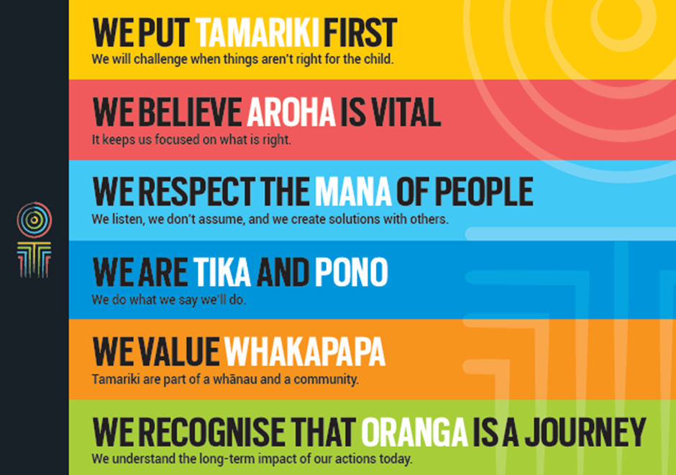
Our core outcomes | Our core outcomes are:  - All children and young people are in loving families and communities where they can be safe, strong, connected, and able to flourish.  - Improved outcomes for all children, especially Maori tamariki and rangatahi.

POSITION PURPOSE
The Supervisor is responsible for the effective management of a team of social workers and support staff to ensure the efficient delivery of case work that fulfils Oranga Tamariki’s service delivery responsibilities as agreed with the Minister. They will also ensure that the services and resources are managed in accordance with the Children Young Persons and Their Families Act 1989 and the State Sector Act 1988 and other relevant legislation.
The Supervisor will implement and maintain protocols, processes and systems to enable full and effective delivery of social work services to meet the KPI’s and business plan requirements. This includes close communication and collaboration with the Site Manager and Practice Leader.
KEY ACCOUNTABILITIES
Key Result area | Key Accountabilities
Service delivery | - Responsible for the effective and efficient delivery of service in accordance with relevant legislation, policies and business plan priorities  - Lead and manage a social work team including support staff, by providing an environment within which service delivery excellence can be achieved  - Contribute to the efficient and effective management of financial resources and assets working within the site’s budget  - Ensure that the Professional Supervision Policy operates effectively as per the policy guidelines and that staff health and safety systems including the Dangerous Situations, CISM and EAP Policies are operating within locations  - Ensure that Key Performance Indicators (KPIs), casework and quality indicators and standards are managed and met  - Promote and maintain effective relationships with partner agencies, NGOs, Iwi and Pacific people, community groups and contracted service providers as they relate to casework  - Manage the effective use of contracted services in accordance with the department’s stated outcomes, national priorities and standard operating procedures to ensure high quality outcomes for children, young people and their families  - Work with the Site Manager and Practice Leader to regularly assess and monitor Site practices and processes to ensure they continue to meet the Department’s and clients’ needs. Where appropriate, identify and implement improvement opportunities as required  - Respond to complaints in accordance with departmental procedures and ensure Ministerials, Official Information Act and Privacy Act requests are managed in accordance with organisational standards  - Identify and manage risks, including casework risks and escalate where appropriate  - Contribute to and implement practice improvement recommendations as outlined in audit reports.
Key Collective Accountabilities | - Assess and monitor team service delivery performance and contribute to practice improvement initiatives  - Ensure consistency of operational practice across the Site in accordance with statute and Ministry Policy  - Contribute to the management of service delivery within budgetary allocations  - Build Social Worker capability to ensure service excellence  - Identify and manage internal and external service delivery risks and ensure intervention and escalation as appropriate  - Build the focus on quality within Oranga Tamariki and promote and support quality assurance practices  - Ensure that activities comply with all relevant legislation and ethical and industry standards.
Leadership and management | - Future builder - help staff and the organisation navigate the future  - People builder – develop people and identify talent  - Deliverer - make things happen, with and through others  - Steward - lead in a public service context, contributing to a better New Zealand  - Understand and implement your manager Health, Safety and Security accountabilities  - Ensure health, safety and security policies and procedures are understood, followed and implemented by all employees.
Being part of the Oranga Tamariki team | - Actively and positively participate as a member of the team  - Proactively look for opportunities to improve Oranga Tamariki’s operations  - Perform any other duties as needed by Oranga Tamariki  - Comply with and support all health and safety policies, guidelines and initiatives  - Ensure all incidents, injuries and near misses are reported into our H&S reporting tool  - Comply with all legislative and regulatory requirements, and report any breaches as soon as they become known  - Adhere to all Oranga Tamariki’s procedures, policies, guidelines, and standards of integrity and conduct  - Commitment to the Treaty of Waitangi and respect and incorporate these into your work.

KEY RELATIONSHIPS
Internal | - Site Manager  - Practice Leaders  - Legal Services  - Residence Managers and staff  - Site staff  - Service Centre  - Oranga Tamariki staff
External | - Contracted service providers  - Partner Agency representatives  - NGO representatives  - Service and Community Providers
QUALIFICATIONS & EXPERIENCE
Qualifications | - A relevant tertiary qualification in social work is mandatory  - A clean, current driver’s licence is essential.
Knowledge and Experience | - Proven successful experience in quality social work service delivery  - Success in leading and supporting other social workers and/or initiatives that improve the quality of social work practice  - Experience in planning, financial management, resource allocation and performance monitoring processes  - Proven practical background in process planning – including how to set up systems and processes to ensure efficient service delivery with a focus on quality and risk management. This includes systems and people management aspects of process planning  - Experience in complex politically sensitive environments  - Proven and successful people management experience including motivating people for improved performance  - Successful management of risk in critical situations  - Proven experience in supporting staff in the complex and sometimes difficult role they undertake  - Demonstrated ability to work in collaborative peer and other stakeholder relationships  - A sound knowledge of relevant legislation.
Skills | - Strong line management or supervisory ability or potential  - Understanding of the social services environment and the complexity of pressures that can impact on staff  - Strengths-based leadership, with the ability to collaborate with others, across the spectrum of Ministerial functions, to achieve mutually agreed goals  - Working to resolve conflicts or difference by finding areas of agreement that benefit the organisation and individuals  - An ability to influence action in areas for which they have responsibility  - An ability to build and maintain rapport with others based on their own integrity and honesty, demonstrating effective interpersonal skills  - Commitment towards positive outcomes for children, young people and their families  - An ability to anticipate and resolve problems making decisions based on sound risk management analysis  - Understanding of the governance arrangements and public sector context within which Oranga Tamariki works and applies it to judgement and decision making  - An ability to resolve problems and make decisions with limited information and in practical and straightforward way  - High level computer skills including Word, Excel, email and data entry  - Excellent verbal, written and interpersonal communication skills  - Ability to communicate complex ideas to a variety of audiences and build and maintain rapport with others  - Understanding and appreciation of cross cultural issues and concerns, in particular, knowledge of tikanga Maori, and Pacific peoples’ culture.

POSITION COMPETENCIES
Competency |  | Description of success profile behaviour
- Client Focus  The desire and willingness to understand and meet or exceed client expectations. Clients are those groups or individuals, internal or external, who use Oranga Tamariki’s services. |  | - Delivers superior service to clients.  - Understands, empathises with, and identifies the needs, concerns and priorities of clients and ensures that services are delivered to take account of these.  - Takes personal responsibility for correcting client service problems and/or “championing” client issues.  - Corrects problems promptly, without getting defensive.  - Attempts to give added value to the client.  - Actively supports the interests of the client by making choices and setting priorities to meet their needs.
- Team management  The ability to provide direction and leadership to others and to maximise the effectiveness of a team. This includes ensuring that staff has clear expectations and standards for performance, promoting and developing team spirit, ensuring that team efforts are focused on the achievement of key objectives and positively influencing people and motivating them to perform. |  | - Empowers and encourages people to perform better.  - Brings out the best in people through setting challenging objectives.  - Uses a range of strategies to promote team morale and productivity.  - Holds people accountable for performance and consistently compares performance against standards.  - Addresses performance issues effectively, including taking disciplinary action where appropriate.
- Planning and organisation  The ability to identify objectives and develop effective action plans to achieve them. This may include using sound personal organisation disciplines, a methodical and systematic approach towards planning workloads and using project management skills. |  | - When prioritising own work, is aware of impact on others.  - Balances conflicting priorities as necessary.  - Anticipates future demands and prepares appropriately; anticipates difficulties and develops contingency plans.  - Contributes to the preparation of plans for the team.  - Demonstrates effective project management skills and breaks down large tasks into separate milestones and deadlines.  - Introduces complex systems and monitors their use.
- Communication  The ability to clearly convey thoughts and ideas effectively. This may include listening, interpreting, formulating and delivering: verbal, non-verbal, written, and/or electronic messages. |  | - Work shows recognition of the importance of communication in achieving results.  - Seeks to understand others’ frame of reference and uses this understanding to identify the most effective method of conveying information.  - Uses different ways of conveying a message to add clarity and meaning to communications.  - Adapts communications to the views and level of knowledge of the audience.  - Prepares and structures communication well. Is able to make complex issues understandable.  - Sets out arguments clearly and logically; persuades and influences others.
- Relationship management  The ability to interact with and develop effective working relationships with a wide range of people of different types and in different situations. |  | - Develops formal and informal relationships with a wide circle of people, beyond those involved in current activities.  - Nurtures existing and potential relationships to help achieve the Ministry's strategic objectives.  - Manages difficult relationships effectively and demonstrates confidence and diplomacy in demanding interpersonal situations.
- Technical skills & knowledge  Demonstrates specialist or technical knowledge and skills within one’s functional area (e.g. Administration, Finance etc). |  | - Possesses advanced knowledge of functional area.  - Establishes credibility, earns respect and influences others on the basis of technical knowledge.  - Applies technical skills and knowledge to support the direction of the Ministry.
- Teamwork  The ability and willingness to work with others co-operatively and productively in order to achieve group objectives. This may include informal work groups, advisory groups or committees and project teams. |  | - Acts to promote a welcoming, productive climate, good morale and co-operation within and between teams.  - Genuinely values others' input and expertise.  - Contributes own expertise to the team.  - Facilitates and influences positive outcomes that support team goals.  - Promotes team co-operation, even during heated discussions.  - Is willing to set aside personal agenda in order to support the team consensus.  - Assists in mediating between team members to resolve conflict.
- Cultural Responsiveness  The ability and desire to show cultural sensitivity, awareness and understanding of diversity. This includes reinforcing culturally sensitive behaviour, being responsive to Maori and other cultural groups, effectively relating to clients from diverse cultural backgrounds, fostering a culturally safe working environment for staff. | - Knows how to address issues that impact on clients, employees, stakeholders and communities from different cultural backgrounds;  - Provides services to clients with sensitivity, understanding, and respect for the client’s culture;  - Works in ways that enhance consultative relationships with different cultural groups and acts on opportunities to engage with them.

Desirable competencies
Competency |  | Description of success profile behaviour
- Results orientation  The ability to take personal responsibility for the delivery of results. This includes delivering required results consistently and successfully, exhibiting appropriate initiative and persistence and focusing on work that is of high quality. | - Takes full responsibility for making things happen, including in situations that are very demanding or not clearly defined.  - Tenacious in finding alternative means to meet a goal if difficulties arise.  - Regarded as totally dependable to achieve planned results.
- Change orientation  The ability to think about a situation, issue or process in new or varying ways and to generate new ideas. This includes the willingness to seek out and implement better ways of doing things and to embrace change. |  | - Stretches to continuously improve activities and results beyond work unit.  - Helps to establish a climate that encourages innovation and receptivity to change.  - Demonstrates consistent ability to generate new ideas and initiatives.  - Shifts focus and activities quickly in response to changing organisational priorities.
- Integrity  The ability to maintain confidences and trust and to act in an honest, ethical and professional manner. |  | - Sets and adheres to personal and organisational ethical standards.  - Demonstrates desired behaviours and treats all people with respect and dignity.  - Is committed to the values of the Ministry.

