Title: Senior Analyst, Research and Evaluation
Group: Evidence and Investment
Reports to: Manager Research and Evaluation
Location: Wellington
Direct Reports: None
Budget: None
OUR ORGANISATION
About us | The Ministry for Vulnerable Children, Oranga Tamariki is a new Ministry dedicated to supporting any child in New Zealand whose wellbeing is at significant risk of harm now, or in the future. We also work with young people who may have offended, or are likely to offend. Our belief is that in the right environment, with the right people surrounding and nurturing them, any child can, and should flourish.
Our vision | Our vision is: New Zealand values the wellbeing of tamariki above all else.
Our purpose | Our purpose is: To ensure that all tamariki are in loving whānau and communities where oranga tamariki can be realised.
The Oranga Tamariki way | We’re introducing a new way of doing things. A way of looking at the world that guides everything we do:  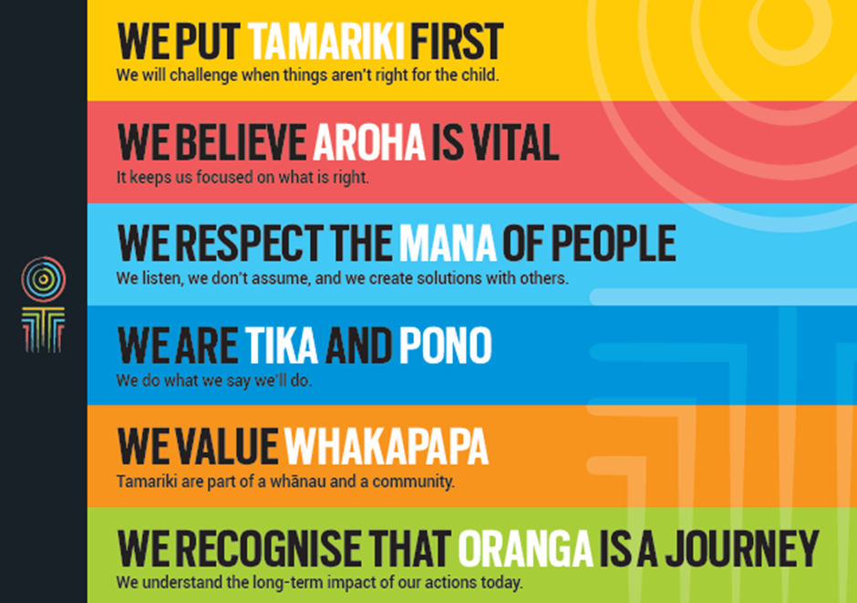
Our core outcomes | Our core outcomes are:  - All children and young people are in loving families and communities where they can be safe, strong, connected, and able to flourish  - Improved outcomes for all children, especially Maori tamariki and rangatahi.

POSITION PURPOSE
The Policy, Investment and Evidence Group guides Oranga Tamariki’s performance, outcomes and investment focus to ensure better outcomes are delivered for children and young people. The Senior Analyst, Research and Evaluation role contributes to analysis of data and evidence to inform investment decisions focused on improving the future wellbeing of children and young people.
KEY ACCOUNTABILITIES
Key Result area | Key Accountabilities
Deliverables | - Design and deliver evaluation and research projects through all stages of the process - from design, through to data capture, analysis and effective dissemination of results  - Deliver evidence synthesis products, including literature reviews, annotated bibliographies, “what works” briefs, and rapid evidence synthesis products.
Supporting | - Experience in providing information and analysis to support provision of social services policy  - Strong understanding of social investment approach and principles in the social sector  - Excellent verbal, written and interpersonal communication skills in presenting to a variety of audiences  - Provide relevant, timely and accurate information to the Leadership Team and other stakeholders  - Manage all aspects of multiple related projects to ensure alignment to achievement of the Ministry’s strategic objectives  - Proactively anticipate and manage risks, providing timely feedback to the Manager Investment Approach  - Co-ordinate interdependencies, and any risks and other issues that may arise.
Leadership | - Provide leadership to relevant working groups as required, creating an environment where results are achieved that best meet children’s needs  - Work creatively in a problem-solving environment demonstrating teamwork, innovation and excellence.
Communication | - Communicate constructively with business units and stakeholders  - Deliver engaging, informative, well-organised presentations  - Resolve and/or escalate issues in a timely fashion  - Understand how to communicate difficult/sensitive information tactfully  - Actively seek feedback from the business and communicate this to the team to ensure successful delivery of the project.
Being part of the Oranga Tamariki team | - Actively and positively participate as a member of the team  - Proactively look for opportunities to improve Oranga Tamariki’s operations  - Comply with and support all health and safety policies, guidelines and initiatives  - Ensure all incidents, injuries and near misses are reported into our H&S reporting tool  - Comply with all legislative and regulatory requirements, and report any breaches as soon as they become known  - Adhere to all Oranga Tamariki’s procedures, policies, guidelines, and standards of integrity and conduct  - Show commitment to the Treaty of Waitangi and respect and incorporate these into your work.
KEY RELATIONSHIPS
Internal | - Investment Model Team  - Policy Team  - Oranga Tamariki staff including the Service Design Team, Operations and the Office of the Chief Social Worker
External | - Central agencies as appropriate  - Other government agencies as appropriate
QUALIFICATIONS & EXPERIENCE
Qualifications | - A relevant tertiary qualification.
Experience | - Experience in leading evaluation or research projects including all stages of the process - from design, through to data capture, analysis and effective dissemination of results.  - Strong theoretical grounding in quantitative and/or qualitative methods  - Practical experience of applying mixed methods design in evaluation or research.  - Practical experience in conducting Randomised Control Trials is an advantage.
Competency | - Ability to understand complex information and communicate simple messages and ideas to a variety of audiences  - Excellent verbal, written and interpersonal communication skills in presenting to a variety of audiences  - Proven ability to understand operating models and provide clear advice on tactical action required to improve performance  - Ability to stand back from the immediacy of situations and take a broad or long-term view foreseeing opportunities and developing pragmatic solutions to problems  - Proven project management skills, particularly in management of multi-faceted, complex and multi-stakeholder projects  - Proven ability to analyse trends across multiple data and evidence information and provide clear advice on action required  - Solid strategic thinking ability and proven experience in translating strategy into operations  - Strong analytics modelling and capability including high level of computer literacy, such as SAS and Excel.

