Title: Senior Advisor, Pā Harakeke Family
Group: Tamariki Advocate/Voices of Children
Reports to: Team Leader, Pā Harakeke Family
Location: Wellington
Direct Reports: Nil
Budget: Nil
OUR ORGANISATION
About us | Oranga Tamariki—Ministry for Children is a new Ministry dedicated to supporting any child in New Zealand whose wellbeing is at significant risk of harm now, or in the future. We also work with young people who may have offended, or are likely to offend. Our belief is that in the right environment, with the right people surrounding and nurturing them, any child can, and should flourish.
Our vision | Our vision is: New Zealand values the wellbeing of tamariki above all else.
Our purpose | Our purpose is: To ensure that all tamariki are in loving whānau and communities where oranga tamariki can be realised.
The Oranga Tamariki way | We’re introducing a new way of doing things. A way of looking at the world that guides everything we do:  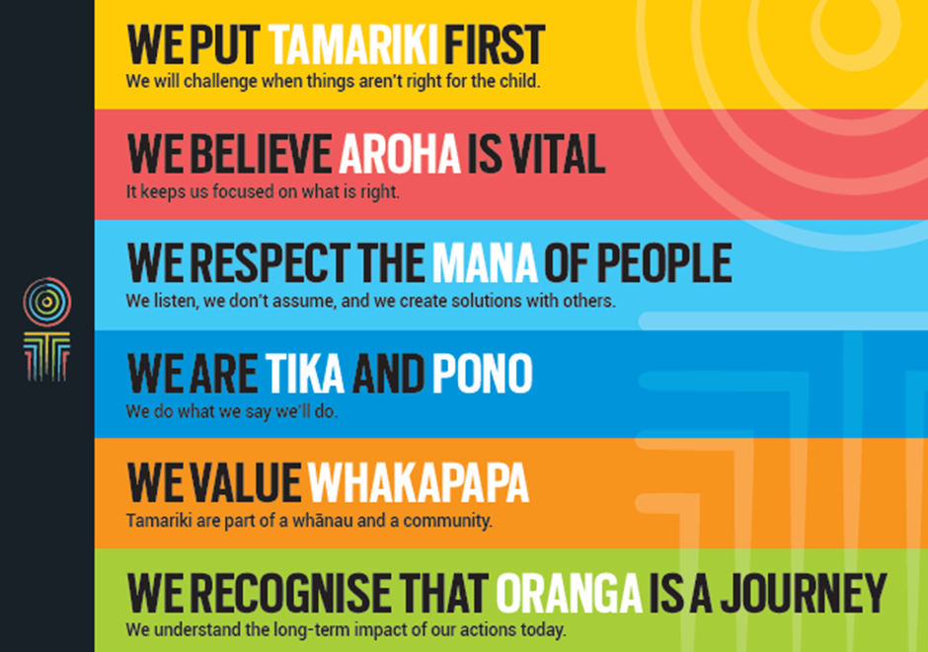
Our core outcomes | Our core outcomes are:  - All children and young people are in loving families and communities where they can be safe, strong, connected, and able to flourish  - Improved outcomes for all children, especially tamariki and rangatahi Māori.

POSITION PURPOSE
The Tamariki Advocate group ensures the voices of children and young people are embedded in all Oranga Tamariki decision-making. The group play a vital role in transforming the experiences of vulnerable children and young people.
The Whānau and Community Initiatives team leads early intervention and prevention initiatives to keep tamariki and rangitahi safe and help them thrive; we achieve this by working with community based partners; and through iwi and Maori partnerships hold fast to the principles of Mana Tamaiti, Whanaungatanga and Whakapapa. The Senior Advisor Pā Harakeke will provide current evidence based information on child development and positive parenting for tamariki aged 0 to 5. The Senior advisor will made the links between the information and practical ways whanau can create nurturing environments for tamariki. The Senior Advisor will support community led initiatives, using inspiring facilitation and mentoring skills.
The Senior Advisor will build relationships with community organisations, key government stakeholders and internal ministry staff to foster an environment of increased capability and capacity. This includes working closely with Ministry staff and management of the interface with other business groups.
The Senior Advisor plays a key role in mentoring and developing capability within the Pa Harakeke Family team.
KEY ACCOUNTABILITIES
Key Result area | Key Accountabilities
Work programme | - Working closely with the Pa Harakeke Family team to develop and implement the SKIP work plan  - Monitor and report on achievement of their agreed work programme  - Identify potential risks and mitigation strategies to achieve the work programme
Advice and support | - Provide advice and support to internal and external stakeholders on child development and parenting of 0-5 year olds to  - Synthesise and communicate best practice, evidence and insights so they can be easily applied across the organisation and in communities  - Provide timely, accurate and complete reports to management and the wider business
Profile, Analysis and Research | - Provide intellectual subject matter expertise and leadership in child development and the needs of 0-5 year olds  - Make a significant contribution to the strategic direction of Oranga Tamariki through influence, expertise and advice  - Communicate the findings of research and evaluation to stakeholders and ensure all key stakeholders are aware of wider issues around services that support families, and opportunities for innovative initiatives/projects.
Reporting and Monitoring/Risk Management | - Monitor and report on the effectiveness of initiatives/programmes and services  - Write regular and ad hoc reports, as appropriate, on work in progress/initiatives for Pā Harakeke Family  - Advise on risk areas, opportunities and emerging issues and on strategies to manage these risks.
Project Management | - Coordinate the scoping of projects, including the development of key milestones, timelines, consultation processes, risk analysis and resourcing requirements  - Ensure key milestones are met  - Keep manager informed of work progress and emerging issues  - Ensure any governance requirements and processes are met  - Ensure accurate reporting as required (e.g. status reports, exception and change reporting)  - Undertake project review and evaluation  - Identify and consult with all key stakeholders of any project/process and ensures strategies are developed to gain buy-in and commitment to desired outcomes.
Process Improvement/Information Sharing | - Analyse business and project processes to evaluate their effectiveness and efficiency and recommend improvements  - Provide regular feedback on any issues and trends emerging in parent support and development within the Ministry and external channels  - Provide support, training and advice to staff in the Ministry linking with parent support and development providers and programmes.
Mentoring/Coaching | - Provide coaching and/or mentoring to other team members as well as professional support and advice as necessary  - Provide a leadership role in forums and processes within Pā Harakeke Family and within wider Oranga Tamariki and external forums as required  - Represent and support the Team Leader where required  - Provide support, training and advice to staff in Oranga Tamariki linking with family start and development providers and programmes.
Being part of the Oranga Tamariki team | - Actively and positively participate as a member of the team  - Proactively look for opportunities to improve the operations of Oranga Tamariki  - Perform any other duties as needed by Oranga Tamariki  - Comply with and support all health and safety policies, guidelines and initiatives  - Ensure all incidents, injuries and near misses are reported into our H&S reporting tool  - Comply with all legislative and regulatory requirements, and report any breaches as soon as they become known  - Adhere to all Oranga Tamariki procedures, policies, guidelines, and standards of integrity and conduct  - Commitment to the Treaty of Waitangi and respect and incorporate these into your work.
KEY RELATIONSHIPS
Internal | - Reporting to Team Leader  - Whanau and Community Initiatives manager and team members  - Oranga Tamariki staff
External | - Service providers  - External agencies such as Ministry of Social Development, NZ Police, Ministry of Health, Ministry of Education and other key stakeholders  - VOYCE - Whakarongo Mai  - Office of the Children’s Commissioner  - Te Whānau Aroha and other youth advisory groups that may be established  - Iwi and Māori organisations  - Chief Executives and staff of relevant national NGOs  - Agencies, local and national, working in the child development and parenting area  - Other Non-Government Organisations/Community Organisations  - Community and voluntary sector organisations including local government bodies  - International and overseas government agencies and organisations with social policy interests
QUALIFICATIONS & EXPERIENCE
Qualifications | - Relevant tertiary or post graduate qualification is desirable  - Holds current clean driver’s licence and is prepared to drive the Ministry’s vehicles if required.
Experience | - Expertise in child development is desired (especially for 0-5 year olds)  - Expertise in community development and mobilisation is desired  - Experience in the social services or government sector is desired  - Knowledge and/or experience of contemporary issues in social services delivery, community development or child development  - Project management experience  - Knowledge of government processes and direction  - Extensive experience in working with government agencies, NGOs, Community, Iwi/Māori and Pasifika organisations.
Skills | - Strong organisational ability to optimise and prioritise conflicting demands in a busy environment, to achieve deadlines and see responsibilities through to completion  - Good interpersonal and communication skills, including oral and written communication and particularly the ability to present ideas, information and advice in a way that is understandable by a range of audiences  - Excellent self-management skills, including working effectively without direct supervision, managing and organising fluctuating workloads in sometimes stressful situations  - Is able to personally cope with ambiguity and change  - Able to work effectively and competently with people at all levels; build and maintain relationships, within and external to the Ministry  - Strong problem resolution and decision making skills - able to clearly identify problems, seek alternative solutions, identify risks and benefits, seek input from others and make sound decisions based these considerations  - Coaching and mentoring skills  - Exercises sound analysis, judgment, and political sensitivity  - Effective facilitation skills  - Flexible, adaptable and pragmatic  - Welcomes and values diversity, and contributes to an inclusive working environment where differences are acknowledged and respected  - Understands and appreciates cross cultural issues and concerns, in particular, knowledge of tikanga Māori, and Pacific peoples’ culture.
POSITION COMPETENCIES
 | Competency | Description of success profile behaviour
Identifying and Developing talent  Coach and develop diverse talent; to build the people capability required to deliver outcomes |  | - Develop Others (i.e. share own experiences and learnings; demonstrate and teach specific technical skills)
Engaging others  Connect with people; to build trust and become a leader that people want to work and for. |  | - Connects with others (i.e. makes a personal connection with people, puts them at ease and shows an interest in them and their wellbeing).  - Listens (i.e. allows others space to speak, and shows a keen interest and understanding of others’ points of view).  - Displays a sensitivity towards Māori  - Displays a sensitivity towards Pacific Peoples and other cultures  - Reads people and situations (i.e. picks up on ‘what is not being said’ in situations).  - Communicates tactfully (i.e. conveys potentially sensitive messages in a diplomatic way).
Managing work priorities  Plan, prioritise, and organise work; to deliver on short and long-term objectives across the breadth of their role. |  | - Manage and deliver on work priorities (i.e. plan and organise yourself to deliver work commitments to required timeframes and quality standards)
Achieving ambitious goals  Demonstrate achievement drive, ambition, optimism and delivery focus; to make things happen and achieve ambitious outcomes. |  | - Committed and tenacious (i.e. takes ownership; is persistent in the face of obstacles; and shows a strong focus on achieving outcomes, rather than a narrower focus on following processes).  - Ambitious (i.e. sets and achieves specific and challenging goals; focuses on opportunities rather than constraints; and takes an expansive view of the outcomes they can achieve for their organisation and New Zealand.
Curious  Show curiosity, flexibility, and openness in analysing and integrating ideas, information, and differing perspectives; to make fit-for-purpose decisions. |  | - Thinks analytically and critically (i.e. gets to the heart of issues and uncovers underlying causes; and clearly describes their analytical process and the rationale for their decisions).  - Takes into account the impact of decisions on Māori tamariki and rangatahi, and Oranga Tamariki’s goals for diversity and inclusion;  - Displays curiosity (i.e. identifies a range of alternative options and encourages others to critique their ideas).  - Mitigates analytical and decision-making biases (i.e. insightful about the strengths and weaknesses of their analysis and decision-making approach, so that they mitigate potential decision-making biases).
Honest and courageous  Deliver the hard messages, and makes unpopular decisions in a timely manner; to advance the longer-term best interests of Māori tamariki and rangatahi and New Zealand. |  | - Shows courage (i.e. makes the hard and unpopular decisions and takes the lead on controversial issues).  - Shows decisiveness (i.e. acts decisively when required, even when information is conflicting or incomplete).  - Leads with integrity (i.e. acts according to a clear set of ethical principles aligned with Public Service values; and challenges behaviour that does not meet ethical standards).
Resilient  Show composure, grit, and a sense of perspective when the going gets tough; to help others maintain optimism and focus. |  | - Displays resilience (i.e. bounces back after setbacks; maintains focus and optimism in challenging situations; and adopts habits which maintain personal balance and wellbeing).  - Demonstrates composure (i.e. displays a calm and composed approach and a sense of perspective in challenging situations).
Self-aware and agile  Leverage self-awareness to improve skills and adapt approach; to strengthen personal capability over time and optimise effectiveness with different situations and people. |  | - Encourages feedback on own performance (i.e. actively encourages feedback on their leadership approach and/or work style from a range of sources).  - Self-assesses (i.e. reflects self-critically to develop a strong awareness of their preferences, strengths and development needs).  - Adapts approach (i.e. adroitly adapts their approach to optimise their effectiveness with new and different situations and people).  - Shows commitment to development (i.e. sets challenging self-development objectives; takes action; and achieves gains on the areas targeted for development).

