Title: Senior Advisor - Infrastructure Delivery
Group: Corporate Services
Reports to: Manager - Infrastructure Strategy and Delivery
Location: Wellington
Direct Reports: No
Budget: No
OUR ORGANISATION
About us | Oranga Tamariki—Ministry for Children is a Ministry dedicated to supporting any child in New Zealand whose wellbeing is at significant risk of harm now, or in the future. We also work with young people who may have offended, or are likely to offend. Our belief is that in the right environment, with the right people surrounding and nurturing them, any child can, and should flourish.
Our vision | Our vision is: New Zealand values the wellbeing of tamariki above all else.
Our purpose | Our purpose is: To ensure that all tamariki are in loving whānau and communities where oranga tamariki can be realised.
The Oranga Tamariki way | We’re introducing a new way of doing things. A way of looking at the world that guides everything we do:  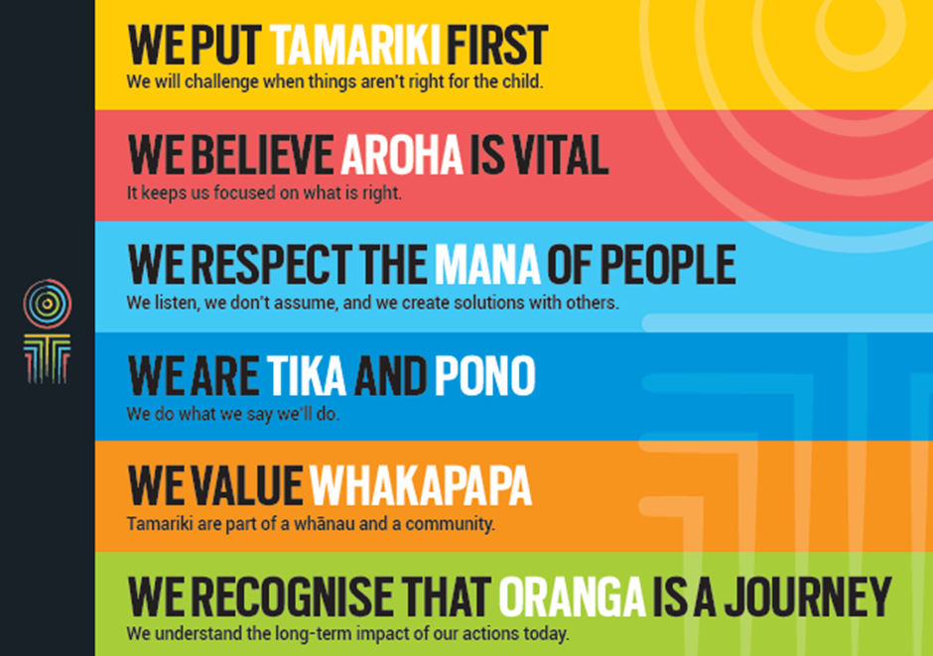
Our core outcomes | Our core outcomes are:  - All children and young people are in loving families and communities where they can be safe, strong, connected, and able to flourish  - Improved outcomes for all children, especially tamariki and rangatahi Māori.
POSITION PURPOSE
The Senior Advisor - Infrastructure Delivery (Senior Advisor) is responsible for ensuring our staff have the infrastructure (physical sites, facilities and vehicles) they need to effectively carry out their jobs and realise the Oranga Tamariki vision.
Working closely with the Manager - Infrastructure Strategy and Delivery, the Senior Advisor will ensure that our staff are provided with clear processes, support and assistance to address any infrastructure related needs. They will manage the programme of infrastructure work with a focus on anticipating and planning for future needs, and the initiation and benefit realisation phases of specific initiatives.
They will use their business acumen skills to ensure initiatives (programmes and projects) are analysed thoroughly and provide solutions to meet the needs of the customer.
KEY ACCOUNTABILITIES
Key Result area | Key Accountabilities
Management of Infrastructure Work Programme | - Proactively gather infrastructure needs through stakeholders, ensuring future changes are well anticipated  - Maintain a clear programme of infrastructure projects including a backlog of demand  - Manage workflow by ensuring appropriate planning, prioritisation and re-prioritisation of work as required, ensuring that priority work is completed to an appropriate standard  - Ensure health, safety and security policies and procedures are understood, followed and implemented by all employees.
Infrastructure Work Programme Delivery | - Provide “hands on” management of designated programme and project work streams  - Ensure proposed infrastructure initiatives meet the business needs and deliver solutions that are in line with the future direction of Oranga Tamariki  - Use sound commercial practice to ensure value for money.
Communication | - Ensure project team members are aware of their responsibilities and are kept up to date with progress and issues  - Identify, monitor and report to the Infrastructure Strategy and Delivery Manager on project performance specifically covering finances, resources, programme, client relationships, team morale, health and safety, risks and quality related issues  - Communicate constructively with business units and stakeholders  - Facilitate team and client meetings effectively  - Keep the project team well informed of changes relevant to the project  - Deliver engaging, informative, well-organised presentations  - Resolve and/or escalate issues in a timely fashion  - Understand how to communicate difficult/sensitive information tactfully  - Actively seek feedback from the business units and communicate this to the team to ensure the successful delivery of the project.
Stakeholder Engagement and Relationship Management | - Work in partnership with the Ministry of Social Development Property (shared services) team to deliver programme and projects  - Solve complex problems that are raised by managers and stakeholders  - Liaise directly with sites to ensure needs are well understood including facilitation of workshops as needed  - Ensure the programmes and projects achieve shared outcomes by working with a diverse range of stakeholder groups, including Iwi/Māori, Pacific people, government and non-government agencies  - Interface with other government agencies in relation to infrastructure as required.
Risk Management | - Actively identify and manage organisational and operational risks of the programmes and projects  - Ensure that analysis, data and information supplied is accurate and verified  - Establish and maintain quality management processes for the programmes and projects  - Ensure our infrastructure safeguards the health and safety of our staff, clients and the community  - Keep the Manager - Infrastructure Strategy and Delivery informed of any risks and/or issues that may impact on organisational reputation.
Finance and Budget Management | - Manage the infrastructure budgets including maintenance of variance reporting, forecasting and internal budgeting  - Accurately report on progress against the programme and project budget, monthly and as required  - Escalate budget issues to the Manager - Infrastructure Strategy and Delivery as appropriate  - Contribute to Treasury bids for additional funding requirements.
Being part of the Oranga Tamariki team | - Actively and positively participate as a member of the team  - Proactively look for opportunities to improve the operations of Oranga Tamariki  - Perform any other duties as needed by Oranga Tamariki  - Comply with and support all health and safety policies, guidelines and initiatives  - Ensure all incidents, injuries and near misses are reported into our H&S reporting tool  - Comply with all legislative and regulatory requirements, and report any breaches as soon as they become known  - Adhere to all Oranga Tamariki procedures, policies, guidelines, and standards of integrity and conduct  - Commitment to the Treaty of Waitangi and respect and incorporate these into your work.
KEY RELATIONSHIPS
Internal | - Technology, Infrastructure and Commercial team  - Oranga Tamariki Managers and relevant staff  - Business unit members that the project is delivering to
External | - External Contractors  - Staff in other government agencies including Police  - Ministry of Social Development  - NGOs

QUALIFICATIONS & EXPERIENCE
Qualifications | - Tertiary qualifications at preferably post graduate level and a relevant discipline or equivalent experience
Experience | - Demonstrated ability to see the "big picture" and the purpose of projects to help achieve the organisation’s goals  - Experience working across a diverse range of stakeholders to facilitate agreement on a solution  - Demonstrated ability to identify how infrastructure can enable positive changes to people’s ways of working and the outcomes they achieve in their role.  - Experience delivering and balancing multiple BAU projects and providing the discipline of planning, monitoring, coordinating and prioritising  - Demonstrated ability to understand financial data and information, cost out all options and support recommendations with quantitative data.
Skills | - Excellent verbal, written and interpersonal communication skills.  - Ability to communicate complex ideas to a variety of audiences and build and maintain rapport with others.  - Understanding and appreciation of cross cultural issues and concerns, in particular, knowledge of tikanga Maori, and Pacific peoples’ culture.  - Knowledge of programme, project and change management principles and processes  - Experience in managing project teams and growing client relationships successfully  - Strong people management, organisational and planning skills  - The ability to solve complex problems
Other Requirements | - Willing to travel to fulfil job requirements.  - Holds current clean driver’s licence and is prepared to drive Ministry vehicles if required.

