Title: Resource Worker
Group:
Reports to: Supervisor - Social Work
Location: As specified
Direct Reports: Nil
Budget: No (insert to what delegation level if appropriate)
OUR ORGANISATION
About us | Oranga Tamariki—Ministry for Children is a new Ministry dedicated to supporting any child in New Zealand whose wellbeing is at significant risk of harm now, or in the future. We also work with young people who may have offended, or are likely to offend. Our belief is that in the right environment, with the right people surrounding and nurturing them, any child can, and should flourish.
Our vision | Our vision is: New Zealand values the wellbeing of tamariki above all else.
Our purpose | Our purpose is: To ensure that all tamariki are in loving whānau and communities where oranga tamariki can be realised.
The Oranga Tamariki way | We’re introducing a new way of doing things. A way of looking at the world that guides everything we do:  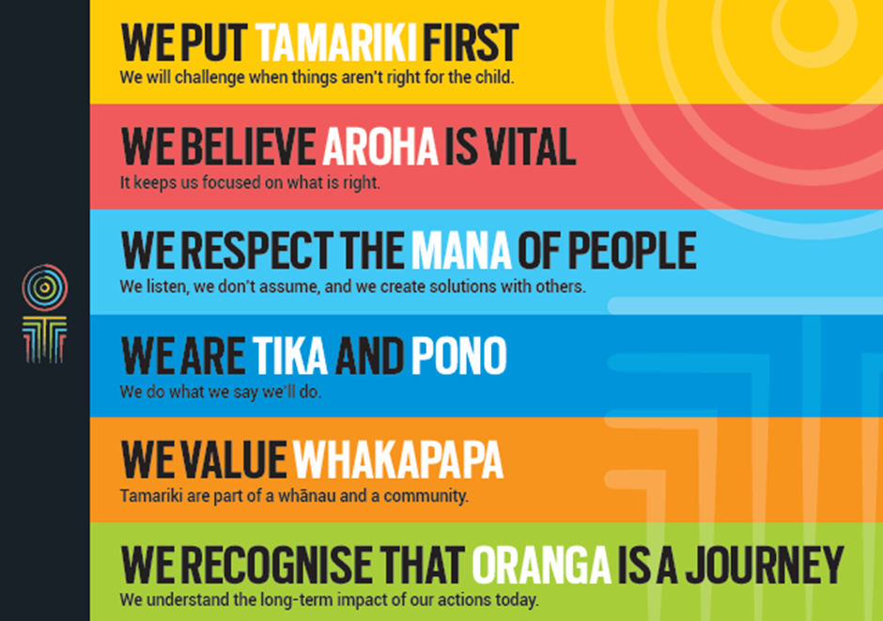
Our core outcomes | Our core outcomes are:  - All children and young people are in loving families and communities where they can be safe, strong, connected, and able to flourish  - Improved outcomes for all children, especially tamariki and rangatahi Māori.

POSITION PURPOSE
The purpose of this position is to undertake paid casual work as Resource Workers with clients of Oranga Tamariki. All work will be undertaken on a short-term contract basis and regular work is not guaranteed. Decisions regarding the allocation of tasks will be made by the key social worker in consultation with their supervisor. The position holder will adhere to the principles and processes as laid down in the Oranga Tamariki Act 1989.
KEY ACCOUNTABILITIES
Key Result area | Key Accountabilities
Delivery of services | - Completion of tasks negotiated with the referring social worker including:  - escorting young people to some Oranga Tamariki residences and other placements e.g. Whakapakari  - supervision of community work  - support work at Family Homes  - one-on-one work with clients assisting them to achieve specific goals  - supervision of access visits  - baby sitting  - providing transport  - keeping accurate written records of client contact  - attendance at Family Court where necessary to provide evidence in relation to Oranga Tamariki clients.
Being part of the Oranga Tamariki team | - Actively and positively participate as a member of the team  - Proactively look for opportunities to improve the operations of Oranga Tamariki  - Perform any other duties as needed by Oranga Tamariki  - Comply with and support all health and safety policies, guidelines and initiatives  - Ensure all incidents, injuries and near misses are reported into our H&S reporting tool  - Comply with all legislative and regulatory requirements, and report any breaches as soon as they become known  - Adhere to all Oranga Tamariki procedures, policies, guidelines, and standards of integrity and conduct  - Commitment to the Treaty of Waitangi and respect and incorporate these into your work.

KEY RELATIONSHIPS
Internal | - Oranga Tamariki staff
External | - Police  - Courts  - Other government agencies  - Local community groups  - Iwi social services.

QUALIFICATIONS & EXPERIENCE
Qualifications | - A clean, current driver’s licence is essential.
Knowledge and Experience | - Previous successful experience in social services work or other relevant experience  - Previous successful experience in working with children and young people  - Ability to manage sensitive and confidential information in an appropriate manner  - Ability to become familiar with working with Acts and regulations  - Demonstrated understanding of Maori/Pacific Island and other cultures  - Empathic and non-judgemental.
Skills | - Excellent verbal, written and interpersonal communication skills  - Competence in managing and supporting children and young people  - Excellent observation skills  - Behaviour management/conflict resolution skills  - Calm and professional manner, with the ability to maintain performance under stress such as distressed children and angry adults  - Positive role modelling – being consistent in behaviour, generating confidence and displaying commitment to others  - Ethical practice and the ability to maintain professional boundaries.  - Understanding and appreciation of cross cultural issues and concerns, in particular, knowledge of tikanga Māori, and Pacific peoples’ culture.

POSITION COMPETENCIES
Competency | Description of success profile behaviour
- Client focus  The desire and willingness to understand and meet or exceed client expectations. Clients are those groups or individuals, internal or external, who use the services of Oranga Tamariki. | - Knows who the client is and talks about the importance of client focus  - Demonstrates professional and courteous service. Is approachable, positive and responsive  - Follows through on client enquiries, requests and complaints  - Keeps client up to date on progress of projects or issues. Is open to client feedback.
- Communication  The ability to clearly convey thoughts and ideas effectively. This may include listening, interpreting, formulating and delivering: verbal, non-verbal, written, and/or electronic messages. | - Communicates clearly, concisely, confidently, courteously, calmly and tactfully  - Listens and understands  - Shares information in an open and honest way  - Demonstrates basic written and oral skills, including telephone skills and ability to use email  - Takes clear and accurate messages  - Records/inputs information accurately and collates information appropriately.
- Teamwork  The ability and willingness to work with others co-operatively and productively in order to achieve group objectives. This may include informal work groups, advisory groups or committees and project teams. | - Participates willingly and co-operates with others  - Respects others and does one’s share of the work  - Supports team decisions and is a good “team player”  - Expresses positive expectations of others and genuinely values others’ input, ideas and points of view  - Keeps people informed and up-to-date  - Shares all relevant or useful information as required.
- Relationship management  The ability to interact with and develop effective working relationships with a wide range of people of different types and in different situations. This includes establishing formal and informal working relationships, developing win/win relationships and assessing and responding to individual behaviour. | - Develops and maintains positive relationships with relevant people  - Is considerate and demonstrates respect and tolerance for others  - Builds good rapport with people at all levels  - Actively seeks opportunities to contribute to positive outcomes for clients, stakeholders, staff and colleagues  - Approaches issues or disagreements with the objective of reaching win/win solutions  - Develops relationships with the intent of achieving effective delivery of relevant services.
- Planning and Organisation  The ability to identify objectives and develop effective action plans to achieve them. | - Prepares day-to-day work in advance and effectively prioritises tasks  - Completes tasks in an efficient and timely manner  - Follows up on tasks and monitors progress against plans and timeframes.  - Adopts a neat, tidy and logical approach to work.
- Problem solving & judgement  The ability to apply an objective, logical reasoning process to a problem or work situation in order to develop a conclusion or recommendation. This includes logically breaking down problems into different parts, identifying key issues and their relationships, interpreting, clarifying, analysing, explaining and developing recommendations or advice. | - Breaks problems down into simple lists of tasks  - Understands simple linkages (e.g. A leads to B) Identifies the relevant issues  - Draws on past experience to solve the current problem
- Cultural responsiveness  The ability and desire to show cultural sensitivity, awareness and understanding of diversity. This includes reinforcing culturally sensitive behaviour, being responsive to Maori and other cultural groups, effectively relating to clients from diverse cultural backgrounds, fostering a culturally safe working environment for staff. | - Understands and is responsive to the needs of different cultural groups in the delivery of services  - Maintains effective relationships with Oranga Tamariki clients and employees and understands their perspectives and priorities;  - Understands the practices surrounding the Treaty of Waitangi;  - Interacts appropriately with Maori taking into consideration tikanga and kawa  - Engages effectively with family/whanau to ensure participation in decision making.
- Integrity  The ability to maintain confidences and trust, and to act in an honest, ethical and professional manner. | - Is honest, trustworthy and can be relied on for confidentiality  - Demonstrates professionalism at all times  - Sets and adheres to personal and organisational ethical standards.  - Demonstrates desired behaviours and treats all people with respect and dignity  - Is committed to the values of Oranga Tamariki.

