Title: Psychologist
Reports to: Manager Clinical Services
Location: Specialist Services
OUR ORGANISATION
About us | The Ministry for Vulnerable Children, Oranga Tamariki is a new Ministry dedicated to supporting any child in New Zealand whose wellbeing is at significant risk of harm now, or in the future. We also work with young people who may have offended, or are likely to offend. Our belief is that in the right environment, with the right people surrounding and nurturing them, any child can, and should flourish.
Our vision | Our vision is: New Zealand values the wellbeing of tamariki above all else.
Our purpose | Our purpose is: To ensure that all tamariki are in loving whānau and communities where Oranga Tamariki can be realised.
The Oranga Tamariki way | We’re introducing a new way of doing things. A way of looking at the world that guides everything we do:  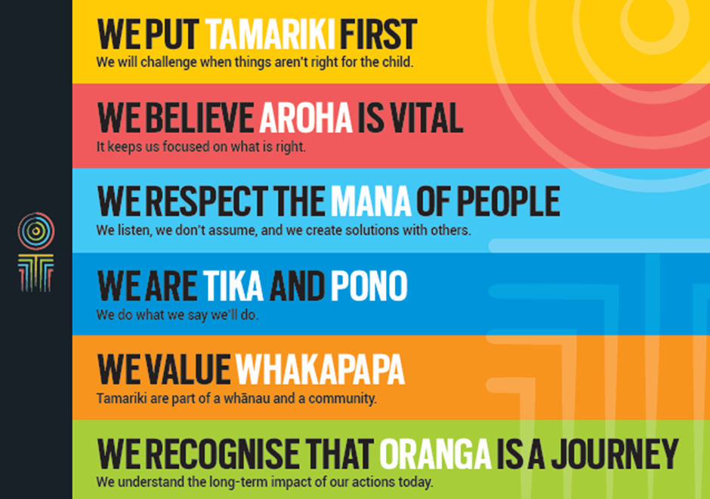
Our core outcomes | Our core outcomes are:  - All children and young people are in loving families and communities where they can be safe, strong, connected, and able to flourish.  - Improved outcomes for all children, especially Maori tamariki and rangatahi.

POSITION PURPOSE
The purpose of this role is to provide psychological services primarily for clients referred by social workers from the Auckland offices of the Ministry for Vulnerable Children, Oranga Tamariki (MVCOT).
In providing this service the person will be expected to:
- Assist clients of MVCOT through direct contact as well as indirectly by working with MVCOT staff and the community.
- Undertake appropriate professional liaison with social workers, other MVCOT staff and the community.
- Contribute their own particular skills, knowledge and perspective to the development and wider work of the team.
STATEMENT OF SERVICES
MVCOT provides the following services:
Public Awareness Services: These services include public education activities that promote the well-being of children, young persons and their families.
Risk Identification and Management: These services include the investigation and management in compliance with the law, of all situations where children and young persons are reported at risk of abuse, neglect or deprivation, or exhibit harmful behaviours.
Family Resolution: These services include the management of resolution processes by means of Agreement with families, and statutory Family Group Conferences, and giving effect to Plans and Orders of Conferences and Courts.
KEY ACCOUNTABILITIES
Key Result area | Key Accountabilities
Specialist Services | - Provide professional expertise in the assessment, management, counselling and therapy of children, young persons and their families, referred by MVCOT social workers.  - Recognise the social values of all cultural groups, meet the professional standards of assessment, intervention, recording, and statutory processes, emphasise the best interests of children and young persons, and support the empowerment of individuals, family and community groups to make their own decisions.
Service Delivery | - Provide assessments of children and their families/whanau referred to Specialist Services by social workers to a standard of professional competence and within an appropriate time frame.  - Provide reports, maintain clinical records, and fulfil all requirements regarding documentation and record keeping for clinical and organisational purposes.  - Conduct competent planned interventions for clients.  - Provide a clinical consultative service for MVCOT social workers and other community based professionals.  - Ensure availability to all sections of MVCOT and other agencies for consultation, programme, policy and training development and evaluation.  - Undertake projects and areas of research relevant to MVCOT policies and programmes, or to Specialist Services service delivery.  - Develop and deliver training programmes which are responsive to the needs of social workers and community groups, in liaison with the appropriate training personnel.  - Provide education about Specialist Services and specialist areas of knowledge and skills to both MVCOT staff and to community groups.  - Undertake any other appropriate specialist activities in consultation with the clinical supervisor and/or Psychologist Team Leader.
Team Management and Self-Management | - Contribute to the development of the professional knowledge and skills base of MVCOT and the Specialist Services Unit in particular.  - Apply appropriate organisational and self-management skills to ensure an efficient, timely and professional service.
Being part of the Oranga Tamariki team | - Actively and positively participate as a member of the team.  - Proactively look for opportunities to improve Oranga Tamariki’s operations.  - Perform any other duties as needed by Oranga Tamariki.  - Comply with and support all health and safety policies, guidelines and initiatives.  - Ensure all incidents, injuries and near misses are reported into our H&S reporting tool.  - Comply with all legislative and regulatory requirements, and report any breaches as soon as they become known.  - Adhere to all Oranga Tamariki’s procedures, policies, guidelines, and standards of integrity and conduct.  - Commitment to the Treaty of Waitangi and respect and incorporate these into your work.

KEY RELATIONSHIPS
Internal | - Specialist Services staff  - Practice Leaders  - Social workers
External | - Clients and their families, whanau  - Professional bodies.
QUALIFICATIONS & EXPERIENCE
Qualifications | - Must be registered as a psychologist with the New Zealand Psychologists’ Board.  - Preferably have postgraduate qualifications in Clinical or Educational Psychology.  - A ‘clean’ current drivers licence is essential.
Experience | - Have proven practical experience in a wide range of applied psychology, including assessment, intervention, consultation, training and evaluation with children, young persons and their families.  - Have practical experience in working with children, young people and their families, including Māori and/or Pacific Island families.  - Have demonstrated the capacity to work diligently and professionally, with respect for organisational requirements and deadlines.  - Should have some knowledge of the responsibilities of Child, Youth and Family, and an understanding and appreciation of the role of social workers and other departmental staff.  - Understand Te Tiriti o Waitangi, its application to the work of the MVCOT’s services and the commitment of the Ministry to biculturalism.
Skills | - Appreciate and understand relevant cultural issues in working with Māori and Pacific Island families and groups.  - Develop good relationships with colleagues, professionals in other governmental agencies and in the community.  - Work in ways that are respectful of clients and colleagues.  - Use skills of negotiation and diplomacy.  - Will be acquainted with the Children, Young Persons and Their Families Act 1989 and other relevant legislation.  - Present information in a concise and logical manner both orally and in writing.  - Apply well-developed listening, comprehension and analytical skills.  - Network with the community and other professionals.

