Title: Project Coordinator
Group: Policy and Organisational Strategy
Reports to: Project Delivery Manager
Location: National Office, Wellington
Direct Reports: No
Budget: No
OUR ORGANISATION
About us | Oranga Tamariki—Ministry for Children is a Ministry dedicated to supporting any child in New Zealand whose wellbeing is at significant risk of harm now, or in the future. We also work with young people who may have offended, or are likely to offend. Our belief is that in the right environment, with the right people surrounding and nurturing them, any child can, and should flourish.
Our vision | Our vision is: New Zealand values the wellbeing of tamariki above all else.
Our purpose | Our purpose is: To ensure that all tamariki are in loving whānau and communities where oranga tamariki can be realised.
The Oranga Tamariki way | We’re introducing a new way of doing things. A way of looking at the world that guides everything we do:  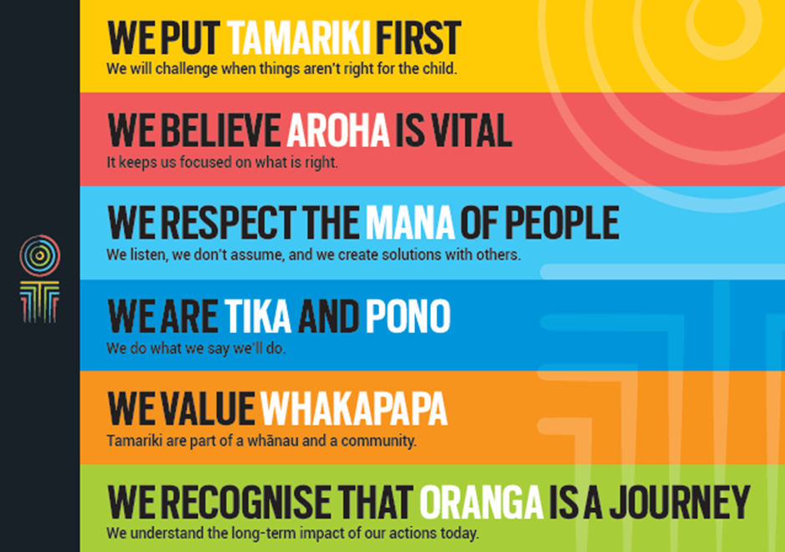
Our core outcomes | Our core outcomes are:  - All children and young people are in loving families and communities where they can be safe, strong, connected, and able to flourish  - Improved outcomes for all children, especially tamariki and rangatahi Māori.

POSITION PURPOSE
The purpose of this role is to support the successful delivery of Change initiatives at Oranga Tamariki through the provision of project coordination and administration duties for projects. The Project Coordinator works closely with Programme/Project Managers, project teams and the Change Programme Management Office (PMO). The Project Coordinator role is responsible for providing project, logistical and general coordination support to an in-flight project.
KEY ACCOUNTABILITIES
Key Result area | Key Accountabilities
Project Coordination | - Prepare governance reports, project status reports, presentations, agendas and minutes, and maintain logs and registers.  - Take an active part in the project risk/issue management process by contributing to the identification and prioritisation of existing and potential risks and issues.  - Monitor, analyse and report on project budget and forecast to the Project Manager.  - Develop (in consultation with stakeholders) robust project schedules including identifying sequence of tasks, dependencies between tasks and effort to complete.  - Manage the project plan using MS Project, reviewing the plans regularly to ensure tasks and milestones are being achieved in a timely manner. Follow up on any actions, addressing any challenges and escalate issues to the Project Manager where necessary.  - Support the project team in achieving project outcomes by establishing standards, tools and procedures including issue, risk change and information management.  - Arrange and attend weekly project meetings across various project streams, taking notes and distributing meeting minutes.  - Undertake other tasks as directed by your manager from time to time as agreed.  - Support the assurance process and follow up on the action register.  - Set up and maintain project files and establish document control procedures.  - Organise logistics for project meetings including Steering Group, Advisory Group, Team and ad hoc meetings.  - Proactively maintain a current awareness of the project activities and status.  - Liaise with project managers to source resources and participants needed to achieve project goals.  - Track and report on project tasks, milestones and deliverables.  - Identify and mitigate issues/risks within projects, maintaining an issue/risk register and escalating to senior management where necessary.  - Liaise with project stakeholders on an on-going basis.
Risk Management | - Identify and mitigate issues/risks within projects, maintaining an issue/risk register and escalating to senior management where necessary.  - Take an active part in the project issue/risk management process, by contributing to the identification and prioritisation of existing and potential issues and risks, and helping to develop strategies and controls to mitigate these. Use sound judgement to identify which issues and risks should be escalated to governance groups, and prepare relevant reports/documentation.
Relationship Management | - Build and maintain effective relationships with a wide range of people in addition to your own team, including project sponsors, senior managers, stakeholders/customers, other project team members and managers, external agencies and vendors.
Being part of the Oranga Tamariki team | - Actively and positively participate as a member of the team  - Proactively look for opportunities to improve the operations of Oranga Tamariki  - Perform any other duties as needed by Oranga Tamariki  - Comply with and support all health and safety policies, guidelines and initiatives  - Ensure all incidents, injuries and near misses are reported into our H&S reporting tool  - Comply with all legislative and regulatory requirements, and report any breaches as soon as they become known  - Adhere to all Oranga Tamariki procedures, policies, guidelines, and standards of integrity and conduct  - Demonstrate a commitment to and respect for the Treaty of Waitangi and incorporate these into your work.

KEY RELATIONSHIPS
Internal | - Project team  - Project governance groups  - Change PMO
External | - Cross-government working groups

QUALIFICATIONS & EXPERIENCE
Qualifications | - Have intermediate knowledge of email software, MS Word, PowerPoint, Excel.  - Have advanced/expert knowledge of MS Project or other project management software.  - Have a working knowledge of Prince2 and Agile methodologies.  - A clean, current driver’s licence is essential and a willingness to drive the Ministry’s vehicles if needed.
Experience | - Demonstrated experience in supporting Project Manager/Project Team in a large scale project, ideally at least 2 years’ experience.  - Experience in maintaining project plans.  - Experience of maintaining project finances.  - Experience in producing effective presentations, status reports and other project artefacts.
Skills | - Excellent verbal, written and interpersonal communication skills.  - Be flexible and highly adaptable to ever changing priorities.  - Ability to communicate complex ideas to a variety of audiences and build and maintain rapport with others.  - Accurately and clearly convey timely information and ideas, using a style and manner of presentation appropriate to the target audience.  - Effective time management skills and ability to juggle multiple priorities.  - Self-motivated and ability to work unsupervised.  - Sound judgement and initiative.

