Title: Practice Leader
Group: Services for Children and Families
Reports to: Site Manager
Location: As specified
Direct Reports: Nil
Budget: No
OUR ORGANISATION
About us | Oranga Tamariki—Ministry for Children is a new Ministry dedicated to supporting any child in New Zealand whose wellbeing is at significant risk of harm now, or in the future. We also work with young people who may have offended, or are likely to offend. Our belief is that in the right environment, with the right people surrounding and nurturing them, any child can, and should flourish.
Our vision | Our vision is: New Zealand values the wellbeing of tamariki above all else.
Our purpose | Our purpose is: To ensure that all tamariki are in loving whānau and communities where oranga tamariki can be realised.
The Oranga Tamariki way | We’re introducing a new way of doing things. A way of looking at the world that guides everything we do:  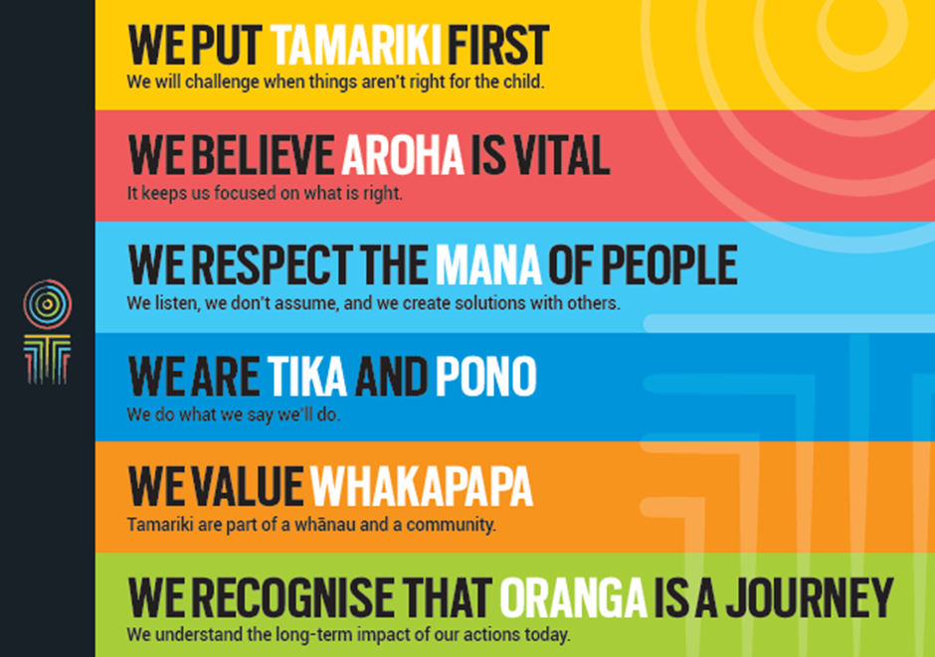
Our core outcomes | Our core outcomes are:  - All children and young people are in loving families and communities where they can be safe, strong, connected, and able to flourish.  - Improved outcomes for all children, especially Maori tamariki and rangatahi.

POSITION PURPOSE
The Practice Leader role is integral to strengthening practice within sites, and demonstrates the Ministry’s commitment to our professionalisation strategy.
The role works as part of a wider team to provide professional leadership, influence and direction in order to maintain and enhance the level of practice excellence and capability. The wider team consists of Site Managers, Youth Justice Managers and Social Work Supervisors, supported by Regional and National Advisory/Consultancy staff.
The primary purpose of this role is to act:
- To ensure a clear focus on key strategic practice priorities.
- To lead the transfer of knowledge and our evidence base to site practice.
- To ensure the strengthening of practice competency on site.
- To work with the Site/Youth Justice Manager to ensure professional site plans are appropriate and facilitated.
- To support the provision of quality professional supervision.
KEY ACCOUNTABILITIES
Key Result area | Key Accountabilities
Lead Professional Practice | - Ensure a clear focus on key strategic practice priorities.  - Lead, influence, and support Social Work Supervisors and Social Workers to exercise professional expertise, decision making and judgement.  - Provide professional supervision, mentoring and support to social work supervisors.  - Identify areas needing practice improvement and work with the Site/Youth Justice Manager to implement strategies/plans to strengthen practice.  - Facilitate the implementation of practice initiatives/tools/ systems.  - Ensure practice policies are promoted, enhanced and adhered to.  - Ensure that all activities maximise the key principles identified in the Children, Young Persons and their Families Act’s 1989.
Build Site Capability | - Lead, in conjunction with the Site/Youth Justice Manager, as part of the workforce planning process, the development, implementation and evaluation of the site Professional Development Plan.  - Provide leadership and influence to facilitate transfer of learning from training and other learning opportunities.  - Mobilise, in conjunction with workforce development staff, local opportunities for continuing professional development that will give effect to site and individual Professional Development Plans.  - Strengthen the climate of critical thinking and reflective supervision on site.  - Support supervisors to induct new staff into the Oranga Tamariki practice centre and maintain knowledge currency within the site.  - Support the Site Manager in the establishment and functioning of effective Care and Protection Resource Panels.
Site Responsibilities | - As a member of the management team, provide collective responsibility for the management and direction of service delivery performance.  - Identify trends and developments in practice and, in conjunction with Regional Practice Advisors and Site/Youth Justice Managers, apply a continuous improvement approach to service delivery.  - Escalate service delivery risks to Site/Youth Justice Manager as needed.  - Ensure that activities comply with all relevant legislation and ethical and industry standards.
Regional Responsibilities | - Provide peer support to other Practice Leaders and take collective responsibility for the development and monitoring of social work practice.  - Contribute and support national and regional service delivery performance, systems and practice improvement initiatives.  - Build regional capability in social work best practice in conjunction with other Practice Leaders, Practice Advisors and other relevant regional staff.
Being part of the Oranga Tamariki team | - Actively and positively participate as a member of the team  - Proactively look for opportunities to improve Oranga Tamariki’s operations  - Perform any other duties as needed by Oranga Tamariki  - Comply with and support all health and safety policies, guidelines and initiatives  - Ensure all incidents, injuries and near misses are reported into our H&S reporting tool  - Comply with all legislative and regulatory requirements, and report any breaches as soon as they become known  - Adhere to all Oranga Tamariki’s procedures, policies, guidelines, and standards of integrity and conduct  - Commitment to the Treaty of Waitangi and respect and incorporate these into your work.

KEY RELATIONSHIPS
Internal | - Site Manager  - Youth Justice Manager  - Care Services Manager  - Practice Advisor  - Other Practice Leaders, Advisors and Specialists  - Social Work Supervisors/Social Workers  - Care Protection/Youth Justice Co-ordinators  - Other Site Office staff  - Residence Managers and staff  - Adoptions staff  - Contact Centre  - Chief Social Worker and staff  - Service Support staff  - Learning and Development staff  - Oranga Tamariki staff
External | - X  - X  - X

QUALIFICATIONS & EXPERIENCE examples in italics
Qualifications | - A relevant tertiary qualification in social work is essential  - Current registration with the Social Worker Registration Board  - A current, “clean” driving licence is essential
Knowledge and Experience | - Extensive successful experience in a supervisory or advisory role within a service delivery operation in social work services or comparable organisation.  - Demonstrated evidence of practice leadership.  - Knowledge and/or experience of contemporary issues in social services delivery.  - Experience in and demonstrated ability to use influence to improve practice.  - Demonstrated commitment to the knowledge base underpinning Oranga Tamariki’s practice (the practice frameworks) and the ability to communicate this effectively to others.  - Demonstrated experience in managing complex practice and casework.  - Demonstrated ability to work in collaborative peer and other stakeholder relationships.  - Academic commitment to on-going learning and development.  - A sound knowledge of relevant legislation.
Skills and Behaviours | - Excellent verbal, written and interpersonal communication skills.  - An ability to influence action in areas for which they have responsibility but not line management authority.  - An ability to strengthen critical reasoning resulting in sound decision making.  - Strengths-based leadership, with the ability to collaborate with others across the spectrum of regional functions, to achieve mutually agreed goals.  - Building and maintaining rapport with others based on their own integrity and honesty, demonstrating effective interpersonal skills.  - Commitment towards positive outcomes for children, young people and their families.  - An ability to work to resolve conflicts or difference by finding areas of agreement that benefit the organisation and individuals.  - Understanding of the social services environment and the complexity of pressures that can impact on staff.  - Resiliency and ability to recover from setbacks and work under pressure.  - Experience in leading and managing change.  - An appreciation of the political aspects of Oranga Tamariki’s work.  - Computer literacy  - An ability to communicate complex ideas to a variety of audiences and build and maintain rapport with others  - Understanding and appreciation of cross cultural issues and concerns, in particular, knowledge of tikanga Maori, and Pacific peoples’ culture.
Other requirements | - Regular travel on official business around the Region will be required and some travel within NZ may also be required.

POSITION COMPETENCIES
Competency | Description of success profile behaviour
- Leadership  The ability to inspire and communicate a compelling vision which generates enthusiasm and commitment to the organisation’s goals. | - Demonstrates the organisation’s vision, values, principles and strategic goals.  - Demonstrates the ability to maintain a work environment which people find supportive and stimulating; keeps the team focused on the desired outcomes.
- Service delivery  The ability and desire to focus attention on meeting the needs of all Oranga Tamariki’s clients and to ensure service delivery standards are met or exceeded. | - Works to exceed client expectations.  - Contributes to the development and implementation of a client-focused strategy.  - Monitors client satisfaction; monitors service standards and implements cost-effective ways to improve service quality.  - Identifies potential setbacks or obstacles to meeting clients’ needs.  - Improves others’ ability to meet client needs across a region.
- Continuous improvement  The ability to review, develop and improve systems, processes and services in order to maximise organisational performance and support the achievement of the Ministry’s strategic goals. This includes the ability to lead and drive change and to support others through change processes. | - Often questions the status quo and looks for better ways of doing things.  - Is prepared to initiate improvements, mainly within local work area.  - Is generally enthusiastic about changes which may lead to improvement; responds positively to change.  - Communicates changes to others and provides advice on how to respond.
- Knowledge and experience  The willingness and ability through self and peer review to further develop, maintain and enhance current levels of technical knowledge, skills and expertise. | - Maintains a high level of technical and professional skills/knowledge in position-related areas.  - Keeps abreast of current developments, trends, best practice systems, methodologies and principles in areas of expertise.  - Improves efficiency by examining own processes and work methods and designs new methods where established methods and procedures are not applicable or unavailable.  - Learns from errors and as a consequence improves processes and systems.  - Identifies a need for, and knows where or how to gather information.
- Impact & influence  The ability to seek and gain mutual understanding in a variety of situations in order to develop effective relationships and to influence favourable outcomes for the organisation. | - Demonstrates strategies or means for influencing others.  - Takes time to build credibility with external parties.  - Recognises that not everyone responds to the same approach and adapts an approach to appeal to different groups.
- Problem solving  The ability to apply an objective, logical and systematic approach to understand an issue or problem and to make a decision or to develop a recommendation or solution. | - Acknowledges and identifies straightforward problems and issues.  - Is able to define and break down issues into clear and logical steps to develop a range of solutions.  - Tends to problem solve alone, but attempts to listen to others' ideas.  - Prioritises appropriately although in a task focused way.
- Team orientation  Teamwork is working collaboratively with others and actively committing to be part of the team. It involves developing trust between team members and following through on commitments made to the team. | - Keeps people up to date and informed by sharing all useful information.  - Works effectively with other team members and is able to gain acceptance as part of the team effort.  - Recognises individual strengths and weaknesses in order to achieve objectives by working together; participates willingly and aims for consensus.
- Strategic focus  The ability to stand apart from day-to-day activities and take a broad or long-term perspective. This includes the ability to define a future view of the organisation and to identify broader strategic and conceptual issues for planning and decision making. | - Is clear on the direction of own service area and how it relates to the whole organisation.  - Is aware of current trends, threats and opportunities, usually externally generated rather than generated by self.  - Considers the medium term issues when planning and choosing a course of action.

Desirable competencies

Competency | Description of success profile behaviour
- Results orientation  The ability and desire to achieve effective results, and work towards or exceed an agreed goal. | - Plans and achieves required results on tasks.  - Demonstrates an ability and preference to act independently in familiar situations; manages priorities.  - Takes on challenging tasks; works for a sense of accomplishment.
- Integrity  The ability to maintain confidences and trust, and to act in an honest, ethical and professional manner. This also includes operating with credibility in any situation. | - Displays high personal ethics and acts as a role model for the organisation.  - Consistently demonstrates the desired behaviours and has a reputation for trustworthiness.  - Able to handle situations that involve major ethical dilemmas.
- Cultural responsiveness  The ability and desire to show cultural sensitivity, awareness and understanding of diversity. | - Knows how to address issues that impact on clients, employees, stakeholders and communities from different cultural backgrounds.  - Provides services to clients with sensitivity, understanding, and respect for the client’s culture.  - Works in ways that enhance consultative relationships with different cultural groups and acts on opportunities to engage with them.  - Is able to participate confidently and competently in situations that involve processes, systems and organisations based on ‘Matauranga Māori’.
- Public service context  Understands the principles and conventions of government and the constitutional, legal and politically neutral framework in which one works in the Public Service. This includes recognising the impact of future environmental, economic, and social developments and trends on public sector policies, processes and methods. | - Understands and adheres to current government policies and practices, recognising what the Ministry is doing and why.  - Demonstrates sensitivity to the relationships between key players in the Public Service.  - Is able to see one’s own organisation from different perspectives.
- Stakeholder engagement  The ability to build and maintain effective working relationships with key stakeholders in order to enhance understanding and co-operation to achieve desired results. | - Develops networks and relationships with individuals and agencies that have a role to play in meeting clients’ needs.  - Facilitates individuals working together by identifying common goals, encouraging collaboration and joint ownership of ideas and approaches.  - Understands and helps others to understand one’s own organisation and how it interfaces with other agencies and community organisations.

