Title: Advisor - Governance
Group: Corporate Services
Reports to: Manager, Governance
Location: National Office, Wellington
Direct Reports: No
Budget: No
OUR ORGANISATION
About us | Oranga Tamariki—Ministry for Children is a Ministry dedicated to supporting any child in New Zealand whose wellbeing is at significant risk of harm now, or in the future. We also work with young people who may have offended, or are likely to offend. Our belief is that in the right environment, with the right people surrounding and nurturing them, any child can, and should flourish.
Our vision | Our vision is: New Zealand values the wellbeing of tamariki above all else.
Our purpose | Our purpose is: To ensure that all tamariki are in loving whānau and communities where oranga tamariki can be realised.
The Oranga Tamariki way | We’ve introduced a new way of doing things. A way of looking at the world that guides everything we do:  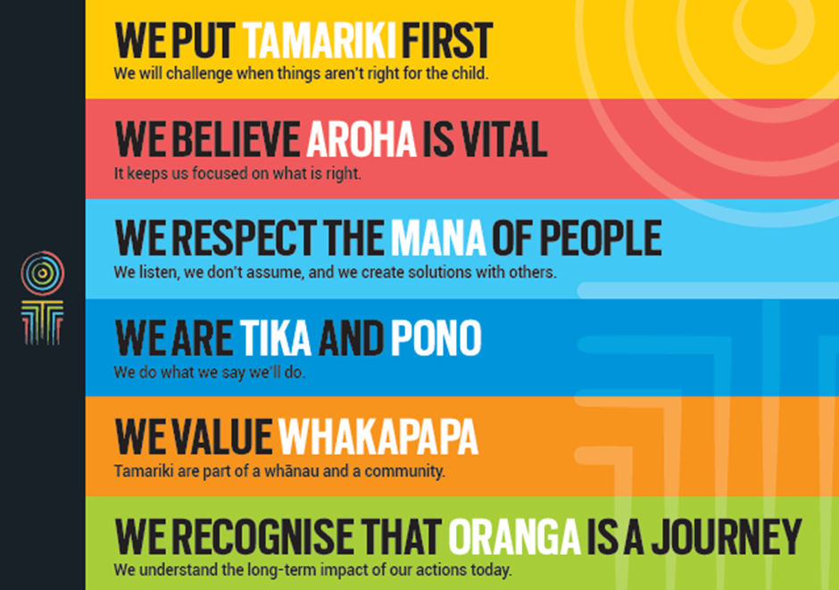
Our core outcomes | Our core outcomes are:  - All children and young people are in loving families and communities where they can be safe, strong, connected, and able to flourish  - Improved outcomes for all children, especially tamariki and rangatahi Māori.

POSITION PURPOSE
The purpose of this role is to support the Governance Team to provide advice to the Chief Executive and the Oranga Tamariki Leadership Team on governance and to manage and support governance processes to enable the effective and efficient operation of the organisation.
KEY ACCOUNTABILITIES
Key Result area | Key Accountabilities
Governance Secretariat | - Contribute to an efficient and effective secretariat function to governance committees and boards, that can include but is not limited to:  - meeting administration – scheduling meetings, agenda, collation and distribution of papers, distribution of minutes, following up action points  - meeting attendance – capturing key discussion points, decisions and action points  - planning and development – forward work programme development, terms of reference, updating intranet content  - support – point of contact for committee matters, IT support for meetings, quality assurance
Governance Support | - Establish and maintain governance processes and documentation for governance committees and boards, and the Governance Team  - Help ensure that information flows and sequencing of decisions across governance committees is well managed  - Support the Governance Team with planning and sequencing of governance activity  - Manage the Governance Team’s email inbox to ensure effective information flows  - Maintain the team’s intranet page to make governance activity easy for the organisation
Governance Advice | - Contribute to advice on the overall governance framework, process and operations of Oranga Tamariki  - Contribute to advice and oversight of internal governance committees and other advisory bodies and committees (internal and external)  - Liaise across Oranga Tamariki to ensure policies, delegations and other documents are aligned with the governance framework, processes and operations  - Carry out activity that supports the health and integrity of the governance framework, processes and operations
Relationship Management | - Build and maintain strong working relationships with relevant teams, senior managers and advisors across Oranga Tamariki to enable the provision of governance related advice  - Build and maintain strong working relationships with people across Oranga Tamariki to ensure governance processes are followed  - Build and maintain strong working relationships with committee members, particularly Chairs
Continuous Improvement | - Identify and make improvements to governance processes and systems  - Contribute to the development and conduct of evaluations of the governance framework and committees to ensure effectiveness and efficiency
Being part of the Oranga Tamariki team | - Actively and positively participate as a member of the team  - Proactively look for opportunities to improve Oranga Tamariki’s operations  - Perform any other duties as needed by Oranga Tamariki  - Comply with and support all health and safety policies, guidelines and initiatives  - Ensure all incidents, injuries and near misses are reported into health and safety reporting tool for Oranga Tamariki  - Comply with all legislative and regulatory requirements, and report any breaches as soon as they become known  - Adhere to all Oranga Tamariki’s procedures, policies, guidelines, and standards of integrity and conduct  - Commitment to the Treaty of Waitangi and respect and incorporate these into your work

KEY RELATIONSHIPS
Internal | - Chief Executive  - Deputy Chief Executives  - Chief Financial Officer  - Senior managers across Oranga Tamariki  - Corporate Services  - Strategy and Organisational Policy
External | - Minister’s Office  - Central governance agencies, particularly the SSC and the Treasury  - External committee members  - Ministry of Social Development shared service providers and other equivalent roles

QUALIFICATIONS & EXPERIENCE
Qualifications | - A tertiary qualification in a related area or equivalent operational experience is preferred
Experience | - Some experience providing secretariat services and advice to committees, boards, project teams other similar groups  - Some experience collating information and turning it into advice  - Working in the public sector, ideally with an understanding of organisational governance  - Working across an organisation and influencing without formal authority  - Managing multiple pieces of work with varied and competing timeframes  - Developing, maintaining, and documenting systems, processes and practices
Skills | - Some knowledge of government processes relating to governance and appointments would be ideal  - High level of integrity, professionalism and discretion  - Analytical skills with the ability to make sound and respected decisions  - Ability to effectively manage or escalate issues  - Ability to write to a high standard, appropriate to the audience, including proof reading with a high level of accuracy  - Highly organised with the ability manage multiple pieces of work, prioritise and cope with the pressure of meeting fixed timeframes  - Build and maintain relationships across an organisation, using appropriate style and method to communicate with others  - Ability to design and implement pragmatic process design and improvement
Other | - Willing to travel within New Zealand to fulfil job requirements such as supporting meetings held outside of Wellington (infrequent)

