Title: Lead Enterprise Architect
Group: Corporate Services
Reports to: Manager, Strategy and Performance
Location: Wellington
Direct Reports: No
Budget: No
OUR ORGANISATION
About us | Oranga Tamariki—Ministry for Children is a Ministry dedicated to supporting any child in New Zealand whose wellbeing is at significant risk of harm now, or in the future. We also work with young people who may have offended, or are likely to offend. Our belief is that in the right environment, with the right people surrounding and nurturing them, any child can, and should flourish.
Our vision | Our vision is: New Zealand values the wellbeing of tamariki above all else.
Our purpose | Our purpose is: To ensure that all tamariki are in loving whānau and communities where oranga tamariki can be realised.
The Oranga Tamariki way | We’re introducing a new way of doing things. A way of looking at the world that guides everything we do:  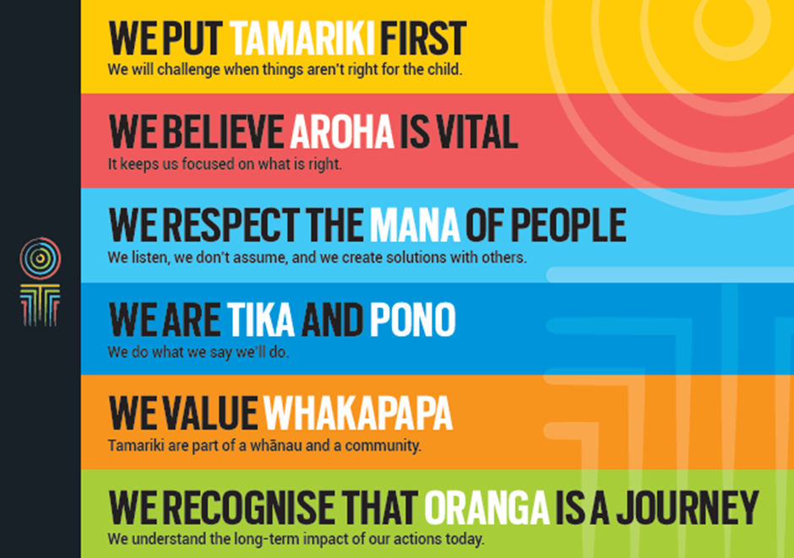
Our core outcomes | Our core outcomes are:  - All children and young people are in loving families and communities where they can be safe, strong, connected, and able to flourish  - Improved outcomes for all children, especially tamariki and rangatahi Māori.

BACKGROUND
Technology and Channels is responsible for the Ministry’s technology strategy, systems and services. We are implementing a new operating model so that we can deliver our responsibilities more efficiently, through a business-aligned structure. Our operating model is founded on three main principles:
- User-centricity is paramount, with a focus on the front-line and the wider sector.
- We will be cloud-first and asset-light, choosing to buy as-a-service offerings from third party suppliers, rather than own technology assets.
- Our systems and processes will be agile and enabling, to deliver changes faster, reduce complexity and simplify system interactions.

Under the new structure, the Strategy and Performance team, led by the Manager, Strategy and Performance, will be responsible for overarching frameworks – technology strategy, architecture, technology procurement, partner performance management and quality assurance.
Sitting alongside Strategy and Performance, there will be four dedicated teams called Service Portfolios. Each Service Portfolio will be responsible for a set of systems that is broadly aligned to agency business functions. Each Service Portfolio will be led by a Service Portfolio Manager and supported by a Portfolio Architect who is responsible for developing and maintaining the architectural design for all systems within the Service Portfolio.
Within the Strategy and Performance team, the Lead Enterprise Architect is responsible for developing and maintaining the architectural frameworks and ensuring alignment of architectures developed within individual Service Portfolios described above.
This is a senior architectural role with a wide span of influence.
POSITION PURPOSE
The purpose of this role is to:
- Develop technology strategy and direction for the Ministry
- Develop capability roadmaps to assist business units in leveraging technology to achieve business outcomes
- Provide leadership of core Enterprise architecture disciplines - Application Architecture, Business Architecture, Data Architecture, Security Architecture and Technology/Infrastructure Architecture
- Architecture governance to ensure that the overall architectural direction and service portfolio and project level architecture decisions are consistent and aligned with business objectives and lead to cost effective, agile, integrated and suitably future-proofed applications
- Lead technology innovation within the Ministry
- Develop and maintain architecture frameworks to implement Ministry’s Technology strategy
- Develop architecture programmes of work that guide the evolution, and enable modernisation, of the Ministry’s IT systems
- Engage with and contribute to all-of-government initiatives.

KEY ACCOUNTABILITIES
Key Result area | Key Accountabilities
Strategy | - Development of a digital strategy for Oranga Tamariki, working alongside the Manager Strategy and Performance and the Chief Technology Officer  - Develop technology standards and principles to provide guidance to the ICT team when acquiring and implementing technology solutions  - Lead the continuous improvement of the agency’s architecture practices, patterns and processes  - Keep up to date with innovation in technology and government service delivery  - Lead and guide ‘user experience’ design in order to deliver the best usability, accessibility, and satisfaction of technologies used by frontline staff  - Develop capability roadmaps to assist business units in leveraging technology to achieve business outcomes  - Lead technology innovation within the Ministry  - Develop and maintain architecture frameworks to implement the Ministry’s Technology strategy  - Develop architecture programmes of work that guide the evolution, and enable modernisation of the Ministry’s IT systems  - Contribute to the long-term technology investment planning of Oranga Tamariki  - Engage with and contribute to all-of-government initiatives  - Work closely with Enterprise Architects from other government agencies.
Performance | - Provide leadership of core Enterprise architecture disciplines - Application Architecture, Business Architecture, Data Architecture, Security Architecture and Technology/ Infrastructure Architecture  - Set up an architecture governance regime to ensure that the overall architectural direction and service portfolio and project level architecture decisions are consistent and aligned with business objectives and lead to cost effective, agile, integrated and suitably future-proofed applications  - Develop and maintain strong technology and data governance systems and processes, so data in technology systems are protected while maximum value is derived  - Govern the work of portfolio and solution architects to ensure that best practice technology advice and support is provided to Oranga Tamariki decision makers  - Work closely with other teams in Technology and Channels, and with the business to develop and uphold Oranga Tamariki’s technology architecture and user experience standards  - Preserve the architectural integrity, reliability and functionality of the services provided by our vendor partners, of Cloud-based systems that are acquired and configured, and our legacy data, systems and infrastructure currently managed by the Ministry of Social Development (MSD)  - Support development of a strong cyber-security, resilience and technology risk management practice.
Being part of the Oranga Tamariki team | - Actively and positively participate as a member of the team  - Proactively look for opportunities to improve the operations of Oranga Tamariki  - Perform any other duties as needed by Oranga Tamariki  - Comply with and support all health and safety policies, guidelines and initiatives  - Ensure all incidents, injuries and near misses are reported into our H&S reporting tool  - Comply with all legislative and regulatory requirements, and report any breaches as soon as they become known  - Adhere to all Oranga Tamariki procedures, policies, guidelines, and standards of integrity and conduct  - Demonstrate a commitment to and respect for the Treaty of Waitangi and incorporate these into your work.

KEY RELATIONSHIPS
Internal | - General Managers and senior leaders within Oranga Tamariki  - Service Portfolio Managers, Portfolio Architects and Systems Leads with Technology and Channels team  - Project managers and Solutions architects in change projects  - Oranga Tamariki staff
External | - Office of the Government Chief Digital officer (GCDO)  - Enterprise Architects from other government agencies  - External service providers and vendor partners

QUALIFICATIONS & EXPERIENCE
Qualifications | - Tertiary qualifications in a relevant discipline or equivalent experience  - A thorough understanding of:  - Architectural frameworks, processes and industry standards, including All-of-Government standards  - Core Enterprise architecture disciplines - Application Architecture, Business Architecture, Data Architecture, Security Architecture and Technology/Infrastructure Architecture  - Best practice security architecture  - Software-as-a-Service and Mobile architecture frameworks  - DevOps models  - Integration architecture.
Other requirements | - Willingness to travel within New Zealand to fulfil the requirements of the role
Experience | - Significant experience as a Senior or Lead Enterprise Architect in a large organisation  - Demonstrable experience in:  - an IT architecture environment, researching, developing and applying technical strategies, standards and solutions  - leading Architecture teams  - setting up and leading Architecture Governance bodies  - Architecting practical solutions to solve complex organisational problems, having analysed the pros and cons of available options,  - Integration and interface design within a large enterprise,  - Supporting project teams to deliver successful technology outcomes  - Five or more years’ experience as an architect in a large organisation.
Skills | - Ability to synthesise a cohesive technology strategy across all the elements of a technology-enabled business  - Deep expertise in technology and current industry best practice  - Business and client-focused approach to technology and channels  - Ability to communicate complex ideas to a variety of audiences and build and maintain rapport with others  - Strong problem solving abilities and lateral thinking, while still maintaining attention to detail  - Detailed knowledge of ICT functions, environments, business practice and systems  - Ability to ‘translate’ technology concepts to business stakeholders clearly and respectfully  - Ability to build strong working relationships and develop credibility with managers, colleagues, staff, suppliers and other stakeholders  - Commercial expertise, including experience working with counterparts in external provider organisations  - Deep expertise in technology architecture best practice  - Ability to bring the benefits of technology co-design of services for children, young people, whānau, partners and providers  - Knowledge of All-of-Government common ICT capabilities  - Understanding and appreciation of cross cultural issues and concerns, in particular, knowledge of tikanga Maori, and Pacific peoples’ culture  - Excellent verbal, written and interpersonal communication skills.

POSITION COMPETENCIES
Competency | Description of success profile behaviour
Business-focused | - Must be able to apply architectural skills in a practical way, in a busy and fast-moving environment  - Must build strong, working relationships with a wide range of people, including cross-business project teams and technology service providers.
Credible | - Must be able to display a deep understanding of how ICT supports the Ministry’s business, and must be able to explain technology-related issues and ideas using business language, where appropriate for the audience.
Self-motivated | - Must seek out opportunities to engage with technology providers, customers and other stakeholders – for example, by visiting regional sites, presenting to senior management and engaging with suppliers.
Innovative | - Must be ‘up with the play’ and open to new ideas, proactively promoting innovation within Technology and Channels.
Adaptable | - Must be comfortable working within an agile and light technology operating model, where change is to be expected.
Personable | - Must be friendly and professional.

