Title: Multimedia Producer
Group: Engaging all New Zealanders (EaNZ)
Reports to: General Manager, EANZ
Location: Wellington
Direct Reports: Nil
Budget: No
OUR ORGANISATION
About us | The Ministry for Vulnerable Children, Oranga Tamariki is a new Ministry dedicated to supporting any child in New Zealand whose wellbeing is at significant risk of harm now, or in the future. We also work with young people who may have offended, or are likely to offend. Our belief is that in the right environment, with the right people surrounding and nurturing them, any child can, and should flourish.
Our vision | Our vision is: New Zealand values the wellbeing of tamariki above all else.
Our purpose | Our purpose is: To ensure that all tamariki are in loving whānau and communities where Oranga Tamariki can be realised.
The Oranga Tamariki way | We’re introducing a new way of doing things. A way of looking at the world that guides everything we do:  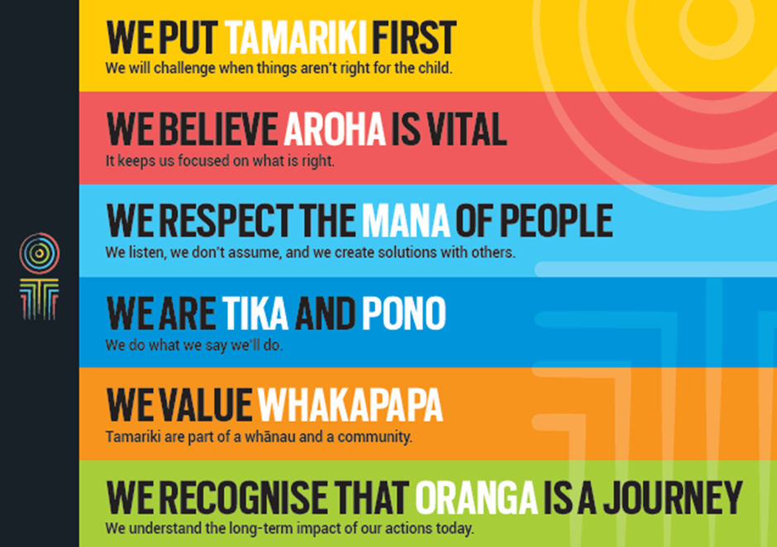
Our core outcomes | Our core outcomes are:  - All children and young people are in loving families and communities where they can be safe, strong, connected, and able to flourish.  - Improved outcomes for all children, especially Maori tamariki and rangatahi.

POSITION PURPOSE
The creation of on-brand, engaging content and its distribution via social media presents a significant opportunity for our Ministry to reach the public, increase their awareness of vulnerable children and young people, and motivate them to take relevant actions that will support vulnerable children.
It also offers the opportunity for direct engagement between Oranga Tamariki and New Zealanders.
The purpose of this role is to create frequent, consistently on-brand, engaging video content that is always ‘real’ and ‘human’ in its approach.
Over time – through our content, the public will improve their understanding of issues relating to vulnerable children and young people. They will be able to identify actions they can take to help young people to thrive and will feel motivated to take those actions.
Through our content New Zealanders will also gain a better understanding about the work our staff are engaged in, and the personalities of people who are carrying out this important work. New Zealanders will see that we’re out there every day, working towards the same objectives.
KEY ACCOUNTABILITIES
Key Result area | Key Accountabilities
Content Development and Management | - Create video, graphics, interactive features and/or other multimedia ensuring the Ministry’s goals are achieved.  - Ensure our content is always on-brand and appropriately focused. In other words, it’s all totally aligned with our values, has the voice of children at its heart and helps to achieve our goals.  - Ensure our products are engaging and shareworthy.  - Ensure that projects meet milestones, budgetary constraints and editorial standards.  - Be familiar with social media and play an active role in the Ministry’s social media strategy to drive traffic and increase engagement.  - Play a hands on role from time to time, managing our social media presence.
Increasing Awareness | - Ensure our efforts result in an increased understanding of the issues we expose our audiences to (measured via independent surveys and other sources).  - Ensure our efforts result in an increased pool of people who are taking actions to support vulnerable and at risk children and young people (measured via independent surveys and other sources).
Leadership Expectations | - Lead the creation of regular video content that works towards achieving the Ministry’s goals.  - Up-skill staff so they feel comfortable creating their own multimedia products.  - Stay updated with latest media techniques, trends and production technologies.  - Ensure the Ministry’s content keeps pace with industry developments and best practice.
Being part of the Oranga Tamariki team | - Actively and positively participate as a member of the team.  - Proactively look for opportunities to improve Oranga Tamariki’s operations.  - Perform any other duties as needed by Oranga Tamariki.  - Comply with and support all health and safety policies, guidelines and initiatives.  - Ensure all incidents, injuries and near misses are reported into our H&S reporting tool.  - Comply with all legislative and regulatory requirements, and report any breaches as soon as they become known.  - Adhere to all Oranga Tamariki’s procedures, policies, guidelines, and standards of integrity and conduct.  - Commitment to the Treaty of Waitangi and respect and incorporate these into your work.
KEY RELATIONSHIPS
Internal | - Engaging all New Zealanders team  - Communications and Engagement team  - Service Design team  - Frontline staff  - Voices of Children staff.
External | - Other child/young person focused Government agencies  - Ministry of Social Development  - Liaison/collaboration with creative/media agency staff.

QUALIFICATIONS & EXPERIENCE
Qualifications | - A relevant tertiary qualification in media development (and/or equivalent experience) is mandatory.  - A clean, current driver’s licence is essential.
Experience | - Strong solid experience of multimedia and online product project management.  - Solid history of producing quick turn-around, short format video content and meme-worthy images.  - Experience in the ideation, creation and distribution of original content that achieved a very large organic reach.  - Experience in the creation and distribution of organic content that led to free media coverage.  - Experience in social media management would be an advantage.  - Background in child/youth focused organisations would be an advantage.  - Experience working with a wide range of image and video production and editing programmes.
Interpersonal Skills | - Excellent verbal, written and interpersonal communication skills.  - Ability to communicate complex ideas to a variety of audiences and build and maintain rapport with others.  - Must be pro-active, possess excellent organisational and problem solving skills.  - Be able to frequently revise priorities to effectively manage a number of projects.  - A solid understanding of a continuous improvement methodology.  - Highly customer focused with an ability to conduct post-project reviews to ensure internal customer satisfaction.
General Knowledge and Technical Skills | - Video production.  - Strong project management skills. Able to manage multiple time-sensitive projects at once.

