Title: Media Support Specialist
Group: Communications and Engagement
Reports to: Chief Media Advisor
Location: As specified
Direct Reports: Nil
Budget: Nil
OUR ORGANISATION
About us | Oranga Tamariki—Ministry for Children is a new Ministry dedicated to supporting any child in New Zealand whose wellbeing is at significant risk of harm now, or in the future. We also work with young people who may have offended, or are likely to offend. Our belief is that in the right environment, with the right people surrounding and nurturing them, any child can, and should flourish.
Our vision | Our vision is: New Zealand values the wellbeing of tamariki above all else.
Our purpose | Our purpose is: To ensure that all tamariki are in loving whānau and communities where oranga tamariki can be realised.
The Oranga Tamariki way | We’re introducing a new way of doing things. A way of looking at the world that guides everything we do:  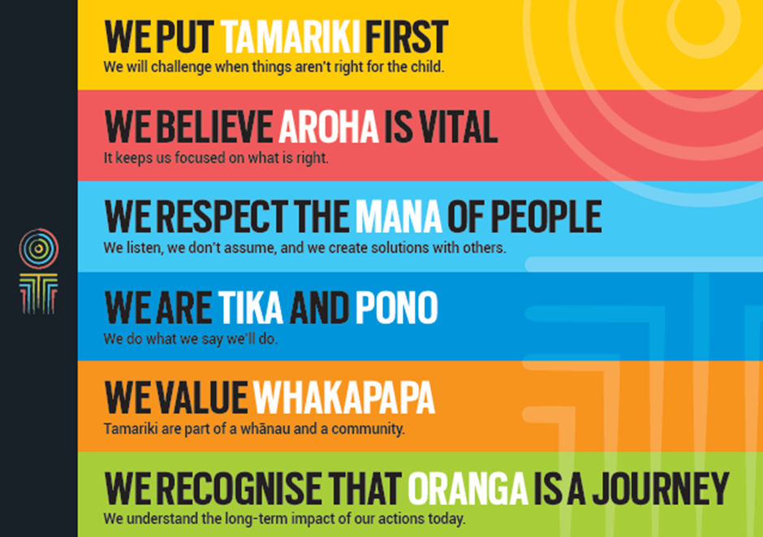
Our core outcomes | Our core outcomes are:  - All children and young people are in loving families and communities where they can be safe, strong, connected, and able to flourish  - Improved outcomes for all children, especially tamariki and rangatahi Māori.

POSITION PURPOSE
The purpose of this role is to generate high quality, well informed content and coverage, to enable Oranga Tamariki to achieve its mission. The Media Support Specialist will do this by building strong, open and direct relationships with reporters, editors, citizen journalists and bloggers. In addition, the Media Support Specialist will anticipate news trends, drive the direction of stories, promote the work of Oranga Tamariki, and enable communities to be well informed with the ultimate aim of improving the lives of New Zealand children.
KEY ACCOUNTABILITIES
Key Result area | Key Accountabilities
Relationship building | - Understand and clearly articulate the Ministry’s work, principles, goals, culture and strategic direction in a changing and challenging environment  - Strengthen relationships with journalists to anticipate issues and proactively share the work of Oranga Tamariki and its partners with all of New Zealand  - Become an expert in your field that journalists and social media thought leaders come to for open and direct, accurate information  - Investigate all aspects of the Ministry, seeking stories to share and talent to foster for media opportunities  - Generate and direct proactive media across a variety of platforms, which informs and engages  - Establish relationships with journalists, producers and news leaders to anticipate news and co-create feature opportunities  - Create content for reporters for sharing on the social media platforms of our partners to enable our agency partners to deliver via their internal and external networks  - In conjunction with the Communications and Engagement Team, create and promote consistent, Ministry-wide messaging to support the Ministry’s strategy to a variety of audiences, and via a range of channels and approaches  - Provide a consistent, strategic ‘voice’ of Oranga Tamariki
Respond to media opportunities/assess risks | - Manage incoming media requests and build relationships with journalists; create, execute and measure media coverage.
Intersectoral engagement | - Creatively leverage online and traditional communications platforms to reach a wide range of audiences  - Coordinate with the team to identify opportunities and risk  - Identify the right reporter for the right opportunity, and work with Ministry staff to have a strong story told well  - Network with others outside of the Ministry to generate content which leverages the core work of Oranga Tamariki  - Provide reports and analysis which informs the overarching strategy of the Communications and Engagement function.
Trends and Issues | - Support the Chief Executive, leadership team and national communications team with top quality advice and communications material  - Anticipate and respond to change as well as leadership and audience needs  - Supply expert communications and engagement services to the Ministry by providing:  - advisory support, theming and targeting opportunities, content and resources  - project specific specialist support  - crisis/issues management specialist support.  - Champion clear, open and effective communication as a way of putting children’s needs at the centre of our work, including families of children and young people, decision-makers, partners or Ministers.
Being part of the Oranga Tamariki team | - Actively and positively participate as a member of the team  - Proactively look for opportunities to improve the operations of Oranga Tamariki  - Perform any other duties as needed by Oranga Tamariki  - Comply with and support all health and safety policies, guidelines and initiatives  - Ensure all incidents, injuries and near misses are reported into our H&S reporting tool  - Comply with all legislative and regulatory requirements, and report any breaches as soon as they become known  - Adhere to all Oranga Tamariki procedures, policies, guidelines, and standards of integrity and conduct  - Demonstrate a commitment to and respect for the Treaty of Waitangi and incorporate these into your work.

KEY RELATIONSHIPS
Internal | - Communications and Engagement colleagues  - All of Oranga Tamariki especially:  - Engaging All New Zealanders  - OIA team  - Serious Issues  - Organisational Development  - The Tamariki Advocate  - The Office of the Chief Social Worker  - Māori and Pacific Leads  - Regional sites where our Communications and Engagement Advisors are based (Te Tai Tokerau, Auckland, Waikato, and Canterbury).
External | - News media  - News influencers  - Social sector communications colleagues.

QUALIFICATIONS & EXPERIENCE
Qualifications | - A tertiary qualification is desirable.
Experience | - You will have worked in newsrooms as a reporter or with reporters as a communications professional  - Ideally you have prior experience at creating content and have the ability to create content to support a reporter’s story or to provide to social media  - You will have experience at handling crisis situations involving people, with empathy, where you have already mitigated risk  - you will have supported reporters to tell good stories well, going beyond accuracy, fairness and balance, to informative, interesting and engaging
Skills | - Te reo Māori is an advantage  - Ability to establish positive, trusted relationships at a high level and to manage complex working relationships with people at all levels  - Well-developed networks, with an expert ability to prioritise, working quickly and effectively  - Highly expert communication skills including writing and creation of digital content with a sound understanding of social media channels  - Ability to fully integrate a broad range of communications and engagement initiatives, resulting in an effective, efficient and strategic work plan  - A reputation for being credible, responsive and honest  - Sound risk assessment, and risk mitigation skills  - Ability to use discretion, exercise sound judgement and successfully negotiate and influence  - An understanding of the strategic issues facing the Ministry  - A calm professional demeanour, especially when under pressure, and the ability to manage multiple pieces of work in a high pressure environment  - Ability to self-manage and work as an effective member of a team.

