Title: General Manager Policy
Group: Policy, Investment and Evidence
Reports to: Deputy Chief Executive, Policy, Investment and Evidence
Location: National Office, Wellington
Direct Reports: Business Unit comprises around 30 FTE (direct and indirect reports)
Budget: yes, tbc
OUR ORGANISATION
About us | The Ministry for Vulnerable Children, Oranga Tamariki is a new Ministry dedicated to supporting any child in New Zealand whose wellbeing is at significant risk of harm now, or in the future. We also work with young people who may have offended, or are likely to offend. Our belief is that in the right environment, with the right people surrounding and nurturing them, any child can, and should flourish.
Our vision | Our vision is: New Zealand values the wellbeing of tamariki above all else.
Our purpose | Our purpose is: To ensure that all tamariki are in loving whānau and communities where Oranga tamariki can be realised.
The Oranga Tamariki way | We’re introducing a new way of doing things. A way of looking at the world that guides everything we do:  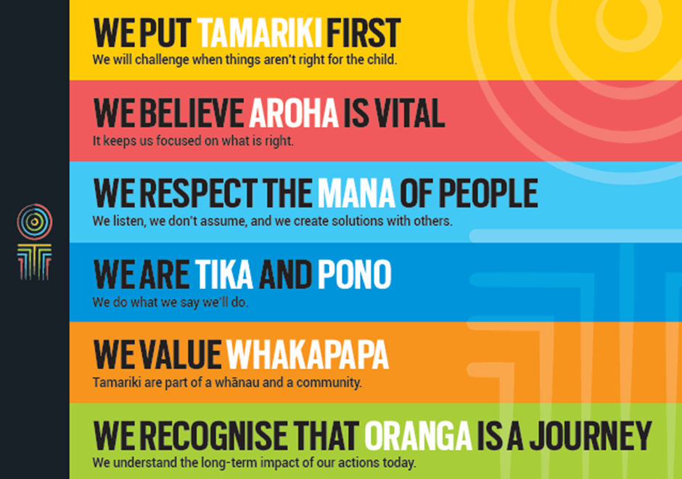
Our core outcomes | Our core outcomes are:  - All children and young people are in loving families and communities where they can be safe, strong, connected, and able to flourish  - Improved outcomes for all children, especially Maori tamariki and rangatahi.
POSITION PURPOSE
The purpose of this role is to provide leadership and management support to the Policy, Investment and Evidence Group. The role is one of three management roles reporting to the Deputy Chief Executive Policy, Investment and Evidence. The GM Policy is responsible for delivering a policy work programme to support an investment approach to improving outcomes for vulnerable children. This will be done through managing and leading a high performing policy team who will contribute to, and support the transformation of the Ministry and provide high quality advice to enhance the wellbeing of New Zealand’s vulnerable children. The work of the policy group spans delivery of complex legislative reforms, development of strategic frameworks and policies to operationalise change.
KEY ACCOUNTABILITIES
Key Result area | Key Accountabilities
Contribution to Leadership team | - Provide an active contribution to the Policy, Investment and Evidence Group at a level expected from a senior manager  - Contribute to cultivating a climate of openness, honesty, and encouragement with management colleagues  - Promote a ‘no surprises’ approach to escalate and share any significant risks with the DCE and/management team  - Identify and share ideas for lifting performance across the Group by contributing input and ideas  - Ensure the provision of high quality, balanced analysis and advice on a wide range of extremely complex issues within specified time frames  - Lead and ensure the development and delivery of high quality policy advice, services, and support.
Policy development | - Oversee the development of robust policy initiatives and strategies aligned to MVCOT’s overall strategic goals  - Contribute to achieving high aspirations for Māori tamariki and rangatahi, Pacific children and young people, and other vulnerable children  - Develop and enhance the Ministry’s policy capabilities  - Work undertaken adds value to the effectiveness of operations and to long term strategies and plans as directed by the CE  - Develop monitoring systems for measuring quality of policy analysis, advice and other services  - Manage workflow in conjunction with the DCE, by ensuring appropriate planning, prioritisation and re-prioritisation of work as required, ensuring that priority work is completed to an appropriate standard.
Staff leadership and management | - Provide support to reporting staff, ensure their performance meets the standards expected of them  - Identify skill and/or training gaps that need addressing to enable delivery of policy initiatives that are relevant and within specified time frames  - Actively encourage open working relationships with staff and peers to draw out ideas and proposals that contribute to the knowledge stream  - Provide evaluation and coaching to lift performance of each individual member of the team.
Being part of the Oranga Tamariki team | - Actively and positively participate as a member of the management team  - Proactively look for opportunities to improve Oranga Tamariki’s operations  - Perform any other duties as needed by Oranga Tamariki  - Adhere to all Oranga Tamariki’s procedures, policies, guidelines, and standards of integrity and conduct  - Commitment to the Treaty of Waitangi and respect and reflect its importance in relation to MVCOT practices and relationships.
Relationship management | - Actively build and foster positive professional relationships across Oranga Tamariki and other stakeholders  - Build sound working relationships with colleagues and staff throughout the Ministry, as well as forming good networks and relationships with staff in other social sector agencies relevant to the nature of the work.
Risk management | - Identify any organisational risks and take action to minimise their impact  - Identify any financial risks, and ensure sound processes and systems are in place to manage those risks  - Ensure that appropriate risk management and monitoring strategies are in place in relation to contract management  - Keep the Deputy Chief Executive informed of any risk issues which may impact on the Ministry’s reputation.
Health and safety | The Ministry of Vulnerable Children, Oranga Tamariki recognises the importance of complying with all health and safety legislation to provide a safe working environment and to meet its responsibilities under the Health and Safety at Work Act 2015.  The Ministry does this by:  - Reinforcing the health and safety message to all staff  - Identifying health and safety risks and implements strategies to take all practicable steps to prevent, minimise or eliminate hazards that may result in injury or risk to health  - Ensuring that all employees have a clear understanding of MVCOT’s health and safety policies and expectations  - Complying with all relevant legislation to provide a healthy and safe working environment  - http://www.legislation.govt.nz/Health and Safety at Work Act 2015.
KEY RELATIONSHIPS
Internal | - Other senior managers and employees of the Policy, Investment & Evidence Group for example:  - GM Funding and Performance  - GM Evidence & Investment  - Policy Managers  - Principal Analysts  - Staff and managers across MVCOT
External | - Ministries and their staff  - Ministry of Social Development  - Policy Managers from other Government organisations  - Senior executives and representatives in Ministries, Government Departments, Central Agencies  - Iwi Networks and Maori Interest groups  - Local government, non-governmental organisations, community and voluntary sector groups.

QUALIFICATIONS & EXPERIENCE
Qualifications | - Appropriate Tertiary degree is mandatory. This could be drawn from a range of disciplines, for example but not limited to: Public Policy, Law, Business, Public / Business Administration.
Experience | - Must have thorough grounding in Policy Development/Analysis at a senior level  - Demonstrated people management experience in leading high performing teams, particularly in the public sector  - Sound knowledge of Government direction and policy priorities  - Knowledge and/or experience of contemporary issues in social policy
Skills | - Excellent verbal, written and interpersonal communication skills  - Ability to communicate complex ideas to a variety of audiences and build and maintain rapport with others  - Understanding of analytical concepts and application of these in a social policy or similar area  - Sensitivity towards Maori, Pacific Peoples and other cultures  - Some understanding of basic Te Reo Maori, Mandarin, or Samoan both verbally and written would be valuable  - Welcomes and values diversity, and contributes to an inclusive working environment where differences are acknowledged and respected.

POSITION COMPETENCIES
Competency | Description of success profile behaviour
Analytical skills
- Demonstrates clarity of thinking, defines problems clearly, produces advice that is thorough, objective and methodologically sound, constructs logical arguments that reconcile areas of complexity or ambiguity, and creates practical recommendations and solutions back up with solid reasoning.
Results-oriented
- Is motivated, persistent, and delivers; takes action to achieve goals, anticipates potential issues, obstacles or problems and deals with them effectively, and completes projects and work assignments efficiently and on time without the need for prompting.
Innovation and creativity
- Continuously encourages others to identify opportunities for different and innovative approaches to address organisational problems and opportunities.
Communication skills
- Expresses ideas effectively in written communication and in individual and group situations; adjusts style to the needs of the intended audience. Demonstrates excellent listening skills.
Relationship management skills
- Works effectively with internal and external stakeholders, colleagues, staff, groups outside the formal line of authority, communities, interest groups and clients, external agencies and providers, to accomplish organisation goals. Uses appropriate interpersonal styles and methods to articulate the Ministry’s position and strategy on issues (and related rationale) with accuracy and persuasion.
Judgement
- Behaves in an ethical, honest and transparent manner. Is trusted to make decisions (appropriate to their level) backed up with sound reasoning.
Contributes to collective interests
- Identifies and acts on opportunities to raise the profile of their team, group and the Ministry in a positive way, encourages others to make a contribution, shares knowledge and information.

