Title: Family Home Reliever
Employment Status: Casual
Group: As specified
Reports to: Social Work Supervisor
Location: As specified
OUR ORGANISATION
About us | Oranga Tamariki—Ministry for Children is a new Ministry dedicated to supporting any child in New Zealand whose wellbeing is at significant risk of harm now, or in the future. We also work with young people who may have offended, or are likely to offend. Our belief is that in the right environment, with the right people surrounding and nurturing them, any child can, and should flourish.
Our vision | Our vision is: New Zealand values the wellbeing of tamariki above all else.
Our purpose | Our purpose is: To ensure that all tamariki are in loving whānau and communities where Oranga Tamariki can be realised.
The Oranga Tamariki way | We’re introducing a new way of doing things. A way of looking at the world that guides everything we do:  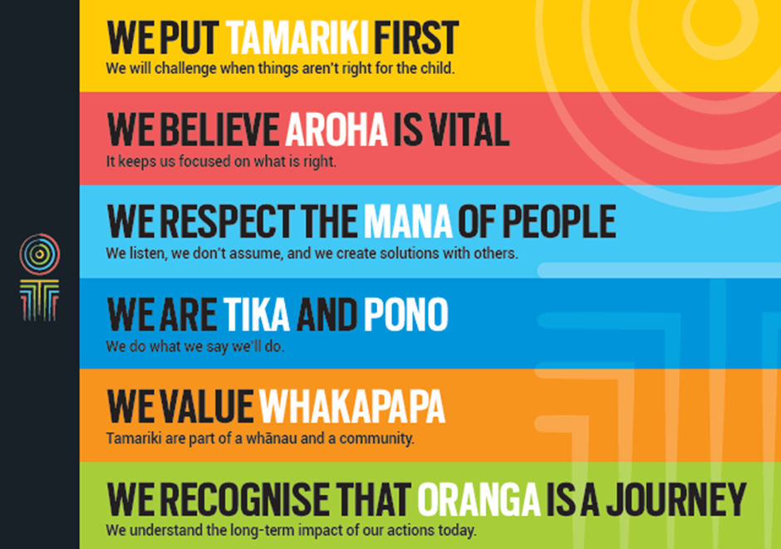
Our core outcomes | Our core outcomes are:  - All children and young people are in loving families and communities where they can be safe, strong, connected, and able to flourish.  - Improved outcomes for all children, especially tamariki and rangatahi Māori.

POSITION PURPOSE
The purpose of this role is to provide care at the family home during the absence of the primary (family home) care giver, for any children and young persons that Oranga Tamariki—Ministry for Children (Oranga Tamariki) places, in accordance with the Principles/Guidelines and Policy for Caregiver Services, and in accordance with the professional standards and practices required in the Casuals/Permanent Variable Hours (PVH) Orientation Handbook to maintain in all respects a safe, caring, responsible and supportive family environment in the family home.
KEY ACCOUNTABILITIES
Key Result area | Key Accountabilities
Family Home Reliever – primary (family home) caregiver | To be the primary caregiver available 24 hours per day and to maintain a safe, caring, responsible and supportive family environment in the family home:  - Be familiar with the care plan for the child/young person and ensure that activities undertaken are consistent with the care plan.  - If required, work weekends and school holidays to provide family home relieving.  - Other duties as required, for example baby sitting and household help, on an as and when basis.
Physical and psychological safety of children and young people | - Family Home Relievers should maintain an appropriate level of vigilance and as described in the job assignment/briefing.  - Take reasonable steps within Non Violent Crisis Intervention (NVCI) procedures to prevent:  - the child/young person from self-harming or causing serious harm to others;  - the child/young person from absconding; and  - the child/young person from damaging property.  - Pick up and deliver children and young people in a safe and appropriate manner at times and venues designated by the social worker in adherence with the Policy on the transport of children and young people, ensuring that any vehicle used while transporting a child/young person (whether it is an Oranga Tamariki vehicle or private vehicle) is registered and warranted and appropriately insured.  - Where there are problems, the reliever must take whatever reasonable steps to ensure the safety of the child/young person and ensure that Oranga Tamariki are informed immediately.
Familiarisation with policy and guidelines | Accept responsibility for learning the requirements of the job and as outlined in the Casuals/PVH Orientation Handbook. For example:  - Treat client and official information provided to the employee as part of their role, in accordance with the Privacy Act and Oranga Tamariki policy.  - Comply with the health and safety policies and guidelines outlined in the Family Home Caregiver Supplement.  - Run the family home in accordance with the objects and principles of Oranga Tamariki, Children, Young Persons, and Their Families Act 1989, in accordance with the Caregivers handbook.  - Comply with the Policy and Guidelines of Oranga Tamariki on corporal, physical and emotional punishment and discipline of children or young persons.  - Comply with requirements in respect of vehicles including, paying any traffic infringements (where the employee received a parking ticket in the course of their duties they may be eligible for payment of these where an emergency situation existed), and ensuring there is no smoking in any vehicles in which a child/young person is being transported regardless of who owns the vehicle.  - Maintaining a sense of professionalism at all times as a public servant and as described in the Code of Conduct.
Administration/Reporting | - Undertake administrative tasks as appropriate and ensure that legislative requirements are complied with.  - Complete reports (verbally or in writing) as required by the social worker responsible for the children/young person’s case.
Being part of the Oranga Tamariki team | - Actively and positively participate as a member of the team.  - Proactively look for opportunities to improve Oranga Tamariki’s operations.  - Perform any other duties as needed by Oranga Tamariki.  - Comply with and support all health and safety policies, guidelines and initiatives.  - Ensure all incidents, injuries and near misses are reported into our H&S reporting tool.  - Comply with all legislative and regulatory requirements, and report any breaches as soon as they become known.  - Adhere to all Oranga Tamariki’s procedures, policies, guidelines, and standards of integrity and conduct.  - Commitment to the Treaty of Waitangi and respect and incorporate these into your work.
KEY RELATIONSHIPS
Internal | - Oranga Tamariki staff  - Family Home Caregivers
External | - Ministry of Social Development  - Other Government agencies  - Police  - Courts  - Local community groups  - Iwi Social Services.

QUALIFICATIONS & EXPERIENCE
Qualifications | - Hold a current full clean drivers licence (including the ability to drive a manual vehicle).
Experience | The ideal appointee will have:  - Previous successful experience in social services work or other relevant experience.  - Previous successful experience in working with children and young people.  - Ability to manage sensitive and confidential information in an appropriate manner and to maintain privacy of client information.  - Ability to become familiar with working with Acts and regulations.  - Demonstrated understanding of Māori/Pacific Island and other cultures.
Skills | The ideal appointee will need to demonstrate:  - Competence in managing and supporting children and young people.  - Oral and written skills.  - Excellent listening skills.  - Excellent observation skills.  - Behaviour management/conflict resolution skills.  - Ability to work well in a team and with groups.  - Calm and professional manner, with the ability to maintain performance under stress such as with distressed children and angry adults.  - Positive role modelling – being consistent in behaviour, generating confidence and displaying commitment to others.  - Ethical practice and the ability to maintain professional boundaries.
POSITION COMPETENCIES
Competency | Description of success profile behaviour
- Client Focus  The desire and willingness to understand and meet or exceed client expectations. Clients are those groups or individuals, internal or external, who use the services of Oranga Tamariki. | - Knows who the client is and talks about the importance of client focus.  - Demonstrates professional and courteous service. Is approachable, positive and responsive.  - Follows through on client enquiries, requests and complaints.  - Keeps client up to date on progress of projects or issues. Is open to client feedback.
- Communication  The ability to clearly convey thoughts and ideas effectively. This may include listening, interpreting, formulating and delivering verbal, non-verbal, written, and/or electronic messages. | - Communicates clearly, concisely, confidently, courteously, calmly and tactfully.  - Listens and understands.  - Shares information in an open and honest way.  - Demonstrates basic written and oral skills, including telephone skills and ability to use email.  - Takes clear and accurate messages.  - Records/inputs information accurately and collates information appropriately.
- Teamwork  The ability and willingness to work with others  co-operatively and productively in order to achieve group objectives. This may include informal work groups, advisory groups or committees and project teams. | - Participates willingly and co-operates with others.  - Respects others and does one’s share of the work.  - Supports team decisions and is a good “team player”.  - Expresses positive expectations of others and genuinely values others’ input, ideas and points of view.  - Keeps people informed and up-to-date.  - Shares all relevant or useful information as required.
- Relationship management  The ability to interact with and develop effective working relationships with a wide range of people of different types and in different situations. This includes establishing formal and informal working relationships, developing win/win relationships and assessing and responding to individual behaviour. | - Develops and maintains positive relationships with relevant people.  - Is considerate and demonstrates respect and tolerance for others.  - Builds good rapport with people at all levels.  - Actively seeks opportunities to contribute to positive outcomes for clients, stakeholders, staff and colleagues.  - Approaches issues or disagreements with the objective of reaching win/win solutions.  - Develops relationships with the intent of achieving effective delivery of relevant services.
- Planning and organisation  The ability to identify objectives and develop effective action plans to achieve them. | - Prepares day-to-day work in advance and effectively prioritises tasks.  - Completes tasks in an efficient and timely manner.  - Follows up on tasks and monitors progress against plans and timeframes.  - Adopts a neat, tidy and logical approach to work.
- Problem solving and judgement  The ability to apply an objective, logical reasoning process to a problem or work situation in order to develop a conclusion or recommendation. This includes logically breaking down problems into different parts, identifying key issues and their relationships, interpreting, clarifying, analysing, explaining and developing recommendations or advice. | - Breaks problems down into simple lists of tasks.  - Understands simple linkages (e.g. A leads to B). Identifies the relevant issues.  - Draws on past experience to solve the current problem.
- Cultural responsiveness  The ability and desire to show cultural sensitivity, awareness and understanding of diversity. This includes reinforcing culturally sensitive behaviour, being responsive to Māori and other cultural groups, effectively relating to clients from diverse cultural backgrounds, fostering a culturally safe working environment for staff. | - Understands and is responsive to the needs of different cultural groups in the delivery of services.  - Maintains effective relationships with clients and employees of Oranga Tamariki and understands their perspectives and priorities.  - Understands the practices surrounding the Treaty of Waitangi.  - Interacts appropriately with Māori taking into consideration tikanga and kawa.  - Engages effectively with family/whanau to ensure participation in decision making.
- Integrity  The ability to maintain confidences and trust, and to act in an honest, ethical and professional manner. | - Is honest, trustworthy and can be relied on for confidentiality.  - Demonstrates professionalism at all times.  - Sets and adheres to personal and organisational ethical standards.  - Demonstrates desired behaviours and treats all people with respect and dignity.  - Is committed to the values of Oranga Tamariki.

