Title: Family Violence Response Specialist
Group: Child and Family Services
Reports to: Site Manager
Location: As specified
Direct Reports: Nil
Budget: No
OUR ORGANISATION
About us | Oranga Tamariki—Ministry for Children is a new Ministry dedicated to supporting any child in New Zealand whose wellbeing is at significant risk of harm now, or in the future. We also work with young people who may have offended, or are likely to offend. Our belief is that in the right environment, with the right people surrounding and nurturing them, any child can, and should flourish.
Our vision | Our vision is: New Zealand values the wellbeing of tamariki above all else.
Our purpose | Our purpose is: To ensure that all tamariki are in loving whānau and communities where oranga tamariki can be realised.
The Oranga Tamariki way | We’re introducing a new way of doing things. A way of looking at the world that guides everything we do:  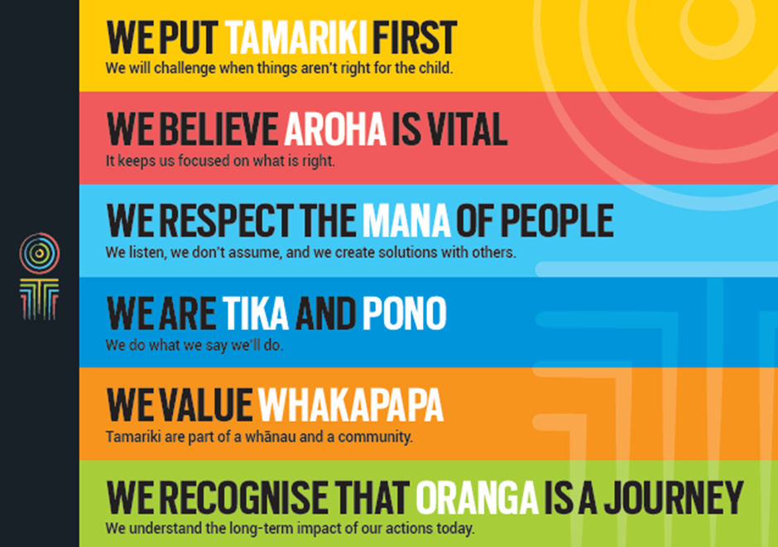
Our core outcomes | Our core outcomes are:  - All children and young people are in loving families and communities where they can be safe, strong, connected, and able to flourish  - Improved outcomes for all children, especially tamariki and rangatahi Māori.

POSITION PURPOSE
The Family Violence Response Team is a multi-agency approach to ensure families experiencing violence get the help they need from government and community services.
A key feature is the identification of ‘high risk’ victims and an independent family violence specialist to support these victims to reduce the risk of further violence.
The approach focuses on the joined-up support and services that families including victims and perpetrators receive, following family violence reported to NZ Police and high risk prison releases.
Family Violence Response Specialists are responsible for assessing family violence referrals from Police and Justice and, in conjunction with interagency partners, planning interventions that contribute to the safety and wellbeing of families.
The purpose of this role is to coordinate our response and to facilitate, lead, guide and support our work with our partners as we evolve our family harm, and youth suicide prevention focus. The Family Violence Response Specialist will at times be working within our partner agencies. The safety and best interests of children and young people are at the centre of this role. Family Violence Response Specialists are responsible for ensuring safe and sound decision-making occurs in respect of children and young people, utilising their knowledge and understanding of the dynamics of family violence, especially the impact of family violence and youth suicide on children and young people, to inform decision-making.
KEY ACCOUNTABILITIES
Key Result area | Key Accountabilities
Assessment | - Undertake comprehensive assessments, ensuring that the assessments are child centred. This includes:  - Reviewing Police, Corrections and agency referrals to determine the nature of Oranga Tamariki involvement  - Making a decision on Oranga Tamariki intervention options  - Preparing a summary of information to present at the daily interagency Safety Assessment Meeting.
Intervention planning | - Participate in planning for the safety and wellbeing of families, ensuring the planning is child focussed. This includes:  - Participating in the daily interagency Safety Assessment Meetings  - Completing any assigned tasks from the Safety Assessment Meetings  - Participating in the Intensive Case Management planning for families at high risk of harm from family violence, and for cases of high complexity  - Complete any assigned tasks.
Lead family violence and youth suicide best practice | - Strengthen understanding and capability in family violence and youth suicide by:  - Keeping up to date with family violence and suicide best practice, and sharing family violence expertise across Oranga Tamariki  - Providing assistance in complex or high risk situations where family violence and youth suicide is an important dynamic  - Act as an expert and consultant for sites in relation to family violence and youth suicide matters  - Act as an educator to help increase knowledge in relation to family violence and youth suicide.
Work collaboratively | - Work closely and effectively with key players in the family violence sector, including Police, Justice, Health, Education, NGOs etc. to achieve positive outcomes for children, as well as their family/whānau  - Act as a conduit between the family violence sector and Oranga Tamariki, as required  - Confidently represent Oranga Tamariki in the family violence sector.
Cultural competence | - Recognise bicultural partnership in Aotearoa New Zealand and reinforce the values, rights and mana of Māori, underpinned by the principles of Te Tiriti o Waitangi  - Ensure assessments and intervention planning are underpinned by cultural awareness, sensitivity, knowledge, skills and behaviours.
Professional development | - Actively contribute to an environment of continual improvement and on-going professional learning by:  - Using a well-developed understanding and knowledge of the dynamics of family violence to exercise judgement and action  - Keeping abreast of the latest development in family violence research and practice  - Participating in reflective supervision and encouraging others to do so.
Being part of the Oranga Tamariki team | - Actively and positively participate as a member of the team  - Proactively look for opportunities to improve the operations of Oranga Tamariki  - Perform any other duties as needed by Oranga Tamariki  - Comply with and support all health and safety policies, guidelines and initiatives  - Ensure all incidents, injuries and near misses are reported into our H&S reporting tool  - Comply with all legislative and regulatory requirements, and report any breaches as soon as they become known  - Adhere to all Oranga Tamariki procedures, policies, guidelines, and standards of integrity and conduct  - Commitment to the Treaty of Waitangi and respect and incorporate these into your work.
KEY RELATIONSHIPS
Internal | - Social Work Supervisor  - Site Manager  - Practice Leaders  - FGC Co-ordinators  - Social Work Resource Assistants  - Regional Practice Advisors  - Regional Disability Advisor  - Other Social Workers  - Legal Services  - Staff in Residences  - Oranga Tamariki staff.
External | - Police  - Health  - Education  - NGO and community groups  - Care and Protection Resource Panels  - Cultural Authorities and other ethnic social services/providers  - Children’s Teams  - Other relevant government agencies  - Iwi and Māori communities  - Lawyer for Child, Youth Advocate and Lay Advocate  - Other MSD service lines.
QUALIFICATIONS & EXPERIENCE
Qualifications | - Social Worker Registration Board (SWRB) registration required  - Maintenance of a current Annual Practicing Certificate and SWRB competence requirements  - A clean, current driver’s licence is essential.
Knowledge and Experience | - Ongoing professional development to ensure high levels of competence and performance  - Thorough knowledge of Oranga Tamariki processes and responses  - Sound knowledge of the Oranga Tamariki Act 1989, the Vulnerable Children’s Act 2014, and other relevant legislation  - Experience working with children and their families/whanau as well as proven successful experience in working with people from diverse cultural backgrounds, in particular Māori and Pacific people  - Knowledge of family violence response pathways  - Knowledge of the theories of family violence and interventions, and associated concepts/constructs  - An understanding of the non-government sector (NGO) and the public sector context within which Oranga Tamariki works.
Skills and behaviours | - A passion and commitment for working with, and advocating for, children and young people  - An ability to bring a child-focus to interagency discussions and intervention planning  - A well-developed understanding of the dynamics of family violence, especially the impact of family violence on children and young people  - Competence in working closely and cooperatively with a range of service providers both Government agencies and NGOs  - Excellent verbal, written and interpersonal communication skills  - Strong assessment, analytical and conceptual skills  - Proven ability to write reports and plans to a high standard  - Commitment towards positive outcomes for children, young people and their family/whānau  - Commitment to ensuring best practice  - An ability to work successfully under pressure  - Ability to communicate complex ideas to a variety of audiences and build and maintain rapport with others  - Understanding and appreciation of cross cultural issues and concerns, in particular, knowledge of tikanga Māori, and Pacific peoples’ culture.

