Title: Commissioning Manager
Group: Partnering for Outcomes
Reports to: GM Commissioning and Market Building
Location: Wellington
Direct Reports: None
Budget: No
OUR ORGANISATION
About us | Oranga Tamariki—Ministry for Children is a new Ministry dedicated to supporting any child in New Zealand whose wellbeing is at significant risk of harm now, or in the future. We also work with young people who may have offended, or are likely to offend. Our belief is that in the right environment, with the right people surrounding and nurturing them, any child can, and should flourish.
Our vision | Our vision is: New Zealand values the wellbeing of tamariki above all else.
Our purpose | Our purpose is: To ensure that all tamariki are in loving whānau and communities where oranga tamariki can be realised.
The Oranga Tamariki way | We’re introducing a new way of doing things. A way of looking at the world that guides everything we do:  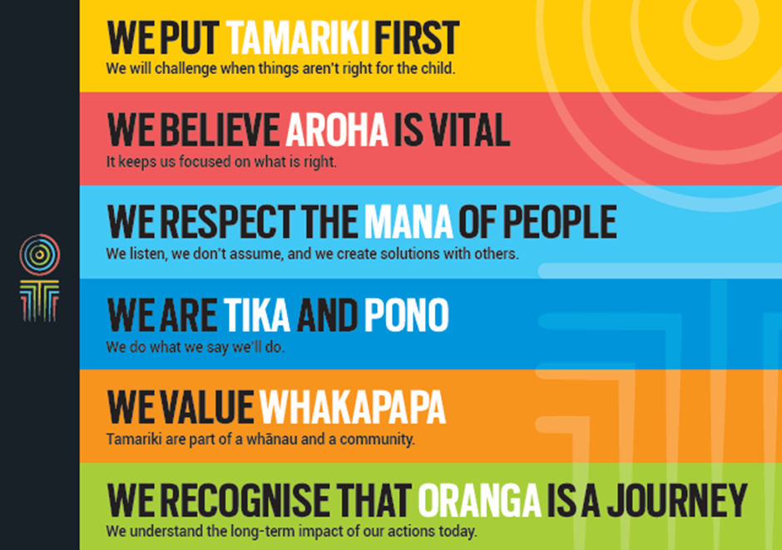
Our core outcomes | Our core outcomes are:  - All children and young people are in loving families and communities where they can be safe, strong, connected, and able to flourish.  - Improved outcomes for all children, especially tamariki and rangatahi Māori.

POSITION PURPOSE
The purpose of this role is to manage the commissioning cycle for one of the following population groups:

- Children and young people in care with high needs
- Young people in care preparing for independence
- Caregivers
- Families and whānau

This will initially involve working across Oranga Tamariki and with external partners to ensure that, organisationally, we have a clear strategic analysis and needs assessment for this population group; a comprehensive understanding of the current state of support services; a design model (for the future state) that will deliver improved outcomes; and, a clear approved commissioning plan (including sourcing strategy / procurement plan / ‘business’ case).
The post holder will then take responsibility for coordinating delivery of the commissioning plan – working alongside colleagues in regional teams, the complex needs teams, and a range of external partners and stakeholders, to ensure that the budgets we allocate to external social services meet the needs of the population group.
KEY ACCOUNTABILITIES
Key Result area | Key Accountabilities
Analysis | - Understanding the strategic context for this population group – including the political, economic, legislative and socio-demographic environment – and how this is likely to change overtime  - Working with finance colleagues and Planning Team Leader to build an increasingly clear picture of the current funding allocated to this population group – including the cost of relevant social services and internal service delivery costs  - Working with the Reporting Team Leader /and colleagues in PIE to develop a strong understanding of current service delivery for this population group  - Ensuring that analysis of the characteristics, needs and aspirations of the population group can inform detailed service design planning, strategic business cases (to justify / secure funding), and, ultimately contractual partnerships with social service providers  - Working with colleagues and advocacy organisations to ensure that the voice of the population group directly influences forward strategy (including agreeing outcomes), service design, and forward plans
Planning | - Ensuring that service planning and design is informed by the results of needs analysis, our understanding of the strategic context, the voice of the population group, and other experts by experience (inc frontline staff)  - Leading or contributing to the development of the strategic and financial case for any changes in provision or service for the population group  - Developing a clear commissioning plan that brings together the analysis and planning above and sets out our approach and strategy for supporting the population group to achieve improved outcomes  - Work with the Contract and Procurement Team Leader to develop a procurement plan, where required, to support the delivery of the commissioning plan
Management and Review | - Ensuring that contract management, reporting, and gathering of insight and intelligence informs the continuous improvement of support for the population group  - Maintaining an up-to-date view of the strategic context for the population group and the impact of any funded services  - Leading on the development and implementation of any capability / capacity building for social service providers in this area
Relationship Management | - Building and maintaining relationships with key stakeholders with expertise and influence in relation to this population group – including key experts by experience and advocacy groups  - Ensuring the continuous and meaningful involvement of social service providers and experts by experience across the commissioning cycle
Leadership and Management | - Future builder - help staff and the organisation navigate the future  - People builder – identify talent across Oranga Tamariki and helping people contribute to meeting the needs of the population group  - Deliverer - make things happen, with and particularly through others  - Steward - lead in a public service context, contributing to a better New Zealand.  - Ensuring that the function operates in a way that is consistent with Treaty principles and values (more than ‘compliant’)
Being part of the Oranga Tamariki team | - Actively and positively participate as a member of the team  - Proactively look for opportunities to improve the operations of Oranga Tamariki  - Perform any other duties as needed by Oranga Tamariki  - Comply with and support all health and safety policies, guidelines and initiatives  - Ensure all incidents, injuries and near misses are reported into our H&S reporting tool  - Comply with all legislative and regulatory requirements, and report any breaches as soon as they become known  - Adhere to all Oranga Tamariki procedures, policies, guidelines, and standards of integrity and conduct  - Demonstrate a commitment to and respect for the Treaty of Waitangi and incorporate these into your work.
KEY RELATIONSHIPS
Internal | - PfO Managers  - GM Change  - GM Voice  - GM with responsibility for Care and Support  - GM with responsibility for residences
External | - Non-Government Organisations (NGOs)  - Staff from other government agencies  - Project specific focus groups

QUALIFICATIONS & EXPERIENCE
Qualifications | - A degree level qualification relevant to the role or similar qualification  - Post-graduate qualification relevant to role or relevant experience (desirable)
Experience | - Experience of making sense of complex non-financial and financial data and intelligence in the public and / or private sector  - Understanding of and involvement in the development of social services  - Experience of working collaboratively and influencing successfully across large organisations  - Demonstrated ability to critically evaluate data, analysis and research findings  - An understanding of the strategic challenges and issues facing the Ministry and the population group  - Experience of prioritising in an often busy and complex environment and applying sound judgement when dealing with competing deadlines  - A high level of computer literacy – including excel and any other data related packages
Skills | - Outstanding verbal, written and interpersonal communication skills  - Excellent quantitative and qualitative analytical skills  - Ability to communicate complex ideas to a variety of audiences and build and maintain rapport with others  - Understanding and appreciation of cross cultural issues and concerns, in particular, knowledge of tikanga Maori, and Pacific peoples’ culture.

