title: Children’s Team Coordinator
Group: Services for Children and Families South
Reports to: Children’s Director
Location: As specified
Direct Reports: No
Budget: No
OUR ORGANISATION
About us | Oranga Tamariki—Ministry for Children is a new Ministry dedicated to supporting any child in New Zealand whose wellbeing is at significant risk of harm now, or in the future. We also work with young people who may have offended, or are likely to offend. Our belief is that in the right environment, with the right people surrounding and nurturing them, any child can, and should flourish.
Our vision | Our vision is: New Zealand values the wellbeing of tamariki above all else.
Our purpose | Our purpose is: To ensure that all tamariki are in loving whānau and communities where oranga tamariki can be realised.
The Oranga Tamariki way | We’re introducing a new way of doing things. A way of looking at the world that guides everything we do:  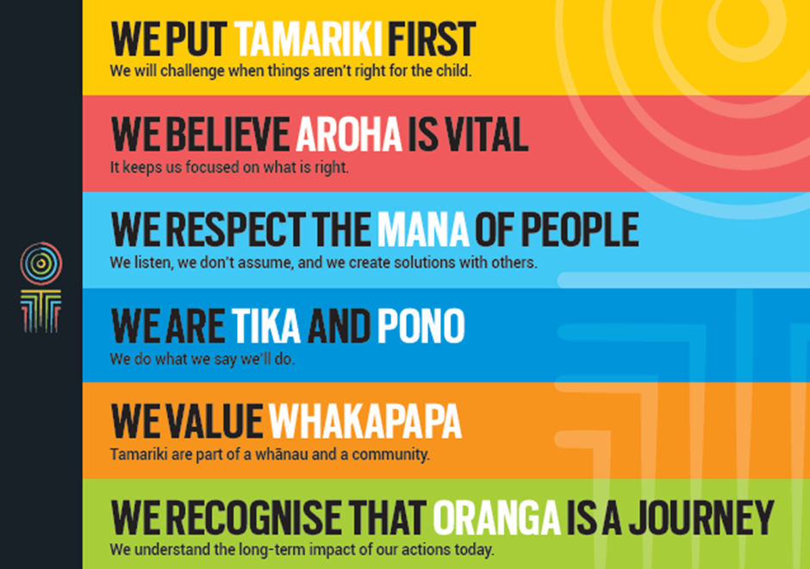
Our core outcomes | Our core outcomes are:  - All children and young people are in loving families and communities where they can be safe, strong, connected, and able to flourish  - Improved outcomes for all children, especially tamariki and rangatahi Māori.

POSITION PURPOSE
The purpose of the Children’s Team (CT) Coordinator is to coordinate and facilitate the seamless operation of the Children’s Team service. The CT Coordinator is responsible for managing referrals. In particular, the CT Coordinator will need to proactively support the Lead Professionals and Service Brokers to efficiently deliver services in a way that achieves positive outcomes for the child.
KEY ACCOUNTABILITIES
Key Result area | Key Accountabilities
Relationship Management and Liaison | - Build and maintain effective relationships and strong networks with:  - referral agencies  - government agencies and service providers  - community organisations  - Liaise with relevant agencies, organisations and groups to provide knowledge transfer of the Children’s Team service  - Ensure effective communication processes and channels, both internally and externally  - Liaise closely with:  - Children’s Team members and the Children’s Team directorate  - CT Coordinators across Children’s Team services  - Ensure timely and effective communication with children and families as appropriate.
CT Service Facilitation and Coordination | - Facilitate the seamless operation of the Children’s Team service in accordance with CT service guidelines  - Escalate risks or issues to Children’s Director as appropriate  - Coordinate the Children’s Team meetings, making sure that all administrative and logistical arrangements are timely  - Proactively support the Lead Professional, Service Brokers and the Children’s Team to efficiently deliver in a way that achieves positive outcomes for the child  - Work constructively and collaboratively with other colleagues including the Team Administrator to ensure that best practice is shared and overload situations can be managed efficiently.
Monitoring and Reporting | - Enter records into the case management system as required  - Prepare regular update reports as required by the Children’s Director to track progress on outcomes  - All reports to be completed within agreed timeframes and to expected quality standards.
Quality | - All work undertaken in a timely and efficient manner  - Maintains standards with regular evaluation to ensure compliance and notify the Children’s Director of any major difficulties in a timely manner  - Monitors the delivery of CT services, and reports on the achievements against key objectives, standards and guidelines  - Maintains up to date working knowledge of Children’s Team policy, procedures and practices to ensure accuracy when transferring knowledge.
Being part of the Oranga Tamariki team | - Actively and positively participate as a member of the team  - Proactively look for opportunities to improve the operations of Oranga Tamariki  - Perform any other duties as needed by Oranga Tamariki  - Comply with and support all health and safety policies, guidelines and initiatives  - Ensure all incidents, injuries and near misses are reported into our H&S reporting tool  - Comply with all legislative and regulatory requirements, and report any breaches as soon as they become known  - Adhere to all Oranga Tamariki procedures, policies, guidelines, and standards of integrity and conduct  - Demonstrate a commitment to and respect for the Treaty of Waitangi and incorporate these into your work.

KEY RELATIONSHIPS
Internal | - Children’s Team members  - Other service coordinators (Oranga Tamariki differential response, Strengthening Families, Whanau ora navigators)  - Service Providers  - Local government/community/iwi groups and providers
External | - Family/Whanau  - Community/Iwi groups  - Other lead professionals  - Agencies and community providers

QUALIFICATIONS & EXPERIENCE
Qualifications | - .  - A tertiary qualification in social work is not essential A clean, current driver’s licence is essential.
Other requirements | - Willing to travel to fulfil job requirements
Knowledge and Experience | - Knowledge and/or experience of child welfare or family contact work is desirable  - Working knowledge of how key agencies work with children and families in the social/health/education and justice sectors, including an awareness of current resources and services is desirable  - Knowledge of local services and personnel  - Demonstrated experience in providing high-level coordination and facilitation services  - The ability to work across government and community sectors, including working with iwi and with other ethnic groups  - The ability to mix professionally and build effective relationships at all levels both within the Ministry and with outside agencies and clients  - Advanced level of technical proficiency in the Microsoft office suite of applications, specifically Word, Excel and PowerPoint and also including research tools (internet and database use).
Skills | - Well-developed relationship management skills; able to establish, build and maintain effective working relationships, able to develop extensive networks  - Excellent interpersonal skills; able to adapt to the needs of the audience with well-developed written and oral communication skills  - Excellent organisation, record keeping and time management skills; able to prioritise, schedule and work systematically, achieves/meets competing deadlines without compromising quality  - Strong client focus – adapts approach to meet needs, looks to create the best outcome for all, anticipates needs and responds appropriately  - Exercises sound judgement and is flexible, adaptable and proactive  - Welcomes and values diversity, and contributes to an inclusive working environment where differences are acknowledged and respected  - Understanding and appreciation of cross cultural issues and concerns, in particular, knowledge of tikanga Māori, and Pacific peoples’ culture.

