Title: Care and Protection Coordinator
Reports to: Site Manager
Location: As specified
Budget: No
OUR ORGANISATION
About us | Oranga Tamariki—Ministry for Children is a new Ministry dedicated to supporting any child in New Zealand whose wellbeing is at significant risk of harm now, or in the future. We also work with young people who may have offended, or are likely to offend. Our belief is that in the right environment, with the right people surrounding and nurturing them, any child can, and should flourish.
Our vision | Our vision is: New Zealand values the wellbeing of tamariki above all else.
Our purpose | Our purpose is: To ensure that all tamariki are in loving whānau and communities where Oranga Tamariki can be realised.
The Oranga Tamariki way | We’re introducing a new way of doing things. A way of looking at the world that guides everything we do:  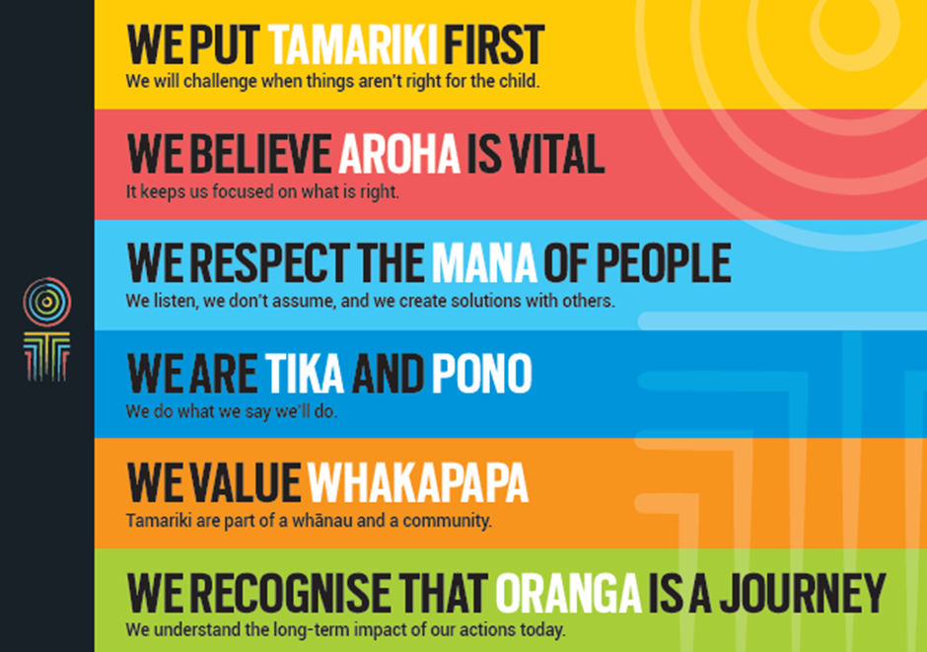
Our core outcomes | Our core outcomes are:  - All children and young people are in loving families and communities where they can be safe, strong, connected, and able to flourish.  - Improved outcomes for all children, especially Maori tamariki and rangatahi.

POSITION PURPOSE
Care and Protection Coordinators are responsible for managing care and protection family group conferences within the spirit of Pūao-te-Ata-tū and its operational intent, the Children, Young Persons and Their Families Act.
Legislative functions include receiving reports, convening the Family Group Conference (FGC), consulting with relevant people, and recording and reviewing the outcomes of the FGC. Care and Protection Coordinators must exercise their statutory functions and powers in accordance with the provisions of the Act.
Key accountabilities include:
- Understanding and applying the provisions of the Children, Young Persons and Their Families (CYP&F) Act 1989 with regard to Part 2 (Care and Protection).
- Embracing the principles of the CYP&F Act, ensuring the spirit of FGCs is reflected in the process.
- Understanding and applying the FGC standards throughout the FGC process.
- Championing the alignment of the principles and practices outlined in the Oranga Tamariki Indigenous and Bicultural Framework with FGC practice.
- Leading FGC practice within the team to increase understanding and build capability.
- Ensuring all members of families, whānau, hapu, Iwi and family groups, and/or entitled others who may wish to attend the FGC are able to do so.
- Facilitating conferences to develop family/whānau led plans that map out a strategy for the future safety and/or wellbeing of the child or young person.
- Working in partnership with individuals/stakeholders to encourage community-wide responsibility for developing strategies, programmes and protocols in relation to care and protection.
- Reviewing the decisions and recommendations of the FGC in line with the agreed review process, ensuring the conference is reconvened if required.
KEY ACCOUNTABILITIES
Key Result area | Key Accountabilities
Legislative/bicultural/organisational context | - Manage a process whereby the family group and the social worker or the Police, arrive at a decision for any child or young person that is in accord with the principles of the CYP&F Act 1989.  - Ensure that all FGCs are convened and held in accordance with the provisions of the CYP&F Act 1989.  - Actively uphold the principles of Te Tiriti o Waitangi and Puao-te-Ata-tu.  - Convene and hold FGCs that reflect the principles and practices outlined in Te Toka Tumoana (Oranga Tamariki Indigenous and Bicultural Framework).  - Ensure FGC standards are applied throughout the FGC process.
Engagement with family/whānau | - Engage early with known family/whānau so that additional family/whānau can be identified and contacted.  - Meet face to face with family/whānau members prior to the FGC.  - Consult with family/whānau about where and when the conference will be held, and any protocols they may wish to adopt at the conference.  - Ensure family/whānau are informed about what they can expect at the conference and empowered to participate in the conference process, including different options for presenting their views if unable to attend the conference.
Voices of children/young people | - Ensure children/young people are enabled and encouraged to present their information to the conference in a way that is meaningful to them.  - Meet face to face with children/young people to identify who can support them and talk for them if they are unable to do this themselves.  - Provide children/young people with information about the conference that is appropriate to their age, developmental and cultural needs.
Lead family group conferencing practice | - Manage and facilitate pre-FGC consults to identify appropriate assessments, support people and the required next steps, ensuring the interface between care and protection and youth justice is managed.  - Ensure that all relevant information and advice presented to the conference, and people able to support and contribute to the FGC, are identified and have a clear understanding of the process and their role.  - Consult the FGC budget holder to ensure that FGC decisions and plans can be supported.  - Provide support and mentoring in the FGC process to colleagues (both internal and external) as required.
Effective facilitation | Provide effective facilitation of the FGC ensuring the:  - authority and mana of the family, whānau, iwi or family group is preserved.  - participants have the opportunity to fully understand all information presented during the conference.  - culture(s) of the child or young person and family involved are recognised.  - environment is safe and conducive to good engagement by all participants.  - focus is on developing solutions to address the needs of the child or young person.  - child protection standards and child care practice are maintained.  - resolution is clear, complete and unambiguous.  - outcomes are recorded in an active plan.
Monitor reviews | - Ensure that the decisions and recommendations of the FGC and the wellbeing of the child are reviewed in accordance with the agreed review process decided by the FGC.  - Reconvene FGCs as appropriate or when required.
Community networks | - Promote the principles of the CYP&F Act within communities, encouraging community-wide responsibility for developing strategies, programmes and protocols in relation to youth offending.  - Work in partnership with key players, including Health, Education, Child Protection Teams, Care and Protection Resource Panels, Iwi and Cultural Authorities, Courts, and other agencies and groups, to ensure that local systems and protocols are developed, monitored and maintained.  - Work with wider-Ministry staff and communities of interest to identify services required for children, young people and their family/whānau.
Being part of the Oranga Tamariki team | - Actively and positively participate as a member of the team.  - Proactively look for opportunities to improve Oranga Tamariki’s operations.  - Perform any other duties as needed by Oranga Tamariki.  - Comply with and support all health and safety policies, guidelines and initiatives.  - Ensure all incidents, injuries and near misses are reported into our H&S reporting tool.  - Comply with all legislative and regulatory requirements, and report any breaches as soon as they become known.  - Adhere to all Oranga Tamariki’s procedures, policies, guidelines, and standards of integrity and conduct.  - Commitment to the Treaty of Waitangi and respect and incorporate these into your work.
.
KEY RELATIONSHIPS
Internal | - Co-ordinators  - Resource Assistants  - Practice Leaders  - Regional Practice Advisors  - Regional Disability Advisor  - Social Work Supervisors  - Social Workers  - Legal Services  - Staff in Residences  - Care Services Team  - Oranga Tamariki staff.
External | - Ministry of Social Development  - Health  - Education, including schools  - Police  - Ministry of Justice (Family Court)  - Corrections  - Other relevant government agencies  - Local government councils  - Iwi and Māori communities  - NGO and community groups  - Professional service providers and client support groups  - Cultural Authorities and other ethnic social service providers  - Lawyer for Child, Youth Advocate & Lay Advocate.
QUALIFICATIONS & EXPERIENCE
Qualifications | - A relevant tertiary qualification and/or experience working with local community and Iwi/Māori services.  - A commitment to completing the coordinator accreditation process.  - A clean, current driver’s licence is essential.
Experience | - Demonstrated successful experience in working with communities and other key stakeholders.  - Demonstrated successful experience in working with Māori.  - Demonstrated successful experience in working with people from diverse cultural backgrounds, in particular Pacific people.  - Demonstrated successful experience in accessing people in an Iwi who have knowledge of whakapapa or genealogies of the local people.  - Demonstrated successful experience in facilitating and negotiating culturally relevant decision making processes.  - Knowledge and experience in understanding the dynamics of child abuse and family violence.  - An understanding of the non-government sector (NGO) and the public sector context within which Oranga Tamariki works.  - A comprehensive understanding of New Zealand history and of local Māori history.  - Understanding the importance of recognising and strengthening mana in others to support whānau to achieve wellbeing.  - Leadership experience and decision making in a complex environment.  - Established community knowledge and networks.  - Demonstrated ability to write reports and plans to a high standard.
Skills | - Sound knowledge of the Children, Young Persons, and their Families Act 1989 and other relevant legislation (e.g. Vulnerable Children’s Act).  - Competence and flexibility in working with children and young people.  - An ability to speak to/engage with children/young people in age appropriate ways.  - Competence and flexibility in working with family, whānau hapu, Iwi or family group.  - Excellent communication and interpersonal skills demonstrated in a range of situations.  - A basic understanding of te reo Māori, a working knowledge of Maori worldviews, process and tikanga.  - Understands the impact of their own values and frameworks on their practice and the importance of respectfully engaging with the values and belief systems of others.  - Strong facilitation, mediation, negotiation and conflict resolution skills.  - Strong relationship management skills coupled with community development skills.  - Commitment towards positive outcomes for children, young people and their families.

POSITION COMPETENCIES
Essential Competencies | Description of success profile behaviour
- Client focus  The desire and willingness to understand and meet or exceed client expectations. Clients are those groups or individuals, internal or external, who use Oranga Tamariki’s services. | - Delivers quality service to clients.  - Understands, empathises with, and identifies the needs, concerns and priorities of clients and ensures that services are delivered to take account of these.  - Takes personal responsibility for correcting client service problems and/or “championing” client issues.  - Corrects problems promptly, without getting defensive.  - Attempts to give added value to the client.  - Actively supports the interests of the client by making choices and setting priorities to meet their needs.
- Planning and organisation  The ability to identify objectives and develop effective action plans to achieve them. | - When prioritising own work, is aware of impact on others.  - Balances conflicting priorities as necessary.  - Anticipates future demands and prepares appropriately.  - Anticipates difficulties and develops contingency plans.  - Contributes to the preparation of plans for the team.  - Demonstrates effective project management skills and breaks down large tasks into separate milestones and deadlines.  - Introduces complex systems and monitors their use.
- Information gathering  The ability to collect and manage information relevant to an issue through a variety of methods. This includes research, networking with others, observation, computer databases and sharing knowledge and information with others. | - Demonstrates thorough knowledge of appropriate information sources.  - Uses all means to research and secure relevant information.  - Is proactive in seeking out new or alternative sources of information.  - Demonstrates a thorough understanding of all information collected and its relevance.  - Ensures that information is accurate, up to date and provided in an easily understood format.
- Communication  The ability to clearly convey thoughts and ideas effectively. This may include listening, interpreting, formulating and delivering verbal, non-verbal, written, and/or electronic messages. | - Work shows recognition of the importance of communication in achieving results.  - Seeks to understand others’ frame of reference and uses this understanding to identify the most effective method of conveying information.  - Uses different ways of conveying a message to add clarity and meaning to communications.  - Adapts communications to the views and level of knowledge of the audience.  - Prepares and structures communication well. Is able to make complex issues understandable.  - Sets out arguments clearly and logically; persuades and influences others.
- Technical skills & knowledge  Demonstrates specialist or technical knowledge and skills within one’s functional area (e.g. Finance, HR, Policy, QA, etc). | - Possesses expert knowledge in the most complex and advanced aspects of functional area.  - Serves as a subject matter expert and is recognised as a source of expertise within and across divisional groups.  - Challenges current policies and practices.
- Cultural Responsiveness  The ability and desire to show cultural sensitivity, awareness and understanding of diversity. This includes reinforcing culturally sensitive behaviour, being responsive to Māori and other cultural groups. | - Demonstrates an understanding of the key concepts embodied within the Treaty of Waitangi and their application to Oranga Tamariki, along with the Indigenous and Bicultural Framework Principles.  - Understands the social, ethnic and behavioural characteristics of those from different cultural backgrounds and is able to translate that knowledge into work practices and delivery of services.  - Collaborates with different cultural communities regarding service delivery, and demonstrates a willingness to work together.  - Demonstrates that cultural responsiveness is valued, clearly defined, understood and applied within Oranga Tamariki.
- Teamwork  The ability and willingness to work with others co-operatively and productively in order to achieve group objectives. This may include informal work groups, advisory groups or committees and project teams. | - Contributes positively by actively sharing information and listening and accepting others' points of view.  - Shares the workload with others and contributes by being prepared and completing assigned tasks.  - Maintains a positive outlook and shows flexibility to new approaches and ideas.  - Is willing to learn from others at all levels.  - Promotes team co-operation.
- Relationship management  The ability to interact and develop effective working relationships with a wide range of people of different types and in different situations. | - Builds good rapport with people at all levels.  - Actively seeks opportunities to contribute to positive outcomes for clients, stakeholders, staff and colleagues.  - Approaches issues or disagreements with the objective of reaching win/win solutions.  - Develops relationships with the intent of achieving effective delivery of relevant services.
- Results Orientation  The ability to take personal responsibility for the delivery of results. This includes delivering required results consistently and successfully, exhibiting appropriate initiative and persistence and focusing on work that is of high quality. | - Takes full responsibility for making things happen within own area of control.  - Displays drive and energy in achieving goals and perseveres when obstacles emerge.  - Tracks progress against job expectations in order to make adjustments to performance as required.

Desirable competencies | Description of success profile behaviour
- Problem solving & judgement  The ability to apply an objective, logical reasoning process to a problem or work situation in order to develop a conclusion or recommendation. | - Breaks down complex situations into manageable parts in a systematic way.  - Recognises several likely causes of events.  - Does not stop at first answer; strives to find out why something happened.  - Considers all aspects of a situation, weighing up different options to arrive at the best solution.  - Makes clear decisions based on a logical analysis of the options.  - Acquires new information and applies knowledge to analyse issues and resolve problems.
- Change Orientation  The ability to think about a situation, issue or process in new or varying ways and to generate new ideas. This includes the willingness to seek out and implement better ways of doing things and to embrace change. | - Stretches to continuously improve activities and results beyond work unit.  - Helps to establish a climate that encourages innovation and receptivity to change.  - Demonstrates consistent ability to generate new ideas and initiatives.  - Shifts focus and activities quickly in response to changing organisational priorities.
- Integrity  The ability to maintain confidences and trust, and to act in an honest, ethical and professional manner. | - Takes action based on a clearly stated set of values, even if such action might disadvantage oneself.  - Does not lie to cover up disadvantageous facts.  - Challenges or confronts abuse of power.
- Self-Development  The ability and desire to take ownership of one’s development, and to proactively pursue opportunities to learn and develop. | - Learning is focused on current role and also on career development.  - Designs a personal action plan to address own issues constructively and understand the most appropriate learning style for self.  - Uses a range of sources to develop own knowledge and skills.  - Seeks feedback from others with the intent of self-improvement.

