Title: Business Support Manager, Children’s Teams
Group: Services for Children and Families South
Reports to: Operation Support Manager, Children’s Teams
Location: Wellington
Direct Reports: 8
Budget: No
OUR ORGANISATION
About us | Oranga Tamariki—Ministry for Children is a new Ministry dedicated to supporting any child in New Zealand whose wellbeing is at significant risk of harm now, or in the future. We also work with young people who may have offended, or are likely to offend. Our belief is that in the right environment, with the right people surrounding and nurturing them, any child can, and should flourish.
Our vision | Our vision is: New Zealand values the wellbeing of tamariki above all else.
Our purpose | Our purpose is: To ensure that all tamariki are in loving whānau and communities where oranga tamariki can be realised.
The Oranga Tamariki way | We’re introducing a new way of doing things. A way of looking at the world that guides everything we do:  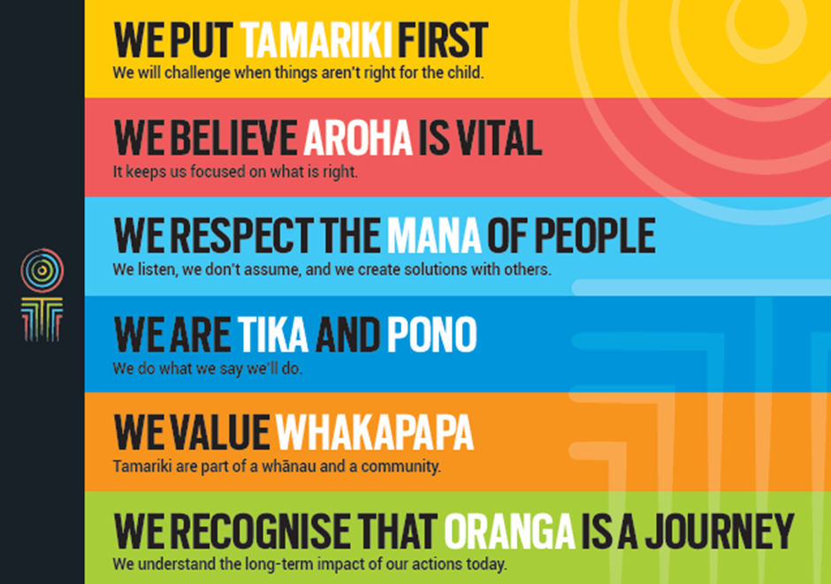
Our core outcomes | Our core outcomes are:  - All children and young people are in loving families and communities where they can be safe, strong, connected, and able to flourish.  - Improved outcomes for all children, especially tamariki and rangatahi Māori.

POSITION PURPOSE
The purpose of this position is to lead and provide managerial support for the National Operations Team. The Business Support Manager will ensure that the National Operations Team provides high quality reporting, advice, guidance, and support to the Children’s Teams. They will also be responsible for managing VIKI and the Shared Work Space technology and resolve any issues that may occur in these systems.
This role will work closely with the Children’s Team Directors and their teams. This role champions service culture and seeks opportunities for continuous improvement in Children’s Team and reporting practice and processes.
KEY ACCOUNTABILITIES
Key Result area | Key Accountabilities
Management of the National Office Operations Team | - Lead the National Operations Team to transform and contribute to achieving high aspirations for Māori tamariki and rangatahi, Pacific children and young people, and other vulnerable children.  - Lead, develop and inspire the National Operations Team to ensure that responsive and high quality advice, guidance, support and direction is provided to the regional Children’s Teams.  - Ensure high quality reporting outcomes are achieved on time through monthly regional and national reporting data and analysis.  - Ensure the capability and capacity is in place in the operations team to achieve the timely and appropriate advice, guidance, support and direction to the Children’s Teams.  - Manage professional practice enquiries, issues and resolutions working in collaboration with the Professional Practice Manager and Regional Practice Advisors.  - Manage ViKI and Shared Work Space technology issues working with the appropriate Business Analysts.  - With colleagues, implement the vision of Oranga Tamariki.  - Collaborate with sector partners to support the wider system to achieve good outcomes for vulnerable children.  - Model desired organisational culture and values through their own behaviour.  - Ensure that client voice, professional practice and service quality are embedded in all activities.
Staff Leadership and Management | - Future builder - help staff and the organisation navigate the future.  - People builder – develop people and identify talent.  - Deliverer - make things happen, with and through others.  - Steward - lead in a public service context, contributing to a better New Zealand.  - Understand and implement your manager Health, Safety and Security accountabilities.  - Ensure health, safety and security policies and procedures are understood, followed and implemented by all employees.
Risk Management | - Identify and manage risks, including system risks and escalate where appropriate.  - Provide oversight of safety, security and risk management practices, by ensuring that all risks and issues are identified and communicated. This includes the requirement to escalate critical risk situations as appropriate to Oranga Tamariki management and police, as necessary.  - Organisational health and safety requirements.  - Maintain relationships through community liaison arrangements.
Relationship Management | - Develop and maintain relationships with other delivery agencies, NGOs, iwi and Māori organisations to ensure services to children and young people are aligned.
Being part of the Oranga Tamariki team | - Actively and positively participate as a member of the team.  - Proactively look for opportunities to improve the operations of Oranga Tamariki  - .  - Perform any other duties as needed by Oranga Tamariki.  - Comply with and support all health and safety policies, guidelines and initiatives.  - Ensure all incidents, injuries and near misses are reported into our H&S reporting tool.  - Comply with all legislative and regulatory requirements, and report any breaches as soon as they become known.  - Adhere to all Oranga Tamariki procedures, policies, guidelines, and standards of integrity and conduct.  - Commitment to the Treaty of Waitangi and respect and incorporate these into your work.

KEY RELATIONSHIPS
Internal | - Children’s Team Manager  - Children’s Team Directors and Teams  - Other Managers and senior leaders across Oranga Tamariki
External | - Other key agencies, including the Ministry of Health, the Ministry of Education, the Ministry of Social Development, NZ Police and Te Puni Kōkiri  - Iwi and Māori organisations  - Other providers.
QUALIFICATIONS & EXPERIENCE
Qualifications | - A relevant tertiary qualification or equivalent experience in a related field is desirable for effective performance in the position.  - A clean, current driver’s licence is essential.
Experience | - Management experience in the public sector or in a non-government/community organisation, in a service environment.  - Proven experience and knowledge in quality assurance and risk management.  - Proven record of managing operational initiatives and teams in a complex and demanding environment.  - Sound knowledge of government and State Sector processes and systems.  - Working knowledge of the machinery of government including issues management and processes.  - Demonstrated ability to work with Maori and Pacific communities and providers to develop culturally appropriate programmes.  - Experience in leading and implementing service transformation.  - Drive the changes needed to create a new organisational culture.
Skills | - Excellent relationship management skills – able to establish, build and maintain effective working relationships at all levels of the Ministry, as well as with key stakeholders.  - High degree of political nous and sensitivity.  - Strong leadership skills and motivation skills – able to lead and motivate a team towards the achievement of goals, understands leadership styles and their influence.  - Strong commitment to attaining goals – target driven, generates new ideas, seeks solutions to problems before being asked, takes action that goes beyond solving the immediate problem.  - Strong problem resolution and decision making skills – able to clearly identify problems, seek alternative solutions, identify risks and benefits, seek input from others and make sound decisions based on these considerations.  - Excellent interpersonal skills – able to adapt these to suit the needs of the audience, able to influence others to accept ideas/strategies.  - Understanding and appreciation of cross cultural issues and concerns, in particular, knowledge of tikanga Maori, and Pacific peoples’ culture.

