Title: Business Analyst
Group: Services for Children and Families South
Reports to: Business Support Manager
Location: As specified
Direct Reports: Nil
Budget: No
OUR ORGANISATION
About us | Oranga Tamariki—Ministry for Children is a new Ministry dedicated to supporting any child in New Zealand whose wellbeing is at significant risk of harm now, or in the future. We also work with young people who may have offended, or are likely to offend. Our belief is that in the right environment, with the right people surrounding and nurturing them, any child can, and should flourish.
Our vision a | Our vision is: New Zealand values the wellbeing of tamariki above all else.
Our purpose | Our purpose is: To ensure that all tamariki are in loving whānau and communities where oranga tamariki can be realised.
The Oranga Tamariki way | We’re introducing a new way of doing things. A way of looking at the world that guides everything we do:  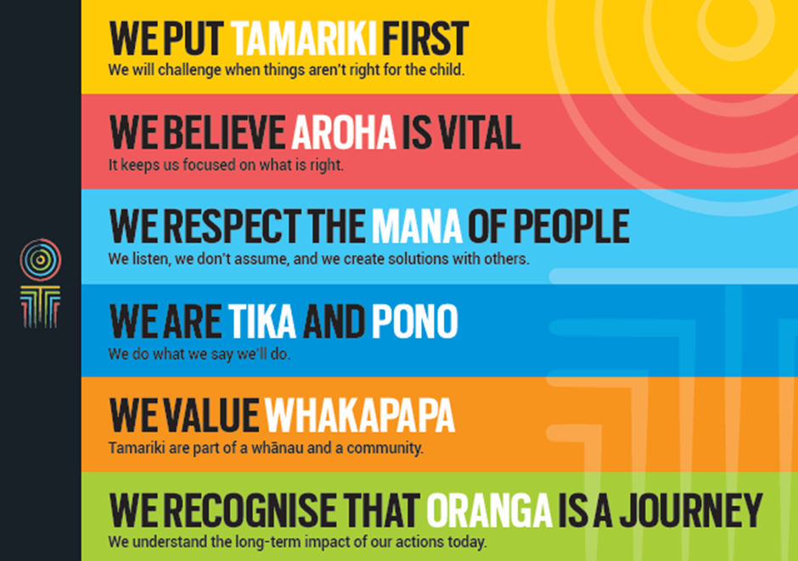
Our core outcomes | Our core outcomes are:  - All children and young people are in loving families and communities where they can be safe, strong, connected, and able to flourish.  - Improved outcomes for all children, especially tamariki and rangatahi Māori.

POSITION PURPOSE
The purpose of this position is to support the utilisation of Children’s Team service activity and outcomes being achieved through the provision of sound business analysis to meet accountabilities and to inform continued improvement.
The Business Analyst will collect and analyse quantitative and qualitative data from a variety of sources and be responsible for providing high quality, accurate advice and information to inform funding, strategy, and planning within the Children’s Teams to achieve desired outcomes.
KEY ACCOUNTABILITIES
Key Result area | Key Accountabilities
Data collection, analysis and interpretation | - Use modelling and data mining methods provided by others, to investigate the current funded services to identify opportunities to re-align services to meet the needs of vulnerable/at risk children that will be supported through the Children’s Teams  - Use modelling and data mining methods provided by others, to undertake population analysis to confirm expected levels of referrals to the Children’s Teams and ensure the high priority children are being referred  - Provide high quality objective analysis of both quantitative and qualitative data within specified time frames, both on a monthly basis and on an ad hoc basis as requested.
Advice and support | - Respond to government queries, e.g. Parliamentary or Select Committee questions, in a timely manner, ensuring data is accurate and consistent with previous reporting  - Build understanding of new methods by responding to enquiries from internal and external sources  - Understand the limitations of Children’s Teams’ data, providing advice on its reliability and reflection of operational practice  - Provide advice on the use of available data to address different business issues  - Present results to a range of internal and external stakeholders  - Support the Children’s Team Directors to understand any new quality improvement business processes and how they impact on performance and results being achieved  - Provide recommendations on actions required to improve/maintain performance taking a continuous improvement approach.
Requests, correspondence and issues management | - Provide business analytical support with responses to Official Information requests, Parliamentary Questions and the Select Committee questions, Ministerial correspondence, Ombudsman enquiries and Privacy Commissioner enquiries.
Report writing | - Write clear reports that are accurate and succinct  - Contribute to Children’s Teams’ reports where required  - Provide advice, information and support to the team as requested  - Adjust language and content of reports based on the audience groups.
Communication | - Act as a point of contact for the use of business analytics  - Work effectively and communicate with Operations and Children’s Team personnel by making complex issues understandable  - Set out arguments clearly and logically; assist senior business analysts to persuade and influence others  - Adapt communications to the views and level of knowledge of the audience  - Prepare and structure communication well, making complex issues understandable  - Ensure communications are easily understood and fully disseminated and all relevant managers are fully updated and made aware of any risks to the Ministry.
Service Quality | - Receive quality information, analyse the data and provide a report to management highlighting areas for concern with recommendations to ensure that results are being maintained or improving  - Liaise with business unit quality portfolio holders to ensure consistency and transparency of results across business systems and processes  - Provide support and advice on quality resources and tools that business units can use to maximise performance  - Ensure quality documentation is up-to-date and readily available to management and staff  - Review and audit sampling processes from time-to-time  - Monitor, evaluate and drive continuous improvement to Children’s Team processes and procedures to improve service quality, effectiveness and mitigate risk.
Audit and Assurance | - Contribute to the overview and facilitate Children’s Workforce audit requirements, and ensure that tasks are completed in a timely manner and any concerns are raised to management for consideration  - Oversee the administration of Children’s Teams assurance responsibilities.
Risk and Compliance | - Ensure the Children’s Team’s risk register is maintained and reviewed by management to ensure risks are appropriate and can be controlled and/or influenced by Children’s Teams, and that mitigations developed are workable and relevant  - As a result of business reviews, identify matters that may cause concern or pose a risk, and bring this to the attention of the Children’s Team for consideration and escalation  - Ensure that Children’s Teams are adhering to and complying with the Ministry’s risk and compliance requirements and that reporting standards and requirements are met  - Maintain the Children’s Team Business Continuity Plan (BCP) ensuring this is regularly reviewed by management.
Stakeholder and Relationship Management | - Identify, build and maintain networks and effective working relationships with key external and internal stakeholders within Children’s Teams, Services for families South  - Promote and represent Children’s Teams professionally and credibly.  - Maintain an in-depth knowledge of Oranga Tamariki business activities and processes, and ensure that this knowledge is kept current and relevant by actively working within and across business units, so that they are able to represent Children’s Teams or provide comment and insight on likely impacts of change or initiatives  - Understand the Ministry’s strategy, framework and processes and represent this view when engaging with stakeholders, including sector representatives.
Change and Project Management | - Participate in projects across Children’s Teams as required  - Assess the impact of proposed changes that affect the operations and delivery of business activity, contributing to the development implementation, and changes plans  - Identify potential issues and risks associated with change  - Encourage and support operational teams through change processes  - Self-manage own work load to meet agreed deadlines, managing a variety of task concurrently and showing flexibility of work patterns in order to meet timeframes for delivery  - Contribute to planning, including project plans, schedules and budget.
Work Programme | - Contribute to other areas of the work programme as agreed with Management of Children’s Teams in accordance with the needs of the Children’s Teams, and your professional areas of expertise  - Connect with key personnel from other agencies related to business analysis concerning vulnerable/at risk children, in particular Better Public Service targets and related activity.
Being part of the Oranga Tamariki team | - Actively and positively participate as a member of the team  - Proactively look for opportunities to improve the operations of Oranga Tamariki  - Perform any other duties as needed by Oranga Tamariki  - Comply with and support all health and safety policies, guidelines and initiatives  - Ensure all incidents, injuries and near misses are reported into our H&S reporting tool  - Comply with all legislative and regulatory requirements, and report any breaches as soon as they become known  - Adhere to all Oranga Tamariki procedures, policies, guidelines, and standards of integrity and conduct  - Commitment to the Treaty of Waitangi and respect and incorporate these into your work.

KEY RELATIONSHIPS
Internal | - General Manager Children’s Teams  - Children’s Teams Manager  - Operations Support Manager  - Children’s Teams Directors and staff  - Staff within Oranga Tamariki
External | - Relevant sector stakeholders  - Other government departments and social sector agencies  - NGO and iwi stakeholders in relation to Children’s Teams  - Other organisations/agencies/people as required.

QUALIFICATIONS & EXPERIENCE
Qualifications | - An appropriate relevant tertiary qualification or a high level of relevant equivalent experience in data analysis, reporting and information management is desirable  - Computer literate, with competence in the use of the Microsoft Office Suite (essential).
Experience | - Advanced skill and significant experience to extract, analyse, and present data; Visual Basic and SAS experience desirable, but not required  - Understanding of and experience in the collection, analysis and management of social sector data  - Sound knowledge of information management  - Experience in investigating and analysing complex problems, and reaching sound conclusions  - Sound knowledge of the analysis of both text and numeric data to determine key facts, trends and issues  - Experience in investigating and analysing problems, and reaching sound conclusions  - Experience in report writing, plain English editing and proof-reading  - Proven ability to communicate at both a general business requirement and technical level  - Detailed knowledge of business performance reporting requirements  - Proven experience in a government environment.  Preferred  - Experience in a business analyst role with configurable software packages such as Microsoft Dynamics CRM  - Understanding of data modelling and database structure  - Experience with SQL queries  - Comprehensive knowledge of Oranga Tamariki and the wider government products, systems and services  - Experience overseeing and prioritising workflow in a busy operational environment  - A demonstrated knowledge and understanding of relevant legislation and policy that support business processes  - An understanding of the Ministry’s risk and audit requirements  - An awareness of our interdependent linkages with other internal and external agencies and our relationship to them.
Skills | - Excellent analytical skills – an ability to analyse data to determine key facts, trends and issues, and present robust analysis and conclusions  - Ability to translate information and analysis into outputs which are readily interpreted by operationally-focused and non-technical people  - Demonstrated ability to manipulate data and generate appropriate reports in a timely manner  - Strong report writing ability, and the ability to write clearly and persuasively for a range of audiences  - Attention to detail  - Proven self-management and organisational skills  - Exercises sound judgement  - Excellent verbal, written and interpersonal communication skills  - Ability to communicate complex ideas to a variety of audiences and build and maintain rapport with others  - Flexible, adaptable and realistic  - Strong client focus  - Works well under pressure  - Can arrange work demands to meet priorities  - Understanding and appreciation of cross cultural issues and concerns, in particular, knowledge of tikanga Māori, and Pacific peoples’ culture.
Other requirements | Willing to travel to fulfil job requirements  Holds current clean driver’s licence and is prepared to drive the Ministry’s vehicles if required.

